IMLS eGMS Payment Request Web Form
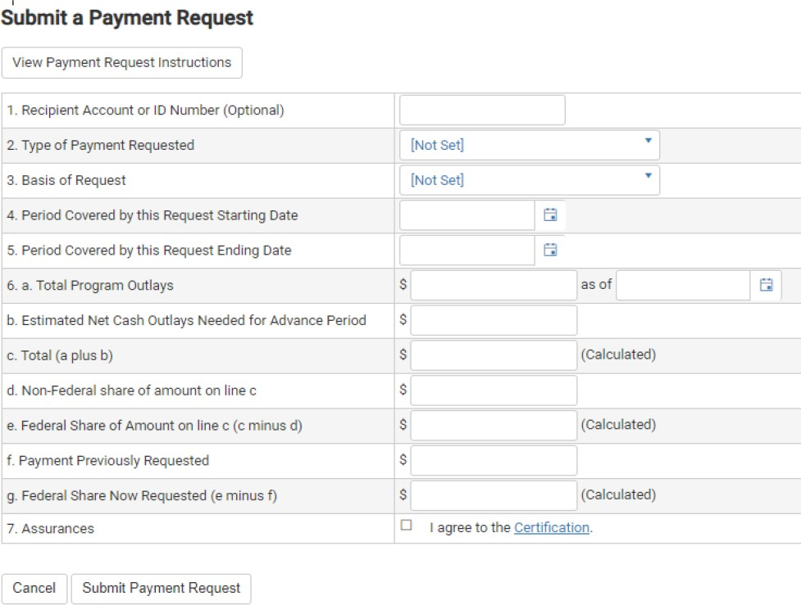

PAYMENT REQUEST INSTRUCTIONS

Line 1. Recipient Account or ID Number (Optional)
Leave blank or enter an account or ID number that is important for your organization.

Line 2. Type of Payment Requested
If this is the last or only payment request you plan to make, select FINAL; otherwise select PARTIAL.

Line 3. Basis of Request
- Reimbursement: Select CASH.
- Advance: Select ACCRUED EXPENDITURES.

Line 4. Period Covered by this Request Starting Date
- Reimbursement: This date cannot be prior to the start date of the award.
- Advance: This date must not be more than 15 business days before the date you submit this form.

Line 5. Period Covered by this Request Ending Date
- Reimbursement: This date must be prior to the date you submit this form. It cannot be after the end date of the award.
- Advance: This date must not be more than 30 days beyond the date entered on Line 4. You must obligate/expend the full amount of the advanced funds within the 30-day period.

Line 6. Computation of Amount Requested
- Total Program Outlays:
- Reimbursement: Enter all costs incurred up to the requested ending date, including both the Federal and Non-Federal shares. If this is your first request, enter the amount you are requesting plus the amount you have provided so far as Non-Federal share.
- Advance: Enter all costs incurred up to the requested ending date, including both the Federal and Non-Federal shares, but excluding the current Advance request.
- Enter today’s date in the “as of” box.
- Estimated Net Cash Outlays Needed for Advance Period: Enter ONLY the Federal funds you are requesting for this advance. If you are requesting a reimbursement, enter $0.00 here.
- Total (a plus b): This box is automatically calculated.
- Non-Federal share of amount on line c: Enter the amount of cost share provided for the period covered by this request. If there is no cost share, enter $0.00.
- Federal Share of Amount on line c (c minus d): This box is automatically calculated. The Total cannot exceed the total amount of the award.
- Payment Previously Requested: If this is your second, third, or any request other than your first one, enter the cumulative total amount of Federal funds requested previously for this award.
- Federal Share Now Requested (e minus f): This box is automatically calculated based on previous fields. This is the amount you are now requesting. Requests must not be less than $1.00.
Line 7. Assurances
Checking the Assurances box confirms your agreement to all the terms and conditions of the award, including Authorizing Official certification.
When your Payment Request is complete, click SUBMIT PAYMENT REQUEST. You can track the status of your Payment Request through the Payments Tab in eGMS Reach. You can generally expect payment 5-7 business days after the Payment Request status changes to Approved in eGMS Reach.
PAPERWORK REDUCTION ACT STATEMENT
The public reporting burden for this collection of information is estimated at an average of one hour per response. This includes the time for reviewing instructions, searching existing data sources, gathering and maintaining the data needed, and completing and reviewing the collection of information. Send any comments regarding this burden estimate or any other aspect of this collection of information, including suggestions for reducing this burden, to the Institute of Museum and Library Services at 955 L’Enfant Plaza North, SW, Suite 4000, Washington, DC 20024-2135, and to the Office of Management and Budget, Paperwork Reduction Project, Washington, DC 20503.
Note: Awardees are not required to respond to a collection of information unless it displays a currently valid U.S. Office of Management and Budget (OMB) control number.
OMB Control #: 3137-XXXX, Expiration Date x/xx/xxxx

