In the “Specific Instructions” section, we wish to modify the instructions for f1 through f4 to be consistent with f5. For f5, we wish to capitalize the “D” in Damage and add a period after “No”.

Original:

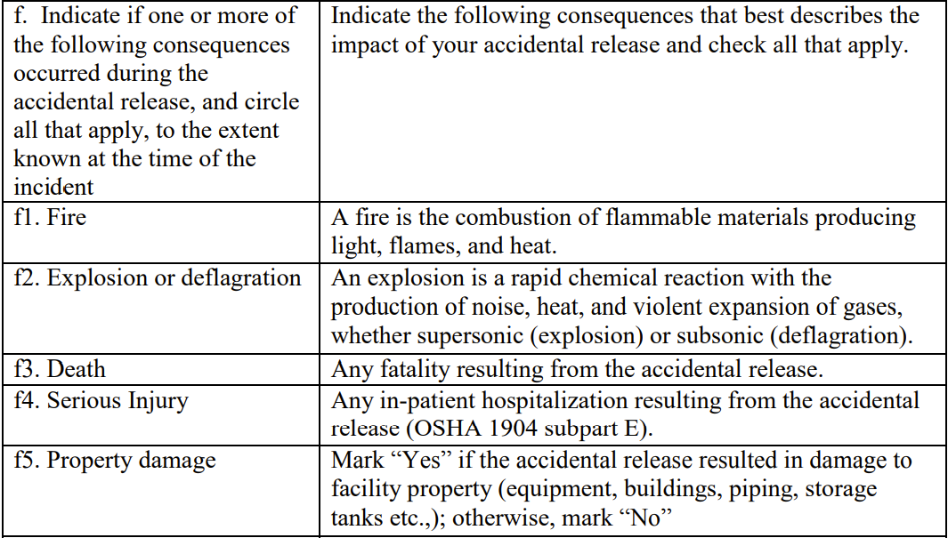

Proposed Modification:

|  |  |
| --- | --- |
| f1. Fire | Mark “Yes” if the acidental release resulted in a fire; otherwise, mark “No”. |
| f2. Explosion | Mark “Yes” if the acidental release resulted in an explosion; otherwise, mark “No”. |
| f3. Death | Mark “Yes” if the acidental release resulted in a death (fatality); otherwise, mark “No”. |
| f4. Serious Injury | Mark “Yes” if the acidental release resulted in a serious injury (in-patient hospitalization (OSHA 1904 subpart E)); otherwise, mark “No”. |
| f5. Property Damage | Mark “Yes” if the accidental release resulted in damage to facility property (equipment, buildings, piping, storage tanks etc.,); otherwise, mark “No”. |

In the “Specific Instructions” section, we wish to modify the instructions for g. to inculde the word “registry” between “and” and “number”.

We also wish to modify g1. and g2. to read “CAS Name and Number”.

Original:

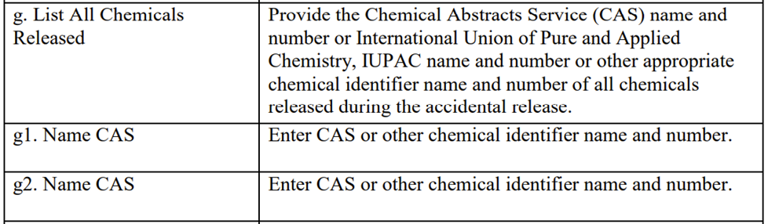

Proposed Modification:

|  |  |
| --- | --- |
| g. List All Chemicals Released | Provide the Chemical Abstracts Service (CAS) name and registry number or International Union of Pure and Applied Chemistry, IUPAC name and number or other appropriate chemical identifier name and number of all chemicals released during the accidental release. |
| g1. CAS Name and Number | Enter CAS or other chemical identifier name and number. |
| g2. CAS Name and Number | Enter CAS or other chemical identifier name and number. |

In the “CSB Accidental Release Reporting Form” section, we wish to modify g1. and g2. to read “CAS Name and Number” rather than “Name CAS”.

Original:

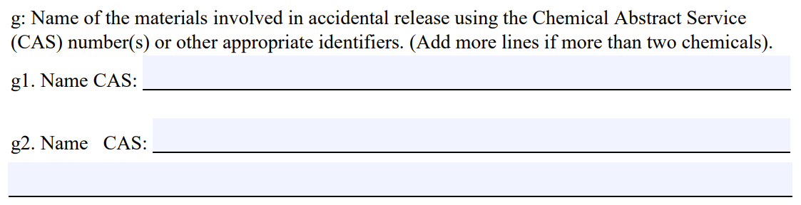

Proposed Modification:

g: Name of the materials involved in accidental release using the Chemical Abstract Service (CAS) number(s) or other appropriate identifiers. (Add more lines if more than two chemicals).

g1. CAS Name and Number: _________________________________________________________

g2. CAS Name and Number: _________________________________________________________

_________________________________________________________________________________

In the “CSB Accidental Release Reporting Form” section, we wish to modify j2. to read “j1. Number of Serious Injuries:”.

Original:



Proposed Modification:

j1. Number of Serious Injuries: ________________________________________________________