New CSOS:
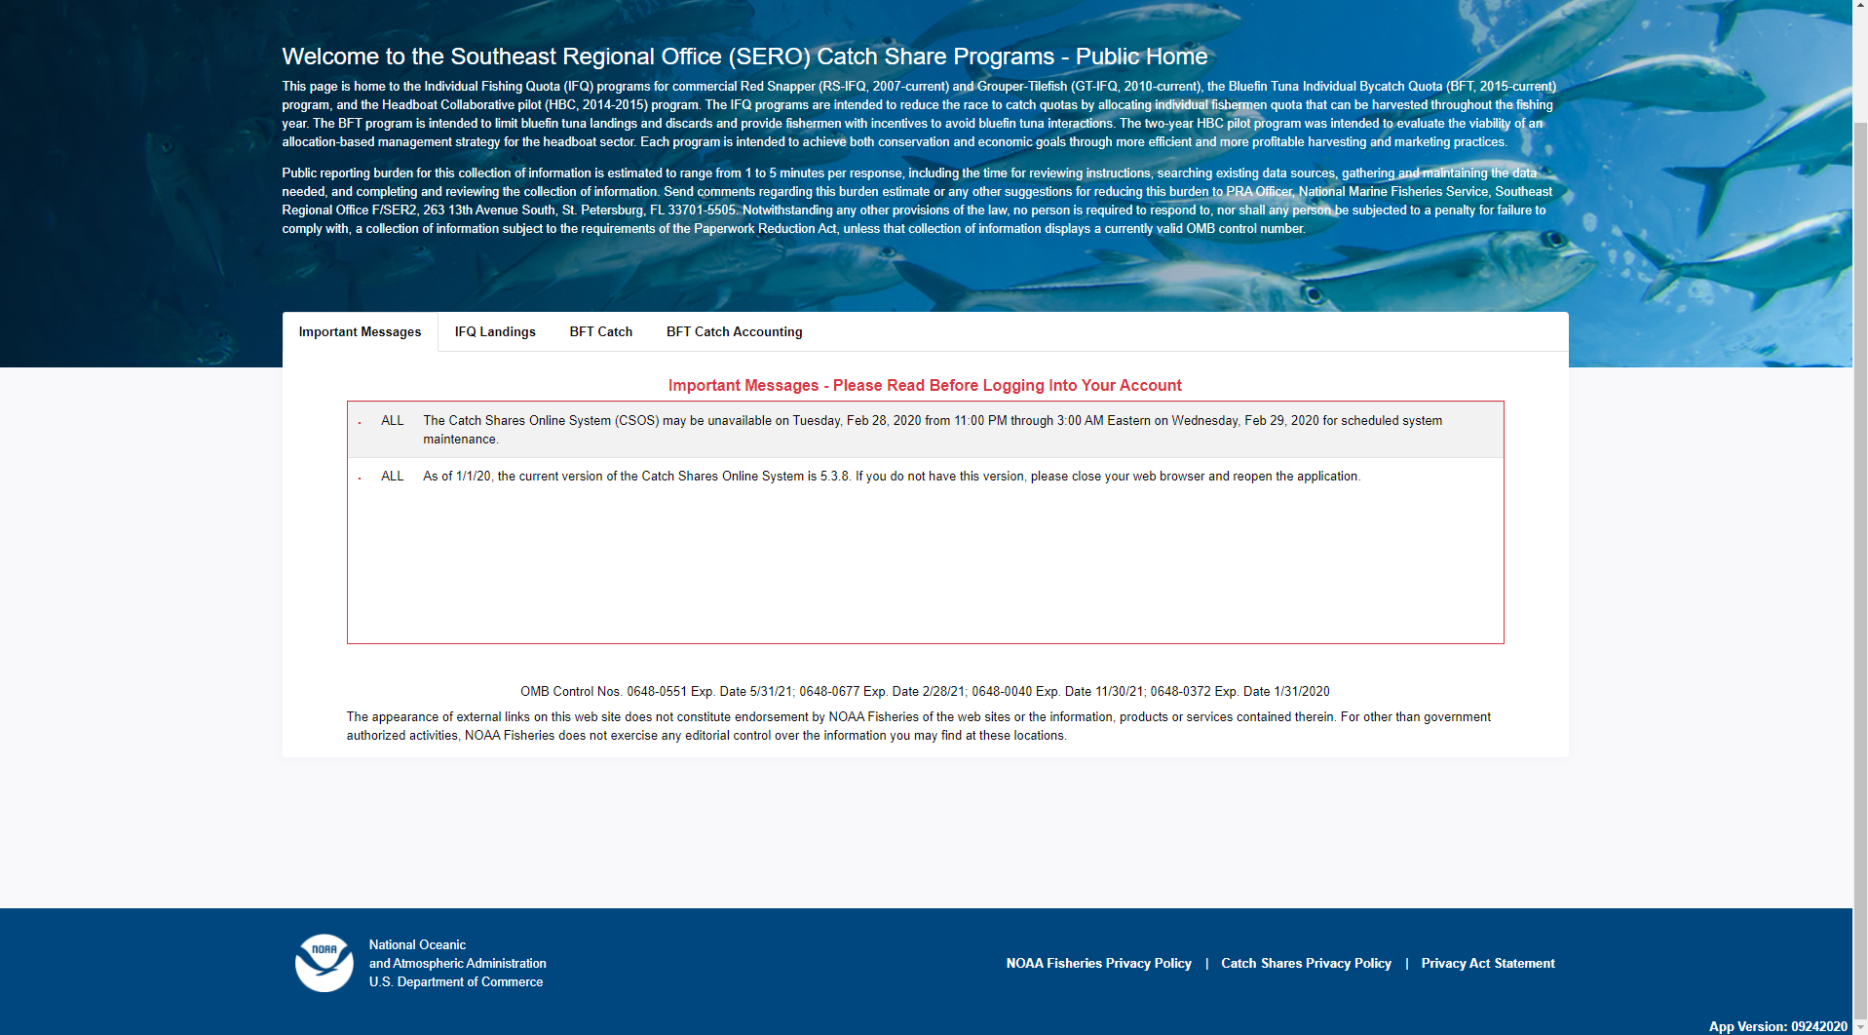

NOAA Fisheries Privacy Policy (link to https://www.fisheries.noaa.gov/privacy-policy)

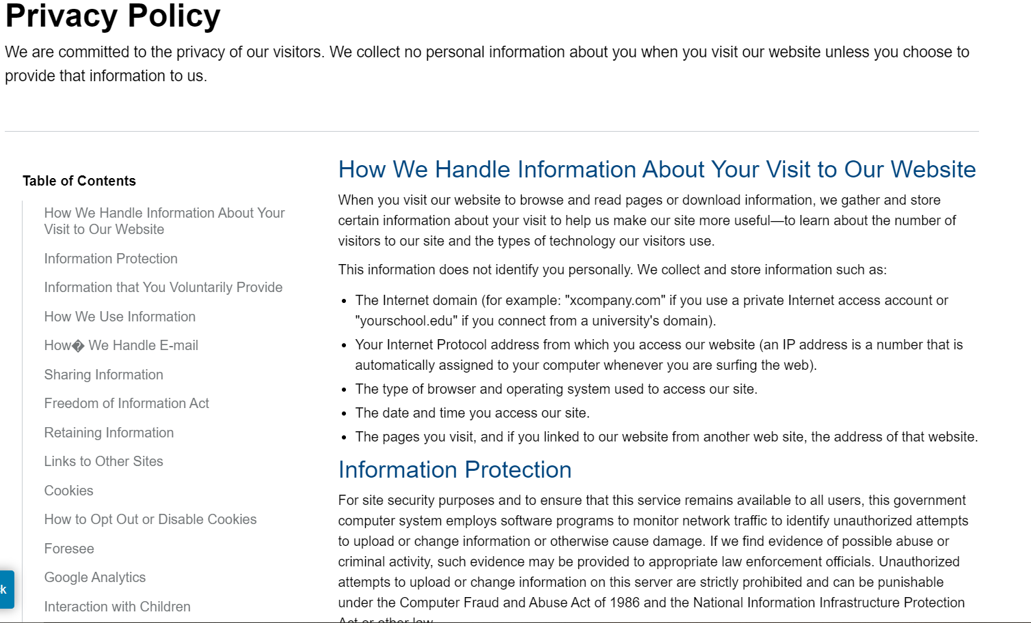
Catch Shares Privacy Policy (link to https://portal.southeast.fisheries.noaa.gov/cs/ifq_privacy_policy.html)
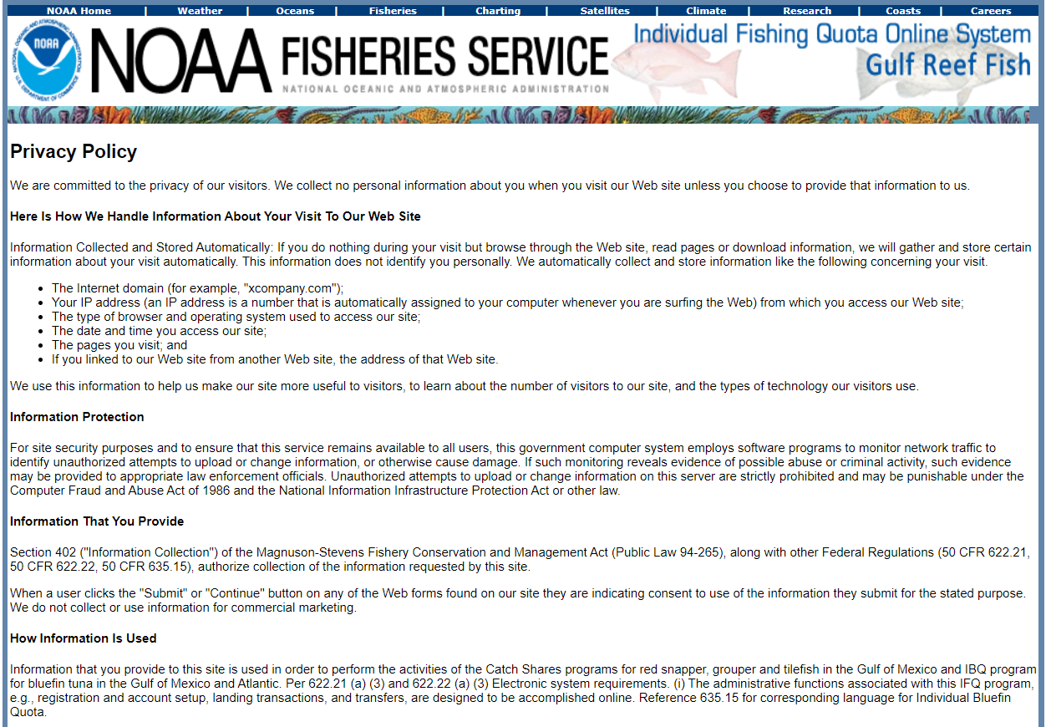
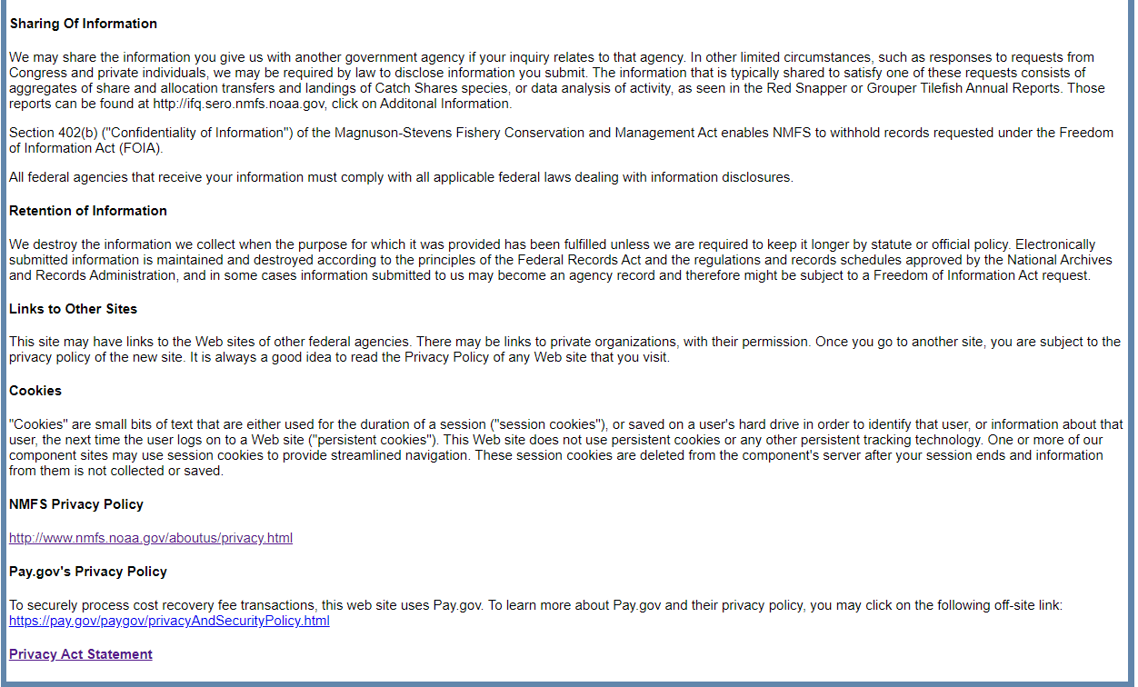
Privacy Act Statement (link to https://portal.southeast.fisheries.noaa.gov/cs/ifq_pas.html)
