COVID-19 Data Collection

Survey Tool Questions

[REVISED 1/29/2021]

As part of COVID-19 (Coronavirus) emergency-response efforts, we are asking health centers to fill out a weekly survey to help track health center capacity and the impact of COVID-19 on health center operations, patients, and staff. The Health Resources and Services Administration will use the information collected to better understand training and technical assistance, funding, and other health center resource needs.

Please refer to the COVID-19 Data Collection Survey Tool User Guide to assist you in completing the survey.

[Part 1. Main Questions – All Responding Health Centers]

Question Number | Question Field | Description | Answer Field
Question 1 | Please enter your email address | [you@example.com] | [text field]
Question 2 | Please select the State/Territory that your health center is located in: | [Select an answer choice from the list] | Pick List of all the States + US Territories
Question 3 | Please select your health center name and associated Grant Number: | [Select an answer choice from the list] | Pick List of all of the Health Centers + Active H80 Grants
Question 4 | Does your health center currently have the ability to test patients for COVID-19? (Testing refers to specimen collection regardless of where the specimen is processed. Include tests for SARS-CoV-2 virus detection (PCR, antigen) only. Do not include tests for antibody detection (serology).) | [Select an answer choice from the list] | Pick List Y/N
Question 5 | Does your health center currently have walk-up/drive-up COVID-19 testing sites? | [This question does not appear if N was selected for Question 3.]  [Select an answer choice from the list] | Pick list Y/N
Question 6 | On average for this week, how quickly is your health center able to obtain COVID-19 test results for SARS-CoV-2 virus detection (PCR, antigen)? (Do not include test processing times for antibody detection (serology).) | [This question does not appear if N was selected for Question 3.]  [Select answer choices from the list] | Select one:  - < 1 hour  - 12 hours or less  - 24 hrs  - 2-3 days  - 4-5 days  - More than 5 days
Question 7 | By race and ethnicity, how many of your patients received a test for SARS-CoV-2 virus detection (PCR, antigen) in the last week? (Testing refers to specimen collection regardless of where the specimen is processed. Do not include tests for antibody detection (serology).)  [Enter the number of patients tested by race and ethnicity below]  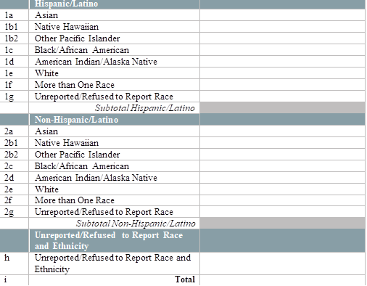 | [This question does not appear if N was selected for Question 3. Please enter a numerical value excluding commas ( ex. 123123)] | Number Field
Question 8 | By race and ethnicity, how many of your patients have tested positive for SARS-CoV-2 virus detection (PCR, antigen) in the last week? (Report all positive results regardless of where patients were tested. Do not include positive test results for antibody detection (serology).)  [Enter the number of patients who tested positive for SARS-CoV-2 virus detection (PCR, antigen) by race and ethnicity below.] | [Please enter a numerical value excluding commas ( ex. 123123)] | Number Field
Question 9 | How many health center staff members have tested positive for COVID-19 in the last week? (Report positive results for viral detection (PCR, antigen) tests only. Do not include positive test results for antibody detection (serology).) | [Please enter a numerical value excluding commas ( ex. 123123)] | Number Field
Question 10 | What percentage of health center staff members were unable to work due to COVID-19 (e.g., due to site/service closure, exposure, family/home obligations, lack of PPE, etc.) in the last week? | [Select an answer choice] | Slider – Range 0-100 Interval of 5
Question 11 | How many of your health center sites were temporarily closed due to COVID-19 this week? (Include only those sites in your HC program scope of project.) | [Please enter a numerical value excluding commas ( ex. 123123)] | Number Field
Question 12 | How does this last week’s number of visits compare to your average number of weekly visits pre-COVID-19? (Consider all visits regardless of service type (e.g., medical, dental, behavioral health, etc.), including virtual visits.) | [With 100% being average, <100% being below average, >100% being above average] | Slider - Range 10-150 Interval of 5
Question 13 | What percentage of your health center’s visits in the last week were virtual (e.g., telehealth/telephonic)? (Consider all visits regardless of service type (e.g., medical, dental, behavioral health, etc.).) | [Select an answer choice] | Slider – Range 0-100 Interval of 5
Question 14 | How long will your health center have an adequate supply of PPE (e.g., masks, gloves, gowns, etc.) to serve your patients?  (If your health center is not currently having supply challenges, please select "No supply challenge at this time," regardless of the number of days for which you have a supply in stock. Please also select this option if your health center does not use a particular item.)  - Surgical masks  - N95/PPR masks  - Gowns  - Gloves  - Face masks/goggles | [Select an answer choice for each type of PPE] | Pick an Option  - 6 or fewer days  - 7-13 days  - 14-20 days  - 21-27 days  - 28 or more days  - No supply challenge at this time
Question 15 | How many health center staff members have initiated (1st dose received) their COVID-19 immunization series in the last week?  [Enter the number of staff who initiated an FDA-approved vaccine series in the last week below.] [Note: Exclude vaccines administered to health center staff while participating in clinical trials.] | [Please enter a numerical value excluding commas ( ex. 123123)] | Number Field
Question 16 | How many health center staff members have completed (2nd dose received) their COVID-19 immunization series in the last week?  [Enter the number of staff who completed an FDA-approved vaccine series in the last week below.] [Note: Exclude vaccines administered to health center staff while participating in clinical trials.] | [Please enter a numerical value excluding commas ( ex. 123123)] | Number Field
Question 17 | By race and ethnicity, how many patients have initiated (1st dose received) their COVID-19 immunization series in the last week?  [Enter the number of patients who initiated an FDA-approved vaccine series in the last week, by race and ethnicity below.] [Note: Exclude vaccines administered to health center patients while participating in clinical trials.]  [Enter the number of patients tested by race and ethnicity below] | [Please enter a numerical value excluding commas ( ex. 123123)] | Number Field
Question 18 | By race and ethnicity, how many patients have completed (2nd dose received) their COVID-19 immunization series in the last week?  [Enter the number of patients who completed an FDA-approved vaccine series in the last week, by race and ethnicity below.] [Note: Exclude vaccines administered to health center patients while participating in clinical trials.]  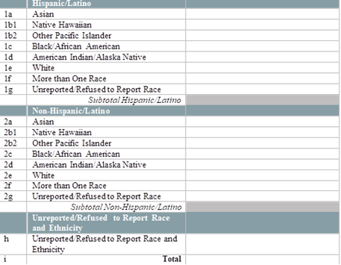 | [Please enter a numerical value excluding commas ( ex. 123123)] | Number Field
Question 19 | What challenges does your health center face in deploying the COVID-19 vaccine?  - None  - Vaccine supply  - Vaccine storage capacity  - Staffing to administer the vaccine  - Financial reimbursement for costs associated with vaccine administration  - Vaccine confidence  - Other – please specify | [Select all answers that apply from the list]  [Please briefly describe the challenges] | Pick List Multi-select (subcategory choices)  [Free text is optional]
Question 20 | Please provide any additional information, comments, or challenges you are experiencing due to COVID-19. |  | [Free text]

Public Burden Statement: Health centers (section 330 grant funded and Federally Qualified Health Center look-alikes) deliver comprehensive, high quality, cost-effective primary health care to patients regardless of their ability to pay and are critical in the national response to COVID-19. These forms provide HRSA with the information essential for analyzing health center progress, challenges, and needed technical assistance around COVID-19. The OMB control number for this information collection is 0906-xxxx and it is valid through XX/XX/202X. This information collection is mandatory under the Health Center Program authorized by section 330 of the Public Health Service (PHS) Act (42 U.S.C. 254b). Public reporting burden for this collection of information is estimated to average 1 hour per response, including the time for reviewing instructions, searching existing data sources, and completing and reviewing the collection of information. Send comments regarding this burden estimate or any other aspect of this collection of information, including suggestions for reducing this burden, to HRSA Reports Clearance Officer, 5600 Fishers Lane, Room 14N136B, Rockville, Maryland, 20857 or paperwork@hrsa.gov.

