Form Approved  
OMB No. 0920-xxxx  
Exp. Date xx/xx/xxxx

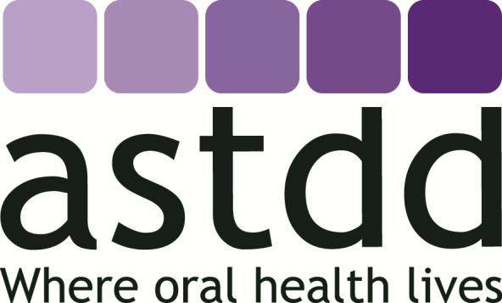

|  |
| --- |
| **Basic Screening Survey** |
|  |
| ***An Approach to Monitoring Community Oral Health***  ***Head Start and School Children*** |

##### ASSOCIATION OF STATE AND TERRITORIAL DENTAL DIRECTORS

December 19, 2019

Public reporting burden of this collection of information varies from 431 to 2,570 hours with an estimated average of 1,183 hours per response, including the time for reviewing instructions, searching existing data/information sources, gathering and maintaining the data/information needed, and completing and reviewing the collection of information. An agency may not conduct or sponsor, and a person is not required to respond to a collection of information unless it displays a currently valid OMB control number. Send comments regarding this burden estimate or any other aspect of this collection of information, including suggestions for reducing this burden to CDC/ATSDR Information Collection Review Office, 1600 Clifton Road NE, MS D-74, Atlanta, Georgia 30333; ATTN: PRA (0920-XXXX).

**CONTENTS**

ACKNOWLEDGEMENTS 5

SUMMARY OF REVISIONS 6

HOW TO USE THIS MANUAL 6

INTRODUCTION 7

BSS PLANNING GUIDE 7

Preliminary Planning Phase (9-12 months before screening) 8

Implementation Phase (3-9 months before screening) 9

Screening Phase 12

Post-Screening Phase 13

DENTAL CARIES OVERVIEW 15

OVERVIEW OF SCREENING INDICATORS 16

INDICATOR #1: UNTREATED DECAY 17

INDICATOR #2: TREATED DECAY 19

INDICATOR #3: DENTAL SEALANTS ON PERMANENT MOLARS 20

INDICATOR #4: URGENCY OF NEED FOR DENTAL CARE 21

OPTIONAL INDICATOR #1: DENTAL SEALANTS ON PRIMARY MOLARS 23

OPTIONAL INDICATOR #2: POTENTIALLY ARRESTED DECAY 24

Screeening Details 26

Lighting 26

Loupes 26

Retraction/Visualization 26

Removing Food Debris from Teeth 26

Instrumentation 27

Budget 27

Screener Training 27

Parental Consent 28

Optional Parent Questionnaire 29

Optional Questions 29

Sampling and Analysis 32

Criteria for Inclusion of BSS Data in National Oral Health Surveillance System 32

Data Management 33

Data Privacy and Security 35

Report Preparation And Dissemination 36

Contacts/Technical Assistance/Other Resources 36

APPENDIX 37

Sample Oral Health Screening Form for Head Start Children 38

Sample Oral Health Screening Form for School Children 39

Sample Letter to Principals – #1, Positive Consent 40

Sample Letter to Principals – #2, Positive Consent and Questionnaire 42

Sample Letter to Principals – #3, Passive Consent and Option for Questionnaire 44

Sample Passive Consent Cover Letter for Parents/Caregivers 46

Sample Positive Consent Cover Letter for Parents/Caregivers 48

Sample Positive Consent Cover Letter for Parents/Caregivers with Questionnaire 50

Sample Verbal Consent Form 52

Sample Optional Questionnaire <attach or copy onto the back of the consent form> 52

Sample Screening Results Letter for Parents 55

Sample Recording Form for Examiner Training 56

Race and Ethnicity Categories and Definitions 57

Tooth Eruption Patterns 58

Advisory Committees 59

ACKNOWLEDGEMENTS

The development of the initial Basic Screening Survey (BSS) model in 1999 was led by the Association of State and Territorial Dental Directors (ASTDD) in collaboration with the Ohio Department of Health. Technical assistance was provided by the Division of Oral Health, National Center for Chronic Disease Prevention and Health Promotion, US Centers for Disease Control and Prevention. Portions of this manual were adapted from *Oral Health Examination Survey Manual*, a companion document to *Assessing Oral Health Needs – ASTDD Seven-Step Model* by Barbara Carnahan, RDH, MS. ATSDD published the first manual in 1999 with revisions in 2003, 2008, 2015, 2017 and 2019.

ASTDD Project Director and Project Assistant, 1999

Mark D. Siegal, DDS, MPH

Cathy L. Raymond, RDH, BS

Bureau of Oral Health Services

Ohio Department of Health

Columbus, Ohio

CDC Project Officer, 1999

Dolores M. Malvitz, DrPH

Division of Oral Health

National Center for Chronic Disease Prevention and Health Promotion

Centers for Disease Control and Prevention

Atlanta, Georgia

CDC Epidemiologist, 2019

Mei Lin, MD, MPH, MSc

Division of Oral Health

National Center for Chronic Disease Prevention and Health Promotion

Centers for Disease Control and Prevention

Atlanta, Georgia

Consultant, 2019

Alison Amoroso, M.Ed.

Deloitte Consulting

Atlanta, Georgia

Project Director for 2003, 2008, 2015, 2017 and 2019 Revisions

Kathy Phipps, RDH, MPH, DrPH

ASTDD Data and Surveillance Coordinator

Morro Bay, CA

In 1999, two advisory committees (See Appendix), made essential contributions to the survey. The members of the Policy/Content Advisory Committee determined what items were included in both the direct observation and the questionnaire components. The Technical/Criteria Advisory Committee determined the screening criteria for the direct observation portion. Members of ASTDD’s Data Committee and Board of Directors reviewed and approved the 2003, 2008, 2015, and 2017 revisions. We would also like to thank Drs. John Warren and John Zimmer for providing some of the photos used in this document.

The 2019 revisions to this publication and any accompanying materials were supported by Cooperative Agreement CDC-RFA-DP18-1811 from CDC, the Division of Oral Health. The contents are solely the responsibility of the authors and do not necessarily represent the official views of CDC.

SUMMARY OF REVISIONS

Previous state and local experiences provided insight into ways the BSS could be improved. The 2003 version of *Basic Screening Survey: An Approach to Monitoring Community Oral Health, Head Start and School Children,* included several minor and one major revision. The major revision was an update on the method for collecting information regarding race and ethnicity. The 1999 version had one data element for race and another for ethnicity. Field-testing found two problems with the 1999 method – missing data and the inability to code multi-racial children. The 2003 version combined race and ethnicity into one question (to reduce the amount of missing data) and included a code for multi-racial children.

The 1999 version of *Basic Screening Surveys* included “untreated decay” and “caries experience” as two of the screening indicators. Using these two indicators, however, did not allow states, territories, and tribes (hereon referred to as “states”) to determine which children had received previous treatment for caries. In 2008, the BSS indicator “caries experience” was changed to “treated decay.” Caries experience remains an indicator of the National Oral Health Surveillance System (NOHSS) framework but is calculated from untreated decay and treated decay.

As states developed their oral health surveillance infrastructure, health departments voiced an interest in collecting information on disease severity in addition to prevalence data. The 2008 version of the *Basic Screening Survey* added a set of options for each indicator ranging from a simple no/yes to the more complex.

In 2015, two revisions were made to *Basic Screening Surveys*. The early childhood caries (ECC) indicator – caries experience on maxillary anterior teeth – was deleted because the generally accepted definition of ECC is decay on any tooth rather than just the maxillary anterior teeth, and the optional questions were updated to align with national surveys collecting oral health data.

The 2017 version of the *Basic Screening Surveys* included two major revisions. First, optional indicators for dental sealants on primary molars and potentially arrested decay were added for states wishing to monitor the use of primary molar sealants and caries arresting agents such as silver diamine fluoride. Second, the optional questions were further updated to align with current national surveys.

The 2019 revision updates the Basic Screening Survey for children so that it complies with the Paperwork Reduction Act of 1995. This revision includes updated protocols that meet privacy and scientific data quality standards and federal demographic guidelines (e.g. asking ethnicity separate from race). It also provides clarifications on screener training protocols and that the survey is public health practice rather than research.

HOW TO USE THIS MANUAL

This manual provides general information on how to conduct a Basic Screening Survey in Head Start and school children. It includes the clinical indicators that should, at a minimum, be collected as well as the diagnostic criteria that all jurisdictions should use when collecting oral health data.

In addition to this manual, ASTDD has developed a set of supplemental materials that should be reviewed in planning the oral health survey. They are available at: [www.astdd.org/basic-screening-survey-tool/](http://www.astdd.org/basic-screening-survey-tool/). While this set of materials provides basic information, we encourage obtaining technical assistance from your agency’s epidemiologist or statistician to assure the use of sound survey techniques. If you, or your agency, have further questions please contact ASTDD ([www.astdd.org](http://www.astdd.org/)).

INTRODUCTION

Recognizing the need for standard, community-level oral health status data, ASTDD developed the *Basic Screening Survey* (BSS). The primary purpose of the BSS is to provide a framework for obtaining oral health data that is easy to implement; yet always consistent. By collecting data in a consistent manner, communities and states can compare their data with (1) data collected by other organizations or agencies using the same methodology and/or (2) data from previous surveys.

Developing training materials for the BSS involved a number of experts in oral health and individuals with experience in health policy. The training materials were designed so they could be used by screeners with or without dental backgrounds. This approach was taken because non-dental health professionals, such as school nurses, sometimes have direct access to some population groups and because some states and communities have few public health dental professionals to assist in screening surveys.

Before embarking on a screening survey, it is important to understand its limitations. A dental screening is not a thorough clinical examination and does not involve making a clinical diagnosis resulting in a treatment plan. A screening is intended to identify definitive dental or oral lesions, and is conducted by dentists, dental hygienists, or other appropriate health care workers, in accordance with applicable state law. The information gathered through a screening survey is at a level consistent with monitoring the national health objectives found in Healthy People ([www.healthypeople.gov/](http://www.healthypeople.gov/)), the United States Public Health Service’s 10-year agenda for improving the Nation’s health. Surveys are cross sectional (looking at a population at a point in time) and descriptive (intended for determining estimates of oral health status for a defined population).

The BSS model has two basic components:

1. direct observation of a child’s mouth
2. the collection of demographic information

Through the direct observation of a child’s mouth, the BSS collects data of key indicators of the National Oral Health Surveillance System (NOHSS), including caries experience, untreated tooth decay, dental sealants on permanent molars, and urgent need for dental care. Because demographic information is necessary to evaluate and document oral health disparities, ASTDD and CDC strongly recommend that states collect child-level demographics. Aggregated BSS data is submitted to ASTDD, and ASTDD verifies that the data meet the inclusion criteria for NOHSS and posting on the Oral Health Data (OHD) portal hosted by CDC.

States may wish to supplement the NOHSS indicators with a questionnaire to be completed by a child’s parent or guardian or with additional direct observations indicators. Both optional and neither are submitted to the OHD portal.

BSS PLANNING GUIDE

A successful Basic Screening Survey requires planning and forethought. Following is a step-by-step guide for planning a BSS, from the preliminary planning to the post-screening phase. In general, planning for a BSS for children should start during the school year prior to the school year in which you want to collect data. Many states find that survey plans should be in place in the spring so that data collection can begin in the fall, although some states may be able to complete the entire process during one school year.

The focus of this planning guide is school-based surveys. Although the steps are similar, you may need to modify the procedures for a Head Start survey. States, territories, and tribes are referred to as “states.”

###### Preliminary Planning Phase (9-12 months before screening)

1. Develop a survey plan by answering the following questions:
   * What gaps in surveillance or policy do I want to find out, and for what purpose?

Once the data is collected, what will you use it for – program evaluation, budgeting, advocacy, documenting disparities, etc.?

* + What age groups and/or grades do I want to include in the survey?

For example, do you want information on Head Start children, kindergarten, third grade, and/or children in other grades? NOTE: ASTDD and CDC recommend that states obtain information on at least third grade children.

* + What level of estimate do I want to obtain?

For example, do you want information for the state, for regions within the state, or county-level information? NOTE: The smaller the level of interest, the more expensive the survey becomes.

* + What level of funding is available for this project?

Can I obtain funding from other sources such as the state dental association or an insurance plan?

* + Do I want to include a questionnaire with the screening and if yes, what information do I want to obtain that I can’t obtain through other government data sources?
  + In addition to the BSS clinical parameters and demographic characteristics, consider if including a parent or caretaker questionnaire to collect related data would help your state achieve other goals, and how to implement it without reducing response rates. Are there other programs in the state with which I can partner, such as vision, hearing, or scoliosis screening, or sealant programs?

You may be able to add the oral health component to an established program or share staff and data.

***TIP:*** Consider forming a survey advisory committee that includes representatives from key stakeholder organizations such as the health department, department of education, dental and dental hygiene associations, dental school, potential funding organizations, and the school nurses’ association. If you have a state-wide oral health coalition, this group could act as the advisory committee.

1. Determine protocols for consent, approvals, and privacy.
   * Public health activities are not governed by human subjects’ research policies; however, your state health department or board of education may have a protocol to follow. Some states may require that the survey plan be submitted to a state IRB for an exemption, and some state departments of education and local school districts may have internal research review committees with jurisdiction over public health activities. Ethics rules always apply.
   * Determine the appropriate consent process (passive vs. positive). Using passive consent will result in a response rate of about 75-90% while using positive consent will generally result in a response rate of less than 50%; with some states having only a 20% response rate with positive consent. Using passive consent, however, will reduce your ability to obtain information from a parent or caregiver questionnaire. Consider the plusses and minuses of various response rates weighed against the need for additional data obtained through a questionnaire.
   * If your state’s BSS will be conducted by a private agency governed by HIPPA, the oral health program manager may want to discuss this non-research survey with the state HIPAA coordinator.

***TIP:*** Review any IRB protocol or other regulations at least 6-months before starting the project.

1. Contact your state’s department of education and/or Head Start office to gain their support.
   * Discuss the consent process your program wants to use with the DOE. Some school districts use passive consent, while others may prefer positive consent. If you prefer passive and the DOE does not, explain your reasoning and the ramifications on the quality of data and ability to document disparities.
   * Obtain documentation from the DOE which shows support or approval for the BSS or have a representative co-sign a letter to schools and/or districts.
   * Determine if school districts require background checks for screeners and find out their processes.
   * Determine if the state has a translation service and policy for consent and result letters.
   * Discuss data sharing and determine a process for obtaining child-level demographic data from the DOE.
   * Determine to whom letters regarding survey participation should be sent – school principals and/or the district superintendents? Send a copy of the letter to the school nurse either at this stage or after confirmation.

***TIP:*** In some cases, it helps to contact the school nurses’ association and the nurses at the selected schools for their support. Often, principals will not want to participate but the nurses will convince them to take part.

***TIP:*** Ask the DOE to designate a specific contact person to assist you during the survey planning and implementation process.

**Additional Information:** Refer to “Parental Consent” on page 28 of this manual. Sample letters are in the Appendix.

1. Determine if you will hire paid or volunteer screeners. While volunteer screeners are cost-effective, paid screeners tend to be more reliable and better in terms of maintaining standardization of data collection.
2. Calculate your budget and gather resources.

###### Implementation Phase (3-9 months before screening)

1. Determine methods for collecting demographic data.

* At a minimum, include school-level percentage of children eligible for the National School Lunch Program (NSLP), a proxy measure for sociodemographic status. ASTDD recommends that school-level NSLP participation be used as an implicit stratification variable for BSS sampling and the data are typically available through state DOE websites.
* ASTDD and CDC strongly recommend that states collect child-level demographics to assess and document oral health disparities. The recommended demographic data include sex, race and ethnicity, grade and eligibility for NSLP. States may also collect child’s age or date of birth to derive age to supplement the grade. The best source of the demographic data is from government sources such as the Department of Education at the state, district, or school level, or the Head Start office. If your health department is unsuccessful in obtaining government data, contact ASTDD for guidance. If you are unable to use official data, the parent or caretaker questionnaire can be an alternative source for collecting child demographics.
* Determine supplemental demographic information to be collected, if any.
* The exact process for obtaining the child-level demographic information from official government data will vary by state, but regardless of the process, you will need to collect a child’s state student ID number (SSID). In most states, every student is assigned a unique SSID number by the department of education and this number is used throughout the child’s education even if they change schools. By including this unique ID number on a child’s survey form, you may be able to use the department of education student data to populate your demographic variables.
* In general, DOE uses its secured data system to link the oral health screening data with the DOE demographic data using the SSID, and then remove the SSID before sending the dataset to the state oral health program.
* If the DOE requests a memorandum of understanding, check with your health department to see if one already exists or your policy office to see if it’s necessary.
* For a Head Start survey, demographic information can be obtained from the Head Start office.

1. Determine the data recording method.

* For high-quality data, electronic data entry using a computer or mobile device is preferred; however, if your program has barriers to this, discuss solutions with ASTDD and determine if you will use paper or scannable forms.
* Use the sample forms and fields in Appendix to develop collection forms and/or data entry forms. Epi Info and Microsoft Access are good options for data entry.
* Create a data management plan for the survey including detailed information on methods to assure privacy and data security. If you are using federal dollars to fund your BSS, you must comply with the DHHS grants management rules. Refer to “Data Privacy and Security” on page 35 of this manual.

***TIP:*** If you need help with creating a data entry system, please contact ASTDD for additional information.

**Additional Information:** Refer to “Optional Parent Questionnaire” on page 29 and “Data Management” on page 33 of this manual.

1. Determine your sampling strategy.
   * + Consider contacting ASTDD for technical assistance to ensure the sampling strategy meets NOHSS quality standards.
     + Meet with your health department’s epidemiologist to discuss the sampling scheme. ***NOTE: For oral health status information to be included in the National Oral Health Surveillance System it must be from a probability sample representative of the state.***
     + For a school-based survey, obtain an electronic list of schools with target grades from the state department of education. This information is often available on the department of education’s website. Ideally, the list should include the following:
     + District ID number, school ID number, district name, school name, county.
     + School contact information: address, phone number, principal’s name.
     + Number of children (enrollment) in target grade(s).
     + Percent eligible for the National School Lunch Program at the school. NOTE: States with many schools participating in the Community Eligibility Provision[1] may have another measure of socioeconomic status that could be used for sampling.
     + Obtain enrollment numbers or percentages by race and ethnicity at the school or grade level if available, and/or other data related to subpopulations that you are particularly interested in.
   * For a Head Start survey, obtain an electronic list of Head Start sites with funded enrollment from your state’s Head Start coordinator or directly from the Head Start grantees if your state does not have a centralized coordinator.
   * Draw the sample.

***TIP:*** Contacting ASTDD before or during your initial sampling scheme discussions will be helpful and will ensure that sampling methods meet standards for BSS data submission.

**Additional Information:** Refer to “Sampling and Analysis” on page 32 of this manual and ASTDD’s [*Guidance on Selecting a Sample for a School-Based Oral Health Survey*](https://www.astdd.org/docs/school-survey-sampling-guidance-july-2017.pdf)*.*

1. Develop survey letters:
   1. Letters to school district superintendents and schools, co-signed by department of education are useful.
   2. Letters to Head Start sites.
   3. Informational letter and consent form (with questionnaire if used) for parents/guardians.
   4. Survey result letter to parents/guardians.
   5. Translated versions of letters, as necessary. Be sure to factor in enough time for translation.

***TIP:*** Examples are available in the Appendix.

1. Contact programs that provide school-based dental services.
   1. Determine what entities provide school-based, preventive dental care, or restorative dental care services in your state and develop a relationship with them so that the BSS can be conducted in conjunction with their dental screenings.
   2. Any partner programs must follow the BSS protocol and attend screener trainings.
2. Contact schools.
   1. Talk to the state DOE and determine the appropriate contact for selected schools. In some states it may be the district superintendent while in other states it may be the school’s principal and/or nurse.
   2. As soon as the sample is selected, reach out to the appropriate contact. Although email is convenient, many states are finding that schools/districts do not respond to email. Sending an email along with a letter and/or phone call may result in higher school participation rates.
   3. If you do not get a response to your email/letter or if the school/district declines, follow-up with a phone call. You may want to talk to both the superintendent/principal and the school nurse. States have found that personal contact is the most effective way to recruit schools and that a school that declined based on an email may be willing to participate after a phone call.
   4. Ask for a school liaison and review the survey plan with the liaison, including your sampling goals to ensure adequate consent response, and to identify the contact person to follow-up with any children found needing urgent care.
   5. Confirm the number of children enrolled in the target grade(s), the number of children that will be invited to participate (if only a set number of classrooms are being screened), and the number and type of translated materials required.
   6. Identify potential screening dates, make sure that the screening date does not conflict with field trips or special school events, and confirm.
   7. Inform schools that you will need a class roster on the day of the screening along with the information you want included on the roster (state student ID number, demographic information that has not been or will not be provided through the state DOE or a questionnaire). NOTE: If you will be obtaining child level demographic information from the department of education, the class roster should include the child’s state student ID number rather than the school student ID number.
   8. To increase school participation, consider offering a small incentive to the school, liaison, or teachers. Your department of education could provide guidance on appropriate incentives. Please note, if you are using federal funds for any part of the survey, there are strict limits on the amount allowable per school, and it must be reflected in your budget. Toothbrushes and other token oral health items are not considered monetary incentives.
   9. If a school refuses to participate in the survey, randomly select a replacement school within the same strata or sampling interval. Consult with ASTDD as needed on appropriate replacement methods as needed (refer to “Sampling and Analysis” on page 32 of this manual and ASTDD’s [*Guidance on Selecting a Sample for a School-Based Oral Health Survey*](https://www.astdd.org/docs/school-survey-sampling-guidance-july-2017.pdf)).
   10. Ask the school to provide 1-2 older students or parent volunteers as assistants. The assistants can help “move” the students to and from the classroom and the screening site. Be sure to follow your state’s privacy policy to protect the child’s information. Take precautions to keep the child’s information private, such as ordering security envelops for the consent and results forms. Also, refer to the “Data Privacy and Security” information on page 35 of this manual.

***TIP:*** Be flexible. You may need to alter your schedule in order to accommodate the school’s schedule.

1. Identify and train the dental screeners.
   1. Determine which types of professionals will screen the children. Most states use paid dental hygienists. At least two states have used volunteer dentists. Since ASTDD recommends that non-dental professionals do not use adjunct materials for sealant screening, consider how to ensure the quality of sealant monitoring if you use non-dental professionals.
   2. Determine if participating school districts require screeners to complete a Department of Justice background check and/or tuberculosis screening.
   3. Training consists of 2-3 hours of didactic training and 2-3 hours of clinical training. For the clinical training, about 20 children from the same grade levels to be surveyed should be screened.
   4. Provide ample training about how to complete the screening form.
   5. Provide detailed information about how to assure the child and family’s data is kept secure both at the screening site, while in the screeners’ possession, and at the oral health office. Stress that the data belongs to the state, and not to the screener or any partner program.

**Additional Information:** Refer to “Screener Training” on page 27 of this manual.

1. Make decisions about how to implement the screening.
   1. Decide how you will conduct the screening, such as lighting and visualization.
   2. Order screening supplies – disposable mirrors or tongue blades, gloves, gauze, antiseptic hand rub, toothpicks to check for the presence of sealants (optional), portable lights, etc.
   3. Order toothbrushes or other tokens.

**TIP:** If you plan to ship supplies to schools, make sure to include a shipping line item in your budget.

**Additional Information:** Refer to “Screening Details” on page 26 of this manual.

###### Screening Phase

1. Consent.
   1. Photocopy consent forms and letters for parents or guardians.
   2. Mail/deliver letters and consent forms to schools for distribution. Make sure to include translated materials for schools with non-English speaking parents or guardians.
   3. Determine a collection process with the school and a schedule to obtain response rates that account for non-consent and no response. Ensure the schedule allows sufficient time to trouble shoot or postpone the screening.
   4. Discuss a reminder and verbal consent plan and enlist the school to contact the parent or caretaker to remind them to complete positive forms and/or obtain verbal consent. Provide enough forms to the school to record verbal consent and/or resend paper forms.
   5. Work with the school liaison to ensure adequate response for those using positive consent. If the school is unwilling to assist, obtain phone and email information for the class in order to gain consent directly.

***TIP:*** Talk to each school about the best method for distribution. If you plan early enough, you may be able to have the consent form included in the enrollment packet sent to each parent or guardian at the end or beginning of the school year.

**Additional Information:** Sample letters and forms are in the Appendix.

1. Reconfirm screening date.
   1. One week before screening, reconfirm screening date and time with the school and the screener.
   2. Obtain the consent response rates for positive and verbal consent, and trouble shoot any problems.
   3. Confirm with the school the class roster information needed and request that children whose parents/guardians refused consent be identified.
   4. Determine if the liaison or the student will provide the positive consent form (if used).
   5. Find out the logistics of where the screening will take place and to whom the screener should report.
2. Screening day logistics.
   1. School enrollment fluctuates. In order to determine an accurate response rate, obtain the enrollment for the target grade(s) on the day of the screening. Refer to “Sampling and Analysis” on page 32 of this manual.
   2. Arriving at the screening site at least 30 minutes before the first scheduled screening may be useful.
   3. Check-in at the school’s office before setting up for the screening. Ask the office for a list of the appropriate classrooms and when each class has recess, lunch and special activities that take children out of the classroom.
   4. Obtain the class roster for each classroom that will be screened and ensure it has the information requested. NOTE: If you will be obtaining child level demographic information from the department of education, confirm with the school the class roster includes the child’s state student ID number rather than the school student ID number.
   5. Obtain the signed positive consent forms, verbal consent forms, and completed questionnaires, if applicable, and check them against the roster. Identify children with a parent who has refused consent.
   6. Greet and orient any parent volunteers or students. Introduce yourself to the assistant(s) and briefly tell them what you want them to do. In general, the assistants will be “runners,” bringing students to the screening site (about 10-20 at a time works well).
   7. If using positive or verbal consent, and the student is to deliver the form, the volunteer should ensure the child brings it to the screening, holding it in her or his hand.
3. Collect screening data.
   1. Complete the direct oral observation portion of the survey. Enter the results on the screening paper form or data entry screen for each child. Fill in each field of the oral examination completely. For states that obtain child level demographic information from the state DOE, enter SSID onto the screening form. DO NOT LEAVE ANY FIELD BLANK and do not record any names.
   2. Staple the parent or guardian reported questionnaire (if included in your survey) to the screening form. This assures that the questionnaire data can be linked to the screening data.
   3. Give the child a toothbrush or token and send the child back to their classroom with the volunteer.
   4. Complete the appropriate results and referral letter for the parent or caretaker and place in a sealed privacy envelop.
   5. At the end of the screening day, bundle the results letters by classroom and give them to the teacher (or designated staff) for distribution to the children.
   6. Consult with the school nurse or designated contact regarding children with urgent and early needs to ensure follow-through or flag children with health or safety risks.
   7. When finished for the day, stop by the office and thank the staff for helping with the survey and ask where you can throw away the garbage (staff may ask you to take it with you).
   8. Send or give data to the state survey coordinator, following privacy protocols. Refer to “Data Management” on page 33 and “Data Privacy and Security” on page 35 of this manual.

###### Post-Screening Phase

1. Data entry, cleaning, verification, and analysis.
   1. If you did not use direct data entry, enter the survey data. Double entry should be used to check for entry errors and ensure accurate data entry.
   2. Review the entered data for logic and out-of-bounds errors. Clean the data as needed.
   3. Verify that no child’s name is included in the database.
   4. If you plan to obtain demographic data from DOE, follow the process determined during the planning, implementation, and screening phase to ensure that the screening form includes SSID, which is then used at DOE to link the screening data with the demographic data maintained by DOE. SSID is removed from the dataset once the data linkage is complete.
   5. Analyze the data making sure to adjust for non-response and for the sampling scheme (stratification and cluster sampling effects, and varying probabilities of selection). ***Contact ASTDD for technical assistance if you plan to include data in the Oral Health Data portal***.
   6. Securely store paper files in a locked cabinet and ensure the database/data sets are protected.

**Additional Information:** Refer to “Sampling and Analysis” on page 32 and “Data Management” on page 33 of this manual.

1. Report preparation.
   1. Identify your target audience and develop a report(s) appropriate for the audience. For example, avoid an overly scientific report if your target audience is legislators.
   2. Develop one or two pages, graphically appealing, executive summary.

**Additional Information:** Take advantage of the health communications materials available from ASTDD. [www.astdd.org/health-communications-committee/](http://www.astdd.org/health-communications-committee/)

**Additional Information:** Refer to “Report Preparation and Dissemination” on page 36 of this manual.

1. Disseminate the report.
   1. Disseminate the report, executive summary, and infographic to all key stakeholders.
   2. Consider a press conference and a series of oral health-related “spots” for TV, radio, and print.

**Additional Information:** Take advantage of the health communications materials available from ASTDD. [www.astdd.org/health-communications-committee/](http://www.astdd.org/health-communications-committee/)

**Additional Information:** Refer to “Report Preparation and Dissemination” on page 36 of this manual.

1. Submit aggregate data to be included in the Oral Health Data Portal hosted by CDC (www.cdc.gov/oralhealthdata).
   1. Complete the *BSS Data Submission Form* and submit to ASTDD.
   2. ASTDD sends the *BSS Data Submission Form* (Fillable Word document) to states annually to capture the state variabilities in BSS frequency and schedule.
   3. States may submit data to ASTDD throughout the year as soon as new data are available.
   4. ASTDD verifies the data for the NOHSS indicators meets the criteria for inclusion in NOHSS and submits verified aggregated state data to CDC.
   5. CDC posts the state prevalence data for NOHSS indicators on its portal.

**Additional Information:** Refer to “Criteria for Inclusion of BSS data in National Oral Health Surveillance System” on page 32 of this manual.

1. Create a “lessons learned” document that outlines what worked, what didn’t work, and what you would do the same or differently the next time you conduct a Basic Screening Survey. This will make your planning process for your next survey much easier.

DENTAL CARIES OVERVIEW

Dental caries is a widespread disease caused by acids produced by bacteria in the mouth. The acids lead to loss of calcium and phosphate compounds (demineralization), the building blocks of teeth. Counteracting the effect of demineralization of tooth surfaces are several protective factors in saliva and the oral environment that contribute to the uptake of calcium and phosphate compounds (remineralization).

Dental caries occurs when the balance between the detrimental process of demineralization and the protective process of remineralization shifts towards demineralization. Early signs of dental caries appear when the process of demineralization progresses to the degree that the color and translucency of the tooth surface are altered. At this early stage, the enamel surface is still intact and the lesions are referred to as “precavitated.” Information on the presence of precavitated lesions can be optionally collected but for the purpose of the BSS, ***precavitated lesions are not coded as untreated decay***.

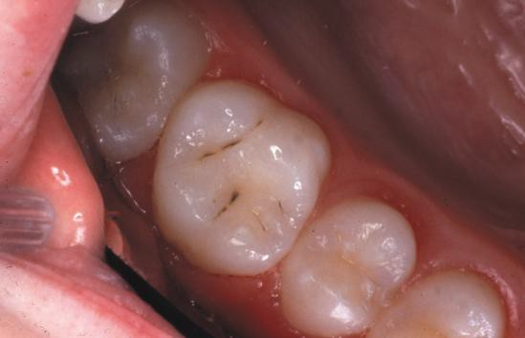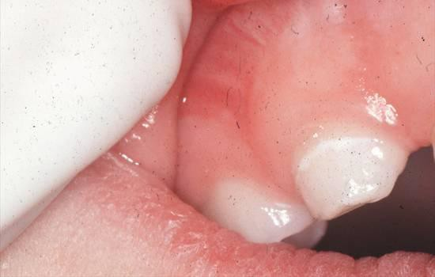

Precavitated Pit & Fissure Caries

Precavitated Smooth Surface Caries

If demineralization continues, the outer tooth structure collapses leading to the formation of a cavitated carious lesion; commonly referred to as a cavity. For the purposes of the BSS model, ***teeth are only considered decayed at the point in the caries process when enough enamel has been lost from the surface to create a definitive break in the enamel*** or, more simply stated, a hole.

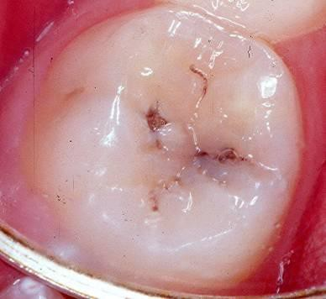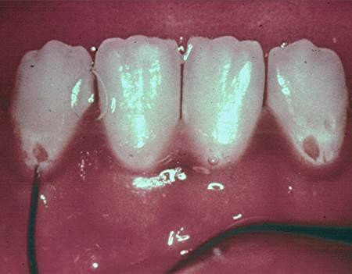

Cavitated Pit & Fissure Caries

Cavitated Smooth Surface Caries

OVERVIEW OF SCREENING INDICATORS

For children and adolescents there are four oral health status indicators included in the direct observation portion of the BSS. These four indicators are also indicators for NOHSS. Your screening survey should include, at a minimum, the following indicators:

**Head Start Children**

* + - Untreated decay (includes active and potentially arrested carious lesions)
    - Treated decay
    - Urgency of need for dental care

**School-Age Children (Kindergarten to 12th grade)**

* Untreated decay (includes active and potentially arrested carious lesions)
* Treated decay
* Dental sealants on permanent first and/or second molars
* Urgency of need for dental care

Some states may be also interested in monitoring sealants on primary molars and/or the prevalence of potentially arrested decay. Because of this, the following two optional clinical indicators are included in the BSS protocol.

**IMPORTANT NOTE:** Determining if a carious lesion is arrested requires the use of a periodontal probe or blunt instrument to check the surface for hardness. Because the BSS model is non-invasive and does not use probes or other instruments, the indicator is for “potentially” arrested decay based on a visual assessment only. When submitting untreated decay rates for the Oral Health Data Portal, be sure to define untreated decay as having active untreated decay and/or potentially arrested decay.

**OPTIONAL INDICATORS**

* Dental sealants on primary first and/or second molars
* Potentially arrested decay

###### INDICATOR #1: UNTREATED DECAY

The presence of untreated decay is detected by visual inspection only – explorers are not used. A tooth is considered to have untreated decay when the screener can readily observe ***breakdown of the enamel surface***. In other words, only cavitated lesions are considered to be untreated decay. This applies to pits and fissures as well as smooth tooth surfaces.

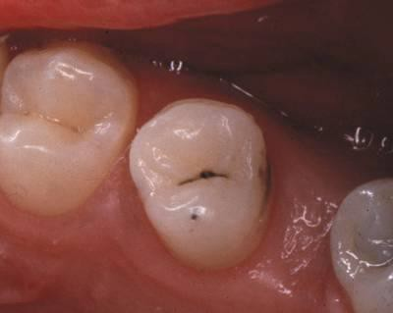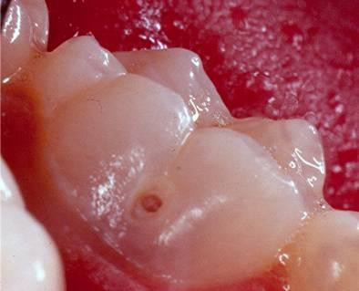

Cavitated Pit & Fissure Caries

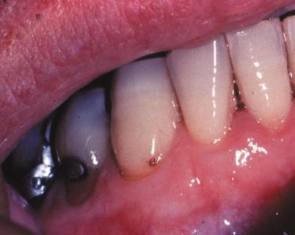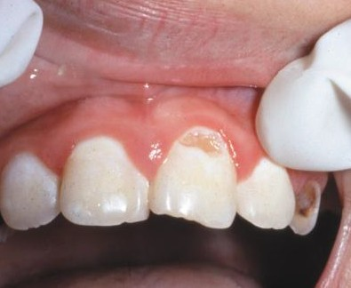

Cavitated Smooth Surface Caries

The following are two guidelines that you should remember when classifying untreated decay for a basic screening survey:

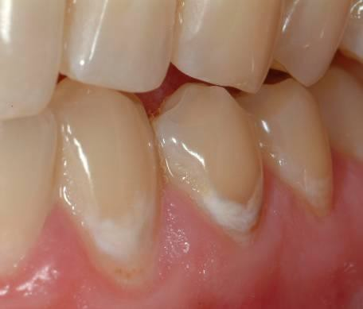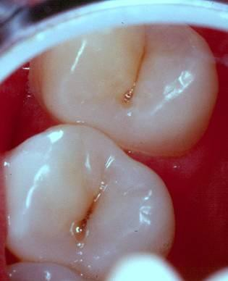

***Not*** *Untreated Decay*

Stained fissures but

no break in the enamel

***Not*** *Untreated Decay*

White spot lesions but

no break in the enamel

1. If a pit or fissure is stained and there is no apparent breakdown of the enamel structure, this is not untreated decay.
2. White spot lesions are not considered to be untreated decay.

***A good rule of thumb in a screening survey is – when in doubt, be conservative.***

***If you are not sure that a condition is present, score that it is not.***

Broken or chipped teeth are considered sound unless a cavity is found. Similarly, a tooth with a broken filling without recurrent decay is considered to have treated decay rather than untreated decay. If a tooth has an enamel defect, consider it sound unless caries is also present.

If the screener notices a retained root, assume that the whole tooth was destroyed by caries and code the individual as having untreated decay. If a child has untreated decay on a primary tooth that is about to exfoliate, they would be classified as having untreated decay, regardless of dental treatment need.

If a tooth has untreated decay that appears to be arrested (the lesion is black/dark with a hard, glossy appearance), code it as untreated decay if there is a break in the enamel surface.

**IMPORTANT NOTE:** If you are including the optional indicator for potentially arrested decay, please refer to page 24 for the appropriate coding.

Retained Roots

Untreated Decay=Yes

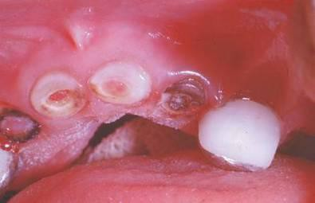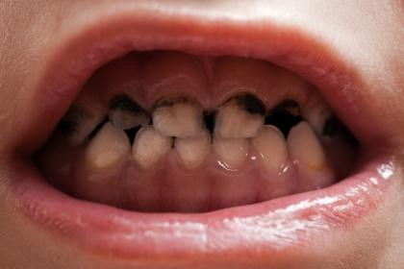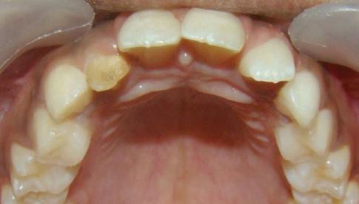

Arrested Decay

Untreated Decay=Yes

Enamel Defect without Caries

Untreated Decay=No

**Options for Coding Untreated Decay:** For untreated decay, states may opt to collect just prevalence data (no/yes) or they may collect a measure of severity. The following table lists a “menu” of untreated decay measures that can easily be obtained using the BSS format. Each of the severity measures may be collapsed to determine the percent of children with untreated decay – the National Oral Health Surveillance System indicator variable for untreated decay.

**Menu of Measures for Untreated Decay**

|  |  |  |  |
| --- | --- | --- | --- |
| **Most Basic** | **Less Basic** | **More Complex** | **Most Complex** |
| No/Yes | None  Primary only  Primary & Permanent  Permanent only | # decayed teeth | # decayed primary teeth  # decayed permanent teeth |

**Comparing the BSS Criteria for Untreated Decay to ICDAS:** Dental screeners may use or be familiar with the International Caries Detection and Assessment System (ICDAS).[2] The following table provides the appropriate BSS code for the six ICDAS codes.

|  |  |  |  |  |  |  |  |
| --- | --- | --- | --- | --- | --- | --- | --- |
| **System** | **Sound** | **Early Stage Untreated Decay** | | **Established Untreated Decay** | | **Severe Untreated Decay** | |
| ICDAS | Sound  (Code=0) | First visual change in enamel  (Code=1) | Distinct visual change in enamel  (Code=2) | Localized enamel breakdown  (Code=3) | Underlying dentin shadow  (Code=4) | Distinct cavity with visible dentin  (Code=5) | Extensive cavity with visible dentin  (Code=6) |
| BSS | Sound  (Untreated=No) | Sound  (Untreated=No) | Sound  (Untreated=No) | Caries  (Untreated=Yes) | Caries  (Untreated=Yes)  Only if there is a  break in the enamel | Caries  (Untreated=Yes) | Caries  (Untreated=Yes) |

###### INDICATOR #2: TREATED DECAY

Treated decay is determined by the presence of any type of filling, including a preventive resin restoration, crown, temporary filling, or a tooth that is missing because it was extracted as the result of tooth decay.

There are four basic types of fillings that may be seen during a screening: amalgam (silver), composite (tooth color), temporary (generally white), and a preventive resin restoration (PRR). It may be difficult to differentiate between a PRR and a dental sealant. If you see a definitive preparation under a sealant, classify it as treated decay. If there is no indication of a cavity preparation, code it as a dental sealant.

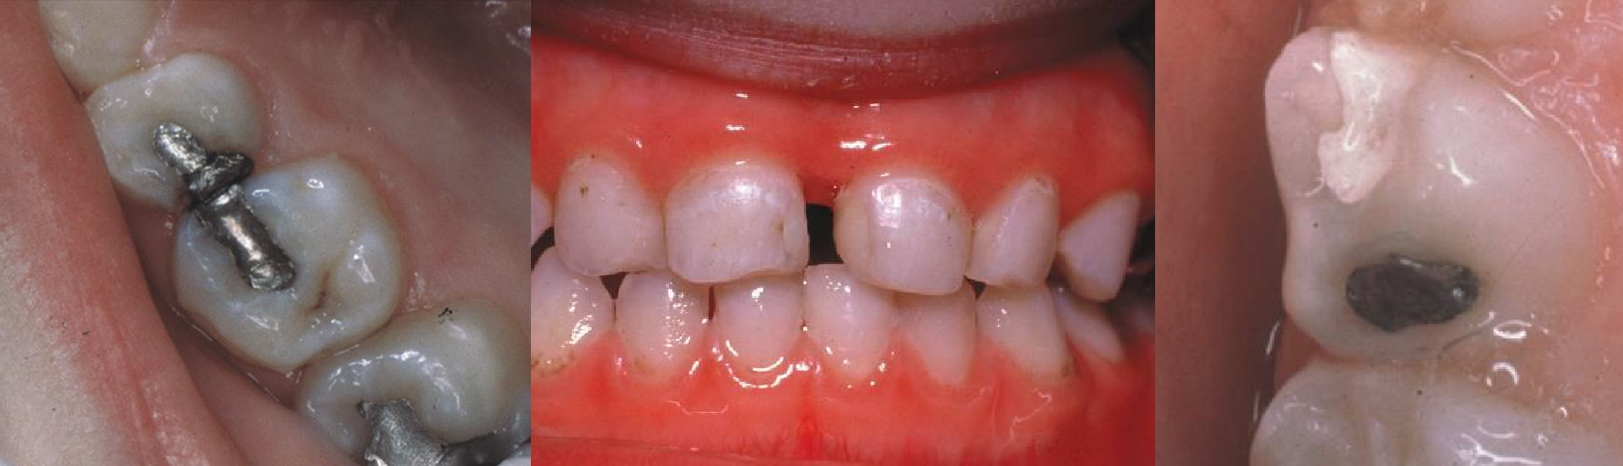

Amalgam Fillings

Composite Fillings

Temporary Filling

For the purpose of the BSS screening, crowns, which cover the whole tooth or most of the tooth, are akin to fillings. The presence of a crown categorizes the child as having treated decay. The most common type of crown seen in children is a stainless steel crown, usually found on the back primary teeth. Tooth-colored crowns, however, may be seen on the front teeth of young children. Crowns may be seen in adolescents, but only rarely. Tooth-colored crowns often have metal on the back of the tooth.

A crowned front tooth in an adolescent may be the result of injury rather than caries. Therefore, you should question the adolescent about their recollection of injury and code the child accordingly. If a tooth is crowned for trauma rather than decay, then the tooth is considered to be sound.

The same scenario is true for teeth that are missing (generally premolars) because of orthodontics; they are not considered treated decay.

**Options for Coding Treated Decay:** For treated decay, states may opt to collect just prevalence data (no/yes) or they may collect a measure of severity. The following table lists a “menu” of treated decay measures that can easily be obtained using the BSS format. Each of the severity measures may be combined with the untreated decay measures to obtain the percent of children with caries experience – one of the NOHSS indicator variables.

**Menu of Measures for Treated Decay**

|  |  |  |  |
| --- | --- | --- | --- |
| **Most Basic** | **Less Basic** | **More Complex** | **Most Complex** |
| No/Yes | None  Primary only  Primary & Permanent  Permanent only | # treated teeth | # treated primary teeth  # treated permanent teeth |

###### INDICATOR #3: DENTAL SEALANTS ON PERMANENT MOLARS

The third screening indicator, sealants on permanent first and/or second molars, is collected only for elementary, middle, and high school children, not those in Head Start. Code children as having sealants if they have at least one sealant on a ***permanent molar tooth***, whether or not the sealant covers all or part of the pits or fissures or is partially lost. *Do not record sealants on primary teeth*.

Dental sealants are usually transparent or opaque but occasionally you may see a pink (glass ionomer) sealant. While opaque white sealants are rather easy to identify visually, other shades, including transparent sealants, may be very difficult to identify.

To help you identify the presence of a dental sealant, you can use an adjunct such as a toothpick or a cotton tipped applicator to gently feel the surface. When feeling for sealants, a distinction is made between a smooth area and an area made rougher by the pits and fissures. The BSS model recommends that non-dental screeners do not use adjuncts.

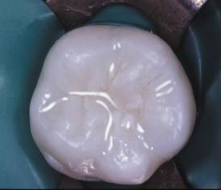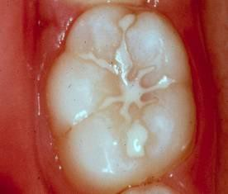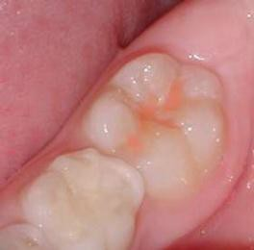

Transparent Sealant

Opaque Sealant

Tinted Sealant

Even a partially retained sealant is enough for an individual to be categorized as having sealants.

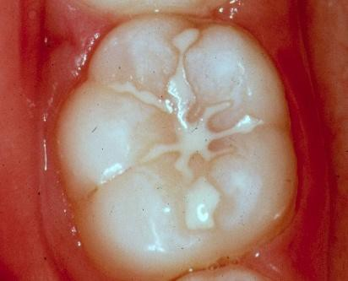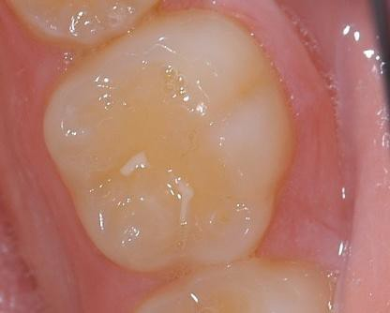

Partially Retained Sealant

Fully Retained Sealant

**Preventive Resin Restoration or Sealant:** It can be difficult to differentiate between a PRR and a dental sealant. If you can see a preparation under a sealant, code it as treated decay rather than a dental sealant. In other words, preventive resin restorations are considered to be the equivalent of a filling.

**Options for Coding Sealants:** For sealants, states may opt to collect just prevalence data (no/yes) or they may collect the number of permanent molars with sealants.

**Menu of Measures for Dental Sealants**

|  |  |  |  |
| --- | --- | --- | --- |
| **Most Basic** | **Less Basic** | **More Complex** | **Most Complex** |
| No/Yes | NA | NA | # perm molars with sealants |

###### INDICATOR #4: URGENCY OF NEED FOR DENTAL CARE

The final screening indicator is urgency of need for dental care. After categorizing a child according to his or her caries status, assign one of three treatment urgency codes to estimate how soon he or she should be taken to the dentist for clinical diagnosis and any necessary treatment.

Urgent need for dental care is used for those who need dental care within 24 to 48 hours because of signs or symptoms that include ***pain, infection, or swelling***. In children, the most common reason for being classified as needing urgent care is an abscess.

If someone needs to see a dentist because of untreated decay or a broken filling, but they do not have pain or an infection, they are classified as needing early dental care. For BSS purposes, early treatment means that they should see a dentist within the next several weeks or before their next regularly scheduled dental appointment. An individual with a broken or missing filling, but no other untreated decay, would be classified as needing *early* dental care.

Children with no untreated decay or other dental problems requiring early attention are considered to have no obvious problem, which means that they should receive routine dental check-ups and preventive dental services.

|  |  |  |
| --- | --- | --- |
| **Category** | **Recommendation for Next Dental Visit** | **Criteria** |
| Urgent need for dental care | As soon as possible | Signs or symptoms that include pain, infection, or swelling |
| Early dental care needed | Within several weeks | Caries without accompanying signs or symptoms or individuals with other oral health problems requiring care before their next routine dental visit |
| No obvious problems | Next regular check-up | Any patient without above problems |

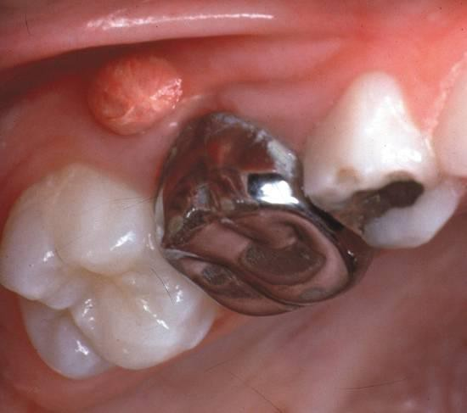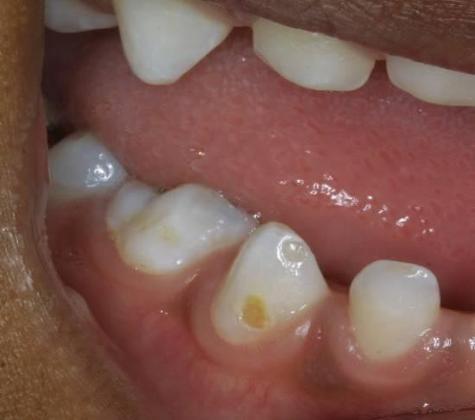

Urgent Care Needed

Early Care Needed

If a child has untreated decay on a primary tooth that is about to exfoliate, they would be classified as having untreated decay but no obvious problem (and no need for urgent or early treatment).

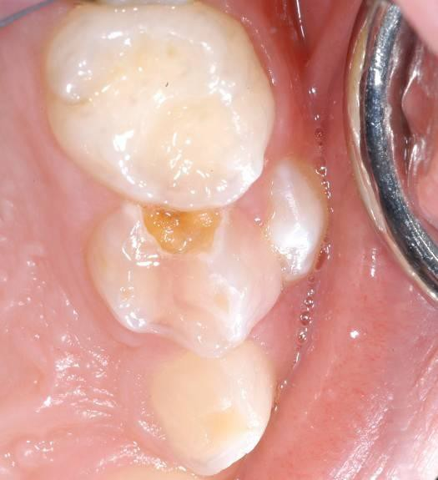

No Obvious Problem

Primary tooth with untreated decay about to exfoliate

No Obvious Problem

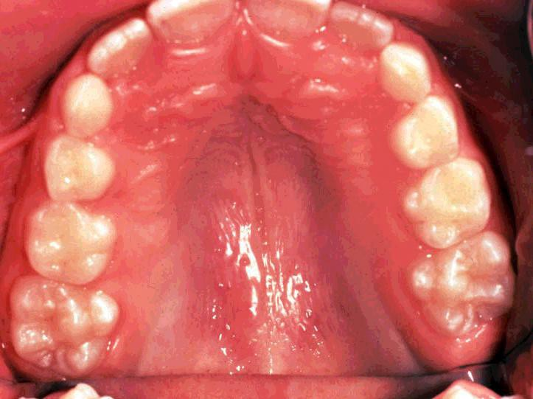

###### OPTIONAL INDICATOR #1: DENTAL SEALANTS ON PRIMARY MOLARS

The first optional screening indicator is sealants on primary first and/or second molars. Children will be coded as having sealants if they have at least one sealant on a ***primary molar tooth***, whether or not the sealant covers all or part of the pits or fissures, or is partially lost.

Dental sealants are usually transparent or opaque but occasionally you may see a tinted (glass ionomer) sealant. While opaque white sealants are rather easy to identify visually, other shades, including transparent sealants, may be very difficult to identify.

To help you identify the presence of a dental sealant, you can use an adjunct such as a toothpick or a cotton- tipped applicator to gently feel the surface. When feeling for sealants, a distinction is made between a smooth area and an area made rougher by the pits and fissures. The BSS model recommends that non-dental screeners do not use adjuncts.

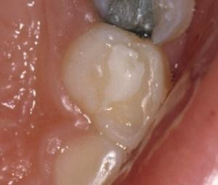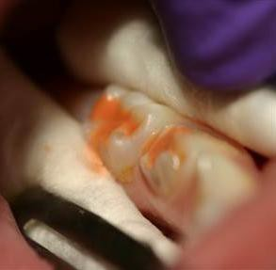

Transparent Sealant

Opaque Sealant

Tinted Sealant

Even a partially retained sealant is enough for an individual to be categorized as having sealants.



Partially Retained Sealant

on Permanent Molar

Fully Retained Sealant

on Permanent Molar

**Preventive Resin Restoration or Sealant:** It can be difficult to differentiate between a preventive resin restoration and a dental sealant. If you can see a preparation under a sealant, code it as treated decay rather than a dental sealant. In other words, preventive resin restorations are considered as the equivalent of a filling.

**Options for Coding Sealants:** For sealants, states may opt to collect just prevalence data (no/yes) or they may collect the number of primary molars with sealants.

**Menu of Measures for Dental Sealants**

|  |  |  |  |
| --- | --- | --- | --- |
| **Most Basic** | **Less Basic** | **More Complex** | **Most Complex** |
| No/Yes | NA | NA | # primary molars with  sealants |

###### OPTIONAL INDICATOR #2: POTENTIALLY ARRESTED DECAY

The second optional screening indicator is potentially arrested decay. If you are including this indicator, your BSS will have the following three decay indicators:

* *Active* untreated decay
* Potentially arrested decay
* Treated decay

A tooth is considered to have potentially arrested decay when the screener can readily observe breakdown of the enamel surface that is dark/black and appears to have a hard, glossy appearance.

**IMPORTANT NOTE:** Determining if a carious lesion is arrested requires the use of a periodontal probe or blunt instrument to check the surface for hardness. Because the BSS model is non-invasive and does not use probes or other instruments, the indicator is for potentially arrested decay **based on a visual assessment only**.

If a tooth has a definitive break in the enamel surface that is ***not*** dark/black and does ***not*** have a hard, glossy appearance, it is coded as having active untreated decay rather than potentially arrested decay.

If you collect data on active and potentially arrested decay, you will need to calculate the NOHSS indicators for prevalence of untreated decay and prevalence of caries experience using the formulas below.

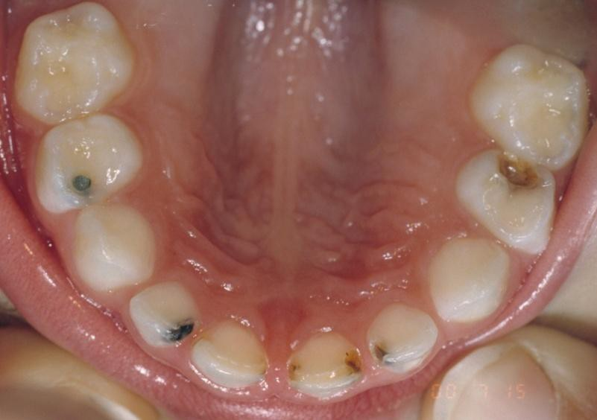

Treated Decay = Yes

Active

Untreated Decay = Yes

Potentially

Arrested Decay = Yes

**Calculating the Prevalence of Caries Experience and Untreated Decay for the NOHSS indicators:** If you are collecting information on both active and potentially arrested decay, you will need to calculate the prevalence of caries experience and untreated decay using the following formulas:

If active untreated decay=no *and* arrested decay=no *and* treated decay=no then caries experience=no

If active untreated decay=yes *or* arrested decay=yes *or* treated decay=yes then caries experience=yes

If active untreated decay=no *and* arrested decay=no then untreated decay=no

If active untreated decay=yes *or* arrested decay=yes then untreated decay=yes

Screeening Details

As you plan the direct observation portion of your screening survey, there are a number of questions you will have to answer. This section provides additional information to help you make the necessary decisions.

###### Lighting

What type of lighting do I need?

Although screening for obvious cavities and fillings can be done with good available light, screening for sealants and smaller cavities cannot. The BSS assumes that natural and/or overhead lighting will be available but ***requires an additional light source*** that can be focused on the teeth. Lighting options include:

* Flashlight/Penlight
* Portable dental light
* Non-dental exam light
* Head lamp

If your choice is to use portable dental lights, non-dental exam lights or head lamps, you can contact local dental suppliers, portable equipment manufacturers, or camping/outdoor equipment suppliers.

###### Loupes

Can screeners use loupes?

The Basic Screening Survey diagnostic criteria are designed to be comparable to the National Health and Nutrition Examination Survey (NHANES) criteria. The NHANES dental examiners do not use loupes. Because of this, we encourage BSS examiners not to use loupes. If the dental examiners eyesight is such that they cannot see the tooth without loupes, exceptions can be made but are discouraged.

###### Retraction/Visualization

How can I get a “good look” in the mouth?

The choices you make about how to help screeners visualize the mouth will depend largely on what resources are available to you and, to some extent, on personal preference. All of the alternatives that follow are acceptable, but some clearly allow better visualization. Local clinics, health departments, private dental offices or dental supply companies may be willing to donate some of the items.

* ***Tongue blades*** are a relatively inexpensive and common choice for retracting lips and cheeks to gain visual access to the teeth. The cost per tongue blade is approximately $0.01-$0.02.
* ***Dental mirrors*** provide much better visibility than tongue blades, particularly for the upper back teeth and for detecting sealants. Screeners may opt to have a limited number of disposable mirrors available for use in situations where visualization is otherwise inadequate. Disposable mirrors add cost, approximately $0.35-$0.45 each.

###### Removing Food Debris from Teeth

How do I find cavities or sealants when teeth are covered by food?

If tooth surfaces cannot be visualized because debris obscures the view, a toothbrush is most effective for cleaning away the food. Alternatively, a toothpick or the wooden end of a cotton-tipped applicator may be used to dislodge debris. Remember, contact of gloves with mucosa or saliva requires hand cleaning and re-gloving.

For teeth that are too wet to see the tooth surfaces, screeners can use a cotton-tipped applicator, cotton roll, or gauze square to soak up saliva.

###### Instrumentation

Do I need to use a dental explorer for the screening?

No, dental explorers are not standard equipment for this screening model and their use for determining the presence of caries, especially in newly erupted teeth with pits and fissures, is discouraged.

If your examiners are dentists or hygienists, however, it may be useful to provide a way that they can ***gently*** feel fissured surfaces to determine the presence of dental sealants. For this purpose, you can use a toothpick or periodontal probe.

###### Budget

How much will a survey cost?

The cost of a state-wide oral health survey is largely dependent on the number of schools you screen and the availability of in-kind services. The primary cost will be personnel – a survey coordinator and screeners. ASTDD has developed a sample budget that should help you estimate survey costs at [www.astdd.org/basic-screening-survey-tool/](http://www.astdd.org/basic-screening-survey-tool/).

Screener Training

* All screeners should participate the BSS training before conducting the screening.
* It is recommended that prospective screeners participate in a practice session so they can use their new skills and discuss potential differences in interpretation of screening criteria under field conditions. This also will provide practical experience using the BSS model and increase everyone’s level of confidence that the screening results are reliable.
* Additional training options include offering a webinar or in-person trainings with an experienced BSS screener.
* All screeners should be trained regarding how to assure the child and family’s privacy and data is kept secure both at the screening site, while in the screeners’ possession, and at the oral health office. Stress that the data belongs to the state, and not to the screener or any partner program.
* A retraining is required for all screeners before each cycle of BSS.
* Questions about conducting the training can be directed to ASTDD.

**Practice Sessions**

Provide each screener a recorder and screening station, such as a small table or a school desk, to hold the screening supplies. The recorder either may be another trainee who will later alternate positions with the screener, or someone who will not be trained to screen. Use the form for recording screening codes for multiple children found in the Appendix.

Screeners should see enough participants to be comfortable with the consistency of their interpretation of the screening criteria compared with the other screeners in their group. When screeners reach the point where their calls on the vast majority of participants are in agreement with each other, they have practiced enough.

At a minimum, screeners should look at about 20 participants in the age range that they will be screening. To assure that screeners will see a variety of oral health problems, the best location for a screener training is at a school with a high percentage of the students eligible for NSLP.

The screening stations should be arranged far enough apart so that the screeners cannot hear the calls of the adjacent screeners. Each subject being screened in the practice session carries her/his score sheet to each station, consecutively, so that all screeners see each subject. The screener “calls” her/his screening code decisions and the recorder writes them in the appropriate spaces on the score sheet. Care is needed to assure that the screener is not able to see the scores of the other screeners on the score sheet before making her/his decision.

After the person being screened goes to the last station, identify the participants for whom screeners were not unanimous on *all* scores. These participants are retained for discussion after all the screenings have been completed. At that time, the group of trainees gets together to discuss and resolve their disagreements by mutually deciding the “best call” for each situation, using the screening criteria and guidance from the trainer.

Consider retraining or not using screeners whose results were significantly different than the rest of the group’s. Be sure to follow procedures for obtaining consent, protecting privacy, and follow-up care for urgent dental needs described elsewhere in this manual for the participants.

**Demographic Data from the State Department of Education**

The best source of demographic data for an oral health survey is your state’s department of education (DOE). ASTDD recommends that you work directly with your DOE to obtain basic information about the child including age (or date of birth used to calculate age), sex, race and ethnicity, and eligibility for NSLP. This will allow you to evaluate oral health disparities. The exact process for obtaining the demographic information will vary by state but regardless of the process, you will need to collect a child’s SSID. In general, DOE uses its secured data system to link the oral health data with the DOE dataset using the SSID, and then remove the SSID before sending the dataset to the state oral health program.

Parental Consent

Government-conducted or -sponsored surveys require consent. Surveys of minors require parental or guardian consent. There are usually two possible forms of consent, positive (also referred to as active) and passive (also referred to as opt-out).

Positive consent for minors usually involves a consent form or other method for the parent or guardian to a indicate that they consent to their child participating. Passive consent is a consent form which goes to the parent or guardian informing them of the activity and requiring them to return the form if they don’t want their child to participate In a public health activity such as a survey, verbal consent is acceptable for positive consent. This consent must be documented.

Positive consent requiring a signature, particularly if it’s requested on a paper form that is returned, usually results in substantially lower participation rates.

If the benefits of child oral health screening and the concerns for data quality and disparities are effectively conveyed, DOEs will often be supportive of passive consent. If your state has other public health programs who have success with support from DOE to use passive consent, learning experience from them may be helpful. Support from the state DOEs for passive consent for your BSS can be very helpful when approaching school districts and individual schools that set their own consent policies.

If the state or district already offers screening for vision, hearing, etc., explore with the DOE if the consent is broad enough for the BSS.

It is not uncommon that a school, district, or state DOE mistakenly believes active consent is a requirement for a public health screening, perhaps confounding it with a medical procedure or a FERPA regulation. If you are unsuccessful describing that public health practice is not research, or that FERPA is not applicable to the health department screening, your policy office may be a useful resource. Sharing information about the Oral Health Data portal and CDC’s support for the BSS may also be helpful.

Conversely, by using passive consent, the response rate for the parent questionnaire is diminished. The questionnaire can be distributed by paper and emailed to parents, however, if it is not required for participation, collecting it will be more difficult. States could consider a reminder system and incentives to increase the response rate.

Optional Parent Questionnaire

The following questions may be selectively chosen and accompany the consent form. Coupled with the oral health screening information obtained through the direct observation, answers to the questions provide more data about the status of the state’s oral health.

Further, if the program is unsuccessful in obtaining official child-level government data from a state, district, or school DOE, a questionnaire is useful for collecting demographic information about the children to stratify your findings for reporting. Demographic questions are located in the Appendix. If you want to collect more detailed demographic information, contact ASTDD for technical assistance. Collections using federal funds must comply with the Office of Management and Budget guidelines; ATSDD sample forms are in compliance.

###### Optional Questions

Domain: Parent or caretaker reported oral health status

1. How would you describe the condition of your child’s teeth? (Please check one) [Source: National Survey of Children’s Health, 2016]
   1. Excellent
   2. Very good
   3. Good
   4. Fair
   5. Poor
2. During the past 12 months, did your child have a toothache, decayed teeth, or unfilled cavities? (Please check one) [Source: National Survey of Children’s Health, 2011-2012]
   1. No
   2. Yes
   3. Don’t know/don’t remember
3. During the past 12 months, has your child had frequent or chronic difficulty with any of the following? (Check all that apply) [Source: National Survey of Children’s Health, 2016]
4. Toothaches (no/yes)
5. Bleeding gums (no/yes)
6. Decayed teeth or cavities (no/yes)

Domain: Dental visit

1. During the past 12 months, did your child see a dentist or other oral health care provider for any kind of dental or oral health care? (Please check one) [Source: National Survey of Children’s Health, 2016]
   1. Yes, saw a dentist
   2. Yes, saw other oral health care provider
   3. No
2. About how long has it been since your child **last** visited (saw) a dentist? Include all types of dentists, such as, orthodontists, oral surgeons, and all other dental specialists, as well as dental hygienists. (Please check one) [Sources: National Health and Nutrition Examination Survey, 2015-2016; National Health Interview Survey, 2016]
   1. 12 months or less
   2. More than 1 year, but not more than 3 years ago
   3. More than 3 years ago
   4. My child has never been to a dentist
   5. Don’t know/don’t remember
3. What was the main reason your child last visited a dentist? (Please check one) [Source: National Health and Nutrition Examination Survey, 2015-2016]
   1. Went in on own for check-up, examination or cleaning
   2. Was called in by the dentist for check-up, examination or cleaning
   3. Something was wrong, bothering or hurting
   4. Went for treatment of a condition that dentist discovered at earlier check-up or examination
   5. Other
   6. Don’t know/don’t remember

Domain: Problems accessing dental care

1. During the past 12 months, was there any time when your child NEEDED dental care (including check-ups) but didn't get it because you couldn't afford it? (Please check one) [Source: National Health Interview Survey, 2016]
   1. No
   2. Yes
   3. Don’t know/don’t remember
2. During the past 12 months, was there a time when your child needed dental care but could not get it at that time? (Please check one) [Source: National Health and Nutrition Examination Survey, 2015-2016]
   1. No
   2. Yes
   3. Don’t know/don’t remember

**IF YES TO Q2** (Use with Q2): What were the reasons that your child could not get the dental care she/he needed? (Check all that apply) [Source: National Health and Nutrition Examination Survey, 2015-2016]

1. Could not afford the cost
2. Did not want to spend the money
3. Insurance did not cover recommended procedures
4. Dental office is too far away
5. Dental office is not open at convenient times
6. Another dentist recommended not doing it
7. Afraid or do not like dentists
8. Unable to take time off from work
9. Too busy
10. I did not think anything serious was wrong/expected dental problems to go away
11. Other
12. Don't know/don’t remember

Domain: Dental insurance

1. Do you have any kind of insurance that pays for some or all of your child’s DENTAL CARE? Include health insurance obtained through employment or purchased directly as well as government programs like Medicaid.
   1. No
   2. Yes
   3. Don’t know/don’t remember

**NOTE:** ASTDD encourages states to add the state-specific name of their Medicaid or CHIP program to the dental insurance question (e.g. PeachCare, TennCare, Denti-Cal, etc.).

Additional general health or medical questions for survey planners to consider:

1. In general, how would you describe your child’s health? (Please check one) [Source: National Survey of Children’s Health, 2016]
   1. Excellent
   2. Very good
   3. Good
   4. Fair
   5. Poor
   6. Don’t know
2. During the past 12 months, did your child see a doctor, nurse, or other health care professional for sick- child care, well-child check-ups, physical exams, hospitalizations or any other kind of medical care? (Please check one) [Source: National Survey of Children’s Health, 2016]
   1. No
   2. Yes
   3. Don’t know/don’t remember
3. During the past 12 months, was there any time when your child NEEDED medical care, but did not get it because you couldn't afford it? (Please check one) [Source: National Health Interview Survey, 2015]
   1. No
   2. Yes
   3. Don’t know/don’t remember

Sampling and Analysis

**When it comes to the question of sampling and analysis, there is a short answer and a long answer (which circles back to the short answer). The short answer is: “Get Help!”**

**Where do I get sampling and analysis help?**

ASTDD has developed the monograph *Guidance on Selecting a Sample for a School-Based Oral Health Survey*. This guidance, which includes information on sampling strategies, sample size and sample selection, is available at: [www.astdd.org/basic-screening-survey-tool/](http://www.astdd.org/basic-screening-survey-tool/).

ASTDD has also developed detailed guidance on how to appropriately analyze data from a statewide oral health survey that has employed a complex sampling design. *Guidance on How to Analyze Data From a School-Based Oral Health Survey*, which includes information on preparing for analysis, calculating the appropriate weights, and sample software coding, is available at [www.astdd.org/basic-screening-survey-tool/](http://www.astdd.org/basic-screening-survey-tool/).

We encourage you to read the documents, discuss it with your state’s epidemiologist or biostatistician, and then contact ASTDD for specific guidance for your state.

If you follow the guidance provided by ASTDD for sampling and data analysis, your state BSS indicator data should meet the National Oral Health Surveillance System (NOHSS) criteria described in the section below and therefore be included in the Oral Health Data portal hosted by CDC ([www.cdc.gov/oralhealthdata](http://www.cdc.gov/oralhealthdata)).

Criteria for Inclusion of BSS Data in National Oral Health Surveillance System

NOHSS (www.cdc.gov/oralhealthdata/overview/nohss.html) is a collaborative effort between CDC's Division of Oral Health and ASTDD. NOHSS is designed to provide national and state-level data monitoring the burden of oral disease, use of the oral health care delivery system, and the status of community water fluoridation based on data sources and surveillance capacity available to most states. The Council of State and Territorial Epidemiologists (CSTE), ASTDD and CDC were instrumental in developing the framework for standardized oral health surveillance indicators and their corresponding data sources for inclusion in NOHSS. BSS is the designated data source for key NOHSS indicators.

Your state’s BSS data for caries experience, untreated decay, dental sealants and urgent dental care must meet the following criteria to be included in NOHSS:

* + The data for children must be from a ***statewide probability sample*** of public elementary schools or Head Start sites.
  + If a complex sampling scheme is used, the estimates must be weighted for the sampling scheme and non-response, and calculation of variance estimates and confidence intervals should account for stratification and cluster sampling effects.
  + The clinical examiners must be trained within one year prior to data collection. Examiners may be dentists, dental hygienists or non-dental health professionals.
  + The diagnostic criteria outlined in the Basic Screening Survey model in this manual must be used.
  + At a minimum, third grade children should be screened. You may also include Head Start and grades K-2 in the NOHSS database.
  + The data must be stratified by grade rather than age.
  + Data must be submitted by school year – not calendar year.

Data on selected NOHSS indicators, including BSS data can be accessed through the CDC-hosted web-based Oral Health Data portal found on [www.cdc.gov/oralhealthdata](http://www.cdc.gov/oralhealthdata). For your state BSS data to be displayed, you must submit it to ASTDD using the BSS Submission Form. Each year, ASTDD will send states an email request to submit BSS data not previously submitted and send a reminder email to states that do not respond to the initial email request. States can submit data at any time throughout the year. The email will include the *BSS Submission Form (a fillable Word document)*. Only state aggregated data are submitted to ASTDD. During verification, ASTDD will contact you if your state data does not meet the criteria, and offer technical assistance to help you improve the data.

**NOTE:** The BSS collects information on treated decay and untreated decay while the NOHSS indicators are caries experience and untreated decay. Caries experience should be calculated from the treated decay and untreated decay variables in the following manner:

If treated decay=no and untreated decay=no then caries experience=no

If treated decay=yes or untreated decay=yes then caries experience=yes

If you are collecting information on arrested decay as an optional separate indicator then caries experience should be calculated from the treated decay, untreated decay and arrested decay variables in the following manner:

If treated decay=no and active untreated decay=no and arrested decay=no then caries experience=no

If treated decay=yes or active untreated decay=yes or arrested decay=yes then caries experience=yes

The NOHSS indicator for untreated decay includes both active decay and potentially arrested decay. If you are collecting information on potentially arrested decay, you will need to calculate the prevalence of untreated decay using the following formula:

If active untreated decay=no and arrested decay=no then untreated decay=no

If active untreated decay=yes or arrested decay=yes then untreated decay=yes

Data Management

In general, observational data may be recorded in four ways: 1) on paper forms, 2) on scan forms, 3) electronically, using direct data entry software or native app on a laptop, tablet, or mobile device, or 4) electronically, using a mobile web-based application on a laptop, tablet, or mobile device.

The primary determinants of the data collection method used often are the availability of software or portable devices and the comfort of screeners in using electronic data entry. While using paper forms is often an “easier” method for screeners in the field, it requires personnel both to enter the data into an electronic format and for validation and analysis, thus limiting data quality. Thus, states should plan to migrate to electronic collection

Regardless of your data collection method, you must assure that all data is collected, transmitted, and stored in a way that protects the child’s privacy. Refer to “Data Privacy and Security” on page 35 of this manual. ASTDD recommends that states develop a data management plan specifically for the BSS that abides by your state’s data privacy and security policies.

|  |  |  |
| --- | --- | --- |
| **Method** | **Pros** | **Cons** |
| Paper Forms | * easy for exam staff * does not require a device in the field * can be used if electricity is a problem | * requires collecting the forms * no method to check for valid values at the time of data collection * requires time consuming data entry |
| Scan Forms | * easy for exam staff * does not require a device in the field * can be used if electricity is a problem * quick data entry | * requires scan form software * no method to check for valid values at the time of data collection * error reviews can be time consuming |
| Direct Data Entry Computer or mobile device | * limits data entry to allowable values * can auto-populate variables such as date of exam | * screening may take longer * requires a computer * staff must be comfortable using a device * requires down-loading into master database |
| Web-based application | * limits data entry to allowable values * can auto-populate variables such as date of exam * live data entry can be monitored from a central point * reduces time and error to combine data from various sites | * screening may take longer * requires a device * staff must be comfortable using a device * requires Internet access |

Sample data collection forms or fields are located in the Appendix.

*Data collection using paper forms:* It is essential that all data boxes contain an appropriate entry. Be sure to review forms at the end of each day for:

* + - correct screening date
    - correct site code
    - completeness (all boxes should contain an entry)

After data are recorded on paper, the forms should be delivered in a secure manner to the designated data coordinator who will be responsible for data entry. Use double entry to check for entry errors and ensure accurate data entry. If screeners make copies, they should be destroyed immediately after they are received by the health department. Data is not to be copied or used by other entities.

*Data collection using scan forms:* Scan forms use predefined “bubbles” for recording data, thereby reducing the number of data recording errors that might be present in paper forms. The forms should be delivered in a secure manner to the designated data coordinator who will be responsible for data entry.

*Data collection using laptop computers or mobile devices:* The primary benefit of direct data entry is that it forces the recorder to enter appropriate data in every field. For example, if the allowable codes for untreated decay are 0 or 1, the data entry program does not allow the recorder to enter 2 by mistake. Access to the computer or device should be password protected.

*Data collection using laptop computers or mobile devices into a web-based database:* In addition to reducing the possibility of data entry mistakes, using a web-based application enables all data to be entered into the master database and avoids uploading and downloading of data sets, and less data circulating in various computers. Access to the computer or device should be password protected. Use a secure data system for the data entry.

Data Privacy and Security

*Protection of Personally identifiable information (PII):* The child’s name is collected on the class roster, parent or guardian consent form, questionnaire, and screening results letter for parents to ensure that there is consent for the child, the questionnaire is attached to the screening collection form for the correct child, and the screening result is distributed to the correct child.

Do not send the class roster to the state oral health program. It should be returned to the school liaison or designated personnel. Upon screening completion, use the roster to ensure the sealed results letter is matched with the child’s envelop and class. Also use it for referrals to the school nurse or designated personnel to ensure children with urgent dental needs are cared for in a timely manner by parents, caretakers or authorities.

For states that collect the child’s demographic data from the state DOE, inform schools to include the state DOE assigned SSID on the class roster. Enter the SSID onto the screening data record (or paper record form). Generally, DOE will use its secured data system to link the requested child-level demographic information with the screening data, and then remove the SSID before sending the dataset to the state oral health program (refer to “Implementation Phase” on page 9).

For states that collect the child’s date of birth to calculate age, retain age only in the dataset after data cleaning and generation.

After screening is completed for the day, the screener should store the completed oral health paper screening forms, parent or caretaker consent forms, and questionnaires in a sealed security envelop or opaque container and send it to the state oral health program designated contact through the first class US mail or other secure system. All the paper forms should be then stored in a locked cabinet of the state department of health and accessible only by limited personnel designated by the state oral health program.

*Electronic data entry and management*: Access to individual, child-level data in either paper or electronic form should be only granted to a limited number of personnel who conduct and support the BSS data collection, management, and analysis. The state dental director or BSS manager is responsible for designating specific personnel, assigning their roles and responsibilities, determining level of data access, and routinely reviewing data access work to ensure specific access rights are implemented.

The electronic data entry and the data set generated should be stored on the state agency’s secured and password-protected network, in a directory accessible only to those designated personnel. Use encrypted files when handling PII. To ensure data quality, double data entry or validation by comparing the paper or scanned records to the electronic data should be performed. Use data entry validation rules to prevent common types of errors. The child’s name is only used to validate the electronic data entry against the consent forms and questionnaires and should not be entered into the electronic data system.

After data entry, cleaning and generation, ASTDD recommends that only de-identified data are maintained in the state secured electronic data system, and that no data are stored on any partner systems. ASTDD recommends that states create a data management plan for their BSS that outlines the steps that will be taken to keep a child’s information private and to ensure that data is safely and appropriately stored and disposed of. It is essential that the steps outlined in the data management plan meet state guidelines and federal guidelines (if federal funds are being used).

Report Preparation And Dissemination

**I’ve collected the data, now what?**

Developing a BSS report and disseminating the findings are just as important as collecting the data. When preparing your report, determine your target audiences and gear your report(s) accordingly. You might find it useful to look at reports developed by other states. Remember that short and simple is better than long and complex. Essential sections may include a summary, background, methodology, key findings, and recommendations.

To help states prepare reports and disseminate findings, ASTDD has developed several resources including:

* *Using Oral Health Data to Inform Decisions and Policy Development*

[www.astdd.org/basic-screening-survey-tool/](http://www.astdd.org/basic-screening-survey-tool/)

* Health Communications Resources [www.astdd.org/health-communications-committee/](http://www.astdd.org/health-communications-committee/)

Contacts/Technical Assistance/Other Resources

**Association of State and Territorial Dental Directors, Reno, NV**

ASTDD provides technical assistance in the various aspects of using the BSS model including assistance with sampling, survey design, and analysis. In addition, a detailed model for conducting needs assessments, *Assessing Oral Health Needs: ASTDD Seven-Step Model*, is available for downloading from the ASTDD website ([www.astdd.org/basic-screening-survey-tool/](http://www.astdd.org/basic-screening-survey-tool/)). Contact ASTDD at:

Phone: (775) 626-5008

Fax: (775) 626-9268

[www.astdd.org](http://www.astdd.org/)

APPENDIX

###### Sample Oral Health Screening Form for Head Start Children

Form Approved  
OMB No. 0920-xxxx  
Exp. Date xx/xx/xxxx

|  |  |  |  |
| --- | --- | --- | --- |
| **Information obtained by the screener on the day of the screening** | | | |
| Screen Date:  /  / | Site Code: | | Screeners Initials: |
| Untreated Decay:  No  Yes | Treated Decay:  No  Yes | | Treatment Urgency:  None  Early  Urgent |
| **Sources to obtain demographic information:**   * **From the Head Start program:** include the demographic information below on the screening form. * **From the parent or guardian questionnaire:** staple the questionnaire to the screening form. Refer to sample questionnaire on page 53. | | | |
| Sex:  Female  Male | | Date of Birth:  /  /  or Age (Years): | |
| Hispanic or Latino:  No  Yes | | | |
| Race (check all that apply):  American Indian/Alaska Native  Black/African American  Native Hawaiian/Other Pacific Islander  Asian  White | | | |

NOTE:

ASTDD recommends that you use official Head Start data as a primary source for demographics and the parent or guardian consent form or questionnaire secondarily.

Public reporting burden of this collection of information varies from 431 to 2,570 hours with an estimated average of 1,183 hours per response, including the time for reviewing instructions, searching existing data/information sources, gathering and maintaining the data/information needed, and completing and reviewing the collection of information. An agency may not conduct or sponsor, and a person is not required to respond to a collection of information unless it displays a currently valid OMB control number. Send comments regarding this burden estimate or any other aspect of this collection of information, including suggestions for reducing this burden to CDC/ATSDR Information Collection Review Office, 1600 Clifton Road NE, MS D-74, Atlanta, Georgia 30333; ATTN: PRA (0920-XXXX).

###### Sample Oral Health Screening Form for School Children

Form Approved  
OMB No. 0920-xxxx  
Exp. Date xx/xx/xxxx

|  |  |  |
| --- | --- | --- |
| **Information obtained by the screener on the day of the screening** | | |
| Screen Date:  /  / | School Code: | Screeners Initials: |
| SSID: | | Grade*: |
| Untreated Decay:  No  Yes | Treated Decay:  No  Yes | Dental Sealants:  No  Yes |
| Treatment Urgency:  None  Early  Urgent |  |  |
| **Sources to obtain demographic information:**   * **From the school:** include the demographic information below on the screening form. * **From the Department of Education:** make sure to include SSID on the screening form. Use the demographic information section below as a guide for collecting the corresponding variables and their categories. * **From the parent or guardian questionnaire:** staple the questionnaire to the screening form. Refer to sample questionnaire on page 53. | | |
| Sex:  Female  Male | Date of Birth:  /  /  or Age (Years): | NSLP:  Not Eligible  Eligible |
| Hispanic or Latino:  No  Yes | | |
| Race (check all that apply):  American Indian/Alaska Native  Black/African American  Native Hawaiian/Other Pacific Islander  Asian  White | | |

NOTE: ASTDD recommends that you use official data from the Department of Education or schools as a primary source for demographics and the parent or guardian consent form or questionnaire secondarily.

* Grade is collected only if multiple grades are included.

Public reporting burden of this collection of information varies from 431 to 2,570 hours with an estimated average of 1,183 hours per response, including the time for reviewing instructions, searching existing data/information sources, gathering and maintaining the data/information needed, and completing and reviewing the collection of information. An agency may not conduct or sponsor, and a person is not required to respond to a collection of information unless it displays a currently valid OMB control number. Send comments regarding this burden estimate or any other aspect of this collection of information, including suggestions for reducing this burden to CDC/ATSDR Information Collection Review Office, 1600 Clifton Road NE, MS D-74, Atlanta, Georgia 30333; ATTN: PRA (0920-XXXX).

###### Sample Letter to Principals – #1, Positive Consent

**Letterhead**

Form Approved  
OMB No. 0920-xxxx  
Exp. Date xx/xx/xxxx

Dear Principal,

Your school has been selected to participate in a state-wide assessment of the oral health of elementary school students during the 2019-2020 school year. The assessment {Oral Health Basic Screening Survey} is funded by the {state}State Department of Health {and the US Centers for Disease Control and Prevention} {in cooperation with *the Office of State Superintendent of Public Instruction}.*

The findings of this assessment will be used to assure that our preventive oral health programs are effective. Children need good oral health in order to speak with confidence, express themselves openly, and to be healthy and ready to learn.

Schools throughout the state have been randomly selected for participation in the assessment. Selected third grade {and grade} children with a signed consent from a parent or caregiver, will be given a free dental screening. The screening will take about one minute per child. No x-rays will be taken and no dental treatment will be provided.

We understand that minimal class disruption is essential in the operation of your school. For this reason, each school will only be asked to participate for {one} day. Each participating child will receive a toothbrush and a letter to the parent or caregiver noting the results of the screening. Your school will incur no cost for participating.

We would like to ask for your support and the support of your staff to carry out this important assessment of our children’s oral health needs. Attached are sample consent and results forms. Parents or caretakers may also provide verbal consent in order to reduce their burden and mediate the chance a student will lose the form.

The state coordinator *is Jane Doe, RDH.* She will be contacting you to answer your questions and to receive your support for conducting the assessment. Her telephone number is *(555) 555-5555* and her email is [*jdoe@utopia.us.*](mailto:jdoe@utopia.us)

As you know, poor oral health has been related to decreased school performance, poor social relationships, and less success later in life. For this reason, we thank you in advance for making this contribution to the health and well-being of ourchildren in {state}*.*

Sincerely,

{state}Health Department {state}Department of Education

Name, title

Contact info

Enclosure

CC: state or local DOE

Public reporting burden of this collection of information varies from 431 to 2,570 hours with an estimated average of 1,183 hours per response, including the time for reviewing instructions, searching existing data/information sources, gathering and maintaining the data/information needed, and completing and reviewing the collection of information. An agency may not conduct or sponsor, and a person is not required to respond to a collection of information unless it displays a currently valid OMB control number. Send comments regarding this burden estimate or any other aspect of this collection of information, including suggestions for reducing this burden to CDC/ATSDR Information Collection Review Office, 1600 Clifton Road NE, MS D-74, Atlanta, Georgia 30333; ATTN: PRA (0920-XXXX).

###### Sample Letter to Principals – #2, Positive Consent and Questionnaire

**Letterhead**

Form Approved  
OMB No. 0920-xxxx  
Exp. Date xx/xx/xxxx

Dear Principal,

Your school has been selected to participate in a statewide assessment of the oral health of elementary school students during the 2019-2020 school year. The assessment is funded by the {state}State Department of Health {and the US Centers for Disease Control and Prevention} {in cooperation with *the Office of State Superintendent of Public Instruction}.*

The findings of this assessment will be used to assure that our preventive oral health programs are effective. Children need good oral health in order to speak with confidence, express themselves openly, and to be healthy and ready to learn.

Schools throughout the state have been randomly selected for participation in the assessment. Selected third grade {and grade} children with a signed consent from a parent or caregiver, will be given a free dental screening. The screening will take about one minute per child. No x-rays will be taken, and no dental treatment will be provided.

We understand that minimal class disruption is essential in the operation of your school. For this reason, each school will only be asked to participate for {one} day. Each participating child will receive a toothbrush and a letter to the parent or caregiver noting the results of the screening. Your school will incur no cost for participating.

We would like to ask for your support and the support of your staff to carry out this important assessment of our children’s oral health needs. Attached are sample consent and results forms. Parents or caretakers may give verbal consent in order to reduce their burden and mediate the chance a student will lose the form. The state of {State} is also assessing the challenges of families to access oral health care, therefore on back of the consent form is an optional questionnaire for families to complete and return.

The state coordinator *is Jane Doe, RDH.* She will be contacting you to answer your questions. Her telephone number is *(555) 555-5555* and her email is [*jdoe@utopia.us.*](mailto:jdoe@utopia.us)

As you know, poor oral health has been related to decreased school performance, poor social relationships, and less success later in life. For this reason, we thank you in advance for making this contribution to the health and well-being of ourchildren in {state}.

Sincerely,

{state}Health Division {state}Department of Education

Name, title

Contact info

Enclosure

CC: state or local DOE

Public reporting burden of this collection of information varies from 431 to 2,570 hours with an estimated average of 1,183 hours per response, including the time for reviewing instructions, searching existing data/information sources, gathering and maintaining the data/information needed, and completing and reviewing the collection of information. An agency may not conduct or sponsor, and a person is not required to respond to a collection of information unless it displays a currently valid OMB control number. Send comments regarding this burden estimate or any other aspect of this collection of information, including suggestions for reducing this burden to CDC/ATSDR Information Collection Review Office, 1600 Clifton Road NE, MS D-74, Atlanta, Georgia 30333; ATTN: PRA (0920-XXXX).

###### Sample Letter to Principals – #3, Passive Consent and Option for Questionnaire

**Letterhead**

Form Approved  
OMB No. 0920-xxxx  
Exp. Date xx/xx/xxxx

Dear Principal,

Your school has been selected to participate a state-wide assessment of the oral health of elementary school students funded by the {state}State Department of Health {and the US Centers for Disease Control and Prevention} {in cooperation with *the Office of State Superintendent of Public Instruction}.*

The findings of the Oral Health Basic Screening Survey will be used to assure that our preventive oral health programs are effective. Children need good oral health in order to speak with confidence, express themselves openly, and to be healthy and ready to learn.

Schools throughout the state have been randomly selected for participation in the assessment. Selected third grade {and grade} children will be given a free dental screening. The screening will take about one minute per child. No x-rays will be taken and no dental treatment will be provided.

We understand that minimal class disruption is essential in the operation of your school. For this reason, each school will only be asked to participate for {one} day. Each participating child will receive a toothbrush and a letter to the parent or caregiver noting the results of the screening. Your school will incur no cost for participating.

We would like to ask for your support and the support of your staff to carry out this important assessment of our children’s oral health needs. Attached are sample consent and results forms. {The state of {State} is also assessing the challenges of families to access oral health care, therefore an optional questionnaire for families to complete and return is included.}

The state coordinator *is Jane Doe, RDH.* She will be contacting you to answer your questions. Her telephone number is *(555) 555-5555* and her email is [*jdoe@utopia.us.*](mailto:jdoe@utopia.us)

As you know, poor oral health has been related to decreased school performance, poor social relationships, and less success later in life. For this reason, we thank you in advance for making this contribution to the health and well-being of {state}*’s* children.

Sincerely,

{state}Health Department {state}Department of Education

Name, title

Contact info

Enclosure

CC: state or local DOE

Public reporting burden of this collection of information varies from 431 to 2,570 hours with an estimated average of 1,183 hours per response, including the time for reviewing instructions, searching existing data/information sources, gathering and maintaining the data/information needed, and completing and reviewing the collection of information. An agency may not conduct or sponsor, and a person is not required to respond to a collection of information unless it displays a currently valid OMB control number. Send comments regarding this burden estimate or any other aspect of this collection of information, including suggestions for reducing this burden to CDC/ATSDR Information Collection Review Office, 1600 Clifton Road NE, MS D-74, Atlanta, Georgia 30333; ATTN: PRA (0920-XXXX).

###### Sample Passive Consent Cover Letter for Parents or Caregivers

**Letterhead**

Form Approved  
OMB No. 0920-xxxx  
Exp. Date xx/xx/xxxx

Dear Parent or Guardian:

Your child’s school has been chosen to take part in the state health department’s *Smile Survey*. The purpose of the *Smile Survey* is to gather information about the dental health needs of children throughout {state}. This will allow the health department to create a plan to improve oral health for all of {state}’s children.

If you choose to let your child participate, a dentist or dental hygienist will perform a one-minute “smile check” using only a mouth mirror. They will wear dental gloves and use a new, disposable, sterilized mirror for each child. Results of your child’s assessment will be kept private, and your child will not be named in any reports.

Your child will receive a toothbrush and a letter to take home to inform you of the screening results. If you need assistance obtaining dental care or insurance, please contact the school nurse or social worker for resources. This screening does not take the place of regular dental check- ups. Even if you have a family dentist, we encourage you to participate in the *Smile Survey*. By surveying all children in selected schools, we will have a better understanding of the dental health needs of children throughout {state}.

If you do not wish for your child to have this quick “smile check”, please check the NO box below and return the form to your child’s teacher by {date}. If you want your child to have a “smile check” you do not need to return this form.

As you know, a healthy mouth is part of total health and wellness and makes a child more ready to learn. By letting your child take part in this dental screening, you will help contribute new information that benefits all of {state}’s children. If you have any questions about the *Smile Survey*, please contact Susan Smith at (333) 555-5555 x1234 or by email at [ssmith@state.doh.gov](mailto:%20ssmith@state.doh.gov).

Sincerely,

Name, title, affiliation



**Smile Survey**

***If you do not want your child to have a dental screening, please check the NO box, sign, and return to your child’s teacher.***

Child’s Name:

Child’s Teacher:

_____ NO, I do not want my child to receive a dental screening

______________________________________________________ _________________________________________________

Parent or Guardian Signature Date

Public reporting burden of this collection of information varies from 431 to 2,570 hours with an estimated average of 1,183 hours per response, including the time for reviewing instructions, searching existing data/information sources, gathering and maintaining the data/information needed, and completing and reviewing the collection of information. An agency may not conduct or sponsor, and a person is not required to respond to a collection of information unless it displays a currently valid OMB control number. Send comments regarding this burden estimate or any other aspect of this collection of information, including suggestions for reducing this burden to CDC/ATSDR Information Collection Review Office, 1600 Clifton Road NE, MS D-74, Atlanta, Georgia 30333; ATTN: PRA (0920-XXXX).

###### Sample Positive Consent Cover Letter for Parents or Caregivers

**Letterhead**

Form Approved  
OMB No. 0920-xxxx  
Exp. Date xx/xx/xxxx

Dear Parent or Guardian:

Your child’s school has been chosen to take part in the state health department’s *Smile Survey*. The purpose of the *Smile Survey* is to gather information on the dental health needs of children throughout {state}. This will allow the health department to create a plan to improve dental care for all of {state}’s children.

If you choose to let your child participate, a dentist or dental hygienist will perform a one-minute “smile check” using only a mouth mirror. They will wear dental gloves and use a new, disposable, sterilized mirror for each child. Results of your child’s assessment will be kept private, and your child will not be named in any report.

Your child will receive a toothbrush and a letter to take home to inform you the screening results. If you need assistance obtaining dental care or insurance, please contact the school nurse or social worker. This screening does **not** take the place of regular dental check- ups. Even if you have a family dentist, we encourage you to participate in the *Smile Survey*. By surveying all children in selected schools, we will have a better understanding of the dental health needs of children throughout {state}.

Please complete and sign the attached consent form. This will allow your child to be in Smile Survey. Return the form to your child’s teacher by {date}.

As you know, a healthy mouth is part of total health and wellness and makes a child more ready to learn. By letting your child take part in this dental screening, you will help contribute new information that benefits all of {state}’s children. If you have any questions about the *Smile Survey*, please contact {Susan Smith at (333) 555-5555 x1234 or by email at [ssmith@state.doh.gov](mailto:%20ssmith@state.doh.gov)}.

Sincerely,

Name, title, affiliation

Enc.

Child’s Name:

**Yes, I give permission** for my child to have his/her teeth checked.

**No, I do not give permission** for my child to have his/her teeth checked.





Public reporting burden of this collection of information varies from 431 to 2,570 hours with an estimated average of 1,183 hours per response, including the time for reviewing instructions, searching existing data/information sources, gathering and maintaining the data/information needed, and completing and reviewing the collection of information. An agency may not conduct or sponsor, and a person is not required to respond to a collection of information unless it displays a currently valid OMB control number. Send comments regarding this burden estimate or any other aspect of this collection of information, including suggestions for reducing this burden to CDC/ATSDR Information Collection Review Office, 1600 Clifton Road NE, MS D-74, Atlanta, Georgia 30333; ATTN: PRA (0920-XXXX).

###### Sample Positive Consent Cover Letter for Parents/Caregivers with Questionnaire

**Letterhead**

Form Approved  
OMB No. 0920-xxxx  
Exp. Date xx/xx/xxxx

Dear Parent or Guardian:

Your child’s school has been chosen to take part in the state health department’s *Smile Survey*. The purpose of the *Smile Survey* is to gather information on the dental health needs of children throughout {state}. This will allow the health department to create a plan to improve oral health for all of {state}’s children.

If you choose to let your child participate, a dentist or dental hygienist will perform a one-minute “smile check” using only a mouth mirror. They will wear dental gloves and use a new, disposable, sterilized mirror for each child. Results of your child’s assessment will be kept private, and your child will not be named in any report.

Your child will receive a toothbrush and a letter to take home to inform you of the screening results. If you need assistance obtaining dental care or insurance, please contact the school nurse or social worker. This screening does **not** take the place of regular dental check-ups. Even if you have a family dentist, we encourage you to participate in the *Smile Survey*. By surveying all children in selected schools, we will have a better understanding of the dental health needs of children throughout {state}.

Please complete and sign the attached consent form for your child to participate in the Smile Survey. Return the form to your child’s teacher by {date}. On the back is a questionnaire to help the health department address challenges families in {state} experience accessing dental care. We’d appreciate it if you would answer the questions and return it with your child.

As you know, a healthy mouth is part of total health and wellness and makes a child more ready to learn. By permitting your child to take part in this dental screening, you will help contribute new information that benefits all of {state}’s children. If you have any questions about the Smile Survey, please contact {Susan Smith at (333) 555-5555 x1234 or by email at [ssmith@state.doh.gov](mailto:%20ssmith@state.doh.gov)}.

Sincerely,

Name, title, affiliation

Enc.

Child’s Name:

**Yes, I give permission** for my child to have his/her teeth checked.

**No, I do not give permission** for my child to have his/her teeth checked.





Public reporting burden of this collection of information varies from 431 to 2,570 hours with an estimated average of 1,183 hours per response, including the time for reviewing instructions, searching existing data/information sources, gathering and maintaining the data/information needed, and completing and reviewing the collection of information. An agency may not conduct or sponsor, and a person is not required to respond to a collection of information unless it displays a currently valid OMB control number. Send comments regarding this burden estimate or any other aspect of this collection of information, including suggestions for reducing this burden to CDC/ATSDR Information Collection Review Office, 1600 Clifton Road NE, MS D-74, Atlanta, Georgia 30333; ATTN: PRA (0920-XXXX).

###### Sample Verbal Consent Form

Form Approved  
OMB No. 0920-xxxx  
Exp. Date xx/xx/xxxx

Child’s Name: Child’s teacher:

**Yes, I give permission for my child to have his/her teeth checked.**

**No, I do not give permission for my child to have his/her teeth checked.**







Name/title of school personnel receiving verbal consent from parent/caretaker



Signature of school personnel receiving verbal consent Date received:

Public reporting burden of this collection of information varies from 431 to 2,570 hours with an estimated average of 1,183 hours per response, including the time for reviewing instructions, searching existing data/information sources, gathering and maintaining the data/information needed, and completing and reviewing the collection of information. An agency may not conduct or sponsor, and a person is not required to respond to a collection of information unless it displays a currently valid OMB control number. Send comments regarding this burden estimate or any other aspect of this collection of information, including suggestions for reducing this burden to CDC/ATSDR Information Collection Review Office, 1600 Clifton Road NE, MS D-74, Atlanta, Georgia 30333; ATTN: PRA (0920-XXXX).

###### Sample Optional Questionnaire <attach or copy onto the back of the consent form>

Use official Department of Education data (state, local or school-level) or Head Start data as a primary source for demographics, and the parent or caretaker consent form or questionnaire secondarily. When a primary source is available, remove the following demographic questions: name, date of birth or age, sex, free/reduced lunch, ethnicity, and race.

Dear Parent or Caretaker:

Please complete this form and return it to your child’s teacher by _________. Your answers will help the health department improve oral health of our children in {state}. Your answers will remain private, and your child’s personal information will not be shared. ***These questions are optional.*** If you do not want to answer the questions, you may still give permission for your child to have his or her teeth checked.

Child’s name: ____________________________________Sex: __________

Child’s age in years: ________ (or Child’s date of birth: ________)

1. How would you describe the condition of your child’s teeth? (Please check one)
   * Excellent □ Very Good □ Good □ Fair □ Poor
2. During the past 12 months, did your child have a toothache, decayed teeth, or unfilled cavities? (Please check one)
   * No □ Yes □ Don’t know
3. During the past 12 months, did your child see a dentist for any kind of dental care, including check-ups, dental cleanings, x-rays, or filling cavities? (Please check one)
   * No □ Yes □ Don’t know
4. During the past 12 months, was there any time when your child NEEDED dental care (including check-ups) but didn't get it because you couldn't afford it? (Please check one)
   * No □ Yes □ Don’t know
5. Do you have any kind of insurance that pays for some or all of your child’s DENTAL CARE? Include health insurance obtained through employment or purchased directly as well as government programs like Medicaid.
   * No □ Yes □ Don’t know
6. How do you describe your child’s ethnicity?
   * Hispanic or Latino □ Not Hispanic or Latino
7. Regardless of your answer to the prior question on your child’s ethnicity, how do you describe your child’s race? (Check all that apply)
   * American Indian/Alaska Native □ Asian □ Black or African American

□ Native Hawaiian or other Pacific Islander □ White

1. Is your child eligible for the free or reduced price school lunch program? (Check one)
   * No □ Yes □ Don’t know

**THANK YOU FOR PARTICIPATING IN “*MAKE YOUR SMILE COUNT!”***

###### Sample Screening Results Letter for Parents

{state} **DEPARTMENT OF HEALTH**

Child’s Name:

Date:

Dear Parent or Caretaker,

As part of the *Make Your Smile Count* Survey, your child received a dental screening at school. No x-rays were taken, and the screening does not replace an in-office dental examination by a dentist. The results of the screening indicate that:

Your child has no obvious dental problems but should continue to have routine dental examinations by a dentist.

Your child has a tooth or teeth that should be evaluated by a dentist. The dentist will determine whether treatment is needed.

Your child has a tooth or teeth that appear to need immediate care. Contact a dentist **as soon as possible** for a complete evaluation and appropriate treatment.

If you do not have a family dentist and you need assistance obtaining dental care or insurance, you may contact {name of referral source for area}.

Sincerely,

Name, title, affiliation

###### Sample Recording Form for Examiner Training

Child Identifier:

|  |  |  |  |  |
| --- | --- | --- | --- | --- |
| Screener | Untreated Decay | Treated  Decay | Dental  Sealants | Treatment Urgency |
|  | No  Yes | No  Yes | No  Yes | None  Early  Urgent |
|  | No  Yes | No  Yes | No  Yes | None  Early  Urgent |
|  | No  Yes | No  Yes | No  Yes | None  Early  Urgent |
|  | No  Yes | No  Yes | No  Yes | None  Early  Urgent |
|  | No  Yes | No  Yes | No  Yes | None  Early  Urgent |
|  | No  Yes | No  Yes | No  Yes | None  Early  Urgent |
|  | No  Yes | No  Yes | No  Yes | None  Early  Urgent |
|  | No  Yes | No  Yes | No  Yes | None  Early  Urgent |
|  | No  Yes | No  Yes | No  Yes | None  Early  Urgent |
|  | No  Yes | No  Yes | No  Yes | None  Early  Urgent |

###### Race and Ethnicity Categories and Definitions

Use the race and ethnicity definitions developed by the Office of Management and Budget (OMB) and published in the Federal Register on October 30, 1997.

Use separate questions to measure race and ethnicity, with question on ethnicity presented first. Respondents can select multiple race categories.

**Ethnicity categories:**

* **Hispanic or Latino:** A person of Cuban, Mexican, Puerto Rican, South or Central American, or other Spanish culture or origin, regardless of race.
* **Not Hispanic or Latino**

**Race categories:**

* **American Indian or Alaska Native:** A person having origins in any of the original peoples of North and South America (including Central America), and who maintains tribal affiliation or community attachment.
* **Asian:** A person having origins in any of the original peoples of the Far East, Southeast Asia, or the Indian subcontinent including, for example, Cambodia, China, India, Japan, Korea, Malaysia, Pakistan, the Philippine Islands, Thailand, and Vietnam.
* **Black or African American:** A person having origins in any of the black racial groups of Africa.
* **Native Hawaiian or Other Pacific Islander:** A person having origins in any of the original peoples of Hawaii, Guam, Samoa, or other Pacific Islands.
* **White:** A person having origins in any of the original peoples of Europe, the Middle East, or North Africa.

###### Tooth Eruption Patterns

If school nurses or other non-dental professionals are being trained as screeners, you may need to review tooth types and eruption patterns so that non-dental screeners are prepared. The following graphic displays the eruption patterns of the primary and permanent teeth.

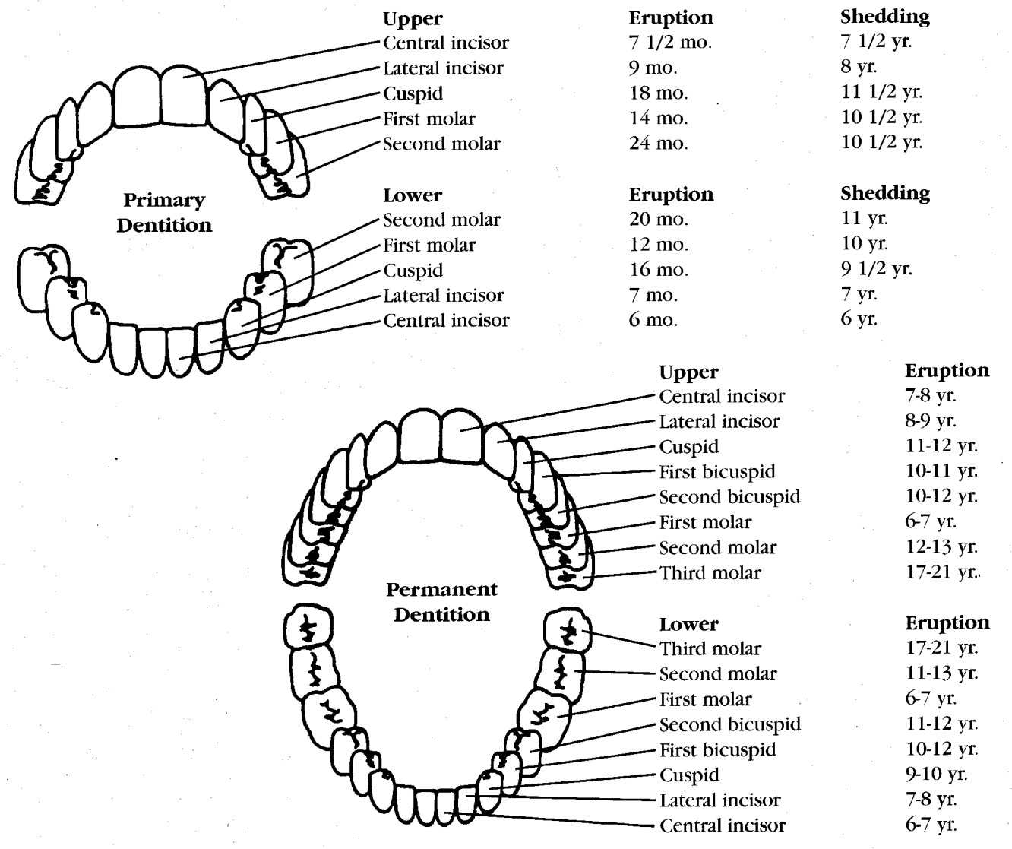

###### Advisory Committees

|  |  |
| --- | --- |
| **Policy/Content (1999)** Burton L. Edelstein, DDS, MPH Claude Earl Fox, III, MD, MPH Lawrence Hill, DDS, MPH Robert Isman, DDS, MPH  Kay A. Johnson, MPH, EdM Millie Jones, MPH  Robert D. Jones, DDS Raymond A. Kuthy, DDS, MPH Robin M. Lawrence, DDS, MPH Eugene J. Lengerich, VMD, MS Martha Liggett, Esq.  Stuart Lockwood, DMD, MPH Dorothy Moss  John Rossetti, DDS, MPH  R. Gary Rozier, DDS, MPH Yvonne Sylva  Jane A. Weintraub, DDS, MPH  Deborah M. Winn, PhD | **Technical/Criteria (1999)**  Eugenio Beltran, DMD, MPH, MS, DrPH Paul Casamassimo, DDS, MS  Burton L. Edelstein, DDS, MPH Stephen Eklund, DDS, MHSA, DrPH Amid Ismail, BDS, MPH, DrPH Rebecca King, DDS, MPH Raymond A. Kuthy, DDS, MPH Jayanth V. Kumar, DDS, MPH Robin M. Lawrence, DDS, MPH David M. Perry, DDS  Kathy Phipps, MPH, DrPH John Rossetti, DDS, MPH  R. Gary Rozier, DDS, MPH Deborah M. Winn, PhD |

1. Information on the Community Eligibility Provision can be found at: [www.fns.usda.gov/school-meals/community-eligibility-provision](http://www.fns.usda.gov/school-meals/community-eligibility-provision)
2. International Caries Detection and Assessment System, [www.icdas.org/](http://www.icdas.org/)