For CogState tests and exercise bike tests, we don’t have any collection forms/instrument. The assessment tools are part of their clinical assessment. In brief, a brief Battery of CogState tests are used in the Cognition and Exercise testing part of the MCAM study. CogState is administered at Practice, Baseline, Tim1-Time4 sessions. See screen shot below for CogState tests.
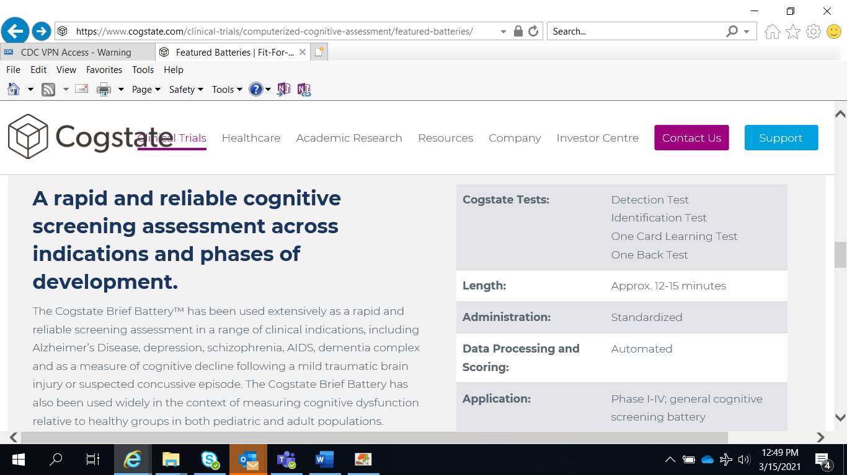
By clicking the following link, one can explore various cognitive tests in CogState.
https://www.cogstate.com/clinical-trials/computerized-cognitive-assessment/

Explore Our Cognitive Tests
Cogstate tests, each designed to measure a specific area of cognition, are grouped together to form customized batteries based on the unique requirements of the study design and population. Learn more about our different tests and how they can support the unique needs of your study by exploring the details and demos below.
Tests | Hours
CogState Practice Section | 17/60
CogState Baseline Section | 27/60
WAIS IV DS F+B, TOPF | 10/60
Exercise (Bike) Testing | 30/60
CogState Time 1 Section | 22/60
CogState Time 2 Section | 12/60
CogState Time 3 Section | 12/60
CogState Time 4 Section | 12/60

Below is a picture for the exercise bike test that would look like. Signal or vital sign information will be exported from the computer that connected with the machine.
