

Attachment 16.b.

**Study to Explore Early Development**

How to Collect Saliva Samples

Thank you for agreeing to provide saliva samples. This kit contains the following items:

* Consent form(s)
* Package or envelope containing one saliva kit per person
* Saliva Sample Record form (one form per person)
* Large postage paid, addressed envelope

**Please read this document before you start collecting the saliva samples.**

Wait at least 30 minutes after eating before you collect the samples.

**Please read all the directions before you start collecting the saliva samples.**

The Oragene® (OG) saliva collection kits are intended for use by all participants, whether a blood sample was obtained or not.

• There are two styles of collection kit with individualized instructions below.

• Utilize the OG-500 Self Collection kit for all participants that are capable of controlled spitting. Age does not matter.

• Use the OG-575 Assisted Collection kit for all participants who are not able to spit

(for example, a child).

Donors should not eat, drink or chew gum 30 minutes prior to sample collection.

* If a participant is capable of controlled spitting, proceed to step A.
* If a participant is NOT able to spit proceed to step B

**A. OG-500 Self-Collection Kit (for participants capable of controlled spitting)**

Contents:

* Collection tube
* Collection tube cap
* Directions

1. Spit into the funnel located at the top of the collection tube until the amount of saliva in the tube reaches the fill line. Use the saliva level and not the bubbles to determine when the fill line is reached.
2. Close the lid by pushing firmly down until you hear a loud click.
3. Unscrew the funnel and use small blue cap in the collection kit to close the tube tightly.
4. Invert the capped tube for 5 seconds.
5. Leave collection tube at room temperature until you ship it.
6. The saliva kit and funnel can be put in the trash.

**B. OG-575 Assisted Collection Kit (for participants who cannot spit)**

Contents:

* Collection tube
* Collection tube cap
* Collection Sponge
* Directions

1. Place and move sponge in cheek pouch along the gums and inner cheeks, soaking up as much saliva as possible for 30 seconds. Use the same sponge to collect additional saliva.
2. Insert saturated sponge in V-notch of the funnel located at the top of the collection tube and press the sponge against the inner wall of the V-notch. This will cause the saliva to flow into the collection tube.
3. Repeat step one and two until the saliva reaches the fill line in the collection tube.
4. Close the lid by pushing firmly down until you hear a loud click.
5. Unscrew the funnel and use small blue cap in the collection kit to close the tube tightly.
6. Invert the capped tube for 5 seconds.
7. Leave collection tube at room temperature until you ship it.

**Note:** OrageneDNA fluid is non-toxic. If the fluid should get onto a participants face or hands, just wash with soap and water. If fluid gets into the eyes it might feel like it is burning because of the salt present in the fluid. Splash water into the eyes to rinse the fluid and salt out if this happens.

**DIAGRAMTIC INSTRUCTIONS FOR Oragene® DNA COLLECTION KIT**

**Directions:** *Follow instructions below, if the person performing collection is someone other than the donor, wear gloves to avoid contamination. Wash hands/skin following collection or in case of spill and dispose of funnel and/or sponge in general waste. Sample should be stored and shipped at room temperature.*

|  |  |  |
| --- | --- | --- |
| |  | | --- | | Oragene®•DNA Self-Collection Kit User Instructions  (OG-500 Tube Format) | | Do not eat, drink, smoke or chew gum for 30 minutes before giving your saliva sample. | |
| |  | | --- | | Instructions_Spacer | |

|  |  |  |  |  |  |  |  |  |  |  |  |  |  |  |  |  |
| --- | --- | --- | --- | --- | --- | --- | --- | --- | --- | --- | --- | --- | --- | --- | --- | --- |
| |  |  |  |  | | --- | --- | --- | --- | | DNA_Inst_OG500_01 | DNA_Inst_OG500_02 | DNA_Inst_OG500_03 | DNA_Inst_OG500_04 |  |  |  |  |  |  |  |  |  |  |  |  |  | | --- | --- | --- | --- | --- | --- | --- | --- | --- | --- | --- | --- | | |  |  | | --- | --- | | Instr_01 | Spit until the amount of saliva (not bubbles) reaches the fill line. | | |  |  | | --- | --- | | Instr_02 | Close lid by pushing down hard on the funnel lid. | | |  |  | | --- | --- | | Instr_03 | Unscrew the tube from the funnel. | | |  |  | | --- | --- | | Instr_04 | Close tube tightly with small cap and gently invert the capped tube for 5 seconds. | | |
| |  | | --- | | Oragene®•DNA Assisted Collection User Instructions  (OG-575 Tube Format) |  |  | | --- | | Do not eat, drink, smoke or chew gum for 30 minutes before giving your saliva sample. | |
| |  | | --- | | Instructions_Spacer | |

|  |  |  |  |  |  |  |  |  |  |  |  |  |  |  |  |  |
| --- | --- | --- | --- | --- | --- | --- | --- | --- | --- | --- | --- | --- | --- | --- | --- | --- |
| |  |  |  |  | | --- | --- | --- | --- | | DNA_Inst_OG575_01 | DNA_Inst_OG575_02 | DNA_Inst_OG575_03 | DNA_Inst_OG575_04 |  |  |  |  |  |  |  |  |  |  |  |  |  | | --- | --- | --- | --- | --- | --- | --- | --- | --- | --- | --- | --- | | |  |  | | --- | --- | | Instr_01 | Place and move sponge in cheek pouch along the gums and inner cheeks to soak up as much saliva as possible. | | |  |  | | --- | --- | | Instr_02 | Insert saturated sponge in V-notch funnel and wring saliva out against the inner wall of the V-notch. Saliva will flow into tube. Repeat until saliva (not bubbles) reaches fill line. | | |  |  | | --- | --- | | Instr_03 | Close lid tightly  by firmly pushing down until you hear a loud click. | | |  |  | | --- | --- | | Instr_04 | Unscrew the funnel and use small cap in the collection kit to close the tube tightly. Gently invert the capped tube for  5 seconds. | | |

**Please follow the following steps for packaging and shipping saliva sample:**

1. After collecting the saliva sample, complete Sections A and B on the transmittal form (color paper).
2. Place the capped saliva tube into the transparent biohazard bag which contains the absorbent material. Peel off liner and seal by pressing down on glue line. Ensure that all air is removed from the biohazard bag before sealing.

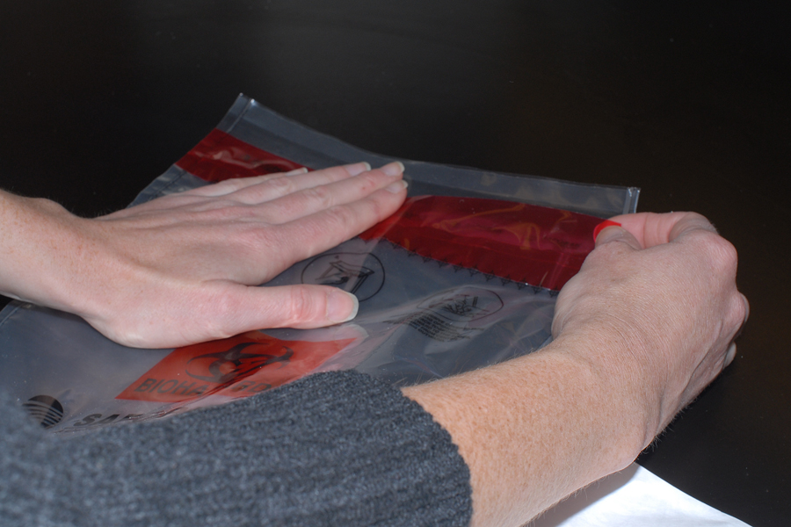

1. Insert the biohazard bag into the Tyvek or larger biohazard bag. Also put the transmittal colored form in this bag.

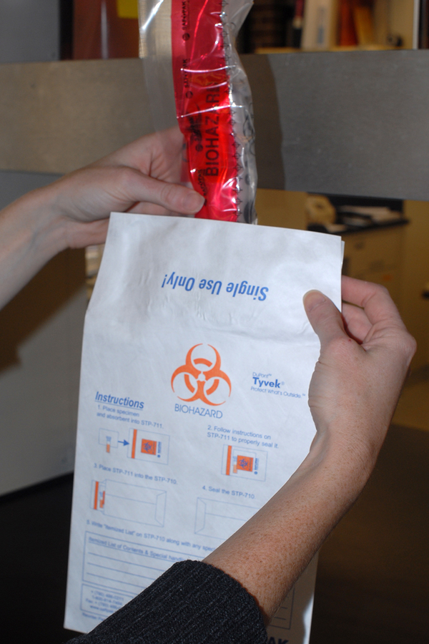

1. Ensure that all air is removed from the Tyvek or large biohazard bag. Seal the Tyvek or large biohazard Bag.

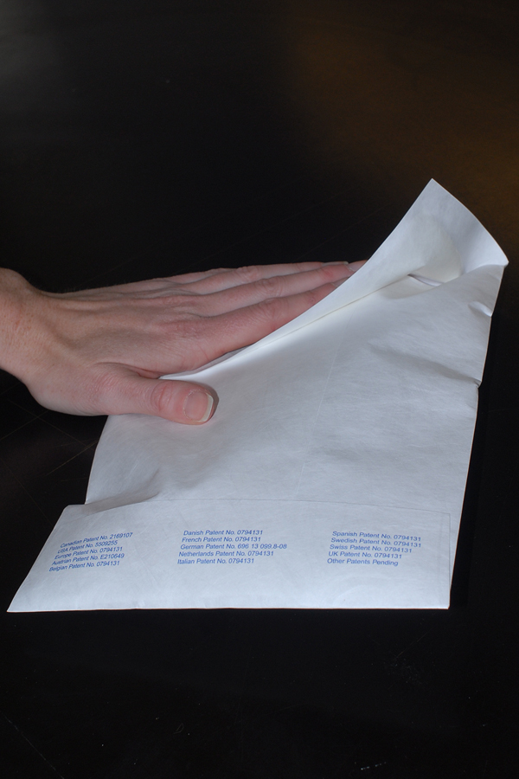

5) Do this for each person assigned a saliva kit.

6) Place each Tyvek or large biohazard bag into the pre-addressed, stamped bubble padded envelope with “Exempt human specimen” label on the outside.

7) Please be sure you have included the signed and dated the consent form before mailing to the local SEED site.

8) Seal the large return envelope and send it to us by U.S. mail. Remember; mail the samples within 24 hours of collecting them.