Fellowship Management System (FMS)
FMS Application Module
Privacy Act and Public Burden Information
Privacy Act Information
The Privacy Act applies to this information collection. Information collected will be kept private as noted in the System of Records Notice is 09-20-0112, Fellowship Program and Guest Researcher Records.

Public Burden Information
Form Approved
OMB No. 0920-0765
Exp. Date 01/31/2021

Public reporting burden of this collection of information is an estimated average of 75 minutes per response, including the 15 minutes for the reference letter writers, and including the time for reviewing instructions, searching existing data sources, gathering and maintaining the data needed, and completing and reviewing the collection of information. An agency may not conduct or sponsor, and a person is not required to respond to a collection of information unless it displays a currently valid OMB control number. Send comments regarding this burden estimate or any other aspect of this collection of information, including suggestions for reducing this burden to CDC/ATSDR Reports Clearance Officer; 1600 Clifton Road NE, MS D-74, Atlanta, Georgia 30333; ATTN: PRA (0920-0765).
2020

Table of Contents
Table of Contents 2
1. Introduction 7
1.1 Document Structure 8
2. Sign-In & Sign-Up Pages 9
2.1 Sign-In Page 9
2.2 Sign-Up Page (For New Users) 11
3. eFMS System Help Desk Ticket 12
4. Application Welcome Page 14
5. Applicant Profile 15
5.1 Create a Profile to Get Started 15
5.2 Applicant Name 16
5.3 Email Address 17
5.4 Phone Number 18
5.5 Mailing Address 19
5.6 Emergency Contact 20
6. Eligibility 21
6.1 Get Started 21
6.2 Citizenship Status 22
6.3 TOEFL Score 24
6.4 PMR/F 25
6.4.1 Eligibility 25
6.4.2 Commissioned Corps 29
6.4.3 Public Health Work Experience 30
6.5 PHIFP 31
6.5.1 Eligibility 31
6.6 SAF 33
6.6.1 Teaching Experience 33
6.7 EEP 34
6.7.1 Academic Endorsement 34
6.8 PHAP 35
6.8.1 Special Requirements 35
6.9 FLIGHT 39
6.9.1 Clinical Category & Training 39
6.9.2 Current EIS Position 40
6.9.3 Current Primary Supervisor 41
6.9.4 Scientific Experience 42
6.10 PH-TIPP 44
6.10.1 Eligibility 44
6.10.2 Program & Organization 45
6.10.3 Host Site Position Description 47
6.11 ELI 50
6.11.1 Organization Details 50
6.11.2 Educational Experience 52
6.11.3 Work Experience 54
6.11.4 e-Learning Content Example 56
6.12 EIS 58
6.12.1 EIS Federal Student Loan Repayment Interest 58
6.12 Confirming Accuracy & Minimum Eligibility 59
7. Education & Licenses 60
7.1 Adding Education or Licenses 60
7.2 Choose Category 61
7.3 Coursework Type 62
7.4 Location 63
7.5 College/University 64
7.6 Status 65
7.7 Degree 66
7.8 Additional Coursework 68
7.9 License 69
7.10 Dates 70
7.11 Incomplete Reason 72
8. Work & Volunteer Experience 73
8.1 Adding Work or Volunteer Experience 73
8.2 Choose Category 74
8.3 Organization Details 75
8.4 Position Details 77
8.5 Dates 79
8.6 Position Location 80
9. Additional Training & Skills 82
9.1 Adding Additional Training & Skills 82
9.2 Choose Category 83
9.3 Clinical Training 84
9.4 U.S. Board Certifications and Specialty 85
9.5 Additional Training, Certifications, or Professional Development 86
9.6 Institution Details and Location 87
9.7 Dates 88
9.8 Language Skills 90
10. Publications, Presentations, Working Papers, Monographs or Reports, Grants, Honors and Awards 92
10.1 Adding Publications, Presentations, Working Papers, Monographs or Reports, Grants, Honors and Awards 92
10.2 Choose Category 93
10.3 Details 94
11. Personal Statement 96
11.1 All Fellowships except FLIGHT 96
11.2 FLIGHT 99
11.3 Location Preferences 101
11.4 CDC Fellowship Participation 103
12. Standardized Letters of Recommendation (SLOR) 105
12.1 SLOR Requests 105
12.1.1 Starting a SLOR Request 105
12.1.2 SLOR Request Fields 106
12.2 System Emails to Letter Writers 108
12.3 Letters of Recommendation 109
12.3.1 Section A 109
12.3.2 Section B 111
12.3.3 Section C 116
13. Final Application Sections 118
13.1 Self-Assessment of Skills 118
13.1.1 PHIFP 118
13.1.2 PE 122
13.2 Applicant Survey 127
13.3 EEP Rotation Preferences & Topic/Subject Areas 132
13.3.1 Rotation Preferences 132
13.3.2 Topic & Subject Areas 134
13.3.3 Location Preferences 137
13.4 SAF Public Health Interests 139
13.5 EIS CIO Assignment Interests 141
13.6. Writing Samples 143
13.6.1 EIS Writing Samples 143
14. Match 144
14.1 Match or Prematch Rank/Rating Form 144
14.2 Match or Prematch Acceptance Form 145
Appendix 146
I. Field Value Tables 146
II. Lookup Tables 150

Introduction
The purpose of this document is to list all the data elements collected online through the Fellowship Management System (FMS). The FMS online application module is a streamlined mechanism for applicants of the Centers for Disease Control and Prevention (CDC) fellowships to submit their information online and track statuses of the application processes (e.g., all required materials received, invited for interviews). The FMS is a robust flexible framework and the FMS Application Module is tailored successfully for various CDC fellowships:
- Epidemic Intelligence Service (EIS)
- CDC E-learning Institute (ELI)
- Epidemiology Elective Program (EEP)
- Future Leaders in Infections and Global Health Threats (FLIGHT)
- Laboratory Leadership Service (LLS)
- CDC Steven M. Teutsch Prevention Effectiveness (PE) Fellowship
- Public Health Associate Program (PHAP)
- Public Health Informatics Fellowship Program (PHIFP)
- Science Ambassador Fellowship (SAF)
- Preventive Medicine Residency and Fellowship (PMR/F)
- Population Health Training in Place Program (PH-TIPP)

Document Structure
This document is broken down by the major pages of the FMS Application. In this document, each page of the FMS Application has sections and some sub-sections. In addition, application instructions, login, and registration pages are included. Instructions and emails in the FMS Application are tailored to each CDC fellowship’s requirements, eligibility criteria, information, and timeline.
Following the screenshots in each section is a table that shows the status of the collection of data elements by each CDC fellowships. The following labels indicate the status of the collection:
- “Yes” indicates that the fellowship collects the information and that applicants are required to submit this information.
- “No” indicates that the fellowship does not collect this information.
- “-” indicates open text field
In addition, the table shows the data values of each data element, and for ones that have a list of dropdown values, the data value category is hyperlinked to its list located in the Appendix.

Sign-In & Sign-Up Pages

Sign-In Page

Figure 2.1-a. Sign-In Page
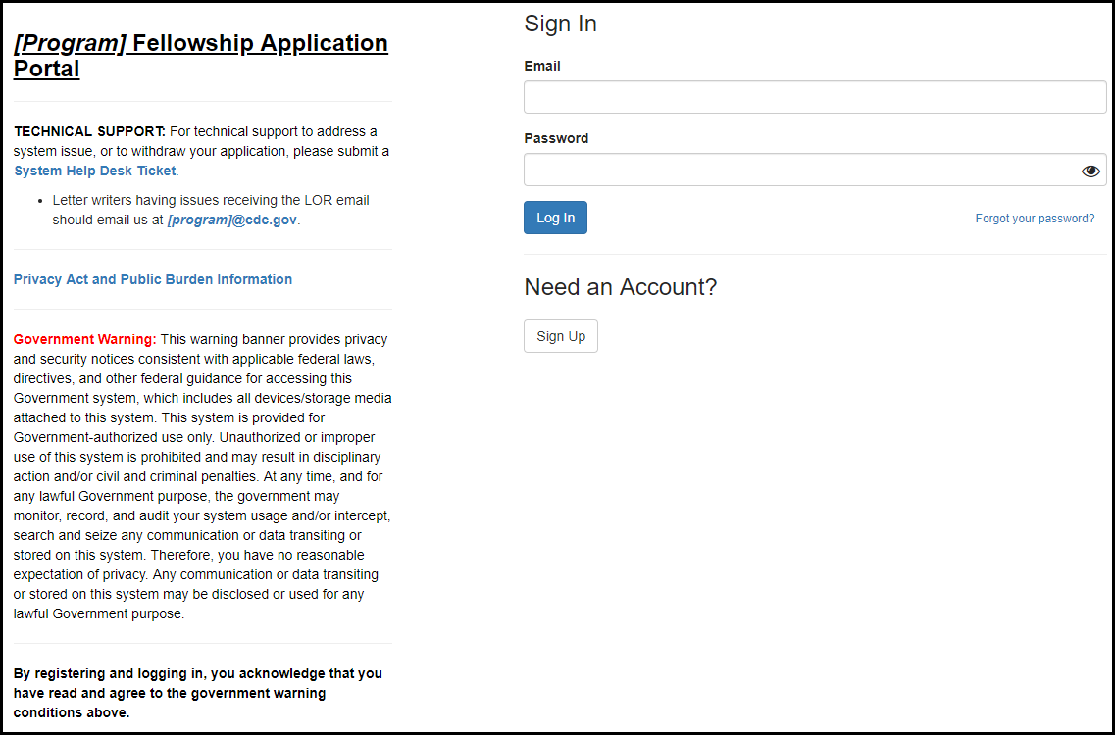

Figure 2.1-b. Privacy Act and Public Burden Information
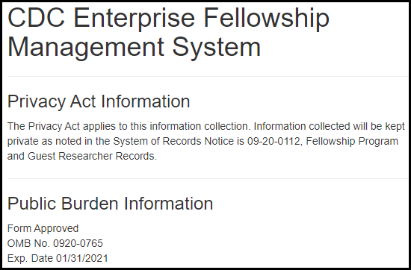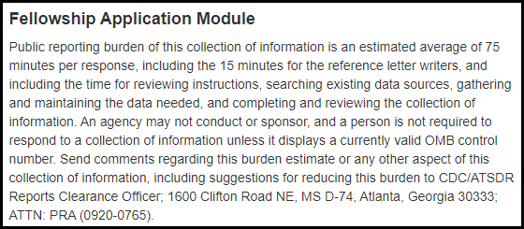
Table 2.1-a. Sign-In Fields
Field | Values | EIS | LLS | FLIGHT | EEP | SAF | PMR/F | PH-TIPP | PHIFP | PE | ELI | PHAP
Email | - | Yes | Yes | Yes | Yes | Yes | Yes | Yes | Yes | Yes | Yes | Yes
Password | - | Yes | Yes | Yes | Yes | Yes | Yes | Yes | Yes | Yes | Yes | Yes

Sign-Up Page (For New Users)

Figure 2.2-a. Sign-Up Fields
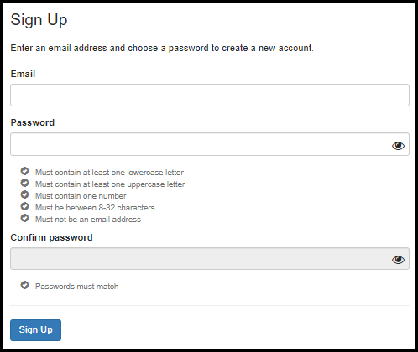
Table 2.2-a. Sign-Up Fields
Field | Values | EIS | LLS | FLIGHT | EEP | SAF | PMR/F | PH-TIPP | PHIFP | PE | ELI | PHAP
Email | - | Yes | Yes | Yes | Yes | Yes | Yes | Yes | Yes | Yes | Yes | Yes
Password | - | Yes | Yes | Yes | Yes | Yes | Yes | Yes | Yes | Yes | Yes | Yes
Confirm Password | - | Yes | Yes | Yes | Yes | Yes | Yes | Yes | Yes | Yes | Yes | Yes

eFMS System Help Desk Ticket

Figure 3-a. eFMS System Help Desk Ticket Fields
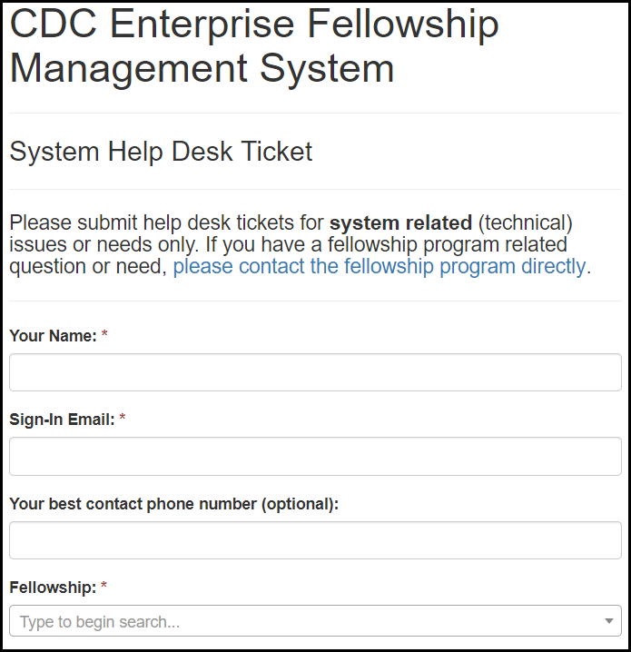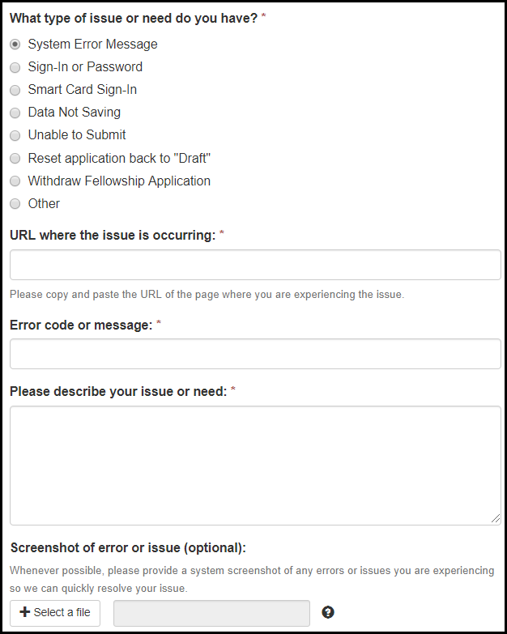

Table 3-a. eFMS System Help Desk Ticket Fields
Field | Values | EIS | LLS | FLIGHT | EEP | SAF | PMR/F | PH-TIPP | PHIFP | PE | ELI | PHAP
Your Name: | - | Yes | Yes | Yes | Yes | Yes | Yes | Yes | Yes | Yes | Yes | Yes
Sign-In Email: | - | Yes | Yes | Yes | Yes | Yes | Yes | Yes | Yes | Yes | Yes | Yes
Contact Phone Number: | - | Yes | Yes | Yes | Yes | Yes | Yes | Yes | Yes | Yes | Yes | Yes
Fellowship: | Fellowship Lookup Table | Yes | Yes | Yes | Yes | Yes | Yes | Yes | Yes | Yes | Yes | Yes
What type of issue or need do you have? | 1. System Error Message  2. Sign-In or Password  3. Smart Card Sign-In  4. Data Not Saving  5. Unable to Submit  6. Reset application back to "Draft"  7. Withdraw Fellowship Application  8. Other | Yes | Yes | Yes | Yes | Yes | Yes | Yes | Yes | Yes | Yes | Yes
URL where the issue is occurring: | - | Yes | Yes | Yes | Yes | Yes | Yes | Yes | Yes | Yes | Yes | Yes
Error code message: | - | Yes | Yes | Yes | Yes | Yes | Yes | Yes | Yes | Yes | Yes | Yes
Please describe your issue or need: | - | Yes | Yes | Yes | Yes | Yes | Yes | Yes | Yes | Yes | Yes | Yes
Screenshot of error or issue (optional): | - | Yes | Yes | Yes | Yes | Yes | Yes | Yes | Yes | Yes | Yes | Yes

Application Welcome Page

Figure 4-a. Application Welcome Page
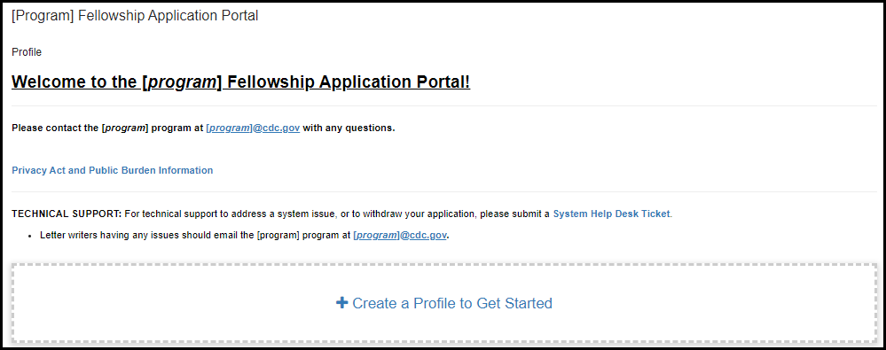

Applicant Profile

Create a Profile to Get Started

Figure 5.1-a. Create a Profile to Get Started

Applicant Name

Figure 5.2-a. Applicant Name Fields
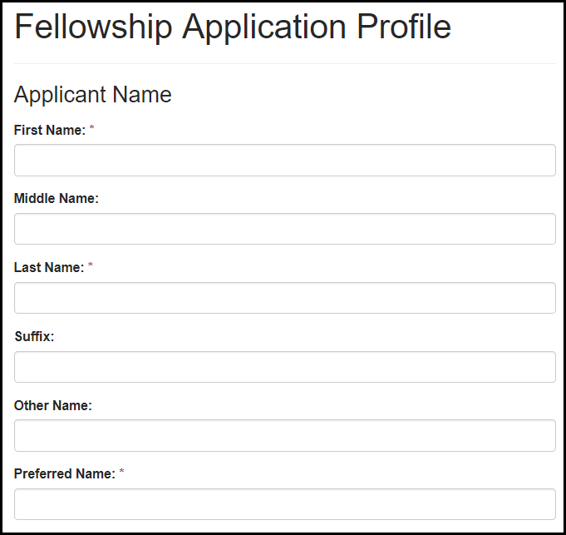
Table 5.2-a. Applicant Name Fields
Field | Values | EIS | LLS | FLIGHT | EEP | SAF | PMR/F | PH-TIPP | PHIFP | PE | ELI | PHAP
First Name: | - | Yes | Yes | Yes | Yes | Yes | Yes | Yes | Yes | Yes | Yes | Yes
Middle Name: | - | Yes | Yes | Yes | Yes | Yes | Yes | Yes | Yes | Yes | Yes | Yes
Last Name: | - | Yes | Yes | Yes | Yes | Yes | Yes | Yes | Yes | Yes | Yes | Yes
Suffix: | - | Yes | Yes | Yes | Yes | Yes | Yes | Yes | Yes | Yes | Yes | Yes
Other Name: | - | Yes | Yes | Yes | Yes | Yes | Yes | Yes | Yes | Yes | Yes | Yes
Preferred Name: | - | Yes | Yes | Yes | Yes | Yes | Yes | Yes | Yes | Yes | Yes | Yes

Email Address

Figure 5.3-a. Email Address Fields
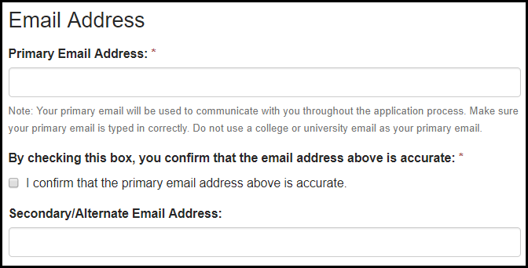
Table 5.3-a. Email Address Fields
Field | Values | EIS | LLS | FLIGHT | EEP | SAF | PMR/F | PH-TIPP | PHIFP | PE | ELI | PHAP
Primary Email Address: | - | Yes | Yes | Yes | Yes | Yes | Yes | Yes | Yes | Yes | Yes | Yes
By checking this box, you confirm that the email address above is accurate: | 1. I confirm that the email address above is accurate. | Yes | Yes | Yes | Yes | Yes | Yes | Yes | Yes | Yes | Yes | Yes
Secondary/Alternate Email Address: | - | Yes | Yes | Yes | Yes | Yes | Yes | Yes | Yes | Yes | Yes | Yes

Phone Number

Figure 5.4-a. Phone Number Fields
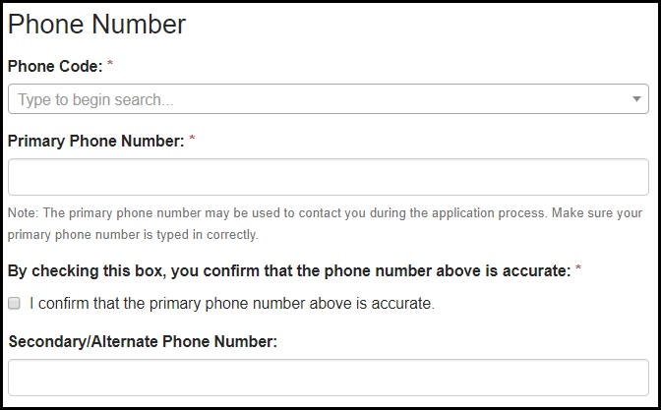
Table 5.4-a. Phone Number Fields
Field | Values | EIS | LLS | FLIGHT | EEP | SAF | PMR/F | PH-TIPP | PHIFP | PE | ELI | PHAP
Phone Code: | Phone Code Lookup Table | Yes | Yes | Yes | Yes | Yes | Yes | Yes | Yes | Yes | Yes | Yes
Primary Phone Number: | - | Yes | Yes | Yes | Yes | Yes | Yes | Yes | Yes | Yes | Yes | Yes
By checking this box, you confirm that the phone number above is accurate: | 1. I confirm that the phone number above is accurate. | Yes | Yes | Yes | Yes | Yes | Yes | Yes | Yes | Yes | Yes | Yes
Secondary/Alternate Phone Number: | - | Yes | Yes | Yes | Yes | Yes | Yes | Yes | Yes | Yes | Yes | Yes

Mailing Address

Figure 5.5-a. Mailing Address Fields
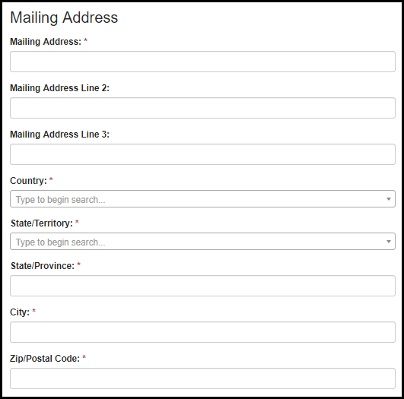
Table 5.5-a. Mailing Address Fields
Field | Values | EIS | LLS | FLIGHT | EEP | SAF | PMR/F | PH-TIPP | PHIFP | PE | ELI | PHAP
Mailing Address: | - | Yes | Yes | Yes | Yes | Yes | Yes | Yes | Yes | Yes | Yes | Yes
Mailing Address Line 2: | - | Yes | Yes | Yes | Yes | Yes | Yes | Yes | Yes | Yes | Yes | Yes
Mailing Address Line 3: | - | Yes | Yes | Yes | Yes | Yes | Yes | Yes | Yes | Yes | Yes | Yes
Country: | Country Lookup Table | Yes | Yes | Yes | Yes | Yes | Yes | Yes | Yes | Yes | Yes | Yes
State/Territory: | State/Territory Lookup Table | Yes | Yes | Yes | Yes | Yes | Yes | Yes | Yes | Yes | Yes | Yes
State/Province: | - | Yes | Yes | Yes | Yes | Yes | Yes | Yes | Yes | Yes | Yes | Yes
City: | - | Yes | Yes | Yes | Yes | Yes | Yes | Yes | Yes | Yes | Yes | Yes
Zip/Postal Code: | - | Yes | Yes | Yes | Yes | Yes | Yes | Yes | Yes | Yes | Yes | Yes

Emergency Contact

Figure 5.6-a. Emergency Contact Fields
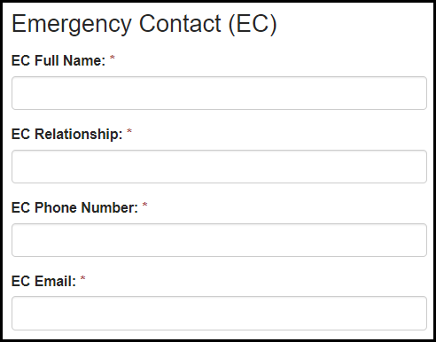
Table 5.6-a. Emergency Contact Fields
Field | Values | EIS | LLS | FLIGHT | EEP | SAF | PMR/F | PH-TIPP | PHIFP | PE | ELI | PHAP
EC Full Name: | - | Yes | Yes | Yes | Yes | Yes | Yes | Yes | Yes | Yes | Yes | Yes
EC Relationship: | - | Yes | Yes | Yes | Yes | Yes | Yes | Yes | Yes | Yes | Yes | Yes
EC Phone Number: | - | Yes | Yes | Yes | Yes | Yes | Yes | Yes | Yes | Yes | Yes | Yes
EC Email: | - | Yes | Yes | Yes | Yes | Yes | Yes | Yes | Yes | Yes | Yes | Yes

Eligibility

Get Started

Figure 6.1-a. Get Started
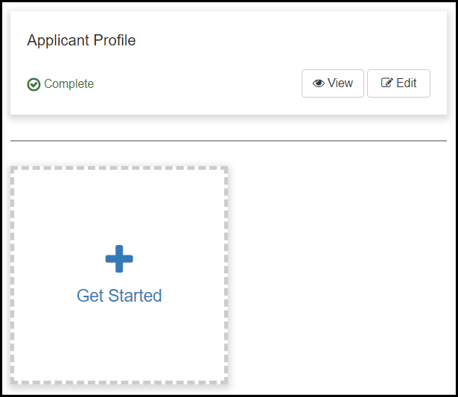
Figure 6.1-a. Part 1: Eligibility Stage
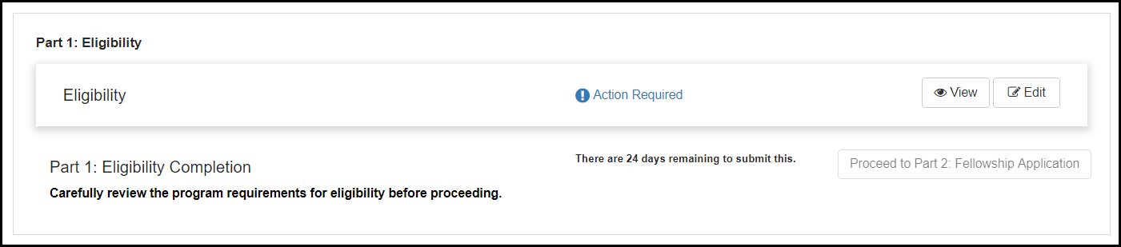

Citizenship Status

Figure 6.2-a. Citizenship Status Fields
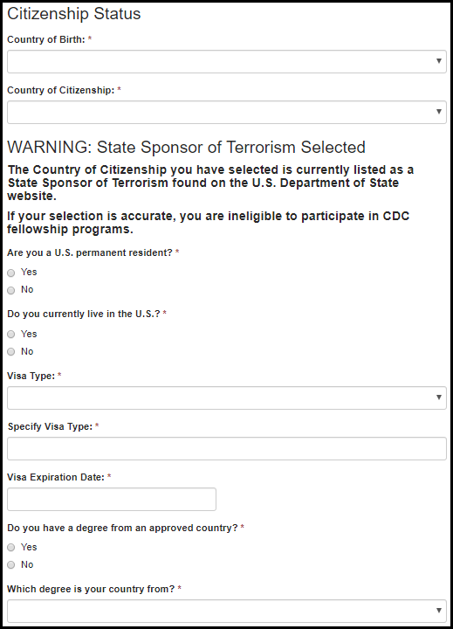

Table 6.2-a. Citizenship Status Fields
Field | Values | EIS | LLS | FLIGHT | EEP | SAF | PMR/F | PH-TIPP | PHIFP | PE | ELI | PHAP
Country of Birth: | Country Lookup | No | No | No | No | No | Yes | Yes | No | No | No | Yes
Country of Citizenship: | Country Lookup | Yes | Yes | No | Yes | Yes | Yes | Yes | Yes | Yes | Yes | Yes
Are you a U.S. permanent resident? | 1. Yes  2. No | Yes | Yes | No | No | No | Yes | Yes | Yes | Yes | Yes | Yes
Do you currently live in the U.S.? | 1. Yes  2. No | Yes | Yes | No | No | No | Yes | Yes | Yes | Yes | Yes | Yes
Visa Type: | 1. F-1  2. H-1B  3. J-1  4. O-1  5. TN  6. Other | Yes | Yes | No | No | No | Yes | Yes | Yes | Yes | No | Yes
Specify Visa Type: |  | Yes | Yes | No | No | No | Yes | Yes | Yes | Yes | No | Yes
Visa Expiration Date: |  | Yes | Yes | No | No | No | Yes | Yes | Yes | Yes | No | Yes
Do you have a completed degree from the approved TOEFL exempt countries list? | 1. Yes  2. No | Yes | Yes | No | No | No | No | No | No | No | No | No
Which degree is your country from? | Approved Country List | Yes | Yes | No | No | No | No | No | No | No | No | No

TOEFL Score

Figure 6.3-a. TOEFL Score Fields
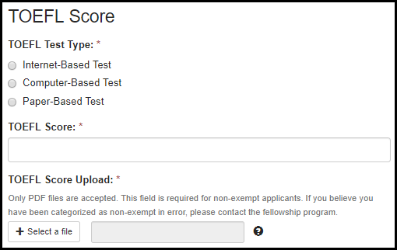
Table 6.3-a. TOEFL Score Fields
Field | Values | EIS | LLS | FLIGHT | EEP | SAF | PMR/F | PH-TIPP | PHIFP | PE | ELI | PHAP
TOEFL Test Type: | 1. Internet-Based Test  2. Computer-Based Test  3. Paper-Based Test | Yes | No | No | No | No | Yes | Yes | Yes | No | No | No
TOEFL Score: | - | Yes | No | No | No | No | Yes | Yes | Yes | No | No | No
TOEFL Score Upload: | - | Yes | No | No | No | No | Yes | Yes | Yes | No | No | No

PMR/F

Eligibility

Figure 6.4.1-a. Eligibility Fields Figure 6.4.1-b. Eligibility Fields Figure 6.4.1-c. Eligibility Fields
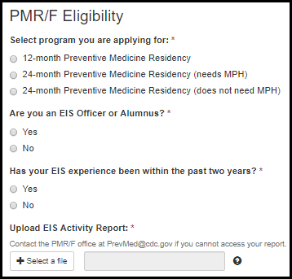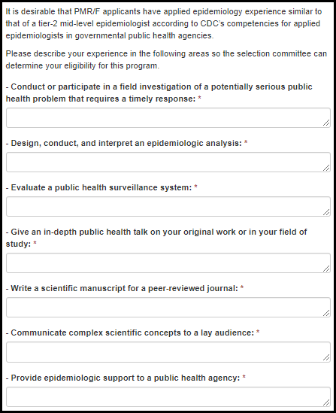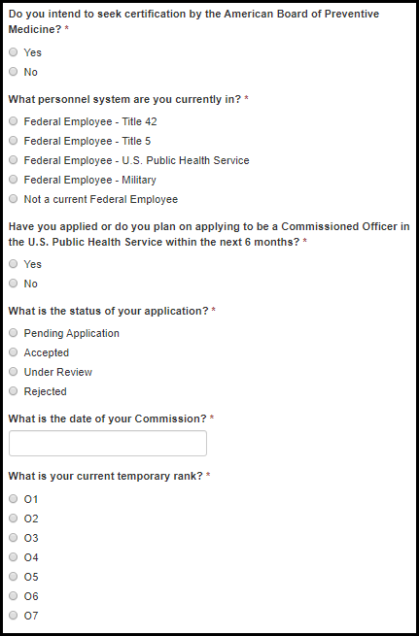

Figure 6.4.1-d. Eligibility Fields
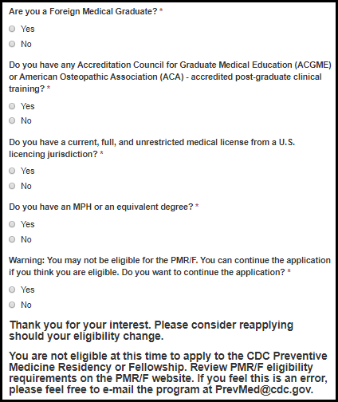

Table 6.4.1-a. Eligibility Fields
Field | Values | EIS | LLS | FLIGHT | EEP | SAF | PMR/F | PH-TIPP | PHIFP | PE | ELI | PHAP
Select preventive medicine program you are applying for: | 1. 12-month Preventive Medicine Residency  2. 24-month Preventive Medicine Residency (needs MPH)  3. 24-month Preventive Medicine Residency (does not need MPH) | No | No | No | No | No | Yes | No | No | No | No | No
Are you either an EIS Officer or Alumnus? | 1. Yes  2. No | No | No | No | No | No | Yes | No | No | No | No | No
Has your EIS experience been within the past two years? | 1. Yes  2. No | No | No | No | No | No | Yes | No | No | No | No | No
EIS Activity Report Upload: | - | No | No | No | No | No | Yes | No | No | No | No | No
Conduct or participate in a field investigation of a potentially serious public health problem that requires a timely response: | - | No | No | No | No | No | Yes | No | No | No | No | No
Design, conduct, and interpret an epidemiologic analysis: | - | No | No | No | No | No | Yes | No | No | No | No | No
Evaluate a public health surveillance system: | - | No | No | No | No | No | Yes | No | No | No | No | No
Give an in-depth public health talk on your original work or in your field of study: | - | No | No | No | No | No | Yes | No | No | No | No | No
Write a scientific manuscript for a peer-reviewed journal: | - | No | No | No | No | No | Yes | No | No | No | No | No
Communicate complex scientific concepts to a lay audience: | - | No | No | No | No | No | Yes | No | No | No | No | No
Provide epidemiologic support to a public health agency: | - | No | No | No | No | No | Yes | No | No | No | No | No
Do you intend to seek certification by the American Board of Preventive Medicine? | 1. Yes  2. No | No | No | No | No | No | Yes | No | No | No | No | No
What personnel system are you currently in? | 1. Federal Employee - Title 42  2. Federal Employee - Title 5  3. Federal Employee - U.S. Public Health Service  4. Federal Employee - Military  5. Not a current Federal Employee | No | No | No | No | No | Yes | No | No | No | No | No
Have you applied or do you plan on applying to be a Commissioned Officer in the U.S. Public Health Service within the next 6 months? | 1. Yes  2. No | No | No | No | No | No | Yes | No | No | No | No | No
What is the status of your application? | 1. Pending Application  2. Accepted  3. Under Review  4. Rejected | No | No | No | No | No | Yes | No | No | No | No | No
What is the date of your Commission? | - | No | No | No | No | No | Yes | No | No | No | No | No
What is your current temporary rank? | 1. O1  2. O2  3. O3  4. O4  5. O5  6. O6  7. O7 | No | No | No | No | No | Yes | No | No | No | No | No
Are you a Foreign Medical Graduate? | 1. Yes  2. No | No | No | No | No | No | Yes | No | No | No | No | No
Do you have any Accreditation Council for Graduate Medical Education (ACGME) or American Osteopathic Association (ACA) - accredited post-graduate clinical training? | 1. Yes  2. No | No | No | No | No | No | Yes | No | No | No | No | No
Do you have a current, full, and unrestricted medical license from a U.S. licensing jurisdiction? | 1. Yes  2. No | No | No | No | No | No | Yes | No | No | No | No | No
Do you have an MPH or an equivalent degree? | 1. Yes  2. No | No | No | No | No | No | Yes | No | No | No | No | No
Warning: You may not be eligible for the PMR/F. You can continue the application if you think you are eligible. Do you want to continue the application? | 1. Yes  2. No | No | No | No | No | No | Yes | No | No | No | No | No

Commissioned Corps

Figure 6.4.2-a. Commissioned Corps Fields
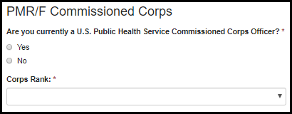

Table 6.4.2-a. Commissioned Corps Fields
Field | Values | EIS | LLS | FLIGHT | EEP | SAF | PMR/F | PH-TIPP | PHIFP | PE | ELI | PHAP
Are you currently a U.S. Public Health Service Commissioned Corps Officer? | 1. Yes  2. No | No | No | No | No | No | Yes | No | No | No | No | No
Corps Rank: | 1. O-3 LT  2. O-4 LCDR  3. O-5 CDR  4. O-6 CAPT  5. O-7 RADM  6. O-8 RADM | No | No | No | No | No | Yes | No | No | No | No | No

6.4.3 Public Health Work Experience

Figure 6.4.3-a. Public Health Work Experience Fields

Table 6.4.3-a. Public Health Work Experience Fields
Field | Values | EIS | LLS | FLIGHT | EEP | SAF | PMR/F | PH-TIPP | PHIFP | PE | ELI | PHAP
Indicate where you have had Public Health/Population based work experience: | 1. National or deferral level or CDC headquarters  2. State or local health department  3. Both State or local health department and National or deferral level or CDC headquarters  4. Other | No | No | No | No | No | Yes | No | No | No | No | No

PHIFP

Eligibility

Figure 6.5.1-a. Eligibility Fields Figure 6.5.1-b. Eligibility Fields
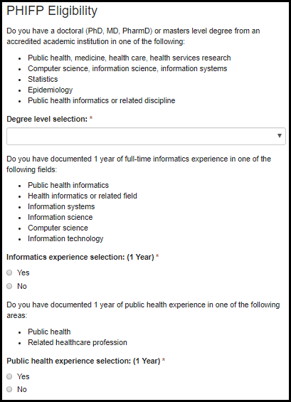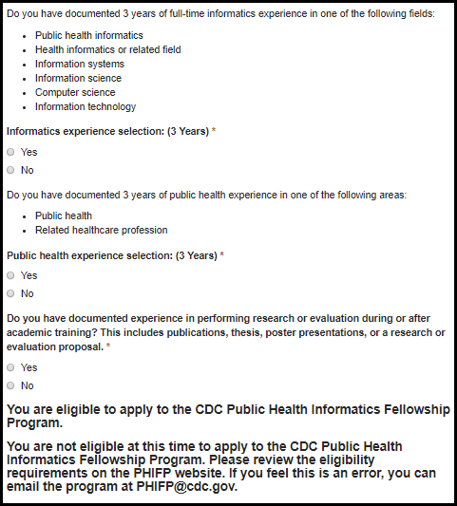

Table 6.5.1-a. PHIFP - Eligibility Fields
Field | Values | EIS | LLS | FLIGHT | EEP | SAF | PMR/F | PH-TIPP | PHIFP | PE | ELI | PHAP
Degree level selection: | 1. Doctoral  2. Masters  3. None | No | No | No | No | No | No | No | Yes | No | No | No
Informatics experience selection: (1 Year) | 1. Yes  2. No | No | No | No | No | No | No | No | Yes | No | No | No
Public health experience selection: (1 Year) | 1. Yes  2. No | No | No | No | No | No | No | No | Yes | No | No | No
Informatics experience selection: (3 Years) | 1. Yes  2. No | No | No | No | No | No | No | No | Yes | No | No | No
Public health experience selection: (3 Years) | 1. Yes  2. No | No | No | No | No | No | No | No | Yes | No | No | No
Do you have documented experience in performing research or evaluation during or after academic training? This includes publications, thesis, poster presentations, or a research or evaluation proposal. | 1. Yes  2. No | No | No | No | No | No | No | No | Yes | No | No | No

SAF

Teaching Experience
Figure 6.6.1-a. Teaching Experience Fields
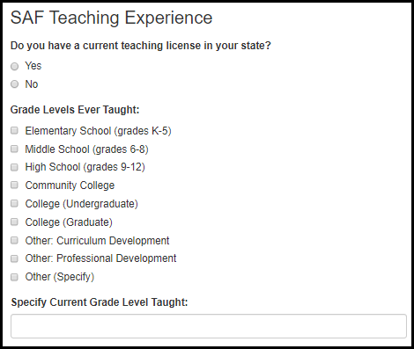
Table 6.6.1-a. Teaching Experience Fields
Field | Values | EIS | LLS | FLIGHT | EEP | SAF | PMR/F | PH-TIPP | PHIFP | PE | ELI | PHAP
Do you have a current teaching license in your state? | 1. Yes  2. No | No | No | No | No | Yes | No | No | No | No | No | No
Grade Levels Ever Taught: | 1. Elementary School (grades K-5)  2. Middle School (grades 6-8)  3. High School (grades 9-12)  2. Community College  3. College (Undergraduate)  4. College (Graduate)  5. Other: Curriculum Development  6. Other: Professional Development  7. Other (Specify) | No | No | No | No | Yes | No | No | No | No | No | No
Specify Grade Level Taught: | - | No | No | No | No | Yes | No | No | No | No | No | No

EEP

Academic Endorsement

Figure 6.7.1-a. Academic Endorsement Fields
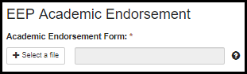
Table 6.7.1-a. Academic Endorsement Fields
Field | Values | EIS | LLS | FLIGHT | EEP | SAF | PMR/F | PH-TIPP | PHIFP | PE | ELI | PHAP
Academic Endorsement Form: | - | No | No | No | Yes | No | No | No | No | No | No | No

PHAP

Special Requirements

Figure 6.8.1-a. Special Requirements Fields Figure 6.8.1-b. Special Requirements Fields
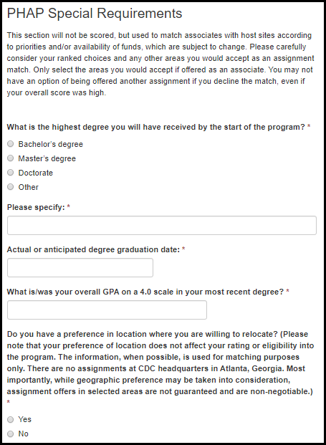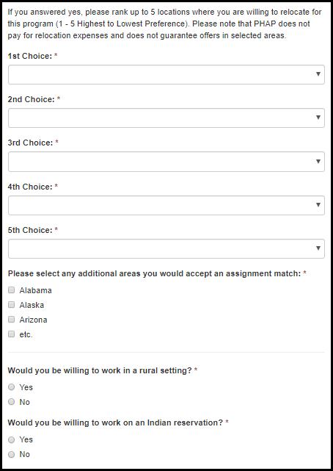
Figure 6.8.1-c. Special Requirements Fields
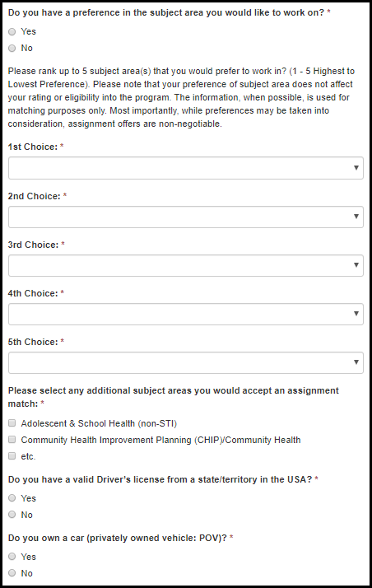

Table 6.8.1-a. Special Requirements Fields
Field | Values | EIS | LLS | FLIGHT | EEP | SAF | PMR/F | PH-TIPP | PHIFP | PE | ELI | PHAP
What is the highest degree you will have received by the start of the program? | 1. Bachelor’s degree  2. Master’s degree  3. Doctorate  4. Other | No | No | No | No | No | No | No | No | No | No | Yes
Please specify: | - | No | No | No | No | No | No | No | No | No | No | Yes
Actual or anticipated degree graduation date: | - | No | No | No | No | No | No | No | No | No | No | Yes
What is/was your overall GPA on a 4.0 scale in your most recent degree? | - | No | No | No | No | No | No | No | No | No | No | Yes
Do you have a preference in location where you are willing to relocate? (Please note that your preference of location does not affect your rating or eligibility into the program. The information, when possible, is used for matching purposes only. There are no assignments at CDC headquarters in Atlanta, Georgia. Most importantly, while geographic preference may be taken into consideration, assignment offers in selected areas are not guaranteed and are non-negotiable.) | 1. Yes  2. No | No | No | No | No | No | No | No | No | No | No | Yes
1st Choice: | State/Territory Lookup | No | No | No | No | No | No | No | No | No | No | Yes
2nd Choice: | State/Territory Lookup | No | No | No | No | No | No | No | No | No | No | Yes
3rd Choice: | State/Territory Lookup | No | No | No | No | No | No | No | No | No | No | Yes
4th Choice: | State/Territory Lookup | No | No | No | No | No | No | No | No | No | No | Yes
5th Choice: | State/Territory Lookup | No | No | No | No | No | No | No | No | No | No | Yes
Please select any additional areas you would accept an assignment match: | State/Territory Lookup | No | No | No | No | No | No | No | No | No | No | Yes
Table 6.8.1-b. Special Requirements Fields
Field | Values | EIS | LLS | FLIGHT | EEP | SAF | PMR/F | PH-TIPP | PHIFP | PE | ELI | PHAP
Would you be willing to work in a rural setting? | 1. Yes  2. No | No | No | No | No | No | No | No | No | No | No | Yes
Would you be willing to work on an Indian reservation? | 1. Yes  2. No | No | No | No | No | No | No | No | No | No | No | Yes
Do you have a preference in the subject area you would like to work on? | 1. Yes  2. No | No | No | No | No | No | No | No | No | No | No | Yes
1st Choice: | Subject Area  Field Value Table | No | No | No | No | No | No | No | No | No | No | Yes
2nd Choice: | Subject Area  Field Value Table | No | No | No | No | No | No | No | No | No | No | Yes
3rd Choice: | Subject Area  Field Value Table | No | No | No | No | No | No | No | No | No | No | Yes
4th Choice: | Subject Area  Field Value Table | No | No | No | No | No | No | No | No | No | No | Yes
5th Choice: | Subject Area  Field Value Table | No | No | No | No | No | No | No | No | No | No | Yes
Please select any additional subject areas you would accept an assignment match: | - | No | No | No | No | No | No | No | No | No | No | Yes
Do you have a valid Driver’s license from a state/territory in the USA? | 1. Yes  2. No | No | No | No | No | No | No | No | No | No | No | Yes
Do you own a car (privately owned vehicle: POV)? | 1. Yes  2. No | No | No | No | No | No | No | No | No | No | No | Yes

FLIGHT

Clinical Category & Training

Figure 6.9.1-a. Clinical Category & Training Fields
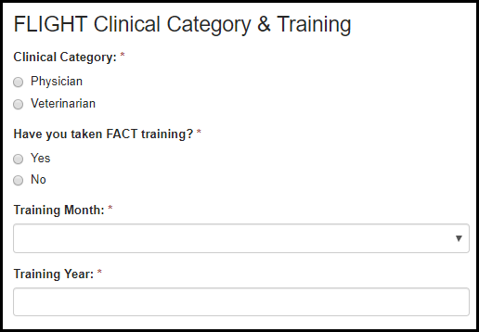
Table 6.9.1-a. Clinical Category & Training Fields
Field | Values | EIS | LLS | FLIGHT | EEP | SAF | PMR/F | PH-TIPP | PHIFP | PE | ELI | PHAP
Clinical Category: | 1. Physician  2. Veterinarian | No | No | Yes | No | No | No | No | No | No | No | No
Have you taken FACT training? | 1. Yes  2. No | No | No | Yes | No | No | No | No | No | No | No | No
Training Month: | - | No | No | Yes | No | No | No | No | No | No | No | No
Training Year: | - | No | No | Yes | No | No | No | No | No | No | No | No

Current EIS Position

Figure 6.9.2-a. Current EIS Position
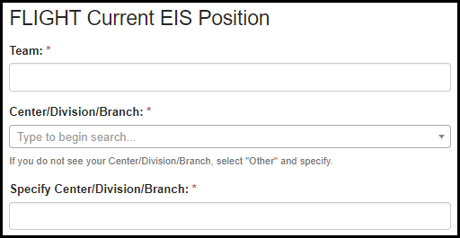
Table 6.9.2-a. Current EIS Position.
Field | Values | EIS | LLS | FLIGHT | EEP | SAF | PMR/F | PH-TIPP | PHIFP | PE | ELI | PHAP
Team: | - | No | No | Yes | No | No | No | No | No | No | No | No
Center/Division/Branch: | Center/Division/Branch Lookup | No | No | Yes | No | No | No | No | No | No | No | No
Specify: | - | No | No | Yes | No | No | No | No | No | No | No | No

Current Primary Supervisor

Figure 6.9.3-a. Current Primary Supervisor
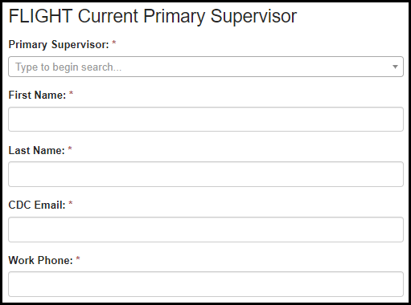
Table 6.9.3-a. Current Primary Supervisor
Field | Values | EIS | LLS | FLIGHT | EEP | SAF | PMR/F | PH-TIPP | PHIFP | PE | ELI | PHAP
First Name: | - | No | No | Yes | No | No | No | No | No | No | No | No
Last Name: | - | No | No | Yes | No | No | No | No | No | No | No | No
CDC Email: | - | No | No | Yes | No | No | No | No | No | No | No | No
Work Phone: | - | No | No | Yes | No | No | No | No | No | No | No | No

Scientific Experience

Figure 6.9.4-a. Scientific Experience
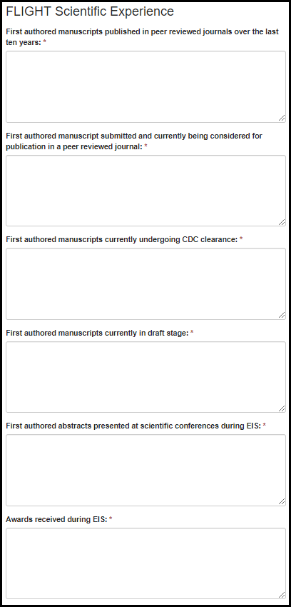

Table 6.9.4-a. Scientific Experience
Field | Values | EIS | LLS | FLIGHT | EEP | SAF | PMR/F | PH-TIPP | PHIFP | PE | ELI | PHAP
First authored manuscripts published in peer reviewed journals over the last ten years: | - | No | No | Yes | No | No | No | No | No | No | No | No
First authored manuscript submitted and currently being considered for publication in a peer reviewed journal: | - | No | No | Yes | No | No | No | No | No | No | No | No
First authored manuscripts currently undergoing CDC clearance: | - | No | No | Yes | No | No | No | No | No | No | No | No
First authored manuscripts currently in draft stage: | - | No | No | Yes | No | No | No | No | No | No | No | No
First authored abstracts presented at scientific conferences during EIS: | - | No | No | Yes | No | No | No | No | No | No | No | No
Awards received during EIS: | - | No | No | Yes | No | No | No | No | No | No | No | No

PH-TIPP

Eligibility

Figure 6.10.1-a. Eligibility
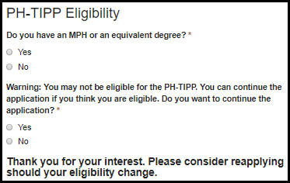
Table 6.10.1-a. Eligibility
Field | Values | EIS | LLS | FLIGHT | EEP | SAF | PMR/F | PH-TIPP | PHIFP | PE | ELI | PHAP
Do you have an MPH or an equivalent degree? | 1. Yes  2. No | No | No | No | No | No | No | Yes | No | No | No | No
Warning: You may not be eligible for the PH-TIPP. You can continue the application if you think you are eligible. Do you want to continue the application? | 1. Yes  2. No | No | No | No | No | No | No | Yes | No | No | No | No

Program & Organization

Figure 6.10.2-a. Program & Organization
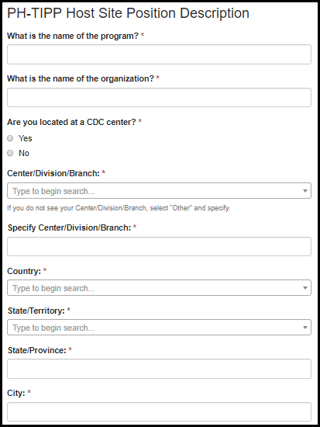

Table 6.10.2-a. Program & Organization
Field | Values | EIS | LLS | FLIGHT | EEP | SAF | PMR/F | PH-TIPP | PHIFP | PE | ELI | PHAP
What is the name of the program? | - | No | No | No | No | No | No | Yes | No | No | No | No
What is the name of the organization? | - | No | No | No | No | No | No | Yes | No | No | No | No
Are you located at a CDC center? | 1. Yes  2. No | No | No | No | No | No | No | Yes | No | No | No | No
Center/Division/Branch: | Center/Division/Branch Lookup | No | No | No | No | No | No | Yes | No | No | No | No
Specify: | - | No | No | No | No | No | No | Yes | No | No | No | No
Country: | Country Lookup | No | No | No | No | No | No | Yes | No | No | No | No
State/Territory: | State Lookup | No | No | No | No | No | No | Yes | No | No | No | No
State/Province: | - | No | No | No | No | No | No | Yes | No | No | No | No
City: | - | No | No | No | No | No | No | Yes | No | No | No | No

Host Site Position Description

Figure 6.10.3-a. Host Site Position Description Figure 6.10.3-b. Host Site Position Description
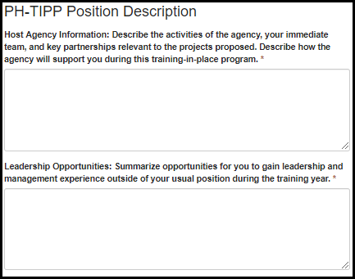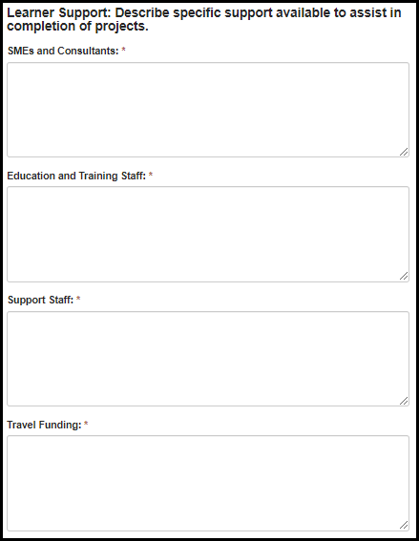

Figure 6.10.3-c. PH-TIPP – Host Site Position Description Figure 6.10.3-d. PH-TIPP – Host Site Position Description
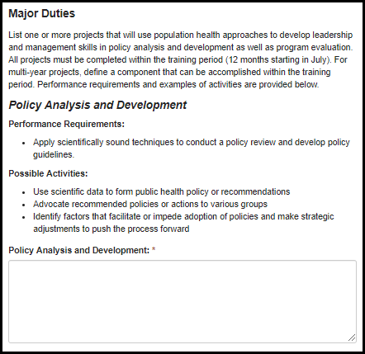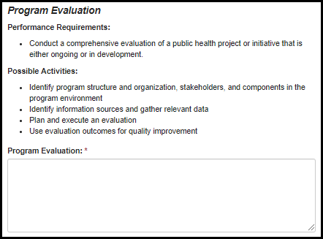

Table 6.10.3-c. PH-TIPP – Host Site Position Description
Field | Values | EIS | LLS | FLIGHT | EEP | SAF | PMR/F | PH-TIPP | PHIFP | PE | ELI | PHAP
Host Agency Information: Describe the activities of the agency, your immediate team, and key partnerships relevant to the projects proposed. Describe how the agency will support you during this training-in-place program. | - | No | No | No | No | No | No | Yes | No | No | No | No
Leadership Opportunities: Summarize opportunities for you to gain leadership and management experience outside of your usual position during the training year. | - | No | No | No | No | No | No | Yes | No | No | No | No
SMEs and Consultants: | - | No | No | No | No | No | No | Yes | No | No | No | No
Education and Training Staff: | - | No | No | No | No | No | No | Yes | No | No | No | No
Support Staff: | - | No | No | No | No | No | No | Yes | No | No | No | No
Travel Funding: | - | No | No | No | No | No | No | Yes | No | No | No | No
Policy Analysis and Development: | - | No | No | No | No | No | No | Yes | No | No | No | No
Program Evaluation: | - | No | No | No | No | No | No | Yes | No | No | No | No

ELI

Organization Details

Figure 6.11.1-a. Organization Details Fields
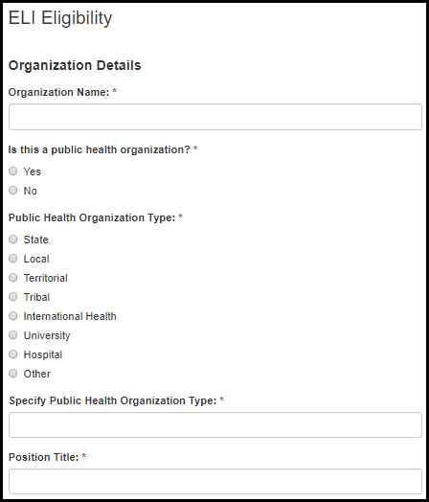

Table 6.11.1-a. Organization Details Fields
Field | Values | EIS | LLS | FLIGHT | EEP | SAF | PMR/F | PH-TIPP | PHIFP | PE | ELI | PHAP
Organization Name: | - | No | No | No | No | No | No | No | No | No | Yes | No
Is this a public health organization? | 1. Yes  2. No | No | No | No | No | No | No | No | No | No | Yes | No
Public Health Organization Type: | 1. State  2. Local  3. Territorial  4. Tribal  5. International Health  6. University  7. Hospital  8. Other | No | No | No | No | No | No | No | No | No | Yes | No
Specify Public Health Organization Type: | - | No | No | No | No | No | No | No | No | No | Yes | No
Position Title: | - | No | No | No | No | No | No | No | No | No | Yes | No

Educational Experience

Figure 6.11.2-a. Educational Experience Fields
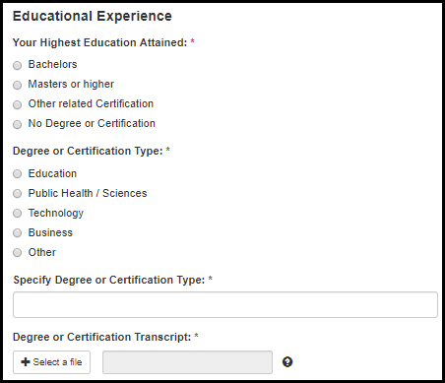

Table 6.11.2-a. Educational Experience Fields
Field | Values | EIS | LLS | FLIGHT | EEP | SAF | PMR/F | PH-TIPP | PHIFP | PE | ELI | PHAP
Your Highest Degree Attained: | 1. Bachelors  2. Masters or higher  3. Other related Certification  4. No Degree or Certification | No | No | No | No | No | No | No | No | No | Yes | No
Degree or Certification Type: | 1. Education  2. Public Health / Sciences  3. Technology  4. Business  5. Other | No | No | No | No | No | No | No | No | No | Yes | No
Specify Degree or Certification Type: | - | No | No | No | No | No | No | No | No | No | Yes | No
Degree or Certification Transcript: | - | No | No | No | No | No | No | No | No | No | Yes | No

Work Experience

Figure 6.11.3-a. Work Experience Fields
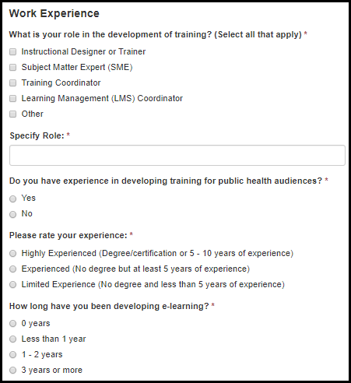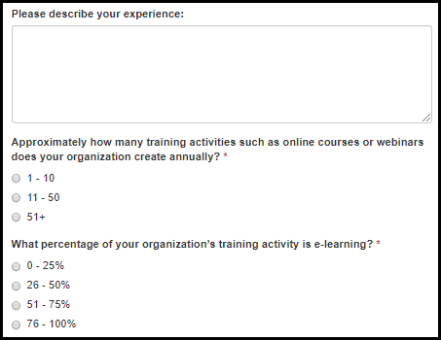

Table 6.11.3-a. Work Experience Fields
Field | Values | EIS | LLS | FLIGHT | EEP | SAF | PMR/F | PH-TIPP | PHIFP | PE | ELI | PHAP
What is your role in the development of training? (Select all that apply) | 1. Instructional Designer or Trainer  2. Subject Matter Expert (SME)  3. Training Coordinator  4. Learning Management (LMS) Coordinator  5. Other | No | No | No | No | No | No | No | No | No | Yes | No
Specify Role: | - | No | No | No | No | No | No | No | No | No | Yes | No
Do you have experience in developing training for public health audiences? | 1. Yes  2. No | No | No | No | No | No | No | No | No | No | Yes | No
Please rate your experience: | 1. Highly Experienced (Degree/certification or 5 - 10 years of experience)  2. Experienced (No degree but at least 5 years of experience)  3. Limited Experience (No degree and less than 5 years of experience) | No | No | No | No | No | No | No | No | No | Yes | No
How long have you been developing e-learning? | 1. 0 years  2. Less than 1 year  3. 1 - 2 years  4. 3 years or more | No | No | No | No | No | No | No | No | No | Yes | No
Please describe your experience: | - | No | No | No | No | No | No | No | No | No | Yes | No
Approximately how many training activities such as online courses or webinars does your organization create annually? | 1. 1 - 10  2. 11 - 50  3. 51+ | No | No | No | No | No | No | No | No | No | Yes | No
What percentage of your organization’s training activity is e-learning? | 1. 0 - 25%  2. 26 - 50%  3. 51 - 75%  4. 76 - 100% | No | No | No | No | No | No | No | No | No | Yes | No

e-Learning Content Example

Figure 6.11.4-a. e-Learning Content Example Fields
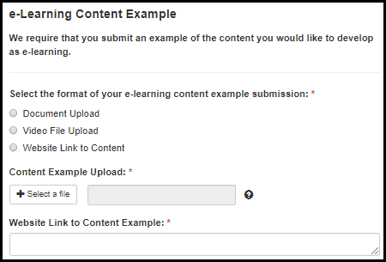

Table 6.11.4-a. e-Learning Content Example Fields
Field | Values | EIS | LLS | FLIGHT | EEP | SAF | PMR/F | PH-TIPP | PHIFP | PE | ELI | PHAP
Select the format of your e-learning content example submission: | - | No | No | No | No | No | No | No | No | No | Yes | No
Content Example Upload: | - | No | No | No | No | No | No | No | No | No | Yes | No
Website Link to Content Example: | - | No | No | No | No | No | No | No | No | No | Yes | No

6.12 EIS

6.12.1 EIS Federal Student Loan Repayment Interest

Figure 13.6-a. EIS Federal Student Loan Repayment Interest Fields
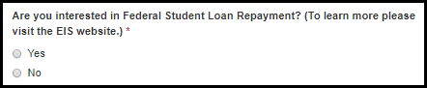

Table 13.6-a. EIS Federal Student Loan Repayment Interest Fields
Field | Values | EIS | LLS | FLIGHT | EEP | SAF | PMR/F | PH-TIPP | PHIFP | PE | ELI | PHAP
Are you interested in Federal Student Loan Repayment? (To learn more please visit the EIS website.) | 1. Yes  2. No | Yes | No | No | No | No | No | No | No | No | No | No

Confirming Accuracy & Minimum Eligibility

Figure 6.12-a. Confirming Accuracy & Minimum Eligibility Fields
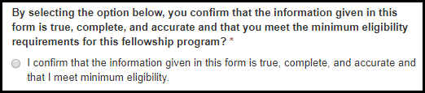
Table 6.12-a. Confirming Accuracy & Minimum Eligibility Fields
Field | Values | EIS | LLS | FLIGHT | EEP | SAF | PMR/F | PH-TIPP | PHIFP | PE | ELI | PHAP
By selecting the option below, you confirm that the information given in this form is true, complete, and accurate and that you meet the minimum eligibility requirements for this fellowship program? | 1. I confirm that the information given in this form is true, complete, and accurate and that I meet the minimum eligibility. | Yes | Yes | Yes | Yes | Yes | Yes | Yes | Yes | Yes | Yes | Yes

Figure 6.12-b. Not Eligible Fields
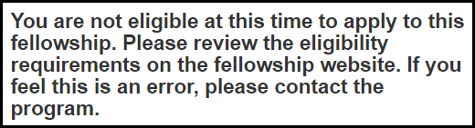

Education & Licenses

Adding Education or Licenses

Figure 7.1-a. Adding Education or Licenses
Figure 7.1-b. Adding Education or Licenses
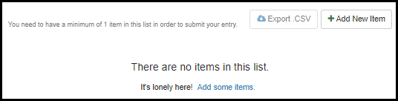

Choose Category

Figure 7.2-a. Choose Category Fields
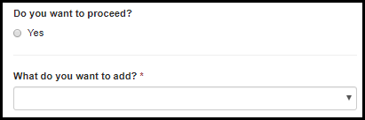
Table 7.2-a. Choose Category Fields
Field | Values | EIS | LLS | FLIGHT | EEP | SAF | PMR/F | PH-TIPP | PHIFP | PE | ELI | PHAP
Do you want to proceed? | 1. Yes | Yes | Yes | Yes | Yes | Yes | Yes | Yes | Yes | Yes | No | Yes
What do you want to add? | 1. Undergraduate Education  2. Graduate Education  3. Additional Coursework  4. Active U.S. License | Yes | Yes | Yes | Yes | Yes | Yes | Yes | Yes | Yes | No | Yes

Coursework Type

Figure 7.3-a. Coursework Type Fields
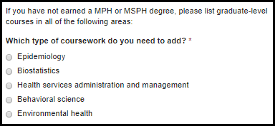
Table 7.3-a. Coursework Type Fields
Field | Values | EIS | LLS | FLIGHT | EEP | SAF | PMR/F | PH-TIPP | PHIFP | PE | ELI | PHAP
Which type of coursework do you need to add? | - | No | No | No | No | No | Yes | Yes | No | No | No | No

Location

Figure 7.4-a. Location Fields
Table 7.4-a. Location Fields
Field | Values | EIS | LLS | FLIGHT | EEP | SAF | PMR/F | PH-TIPP | PHIFP | PE | ELI | PHAP
Country: | - | Yes | Yes | Yes | Yes | Yes | Yes | Yes | Yes | Yes | No | Yes
State/Province: | - | Yes | Yes | Yes | Yes | Yes | Yes | Yes | Yes | Yes | No | Yes

College/University

Figure 7.5-a. College/University Fields
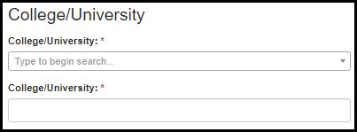
Table 7.5-a. College/University Fields
Field | Values | EIS | LLS | FLIGHT | EEP | SAF | PMR/F | PH-TIPP | PHIFP | PE | ELI | PHAP
College/University: | College Lookup | Yes | Yes | Yes | Yes | Yes | Yes | Yes | Yes | Yes | No | Yes
College/University: | - | Yes | Yes | Yes | Yes | Yes | Yes | Yes | Yes | Yes | No | Yes

Status
Figure 7.6-a. Status Fields
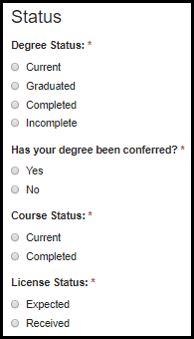
Table 7.6-a. Status Fields
Field | Values | EIS | LLS | FLIGHT | EEP | SAF | PMR/F | PH-TIPP | PHIFP | PE | ELI | PHAP
Degree Status: | 1. Current  2. Graduated  3. Completed  3. Incomplete | Yes | Yes | Yes | Yes | Yes | Yes | Yes | Yes | Yes | Yes | Yes
Has your degree been conferred? | 1. Yes  2. No | Yes | Yes | No | Yes | Yes | Yes | Yes | Yes | Yes | Yes | Yes
Course Status: | 1. Current  2. Completed | No | No | No | No | No | Yes | Yes | No | No | No | Yes
License Status: | 1. Expected  2. Received | Yes | Yes | Yes | No | No | Yes | Yes | No | No | No | Yes

Degree

Figure 7.7-a. Degree Fields Figure 7.7-b. Degree Fields
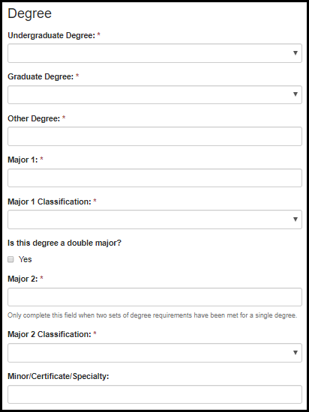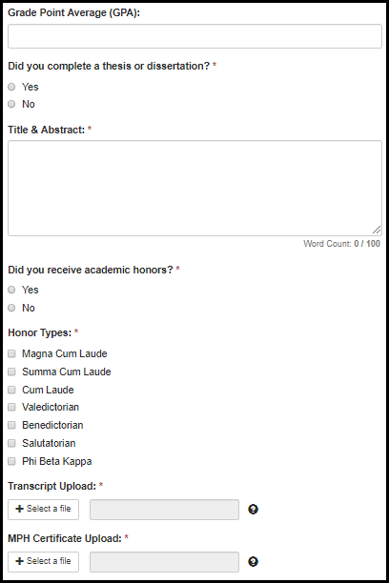

Table 7.7-a. Degree Fields
Field | Values | EIS | LLS | FLIGHT | EEP | SAF | PMR/F | PH-TIPP | PHIFP | PE | ELI | PHAP
Undergraduate Degree: | Undergraduate Degree List | Yes | Yes | Yes | Yes | Yes | No | No | No | No | Yes | Yes
Graduate Degree: | Graduate Degree List | Yes | Yes | Yes | Yes | Yes | Yes | Yes | Yes | Yes | Yes | Yes
Other Degree: | - | Yes | Yes | Yes | Yes | Yes | Yes | Yes | Yes | Yes | Yes | Yes
Major 1: | - | Yes | Yes | No | Yes | Yes | Yes | Yes | Yes | Yes | Yes | Yes
Major 1 Classification: | Major Classification List | Yes | Yes | No | Yes | Yes | Yes | Yes | Yes | No | Yes | Yes
Is this degree a double major? | - | Yes | Yes | No | Yes | Yes | Yes | Yes | Yes | No | No | Yes
Major 2: | - | Yes | Yes | No | Yes | Yes | Yes | Yes | Yes | Yes | No | Yes
Major 2 Classification: | Major Classification List | Yes | Yes | No | Yes | Yes | Yes | Yes | Yes | No | No | Yes
Minor/Certificate/Specialty: | - | Yes | Yes | No | Yes | Yes | Yes | Yes | Yes | Yes | No | Yes
Grade Point Average (GPA): | - | Yes | Yes | No | Yes | No | No | No | No | No | Yes | Yes
Did you complete a thesis or dissertation? | 1. Yes  2. No | Yes | Yes | No | Yes | No | Yes | Yes | Yes | Yes | No | Yes
Title & Abstract: | - | Yes | Yes | No | Yes | No | Yes | Yes | Yes | Yes | No | Yes
Did you receive academic honors? | 1. Yes  2. No | Yes | Yes | No | Yes | No | Yes | Yes | Yes | No | No | Yes
Honor Types: | Honor List | Yes | Yes | No | Yes | No | Yes | Yes | Yes | No | No | Yes
Transcript Upload: | - | Yes | Yes | No | No | No | No | No | No | Yes | No | Yes
MPH Certificate Upload: | - | No | No | No | No | No | Yes | Yes | No | No | No | No

Additional Coursework

Figure 7.8-a. Additional Coursework Fields
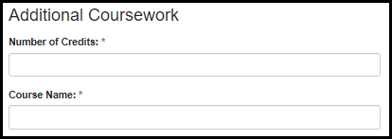
Table 7.8-a. Additional Coursework Fields
Field | Values | EIS | LLS | FLIGHT | EEP | SAF | PMR/F | PH-TIPP | PHIFP | PE | ELI | PHAP
Number of Credits: | - | No | No | No | No | No | Yes | Yes | No | No | No | Yes
Course Name: | - | No | No | No | No | No | Yes | Yes | No | No | No | Yes

License

Figure 7.9-a. License Fields
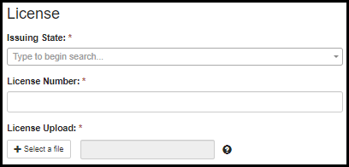
Table 7.9-a. License Fields
Field | Values | EIS | LLS | FLIGHT | EEP | SAF | PMR/F | PH-TIPP | PHIFP | PE | ELI | PHAP
Issuing State: | State Lookup Table | Yes | Yes | Yes | No | Yes | Yes | Yes | No | No | No | No
License Number: | - | Yes | Yes | Yes | No | No | Yes | Yes | No | No | No | No
License Upload: | - | Yes | Yes | Yes | No | No | Yes | Yes | No | No | No | No

Dates

Figure 7.10-a. Date Fields
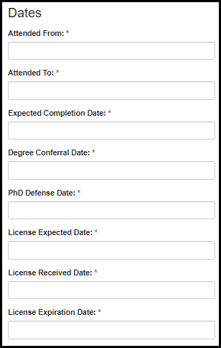

Table 7.10-a. Date Fields
Field | Values | EIS | LLS | FLIGHT | EEP | SAF | PMR/F | PH-TIPP | PHIFP | PE | ELI | PHAP
Attended From: | - | Yes | Yes | Yes | Yes | Yes | Yes | Yes | Yes | Yes | No | Yes
Attended To: | - | Yes | Yes | Yes | Yes | Yes | Yes | Yes | Yes | Yes | No | Yes
Expected Completion Date: | - | Yes | Yes | No | Yes | Yes | Yes | Yes | Yes | Yes | No | Yes
Degree Conferral Date: | - | Yes | Yes | No | Yes | Yes | Yes | Yes | Yes | Yes | No | Yes
PhD Defense Date: | - | Yes | Yes | No | No | No | Yes | Yes | Yes | Yes | No | Yes
License Expected Date: | - | Yes | Yes | Yes | No | No | Yes | Yes | No | No | No | No
License Received Date: | - | Yes | Yes | Yes | No | No | Yes | Yes | No | No | No | No
License Expiration Date: | - | Yes | Yes | Yes | No | No | Yes | Yes | No | No | No | No

Incomplete Reason

Figure 7.11-a. Incomplete Reason Field
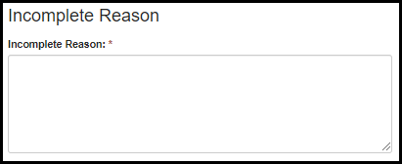
Table 7.11-a. Incomplete Reason Field
Field | Values | EIS | LLS | FLIGHT | EEP | SAF | PMR/F | PH-TIPP | PHIFP | PE | ELI | PHAP
Incomplete Reason: | - | Yes | Yes | Yes | Yes | Yes | Yes | Yes | Yes | Yes | No | Yes

Work & Volunteer Experience

Adding Work or Volunteer Experience

Figure 8.1-a. Adding Work or Volunteer Experience
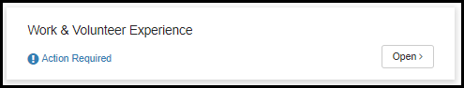

Figure 8.1-b. Adding Work or Volunteer Experience

Choose Category

Figure 8.2-a. Choose Category Fields

Table 8.2-a. Choose Category Fields
Field | Values | EIS | LLS | FLIGHT | EEP | SAF | PMR/F | PH-TIPP | PHIFP | PE | ELI | PHAP
Do you want to proceed? | 1. Yes | Yes | Yes | No | Yes | Yes | Yes | Yes | Yes | Yes | No | No
What do you want to add? | 1. Work Experience  2. Volunteer Experience | Yes | Yes | No | Yes | Yes | Yes | Yes | Yes | Yes | No | No

Organization Details

Figure 8.3-a. Organization Details Fields
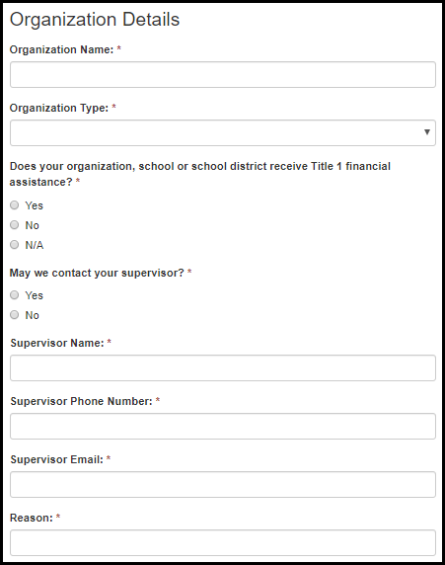
Table 8.3-a. Organization Details Fields
Field | Values | EIS | LLS | FLIGHT | EEP | SAF | PMR/F | PH-TIPP | PHIFP | PE | ELI | PHAP
Organization Name | - | Yes | Yes | No | Yes | Yes | Yes | Yes | Yes | Yes | No | No
Organization Type | 1. Additional education or training (including degree or residency programs, fellowships and post-doctoral research positions)  2. Government – CDC (including contractor work)  3. Government – non-CDC federal government (including contractor work)  4. Government – state, tribal, local, or territorial health agency (including contractor work)  5. Non-governmental, community, or other organization (NGO)  6. Academia (as faculty or staff)  7. Industry (private, non-clinical business)  8. Clinical work | Yes | Yes | No | Yes | No | Yes | Yes | Yes | Yes | No | No
Does your organization, school or school district receive Title 1 financial assistance? | 1. Yes  2. No  3. N/A | No | No | No | No | Yes | No | No | No | No | No | No
May we contact your supervisor? | 1. Yes  2. No | Yes | Yes | No | Yes | No | Yes | Yes | Yes | Yes | No | No
Supervisor Name | - | Yes | Yes | No | Yes | No | Yes | Yes | Yes | Yes | No | No
Supervisor Phone Number | - | Yes | Yes | No | Yes | No | Yes | Yes | Yes | Yes | No | No
Supervisor Email | - | Yes | Yes | No | Yes | No | Yes | Yes | Yes | Yes | No | No
Reason | - | Yes | Yes | No | Yes | No | Yes | Yes | Yes | Yes | No | No

Position Details

Figure 8.4-a. Position Details Fields
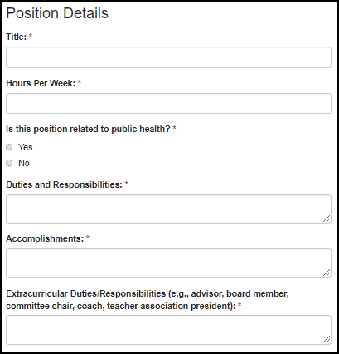

Table 8.4-a. Position Details Fields
Field | Values | EIS | LLS | FLIGHT | EEP | SAF | PMR/F | PH-TIPP | PHIFP | PE | ELI | PHAP
Title | - | Yes | Yes | No | Yes | Yes | Yes | Yes | Yes | Yes | No | No
Hours Per Week | - | Yes | Yes | No | Yes | No | Yes | Yes | Yes | Yes | No | No
Is this position related to public health? | 1. Yes  2. No | Yes | Yes | No | Yes | No | Yes | Yes | Yes | Yes | No | No
Duties and Responsibilities | - | Yes | Yes | No | Yes | Yes | Yes | Yes | Yes | Yes | No | No
Accomplishments | - | No | No | No | No | No | Yes | Yes | Yes | No | No | No
Extracurricular Duties/Responsibilities (e.g., advisor, board member, committee chair, coach, teacher association president) | - | No | No | No | No | Yes | No | No | No | No | No | No

Dates

Figure 8.5-a. Date Fields
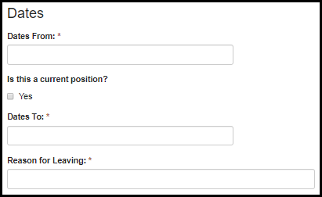
Table 8.5-a. Date Fields
Field | Values | EIS | LLS | FLIGHT | EEP | SAF | PMR/F | PH-TIPP | PHIFP | PE | ELI | PHAP
Dates From | - | Yes | Yes | No | Yes | Yes | Yes | Yes | Yes | Yes | No | No
Is this a current position? | - | Yes | Yes | No | Yes | Yes | Yes | Yes | Yes | Yes | No | No
Dates To | - | Yes | Yes | No | Yes | Yes | Yes | Yes | Yes | Yes | No | No
Reason for Leaving | - | Yes | Yes | No | Yes | Yes | Yes | Yes | Yes | Yes | No | No

Position Location

Figure 8.6-a. Position Location Fields
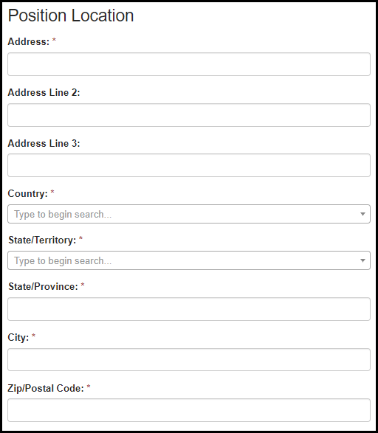

Table 8.6-a. Position Location Fields
Field | Values | EIS | LLS | FLIGHT | EEP | SAF | PMR/F | PH-TIPP | PHIFP | PE | ELI | PHAP
Address | - | Yes | Yes | No | Yes | Yes | Yes | Yes | Yes | Yes | No | No
Address Line 2 | - | Yes | Yes | No | Yes | Yes | Yes | Yes | Yes | Yes | No | No
Address Line 3 | - | Yes | Yes | No | Yes | Yes | Yes | Yes | Yes | Yes | No | No
Country | Country Lookup Table | Yes | Yes | No | Yes | Yes | Yes | Yes | Yes | Yes | No | No
State/Territory: | State Lookup Table | Yes | Yes | No | Yes | Yes | Yes | Yes | Yes | Yes | No | No
State/Province | - | Yes | Yes | No | Yes | Yes | Yes | Yes | Yes | Yes | No | No
City | - | Yes | Yes | No | Yes | Yes | Yes | Yes | Yes | Yes | No | No
Zip/Postal Code | - | Yes | Yes | No | Yes | Yes | Yes | Yes | Yes | Yes | No | No

Additional Training & Skills

Adding Additional Training & Skills

Figure 9.1-a. Adding Additional Training & Skills

Figure 9.1-b. Adding Additional Training & Skills
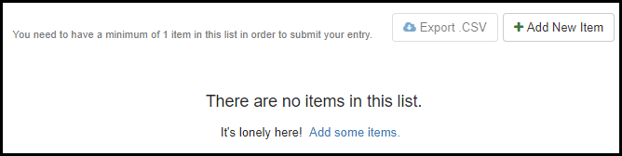

Choose Category

Figure 9.2-a. Choose Category Fields

Table 9.2-a. Choose Category Fields
Field | Values | EIS | LLS | FLIGHT | EEP | SAF | PMR/F | PH-TIPP | PHIFP | PE | ELI | PHAP
Do you want to proceed? | 1. Yes | Yes | Yes | Yes | Yes | Yes | Yes | Yes | Yes | Yes | Yes | No
What do you need to add? | 1. Clinical Training  2. U.S. Board Certification  3. Additional Training, Certification or Professional Development  4. Language Skill  5. None of the Above | Yes | Yes | Yes | Yes | Yes | Yes | Yes | Yes | Yes | Yes | No

Clinical Training

Figure 9.3-a. Clinical Training Fields
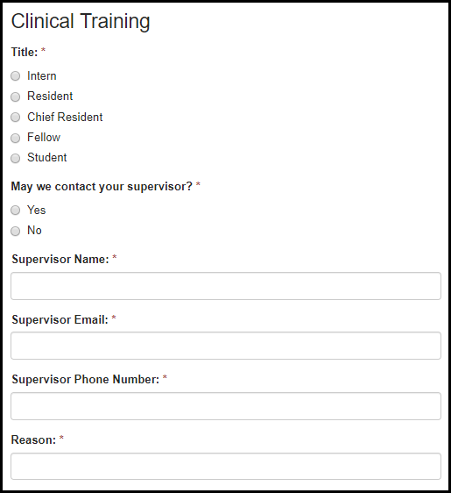
Table 9.3-a. Clinical Training Fields
Field | Values | EIS | LLS | FLIGHT | EEP | SAF | PMR/F | PH-TIPP | PHIFP | PE | ELI | PHAP
Title: | - | Yes | Yes | No | No | No | Yes | Yes | Yes | No | No | No
May we contact your supervisor? | 1. Yes  2. No | Yes | Yes | No | No | No | Yes | Yes | Yes | No | No | No
Supervisor Name: | - | Yes | Yes | No | No | No | Yes | Yes | Yes | No | No | No
Supervisor Email: | - | Yes | Yes | No | No | No | Yes | Yes | Yes | No | No | No
Supervisor Phone Number: | - | Yes | Yes | No | No | No | Yes | Yes | Yes | No | No | No
Reason: | - | Yes | Yes | No | No | No | Yes | Yes | Yes | No | No | No

U.S. Board Certifications and Specialty

Figure 9.4-a. Clinical Training Fields
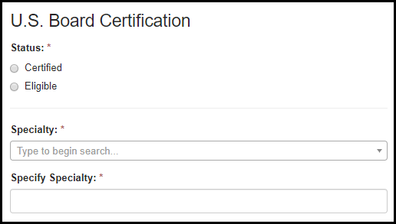
Table 9.4-a. Clinical Training Fields
Field | Values | EIS | LLS | FLIGHT | EEP | SAF | PMR/F | PH-TIPP | PHIFP | PE | ELI | PHAP
Status: | 1. Certified  2. Eligible | Yes | Yes | Yes | No | No | Yes | Yes | No | No | No | No
Specialty: | Specialty Lookup Table | Yes | Yes | Yes | No | No | Yes | Yes | Yes | No | No | No
Specify Specialty: | - | Yes | Yes | Yes | No | No | Yes | Yes | Yes | No | No | No

Additional Training, Certifications, or Professional Development

Figure 9.5-a. Additional Training, Certifications, or Professional Development Fields
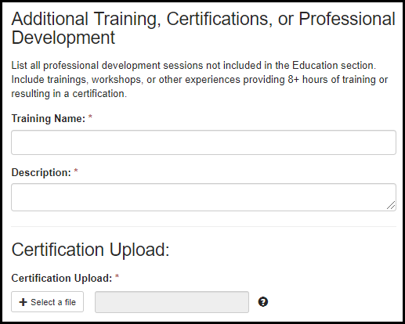
Table 9.5-a. Additional Training, Certifications, or Professional Development Fields
Field | Values | EIS | LLS | FLIGHT | EEP | SAF | PMR/F | PH-TIPP | PHIFP | PE | ELI | PHAP
Training Name: | - | Yes | Yes | No | Yes | Yes | Yes | Yes | Yes | Yes | No | No
Description: | - | Yes | Yes | No | Yes | Yes | Yes | Yes | Yes | Yes | No | No
Certification Upload: | - | Yes | Yes | No | No | No | Yes | Yes | Yes | Yes | No | No

Institution Details and Location

Figure 9.6-a. Institution Details and Location Fields
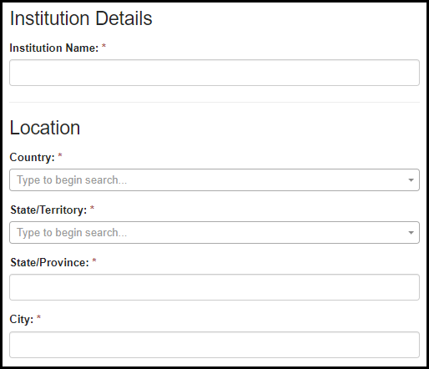
Table 9.6-a. Institution Details and Location Fields
Field | Values | EIS | LLS | FLIGHT | EEP | SAF | PMR/F | PH-TIPP | PHIFP | PE | ELI | PHAP
Institution Name: | - | Yes | Yes | No | Yes | Yes | Yes | Yes | Yes | Yes | No | No
Country: | Country Lookup Table | Yes | Yes | No | Yes | Yes | Yes | Yes | Yes | Yes | No | No
State/Territory: | State/Territory Lookup Table | Yes | Yes | No | Yes | Yes | Yes | Yes | Yes | Yes | No | No
State/Province: | - | Yes | Yes | No | Yes | Yes | Yes | Yes | Yes | Yes | No | No
City: | - | Yes | Yes | No | Yes | Yes | Yes | Yes | Yes | Yes | No | No

Dates

Figure 9.7-a. Date Fields
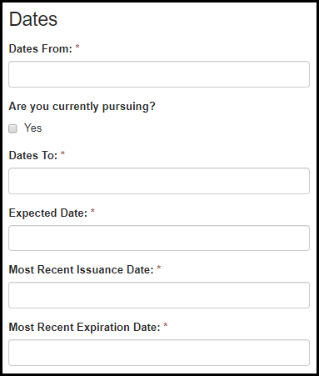

Table 9.7-a. Date Fields
Field | Values | EIS | LLS | FLIGHT | EEP | SAF | PMR/F | PH-TIPP | PHIFP | PE | ELI | PHAP
Dates From: | - | Yes | Yes | No | Yes | Yes | Yes | Yes | Yes | Yes | No | No
Are you currently pursuing? | - | Yes | Yes | No | Yes | Yes | Yes | Yes | Yes | Yes | No | No
Dates To: | - | Yes | Yes | No | Yes | Yes | Yes | Yes | Yes | Yes | No | No
Expected Date: | - | Yes | Yes | Yes | No | No | Yes | Yes | No | No | No | No
Most Recent Issuance Date: | - | Yes | Yes | Yes | No | No | Yes | Yes | No | No | No | No
Most Recent Expiration Date: | - | Yes | Yes | Yes | No | No | Yes | Yes | No | No | No | No

Language Skills

Figure 9.8-a. Language Skill Fields
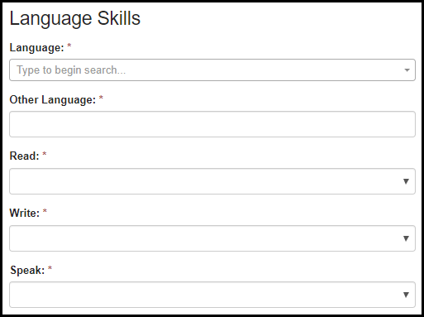

Table 9.8-a. Language Skill Fields
Field | Values | EIS | LLS | FLIGHT | EEP | SAF | PMR/F | PH-TIPP | PHIFP | PE | ELI | PHAP
Language: | Languages Lookup Table | Yes | Yes | No | Yes | No | Yes | Yes | Yes | Yes | No | Yes
Other Language: | - | Yes | Yes | No | Yes | No | Yes | Yes | Yes | Yes | No | Yes
Read: | 1. Poor  2. Fair  3. Good  4. Excellent | Yes | Yes | No | Yes | No | Yes | Yes | Yes | Yes | No | Yes
Write: | 1. Poor  2. Fair  3. Good  4. Excellent | Yes | Yes | No | Yes | No | Yes | Yes | Yes | Yes | No | Yes
Speak: | 1. Poor  2. Fair  3. Good  4. Excellent | Yes | Yes | No | Yes | No | Yes | Yes | Yes | Yes | No | Yes

Publications, Presentations, Working Papers, Monographs or Reports, Grants, Honors and Awards

Adding Publications, Presentations, Working Papers, Monographs or Reports, Grants, Honors and Awards

Figure 10.1-a. Adding Publications, Presentations, Working Papers, Monographs or Reports, Grants, Honors and Awards
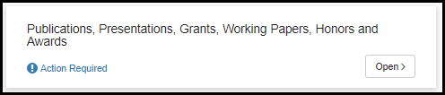
Figure 10.1-b. Adding Publications, Presentations, Working Papers, Monographs or Reports, Grants, Honors and Awards

Choose Category

Figure 10.2-a. Choose Category Fields
Table 10.2-a. Choose Category Fields
Field | Values | EIS | LLS | FLIGHT | EEP | SAF | PMR/F | PH-TIPP | PHIFP | PE | ELI | PHAP
Do you want to proceed? | 1. Yes | Yes | Yes | No | Yes | Yes | Yes | Yes | Yes | Yes | No | No
What do you want to add? | 1. Publications  2. Presentations  3. Grants  4. Honor or Awards  5. Monographs or Reports  6. Research Grants  7. Working Papers (Job Market Papers) | Yes | Yes | No | Yes | Yes | Yes | Yes | Yes | Yes | No | No

Details

Figure 10.3-a. Detail Fields Figure 10.3-b. Detail Fields
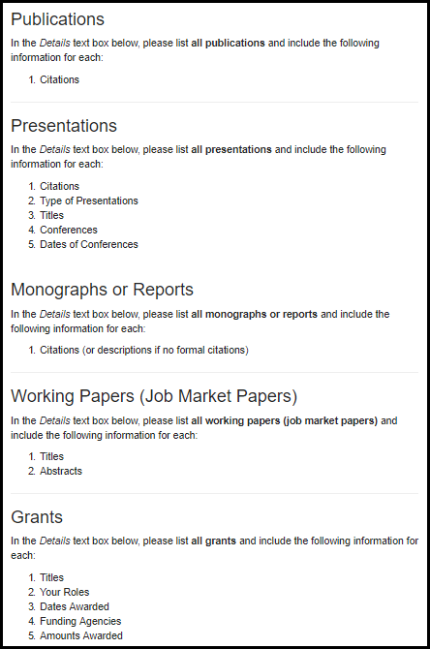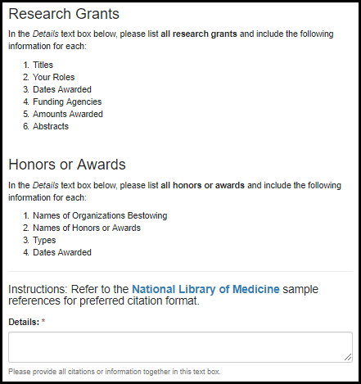

Table 10.3-a. Detail Fields
Field | Values | EIS | LLS | FLIGHT | EEP | SAF | PMR/F | PH-TIPP | PHIFP | PE | ELI | PHAP
Details: | - | Yes | Yes | No | Yes | Yes | Yes | Yes | Yes | Yes | No | No

Personal Statement

All Fellowships except FLIGHT
Figure 11.1-a. Personal Statement Fields
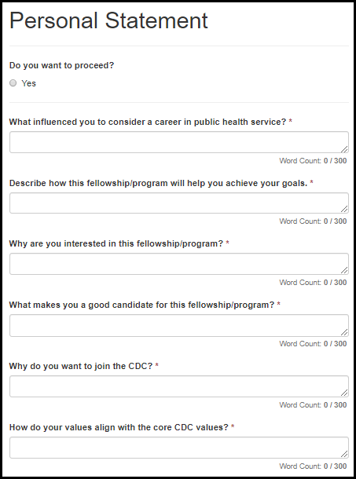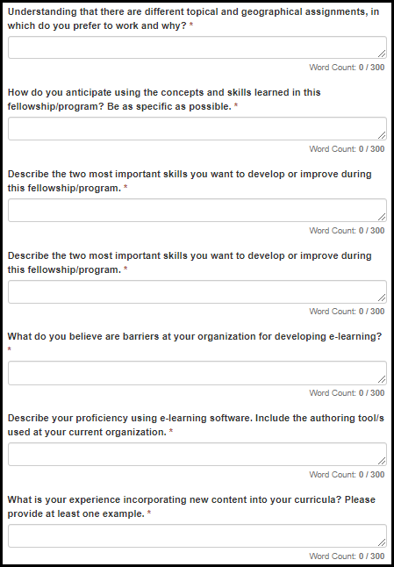

Figure 11.1-b. Personal Statement Fields
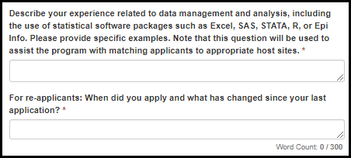

Figure 11.1-a. Personal Statement Fields
Field | Values | EIS | LLS | FLIGHT | EEP | SAF | PMR/F | PH-TIPP | PHIFP | PE | ELI | PHAP
What influenced you to consider a career in public health service? | - | Yes | Yes | No | Yes | No | Yes | No | No | No | No | Yes
Describe how this fellowship/program will help you achieve your goals. | - | Yes | Yes | No | Yes | Yes | Yes | Yes | No | Yes | No | Yes
Why are you interested in this fellowship/program? | - | No | No | No | No | No | No | No | No | Yes | Yes | Yes
What makes you a good candidate for this fellowship/program? | - | No | No | No | No | No | No | No | No | Yes | Yes | Yes
Why do you want to join the CDC? | - | No | No | No | No | No | No | No | No | Yes | No | No
How do your values align with the core CDC values? | - | No | No | No | No | No | No | No | No | No | No | Yes
Understanding that there are different topical and geographical assignments, in which do you prefer to work and why? | - | Yes | No | No | Yes | No | No | Yes | No | No | No | Yes
How do you anticipate using the concepts and skills learned in this fellowship/program? Be as specific as possible. | - | No | No | No | No | Yes | No | No | No | Yes | Yes | No
Describe the two most important skills you want to develop or improve during this fellowship/program. | - | No | Yes | No | No | No | No | No | No | No | Yes | No
What do you believe are facilitators at your organization for developing e-learning? | - | No | No | No | No | No | No | No | No | No | Yes | No
What do you believe are barriers at your organization for developing e-learning? | - | No | No | No | No | No | No | No | No | No | Yes | No
Describe your proficiency using e-learning software. Include the authoring tool/s used at your current organization. | - | No | No | No | No | No | No | No | No | No | Yes | No
What is your experience incorporating new content into your curricula? Please provide at least one example. | - | No | No | No | No | Yes | No | No | No | No | No | No
Describe your experience related to data management and analysis, including the use of statistical software packages such as Excel, SAS, STATA, R, or Epi Info. Please provide specific examples. Note that this question will be used to assist the program with matching applicants to appropriate host sites. | - | No | No | No | Yes | No | No | No | No | Yes | No | No
For re-applicants: When did you apply and what has changed since your last application? | - | Yes | Yes | No | Yes | Yes | No | Yes | No | No | No | Yes

FLIGHT

Figure 11.2-a. FLIGHT Personal Statement Fields
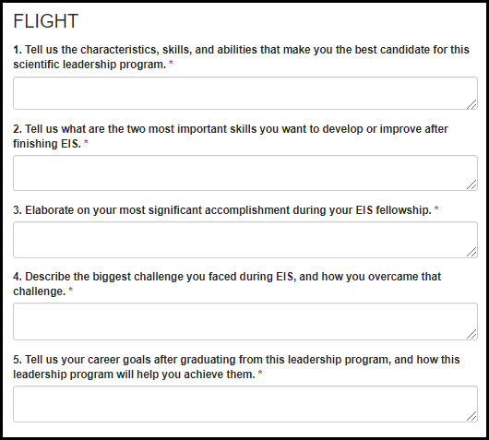

Table 11.2-a. FLIGHT Personal Statement Fields
Field | Values | EIS | LLS | FLIGHT | EEP | SAF | PMR/F | PH-TIPP | PHIFP | PE | ELI | PHAP
1. Tell us the characteristics, skills, and abilities that make you the best candidate for this scientific leadership program. | - | No | No | Yes | No | No | No | No | No | No | No | No
2. Tell us what the two most important skills you want to develop or improve after finishing EIS. | - | No | No | Yes | No | No | No | No | No | No | No | No
3. Elaborate on your most significant accomplishment during your EIS fellowship. | - | No | No | Yes | No | No | No | No | No | No | No | No
4. Describe the biggest challenge you faced during EIS, and how you overcame that challenge. | - | No | No | Yes | No | No | No | No | No | No | No | No
5. Tell us your career goals after graduating from this leadership program, and how this leadership program will help you achieve them. | - | No | No | Yes | No | No | No | No | No | No | No | No

11.3 Location Preferences
Figure 11.3-a. Location Preference Fields
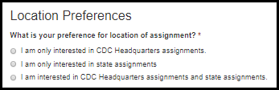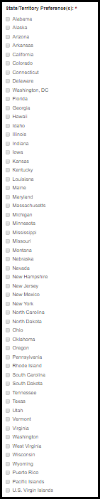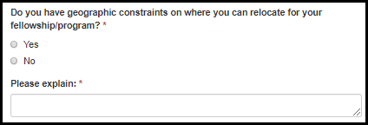

Table 11.3-a. Location Preference Fields
Field | Values | EIS | LLS | FLIGHT | EEP | SAF | PMR/F | PH-TIPP | PHIFP | PE | ELI | PHAP
What is your preference for location of assignment? | 1. I am only interested in CDC Headquarters assignments.  2. I am only interested in state assignments  3. I am interested in CDC Headquarters assignments and state assignments. | Yes | Yes | No | No | No | Yes | No | Yes | Yes | No | No
State/Territory Preference(s): | State/Territory List | Yes | Yes | No | No | No | Yes | No | Yes | Yes | No | No
Do you have geographic constraints on where you can relocate for your fellowship/program? | 1. Yes  2. No | Yes | Yes | No | Yes | No | Yes | Yes | Yes | Yes | No | Yes
Please explain: | - | Yes | Yes | No | Yes | No | Yes | Yes | Yes | Yes | No | Yes

11.4 CDC Fellowship Participation

Figure 11.3-a. CDC Fellowship Participation Fields
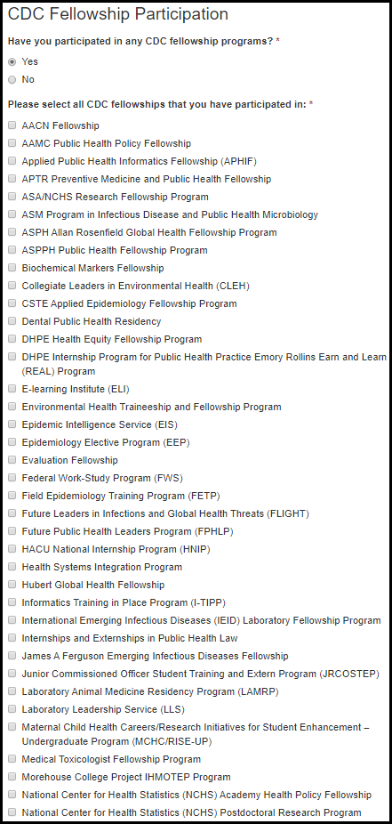

Table 11.3-a. CDC Fellowship Participation Fields
Field | Values | EIS | LLS | FLIGHT | EEP | SAF | PMR/F | PH-TIPP | PHIFP | PE | ELI | PHAP
Have you participated in any CDC fellowship programs? | 1. Yes  2. No | Yes | Yes | Yes | Yes | Yes | Yes | Yes | Yes | Yes | Yes | Yes
Please select all CDC fellowships that you have participated in: | CDC Fellowship List | Yes | Yes | Yes | Yes | Yes | Yes | Yes | Yes | Yes | Yes | Yes

Standardized Letters of Recommendation (SLOR)

SLOR Requests

Starting a SLOR Request

Figure 12.1.1-a. Starting a SLOR Request

Figure 12.1.1-a. Starting a SLOR Request
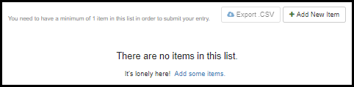

SLOR Request Fields

Figure 12.1.2-a. SLOR Request Fields Figure 12.1.2-b. SLOR Request Fields
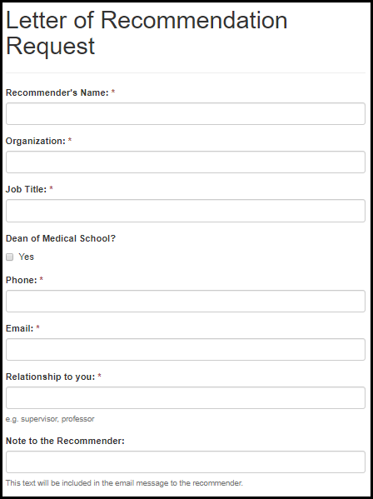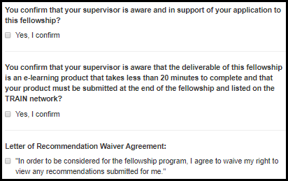

Table 12.1.2-a. LOR Request Fields
Field | Values | EIS | LLS | FLIGHT | EEP | SAF | PMR/F | PH-TIPP | PHIFP | PE | ELI | PHAP
Recommender's Name: | - | Yes | Yes | Yes | Yes | Yes | Yes | Yes | Yes | Yes | Yes | Yes
Organization: | - | Yes | Yes | No | Yes | Yes | Yes | Yes | Yes | Yes | Yes | Yes
Job Title: | - | Yes | Yes | Yes | Yes | Yes | Yes | Yes | Yes | Yes | Yes | Yes
Dean of Medical School? | 1. Yes | Yes | No | No | Yes | No | Yes | Yes | Yes | Yes | No | Yes
Phone: | - | Yes | Yes | Yes | Yes | Yes | Yes | Yes | Yes | Yes | Yes | Yes
Email: | - | Yes | Yes | Yes | Yes | Yes | Yes | Yes | Yes | Yes | Yes | Yes
Relationship to you: | - | Yes | Yes | Yes | Yes | Yes | Yes | Yes | Yes | Yes | Yes | Yes
Note to the recommender: | - | Yes | Yes | Yes | Yes | Yes | Yes | Yes | Yes | Yes | Yes | Yes
You confirm that your supervisor is aware and in support of your application to this fellowship? | 1. Yes, I confirm | No | No | No | No | No | No | No | No | No | Yes | No
You confirm that your supervisor is aware that the deliverable of this fellowship is an e-learning product that takes less than 20 minutes to complete and that your product must be submitted at the end of the fellowship and listed on the TRAIN network? | 1. Yes, I confirm | No | No | No | No | No | No | No | No | No | Yes | No
Letter of Recommendation Waiver Agreement: | 1. "In order to be considered for the fellowship program, I agree to waive my right to view any recommendations submitted for me." | Yes | Yes | Yes | Yes | Yes | Yes | Yes | Yes | Yes | Yes | Yes

System Emails to Letter Writers

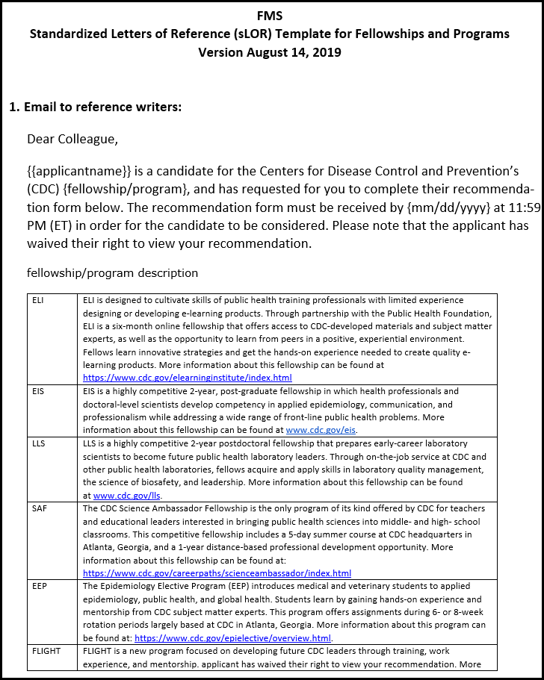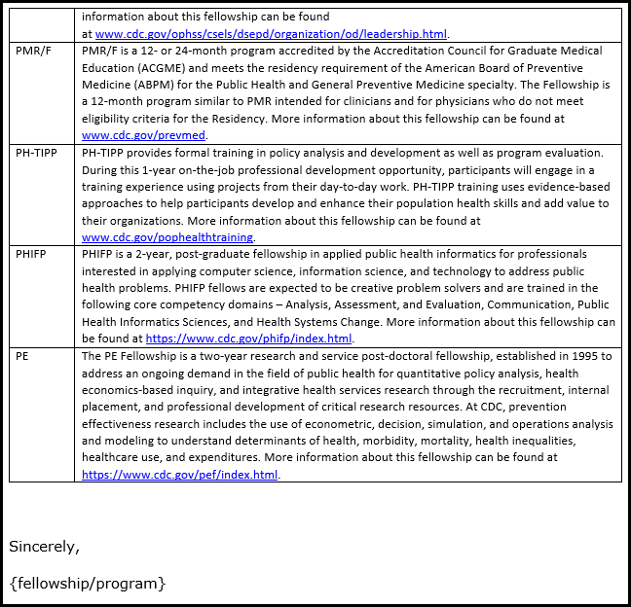

Letters of Recommendation

Section A

Figure 12.3.1-a. Section A Fields
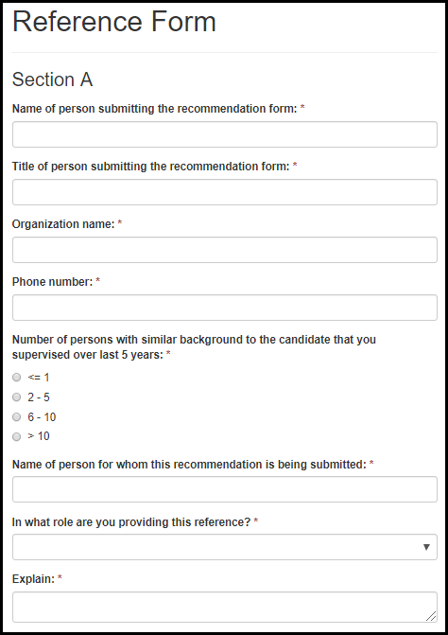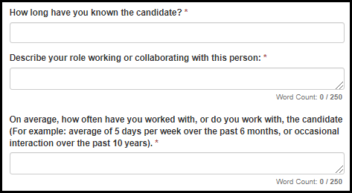

Figure 12.3.1-a. Section A Fields
Field | Values | EIS | LLS | FLIGHT | EEP | SAF | PMR/F | PH-TIPP | PHIFP | PE | ELI | PHAP
Name of person submitting the recommendation form: | - | Yes | Yes | Yes | Yes | Yes | Yes | Yes | Yes | Yes | Yes | Yes
Title of person submitting the recommendation form: | - | Yes | Yes | Yes | Yes | Yes | Yes | Yes | Yes | Yes | Yes | Yes
Organization name: | - | Yes | Yes | Yes | Yes | Yes | Yes | Yes | Yes | Yes | Yes | Yes
Phone number: | - | Yes | Yes | Yes | Yes | Yes | Yes | Yes | Yes | Yes | Yes | Yes
Number of persons with similar background to the candidate that you supervised over last 5 years: | 1. <= 1  2. 2 - 5  3. 6 - 10  4. > 10 | Yes | Yes | Yes | Yes | Yes | Yes | Yes | Yes | Yes | Yes | Yes
Name of person for whom this recommendation is being submitted: | - | Yes | Yes | Yes | Yes | Yes | Yes | Yes | Yes | Yes | Yes | Yes
In what role are you providing this reference? | 1. Supervisor  2. Advisor  3. Program director  4. Dean  5. Professor  6. Faculty member  7. Thesis committee member  8. Other (Explain) | Yes | Yes | Yes | Yes | Yes | Yes | Yes | Yes | Yes | Yes | Yes
Explain: | - | Yes | Yes | Yes | Yes | Yes | Yes | Yes | Yes | Yes | Yes | Yes
How long have you known the candidate? | - | Yes | Yes | Yes | Yes | Yes | Yes | Yes | Yes | Yes | Yes | Yes
Describe your role working or collaborating with this person: | - | Yes | Yes | Yes | Yes | Yes | Yes | Yes | Yes | Yes | Yes | Yes
On average, how often have you worked with, or do you work with, the candidate (For example: average of 5 days per week over the past 6 months, or occasional interaction over the past 10 years). | - | Yes | Yes | Yes | Yes | Yes | Yes | Yes | Yes | Yes | Yes | Yes

Section B

Figure 12.3.2-a. Section B Fields
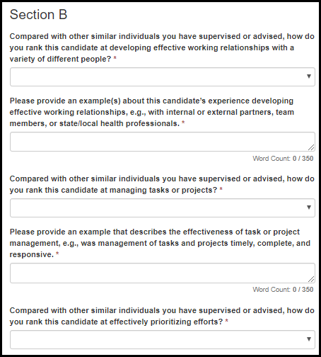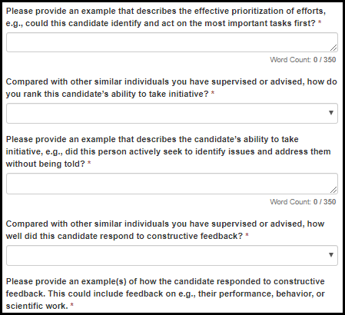

Table 12.3.2-a. Section B Fields
Field | Values | EIS | LLS | FLIGHT | EEP | SAF | PMR/F | PH-TIPP | PHIFP | PE | ELI | PHAP
Compared with other similar individuals you have supervised or advised, how do you rank this candidate at developing effective working relationships with a variety of different people? | 1. Average (75% or below)  2. Above Average (Top 25%)  3. Excellent (Top 10%)  4. Superior (Top 2%)  5. Not able to judge | Yes | Yes | No | Yes | Yes | Yes | Yes | No | No | Yes | No
Please provide an example(s) about this candidate’s experience developing effective working relationships, e.g., with internal or external partners, team members, or state/local health professionals. | - | Yes | Yes | No | No | No | Yes | Yes | No | No | Yes | No
Compared with other similar individuals you have supervised or advised, how do you rank this candidate at managing tasks or projects? | 1. Average (75% or below)  2. Above Average (Top 25%)  3. Excellent (Top 10%)  4. Superior (Top 2%)  5. Not able to judge | No | Yes | No | Yes | No | Yes | No | No | No | Yes | No
Please provide an example that describes the effectiveness of task or project management, e.g., was management of tasks and projects timely, complete, and responsive. | - | No | No | No | No | No | Yes | No | No | No | Yes | No

Table 12.3.2-b. Section B Fields
Field | Values | EIS | LLS | FLIGHT | EEP | SAF | PMR/F | PH-TIPP | PHIFP | PE | ELI | PHAP
Compared with other similar individuals you have supervised or advised, how do you rank this candidate at effectively prioritizing efforts? | 1. Average (75% or below)  2. Above Average (Top 25%)  3. Excellent (Top 10%)  4. Superior (Top 2%)  5. Not able to judge | Yes | Yes | No | No | No | Yes | Yes | No | No | Yes | No
Please provide an example that describes the effective prioritization of efforts, e.g., could this candidate identify and act on the most important tasks first? | - | Yes | No | No | No | No | Yes | Yes | No | No | Yes | No
Compared with other similar individuals you have supervised or advised, how do you rank this candidate’s ability to take initiative? | 1. Average (75% or below)  2. Above Average (Top 25%)  3. Excellent (Top 10%)  4. Superior (Top 2%)  5. Not able to judge | Yes | Yes | No | Yes | Yes | Yes | No | No | No | No | Yes
Please provide an example that describes the candidate’s ability to take initiative, e.g., did this person actively seek to identify issues and address them without being told? | - | Yes | Yes | No | No | No | Yes | No | No | No | No | Yes
Compared with other similar individuals you have supervised or advised, how well did this candidate respond to constructive feedback? | 1. Average (75% or below)  2. Above Average (Top 25%)  3. Excellent (Top 10%)  4. Superior (Top 2%)  5. Not able to judge | Yes | Yes | No | Yes | Yes | Yes | Yes | No | No | Yes | Yes
Please provide an example(s) of how the candidate responded to constructive feedback. This could include feedback on e.g., their performance, behavior, or scientific work. | - | Yes | Yes | No | No | No | Yes | Yes | No | No | Yes | Yes

Figure 12.3.2-b. Section B Fields
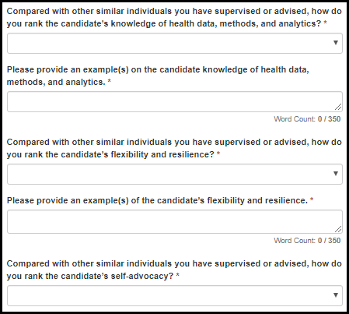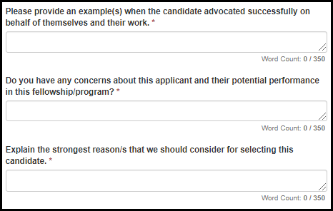

Table 12.3.2-c. Section B Fields
Field | Values | EIS | LLS | FLIGHT | EEP | SAF | PMR/F | PH-TIPP | PHIFP | PE | ELI | PHAP
Compared with other similar individuals you have supervised or advised, how do you rank the candidate’s knowledge of health data, methods, and analytics? | 1. Average (75% or below)  2. Above Average (Top 25%)  3. Excellent (Top 10%)  4. Superior (Top 2%)  5. Not able to judge | No | No | No | Yes | No | No | No | No | Yes | No | No
Please provide an example(s) of the candidate’s knowledge of health data, methods, and analytics. | - | No | No | No | No | No | No | No | No | Yes | No | No
Compared with other similar individuals you have supervised or advised, how do you rank the candidate’s flexibility and resilience? | 1. Average (75% or below)  2. Above Average (Top 25%)  3. Excellent (Top 10%)  4. Superior (Top 2%)  5. Not able to judge | No | No | No | Yes | No | No | No | No | Yes | No | Yes
Please provide an example(s) of the candidate’s flexibility and resilience. | - | No | No | No | No | No | No | No | No | Yes | No | Yes
Compared with other similar individuals you have supervised or advised, how do you rank the candidate’s self-advocacy? | 1. Average (75% or below)  2. Above Average (Top 25%)  3. Excellent (Top 10%)  4. Superior (Top 2%)  5. Not able to judge | No | No | No | Yes | No | No | No | No | Yes | No | Yes
Please provide an example(s) when the candidate advocated successfully on behalf of themselves and their work. | - | No | No | No | No | No | No | No | No | Yes | No | Yes
Do you have any concerns about this applicant and their potential performance in this fellowship/program? | - | Yes | Yes | No | No | No | Yes | Yes | No | No | No | No
Explain the strongest reason/s that we should consider for selecting this candidate. | - | No | No | No | No | No | No | No | No | Yes | No | No

Section C

Figure 12.3.3-a. Section C Fields
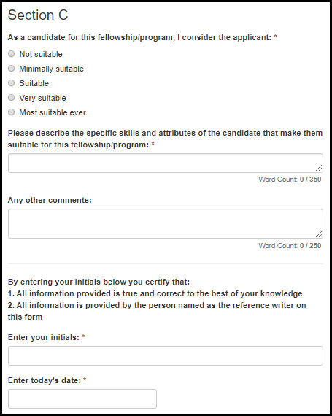

Table 12.3.3-a. Section C Fields
Field | Values | EIS | LLS | FLIGHT | EEP | SAF | PMR/F | PH-TIPP | PHIFP | PE | ELI | PHAP
As a candidate for this fellowship/program, I consider the applicant: | 1. Not suitable  2. Minimally suitable  3. Suitable  4. Very suitable  5. Most suitable ever | Yes | Yes | Yes | Yes | Yes | Yes | Yes | Yes | Yes | Yes | Yes
Please describe the specific skills and attributes of the candidate that make them suitable for this fellowship/program: | - | Yes | No | Yes | Yes | Yes | Yes | Yes | Yes | Yes | Yes | Yes
Any other comments: | - | Yes | Yes | Yes | Yes | Yes | Yes | Yes | Yes | Yes | Yes | Yes
Enter your initials: | - | Yes | Yes | Yes | Yes | Yes | Yes | Yes | Yes | Yes | Yes | Yes
Enter today's date: | - | Yes | Yes | Yes | Yes | Yes | Yes | Yes | Yes | Yes | Yes | Yes

Final Application Sections

13.1 Self-Assessment of Skills

13.1.1 PHIFP
Figure 13.1.1-a. PHIFP Self-Assessment of Skills Fields
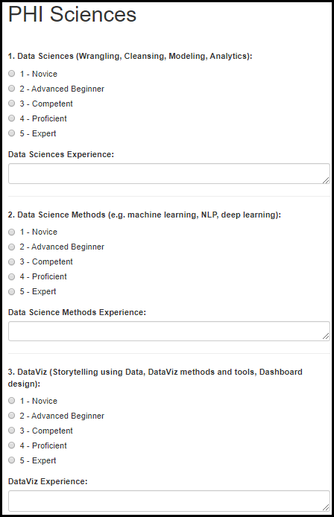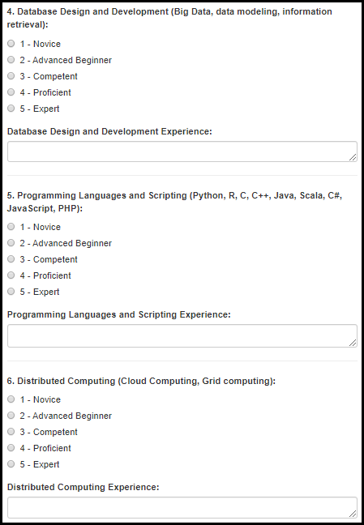
Table 13.1.1-a. PHIFP Self-Assessment of Skills Fields
Field | Values | EIS | LLS | FLIGHT | EEP | SAF | PMR/F | PH-TIPP | PHIFP | PE | ELI | PHAP
1. Data Sciences (Wrangling, Cleansing, Modeling, Analytics): | 1. Novice  2. Advanced Beginner  3. Competent  4. Proficient  5. Expert | No | No | No | No | No | No | No | Yes | No | No | No
Data Sciences Experience: | - | No | No | No | No | No | No | No | Yes | No | No | No
2. Data Science Methods (e.g. machine learning, NLP, deep learning): | 1. Novice  2. Advanced Beginner  3. Competent  4. Proficient  5. Expert | No | No | No | No | No | No | No | Yes | No | No | No
Data Science Methods Experience: | - | No | No | No | No | No | No | No | Yes | No | No | No
3. DataViz (Storytelling using Data, DataViz methods and tools, Dashboard design): | 1. Novice  2. Advanced Beginner  3. Competent  4. Proficient  5. Expert | No | No | No | No | No | No | No | Yes | No | No | No
DataViz Experience: | - | No | No | No | No | No | No | No | Yes | No | No | No
4. Database Design and Development (Big Data, data modeling, information retrieval): | 1. Novice  2. Advanced Beginner  3. Competent  4. Proficient  5. Expert | No | No | No | No | No | No | No | Yes | No | No | No
Database Design and Development Experience: | - | No | No | No | No | No | No | No | Yes | No | No | No
5. Programming Languages and Scripting (Python, R, C, C++, Java, Scala, C#, JavaScript, PHP): | 1. Novice  2. Advanced Beginner  3. Competent  4. Proficient  5. Expert | No | No | No | No | No | No | No | Yes | No | No | No
Programming Languages and Scripting Experience: | - | No | No | No | No | No | No | No | Yes | No | No | No
6. Distributed Computing (Cloud Computing, Grid computing): | 1. Novice  2. Advanced Beginner  3. Competent  4. Proficient  5. Expert | No | No | No | No | No | No | No | Yes | No | No | No
Distributed Computing Experience: | - | No | No | No | No | No | No | No | Yes | No | No | No

Figure 13.1.1-b. PHIFP Self-Assessment of Skills Fields
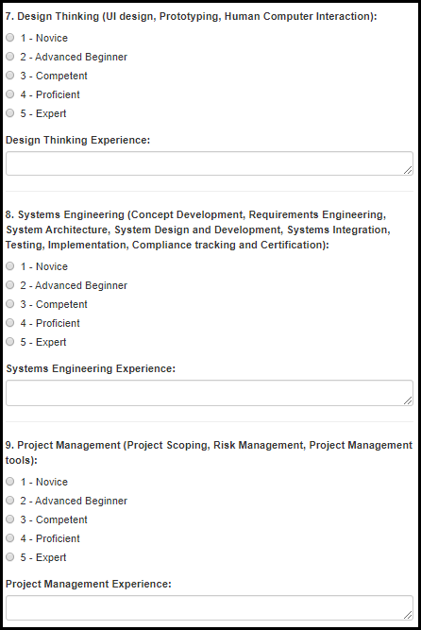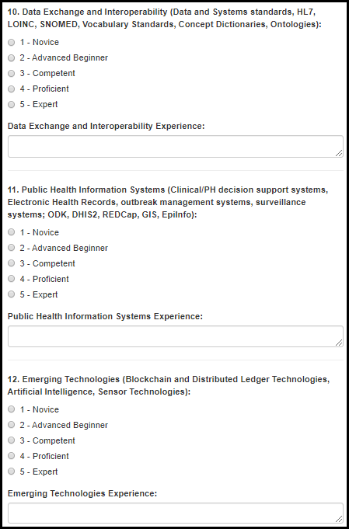
Table 13.1.1-d. PHIFP Self-Assessment of Skills Fields
Field | Values | EIS | LLS | FLIGHT | EEP | SAF | PMR/F | PH-TIPP | PHIFP | PE | ELI | PHAP
7. Design Thinking (UI design, Prototyping, Human Computer Interaction): | 1. Novice  2. Advanced Beginner  3. Competent  4. Proficient  5. Expert | No | No | No | No | No | No | No | Yes | No | No | No
Design Thinking Experience: | - | No | No | No | No | No | No | No | Yes | No | No | No
8. Systems Engineering (Concept Development, Requirements Engineering, System Architecture, System Design and Development, Systems Integration, Testing, Implementation, Compliance tracking and Certification): | 1. Novice  2. Advanced Beginner  3. Competent  4. Proficient  5. Expert | No | No | No | No | No | No | No | Yes | No | No | No
Systems Engineering Experience: | - | No | No | No | No | No | No | No | Yes | No | No | No
9. Project Management (Project Scoping, Risk Management, Project Management tools): | 1. Novice  2. Advanced Beginner  3. Competent  4. Proficient  5. Expert | No | No | No | No | No | No | No | Yes | No | No | No
Project Management Experience: | - | No | No | No | No | No | No | No | Yes | No | No | No
10. Data Exchange and Interoperability (Data and Systems standards, HL7, LOINC, SNOMED, Vocabulary Standards, Concept Dictionaries, Ontologies): | 1. Novice  2. Advanced Beginner  3. Competent  4. Proficient  5. Expert | No | No | No | No | No | No | No | Yes | No | No | No
Data Exchange and Interoperability Experience: | - | No | No | No | No | No | No | No | Yes | No | No | No
11. Public Health Information Systems (Clinical/PH decision support systems, Electronic Health Records, outbreak management systems, surveillance systems; ODK, DHIS2, REDCap, GIS, EpiInfo): | 1. Novice  2. Advanced Beginner  3. Competent  4. Proficient  5. Expert | No | No | No | No | No | No | No | Yes | No | No | No
Public Health Information Systems Experience: | - | No | No | No | No | No | No | No | Yes | No | No | No
12. Emerging Technologies (Blockchain and Distributed Ledger Technologies, Artificial Intelligence, Sensor Technologies): | 1. Novice  2. Advanced Beginner  3. Competent  4. Proficient  5. Expert | No | No | No | No | No | No | No | Yes | No | No | No
Emerging Technologies Experience: | - | No | No | No | No | No | No | No | Yes | No | No | No

13.1.2 PE

Figure 13.1.2-a. PE Self-Assessment of Skills Fields
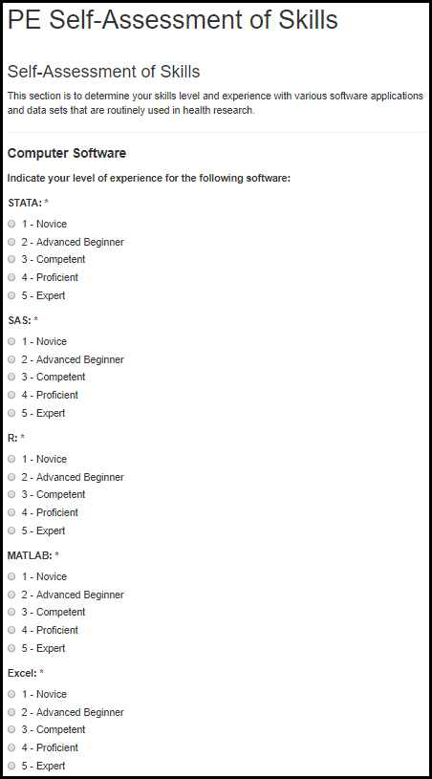

Table 13.1.2-a. PE Self-Assessment of Skills Fields
Field | Values | EIS | LLS | FLIGHT | EEP | SAF | PMR/F | PH-TIPP | PHIFP | PE | ELI | PHAP
STATA: | 1. Novice  2. Advanced Beginner  3. Competent  4. Proficient  5. Expert | No | No | No | No | No | No | No | No | Yes | No | No
SAS: | 1. Novice  2. Advanced Beginner  3. Competent  4. Proficient  5. Expert | No | No | No | No | No | No | No | No | Yes | No | No
R: | 1. Novice  2. Advanced Beginner  3. Competent  4. Proficient  5. Expert | No | No | No | No | No | No | No | No | Yes | No | No
MATLAB: | 1. Novice  2. Advanced Beginner  3. Competent  4. Proficient  5. Expert | No | No | No | No | No | No | No | No | Yes | No | No
Excel: | 1. Novice  2. Advanced Beginner  3. Competent  4. Proficient  5. Expert | No | No | No | No | No | No | No | No | Yes | No | No

Figure 13.1.2-b. PE Self-Assessment of Skills Fields
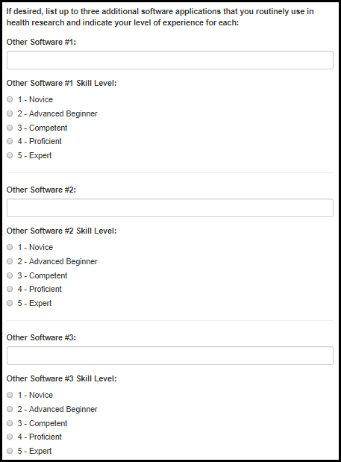

Table 13.1.2-b. PE Self-Assessment of Skills Fields
Field | Values | EIS | LLS | FLIGHT | EEP | SAF | PMR/F | PH-TIPP | PHIFP | PE | ELI | PHAP
Other Software #1: | - | No | No | No | No | No | No | No | No | Yes | No | No
Other Software #1 Skill Level: | 1. Novice  2. Advanced Beginner  3. Competent  4. Proficient  5. Expert | No | No | No | No | No | No | No | No | Yes | No | No
Other Software #2: | - | No | No | No | No | No | No | No | No | Yes | No | No
Other Software #2 Skill Level: | 1. Novice  2. Advanced Beginner  3. Competent  4. Proficient  5. Expert | No | No | No | No | No | No | No | No | Yes | No | No
Other Software #3: | - | No | No | No | No | No | No | No | No | Yes | No | No
Other Software #3 Skill Level: | 1. Novice  2. Advanced Beginner  3. Competent  4. Proficient  5. Expert | No | No | No | No | No | No | No | No | Yes | No | No

Figure 13.1.2-c. PE Self-Assessment of Skills Fields
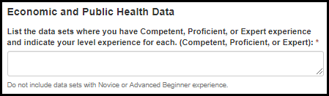

Figure 13.1.2-c. PE Self-Assessment of Skills Fields
Field | Values | EIS | LLS | FLIGHT | EEP | SAF | PMR/F | PH-TIPP | PHIFP | PE | ELI | PHAP
List the data sets where you have Competent, Proficient, or Expert experience and indicate your level experience for each. (Competent, Proficient, or Expert): | - | No | No | No | No | No | No | No | No | Yes | No | No

Applicant Survey

Figure 13.2-a. Applicant Survey Fields
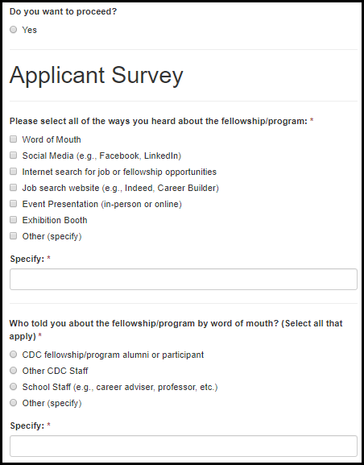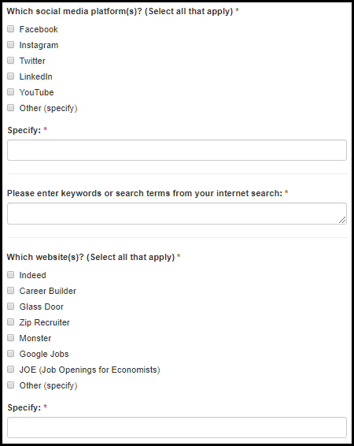

Figure 13.2-b. Applicant Survey Fields
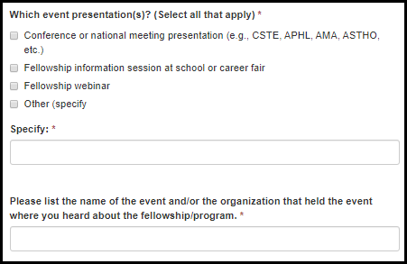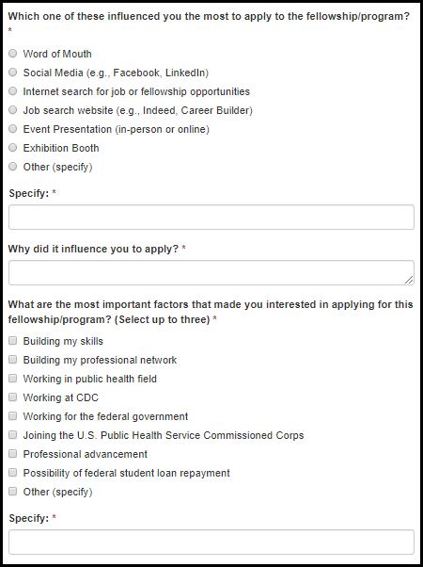

Table 13.2-a. Applicant Survey Fields
Field | Values | EIS | LLS | FLIGHT | EEP | SAF | PMR/F | PH-TIPP | PHIFP | PE | ELI | PHAP
Do you want to proceed? | 1. Yes | Yes | Yes | Yes | Yes | Yes | Yes | Yes | Yes | Yes | Yes | Yes
Please select all of the ways you heard about the fellowship/program: | 1. Word of Mouth  2. Social Media (e.g., Facebook, LinkedIn)  3. Internet search for job or fellowship opportunities  4. Job search website (e.g., Indeed, Career Builder)  5. Event Presentation (in-person or online)  6. Exhibition Booth  7. Other (specify) | Yes | Yes | Yes | Yes | Yes | Yes | Yes | Yes | Yes | Yes | Yes
Specify: | - | Yes | Yes | Yes | Yes | Yes | Yes | Yes | Yes | Yes | Yes | Yes
Who told you about the fellowship/program by word of mouth? (Select all that apply) | 1. CDC fellowship/program alumni or participant  2. Other CDC Staff  3. School Staff (e.g., career adviser, professor, etc.)  4. Other (specify) | Yes | Yes | Yes | Yes | Yes | Yes | Yes | Yes | Yes | Yes | Yes
Specify: | - | Yes | Yes | Yes | Yes | Yes | Yes | Yes | Yes | Yes | Yes | Yes
Which social media platform(s)? (Select all that apply) | 1. Facebook  2. Instagram  3. Twitter  4. LinkedIn  5. YouTube  6. Other (specify) | Yes | Yes | Yes | Yes | Yes | Yes | Yes | Yes | Yes | Yes | Yes
Please enter keywords or search terms from your internet search: | - | Yes | Yes | Yes | Yes | Yes | Yes | Yes | Yes | Yes | Yes | Yes

Table 13.2-b. Applicant Survey Fields
Field | Values | EIS | LLS | FLIGHT | EEP | SAF | PMR/F | PH-TIPP | PHIFP | PE | ELI | PHAP
Which website(s)? (Select all that apply) | 1. Indeed  2. Career Builder  3. Glass Door  4. Zip Recruiter  5. Monster  6. Google Jobs  7. JOE (Job Openings for Economists)  8. Other (specify) | Yes | Yes | Yes | Yes | Yes | Yes | Yes | Yes | Yes | Yes | Yes
Specify: | - | Yes | Yes | Yes | Yes | Yes | Yes | Yes | Yes | Yes | Yes | Yes
Which event presentation(s)? (Select all that apply) | 1. Conference or national meeting presentation (e.g., CSTE, APHL, AMA, ASTHO, etc.)  2. Fellowship information session at school or career fair  3. Fellowship webinar  4. Other (specify) | Yes | Yes | Yes | Yes | Yes | Yes | Yes | Yes | Yes | Yes | Yes
Specify: | - | Yes | Yes | Yes | Yes | Yes | Yes | Yes | Yes | Yes | Yes | Yes
Please list the name of the event and/or the organization that held the event where you heard about the fellowship/program. | - | Yes | Yes | Yes | Yes | Yes | Yes | Yes | Yes | Yes | Yes | Yes

Table 13.2-b. Applicant Survey Fields
Field | Values | EIS | LLS | FLIGHT | EEP | SAF | PMR/F | PH-TIPP | PHIFP | PE | ELI | PHAP
Which one of these influenced you the most to apply to the fellowship/program? | 1. Word of Mouth  2. Social Media (e.g., Facebook, LinkedIn)  3. Internet search for job or fellowship opportunities  4. Job search website (e.g., Indeed, Career Builder)  5. Event Presentation (in-person or online)  6. Exhibition Booth  7. Other (specify) | Yes | Yes | Yes | Yes | Yes | Yes | Yes | Yes | Yes | Yes | Yes
Specify: | - | Yes | Yes | Yes | Yes | Yes | Yes | Yes | Yes | Yes | Yes | Yes
Why did it influence you to apply? | - | Yes | Yes | Yes | Yes | Yes | Yes | Yes | Yes | Yes | Yes | Yes
What are the most important factors that made you interested in applying for this fellowship/program? (Select up to three) | 1. Building my skills  2. Building my professional network  3. Working in public health field  4. Working at CDC  5. Working for the federal government  6. Joining the U.S. Public Health Service Commissioned Corps  7. Professional advancement  8. Possibility of federal student loan repayment  9. Other (specify) | Yes | Yes | Yes | Yes | Yes | Yes | Yes | Yes | Yes | Yes | Yes
Specify: | - | Yes | Yes | Yes | Yes | Yes | Yes | Yes | Yes | Yes | Yes | Yes

EEP Rotation Preferences & Topic/Subject Areas

Rotation Preferences

Figure 13.3.1-a. Rotation Preference Fields
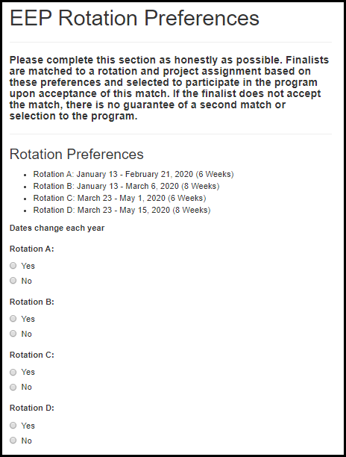

Table 13.3.1-a. Rotation Preference Fields
Field | Values | EIS | LLS | FLIGHT | EEP | SAF | PMR/F | PH-TIPP | PHIFP | PE | ELI | PHAP
Rotation A: | 1. Yes  2. No | No | No | No | Yes | No | No | No | No | No | No | No
Rotation B: | 1. Yes  2. No | No | No | No | Yes | No | No | No | No | No | No | No
Rotation C: | 1. Yes  2. No | No | No | No | Yes | No | No | No | No | No | No | No
Rotation D: | 1. Yes  2. No | No | No | No | Yes | No | No | No | No | No | No | No

13.3.2 Topic & Subject Areas
Figure 13.3.2-a. Topic & Subject Area Fields
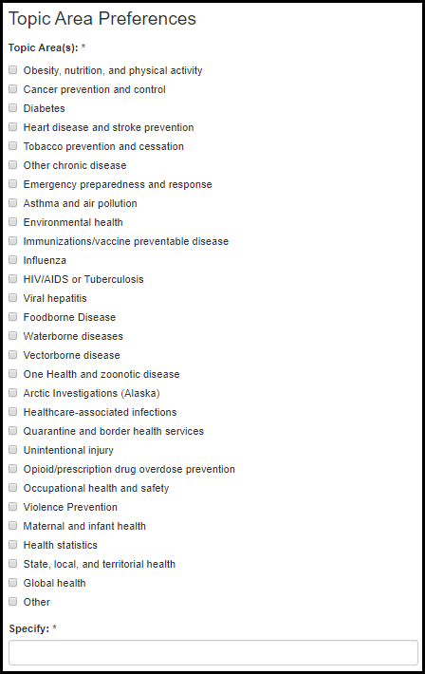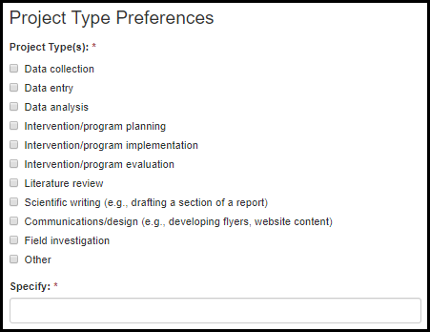
Table 13.3.2-a. Topic & Subject Area Fields
Field | Values | EIS | LLS | FLIGHT | EEP | SAF | PMR/F | PH-TIPP | PHIFP | PE | ELI | PHAP
Topic Area(s): | 1. Obesity, nutrition, and physical activity  2. Cancer prevention and control  3. Diabetes  4. Heart disease and stroke prevention  5. Tobacco prevention and cessation  6. Other chronic disease  7. Emergency preparedness and response  8. Asthma and air pollution  9. Environmental health  10. Immunizations/vaccine preventable disease  11. Influenza  12. HIV/AIDS or Tuberculosis  13. Viral hepatitis  14. Foodborne Disease  15. Waterborne diseases  16. Vectorborne disease  17. One Health and zoonotic disease  18. Arctic Investigations (Alaska)  19. Healthcare-associated infections  20. Quarantine and border health services  21. Unintentional injury  22. Opioid/prescription drug overdose prevention  23. Occupational health and safety  24. Violence Prevention  25. Maternal and infant health  26. Health statistics  27. State, local, and territorial health  28. Global health  29. Other: | No | No | No | Yes | No | No | No | No | No | No | No
Specify: | - | No | No | No | Yes | No | No | No | No | No | No | No

Table 13.3.2-b. Topic & Subject Area Fields
Field | Values | EIS | LLS | FLIGHT | EEP | SAF | PMR/F | PH-TIPP | PHIFP | PE | ELI | PHAP
Project Type: | 1. Data collection  2. Data entry  3. Data analysis  4. Intervention/program planning  5. Intervention/program implementation  6. Intervention/program evaluation  7. Literature review  8. Scientific writing (e.g., drafting a section of a report)  9. Communications/design (e.g., developing flyers, website content)  10. Field investigation  11. Other: | No | No | No | Yes | No | No | No | No | No | No | No
Specify: | - | No | No | No | Yes | No | No | No | No | No | No | No

13.3.3 Location Preferences
Figure 13.3.3-a. Location Preference Fields
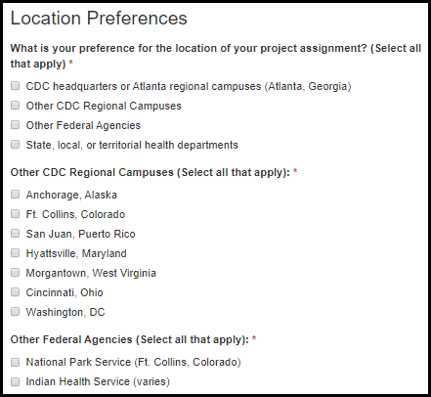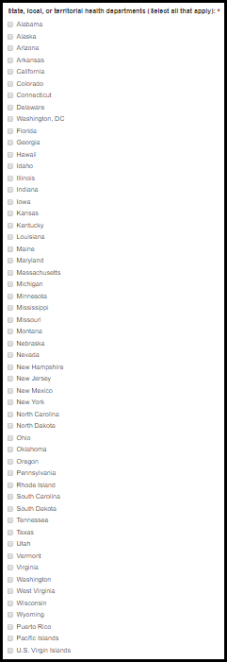

Table 13.3.3-a. Location Preference Fields
Field | Values | EIS | LLS | FLIGHT | EEP | SAF | PMR/F | PH-TIPP | PHIFP | PE | ELI | PHAP
What is your preference for the location of your project assignment? (Select all that apply) | 1. CDC headquarters or Atlanta regional campuses (Atlanta, Georgia)  2. Other CDC Regional Campuses  3. Other Federal Agencies  4. State, local, or territorial health departments | No | No | No | Yes | No | No | No | No | No | No | No
Other CDC Regional Campuses (Select all that apply): | 1. Anchorage, Alaska  2. Ft. Collins, Colorado  3. San Juan, Puerto Rico  4. Hyattsville, Maryland  5. Morgantown, West Virginia  6. Cincinnati, Ohio  7. Washington, DC | No | No | No | Yes | No | No | No | No | No | No | No
Other Federal Agencies (Select all that apply): | National Park Service (Ft. Collins, Colorado)  Indian Health Service (varies) | No | No | No | Yes | No | No | No | No | No | No | No
State, local, or territorial health departments (Select all that apply): | State/Territory List | No | No | No | Yes | No | No | No | No | No | No | No

13.4 SAF Public Health Interests

Figure 13.4-a. SAF Public Health Interests Fields
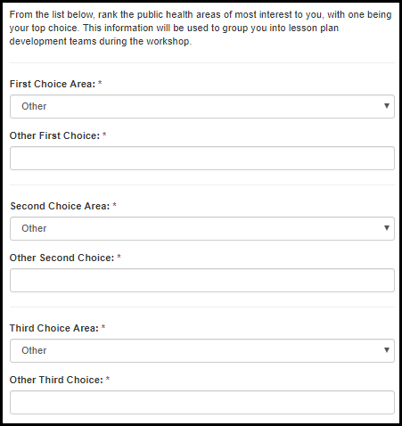

Table 13.5-a. SAF Public Health Interests Fields
Field | Values | EIS | LLS | FLIGHT | EEP | SAF | PMR/F | PH-TIPP | PHIFP | PE | ELI | PHAP
First [Second | Third] Choice Area | 1. Obesity, nutrition, and physical activity  2. Cancer prevention and control  3. Diabetes  4. Heart disease and stroke prevention  5. Tobacco prevention and cessation  6. Other chronic disease  7. Emergency preparedness and response  8. Asthma and air pollution  9. Environmental health  10. Immunizations/vaccine preventable disease  11. Influenza  12. HIV/AIDS or Tuberculosis  13. Viral hepatitis  14. Foodborne Disease  15. Waterborne diseases  16. Vectorborne disease  17. One Health and zoonotic disease  18. Arctic Investigations (Alaska)  19. Healthcare-associated infections  20. Quarantine and border health services  21. Unintentional injury  22. Opioid/prescription drug overdose prevention  23. Occupational health and safety  24. Violence Prevention  25. Maternal and infant health  26. Health statistics  27. State, local, and territorial health  28. Global health  29. Other: | No | No | No | No | Yes | No | No | No | No | No | No
Other First [Second | Third] Choice Area | - | No | No | No | No | Yes | No | No | No | No | No | No

13.5 EIS CIO Assignment Interests
Figure 13.5-a. EIS CIO Assignment Interests
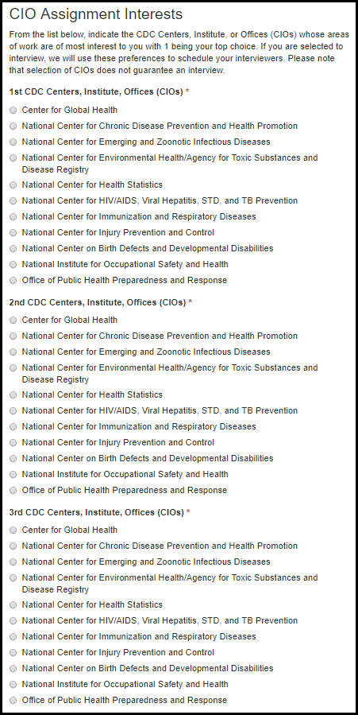
Table 13.5-a. EIS CIO Assignment Interests
Field | Values | EIS | LLS | FLIGHT | EEP | SAF | PMR/F | PH-TIPP | PHIFP | PE | ELI | PHAP
1st CDC Centers, Institute, Offices (CIOs): | 1. Center for Global Health  2. National Center for Chronic Disease Prevention and Health Promotion  3. National Center for Emerging and Zoonotic Infectious Diseases  4. National Center for Environmental Health/Agency for Toxic Substances and Disease Registry  5. National Center for Health Statistics  6. National Center for HIV/AIDS, Viral Hepatitis, STD, and TB Prevention  7. National Center for Immunization and Respiratory Diseases  8. National Center for Injury Prevention and Control  9. National Center on Birth Defects and Developmental Disabilities  10. National Institute for Occupational Safety and Health  11. Office of Public Health Preparedness and Response | Yes | No | No | No | No | No | No | No | No | No | No
2nd CDC Centers, Institute, Offices (CIOs): | 1. Center for Global Health  2. National Center for Chronic Disease Prevention and Health Promotion  3. National Center for Emerging and Zoonotic Infectious Diseases  4. National Center for Environmental Health/Agency for Toxic Substances and Disease Registry  5. National Center for Health Statistics  6. National Center for HIV/AIDS, Viral Hepatitis, STD, and TB Prevention  7. National Center for Immunization and Respiratory Diseases  8. National Center for Injury Prevention and Control  9. National Center on Birth Defects and Developmental Disabilities  10. National Institute for Occupational Safety and Health  11. Office of Public Health Preparedness and Response | Yes | No | No | No | No | No | No | No | No | No | No
3rd CDC Centers, Institute, Offices (CIOs): | 1. Center for Global Health  2. National Center for Chronic Disease Prevention and Health Promotion  3. National Center for Emerging and Zoonotic Infectious Diseases  4. National Center for Environmental Health/Agency for Toxic Substances and Disease Registry  5. National Center for Health Statistics  6. National Center for HIV/AIDS, Viral Hepatitis, STD, and TB Prevention  7. National Center for Immunization and Respiratory Diseases  8. National Center for Injury Prevention and Control  9. National Center on Birth Defects and Developmental Disabilities  10. National Institute for Occupational Safety and Health  11. Office of Public Health Preparedness and Response | Yes | No | No | No | No | No | No | No | No | No | No

13.6. Writing Samples

13.6.1 EIS Writing Samples

Figure 13.6.1-a. EIS Writing Sample Fields
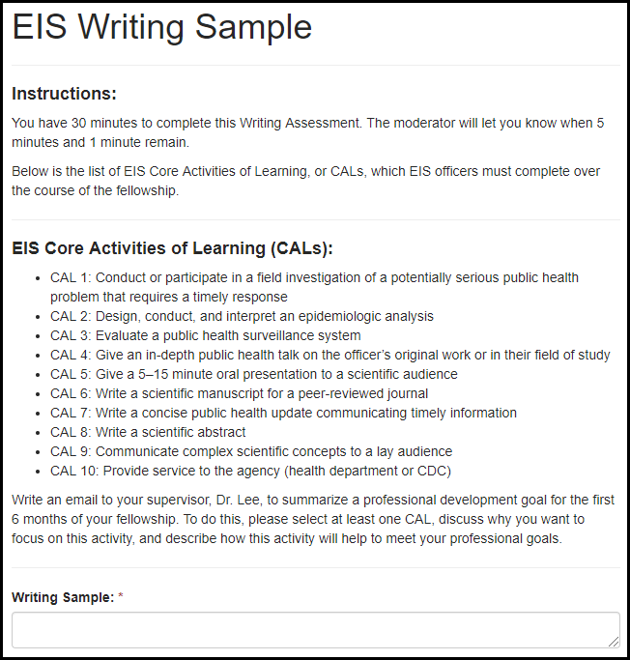
Table 13.6.1-a. EIS Writing Sample Fields
Field | Values | EIS | LLS | FLIGHT | EEP | SAF | PMR/F | PH-TIPP | PHIFP | PE | ELI | PHAP
Writing Sample: | - | Yes | No | No | No | No | No | No | No | No | No | No

Match

Match or Prematch Rank/Rating Form

Figure 15.1-a. Match or Prematch Rank/Rating Form Fields
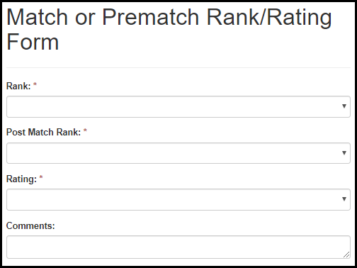
Table 15.1-a. Match or Prematch Rank/Rating Form Fields
Field Name | Values | EIS | LLS | FLIGHT | EEP | SAF | PMR/F | PH-TIPP | PHIFP | PE | ELI | PHAP
Rank: | First Choice - Tenth Choice | Yes | Yes | Yes | Yes | No | Yes | No | Yes | Yes | No | Yes
Post Match Rank: | First Choice - Tenth Choice | Yes | Yes | Yes | Yes | No | Yes | No | Yes | Yes | No | Yes
Rating: | First Choice - Tenth Choice | Yes | Yes | Yes | Yes | No | Yes | No | Yes | Yes | No | Yes
Comments: | - | Yes | Yes | Yes | Yes | No | Yes | No | Yes | Yes | No | Yes

Match or Prematch Acceptance Form

Figure 15.2-a. Match or Prematch Acceptance Form Fields
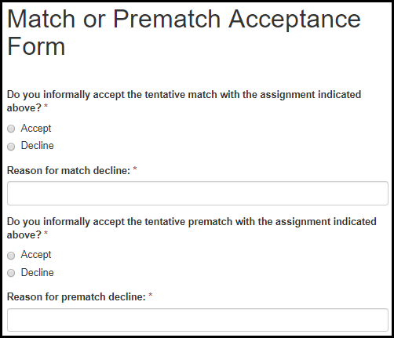
Table 15.2a. Match or Prematch Rank/Rating Form Fields
Field Name | Values | EIS | LLS | FLIGHT | EEP | SAF | PMR/F | PH-TIPP | PHIFP | PE | ELI | PHAP
Do you informally accept the tentative match with the assignment indicated above? | 1. Accept  2. Decline | Yes | Yes | Yes | Yes | No | Yes | No | Yes | Yes | No | Yes
Reason for match decline? | - | Yes | Yes | Yes | Yes | No | Yes | No | Yes | Yes | No | Yes
Do you informally accept the tentative prematch with the assignment indicated above? | 1. Accept  2. Decline | Yes | Yes | Yes | No | No | Yes | No | Yes | Yes | No | Yes
Reason for pre-match decline? | - | Yes | Yes | Yes | No | No | Yes | No | Yes | Yes | No | Yes

Appendix

I. Field Value Tables

Appendix of Field Value Tables
Field Name | Application Locations | Values  1 | Values  2 | Values  3 | Values  4
State Sponsor of Terrorism Country List | 6.2 Citizenship Status | See the U.S. Department of State website for current list: https://www.state.gov/j/ct/list/c14151.htm
Approved Country List | 6.2 Citizenship Status | United States  Anguilla  Antigua  Australia  Bahamas  Barbados  Barbuda  Belize  Bermuda  British Virgin Islands  Canada  Dominica  Grand Cayman Islands | Grenada  Guyana  Irish Republic  Jamaica  Montserrat  New Zealand  Saint Kitts and Nevis  St. Lucia  St. Vincent & the Grenadine  Tabago  Trinidad  Turks and Caicos Islands  United Kingdom
PHAP Subject Areas | 6.8.1 Special Requirements | Adolescent & School Health (non-STI)  Community Health Improvement Planning (CHIP)/Community Health Assessments (CHA)  Chronic Disease  Emergency/Disaster Preparedness and Response  Environmental Health  Genomics  Health Equity/Access to Care  Health Department Improvement/Accreditation  Immunizations/Vaccine Preventable Disease Investigation  Sexually Transmitted Disease Prevention  Tuberculosis Prevention  HIV Prevention  Viral Hepatitis Prevention  Adolescent/school-based Sexually Transmitted Disease prevention  Other Infectious Disease  Injury Prevention  Maternal & Infant Health  Public Health Policy & Law  Public Health Surveillance  Oral Health
Undergraduate Degree List | 7.7 Degree | AB  AM  BA  BS  BS/BA  BSc  DHS  DHSc  DNSc  DPH  DPhil  DrPH  DrS  DrSc  EdD  MA  Med  MHS  MHSc  MHSE  MN  MPH  MPhil  MPHTM  MPVM  MS  MSVPH  MSc  MScPH  MSPH  MTM&H  PhD  SB  ScB  ScD  ScM  SM  Other
Graduate Degree List | 7.7 Degree | AB  AM  BA  BS  BS/BA  BSc  DHS  DHSc  DNSc  DPH  DPhil  DrPH  DrS  DrSc  EdD  MA  Med  MHS  MHSc  MHSE  MN  MPH  MPhil  MPHTM  MPVM  MS  MSVPH  MSc  MScPH  MSPH  MTM&H  PhD  SB  ScB  ScD  ScM  SM  Other
Major Classification List | 7.7 Degree | Biological, biomedical, or animal sciences  Business, management  Community health, public health  Decision or quantitative sciences  Economics (agricultural, applied, health)  Engineering, industrial engineering, operations research  Environmental, occupational sciences  Epidemiology  Global, international health  Health education  Informatics (public health, clinical, nursing)  Health services administration, health policy analysis  Health services research, quantitative policy analysis  Information technology, information science, computer science  Liberal arts, general studies, humanities, language, literature  Maternal and child health  Mathematical sciences, statistics, biostatistics  Physical or chemical sciences  Political science, law  Public administration, policy analysis  Social/behavior science (anthropology, social work, psychology)  Other
Honor List | 7.7 Degree | Magna Cum Laude  Summa Cum Laude  Cum Laude  Valedictorian  Benedictorian  Salutatorian  Phi Beta Kappa
State/Territory List | 11.3 Location Preferences  13.3.3 Location Preferences | Alabama  Alaska  Arizona  Arkansas  California  Colorado  Connecticut  Delaware  Washington, DC  Florida  Georgia  Hawaii  Idaho  Illinois  Indiana  Iowa  Kansas  Kentucky  Louisiana  Maine  Maryland  Massachusetts  Michigan  Minnesota  Mississippi  Missouri  Montana  Nebraska | Nevada  New Hampshire  New Jersey  New Mexico  New York  North Carolina  North Dakota  Ohio  Oklahoma  Oregon  Pennsylvania  Rhode Island  South Carolina  South Dakota  Tennessee  Texas  Utah  Vermont  Virginia  Washington  West Virginia  Wisconsin  Wyoming  Puerto Rico  Pacific Islands  U.S. Virgin Islands
CDC Fellowship List | 11.4 CDC Fellowship Participation | AACN Fellowship  AAMC Public Health Policy Fellowship  Applied Public Health Informatics Fellowship (APHIF)  APTR Preventive Medicine and Public Health Fellowship  ASA/NCHS Research Fellowship Program  ASM Program in Infectious Disease and Public Health Microbiology  ASPH Allan Rosenfield Global Health Fellowship Program  ASPPH Public Health Fellowship Program  Biochemical Markers Fellowship  Collegiate Leaders in Environmental Health (CLEH)  CSTE Applied Epidemiology Fellowship Program  Dental Public Health Residency  DHPE Health Equity Fellowship Program  DHPE Internship Program for Public Health Practice Emory Rollins Earn and Learn (REAL) Program  E-learning Institute (ELI)  Environmental Health Traineeship and Fellowship Program  Epidemic Intelligence Service (EIS)  Epidemiology Elective Program (EEP)  Evaluation Fellowship  Federal Work-Study Program (FWS)  Field Epidemiology Training Program (FETP)  Future Leaders in Infections and Global Health Threats (FLIGHT)  Future Public Health Leaders Program (FPHLP)  HACU National Internship Program (HNIP)  Health Systems Integration Program  Hubert Global Health Fellowship  Informatics Training in Place Program (I-TIPP)  International Emerging Infectious Diseases (IEID) Laboratory Fellowship Program  Internships and Externships in Public Health Law  James A Ferguson Emerging Infectious Diseases Fellowship  Junior Commissioned Officer Student Training and Extern Program (JRCOSTEP)  Laboratory Animal Medicine Residency Program (LAMRP)  Laboratory Leadership Service (LLS)  Maternal Child Health Careers/Research Initiatives for Student Enhancement – Undergraduate Program (MCHC/RISE-UP)  Medical Toxicologist Fellowship Program  Morehouse College Project IHMOTEP Program  National Center for Health Statistics (NCHS) Academy Health Policy Fellowship  National Center for Health Statistics (NCHS) Postdoctoral Research Program

II. Lookup Tables

Appendix of Lookup Tables
Lookup Table Name | Application Locations | Values  1 | Values  2 | Values  3 | Values  4 | Values  5
Fellowship Lookup | 3. eFMS System Help Desk Ticket | CDC E-learning Institute Fellowship Program (ELI)  CDC Steven M. Teutsch Prevention Effectiveness (PE) Fellowship  Epidemic Intelligence Service (EIS)  Epidemiology Elective Program (EEP)  Future Leaders in Infections and Global Health Threats (FLIGHT)  Laboratory Leadership Service (LLS)  Population Health Training in Place Program (PH-TIPP)  Population Health Workforce Initiative (PHWI)  Preventive Medicine Residency and Fellowship (PMR/F)  Public Health Associate Program (PHAP)  Public Health Informatics Fellowship Program (PHIFP)  Science Ambassador Fellowship (SAF)
Phone Code Lookup | 5.4 Phone Number | United States (1)  Azores (351)  Afghanistan (93)  Albania (355)  Algeria (213)  Andorra (376)  Angola (244)  Anguilla (U.K.) (1)  Antigua and Barbuda (1)  Argentina (54)  Armenia (374)  Aruba (297)  Australia (61)  Austria (43)  Azerbaijan (994)  Bahamas, The (1)  Bahrain (973)  Bangladesh (880)  Barbados (1)  Belarus (375)  Belgium (32)  Belize (501)  Benin (229)  Bermuda (U.K.) (1)  Bhutan (975)  Bolivia (591)  Bosnia and Herzegovina (387)  Botswana (267)  Brazil (55)  British Indian Ocean Territory (U.K.) (246)  Brunei (673)  Bulgaria (359)  Burkina Faso (226)  Burundi (257)  British Virgin Islands (1)  Burma (Myanmar) (95)  Canary Islands (Spain) (34) | Congo, Democratic Republic of the (243)  Congo, Republic of the (242)  Cambodia (855)  Cameroon (237)  Canada (1)  Cape Verde (238)  Cayman Islands (U.K.) (1)  Central African Republic (236)  Chad (235)  Chile (56)  China (86)  Christmas Island (Australia) (61)  Cocos (Keeling) Islands (Australia) (61)  Colombia (57)  Comoros (269)  Cook Islands (New Zealand) (682)  Costa Rica (506)  C?te d'Ivoire (225)  Croatia (385)  Cuba (53)  Cyprus (357)  Czech Republic (420)  Denmark (45)  Djibouti (253)  Dominica (1)  Dominican Republic (1)  Easter Island (Chile) (56)  Ecuador (593)  Egypt (20)  El Salvador (503)  Equatorial Guinea (240)  Eritrea (291) | Estonia (372)  Ethiopia (251)  Falkland Islands (Malvinas) (500)  Faroe Islands (Denmark) (298)  Fiji (679)  Finland (358)  France (33)  French Guiana (France) (594)  French Polynesia (France) (689)  Falkland Islands (U.K.) (500)  Guinea-Bissau (245)  Gabon (241)  Gambia, The (220)  Guyana (592)  Haiti (509)  Georgia (995)  Honduras (504)  Germany (49)  Hong Kong SAR (China) (852)  Ghana (233)  Hungary (36)  Gibraltar (U.K.) (350)  Iceland (354)  Greece (30)  India (91)  Greenland (Denmark) (299)  Indonesia (62)  Grenada (1)  Iran (98)  Guadeloupe (590)  Iraq (964)  Guatemala (502)  Ireland (353)  Guinea (224)  Israel (972) | Italy (39)  Jamaica (1)  Japan (81)  Libya (218)  Jordan (962)  Kazakhstan (7)  Liechtenstein (423)  Kenya (254)  Lithuania (370)  Luxembourg (352)  Kiribati (686)  Macau SAR (China) (853)  Korea, North (850)  Macedonia (389)  Korea, South (82)  Kuwait (965)  Madagascar (261)  Kyrgyzstan (996)  Malawi (265)  Kosovo (381)  Malaysia (60)  Laos (856)  Maldives (960)  Latvia (371)  Mali (223)  Lebanon (961)  Malta (356)  Lesotho (266)  Marshall Islands (692)  Liberia (231)  Martinique (France) (596)  Mauritania (222)  Mauritius (230)  Mayotte (France) (262)  Netherlands, The (31)  Mexico (52)  Micronesia, Federated States of (691) | Netherlands Antilles (599)  Moldova (373)  New Caledonia (France) (687)  Monaco (377)  New Zealand (64)  Mongolia (976)  Nicaragua (505)  Montserrat (U.K.) (1)  Niger (227)  Morocco (212)  Nigeria (234)  Mozambique (258)  Niue (New Zealand) (683)  Madeira Islands (Portugal) (351)  Norfolk Island (Australia) (672)  Montenegro (382)  Northern Mariana Islands (U.S.) (670)  Namibia (264)  Norway (47)  Nauru (674)  Oman (968)  Nepal (977)  Pakistan (92)  Palau (680)  Panama (507)  Papua New Guinea (675)  Paraguay (595)  Peru (51)  Samoa (685)  Philippines (63)  San Marino (378)  Pitcairn Islands (U.K.) (0)  S?o Tom? and Pr?ncipe (239)  Poland (48)  Saudi Arabia (966)  Portugal (351)  Qatar (974)  Senegal (221)  Seychelles (248)  R?union (France) (262)  Romania (40)  Sierra Leone (232)  Russia (7)  Singapore (65)  Rwanda (250)  Slovakia (421)  Saint Kitts and Nevis (1)  Slovenia (386)  Saint Lucia (1)  Solomon Islands (677)  Saint Vincent and the Grenadines (1)  Somalia (252)  South Africa (27)  Spain (34)  Sri Lanka (94)  Sudan (249)  Suriname (597)  Swaziland (268)  Sweden (46)  Tokelau (New Zealand) (690)  Switzerland (41)  Syria (963)  Tonga (676)  Saint Helena (U.K.) (290)  Trinidad and Tobago (1)  Saint Pierre and Miquelon (France) (508)  Serbia (381)  Timor-Leste (East Timor) (670)  Taiwan (886)  Tajikistan (992)  Tanzania (255)  Thailand (66)  Togo (228)  Tunisia (216)  Turkey (90)  Turkmenistan (993)  Turks and Caicos Islands (U.K.) (1)  Tuvalu (688)  Uganda (256)  Venezuela (58)  Ukraine (380)  United Arab Emirates (971)  Vietnam (84)  Western Sahara (212)  United Kingdom (44)  Yemen (967)  Uruguay (598)  Zambia (260)  Uzbekistan (998)  Zimbabwe (263)  Vanuatu (678)  Other (0)
Country Lookup | 5.5 Mailing Address  6.2 Citizenship Status  6.10.2 Program & Organization  8.6 Position Location  9.6 Institution Details and Location | United States  Afghanistan  Albania  Algeria  Andorra  Angola  Anguilla (U.K.)  Antigua and Barbuda  Argentina  Armenia  Aruba  Australia  Austria  Azerbaijan  Azores  Bahamas, The  Bahrain  Bangladesh  Barbados  Belarus  Belgium  Belize  Benin  Bermuda (U.K.)  Bhutan  Bolivia  Bosnia and Herzegovina  Botswana  Brazil  British Indian Ocean Territory (U.K.)  British Virgin Islands  Brunei  Bulgaria  Burkina Faso  Burma (Myanmar)  Burundi  Cambodia  Cameroon  Canada | Canary Islands (Spain)  Cape Verde  Cayman Islands (U.K.)  Central African Republic  China  Chad  Christmas Island (Australia)  Chile  Cocos (Keeling) Islands (Australia)  Colombia  Comoros  Congo, Democratic Republic of the  Congo, Republic of the  Cook Islands (New Zealand)  Costa Rica  Cote d'Ivoire  Djibouti  Croatia  Cuba  Dominica  Cyprus  Dominican Republic  Czech Republic  Easter Island (Chile)  Denmark  Ecuador  Egypt  El Salvador  Equatorial Guinea  Eritrea  Estonia  Ethiopia  Falkland Islands (Malvinas)  Finland  Falkland Islands (U.K.)  Faroe Islands (Denmark)  France  Fiji | French Guiana (France)  French Polynesia (France)  Gabon  Gambia, The  Georgia  Germany  Ghana  Gibraltar (U.K.)  Greece  Guinea  Greenland (Denmark)  Grenada  Guinea-Bissau  Guadeloupe  Guyana  Guatemala  Haiti  Honduras  Hong Kong SAR (China)  Hungary  Iceland  India  Indonesia  Iran  Jamaica  Iraq  Japan  Ireland  Jordan  Israel  Kazakhstan  Italy  Kenya  Kiribati  Korea, North  Korea, South  Kosovo  Kuwait  Kyrgyzstan  Laos | Liberia  Latvia  Libya  Lebanon  Liechtenstein  Lesotho  Lithuania  Luxembourg  Macau SAR (China)  Macedonia  Madagascar  Madeira Islands (Portugal)  Malawi  Malaysia  Martinique (France)  Maldives  Mauritania  Mali  Mauritius  Malta  Mayotte (France)  Marshall Islands  Mexico  Moldova  Monaco  Mongolia  Montenegro  Montserrat (U.K.)  Morocco  Mozambique  Netherlands Antilles  Namibia  Nauru  Netherlands, The  Nepal  New Caledonia (France)  New Zealand  Nicaragua  Niger  Nigeria  Niue (New Zealand)  Northfolk Island (Australia)  Northern Mariana Islands (U.S.)  Panama  Norway  Papua New Guinea  Oman | Paraguay  Other  Peru  Pakistan  Philippines  Palau  Pitcairn Islands (U.K.)  Poland  Portugal  Qatar  Reunion (France)  Romania  Russia  Rwanda  Saint Lucia  Saint Helena (U.K.)  Saint Pierre and Miquelon (France)  Saint Kitts and Nevis  Saint Vincent and the Grenadines  Samoa  San Marino  Sao Tome and Principe  Saudi Arabia  Senegal  Serbia  Seychelles  Somalia  Sierra Leone  Singapore  South Africa  Slovakia  Spain  Slovenia  Sri Lanka  Solomon Islands  Sudan  Suriname  Swaziland  Sweden  Switzerland  Syria  Taiwan  Tajikistan  Tanzania  Togo  Thailand  Timor-Leste (East Timor)  Tokelau (New Zealand)  Tonga  Trinidad and Tobago  Tunisia  Turkey  Turkmenistan  Turks and Caicos Islands (U.K.)  Tuvalu  Vanuatu  Uganda  Venezuela  Ukraine  Vietnam  United Arab Emirates  Western Sahara  United Kingdom  Yemen  Uruguay  Zambia  Uzbekistan  Zimbabwe
State/Territory Lookup | 5.5 Mailing Address  6.8.1 Special Requirements  6.10.2 Program & Organization  7.9 License  8.6 Position Location  9.6 Institution Details and Location | Alabama  Alaska  Arizona  Arkansas  California  Colorado  Connecticut  Delaware  Washington, DC  Florida  Georgia  Hawaii  Idaho  Illinois  Indiana  Iowa  Kansas  Kentucky  Louisiana  Maine  Maryland  Massachusetts  Michigan  Minnesota  Mississippi  Missouri  Montana  Nebraska | Nevada  New Hampshire  New Jersey  New Mexico  New York  North Carolina  North Dakota  Ohio  Oklahoma  Oregon  Pennsylvania  Rhode Island  South Carolina  South Dakota  Tennessee  Texas  Utah  Vermont  Virginia  Washington  West Virginia  Wisconsin  Wyoming  Puerto Rico  Pacific Islands  U.S. Virgin Islands  Guam  Northern Mariana Islands
Center/Division/Branch Lookup | 6.9.2 FLIGHT – Current EIS Position  6.10.2 Program & Organization | NIOSH / Office of the Director / Administrative Svcs Branch (Cincinnati)  NIOSH / Office of the Director / Administrative Svcs Branch (Morgantown)  NIOSH / Office of the Director / Administrative Svcs Branch (Spokane)  NIOSH / Office of the Director / Administrative Svrcs Branch (Pittsburgh)  NCHS / Office of Analysis & Epidemiology / Aging & Chronic Disease Statistics Branch  NIOSH / Health Effects Laboratory Division / Allergy & Clinical Immunology Branch  NCHS / Division of Health Care Statistics / Ambulatory and Hospital Care Statistics Branch  NIOSH / Division of Safety Research / Analysis & Field Branch  NCHS / Division of Health & Nutrition Examination Surveys / Analysis Branch  NCHS / Office of Analysis & Epidemiology / Analytic Studies Branch  NCEZID / Division of Scientific Resources / Animal Resources Branch  NCCDPHP / Division for Heart Disease and Stroke Prevention / Applied Research and Evaluation Branch  NCCDPHP / Division of Population Health / Applied Research and Translation Branch  CPR / Division of State and Local Readiness / Applied Science and Evaluation Branch  NCCDPHP / Division of Reproductive Health / Applied Sciences Branch  NCEZID / Division of Vector-Borne Diseases / Arboviral Diseases Branch  NCEZID / Division of Preparedness and Emerging Infections / Arctic Investigations Program  NCCDPHP / Division of Population Health / Arthritis, Epilepsy and Well-Being Branch  NCIRD / Immunization Services Division / Assessment Branch  NCEH / Division of Environmental Health Science and Practice / Asthma and Community Health Branch  NCEZID / Division of Vector-Borne Diseases / Bacterial Diseases Branch  NCEZID / Division of High Consequence Pathogens & Pathology / Bacterial Special Pathogens Branch  NCHHSTP / Division of HIV/AIDS Prevention Surveillance & Epidemiology / Behavioral And Clinical S...  NIOSH / Division of Applied Research & Technology / Biomonitoring & Health Assessment Branch  NIOSH / Health Effects Laboratory Division / Biostatistics & Epidemiology Branch  NCEZID / Division of Foodborne, Waterborne and Environmental Diseases / Biostatistics and Informa...  NCEZID / Division of Scientific Resources / Biotechnology Core Facility Branch  NCBDDD / Division of Congenital and Developmental Disorders / Birth Defects Branch  NCHS / Office of Management & Operations / Building Operations & Services Staff  NCHS / Office of Management & Operations / Business Logistics Staff  NCCDPHP / Division of Cancer Prevention and Control / Cancer Surveillance Branch  NCHHSTP / Division of HIV/AIDS Prevention-Intervention & Support / Capacity Building Branch  CPR / Division of State and Local Readiness / Capacity Building Branch  ATSDR / Division of Community Health Investigations / Central Branch  NIOSH / Division of Applied Research & Technology / Chemical Exposure & Monitoring  NCBDDD / Division of Human Development and Disability / Child Development and Disability Branch  NCEZID / Division of High Consequence Pathogens & Pathology / Chronic Viral Diseases Branch  NCHS / Classification & Public Health Data Standards Staff / Classification & Public Health Data ...  NCEZID / Division of Healthcare Quality Promotion / Clinical & Environmental Microbiology Branch  NCEH / Division of Laboratory Science / Clinical chemistry branch  NCHHSTP / Division of Tuberculosis Elimination / Clinical Research Branch  NCHS / Division of Research & Methodology / Collaborating Center for Questionnaire Design & Evalu...  NCHS / Division of Research & Methodology / Collaborating Center for Statistical Research & Surve...  NCIRD / Immunization Services Division / Communication and Education Branch  NCHHSTP / Division of Tuberculosis Elimination / Communications, Education, and Behavioral Studie...  CSELS / Division of Public Health Information and Dissemination / Community Guide Branch  NCCDPHP / Division of Cancer Prevention and Control / Comprehensive Cancer Control Branch  ATSDR / Division of Toxicology and Human Health Sciences / Computational Toxicology and Methods D...  NIOSH / Education & Information Division / Document Development Branch  NIOSH / National Personal Protective Technology Laboratory / Conformity Verification & Standards ...  NCCDPHP / Division of Population Health / Coordinated State Support Branch  NIOSH / Pittsburgh Mining Research Division / Dust, Ventilation & Toxic Substances Branch  CGH / Division of Global Health Protection / Country Strategy and Implementation Branch  ATSDR / Division of Community Health Investigations / Eastern Branch  NCHS / Division of Vital Statistics / Data Acquisition, Classification & Evaluation Branch  CGH / Division of Global HIV and TB / Economics and Health Services Research Branch | NCHS / Division of Health Interview Statistics / Data Analysis & Quality Assurance Branch  CSELS / Division of Scientific Education and Professional Development / Education and Training Se...  NCHHSTP / Division of Tuberculosis Elimination / Data Management and Statistics Branch  NIOSH / Pittsburgh Mining Research Division / Electrical & Mechanical Systems Safety Branch  NCHS / Division of Health Interview Statistics / Data Production & Systems Branch  CPR / Division of Emergency Operations / Emergency and Risk Communications Branch  NCEZID / Division of Vector-Borne Diseases / Dengue Branch  NCEH / Division of Environmental Health Science and Practice / Emergency Management, Radiation, a...  NCBDDD / Division of Congenital and Developmental Disorders / Developmental Disabilities Branch  NCEZID / Division of Preparedness and Emerging Infections / Emergency Preparedness and Response B...  NCBDDD / Division of Human Development and Disability / Disability and Health Branch  CGH / Division of Global Health Protection / Emergency Response and Recovery Branch  NIOSH / Division of Compensation Analysis & Support / Division of Compensation Analysis & Support  NCEH / Division of Laboratory Science / Emergency response branch  NCCDPHP / Division of Oral Health / Division of Oral Health  ATSDR / Division of Toxicology and Human Health Sciences / Emergency Response Program  NIOSH / Health Effects Laboratory Division / Engineering & Control Branch  NIOSH / Division of Applied Research & Technology / Engineering & Physical Hazards Branch  NCEZID / Division of Foodborne, Waterborne and Environmental Diseases / Enteric Diseases Epidemio...  NCEZID / Division of Foodborne, Waterborne and Environmental Diseases / Enteric Diseases Laborato...  CGH / Division of Parasitic Diseases and Malaria / Entomology Branch  ATSDR / Division of Toxicology and Human Health Sciences / Environmental Epidemiology Branch  NCCDPHP / Division of Population Health / Epidemiology and Surveillance Branch  NCEH / Division of Emergency and Environmental Health Services / Environmental Health Services Br...  ATSDR / Division of Toxicology and Human Health Sciences / Environmental Health Surveillance Branch  NCHHSTP / Division of Viral Hepatitis / Epidemiology and Surveillance Branch  ATSDR / Division of Toxicology and Human Health Sciences / Environmental Medicine Branch  NCHHSTP / Division of HIV/AIDS Prevention Surveillance & Epidemiology / Epidemiology Branch  NCEH / Division of Emergency and Environmental Health Services / Environmental Public Health Read...  NCCDPHP / Office on Smoking and Health / Epidemiology Branch  ATSDR / Division of Toxicology and Human Health Sciences / Environmental Toxicology Branch  NCEZID / Division of Healthcare Quality Promotion / Epidemiology Research and Innovations Branch  NCCDPHP / Division of Cancer Prevention and Control / Epidemiology and Applied Research Branch  CSELS / Division of Scientific Education and Professional Development / Epidemiology Workforce Br...  NCIRD / Influenza Division / Epidemiology and Prevention Branch  CGH / Division of Global Health Protection / Epidemiology, Informatics, Surveillance and Lab Branch  NCCDPHP / Division of Diabetes Translation / Epidemiology and Statistics Branch  NIOSH / National Personal Protective Technology Laboratory / Evaluation & Testing Branch  NCHHSTP / Division of Sexually Transmitted Disease Prevention / Epidemiology and Statistics Branch  NIOSH / Health Effects Laboratory Division / Exposure Assessment Branch  NCCDPHP / Division for Heart Disease and Stroke Prevention / Epidemiology and Surveillance Branch  NCHHSTP / Division of Sexually Transmitted Disease Prevention / Field Services Branch  NCBDDD / Division of Blood Disorders / Epidemiology and Surveillance Branch  CPR / Division of State and Local Readiness / Field Services Branch  CGH / Division of Global HIV and TB / Epidemiology and Surveillance Branch  NCHHSTP / Division of Tuberculosis Elimination / Field Services Branch  NIOSH / Respiratory Health Division / Field Studies Branch  NCCDPHP / Division of Reproductive Health / Field Support Branch | NIOSH / Pittsburgh Mining Research Division / Fires and Explosions Branch  NCEZID / Division of Foodborne, Waterborne and Environmental Diseases / Food Safety Office  NCEZID / Division of Global Migration and Quarantine / Geographic Medicine and Health Promotion B...  NCHS / Office of Analysis & Epidemiology / Health Promotion Statistics Branch  ATSDR / Division of Toxicology and Human Health Sciences / Geospatial Research, Analysis, and Ser...  CGH / Division of Global Health Protection / Global Non-communicable Disease Branch  NCCDPHP / Office on Smoking and Health / Global Tobacco Control Branch  NCHHSTP / Division of Sexually Transmitted Disease Prevention / Health Services Research and Eval...  CGH / Division of Global HIV and TB / Global Tuberculosis Branch  NCIPC / Division of Unintentional Injury Prevention / Health Systems and Trauma Systems Branch  NIOSH / Pittsburgh Mining Research Division / Ground Control Branch  NCEH / Division of Emergency and Environmental Health Services / Healthy Community Design Initiative  NIOSH / Division of Surveillance, Hazard Evaluations & Field Studies / Hazard Evaluations & Techn...  NCEH / Division of Emergency and Environmental Health Services / Healthy Homes and Lead Poisoning...  NIOSH / Health Effects Laboratory Division / Health Communication Research Branch  NCBDDD / Division of Blood Disorders / Hemostasis Laboratory Branch  NCCDPHP / Office of the Director / Health Communication Science Office  NCHHSTP / Office of the Director / Health Communication Science Office  CGH / Division of Global HIV and TB / HIV Care and Treatment Branch  NCBDDD / Office of the Director / Health Communication Science Office  NCHHSTP / Division of HIV/AIDS Prevention Surveillance & Epidemiology / HIV Incidence and Case Su...  NIOSH / Pittsburgh Mining Research Division / Health Communication, Surveillance, Research Suppor...  CGH / Division of Global HIV and TB / HIV Prevention Branch  NCCDPHP / Office on Smoking and Health / Health Communications Branch  NCIPC / Division of Unintentional Injury Prevention / Home, Recreation, and Transportation Branch  CGH / Division of Global HIV and TB / Health Informatics, Data Management, and Statistics Branch  NIOSH / Pittsburgh Mining Research Division / Human Factors Branch  NCEZID / Division of Global Migration and Quarantine / Immigrant, Refugee, and Migrant Health Branch  NCIRD / Immunization Services Division / Immunization Information System Support Branch  NCEZID / Division of Healthcare Quality Promotion / Immunization Safety Office  CGH / Global Immunization Division / Immunization System Branch  NCIRD / Influenza Division / Immunology and Pathogenesis Branch  NIOSH / Division of Surveillance, Hazard Evaluations & Field Studies / Industrywide Studies Branch  NCHS / Office of Analysis & Epidemiology / Infant, Child, & Women?s Health Statistics Branch  NCEZID / Division of High Consequence Pathogens & Pathology / Infectious Diseases Pathology Branch  NCIRD / Office of the Director / Influenza Coordination Unit  CGH / Division of Global HIV and TB / International Laboratory Branch  NCHS / Division of Health & Nutrition Examination Surveys / Informatics Branch  CSELS / Division of Public Health Information and Dissemination / Informatics Innovation Unit  NCHHSTP / Division of HIV/AIDS Prevention Surveillance & Epidemiology / Laboratory Branch  NCHHSTP / Office of the Director / Informatics Office  NCHHSTP / Division of Tuberculosis Elimination / Laboratory Branch  NCHS / Office of Information Services / Information Design & Publishing Staff  NCHHSTP / Division of Viral Hepatitis / Laboratory Branch  NCHS / Office of Information Services / Information Dissemination Staff  NIOSH / Education & Information Division / Information Resources and Dissemination Branch  CSELS / Division of Laboratory Systems / Laboratory Practice Standards Branch  NCEZID / Division of Preparedness and Emerging Infections / Laboratory Preparedness and Response ...  CSELS / Division of Health Informatics and Surveillance Systems / Information Systems Branch  NCHHSTP / Division of Sexually Transmitted Disease Prevention / Laboratory Reference and Research...  NCHS / Division of Vital Statistics / Information Technology Branch  NCHS / Office of Information Technology / Information Technology Solutions & Services Staff  CSELS / Division of Laboratory Systems / Laboratory | Research and Evaluation Branch  NCEH / Division of Laboratory Science / Inorganic and radiation analytical toxicology branch  CSELS / Division of Laboratory Systems / Laboratory Training and Services Branch  NCEH / Division of Environmental Health Science and Practice / Lead Poisoning Prevention and Envi...  CSELS / Division of Public Health Information and Dissemination / Library Science Branch  CPR / Division of Strategic National Stockpile / Logistics Branch  CPR / Division of Emergency Operations / Logistics Support Branch  NCHS / Division of Health Care Statistics / Long-Term Care Statistics Branch  CGH / Division of Parasitic Diseases and Malaria / Malaria Branch  CGH / Division of Global HIV and TB / Management and Operations Branch  NIOSH / Office of the Director / Management Systems Branch  CGH / Division of Global HIV and TB / Maternal and Child Health Branch  NCCDPHP / Division of Reproductive Health / Maternal and Infant Health Branch  NCIRD / Division of Bacterial Branch / Meningitis and Vaccine Preventable Diseases Branch  CGH / Division of Global HIV and TB / Monitoring, Evaluation, and Data Analysis Branch  NIOSH / Office of the Director / Office of Extramural Coordination & Special Projects  NCHS / Division of Vital Statistics / Mortality Statistics Branch  NCEZID / Division of Foodborne, Waterborne and Environmental Diseases / Mycotic Diseases Branch  NCEH / Office of the Director / Office of Financial, Administrative, and Information Services  NCEH / Division of Laboratory Science / Newborn screening and molecular biology branch  NCIRD / Office of the Director / Office of Health Communication Science  NCCDPHP / Division of Nutrition, Physical Activity, & Obesity / Nutrition Branch  NCHHSTP / Office of the Director / Office of Health Equity  NCEH / Division of Laboratory Science / Nutritional biomarkers branch  NCIRD / Office of the Director / Office of Informatics  NCCDPHP / Division of Nutrition, Physical Activity, & Obesity / Obesity Prevention and Control Br...  NCIRD / Office of the Director / Office of Laboratory Science  NIOSH / Office of the Director / Office of Administrative & Management Svcs  NCIRD / Office of the Director / Office of Management and Operations  NCEH / Office of the Director / Office of Communication  NCHHSTP / Office of the Director / Office of Management and Program Support  NCIPC / Office of the Director / Office of Communication  NCHS / Office of Planning Budget and Legislation / Office of Planning Budget and Legislation  NCIRD / Office of the Director / Office of Policy  NCIPC / Office of the Director / Office of Policy and Partnerships  NCEH / Office of the Director / Office of Policy, Planning, and Evaluation  NCIPC / Office of the Director / Office of Program Management and Operations  NCHHSTP / Office of the Director / Office of Program Planning & Policy Coordination  CSELS / Division of Public Health Information and Dissemination / Office of Public Health Genomics  NCCDPHP / Office of the Director / Office of Public Health Practice  NCIRD / Office of the Director / Office of Science and Integrated Programs  NCHHSTP / Office of the Director / Office of the Associate Director for Laboratory Science  NCHHSTP / Office of the Director / Office of the Associate Director for Science  NCIPC / Office of the Director / Office of the Associate Director for Science  NCHS / Office of the Director / Office of the Director  NCHS / Division of Health & Nutrition Examination Surveys / Office of the Director  NCHS / Division of Health Care Statistics / Office of the Director  CPR / Office of the Director / Office of the Director  NCHS / Division of Health Interview Statistics / Office of the Director  NCEZID / Division of Healthcare Quality Promotion / Office of the Director/International Infectio...  NCCDPHP / Division of Reproductive Health / Office of the Director  NCCDPHP / Division of Cancer Prevention and Control / Office of the Director/Office of Internatio...  NCHS / Division of Vital Statistics / Office of the Director  NCEZID / Office of the Director / One Health Office  NCHS / Office of Analysis & Epidemiology / Office of the Director  CPR / Division of Emergency Operations / Operations Branch  CGH / Office of the Director / Office of the Director  NCHS / Division of Health & Nutrition Examination Surveys / Operations Branch  CSELS / Office of the Director / Office of the Director | CPR / Division of Select Agents and Toxins / Operations Branch  NCEZID / Office of the Director / Office of the Director  NCEH / Division of Laboratory Science / Organic analytical toxicology branch  NCHS / Office of the Director / Office of the Director  NIOSH / Division of Applied Research & Technology / Organizational Science & Human Factors Branch  NCEZID / Division of Foodborne, Waterborne and Environmental Diseases / Outbreak Response and Pre...  CGH / Division of Global Health Protection / Overseas Business Operations Branch  CGH / Division of Global HIV and TB / Overseas Strategy and Management Branch  CGH / Division of Parasitic Diseases and Malaria / Parasitic Diseases Branch  CSELS / Division of Health Informatics and Surveillance Systems / Partnerships and Evaluation Branch  NIOSH / Health Effects Laboratory Division / Pathology & Physiological Research Branch  NCCDPHP / Division of Nutrition, Physical Activity, & Obesity / Physical Activity and Health Branch  CPR / Division of Strategic National Stockpile / Planning and Analysis Branch  NCHS / Division of Health & Nutrition Examination Surveys / Planning Branch  CPR / Division of Emergency Operations / Plans, Training, Exercise and Evaluation Branch  NCIPC / Division of Violence Prevention / Prevention Practice and Translation Branch  NCBDDD / Office of the Director / Policy, Planning, and Evaluation Team  NCHHSTP / Division of HIV/AIDS Prevention-Intervention & Support / Prevention Program Branch  NCIRD / Division of Viral Diseases / Polio and Picornavirus Laboratory Branch  NCBDDD / Division of Congenital and Developmental Disorders / Prevention Research and Translation...  CGH / Global Immunization Division / Polio Eradication  NCCDPHP / Division of Population Health / Population Health Surveillance Branch  NCHHSTP / Division of HIV/AIDS Prevention-Intervention & Support / Prevention Research Branch  CSELS / Division of Scientific Education and Professional Development / Population Health Workfor...  NCEZID / Division of High Consequence Pathogens & Pathology / Prion & Public Health Office  NCEZID / Division of High Consequence Pathogens & Pathology / Poxvirus and Rabies Branch  NCHHSTP / Office of the Director / Program and Performance Improvement Office  NCIPC / Division of Analysis, Research, and Practice Integration / Practice Integration and Evalu...  CGH / Division of Global HIV and TB / Program Budget and Extramural Management Branch  NCEZID / Division of Healthcare Quality Promotion / Prevention & Response Branch  NCCDPHP / Division of Nutrition, Physical Activity, & Obesity / Program Development and Evaluatio...  NCHHSTP / Division of Viral Hepatitis / Prevention Branch  NCCDPHP / Division for Heart Disease and Stroke Prevention / Program Development and Services Branch  NCHHSTP / Division of HIV/AIDS Prevention-Intervention & Support / Prevention Communications Branch  NCHHSTP / Division of Adolescent and School Health / Program Development and Services Branch  NCHHSTP / Division of HIV/AIDS Prevention-Intervention & Support / Program Evaluation Branch  NCCDPHP / Division of Diabetes Translation / Program Implementation Branch  CPR / Division of Select Agents and Toxins / Program Management and Operations Branch  NCIRD / Immunization Services Division / Program Operations Branch  NCCDPHP / Division of Cancer Prevention and Control / Program Services Branch  CPR / Division of Select Agents and Toxins / Program Services Branch  CPR / Division of State and Local Readiness / Program Services Branch  NCCDPHP / Office of the Director / Program Services Branch  NCCDPHP / Office on Smoking and Health / Program Services Branch  NCHHSTP / Division of Sexually Transmitted Disease Prevention / Programs Development and Quality ...  NIOSH / Division of Safety Research / Protective Technology Branch  NCIRD / Division of Viral Diseases / Respiratory Viruses Branch  NCHHSTP / Division of HIV/AIDS Prevention Surveillance & Epidemiology / Quantitative Sciences and...  NCEZID / Division of Global Migration and Quarantine / Quarantine and Border Health Services Branch  CPR / Division of Strategic National Stockpile / Response Branch  NCHS / Division of Vital Statistics / Reproductive Statistics Branch  NCEZID / Division of Vector-Borne Diseases / Rickettsial Zoonoses Branch  NCIPC / Division of Violence Prevention / Research and Evaluation Branch  NIOSH / Education & Information Division / Risk Evaluation Branch  NCHHSTP / Division of Adolescent and School Health / Research Application and Evaluation Branch  NCCDPHP / Division of Population Health / School Health Branch  NIOSH / National Personal Protective Technology Laboratory / Research Branch  NCHS / Division of Research & Methodology / Research Data Center  NCHHSTP / Division of Adolescent and School Health / School-Based Surveillance Branch  NCBDDD / Office of the Director / Resource Management Office  NCBDDD / Office of the Director / Science and Public Health Team  NCIRD / Division of Bacterial Branch / Respiratory Diseases Branch  CGH / Division of Global HIV and TB / Science Integrity Branch  ATSDR / Division of Community Health Investigations / Science Support Branch  NCEZID / Division of Preparedness and Emerging Infections / Scientific and Program Services Branch  NCEZID / Division of Scientific Resources / Scientific Products and Support Branch  CSELS / Division of Public Health Information and Dissemination / Scientific Publications Branch  NCHHSTP / Division of Sexually Transmitted Disease Prevention / Social and Behavioral Research an...  CGH / Division of Global HIV and TB / Special Initiatives Branch  NCHS / Office of Analysis & Epidemiology / Special Projects Branch  NCIPC / Division of Violence Prevention / Special Surveys & Prevention Initiatives Branch (proposed)  NCEZID / Division of Scientific Resources / Specimen Management Branch  NIOSH / Spokane Mining Research Division / Spokane Mining Research Division  NIOSH / Division of Surveillance, Hazard Evaluations & Field Studies / Statistical Support Most E...  NCIPC / Division of Analysis, Research, and Practice Integration / Statistics, Programming, and E...  CGH / Global Immunization Division / Strategic Information and Workforce Development Branch  NCHS / Division of Health Interview Statistics / Survey Planning & Special Surveys Branch  CGH / Division of Global HIV and TB / Strategy, Policy, and Communication Branch  CSELS / Division of Health Informatics and Surveillance Systems / Surveillance and Data Branch  NCHS / Division of Health Care Statistics / Technical Services Branch  NCHHSTP / Division of Sexually Transmitted Disease Prevention / Surveillance and Data Management ...  NCEH / Division of Laboratory Science / Tobacco and volatiles branch  NIOSH / Health Effects Laboratory Division / Toxicology & Molecular Biology Branch  NIOSH / Division of Safety Research / Surveillance and Field Investigations Branch  NIOSH / Education & Information Division / Training Research & Evaluation Branch  NCEZID / Division of Healthcare Quality Promotion / Surveillance Branch  NCCDPHP / Division of Diabetes Translation / Translation, Health Education and Evaluation Branch  NIOSH / Division of Surveillance, Hazard Evaluations & Field Studies / Surveillance Branch  NCEZID / Division of Global Migration and Quarantine / U.S. - Mexico Unit  NCIPC / Division of Violence Prevention / Surveillance Branch  NCIRD / Immunization Services Division / Vaccine Supply and Assurance Branch  NIOSH / Respiratory Health Division / Surveillance Branch  NCIRD / Division of Viral Diseases / Viral Gastroenteritis Branch  NCHHSTP / Division of Tuberculosis Elimination / Surveillance, Epidemiology, & Outbreak Investiga...  NCEZID / Division of High Consequence Pathogens & Pathology / Viral Special Pathogens Branch  NCIRD / Division of Viral Diseases / Viral Vaccine Preventable Diseases Branch  NCIRD / Influenza Division / Virology, Surveillance and Diagnosis Branch  NCEH / Division of Environmental Health Science and Practice / Water, Food, and Environmental Hea...  NCEZID / Division of Foodborne, Waterborne and Environmental Diseases / Waterborne Diseases Preve...  ATSDR / Division of Community Health Investigations / Western Branch  NIOSH / Western States Division / Western States Division  NCCDPHP / Division of Reproductive Health / Women?s Health and Fertility Branch  NCHS / Office of Management & Operations / Workforce & Career Development Staff  CGH / Division of Global Health Protection / Workforce and Institute Development Branch  NIOSH / Pittsburgh Mining Research Division / Workplace Health Branch  NIOSH / World Trade Center Health Program / World Trade Center Health Program  NCBDDD / Division of Congenital and Developmental Disorders / Zika Transition Unit  CGH / Global Immunization Division / Accelerated Disease Control and Vaccine Preventable Diseases...  NCCDPHP / Office on Smoking and Health / Office of the Director
College Lookup | 7.5 College/University | Air University - Alabama  Alabama A&M University - Alabama  Alabama State University - Alabama  Athens State University - Alabama  Auburn University - Alabama  Auburn University at Montgomery - Alabama  Birmingham-Southern College - Alabama  Concordia College-Selma - Alabama  Faulkner University - Alabama  Huntingdon College - Alabama  Jacksonville State University - Alabama  Judson College - Alabama  Miles College - Alabama  Oakwood College - Alabama  Samford University - Alabama  Southeastern Bible College - Alabama  Southern Christian University - Alabama  Spring Hill College - Alabama  Stillman College - Alabama  Talladega College - Alabama  Troy University (Dothan campus) - Alabama  Troy University (main campus) - Alabama  Troy University (Montgomery campus) - Alabama  Tuskegee University - Alabama  United States Sports Academy - Alabama  University of Alabama (Birmingham) - Alabama  University of Alabama (Huntsville) - Alabama  University of Alabama (main campus) - Alabama  University of Mobile - Alabama  University of Montevallo - Alabama  University of North Alabama - Alabama  University of South Alabama - Alabama  University of West Alabama - Alabama  Alaska Bible College - Alaska  Alaska Pacific University - Alaska  Sheldon Jackson College - Alaska  University of Alaska, Anchorage - Alaska  University of Alaska, Fairbanks - Alaska  University of Alaska, Southeast (Juneau) - Alaska  A.T. Still University of Health Sciences - Arizona  American Indian College of the Assemblies of God - Arizona  Arizona State University - Arizona  Arizona State University Polytechnic Campus - Arizona  Arizona State University West - Arizona  DeVry University-Phoenix - Arizona  Embry-Riddle Aeronautical University - Arizona  Grand Canyon University - Arizona  Northcentral University - Arizona  Northern Arizona University - Arizona  Prescott College - Arizona  Southwestern College - Arizona  Thunderbird, The Garvin School of International Management - Arizona  University of Arizona - Arizona  University of Phoenix - Arizona  Western International University - Arizona  Arkansas Baptist College - Arkansas  Arkansas State University, Jonesboro - Arkansas  Arkansas Tech University - Arkansas  Central Baptist College - Arkansas  Harding University - Arkansas  Henderson State University - Arkansas  Hendrix College - Arkansas  John Brown University - Arkansas  Lyon College - Arkansas  Ouachita Baptist University - Arkansas  Philander Smith College - Arkansas  Southern Arkansas University - Arkansas  University of Arkansas, Fayetteville - Arkansas  University of Arkansas, Fort Smith - Arkansas  University of Arkansas, Little Rock - Arkansas  University of Arkansas, Medical Sciences - Arkansas  University of Arkansas, Monticello - Arkansas  University of Arkansas, Pine Bluff - Arkansas  University of Central Arkansas - Arkansas  University of the Ozarks - Arkansas  Williams Baptist College - Arkansas  Alliant International University - California  American Jewish University - California  Antioch University-Los Angeles - California  Art Center College of Design - California  Azusa Pacific University - California  Bethany College - California  Bethesda Christian University - California  Biola University - California  California Baptist University - California  California College of the Arts - California  California Institute of Integral Studies - California  California Institute of Technology - California  California Institute of the Arts - California  California Lutheran University - California  California Maritime Academy - California  California Pacific University - California  California Polytechnic State University, San Luis Obispo - California  California State Polytechnic University, Pomona - California  California State University, Bakersfield - California  California State University, Channel Islands - California  California State University, Chico - California  California State University, Dominguez Hills - California  California State University, East Bay - California  California State University, Fresno - California  California State University, Fullerton - California  California State University, Long Beach - California  California State University, Los Angeles - California  California State University, Monterey Bay - California  California State University, Northridge - California  California State University, Sacramento - California  California State University, San Bernardino - California  California State University, San Marcos - California  California State University, Stanislaus - California  Chapman University - California  Charles R. Drew University of Medicine & Science - California  Church Divinity School of the Pacific - California  Claremont Graduate University - California  Claremont McKenna College - California  Cogswell Polytechnical College - California  Concordia University-Irvine - California  DeVry University-Long Beach - California  DeVry University-Pomona - California  Dominican School of Philosophy & Theology - California  Dominican University of California - California  Fielding Graduate Institute - California  Franciscan School of Theology - California  Fresno Pacific University - California  Fuller Theological Seminary - California  Golden Gate University - California  Graduate Theological Union - California  Harvey Mudd College - California  Holy Names University - California  Hope International University - California  Humboldt State University - California  Humphreys College - California  Institute of Transpersonal Psychology - California  Jesuit School of Theology at Berkeley - California  John F. Kennedy University - California  Keck Graduate Institute of Applied Life Sciences - California  La Sierra University - California  Life Pacific College - California  Lincoln University - California  Loma Linda University - California  Loyola Marymount University - California  Marymount College - California  Menlo College - California  Mills College - California  Monterey Institute of International Studies - California  Mount St. Mary's College - California  National Hispanic University - California  National University - California  Naval Postgraduate School - California  New College of California - California  Notre Dame de Namur University - California  Occidental College - California  Otis College of Art & Design - California  Pacific Oaks College - California  Pacific Union College - California  Pacifica Graduate Institute - California  Pardee RAND Graduate School - California  Patten College - California  Pepperdine University - California  Pitzer College - California  Platt College - California  Point Loma Nazarene University - California  Pomona College - California  Saint Mary's College of California - California  Samuel Merritt College - California  San Diego Christian College - California  San Diego State University - California  San Francisco State University - California  San Jose State University - California  Santa Clara University - California  Saybrook Graduate School & Research Center - California  Scripps College - California  Simpson University - California  Soka University of America - California  Sonoma State University - California  Southern California Institute of Architecture - California  Southwestern University School of Law - California  Stanford University - California  The Master's College - California  The Master's Seminary - California  Thomas Aquinas College - California  University of California, Berkeley - California  University of California, Davis - California  University of California, Hastings College of the Law - California  University of California, Irvine - California  University of California, Los Angeles - California  University of California, Merced - California  University of California, Riverside - California  University of California, San Diego - California  University of California, San Francisco - California  University of California, Santa Barbara - California  University of California, Santa Cruz - California  University of La Verne - California  University of Northern California - California  University of Redlands - California  University of San Diego - California  University of San Francisco - California  University of Southern California - California  University of the Pacific - California  Vanguard University of Southern California - California  Western State University College of Law - California  Western University of Health Sciences - California  Westminster Seminary California - California  Westmont College - California  Whittier College - California  William Howard Taft University - California  William Jessup University - California  Woodbury University - California  Adams State College - Colorado  Colorado Christian University - Colorado  Colorado College - Colorado  Colorado School of Mines - Colorado  Colorado State University - Colorado  Colorado State University-Pueblo - Colorado  Colorado Technical University - Colorado  Fort Lewis College - Colorado  Jones International University - Colorado  Mesa State College - Colorado  Metropolitan State College of Denver - Colorado  Naropa Institute - Colorado  National Technological University - Colorado  Nazarene Bible College - Colorado  Regis University - Colorado  Rocky Mountain College of Art & Design - Colorado  United States Air Force Academy - Colorado  University of Colorado, Boulder - Colorado  University of Colorado, Colorado Springs - Colorado  University of Colorado, Denver - Colorado  University of Colorado, Health Sciences Center - Colorado  Quinnipiac College - Connecticut  University of Denver - Colorado  University of Northern Colorado - Colorado  Sacred Heart University - Connecticut  Western State College - Colorado  Southern Connecticut State University - Connecticut  Albertus Magnus College - Connecticut  Central Connecticut State University - Connecticut  St. Joseph College - Connecticut  Charter Oak State College - Connecticut  Trinity College - Connecticut  Connecticut College - Connecticut  United States Coast Guard Academy - Connecticut  Eastern Connecticut State University - Connecticut  University of Bridgeport - Connecticut  Fairfield University - Connecticut  University of Connecticut - Connecticut  Holy Apostles College & Seminary - Connecticut  University of Hartford - Connecticut  Mitchell College - Connecticut  University of New Haven - Connecticut  Post University - Connecticut  Wesleyan University - Connecticut  Western Connecticut State University - Connecticut  Yale University - Connecticut  Delaware State University - Delaware  Goldey-Beacom College - Delaware  University of Delaware - Delaware  Wesley College - Delaware  Wilmington College - Delaware  Barry University - Florida  Beacon College - Florida  Bethune-Cookman College - Florida  Carlos Albizu University-Miami - Florida  Florida Atlantic University - Florida  Chipola College - Florida  Florida Christian College - Florida  Clearwater Christian College - Florida  Florida College - Florida  DeVry University-Orlando - Florida  Florida Gulf Coast University - Florida  Eckerd College - Florida  Florida Hospital College of Health Sciences - Florida  Edward Waters College - Florida  Embry-Riddle Aeronautical University - Florida  Florida Institute of Technology - Florida  Florida International University - Florida  Flagler College - Florida  Florida Agricultural & Mechanical University - Florida  Florida Memorial University - Florida  Florida Metropolitan University - Florida  Florida Southern College - Florida  Florida State University - Florida  Hobe Sound Bible College - Florida  Hodges University - Florida  Jacksonville University - Florida  Jones College - Florida  Keiser University - Florida  Lynn University - Florida  Miami International University of Art & Design - Florida  New College of Florida - Florida  Northwood University - Florida  Stetson University - Florida  Nova Southeastern University - Florida  Palm Beach Atlantic University - Florida  The Baptist College of Florida - Florida  Trinity College of Florida - Florida  Ringling School of Art & Design - Florida  Troy State University-Florida Region - Florida  Rollins College - Florida  University of Central Florida - Florida  Saint John Vianney College Seminary - Florida  University of Florida - Florida  Saint Leo College - Florida  University of Miami - Florida  South Florida Bible College & Theological Seminary - Florida  University of North Florida - Florida  Southeastern University - Florida  University of South Florida - Florida  St. Petersburg College - Florida  University of Tampa - Florida  St. Thomas University - Florida  University of West Florida - Florida  Warner Southern College - Florida  Webber International University - Florida  Agnes Scott College - Georgia  Albany State University - Georgia  American InterContinental University - Georgia  Armstrong Atlantic State University - Georgia  Art Institute of Atlanta - Georgia  Emmanuel College - Georgia  Atlanta Christian College - Georgia  Emory University - Georgia  Augusta State University - Georgia  Fort Valley State University - Georgia  Augusta State University - Georgia  Georgia College & State University - Georgia  Bauder College - Georgia  Georgia Institute of Technology - Georgia  Berry College - Georgia  Georgia Southern University - Georgia  Brenau University - Georgia  Georgia Southwestern State University - Georgia  Brewton-Parker College - Georgia  Georgia State University - Georgia  Interdenominational Theological Center - Georgia  Clark Atlanta University - Georgia  Kennesaw State University - Georgia  Clayton College & State University - Georgia  LaGrange College - Georgia  Columbus State University - Georgia  Life University - Georgia  Covenant College - Georgia  Macon State College - Georgia  Dalton State College - Georgia  Medical College of Georgia - Georgia  Mercer University - Georgia  Morehouse College - Georgia  Morehouse School of Medicine - Georgia  North Georgia College & State University - Georgia  Toccoa Falls College - Georgia  Oglethorpe University - Georgia  Truett-McConnell College - Georgia  Paine College - Georgia  University of Devry-Georgia - Georgia  Piedmont College - Georgia  Reinhardt College - Georgia  University of Georgia - Georgia  Savannah College of Art & Design - Georgia  Valdosta State University - Georgia  Savannah State University - Georgia  Wesleyan College - Georgia  Shorter College - Georgia  University of Guam - Guam  South University - Georgia  Brigham Young University-Hawaii - Hawaii  Southern Polytechnic State University - Georgia  Chaminade University - Hawaii  Spelman College - Georgia  Hawaii Pacific University - Hawaii  State University of West Georgia - Georgia  University of Hawaii, Hilo - Hawaii  Thomas University - Georgia  University of Hawaii, Manoa - Hawaii  University of Hawaii, West Oahu - Hawaii  Albertson College of Idaho - Idaho  Boise State University - Idaho  Brigham Young University-Idaho - Idaho  Idaho State University - Idaho  Lewis-Clark State College - Idaho  Columbia College - Illinois  Northwest Nazarene College - Idaho  University of Idaho - Idaho  Concordia University-Chicago - Illinois  Adler School of Professional Psychology - Illinois  DePaul University - Illinois  American College of Education - Illinois  DeVry University - Illinois  Argosy University - Illinois  DeVry University-Chicago - Illinois  Augustana College - Illinois  DeVry University-DuPage - Illinois  Aurora University - Illinois  Dominican University - Illinois  Benedictine University - Illinois  East-West University - Illinois  Blackburn College - Illinois  Eastern Illinois University - Illinois  Bradley University - Illinois  Elmhurst College - Illinois  Chicago State University - Illinois  Erikson Institute - Illinois  College of DuPage - Illinois  Eureka College - Illinois  Governors State University - Illinois  Greenville College - Illinois  Illinois College - Illinois  Illinois Institute of Technology - Illinois  Illinois State University - Illinois  Illinois Wesleyan University - Illinois  Midwestern University - Illinois  Judson College - Illinois  Millikin University - Illinois  Kendall College - Illinois  Monmouth College - Illinois  Knox College - Illinois  Moody Bible Institute - Illinois  Lake Forest College - Illinois  National University of Health Sciences - Illinois  Lake Forest Graduate School of Management - Illinois  National-Louis University - Illinois  Lakeview College of Nursing - Illinois  North Central College - Illinois  Lewis University - Illinois  North Park University - Illinois  Lincoln Christian College & Seminary - Illinois  Northeastern Illinois University - Illinois  Loyola University Chicago - Illinois  Northern Illinois University - Illinois | Lutheran School of Theology at Chicago - Illinois  Northwestern University - Illinois  McKendree College - Illinois  Olivet Nazarene University - Illinois  McMurray College - Illinois  Principia College - Illinois  Quincy University - Illinois  Robert Morris College - Illinois  Rockford College - Illinois  Roosevelt University - Illinois  Rush University - Illinois  Western Illinois University - Illinois  Saint Anthony College of Nursing - Illinois  Wheaton College - Illinois  School of the Art Institute of Chicago - Illinois  Anderson University - Indiana  Shimer College - Illinois  Ball State University - Indiana  Southern Illinois University - Illinois  Bethel College - Indiana  Spertus Institute of Jewish Studies - Illinois  Butler University - Indiana  St. Xavier University - Illinois  Calumet College of St. Joseph - Indiana  The Chicago School of Professional Psychology - Illinois  Christian Theological Seminary - Indiana  Trinity Christian College - Illinois  College of Technology at South Bend/Elkhart - Indiana  Trinity International University - Illinois  Concordia Theological Seminary-Fort Wayne - Indiana  University of Chicago - Illinois  DePauw University - Indiana  University of Illinois - Illinois  Earlham College - Indiana  University of St. Francis - Illinois  Franklin College - Indiana  Goshen College - Indiana  Grace College - Indiana  Hanover College - Indiana  Holy Cross College - Indiana  Huntington University - Indiana  Manchester College - Indiana  Indiana Institute of Technology - Indiana  Indiana State University - Indiana  Marian College - Indiana  Indiana University, Bloomington - Indiana  Martin University - Indiana  Indiana University, East - Indiana  Oakland City University - Indiana  Indiana University, Kokomo - Indiana  Purdue University - Indiana  Indiana University, Northwest - Indiana  Purdue University Calumet - Indiana  Indiana University, South Bend - Indiana  Purdue University North Central - Indiana  Indiana University, Southeast - Indiana  Rose-Hulman Institute of Technology - Indiana  Indiana University/Purdue University at Columbus - Indiana  Saint Joseph's College - Indiana  Indiana University/Purdue University at Fort Wayne - Indiana  Saint Mary's College - Indiana  Indiana University/Purdue University at Indianapolis - Indiana  Saint Mary-of-the-Woods College - Indiana  Indiana Wesleyan University - Indiana  School of Technology at Anderson/Muncie - Indiana  School of Technology at Columbus/Greensburg - Indiana  School of Technology at Indianapolis - Indiana  School of Technology at Kokomo - Indiana  School of Technology at New Albany - Indiana  School of Technology at Richmond - Indiana  Taylor University - Indiana  Central College - Iowa  Tri-State University - Indiana  University of Evansville - Indiana  Clarke College - Iowa  University of Indianapolis - Indiana  Coe College - Iowa  University of Notre Dame - Indiana  University of Saint Francis - Indiana  Cornell College - Iowa  University of Southern Indiana - Indiana  Des Moines University-Osteopathic Medical Center - Iowa  Valparaiso University - Indiana  Divine Word College - Iowa  Wabash College - Indiana  Dordt College - Iowa  Allen College - Iowa  Drake University - Iowa  Ashford University - Iowa  Briar Cliff College - Iowa  Emmaus Bible College - Iowa  Buena Vista University - Iowa  Faith Baptist Bible College & Theological Seminary - Iowa  Graceland College - Iowa  Grand View College - Iowa  Grinnell College - Iowa  Iowa State University - Iowa  Iowa Wesleyan College - Iowa  Kaplan University - Iowa  Loras College - Iowa  Luther College - Iowa  Maharishi University of Management - Iowa  Morningside College - Iowa  Mount Mercy College - Iowa  Northwestern College of Iowa - Iowa  Wartburg College - Iowa  Simpson College - Iowa  William Penn University - Iowa  St. Ambrose University - Iowa  Baker University - Kansas  University of Dubuque - Iowa  University of Iowa - Iowa  Barclay College - Kansas  University of Northern Iowa - Iowa  Benedictine College - Kansas  Upper Iowa University - Iowa  Bethany College - Kansas  Vennard College - Iowa  Bethel College - Kansas  Waldorf College - Iowa  Central Christian College - Kansas  Emporia State University - Kansas  Fort Hays State University - Kansas  Friends University - Kansas  Haskell Indian Nations University - Kansas  Kansas State University - Kansas  Kansas Wesleyan University - Kansas  Manhattan Christian College - Kansas  McPherson College - Kansas  Mid-America Nazarene College - Kansas  Newman University - Kansas  Ottawa University - Kansas  Pittsburg State University - Kansas  Southwestern College - Kansas  Sterling College - Kansas  Tabor College - Kansas  University of Kansas - Kansas  Asbury Theological Seminary - Kentucky  University of Kansas Medical Center - Kansas  University of Saint Mary - Kansas  Bellarmine College - Kentucky  Washburn University - Kansas  Berea College - Kentucky  Wichita State University - Kansas  Brescia University - Kentucky  Alice Lloyd College - Kentucky  Campbellsville University - Kentucky  Asbury College - Kentucky  Centre College - Kentucky  Clear Creek Baptist Bible College - Kentucky  Eastern Kentucky University - Kentucky  Georgetown College - Kentucky  Kentucky Christian University - Kentucky  Kentucky Mountain Bible College - Kentucky  Kentucky State University - Kentucky  Kentucky Wesleyan College - Kentucky  Lexington Theological Seminary - Kentucky  Lindsey Wilson College - Kentucky  Mid-Continent College - Kentucky  Midway College - Kentucky  Morehead State University - Kentucky  Murray State University - Kentucky  Northern Kentucky University - Kentucky  Pikeville College - Kentucky  Southern Baptist Theological Seminary - Kentucky  Spalding University - Kentucky  University of the Cumberlands - Kentucky  St. Catharine College - Kentucky  Sullivan University - Kentucky  Western Kentucky University - Kentucky  Thomas More College - Kentucky  Centenary College of Louisiana - Louisiana  Transylvania University - Kentucky  Dillard University - Louisiana  Union College - Kentucky  Grambling State University - Louisiana  University of Kentucky - Kentucky  Louisiana College - Louisiana  University of Louisville - Kentucky  Louisiana State University, Alexandria - Louisiana  Louisiana State University, Baton Rouge - Louisiana  Louisiana State University, Health Sciences Center - Louisiana  Louisiana State University, Shreveport - Louisiana  Louisiana Tech University - Louisiana  Loyola University New Orleans - Louisiana  McNeese State University - Louisiana  New Orleans Baptist Theological Seminary - Louisiana  Nicholls State University - Louisiana  Northwestern State University of Louisiana - Louisiana  Our Lady of Holy Cross College - Louisiana  Our Lady of the Lake College - Louisiana  Southeastern Louisiana University - Louisiana  Southern University, Baton Rouge - Louisiana  Southern University, New Orleans - Louisiana  Tulane University - Louisiana  University of Louisiana, Lafayette - Louisiana  Husson College - Maine  University of Louisiana, Monroe - Louisiana  University of New Orleans - Louisiana  Maine College of Art - Maine  Xavier University of Louisiana - Louisiana  Maine Maritime Academy - Maine  Bates College - Maine  St. Joseph's College - Maine  Bowdoin College - Maine  Thomas College - Maine  Colby College - Maine  Unity College - Maine  College of the Atlantic - Maine  University of Maine, Augusta - Maine  University of Maine, Farmington - Maine  University of Maine, Fort Kent - Maine  University of Maine, Machias - Maine  University of Maine, Orono - Maine  University of Maine, Presque Isle - Maine  University of Maine, School of Law - Maine  University of New England - Maine  Baltimore Hebrew University - Maryland  University of Southern Maine - Maine  Baltimore International College - Maryland  Bowie State University - Maryland  Capitol College - Maryland  Chesapeake College - Maryland  College of Notre Dame of Maryland - Maryland  Columbia Union College - Maryland  Coppin State University - Maryland  Morgan State University - Maryland  Frostburg State University - Maryland  Mount Saint Mary's University - Maryland  Goucher College - Maryland  National Labor College - Maryland  Hood College - Maryland  Salisbury University - Maryland  Soujourner-Douglass College - Maryland  Johns Hopkins University - Maryland  St. John's College-Annapolis - Maryland  Loyola College - Maryland  St. Mary's College of Maryland - Maryland  Maryland institute, College of Art - Maryland  St. Mary's Seminary & University - Maryland  McDaniel College - Maryland  Tai Sophia Institute - Maryland  The Uniformed Services University of the Health Sciences - Maryland  Towson University - Maryland  United States Naval Academy - Maryland  University College - Maryland  University of Baltimore - Maryland  University of Maryland, Baltimore - Maryland  University of Maryland, Baltimore County - Maryland  University of Maryland, College Park - Maryland  University of Maryland, Eastern Shore - Maryland  Villa Julie College - Maryland  Washington Bible College - Maryland  Bentley College - Massachusetts  Washington College - Maryland  Berklee College of Music - Massachusetts  American International College - Massachusetts  Boston College - Massachusetts  Amherst College - Massachusetts  Boston Conservatory - Massachusetts  Anna Maria College - Massachusetts  Boston Graduate School of Psychoanalysis - Massachusetts  Assumption College - Massachusetts  Boston University - Massachusetts  Atlantic Union College - Massachusetts  Brandeis University - Massachusetts  Babson College - Massachusetts  Bridgewater State College - Massachusetts  Bay Path College - Massachusetts  Becker College - Massachusetts  Cambridge College - Massachusetts  Benjamin Franklin Institute of Technology - Massachusetts  Clark University - Massachusetts  College of the Holy Cross - Massachusetts  Curry College - Massachusetts  Eastern Nazarene College - Massachusetts  Elms College - Massachusetts  Emerson College - Massachusetts  Emmanuel College - Massachusetts  Endicott College - Massachusetts  Fitchburg State College - Massachusetts  Framingham State College - Massachusetts  Gordon College - Massachusetts  Massachusetts Maritime Academy - Massachusetts  Gordon-Conwell Theological Seminary - Massachusetts  Massachusetts School of Professional Psychology - Massachusetts  Hampshire College - Massachusetts  Merrimack College - Massachusetts  Harvard University - Massachusetts  Mount Holyoke College - Massachusetts  Hult International Business School - Massachusetts  Mount Ida College - Massachusetts  Lasell College - Massachusetts  New England College of Optometry - Massachusetts  Lesley College - Massachusetts  New England Conservatory of Music - Massachusetts  Massachuetts College of Pharmacy & Health Sciences - Massachusetts  Newbury College - Massachusetts  Massachusetts College of Art - Massachusetts  Nichols College - Massachusetts  Massachusetts College of Liberal Arts - Massachusetts  North Adams State College - Massachusetts  Northeastern University - Massachusetts  Massachusetts Institute of Technology - Massachusetts  Pine Manor College - Massachusetts  Regis College - Massachusetts  Salem State College - Massachusetts  Simmons College - Massachusetts  Simon's Rock College - Massachusetts  Smith College - Massachusetts  Springfield College - Massachusetts  Stonehill College - Massachusetts  Suffolk University - Massachusetts  Weston Jesuit School of Theology - Massachusetts  Tufts University - Massachusetts  Wheaton College - Massachusetts  University of Massachusetts, Amherst - Massachusetts  Wheelock College - Massachusetts  University of Massachusetts, Boston - Massachusetts  Williams College - Massachusetts  University of Massachusetts, Dartmouth - Massachusetts  Worcester Polytechnic Institute - Massachusetts  University of Massachusetts, Lowell - Massachusetts  Worcester State College - Massachusetts  University of Massachusetts, Medical School at Worcester - Massachusetts  Adrian College - Michigan  Wellesley College - Massachusetts  Albion College - Michigan  Wentworth Institute of Technology - Massachusetts  Alma College - Michigan  Western New England College - Massachusetts  Andrews University - Michigan  Westfield State College - Massachusetts  Aquinas College - Michigan  Baker College - Michigan  Calvin College - Michigan  Central Michigan University - Michigan  Cleary University - Michigan  College for Creative Studies - Michigan  Concordia College-Ann Arbor - Michigan  Cornerstone University - Michigan  Cranbrook Academy of Art - Michigan  Davenport University - Michigan  Kuyper College - Michigan  Eastern Michigan University - Michigan  Lake Superior State University - Michigan  Ferris State University - Michigan  Lawrence Technological University - Michigan  Finlandia University - Michigan  Madonna University - Michigan  Grace Bible College - Michigan  Marygrove College - Michigan  Grand Valley State University - Michigan  Michigan State University - Michigan  Hillsdale College - Michigan  Michigan Technological University - Michigan  Hope College - Michigan  Northern Michigan University - Michigan  Kalamazoo College - Michigan  Northwood University - Michigan  Kendall College of Art & Design - Michigan  Oakland University - Michigan  Kettering University - Michigan  Olivet College - Michigan  Rochester College - Michigan  Saginaw Valley State University - Michigan  Siena Heights University - Michigan  Spring Arbor University - Michigan  University of Detroit Mercy - Michigan  University of Michigan, Ann Arbor - Michigan  University of Michigan, Dearborn - Michigan  University of Michigan, Flint - Michigan  Walsh College - Michigan  Wayne State University - Michigan  College of St. Catherine - Minnesota  Western Michigan University - Michigan  College of St. Scholastica - Minnesota  Alfred Adler Institute - Minnesota  College of Visual Arts - Minnesota  Augsburg College - Minnesota  Concordia College-Moorhead - Minnesota  Bemidji State University - Minnesota | Concordia College-St. Paul - Minnesota  Bethany Lutheran College - Minnesota  Crossroads College - Minnesota  Bethel University & Seminary - Minnesota  Crown College - Minnesota  Capella University - Minnesota  Gustavus Adolphus College - Minnesota  Carleton College - Minnesota  College of Saint Benedict - Minnesota  Hamline University - Minnesota  Luther Seminary - Minnesota  Macalester College - Minnesota  Martin Luther College - Minnesota  Metropolitan State University - Minnesota  Minneapolis College of Art & Design - Minnesota  Minnesota State University, Mankato - Minnesota  Minnesota State University, Moorhead - Minnesota  North Central University - Minnesota  Northwestern College - Minnesota  Oak Hills Christian College - Minnesota  Walden University - Minnesota  Pillsbury Baptist Bible College - Minnesota  William Mitchell College of Law - Minnesota  Saint John's University - Minnesota  Winona State University - Minnesota  Saint Mary's University of Minnesota - Minnesota  Alcorn State University - Mississippi  Saint Olaf College - Minnesota  Belhaven College - Mississippi  Southwest Minnesota State University - Minnesota  Blue Mountain College - Mississippi  St. Cloud State University - Minnesota  Delta State University - Mississippi  University of Minnesota, Crookston - Minnesota  Jackson State University - Mississippi  University of Minnesota, Duluth - Minnesota  Magnolia Bible College - Mississippi  University of Minnesota, Morris - Minnesota  Millsaps College - Mississippi  University of Minnesota, Twin Cities - Minnesota  Mississippi College - Mississippi  University of Saint Thomas - Minnesota  Mississippi State University - Mississippi  Mississippi University for Women - Mississippi  Mississippi Valley State University - Mississippi  Rust College - Mississippi  Tougaloo College - Mississippi  University of Mississippi - Mississippi  University of Mississippi Medical Center - Mississippi  University of Southern Mississippi - Mississippi  William Carey College - Mississippi  A.T. Still University of Health Sciences - Missouri  Columbia College - Missouri  Avila College - Missouri  Baptist Bible College - Missouri  Concordia Seminary-St. Louis - Missouri  Calvary Bible College & Theological Seminary - Missouri  Culver-Stockton College - Missouri  Central Bible College - Missouri  DeVry University-Kansas City - Missouri  Central Christian College of the Bible - Missouri  Drury University - Missouri  Central Methodist University - Missouri  Evangel University - Missouri  Central Missouri State University - Missouri  Fontbonne University - Missouri  Cleveland Chiropractic College - Missouri  Forest Institute of Professional Psychology - Missouri  College of the Ozarks - Missouri  Greenleaf University - Missouri  Hannibal-Lagrange College - Missouri  Harris-Stowe State University - Missouri  Lincoln University - Missouri  Lindenwood University - Missouri  Logan College of Chiropractic - Missouri  Maryville University of St. Louis - Missouri  Missouri Baptist College - Missouri  Missouri Southern State University - Missouri  Missouri State University - Missouri  Missouri Valley College - Missouri  Missouri Western State University - Missouri  Northwest Missouri State University - Missouri  Ozark Christian College - Missouri  Park University - Missouri  Rockhurst University - Missouri  Saint Louis University - Missouri  University of Missouri, Columbia - Missouri  Southeast Missouri State University - Missouri  Southwest Baptist University - Missouri  University of Missouri, Kansas City - Missouri  St. Louis College of Pharmacy - Missouri  University of Missouri, Rolla - Missouri  Stephens College - Missouri  University of Missouri, St. Louis - Missouri  Truman State University - Missouri  Washington University in St. Louis - Missouri  Webster University - Missouri  Westminster College - Missouri  William Jewell College - Missouri  William Woods University - Missouri  Carroll College - Montana  Montana State University, Billings - Montana  Salish Kootenai College - Montana  Montana State University, Bozeman - Montana  Montana State University, Northern - Montana  University of Great Falls - Montana  University of Montana, Missoula - Montana  Montana Tech - Montana  University of Montana, Western - Montana  Rocky Mountain College - Montana  Bellevue University - Nebraska  Chadron State College - Nebraska  Clarkson College - Nebraska  College of Saint Mary - Nebraska  Concordia University-Nebraska - Nebraska  Creighton University - Nebraska  Dana College - Nebraska  Doane College - Nebraska  Nebraska Christian College - Nebraska  Grace University - Nebraska  Hastings College - Nebraska  Midland Lutheran College - Nebraska  Nebraska Methodist College - Nebraska  Nebraska Wesleyan University - Nebraska  Peru State College - Nebraska  Union College - Nebraska  University of Nebraska, Kearney - Nebraska  University of Nebraska, Lincoln - Nebraska  University of Nebraska, Medical Center - Nebraska  University of Nebraska, Omaha - Nebraska  Wayne State College - Nebraska  York College - Nebraska  Chester College of New England - New Hampshire  Great Basin College - Nevada  Sierra Nevada College - Nevada  Colby-Sawyer College - New Hampshire  University of Nevada - Nevada  Daniel Webster College - New Hampshire  Antioch New England - New Hampshire  Dartmouth College - New Hampshire  Franklin Pierce College - New Hampshire  Franklin Pierce Law Center - New Hampshire  Granite State College - New Hampshire  Keene State College - New Hampshire  New England College - New Hampshire  Plymouth State College - New Hampshire  Rivier College - New Hampshire  Saint Anselm College - New Hampshire  Southern New Hampshire University - New Hampshire  The Thomas More College of Liberal Arts - New Hampshire  University of New Hampshire at Manchester - New Hampshire  University of New Hampshire - New Hampshire  Berkeley College - New Jersey  Bloomfield College - New Jersey  Caldwell College - New Jersey  Centenary College - New Jersey  College of Saint Elizabeth - New Jersey  Drew University - New Jersey  Fairleigh Dickinson University - New Jersey  Felician College - New Jersey  Georgian Court College - New Jersey  Kean University - New Jersey  Princeton University - New Jersey  Monmouth University - New Jersey  Ramapo College - New Jersey  Montclair State University - New Jersey  Richard Stockton College of New Jersey - New Jersey  New Jersey City University - New Jersey  Rider University - New Jersey  Rowan University - New Jersey  New Jersey Institute of Technology - New Jersey  Rutgers University, Camden - New Jersey  Rutgers University, New Brunswick/Piscataway - New Jersey  Rutgers University, Newark - New Jersey  Saint Peter's College - New Jersey  Seton Hall University - New Jersey  Stevens Institute of Technology - New Jersey  The College of New Jersey - New Jersey  Thomas Edison State College - New Jersey  College of Santa Fe - New Mexico  University of Medicine & Dentistry of New Jersey - New Jersey  College of the Southwest - New Mexico  William Paterson University - New Jersey  Eastern New Mexico University - New Mexico  Institute of American Indian Arts - New Mexico  New Mexico Highlands University - New Mexico  New Mexico Institute of Mining & Technology - New Mexico  New Mexico State University - New Mexico  Southwestern College - New Mexico  St. John's College-Santa Fe - New Mexico  University of New Mexico - New Mexico  Western New Mexico University - New Mexico  Adelphi University - New York  Albany College of Pharmacy - New York  Albany Medical College - New York  Alfred University - New York  Arnold & Marie Schwartz College of Pharmacy & Health Sciences - New York  Cazenovia College - New York  Bank Street College of Education - New York  City College - New York  Bard College - New York  Clarkson University - New York  Barnard College - New York  Colgate University - New York  Baruch College - New York  College at Brockport - New York  Boricua College - New York  College at Buffalo (Buffalo State College) - New York  Brooklyn College - New York  College at Cortland - New York  Canisius College - New York  College at Fredonia - New York  College at Geneseo - New York  College at New Paltz - New York  College at Old Westbury - New York  College at Oneonta - New York  College at Oswego - New York  College at Plattsburgh - New York  College at Potsdam - New York  College at Purchase - New York  College of Agriculture & Technology at Cobleskill - New York  College of Agriculture & Technology at Morrisville (Morrisville State College) - New York  College of Environmental Science & Forestry - New York  College of Mount St. Vincent - New York  College of New Rochelle - New York  College of Optometry - New York  College of Saint Rose - New York  Cornell University - New York  College of Staten Island - New York  Culinary Institute of America - New York  College of Technology at Alfred (Alfred State University) - New York  D'Youville College - New York  College of Technology at Canton - New York  Daemen College - New York  College of Technology at Delhi - New York  Davis College - New York  College of Technology at Farmingdale (Farmingdale State University) - New York  Dominican College - New York  Columbia University - New York  Dowling College - New York  Concordia College-Bronxville - New York  Downstate Medical Center - New York  Elmira College - New York  Empire State College - New York  Excelsior College - New York  Fashion Institute of Technology - New York  Five Towns College - New York  Fordham University - New York  Graduate School & University Center - New York  Hamilton College - New York  Hartwick College - New York  Hebrew Union College-Jewish Institute of Religion - New York  Hilbert College - New York  Hobart and William Smith Colleges - New York  Lehman College - New York  Hofstra University - New York  Long Island University, Brentwood Campus - New York  Houghton College - New York  Hunter College - New York  Long Island University, Brooklyn Campus - New York  Institute of Technology at Utica/Rome - New York  Long Island University, C.W. Post Campus - New York  Iona College - New York  Long Island University, Rockland Graduate Campus - New York  Ithaca College - New York  Long Island University, Southampton Graduate Campus - New York  John Jay College of Criminal Justice - New York  Long Island University, Westchester Graduate Campus - New York  Keuka College - New York  Manhattan College - New York  Laboratory Institute of Merchandising - New York  Manhattan School of Music - New York  Le Moyne College - New York  Manhattanville College - New York  Marist College - New York  Maritime College at Ft. Schuyler - New York  Marymount College - New York  Marymount Manhattan College - New York  Medaille College - New York  Medger Evers College - New York  Mercy College - New York  Metropolitan College of New York - New York  Molloy College - New York  Monroe College - New York  Pace University - New York  Mount Saint Mary College - New York  Nazareth College - New York  Parsons School of Design - New York  New School University - New York  Paul Smith's College - New York  Polytechnic University of New York - New York  New York City College of Technology - New York  Pratt Institute - New York  Queens College - New York  New York College of Podiatric Medicine - New York  Rensselaer Polytechnic Institute - New York  New York Institute of Technology - New York  Roberts Wesleyan College - New York  New York Medical College - New York  Rochester Institute of Technology - New York  New York University - New York  Saint Francis College - New York  Niagara University - New York  Sarah Lawrence College - New York  Nyack College - New York  School of Visual Arts - New York  Siena College - New York  Skidmore College - New York  St. Bonaventure University - New York  St. John Fisher College - New York  St. John's University - New York  St. Joseph's College - New York  The Sage Colleges - New York  St. Lawrence University - New York  Touro College - New York  St. Thomas Aquinas College - New York  Unification Theological Seminary - New York  State University of New York, Albany - New York  Union College - New York  State University of New York, Binghamton - New York  Union Theological Seminary - New York  State University of New York, Buffalo - New York  United States Merchant Marine Academy - New York  State University of New York, Stony Brook - New York  United States Military Academy - New York  Syracuse University - New York  University of Rochester - New York  Teachers College, Columbia University - New York  Upstate Medical University - New York  The Cooper Union for the Advancement of Science & Art - New York  Utica College of Syracuse University - New York  The Jewish Theological Seminary of America - New York  Vassar College - New York  The Juilliard School - New York  Vaughn College of Aeronautics & Technology - New York  The Rockefeller University - New York  Wagner College - New York  Webb Institute - New York  Wells College - New York  Yeshiva University - New York  York College - New York  Appalachian State University - North Carolina  Barton College - North Carolina  Belmont Abbey College - North Carolina  Fayetteville State University - North Carolina  Bennett College - North Carolina  Gardner-Webb University - North Carolina  Brevard College - North Carolina  Greensboro College - North Carolina  Campbell University - North Carolina  Guilford College - North Carolina  Catawba College - North Carolina  High Point University - North Carolina  Chowan College - North Carolina  Johnson C. Smith University - North Carolina  Davidson College - North Carolina  Lees-McRae College - North Carolina  Duke University - North Carolina  Lenoir-Rhyne College - North Carolina  East Carolina University - North Carolina  Livingstone College - North Carolina  Elizabeth City State University - North Carolina  Louisburg College - North Carolina  Elon University - North Carolina  Mars Hill College - North Carolina  Meredith College - North Carolina  Methodist College - North Carolina | Montreat College - North Carolina  Mount Olive College - North Carolina  North Carolina A&T State University - North Carolina  North Carolina Central University - North Carolina  North Carolina School of the Arts - North Carolina  North Carolina State University - North Carolina  University of North Carolina, Chapel Hill - North Carolina  North Carolina Wesleyan College - North Carolina  University of North Carolina, Charlotte - North Carolina  Peace College - North Carolina  University of North Carolina, Greensboro - North Carolina  Pfeiffer University - North Carolina  Piedmont Baptist College - North Carolina  University of North Carolina, Pembroke - North Carolina  University of North Carolina, Wilmington - North Carolina  Queens University of Charlotte - North Carolina  Wake Forest University - North Carolina  Roanoke Bible College - North Carolina  Warren Wilson College - North Carolina  Salem College - North Carolina  Western Carolina University - North Carolina  Shaw University - North Carolina  Wingate University - North Carolina  St. Andrews Presbyterian College - North Carolina  Winston-Salem State University - North Carolina  St. Augustine's College - North Carolina  Dickinson State University - North Dakota  Jamestown College - North Dakota  University of North Carolina, Asheville - North Carolina  Mayville State University - North Dakota  Minot State University - North Dakota  North Dakota State University - North Dakota  Trinity Bible College - North Dakota  University of Mary - North Dakota  University of North Dakota - North Dakota  Cincinnati Christian University - Ohio  Valley City State University - North Dakota  Cleveland Institute of Art - Ohio  Air Force Institute of Technology - Ohio  Cleveland Institute of Music - Ohio  Antioch College - Ohio  Cleveland State University - Ohio  Art Academy of Cincinnati - Ohio  College of Mount St. Joseph - Ohio  Ashland University - Ohio  Columbus College of Art & Design - Ohio  Baldwin-Wallace College - Ohio  David N. Myers University - Ohio  Bluffton University - Ohio  Defiance College - Ohio  Bowling Green State University - Ohio  Denison University - Ohio  Capital University - Ohio  Franciscan University of Steubenville - Ohio  Case Western Reserve University - Ohio  Franklin University - Ohio  Cedarville University - Ohio  Heidelberg College - Ohio  Central State University - Ohio  Hiram College - Ohio  John Carroll University - Ohio  Kent State University - Ohio  Kenyon College - Ohio  Lake Erie College - Ohio  Ohio Northern University - Ohio  Laura & Alvin Siegal College of Judaic Studies - Ohio  Ohio State University, Columbus - Ohio  Lourdes College - Ohio  Ohio State University, Lima - Ohio  Malone College - Ohio  Ohio State University, Mansfield - Ohio  Marietta College - Ohio  Ohio State University, Marion - Ohio  Miami University of Ohio - Ohio  Ohio University - Ohio  Mount Union College - Ohio  Ohio Wesleyan University - Ohio  Mount Vernon Nazarene University - Ohio  Otterbein College - Ohio  Muskingum College - Ohio  Shawnee State University - Ohio  Northeastern Ohio Universities College of Medicine - Ohio  The College of Wooster - Ohio  Notre Dame College - Ohio  The University of Findlay - Ohio  Oberlin College - Ohio  Tiffin University - Ohio  Union Institute & University - Ohio  Ohio Christian University - Ohio  University of Akron - Ohio  Ohio Dominican University - Ohio  University of Cincinnati - Ohio  University of Dayton - Ohio  Cameron University - Oklahoma  University of Northwestern Ohio - Ohio  University of Rio Grande - Ohio  East Central University - Oklahoma  Langston University - Oklahoma  University of Toledo - Ohio  Mid-America Christian University - Oklahoma  University of Toledo Health Science Campus - Ohio  Northeastern State University, Broken Arrow campus - Oklahoma  Urbana University - Ohio  Northeastern State University, Muskogee campus - Oklahoma  Ursuline College - Ohio  Northwestern Oklahoma State University - Oklahoma  Oklahoma Baptist University - Oklahoma  Walsh University - Ohio  Oklahoma Christian University of Science & Arts - Oklahoma  Wilberforce University - Ohio  Oklahoma City University - Oklahoma  Wilmington College - Ohio  Oklahoma Panhandle State University - Oklahoma  Wittenberg University - Ohio  Oklahoma State University, Center for Health Sciences - Oklahoma  Wright State University - Ohio  Oklahoma State University, Stillwater - Oklahoma  Xavier University - Ohio  Oklahoma State University, Tulsa - Oklahoma  Youngstown State University - Ohio  Oklahoma Wesleyan University - Oklahoma  Bacone College - Oklahoma  Oral Roberts University - Oklahoma  Phillips University (closed July 1998) - Oklahoma  Eastern Oregon University - Oregon  Rogers State University - Oklahoma  Eugene Bible College - Oregon  Southeastern Oklahoma State University - Oklahoma  George Fox University - Oregon  Southern Nazarene University - Oklahoma  Lewis & Clark College - Oregon  Southwestern Oklahoma State University - Oklahoma  Linfield College - Oregon  St. Gregory's University - Oklahoma  Marylhurst University - Oregon  University of Central Oklahoma - Oklahoma  Mount Angel Seminary - Oregon  Multnomah Bible College & Seminary - Oregon  University of Oklahoma - Oklahoma  National College of Naturopathic Medicine - Oregon  University of Oklahoma Health Sciences Center - Oklahoma  Northwest Christian College - Oregon  University of Science & Arts of Oklahoma - Oklahoma  Oregon Graduate Institute of Science & Technology - Oregon  University of Tulsa - Oklahoma  Oregon Health Sciences University - Oregon  Art Institute of Portland - Oregon  Oregon Institute of Technology - Oregon  Concordia University-Portland - Oregon  Oregon State University - Oregon  Corban College - Oregon  Pacific Northwest College of Art - Oregon  Pacific University - Oregon  Portland State University - Oregon  Reed College - Oregon  Baptist Bible College - Pennsylvania  Southern Oregon University - Oregon  University of Oregon - Oregon  Bloomsburg University of Pennsylvania - Pennsylvania  University of Portland - Oregon  Bryn Athyn College of the New Church - Pennsylvania  Warner Pacific College - Oregon  Bryn Mawr College - Pennsylvania  Western Oregon University - Oregon  Bucknell University - Pennsylvania  Western States Chiropractic College - Oregon  Cabrini College - Pennsylvania  Willamette University - Oregon  California University of Pennsylvania - Pennsylvania  Albright College - Pennsylvania  Carlow College - Pennsylvania  Allegheny College - Pennsylvania  Carnegie Mellon University - Pennsylvania  Alvernia College - Pennsylvania  Cedar Crest College - Pennsylvania  American College - Pennsylvania  Chatham College - Pennsylvania  Arcadia University - Pennsylvania  Chestnut Hill College - Pennsylvania  Cheyney University - Pennsylvania  Clarion University of Pennsylvania - Pennsylvania  College Misericordia - Pennsylvania  Curtis Institute of Music - Pennsylvania  Delaware Valley College - Pennsylvania  DeSales University - Pennsylvania  Gratz College - Pennsylvania  Dickinson College - Pennsylvania  Grove City College - Pennsylvania  Dickinson School of Law - Pennsylvania  Gwynedd Mercy College - Pennsylvania  Drexel University - Pennsylvania  Haverford College in Pennsylvania - Pennsylvania  Duquesne University - Pennsylvania  Holy Family University - Pennsylvania  East Stroudsburg University of Pennsylvania - Pennsylvania  Immaculata College - Pennsylvania  Eastern College - Pennsylvania  Indiana University of Pennsylvania - Pennsylvania  Edinboro University of Pennsylvania - Pennsylvania  Juniata College - Pennsylvania  Elizabethtown College - Pennsylvania  Keystone College - Pennsylvania  Kings College - Pennsylvania  Franklin & Marshall College - Pennsylvania  Kutztown University of Pennsylvania - Pennsylvania  Gannon University - Pennsylvania  La Roche College - Pennsylvania  Geneva College - Pennsylvania  Lafayette College - Pennsylvania  Gettysburg College - Pennsylvania  Lancaster Bible College - Pennsylvania  LaSalle University - Pennsylvania  Lebanon Valley College - Pennsylvania  Lehigh University - Pennsylvania  Lincoln University - Pennsylvania  Lock Haven University of Pennsylvania - Pennsylvania  Peirce College - Pennsylvania  Lycoming College - Pennsylvania  Pennsylvania College of Optometry - Pennsylvania  Mansfield University of Pennsylvania - Pennsylvania  Pennsylvania College of Technology - Pennsylvania  Marywood University - Pennsylvania  Pennsylvania State University, Abington - Pennsylvania  Mercyhurst College - Pennsylvania  Pennsylvania State University, Altoona - Pennsylvania  Messiah College - Pennsylvania  Pennsylvania State University, Beaver - Pennsylvania  Millersville University of Pennsylvania - Pennsylvania  Pennsylvania State University, Berks - Pennsylvania  Moore College of Art & Design - Pennsylvania  Pennsylvania State University, Brandywine - Pennsylvania  Moravian College - Pennsylvania  Pennsylvania State University, College of Medicine - Pennsylvania  Mount Aloysius College - Pennsylvania  Pennsylvania State University, DuBois - Pennsylvania  Muhlenberg College - Pennsylvania  Pennsylvania State University, Great Valley - Pennsylvania  Neumann College - Pennsylvania  Pennsylvania State University, Greater Allegheny - Pennsylvania  Pennsylvania State University, Harrisburg - Pennsylvania  Pennsylvania State University, Hazleton - Pennsylvania  Pennsylvania State University, Lehigh Valley - Pennsylvania  Pennsylvania State University, Mont Alto - Pennsylvania  Pennsylvania State University, New Kensington - Pennsylvania  Saint Joseph's University - Pennsylvania  Pennsylvania State University, Schuylkill - Pennsylvania  Pennsylvania State University, Shenango - Pennsylvania  Saint Vincent College - Pennsylvania  Pennsylvania State University, The Eberly Campus - Pennsylvania  Seton Hill College - Pennsylvania  Pennsylvania State University, University Park - Pennsylvania  Shippensburg University of Pennsylvania - Pennsylvania  Pennsylvania State University, Wilkes-Barre - Pennsylvania  Slippery Rock University of Pennsylvania - Pennsylvania  Pennsylvania State University, Worthington Scranton - Pennsylvania  Susquehanna University - Pennsylvania  Pennsylvania State University, York - Pennsylvania  Swarthmore College - Pennsylvania  Philadelphia Biblical University - Pennsylvania  Temple University - Pennsylvania  The Behrend College, Erie - Pennsylvania  Philadelphia University - Pennsylvania  Point Park University - Pennsylvania  Thiel College - Pennsylvania  Robert Morris College - Pennsylvania  Thomas Jefferson University - Pennsylvania  Rosemont College - Pennsylvania  United States Army War College - Pennsylvania  Saint Francis University - Pennsylvania  University of Pennsylvania - Pennsylvania  University of Pittsburgh (main campus) - Pennsylvania  University of Pittsburgh, Bradford - Pennsylvania  University of Pittsburgh, Greensburg - Pennsylvania  Widener University - Pennsylvania  University of Pittsburgh, Johnstown - Pennsylvania  Wilkes University - Pennsylvania  University of Pittsburgh, Titusville - Pennsylvania  Wilson College - Pennsylvania  University of Scranton - Pennsylvania  York College of Pennsylvania - Pennsylvania  University of the Arts - Pennsylvania  American University of Puerto Rico - Puerto Rico  University of the Sciences in Philadelphia - Pennsylvania  Antillean Adventist University - Puerto Rico  University Park (main campus) - Pennsylvania  Caribbean University - Puerto Rico  Ursinus College - Pennsylvania  Carlos Albizu University, San Juan - Puerto Rico  Valley Forge Christian College - Pennsylvania  Centro de Estudios Avanzados de Puerto Rico y el Caribe - Puerto Rico  Villanova University - Pennsylvania  Conservatorio de Musica de Puerto Rico - Puerto Rico  Washington & Jefferson College - Pennsylvania  Escuela de Artes Plasticas de Puerto Rico - Puerto Rico  Waynesburg College - Pennsylvania  Polytechnic University of Puerto Rico - Puerto Rico  West Chester University of Pennsylvania - Pennsylvania  Ponce School of Medicine - Puerto Rico  Westminster College - Pennsylvania  Pontificia Universidad Catolica de Puerto Rico - Puerto Rico  Westminster Theological Seminary - Pennsylvania  Seminario Evangelico de Puerto Rico - Puerto Rico  Sistema Universitario Ana G. Mendez - Puerto Rico  Universidad Central de Bayamon - Puerto Rico  Universidad Central del Caribe - Puerto Rico  Universidad Interamericana de Puerto Rico, School of Law - Puerto Rico  Universidad del Este - Puerto Rico  Universidad del Sagrado Corazon - Puerto Rico  Universidad Interamericana de Puerto Rico, School of Optometry - Puerto Rico  Universidad del Turabo - Puerto Rico  Universidad Metropolitana - Puerto Rico  Universidad Interamericana de Puerto Rico (Aguadilla Campus) - Puerto Rico  University of Puerto Rico, Aguadilla - Puerto Rico  Universidad Interamericana de Puerto Rico (Arecibo Campus) - Puerto Rico  University of Puerto Rico, Arecibo - Puerto Rico  University of Puerto Rico, Bayamon - Puerto Rico  Universidad Interamericana de Puerto Rico (Barranquitas Campus) - Puerto Rico  University of Puerto Rico, Carolina - Puerto Rico  Universidad Interamericana de Puerto Rico (Bayamon Campus) - Puerto Rico  University of Puerto Rico, Cayey - Puerto Rico  Universidad Interamericana de Puerto Rico (Fajardo Campus) - Puerto Rico  University of Puerto Rico, Ciencias Medicas - Puerto Rico  Universidad Interamericana de Puerto Rico (Guayama Campus) - Puerto Rico  University of Puerto Rico, Humacao - Puerto Rico  Universidad Interamericana de Puerto Rico (Metropolitan Campus) - Puerto Rico  University of Puerto Rico, Mayaguez - Puerto Rico  Universidad Interamericana de Puerto Rico (Ponce Campus) - Puerto Rico  University of Puerto Rico, Ponce - Puerto Rico  Universidad Interamericana de Puerto Rico (San German Campus) - Puerto Rico  University of Puerto Rico, Rio Piedras - Puerto Rico  University of Puerto Rico, Utuado - Puerto Rico  Brown University - Rhode Island  Bryant College - Rhode Island  Johnson & Wales University - Rhode Island  Claflin University - South Carolina  Naval War College - Rhode Island  Clemson University - South Carolina  New England Institute of Technology - Rhode Island  Coastal Carolina University - South Carolina | Providence College - Rhode Island  Coker College - South Carolina  Rhode Island College - Rhode Island  College of Charleston - South Carolina  Rhode Island School of Design - Rhode Island  Columbia College - South Carolina  Columbia International University - South Carolina  Roger Williams University - Rhode Island  Converse College - South Carolina  Salve Regina University - Rhode Island  Erskine College - South Carolina  University of Rhode Island - Rhode Island  Francis Marion University - South Carolina  Allen University - South Carolina  Furman University - South Carolina  Anderson College - South Carolina  Johnson & Wales University-Charleston - South Carolina  Lander University - South Carolina  Benedict College - South Carolina  Limestone College - South Carolina  Bob Jones University - South Carolina  Medical University of South Carolina - South Carolina  Charleston Southern University - South Carolina  Morris College - South Carolina  Newberry College - South Carolina  North Greenville University - South Carolina  Voorhees College - South Carolina  Presbyterian College - South Carolina  Winthrop University - South Carolina  Sherman College of Straight Chiropractic - South Carolina  Wofford College - South Carolina  South Carolina State University - South Carolina  Augustana College - South Dakota  Southern Wesleyan University - South Carolina  Black Hills State University - South Dakota  Dakota State University - South Dakota  The Citadel - South Carolina  Dakota Wesleyan University - South Dakota  University of South Carolina, Aiken - South Carolina  Mount Marty College - South Dakota  University of South Carolina, Beaufort - South Carolina  National American University - South Dakota  University of South Carolina, Columbia - South Carolina  Northern State University - South Dakota  University of South Carolina, Lancaster - South Carolina  Oglala Lakota College - South Dakota  University of South Carolina, Sumter - South Carolina  Presentation College - South Dakota  University of South Carolina, Union - South Carolina  Sinte Gleska University - South Dakota  South Dakota School of Mines & Technology - South Dakota  University of South Carolina, Upstate - South Carolina  South Dakota State University - South Dakota  University of Sioux Falls - South Dakota  Freed-Hardeman University - Tennessee  University of South Dakota - South Dakota  Aquinas College - Tennessee  Johnson Bible College - Tennessee  Austin Peay State University - Tennessee  King College - Tennessee  Baptist Memorial College of Health Sciences - Tennessee  Knoxville College - Tennessee  Belmont University - Tennessee  Lambuth University - Tennessee  Bethel College - Tennessee  Lane College - Tennessee  Bryan College - Tennessee  Lee University - Tennessee  Carson-Newman College - Tennessee  LeMoyne-Owen College - Tennessee  Christian Brothers University - Tennessee  Lincoln Memorial University - Tennessee  Church of God Theological Seminary - Tennessee  Lipscomb University - Tennessee  Crichton College - Tennessee  Martin Methodist College - Tennessee  Cumberland University - Tennessee  Maryville College - Tennessee  East Tennessee State University - Tennessee  Meharry Medical College - Tennessee  Fisk University - Tennessee  Memphis College of Art - Tennessee  Middle Tennessee State University - Tennessee  Milligan College - Tennessee  Rhodes College - Tennessee  South College - Tennessee  Southern Adventist University - Tennessee  Southern College - Tennessee  University of Tennessee, Knoxville - Tennessee  Southern College of Optometry - Tennessee  Tennessee State University - Tennessee  University of Tennessee, Martin - Tennessee  Tennessee Technological University - Tennessee  University of Tennessee, Memphis - Tennessee  Tennessee Temple University - Tennessee  University of the South - Tennessee  Tennessee Wesleyan College - Tennessee  Vanderbilt University - Tennessee  Trevecca Nazarene University - Tennessee  Abilene Christian University - Texas  Tusculum College - Tennessee  Ambassador University (closed spring 1997) - Texas  Union University - Tennessee  University of Memphis - Tennessee  Amberton University - Texas  University of Tennessee, Chattanooga - Tennessee  Angelo State University - Texas  Arlington Baptist College - Texas  Art Institute of Dallas - Texas  Art Institute of Houston - Texas  Austin College - Texas  Austin Graduate School of Theology - Texas  Austin Presbyterian Theological Seminary - Texas  Baptist Missionary Association Theological Seminary - Texas  Baylor College of Dentistry - Texas  Baylor College of Medicine - Texas  Baylor University - Texas  College of Saint Thomas More - Texas  Concordia University-Texas - Texas  Criswell College - Texas  Houston Baptist University - Texas  Dallas Baptist University - Texas  Dallas Christian College - Texas  Howard Payne University - Texas  Dallas Theological Seminary - Texas  Huston-Tillotson University - Texas  DeVry University-Dallas - Texas  Jarvis Christian College - Texas  East Texas Baptist University - Texas  Lamar University - Texas  Episcopal Theological Seminary of the Southwest - Texas  LeTourneau University - Texas  Hardin-Simmons University - Texas  Lubbock Christian University - Texas  Health Sciences Center - Texas  McMurry University - Texas  Midwestern State University - Texas  Northwood University - Texas  Oblate School of Theology - Texas  Our Lady of the Lake University - Texas  Parker College of Chiropractic - Texas  Paul Quinn College - Texas  Prairie View A&M University - Texas  Rice University - Texas  Sam Houston State University - Texas  Schreiner University - Texas  South Texas College of Law - Texas  Southern Methodist University - Texas  Southwestern Adventist University - Texas  Southwestern Assemblies of God University - Texas  Texas A&M International University - Texas  Southwestern Baptist Theological Seminary - Texas  Texas A&M University, College Station - Texas  Southwestern Christian College - Texas  Texas A&M University, Commerce - Texas  Southwestern University - Texas  Texas A&M University, Corpus Christi - Texas  St. Edward's University - Texas  Texas A&M University, Galveston - Texas  St. Mary's University of San Antonio - Texas  Texas A&M University, Health Science Center - Texas  Stephen F. Austin State University - Texas  Texas A&M University, Kingsville - Texas  Sul Ross State University - Texas  Texas A&M University, Texarkana - Texas  Tarleton State University - Texas  Texas Chiropractic College - Texas  Texas Christian University - Texas  Texas College - Texas  Texas Lutheran University - Texas  Texas Southern University - Texas  Texas State University - Texas  Texas State University, San Marcos - Texas  Texas Tech University - Texas  Texas Wesleyan University - Texas  Texas Woman's University - Texas  Trinity University - Texas  University of Dallas - Texas  University of Houston (main campus) - Texas  University of Houston, Clear Lake - Texas  University of Houston, Downtown - Texas  University of Texas, Brownsville - Texas  University of Houston, Victoria - Texas  University of Mary Hardin-Baylor - Texas  University of Texas, Dallas - Texas  University of North Texas - Texas  University of Texas, El Paso - Texas  University of North Texas, Health Science Center at Ft. Worth - Texas  University of Texas, Health Center at Tyler - Texas  University of Saint Thomas - Texas  University of Texas, Health Science Center at Houston - Texas  University of Texas, Arlington - Texas  University of Texas, Health Science Center at San Antonio - Texas  University of Texas, Austin - Texas  University of Texas, M.D. Anderson Cancer Center - Texas  University of Texas, Medical Branch at Galveston - Texas  University of Texas, Pan American - Texas  University of Texas, Permian Basin - Texas  University of Texas, San Antonio - Texas  University of Texas, Southwestern Medical Center at Dallas - Texas  University of Texas, Tyler - Texas  University of the Incarnate Word - Texas  Wayland Baptist University - Texas  West Texas A&M University - Texas  Wiley College - Texas  Brigham Young University - Utah  College of Eastern Utah - Utah  Dixie State College - Utah  Southern Utah University - Utah  University of Utah - Utah  Utah State University - Utah  Utah Valley State College - Utah  Weber State University - Utah  Western Governors University - Utah  Westminster College - Utah  Bennington College - Vermont  Burlington College - Vermont  Castleton State University - Vermont  Vermont Technical College - Vermont  Averett College - Virginia  Bluefield College - Virginia  Bridgewater College - Virginia  Christendom College - Virginia  Christopher Newport University - Virginia  College of William and Mary - Virginia  DeVry University-Crystal City - Virginia  Eastern Mennonite University - Virginia  Eastern Virginia Medical School - Virginia  ECPI College of Technology - Virginia  Emory & Henry College - Virginia  Ferrum College - Virginia  George Mason University - Virginia  George Washington University-Virginia Campus - Virginia  Hampden-Sydney College - Virginia  Hampton University - Virginia  Hollins University - Virginia  Institute for the Psychological Sciences - Virginia  Institute of Textile Technology - Virginia  James Madison University - Virginia  Jefferson College of Health Sciences - Virginia  Liberty University - Virginia  Longwood University - Virginia  Lynchburg College - Virginia  Marine Corps University - Virginia  Mary Baldwin College - Virginia  Marymount University - Virginia  Norfolk State University - Virginia  Old Dominion University - Virginia  Radford University - Virginia  Randolph College - Virginia  Randolph-Macon College - Virginia  Regent University - Virginia  Roanoke College - Virginia  Saint Paul's College - Virginia  Shenandoah University - Virginia  Sweet Briar College - Virginia  United States Marine Corps University - Virginia  University of Mary Washington - Virginia  University of Richmond - Virginia  University of Virginia - Virginia  University of Virginia's College at Wise - Virginia  Virginia Commonwealth University - Virginia  Champlain College - Vermont  Virginia Intermont College - Virginia  College of St. Joseph - Vermont  Goddard College - Vermont  Green Mountain College - Vermont  Johnson State College - Vermont  Lyndon State College - Vermont  Marlboro College - Vermont  Middlebury College - Vermont  Norwich University - Vermont  Saint Michael's College - Vermont  School for International Training - Vermont  Virginia Military Institute - Virginia  Southern Vermont College - Vermont  Virginia Polytechnic Institute and State University - Virginia  Sterling College - Vermont  Virginia State University - Virginia  University of Vermont - Vermont  Virginia Union University - Virginia  Vermont Law School - Vermont  Virginia Wesleyan College - Virginia  Washington & Lee University - Virginia  Washington Bible College/Capital Bible Seminary - Virginia  Antioch University-Seattle - Washington  Art Institute of Seattle - Washington  Bastyr University - Washington  Central Washington University - Washington  City University - Washington  Heritage University - Washington  Eastern Washington University - Washington  Northwest University - Washington  Evergreen State College - Washington  Pacific Lutheran University - Washington  Gonzaga University - Washington  Seattle Pacific University - Washington  Seattle University - Washington  St. Martin's College - Washington  Trinity Lutheran College - Washington  University of Puget Sound - Washington  University of Washington (Bothell campus) - Washington  University of Washington (Seattle/Main campus) - Washington  University of Washington (Tacoma campus) - Washington  Walla Walla University - Washington  Western Washington University - Washington  Washington State University (Spokane campus) - Washington  Whitman College - Washington  Washington State University (Tri-Cities campus) - Washington  Whitworth College - Washington  Washington State University (Vancouver campus) - Washington  American University - Washington, DC  Corcoran College of Art & Design - Washington, DC  Gallaudet University - Washington, DC  George Washington University (Main campus/Foggy Bottom) - Washington, DC  George Washington University (Mount Vernon campus) - Washington, DC  George Washington University (Virginia Campus) - Washington, DC  Georgetown University - Washington, DC  Howard University - Washington, DC  Strayer University - Washington, DC  Institute of World Politics - Washington, DC  Joint Military Intelligence College - Washington, DC  The Catholic University of America - Washington, DC  National Defense University - Washington, DC  Trinity University - Washington, DC  Southeastern University - Washington, DC  University of the District of Columbia - Washington, DC  Washington Theological Union - Washington, DC  Wesley Theological Seminary - Washington, DC  Alderson-Broaddus College - West Virginia  Bethany College - West Virginia  Bluefield State College - West Virginia  Concord University - West Virginia  Davis & Elkins College - West Virginia  Fairmont State College - West Virginia  Ohio Valley College - West Virginia  Glenville State College - West Virginia  Marshall University - West Virginia  Salem International University - West Virginia  Mountain State University - West Virginia  Shepherd University - West Virginia  University of Charleston - West Virginia  West Liberty State College - West Virginia  West Virginia State University - West Virginia  West Virginia University - West Virginia  West Virginia University at Parkersburg - West Virginia  West Virginia University Institute of Technology - West Virginia  West Virginia Wesleyan College - West Virginia  Wheeling Jesuit University - West Virginia  Alverno College - Wisconsin  Beloit College - Wisconsin  Cardinal Stritch College - Wisconsin  Carthage College - Wisconsin  Carroll College - Wisconsin  Concordia University-Wisconsin - Wisconsin  Edgewood College - Wisconsin  Herzing College - Wisconsin  Lakeland College - Wisconsin  Lawrence University - Wisconsin  Maranatha Baptist Bible College - Wisconsin  Marian College of Fond du Lac - Wisconsin  Marquette University - Wisconsin  St. Norbert College - Wisconsin  Medical College of Wisconsin - Wisconsin  University of Wisconsin, Eau Claire - Wisconsin  Milwaukee School of Engineering - Wisconsin  University of Wisconsin, Green Bay - Wisconsin  Mount Mary College - Wisconsin  University of Wisconsin, LaCrosse - Wisconsin  Northland College - Wisconsin  University of Wisconsin, Madison - Wisconsin  Ripon College - Wisconsin  University of Wisconsin, Milwaukee - Wisconsin  Silver Lake College - Wisconsin  University of Wisconsin, Oshkosh - Wisconsin  University of Wisconsin, Parkside - Wisconsin  University of Wisconsin, Platteville - Wisconsin  University of Wisconsin, River Falls - Wisconsin  University of Wisconsin, Stevens Point - Wisconsin  University of Wisconsin, Stout - Wisconsin  University of Wisconsin, Superior - Wisconsin  University of Wisconsin, Whitewater - Wisconsin  Wisconsin Lutheran College - Wisconsin  Viterbo University - Wisconsin  Wisconsin School of Professional Psychology - Wisconsin  University of Wyoming - Wyoming  Other: -  Rocky Vista University College of Osteopathic Medicine - Colorado  Lake Erie College of Osteopathic Medicine (LECOM) - Pennsylvania  Pacific Northwest University of Health Sciences College of Osteopathic Medicine (PNWU-COM) - Wash...  Washington State University (Pullman Campus) - Washington  Geisinger Commonwealth School of Medicine - Pennsylvania
Specialty Loookup Table | 9.4 U.S. Board Certifications and Specialty | Aerospace medicine  Allergy and immunology  Clinical and laboratory immunology  Anesthesiology  Adult Cardiothoracic Anesthesiology  Pediatric anesthesiology  Colon and rectal surgery  Dermatology  Dermatopathology  Procedural dermatology  Emergency medicine  Pediatric emergency medicine  Family medicine  Internal medicine  Cardiovascular disease  Clinical cardiac electrophysiology  Critical care medicine  Endocrinology, diabetes, and metabolism  Gastroenterology  Geriatric medicine  Hematology and oncology  Infectious disease  Interventional cardiology  Nephrology  Oncology  Pulmonary disease  Pulmonary disease and critical care medicine  Rheumatology  Sports medicine  Transplant hepatology  Medical genetics  Molecular genetic pathology | Neurological surgery  Endovascular surgical neuroradiology  Neurology  Child neurology  Orthopaedic sports medicine  Orthopaedic surgery of the spine  Orthopaedic trauma  Pediatric orthopaedics  Otolaryngology  Neurotology  Pediatric otolaryngology  Palliative and hospice care  Pathology-anatomic and clinical  Blood banking/transfusion medicine  Chemical pathology  Cytopathology  Forensic pathology  Hematology  Medical microbiology  Neuropathology  Pediatric pathology  Selective pathology  Pediatrics  Adolescent medicine  Neonatal-perinatal medicine  Pediatric cardiology  Pediatric critical care medicine  Pediatric emergency medicine  Pediatric endocrinology  Pediatric gastroenterology | Pediatric hematology/oncology  Pediatric infectious diseases  Pediatric nephrology  Pediatric pulmonology  Pediatric rheumatology  Pediatric sports medicine  Developmental-behavioral pediatrics  Physical medicine and rehabilitation  Pediatric rehabilitation  Spinal cord injury medicine  Plastic surgery  Craniofacial surgery  Clinical neurophysiology  Neuromuscular medicine  Preventive medicine (General/PH)  Neurodevelopmental disabilities  Preventive medicine (CDC PMR/F ONLY)  Vascular neurology  Nuclear medicine  Obstetrics and gynecology  Occupational medicine  Medical toxicology  Undersea and hyperbaric medicine  Ophthalmology  Orthopaedic surgery  Adult reconstructive orthopaedics  Foot and ankle orthopaedics  Psychiatry | Addiction psychiatry  Musculoskeletal oncology  Child and adolescent psychiatry  Forensic psychiatry  Geriatric psychiatry  Pain medicine  Psychosomatic medicine  Radiation oncology  Radiology, diagnostic  Abdominal radiology  Cardiothoracic radiology  Musculoskeletal radiology  Pediatric radiology  Neuroradiology  Nuclear radiology  Vascular and interventional radiology  Sleep medicine  Surgery  Hand surgery  Pediatric surgery  Surgical critical care  Vascular surgery  Vascular surgery ? Integrated  Thoracic surgery  Congenital Cardiac Surgery  Urology  Pediatric urology  Transitional year  Internal Medicine/Pediatrics
Languages Lookup Table | 9.8 Language Skills | English  Afrikaans  Albanian  Amharic  Arabic (Egyptian)  Aramaic  Armenian  Assamese  Aymara  Azerbaijani  Basque  Belarusian  Bengali  Bislama  Bosnian  Bulgarian  Burmese  Catalan  Cebuano  Cherokee  Mandarin  Croatian  Czech  Danish  Dutch  Egyptian  Estonian  Finnish  French  Georgian  German  Greek  Guarani  Gujarati  Creole (Haitian)  Hausa  Hawaiian  Hebrew | Hindi  Hungarian  Icelandic  Irish  Italian  Japanese  Javanese  Kannada  Kazakh  Khmer  Korean  Lao  Latvian  Lithuanian  Macedonian  Malagasy  Malayalam  Marathi  Mongolian  Nahuatl  Navajo  Nepali  Norwegian  Oriya  Oromo  Farsi  Polish  Portuguese  Punjabi  Pashto  Romanian  Romany  Russian  Sanskrit  Serbian  Slovak  Slovenian  Somali | Spanish  Swahili  Swedish  Tagalog  Tajik  Tamil Telugu  Thai  Tibetan  Tok Pisin  Turkish  Turkmen  Ukrainian  Urdu  Uzbek  Vietnamese  Welsh  Xhosa  Yiddish  Yoruba  Zapotec  Zulu  Arabic (Levantine)  Arabic (Modern Standard)  Arabic (Moroccan)  Indonesian (Not Specified)  Bahasa Melayu  Balochi  Berber  Cantonese  Dari  Ilokano  Inuit  Kurdi  Kyrgyz  Lakota  Ojibwa  Quechua  Quiche | Uyghur  Yucatec Maya  Arabic (Not Specified)  Chinese (Not Specified)  Creole (Not Specified)  Malay  Other Spoken Language:

