FIC CareerTrac Screenshots

Login Page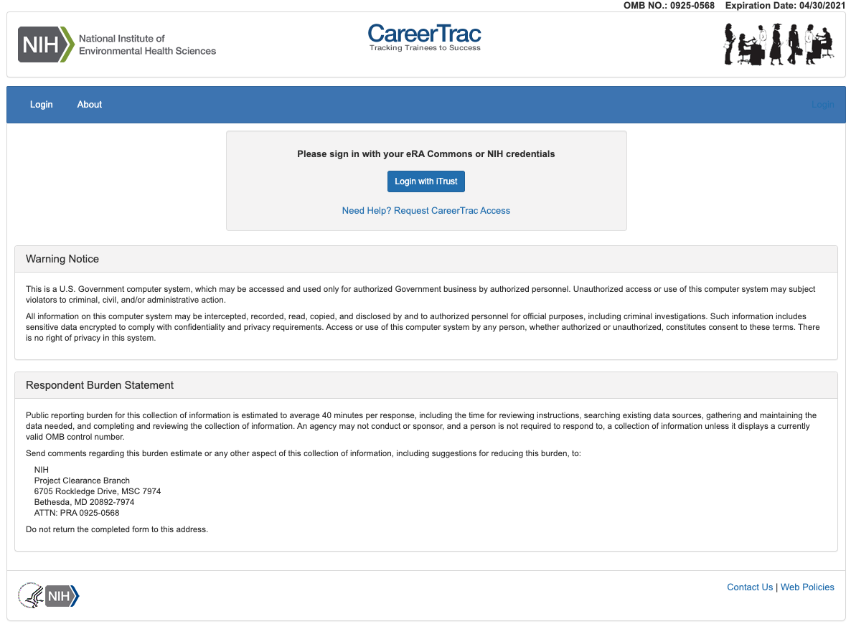

Trainee Search Page
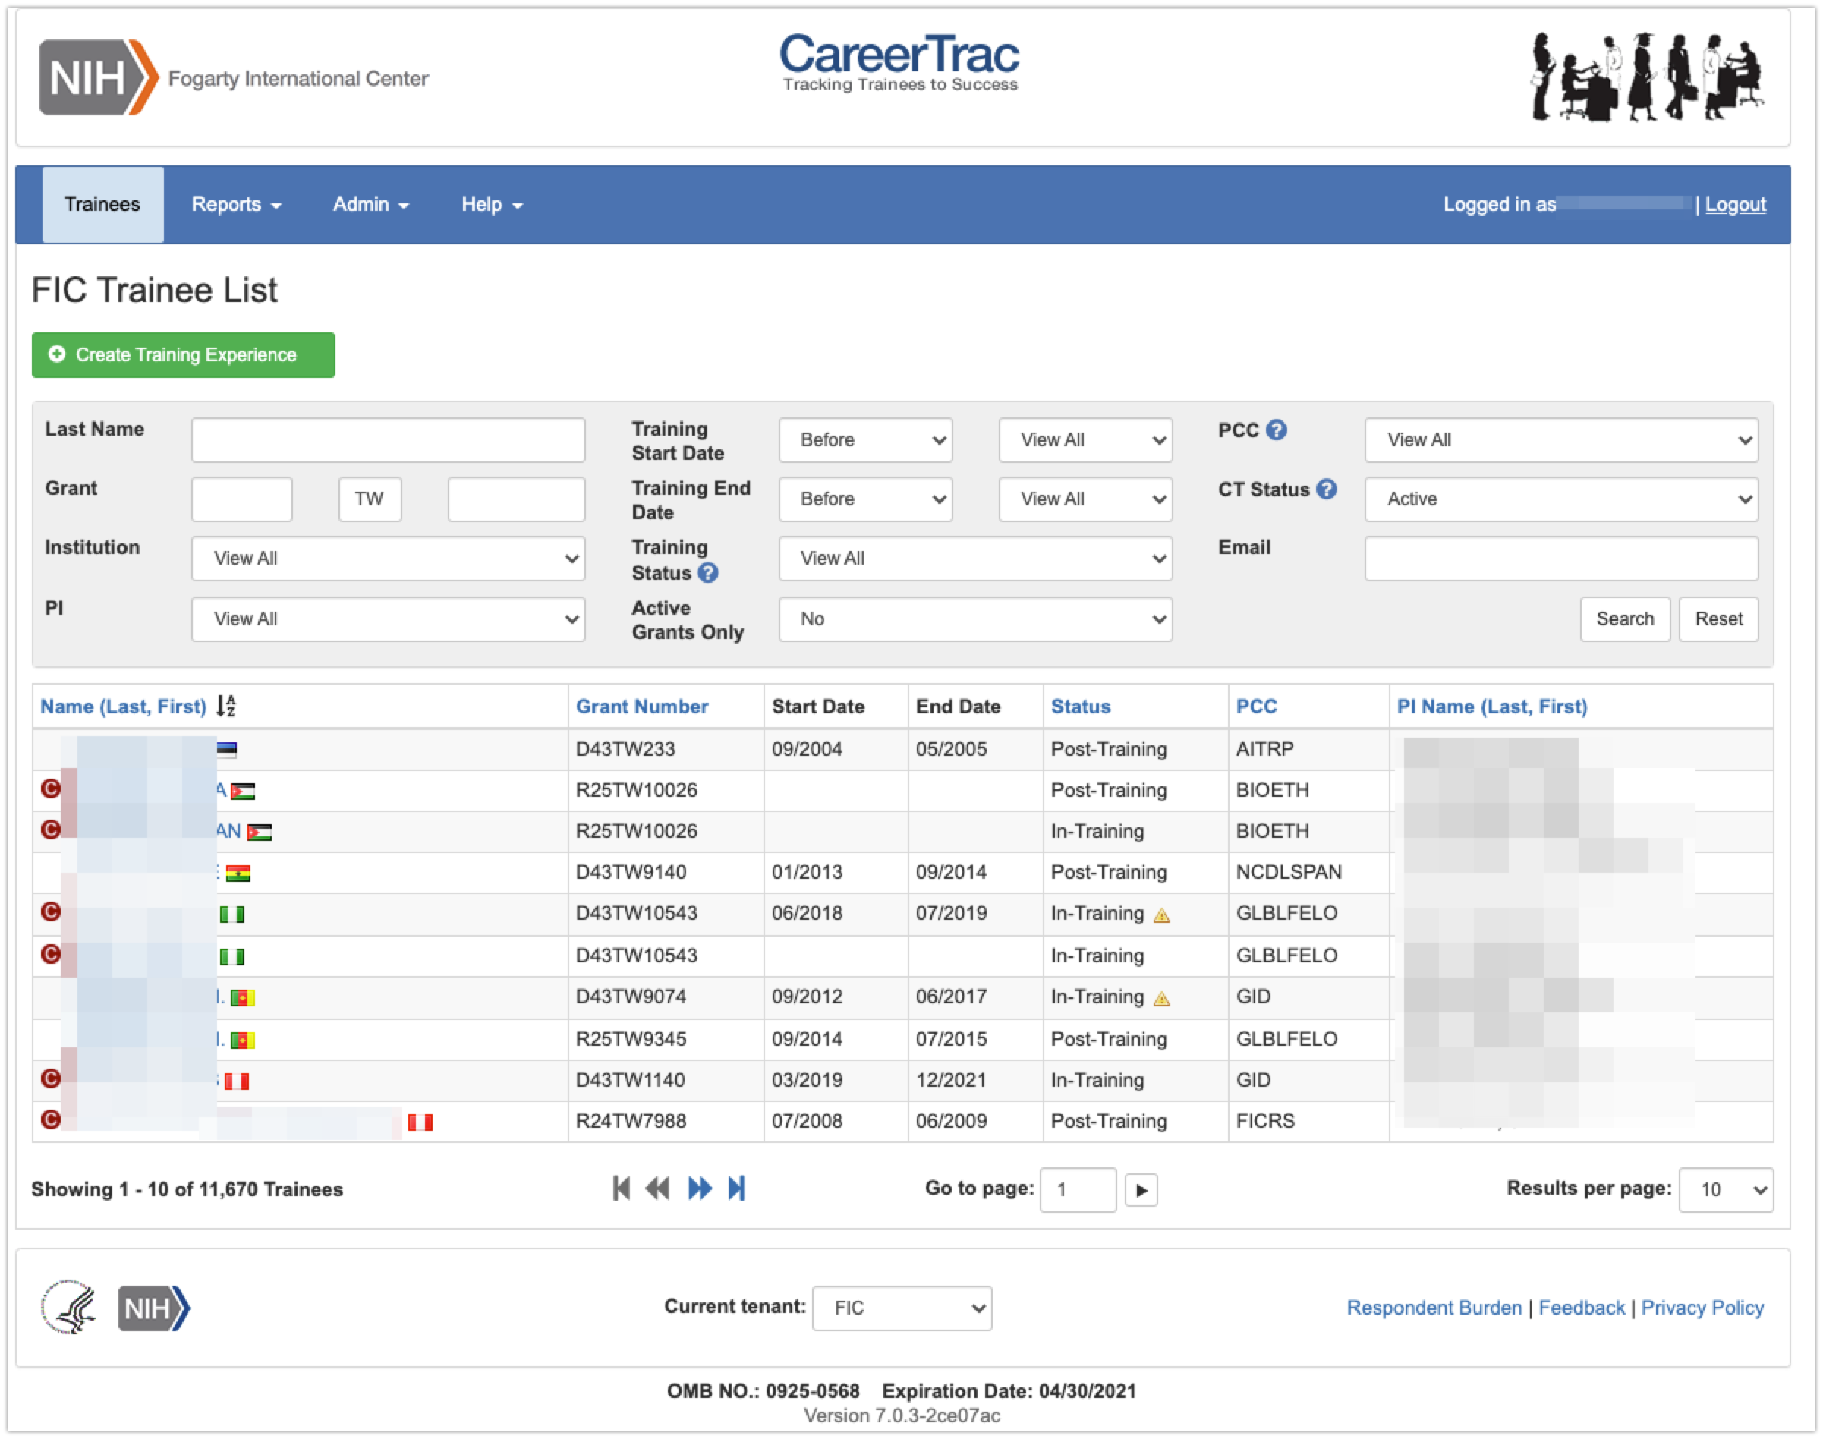

Program Information Page
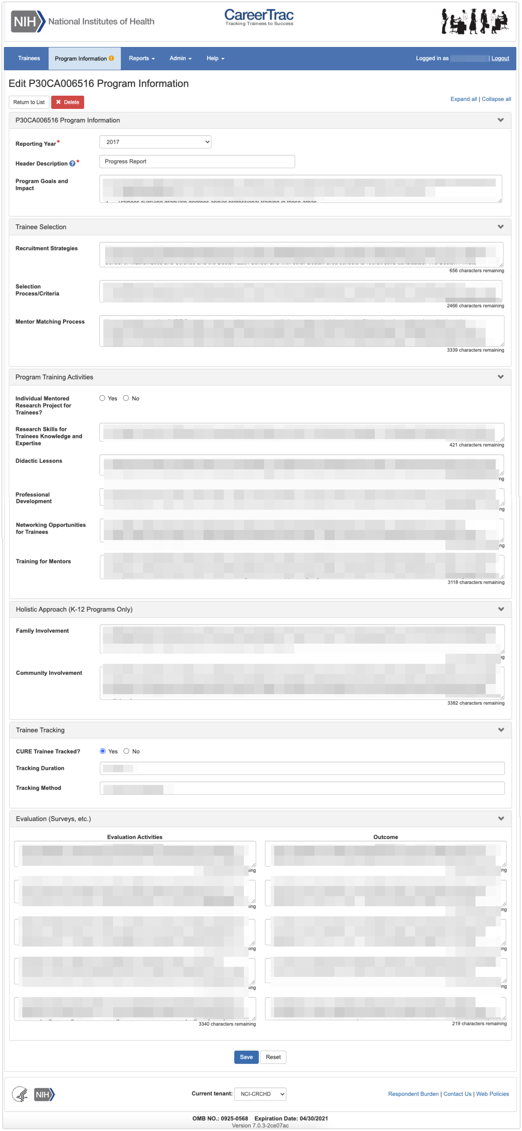

Program Information – Education Products and Teacher Participants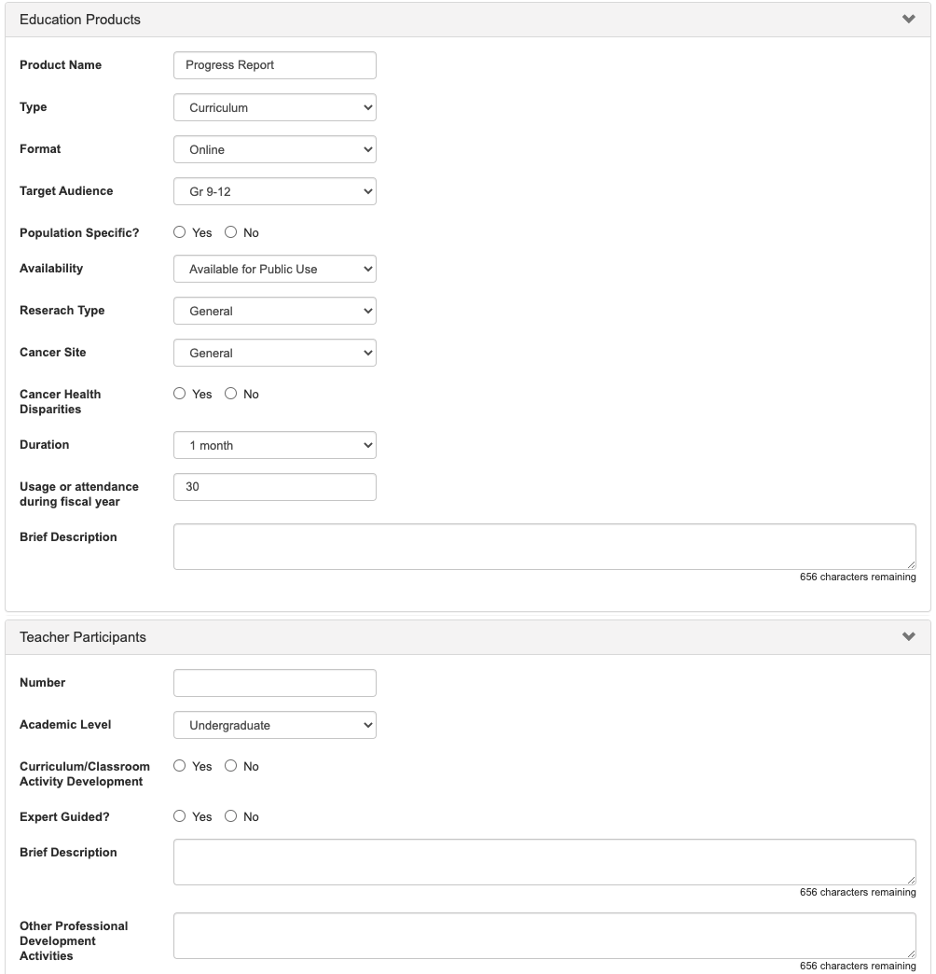

Program Information – Outreach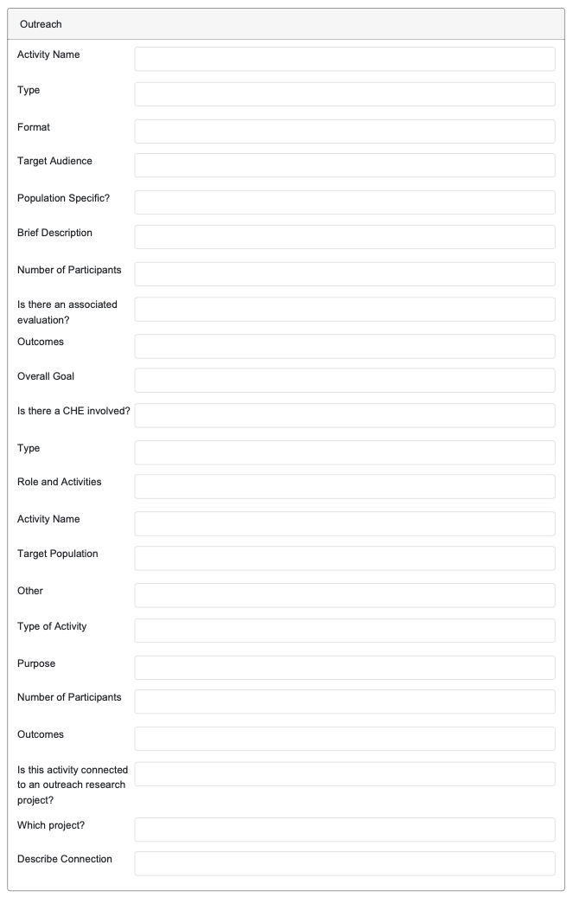

Program Information – Collaboration Efforts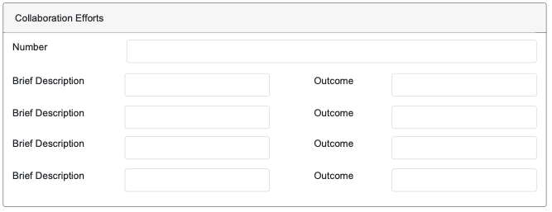

Personal Info Page
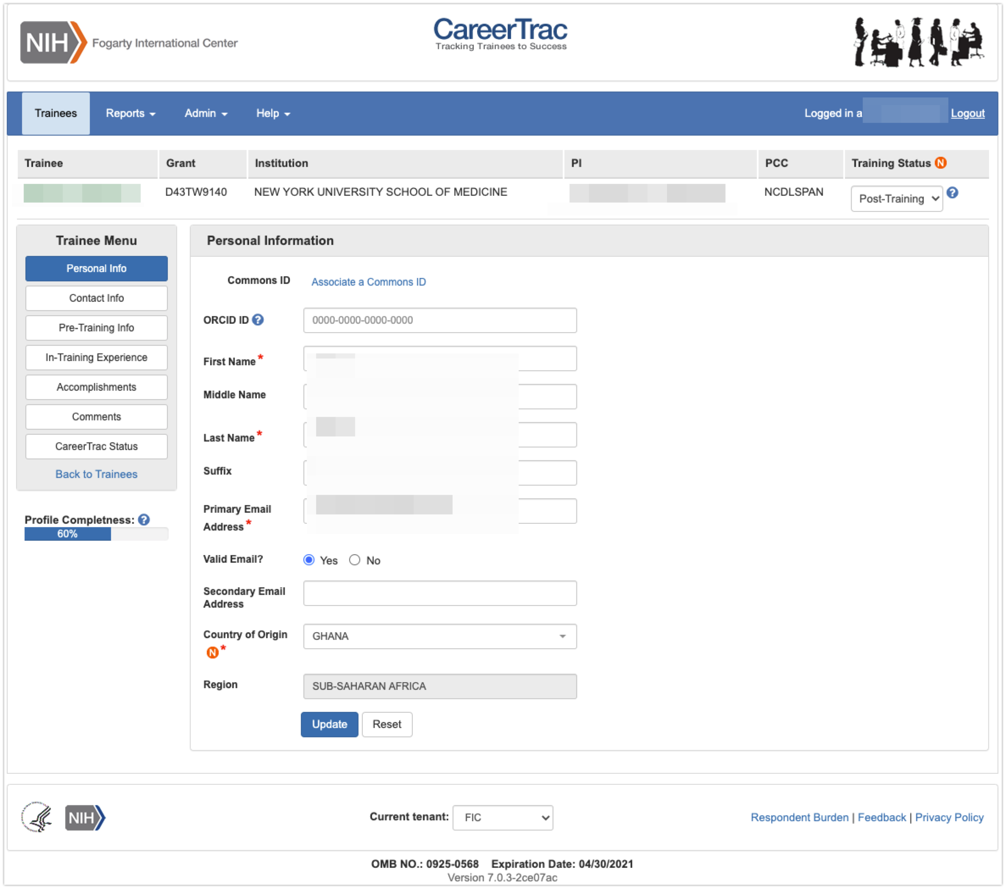

Personal Info Page – Associating a Commons ID (Search)
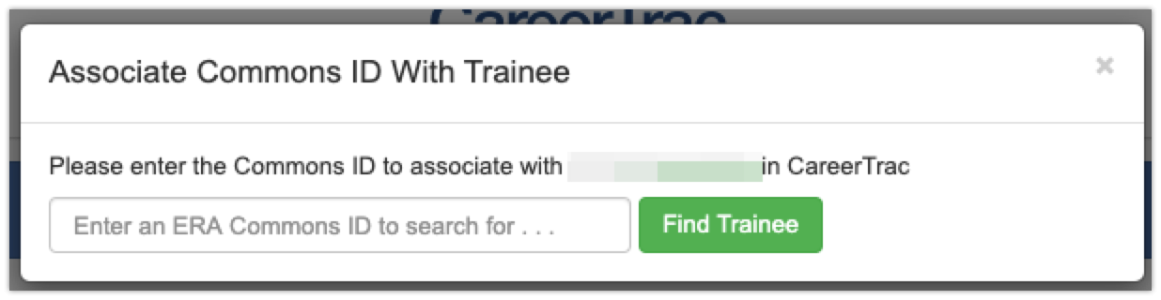

Personal Info Page – Associating a Commons ID (Review) 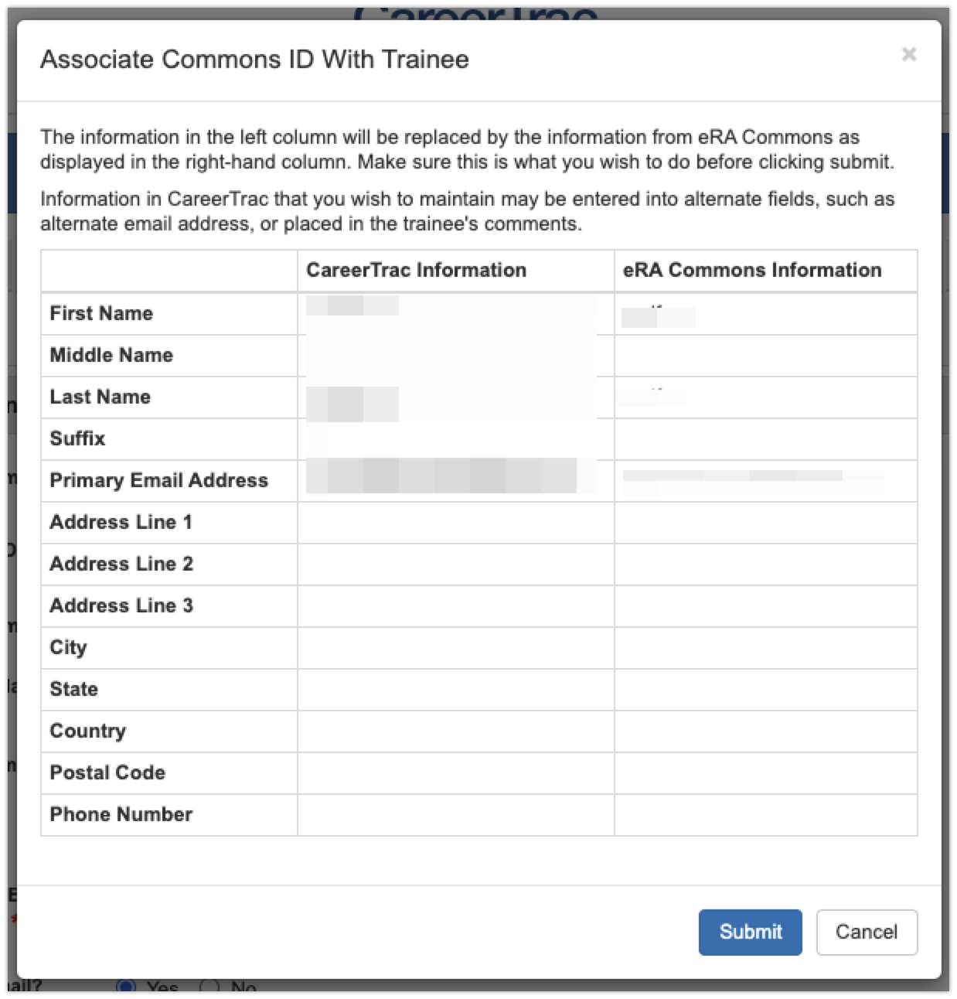

Personal Info Page – Commons Trainee
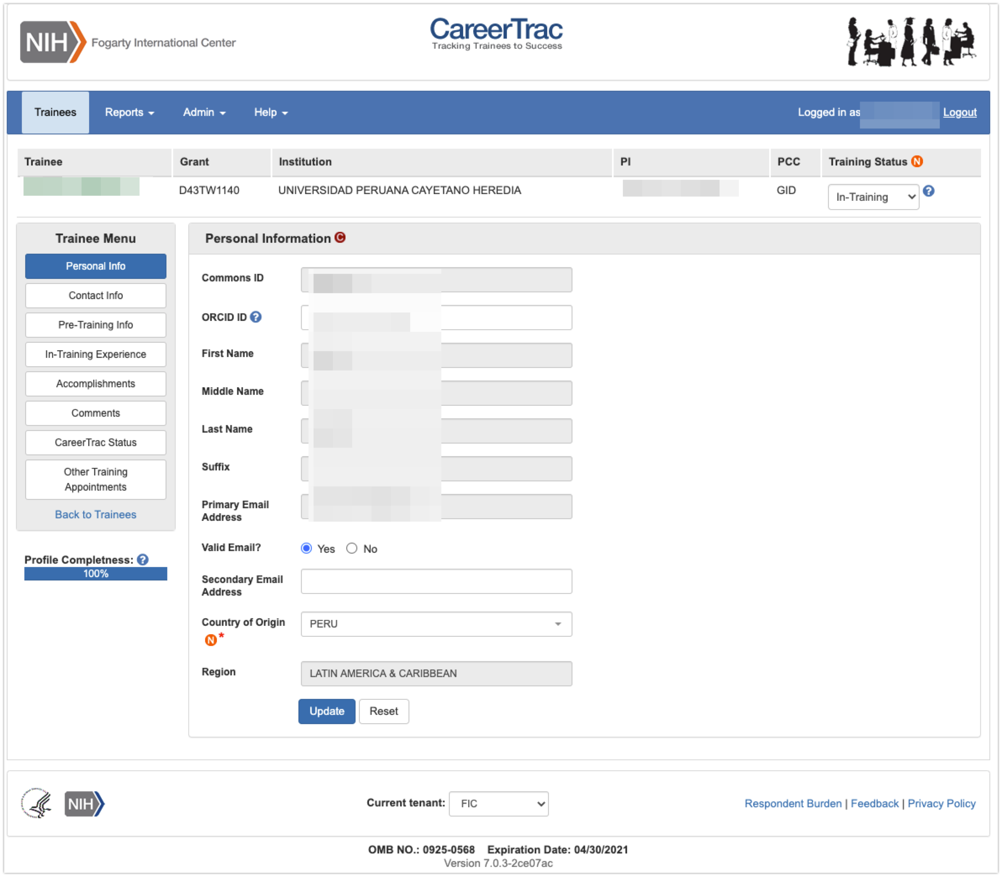

Contact Info Page
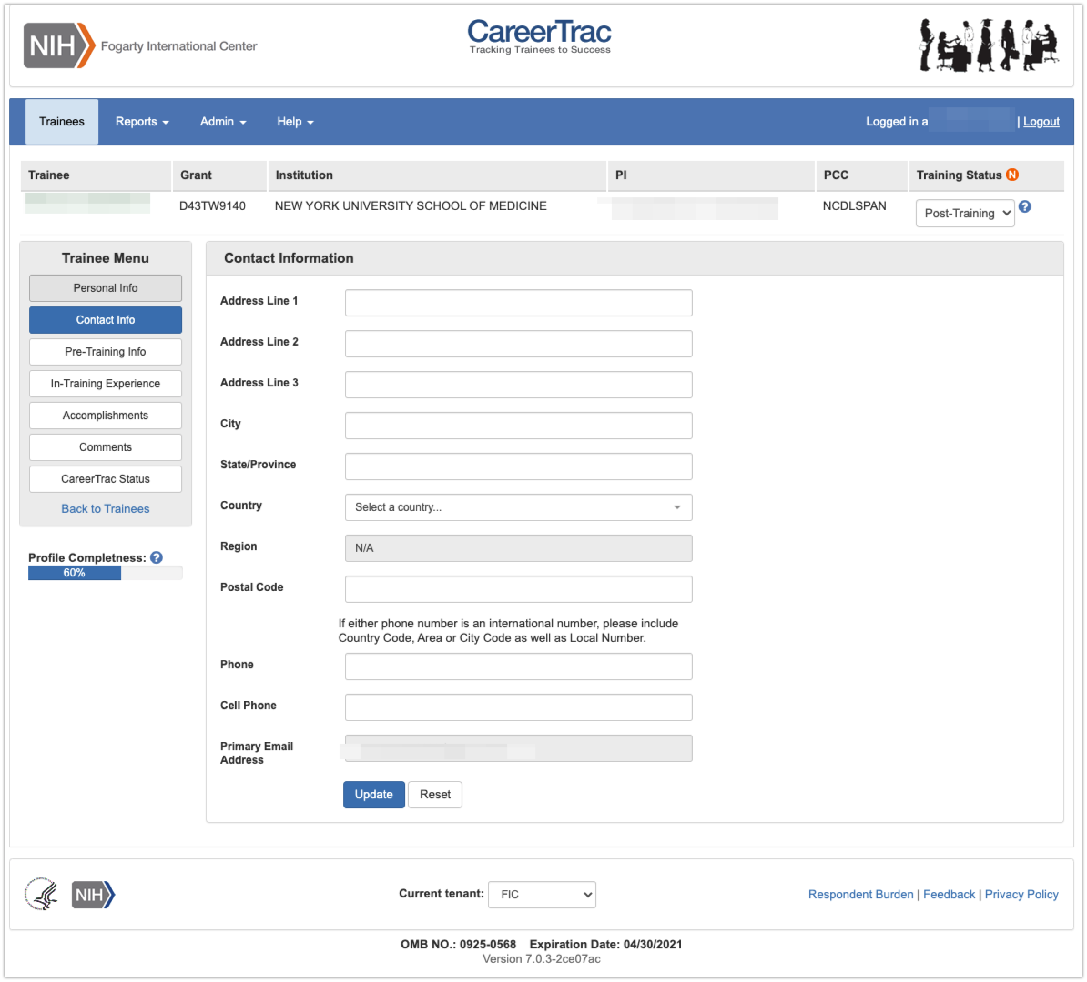

Contact Info Page – Commons Trainee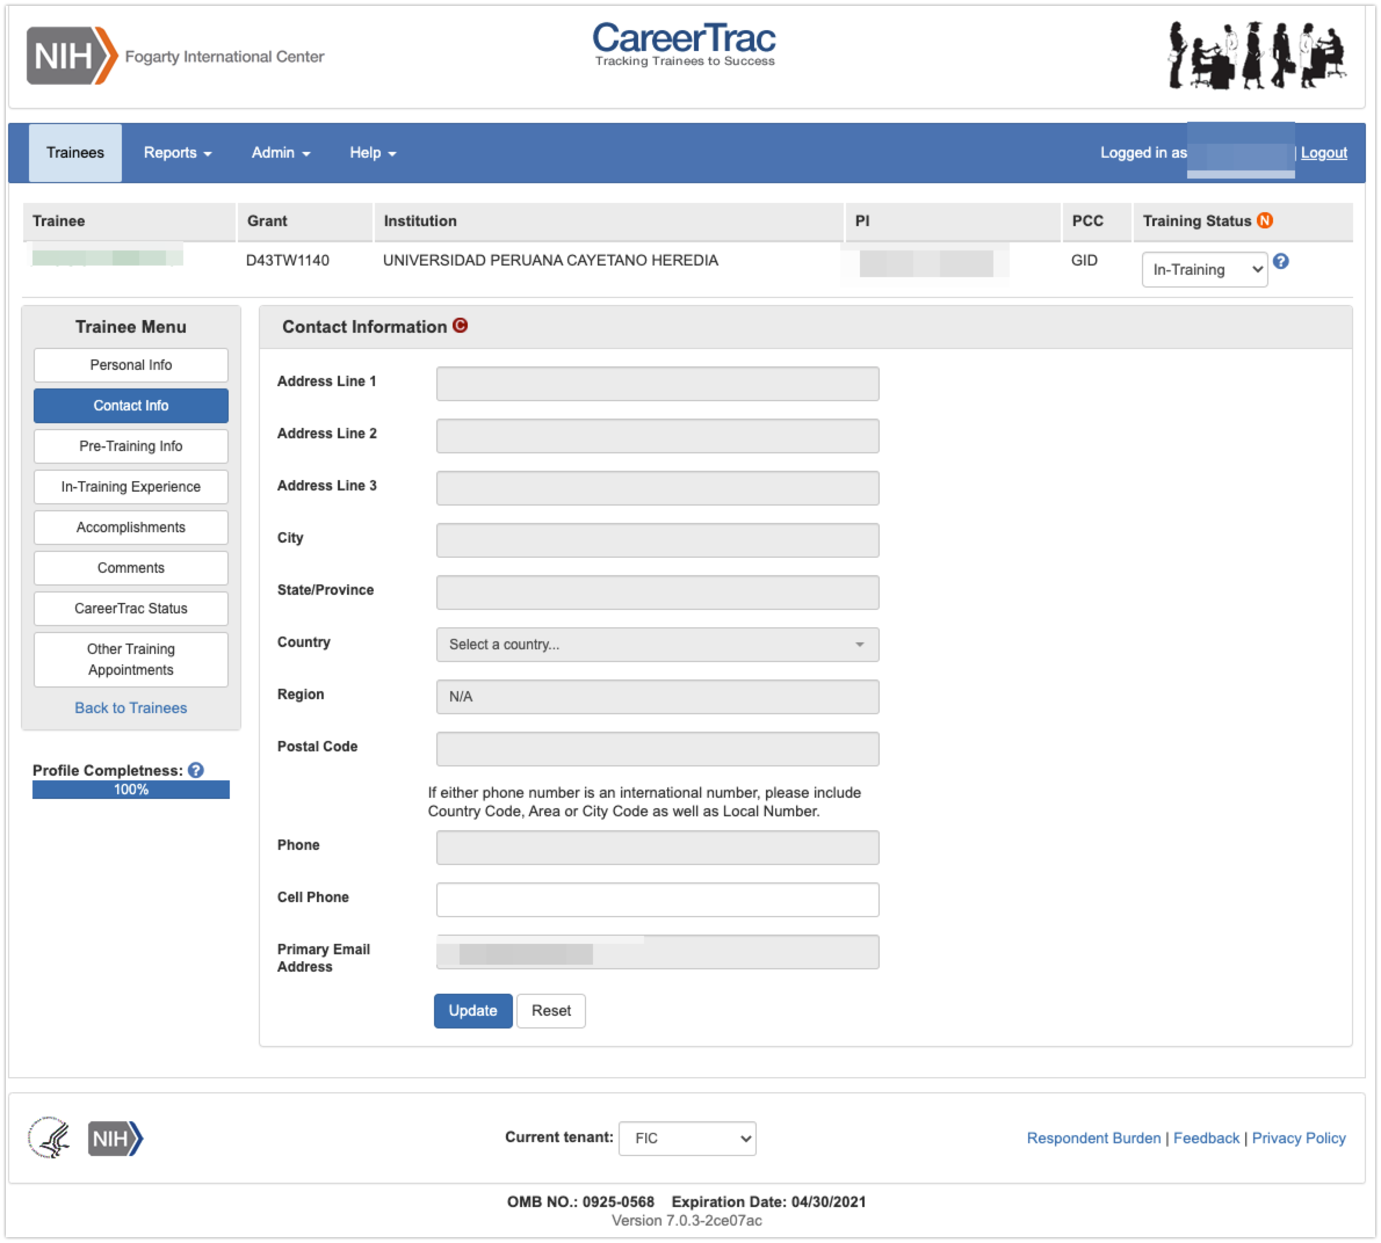

Pre-Training Info Page
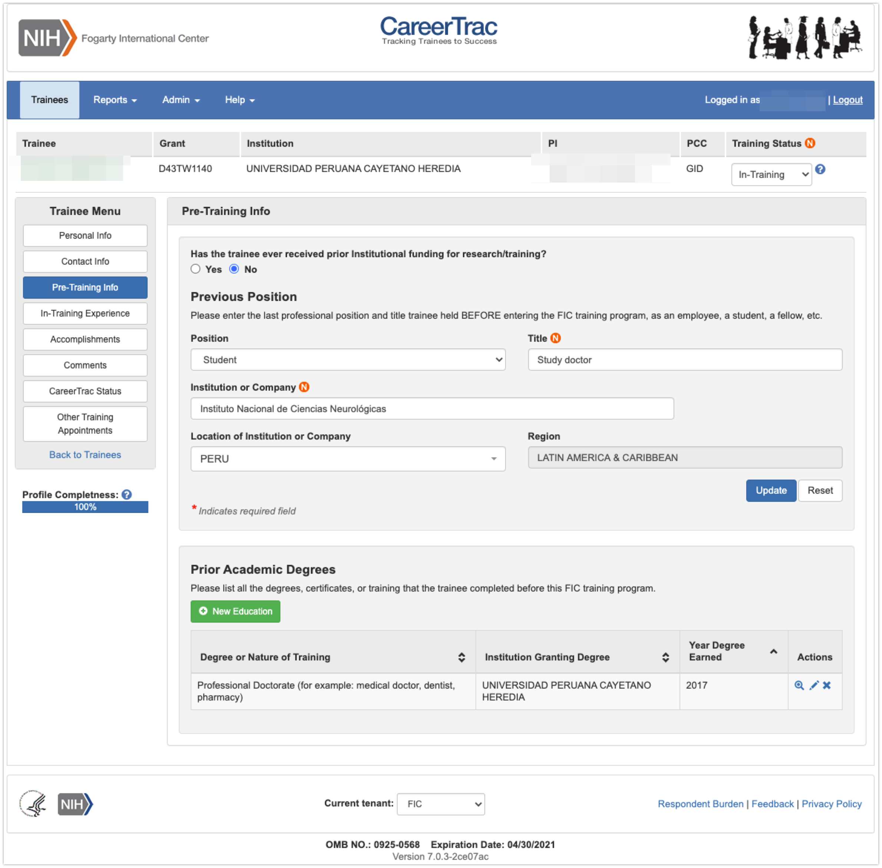

Pre-Training Info Page - Create Prior Academic Degree (Commons Trainee)
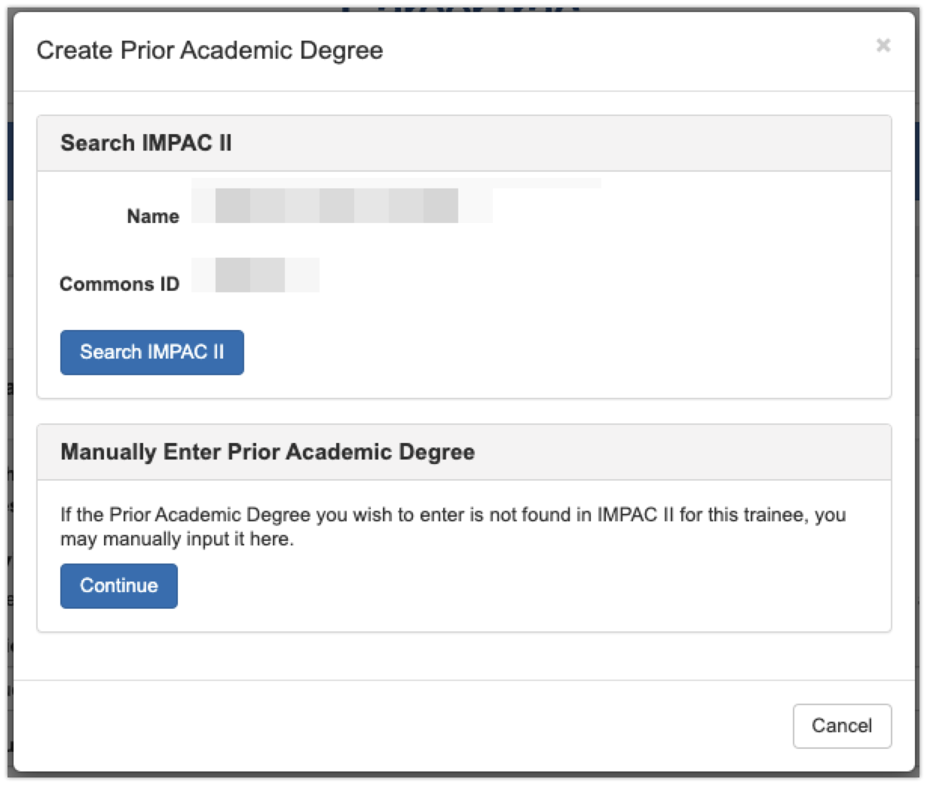

Pre-Training Info Page - Create Prior Academic Degree (Manually Enter)
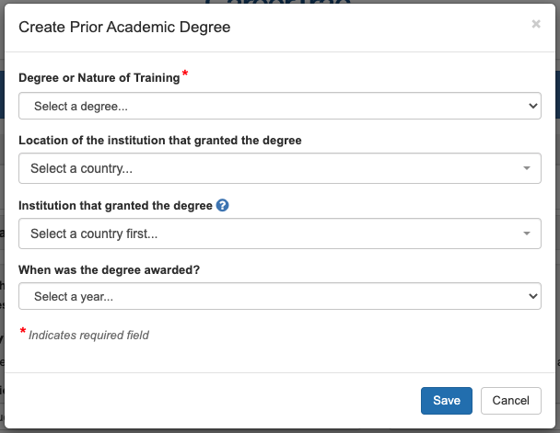

In-Training Info Page
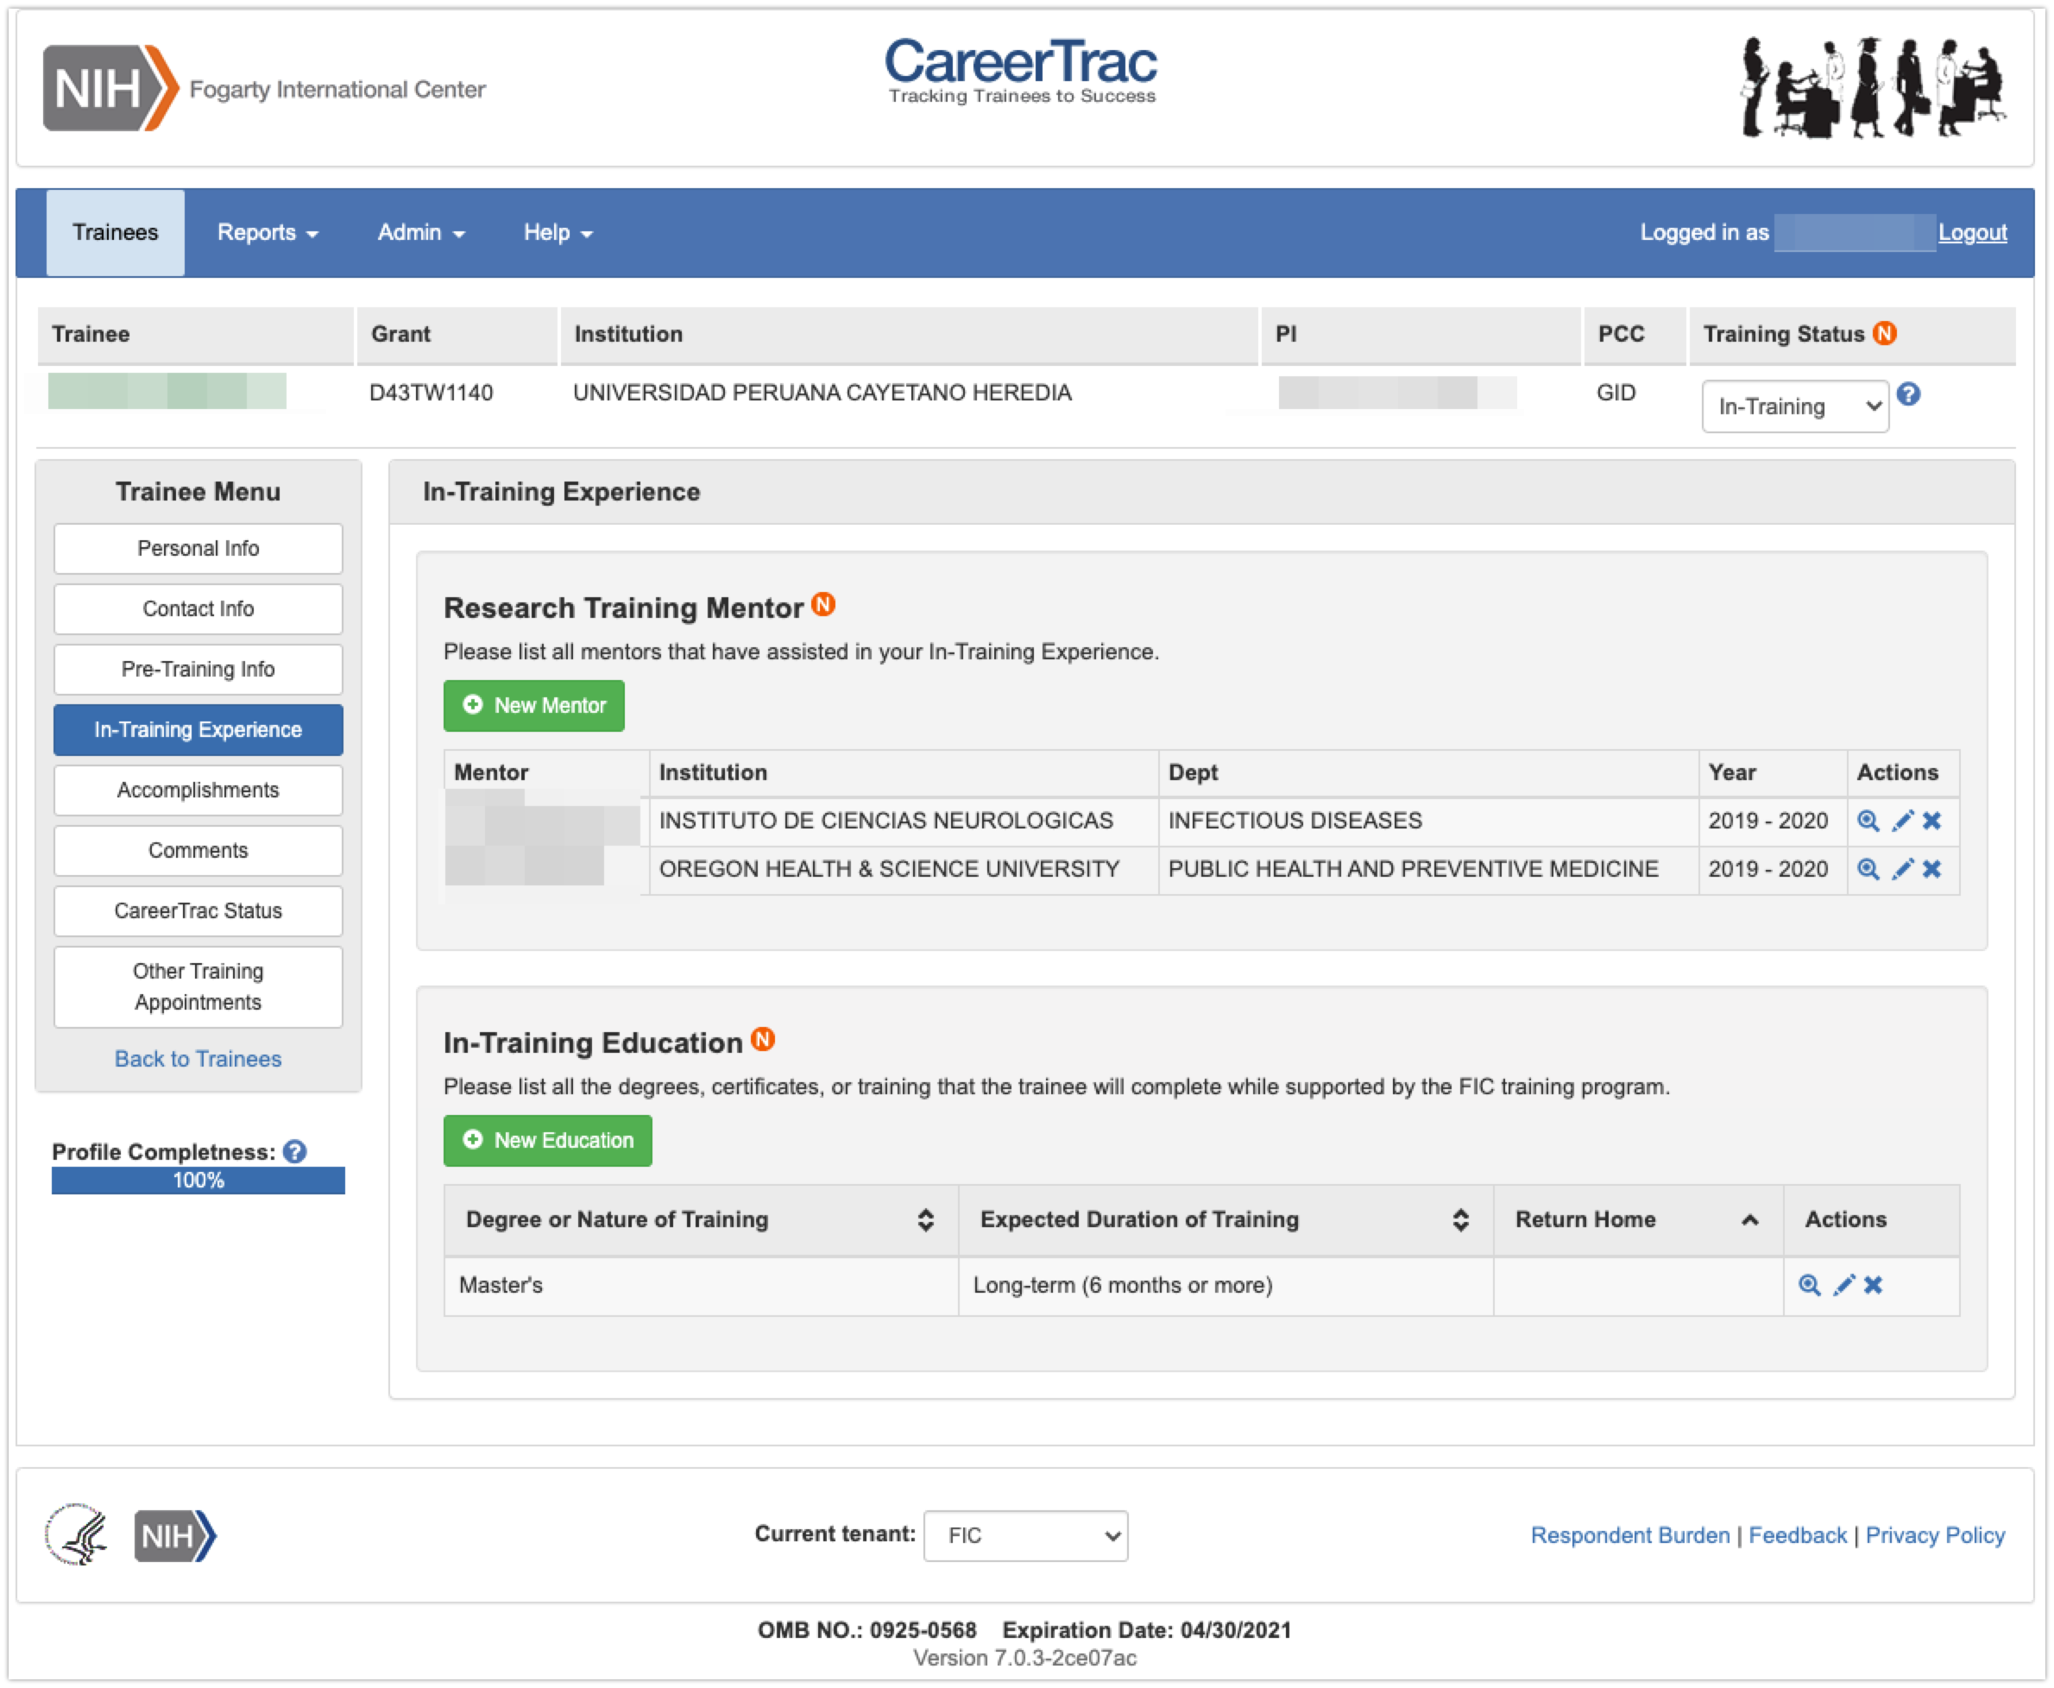

In-Training Info Page – New Mentor (Search)
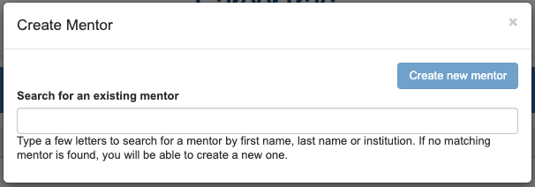

In-Training Info Page – New Mentor (Maunally Enter)
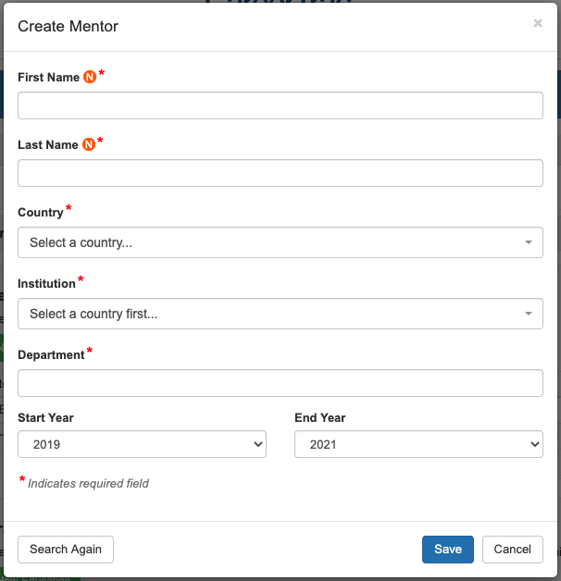

In-Training Info Page – Create Education (Commons Trainee)
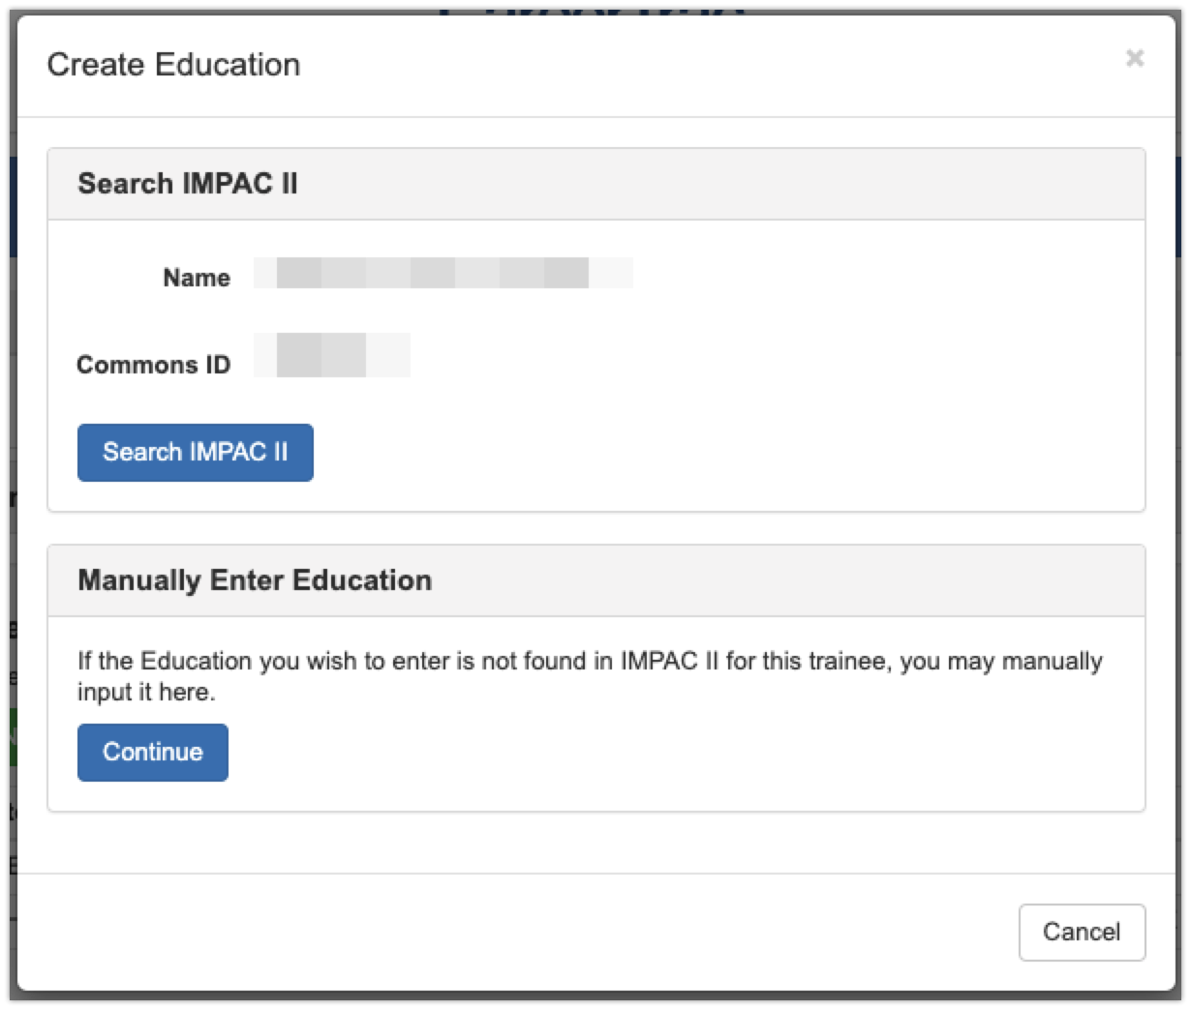

In-Training Info Page – Create Education (Manually Enter)
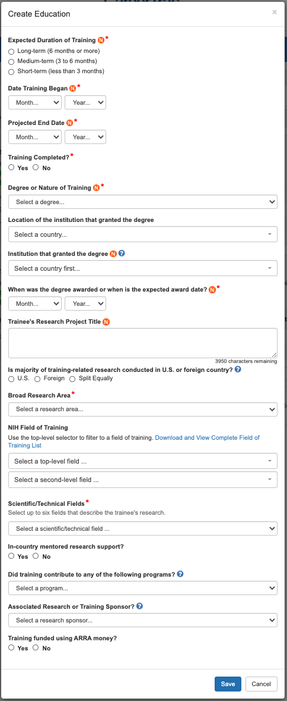

Accomplishments Page
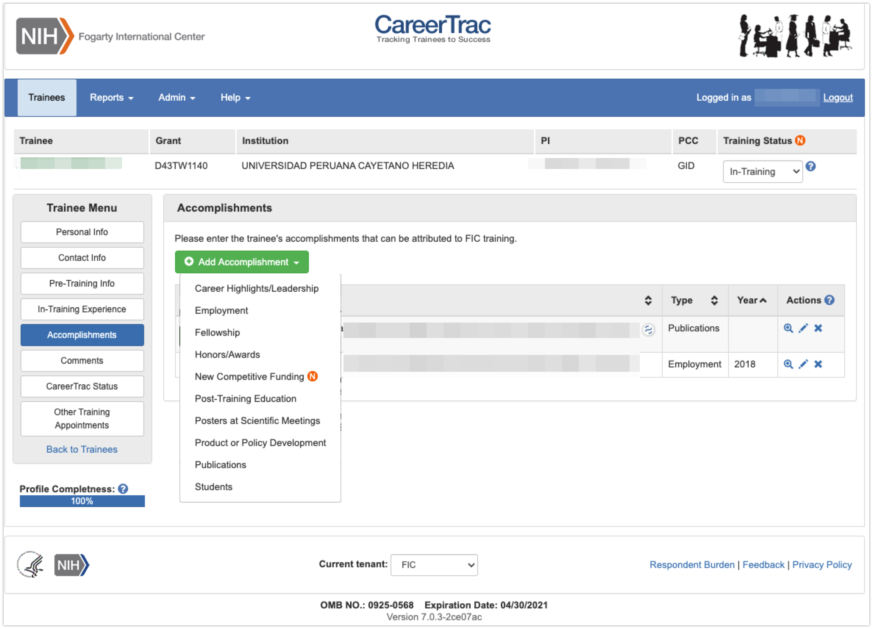

Accomplishments – Career Highlights/Leadership
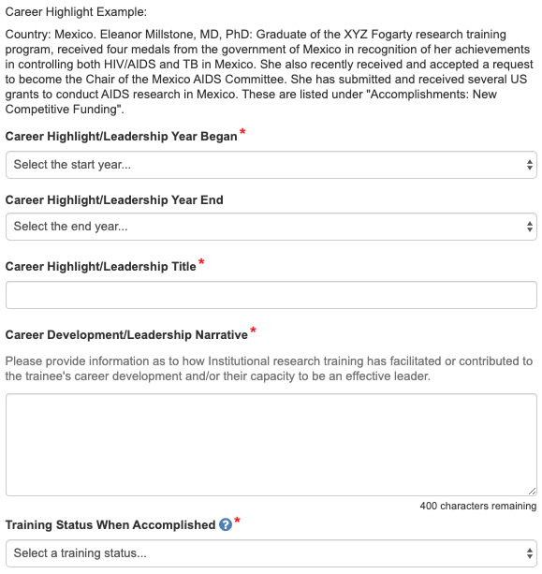

Accomplishments – Employment (Commons Trainee)
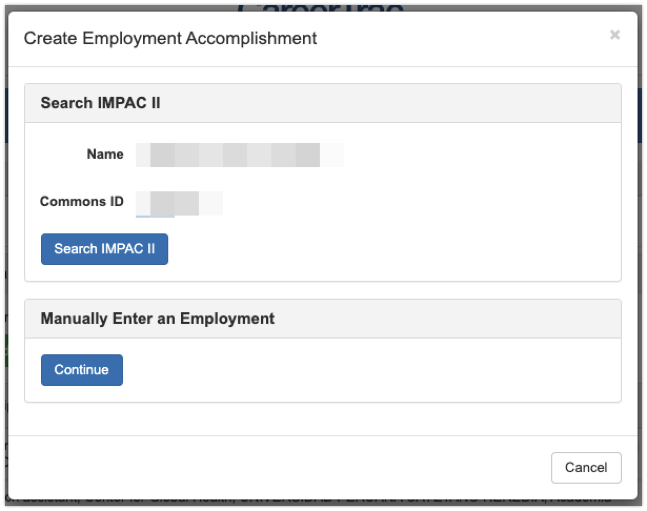

Accomplishments – Employment (Manually Enter)
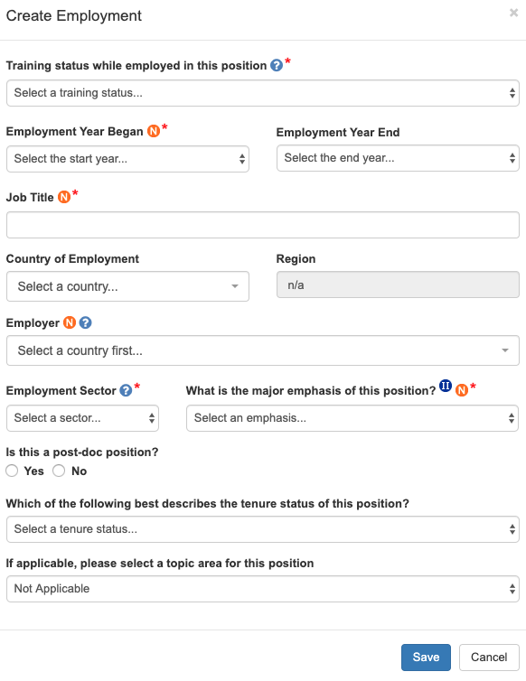

Accomplishments – Fellowship
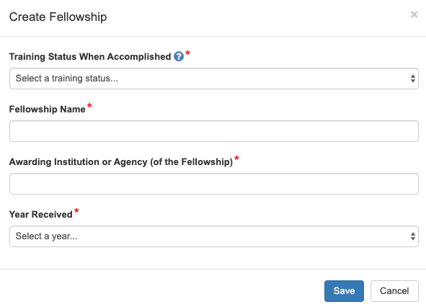

Accomplishments – Honors/Awards 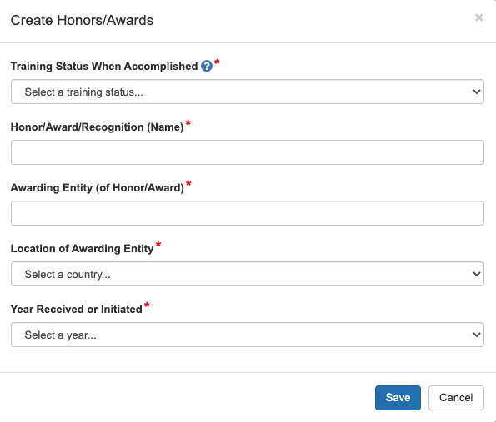

Accomplishments – New Competitive Funding (Commons Trainees)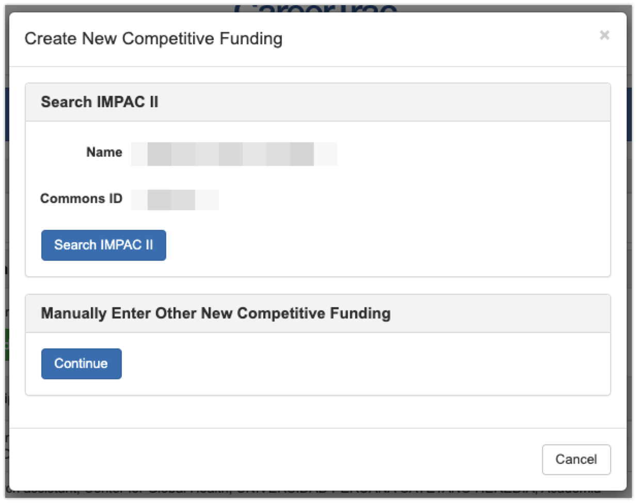

Accomplishments – New Competitive Funding (Manually Enter)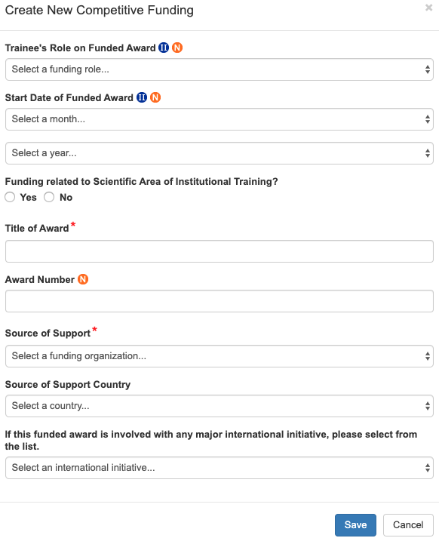

Accomplishments – Post Training Education (Commons Trainees)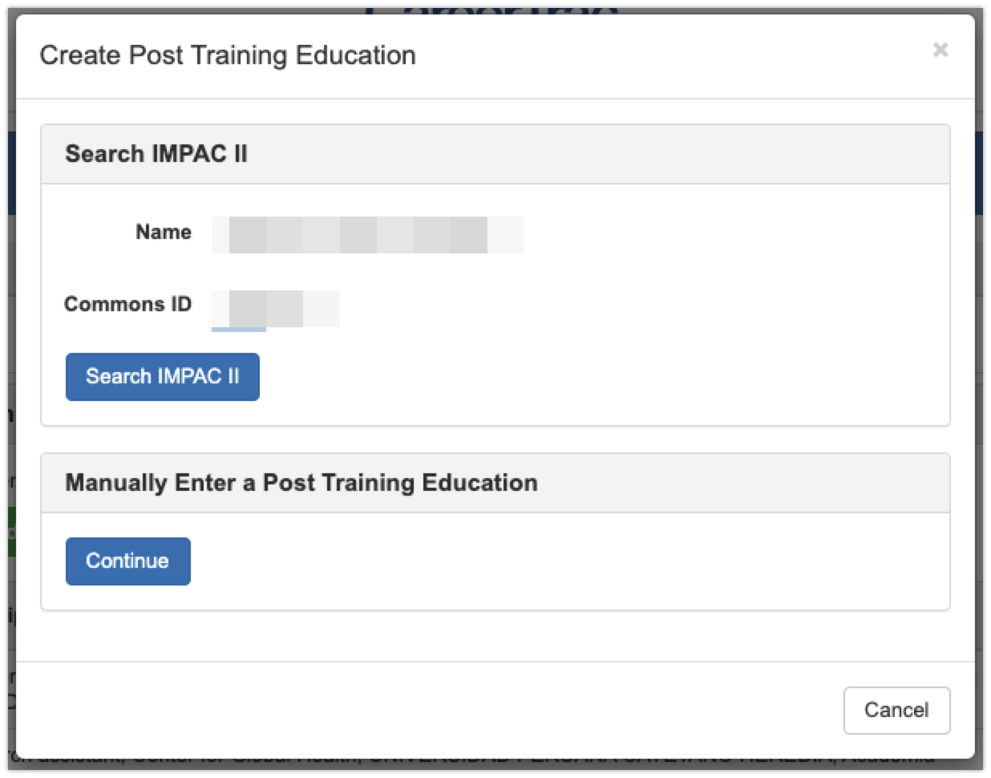

Accomplishments - Post Training Education (Manually Enter)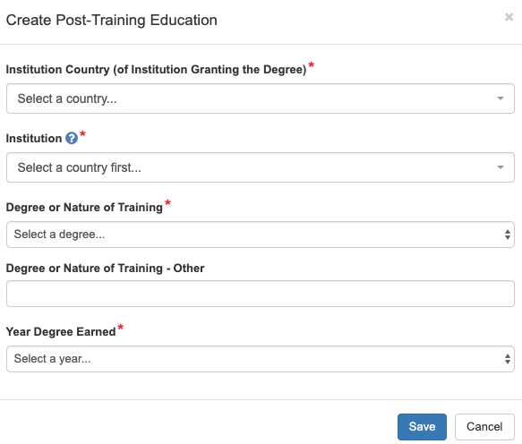

Accomplishments – Posters at Scientific Meetings 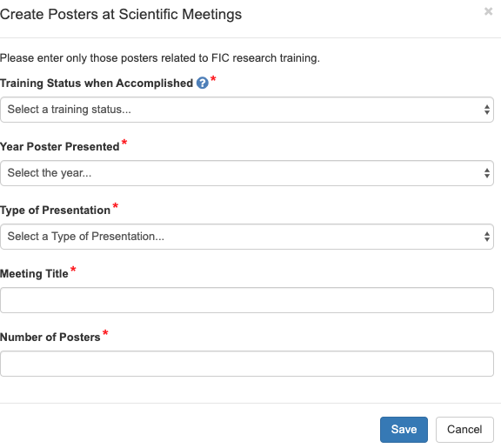

Accomplishments – Product or Policy Development 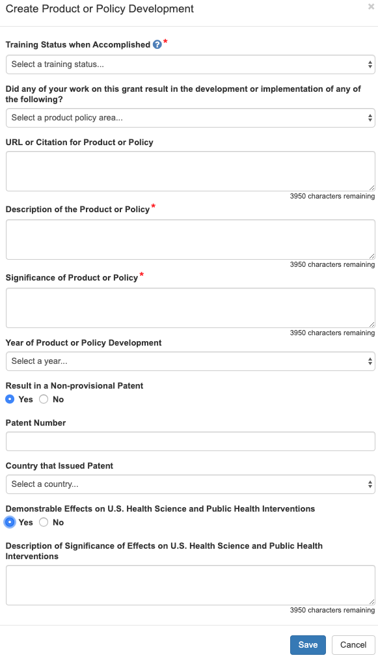

Accomplishments – Publications (Search)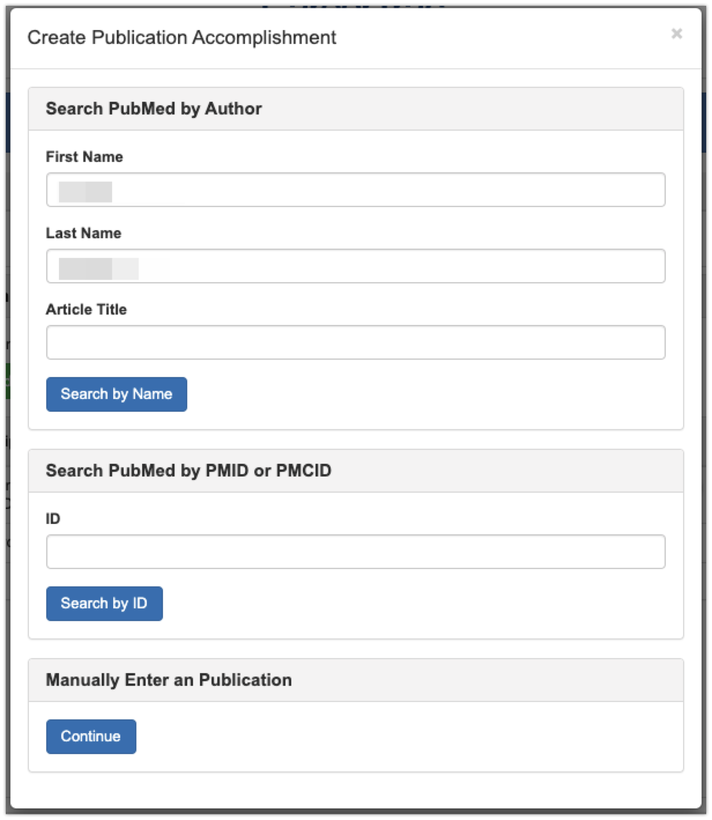

Accomplishments – Publications (Maunally Enter)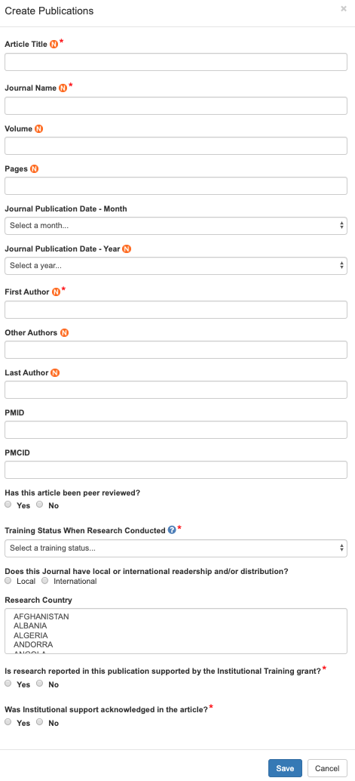

Accomplishments – Students
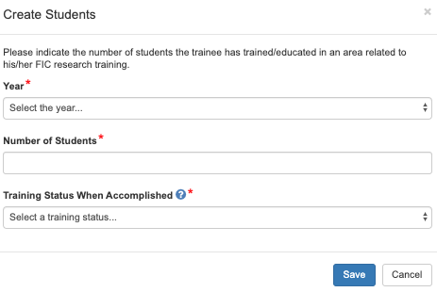

Comments
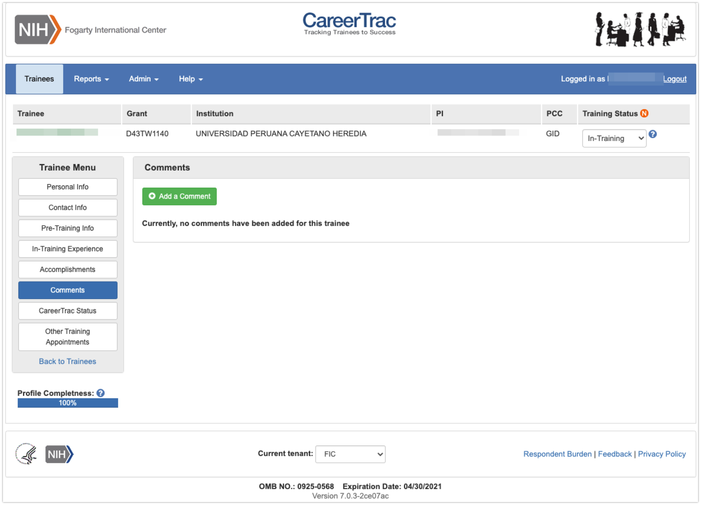

Comments – Add Comments 