**NIEHS and NIDDK CareerTrac Screenshots**

# Login Page

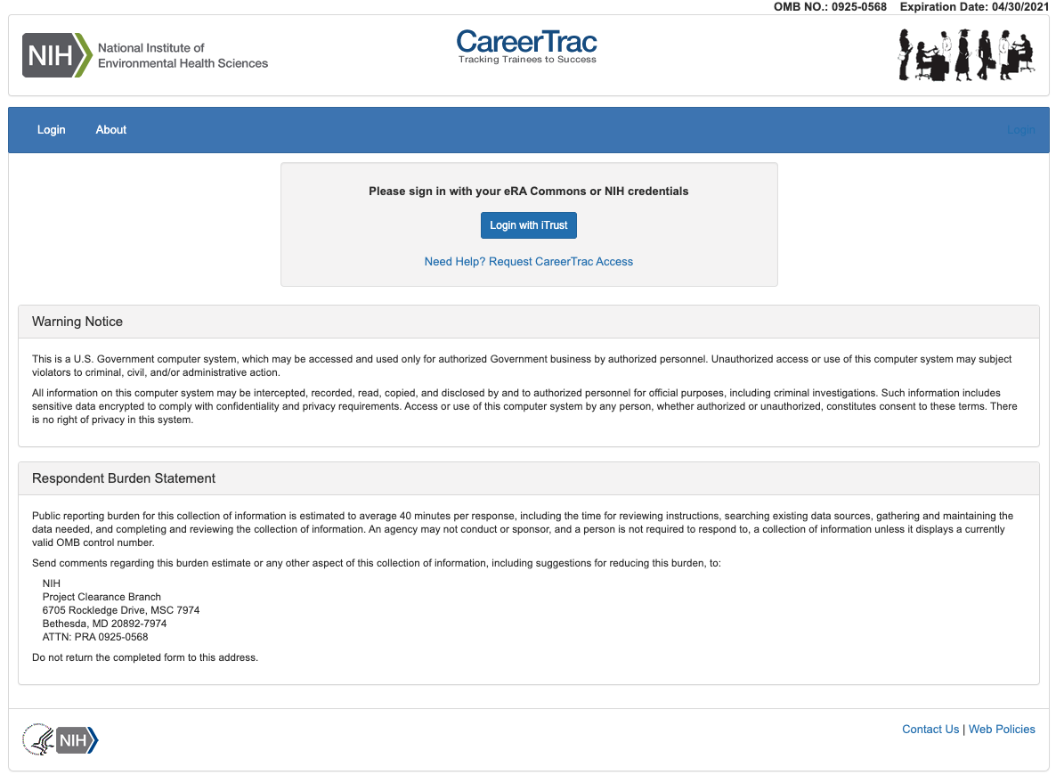

# Trainee Search Page

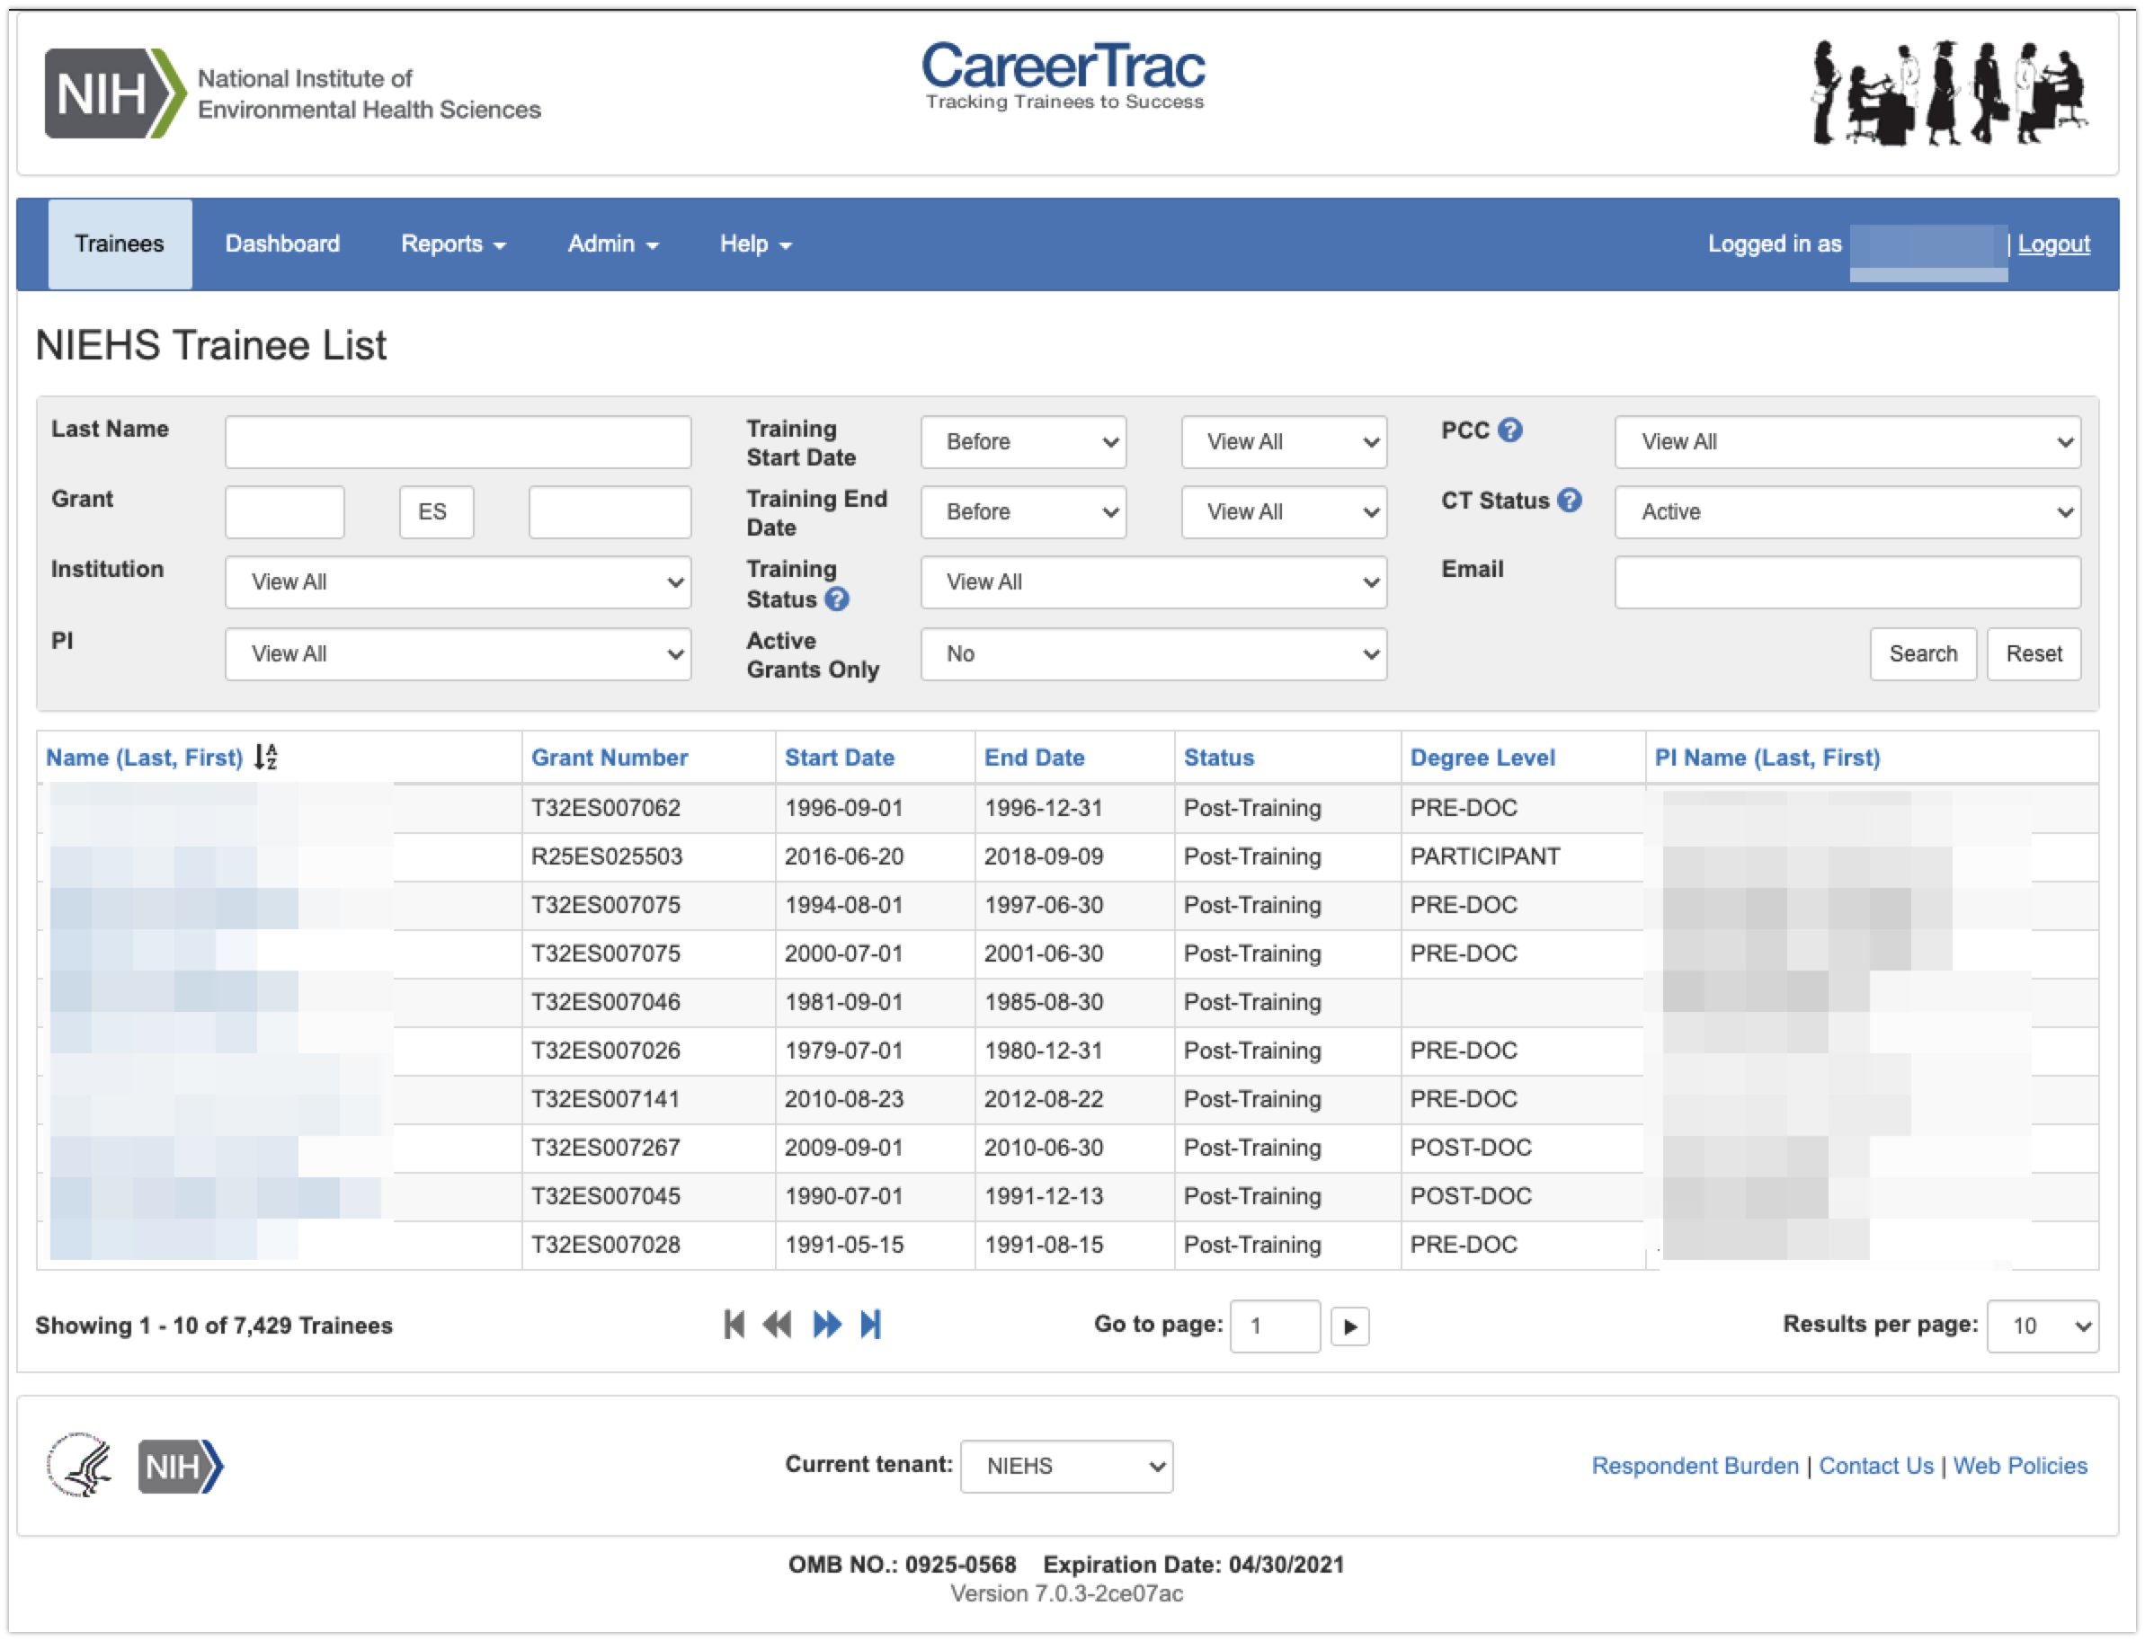

# Program Information Page

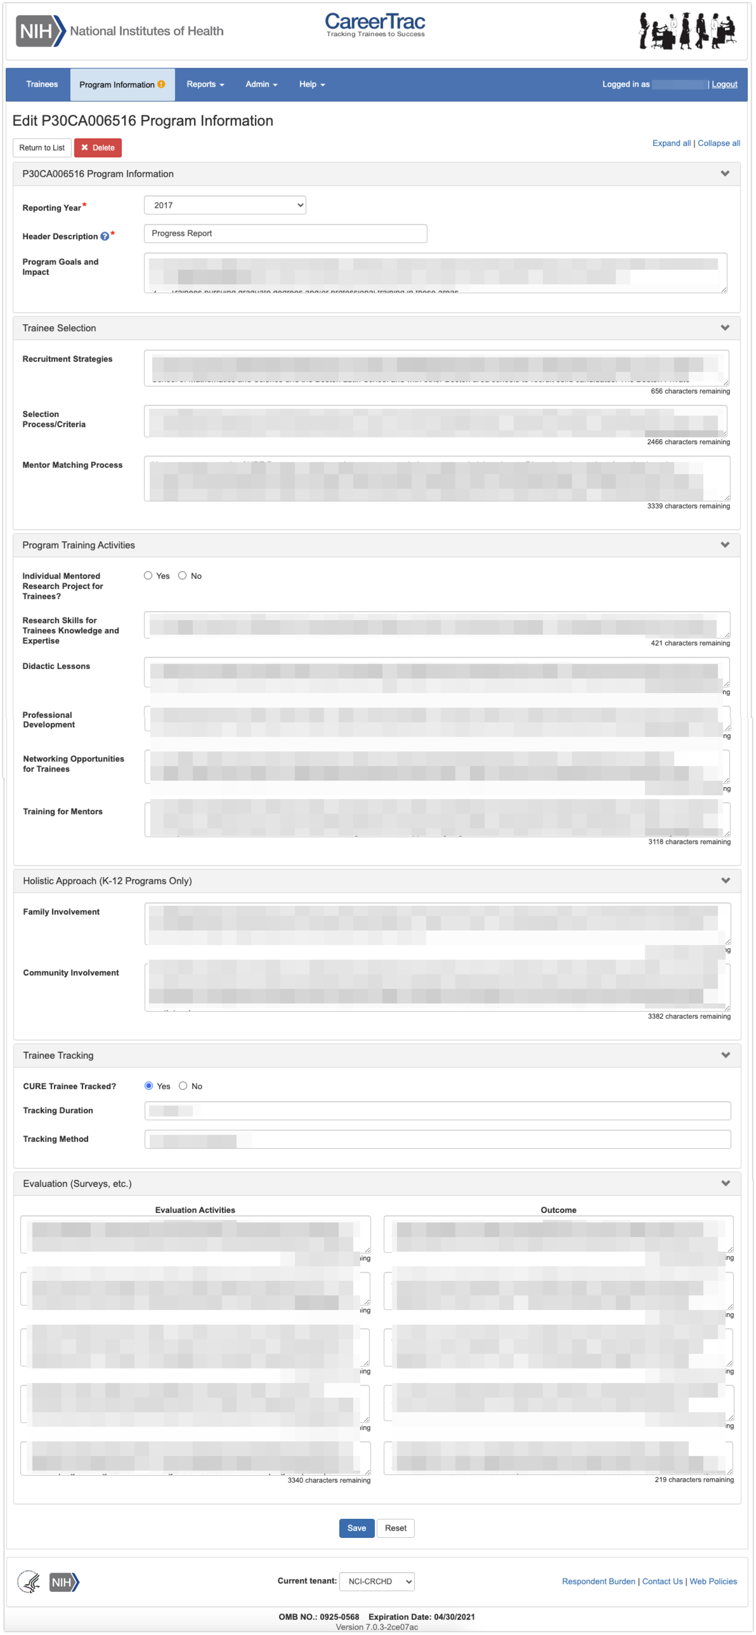

## Program Information – Education Products and Teacher Participants

## Program Information – Outreach

## Program Information – Collaboration Efforts

# Contact Info Page

# Pre-Training Info

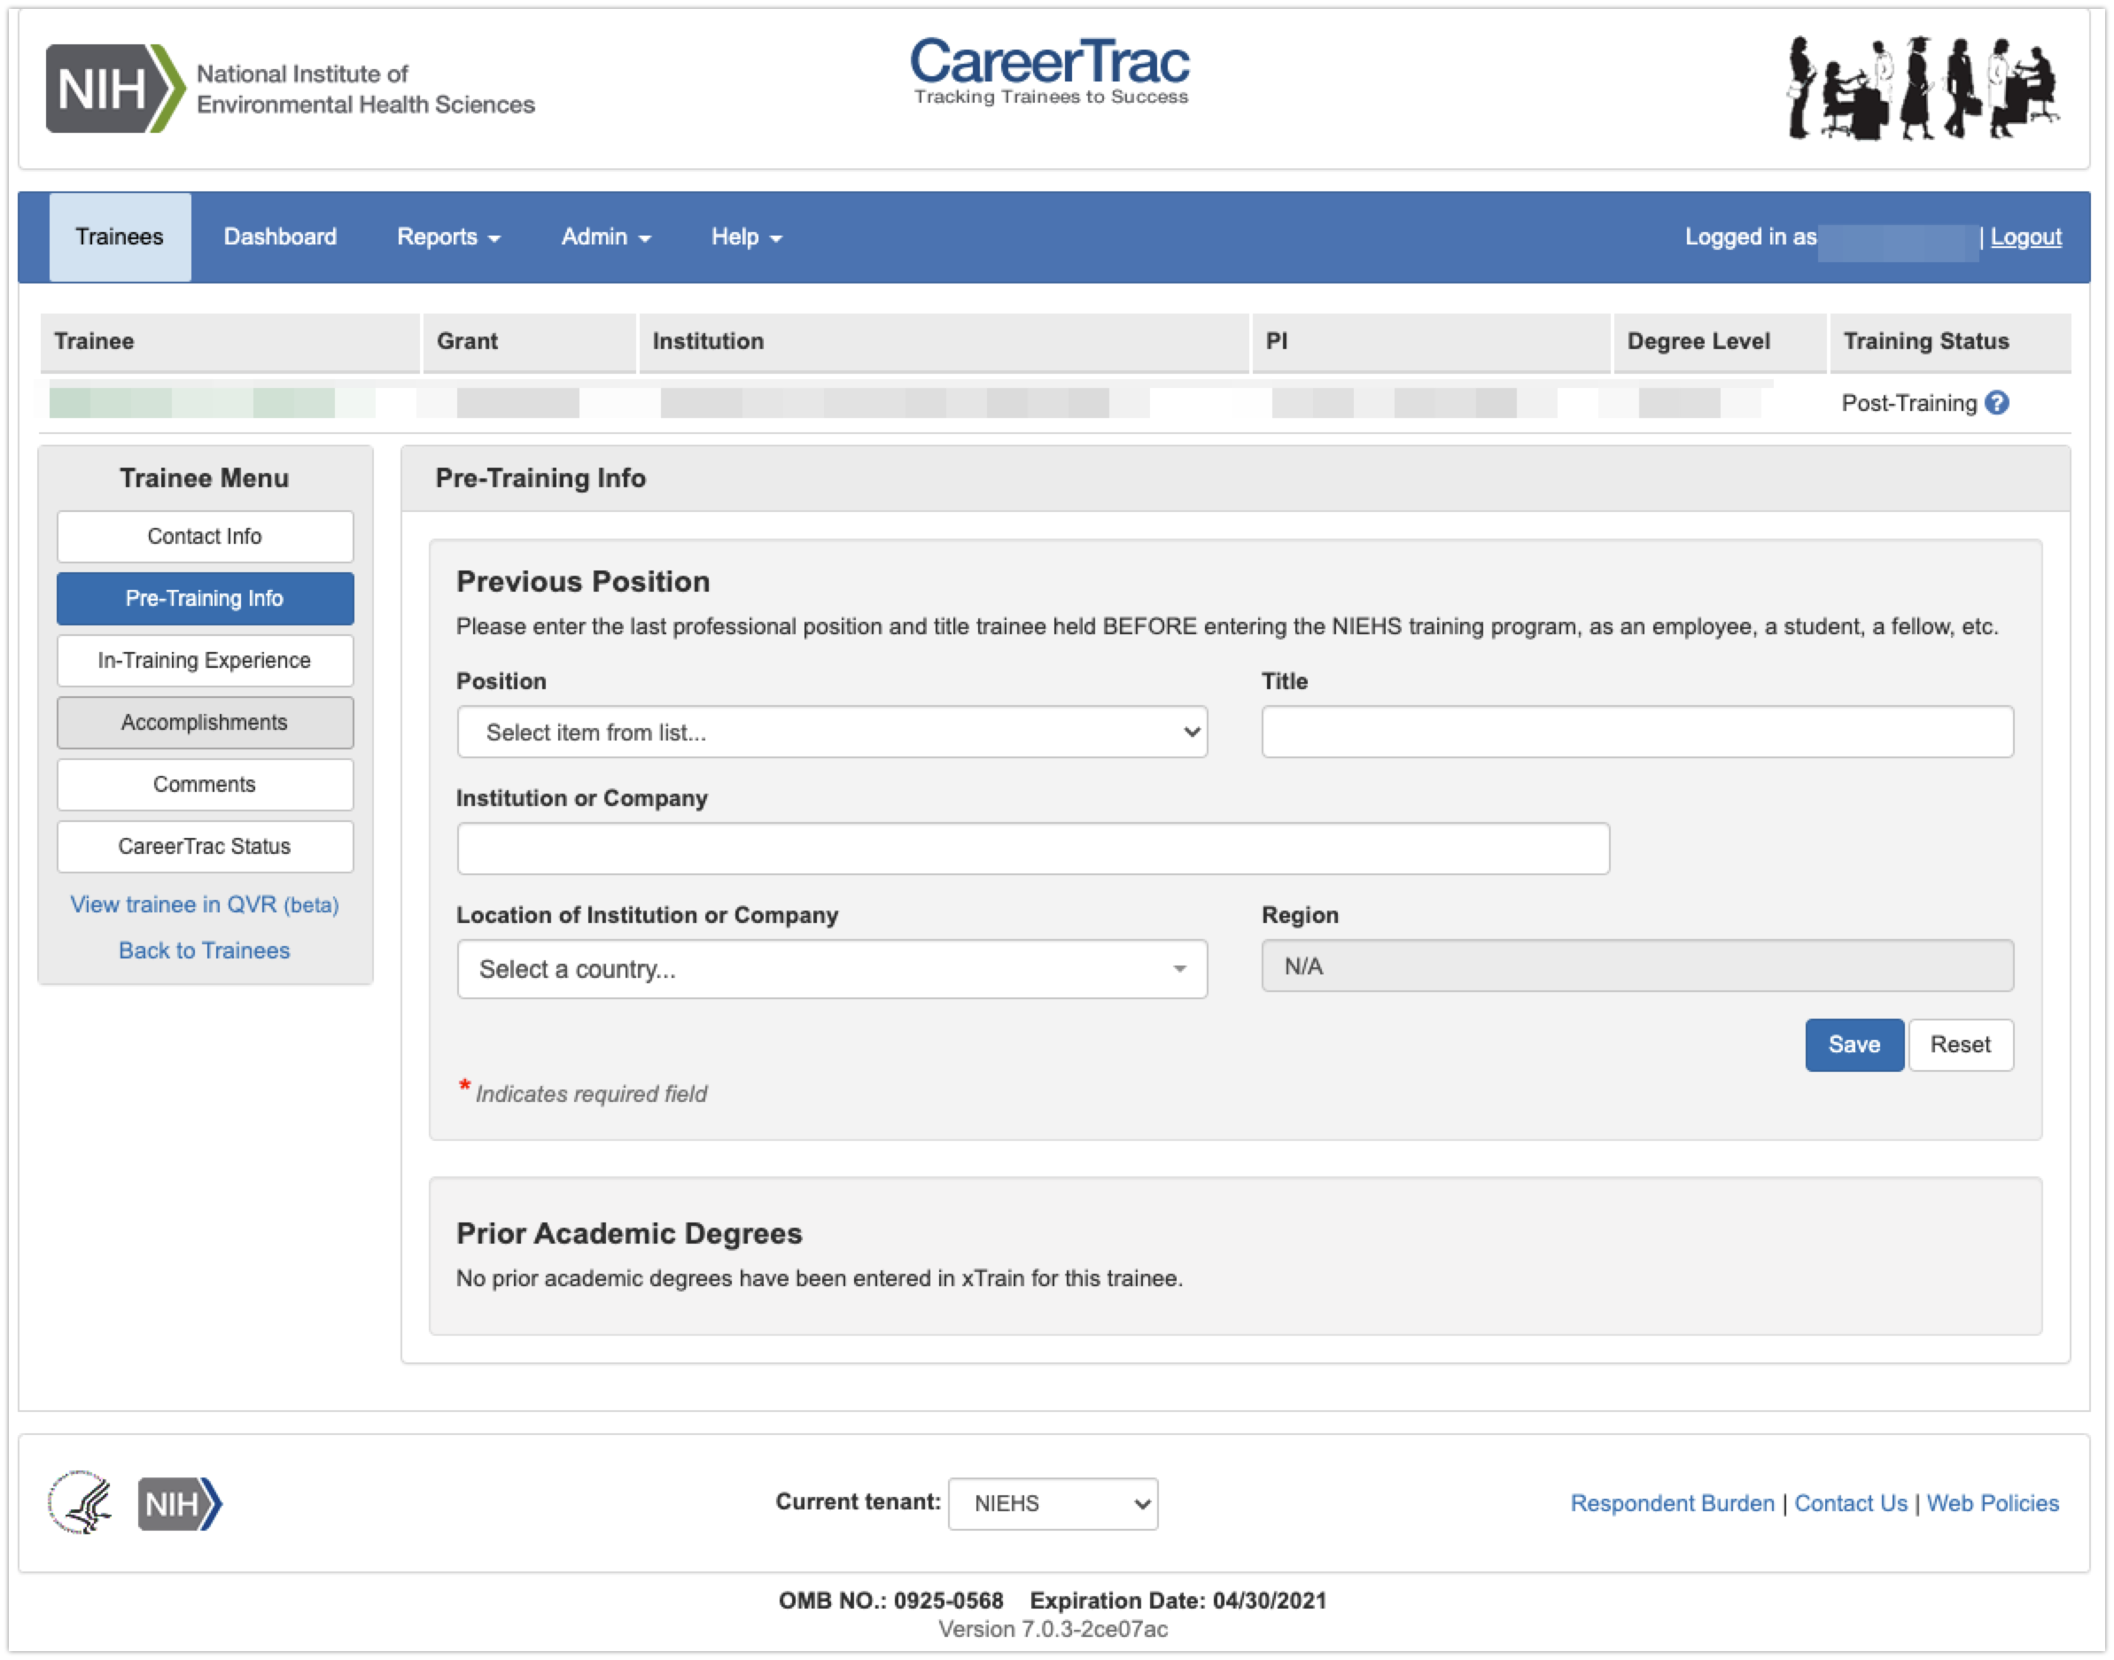

# In-Training Experience

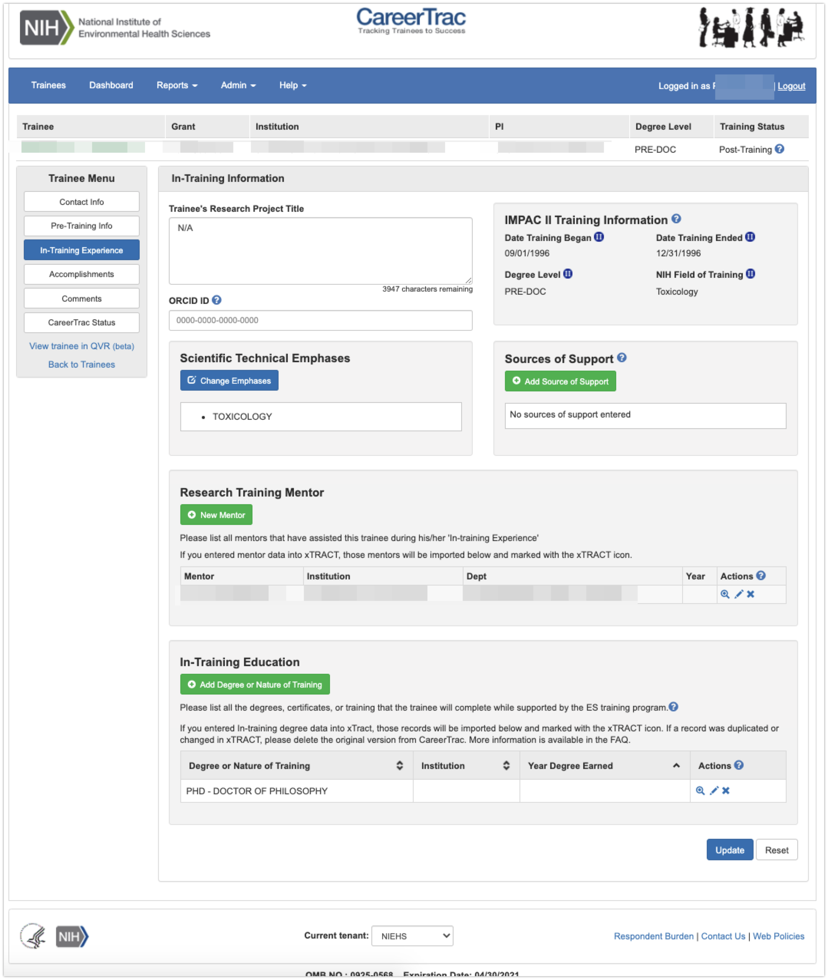

## In-Training Experience – Scientific Technical Emphases

## In-Training Experience – Source of Support

## In-Training Info Page – New Mentor (Search)

## In-Training Info Page – New Mentor (Maunally Enter)

## In-Training Info Page – Create Education (Trainees with Commons ID)

## In-Training Info Page – Create Education (Manually Enter)

# Accomplishments Page

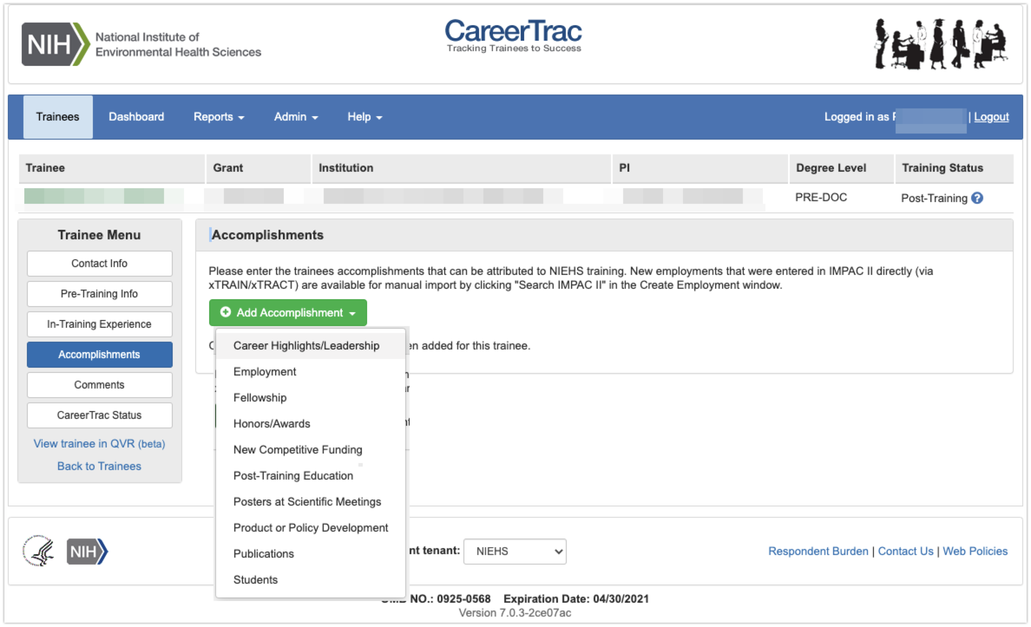

## Accomplishments – Career Highlights/Leadership

## Accomplishments – Employment (Commons Trainee)

## Accomplishments – Employment (Manually Enter)

## Accomplishments – Fellowship

## Accomplishments – Honors/Awards

## Accomplishments – New Competitive Funding (Commons Trainees)

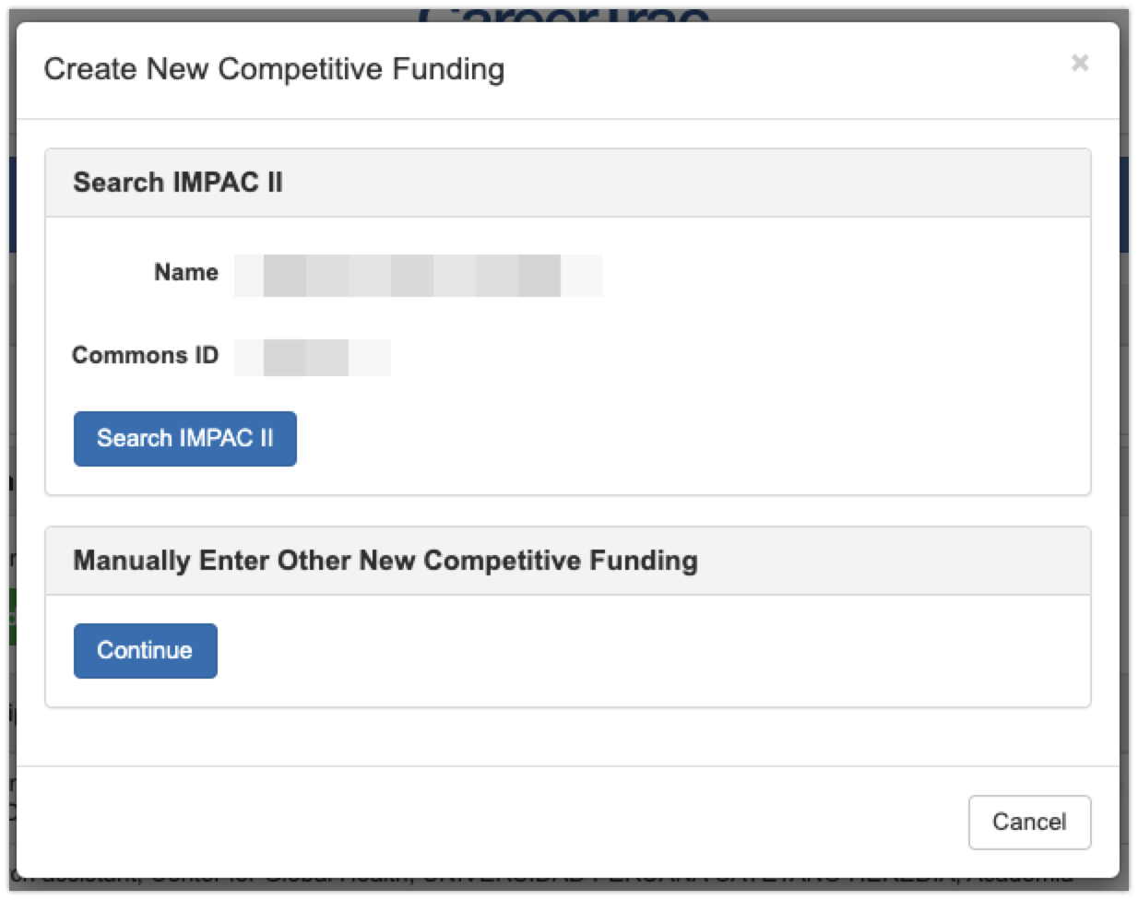

## Accomplishments – New Competitive Funding (Manually Enter)

## Accomplishments – Post Training Education (Commons Trainees)

## Accomplishments - Post Training Education (Manually Enter)

## Accomplishments – Posters at Scientific Meetings

## Accomplishments – Product or Policy Development

## Accomplishments – Publications (Search)

## Accomplishments – Publications (Maunally Enter)

## Accomplishments – Students

# Comments

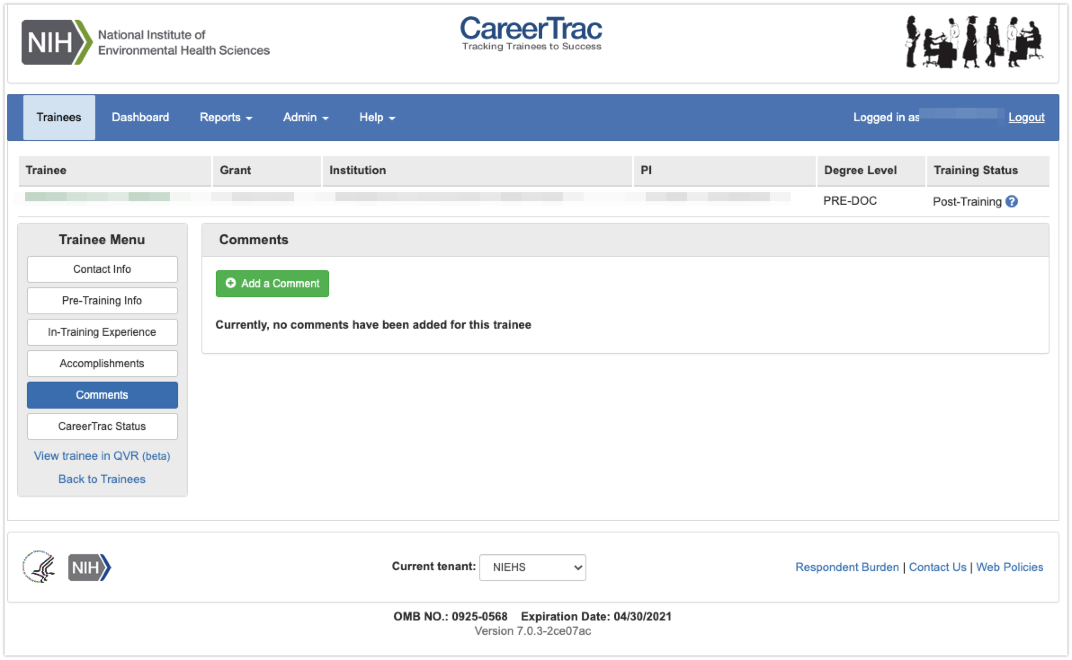

## Comments – Add Comments