NCI-CRCHD CareerTrac Screenshots

Login Page
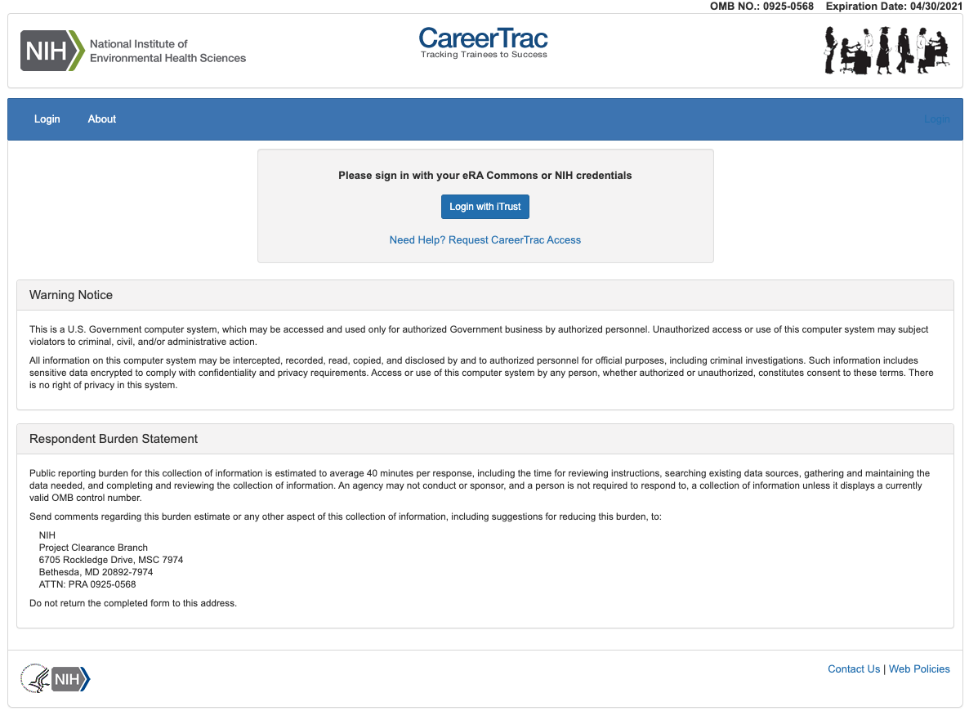

Trainee Search Page
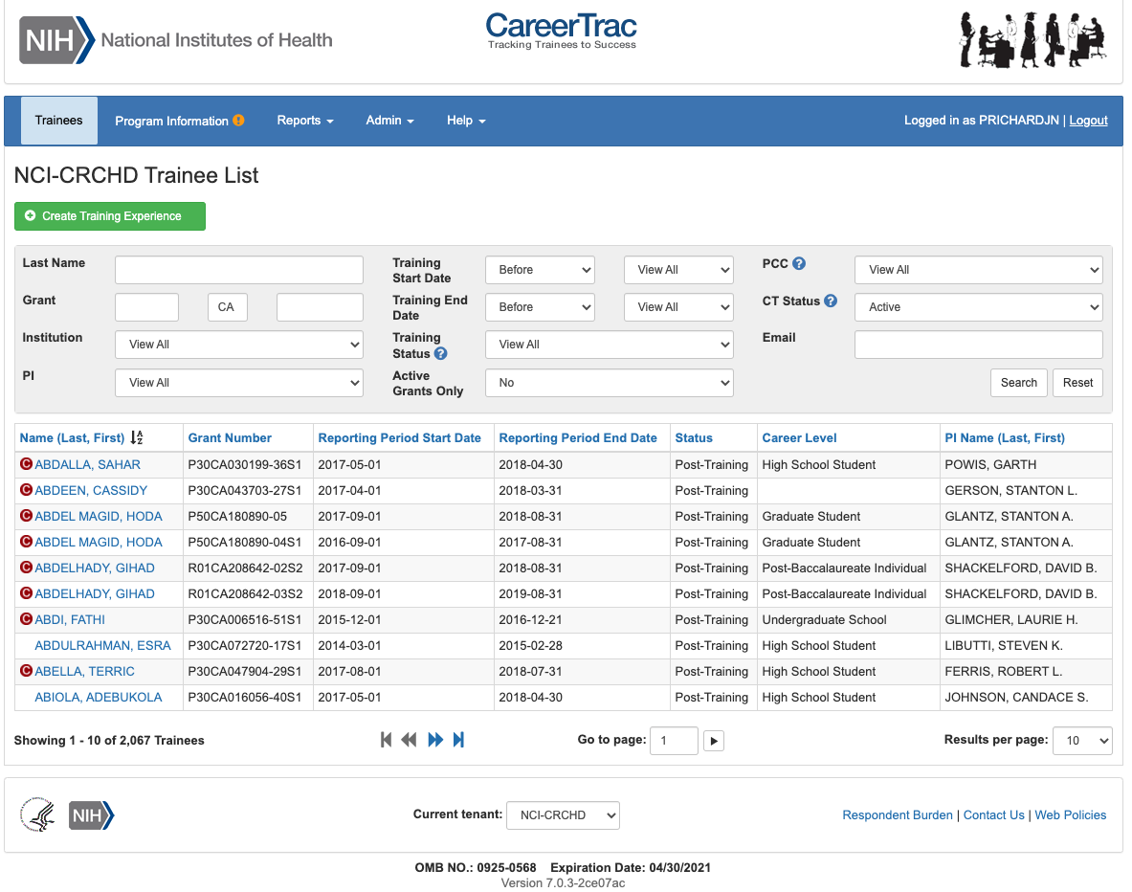

Program Information
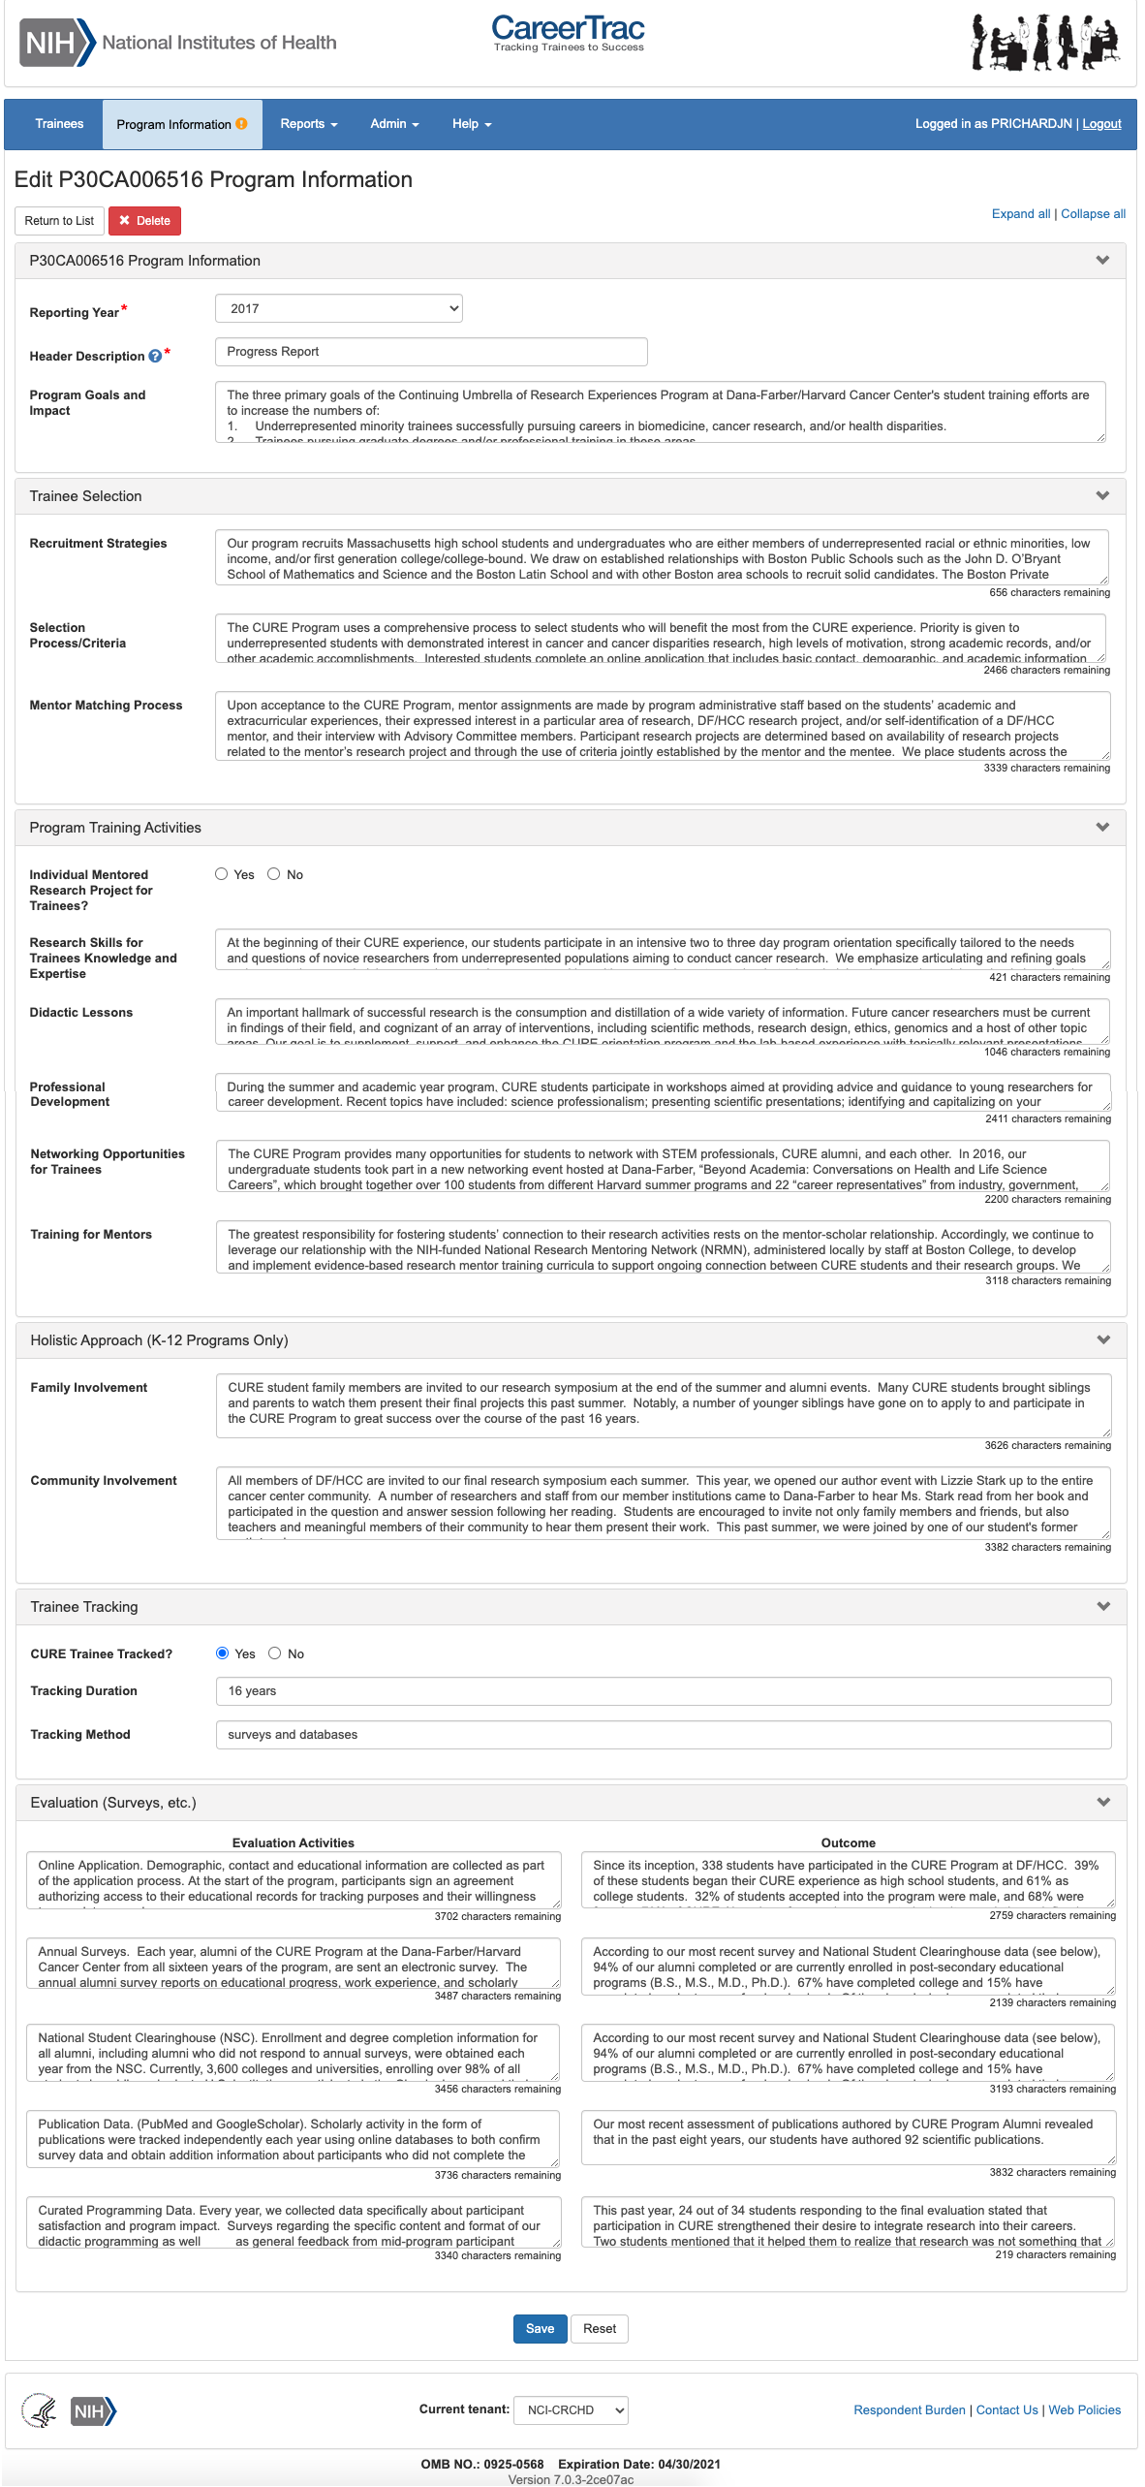

Program Information – Education Products and Teacher Participants
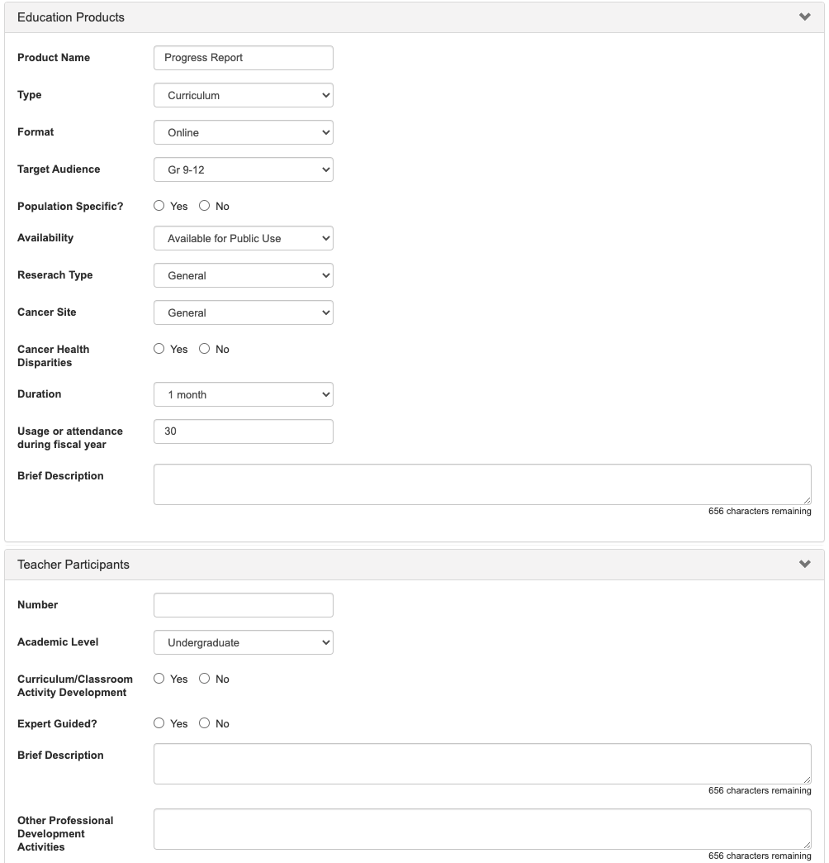

Program Information – Outreach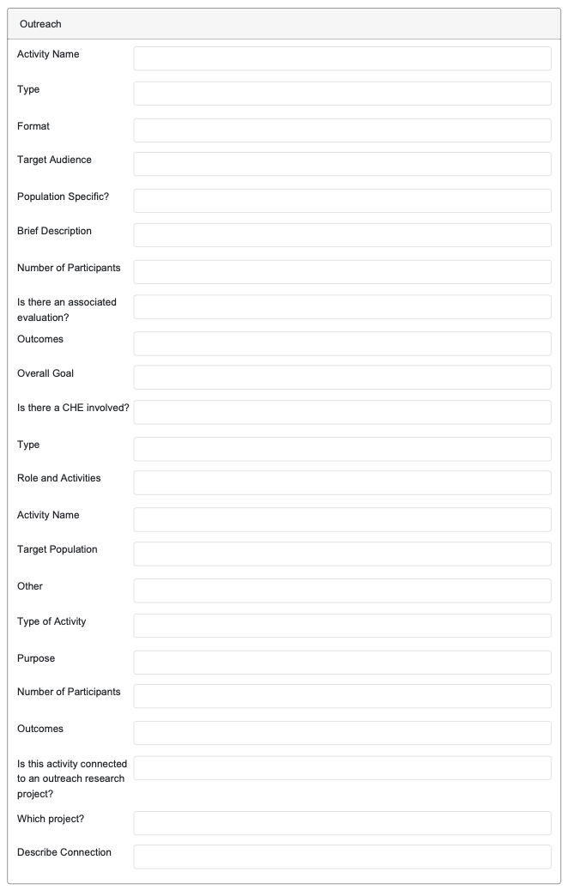

Program Information – Collaboration Efforts
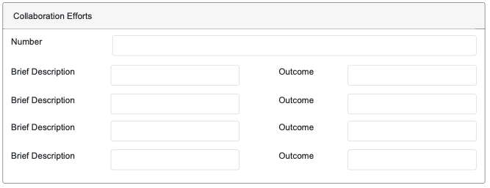

Personal Info Page
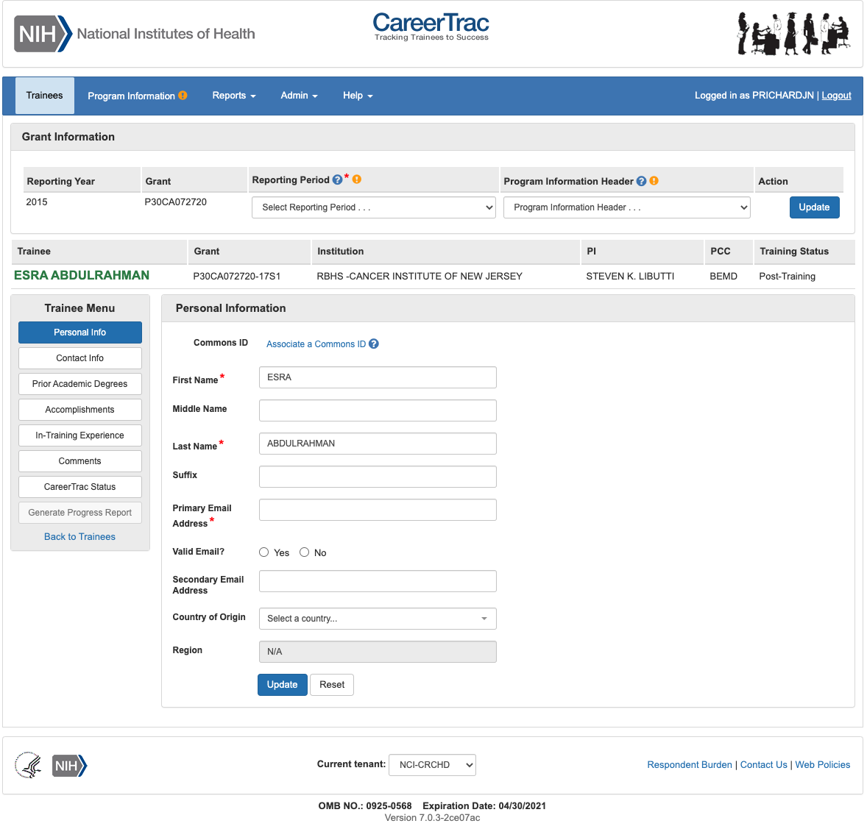

Personal Info Page – Associating a Commons ID (Search)
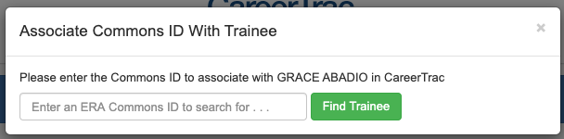

Personal Info Page – Associating a Commons ID (Review) 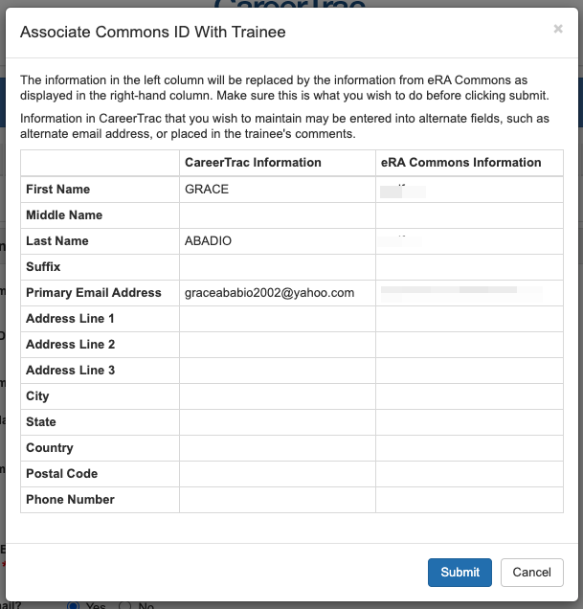

Personal Info Page – Commons Trainee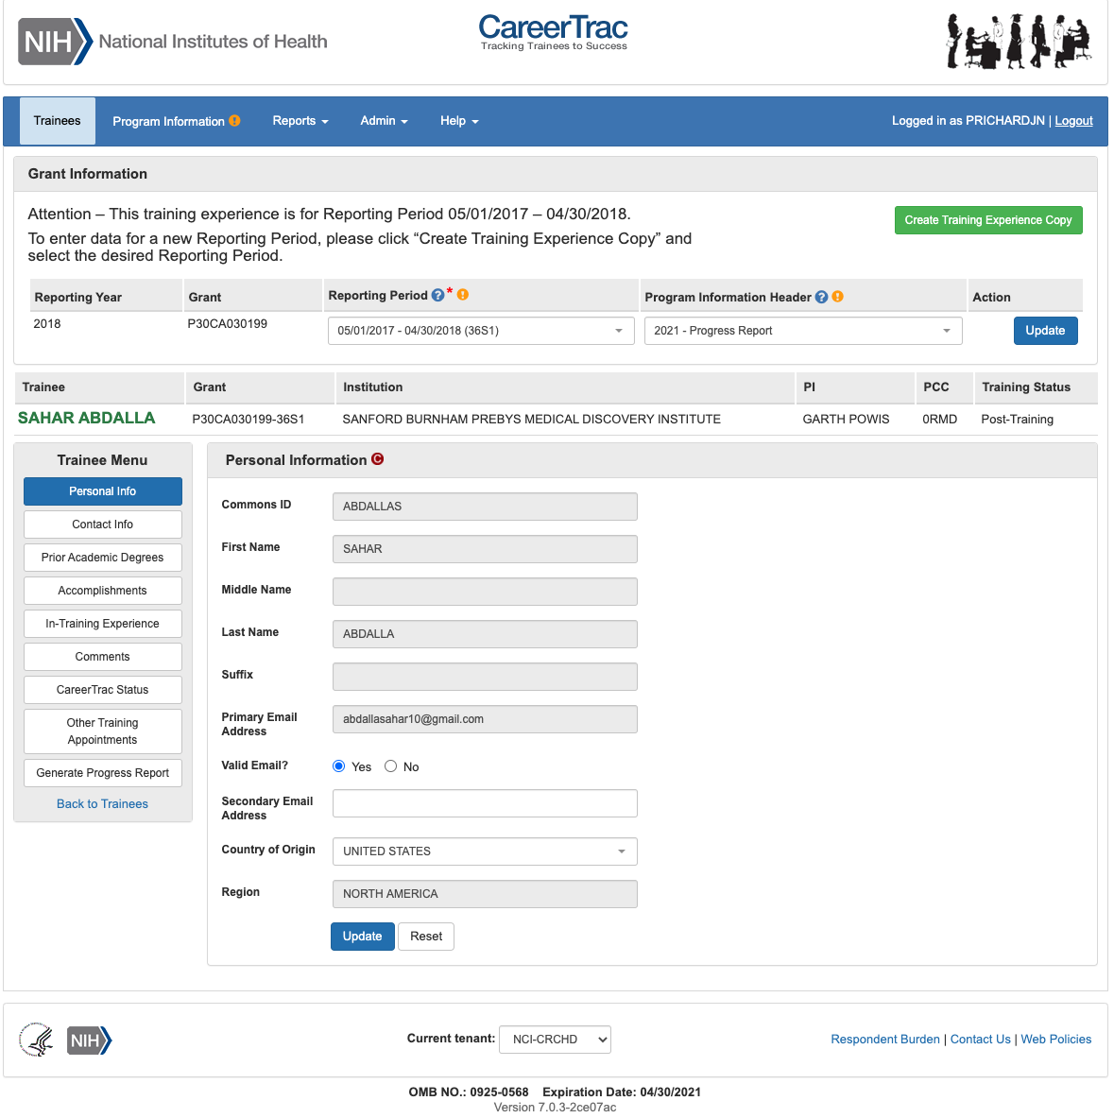

Contact Info Page
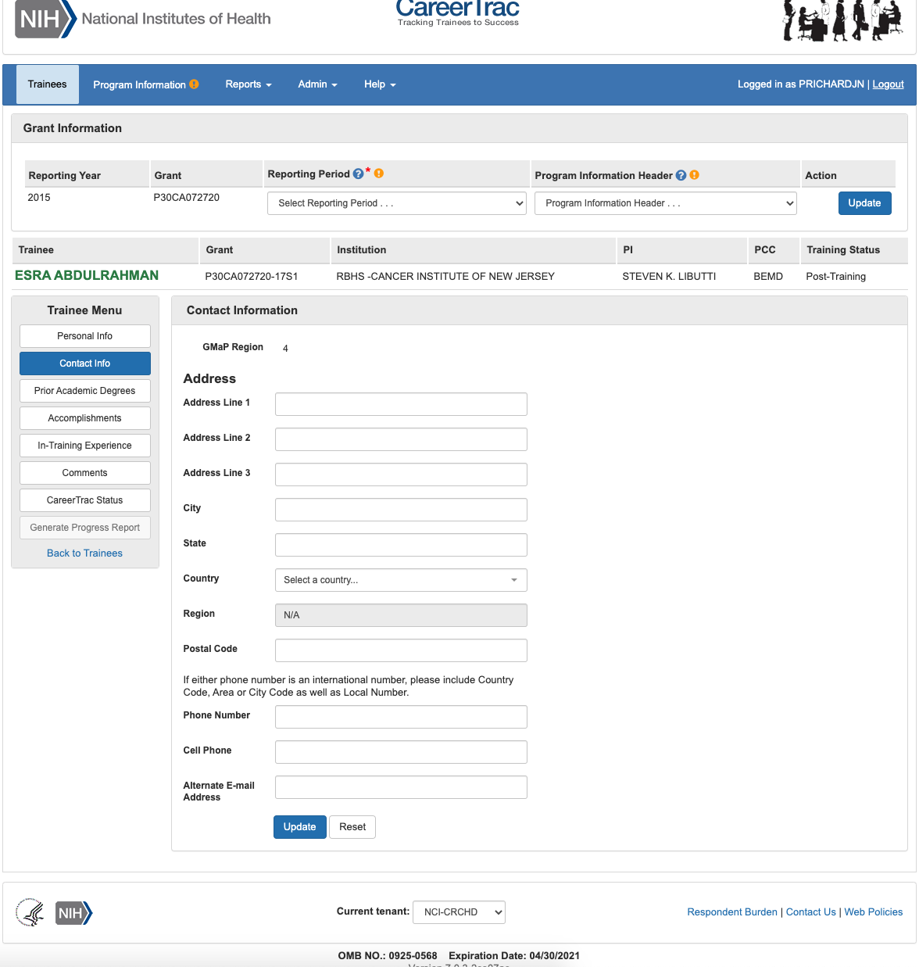

Contact Info Page – Commons Trainee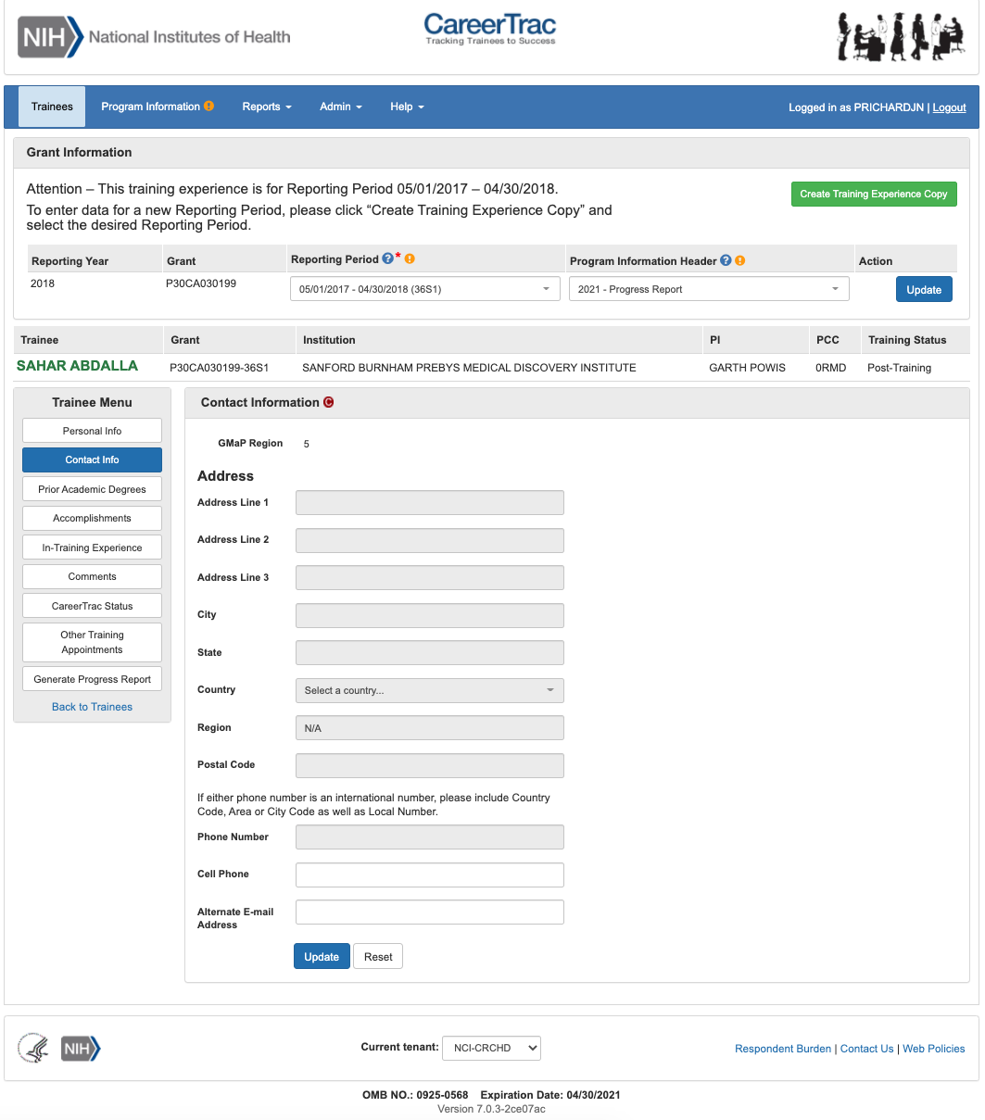

Pre-Training Info Page
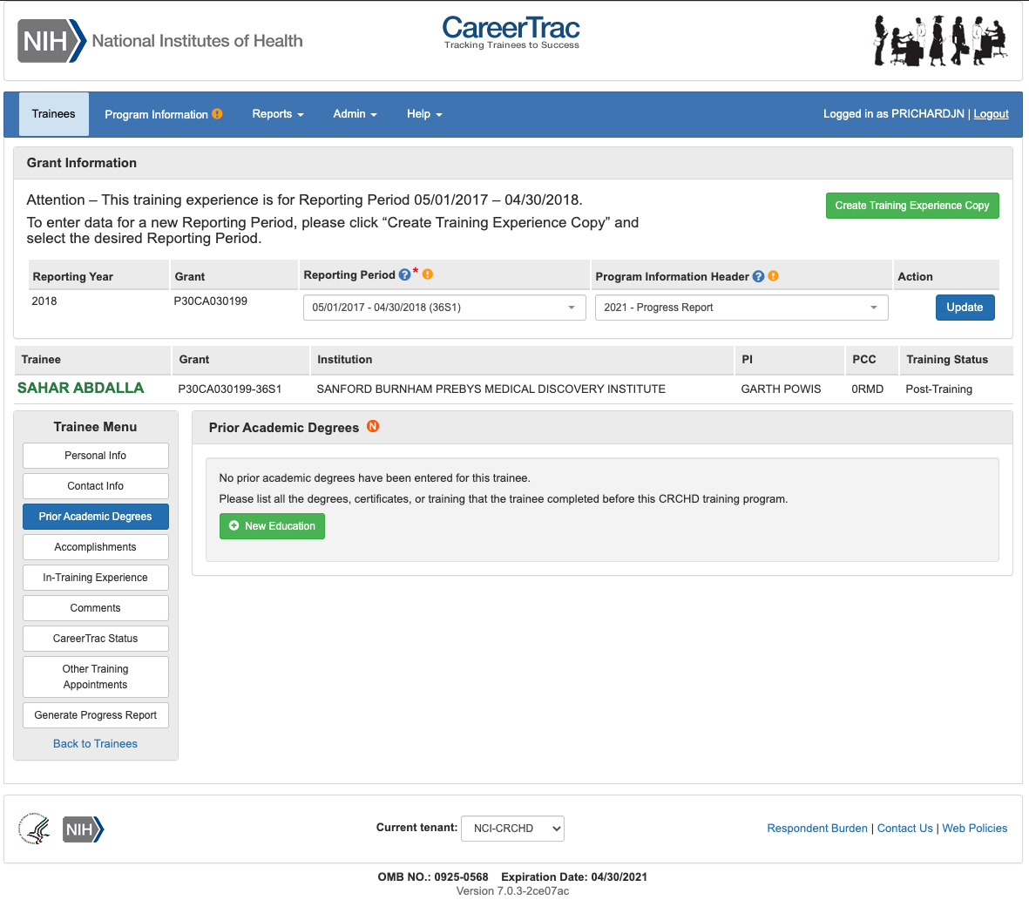

Pre-Training Info Page - Create Prior Academic Degree (Commons Trainee)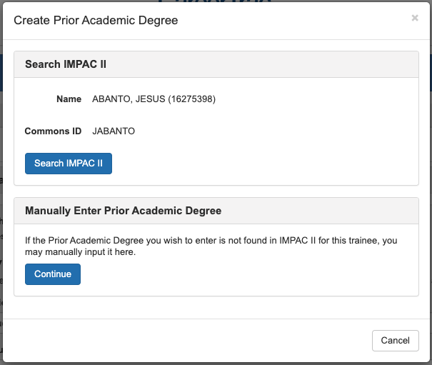

Pre-Training Info Page - Create Prior Academic Degree (Manually Enter)
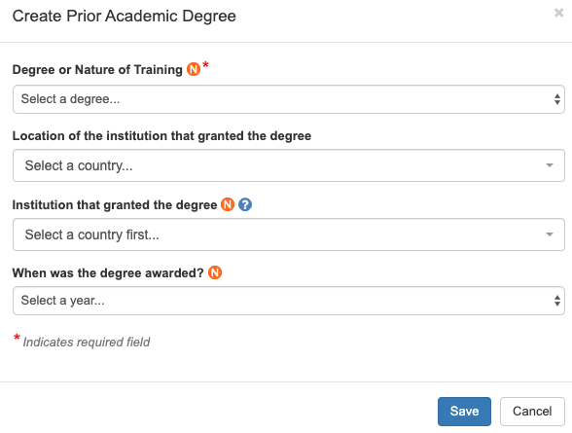

In-Training Info Page
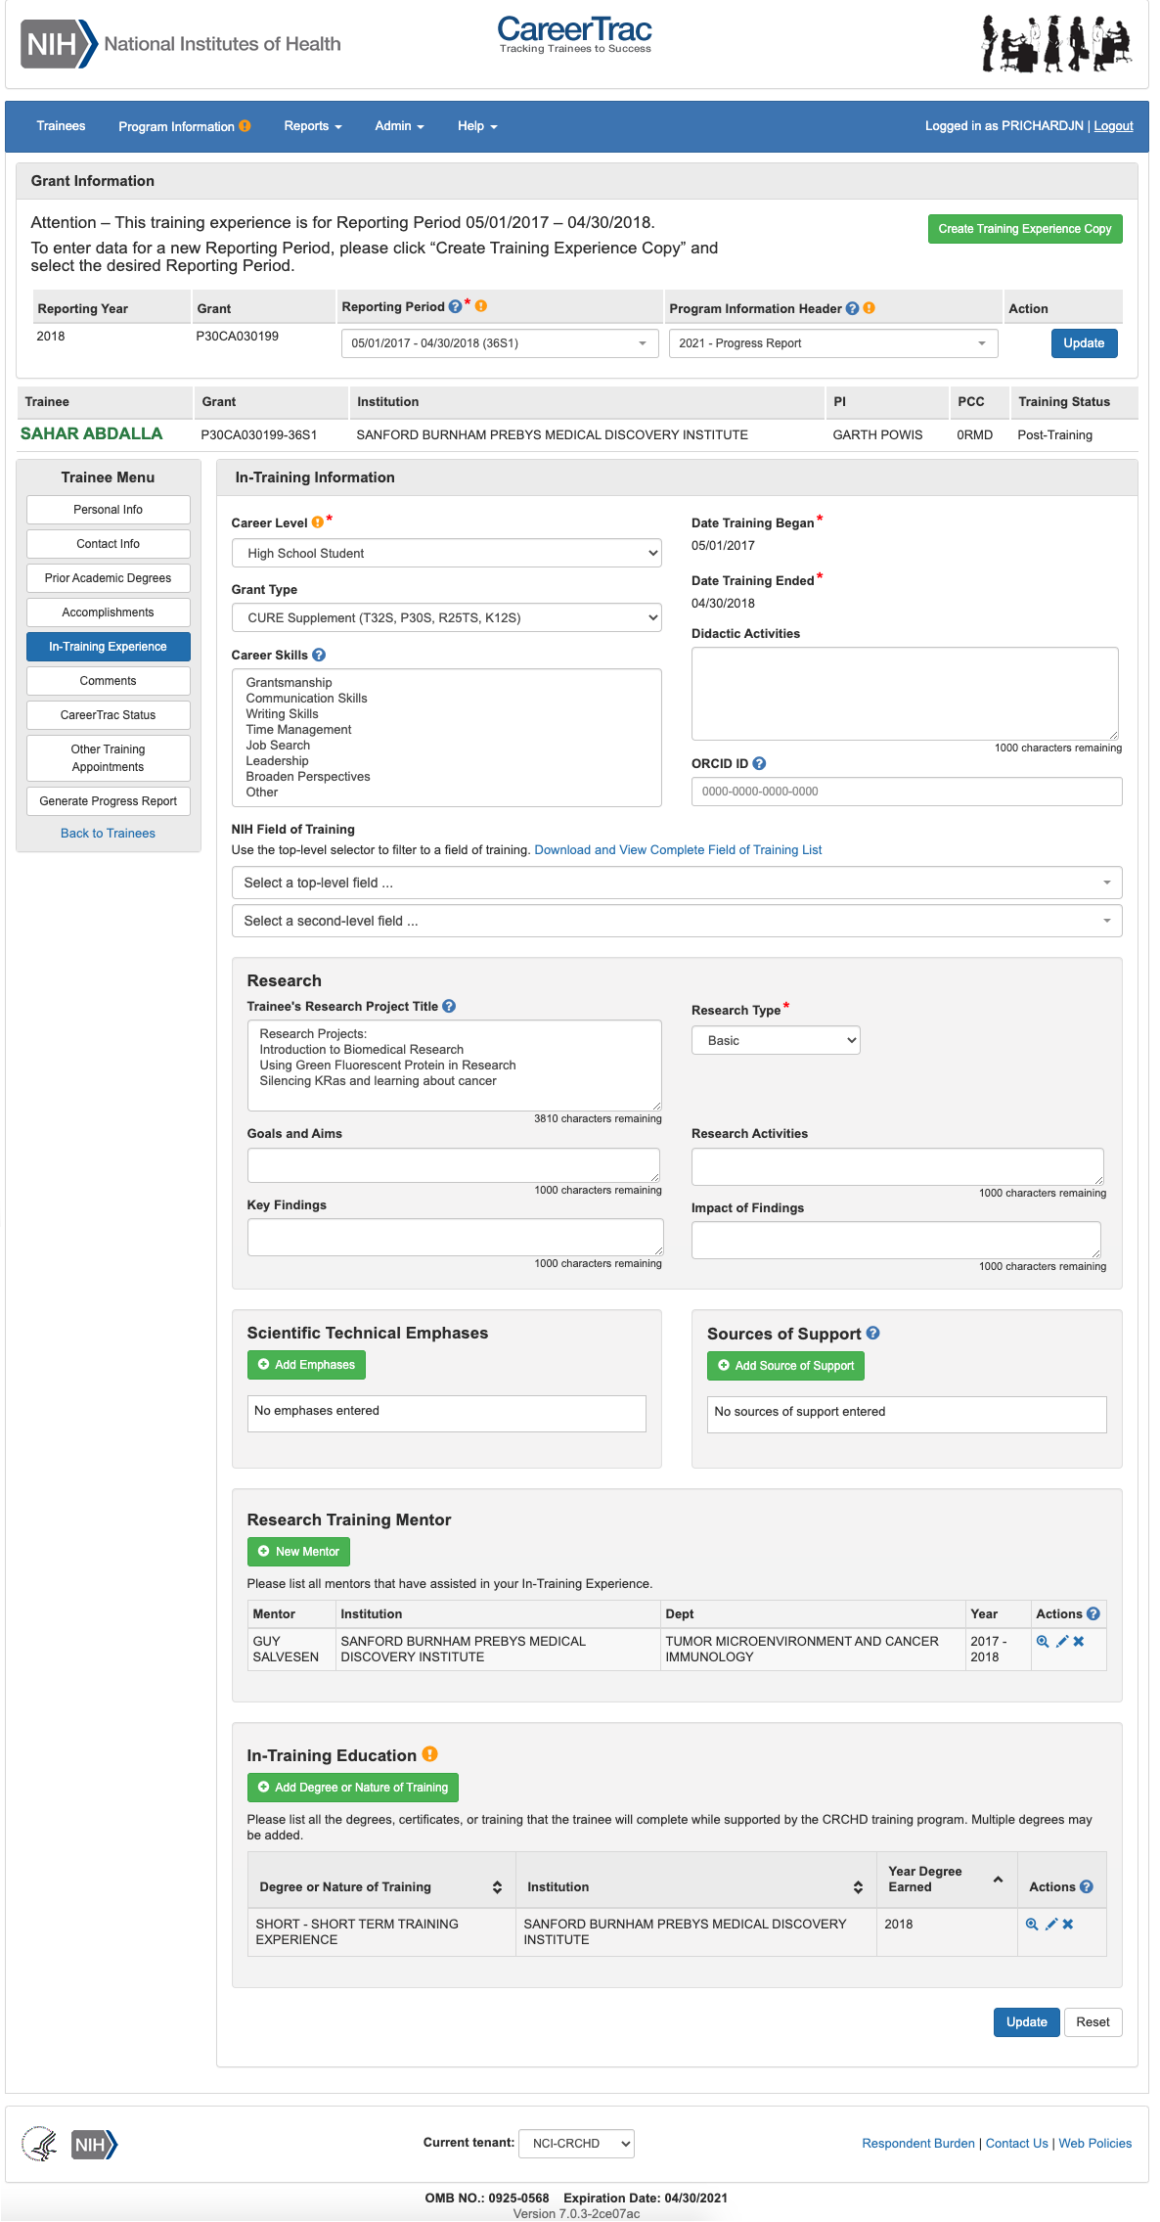

In-Training Info Page – New Mentor (Search)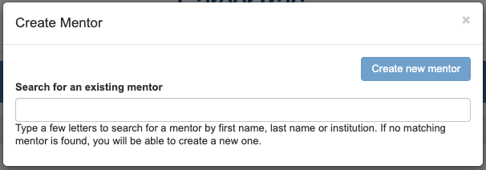

In-Training Info Page – New Mentor (Maunally Enter) 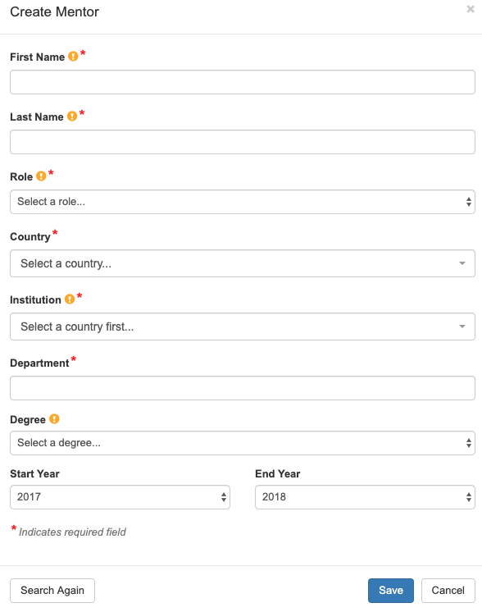

In-Training Info Page – Create Education (Commons Trainee)
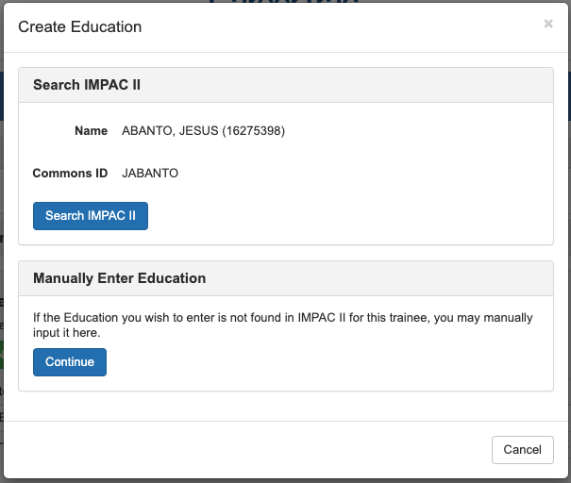

In-Training Info Page – Create Education (Manually Enter) 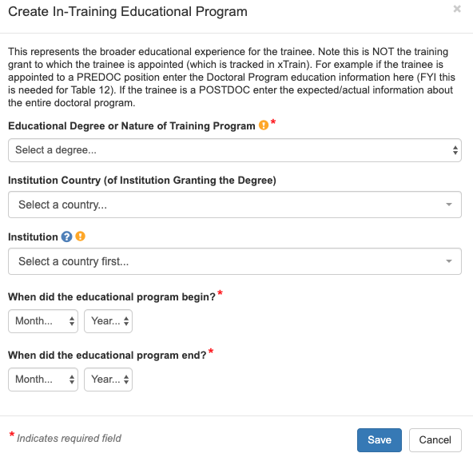

Accomplishments Page
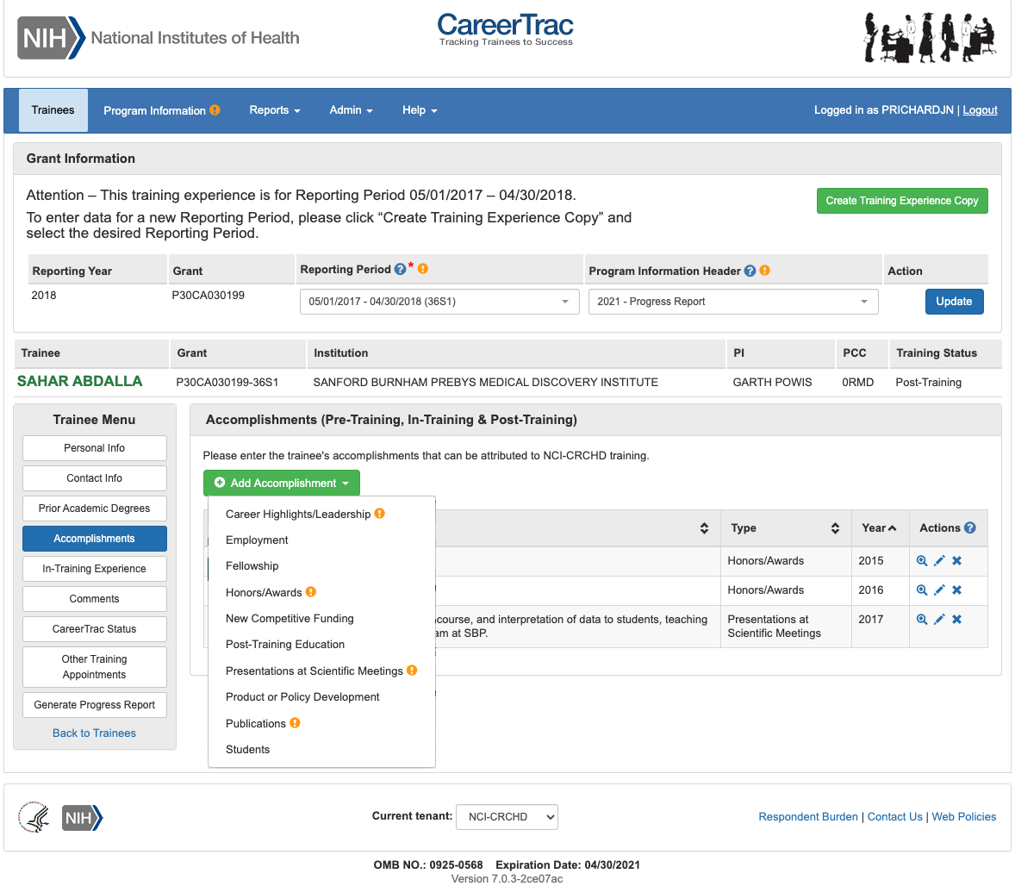

Accomplishments – Career Highlights/Leadership 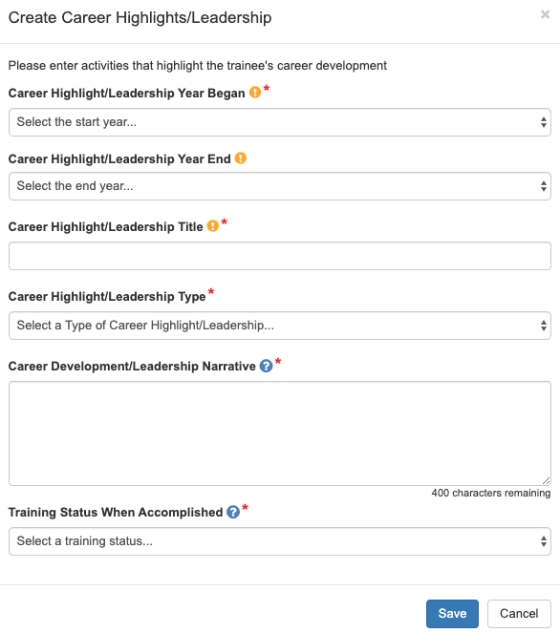

Accomplishments – Employment (Commons Trainee) 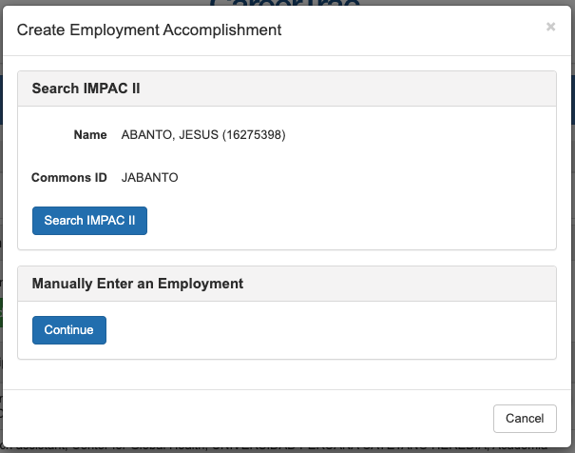

Accomplishments – Employment (Manually Enter) 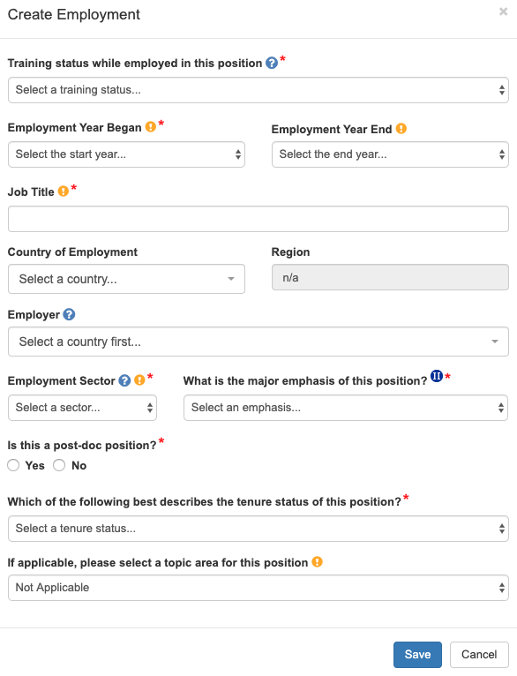

Accomplishments – Fellowship
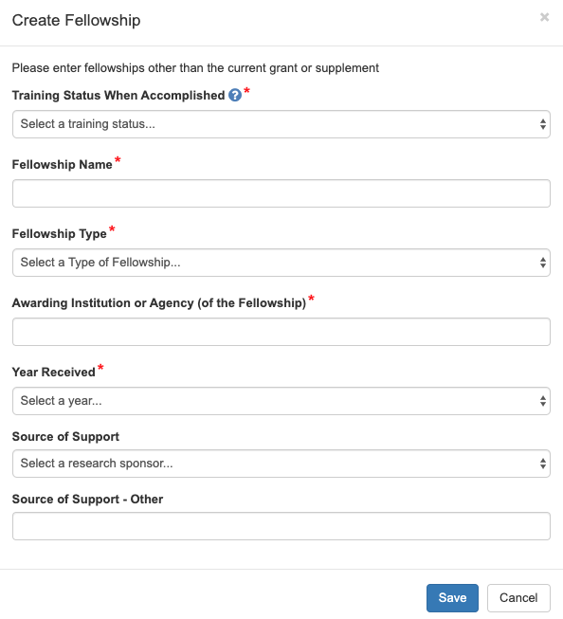

Accomplishments – Honors/Awards 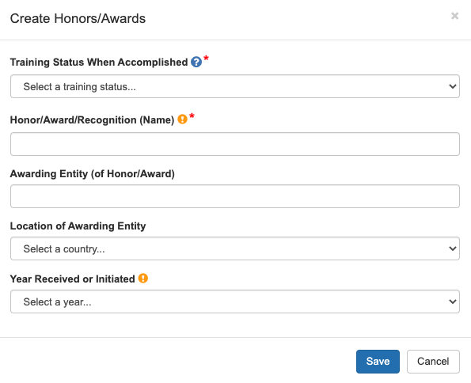

Accomplishments – New Competitive Funding (Commons Trainees)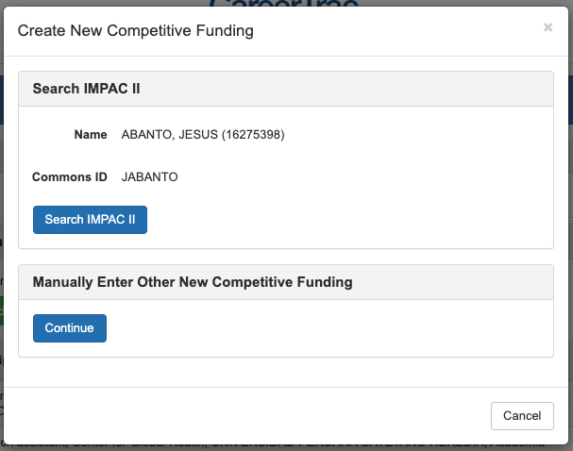

Accomplishments – New Competitive Funding (Manually Enter)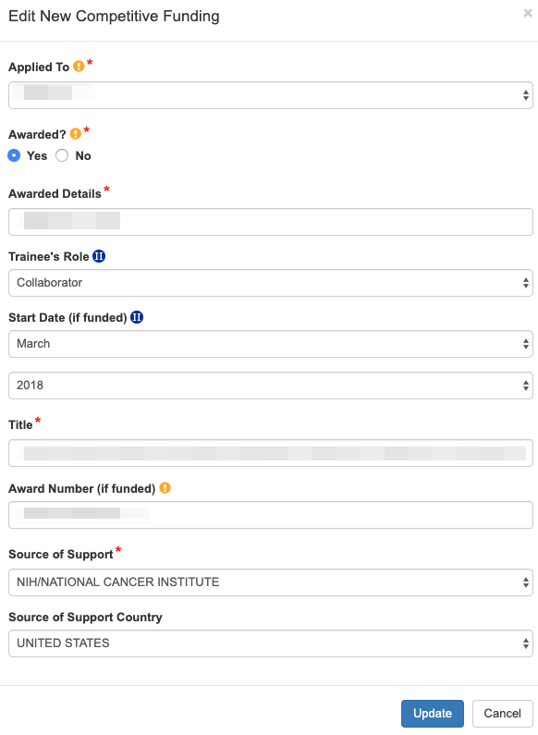

Accomplishments – Post Training Education (Commons Trainees)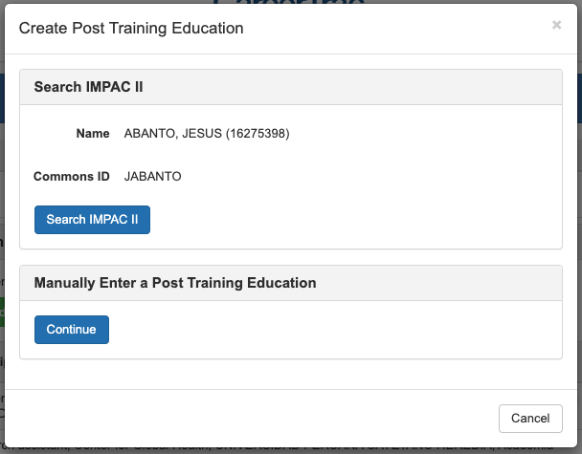

Accomplishments - Post Training Education (Manually Enter)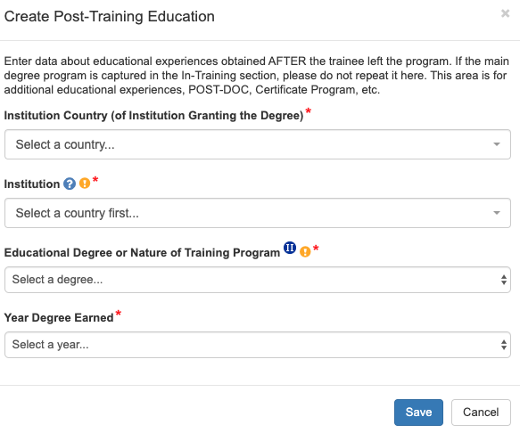

Accomplishments – Presentations at Scientific Meetings 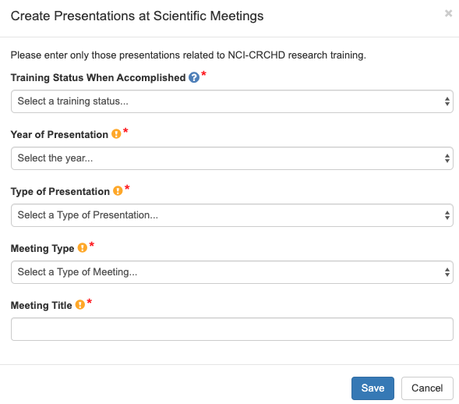

Accomplishments – Product or Policy Development 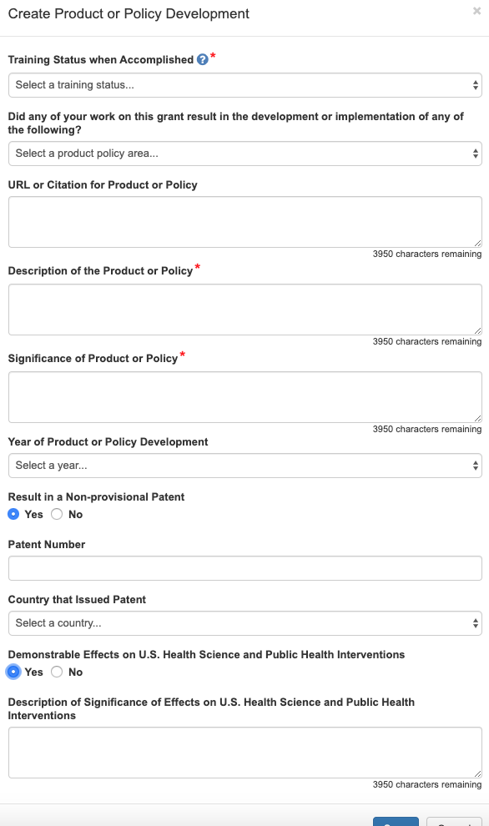

Accomplishments – Publications (Search)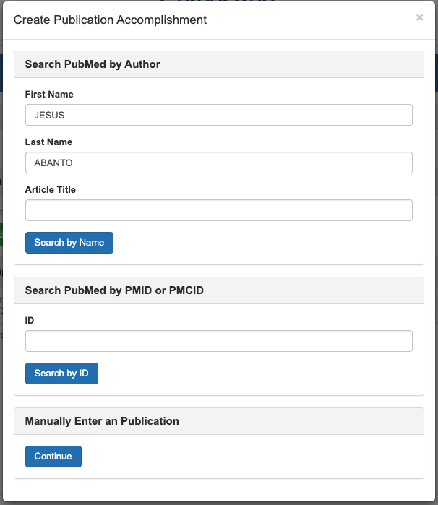

Accomplishments – Publications (Maunally Enter)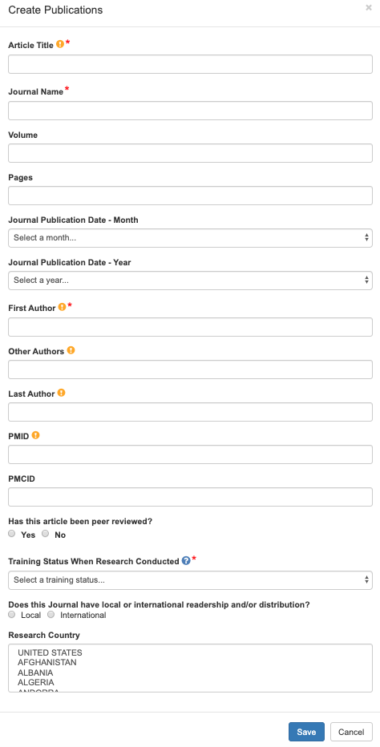

Accomplishments – Students 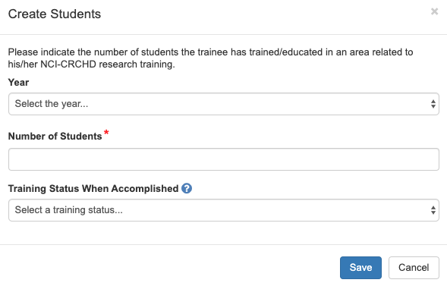

Comments
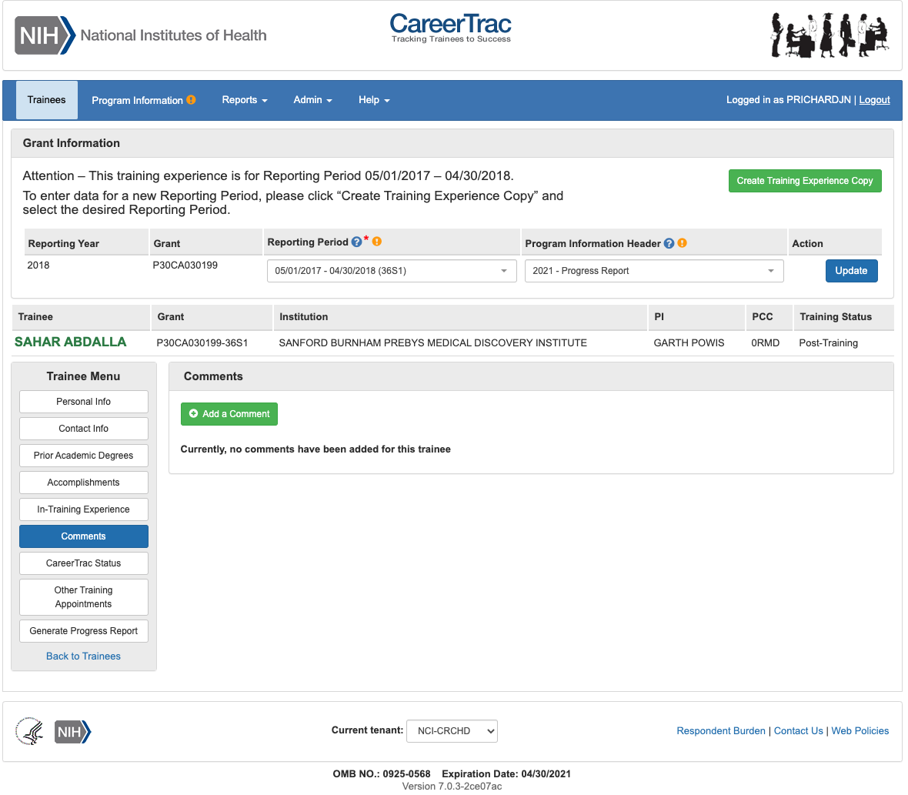

Comments – Add Comments

