CareerTrac Trainee Portal Screenshots

Login Page
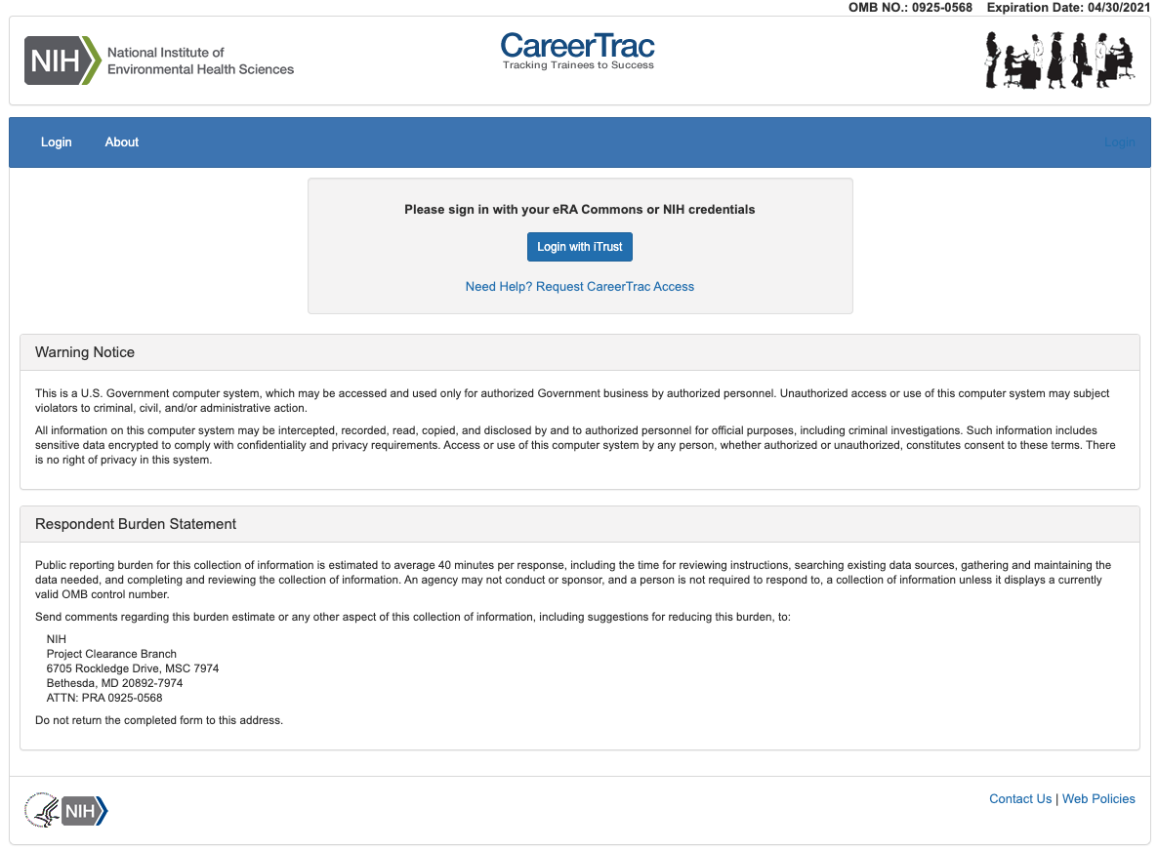

Career Stage Page
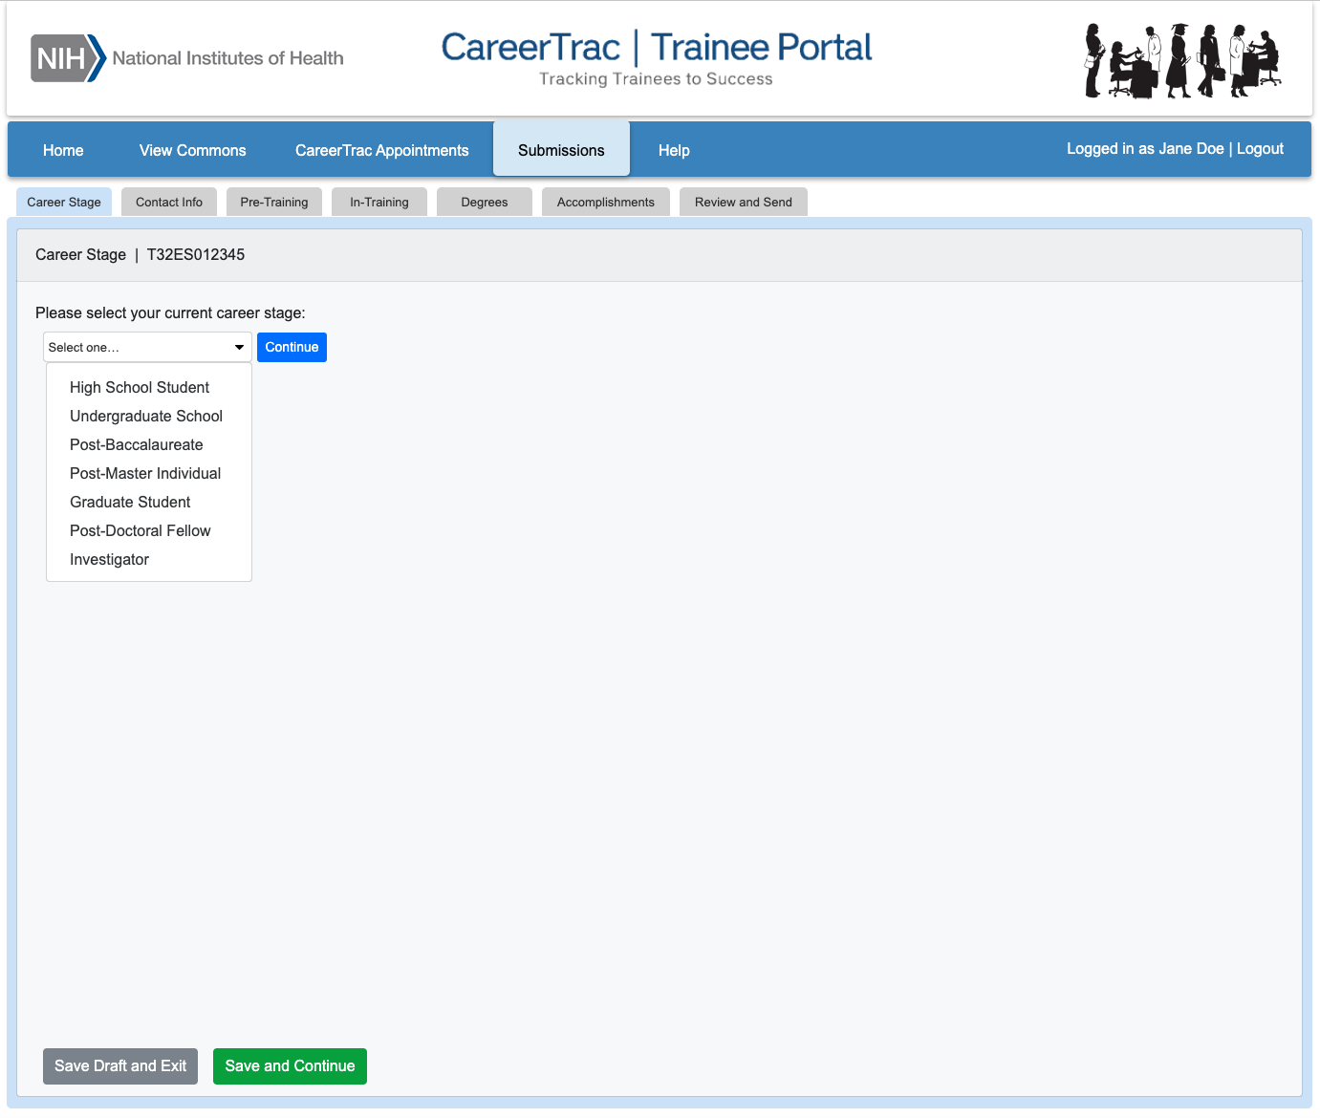

Contact Info Page
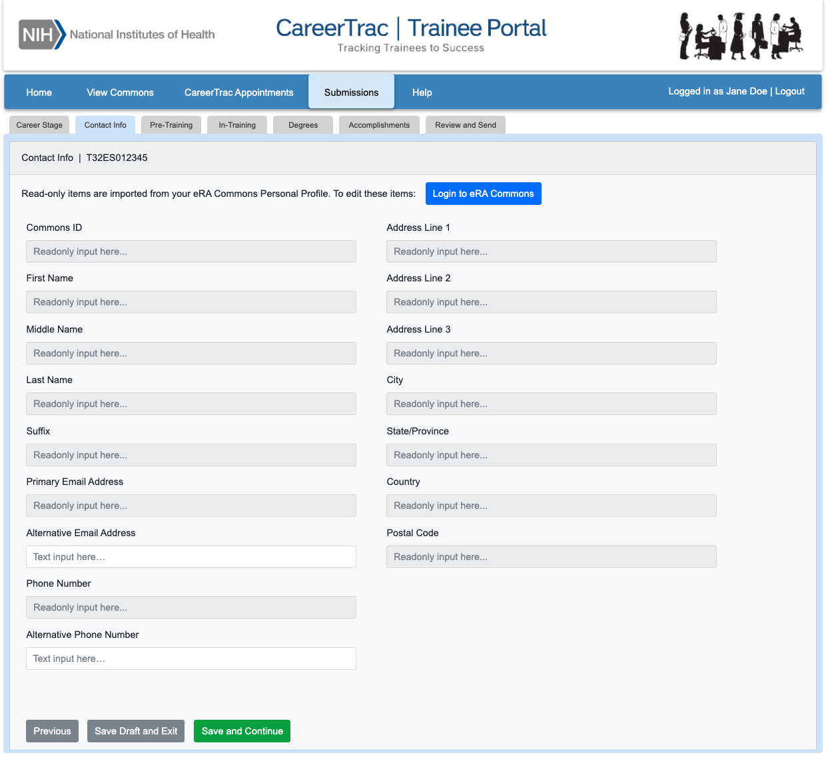

Pre-Training Info Page
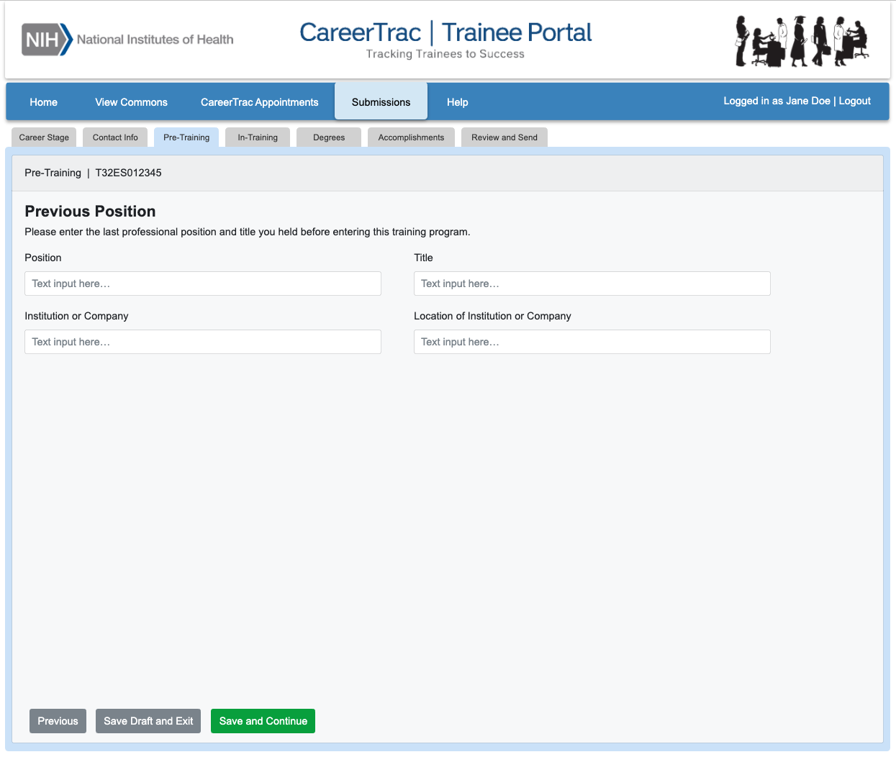

In-Training Info Page
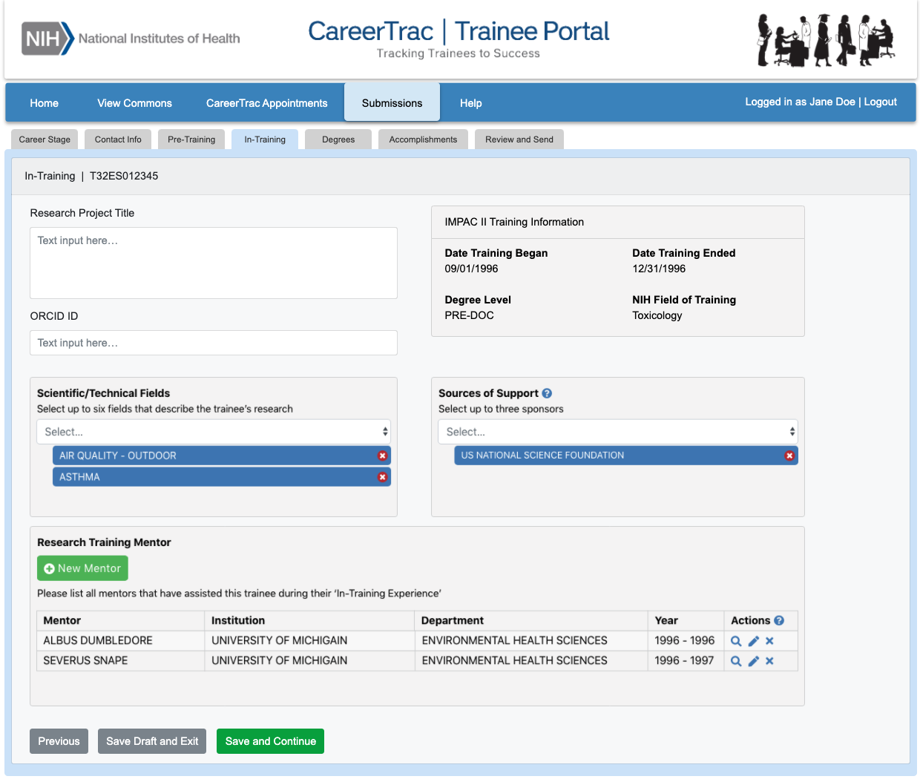

In-Training Info Page – New Mentor (Search)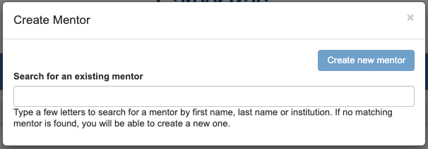

In-Training Info Page – New Mentor (Maunally Enter) 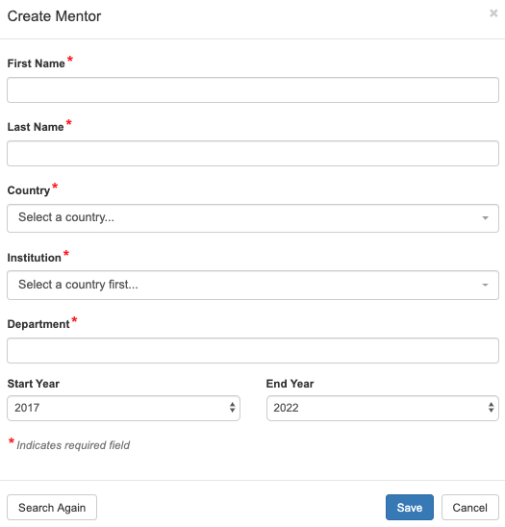

Degrees Page
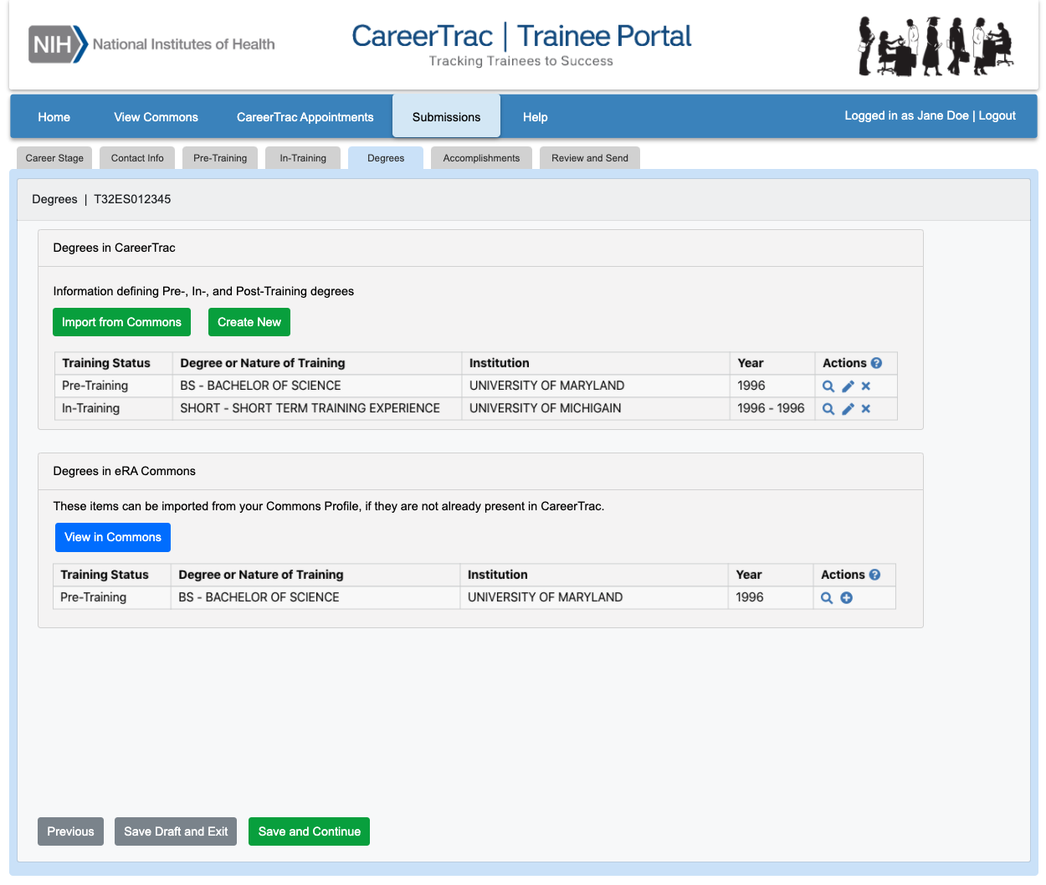

Degrees Page – Create Education (Commons Trainee)
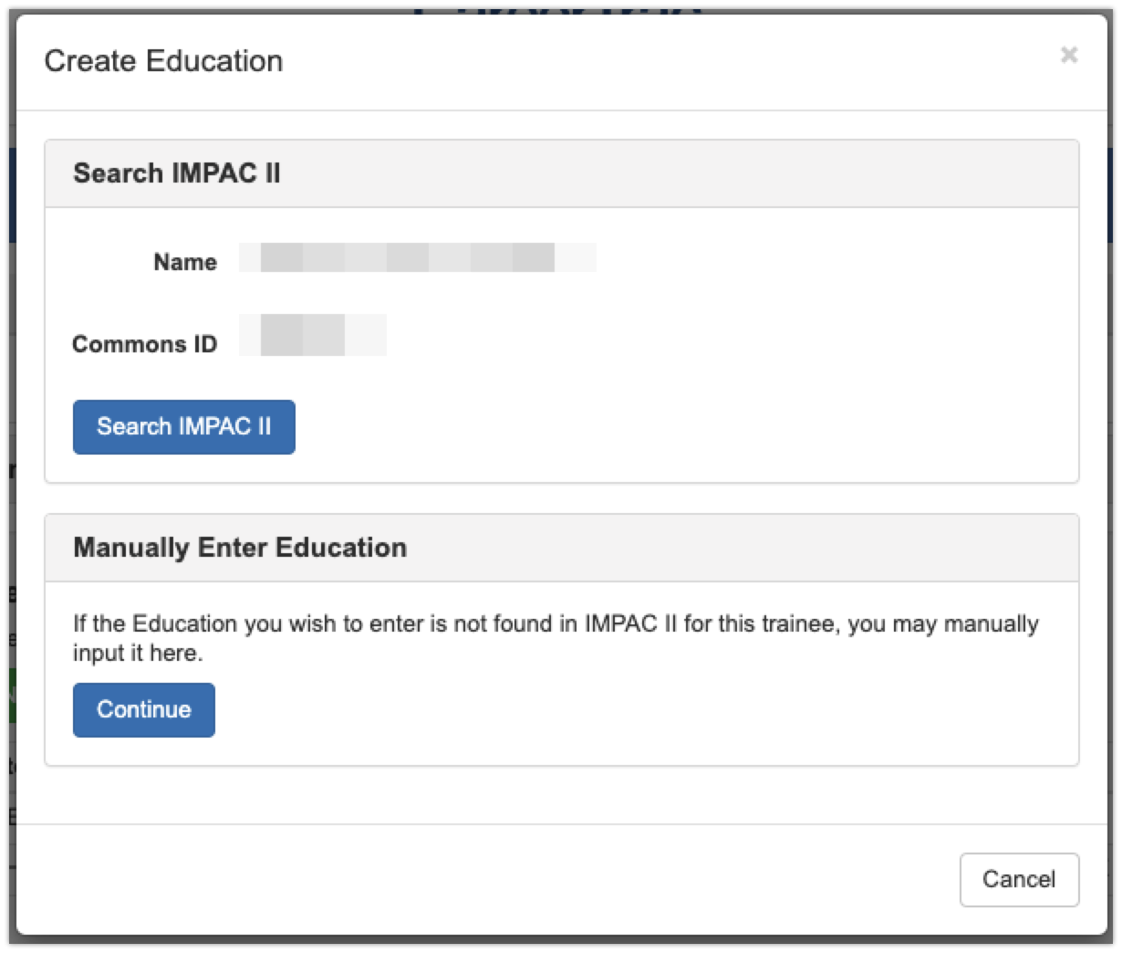

Degrees Page – Create Education (Manually Enter; CRCHD, NIEHS, SRP) 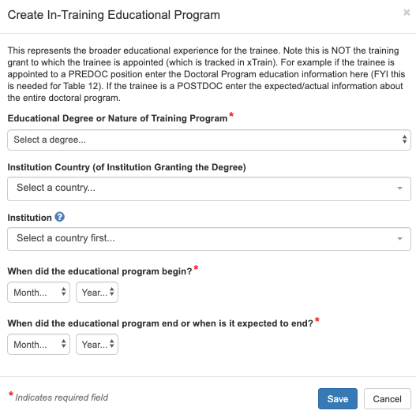

Degrees Page – Create Education (Manually Enter; FIC, NCI) 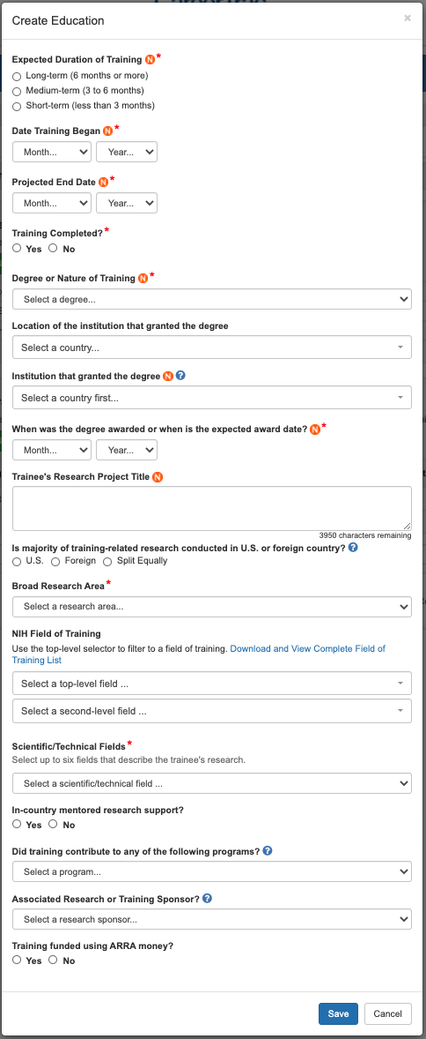

Accomplishments Page
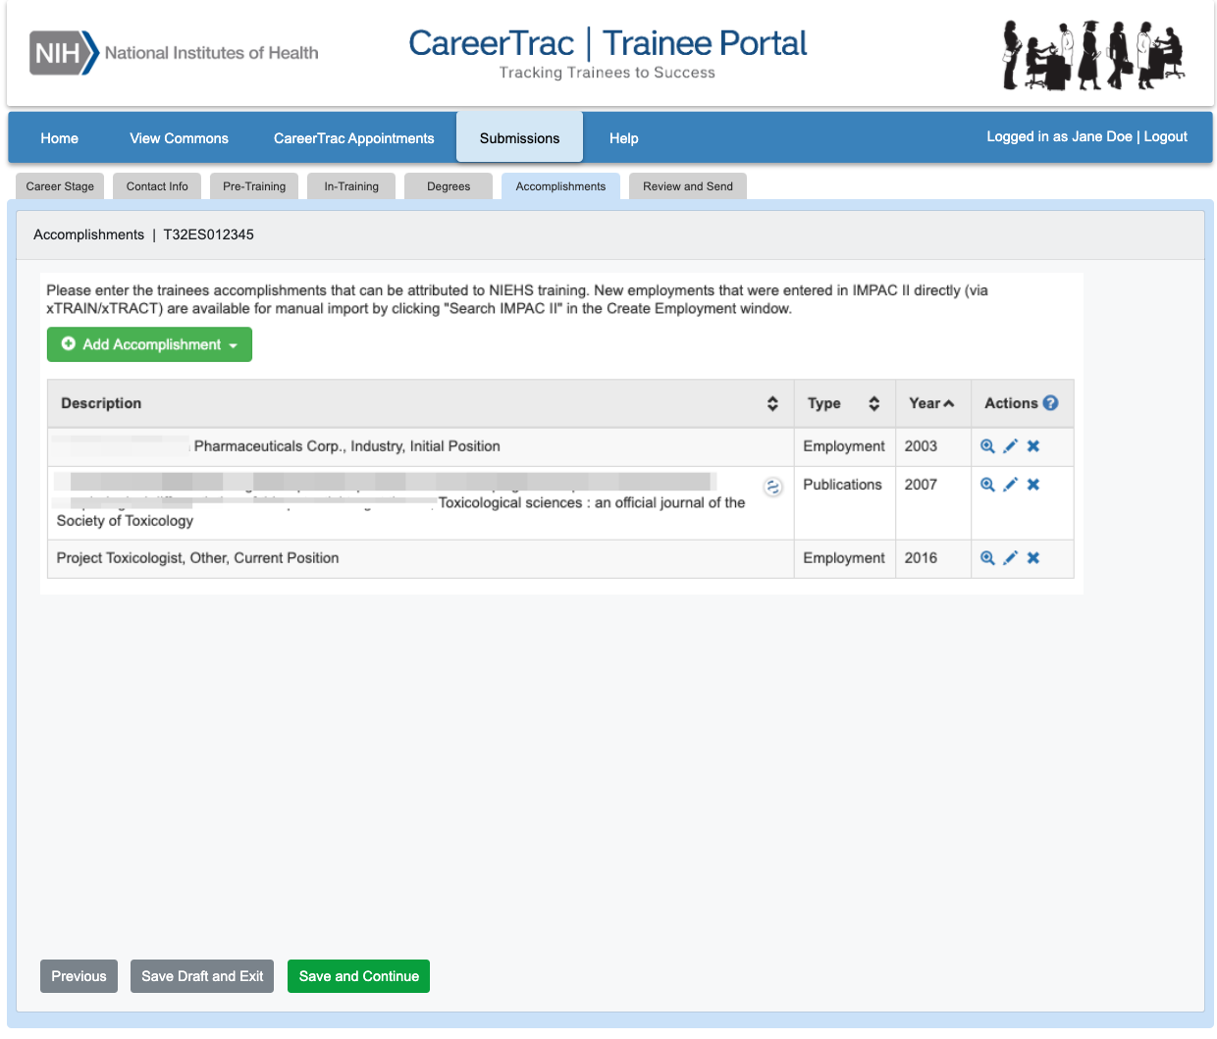

Accomplishments – Career Highlights/Leadership 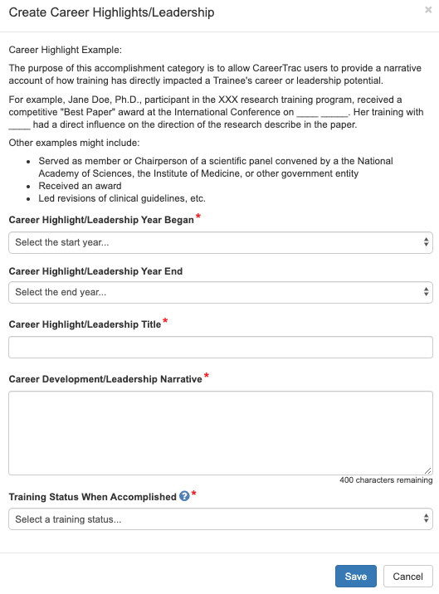

Accomplishments – Employment (Commons Trainee) 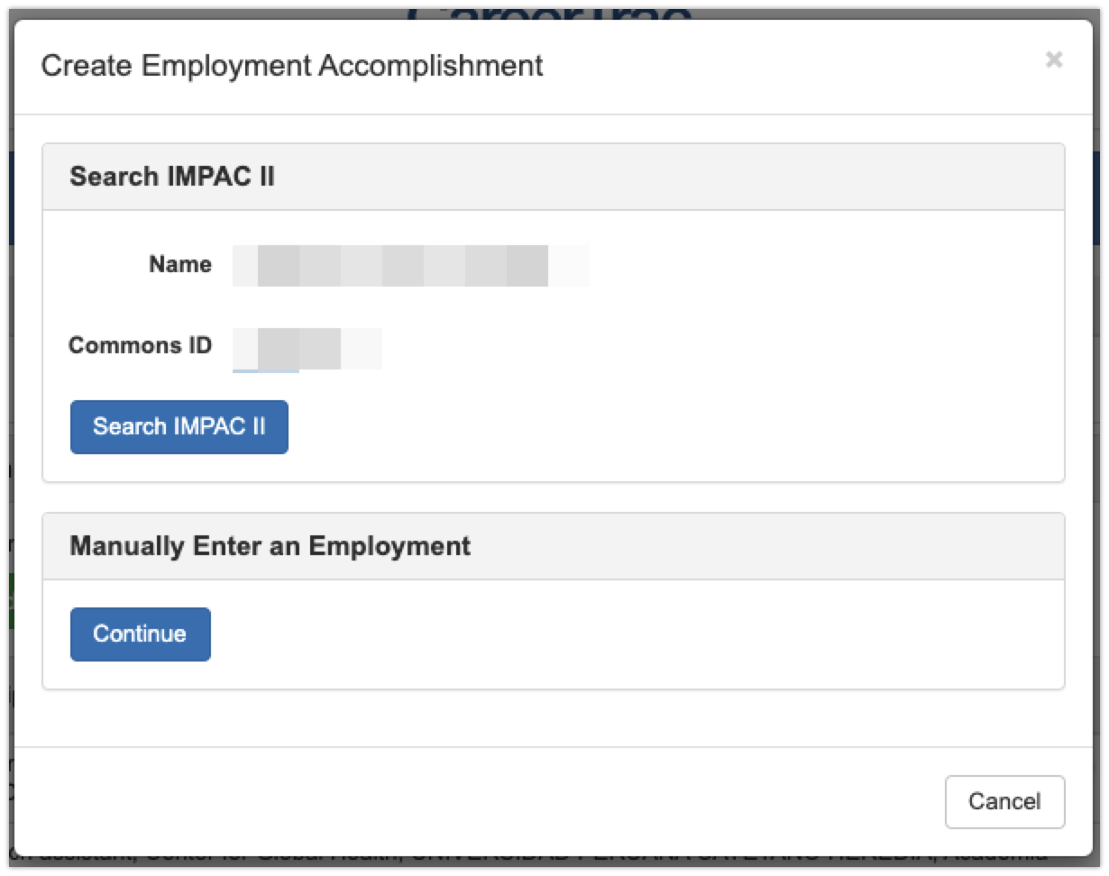

Accomplishments – Employment (Manually Enter) 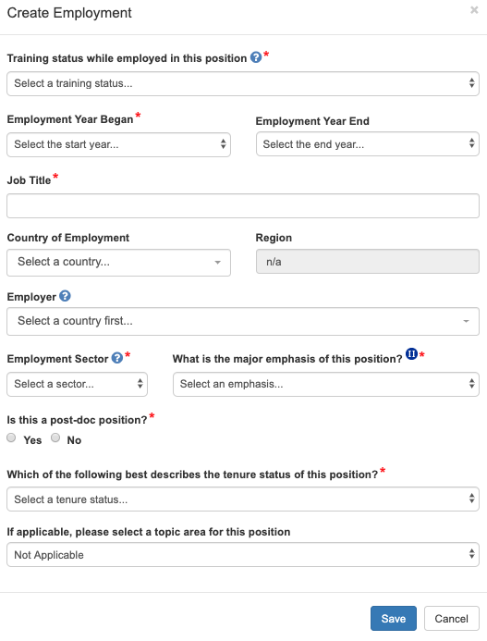

Accomplishments – Fellowship
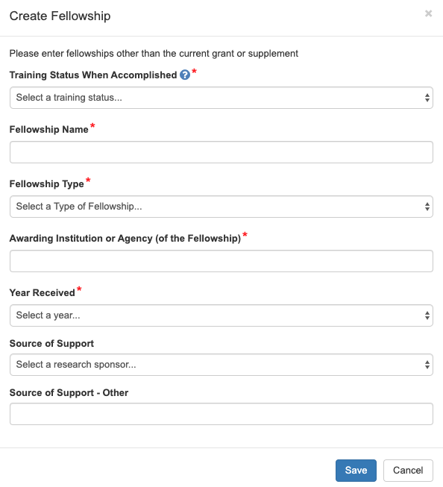

Accomplishments – Honors/Awards 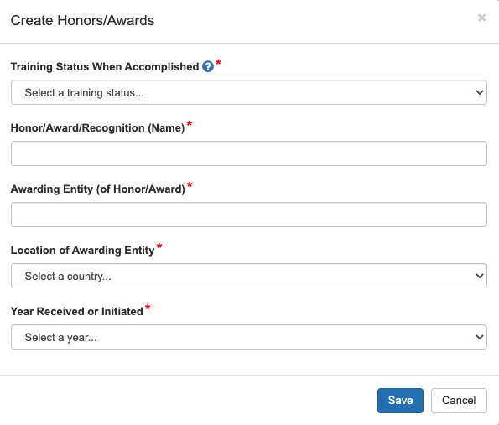

Accomplishments – New Competitive Funding (Commons Trainees)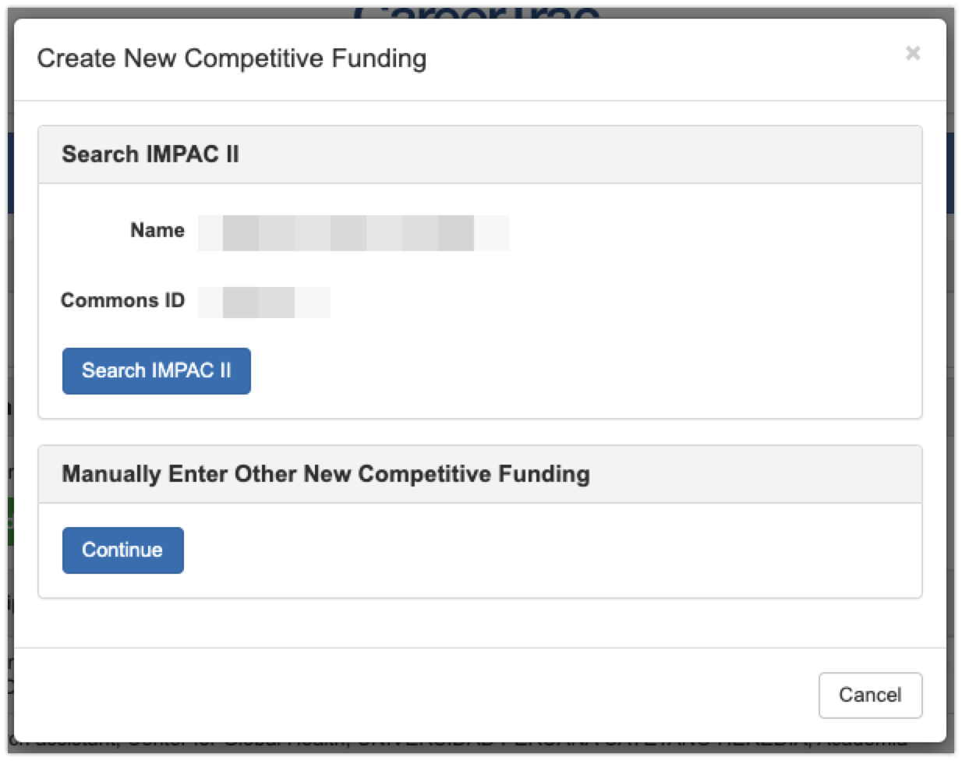

Accomplishments – New Competitive Funding (Manually Enter)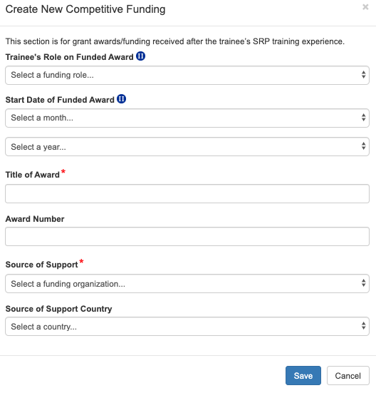

Accomplishments – Posters at Scientific Meetings 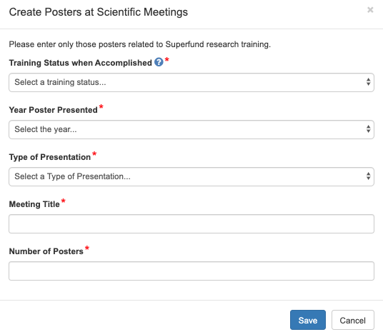

Accomplishments – Product or Policy Development 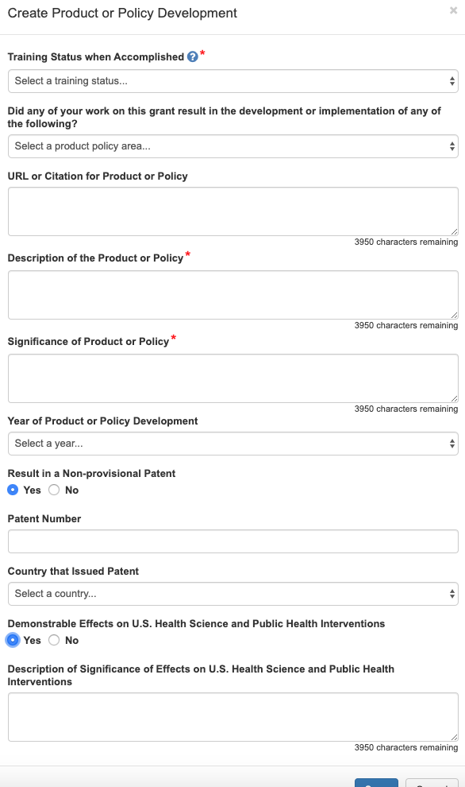

Accomplishments – Publications (Search)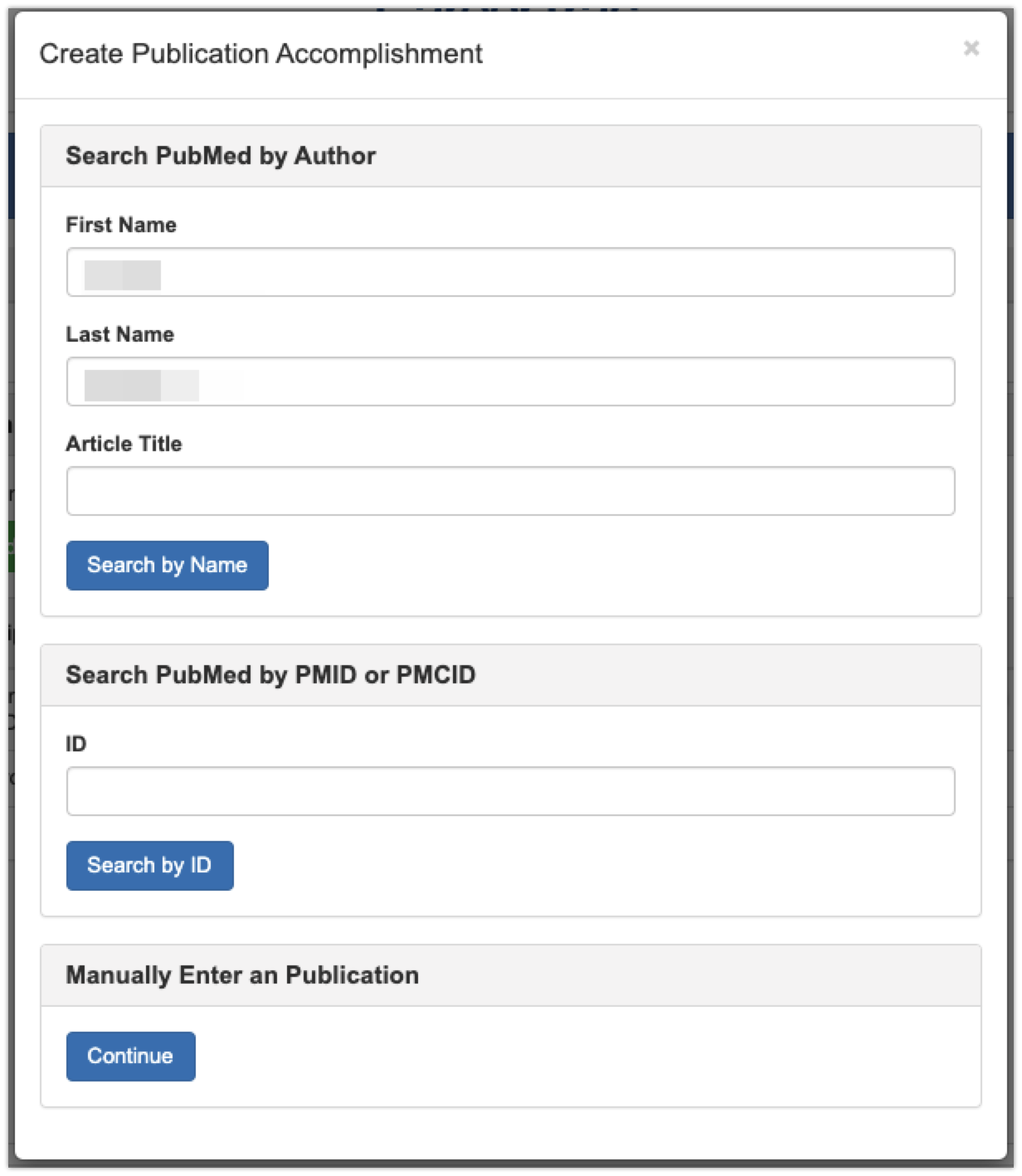

Accomplishments – Publications (Maunally Enter)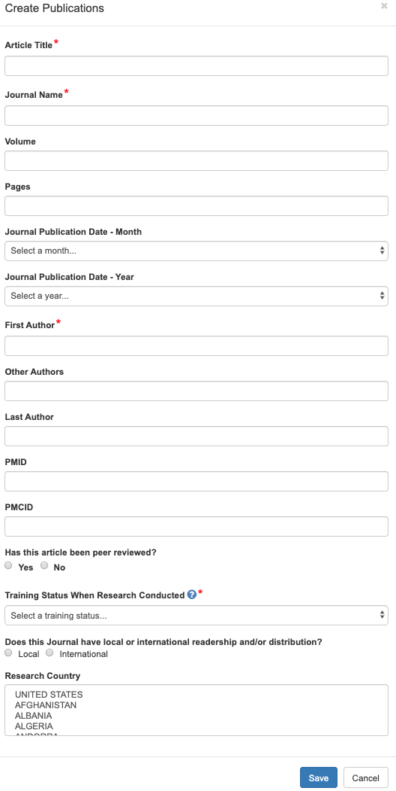

Accomplishments – Students 