20XX CREST Program Survey

You are receiving this survey because your National Institute of Mental Health (NIMH) grant is part of the Clinical Research Education Support and Training (CREST) Program. The purpose of this survey is to gather feedback about the CREST process for your recent visit. Your feedback will inform our ongoing quality improvement efforts for the CREST program. Your responses to these items are completely anonymous and will be reviewed in aggregate by the Office of Clinical Research, NIMH. We would greatly appreciate the PI or study coordinator complete the following items.
Should you have any questions or concerns regarding this survey, please contact Yancy Bodenstein, Clinical Trials Operations Branch Chief at bodensteiny@mail.nih.gov.

Public reporting burden for this collection of information is estimated to average 10 minutes per response, including the time for reviewing instructions, searching existing data sources, gathering and maintaining the data needed, and completing and reviewing the collection of information. An agency may not conduct or sponsor, and a person is not required to respond to, a collection of information unless it displays a currently valid OMB control number. Send comments regarding this burden estimate, or any other aspect of this collection of information, including suggestions for reducing this burden, to: NIH Project Clearance Branch, 6705 Rockledge Drive, MSC 7974, Bethesda, Maryland 20892-7974, ATTN: PRA (0925-0648). Do not return the completed form to this address.
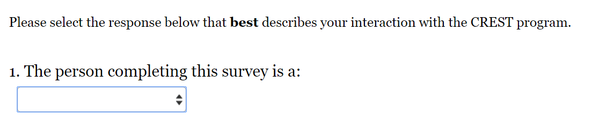
Drop down options (PI – Principal Investigator, Study Coordinator, Other study team staff)

