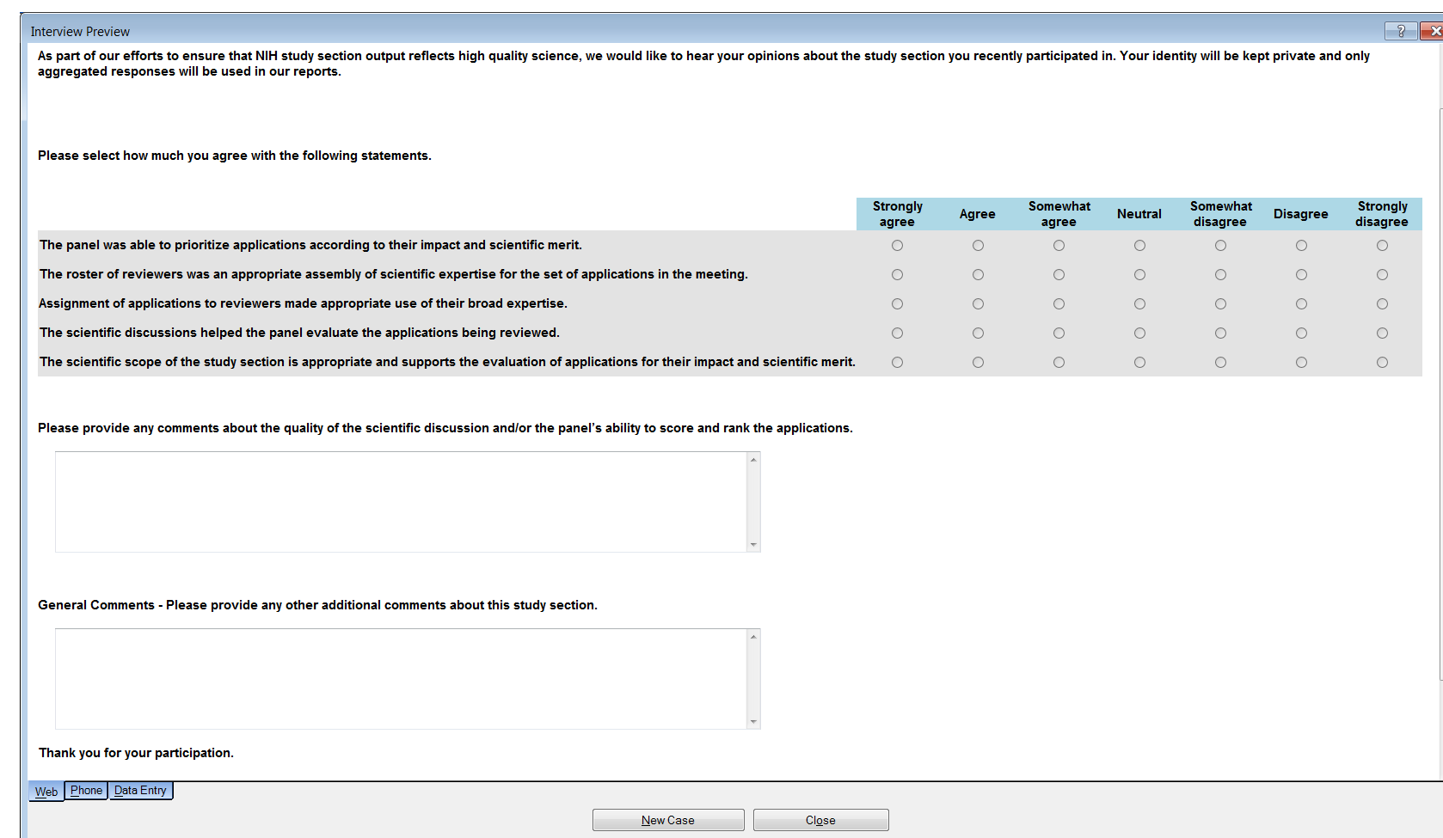
TITLE OF INFORMATION COLLECTION: Survey to Assess the Quality of Grant Review and Study Section Structure Among NIH Center for Scientific Review (CSR) Reviewers

