KAI Research Monitoring Body Meeting Evaluation
To see in real time: http://altarum.dsmbeval.alchemer.com/s3//SG_TEST_RUN

Survey Page 1

Top
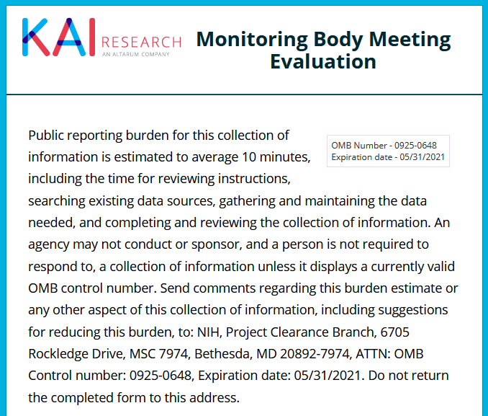

Bottom
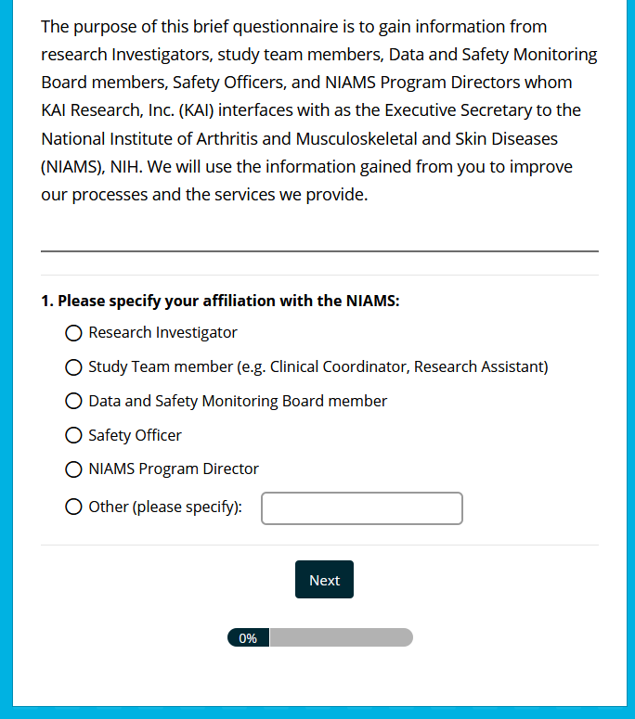

Survey Page 2
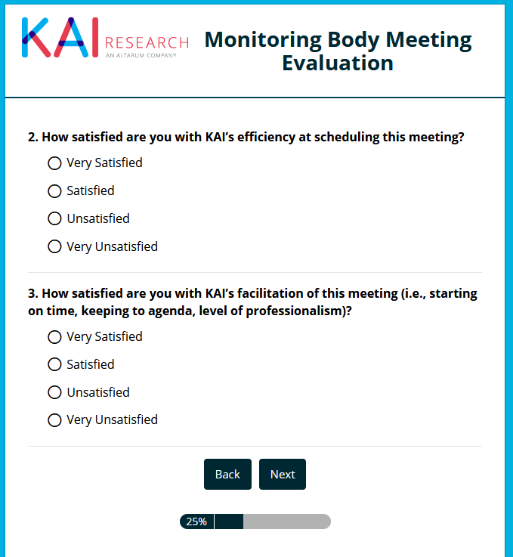

Survey Page 3, Yes
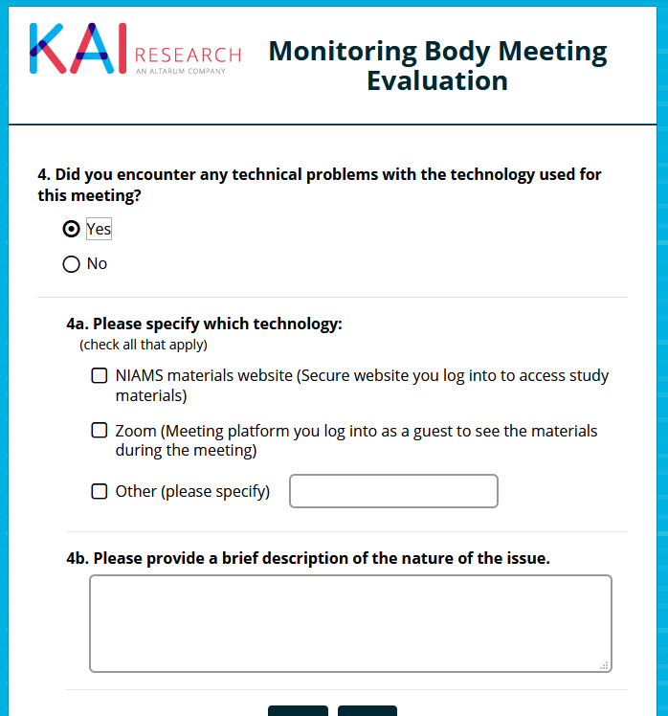

Survey Page 3, No
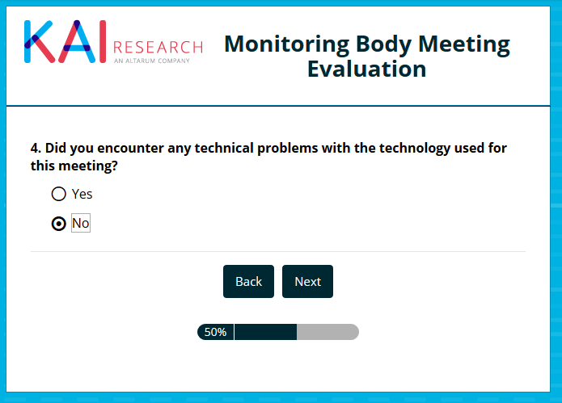

Survey Page 4
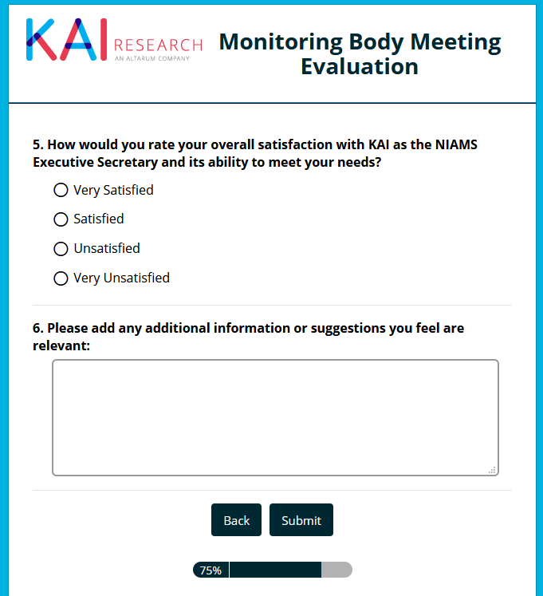

Survey Conclusion Page
