360 Survey – Government Email

DO NOT REPLY to this email.
All questions and comments should be directed to NITAAC Support
This survey in voluntary – Your Responses are kept private to the extent allowable by law.

NITAAC is always working to improve your experience as a valued customer. That’s why we’re requesting feedback about your experience using our Best in Class Government-Wide Acquisition Contracts (GWACs). Your feedback will be used to improve NITAAC services to government customers and contract holders alike. All feedback is anonymous.
Please take a few minutes to access the survey using the link below. The survey will provide NITAAC with valuable data to continue providing you with exceptional acquisition solutions through our contracts.
Begin Survey
We appreciate your feedback and ask that you complete this survey before February 28, 2020.
**Don't worry if your agency is not currently using NITAAC, your feedback is also valuable in our efforts to improve.**
A synopsis of the results will be provided approximately six weeks after the survey closes (March 2020). You’ll receive an email with instructions on accessing the results.

Thank you,
NITAAC Support
Phone: 888.773.6542
NITAACSupport@nih.gov
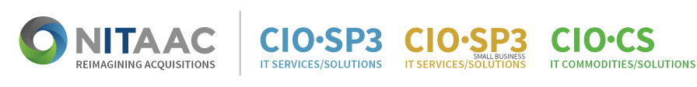
www.nitaac.nih.gov
6011 Executive Boulevard, Suite 501
Rockville, Maryland 20852

About NITAAC
NITAAC is the designated federal Executive Agent authorized by the Office of Management and Budget (OMB) to administer three Best in Class (BIC) Government-Wide Acquisition Contracts (GWACs) for information technology (IT). With a contract ceiling of $60 billion each, the CIO-SP3, CIO-SP3 Small Business and CIO-CS GWACs can be used by any federal civilian or Department of Defense (DoD) agency to procure IT products, services and solutions.

