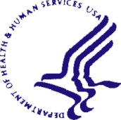DEPARTMENT OF HEALTH AND HUMAN SERVICES | National Institutes of Health  National Institute of  Environmental Health Sciences  P. O. Box 12233  Research Triangle Park, NC 27709  Website: http://www.niehs.nih.gov

Memorandum for a Non-Substantive Change Request

DEPARTMENT OF HEALTH & HUMAN SERVICES

National Institutes of Health
Bethesda, Maryland 20892
February 12, 2021

TO: Office of Management and Budget (OMB)
Through: Reports Clearance Officer, Debbie Kramer, DHHS
Project Clearance Chief, Mikia Currie, NIH
Project Clearance Liaison, (NIEHS)

FROM: Kristianna Pettibone
NIEHS

SUBJECT: Generic Clearance for the Collection of Qualitative Feedback on Agency Service Delivery, OMB # 0925-0648, exp., 5/31/2021

This is a request for OMB to approve a name change of the sub-study entitled, “Children’s Health Exposure Analysis Resource (CHEAR),” previously approved under the NIH’s “Generic Clearance for the Collection of Qualitative Feedback on Agency Service Delivery.” The sub-study was originally submitted on January 9, 2019 and approved on January 19, 2019. The name of the program has changed to “Human Health Exposure Analysis Resource (HHEAR).” We have changed the name of the program throughout the survey but have not changed the questions or response options.

Your full consideration is appreciated.

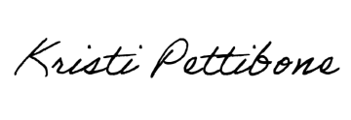
Kristi Pettibone, PhD
Evaluator
NIEHS, Division of Extramural Research and Training, Program Analysis Branch

