OQR Web Based Measures Data Collection Tool with PRA Notice

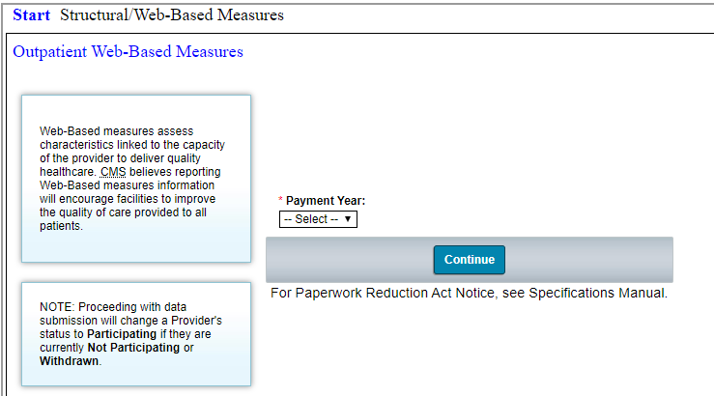

OQR Population & Sampling

