**Out of Network Site Visit Report (Form M-3A)**

**UAC Interview Questions Data Entry Window**

OMB 0970-#### [valid through MM/DD/YYYY]

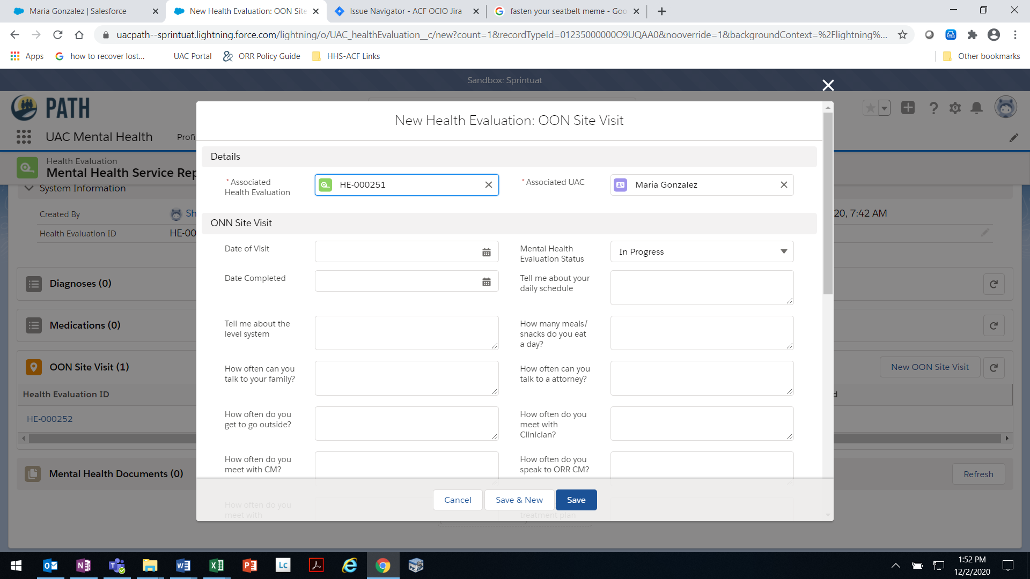

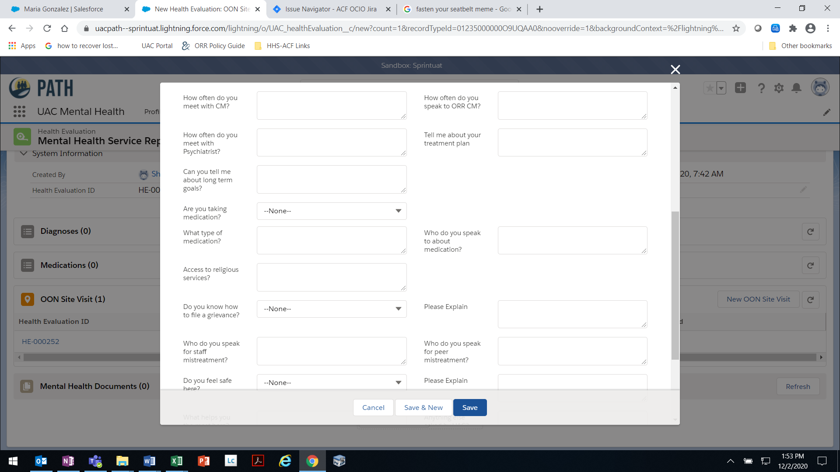

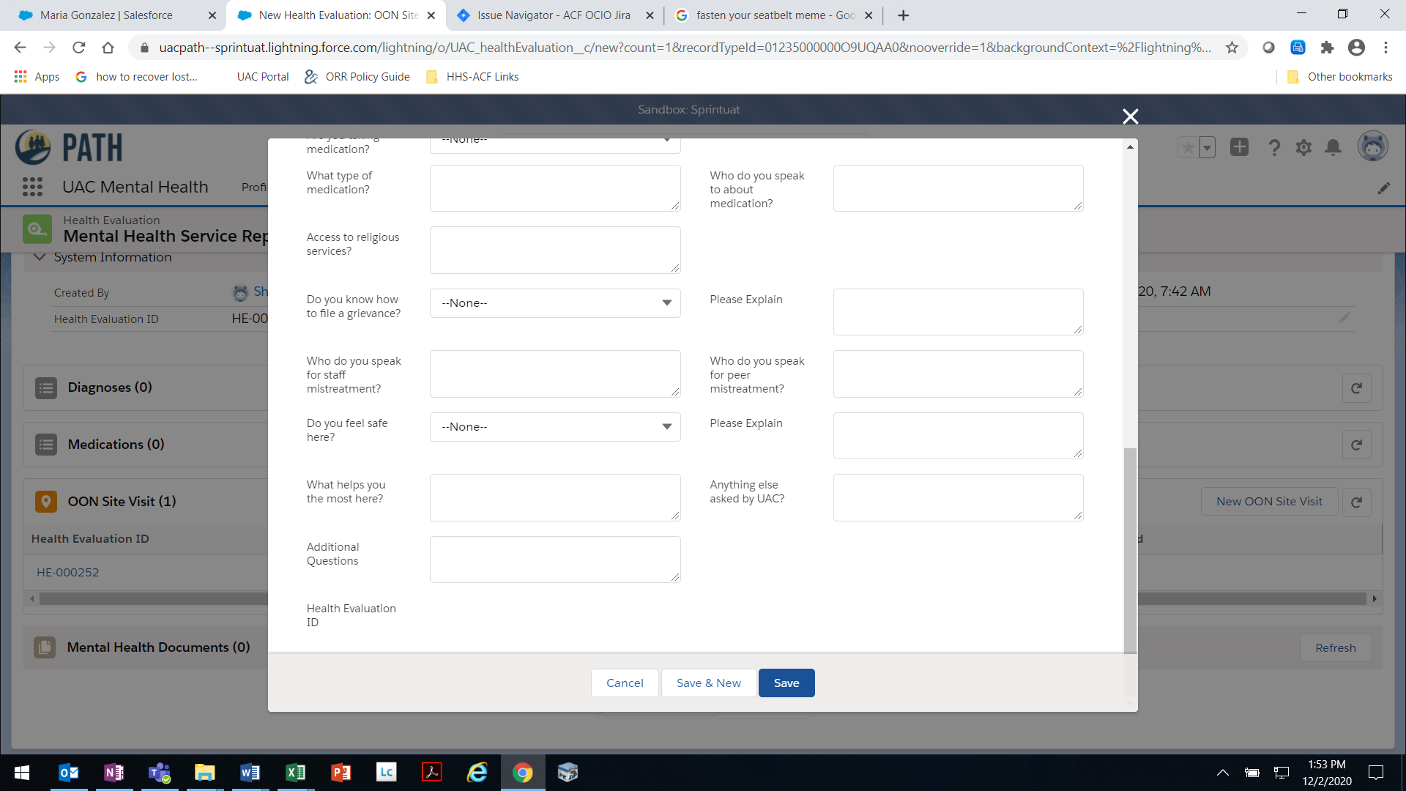

THE PAPERWORK REDUCTION ACT OF 1995 (Pub. L. 104-13) STATEMENT OF PUBLIC BURDEN: The purpose of this information collection is to allow ORR Federal Field Specialists to document site visit observations and interview responses for out-of-network providers. Public reporting burden for this collection of information is estimated to average 1.0 hour per response, including the time for reviewing instructions, gathering and maintaining the data needed, and reviewing the collection of information. This is a mandatory collection of information (Homeland Security Act, 6 U.S.C. 279). An agency may not conduct or sponsor, and a person is not required to respond to, a collection of information subject to the requirements of the Paperwork Reduction Act of 1995, unless it displays a currently valid OMB control number. If you have any comments on this collection of information please contact UACPolicy@acf.hhs.gov.

UAC-M-3B [Rev. MM/DD/YYYY]

**UAC Interview Questions Page – Details Tab**

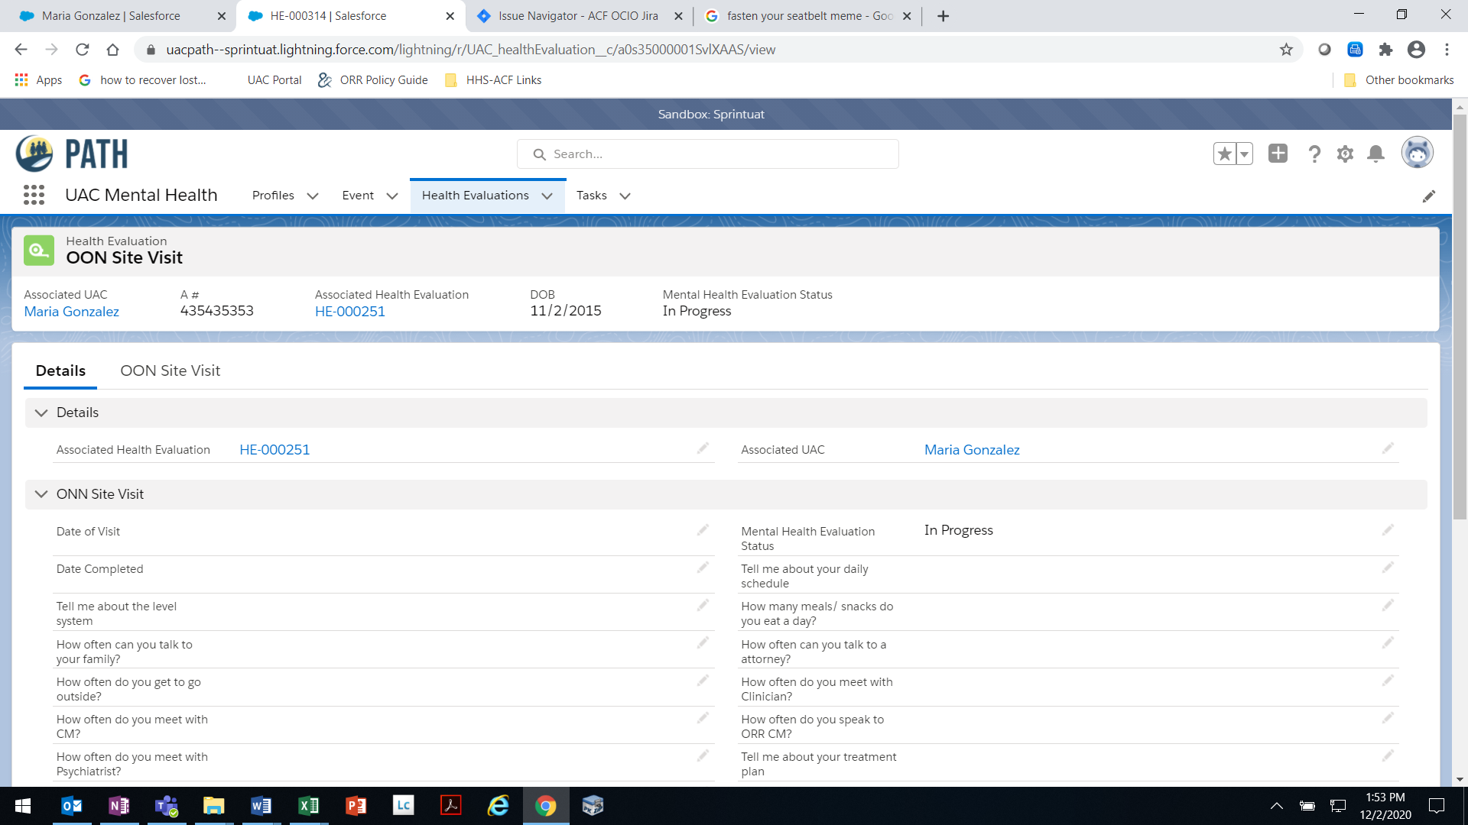

OMB 0970-#### [valid through MM/DD/YYYY]

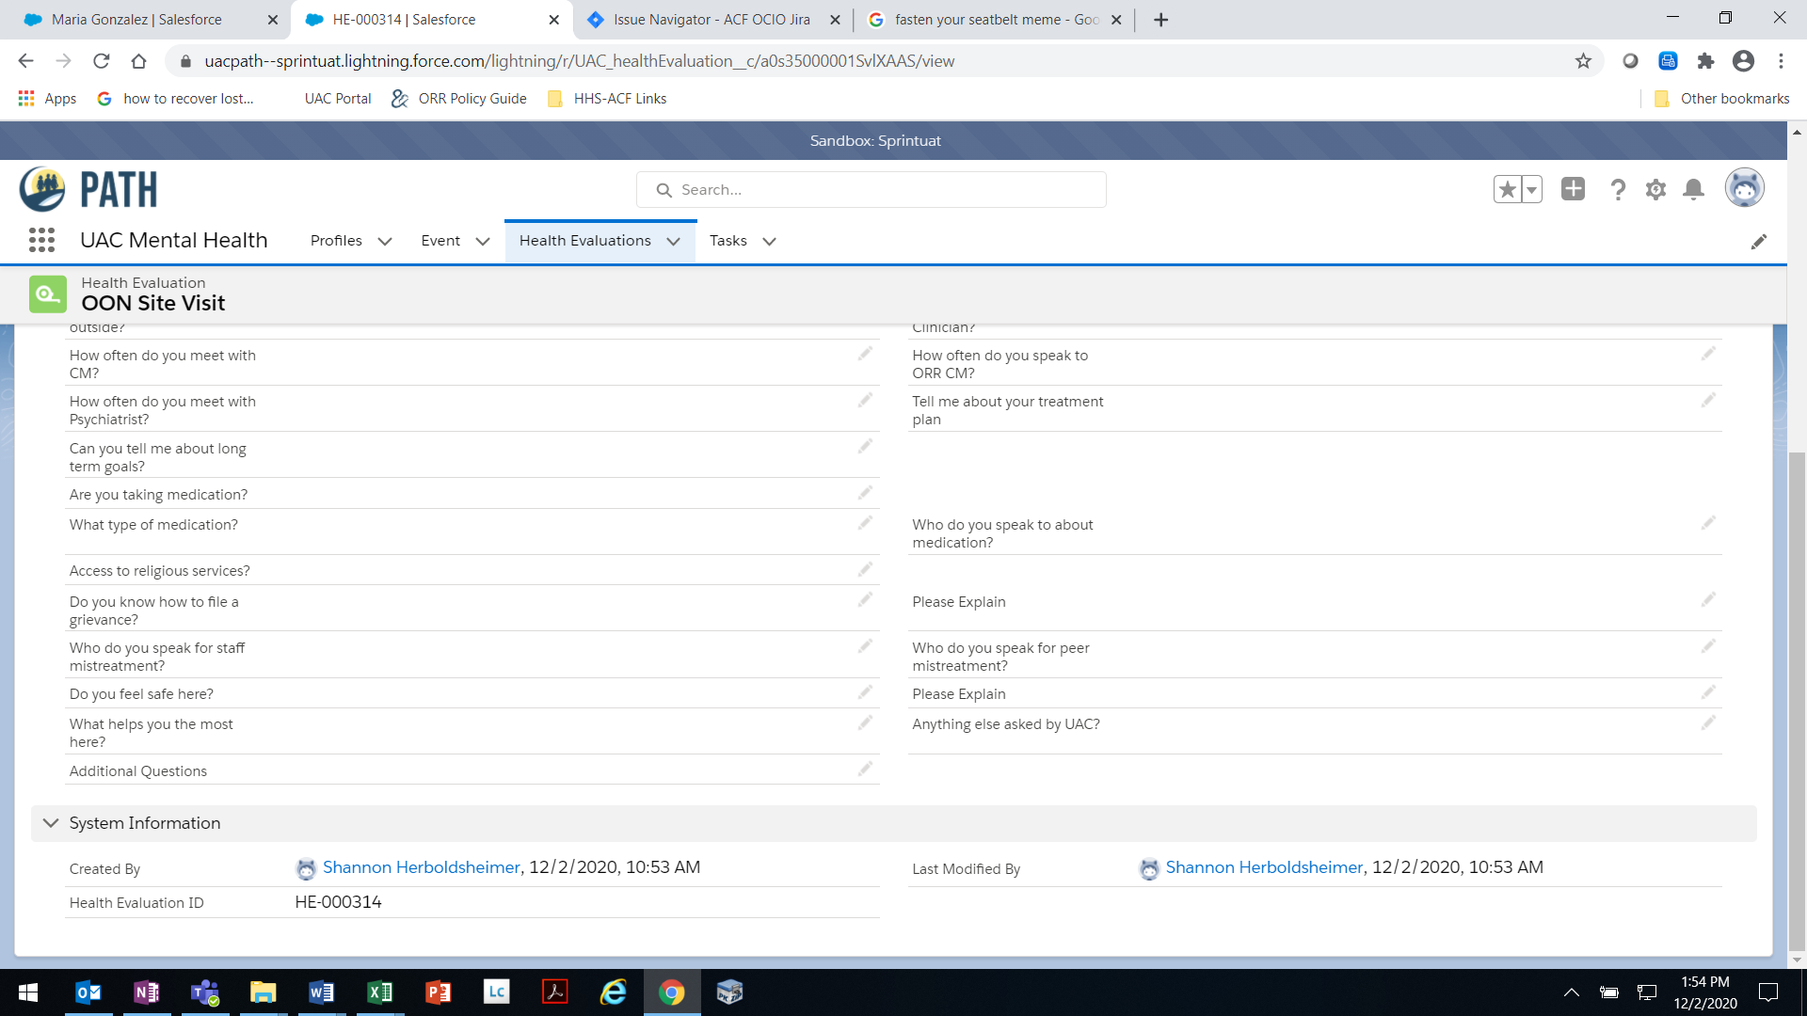

THE PAPERWORK REDUCTION ACT OF 1995 (Pub. L. 104-13) STATEMENT OF PUBLIC BURDEN: The purpose of this information collection is to allow ORR Federal Field Specialists to document site visit observations and interview responses for out-of-network providers. Public reporting burden for this collection of information is estimated to average 1.0 hour per response, including the time for reviewing instructions, gathering and maintaining the data needed, and reviewing the collection of information. This is a mandatory collection of information (Homeland Security Act, 6 U.S.C. 279). An agency may not conduct or sponsor, and a person is not required to respond to, a collection of information subject to the requirements of the Paperwork Reduction Act of 1995, unless it displays a currently valid OMB control number. If you have any comments on this collection of information please contact UACPolicy@acf.hhs.gov.

UAC-M-3B [Rev. MM/DD/YYYY]

**UAC Interview Questions Page- OON Site Visit Tab**

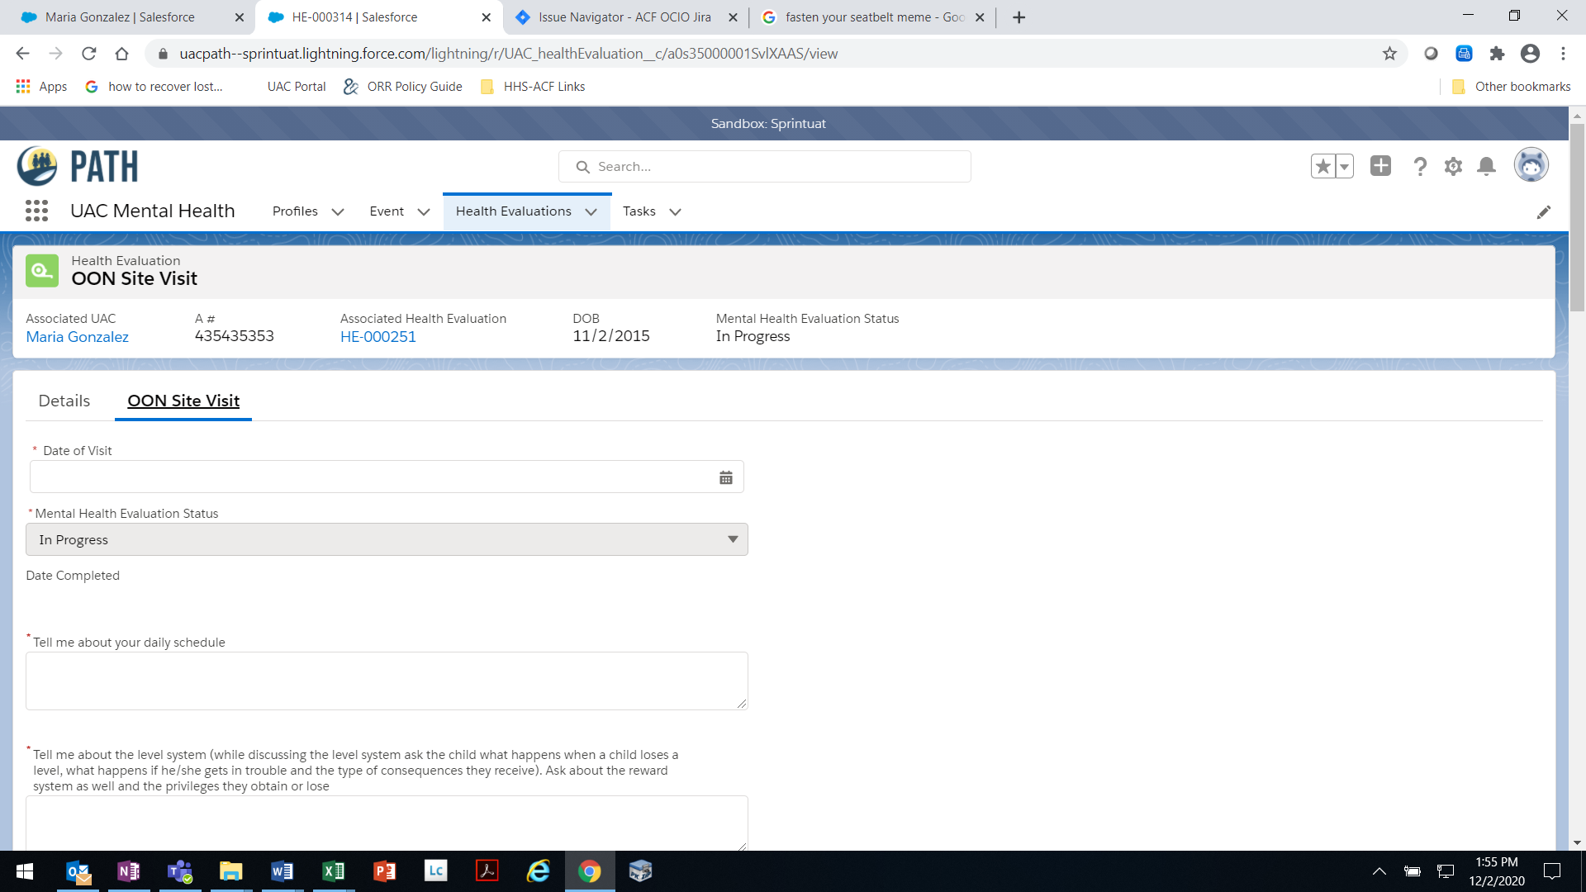

OMB 0970-#### [valid through MM/DD/YYYY]

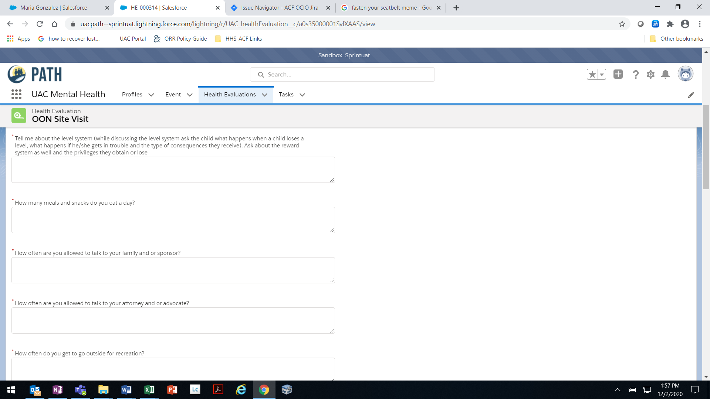

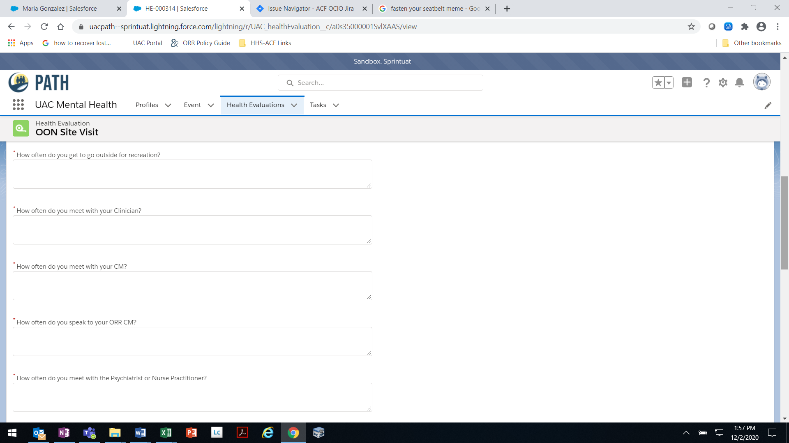

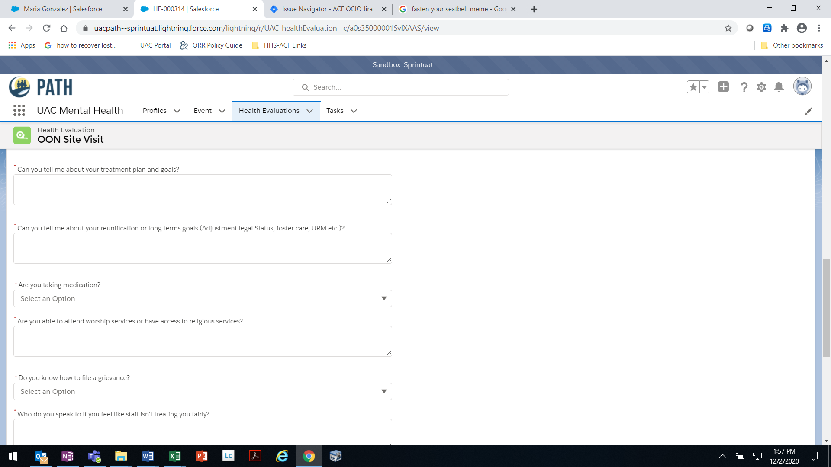

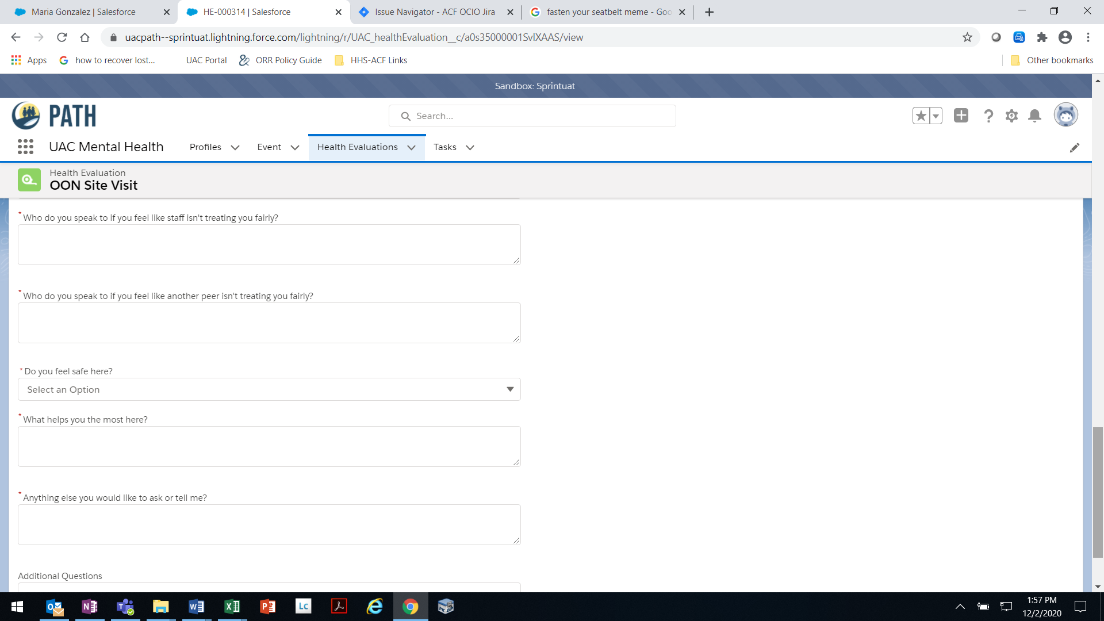

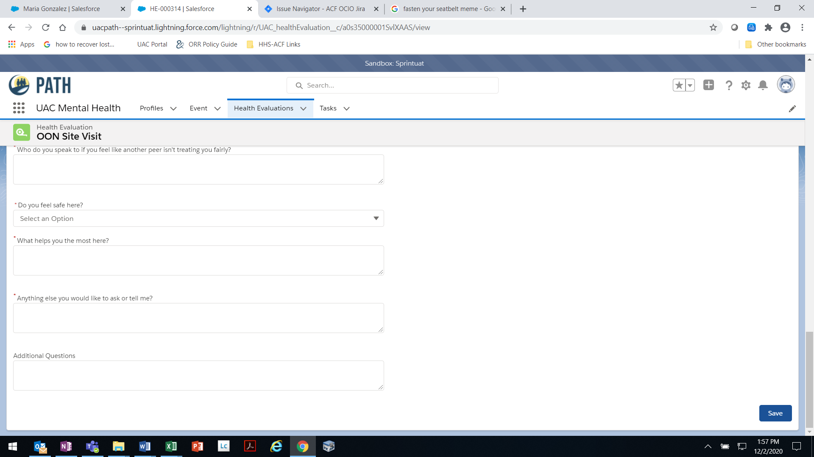

THE PAPERWORK REDUCTION ACT OF 1995 (Pub. L. 104-13) STATEMENT OF PUBLIC BURDEN: The purpose of this information collection is to allow ORR Federal Field Specialists to document site visit observations and interview responses for out-of-network providers. Public reporting burden for this collection of information is estimated to average 1.0 hour per response, including the time for reviewing instructions, gathering and maintaining the data needed, and reviewing the collection of information. This is a mandatory collection of information (Homeland Security Act, 6 U.S.C. 279). An agency may not conduct or sponsor, and a person is not required to respond to, a collection of information subject to the requirements of the Paperwork Reduction Act of 1995, unless it displays a currently valid OMB control number. If you have any comments on this collection of information please contact UACPolicy@acf.hhs.gov.

UAC-M-3B [Rev. MM/DD/YYYY]

**FFS Observations**