Instrument 5. Service receipt tracking - revised

PAPERWORK REDUCTION ACT OF 1995 (Pub. L. 104-13) STATEMENT OF PUBLIC BURDEN:
The purpose of this information collection is to evaluate innovative programs serving individuals facing challenges to employment and economic independence to expand the evidence base. Public reporting burden for this collection of information is estimated to average 5 minutes per response, including the time for reviewing instructions, gathering and maintaining the data needed, and reviewing the collection of information. This is a voluntary collection of information. An agency may not conduct or sponsor, and a person is not required to respond to, a collection of information subject to the requirements of the Paperwork Reduction Act of 1995, unless it displays a currently valid OMB control number. The OMB # is 0970-0545 and the expiration date is 04/30/2023. If you have any comments on this collection of information, please contact Mathematica at NextGenProject@mathematica-mpr.com.
Service Receipt Tracking – Screens in the Random Assignment, Participant Tracking Enrollment, and Reporting, or RAPTER®, system
(this data is only collected for participants assigned to the treatment group)
C1. Participant summary
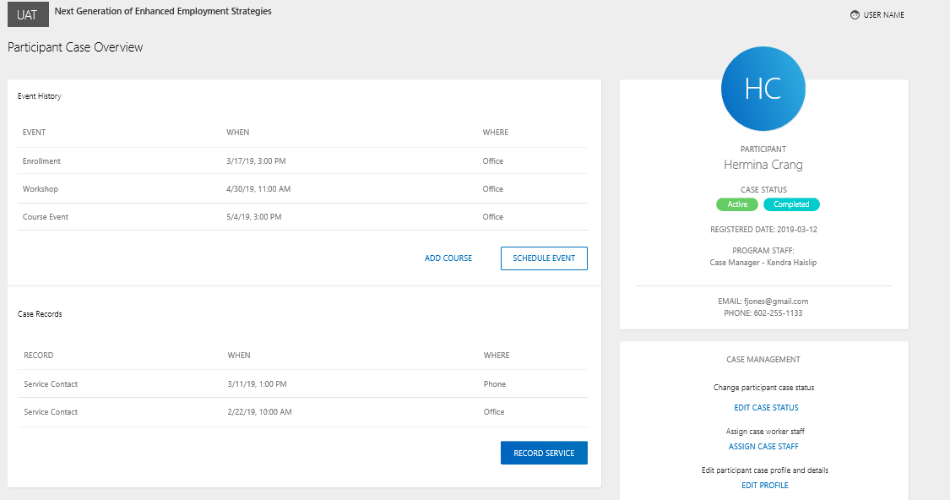
C2. Assign program staff to participant case
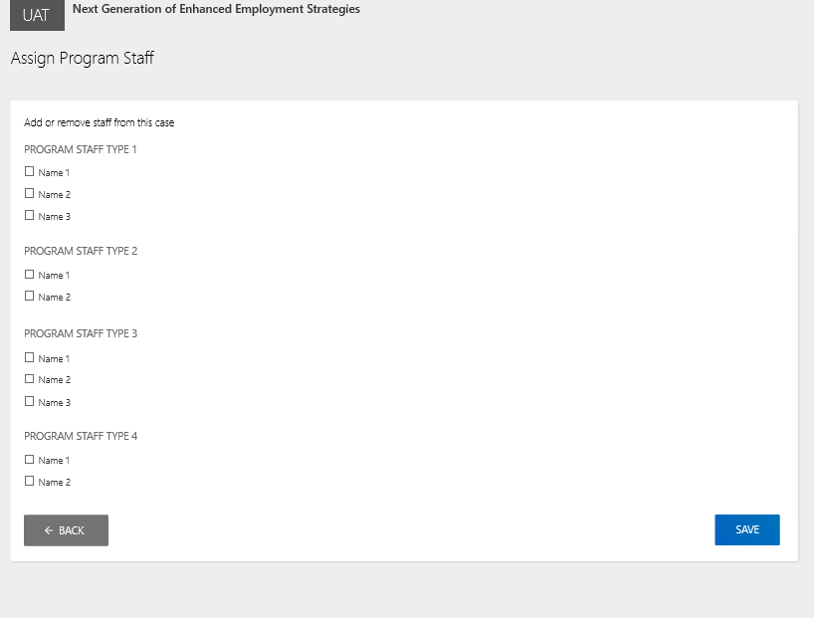
C3. Add service contact
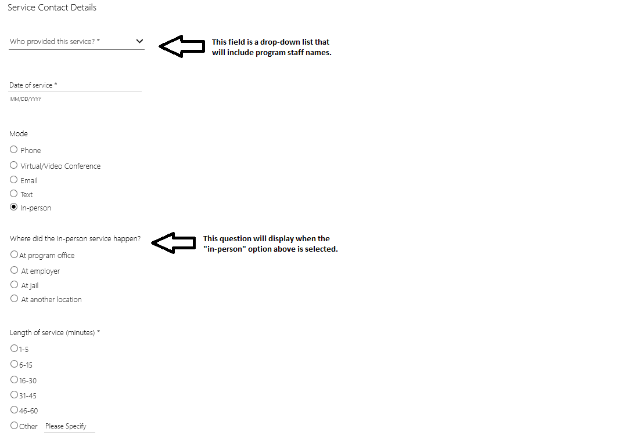
C4. Record collaboration with employer and other partners
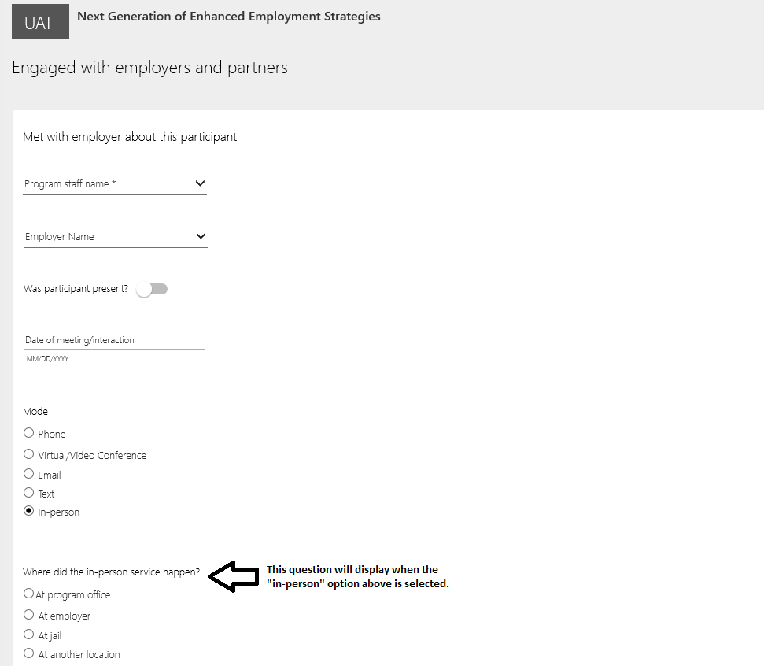
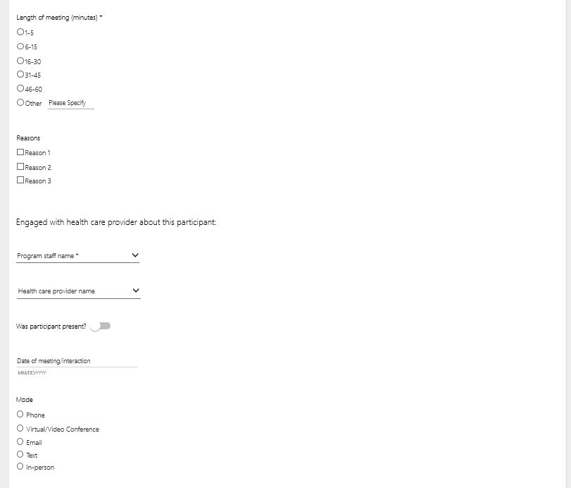

C5. Record work-based experiences and wage subsidies
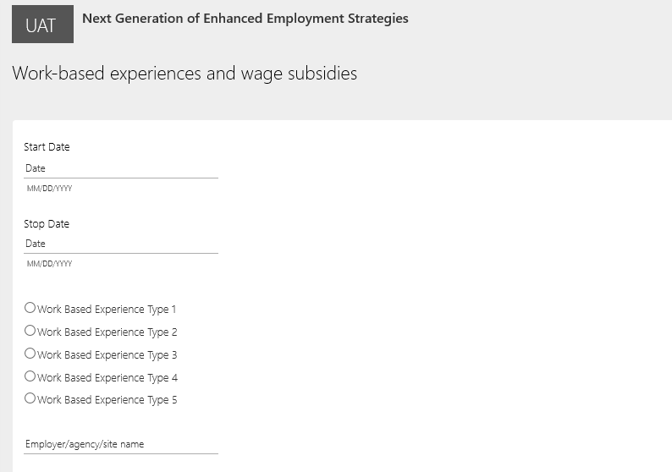

C6. Record education or training programs
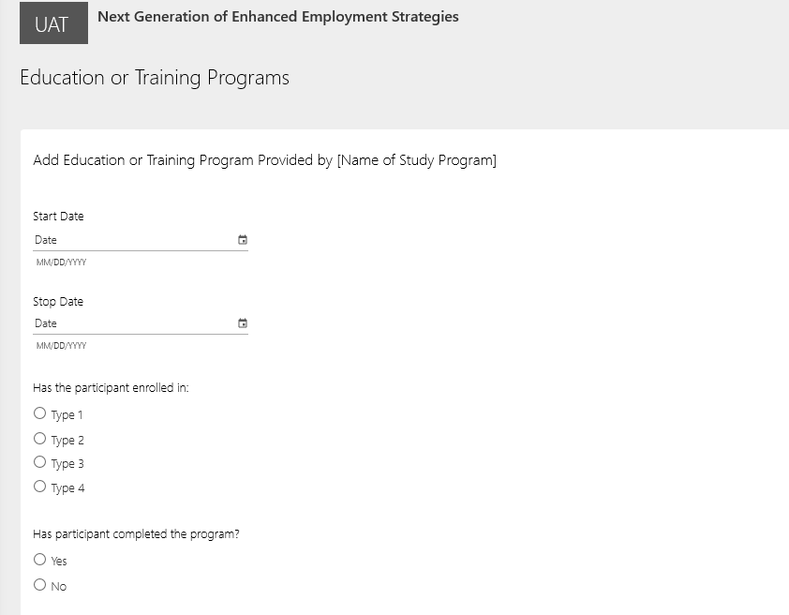

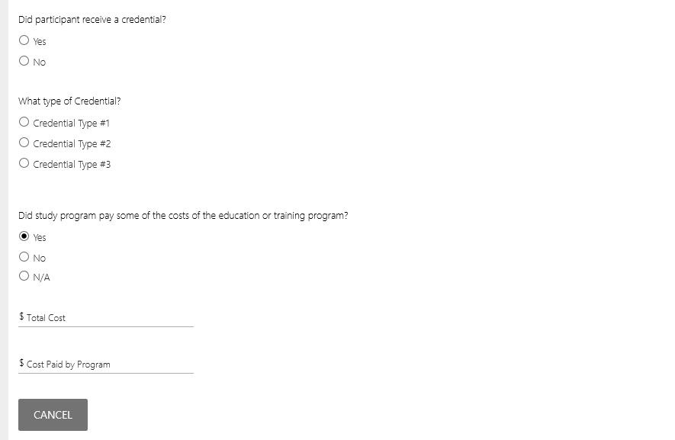

C7. Add financial or in-kind support
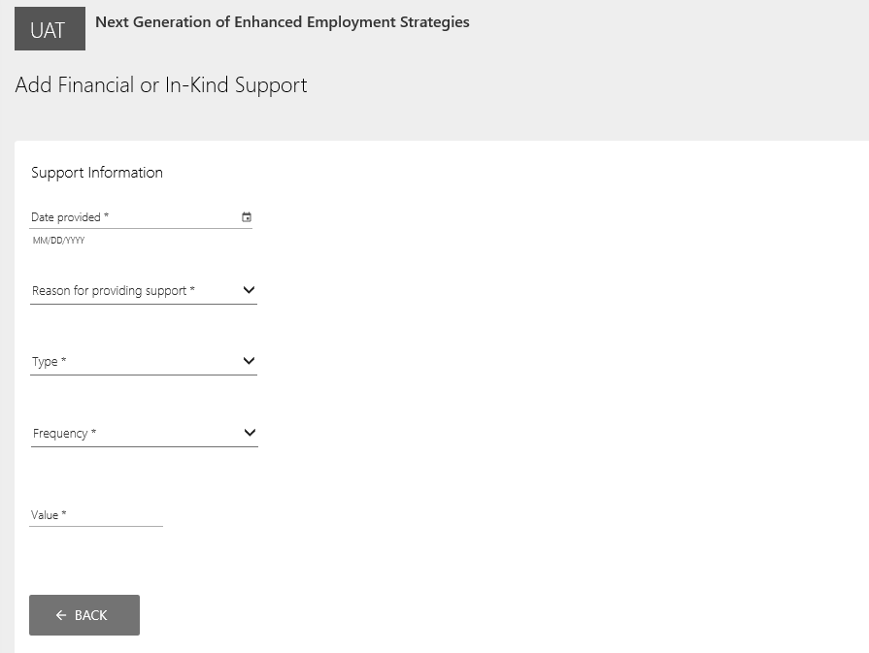
C8. Add referral
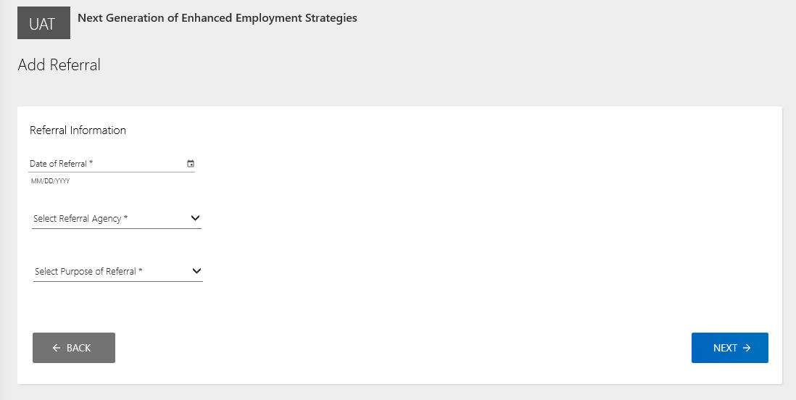

C9. Update participant case status
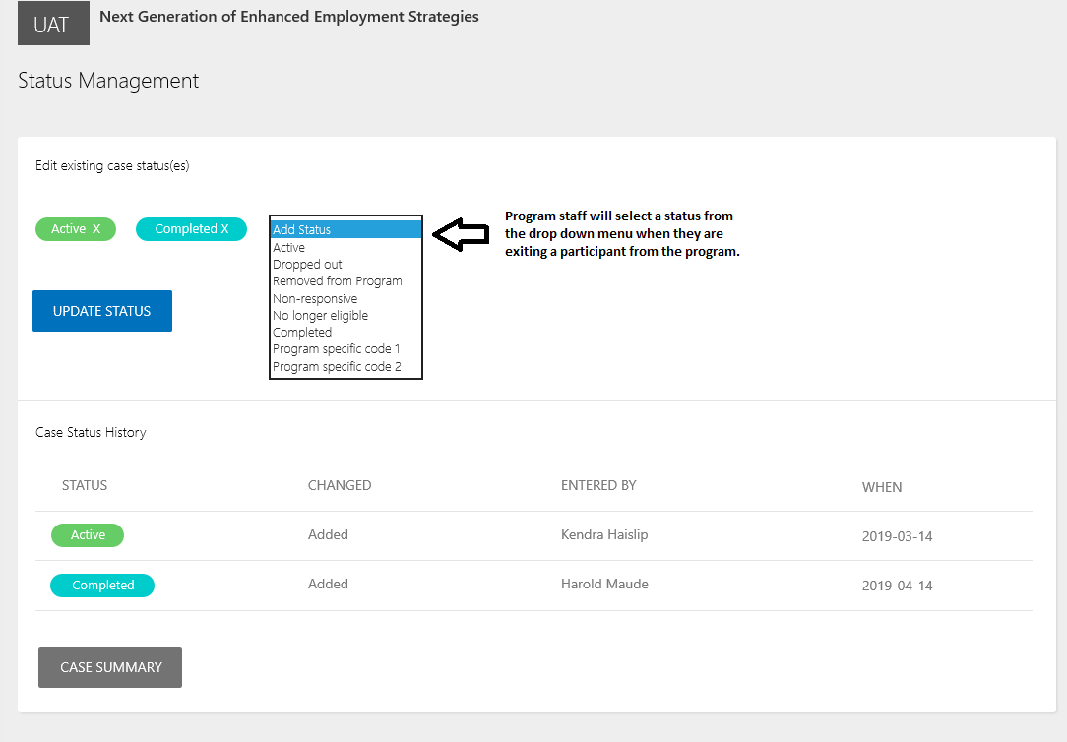
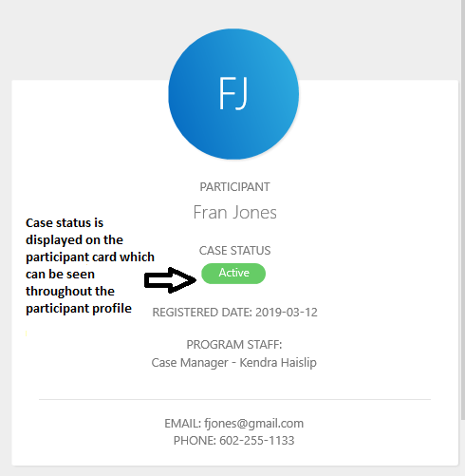

Group Events Screens
D1. Group event summary screen
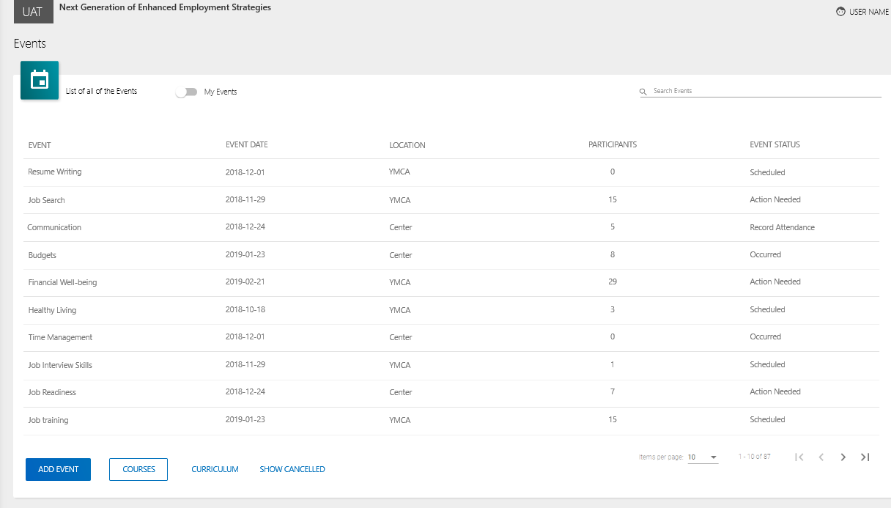

D2. Schedule event screen
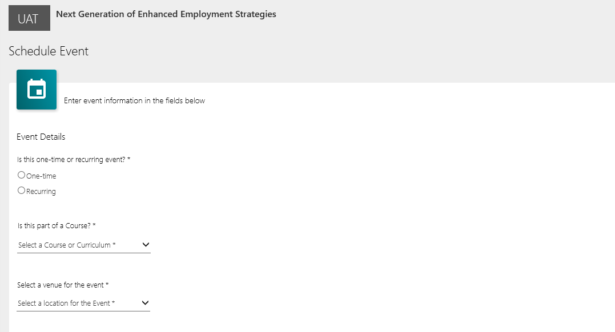

D3. Manage group event roster
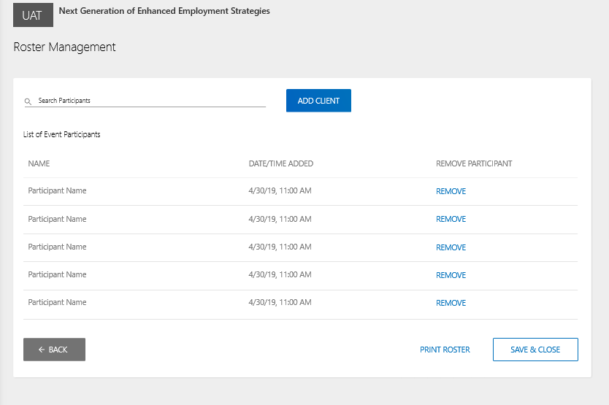

D4. Record group event attendance
