ATTACHMENT G.1  
  
advance mass email

**This page has been left blank for double-sided copying.**

TO: [EMAIL]

FROM: eceichq@mathematica-mpr.com

SUBJECT: Study on the Implementation and Cost of High Quality Early Care and Education

ATTACHMENT: FAQs, Study brochure

[INSERT OPRE LOGO] [INSERT MATHEMATICA LOGO]

Dear [CONTACT_1_FIRST_NAME] [CONTACT_1_LAST_NAME]:

As you know, high quality early care and education (ECE) builds a strong foundation of emotional, social, language, and cognitive skills that are key for children’s future success in school. The U.S. Department of Health and Human Services, Administration for Children and Families (ACF), Office of Planning, Research, and Evaluation (OPRE) has partnered with Mathematica, an independent research organization, to conduct an in-depth study on how centers use their resources to maximize the quality of ECE.

For this study to be successful, it is critical to have the participation of a range of centers—such as big and small centers, and those that receive different types of support. We will be reaching out to centers in your area soon to inform them of their selection for the study. If your center is selected, your input will be extremely helpful in conducting quality research. When the study is complete, we hope the findings will help centers of all types make decisions about using resources to support quality. The findings will also help state and national administrators and policymakers understand how to best invest resources to promote quality ECE. Participation in the study is completely voluntary, but if your center is selected, we hope you will participate. The information selected centers provide will be kept private, and the study will not identify individuals or centers in any of its reports. Selected centers that participate will receive [AMOUNT] for taking part in the study.

I have attached answers to frequently asked questions about the study and a study brochure. If you have any questions prior to our call, or are interested in participating, please contact me at XXX-XXX- XXXX or by email at eceichq@mathematica-mpr.com.

Sincerely,

Annalee Kelly

Survey Director

Paperwork Reduction Act Statement: The referenced collection of information is voluntary. An agency may not conduct or sponsor, and a person is not required to respond to, a collection of information unless it displays a currently valid OMB control number. The OMB control number for this collection is XXX-XXXX and it expires XX/XX/XXXX.

**This page has been left blank for double-sided copying.**

ATTACHMENT G.2  
  
advance mass letter

**This page has been left blank for double-sided copying.**

**Annalee Kelly**

*Survey Director*P.O. Box 2393

Princeton, NJ 08543-2393

Telephone (609) 799-3535

Fax (609) 799-0005

www.mathematica-mpr.com

[DATE]

Dear [CONTACT_1_FIRST_NAME] [CONTACT_1_LAST_NAME]:

As you know, high quality early care and education (ECE) builds a strong foundation of emotional, social, language, and cognitive skills that are key for children’s future success in school. The U.S. Department of Health and Human Services, Administration for Children and Families (ACF), Office of Planning, Research, and Evaluation (OPRE) has partnered with Mathematica, an independent research organization, to conduct an in-depth study on how centers use their resources to maximize the quality of ECE.

For this study to be successful, it is critical to have the participation of a range of centers—such as big and small centers, and those that receive different types of support. We will be reaching out to centers in your area soon to inform them of their selection for the study. If your center is selected, your input will be extremely helpful in conducting quality research. When the study is complete, we hope the findings will help centers of all types make decisions about using resources to support quality. The findings will also help state and national administrators and policymakers understand how to best invest resources to promote quality ECE. Participation in the study is completely voluntary, but if your center is selected, we hope you will participate. The information selected centers provide will be kept private, and the study will not identify individuals or centers in any of its reports. Selected centers that participate will receive [AMOUNT] for taking part in the study.

I have enclosed answers to frequently asked questions about the study and a study brochure. If you have any questions prior to our call, or are interested in participating, please contact me at XXX-XXX-XXXX or by email at [eceichq@mathematica-mpr.com](mailto:eceichq@mathematica-mpr.com).

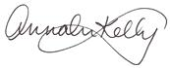 Sincerely,

Annalee Kelly,

Survey Director

Paperwork Reduction Act Statement: The referenced collection of information is voluntary. An agency may not conduct or sponsor, and a person is not required to respond to, a collection of information unless it displays a currently valid OMB control number. The OMB control number for this collection is XXX-XXXX and it expires XX/XX/XXXX.

**This page has been left blank for double-sided copying.**

ATTACHMENT G.3  
  
STUDY BROCHURE

**This page has been left blank for double-sided copying.**

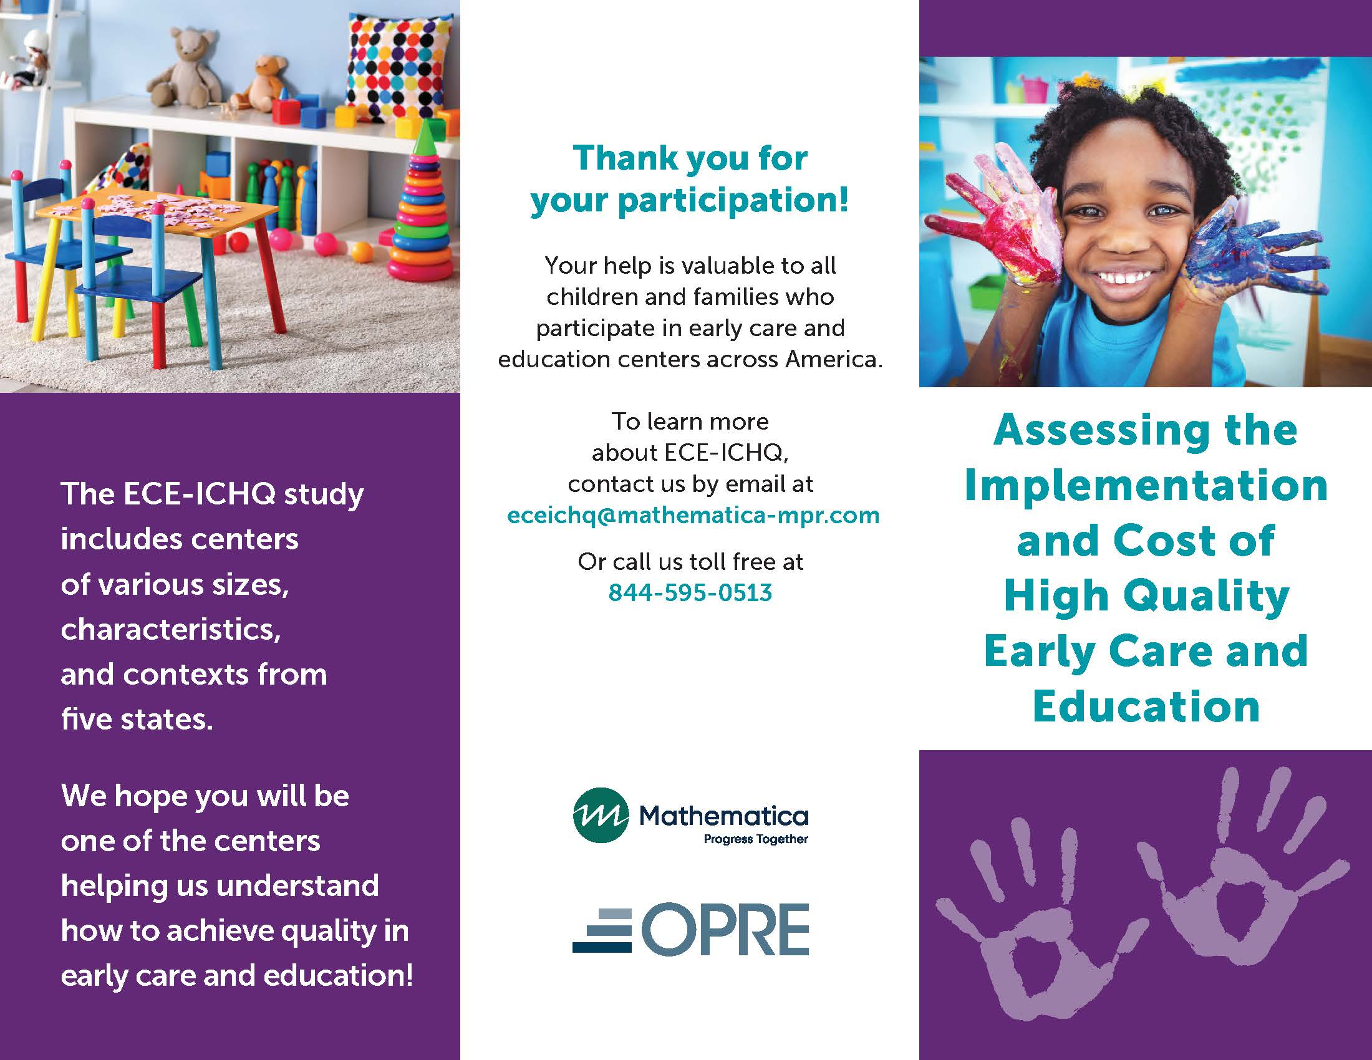



aTTACHMENT G.4  
  
STUDY FREQUENTLY ASKED QUESTIONS

**This page has been left blank for double-sided copying.**

[](http://www.mathematica-mpr.com/) 

FREQUENTLY ASKED QUESTIONS ON ASSESSING THE IMPLEMENTATION AND COST OF HIGH QUALITY EARLY CARE AND EDUCATION (ECE-ICHQ)

# Q: WHAT IS ECE-ICHQ ABOUT?

The purpose of ECE-ICHQ is to produce measures of implementation and costs that can be used with existing observational measures of quality to find out what activities and investments can make a difference in improving ECE quality.

# Q: WHO IS CONDUCTING THE PROJECT?

The U.S. Department of Health and Human Services, Administration for Children and Families, Office of Planning, Research, and Evaluation (OPRE) sponsors the study. The study is being conducted by Mathematica, a respected, independent research organization whose studies of education and other programs have been used to inform national policymakers for more than 50 years.

# Q: HOW WERE CENTERS CHOSEN FOR THE STUDY?

Centers were chosen to reflect a range of characteristics, such as whether or not they serve children who receive subsidies for their care, or whether or not they offer a state prekindergarten program or are a part of Head Start program. Centers were also selected based on the number and ages of the children they serve. Participating centers will receive a [AMOUNT] gift card.

# Q: WHAT WILL YOU ASK CENTER DIRECTORS TO DO?

After a brief call to explain the study and answer any questions, we will ask center directors about their center’s characteristics and staffing structure. In addition, we will ask directors to participate in telephone interviews to help us understand the center’s activities and services.

# Q: WHAT WILL YOU ASK STAFF WHO MANAGE FINANCES TO DO?

After a brief call to explain the study and answer any questions, staff who are familiar with a center’s finances will be asked to provide information about center costs including salaries, benefits, facilities, and overhead costs. They will be sent an electronic workbook to record this information and clear instructions for completing it.

# Q: WHAT WILL YOU ASK CENTER STAFF TO DO?

Center staff will be asked to complete a time-use survey online (or on paper if they prefer). It asks questions about how much time staff spend on various tasks, including teaching, working with families, staff development, communication activities, and management tasks. This should take approximately 15 minutes to complete. Each person who completes a survey will receive a [AMOUNT] gift card.

# Q: WHAT DO THE SITE VISITS ENTAIL?

A member of our study team will visit your center on up to three occasions. During our first visit, we will collect teacher and classroom information and invite staff to complete the time-use survey. During our subsequent visits, we will conduct observations of up to three classrooms in your center. We will observe each classroom(s) for about four hours to get an idea of classroom activities and children’s interactions. We will provide a small gift to each classroom that we observe.

# Q: HOW ARE CLASSROOMS CHOSEN FOR OBSERVATIONS?

In selecting classrooms, we will consider the size of the center and the ages of children served in each classroom. Based on this information, we will randomly select up to three classrooms to observe.

# Q: WHY SHOULD I PARTICIPATE?

You and your center are a valuable part of this study. Your input will help us develop tools to understand differences in what centers do to support quality ECE, and what that costs. It will also help us describe the costs associated with implementing quality care. Taking part in ECE-ICHQ is voluntary. You may also decline to answer any questions we may ask.

# Q: WILL THE INFORMATION BE KEPT PRIVATE?

The research team follows strict rules to protect privacy. All study staff are trained to protect privacy. No reports will describe any person or center in a way that would allow you or your center to be identified.

# Q: WHAT IS THE BACKGROUND OF THE STAFF WHO WILL BE VISITING MY CENTER?

Mathematica hiring policy requires all newly hired and rehired field staff to pass a criminal background check. Sterling Testing Systems will conduct the background checks which will include a Social Security trace, criminal conviction search, sex offender search, and a department of motor vehicles report. For more information on Sterling Testing Systems, visit <http://www.sterlingtestingsolutions.com>.

# Q: IS THERE A NUMBER TO CALL FOR FURTHER QUESTIONS?

If you have additional questions about ECE-ICHQ, contact Gretchen Kirby, project director at 202-484-3470 or Annalee Kelly, survey director at 609-275-2885, or email [eceichq@mathematica-mpr.com.](mailto:eceichq@mathematica-mpr.com)