Draft nFORM Screens to Collect Information

on Services Provided to Participants

**Note: Screen shots include fictional names for illustrative purposes. OMB Control Number and Expiration Date appear on entry to nFORM system and individual surveys.**

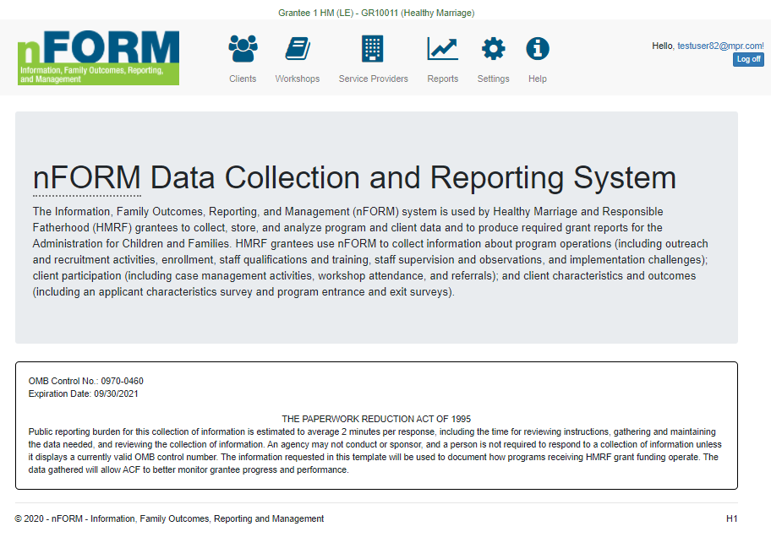

OMB Control No.: 0970-XXXX

Expiration Date: XX/XX/XXXX

THE PAPERWORK REDUCTION ACT OF 1995

(Pub. L. 104-13) STATEMENT OF PUBLIC BURDEN: The purpose of this information collection is to support program performance monitoring and program improvement activities for Healthy Marriage and Responsible Fatherhood programs. Public reporting burden for this collection of information is estimated to average 2 minutes per response, 30 minutes per client total, including the time for reviewing instructions, gathering and maintaining the data needed, and reviewing the collection of information. This is a voluntary collection of information. The answers you give will be kept private. An agency may not conduct or sponsor, and a person is not required to respond to, a collection of information subject to the requirements of the Paperwork Reduction Act of 1995, unless it displays a currently valid OMB control number. The OMB # is 0970-0XXX and the expiration date is XX/XX/XXXX. If you have any comments on this collection of information, please contact Dr. Mathew Stange at [nform2.0helpdesk@mathematica-mpr.com](mailto:nform2.0helpdesk@mathematica-mpr.com).



**C1-C6. Client Level Data on Service Contacts, Referrals, Incentives, and Workshops**

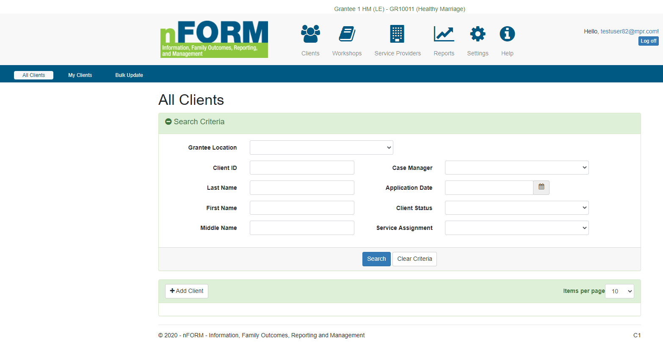

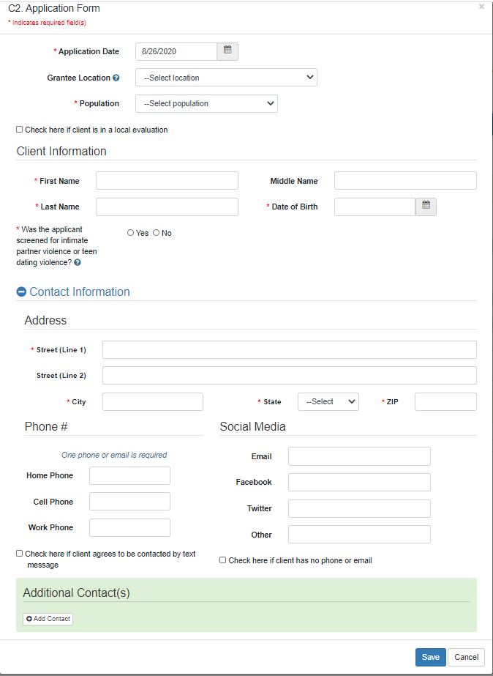

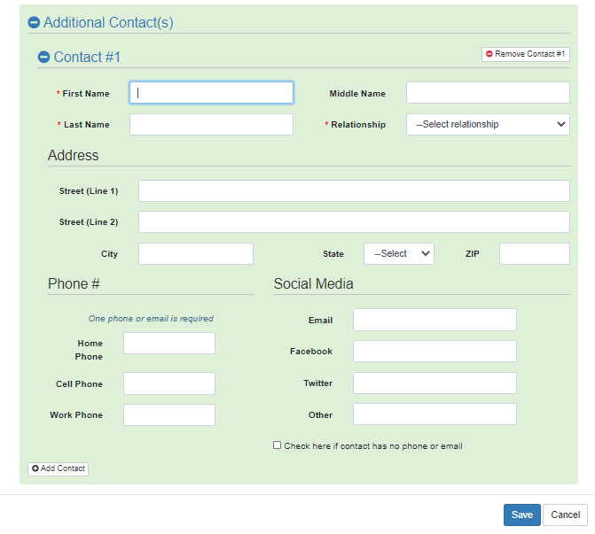

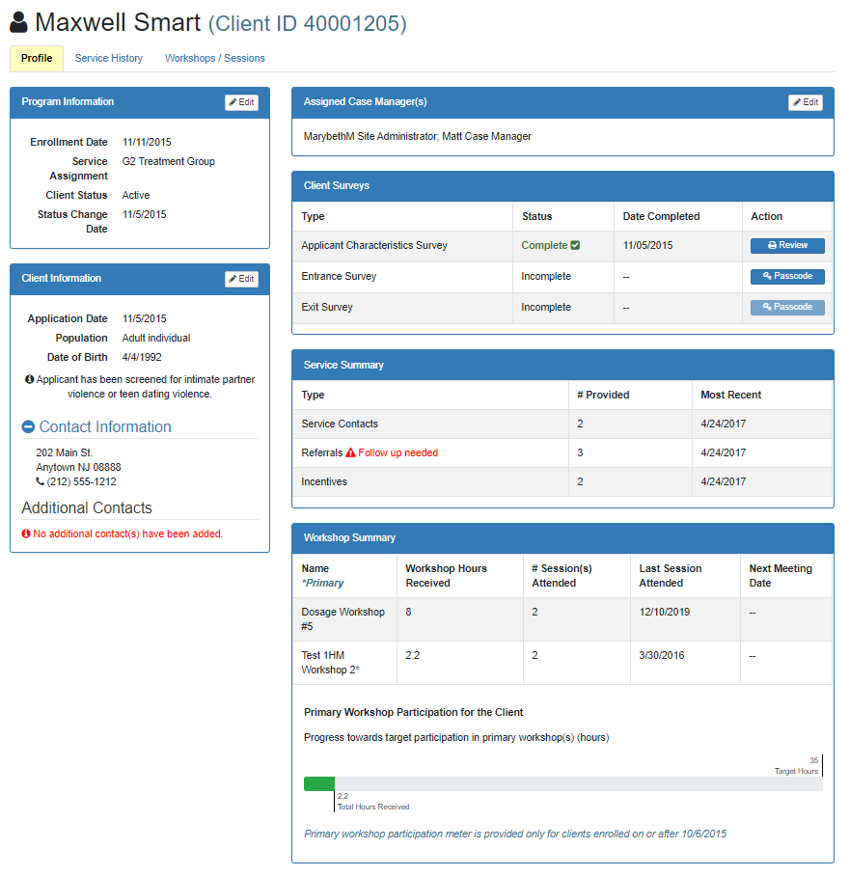

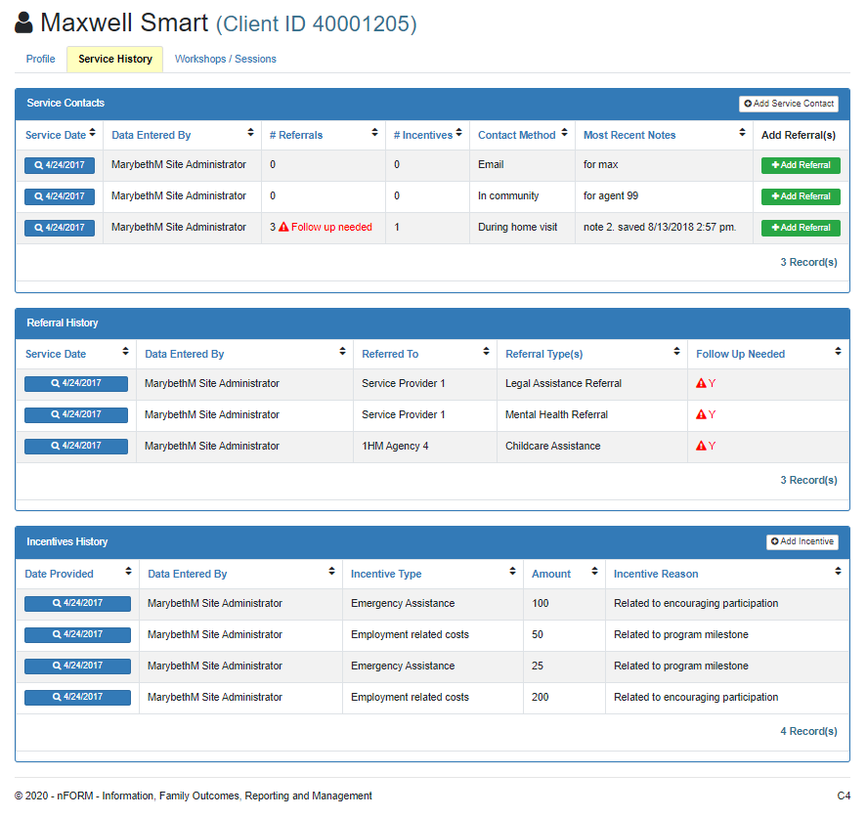

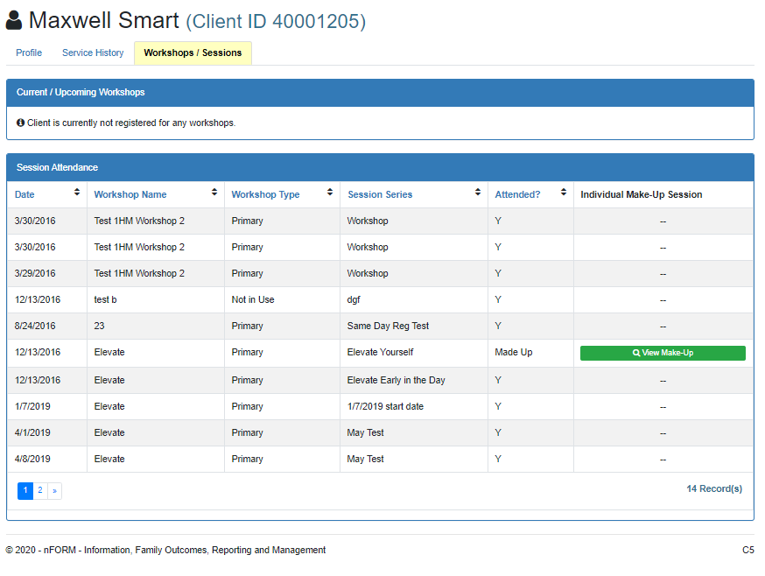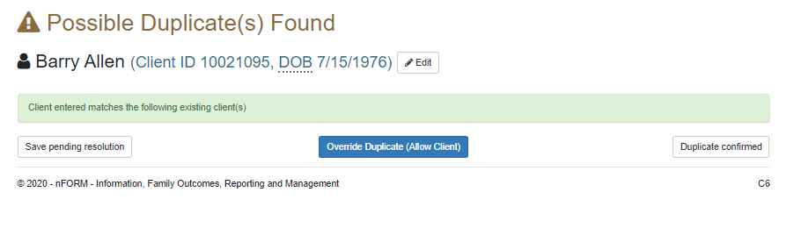

**C7/C12/C13. Add/Edit Client Service Contacts, Referrals, and Incentives**

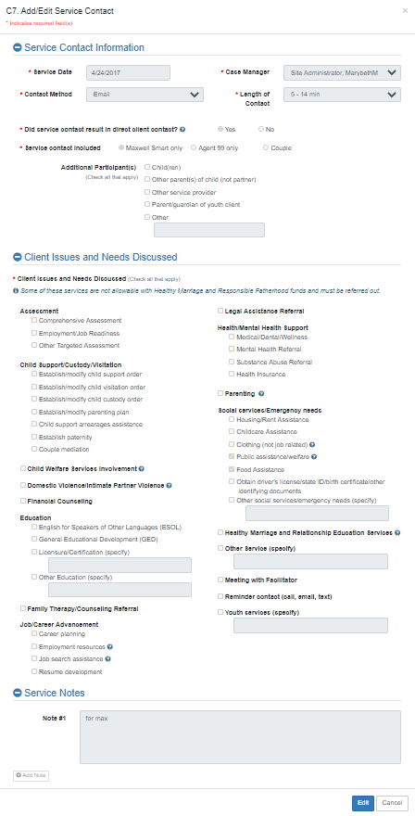

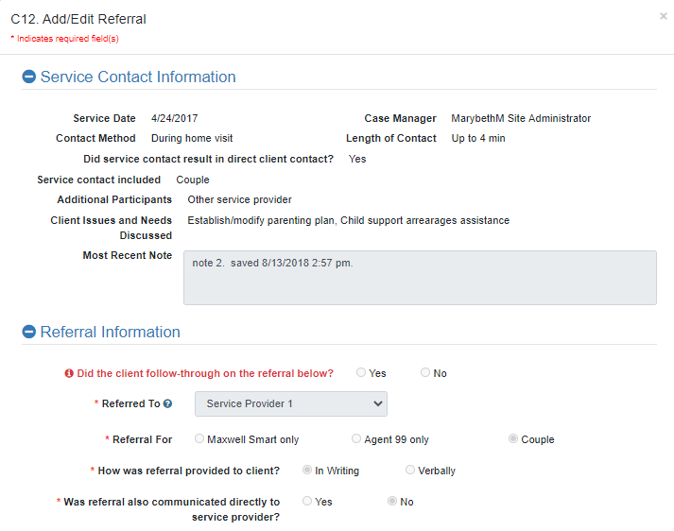

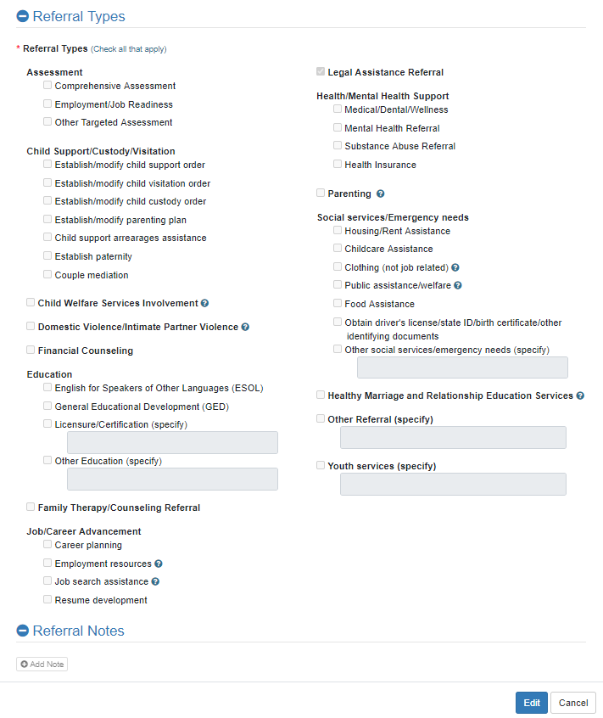

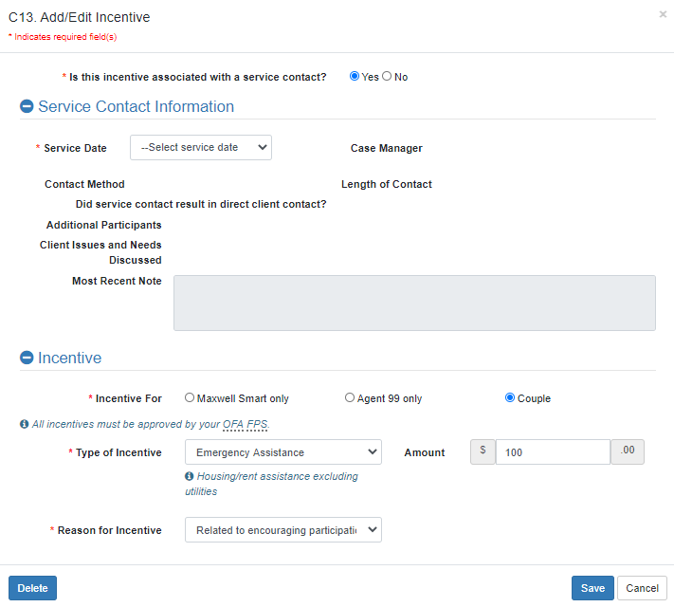

**W1. Workshop List**

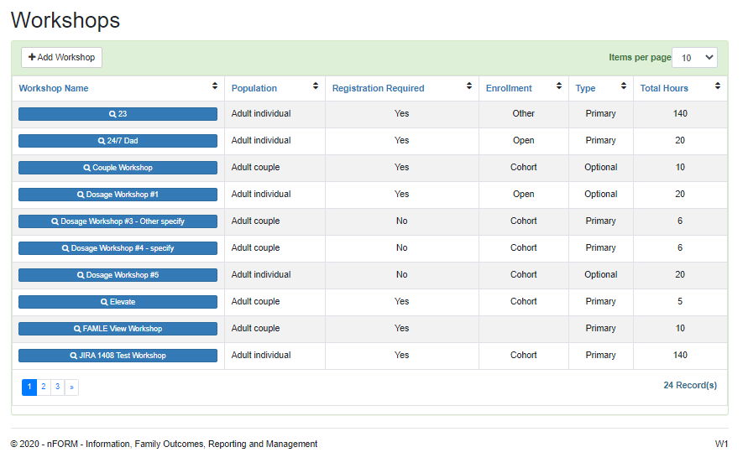

**W2. Add/Edit Workshop**

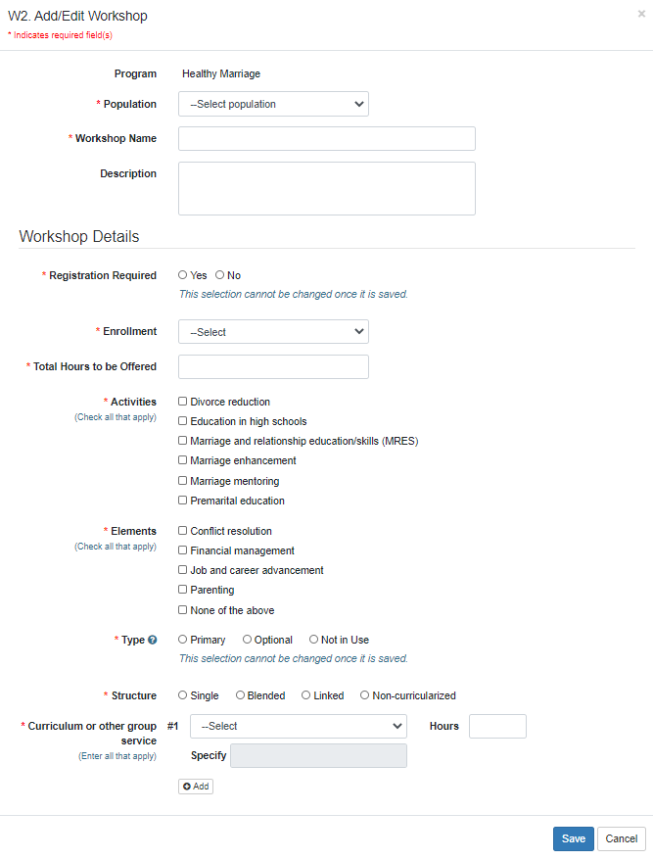

**W5. Add/Edit Workshop Session Series**

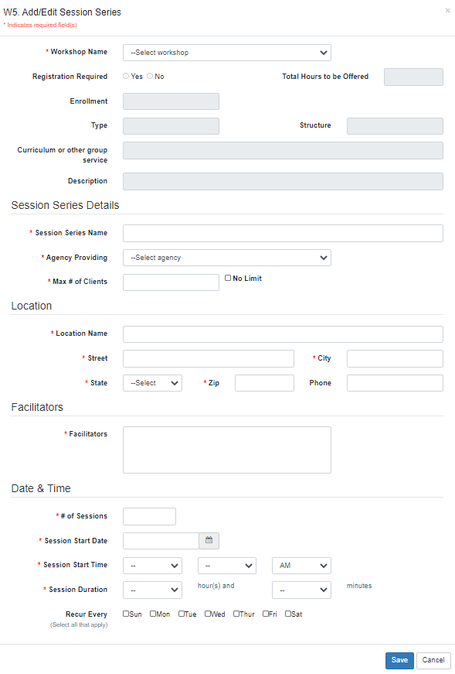

**W4/W8. Manage Session Series and Client Registration**

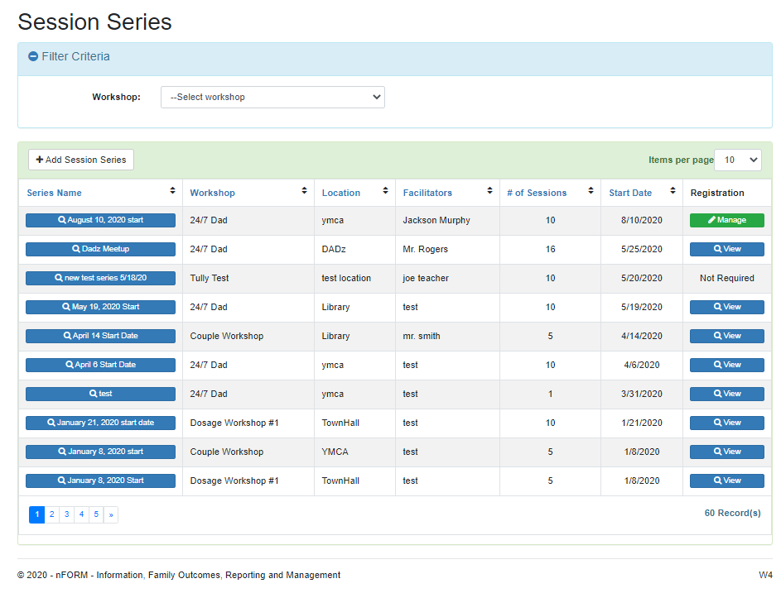

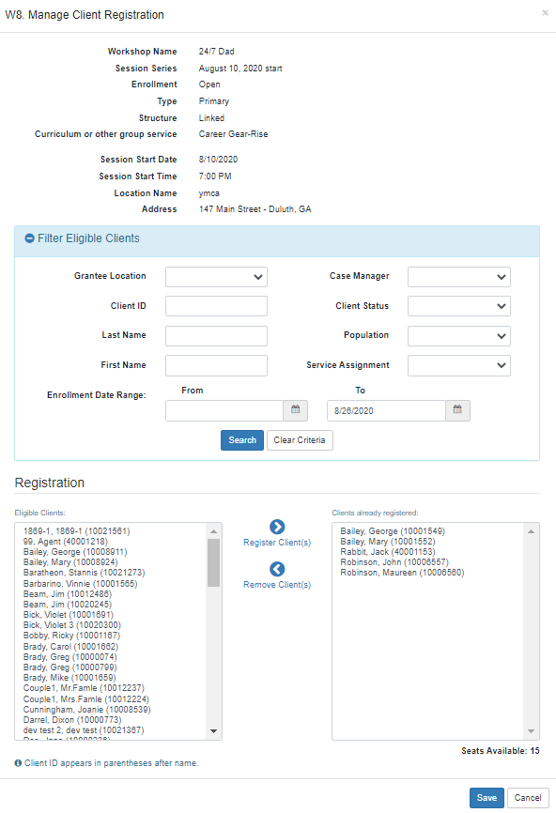

**W7/W9/C11. Manage Session Occurrences and Attendance**

