**Attachment 5 – 2020 Survey Cover Letter to States**

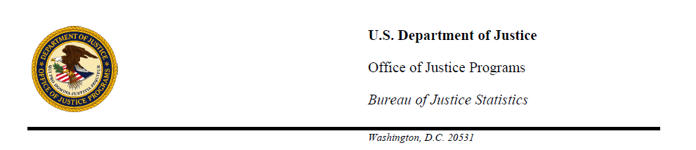

**MEMORANDUM**

**Date:** TBD

**To:** Directors, State Criminal Record Repositories

**From:**  Devon B. Adams

Chief, Criminal Justice Data Improvement Program

**Subject:** Survey of Criminal History Information Systems

I am writing to seek your assistance in providing information to the Bureau of Justice Statistics (BJS), U.S. Department of Justice, on the status of state-held criminal records. Approximately every two years since 1989, the *Survey of State Criminal History Information Systems* has captured a snapshot of the continuing growth, ongoing improvements, and practices associated with initiating and updating state criminal records. As in previous years, your response to this survey is voluntary; however, doing so is a special condition placed on all National Criminal History Improvement Program (NCHIP) and NICS Act Record Improvement Program (NARIP) awards.

Survey responses will be compiled by SEARCH, The National Consortium for Justice Information and Statistics. A copy of the 2020 survey questionnaire is attached. A password-protected section of the SEARCH Web site is available for those states that wish to provide their survey responses online. Responses should reflect conditions as of ***December 31, 2020***. Those wishing to use the online response option to fill out the survey are urged to visit <http://www.searchgroup.org/surveys/repository/> and use your state’s assigned password **XXXX** to gain access. The online survey allows each section to be completed independently by the appropriate staff person. Respondents using the online survey tool to enter 2020 data can view previously submitted 2018 data for comparison purposes. Where applicable, your state’s 2018 responses are displayed in color within each section of the online survey.

Statistical data presented in past surveys has supported and provided insight to both State and Federal legislative efforts that involve the use of criminal history records. Prominent among these is the Brady Handgun Violence Prevention Act, which mandated the development of the National Instant Criminal Background Check System (NICS). Further, the survey provides trend data demonstrating the correlation between continuing federal funding incentives such as the BJS-administered NCHIP and NARIP Program awards and documented results.

Your past cooperation and assistance with this effort has provided a wealth of useful data for law- and policymakers, researchers, justice practitioners, and others who depend on survey data to craft responsible laws, policies, and procedures, and to prepare informative reports and educational materials. The published 2018 survey is available at [ ]

Your contributions to the Web-enabled *Survey of State Criminal History Information Systems* make it a useful resource to users both within and outside of the criminal justice community.

Please contact SEARCH staff Dennis DeBacco at 775-412-1950 (email: [dennis@search.org](mailto:dennis@search.org)) if you have any questions or comments about the survey, or if you would like details on how to submit the survey via fax or mail. **We ask that you submit your survey responses by XXXX, 2021**. Thank you in advance for your assistance and cooperation with this important effort.

DBA/bg