**Justification for Nonmaterial/Nonsubstantive Change**

The Department of Labor (the Department) and the Department of Health and Human Services (HHS) jointly promulgated the National Medical Support Notice Final Rule on December 27, 2000 (65 FR 82128) (NMSN Regulation). The NMSN Regulation, codified at 29 CFR 2590.609-2, includes a model National Medical Support Notice (NMSN) that is comprised of two parts: Part A is a notice from the state agency to the employer, entitled: “Notice to Withhold for Health Care Coverage” (HHS); Part B is a notice from the employer to the Plan Administrator, entitled: “Medical Support Notice to Plan Administrator” (the Department). Both parts have detailed instructions informing the recipient to whom responses are due depending on varying circumstances.

HHS’ office of Child Support Enforcement is automating the NMSN to allow employers and plan administrators to submit both Part A and Part B of the notice electronically. Child support agencies and employers have expressed interest in e-NMSN, and it was one of the recommendations in a 2019 Employer Symposium Report. https://www.acf.hhs.gov/sites/default/files/programs/css/employer_symposium_report_2019.pdf. HHS has also received a number of inquiries during the COVID-19 emergency from employers, plan administrators, and unions about options for responding to the NMSN electronically. Use of the electronic submission process is optional.

HHS needs EBSA’s involvement in the Paperwork Reduction Act (PRA) clearance process, because Part B is a PRA Information collection sponsored by the Department. In order to automate the notices, minor changes need to be made to the form. These changes are only for the e-NMSN form; changes are not being made to the PDF version posted on the web. The name and address information for a plan administrator or representative on page 2 needs to be broken out into individual fields. These changes are not asking for new or more information. Below shows the proposed changes.

Current Part B

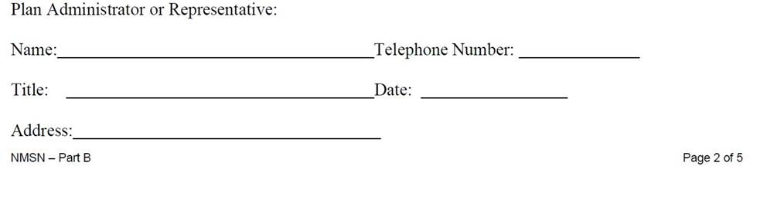

PROPOSED REVISION TO PART B (highlighted fields are required)

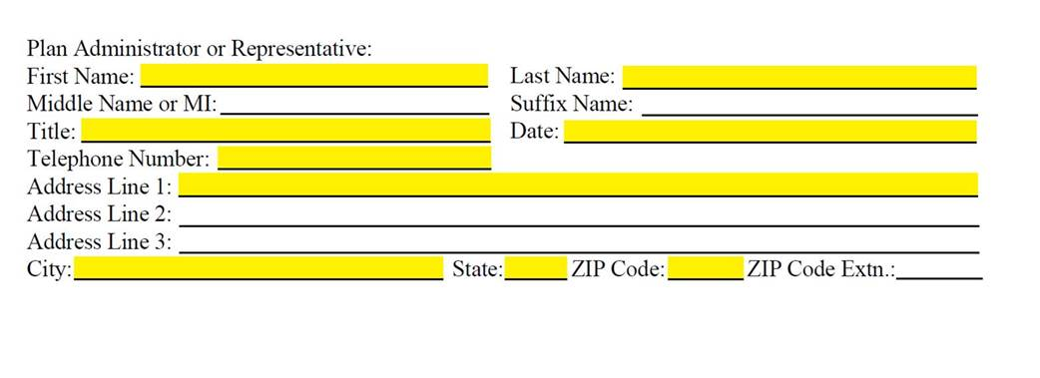

The Department is submitting the changes to NMSN Part B as a non-material/non-substantive change request under OMB Control Number 1210-0113. The Department is not making any program changes to the forms and instructions and estimates that these revisions will not result in any changes to the number of filings.