Webinar Participant Registration Form

- First Name* (Fill in Blank)
- Last Name* (Fill in Blank)
- Email Address* (Fill in Blank)
- Confirm Email Address* (Fill in Blank)

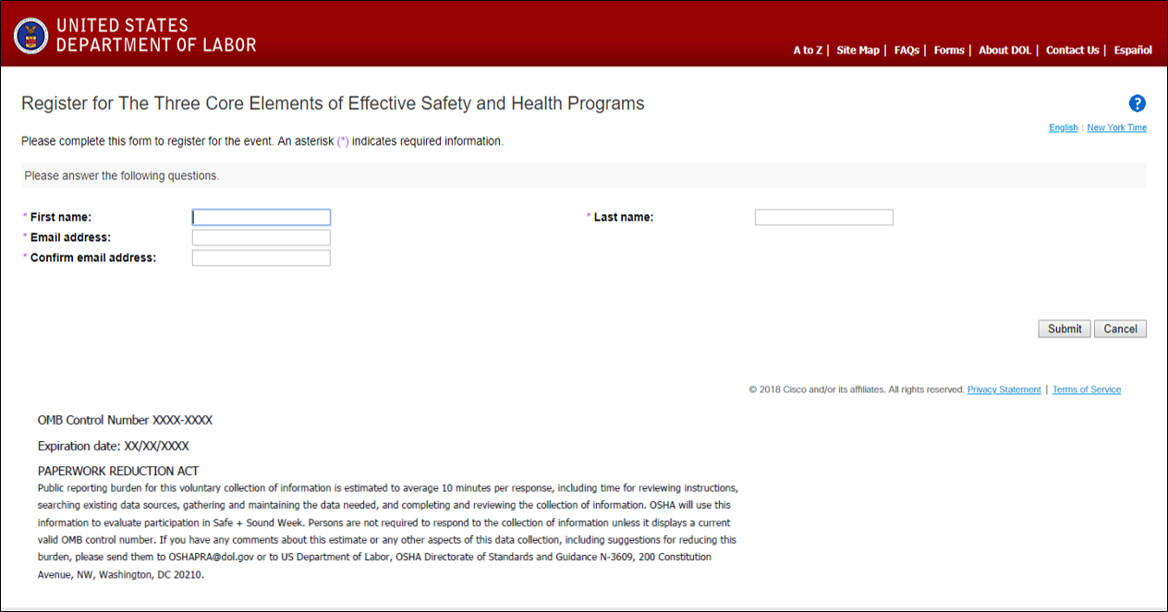

Webinar Participant Feedback Form

- Name (Fill in Blank)

- Organization (Fill in Blank)

- How would you rate the seminar topic and content? The topic was relevant.
Strongly Disagree 1 2 3 4 5 Strongly Agree
(Check box)

Comments: (Fill in Blank)

- How would you rate the seminar topic and content? The information presented was directly applicable to my work.
Strongly Disagree 1 2 3 4 5 Strongly Agree
(Check box)

Comments: (Fill in Blank)

- How would you rate the level and amount of information provided? The level of detail was appropriate.
Not Enough About Right Too Much (Check box)

Comments: (Fill in Blank)

- How would you rate the level and amount of information provided? The duration of the webinar was appropriate.
Not Enough About Right Too Much (Check box)

Comments: (Fill in Blank)

- How would you rate the speaker(s)? The speaker(s) were knowledgeable.
Strongly Disagree 1 2 3 4 5 Strongly Agree
(Check box)

Comments: (Fill in Blank)

- How would you rate the speaker(s)? The speaker(s) were clear and professional.
Strongly Disagree 1 2 3 4 5 Strongly Agree
(Check box)

Comments: (Fill in Blank)

- How would you rate the speaker(s)? The speaker(s) accurately delivered valuable information.
Strongly Disagree 1 2 3 4 5 Strongly Agree
(Check box)

Comments: (Fill in Blank)

- Additional webinar topics you would like to see (Fill in Blank)

OMB Control Number XXXX-XXXX
Expiration date: XX/XX/XXXX
PAPERWORK REDUCTION ACT
Public reporting burden for this voluntary collection of information is estimated to average 10 minutes per response, including time for reviewing instructions, searching existing data sources, gathering and maintaining the data needed, and completing and reviewing the collection of information. OSHA will use this information to evaluate participation in Safe + Sound Week. Persons are not required to respond to the collection of information unless it displays a current valid OMB control number. If you have any comments about this estimate or any other aspects of this data collection, including suggestions for reducing this burden, please send them to OSHAPRA@dol.gov or to US Department of Labor, OSHA Directorate of Standards and Guidance N-3609, 200 Constitution Avenue, NW, Washington, DC 20210.

