WRP.gov Student Homepage. Click “Students Register Now” to proceed.
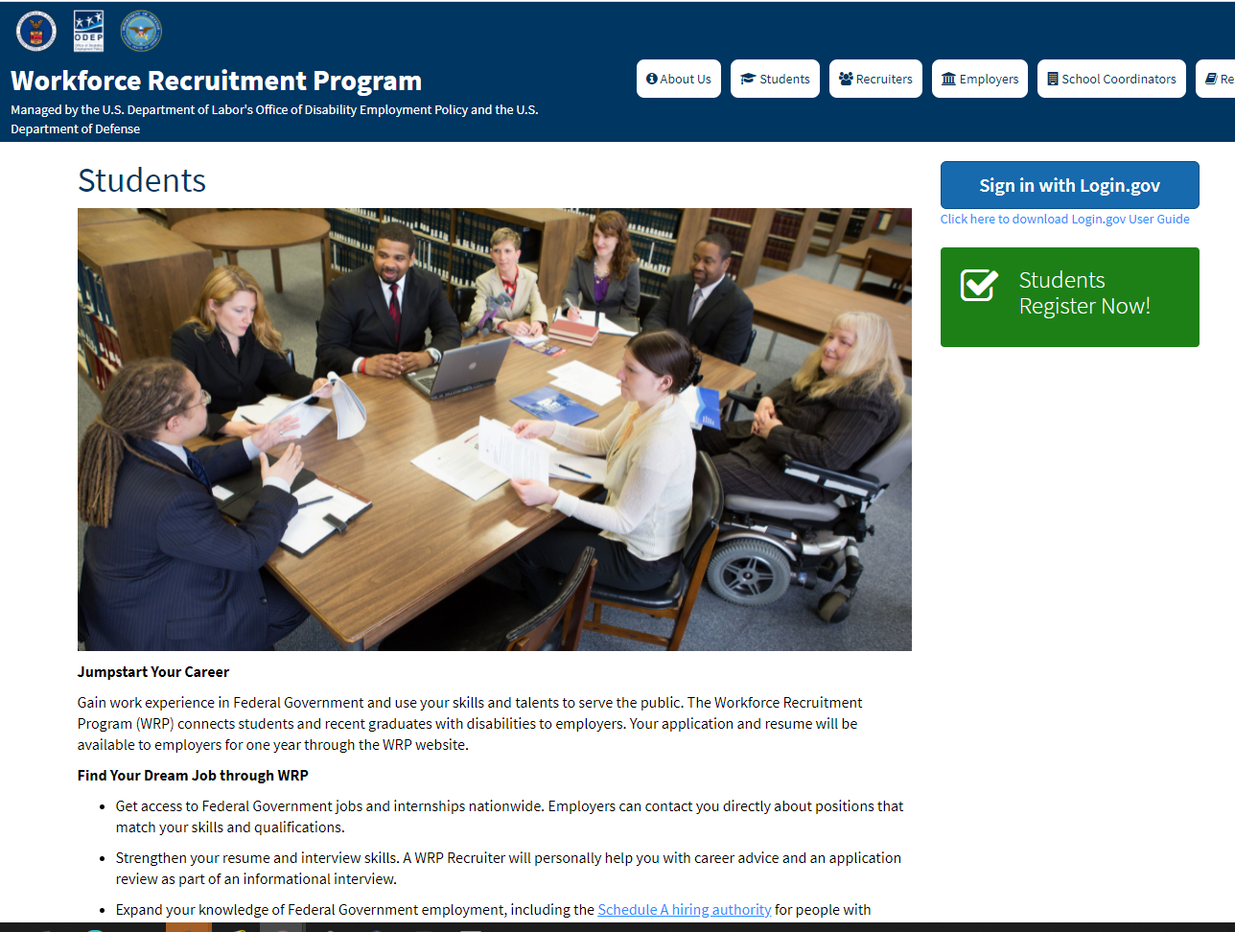
WRP.gov Rules of Behavior. Full language can be read at WRP.gov Rules of Behavior. Click “I Accept” to proceed.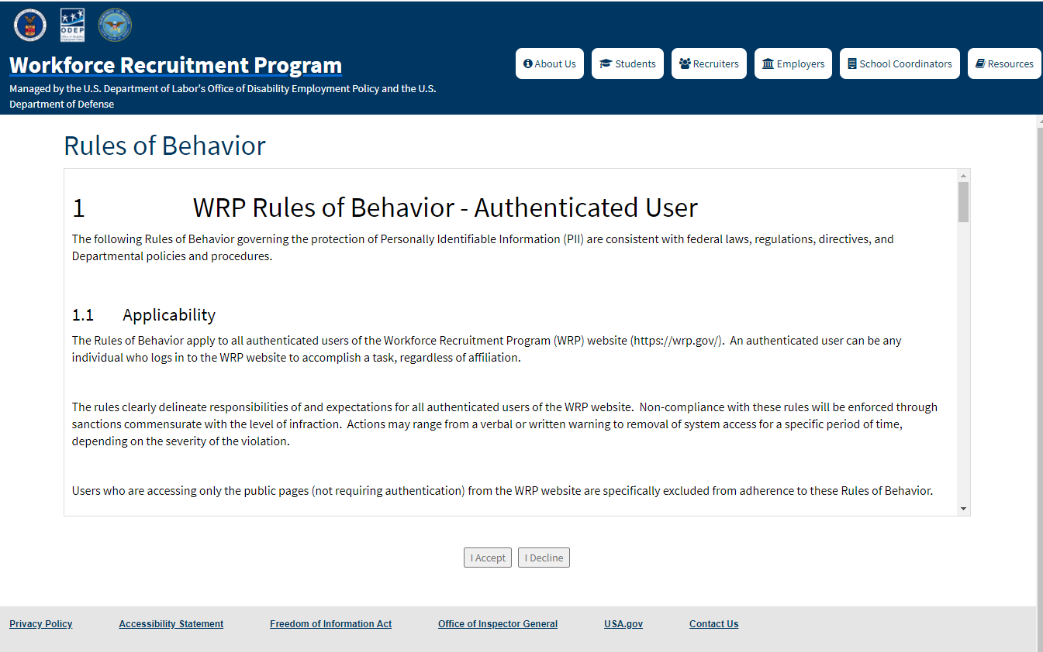

WRP Applicant Agreement Form. Confirm eligibility by clicking checkboxes and clicking “Continue.”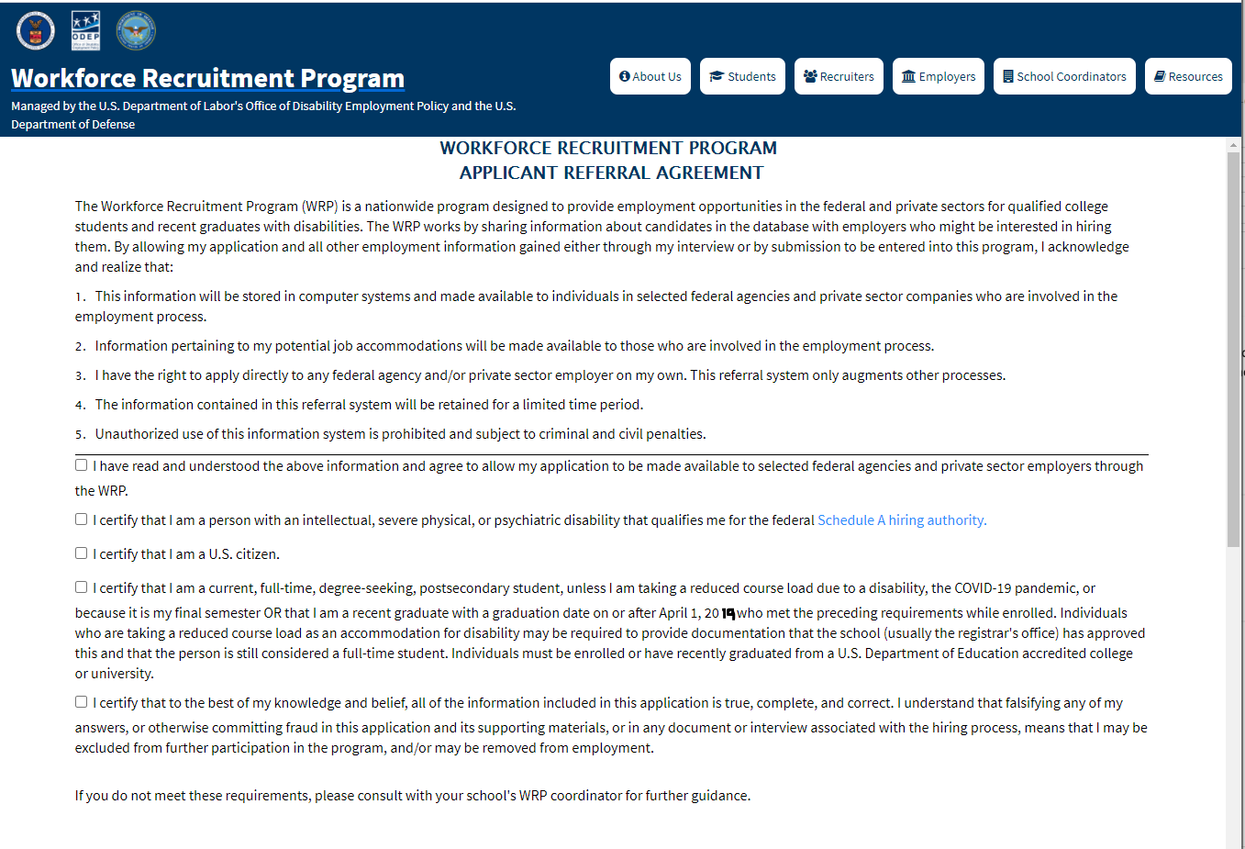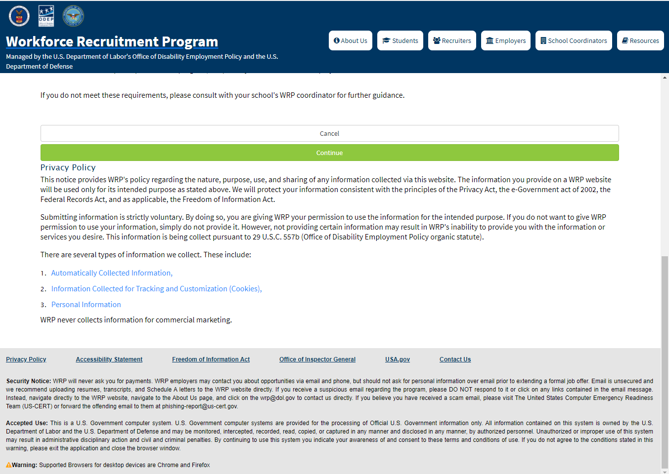
WRP Student Registration form