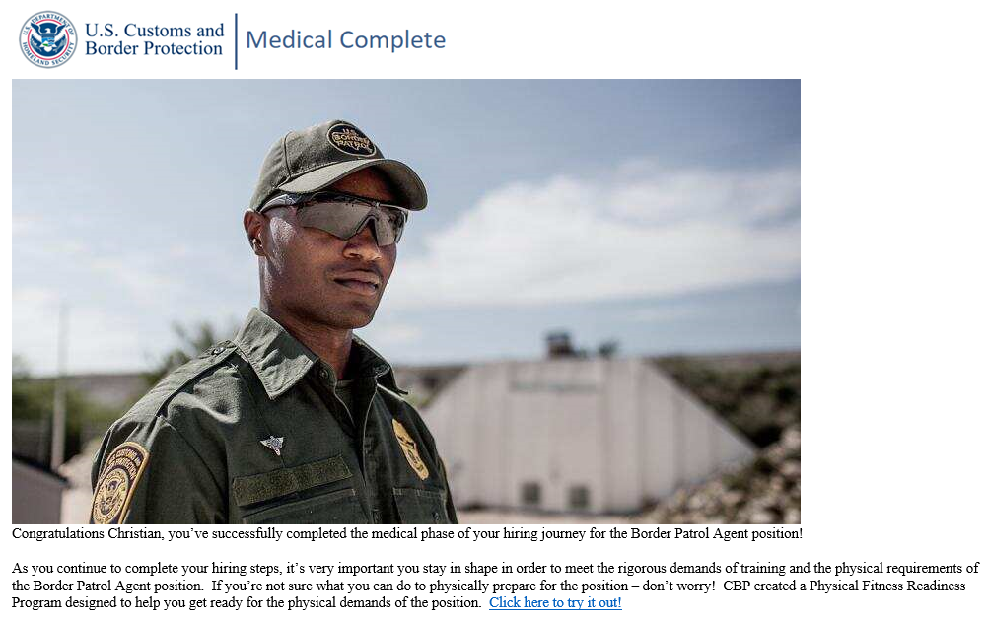
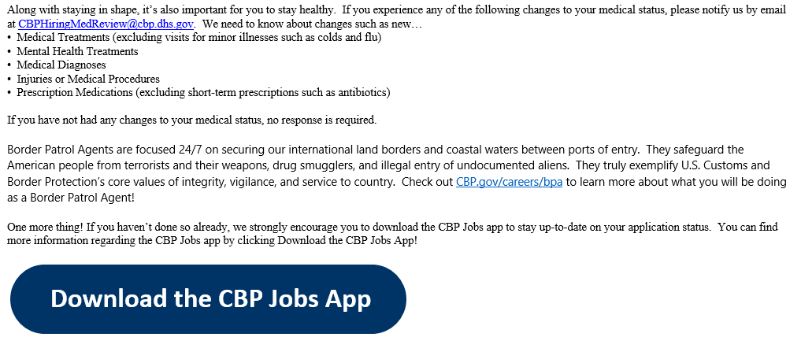

Your opinion matters! Kindly fill out the anonymous short survey so that we may continue to improve our services.

