**Supporting Statement A**

Transit COVID-19 Response Program

OMB Number 2132- TBD

ABSTRACT:

In accordance with the Paperwork Reduction Act (PRA) of 1995, FTA is requesting the Office of Management and Budget (OMB) emergency approval for a new information collection. The collection of information is associated with COVID-19 and the data collected will be used to support transit workforce vaccine distribution and inform FTA’s COVID-19 response and recovery actions (i.e., technical assistance, safety advisories, etc.). If granted, the emergency approval is only valid for 180 days. FTA plans to follow this emergency request with a submission for a 3-year approval through OMB's normal PRA clearance process.

**1. Explain the circumstances that make the collection of information necessary. Identify any legal or administrative requirements that necessitate the collection.**

The collection of this information is necessary for the Federal Transit Administration (FTA) to provide risk-based guidance and support for the COVID-19 recovery efforts of the transit industry. In addition, the collected information will assist FTA in assessing compliance with a recent Centers for Disease Control and Prevention (CDC) Order and Transportation Security Administration (TSA) Security Directive mandating masks on public transit. This information collection is essential to FTA’s safety oversight and grant-making roles—both critical to the Agency’s mission of improving public transportation for America's communities. Delay in acquiring this information may hinder federal efforts regarding emergency funding and assessing the impacts of COVID-19 on the transit industry and thereby increase the risk associated with COVID-19 to transit systems, workers, and passengers.

COVID-19 poses significant risk to the Nation’s communities and transit providers. In January, the United States suffered the deadliest month of the COVID-19 public health emergency.[1] January 20, 2021 set records for the deadliest day of the pandemic with 4,409 deaths recorded.[2] New, more transmissible variants of the virus have recently emerged. On January 15, 2021, the CDC announced that it expects a new, more transmissible SARS-CoV-2 variant to dominate by March—by some estimates, roughly 50% more transmissible—with “the potential to increase the U.S. pandemic trajectory in the coming months”.

Numerous transit providers have suspended service and a greater number have reduced service. Yet, throughout the COVID-19 public health emergency, transit agencies across the country continue to provide millions of trips to lifeline services, including transporting healthcare personnel and other essential workers on the front line of the Nation’s COVID-19 response. Transit agencies also offer additional essential services to support communities during the public health emergency, such as meal delivery and Wi-Fi access in underserved areas, and have begun offering transportation to vaccination sites. Accordingly, the Cybersecurity and Infrastructure Security Agency designates transit workers as essential critical infrastructure workers.

Transit agencies and other stakeholders have expressed concerns about the risk of COVID-19 to the transit industry and, along with the FTA, have taken steps to address these concerns. Numerous transit agencies have implemented mitigations to limit the transmission of SARS-CoV-2, the virus that causes COVID-19, among their workers and within their systems. Despite these efforts, frontline transit workers remain at high risk for work-related exposure to SARS-CoV-2 because their work-related duties must be performed on-site and involve being in close proximity (<6 feet) to the public or to coworkers. In addition, many transit workers fall within racial and socioeconomic demographics that are at increased risk of getting sick and dying from COVID-19.

In December 2020, the U.S. Food and Drug Administration issued Emergency Use Authorizations for two COVID-19 vaccines. Most States have prioritized distribution of the vaccine to their populations consistent with CDC’s Advisory Committee on Immunization Practices (ACIP) recommendations on the allocation of COVID-19 vaccines during the first phase of vaccine delivery (Phase 1).[3]7 Essential workers, including transit workers, are recommended for vaccination in Phase 1b after health care personnel and long term care facility residents. However, FTA’s review of State vaccination plans indicates that approximately 13 States have prioritized transit workers differently than CDC/ACIP guidance and placed another group ahead of transit workers.[4]8 States have already begun distributing COVID-19 vaccine doses to high-risk groups, including frontline workers, thereby increasing the need and urgency of FTA’s information collection request. It may take many months before all frontline transit workers can be vaccinated, though their communities will continue to rely on them to provide critical transportation services every day—including transportation to vaccination sites.

On January 21, 2021, President Biden issued E.O. 13998, “to save lives and allow all Americans, including the millions of people employed in the transportation industry, to travel and work safely,” requiring immediate Federal action to mandate masks on public forms of transportation, including transit. On January 29, 2021, the CDC issued an Order[5] requiring the wearing of masks by travelers, including on public transportation, to prevent spread of the virus that causes COVID-19. The CDC Order requires transportation operators to require that all persons wear masks when boarding, disembarking, and for the duration of travel, with certain exemptions. Operators of transportation hubs, which include bus terminals and subway stations, must require all persons wear a mask when entering or on the premises of a transportation hub. Subsequently, the TSA issued a Security Directive[6] on February 1, 2021 that implements the CDC Order. FTA will be able to use the information collection to assess compliance with the federal mask mandates.

***Authority***

FTA’s authority to collect this information is derived from 49 U.S.C § 5334, the CDC Order, and subsequent TSA Security Directive.

Since April 2020, FTA has allocated $25 billion in emergency relief funding to the U.S. transit industry through the Coronavirus Aid, Relief and Economic Security (CARES) Act (P.L. 116–136) and an additional $14 billion provided through the Coronavirus Response and Relief Supplemental Appropriations Act of 2021 (CRRSAA) (P.L.116-260). Funding through CRRSAA, like the CARES Act, is at 100-percent federal share with no local match required.

In addition, for Fiscal Year 2020, FTA apportioned over $12.5 billion in funding authorized under the Fixing America's Surface Transportation Act (FAST Act) (P.L. 114-94) and the Further Consolidated Appropriations Act, 2020 (P. L. 116-94).

**2. Indicate how, by whom, and for what purpose the information is to be used. Except for a new collection, indicate the actual use the agency has made of the information received from the current collection.**

The FTA will collect this information via an online fillable application. The purpose of this data collection is to enable the FTA to provide risk-based guidance and support for the transit industry’s COVID-19 recovery efforts.

The FTA will require applicable FTA grant recipients to report data on three topics and submit updates up to every two weeks:

* **Transit Worker Counts**: Total number of transit operators, other frontline essential personnel, and other workers during the reporting period. This data is not currently available to the Federal Government for all required reporters. This information is critical to identifying the number of transit workers supporting transportation for essential workers across the country. The information may become necessary to inform the distribution of vaccine doses based on risk to the transit workforce.
* **COVID-19 Impacts on Transit Agency Service Levels**: Yes or no responses to indicate if the agency suspended service, reduced service, or operated at normal levels during the reporting period. This data is not currently available to the Federal Government for all required reporters. This information is critical to understanding agency-level COVID-19 impacts and continued risk to transit agencies’ capability to provide transportation to support essential services in communities across the country, including transportation to vaccination sites.
* **COVID-19 Impacts on Transit Workforce**: Cumulative counts of transit worker COVID-19 positives, fatalities, recoveries, and unvaccinated employees during the reporting period, to the extent the grant recipient is able to compile such information consistent with applicable privacy laws, and yes or no responses on whether the agency is requiring workers to be vaccinated and whether the agency has implemented the CDC Order and TSA Security Directive requiring workers and passengers to wear masks. This data is not currently available to the Federal Government. This information is critical to understanding agency-level COVID-19 risk to transit workers and passengers, and the follow-on effects of worker shortages on operational capacity. This information will help inform policy and guidance regarding COVID-19 recovery efforts in transit with consideration for the health and safety of transit workers and passengers.

**3. Describe whether, and to what extent, the collection of information involves the use of automated, electronic, mechanical, or other technological collection techniques or other forms of information technology.**

The FTA will collect this information via a fillable online electronic application. The electronic application will be added to the existing electronic platform that FTA uses to communicate with its Chapter 53 grant recipients and subrecipients. Users of this platform already have login access and associated permissions to complete the submission of information.

**4. Describe efforts to identify duplication. Show specifically why any similar information already available cannot be used or modified for use for the purposes described in Item 2 above.**

This is a new collection related to the ongoing COVID-19 public health emergency. The specific information requested is unique to this situation and the transit industry, and currently is not collected by the Federal government. The information is not publicly available elsewhere. Though FTA does collect information from some recipients on select aspects of service levels and employee data, this data cannot be used for the purpose of this information collection as it is retrospective and does not provide the contemporaneous information needed for this purpose.

**5. If the collection of information involves small businesses or other small entities, describe the methods used to minimize burden.**

This information collection has been designed to minimize the burden on all respondents. Each data point will be a single entry, with the option of clicking a single button to indicate no change from the previous reporting period.

Recipients may use funding provided at 100-percent federal share with no local match through the CARES Act and the CRRSAA of 2021 to cover costs related to this collection.

**6. Describe the consequence to Federal program or policy activities if the collection is not conducted or is conducted less frequently, as well as any technical or legal obstacles to reducing burden.**

Without approval to collect this information on a bi-weekly basis, FTA will be ill-equipped to provide risk-based guidance and support for the COVID-19 recovery efforts of the transit industry. As the COVID-19 public health emergency evolves, guidance from the CDC and other public health entities is expected to change, and States and transit agencies may adjust their vaccination approaches in response. Delays or reduced frequency in acquiring this information may hinder federal efforts regarding emergency funding, assessing the impacts of COVID-19 on the transit industry, and assessing compliance with recent federal mask mandates, all of which may increase the risk associated with COVID-19 to transit systems, workers, and passengers.

**7. Explain any special circumstances that would cause an information collection to be conducted in a manner inconsistent with OMB guidelines 5 CFR 1320.6:**

The FTA is collecting this information to enable rapid Federal response to a quickly evolving public health emergency and the assessment of new Federal mask requirements. Quarterly updates of this data will not provide the FTA with an understanding of the present transit operational realities sufficient to support the transit industry’s COVID-19 recovery efforts. In order to make risk-based decisions to aid in the vaccine distribution efforts, FTA must have access to up-to-date data. Biweekly to monthly information collections balance the need for up-to-date information and the potential burden placed on respondents.

There is no required written response and no requirement for respondents to submit documentation or retain records beyond what is already required by the FTA.

This is not a statistical data collection; it is a fillable electronic online app.

This information collection does not require respondents to submit proprietary information.

Respondents may use funding provided at 100-percent federal share with no local match through the CARES Act and the CRRSAA of 2021 to cover costs related to this collection.

**8. Provide information on the PRA Federal Register Notice that solicited public comments on the information collection prior to this submission. Summarize the public comments received in response to that notice and describe the actions taken by the agency in response to those comments. Describe the efforts to consult with persons outside the agency to obtain their views on the availability of data, frequency of collection, the clarity of instructions and recordkeeping, disclosure, or reporting format (if any), and on the data elements to be recorded, disclosed, or reported.**

A Federal Register Notice will be published on March 5, 2021 with a public inspection scheduled for March 4.. Since FTA is seeking emergency approval due to the COVID-19 public health emergency, comments are being sought for 15 days. However, after the emergency approval which is only valid for 180 days, FTA plans to follow this emergency request with a submission for a 3-year approval through OMB's normal PRA clearance process. At which time both a 60-Day and 30-Day Federal Register Notice for public comment will be processed.

**9. Explain any decisions to provide payments or gifts to respondents, other than remuneration of contractors or grantees.**

The FTA will not provide payments or gifts.

**10. Describe any assurance of confidentiality provided to respondents and the basis for assurance in statute, regulation, or agency policy.**

The FTA offers no assurance of confidentiality. However, responses will not include personally identifying information. The FTA will aggregate responses for purposes of vaccine planning and distribution.

**11. Provide additional justification for any questions of a sensitive nature, such as sexual behavior and attitudes, religious beliefs, and other matters that are commonly considered private.**

The FTA will not ask questions of a sensitive nature.

**12. Provide estimates of the hour burden of the collection of information.**

**Estimated Total Respondents: 2,390 Comprised of 943 (Section 5307 respondents) 52 (Rural-Section 5311 respondents) 128 (Tribal-Section 5311 respondents) and 1267 (Section 5310 respondents)**

**Estimated Total Responses: 28,680**

**Estimated Total Burden Hours: 10,316**

**Estimated Total Cost: $1,222,008**

**Frequency: Bi-Weekly**

This information collection will apply to recipients and subrecipients of FTA funds under the Urbanized Area Formula Funding program (49 U.S.C. § 5307) or the Formula Grants for Rural Areas program (49 U.S.C. § 5311) that operate transit systems or pass through funds to subrecipients that operate transit systems. Recipients of FTA funds under the Enhanced Mobility of Seniors and Individuals with Disabilities program (49 U.S.C. § 5310) are requested to provide this information on a voluntary basis.

FTA intends to collect this information monthly, but may need to collect this information more frequently on a biweekly basis, given the unpredictability of the COVID-19 public health emergency. Accordingly, FTA has estimated the hours for the most burdensome collection frequency of biweekly.

The FTA anticipates the total annualized burden to the transit industry, assuming forms are submitted every two weeks for one year, to be 10,316 hours, and the total annualized cost to the transit industry to be $1,222,008.

***Section 5307 Public Transportation Agencies = 943 Total Respondents***

The FTA intends to request biweekly responses from approximately 943 transit agencies. These transit agencies currently report financial, service, and safety data to the National Transit Database annually, but do not report the data included in this information collection. On average, we expect each transit agency to spend approximately 5 minutes responding to each bi-weekly collection for a total of 10 minutes per month. For a total of 9,430 minutes

943 x 10 minutes (monthly) = 9,430 minutes (monthly) = 157 hours (rounded)

As FTA plans to collect information for a 12-month period, the total burden will be as follows:

157 hours x 12 months = 1,884 annual burden hours (rounded)

The FTA estimates the total annualized cost to Section 5307 transit agencies on an annual basis to be $222,312.

This estimate is based on the mean hourly wage of a General and Operations Manager. The mean hourly pay for a General and Operations Manager [7] is $59 (rounded), multiplied by 2 to account for benefits plus other overhead costs such as rent, utilities, and office equipment[8], for a fully-loaded hourly wage of $118.

$118 x 1,884 hours = $222,312

***Section 5311 Rural Public Transportation Providers***

The FTA intends to request responses from all recipients of Section 5311 grants that provide funds to 1,300 rural public transportation providers. Fifty-two (52) Section 5311 recipients will be required to respond to the information collection on behalf of the 1,300 rural public transportation providers.

On average, a Section 5311 recipient will provide responses on behalf of 25 Section 5311 subrecipients. We expect the 52 Section 5311 recipients and associated rural public transportation providers to spend approximately 8 minutes per subrecipient to respond to each bi-weekly collection for a total of 16 minutes per month. The 16-minute estimate covers the capture of information from the subrecipient and the entering of information into the form by the recipient.

52 x 25 x 16 minutes (monthly) = 20,800 minutes (monthly) = 347 hours (rounded)

As FTA plans to collect information for a 12-month period, the total burden will be as follows:

347 hours x 12 months = 4,164 hours

The FTA estimates the total annualized cost to 5311 recipients and subrecipients, for collections from February through the end of calendar year 2021, to be $491,352.

This estimate is based on the mean hourly wage of a General and Operations Manager. The mean hourly pay for a General and Operations Manager[9] is $59 (rounded), multiplied by 2 to account for benefits plus other overhead costs such as rent, utilities, and office equipment[10], for a fully-loaded hourly wage of $118.

$118 x 4,164 hours = $491,352

***Section 5311 Tribal Transit Providers***

The FTA intends to request responses from all Section 5311 recipient tribal transit providers. One-hundred and twenty-eight (128) tribal transit providers will be required to respond directly to the information collection. On average, we expect each tribal transit agency to spend approximately 5 minutes responding to each bi-weekly collection.

128 x 10 minutes (monthly) = 1,280 minutes (monthly) = 21 hours (rounded)

As FTA plans to collect information for a 12-month period, the total burden will be as follows:

21 hours x 12 months = 252 hours

The FTA estimates the total annualized cost to Section 5311 tribal transit providers, for collections from February through the end of calendar year 2021, to be $29,736.

This estimate is based on the mean hourly wage of a General and Operations Manager. The mean hourly pay for a General and Operations Manager[11] is $59 (rounded), multiplied by 2 to account for benefits plus other overhead costs such as rent, utilities, and office equipment[12], for a fully-loaded hourly wage of $118.

$118 x 252 hours = $29,736

***Section 5310 Providers (VOLUNTARY COLLECTION)***

The FTA intends to request voluntary responses from all recipients of Section 5310 grants that cover approximately 1,267 Section 5310 subrecipients. Section 5310 recipients will report data on behalf of their Section 5310 subrecipients.

We expect the information collection to take Section 5310 recipients approximately 8 minutes per subrecipient to respond to each bi-weekly collection for a total of 16 minutes per month. The 16-minute estimate covers the capture of information from the subrecipient and entering the information into the form by the recipient.

1,267 x 16 minutes (monthly) = 20,272 minutes (monthly) = 338 hours (rounded)

As FTA plans to collect information for a 12-month period, the total burden will be as follows:

338 hours x 12 months = 4,056 hours

The FTA estimates the total annualized cost to 5310 agencies, for collections from February through the end of calendar year 2021, to be as high as $478,608.

This estimate is based on the mean hourly wage of a General and Operations Manager. The mean hourly pay for a General and Operations Manager[13] is $59 (rounded), multiplied by 2 to account for benefits plus other overhead costs such as rent, utilities, and office equipment[14], for a fully-loaded hourly wage of $118.

$118 x 4,056 hours = $478,608

| **Summary (Annual numbers)** | **Reporting** | **Recordkeeping** |
| --- | --- | --- |
| Section 5307 agencies | | |
| **# of Respondents** | 943 | — |
| **# of Responses per respondent** | 12 |  |
| **Time per Response** | 10 min. |  |
| **Total # of responses** | 11,316 |  |
| **Total burden (hours)** | 1,844 |  |
| Section 5311 rural agencies | | |
| **# of Respondents** | 52 | — |
| **# of Responses per respondent** | 12 |  |
| **Time per Response** | 400 min. |  |
| **Total # of responses** | 624 |  |
| **Total burden (hours)** | 4,164 |  |
| Section 5311 tribal agencies | | |
| **# of Respondents** | 128 | — |
| **# of Responses per respondent** | 12 |  |
| **Time per Response** | 10 min. |  |
| **Total # of responses** | 1,536 |  |
| **Total burden (hours)** | 252 |  |
| Section 5310 agencies (VOLUNTARY) | | |
| **# of Respondents** | 1,267 | — |
| **# of Responses per respondent** | 12 |  |
| **Time per Response** | 16 min. |  |
| **Total # of responses** | 15,204 |  |
| **Total burden (hours)** | 4,056 |  |

**13. Provide an estimate for the total annual cost burden to respondents or record keepers resulting from the collection of information.**

As this collection will be fully online, there is no additional cost burden to respondents.

**14. Provide estimates of annualized costs to the Federal government. Also, provide a description of the method used to estimate cost, which should include quantification of hours, operational expenses (such as equipment, overhead, printing, and support staff), and any other expense that would not have been incurred without this collection of information.**

The total estimated annualized cost to the Federal Government is $370,600. This is based on administering the collection up to every two weeks from February until the end of calendar year 2021.

FTA anticipates that one agency employee at the GS-14-1[15] level ($103 per hour including 75% overhead costs) will provide project management support. FTA anticipates the effort will take the individual approximately 8 hours per collection.

25($103 x 8 hours) = $20,600

The FTA estimates that it will use contractor support resources to conduct ongoing validation and analysis of the collected information. The FTA estimates the cost of these support services to be approximately $350,000.

**15. Explain the reasons for any program changes or adjustments.**

This is a new collection.

**16. For collections of information whose results will be published, outline plans for tabulation and publication. Address any complex analytical techniques that will be used. Provide the time schedule for the entire project, including beginning and ending dates of the collection of information, completion of report, publication dates, and other actions.**

The FTA is collecting this information for internal use only and does not intend to publish the information. The FTA will begin collecting this data on the date of OMB approval and will continue for up to 24 additional and consecutive bi-weekly to monthly collections, through December 31, 2021 or the end of the COVID-19 public health emergency, whichever comes first.

**17. If seeking approval to not display the expiration date for OMB approval of the information collection, explain the reasons why display would be inappropriate.**

The FTA is not seeking such approval and will include all appropriate OMB information on the fillable application.

**18. Explain each exception to the topics of the certification statement identified in “Certification for Paperwork Reduction Act Submissions.”**

There are no exceptions.

**Data Collection Format**

The application will use two data collection formats to collect COVID-19 information from respondents:

* **Baseline Request -** (one-time) used to capture historical data on service reductions and suspensions during the COVID-19 public health emergency.
* **Recurring Request -** will be submitted monthly (up to once every two weeks) to capture data on:
  1. Service levels
  2. Worker counts
  3. Worker positives
  4. Worker fatalities
  5. Worker recoveries

The application will have the required PRA Statement and contain links to key terms and associated policies. A sample screenshot of the application is below followed by the list of question.

**Initial Log-in Screen with the PRA Statement**

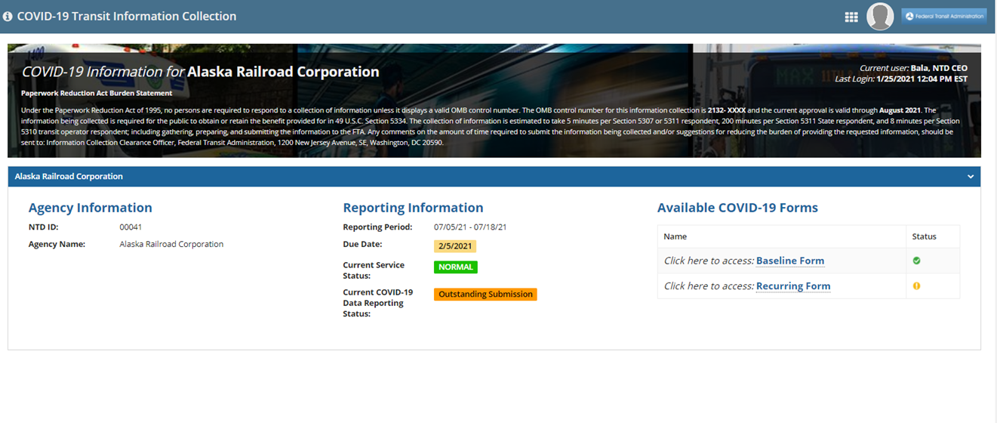

**Baseline Submission**

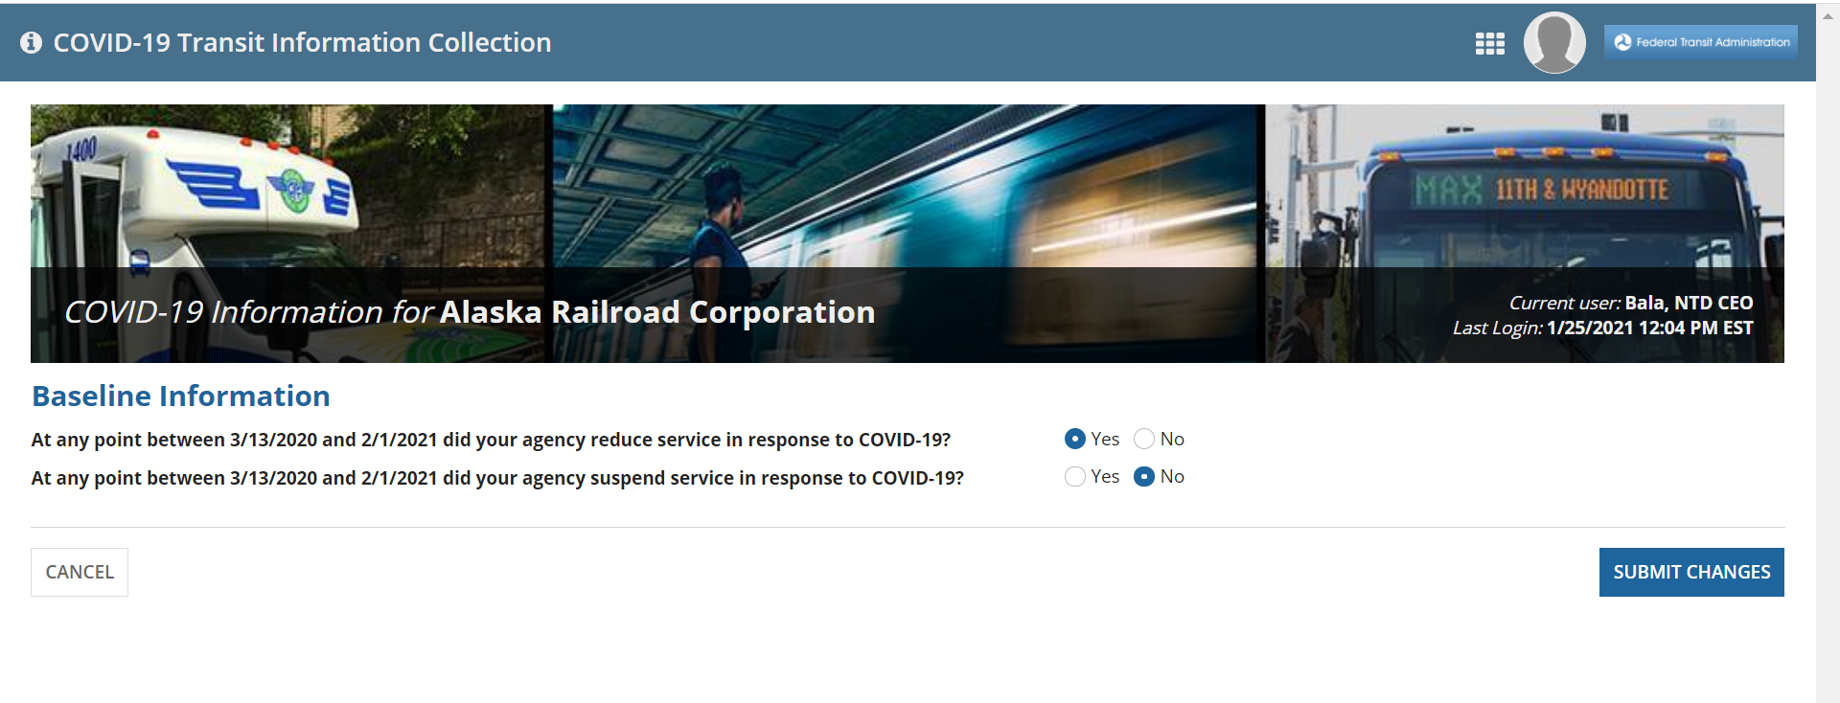

**Recurring Submission**

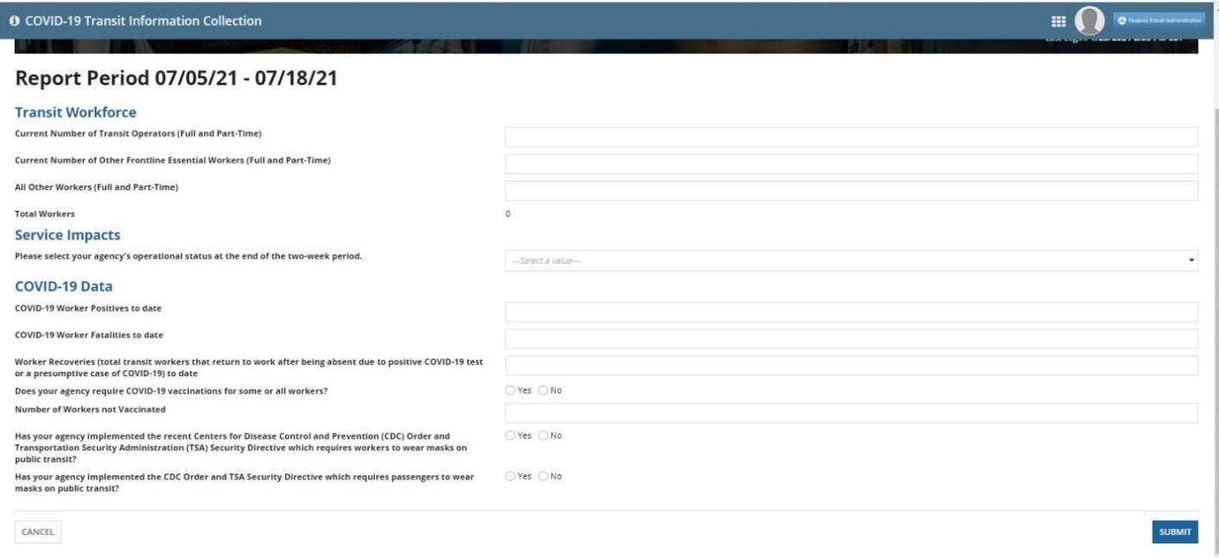

**COVID-19 Baseline Questions**

1. At any point between 3/13/2020 and 2/1/2021 did your agency reduce service in response to COVID-19? Yes or No
2. At any point between 3/13/2020 and 2/1/2021 did your agency suspend service in response to COVID-19? Yes or No

**Recurring Submission Questions**

*Transit Workforce*

1. Current Number of Transit Operators (Full and Part-Time)
2. Current Number of Other Frontline Essential Workers (Full and Part-Time)
3. All Other Workers (Full and Part-Time)

*Service Impacts*

1. Agency’s operational status at the end of the two-week period (Normal, Reduced, or Suspended)

*COVID-19 Data*

1. COVID-19 Worker Positives to date
2. COVID-19 Worker Fatalities to date
3. Worker Recoveries (total transit workers that return to work after being absent due to positive COVID-19 test or presumptive case of COVID-19) to date
4. Does your agency require COVID-19 vaccinations for some or all workers? Yes or No
5. Number of workers not vaccinated
6. Has your agency implemented the recent Centers for Disease Control and Prevention (CDC) Order and Transportation Security Administration (TSA) Security Directive which require workers to wear masks on public transit? Yes or No
7. Has your agency implemented the CDC Order and TSA Security Directive which require passengers to wear masks on public transit? Yes or No

1. <https://covidtracking.com/data/charts/us-daily-deaths>.
2. Id.
3. 7 <https://www.cdc.gov/mmwr/volumes/69/wr/mm695152e2.htm>.
4. 8 <https://www.cdc.gov/mmwr/volumes/69/wr/mm695152e2.htm>.

   w.nga.org/wp-content/uploads/2021/01/Phased-Allocation-of-COVID-19-Vaccines_Jan-7-2021.pdf.
5. https://www.cdc.gov/quarantine/pdf/Mask-Order-CDC_GMTF_01-29-21-p.pdf
6. https://www.tsa.gov/sites/default/files/sd-1582_84-21-01.pdf
7. Based on Occupation 11-1021, BLS Occupational Employment Statistics, May 2019. See [https://www.bls.gov/oes/current/oes_nat.htm - 11-0000](https://www.bls.gov/oes/current/oes_nat.htm%20-%2011-0000).
8. U.S. Department of Health and Human Services, Guidelines for Regulatory Impact Analysis, Table 4.2, Constructing Default Estimates of the Value of Time, 2016. See <https://aspe.hhs.gov/system/files/pdf/242926/HHS_RIAGuidance.pdf>.
9. Based on Occupation 11-1021, BLS Occupational Employment Statistics, May 2019. See [https://www.bls.gov/oes/current/oes_nat.htm - 11-0000](https://www.bls.gov/oes/current/oes_nat.htm#11-0000).
10. U.S. Department of Health and Human Services, Guidelines for Regulatory Impact Analysis, Table 4.2, Constructing Default Estimates of the Value of Time, 2016. See <https://aspe.hhs.gov/system/files/pdf/242926/HHS_RIAGuidance.pdf>.
11. Based on Occupation 11-1021, BLS Occupational Employment Statistics, May 2019. See [https://www.bls.gov/oes/current/oes_nat.htm - 11-0000](https://www.bls.gov/oes/current/oes_nat.htm#11-0000).
12. U.S. Department of Health and Human Services, Guidelines for Regulatory Impact Analysis, Table 4.2, Constructing Default Estimates of the Value of Time, 2016. See <https://aspe.hhs.gov/system/files/pdf/242926/HHS_RIAGuidance.pdf>.
13. Based on Occupation 11-1021, BLS Occupational Employment Statistics, May 2019. See [https://www.bls.gov/oes/current/oes_nat.htm - 11-0000](https://www.bls.gov/oes/current/oes_nat.htm#11-0000).
14. U.S. Department of Health and Human Services, Guidelines for Regulatory Impact Analysis, Table 4.2, Constructing Default Estimates of the Value of Time, 2016. See <https://aspe.hhs.gov/system/files/pdf/242926/HHS_RIAGuidance.pdf>.
15. <https://www.opm.gov/policy-data-oversight/pay-leave/salaries-wages/salary-tables/pdf/2021/DCB_h.pdf>