Appendix B. Supporting Letters

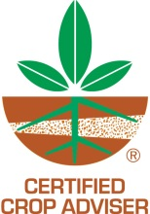
Certified Crop Adviser Program
5585 Guilford Road, Madison, WI 53711-5801 | FAX 608-273-2081 | 608-273-8085
www.certifiedcropadviser.org

To: Jill Schroeder, USDA-OPMP
Elizabeth Hill, USDA-OPMP
From: Luther Smith, CAE 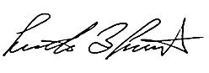
Director Professional Development and Business Relations

Date: June 26, 2019

RE: USDA CCA network development, pesticide use

The International Certified Crop Adviser (ICCA) Program is pleased to partner with USDA-OPMP regarding collecting data from CCAs on pesticide use.

We understand the data collected will be held in aggregate with no identifying information to the individual. The collection process will involve a brief, electronic survey and administered through the ICCA Program office in Madison, WI. Efforts will be made to continually refine the audience parameters to increase the effectiveness.

The primary goal of the project is to assist US-EPA in making pesticide use decisions and enhance their knowledge in this area.

There are 13,577 Certified Crop Advisers (CCAs) throughout North America represented by 34 Local Boards (state/province/region). There are 11,695 CCAs in the United States where the survey will be focused.

Thank you for the opportunity to partner on this project and we look forward to working with you.

