United States Department of Agriculture

OMB Control No. 0560-0176
OMB Expiration Date: 12/31/2021
FPAC-ISD-441B Farm Production and Conservation- Business Center
(proposal 1) Geospatial Enterprise Operations

REQUEST FOR CUSTOM AERIAL PRINT
See Page 2 for Privacy Act and Paperwork Reduction Act Statements
1. NAME |  |  |  |  |  |  |  | INSTRUCTIONS  ORDERING - Products are made to order.  You may email or call with the area description (see Page 2), year range  needed, and shipping address with a phone number to the email address or  telephone number listed at the bottom of the page.  PAYMENT- Prepayment is required.  We accept Credit Cards. Make your check or money order payable to  USDA FPAC-BC. Purchase orders are accepted from tax-supported  agencies. Please do not send cash or blank checks.  SHIPMENT- We ship the most economical method.  No COD's, shipping costs are included in the price of the product.
2. ADDRESS (STREET ADDRESS)
3. ADDRESS (PO BOX)
4. CITY, STATE, ZIP+4
5. CONTACT NAME
6. TELEPHONE NUMBER |  |  |  | 7. FAX NUMBER
8. E-MAIL ADDRESS
9. IF  KNOWN: |  | A. CUSTOMER CODE |  |  | B. AGENCY CODE |  |  | FOR U.S. GOVERNMENT AGENCY USE ONLY
 |  |  |  |  |  |  |  | ORDERING UNIT CODE |  | FUNDS CHARGEABLE
 |  | C. PURCHASE ORDER (PO) NUMBER
 |  |  |  |  |  |  |  | I CERTIFY THAT THESE ITEMS ARE NECESSARY FOR USE IN THE PUBLIC SERVICE
10. CREDIT CARD NUMBER |  |  |  |  |  | 11. EXP. DATE (MM/YY) |  | SIGNATURE
[Use form 441D for payment information]
12. TOTAL REPRODUCTIONS |  |  |  | 13. AMOUNT REMITTED / PO AMOUNT |  |  |  | TITLE |  |  |  |  |  |  | DATE
 |  |  |  | $
IMAGERY DATA SECTION (See Page 2 for Ordering Information)
14. Description of your Area of Interest (AOI): Include state, county, and year(s) desired. Provide quarter quad (QQ) name(s), shapefiles in NAD83 projection, latitude and longitude
coordinates, township/range/section(s), or a detailed map outlining your AOI boundaries.
15. What type of layer(s) would you like on your image?
Topography Hydrography Transportation Public Land Survey None Other (specify):

16. Select your desired paper size.
20"x20" Metallic Photo Paper ($50.00) 24"x24" Metallic Photo Paper ($60.00) 30"x30" Metallic Photo Paper ($70.00)

20"x20" *Semi-Matte Photo Paper ($36.00) 24"x24" *Semi-Matte Photo Paper ($44.00) 30"x30" *Semi-Matte Photo Paper (57.00)

*Semi-matte photo paper requires additional labor charge typically between $6.25 and $15.00 depending on custom work involved.
17. Do you want the GEO template on your image? |  |  |  |  |  |  | YES, Enter border & text box color option number in A & B below.  Standard color options indicated above each template sample. |  |  |  |  |  |  |  |  | NO
 | Standard Black & White Image Border Color No. 4 – Text Box Color No. 3  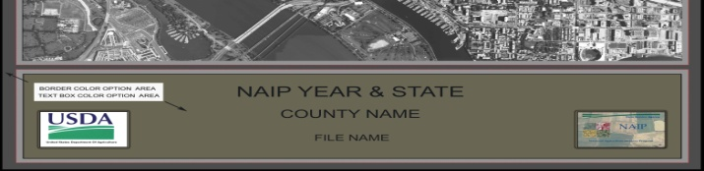  Standard Color Infrared Image Border Color No. 9 – Text Box Color No. 2  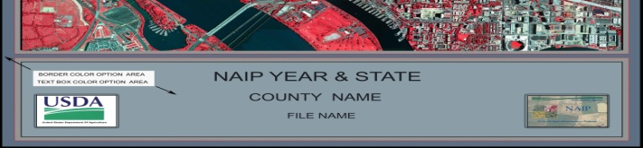 |  |  |  |  |  |  |  | Standard Natural Color Image Border Color No. 7 – Text Box Color No. 1  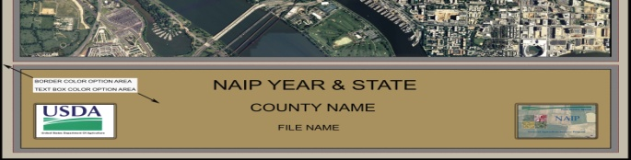
 |  |  |  |  |  |  |  |  | 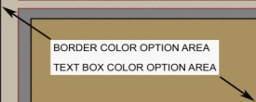 |  | A. Border Color Option No.  B. Text Box Color Option No.
 |  |  |  |  |  |  |  |  | 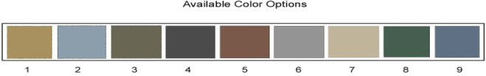
18. Would you like a white border around your template? YES NO
Address Order for  Product or Request for Information to: |  |  | CUSTOMER SERVICES  USDA FPAC-BC GEOSPATIAL ENTERPRISE OPERATIONS  125 SOUTH STATE STREET SUITE 6416  SALT LAKE CITY UT 84138-1102 |  |  |  |  |  |  |  |  | TELEPHONE:  FAX:  E-MAIL:  WEBSITE: |  | 801-844-2922  855-415-2014  GEO.Sales@usda.gov  USDA GEO Website

ORDERING INFORMATION
FPAC-ISD-441B (Page 2) (proposal 1)
 |  | A | Your customer information - please include your street address (Item 2) and telephone number (Item 6). If you are a tax-supported organization and want to be billed, place your purchase order number here (Item 9C).
 |  | B | Total reproductions (Item 12) - in this area indicate the total number of reproductions by product (i.e. 1-24x24)
 |  |  | Amount remitted/PO amount (Item 13) - by check, money order or Credit Card (Item 10).
 |  | C | Area of Interest or AOI (Item 14) – provide state, county, year(s), and description of your area or location here.
 |  |  | Layer(s) available on your image (Item 15) – select option(s) listed or specify other if you want to provide your own.
 |  |  | Paper Size and Type (Item 16) – select your desired paper size and type.
 |  |  | APFO Template (Item 17) – indicate if you would like a template around your image. If YES, select available color options for border and text box in A and B. You may visit our website at USDA GEO Website.
 |  |  | Template Border (Item 18) – Indicate if you would like a white border.
 |  | D | Instructions - these are brief instructions related to your order. See ''HOW TO ORDER CUSTOM AERIAL PRINTS” below.
 |  | E | U.S. Government Agency Use Only - this may substitute for your purchase order. For FSA orders, your signature is required.
 |  | F | Available color options for template border and text box areas.
* HOW TO ORDER CUSTOM AERIAL PRINTS

Fill out Items 14 through 18 on the FPAC-ISD-441B, Request for Custom Aerial Print form. Furnish one or more of the following forms of information and we
will make a print selection for you:

- Latitude and Longitude coordinates (point and radius or four corner points.)
- Legal description of your area of interest in township, range, and section number.
- A topographic, county, or city map outlining your area of interest as accurately as possible.
- Electronic shapefiles in NAD83 projection.

Products are made after an order and payment is received. You may order over the telephone using a major credit card if you have a
complete description of your area of interest using any form of information listed above. We may require you to send us a written request.

* GEO PRODUCTS AND SERVICES

Depending on the original film scale or digital resolution, custom print scales will vary depending on coverage area, paper size, and printer limitations.
Custom aerial prints are defined as a single image requiring geospatial layer(s) or a mosaic of multiple images that may or may not require geospatial
layer(s). Digital film scans are available in TIF format and may require geospatial services to provide a custom aerial print of historical imagery. APFO
utilizes Quarter Quad (QQ) and Compressed County Mosaic (CCM) products from the National Agriculture Imagery Program (NAIP). For special needs not
covered elsewhere on this form, contact us directly. Additional fees may apply.

* OTHER AERIAL IMAGERY

Imagery secured for the Forest Service (FS) and National Resource Conservation Service (NRCS) can be purchased from us by the same procedures
outlined for FSA photography. The negative scales vary from 1:6,000 to 1:80,000, depending on the project area. Most FS photography has been flown in
natural color, some in black and white and color infrared. Most NRCS photography has been flown in black and white, some in natural color and color
infrared.
NOTE: | The following statement is made in accordance with the Privacy Act of 1974 (5 USC 552a - as amended). The authority for requesting the information identified on this form is the Agricultural Adjustment Act of 1938 (7 U.S.C. 1387). The information will be used to process an order for aerial photography. The information collected on this form may be disclosed to other Federal, State, Local government agencies, Tribal agencies, and nongovernmental entities that have been authorized access to the information by statute or regulation and/or as described in applicable Routine Uses identified in the System of Records Notice for USDA/FSA-2, Farm Records File (Automated). Providing the requested information is voluntary. However, failure to furnish the requested information will result in an inability on the part of the Aerial Photography Field Office to process the order for aerial photography.  Public Burden Statement (Paperwork Reduction Act): According to the Paperwork Reduction Act of 1995, an agency may not conduct or sponsor, and a person is not required to respond to, a collection of information unless it displays a valid OMB control number. The valid OMB control number for this information collection is 0560-0176. The time required to complete this information collection is estimated to average 30 minutes per response, including the time for reviewing instructions, searching existing data sources, gathering and maintaining the data needed, and completing and reviewing the collection of information.  The provisions of appropriate criminal and civil fraud, privacy, and other statutes may be applicable to the information provided. RETURN THIS COMPLETED FORM TO THE USDA FPAC-BC GEOSPATIAL ENTERPIRSE OPERATIONS AT THE ADDRESS LISTED ON PAGE 1.
In accordance with Federal civil rights law and U.S. Department of Agriculture (USDA) civil rights regulations and policies, the USDA, its Agencies, offices, and employees, and institutions participating in or administering USDA programs are prohibited from discriminating based on race, color, national origin, religion, sex, gender identity (including gender expression), sexual orientation, disability, age, marital status, family/parental status, income derived from a public assistance program, political beliefs, or reprisal or retaliation for prior civil rights activity, in any program or activity conducted or funded by USDA (not all bases apply to all programs). Remedies and complaint filing deadlines vary by program or incident.

Persons with disabilities who require alternative means of communication for program information (e.g., Braille, large print, audiotape, American Sign Language, etc.) should contact the responsible Agency or USDA’s TARGET Center at (202) 720-2600 (voice and TTY) or contact USDA through the Federal Relay Service at (800) 877-8339. Additionally, program information may be made available in languages other than English.

To file a program discrimination complaint, complete the USDA Program Discrimination Complaint Form, AD-3027, found online at http://www.ascr.usda.gov/complaint_filing_cust.html and at any USDA office or write a letter addressed to USDA and provide in the letter all of the information requested in the form. To request a copy of the complaint form, call (866) 632-9992. Submit your completed form or letter to USDA by: (1) mail: U.S. Department of Agriculture Office of the Assistant Secretary for Civil Rights 1400 Independence Avenue, SW Washington, D.C. 20250-9410; (2) fax: (202) 690-7442; or (3) email: program.intake@usda.gov. USDA is an equal opportunity provider, employer, and lender.

