Appendix U
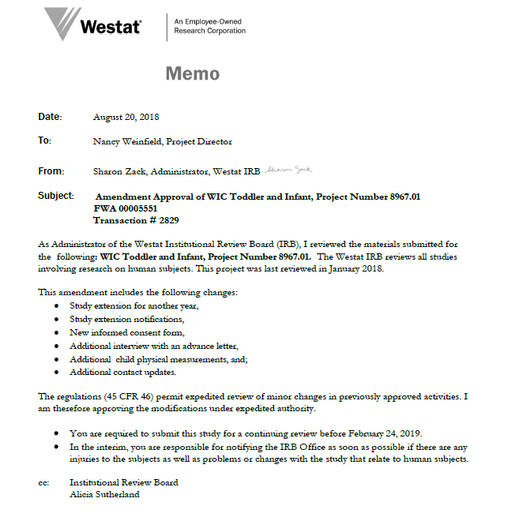
Westat IRB Approval Letter

