Table of Contents

70.4 - Responsibility 4
70.41 - Washington Office 4
70.42 - Regions, Stations, and the Area 4
70.5 - Definitions 4
71 - FOREST SERVICE PROGRAMS COVERED BY TITLE VI, TITLE IX, AND TITLE V 6
71.1 - National Forest Systems Programs 6
71.2 - State and Private Forestry Programs 8
71.3 - Research Programs 8
72 - ASSURANCES 8
72.1 - Responsibilities 8
72.2 - Assurance of Compliance With Department of Agriculture Regulation Under Title VI of the Civil Rights Act of 1964, Form 1700-1 9
72.21 - Plan for Compliance 11
72.22 - Court Order 11
72.3 - Assurance Clause 11
72.4 - Assurance, Statements With Institutions of Higher Education 12
72.5 - Covenant and Reverter Clause 13
72.6 - Coordinating Assurances 14
72.61 - Authority 14
72.62 - Objective 14
72.63 - Policy 14
72.7 - Interdepartmental Agreements 14
72.8 - Intradepartmental Agreements 15
73 - COMPLIANCE REVIEWS 15
73.1 - Objective 15
73.2 - Policy 15
73.3 - Responsibility 16
73.4 - Schedules 16
73.41 - Review Schedule 16
73.42 - Review Form 18
73.43 - Review Procedures 22
74 - COMPLAINTS 22
75 - NONCOMPLIANCE 23
75.1 - Discrimination 23
75.2 - Nonassurance 23
75.3 - Noncompliance Report 23
76 - EFFECTING COMPLIANCE 24
76.1 - Refusing Assistance 24
76.2 - Terminating or Suspending Assistance 25
76.3 - Deferring Assistance 25
77 - MISCELLANEOUS PROVISIONS 25
78 - RECIPIENTS' REPORTS 26
78.1 - Revenue-Sharing Fund Report 26
79 - FOREST SERVICE REPORTS 28
This chapter explains the basis and legal requirements for establishing and implementing Forest Service Federal Financial Assistance Programs (FSM 1770).

The intended users of this chapter are Forest Service line officers, Civil Rights Directors/
Coordinators, and EEO Specialists. Information contained in this chapter is designed to assist managers/specialists with procedural requirements and general guidelines for implementing
FSM 1770.

70.4 - Responsibility

70.41 - Washington Office

The Deputy Chief for Business Operations ensures the application of the requirements for nondiscrimination in the Federal Financial Assistance Programs of the Forest Service. Staff responsibility is delegated to the Director, Civil Rights. All Deputy Chiefs shall give leadership and direction to their program offices for reviewing and monitoring the nondiscrimination aspects of their programs and activities at all organizational levels.

70.42 - Regions, Stations, and the Area

The Regional Foresters, Station Directors, and the Area Director shall, through their staffs, affirmatively administer the Civil Rights Program.

70.5 - Definitions

Applicable terms defined in the law and regulations follow:
Applicant. An applicant submits an application, request, or plan requiring approval by the Forest Service or primary recipient, as a condition to eligibility for assistance.
Beneficiary. A beneficiary receives a benefit, such as goods or services, from a recipient.
Continuing State Program. These are programs that remain in effect from year to year. They are administered by a State or local agency, such as a county. They exclude programs administered by an institution of higher education. Forest Service continuing State programs include the cooperative forestry programs and the revenue sharing programs.
Discrimination. Discrimination is unequal treatment of persons because of race, sex, color, national origin, age, handicap, creed, or marital status. This unequal treatment may be in the quality or timing of assistance, in the method used to provide a benefit, or in the fees charged for a benefit. Any recipient receiving assistance discriminates if, on the basis of any of the above reasons that person:
a. Denies a person any benefit provided under the program.
b. Provides a person any benefit that is different or is provided in a different manner from that provided to others.
c. Subjects a person to segregation, separate or difference of treatment.
d. Restricts a person from taking part of enjoying any benefit that is enjoyed by others.
Federal Financial Assistance. Federal financial assistance includes (1) grants and loans of Federal funds; (2) the grant or donation of Federal property and interests in property; (3) the detail of Federal personnel; (4) the sale and lease of and the permission to use (on other than a casual or transient basis) Federal property or any interests in such property or the furnishing of services without consideration or at a nominal consideration, or at a consideration which is reduced for the purpose of assisting the recipient, or in recognition of the services to the recipient; and (5) any Federal agreement, arrangement, or other contract which has as one of its purposes the provision of assistance.
Federal Financial Assistance Program. All programs or activities where assistance is granted to a recipient who extends a service or benefits to others are Federal financial assistance programs. Federal financial assistance instructions do not apply to:
a. Assistance by insurance or guaranty contracts.
b. Assistance extended before January 3, 1965.
c. Employment practices of a recipient, except where the purpose of the assistance is to provide employment, or where the conditions of employment affect the fairness in services rendered.
Other Recipient. A Subrecipient. Also recipients below the second level when they exist.
Primary Recipient. A primary recipient, such as a State, is a recipient that extends assistance to another recipient, such as a county, for carrying out a program.
Program. A program is any project or activity that provides services, financial aid, or other benefits to individuals. Also, one that provides facilities that furnish services, financial aid, or other benefits to individuals.
Racial/Ethnic Categories.
a. Black, Not Hispanic. A person who has origins in any of the black racial groups of Africa.
b. Hispanic. A person of Mexican, Puerto Rican, Cuban, Central or South American, or other Spanish culture or origin, regardless of race.
c. Asian or Pacific Islander. A person who has origins in any of the original peoples of the Far East, Southeast Asia, the Indian subcontinent, or the Pacific Islands. This area includes, for example, China, Japan, Korea, the Philippine Islands, and Samoa.
d. American Indian or Alaskan Native. A person who has origins in any of the original peoples of North America, and who maintains cultural identification through tribal affiliation or community recognition.
e. White, not of Hispanic Origin. A person who has origins in any of the original people of Europe, North Africa, or the Middle East.
Recipient. A recipient can be a person, group, agency, or entity who receives Federal financial assistance for services or benefits that are extended to others.

71 - FOREST SERVICE PROGRAMS COVERED BY TITLE VI, TITLE IX, AND TITLE V

Programs affected by Title VI of the Civil Rights Act of 1964, Title IX of the Education Act of 1982, and section 504 of the Rehabilitation Act of 1973 (TITLE V), include programs administered by National Forest Systems (NFS), State and Private Forestry (S&PF), and Research Programs (R), as listed. The list may not be complete. The regulations apply to any assistance programs, regardless of whether they are listed. The legal authority to be cited is shown for each. You may refer citations for unlisted programs to the Office of the General Counsel. The Office of the General Counsel has determined that the provisions of Title VI apply to virtually all special-use permits, regardless of the amount of fee paid, and to cooperative agreements.

71.1 - National Forest Systems Programs

Administration and management of National Forests and National Grasslands, and other lands administered by the Forest Service in which Federal assistance is rendered includes, but is not limited to the following activities:
1. Permits for use of National Forests and National Grasslands by other than individuals at a nominal or no charge, Act of June 4, 1897, as amended (16 U.S.C. 551); Secretary's Regulations (36 CFR 252.2); Term Permit Act of March 4, 1915, as amended (16 U.S.C. 497); American Antiquities Act of June 8, 1906 (16 U.S.C. 433); and Title III, Bankhead-Jones Farm Tenant Act of July 22, 1937 (7 U.S.C. 1011 (c)-(d)).
2. Permits for use of Government-owned improvements and land used therewith by other than individuals at a nominal charge, section 7 of Granger-Thye Act of April 24, 1950
(16 U.S.C. 580d).
3. Easements for use of National Forests and National Grasslands by other than individuals at a nominal or no charge, Act of March 4, 1911, as amended (16 U.S.C. 523); Act of May 13, 1946, as amended (49 U.S.C. 1115); and Title III, Bankhead-Jones Farm Tenant Act of July 22, 1937 (7 U.S.C. 1011 (d)).
4. Permits for disposal of common varieties of mineral materials from lands under Forest Service jurisdiction for use by other than individuals at a nominal or no charge, Act of July 31, 1947, as amended (30 U.S.C. 601-603, 611); and Act of June 11, 1960 (5 U.S.C., 511 note).
5. Timber granted free or at nominal cost to any group, Act of June 4, 1897, as amended (16 U.S.C. 551); Title III, Bankhead-Jones Farm Tenant Act of July 22, 1937 (7 U.S.C. 1011 (b); and Secretary's Regulations 36, CFR 223.1).
6. Road rights-of-way, Federal Highway Act of August 27, 1958 (23 U.S.C. 107).
7. Rights-of-way for wagon roads or railroads, Act of March 3, 1899 (16 U.S.C. 525).
8. Use of Federal land for airports, Federal Airport Act of May 13, 1946, as amended
(49 U.S.C. 1105, 1114).
9. Transfer of fire improvements and land to States and political subdivisions thereof, section 5 of the Act of June 5, 1964 (16 U.S.C. 565b).
10. Easements for road rights-of-way over lands administered by the Forest Service; section 2 of the Act of October 13, 1964 (16 U.S.C. 553).
11. Conveyance of land to States or political subdivisions for widening highways, streets, and alleys; Act of July 7, 1960 (40 U.S.C. 565b).
12. Transfer of fire-lookout towers, improvements, and land to States and political subdivisions thereof; section 5 of the Act of June 20, 1958 (16 U.S.C. 565).
13. Revenue-sharing payment to States:
a. Payment of 25 percent of National Forest receipts to States for schools and roads, Act of May 23, 1908, as amended (16 U.S.C. 500).
b. Payment to Minnesota from National Forest receipts of sum based on a formula, section 5 of the Act of June 22, 1948, as amended (16 U.S.C. 577 g-i).
c. Payment to New Mexico and Arizona of proportion of National Forest receipts for common-school fund, sections 6 and 24, Act of June 20, 1910 (36 Stat. 557, 562, 573).
d. Payment of 25 percent of net revenues from Title III, Bankhead-Jones Farm Tenant Act, lands to counties for school and road purposes or both, Section 33, Title III, Bankhead-Jones Farm Tenant Act of July 1937 (7 U.S.C. 1012).

71.2 - State and Private Forestry Programs

Cooperation in the protection, development, management, and utilization of forest resources administered by the Forest Service in which Federal assistance is rendered, includes, but is not limited to, the activities and programs authorized by the Cooperative Forestry Assistance Act of 1978 (P.L. 95-313; 16 U.S.C. 2101).

71.3 - Research Programs

Research programs of the Forest Service in which Federal assistance is rendered include, but are not limited to, the following activities:
1. Advance of funds for cooperative research, Section 20 of Granger-Thye Act of April 24, 1950, added April 6, 1959 (16 U.S.C. 581i-1).
2. Grants for support of scientific research; Act of September 6, 1958 (42 U.S.C. 1891-1893).
3. Research cooperation, McSweeney-McNary Act of May 22, 1928, as amended
(16 U.S.C. 581, et seq.).
4. Grants for Research; Section 2, Act of August 4, 1965 (70 Stat. 431).

72 - ASSURANCES

Every application for Federal financial assistance to carry out a program or to provide a facility shall, as a condition to its approval and the extension of any Federal financial assistance pursuant to the application, contain or be accompanied by an assurance that the applicant shall conduct the program or activity or operate the facility in compliance with all requirements imposed by or pursuant to the authorization in section 72.2, 72.3, or 72.4, whichever is appropriate.

72.1 - Responsibilities

The responsibilities for securing assurances are:
1. The officer who approves a program shall obtain an assurance from the primary recipient. The Regional Forester shall obtain assurances in the revenue-sharing program.
2. Primary recipients shall obtain assurances from secondary recipients. When more than two levels of recipients occur, each level should secure assurances from the next lower level. Where two or more levels occur, the final recipient usually operates the program and others act only as intermediaries. In such cases, the intermediary's assurance, in effect, says that they shall make every effort to secure assurances from subrecipients. Also, the intermediary's assurance says that when it is not possible to secure such assurances, the intermediary shall assist the Forest Service in identifying and reporting the subrecipients who have not filed an assurance.

72.2 - Assurance of Compliance With Department of Agriculture Regulation Under Title VI of the Civil Rights Act of 1964, Form 1700-1

Use this form (ex. 01) for Federal financial assistance programs that received approval before the regulations became effective. Use this form for assistance that received approval after the effective date of the regulations where the original application for Federal Assistance document did not contain a Title VI assurance, in accordance with OMB Circular A-102. Also, use the form for recipients in the revenue-sharing program. An assurance that a recipient signs does not cover a subsequent new application or program unless specifically indicated. Use one form for each program. In the blank space provided, insert after the words "on account of" reference to the permit, lease, or other citation that clearly identifies the assistance extended and the authority under which it is granted. For example:
1. The Act of May 23, 1908, as amended (16 U.S.C. 500), which provides for payment of 25 percent of National Forest receipts to States for schools and roads.
2. The Cooperative Forestry Assistance Act of 1978 (16 U.S.C. 2101).
3. A permit issued under Regulation 36 CFR 251.2 and designated 2710-Uses, Lincoln County, Park and Playground, May 5, 1965.

The responsible Forest Service Officer shall maintain a copy of all assurances from primary recipients and from all other recipients when two or more levels occur.

72.2 - Exhibit 01
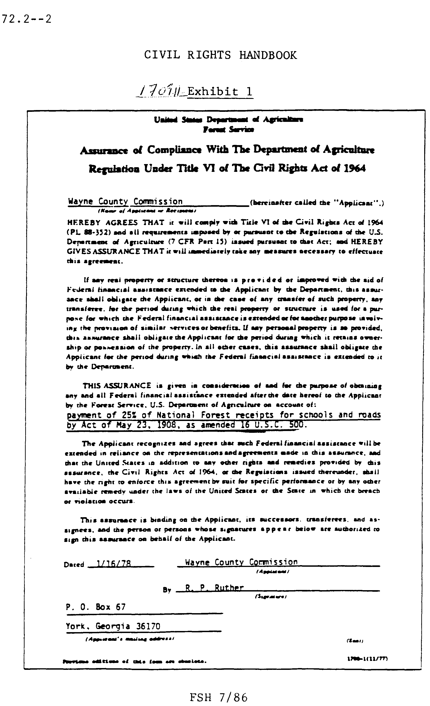

72.21 - Plan for Compliance

A State agency, except an institution of higher education, may submit a plan instead of signing form 1700-1. Use of a plan is limited to continuing State programs.

A plan permits assistance in a continuing State program when some part of the program is not complying. The plan must be acceptable to the responsible Forest Service officer who can approve it or negotiate needed changes. After the plan receives approval, the program may continue. A plan should include:
1. Noncompliance Areas. This should be a listing by areas of the types of noncompliance in the program at the time the plan is made.
2. Program Administration. This may be in the form of a statement. It should set forth methods of administration for the programs by which the recipients shall comply with Title VI and specify planned actions for correcting areas of noncompliance.

72.22 - Court Order

In some cases, a Federal court order is causing a recipient to comply. In such cases, the assistance may continue upon the recipient's giving the Forest Service officer a copy of the court order and a statement of intent to comply with the court order.

Such cases are most likely to occur in the revenue-sharing program where schools are being desegregated by the court.

72.3 - Assurance Clause

Use the clause in item 2 for all new permits and agreements involving assistance except those involving the transfer or use of real property or interest therein. Real property is defined as land or a permanent structure.
1. Requirements. The assurance clause applies to those who receive Federal financial assistance for services and benefits, which they extend to others. Do not use the clause to amend an outstanding permit, agreement, or other instrument. Use Form 1700-1, Assurance of Compliance with the Department of Agriculture Regulation under Title VI of the Civil Rights Act of 1964.
2. Clause Wording. The exact wording to use follows:

By accepting this permit, the permittee hereby agrees to comply with Title VI of the Civil Rights Act of 1964 and all requirements imposed by or pursuant to the regulation of the United States Department of Agriculture (7 CFR, Part 15) issued pursuant to that Act, and hereby assures that in the operation and performance of this permit to take immediately any measures necessary to effectuate this requirement. If any real property or structure thereon is provided or improved with the aid of Federal financial assistance extended to a permittee by the United States Department of Agriculture, this assurance shall obligate the permittee, or in case of any transferee, of such property, any transferee, for the period during which the real property or structure is used for a purpose for which the Federal financial assistance is extended or for another purpose involving the provision of similar services or benefits. If any personal property is so provided, this assurance shall obligate the permittee to the period during which he/she retains ownership or possession of the property.

In all other cases, this assurance shall obligate the permittee for the period during which the Federal financial assistance is extended to him/her by this permit. This assurance is given in consideration of the Federal financial assistance extended in this permit to the permittee by the United States Department of Agriculture. The permittee recognizes and agrees that such Federal financial assistance will be extended in reliance on the representations and agreements made in this assurance. The permittee further agrees that the United States in addition to any other rights and remedies provided by this assurance, the Civil Rights Act of 1964, or the regulations issued thereunder, shall have the right to enforce this agreement by suit for specific performance or by any other available remedy under the laws of the United States or the State in which the breach or violation occurs.
3. Alternate Wording. Alter the clause only as follows:
a. Substitute "party of the second part" or other proper term as needed for "permittee."
b. Substitute "agreement" or other proper term as needed for "permit."

72.4 - Assurance, Statements With Institutions of Higher Education

In these situations, the clause in section 72.2 is not necessarily required. The operation is within the scope of the coordinating assurance (section 72.5). However, the Forest Service needs an assurance statement addressed to the Forest Service or the Department of Agriculture.

The Department of Education's (DOE's) (formerly HEW) assurances are prepared on DOE's form and are not acceptable with schools subjected to DOE reviews. The following statement is acceptable for the assurance:

The extension of benefits under provision of this agreement shall be without discrimination as to race, sex, color, national origin, age, handicap, creed, or marital status.

72.5 - Covenant and Reverter Clause

Use the clause that follows in all new deeds, grants, permits, easements, leases, and similar documents that involve the transfer or use of property interests herein to recipients of Federal financial assistance. Do not use the following clause in documents that do not extend such assistance. See item 2 below for the meaning of numbers in parentheses.
1. Clause Wording. Use the following wording:

The "(1)" does by the acceptance of this document covenant and agree for itself, its assigns, and its successors in interest to the property here, "(2)" or any part thereof, that the covenant set forth below shall attach to and run with the land:
a. That the described property and its appurtenant areas and its building and facilities whether or not on the land therein "(2)" will be operated as a "(3)," in full compliance with Title VI of the Civil Rights Act of 1964 and all requirements imposed by or pursuant to the regulations issued there under by the Department of Agriculture and in effect on the date of this document to the end that no person in the United States shall, on the ground of race, color, or national origin, be excluded from participation in, be denied the benefits of, or be subjected to discrimination under any programs or activities provided thereon; and
b. In the event of a breach of any of the conditions set forth above, all right, title, and interest in and to the above described property shall, at the option of the grantor, revert to and become the property of the United States of America, which shall have an immediate right of entry thereon, and "(1)," its successors or assigns, shall forfeit all right, title, and interest in and to the above described property and in any and all of the tenements, hereditaments and appurtenances thereunto belonging; provided, however, that the failure of the grantor to assist in any one or more instances upon complete performance of any of the said conditions shall not be construed as a waiver or a relinquishment of the future performance of any such conditions but the obligations of the "(1)" with respect to future performance shall continue in full force and effect.

(The Department's Regulation at 7 CFR 15(a)(2) makes inclusion of the reverter language optional in all agency agreements. However, it is to be excluded from Forest Service agreements only when its inclusion defeats agreement consummation. In those instances, issues concerning the Government's reverter interest can be reached through the judicial process.)
2. Alternate Wording. In the blank spaces in the clause in item 1, use the following as appropriate:
a. Spaces Numbered "(1)," use "grantee," "permittee," "lessee," "licenses," "patentee," or "party of the second part."
b. Spaces Numbered "(2)," use "conveyed," "granted," or "leased."
c. Space Numbered "(3)," describe the purpose of the document. For example, "public road," "campground," or "airport."

72.6 - Coordinating Assurances

72.61 - Authority

The Secretary's Regulation (7 CFR 15.12c) provides for interagency coordination.

72.62 - Objective

Administration of Title VI by the agency having primary responsibility for a common recipient of several agency programs shall:
1. Reduce duplication of administration.
2. Reduce impacts on the recipient.
3. Obtain uniform administration of civil rights.

72.63 - Policy

The Secretary approves coordination agreements between the Department of Agriculture and other departments. The Forest Service attempts to secure coordination where practical.

72.7 - Interdepartmental Agreements

Coordination agreements between the Secretary of Education (OE), and the Secretary of Health & Human Services (HHS) are in effect for institutions of higher education (OE) and medical institutions (HHS). The Secretary has agreed that OE and HHS shall enforce Title VI of the Act in institutions of higher education and in medical facilities, such as hospitals. Thus, OE and HHS take care of compliance reviews, investigation of complaints, and related compliance actions. The Washington Office shall receive all complaints or information on noncompliance in such cases for transmittal to OE and HHS through the Secretary. Where no agreement exists, the provisions under section 73 apply.

72.8 - Intradepartmental Agreements

By agreement, the Rural Electrification Administration (REA) assumes, on behalf of the Forest Service, responsibility for compliance reviews of all REA cooperators that receive Federal financial assistance from the Forest Service (FSM 1546). The agreement requires that the Forest Service furnish REA with a list of all cooperatives that receive assistance from the Forest Service.

Field units that grant assistance to REA cooperatives that have not previously received assistance shall inform the Washington Office of the name and address of each new recipient.

73 - COMPLIANCE REVIEWS

Compliance reviews are periodic inspections or investigations of a recipient's assistance programs.

73.1 - Objective

A compliance review should reveal any discriminatory practices, or omission of civil rights requirements, in the assistance programs.

73.2 - Policy

It is the policy of the Forest Service to:
1. Prepare and document compliance reviews before granting Federal financial assistance when the issuing officer believes the applicant is discriminating.
2. Intensify and extend the review of a case or program in instances when compliance status is not readily determinable, or where noncompliance is evident until status can be established.
3. Perform compliance reviews of all recipients, except those made by another agency. Compliance reviews of recipients made by another Federal agency having Title VI compliance responsibility may be acceptable. Standard practice dictates that any agency conducting a compliance review or investigating a complaint of an alleged Title VI violation shall notify any other affected agency upon discovery of its jurisdiction and shall subsequently inform it of the findings. Such reviews or investigations may be made on a joint basis.
4. Ordinarily, complete separate reviews for each separate program of a single recipient. In a few instances, one review may cover two or more programs of a single recipient, provided the review covers all such programs; report as one review under the major program, only.
5. Combine and report in one review when a single recipient receives assistance under several instruments in the same program.
6. Subject the total facility of a recipient to compliance reviews when any phase or part operates as the result of agreement, contract, permit, and so forth, involving Federal financial assistance. For example: When a ski lodge applies for a private facility permit for any part of run (ski track) to cross National Forest land, the whole facility must undergo Forest Service compliance reviews. In situations where another Federal agency also has assistance programs in the facility, coordinate evidence of noncompliance with that agency.

73.3 - Responsibility
1. The officer who administers or supervises the assistance program shall ensure that reviews are scheduled, conducted, documented, and reported.
2. Those who conduct compliance reviews should make every effort to seek the cooperation of recipients and help them comply voluntarily. As needed, furnish recipients with a copy of the regulations. Discuss and explain the regulations as they apply to the recipients' progress.

73.4 - Schedules

73.41 - Review Schedule

Regional Foresters shall notify Forest supervisors annually of the permits requiring scheduling and completion of onsite reviews for the year. Conduct reviews as follows:
1. Annually for Federal financial assistance granted in excess of 1 year.
2. Before the Federal financial assistance is granted when the assistance is granted for a period less than 1 year.
3. Compliance reviews of special-use permits involving assistance are scheduled and completed onsite and to the appropriate level prescribed by the priority and sampling system prescribed below. Use Form FS-1700-4, Compliance Review, as the compliance review (sec. 73.12).
a. Special-use permits requiring Title VI reviews are divided into three priority groups. In priority I is made up of those permits that have the highest potential for noncompliance. Priority III permits are those with the lowest potential for noncompliance.
Examples of these priorities, as well as priority II, follow:
(1) The categories of permits included in each priority are the following kind of use code numbers (FSM) 2720.6 - 2729.42).

Priority I | Priority II | Priority III
111 144 361 | 145 321 821 | 114 612 714
112 147 431 | 146 322 911 | 149 621 715
113 148 432 | 153 341 912 | 164 622 723
132 152 511 | 154 342 914 | 217 631 745
133 155 811 | 156 362 921 | 364 632 821
141 161 832 | 157 531 922 | 425 641 831
 | 158 722 923 | 521 642 832
 | 162 731 931 | 541 643
 | 163 758 | 611 644
 | 216 759
(2) Approximately 20 percent of the eligible permits shall receive on-the-ground reviews each year. The purpose of the sample is to determine the level of compliance in the Regions with plus or minus 5-percent accuracy. Derive the overall sample of approximately 20 percent as follows:
(a) Half of all priority I permits.
(b) One-fifth of all priority II permits.
(c) One-tenth of all priority III permits.
(3) A computer selects the permits according to the priority groups discussed above. The selection process ensures that permits are not subjected to repetitive reviews and that all permits are reviewed on a cyclic basis as follows:
(a) Priority I permits - every 2 years.
(b) Priority II permits - every 5 years.
(c) Priority III permits - every 10 years.
b. In addition, compliance reviews are scheduled and completed onsite regardless of priority, as follows:
(1) All complaints of noncompliance.
(2) All permits where previous onsite review indicates the need for follow-up.

73.42 - Review Form

Use Form FS-1700-4, Compliance Review (ex. 01), to document Title VI compliance review only. Where one form covers assistance granted to a single recipient under two or more instruments, list all programs and cases included in the review. Cross-reference each case file as necessary.
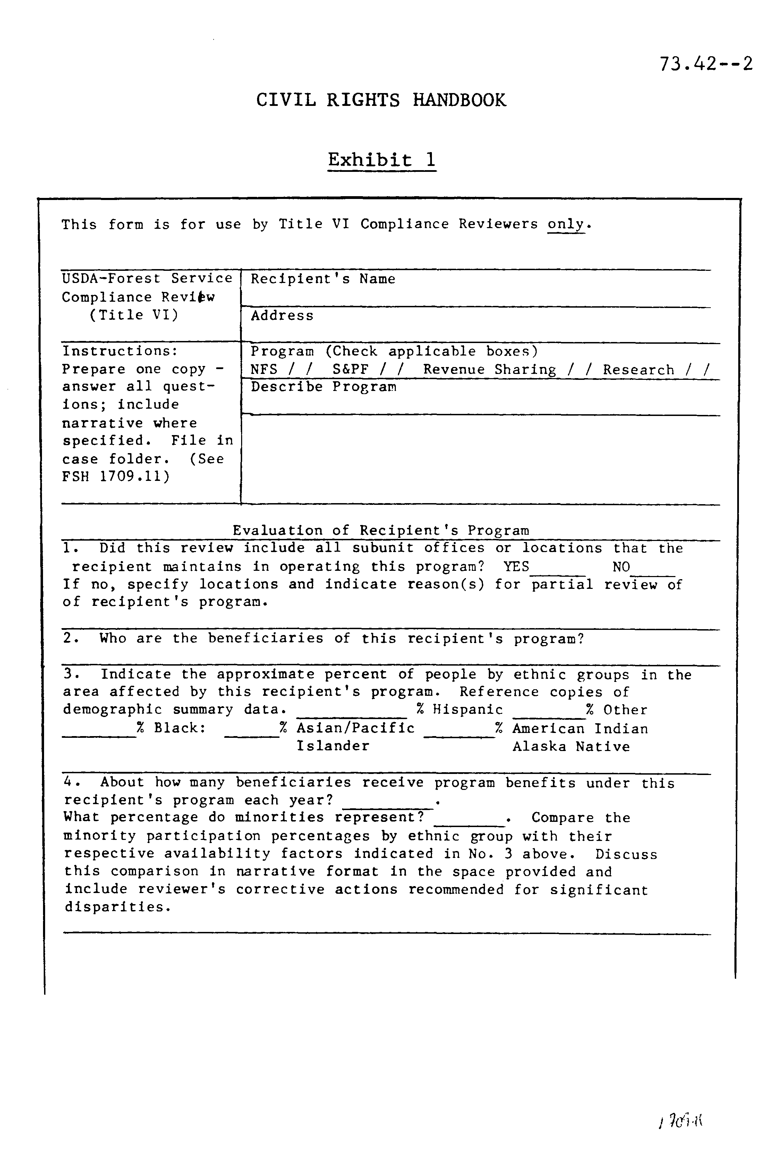72.42 - Exhibit 01

72.42 - Exhibit 01--Continued
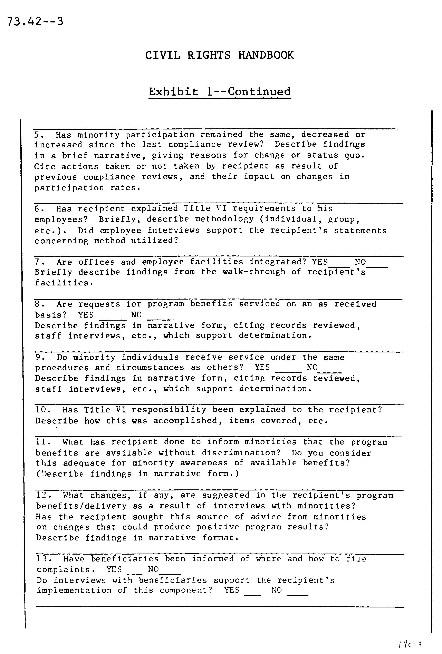
72.42 - Exhibit 01--Continued
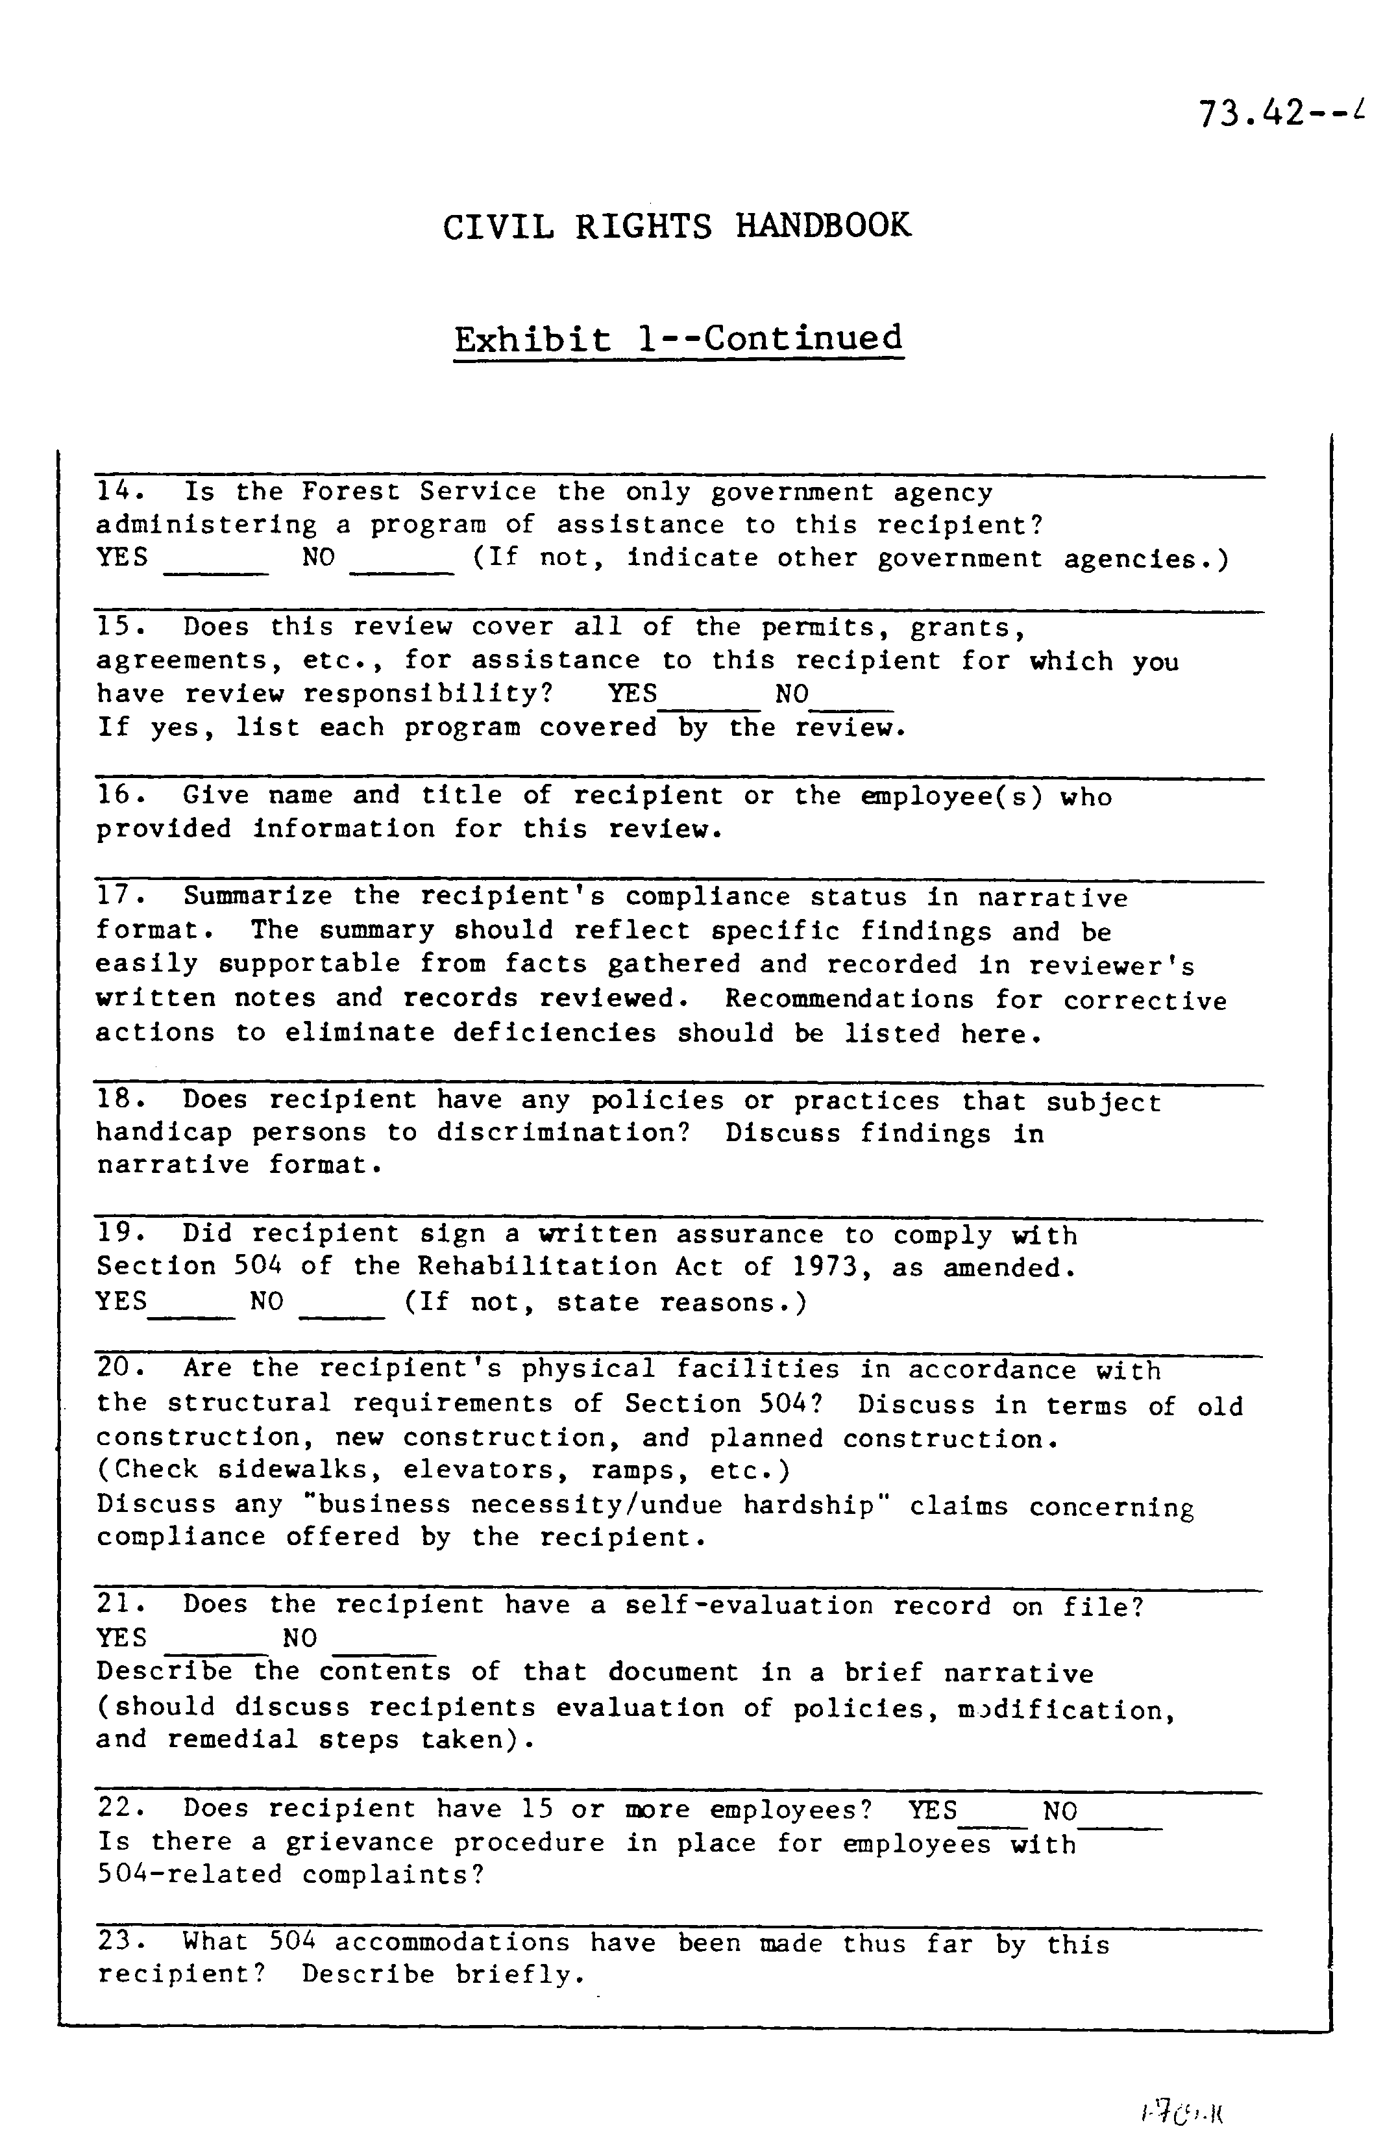

73.43 - Review Procedures
1. Objective. The questions in the evaluation block of form FS-1700-4 are designed to help the reviewer avoid over-looking areas that may reveal possible discrimination. Reviewers should be alert to other lines of inquiry that fit the specific case or program.
2. Interview Techniques. Do not use the questions in the evaluation block as direct questions asked of the recipient. The review should answer them only after the subject suggested by the question has been thoroughly investigated. The reviewer should develop original who, how, when, where, what, and why questions that fit the particular area of inquiry and that fit the particular case or program. Answers to some questions require interviews and contacts with others. Document on the form such contacts and observations made.
3. Suspicion of Discrimination. Where discrimination exists or is suspected, the reviewer shall intensify the investigation and documentation so as to establish in the record the specific instances or areas of noncompliance. The reviewer shall document by memorandum and attach the form, all statements, opinions, findings, observations, and interviews that establish noncompliance.

To be useful such documentation must contain reliable evidence that government attorneys can use in a hearing to support a finding of noncompliance. Documentation should identify who said what, when, and where.
4. Noncompliance Actions. When a review reveals noncompliance, the responsible officer shall advise the recipient in writing. The advice should outline needed corrective actions, which have been discussed with the recipient. The advice should show what is to be done and assign a reasonable time for doing it. When voluntary compliance cannot be obtained by this means, prepare and submit a noncompliance report.

74 - COMPLAINTS

Any person, or the representative, may file a complaint when discrimination is suspected. The complaint must be in writing and signed, and it should name the program, the prohibited action, and time of occurrence. File the complaint within 180 days from the date of the alleged act. Only the Secretary may extend the time for filing. Any Forest Service line officer may accept a complaint. Promptly forward any complaint of discrimination against a recipient through channels to the Washington Office for transmittal to the Director, USDA Office of Advocacy and Enterprise, Office of Equal Opportunity (USDA/OAE/OEO).

No employee shall attempt to influence a complainant in any way. Employees may advise of the program's name and where to file the complaint or request for extension. The identity of a complainant shall remain confidential, except as needed to carry out the purpose of the regulations.

75 - NONCOMPLIANCE

This includes discrimination by a recipient, or failure or refusal to furnish an assurance.

75.1 - Discrimination

Discrimination is disclosed by compliance review or by complaint investigation. When established by review or after investigation, make every effort to secure voluntary compliance. When securing voluntary compliance is not possible, submit a noncompliance report (sec. 75.3).

When racial/ethnic barriers exist and minority participation and benefit need increased representation, Forest Service officers should contact minority leaders, organizations, and others to encourage minority participation and increase program awareness.

75.2 - Nonassurance

When a recipient fails to furnish an assurance, prepare and submit a noncompliance report. In such cases, make personal contact with the recipient and prepare a memorandum that fully documents the recipient's refusal. See section 76.1 for information about refusing assistance.

75.3 - Noncompliance Report

Report instances of noncompliance when unable to secure voluntary compliance. Base reports on a thorough review and investigation of all pertinent facts.
1. Field Report. Submit two copies of each report to the Washington Office. Report each recipient in a separate report. In the National Forest System program, one report can cover two or more instances of noncompliance by the same recipient. A report helps those who review it to decide on the actions needed to obtain compliance. Those who review the report are usually persons who have little or no knowledge about the recipient, the program, or Forest Service procedures. Because of this, it is necessary to provide a complete, concise, and informative report that should contain:
a. Letter of Transmittal. The Regional Forester or Director should submit the report. The letter should name the recipient, the program or part affected, type of noncompliance, and recommendation. Indicate whether assistance has been refused (sec. 76.1) or deferred (sec. 76.3).
b. Noncompliance Notice. Copy of a registered letter to the recipient, giving notice of noncompliance. Either the Regional Forester or Station Director should present such notices.
c. Case Summary. The case summary should be a complete schedule of events in narrative form. It should begin with the application by the recipient and discuss in chronological order all actions and related circumstances pertinent to the case. Statements must be factual, not hearsay. Names, titles, dates, places, and so forth should be specific.
d. Documentation. Furnish copies of all documents that substantiate statements made in the summary. This includes such things as (1) letters to and from the recipient; (2) memorandum of contacts made; (3) inspection or compliance review reports; (4) agreement, permit, or contract; (5) application where applicable; (6) assurance or plan; and (7) deeds or other acquisition case file items if the assistance may qualify as an exception on acquired lands.
2. Washington Office Action. The Washington Office shall:
a. Review each report.
b. Transmit a copy to the Director, USDA Office of Advocacy and Enterprise, Office of Equal Opportunity (USDA/OAE/OEO).
c. Inform field units of all action taken by the Secretary.
d. Take additional action as directed by the Secretary.

76 - EFFECTING COMPLIANCE

Only the Secretary may make the final decision for effecting compliance by terminating, suspending, or refusing to grant or continue assistance.

76.1 - Refusing Assistance

Though the final decision to refuse rests with the Secretary, responsible Forest Service officers shall refer an application for assistance to the Washington Office when all of the following conditions apply:
1. The application is made after January 3, 1965.
2. The applicant refuses or fails to furnish an assurance or the officer believes that the applicant is discriminating.
3. The applicant has been advised in writing of the failure or refusal to furnish an assurance or of the belief that the applicant is discriminating.
4. The case has been promptly reported in accordance with section 75.3.

76.2 - Terminating or Suspending Assistance

The Secretary handles the termination or suspension of assistance in accordance with the procedure in the regulations. The Secretary may terminate or suspend assistance in the following types of cases:
1. A finding of discrimination by a recipient after an opportunity for a hearing.
2. A finding of failure or refusal to furnish an assurance. On programs approved before January 3, 1965, in which assistance is due on a continuing basis after that date; the assistance may continue pending the outcome of the administrative proceedings provided for in the regulations.

76.3 - Deferring Assistance

The Department of Education (DOE) publishes a list of noncomplying recipients. This list is the "Interagency Report - Status of Title VI Activities," and it lists primary and secondary schools, institutions of higher education, and medical institutions that are or may be in noncompliance. If an applicant for assistance under any Forest Service program appears on the DOE list, the responsible officer shall defer final approval of a new or a renewal application until such time as the applicant is removed from the list.

However, any assistance granted under a previously approved new or renewal application should continue until completion of the procedure for refusing or terminating the assistance. When the Forest Service defers approval of a new or renewal application, the responsible officer shall promptly notify the Washington Office through channels of the deferral action. The Washington Office then coordinates procedures with the Director, USDA/OAE/OEO.

One copy of the DOE list is sent to each Region, Station, and the Area upon receipt of the list. As necessary, these units should duplicate and distribute applicable parts of the list to their subunits that have authority to extend assistance to the listed recipients.

77 - MISCELLANEOUS PROVISIONS

Adhere to the following provisions:
1. Site Selection. Discrimination based on race, color, or national origin in the selection of sites or locations for facilities is prohibited. Recipients or applicants may not make selections for facility sites with the purpose or effect of excluding individuals from, denying them the benefits of, or subjecting them or discrimination under any Title VI activity or program.
2. Affirmative Action. Recipients are required to take affirmative action to overcome the effects of prior discrimination based on race, sex, color, national origin, age, handicap, creed, or marital status. If prior discrimination did not exist, a recipient shall take affirmative action to overcome the effects of conditions that result in limiting racial participation in program benefits based on the above characteristic(s).
3. Employment Practices. Where a primary objective of the Federal financial assistance is not to provide employment, but discrimination on the grounds of race, sex, color, national origin, age, handicap, creed, or marital status, in the employment practices of the recipient tends to exclude individuals from participation in, to deny them the benefits of, or to subject them to discrimination under any recipient program, the provisions of this regulation shall apply to the employment practices of the recipient to the extent necessary to ensure equality of opportunity to, and nondiscriminatory treatment of beneficiaries.
4. Planning and Advisory Bodies. Recipients may not deny a person the opportunity to participate as a member of a planning or advisory body that is an integral part of the program or activity.
5. Racial Data. The Forest Service does not require recipients to maintain and have available racial and ethnic data showing the extent to which members of minority groups are beneficiaries of federally assisted programs.

78 - RECIPIENTS' REPORTS

Forest Service officers administering an assistance program may require a recipient to keep such records and submit such reports as necessary to ascertain compliance. Primary recipients should furnish a copy of each assurance statement that they obtain from other recipients in the program.

78.1 - Revenue-Sharing Fund Report

The Forest Service requests this report from recipients of revenue-sharing funds. Obtain the report only from counties that have reported a noncomplying school or road district.
1. Authority. Secretary's Regulations (7 CFR 15.5).
2. Objectives.
a. To determine the proportion of funds distributed to each school district reported in noncompliance so that an equitable decision can be made upon a finding of noncompliance after an opportunity for a hearing.
b. To determine that funds paid to a county are not distributed to noncomplying school and road districts where a final order and decision of the Secretary are in effect.
3. Policy. Request reports:
a. Initially when any district in a county is reported in noncompliance.
b. Annually in those counties where a final order and decision have been issued that affect any district in the county.
4. Responsibility. The Regional Forester shall request the reports from the concerned counties either through the State or direct.
5. Report Format. Include a brief narrative statement concerning each participating county. This statement should include the name of the school district in the county, city, and State where located, and amount of funds received. Obtain the dollar amounts from the tabulation of 25-percent payments to States and counties. These are furnished on a fiscal-year basis for payments under 16 U.S.C. 500, and on a calendar-year basis under 7 U.S.C. 1012.
6. Initial Requests for Report. When a district is in noncompliance, the Washington Office asks the Region to obtain a report from the county.

The Region requests the report by letter. Explain the need to the county. Fill in applicable parts before mailing. Use the dollar amounts from the last tabulation of payments. When received, review the report for completeness and accuracy. A responsible county official should sign the report. Send a copy of the report to the Washington Office.
7. Annual Request for Report. The Regional Foresters, Station Directors, and the Area Director shall administer the Civil Rights Program within their area of responsibility. They shall assign a member of their staff to serve as a Civil Rights Coordinator and act as a contact with the Washington Office Coordinator. Report the name of the assigned staff member to the Washington Office Civil Rights Staff.
8. Interdepartmental Report. The Department of Education (DOE) distributes this report at regular intervals. The Washington Office furnishes each Region, Station, and the Area with one copy. Regions shall reproduce and distribute applicable parts to the forests as necessary.

The report lists by States each noncomplying school district and the status of the hearing proceeding in each case. Field units can follow progress in each case by reviewing the reports.
9. File. The Washington Office maintains a case file for each noncomplying school or district.

79 - FOREST SERVICE REPORTS

Regions, Stations, and the Area shall discontinue the Status Report, Title VI, and the Civil Rights Accomplishments Report formerly requested on the first of February and August. The Office of Equal Opportunity (USDA/OAE/OEO) no longer requires this report from the Forest Service. Cover accomplishments and other activities in the unit's total Civil Rights Program in the Forest Service affirmative Action Plan and/or other reports requested in conjunction with annual data requirements. During the interim report other significant items through the appropriate Regional Civil Rights Staff, Service-wide Civil Rights Committee member, or to the Washington Office Civil Rights Staff.
1. The Act of May 23, 1908, as amended (16 U.S.C. 500), which provides for payment of 25 percent of National Forest receipts to States for schools and roads.
2. The Cooperative Forestry Assistance Act of 1978 (16 U.S.C. 2101).
3. A permit issued under Regulation 36 CFR 251.2 and designated 2710-Uses, Lincoln County, Park and Playground, May 5, 1965.

The responsible Forest Service officer shall maintain a copy of all assurances from primary recipients and from all other recipients when two or more levels occur.

