Provider input/forms in NWFSC Observer Logistics web-based database system

1. Create a record for a new Observer
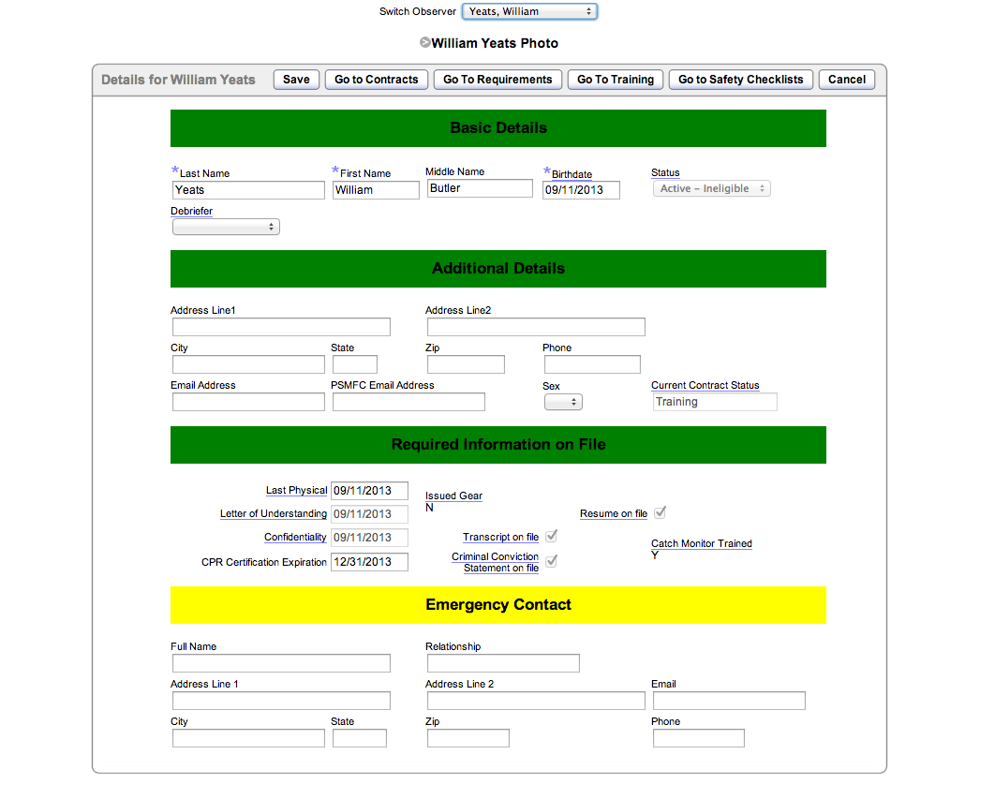

2. Add a contract
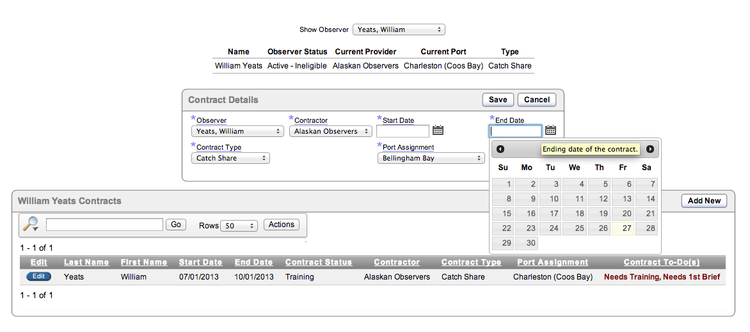

3. Request training in upcoming training or briefing
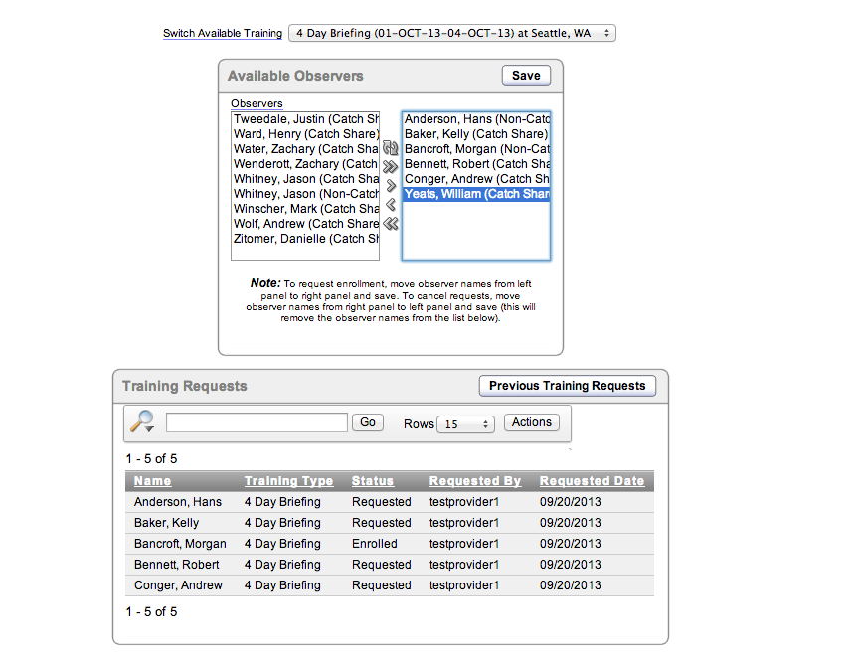

4. Upload Safety Checklist (image or document created by Observer)
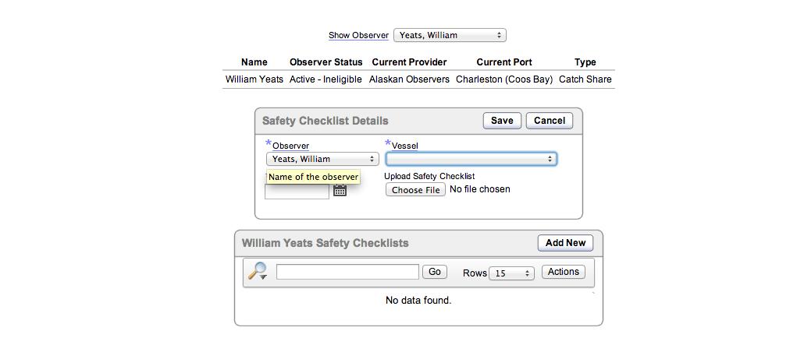

5. After the new Observer has passed training and met all eligibility requirements, the Provider is responsible for recording trips the Observer takes, either by entering them individually:
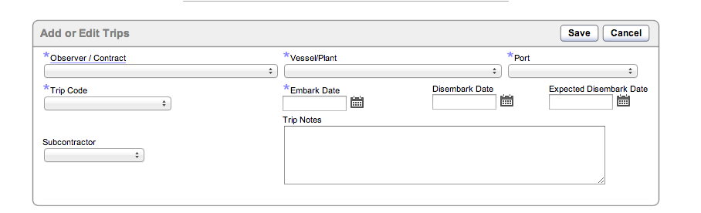

or by uploading .csv files for each week of activity following the template provided by NMFS (see AOI Trip Upload Guide.xlsx):
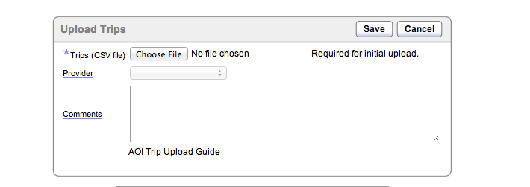

6. Providers must provide at least one incident report per month (if no incidents occurred, there is a “No incidents” choice).
