SUPPORTING STATEMENT - PART A
LOCK PERFORMANCE MONITORING SYSTEM (LPMS) WATERWAY TRAFFIC REPORT OMB Control Number 0710-0008
1. Need for the Information Collection
The authority for the U.S. Army Corps of Engineers to collect data on vessel operations and cargo transiting navigation locks is contained in Section 11 of the Rivers and Harbors Appropriations Act of September 22, 1922 (42 Stat. 1043), as amended, and codified in 33 U.S.C. § 555. This Congressional directive provides:

“Owners, agents, masters and clerks of vessels and other craft plying upon the navigable waters of the United States, and all individuals and corporations engaged in transporting their own goods upon the navigable waters of the United States, shall furnish such statements relative to vessels, passengers, freight and tonnage as may be required by the Secretary of the Army: Provided, That this provision shall not apply to those rafting logs except upon a direct request upon the owner to furnish specific information.

Every person or persons offending against the provisions of this section shall, for each and every offense, be liable to a fine of not more than $5,000 or imprisonment not exceeding two months, to be enforced in any district court in the United States within whose territorial jurisdiction such offense may have been committed. In addition, the Secretary may assess a civil penalty of up to $2,500 per violation, against any person or entity that fails to provide timely, accurate statements required to be submitted pursuant to this section by the Secretary.”

2. Use of the Information
The data is currently furnished on ENG FORM 3102C, “Waterway Traffic Report – Vessel Log,” and ENG FORM 3102D, “Waterway Traffic Report – Detail Vessel Log,” each form having OMB NO 0710-0008. See also 33 CFR Part 207.800, “Collections of Navigation Statistics”. The use of ENG Form 3102C or 3102D is determined by the specific lock site. Some locks are referred to as “Detailed Locks” and others are referred to as “Summary Locks”. Detail Locks collect information using the Detail Vessel Log (3102D) and Summary Locks collect information using the Vessel Log (3102C). Despite this distinction, both forms collect the same information. A spreadsheet showing which locks are classified as summary and which are detail locks is provided with the package.

The LPMS information applies to the navigation system management. It collects and monitors data regarding the use and operation of Federally owned and/or operated locks and canals. It requires general data about the number of vessels, barges, and tows which move through each lock chamber or canal and about the operation time required for passage of these vessels or tows. It also collects general data about cargos by estimated tonnage and category of commodity. This information is then used for the sizing and scheduling of replacements, the timing of rehabilitation or maintenance actions, and the setting of operation procedures and closures for locks and canals.

The master, captain, or pilot of vessels is required to provide the data identified on these forms by contacting the lock operator via radio and relaying the information verbally. The lock operator then logs the information into the LPMS database where it is maintained indefinitely. Below is an example report from LPMS with summary information collected from the vessel operators. The hardcopy forms will only be completed by the lock operator if the LPMS database is down. Then once the database is online, the information will be entered electronically and the hardcopy form will be destroyed. No signature of the person relaying the information is required.

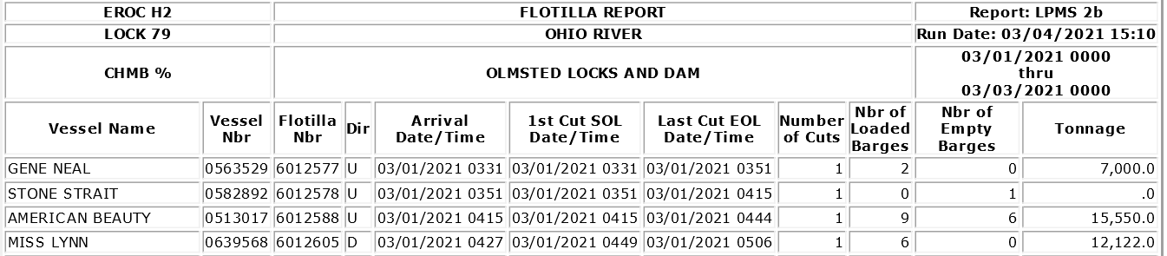

3. Use of Information Technology
0% of the responses are collected through an electronic information system. Respondents to ENG FORMS 3102C and 3102D, verbally communicate the information to lock operators using the radio. Government employees then record this information electronically for storage.

4. Non-duplication
The information obtained through this collection is unique and is not already available for use or adaptation from another cleared source.

5. Burden on Small Businesses
This information collection does not impose a significant economic impact on a substantial number of small businesses or entities.

6. Less Frequent Collection
U.S. Army Corps of Engineers navigation managers use this data on a daily basis and make operational decisions based on data availability. Other USACE and federal users, lock operators and waterway system managers, need near real-time data. During emergency or security events continuous information is required by government and navigation industry to maintain open channels and keep navigation moving on the nation’s waterways. The data is also needed to document events for legal cases on lock incidents and accidents.

7. Paperwork Reduction Act Guidelines
This collection of information does not require collection to be conducted in a manner inconsistent with the guidelines delineated in 5 CFR 1320.5(d)(2).
8. Consultation and Public Comments
Part A: PUBLIC NOTICE
A 60-Day Federal Register Notice for the collection published on Tuesday, January 12, 2021. The 60-Day FRN citation is 86 FRN 2391.
No comments were received during the 60-Day Comment Period.
A 30-Day Federal Register Notice for the collection published on Thursday, March 18, 2021. The 30-Day FRN citation is 86 FR 14736.
Part B: CONSULTATION
We have consulted with the Inland waterways Users Board (IWUB) at meeting #94 which was held virtually on July 22, 2020. There were no comments received.
9. Gifts or Payment
No payments or gifts are being offered to respondents as an incentive to participate in the collection.

10. Confidentiality
A Privacy Act Statement is not required for this collection because we are not requesting individuals to furnish personal information for a system of records.

A System of Record Notice (SORN) is not required for this collection because records are not retrievable by PII.

A Privacy Impact Assessment (PIA) is not required for this collection because PII is not being collected electronically.

Records are created, retained and managed in compliance with Army Records Retention Schedule for record number 400A, 0-6. Records are maintained from creation until no longer needed for business but not longer than six (6) years. Records are destroyed after six (6) years.

11. Sensitive Questions
No questions considered sensitive are being asked in this collection.

12. Respondent Burden and its Labor Costs

Part A: ESTIMATION OF RESPONDENT BURDEN

- Collection Instrument(s)
Eng Form 3102C
- Number of Respondents: 4,631
- Number of Responses Per Respondent: 82
- Number of Total Annual Responses: 379,742
- Response Time: 2.5 minutes
- Respondent Burden Hours: 15,822.6 hours

ENG Form 3102D
- Number of Respondents: 1,898
- Number of Responses Per Respondent: 50
- Number of Total Annual Responses: 94,900
- Response Time: 3 minutes
- Respondent Burden Hours: 4,745 hours

- Total Submission Burden
  - Total Number of Respondents: 6,529
  - Total Number of Annual Responses: 474,642
  - Total Respondent Burden Hours: 20,568 hours

Part B: LABOR COST OF RESPONDENT BURDEN

- Collection Instrument(s)
ENG Form 3102C
- Number of Total Annual Responses: 379,742
- Response Time: 2.5 minutes
- Respondent Hourly Wage: $7.25
- Labor Burden per Response: $0.30
- Total Labor Burden: $114,713.73

ENG Form 3102D
- Number of Total Annual Responses: 94,900
- Response Time: 3 minutes
- Respondent Hourly Wage: $7.25
- Labor Burden per Response: $0.36
- Total Labor Burden: $34,401.25

- Overall Labor Burden
  - Total Number of Annual Responses: 474,642
  - Total Labor Burden: $149,115

Due to diversity of respondent wages, Federal minimum wage is used to calculate burden.

13. Respondent Costs Other Than Burden Hour Costs

There are no annualized costs to respondents other than the labor burden costs addressed in Section 12 of this document to complete this collection.

14. Cost to the Federal Government

Part A: LABOR COST TO THE FEDERAL GOVERNMENT
- Collection Instrument(s)
ENG Form 3102C
- Number of Total Annual Responses: 379,742
- Processing Time per Response: 2.5 minutes
- Hourly Wage of Worker(s) Processing Responses : $10.97
- Cost to Process Each Response: $0.46
- Total Cost to Process Responses: $166,630.79

ENG Form 3102D
- Number of Total Annual Responses: 94,900
- Processing Time per Response: 3 minutes
- Hourly Wage of Worker(s) Processing Responses : $10.97
- Cost to Process Each Response: $0.55
- Total Cost to Process Responses: $52,052.65

- Overall Labor Burden to the Federal Government
  - Total Number of Annual Responses: 474,642
  - Total Labor Burden: $218,683.44

Federal hourly wage was determined using the 2021 minimum basic salary for GS employees with the Rest of U.S. Locality Area, per https://www.opm.gov/policy-data-oversight/pay-leave/salaries-wages/salary-tables/21Tables/html/RUS_h.aspx

Part B: OPERATIONAL AND MAINTENANCE COSTS

- Cost Categories
  - Equipment: $0
  - Printing: $0
  - Postage: $0
  - Software Purchases: $0
  - Licensing Costs: $0
  - Other: $0

- Total Operational and Maintenance Cost: $0

Part C: TOTAL COST TO THE FEDERAL GOVERNMENT

- Total Labor Cost to the Federal Government: $218,683.44

- Total Operational and Maintenance Costs: $0

- Total Cost to the Federal Government: $218,683

15. Reasons for Change in Burden
The respondent burden has decreased slightly due to small calculation changes. Average utilization of each forms remains the same. Total Cost to the Federal Government has increased due to a regular increase in the GS wages paid to processing workers.

16. Publication of Results
There are approximately 19 standard reports and 2 data extracts available internally to the U.S. Army Corps of Engineers from these data. Corps Locks provides reports for summary tonnage information as well as barge numbers traversing lock sites. Additional information and example data can be found on the public Corps Lock website at: https://corpslocks.usace.army.mil/lpwb/f?p=121.

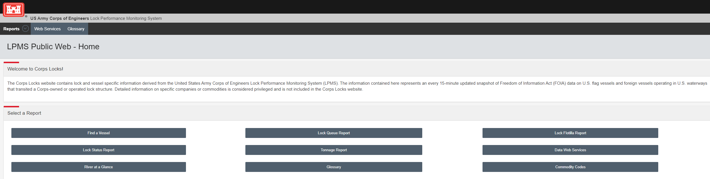

17. Non-Display of OMB Expiration Date
We are not seeking approval to omit the display of the expiration date of the OMB approval on the collection instrument.

18. Exceptions to “Certification for Paperwork Reduction Submissions”
We are not requesting any exemptions to the provisions stated in 5 CFR 1320.9.

