Fellowship Management System (FMS)
FMS Host Site Module
Privacy Act and Public Burden Information
Privacy Act Information
The Privacy Act applies to this information collection. Information collected will be kept private as noted in the System of Records Notice is 09-20-0112, Fellowship Program and Guest Researcher Records.

Public Burden Information
Form Approved
OMB No. 0920-0765
Exp. Date 01/31/2021

Public reporting burden of this collection of information is an estimated average of 60 minutes per response, including the time for reviewing instructions, searching existing data sources, gathering and maintaining the data needed, and completing and reviewing the collection of information. An agency may not conduct or sponsor, and a person is not required to respond to a collection of information unless it displays a currently valid OMB control number. Send comments regarding this burden estimate or any other aspect of this collection of information, including suggestions for reducing this burden to CDC/ATSDR Reports Clearance Officer; 1600 Clifton Road NE, MS D-74, Atlanta, Georgia 30333; ATTN: PRA (0920-0765).
2020

Table of Contents
Table of Contents 2
1. Introduction 5
1.1 Document Structure 6
2. Sign-In & Sign-Up Pages 7
2.1 Sign-In Page 7
2.2 Sign-Up Page (For New Users) 9
3. eFMS System Help Desk Ticket 10
4. Application Welcome Page 12
5. Applicant Profile 13
5.1 Create a Profile to Get Started 13
5.2 Primary Application Contact 14
5.3 Public Health Agency Details 15
6. Position Assignment Details 17
6.1 Get Started 17
6.2 Position Assignment Details 18
6.3 Position Assignment Environment 20
6.4 Travel Opportunities 22
6.5 Position Assignment Location 23
6.6 Consultants & Officer/Fellow Details 25
6.7 EIS 26
6.7.1 Proposed Projects 26
6.7.2 Other Position Assignment Details 28
6.8 LLS 30
6.8.1 Position Assignment Details 30
6.9 EEP 31
6.9.1 Position Assignment Details 31
6.10 FLIGHT 34
6.10.1 Host Site Information 34
6.11 PMR/F 36
6.11.1 Long-Term Trainee Support & Projects 36
6.12 PHIFP 38
6.12.1 Position Assignment Details 38
6.13 PE 39
6.13.1 Position Assignment Details 39
6.14 PHAP 40
6.14.1 Position Assignment Description 40
6.14.2 Subject Area Proposed Assignment 42
6.14.3 Assignment Requests 44
6.14.4 Other Public Health Agency Details 45
6.14.5 Letter of Support 46
6.14.6 Population Information 47
6.14.7 Orientation 49
7. Supervisors 50
7.1 Adding New Supervisors 50
7.2 Supervisor Information 52
7.3 Supervisor Experience 54
7.4 Mentoring Experience 59
8. Activities/Projects 61
8.1 Activity/Project Details 61
8.2 Activity/Project Location 64
8.3 Activity & Deliverable Details 65
8.4 Competencies 66
8.4.1 PHIFP 66
8.4.2 PHAP 68
9. Training & Languages 73
9.1 PHAP 73
10. Student Rotation Preferences 75
10.1 EEP 75
11. Match 77
11.1 Match or Prematch Rank/Rating Form 77
12. Appendix 78
I. Field Value Tables 78
II. Lookup Tables 80

Introduction
The purpose of this document is to list all the data elements of the host site application collected online through the Fellowship Management System (FMS). The FMS online host site assignment module is a streamlined mechanism for agencies, who are interested in hosting fellows of the Centers for Disease Control and Prevention (CDC) fellowships to submit their assignment proposals online and track statuses of the application processes. The FMS is a robust flexible framework and is successfully tailored for various CDC fellowships. The following fellowships use the FMS Host Site Application module to collect applications from federal and non-federal public health agencies and organizations:

- Epidemic Intelligence Service (EIS)
- CDC E-learning Institute (ELI)
- Epidemiology Elective Program (EEP)
- Future Leaders in Infections and Global Health Threats (FLIGHT)
- Laboratory Leadership Service (LLS)
- CDC Steven M. Teutsch Prevention Effectiveness (PE) Fellowship
- Public Health Associate Program (PHAP)
- Public Health Informatics Fellowship Program (PHIFP)
- Science Ambassador Fellowship (SAF)
- Preventive Medicine Residency and Fellowship (PMR/F)
- Population Health Training in Place Program (PH-TIPP)

Document Structure
This document is broken down by the major pages of the FMS Host Site Application. In this document, each page of the FMS Host Site Application has sections and some sub-sections. In addition, application instructions, login, and registration pages are included.
Following the screenshots in each section is a table that shows the status of the collection of data elements by each CDC fellowships. The following labels indicate the status of the collection:
- “Yes” indicates that the fellowship collects the information and that alumni are required to submit this information.
- “No” indicates that the fellowship does not collect this information.
- “-“ indicates open text field

In addition, the table shows the data values of each data element, and for ones that have a list of dropdown values, the data value category is hyperlinked to its list located in the Appendix.

Sign-In & Sign-Up Pages

Sign-In Page

Figure 2.1-a. Sign-In Page
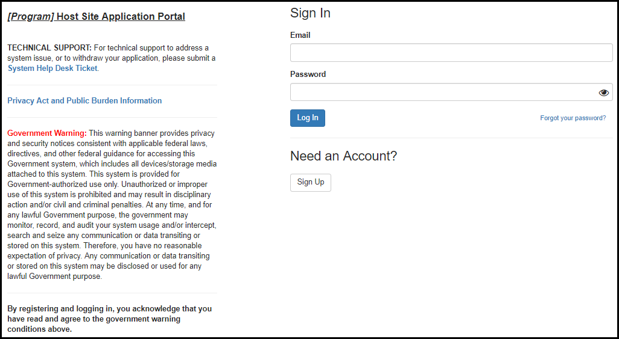

Figure 2.1-b. Privacy Act and Public Burden Information
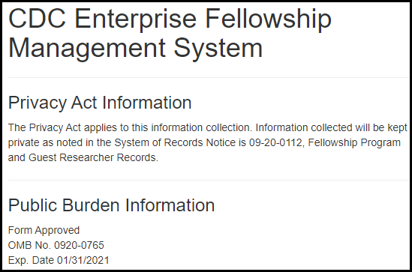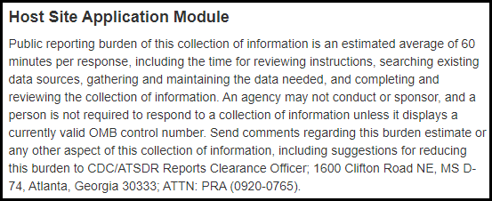
Table 2.1-a. Sign-In Fields
Field | Values | EIS | LLS | FLIGHT | EEP | SAF | PMR/F | PH-TIPP | PHIFP | PE | ELI | PHAP
Email | - | Yes | Yes | Yes | Yes | Yes | Yes | Yes | Yes | Yes | Yes | Yes
Password | - | Yes | Yes | Yes | Yes | Yes | Yes | Yes | Yes | Yes | Yes | Yes

Sign-Up Page (For New Users)

Figure 2.2-a. Sign-Up Fields
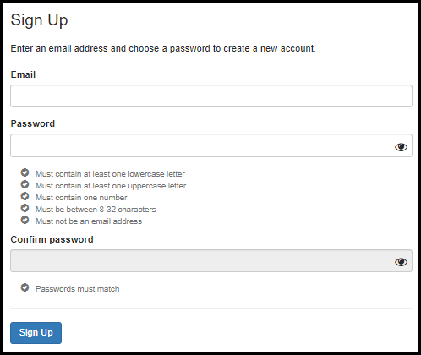
Table 2.2-a. Sign-Up Fields
Field | Values | EIS | LLS | FLIGHT | EEP | SAF | PMR/F | PH-TIPP | PHIFP | PE | ELI | PHAP
Email | - | Yes | Yes | Yes | Yes | Yes | Yes | Yes | Yes | Yes | Yes | Yes
Password | - | Yes | Yes | Yes | Yes | Yes | Yes | Yes | Yes | Yes | Yes | Yes
Confirm Password | - | Yes | Yes | Yes | Yes | Yes | Yes | Yes | Yes | Yes | Yes | Yes

eFMS System Help Desk Ticket

Figure 3-a. eFMS System Help Desk Ticket Fields
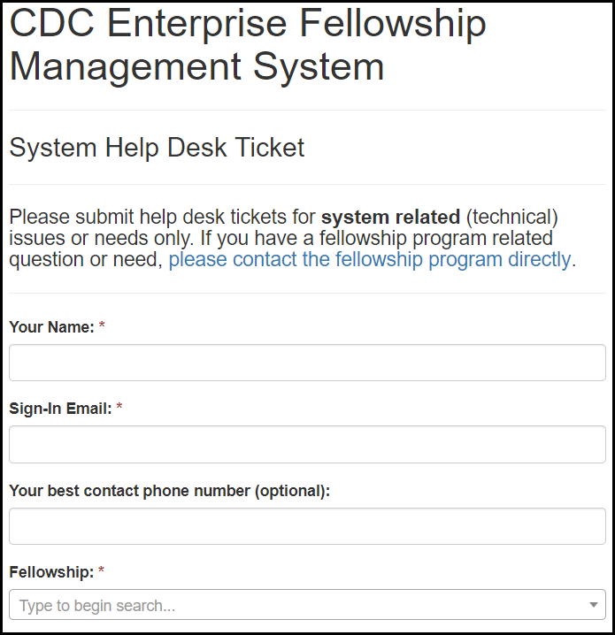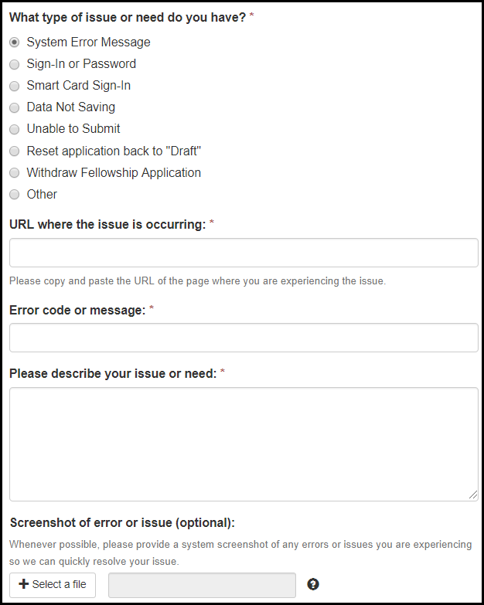

Table 3-a. eFMS System Help Desk Ticket Fields
Field | Values | EIS | LLS | FLIGHT | EEP | SAF | PMR/F | PH-TIPP | PHIFP | PE | ELI | PHAP
Your Name: | - | Yes | Yes | Yes | Yes | Yes | Yes | Yes | Yes | Yes | Yes | Yes
Sign-In Email: | - | Yes | Yes | Yes | Yes | Yes | Yes | Yes | Yes | Yes | Yes | Yes
Contact Phone Number: | - | Yes | Yes | Yes | Yes | Yes | Yes | Yes | Yes | Yes | Yes | Yes
Fellowship: | Fellowship Lookup Table | Yes | Yes | Yes | Yes | Yes | Yes | Yes | Yes | Yes | Yes | Yes
What type of issue or need do you have? | 1. System Error Message  2. Sign-In or Password  3. Smart Card Sign-In  4. Data Not Saving  5. Unable to Submit  6. Reset application back to "Draft"  7. Withdraw Fellowship Application  8. Other | Yes | Yes | Yes | Yes | Yes | Yes | Yes | Yes | Yes | Yes | Yes
URL where the issue is occurring: | - | Yes | Yes | Yes | Yes | Yes | Yes | Yes | Yes | Yes | Yes | Yes
Error code message: | - | Yes | Yes | Yes | Yes | Yes | Yes | Yes | Yes | Yes | Yes | Yes
Please describe your issue or need: | - | Yes | Yes | Yes | Yes | Yes | Yes | Yes | Yes | Yes | Yes | Yes
Screenshot of error or issue (optional): | - | Yes | Yes | Yes | Yes | Yes | Yes | Yes | Yes | Yes | Yes | Yes

Application Welcome Page

Figure 4-a. Application Welcome Page
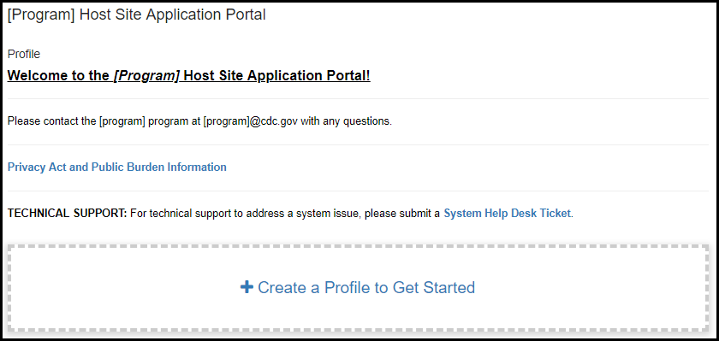

Applicant Profile

Create a Profile to Get Started

Figure 5.1-a. Create a Profile to Get Started

Primary Application Contact

Figure 5.2-a. Primary Application Contact Fields
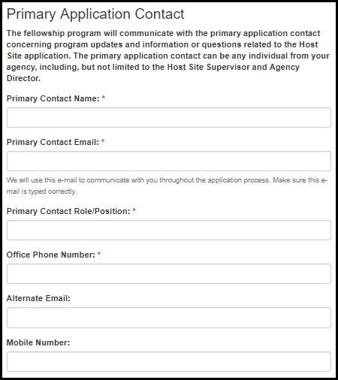
Table 5.2-a. Primary Application Contact Fields
Field Name | Values | EIS | LLS | EEP | FLIGHT | PMR/F | PHIFP | PE | PHAP
Primary Contact Name: | - | Yes | Yes | Yes | Yes | Yes | Yes | Yes | Yes
Primary Contact Email: | - | Yes | Yes | Yes | Yes | Yes | Yes | Yes | Yes
Primary Contact Role/Position: | - | Yes | Yes | Yes | Yes | Yes | Yes | Yes | Yes
Office Phone Number: | - | Yes | Yes | Yes | Yes | Yes | Yes | Yes | Yes
Alternate Email: | - | Yes | Yes | Yes | Yes | Yes | Yes | Yes | Yes
Mobile Number: | - | Yes | Yes | Yes | Yes | Yes | Yes | Yes | Yes

Public Health Agency Details

Figure 5.3-a. Public Health Agency Details Fields
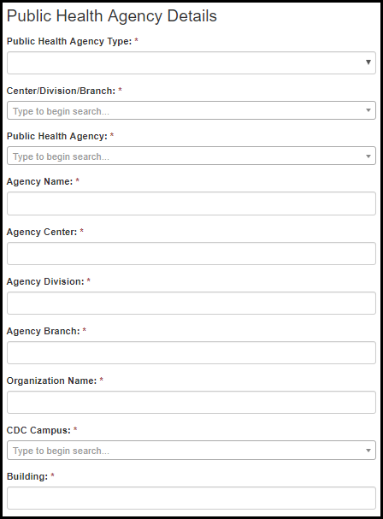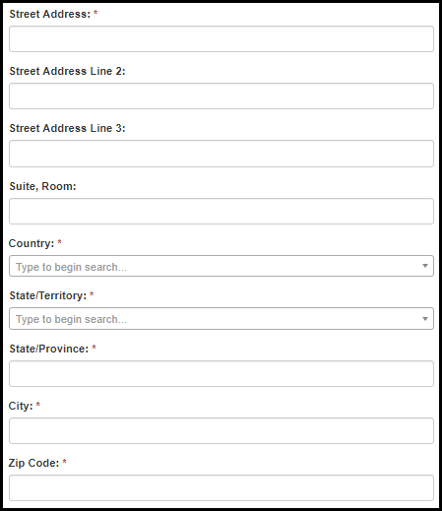

Figure 5.3-a. Public Health Agency Details Fields
Field Name | Values | EIS | LLS | EEP | FLIGHT | PMR/F | PHIFP | PE | PHAP
Public Health Agency Type: | 1. CDC  2. Federal Government (Other)  3. State  4. Local  5. Territorial  6. Tribal  7. Community-based Organization  8. Indian Health Service area offices  9. University or other academia  10. Private public health organization  11. Non-profit organization  12. Other | Yes | Yes | Yes | Yes | Yes | Yes | Yes | Yes
Center/Division/Branch: | - | Yes | Yes | Yes | Yes | Yes | Yes | Yes | Yes
Public Health Agency: | Public Health Agency Lookup | Yes | Yes | Yes | Yes | Yes | Yes | Yes | Yes
Agency Name: | - | Yes | Yes | Yes | Yes | Yes | Yes | Yes | Yes
Agency Center: | - | Yes | Yes | Yes | Yes | Yes | Yes | Yes | Yes
Agency Division: | - | Yes | Yes | Yes | Yes | Yes | Yes | Yes | Yes
Agency Branch: | - | Yes | Yes | Yes | Yes | Yes | Yes | Yes | Yes
Organization Name: | - | Yes | Yes | Yes | Yes | Yes | Yes | Yes | Yes
CDC Campus: | CDC Campus Lookup | Yes | Yes | Yes | Yes | Yes | Yes | Yes | Yes
Building: | - | Yes | Yes | Yes | Yes | Yes | Yes | Yes | Yes
Street Address: | - | Yes | Yes | Yes | Yes | Yes | Yes | Yes | Yes
Street Address Line 2: | - | Yes | Yes | Yes | Yes | Yes | Yes | Yes | Yes
Street Address Line 3: | - | Yes | Yes | Yes | Yes | Yes | Yes | Yes | Yes
Suite, Room: | - | Yes | Yes | Yes | Yes | Yes | Yes | Yes | Yes
Country: | - | Yes | Yes | Yes | Yes | Yes | Yes | Yes | Yes
State/Territory: | State/Territory Lookup | Yes | Yes | Yes | Yes | Yes | Yes | Yes | Yes
State/Province: | - | Yes | Yes | Yes | Yes | Yes | Yes | Yes | Yes
City: | - | Yes | Yes | Yes | Yes | Yes | Yes | Yes | Yes
Zip Code: | - | Yes | Yes | Yes | Yes | Yes | Yes | Yes | Yes

Position Assignment Details

Get Started

Figure 6.1-a. Get Started
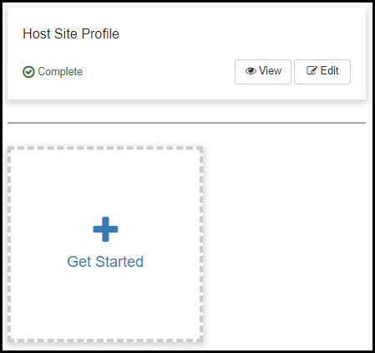
Figure 6.1-b. Get Started
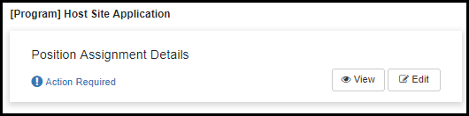

Position Assignment Details

Figure 6.2-a. Position Assignment Detail Fields Figure 6.2-b. Position Assignment Detail Fields
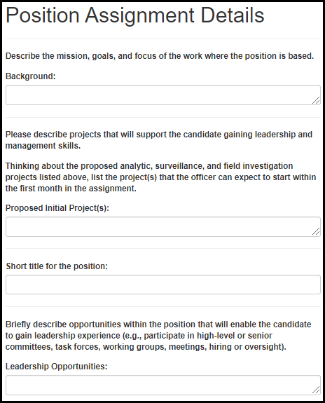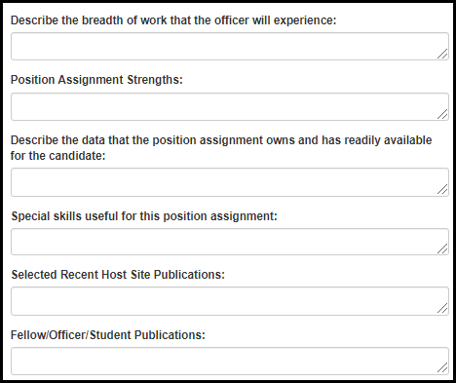

Table 6.2-a. Position Assignment Detail Fields
Field Name | Values | EIS | LLS | EEP | FLIGHT | PMR/F | PHIFP | PE | PHAP
Background: | - | Yes | Yes | Yes | Yes | Yes | No | No | No
Proposed Initial Project(s): | - | Yes | Yes | No | Yes | No | No | No | No
Short title for the position: | - | Yes | No | No | No | No | No | No | No
Leadership opportunities: | - | No | No | No | Yes | Yes | No | No | No
Describe the breadth of work that the candidate will experience: | - | Yes | Yes | No | No | No | No | No | No
Position Assignment Strengths: | - | Yes | Yes | No | Yes | Yes | Yes | Yes | No
Describe the data that the position owns and has readily available for the candidate: | - | Yes | Yes | No | Yes | Yes | Yes | Yes | No
Special skills useful for this position: | - | Yes | Yes | No | Yes | Yes | Yes | Yes | No
Selected Recent Host Site Publications: | - | Yes | Yes | No | Yes | No | No | No | No
Fellow/Officer/Student Publications: | - | Yes | Yes | No | Yes | No | No | No | No

Position Assignment Environment

Figure 6.3-a. Position Assignment Environment Fields
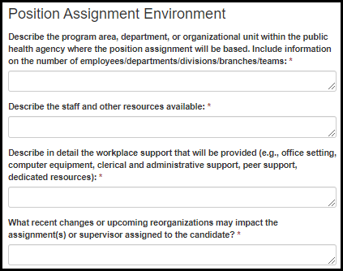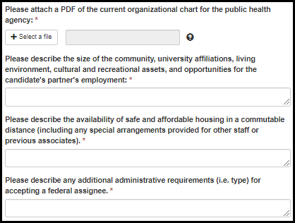

Table 6.3-a. Position Assignment Environment Fields
Field Name | Values | EIS | LLS | EEP | FLIGHT | PMR/F | PHIFP | PE | PHAP
Describe the program area, department, or organizational unit within the public health agency where the position assignment will be based. Include information on the number of employees/departments/divisions/branches/teams: | - | Yes | Yes | No | Yes | Yes | Yes | Yes | Yes
Describe the staff and other resources available: | - | Yes | Yes | No | Yes | Yes | Yes | Yes | Yes
Describe in detail the workplace support that will be provided (e.g., office setting, computer equipment, clerical and administrative support, peer support, dedicated resources): | - | Yes | Yes | No | Yes | Yes | Yes | Yes | Yes
What recent changes or upcoming reorganizations may impact the assignment(s) or supervisor assigned to the candidate? | - | Yes | Yes | No | Yes | Yes | Yes | Yes | Yes
Please attach a PDF of the current organizational chart for the public health agency: | - | Yes | Yes | No | Yes | Yes | Yes | Yes | Yes
Please describe the size of the community, university affiliations, living environment, cultural and recreational assets, and opportunities for the candidate's partner's employment: | - | Yes | Yes | No | Yes | Yes | Yes | Yes | Yes
Please describe the availability of safe and affordable housing in a commutable distance (including any special arrangements provided for other staff or previous associates). | - | No | No | No | No | No | No | No | Yes
Please describe any additional administrative requirements (i.e. type) for accepting a federal assignee. | - | No | No | No | No | No | No | No | Yes

Travel Opportunities

Figure 6.4-a. Travel Opportunities Fields
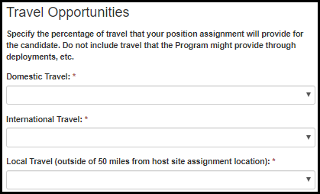
Table 6.4-a. Travel Opportunities Fields
Field Name | Values | EIS | LLS | EEP | FLIGHT | PMR/F | PHIFP | PE | PHAP
Domestic Travel: | 0% - 100% in increments of 10 | Yes | Yes | No | Yes | No | No | No | No
International Travel: | 0% - 100% in increments of 10 | Yes | Yes | No | Yes | No | No | No | No
Local Travel (outside of 50 miles from host site assignment location): | 0% - 100% in increments of 10 | No | No | No | No | N o | No | No | Yes

Position Assignment Location

Figure 6.5-a. Position Assignment Location Fields Figure 6.5-b. Position Assignment Location Fields
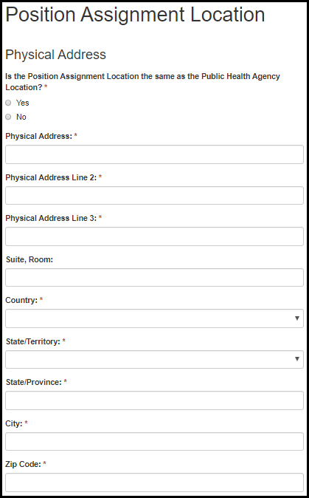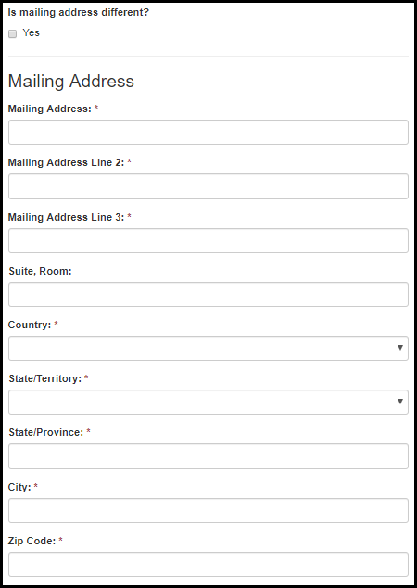

Table 6.5-a. Position Assignment Location Fields
Field Name | Values | EIS | LLS | EEP | FLIGHT | PMR/F | PHIFP | PE | PHAP
Is the Position Assignment Location the same as the Public Health Agency Location? | 1. Yes  2. No | Yes | No | No | No | No | No | No | Yes
Physical Address: | - | Yes | No | No | No | No | No | No | Yes
Address Line 2: | - | Yes | No | No | No | No | No | No | Yes
Address Line 3: | - | Yes | No | No | No | No | No | No | Yes
Suite, Room: | - | Yes | No | No | No | No | No | No | Yes
Country: | Country List | Yes | No | No | No | No | No | No | Yes
State/Territory: | State/Territory List | Yes | No | No | No | No | No | No | Yes
State/Province: | - | Yes | No | No | No | No | No | No | Yes
City: | - | Yes | No | No | No | No | No | No | Yes
Zip Code: | - | Yes | No | No | No | No | No | No | Yes
Is mailing address different? | 1. Yes | Yes | No | No | No | No | No | No | Yes
Mailing Address: | - | Yes | No | No | No | No | No | No | Yes
Mailing Address Line 2: | - | Yes | No | No | No | No | No | No | Yes
Mailing Address Line 3: | - | Yes | No | No | No | No | No | No | Yes
Suite, Room: | - | Yes | No | No | No | No | No | No | Yes
Country: | Country List | Yes | No | No | No | No | No | No | Yes
State/Territory: | State/Territory List | Yes | No | No | No | No | No | No | Yes
State/Province: | - | Yes | No | No | No | No | No | No | Yes
City: | - | Yes | No | No | No | No | No | No | Yes
Zip Code: | - | Yes | No | No | No | No | No | No | Yes

Consultants & Officer/Fellow Details

Figure 6.6-a. Consultants & Officer/Fellow Details Fields
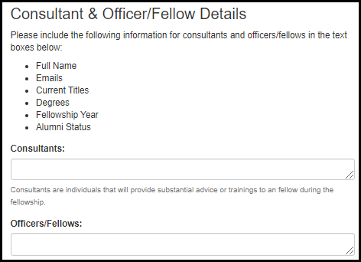
Table 6.6-a. Consultants & Officer/Fellow Details Fields
Field Name | Values | EIS | LLS | EEP | FLIGHT | PMR/F | PHIFP | PE | PHAP
Please include the following information for consultants and officers/fellows in the text boxes below:  - Full Name  - Emails  - Current Titles  - Degrees  - Fellowship Year  - Alumni Status | - | Yes | Yes | No | No | No | No | No | No
Consultants: | - | Yes | Yes | No | No | No | No | No | No
Officers/Fellows: | - | Yes | Yes | No | No | No | No | No | No

EIS

Proposed Projects

Figure 6.7.1-a. Proposed Projects Fields Figure 6.7.1-b. Proposed Projects Fields
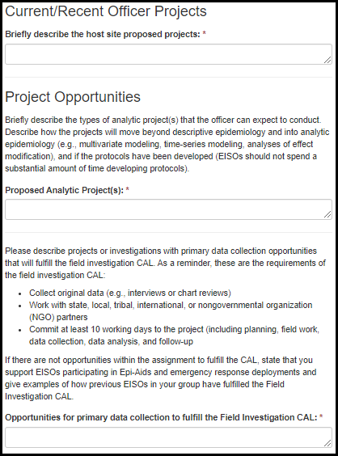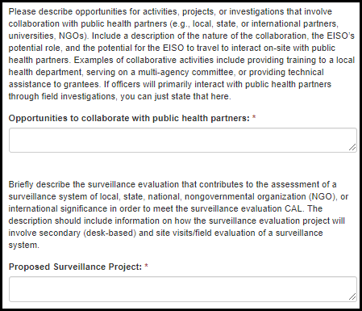

Figure 6.7.1-a. Proposed Projects Fields
Field Name | Values | EIS | LLS | EEP | FLIGHT | PMR/F | PHIFP | PE | PHAP
Briefly describe the host site proposed projects: | - | Yes | No | No | No | No | No | No | No
Proposed Analytic Project(s): | - | Yes | No | No | No | No | No | No | No
Opportunities for primary data collection to fulfill the Field Investigation CAL: | - | Yes | No | No | No | No | No | No | No
Opportunities to collaborate with public health partners: | - | Yes | No | No | No | No | No | No | No
Proposed Surveillance Project: | - | Yes | No | No | No | No | No | No | No

6.7.2 Other Position Assignment Details

Figure 6.7.2-a. Other Position Assignment Details Fields
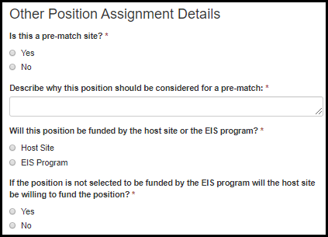

Table 6.7.2-a. Other Position Assignment Details Fields
Field Name | Values | EIS | LLS | EEP | FLIGHT | PMR/F | PHIFP | PE | PHAP
Is this a pre-match position? | 1. Yes  2. No | Yes | No | No | No | No | No | No | No
Describe why this position should be considered for a pre-match: | - | Yes | No | No | No | No | No | No | No
Will this position be funded by the host site or the EIS program? | 1. Host Site  2. EIS Program | Yes | No | No | No | No | No | No | No
If the position is not selected to be funded by the EIS program will the host site be willing to fund the position? | 1. Yes  2. No | Yes | No | No | No | No | No | No | No

LLS

Position Assignment Details

Figure 6.8.1-a. Position Assignment Details Fields
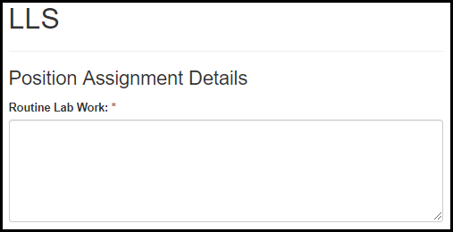
Table 6.8.1-a. Position Assignment Details Fields
Field Name | Values | EIS | LLS | EEP | FLIGHT | PMR/F | PHIFP | PE | PHAP
Routine Lab Work: | - | No | Yes | No | No | No | No | No | No

EEP

Position Assignment Details
Figure 6.9.1-a. Position Assignment Details Fields
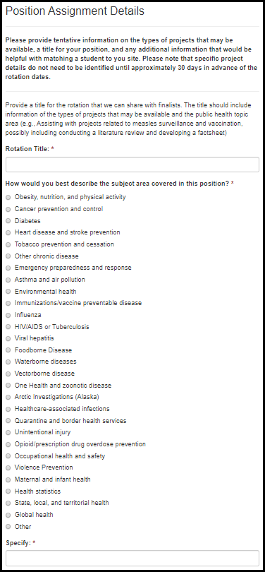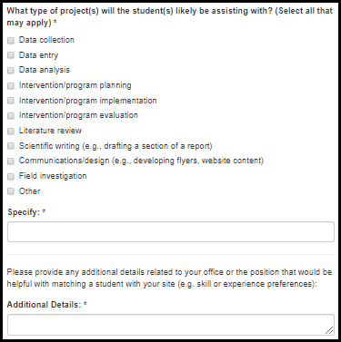

Table 6.9.1-a. Position Assignment Details Fields
Field Name | Values | EIS | LLS | EEP | FLIGHT | PMR/F | PHIFP | PE | PHAP
Rotation Title: | - | No | No | Yes | No | No | No | No | No
How would you best describe the subject area covered in this position? | 1. Obesity, nutrition, and physical activity  2. Cancer prevention and control  3. Diabetes  4. Heart disease and stroke prevention  5. Tobacco prevention and cessation  6. Other chronic disease  7. Emergency preparedness and response  8. Asthma and air pollution  9. Environmental health  10. Immunizations/vaccine preventable disease  11. Influenza  12. HIV/AIDS or Tuberculosis  13. Viral hepatitis  14. Foodborne Disease  15. Waterborne diseases  16. Vectorborne disease  17. One Health and zoonotic disease  18. Arctic Investigations (Alaska)  19. Healthcare-associated infections  20. Quarantine and border health services  21. Unintentional injury  22. Opioid/prescription drug overdose prevention  23. Occupational health and safety  24. Violence Prevention  25. Maternal and infant health  26. Health statistics  27. State, local, and territorial health  28. Global health  29. Other (specify) | No | No | Yes | No | No | No | No | No
Specify: | -

Table 6.9.1-b. Position Assignment Details Fields
Field Name | Values | EIS | LLS | EEP | FLIGHT | PMR/F | PHIFP | PE | PHAP
What type of project(s) will the student(s) likely be assisting with? (Select all that may apply) | 1. Data collection  2. Data entry  3. Data analysis  4. Intervention/program planning  5. Intervention/program implementation  6. Intervention/program evaluation  7. Literature review  8. Scientific writing (e.g., drafting a section of a report)  9. Communications/design (e.g., developing flyers, website content)  10. Field investigation  11. Other: | No | No | Yes | No | No | No | No | No
Specify: | - | No | No | Yes | No | No | No | No | No
Additional Details: | - | No | No | Yes | No | No | No | No | No

FLIGHT

Host Site Information

Figure 6.10.1-a. Host Site Information Fields
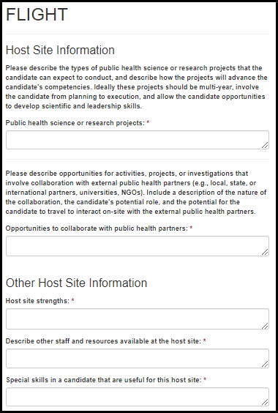

Table 6.10.1-a. Host Site Information Fields
Field Name | Values | EIS | LLS | EEP | FLIGHT | PMR/F | PHIFP | PE | PHAP
Public health science or research projects: | - | No | No | No | Yes | No | No | No | No
Opportunities to collaborate with public health partners: | - | No | No | No | Yes | No | No | No | No
Host site strengths: | - | No | No | No | Yes | No | No | No | No
Describe other staff and resources available at the host site: | - | No | No | No | Yes | No | No | No | No
Special skills in a candidate that are useful for this host site: | - | No | No | No | Yes | No | No | No | No

PMR/F

Long-Term Trainee Support & Projects

Figure 6.11.1-a. Long-Term Trainee Support & Projects
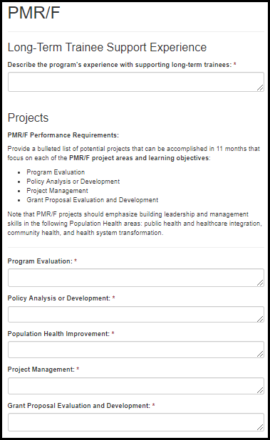

Table 6.11.1-a. Long-Term Trainee Support & Projects
Field Name | Values | EIS | LLS | EEP | FLIGHT | PMR/F | PHIFP | PE | PHAP
Describe the program's experience with supporting long-term trainees: | - | No | No | No | No | Yes | No | No | No
Program Evaluation: | - | No | No | No | No | Yes | No | No | No
Policy Analysis or Development: | - | No | No | No | No | Yes | No | No | No
Population Health Improvement: | - | No | No | No | No | Yes | No | No | No
Project Management: | - | No | No | No | No | Yes | No | No | No
Grant Proposal Evaluation and Development: | - | No | No | No | No | Yes | No | No | No

PHIFP

Position Assignment Details

Figure 6.12.1-a. Position Assignment Details
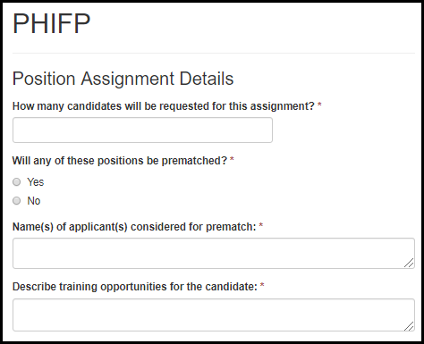
Table 6.12.1-a. Position Assignment Details
Field Name | Values | EIS | LLS | EEP | FLIGHT | PMR/F | PHIFP | PE | PHAP
How many fellows will be requested for this assignment? | - | No | No | No | No | No | Yes | No | No
Will any of these positions be prematched? | 1. Yes  2. No | No | No | No | No | No | Yes | No | No
Name(s) of applicant(s) considered for prematch: | - | No | No | No | No | No | Yes | No | No
Describe training opportunities for the fellow: | - | No | No | No | No | No | Yes | No | No

PE

Position Assignment Details

Figure 6.13.1-a. Position Assignment Details
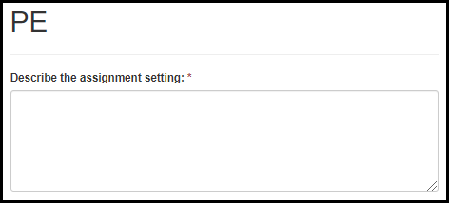
Table 6.13.1-a. Position Assignment Details
Field Name | Values | EIS | LLS | EEP | FLIGHT | PMR/F | PHIFP | PE | PHAP
Describe the assignment setting: | - | No | No | No | No | No | No | Yes | No

PHAP

Position Assignment Description

Figure 6.14.1-a. Position Assignment Description Fields
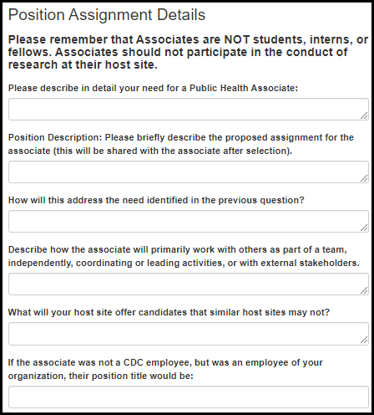

Table 6.14.1-a. Position Assignment Description Fields
Field Name | Values | EIS | LLS | EEP | FLIGHT | PMR/F | PHIFP | PE | PHAP
Please describe in detail your need for a Public Health Associate: | - | No | No | No | No | No | No | No | Yes
Position Description: Please briefly describe the proposed assignment for the associate (this will be shared with the associate after selection). | - | No | No | No | No | No | No | No | Yes
How will this address the need identified in the previous question? | - | No | No | No | No | No | No | No | Yes
Describe how the associate will primarily work with others as part of a team, independently, coordinating or leading activities, or with external stakeholders. | - | No | No | No | No | No | No | No | Yes
What will your host site offer candidates that similar host sites may not? | - | No | No | No | No | No | No | No | Yes
If the associate was not a CDC employee, but was an employee of your organization, their position title would be: | - | No | No | No | No | No | No | No | Yes

Subject Area Proposed Assignment

Figure 6.14.2-a. Subject Area Proposed Assignment Fields
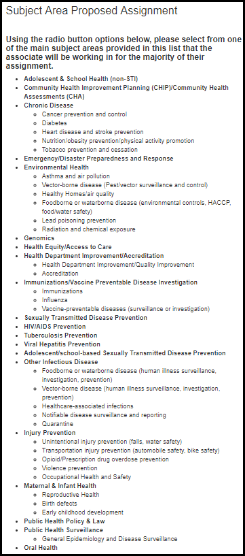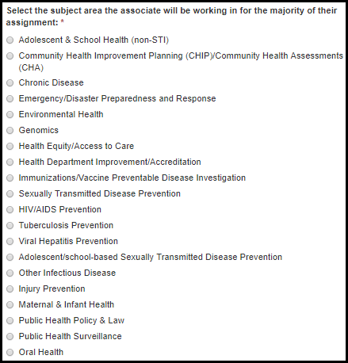

Table 6.14.2-a. Subject Area Proposed Assignment Fields
Field Name | Values | EIS | LLS | EEP | FLIGHT | PMR/F | PHIFP | PE | PHAP
Select the subject area the associate will be working in for the majority of their assignment: | 1. Adolescent & School Health (non-STI)  2. Community Health Improvement Planning (CHIP)/Community Health Assessments (CHA)  3. Chronic Disease  4. Emergency/Disaster Preparedness and Response  5. Environmental Health  6. Genomics  7. Health Equity/Access to Care  8. Health Department Improvement/Accreditation  9. Immunizations/Vaccine Preventable Disease Investigation  10. Sexually Transmitted Disease Prevention  11. HIV/AIDS Prevention  12. Tuberculosis Prevention  13. Viral Hepatitis Prevention  14. Adolescent/school-based Sexually Transmitted Disease Prevention  15. Other Infectious Disease  16. Injury Prevention  17. Maternal & Infant Health  18. Public Health Policy & Law  19. Public Health Surveillance  20. Oral Health | No | No | No | No | No | No | No | Yes

Assignment Requests

Figure 6.14.3-a. Assignment Request Fields
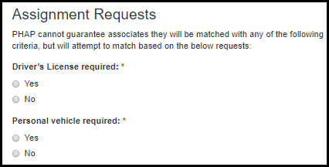
Table 6.14.3-a. Assignment Request Fields
Field Name | Values | EIS | LLS | EEP | FLIGHT | PMR/F | PHIFP | PE | PHAP
Driver’s License required: | 1. Yes  2. No | No | No | No | No | No | No | No | Yes
Personal vehicle required: | 1. Yes  2. No | No | No | No | No | No | No | No | Yes

Other Public Health Agency Details

Figure 6.14.4-a. Other Public Health Agency Detail Fields
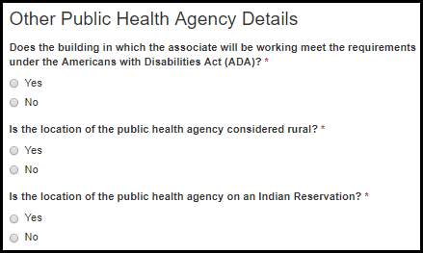
Table 6.14.4-a. Other Public Health Agency Detail Fields
Field Name | Values | EIS | LLS | EEP | FLIGHT | PMR/F | PHIFP | PE | PHAP
Does the building in which the associate will be working meet the requirements under the Americans with Disabilities Act (ADA)? | 1. Yes  2. No | No | No | No | No | No | No | No | Yes
Is the location of the public health agency considered rural? | 1. Yes  2. No | No | No | No | No | No | No | No | Yes
Is the location of the public health agency on an Indian Reservation? | 1. Yes  2. No | No | No | No | No | No | No | No | Yes

Letter of Support

Figure 6.14.5-a. Letter of Support Fields
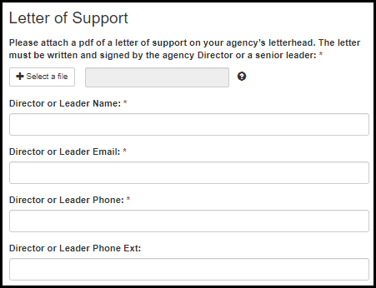
Table 6.14.5-a. Letter of Support Fields
Field Name | Values | EIS | LLS | EEP | FLIGHT | PMR/F | PHIFP | PE | PHAP
Please attach a pdf of a letter of support on your agency’s letterhead. The letter must be written and signed by the agency Director or a senior leader. | - | No | No | No | No | No | No | No | Yes
Director or Leader Name: | - | No | No | No | No | No | No | No | Yes
Director or Leader Email: | - | No | No | No | No | No | No | No | Yes
Director or Leader Phone: | - | No | No | No | No | No | No | No | Yes
Director or Leader Phone Ext: |  | No | No | No | No | No | No | No | Yes

Population Information

Figure 6.14.6-a. Population Information Fields
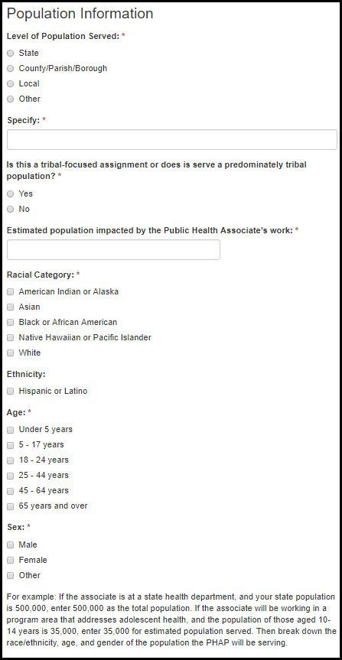

Table 6.14.6-a. Population Information Fields
Field Name | Values | EIS | LLS | EEP | FLIGHT | PMR/F | PHIFP | PE | PHAP
Level of Population Served: | 1. State  2. County/Parish/Borough  3. Local  4. Other | No | No | No | No | No | No | No | Yes
Specify: | - | No | No | No | No | No | No | No | Yes
Is this a tribal-focused assignment or does is serve a predominately tribal population? | 1. Yes  2. No | No | No | No | No | No | No | No | Yes
Estimated population impacted by the Public Health Associate’s work: | - | No | No | No | No | No | No | No | Yes
Racial Category: | 1. American Indian or Alaska  2. Asian  3. Black or African American  4. Native Hawaiian or Pacific Islander  5. White | No | No | No | No | No | No | No | Yes
Ethnicity: | 1. Hispanic or Latino | No | No | No | No | No | No | No | Yes
Age: | 1. Under 5 years  2. 5 - 17 years  3. 18 - 24 years  4. 25 - 44 years  5. 45 - 64 years  6. 65 years and over | No | No | No | No | No | No | No | Yes
Sex: | 1. Male  2. Female  3. Other | No | No | No | No | No | No | No | Yes

Orientation

Table 6.14.7-a. Orientation Fields
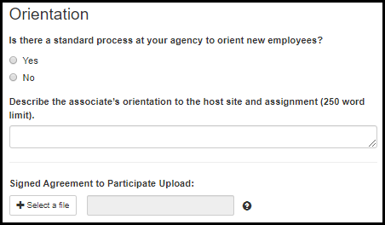
Table 6.14.7-a. Orientation Fields
Field Name | Values | EIS | LLS | EEP | FLIGHT | PMR/F | PHIFP | PE | PHAP
Is there a standard process at your agency to orient new employees? | 1. Yes  2. No | No | No | No | No | No | No | No | Yes
Describe the associate’s orientation to the host site and assignment (250 word limit). | - | No | No | No | No | No | No | No | Yes
Signed Agreement to Participate Upload: | - | No | No | No | No | No | No | No | Yes

Supervisors

Adding New Supervisors

Figure 7.1-a. Adding New Supervisors Fields Figure 7.1-b. Adding New Supervisors Fields Figure 7.1-c. Adding New Supervisors Fields
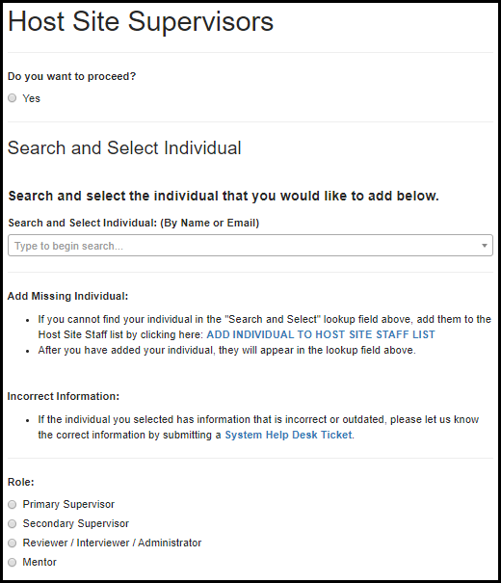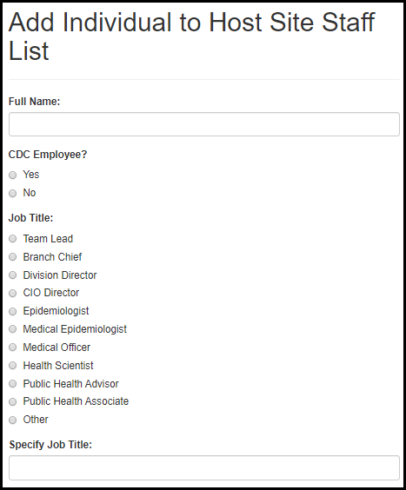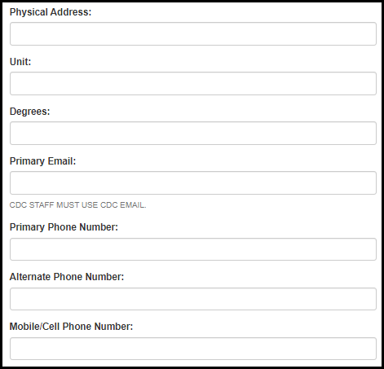

Table 7.1-a. Adding New Supervisors Fields
Field Name | Values | EIS | LLS | EEP | FLIGHT | PMR/F | PHIFP | PE | PHAP
Do you want to proceed? | 1. Yes | Yes | Yes | Yes | Yes | Yes | Yes | Yes | Yes
Search and Select Individual: (By Name or Email) | Supervisor Lookup Table | Yes | Yes | Yes | Yes | Yes | Yes | Yes | Yes
Role: | 1. Primary Supervisor  2. Secondary Supervisor  3. Reviewer/Interviewer/Administrator  4. Mentor | Yes | Yes | Yes | Yes | Yes | Yes | Yes | Yes
Full Name: | - | Yes | Yes | Yes | Yes | Yes | Yes | Yes | Yes
CDC Employee?: | - | Yes | Yes | Yes | Yes | Yes | Yes | Yes | Yes
Job Title: | 1. Team Lead  2. Branch Chief  3. Division Director  4. CIO Director  5. Epidemiologist  6. Medical Epidemiologist  7. Medical Officer  8. Health Scientist  9. Public Health Advisor  10. Public Health Associate  11. Other | Yes | Yes | Yes | Yes | Yes | Yes | Yes | Yes
Specify Job Title: | - | Yes | Yes | Yes | Yes | Yes | Yes | Yes | Yes
Physical Address: | - | Yes | Yes | Yes | Yes | Yes | Yes | Yes | Yes
Unit: | - | Yes | Yes | Yes | Yes | Yes | Yes | Yes | Yes
Degrees: | - | Yes | Yes | Yes | Yes | Yes | Yes | Yes | Yes
Primary Email (CDC Staff Must Use CDC Email): | - | Yes | Yes | Yes | Yes | Yes | Yes | Yes | Yes
Primary Phone Number: | - | Yes | Yes | Yes | Yes | Yes | Yes | Yes | Yes
Alternate Phone Number: | - | Yes | Yes | Yes | Yes | Yes | Yes | Yes | Yes
Mobile/Cell Phone Number: | - | Yes | Yes | Yes | Yes | Yes | Yes | Yes | Yes
Ext: | - | Yes | Yes | Yes | Yes | Yes | Yes | Yes | Yes

Supervisor Information

Figure 7.2-a. Supervisor Information Fields
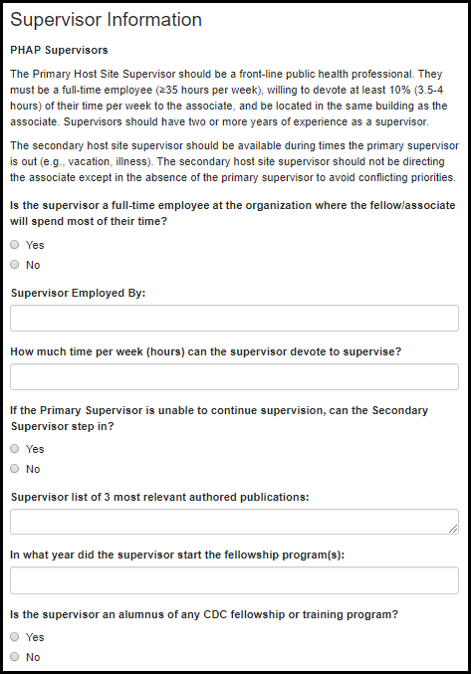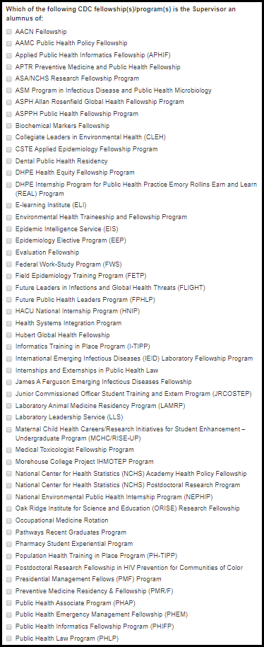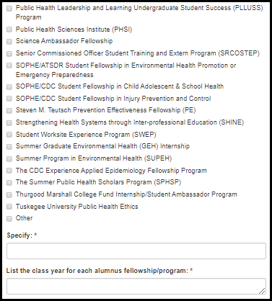

Table 7.2-a. Supervisor Information Fields
Field Name | Values | EIS | LLS | EEP | FLIGHT | PMR/F | PHIFP | PE | PHAP
Is the supervisor a full-time employee at the organization where the fellow/associate will spend most of their time? | 1. Yes  2. No | Yes | Yes | No | Yes | Yes | Yes | No | Yes
Supervisor Employed By: | - | Yes | Yes | No | No | Yes | Yes | No | Yes
How much time per week (hours) can the supervisor devote to supervise? | - | Yes | Yes | No | Yes | Yes | Yes | No | Yes
If the Primary Supervisor is unable to continue supervision, can the Secondary Supervisor step in? | - | Yes | Yes | No | Yes | Yes | Yes | No | Yes
Supervisor list of 3 most relevant authored publications: | - | No | Yes | No | Yes | No | No | No | No
In what year did the supervisor start the fellowship program(s): | - | Yes | Yes | Yes | Yes | Yes | Yes | Yes | Yes
Is the supervisor an alumnus of any CDC fellowship or training program? | 1. Yes  2. No | Yes | Yes | Yes | Yes | Yes | Yes | Yes | Yes
Which of the following CDC fellowship(s)/program(s) is the Supervisor an alumnus of: | CDC Fellowship List | Yes | Yes | Yes | Yes | Yes | Yes | Yes | Yes
Specify: | - | Yes | Yes | Yes | Yes | Yes | Yes | Yes | Yes
List the class year for each alumnus fellowship/program: | - | Yes | Yes | Yes | Yes | Yes | Yes | Yes | Yes

Supervisor Experience

Figure 7.3-a. Supervisor Experience Fields Figure 7.3-b. Supervisor Experience Fields
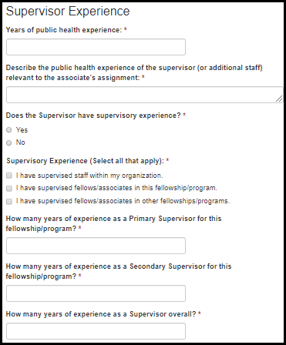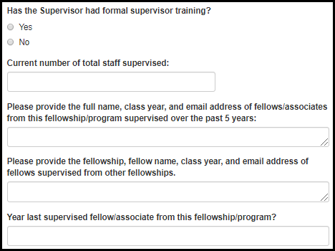

Figure 7.3-c. Supervisor Experience Fields
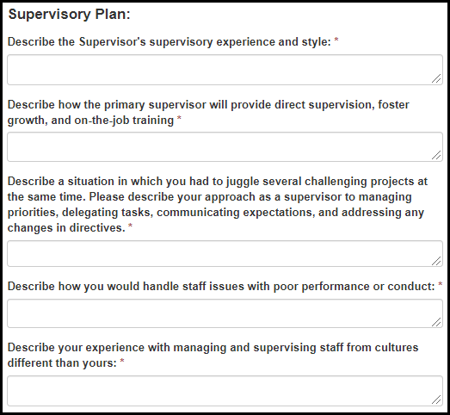

Table 7.3-a. Supervisor Experience Fields
Field Name | Values | EIS | LLS | EEP | FLIGHT | PMR/F | PHIFP | PE | PHAP
Years of public health experience: | - | Yes | Yes | No | Yes | Yes | Yes | No | Yes
Describe the public health experience of the supervisor (or additional staff) relevant to the associate’s assignment: | - | No | No | No | No | No | No | No | Yes
Does the Supervisor have supervisory experience? | 1. Yes  2. No | Yes | Yes | Yes | Yes | Yes | Yes | No | Yes
Supervisory Experience (Select all that apply): | 1. I have supervised staff within my organization.  2. I have supervised fellows/associates in this fellowship/program.  3. I have supervised fellows/associates in other fellowships/programs. | Yes | Yes | Yes | Yes | Yes | Yes | No | Yes
How many years as a Primary Supervisor for this fellowship/program? | - | Yes | Yes | No | Yes | Yes | Yes | No | Yes
How many years as a Secondary Supervisor for this fellowship/program? | - | Yes | Yes | No | Yes | Yes | Yes | No | Yes
How many years as a Supervisor overall? | - | Yes | Yes | No | Yes | Yes | Yes | No | Yes

Table 7.3-b. Supervisor Experience Fields
Field Name | Values | EIS | LLS | EEP | FLIGHT | PMR/F | PHIFP | PE | PHAP
Has the Supervisor had formal supervisor training? | 1. Yes  2. No | Yes | Yes | No | Yes | No | Yes | No | Yes
Current number of total staff supervised: | - | Yes | Yes | No | Yes | Yes | Yes | No | Yes
Please provide the full name, class year, and email address of fellows/associates from this fellowship/program supervised over the past 5 years: | - | Yes | Yes | No | Yes | Yes | Yes | No | Yes
Please provide the fellowship, fellow name, class year, and email address of fellows supervised from other fellowships. | - | Yes | Yes | No | Yes | Yes | Yes | No | No
Last year supervised a fellow/associate from this fellowship/program? | - | Yes | Yes | No | Yes | Yes | Yes | No | Yes

Table 7.3-c. Supervisor Experience Fields
Field Name | Values | EIS | LLS | EEP | FLIGHT | PMR/F | PHIFP | PE | PHAP
Describe the Supervisor's supervisory experience and style: | - | Yes | Yes | No | Yes | No | Yes | No | Yes
Describe how the primary supervisor will provide direct supervision, foster growth, and on-the-job training: | - | Yes | Yes | No | Yes | No | Yes | No | Yes
Describe a situation in which you had to juggle several challenging projects at the same time. Please describe your approach as a supervisor to managing priorities, delegating tasks, communicating expectations, and addressing any changes in directives. | - | No | No | No | No | No | No | No | Yes
Describe how you would handle staff issues with poor performance or conduct: | - | No | No | No | No | No | No | No | Yes
Describe your experience with managing and supervising staff from cultures different than yours: | - | No | No | No | No | No | No | No | Yes

Mentoring Experience

Figure 7.4-a. Mentoring Experience Fields
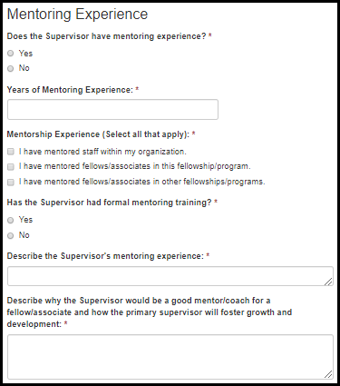

Table 7.4-a. Mentoring Experience Fields
Field Name | Values | EIS | LLS | EEP | FLIGHT | PMR/F | PHIFP | PE | PHAP
Does the Supervisor have mentoring experience? | 1. Yes  2. No | No | No | Yes | No | No | Yes | No | Yes
Years of Mentoring Experience: | - | No | No | No | No | No | Yes | No | Yes
Mentorship Experience (Select all that apply): | 1. I have mentored staff within my organization.  2. I have mentored fellows/associates in this fellowship/program.  3. I have mentored fellows/associates in other fellowships/programs. | No | No | Yes | No | No | Yes | No | Yes
Has the Supervisor had formal mentoring training? | 1. Yes  2. No | No | No | No | No | No | Yes | No | Yes
Describe the Supervisor's mentoring experience: | - | No | No | No | No | No | Yes | No | Yes
Describe why the Supervisor would be a good mentor/coach for a fellow/associate and how the primary supervisor will foster growth and development: | - | No | No | No | No | No | Yes | No | Yes

Activities/Projects

Activity/Project Details

Figure 8.1-a. Activity/Project Details Fields
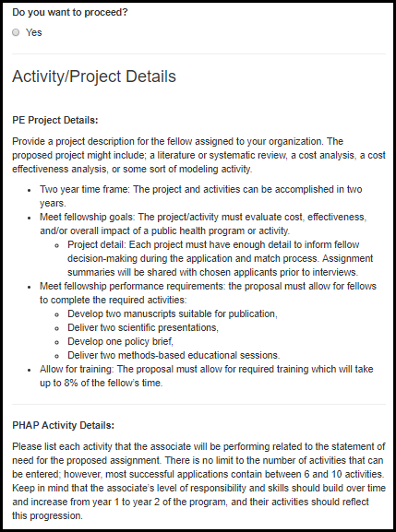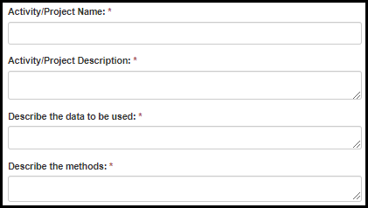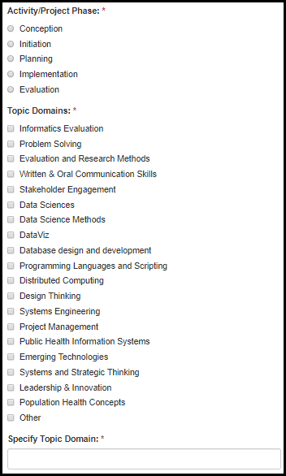

Table 8.1-a. Activity/Project Details Fields
Field Name | Values | EIS | LLS | EEP | FLIGHT | PMR/F | PHIFP | PE | PHAP
Do you want to proceed? | - | No | No | No | No | Yes | Yes | Yes | Yes
Activity/Project Name: | - | No | No | No | No | Yes | Yes | Yes | Yes
Activity/Project Description: | - | No | No | No | No | Yes | Yes | Yes | Yes
Describe the data to be used: | - | No | No | No | No | No | No | Yes | No
Describe the methods: | - | No | No | No | No | No | No | Yes | No
Activity/Project Phase: | 1. Conception  2. Initiation  3. Planning  4. Implementation  5. Evaluation | No | No | No | No | Yes | Yes | Yes | Yes
Topic Domains: | 1. Informatics Evaluation  2. Problem Solving  3. Evaluation and Research Methods  4. Written & Oral Communication Skills  5. Stakeholder Engagement  6. Data Sciences  7. Data Science Methods  8. DataViz  9. Database design and development  10. Programming Languages and Scripting  11. Distributed Computing  12. Design Thinking  13. Systems Engineering  14. Project Management  15. Public Health Information Systems  16. Emerging Technologies  17. Systems and Strategic Thinking  18. Leadership & Innovation  19. Population Health Concepts  20. Other | No | No | No | No | No | Yes | No | No
Specify Topic Domain: | - | No | No | No | No | No | Yes | No | No

Figure 8.1-b. Activity/Project Details Fields
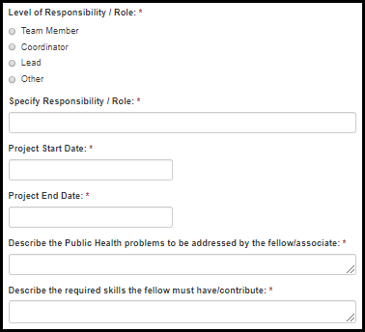
Table 8.1-b. Activity/Project Details Fields
Field Name | Values | EIS | LLS | EEP | FLIGHT | PMR/F | PHIFP | PE | PHAP
Level of Responsibility / Role: | 1. Team Member  2. Coordinator  3. Lead  4. Other | No | No | No | No | Yes | Yes | Yes | Yes
Specify Responsibility / Role: | - | No | No | No | No | Yes | Yes | Yes | Yes
Project Start Date: | - | No | No | No | No | Yes | Yes | Yes | Yes
Project End Date: | - | No | No | No | No | Yes | Yes | Yes | Yes
Describe the Public Health problems to be addressed by the fellow/associate: | - | No | No | No | No | No | Yes | No | Yes
Describe the required skills the fellow must have/contribute: | - | No | No | No | No | No | No | Yes | No

Activity/Project Location

Figure 8.2-a. Activity/Project Location Fields
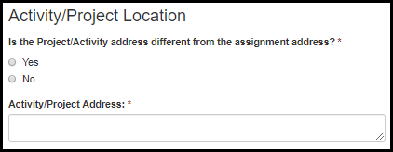
Table 8.2-a. Activity/Project Location Fields
Field Name | Values | EIS | LLS | EEP | FLIGHT | PMR/F | PHIFP | PE | PHAP
Is the Project/Activity address different from the assignment address? | 1. Yes  2. No | No | No | No | No | No | Yes | No | Yes
Activity/Project Address: | - | No | No | No | No | No | Yes | No | Yes

Activity & Deliverable Details

Figure 8.3-a. Activity & Deliverable Details Fields
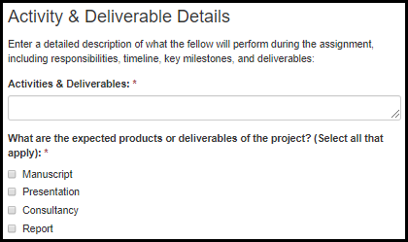
Table 8.3-a. Activity & Deliverable Details Fields
Field Name | Values | EIS | LLS | EEP | FLIGHT | PMR/F | PHIFP | PE | PHAP
Activities & Deliverables: | - | No | No | No | No | Yes | Yes | Yes | Yes
What are the expected products or deliverables of the project? (Select all that apply): | 1. Manuscript  2. Presentation  3. Consultancy  4. Report | No | No | No | No | No | No | Yes | No

Competencies

PHIFP

Figure 8.4.1-a. PHIFP Competencies Fields Figure 8.4.1-b. PHIFP Competencies Fields
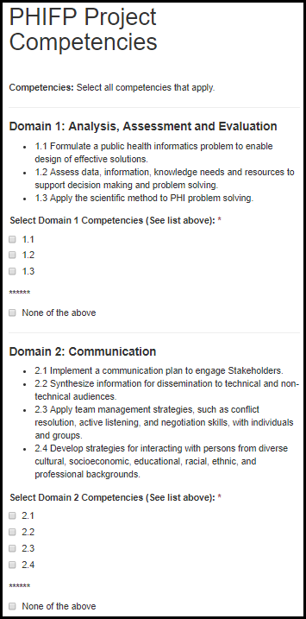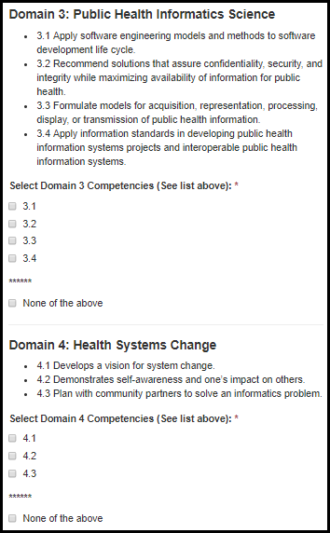

Table 8.4.1-a. PHIFP Competencies Fields
Field Name | Values | EIS | LLS | EEP | FLIGHT | PMR/F | PHIFP | PE | PHAP
Select Domain 1 Competencies (See list above): | 1. 1.1  2. 1.2  3. 1.3 | No | No | No | No | No | Yes | No | No
****** | 1. None of the above | No | No | No | No | No | Yes | No | No
Select Domain 2 Competencies (See list above): | 1. 2.1  2. 2.2  3. 2.3  4. 2.4 | No | No | No | No | No | Yes | No | No
****** | 1. None of the above | No | No | No | No | No | Yes | No | No
Select Domain 3 Competencies (See list above): | 1. 3.1  2. 3.2  3. 3.3  4. 3.4 | No | No | No | No | No | Yes | No | No
****** | 1. None of the above | No | No | No | No | No | Yes | No | No
Select Domain 4 Competencies (See list above): | 1. 4.1  2. 4.2  3. 4.3 | No | No | No | No | No | Yes | No | No
****** | 1. None of the above | No | No | No | No | No | Yes | No | No

PHAP

Figure 8.4.2-a. PHAP Competencies Fields Figure 8.4.2-b. PHAP Competencies Fields
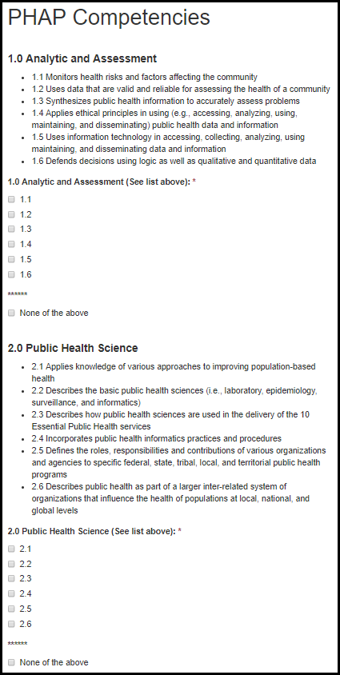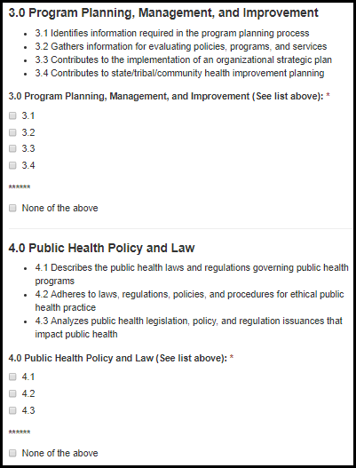

Table 8.4.2-a. PHAP Competencies Fields
Field Name | Values | EIS | LLS | EEP | FLIGHT | PMR/F | PHIFP | PE | PHAP
1.0 Analytic and Assessment (See list above): | 1. 1.1  2. 1.2  3. 1.3  4. 1.4  5. 1.5  6. 1.6 | No | No | No | No | No | No | No | Yes
****** | 1. None of the above | No | No | No | No | No | No | No | Yes
2.0 Public Health Science (See list above): | 1. 2.1  2. 2.2  3. 2.3  4. 2.4  5. 2.5  6. 2.6 | No | No | No | No | No | No | No | Yes
****** | 1. None of the above | No | No | No | No | No | No | No | Yes
3.0 Program Planning, Management, and Improvement (See list above): | 1. 3.1  2. 3.2  3. 3.3  4. 3.4 | No | No | No | No | No | No | No | Yes
****** | 1. None of the above | No | No | No | No | No | No | No | Yes
4.0 Public Health Policy and Law (See list above): | 1. 4.1  2. 4.2  3. 4.3 | No | No | No | No | No | No | No | Yes
****** | 1. None of the above | No | No | No | No | No | No | No | Yes

Figure 8.4.2-c. PHAP Competencies Fields Figure 8.4.2-d. PHAP Competencies Fields
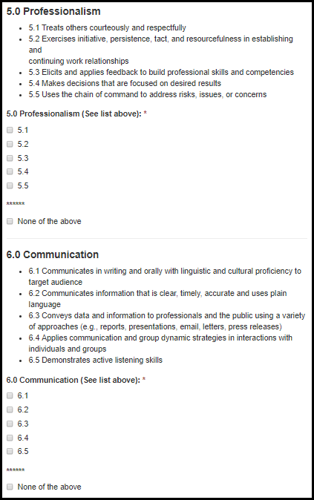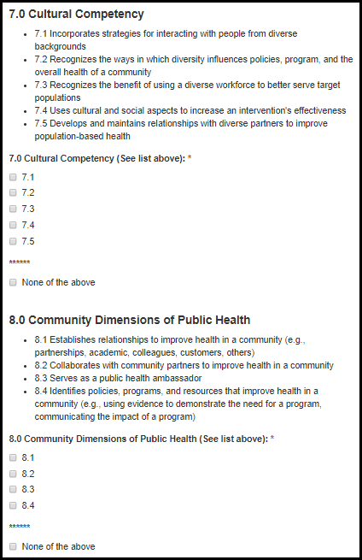

Table 8.4.2-b. PHAP Competencies Fields
Field Name | Values | EIS | LLS | EEP | FLIGHT | PMR/F | PHIFP | PE | PHAP
5.0 Professionalism (See list above): | 1. 5.1  2. 5.2  3. 5.3  4. 5.4  5. 5.5 | No | No | No | No | No | No | No | Yes
****** | 1. None of the above | No | No | No | No | No | No | No | Yes
6.0 Communication (See list above): | 1. 6.1  2. 6.2  3. 6.3  4. 6.4  5. 6.5 | No | No | No | No | No | No | No | Yes
****** | 1. None of the above | No | No | No | No | No | No | No | Yes
7.0 Cultural Competency (See list above): | 1. 7.1  2. 7.2  3. 7.3  4. 7.4  5. 7.5 | No | No | No | No | No | No | No | Yes
****** | 1. None of the above | No | No | No | No | No | No | No | Yes
8.0 Community Dimensions of Public Health (See list above): | 1. 8.1  2. 8.2  3. 8.3  4. 8.4 | No | No | No | No | No | No | No | Yes
****** | 1. None of the above | No | No | No | No | No | No | No | Yes

Figure 8.4.2-e. PHAP Competencies Fields
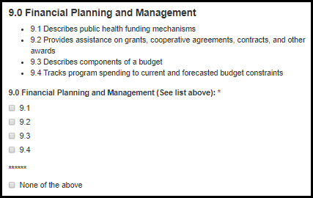
Table 8.4.2-c. PHAP Competencies Fields
Field Name | Values | EIS | LLS | EEP | FLIGHT | PMR/F | PHIFP | PE | PHAP
9.0 Financial Planning and Management (See list above): | 1. 9.1  2. 9.2  3. 9.3  4. 9.4 | No | No | No | No | No | No | No | Yes
****** | 1. None of the above | No | No | No | No | No | No | No | Yes

Training & Languages

PHAP
Figure 9.-a. Training & Language Fields Figure 9.-b. Training & Language Fields
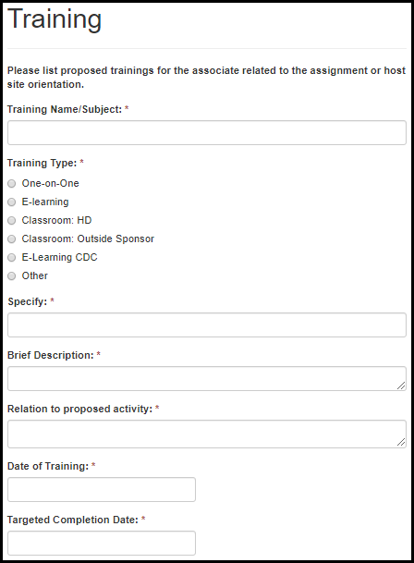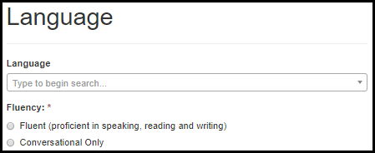

Table 9.-a. Training & Language Fields
Field Name | Values | EIS | LLS | EEP | FLIGHT | PMR/F | PHIFP | PE | PHAP
Training Name/Subject: | - | No | No | No | No | No | No | No | Yes
Training Type: | 1. One-on-One  2. E-learning  3. Classroom: HD  4. Classroom: Outside Sponsor  5. E-Learning CDC  6. Other | No | No | No | No | No | No | No | Yes
Specify: | - | No | No | No | No | No | No | No | Yes
Brief Description: | - | No | No | No | No | No | No | No | Yes
Relation to proposed activity: | - | No | No | No | No | No | No | No | Yes
Date of Training: | - | No | No | No | No | No | No | No | Yes
Target Completion Date: | - | No | No | No | No | No | No | No | Yes
Language: | Language Lookup | No | No | No | No | No | No | No | Yes
Fluency: | 1. Fluent (proficient in speaking, reading and writing)  2. Conversational Only | No | No | No | No | No | No | No | Yes

Student Rotation Preferences

EEP

Figure 10.-a. Student Rotation Preference Fields
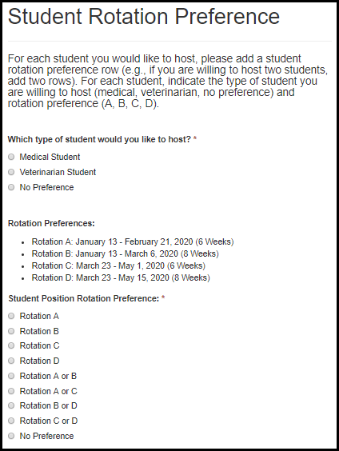

Table 10.-a. Student Rotation Preference Fields
Field Name | Values | EIS | LLS | EEP | FLIGHT | PMR/F | PHIFP | PE | PHAP
Which type of student would you like to host? | 1. Medical Student  2. Veterinarian Student  3. No Preference | No | No | Yes | No | No | No | No | No
Student Position Rotation Preference: | 1. Rotation A  2. Rotation B  3. Rotation C  4. Rotation D  5. Rotation A or B  6. Rotation A or C  7. Rotation B or D  8. Rotation B or C  9. No Preference | No | No | Yes | No | No | No | No | No

Match

Match or Prematch Rank/Rating Form

Figure 11.-a. Match or Prematch Rank/Rating Fields
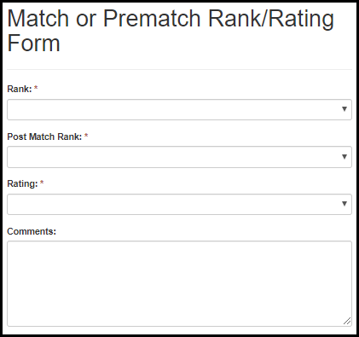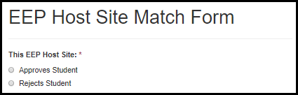
Table 11.-a. Match or Prematch Rank/Rating Fields
Field Name | Values | EIS | LLS | EEP | FLIGHT | PMR/F | PHIFP | PE | PHAP
Rank: | First Choice - Tenth Choice | Yes | Yes | No | Yes | Yes | Yes | Yes | No
Post Match Rank: | First Choice - Tenth Choice | Yes | Yes | No | Yes | Yes | Yes | Yes | No
Rating: | First Choice - Tenth Choice | Yes | Yes | No | Yes | Yes | Yes | Yes | No
Comments: |  | Yes | Yes | No | Yes | Yes | Yes | Yes | No
This EEP Host Site: | 1. Approves Student  2. Rejects Student | No | No | Yes | No | No | No | No | No

Appendix

I. Field Value Tables

Appendix of Field Value Tables
Field Name | Application Locations | Values  1 | Values  2 | Values  3 | Values  4
Approved Country List | 6.5 Position Assignment Location | United States  Anguilla  Antigua  Australia  Bahamas  Barbados  Barbuda  Belize  Bermuda  British Virgin Islands  Canada  Dominica  Grand Cayman Islands | Grenada  Guyana  Irish Republic  Jamaica  Montserrat  New Zealand  Saint Kitts and Nevis  St. Lucia  St. Vincent & the Grenadine  Tabago  Trinidad  Turks and Caicos Islands  United Kingdom
State/Territory List | 6.5 Position Assignment Location | Alabama  Alaska  Arizona  Arkansas  California  Colorado  Connecticut  Delaware  Washington, DC  Florida  Georgia  Hawaii  Idaho  Illinois  Indiana  Iowa  Kansas  Kentucky  Louisiana  Maine  Maryland  Massachusetts  Michigan  Minnesota  Mississippi  Missouri  Montana  Nebraska | Nevada  New Hampshire  New Jersey  New Mexico  New York  North Carolina  North Dakota  Ohio  Oklahoma  Oregon  Pennsylvania  Rhode Island  South Carolina  South Dakota  Tennessee  Texas  Utah  Vermont  Virginia  Washington  West Virginia  Wisconsin  Wyoming  Puerto Rico  Pacific Islands  U.S. Virgin Islands
CDC Fellowship List | 7.2 Supervisor Information | AACN Fellowship  AAMC Public Health Policy Fellowship  Applied Public Health Informatics Fellowship (APHIF)  APTR Preventive Medicine and Public Health Fellowship  ASA/NCHS Research Fellowship Program  ASM Program in Infectious Disease and Public Health Microbiology  ASPH Allan Rosenfield Global Health Fellowship Program  ASPPH Public Health Fellowship Program  Biochemical Markers Fellowship  Collegiate Leaders in Environmental Health (CLEH)  CSTE Applied Epidemiology Fellowship Program  Dental Public Health Residency  DHPE Health Equity Fellowship Program  DHPE Internship Program for Public Health Practice Emory Rollins Earn and Learn (REAL) Program  E-learning Institute (ELI)  Environmental Health Traineeship and Fellowship Program  Epidemic Intelligence Service (EIS)  Epidemiology Elective Program (EEP)  Evaluation Fellowship  Federal Work-Study Program (FWS)  Field Epidemiology Training Program (FETP)  Future Leaders in Infections and Global Health Threats (FLIGHT)  Future Public Health Leaders Program (FPHLP)  HACU National Internship Program (HNIP)  Health Systems Integration Program  Hubert Global Health Fellowship  Informatics Training in Place Program (I-TIPP)  International Emerging Infectious Diseases (IEID) Laboratory Fellowship Program  Internships and Externships in Public Health Law  James A Ferguson Emerging Infectious Diseases Fellowship  Junior Commissioned Officer Student Training and Extern Program (JRCOSTEP)  Laboratory Animal Medicine Residency Program (LAMRP)  Laboratory Leadership Service (LLS)  Maternal Child Health Careers/Research Initiatives for Student Enhancement – Undergraduate Program (MCHC/RISE-UP)  Medical Toxicologist Fellowship Program  Morehouse College Project IHMOTEP Program  National Center for Health Statistics (NCHS) Academy Health Policy Fellowship  National Center for Health Statistics (NCHS) Postdoctoral Research Program

II. Lookup Tables

Appendix of Lookup Tables
Lookup Table Name | Application Locations | Values  1 | Values  2 | Values  3 | Values  4 | Values  5
Fellowship Lookup | 3. eFMS System Help Desk Ticket | CDC E-learning Institute Fellowship Program (ELI)  CDC Steven M. Teutsch Prevention Effectiveness (PE) Fellowship  Epidemic Intelligence Service (EIS)  Epidemiology Elective Program (EEP)  Future Leaders in Infections and Global Health Threats (FLIGHT)  Laboratory Leadership Service (LLS)  Population Health Training in Place Program (PH-TIPP)  Population Health Workforce Initiative (PHWI)  Preventive Medicine Residency and Fellowship (PMR/F)  Public Health Associate Program (PHAP)  Public Health Informatics Fellowship Program (PHIFP)  Science Ambassador Fellowship (SAF)
State/Territory Lookup | 5.3 Public Health Agency Details | Alabama  Alaska  Arizona  Arkansas  California  Colorado  Connecticut  Delaware  Washington, DC  Florida  Georgia  Hawaii  Idaho  Illinois  Indiana  Iowa  Kansas  Kentucky  Louisiana  Maine  Maryland  Massachusetts  Michigan  Minnesota  Mississippi  Missouri  Montana  Nebraska | Nevada  New Hampshire  New Jersey  New Mexico  New York  North Carolina  North Dakota  Ohio  Oklahoma  Oregon  Pennsylvania  Rhode Island  South Carolina  South Dakota  Tennessee  Texas  Utah  Vermont  Virginia  Washington  West Virginia  Wisconsin  Wyoming  Puerto Rico  Pacific Islands  U.S. Virgin Islands  Guam  Northern Mariana Islands
Public Health Agency Lookup | 5.3 Public Health Agency Details | CDC Anchorage Quarantine Station - Alaska  CDC Atlanta Quarantine Station - Georgia  CDC Boston Quarantine Station - Massachusetts  CDC Dallas/Ft. Worth Quarantine Station - Texas  CDC Detroit Quarantine Station - Michigan  CDC El Paso Quarantine Station - Texas  CDC Honolulu Quarantine Station - Hawaii  CDC Houston Quarantine Station - Texas  CDC Los Angeles Quarantine Station - California  CDC Miami Quarantine Station - Florida  CDC Minneapolis Quarantine Station - Minnesota  CDC Newark Quarantine Station - New Jersey  CDC New York Quarantine Station - New York  CDC Philadelphia Quarantine Station - Pennsylvania  CDC San Diego Quarantine Station - Florida  CDC San Francisco Quarantine Station - California  CDC San Juan Quarantine Station - Puerto Rico  CDC Seattle Quarantine Station - Washington  CDC Washington Quarantine Station - Washington, DC  Shoalwater Bay Health Clinic - Washington  Marion County Health Department - Oregon  Michigan Department of Community Health - Michigan  Linn County Public Health Department - Iowa  Prince William Health District - Virginia  District 2: North Health District - Georgia  Hillsborough County Health Department - Florida  Palm Beach County Health Department - Florida  American Samoa Dept of Health - American Samoa  Guam Dept Pub Health & Soc Serv - Guam  Puerto Rico Departamento de Salud - Puerto Rico  Virgin Islands Department of Health - U.S. Virgin Islands  Rosebud Sioux Tribe - South Dakota  Three Affiliated Tribes - North Dakota  Lower Brule Sioux Tribe - South Dakota  Spirit Lake Tribe - North Dakota  Sisseton-Wahpeton Oyate of the Lake Traverse Reservation - South Dakota  Trenton Indian Service Area - North Dakota  Standing Rock Sioux Tribe - North Dakota  Crow Creek Sioux Tribe - South Dakota  Santee Sioux Nation - Nebraska  Cheyenne River Sioux Tribe - South Dakota  Ponca Tribe of Nebraska - Nebraska  Turtle Mountain Band of Chippewa - North Dakota  Flandreau Santee Sioux Tribe - South Dakota  Yankton Sioux Tribe - South Dakota  Sac & Fox Tribe of the Mississippi in Iowa - Iowa  Oglala Sioux Tribe - South Dakota  Winnebago Tribe of Nebraska - Nebraska  Omaha Tribe of Nebraska - Nebraska  Native Village of Tyonek - Alaska  Searhc Mt. Edgecumbe Hospital - Alaska  Metlakatla Indian Community - Alaska  Fairbanks Native Association - Alaska  Alaska Native Tribal Health Consortium - Alaska  Mount Sanford Tribal Consortium - Alaska  Arctic Slope Native Association - Alaska  Bristol Bay Area Health Corporation - Alaska  Ukpeagvik Inupiat Corporation - Alaska  Maniilaq Association - Alaska  Searhc Juneau Medical Center - Alaska  Akiachak Native Community - Alaska  Southcentral Foundation - Alaska  Chickaloon Native Village - Alaska  SouthEast Alaska Regional Health Consortium - Alaska  Valdez Native Tribe - Alaska  Alaska Native Medical Center - Alaska  Tanana Chiefs Conference - Alaska  North Slope Borough Health Corp - Alaska  Chief Andrew Isaac Health Center - Alaska  Ninilchik Traditional Council - Alaska  Ketchikan Indian Corporation - Alaska  Eastern Aleutian Tribes, Inc - Alaska  Native Village of Kwinhagak - Alaska  St. George Community Council - Alaska  Cook Inlet Tribal Council, Inc. - Alaska  Yukon-Kuskokwim Regional Health Corporation - Alaska  Kenaitze Indian Tribe - Alaska  Aleutian Pribilof Islands Association, Inc. - Alaska  Norton Sound Health Corporation - Alaska  Copper River Native Association - Alaska  Council of Athabascan Tribal Governments - Alaska  Tanana Tribal Council - Alaska  Kodiak Area Native Association - Alaska  Towaoc PHS Indian Health Center - Colorado  Santa Fe PHS Indian Hospital - New Mexico  Isleta Health Center - New Mexico  Santa Clara PHS Indian Hlth Ctr - New Mexico  Tribal Human Services - New Mexico  Zuni Health Program - New Mexico  San Ildefonso Pueblo Health Program - New Mexico  Alamo Navajo School Board - New Mexico  Ysleta del Sur Pueblo - Texas  Zia Pueblo Health Program - New Mexico  Ramah Navajo School Board, Inc. - New Mexico  Kewa Pueblo Health Program - New Mexico  Ignacio PHS Indian Health Center - Colorado  Pine Hill Indian Health Center - New Mexico  Alamo Navajo Health Station - New Mexico  Jicarilla Apache Tribe - New Mexico  San Juan Pueblo Health Program - New Mexico  Santa Ana Pueblo Health Program - New Mexico  Five Sandoval Indian Pueblos, Inc. - New Mexico  Eight Northern Indian Pueblos, Inc. Hlth Prog. - New Mexico  Southern Ute Health Program - Colorado  Jemez Dept of Health & Human Svcs - New Mexico  San Felipe Health Program - New Mexico  Santa Ana Health Clinic - New Mexico  Zia Health Clinic - New Mexico  Santa Clara Pueblo Health Program - New Mexico  Taos CHR Program - New Mexico  Tesuque Pueblo Health Program - New Mexico  Ute Mountain Ute Health Program - Colorado  Sandia Health Program - New Mexico  Red Lake Comprehensive Hlth Svc - Minnesota  Bad River Health Services - Wisconsin  Ho-Chunk Nation Health Dept - Wisconsin  Little River Band of Ottawa Indians - Michigan  Grand Traverse Ottawa & Chippewa - Michigan  Sault Ste. Marie HHS - Michigan  Oneida Community Health Center - Wisconsin  Match-E-Be-Nash-She-Wish Pottawatomi - Michigan  Red Cliff Health Services - Wisconsin  Lac Courte Oreilles Comm Hlth Ctr - Wisconsin  White Earth Band Health Division - Minnesota  Lac Vieux Desert Band - Michigan  Minnesota Chippewa Tribe - Minnesota  Bois Forte Tribal Clinic - Minnesota  Inter-Tribal Council of Michigan, Inc. - Michigan  Potawatomi Health & Wellness Center - Wisconsin  Leech Lake Band of Chippewa Indians - Minnesota  Ellen Marshall Memorial Center - Michigan  Keweenaw Bay Indian Community - Michigan  Shakopee Mdewakanton Business Council - Minnesota  Huron Potawatomi, Inc. - Michigan  Prairie Island Family Health Clinic - Minnesota  Hannahville Health Center - Michigan  Stockbridge-Munsee Tribal Health Center - Wisconsin  St. Croix Tribal Health Dept. - Wisconsin  Fond du Lac Min-No-Aya-Win Clinic - Minnesota  Nimkee Memorial Wellness Center - Michigan  Pokagon Potawatomi Health Services - Michigan  Grand Portage Band Tribal Office - Minnesota  Mille Lacs Band Ne-Ia-Shing Clinic - Minnesota  Great Lake Inter-Tribal Council - Wisconsin  Lac du Flambeau - Pete Christensen Hlth Ctr - Wisconsin  Lower Sioux Community Council - Minnesota  Little Traverse Bay Band of Odawa - Michigan  Upper Sioux Community - Minnesota  Sokaogon Chippewa Indian Community - Wisconsin  Menominee Tribal Clinic - Wisconsin  Arapaho Clinic - Wyoming  Wolf Point Clinic - Montana  Lodge Grass Clinic - Montana  Heart Butte Clinic - Montana  Hays Clinic - Montana  Fort Belknap Tribal Health Dept. - Montana  Flathead Tribal Hlth & Human Svcs Dept. - Montana  Crow Tribal Health Department - Montana  Fort Peck Tribal Health Project - Montana  Northern Cheyenne Tribal Health Dept. - Montana  Northern Arapaho Tribal Health Dept. - Wyoming  Shoshone Tribal Health Department - Wyoming  Rocky Boy Tribal Health Dept. - Montana  Blackfeet Tribal Health Department - Montana  Lone Pine Indian Health Clinic - California  Table Mountain Rancheria - California  Cabazon Band of Mission Indians - California  Colusa Indian Community Council - California  Greenville Rancheria of Maidu Indians - California  Tule River Indian Health Center, Inc. - California  Cold Springs Rancheria of Mono Indians - California  Shingle Springs Tribal Health Programs - California  Hopland Band of Pomo Indians - California  Susanville Indian Health Center - California  Chapa-De Indian Health Program, Inc. - California  Sycuan Band of the Kumeyaay Nation - California  Sherwood Valley Band of Pomo Indians - California  Central Valley Indian Health, Inc. - California  Santa Rosa Rancheria - California  Consolidated Tribal Health Project, Inc. - California  Guidiville Indian Rancheria - California  Soboba Indian Health Clinic - California  Indian Health Center of Santa Clara Valley - California  Feather River Tribal Health Inc. - California  Southern Indian Health Council - California  Tuolumne Me-Wuk Indian Hlth Ctr - California  Northern Valley Indian Health - California  Toiyabe Indian Health Project - California  Indian Health Council, Inc. - California  Sonoma County Indian Health (CRIHB) - California  Coyote Valley Tribal Council - California  Lytton Rancheria - California  Santa Ynez Band of Chumash Mission Indians - California  Lake County Tribal Health Consortium - California  Quartz Valley Indian Reservation - California  Sierra Tribal Consortium - California  M.A.C.T. Health Board, Inc. - California  Mashpee Wampanoag Tribe - Massachusetts  Round Valley Indian Health Center - California  Warner Mountain Indian Hlth Project - California  Oneida Nation of NY Health Program - New York  Tunica-Biloxi Indian Tribe of Louisiana - Louisiana  Karuk Tribe - California  Mohegan Tribe of Indians of CT - Connecticut  United Indian Health Services - California  Penobscot Nation Health Department - Maine  Redding Rancheria Health Clinic - California  St. Regis Mohawk Health Services - New York  Hoopa Valley Tribe - California  Narragansett Indian Tribe Health Program - Rhode Island  Pinoleville Band of Pomo Indians - California  Houlton Band of Maliseet Indians Hlth Dept - Maine  Pit River Health Services, Inc. - California  Lionel R. John Health Center - New York  Scotts Valley Band of Pomo Indians - California  Passamaquoddy Indian Township Hlth Ctr - Maine  National Indian Education Association - Washington, DC  Miccosukee Tribe of Indians of Florida - Florida  Cattaraugus Indian Reservation Hlth Ctr - New York  Aroostook Band of Micmac Indians - Maine  Miami Nation of Indiana - Indiana  Chitimacha Tribe of Louisiana - Louisiana  Catawba Indian Nation - South Carolina  Poarch Band of Creek Indians - Alabama  Wampanoag Tribe of Gay Head - Massachusetts  UNITY Healing Center - North Carolina  Tohatchi PHS Indian Health Center - New Mexico  Alabama-Coushatta Tribe of Texas - Texas  Mashantucket Pequot Health Dept - Connecticut  Winslow Indian Hlth. Care Ctr., Inc. - Arizona  Jena Band of Choctaw Indians - Louisiana  Navajo Division of Social Services - Arizona  Coushatta Tribe of Louisiana - Louisiana  Navajo Division of Health - Arizona  Choctaw Health Center - Mississippi  Utah Navajo Hlth System, Inc. - Utah  Big Cypress IHS Center - Florida  Navajo Division of EMS - Arizona  Brighton Health Center - Florida  Inscription House Health Center - Arizona  Seminole Tribe of FL - Hth. Admin. - Florida  Passamaquoddy Pleasant Point Hlth Center - Maine  Pawhuska PHS Indian Hlth Ctr - Oklahoma  Dzilth-Na-O-Dith-Hle-PHS Indian Hlth Ctr - New Mexico  Sapulpa Health Center - Oklahoma  San Juan Southern Paiute Tribe - Arizona  Carnegie Indian Health Center - Oklahoma  Health & Social Svcs Committee - Arizona  Fort Sill Apache Tribe - Oklahoma  Tsaile PHS Indian Health Center - Arizona  Sac & Fox Nation of Missouri - Kansas  Tuba City Regional Hlth Care Corp. - Arizona  Eufaula Health Center - Oklahoma  Osage Nation - Oklahoma  Choctaw Nation of Oklahoma - Oklahoma  Ardmore Chickasaw Health Clinic - Oklahoma  Choctaw Nation Health Care Center - Oklahoma  Kickapoo Traditional Tribe of Texas - Texas  Kickapoo Tribe in Kansas - Kansas  Otoe-Missouria Tribe - Oklahoma  Cherokee Nation of Oklahoma - Oklahoma  El Reno PHS Indian Hlth Clinic - Oklahoma  Citizen Potawatomi Nation Hlth Clinic - Oklahoma  Kanza Health Clinic - Oklahoma  Anadarko PHS Indian Hlth Ctr - Oklahoma  Muskogee Indian Health Center - Oklahoma  Prairie Band Potawatomi Tribe - Kansas  Seminole Nation of Oklahoma - Oklahoma  Delaware Nation - Oklahoma  Wyandotte Tribe of Oklahoma - Oklahoma  Choctaw Nation Indian Health Clinic - Oklahoma  Northeastern Tribal Health System - Oklahoma  Quapaw Tribe of Oklahoma - Oklahoma  Modoc Tribal Council - Oklahoma  Kickapoo Health Center - Kansas  Redbird Smith Health Center - Oklahoma  Carl Albert Indian Hospital - Oklahoma  Tishomingo Chickasaw Health Center - Oklahoma  Sam Hider Jay Community Clinic - Oklahoma  Bearskin Health Center - Oklahoma  Iowa Tribe of Kansas & Nebraska - Kansas  Miami Tribe of Oklahoma - Oklahoma  Choctaw Nation Indian Health Clinic - Oklahoma  Apache Tribe of Oklahoma - Oklahoma  Ottawa Tribe of Oklahoma - Oklahoma  Iowa Tribe of Oklahoma - Oklahoma  Choctaw Nation Health Clinic - Oklahoma  Cheyenne & Arapaho Tribes - Oklahoma  Kickapoo Tribal Health Center - Oklahoma  Choctaw Nation Indian Hlth Clinic - Oklahoma  Okemah Indian Health Center - Oklahoma  Muscogee (Creek) Nation Div. of Hlth. Adm. - Oklahoma  Tonkawa Tribe of Oklahoma - Oklahoma  Diabetes Treatment Center - Oklahoma  White Eagle Indian Health Center - Oklahoma  Cherokee Nation Health Clinic - Oklahoma  Eastern Shawnee Tribe - Missouri  Delaware Tribe of Indians (Eastern Oklahoma) - Oklahoma  Absentee Shawnee Tribal Clinic - Oklahoma  Durant Health Center - Oklahoma  Kickapoo Tribe of Oklahoma - Oklahoma  Pawnee Nation of Oklahoma - Oklahoma  Watonga IHS Clinic - Oklahoma  Seneca-Cayuga Tribe of Oklahoma - Oklahoma  Black Hawk Health Center - Oklahoma  Comanche Tribe of Oklahoma - Oklahoma  Peoria Tribe of Oklahoma - Oklahoma  Cibecue PHS Indian Health Ctr - Arizona  Caddo Nation of Oklahoma - Oklahoma  Bylas Health Center - Arizona  Salina Community Clinic - Oklahoma  AZ Assoc. of Community Hlth Ctr - Arizona  Fort McDowell - Wassaja Memorial Health Center - Arizona  Gila River Indian Community - Arizona  Yavapai-Prescott Tribe - Arizona  Yomba Shoshone Tribe - Nevada  Tonto Apache Tribe - Arizona  Paiute Indian Tribe of Utah - Utah  Fort Mojave Indian Tribe - Arizona  Pyramid Lake Paiute Tribe - Nevada  Washoe Tribal Health Center - Nevada  Havasupai Tribe - Arizona  Quechan Tribal Council - Arizona  Fallon Health Center - Nevada  Fort McDermitt Tribe - Nevada  Lovelock Paiute Tribe - Nevada  Chemehuevi Tribe - California  Ak-Chin Indian Community - Arizona  White Mountain Apache Tribe - Arizona  Cocopah Tribe - Arizona  Las Vegas Paiute Tribe - Nevada  Colorado River Indian Community - Arizona  Phoenix Indian Center - Arizona  Salt River Indian Community - Arizona  Duck Valley Shoshone Tribe - Nevada  Salt River Indian Community - Arizona  Hualapai Tribe - Arizona  Wells Band Council - Nevada  Ute Indian Tribe - Utah  Yavapai-Apache Nation - Arizona  Battle Mountain Band - Nevada  Ely Shoshone Tribe - Nevada  Reno-Sparks Tribal Health Center - Nevada  Hopi Health Care Center - Arizona  Tohono O'odham, San Lucy District - Arizona  Desert Visions Youth Wellness Center - Arizona  South Fork Band Council - Nevada  Las Vegas Indian Center - Nevada  Moapa Band of Paiutes - Nevada  Walker River Paiute Tribe - Nevada  Omak Clinic - Washington  Yerington Paiute Tribe - Nevada  Kaibab-Paiute Tribe - Arizona  Chehalis Tribal Clinic - Washington  Moapa Health Clinic - Nevada  Makah Health Center - Washington  Goshute Tribe - Utah  Nimiipuu Health - Idaho  Elko Band Council - Nevada  Burns-Paiute Health Clinic - Oregon  Te-Moak Tribe of Western Shoshone - Nevada  Lummi Indian Health Center - Washington  Duckwater Shoshone Tribe - Nevada  Nooksack Tribal Health Center - Washington  Peach Springs Health Center - Arizona  Tulalip Clinic - Washington  San Carlos Apache Tribe - Arizona  Kootenai Tribal Health Clinic - Idaho  Inchelium Health Clinic - Washington  Puyallup Tribal Health Authority - Washington  Stillaguamish Tribal Clinic - Washington  Port Gamble S'Klallam Tribal Clinic - Washington  Klamath Tribal Health Center - Oregon  Muckleshoot Health & Wellness Center - Washington  Roger Saux Health Center - Washington  Spokane Tribe - Washington  Sauk-Suiattle Health Clinic - Washington  Upper Skagit Tribal Clinic - Washington  Healing Lodge of Seven Nations - Washington  Coquille Tribal Health Center - Oregon  Cow Creek Tribal Clinic - Oregon  Niimiipuu Health Center - Idaho  Hoh Tribe - Washington  Swinomish Health Clinic - Washington  Siletz Community Health Clinic - Oregon  Quileute Clinic - Washington  Shoshone-Bannock Tribe - Idaho  Yellowhawk Tribal Hlth Ctr - Oregon  White Swan Clinic - Washington  Quinault Indian Nation - Washington  Wadatika Health Center - Oregon  Jamestown S'Klallam Tribe - Washington  Indian Tribal Consortium - Washington  Kalispel Tribe - Washington  Squaxin Island Health Center - Washington  Cowlitz Tribe - Washington  Samish Tribal Health - Washington  Skokomish Health Clinic - Washington  Grand Ronde Health & Wellness Center - Oregon  Suquamish Tribe - Washington  Nisqually Health Clinic - Washington  Lower Elwha Health Clinic - Washington  Santa Rosa Clinic - Arizona  San Xavier PHS Indian Hlth Ctr - Arizona  Pascua Yaqui Tribe Health Services Division - Arizona  Municipality of Anchorage/Department of Health and Human Services - Alaska  Tohono O'odham Nation - Arizona  Nome Health Center, Norton-Sound Health Corporation - Alaska  Juneau Public Health Center - Alaska  North Slope Borough Health and Social Services Agency - Alaska  Maniilaq Association - Alaska  Aleutian Pribilof Islands Association - Alaska  Arctic Slope Native Association - Alaska  Chickaloon Native Village - Alaska  Kodiak Area Native Association - Alaska  Bethel Center and Itinerant Nursing Services - Alaska  Native Village of Eklutna - Alaska  Southcentral Foundation - Alaska  Cordova Public Health Center South Central Region - Alaska  Tanana Chiefs Conference - Alaska  Craig Public Health Center - Alaska  Yukon-Kuskokwin Health - Alaska  Delta Junction Public Health Center - Alaska  Alaska Native Tribal Health Consortium - Alaska  Dillingham Public Health Center - Alaska  Fairbanks Regional Public Health Center Interior Region - Alaska  Fort Yukon Public Health Center - Alaska  Galena Public Health Center Interior Region - Alaska  Haines Public Health Center - Alaska  Homer Public Health Center - Alaska  Kenai Public Health Center - Alaska  Ketchikan Public Health Center - Alaska  Kodiak Public Health Center - Alaska  Seward Public Health Center - Alaska  Matanuska-Susitna (Mat-Su) Public Health Center - Alaska  Petersburg Public Health Center - Alaska  Sitka Public Helath Center - Alaska  Tok Public Health Center - Alaska  Valdez Public Health Center - Alaska  Wrangell Public Health Center - Alaska  South Central Region - Alaska  Southwest Region - Alaska  Interior Region - Alaska  Butler County Health Department - Alabama  Southeast Region - Alaska  Autauga County Health Department - Alabama  Calhoun County Health Department - Alabama  Baldwin County Health Department - Alabama  Chambers County Health Department - Alabama  Barbour County Health Department - Alabama  Cherokee County Health Department - Alabama  Bibb County Health Department - Alabama  Chilton County Health Department - Alabama  Blount County Health Department - Alabama  Bullock County Health Department - Alabama  Choctaw County Health Department - Alabama  Clarke County Health Department - Alabama  Clay County Health Department - Alabama  Cleburne County Health Department - Alabama  Coffee County Health Department - Alabama  Colbert County Health Department - Alabama  Conecuh County Health Department - Alabama  Coosa County Health Department - Alabama  Cullman County Health Department - Alabama  Covington Health Department - Alabama  Dale County Health Department - Alabama  Crenshaw County Health Department - Alabama  Dallas County Health Department - Alabama  DeKalb County Health Department - Alabama  Alabama Public Health Area 3 - Alabama  Elmore County Health Department - Alabama  Escambia County Health Department - Alabama  Etowah County Health Department - Alabama  Fayette County Health Department - Alabama  Franklin County Health Department - Alabama  Jackson County Health Department - Alabama  Geneva County Health Department - Alabama  Greene County Health Department - Alabama  Jefferson County Department of Health/Alabama Public Health Area 4 - Alabama  Hale County Health Department - Alabama  Lamar County Health Department - Alabama  Henry County Health Department - Alabama  Lauderdale County Health Department - Alabama  Houston County Health Department - Alabama  Lawrence County Health Department - Alabama  Lee County Health Department - Alabama  Limestone County Health Department - Alabama  Lowndes County Health Department - Alabama  Macon County Health Department - Alabama  Madison County Health Department - Alabama  Marengo County Health Department - Alabama  Marion County Health Department - Alabama  Montgomery County Health Department - Alabama  Marshall County Health Department - Alabama  Mobile County Health Department/Alabama Public Health Area 11 - Alabama  Alabama Public Health Area 2 - Alabama  Monroe County Health Department - Alabama  Alabama Public Health Area 5 - Alabama  Perry County Health Department - Alabama  Pickens County Health Department - Alabama  Pike County Health Department - Alabama  Randolph County Health Department - Alabama  Russell County Health Department - Alabama  Shelby County Department of Health - Alabama  St. Clair County Health Department - Alabama  Sumter County Health Department - Alabama  Washington County Health Department - Alabama  Talladega County Health Department - Alabama  Tallapoosa County Health Department - Alabama  Wilcox County Health Department - Alabama  Tuscaloosa County Health Department - Alabama  Winston County Health Department - Alabama  Alabama Public Health Area 8 - Alabama  Walker County Health Department - Alabama  Alabama Public Health Area 1 - Alabama  Alabama Public Health Area 6 - Alabama  Alabama Public Health Area 7 - Alabama  Alabama Public Health Area 9 - Alabama  Alabama Public Health Area 10 - Alabama  Morgan County Health Department - Alabama  Arkansas County Health Unit - Stuttgart - Arkansas  Ashley County Health Unit - Crossett - Arkansas  Baxter County Health Unit - Arkansas  Bradley County Health Unit - Arkansas  Benton County Health Unit - Bentonville - Arkansas  Boone County Health Department - Arkansas  Calhoun County Health Unit - Arkansas  Carroll County Health Unit - Arkansas  Chicot County Health Unit - Lake Village - Arkansas  Clark County Health Unit - Arkansas  Clay County Health Unit - Piggott - Arkansas  Cleburne County Health Unit - Arkansas  Cleveland County Health Unit - Arkansas  Columbia County Health Unit - Arkansas  Desha County Health Unit - McGehee - Arkansas  Conway County Health Unit - Arkansas  Craighead County Health Unit - Arkansas  Drew County Health Unit - Arkansas  Crawford County Health Unit - Arkansas  Faulkner County Health Unit - Arkansas  Crittenden County Health Unit - West Memphis - Arkansas  Fulton County Health Unit - Arkansas  Cross County Health Unit - Arkansas  Garland County Health Unit - Arkansas  Dallas County Health Unit - Arkansas  Grant County Health Unit - Arkansas  Greene County Health Unit - Arkansas  Hempstead County Health Unit - Arkansas  Hot Spring County Health Unit - Arkansas  Howard County Health Unit - Arkansas  Independence County Health Unit - Arkansas  Izard County Health Unit - Arkansas  Jackson County Health Unit - Arkansas  Jefferson County Health Unit - Arkansas  Lafayette County Health Unit - Arkansas  Johnson County Health Unit - Arkansas  Lawrence County Health Unit - Arkansas  Lee County Health Unit - Arkansas  Lincoln County Health Unit - Arkansas  Little River County Health Unit - Arkansas  Logan County Health Unit - Paris - Arkansas  Lonoke County Health Unit - Lonoke - Arkansas  Madison County Health Unit - Arkansas  Ouachita County Health Unit - Arkansas  Marion County Health Unit - Arkansas  Perry County Health Unit - Arkansas  Miller County Health Unit - Arkansas  Phillips County Health Unit - Arkansas  Mississippi County Health Unit - Blytheville - Arkansas  Pike County Health Unit - Arkansas  Monroe County Health Unit - Arkansas  Poinsett County Health Unit - Harrisburg - Arkansas  Montgomery County Health Unit - Arkansas  Polk County Health Unit - Arkansas  Nevada County Health Unit - Arkansas  Pope County Health Unit - Arkansas  Newton County Health Unit - Arkansas  Prairie County Health Unit - Arkansas  Pulaski Health Unit - Central Little Rock - Arkansas  Randolph County Health Unit - Arkansas  Saline County Health Unit - Arkansas  Scott County Health Unit - Arkansas  Searcy County Health Unit - Arkansas  Sebastian County Health Unit - Arkansas  Sevier County Health Unit - Arkansas  Sharp County Health Unit - Arkansas  St. Francis County Health Unit - Forrest City - Arkansas  Stone County Health Unit - Arkansas  Union County Health Unit - Arkansas  Van Buren County Health Unit - Arkansas  Washington County Health Unit - Arkansas  White County Health Unit - Searcy - Arkansas  Pulaski County Health Unit - Southwest Little Rock - Arkansas  Woodruff County Health Unit - Arkansas  Yell County Health Unit - Dardanelle - Arkansas  Pulaski County Health Unit - North Little Rock - Arkansas  Franklin County Health Unit - Arkansas  Pulaski County Health Unit - Jacksonville - Arkansas  Central Public Health Region - Arkansas  Apache County Health Department - Arizona  Northeast Region Office - Arkansas  Cochise County Health Department - Arizona  Northwest Region Office - Arkansas  Coconino County Public Health Services District - Arizona  Southeast Region Office - Arkansas  Gila River Indian Community Department of Public Health - Arizona  SouthWest Region Office - Arkansas  Graham County Health Department - Arizona  Greenlee County Health Department - Arizona  La Paz County Health Department - Arizona  Maricopa County Department of Public Health - Arizona  Mohave County Department of Public Health - Arizona  Navajo County Public Health Services District - Arizona  Pima County Health Department - Arizona  Pinal County Health Department - Arizona  Santa Cruz County Health Department - Arizona  Yavapai County Community Health Services - Arizona  Yuma County Health Department - Arizona  Gila County Health Department - Arizona  White Mountain Apache Health Authority - Arizona  Fort McDowell Indian Community/Wassaja Memorial Health Center - Arizona  Inter-Tribal Health Care Center - Arizona  Calaveras County Public Health Department - California  Pascua Yaqui Health Department - Arizona  San Carlos Apache Tribe - Arizona  Colusa County Health Department - California  Tohono O'Odham Health Department - Arizona  Contra Costa Health Services - California  Alameda County Public Health Department - California  Del Norte County Public Health - California  Alpine County Health and Human Services - California  Amador County, Health and Human Services Agency - California  El Dorado County Health Department - California  Berkeley City Public Health Department - California  Fresno County Department of Public Health - California  Butte County Department of Public Health - California  Glenn County Health Department - California  Humboldt County Department of Health and Human Services - California  Imperial County Health Department - California  Inyo County Health Department - California  Kern County Health Department - California  Kings County Health Department - California  Lake County Department of Health Services - California  Lassen County Department of Health and Social Services - California  Long Beach City Department of Health and Human Services - California  Madera County Public Health - California  Marin County Health and Human Services - California  Mariposa County Health Department - California  Mendocino County Dept of Public Health - California  Merced County Department of Public Health - California  Modoc County Public Health Department - California  Mono County Health Department - California  Monterey County Health Department - California  Sacramento Department of Health and Human Services - California  Napa County Health and Human Services Agency - California  Nevada County Public Health Department - California  San Benito County Health and Human Services - California  Orange County Health Care Agency/Public Health - California  San Bernardino County Department of Public Health - California  City of Pasadena Public Health Department - California  County of San Diego HHS and Public Health Services - California  Placer County Health and Human Services - California  San Francisco Department of Public Health - California  Plumas County Public Health Agency - California  San Joaquin County Public Health Services - California  Riverside County Department of Health - California  San Luis Obispo County Health Department - California  San Mateo County Health Service Department - California  Los Angeles County Public Health Department - California  Santa Clara County Public Health Department - California  Santa Cruz County Health Services Agency - California  Shasta County Public Health - California  Sierra County Health Department - California  Sonoma County Department of Health Services - California  Siskiyou County Public Health Department - California  Solano County Health and Social Services Dept. - Public Health - California  Stanislaus County Public Health Department - California  Sutter County Health Department - California  Tehama County Health Services Agency - California  Trinity County Health and Human Services - California  Tulare County Health and Human Services - California  Tuolumne County Health Department - California  Ventura County Health Department - California  Vernon City Health Department - California  Indian Health Council, Inc. - California  Yolo County Health Department - California  Yuba County Health Department - California  Scotts Valley Health and Social Services - California  Santa Barbara County Public Health Department - California  Southern Indian Health Council, Inc. - California  San Diego Department of Environmental Health - California  Toiyabe Indian Health - California  Cold Springs Rancheria Health Services - California  United Indian Health Services - California  Hoopa Valley Tribe - Kima Medical Center - California  El Dorado County Environmental Management - California  Alamosa County Public Health Department - Colorado  Community Health Services, Inc. - Colorado  Pitkin County Environmental Health Department - Colorado  City and County of Broomfield Department of Health and Human Services - Colorado  Bent County Public Health Agency - Colorado  Boulder County Public Health - Colorado  Chaffee County Public Health Department - Colorado  Cheyenne County Public Health - Colorado  Clear Creek County Public & Environmental Health - Colorado  Conejos County Public Health and Nursing Service - Colorado  Costilla County Public Health Agency - Colorado  Hinsdale County Public Health Agency - Colorado  Custer County Public Health Agency - Colorado  Delta County Department of Health and Human Services - Colorado  Denver Department of Environmental Health - Colorado  Dolores County Public Health Agency - Colorado  Eagle County Health and Human Services Department - Colorado  El Paso County Public Health - Colorado  Elbert County Public Health Nursing Service - Colorado  Gunnison County Public Health - Colorado  Fremont County Public Health Agency - Colorado  Fremont County Environmental Health Department - Colorado  Jackson County Public Health Agency - Colorado  Garfield County Public Health Nursing Service - Colorado  Jefferson County Public Health - Colorado  Gilpin County Public Health Agency - Colorado  Kiowa County Public Health Agency - Colorado  Grand County Public Health - Colorado  Kit Carson County Public Health Nursing Service - Colorado  Larimer County Department of Health and Environment - Colorado  Las Animas-Huerfano County Health and Environment - Colorado  Lincoln County Public Health Nursing Service - Colorado  Mesa County Health Department - Colorado  Mineral County Public Health Nursing Service - Colorado  Montezuma County Health Department - Colorado  Montrose County Health & Human Services - Colorado  Ouray County Public Health Nursing Service - Colorado  Northeast Colorado Health Department - Colorado  Northwest Colorado Visiting Nurse Association and Hospice - Colorado  Park County Environmental Health Department - Colorado  Otero County Department of Health - Colorado  Prowers County Public Health - Colorado  Pueblo City-County Health Department - Colorado  Rio Grande County Public Health Nursing Service - Colorado  Routt County Environmental Health Department - Colorado  Saguache County Public Health Nursing Service - Colorado  San Juan Basin Health Department - Colorado  San Juan County Public Health Nursing Service - Colorado  San Miguel County Public Health Nursing Service - Colorado  Weld County Health Department of Public Health and Environment - Colorado  Summit County Public Health Nursing Service - Colorado  Summit County Environmental Health Department - Colorado  Rio Blanco County Public Health Nursing Service - Colorado  Teller County Public Health - Colorado  Clear Creek County Environmental Health Department - Colorado  Teller County Environmental Health Department - Colorado  Eagle County Environmental Health Department - Colorado  Tri-County Health Department - Colorado  Kit Carson County Environmental Health Department - Colorado  Park County Public Health Nursing Service - Colorado  Southeastern Land and Environment - Colorado  San Miguel County Environmental Health Department - Colorado  Town of Vail Environmental Health - Colorado  Baca County Public Health Nursing Service - Colorado  Aspen City Environmental Health Department - Colorado  Bethel Health Department - Connecticut  Crowley County Public Health Nursing Service - Colorado  Denver Health and Hospital Authority - Colorado  West Hartford-Bloomfield Health District - Connecticut  Lake County Public Health Nursing Service - Colorado  Bridgeport Health Department - Connecticut  Chatham Health District - Connecticut  Bristol-Burlington Health District - Connecticut  Brookfield Town Health Department - Connecticut  Chesprocott Health District - Connecticut  Colchester Health Department - Connecticut  Lebanon Health Department - Connecticut  Cromwell Health Department - Connecticut  Danbury Health Department - Connecticut  Darien Health Department - Connecticut  Essex Health Department - Connecticut  Durham Health Department - Connecticut  East Hartford Health Department - Connecticut  Fairfield Health Department - Connecticut  East Shore District Health Department - Connecticut  Farmington Valley Health District - Connecticut  Easton Health Department - Connecticut  Franklin Health Department - Connecticut  Glastonbury Health Department - Connecticut  Greenwich Department of Health - Connecticut  Griswold Health Department - Connecticut  Guilford Health Department - Connecticut  Haddam Health Department - Connecticut  Hartford Health Department - Connecticut  Meriden Department of Health and Human Services - Connecticut  Killingworth Health Department - Connecticut  Ledge Light Health District - Connecticut  Middlebury Department of Health - Connecticut  Madison Health Department - Connecticut  Middlefield Health Department - Connecticut  Manchester Health Department - Connecticut  Eastern Highlands Health District - Connecticut  Middletown Health Department - Connecticut  Milford Health Department - Connecticut  Trumbull-Monroe Health District - Connecticut  Naugatuck Valley Health District - Connecticut  New Britain Health Department - Connecticut  New Canaan Health Department - Connecticut  New Fairfield Health Department - Connecticut  New Haven Health Department - Connecticut  Norwalk Health Department - Connecticut  New Milford Department of Health - Connecticut  Newtown Health District - Connecticut  Old Lyme Health Department - Connecticut  North Central Health District - Connecticut  Connecticut River Area Health District - Connecticut  Northeast District Department of Health - Connecticut  Orange Health Department - Connecticut  Pomperaug Health District - Connecticut  Preston Health Department - Connecticut  Quinnipiack Valley Health District - Connecticut  Redding Health Department - Connecticut  Ridgefield Health Department - Connecticut  Salem Health Department - Connecticut  Sharon Health Department - Connecticut  Stonington Health Department - Connecticut  Sherman Health Department - Connecticut  Somers Health Department - Connecticut  Stratford Health Department - Connecticut  South Windsor Health Department - Connecticut  Torrington Area Health District - Connecticut  Uncas Health District - Connecticut  Stamford City Health Department - Connecticut  Wallingford Health Department - Connecticut  Washington Health Department - Connecticut  Waterbury Department of Public Health - Connecticut  West Haven Health Department - Connecticut  Westbrook Health Department - Connecticut  Westport-Weston Health District - Connecticut  Central Connecticut Health District - Connecticut  Wilton Health Department - Connecticut  Chester Health Department - Connecticut  Windsor Health Department - Connecticut  Mohegan Tribal Health Department - Connecticut  Lisbon Health Department - Connecticut  North Stonington Health Office - Connecticut  Lyme Health Department - Connecticut  Voluntown Health Department - Connecticut  Mashantucket Pequot Health Department - Connecticut  Plainville-Southington Regional Health District - Connecticut  Government of the District of Columbia Department of Health - Washington, DC  Delaware Department of Health, Northern Health Services - Delaware  Delaware Department of Health, Southern Health Services - Delaware  Duval County Health Department - Florida  Broward County Health Department - Florida  Alachua County Health Department - Florida  Baker County Public Health Department - Florida  Calhoun County Public Health Department - Florida  Bay County Health Department - Florida  Charlotte County Health Department - Florida  Bradford County Health Department - Florida  Citrus County Health Department - Florida  Brevard County Health Department - Florida  Clay County Health Department - Florida  Collier County Health Department - Florida  Columbia County Public Health Department - Florida  Miami-Dade County Health Department - Florida  DeSoto County Health Department - Florida  Dixie County Health Department - Florida  Escambia County Health Department - Florida  Flagler County Health Department - Florida  Hamilton County Health Department - Florida  Gadsden County Health Department - Florida  Gilchrist County Health Department - Florida  Hardee County Health Department - Florida  Gulf County Health Department - Florida  Hendry County Health Department - Florida  Hernando County Health Department - Florida  Highlands County Health Department - Florida  Holmes County Health Department - Florida  Indian River County Health Department - Florida  Jackson County Health Department - Florida  Jefferson County Health Department - Florida  Lafayette County Health Department - Florida  Lake County Health Department - Florida  Madison County Health Department - Florida  Lee County Health Department - Florida  Leon County Health Department - Florida  Manatee County Health Department - Florida  Levy County Health Department - Florida  Marion County Health Department - Florida  Martin County Health Department - Florida  Liberty County Health Department - Florida  Monroe County Health Department - Florida  Nassau County Health Department - Florida  Okaloosa County Health Department - Florida  Okeechobee County Health Department - Florida  Orange County Health Department - Florida  Osceola County Health Department - Florida  Pasco County Health Department - Florida  Pinellas County Health Department - Florida  Polk County Health Department - Florida  Sarasota County Health Department - Florida  Putnam County Health Department - Florida  Santa Rosa County Health Department - Florida  Seminole County Health Department - Florida  St. Johns County Public Health Department - Florida  St. Lucie County Health Department - Florida  Sumter County Health Department - Florida  Suwannee County Health Department - Florida  Taylor County Health Department - Florida  Union County Health Department - Florida  Volusia County Department of Health - Florida  Wakulla County Health Department - Florida  Bacon County Health Department - Georgia  Walton County Health Department - Florida  Washington County Health Department - Florida  Baker County Health Department - Georgia  Glades County Health Department - Florida  Baldwin County Health Department - Georgia  Appling County Health Department - Georgia  Banks County Health Department - Georgia  Atkinson County Health Department - Georgia  Barrow County Health Department - Georgia  Bartow County Health Department - Georgia  Ben Hill County Health Department - Georgia  Berrien County Health Department - Georgia  Bibb County Health Department - Georgia  Bleckley County Health Department - Georgia  Brantley County Health Department - Georgia  Brooks County Health Department - Georgia  Bryan County Health Department - Georgia  Bulloch County Health Department - Georgia  Butts County Health Department - Georgia  Burke County Health Department - Georgia  Calhoun County Health Department - Georgia  Camden County Health Department - Georgia  Candler County Health Department - Georgia  Carroll County Health Department - Georgia  Catoosa County Health Department - Georgia  Charlton County Health Department - Georgia  Chatham County Health Department - Georgia  Coffee County Health Department - Georgia  Chattahoochee County Health Department - Georgia  Chattooga County Health Department - Georgia  Cherokee County Health Department - Georgia  Colquitt County Health Department - Georgia  Clarke County Health Department - Georgia  Columbia County Health Department - Georgia  Clay County Health Department - Georgia  Cook County Health Department - Georgia  Clinch County Health Department - Georgia  Coweta County Health Department - Georgia  Cobb County Board of Health - Georgia  Crawford County Health Department - Georgia  Crisp County Health Department - Georgia  Dade County Health Department - Georgia  Dawson County Health Department - Georgia  District 3, Unit 5: DeKalb Health District - Georgia  Decatur County Health Department - Georgia  Floyd County Health Department - Georgia  District 1, Unit 1: Northwest District - Georgia  Dooly County Health Department - Georgia  Gwinnett County Health Department - Georgia  Dodge County Health Department - Georgia  Dougherty County Health Department - Georgia  Douglas County Board of Health - Georgia  Early County Health Department - Georgia  Echols County Health Department - Georgia  Effingham County Health Department - Georgia  Elbert County Health Department - Georgia  Emanuel County Health Department - Georgia  Evans County Health Department - Georgia  Glascock County Health Department - Georgia  Fannin County Health Center - Georgia  Fayette County Health Department - Georgia  Glynn County Health Department - Georgia  Forsyth County Health Department - Georgia  Gordon County Health Department - Georgia  Franklin County Health Department - Georgia  Grady County Health Department - Georgia  District 3, Unit 2: Fulton County Health District - Georgia  Greene County Health Department - Georgia  Gilmer County Health Department - Georgia  District 3, Unit 4: East Metro Health District - Georgia  Habersham County Health Department - Georgia  Hall County Health Department - Georgia  Hancock County Health Department - Georgia  Haralson Community Health Services - Georgia  Harris County Health Department - Georgia  Hart County Health Department - Georgia  District 8, Unit 2, Southwest Health District - Georgia  Houston County Health Department - Georgia  Heard County Health Department - Georgia  Henry County Health Department - Georgia  Irwin County Health Department - Georgia  Jackson County Health Department - Georgia  Jasper County Health Department - Georgia  Jeff Davis County Health Department - Georgia  Jefferson County Board of Health - Georgia  Jenkins County Health Department - Georgia  Johnson County Health Department - Georgia  Jones County Health Department - Georgia  Lamar County Health Department - Georgia  Lanier County Health Department - Georgia  Laurens County Health Department - Georgia  Lee County Health Department - Georgia  Liberty County Health Department - Georgia  Lincoln County Health Department - Georgia  Long County Health Department - Georgia  Lowndes County Health Department - Georgia  Lumpkin County Health Department - Georgia  Macon County Health Department - Georgia  Madison County Health Department - Georgia  Marion County Health Department - Georgia  McDuffie County Health Department - Georgia  McIntosh County Health Department - Georgia  Meriwether County Health Department - Georgia  Miller County Health Department - Georgia  Mitchell County Health Department - Georgia  Monroe County Health Department - Georgia  Montgomery County Health Department - Georgia  Morgan County Health Department - Georgia  Murray County Health Department - Georgia  Newton County Health Department - Georgia  Oconee County Health Department - Georgia  Oglethorpe County Health Department - Georgia  Paulding County Health Department - Georgia  Peach County Health Department - Georgia  Pickens County Health Department - Georgia  Pierce County Health Department - Georgia  Pike County Health Department - Georgia  Polk County Health Department - Georgia  Pulaski County Health Department - Georgia  Putnam County Health Department - Georgia  Quitman County Health Department; District 7-0 - Georgia  Rabun County Health Department - Georgia  Randolph County Health Department - Georgia  Richmond County Health Department - Georgia  Rockdale County Health Department - Georgia  Schley County Health Department - Georgia  Seminole County Health Department - Georgia  District 5, Unit 1: South Central District - Georgia  Spalding County Health Department - Georgia  Stephens County Health Department - Georgia  Stewart County Health Department - Georgia  Sumter County Health Department - Georgia  Talbot County Health Department - Georgia  Taliaferro County Health Department - Georgia  Tattnall County Health Department - Georgia  Taylor County Health Department - Georgia  Telfair County Health Department - Georgia  Terrell County Health Department - Georgia  Thomas County Health Department - Georgia  Tift County Health Department - Georgia  Toombs County Health Department - Georgia  Towns County Health Department - Georgia  Treutlen County Health Department - Georgia  Troup County Health Department - Georgia  Turner County Health Department - Georgia  Twiggs County Health Department - Georgia  Union County Health Department - Georgia  Upson County Health Department - Georgia  Walker County Health Department - Georgia  Walton County Health Department - Georgia  Ware County Health Department - Georgia  Warren County Health Department - Georgia  Washington County Health Department - Georgia  Wayne County Health Department - Georgia  Webster County Health Department - Georgia  Wheeler County Health Department - Georgia  White County Health Department - Georgia  Whitfield County Health Department - Georgia  Wilcox County Health Department - Georgia  Wilkes County Health Department - Georgia  Wilkinson County Health Department - Georgia  Worth County Health Department - Georgia  Screven County Health Department - Georgia  District 4: LaGrange Health District - Georgia  District 1, Unit 2: North Georgia Health District - Georgia  District 3, Unit 1: Cobb-Douglas Health District - Georgia  District 3, Unit 3: Clayton County Health District - Georgia  District 5, Unit 2: North Central District - Georgia  District 6: East Central Health District - Georgia  District 7: West Central District - Georgia  District 8, Unit 1: South Health District - Georgia  District 9, Unit 1: Coastal Health District - Georgia  District 9, Unit 2: Southeast Health District - Georgia  District 10: Northeast Health District - Georgia  Hawaii District Health Office - Hawaii  Kauai District Health Office - Hawaii  Maui District Health Office - Hawaii  Honolulu Department of Health - Hawaii  Kalawao District Health Office - Hawaii  Adair County Home Care - Iowa  Adams County/Alegent Health Family Home Care - Iowa  Allamakee County / Veterans Memorial Hospital Community and Home Care - Iowa  Appanoose County Public Health Nursing Service - Iowa  Audubon County Public Health Nursing Service - Iowa  Benton County / Virginia Gay Hospital Home Health Agency - Iowa  Black Hawk County Health Department - Iowa  Boone County / Hospital Home Care Services - Iowa  Henry County Public Health/Health Center - Iowa  Buchanan County Public Health Department - Iowa  Buena Vista County Public Health and Home Care - Iowa  Butler County Public Health - Iowa  Calhoun County Public Health - Iowa  Cass County / CCMH Home Care/Hospice - Iowa  Cedar County Public Health Nursing Service - Iowa  Cerro Gordo County Public Health Department - Iowa  Cherokee County Home Choice/Hospice/Public Health - Iowa  Chickasaw County Public Health - Iowa  Clarke County Public Health Department - Iowa  Clay County / Spencer Hospital Public Health - Iowa  Clayton County Visiting Nurses Association - Iowa  Clinton County / Genesis Visiting Nurses Association & Hospice - Iowa  Council Bluffs City Health Department - Iowa  Jones County / Community Health of Jones County - Iowa  Crawford County Home Health and Hospice Agency - Iowa  Dallas County Public Health Nursing Service - Iowa  Davis County Hospital Home and Community Health - Iowa  Decatur County Public Health and Home Care - Iowa  Delaware County Public Health - Iowa  Des Moines County Public Health - Iowa  Dickinson County / Lakes Regional Healthcare - Iowa  City of Dubuque Health Services Department - Iowa  Dubuque County Health Department - Iowa  Madison County Public Health - Iowa  Emmet County Public Health - Iowa  Fayette County / Palmer Home Agency - Iowa  Webster County Public Health Agency - Iowa  Franklin County Public Health Nursing Service - Iowa  Greene County Medical Center Public Health - Iowa  Grundy County Public Health - Iowa  Guthrie County Public Health Nursing Service - Iowa  Hancock County Public Health Services - Iowa  Hardin County / Greenbelt Home Care - Iowa  Howard County / Regional Health Service of Howard County - Iowa  Ida County / Horn Memorial Hospital Community Health Services - Iowa  Iowa County Health Department - Iowa  Jefferson County Public Health - Iowa  Johnson County Public Health - Iowa  Keokuk County Public Health - Iowa  Kossuth County Regional Health Center/Community Health - Iowa  Lee County Health Department, Community Nursing and EH Services - Iowa  Louisa County Public Health - Iowa  Lucas County Public Health Nursing Service - Iowa  Lyon County Health Services - Iowa  Mahaska County Partnership Community Health - Iowa  Marion County / Community Health Services of Marion County - Iowa  Mills County Public Health Department - Iowa  Monona County Public Health Nursing Service - Iowa  Monroe County Public Health - Iowa  Muscatine County/Unity Health Care - Iowa  O'Brien County Public Health - Iowa  Osceola County Health Service - Iowa  City of Ottumwa Health Department - Iowa  Page County Public Health Service - Iowa  Palo Alto County Community Health Service - Iowa  Pocahontas County Nursing and Health Service - Iowa  Polk County Health Department - Iowa  Pottawattamie County/Visiting Nurse Association - Iowa  Ringgold County Public Health Nursing Agency - Iowa  Sac County Public Health Nursing - Iowa  Scott County Health Department - Iowa  Sioux County/Community Health Partners - Iowa  Woodbury County/Siouxland District Health Department - Iowa  HOMEWARD, Story County - Mary Greely Medical Center - Iowa  Tama County Public Health and Home Care - Iowa  Taylor County Public Health Agency - Iowa  Van Buren County Public Health Nursing Service - Iowa  Wapello County Public Health - Iowa  Washington County Public Health and Home Care - Iowa  Wayne County Public Health - Iowa  Winnebago County Public Health Nursing Service - Iowa  Winneshiek County Public Health Nursing Service - Iowa  Worth County Public Health - Iowa  Wright County Public Health Nursing Service/Hospice for Wright County - Iowa  Hamilton County Public Health - Iowa  Jackson County Regional Health Center - Iowa  Floyd County Public Health/Home Health Care - Iowa  Union County/Greater Community Hospital Outreach Services - Iowa  Harrison County Public Health - Iowa  Mitchell County Home Health Care - Iowa  Southwest Iowa Home Health - Iowa  Carroll County / St. Anthony Home Health Agency - Iowa  Bremer County Home Care - Iowa  Marshall Medical and Surgical Center Home Care Plus - Iowa  Montgomery County Public Health Nursing Service - Iowa  Floyd Valley Community Health Service - Iowa  Poweshiek County/Grinnell Regional Home Care - Iowa  Shelby County/Myrtue Memorial Hospital Home and Public Health - Iowa  Warren County Health Services - Iowa  Region 6/Iowa Department of Public Health - Iowa  Region 4/Iowa Department of Public Health - Iowa  Region 5/Iowa Department of Public Health - Iowa  Region 3/Iowa Department of Public Health - Iowa  Region 2/Iowa Department of Public Health - Iowa  Region 1/Iowa Department of Public Health - Iowa  Jasper County Home Care Aides - Iowa  Brown County Health Department - Illinois  Unity Public Health - Iowa  Bureau County Health Department - Illinois  Central District Health Department (Region 4) - Idaho  Calhoun County Health Department - Illinois  Eastern Idaho Public Health District (Region 7) - Idaho  Cass County Health Department - Illinois  North Central District Health Department (Region 2) - Idaho  Champaign-Urbana Public Health District - Illinois  Panhandle Health District (Region 1) - Idaho  Southwest District Health Department (Region 3) - Idaho  Chicago Department of Public Health - Illinois  South Central Public Health District (PHD 5) - Idaho  Christian County Health Department - Illinois  Clay County Health Department - Illinois  Southeastern District Health Department (Region 6) - Idaho  Coles County Health Department - Illinois  Adams County Health Department - Illinois  Cook County Department of Public Health - Illinois  Bond County Health Department - Illinois  Cumberland County Health Department - Illinois  Boone County Department of Public Health - Illinois  DeKalb County Health Department - Illinois  DeWitt-Piatt Bi County Health Department - Illinois  Douglas County Health Department - Illinois  DuPage County Health Department - Illinois  East Side Health District - Illinois  Effingham County Health Department - Illinois  Egyptian Health Department - Illinois  Evanston Department of Health and Human Services - Illinois  Jasper County Health Department - Illinois  Fayette County Health Department - Illinois  Jefferson County Health Department - Illinois  Jersey County Health Department - Illinois  Jo Daviess County Health Department - Illinois  Kane County Health Department - Illinois  Kankakee County Health Department - Illinois  Kendall County Health Department - Illinois  Knox County Health Department - Illinois  LaSalle County Health Department - Illinois  Ford-Iroquois Public Health Department - Illinois  Lake County Health Department - Illinois  Franklin-Williamson Bi-County Health Department - Illinois  Lawrence County Health Department - Illinois  Fulton County Health Department - Illinois  Lee County Health Department - Illinois  Greene County Health Department - Illinois  Livingston County Health Department - Illinois  Grundy County Health Department - Illinois  Logan County Department of Public Health - Illinois  Hamilton County Health Department - Illinois  Macon County Health Department - Illinois  Hancock County Health Department - Illinois  Henderson County Health Department - Illinois  Henry and Stark County Health Department - Illinois  Jackson County Health Department - Illinois  Macoupin County Health Department - Illinois  Peoria City/County Health Department - Illinois  Mason County Health Department - Illinois  Carroll County Health Department - Illinois  McDonough County Health Department - Illinois  McHenry County Department of Health - Illinois  Pike County Health Department - Illinois  McLean County Health Department - Illinois  Putnam County Health Department - Illinois  Menard County Health Department - Illinois  Rock Island County Health Department - Illinois  Mercer County Health Department - Illinois  Sangamon County Health Department - Illinois  Randolph County Health Department - Illinois  Schuyler County Health Department - Illinois  Montgomery County Health Department - Illinois  Shelby County Health Department - Illinois  Morgan County Health Department - Illinois  Skokie Health Department - Illinois  Oak Park Department of Public Health - Illinois  Southern Seven Health Department - Illinois  St. Clair County Health Department - Illinois  Ogle County Health Department - Illinois  Clark County Health Department - Illinois  Stephenson County Health Department - Illinois  Perry County Health Department - Illinois  Stickney Public Health District - Illinois  Tazewell County Health Department - Illinois  Vermilion County Health Department - Illinois  Wabash County Health Department - Illinois  Wayne County Health Department - Illinois  Whiteside County Health Department - Illinois  Will County Health Department - Illinois  Marion Regional Office/Illinois Department of Public Health - Illinois  Winnebago County Health Department - Illinois  Woodford County Health Department - Illinois  Clinton County Health Department - Illinois  Peoria Regional Office/Illinois Department of Public Health - Illinois  Crawford County Health Department - Illinois  Rockford Regional Office/Illinois Department of Public Health - Illinois  Edgar County Public Health Department - Illinois  West Chicago Regional Office/Illinois Dept. of Public Health - Illinois  Madison County Health Department - Illinois  Warren County Health Department - Illinois  Marion County Health Department - Illinois  Stark County Health Department - Illinois  Washington County Health Department - Illinois  Monroe County Health Department - Illinois  Moultrie County Health Department - Illinois  Adams County Health Department - Indiana  Scott County Health Department - Illinois  Fort Wayne - Allen County Health Department - Indiana  Bartholomew County Health Department - Indiana  Chicago Regional Office/Illinois Department of Health - Illinois  Benton County Health Department - Indiana | Edwardsville Regional Office/Illinois Department of Public Health - Illinois  Blackford County Health Department - Indiana  Boone County Health Department - Indiana  Brown County Health Department - Indiana  Carroll County Health Department - Indiana  Cass County Health Department - Indiana  Clark County Health Department - Indiana  Clay County Health Department - Indiana  Fountain-Warren County Health Department - Indiana  Clinton County Health Department - Indiana  Crawford County Health Department - Indiana  Franklin County Health Department - Indiana  Daviess County Health Department - Indiana  Fulton County Health Department - Indiana  DeKalb County Health Department - Indiana  Gary City Health Department - Indiana  Dearborn County Health Department - Indiana  Gibson County Health Department - Indiana  Decatur County Health Department - Indiana  Grant County Health Department - Indiana  Delaware County Health Department - Indiana  Greene County Health Department - Indiana  Hamilton County Health Department - Indiana  Dubois County Health Department - Indiana  Lake County Health Department - Indiana  East Chicago City Health Department - Indiana  Hancock County Health Department - Indiana  Elkhart County Health Department - Indiana  Harrison County Health Department - Indiana  Fayette County Health Department - Indiana  Hendricks County Health Department - Indiana  Floyd County Health Department - Indiana  Henry County Health Department - Indiana  Howard County Health Department - Indiana  Huntington County Health Department - Indiana  Jackson County Health Department - Indiana  Jasper County Health Department - Indiana  Jay County Health Center - Indiana  Miami County Health Department - Indiana  Jefferson County Health Department - Indiana  Jennings County Health Department - Indiana  Monroe County Health Department - Indiana  Johnson County Health Department - Indiana  Montgomery County Health Department - Indiana  Knox County Health Department - Indiana  Morgan County Health Department - Indiana  Kosciusko County Health Department - Indiana  LaGrange County Health Department - Indiana  Newton County Health Department - Indiana  LaPorte County Health Department - Indiana  Noble County Health Department - Indiana  Lawrence County Health Department - Indiana  Ohio County Health Department - Indiana  Madison County Health Department - Indiana  Orange County Health Department - Indiana  Marion County Public Health Department - Indiana  Owen County Health Department - Indiana  Marshall County Health Department - Indiana  Parke County Health Department - Indiana  Perry County Health Department - Indiana  Martin County Health Department - Indiana  Pike County Health Department - Indiana  Porter County Health Department - Indiana  Posey County Health Department - Indiana  Pulaski County Health Department - Indiana  Putnam County Health Department - Indiana  Randolph County Health Department - Indiana  Vanderburgh County Health Department - Indiana  Ripley County Health Department - Indiana  Rush County Health Department - Indiana  Vermillion County Health Department - Indiana  Scott County Health Department - Indiana  Vigo County Health Department - Indiana  Wabash County Health Department - Indiana  Shelby County Health Department - Indiana  Warrick County Health Department - Indiana  Spencer County Health Department - Indiana  Washington County Health Department - Indiana  St. Joseph County Health Department - Indiana  Wayne County Health Department - Indiana  Starke County Health Department - Indiana  Wells County Health Department - Indiana  Steuben County Health Department - Indiana  Sullivan County Health Department - Indiana  White County Health Department - Indiana  Whitley County Health Department - Indiana  Switzerland County Health Department - Indiana  Barber County Public Health Department - Kansas  Tippecanoe County Health Department - Indiana  Barton County Health Department - Kansas  Tipton County Health Department - Indiana  Butler County Health Department - Kansas  Union County Health Department - Indiana  Chase County Health Department - Kansas  Chautauqua Health Department - Kansas  Cherokee County Health Department - Kansas  Ellsworth County Health Department - Kansas  Cheyenne County Health Department - Kansas  Clark County Health Department - Kansas  Finney County Health Department - Kansas  Clay County Health Department - Kansas  Ford County Health Department - Kansas  Cloud County Health Department - Kansas  Franklin County Health Department - Kansas  Coffey County Health Department - Kansas  Gove County Health Department - Kansas  Comanche County Health Department - Kansas  Graham County Health Department - Kansas  City-Cowley County Health Department - Kansas  Grant County Health Department - Kansas  Crawford County Health Department - Kansas  Gray County Health Department - Kansas  Decatur Health Department - Kansas  Greeley County Health Department - Kansas  Dickinson County Health Department - Kansas  Hamilton County Health Department - Kansas  Doniphan County Health Department - Kansas  Harper County Health Department and Home Health Agency - Kansas  Edwards County Health Department - Kansas  Harvey County Health Department - Kansas  Elk County Health Department - Kansas  Hodgeman County Health Department - Kansas  Ellis County Health Department - Kansas  Jefferson County Health Department - Kansas  Jewell County Health Department - Kansas  Johnson County Public Health - Kansas  McPherson County Health Department - Kansas  Junction City Geary County Health Department - Kansas  Meade County Health Department - Kansas  Kearny County Health Department - Kansas  Kingman County Health Department - Kansas  Miami County Health Department - Kansas  Kiowa County Health Department - Kansas  Mitchell County Health Department - Kansas  Labette County Health Department - Kansas  Montgomery County Health Department - Kansas  Lane County Health Department - Kansas  Morris County Health Department - Kansas  Lawrence-Douglas County Health Department - Kansas  Morton County Health Department - Kansas  Leavenworth County Health Department - Kansas  NEK Multi-County Health Department - Kansas  Seward County Health Department - Kansas  Nemaha County Community Health Services - Kansas  Lincoln County Health Department - Kansas  Neosho County Health Department - Kansas  Logan County Health Department - Kansas  Ness County Health Department - Kansas  Lyon County Health Dept./Flint Hills Community Health Center - Kansas  Norton County Health Department - Kansas  Marion County Health Department - Kansas  Osage County Health Department - Kansas  Marshall County Health Department - Kansas  Osborne County Health Department - Kansas  Ottawa County Health Department/Hospice - Kansas  Pawnee County Health Department - Kansas  Sheridan County Public Health Department - Kansas  Phillips County Health Department - Kansas  Pottawatomie County Health Department - Kansas  Sherman County Health Department - Kansas  Pratt County Health Department - Kansas  Rawlins County Health Department - Kansas  Smith County Health Department - Kansas  Reno County Health Department - Kansas  Stafford County Health Department - Kansas  Republic County Health Department - Kansas  Stanton County Health Department - Kansas  Rice County Health Department - Kansas  Riley County-Manhattan Health Department - Kansas  Sumner County Health Department - Kansas  Rooks County Health Department - Kansas  Thomas County Health Department - Kansas  Rush County Health Department - Kansas  Shawnee County Health Agency - Kansas  Russell County Health Department - Kansas  Trego County Health Department - Kansas  Allen SEK Multi-County Health Department - Kansas  Wabaunsee County Health Department - Kansas  Salina-Saline County Health Department - Kansas  Wallace County Health Department - Kansas  Scott County Health Department - Kansas  Washington County Health Department - Kansas  Wichita County Health Department - Kansas  Sedgwick County Health Department - Kansas  Wilson County Health Department - Kansas  Unified Government of Wyandotte County Public Health Department - Kansas  Haskell County Health Department - Kansas  Anderson SEK-Multi County Health Department - Kansas  West Central Public Health Initiative - Kansas  Atchison NEK-Multi County Health Department - Kansas  Bourbon SEK-Multi County Health Department - Kansas  Sumner County Planning-Zoning-Environmental Health - Kansas  Jackson NEK-Multi County Health Department - Kansas  Anderson County Health Department - Kentucky  Linn County Health Department - Kansas  Barren River District Health Department - Kentucky  Woodson SEK-Multi County Health Department - Kansas  Bourbon County Health Department - Kentucky  Stevens County Health Department - Kansas  Boyle County Health Department - Kentucky  Northwest District Office/KDHE - Kansas  Breathitt County Health Department - Kentucky  Southwest District Office/KDHE - Kansas  Buffalo Trace District Health Department - Kentucky  North Central District Office/KDHE - Kansas  Bullitt County Health Department - Kentucky  South Central District Office/KDHE - Kansas  Christian County Health Department - Kentucky  Northeast District Office/KDHE - Kansas  Clark County Health Department - Kentucky  Southeast District Office/KDHE - Kansas  Cumberland Valley District Health Department - Kentucky  Estill County Health Department - Kentucky  Ashland-Boyd County Health Department - Kentucky  Fleming County Health Department - Kentucky  Floyd County Health Department - Kentucky  Franklin County Health Department - Kentucky  Lincoln Trail District Health Department - Kentucky  Gateway District Health Department - Kentucky  Green River District Health Department - Kentucky  Little Sandy District Health Department - Kentucky  Greenup County Health Department - Kentucky  Louisville Metro Department of Public Health and Wellness - Kentucky  Hopkins County Health Department - Kentucky  Madison County Health Department - Kentucky  Jessamine County Health Department - Kentucky  Magoffin County Health Department - Kentucky  Johnson County Health Department - Kentucky  Marshall County Health Department - Kentucky  Kentucky River District Health Department - Kentucky  Martin County Health Department - Kentucky  Knox County Health Department - Kentucky  Monroe County Health Department - Kentucky  Lake Cumberland District Health Department - Kentucky  Muhlenberg County Health Department - Kentucky  Laurel County Health Department - Kentucky  North Central District Health Department - Kentucky  Lewis County Health Department - Kentucky  Northern Kentucky Independent District Health Department - Kentucky  Lexington-Fayette County Health Department - Kentucky  Oldham County Health Department - Kentucky  Lincoln County Health Department - Kentucky  Pennyrile District Health Department - Kentucky  Pike County Health Department - Kentucky  Powell County Health Department - Kentucky  Purchase District Health Department - Kentucky  Hart County Center - Kentucky  Three Rivers District Health Department - Kentucky  Todd County Health Department - Kentucky  Logan County Center - Kentucky  Wedco District Health Department - Kentucky  Metcalfe County Center - Kentucky  Whitley County Health Department - Kentucky  Simpson County Center - Kentucky  Woodford County Health Department - Kentucky  Bowling Green - Warren County Center - Kentucky  Montgomery County Health Department - Kentucky  Mason County Center - Kentucky  Allen County Health Department - Kentucky  Robertson County Center - Kentucky  Bracken County Health Department - Kentucky  Bell County Center - Kentucky  Mercer County Health Department - Kentucky  Clay County Center - Kentucky  Garrard County Health Department - Kentucky  Harlan County Center - Kentucky  Breckinridge County Health Department - Kentucky  Jackson County Center - Kentucky  Barren County Center - Kentucky  Butler County Center - Kentucky  Rockcastle County Center - Kentucky  Edmonson County Center - Kentucky  Lawrence County Health Department - Kentucky  Bath County Center - Kentucky  Menifee County Center - Kentucky  Morgan County Center - Kentucky  Rowan County Center - Kentucky  Wolfe County Center - Kentucky  Daviess County Center - Owensboro - Kentucky  Hancock County Center - Kentucky  Adair County Center - Kentucky  Henderson County Center - Kentucky  Casey County Center - Kentucky  McLean County Center - Kentucky  Clinton County Center - Kentucky  Ohio County Center - Kentucky  Cumberland County Center - Kentucky  Union County Center - Kentucky  Green County Center - Kentucky  Webster County Center - Kentucky  Knott County Center - Kentucky  McCreary County Center - Kentucky  Lee County Health Center - Kentucky  Pulaski County Center - Kentucky  Leslie County Center - Kentucky  Russell County Center - Kentucky  Letcher County Center - Kentucky  Taylor County Center - Kentucky  Owsley County Center - Kentucky  Wayne County Center - Kentucky  Perry County Health Center - Kentucky  Breckinridge County Home Health - Kentucky  Grayson County Center - Kentucky  Hardin County Center - Kentucky  Larue County Center - Kentucky  Marion County Center - Kentucky  Meade County Health Department - Kentucky  Nelson County Center - Kentucky  Washington County Center - Kentucky  Ballard County Center - Kentucky  Carter County Center - Kentucky  Calloway County Center - Kentucky  Elliott County Center - Kentucky  Carlisle County Center - Kentucky  Henry County Center - Kentucky  Shelby County Center - Kentucky  Fulton County Center - West - Kentucky  Spencer County Center - Kentucky  Graves County Health Department - Kentucky  Trimble County Center - Kentucky  Hickman County Center - Kentucky  Caldwell County Health Department - Kentucky  Paducah - McCracken County Center - Kentucky  Crittenden County Health Department - Kentucky  Carroll County Center - Kentucky  Livingston County Health Department - Kentucky  Gallatin County Center - Kentucky  Lyon County Health Department - Kentucky  Owen County Center - Kentucky  Trigg County Health Department - Kentucky  Pendleton County Center - Kentucky  Harrison County Center - Kentucky  Nicholas County Center - Kentucky  Scott County Center - Kentucky  Acadia Parish Health Unit - Louisiana  Allen Parish Health Unit - Louisiana  Ascension Parish Health Unit - Louisiana  Assumption Parish Health Unit - Louisiana  Avoyelles Parish Health Unit - Louisiana  Region 2 (Capitol Regional Office) - Louisiana  Beauregard Parish Health Unit - Louisiana  Region 6 (Central Regional Office) - Louisiana  Bienville Parish Health Unit - Louisiana  Region 9 (Southeast Regional Office) - Louisiana  Bossier Parish Health Unit - Louisiana  Region 1 (Metro Regional Office) - Louisiana  Caddo Parish Health Unit - Louisiana  Region 8 (Northeast Regional Office) - Louisiana  Calcasieu Parish Health Unit - Louisiana  Region 7 (Northwest Regional Office) - Louisiana  Caldwell Parish Health Unit - Louisiana  Region 5 (Southwest Regional Office) - Louisiana  Cameron Parish Health Unit - Louisiana  Desoto Parish Health Unit - Louisiana  Catahoula Parish Health Unit - Louisiana  East Baton Rouge Parish Health Unit - Louisiana  Claiborne Parish Health Unit - Louisiana  East Carroll Parish Health Unit - Louisiana  Concordia Parish Health Unit - Louisiana  East Feliciana Parish Health Unit - Louisiana  Region 4 (Acadian Regional Office) - Louisiana  Evangeline Parish Health Unit - Louisiana  Franklin Parish Health Unit - Louisiana  Grant Parish Health Unit - Louisiana  Iberia Parish Health Unit - Louisiana  Iberville Parish Health Unit - Louisiana  Jackson Parish Health Unit - Louisiana  Jefferson Davis Parish Health Unit - Louisiana  Red River Parish Health Unit - Louisiana  Lafayette Parish Health Unit - Louisiana  Region 3 (Office of Public Health) - Louisiana  Richland Parish Health Unit - Louisiana  Lasalle Parish Health Unit - Louisiana  Sabine Parish Health Unit - Louisiana  Lincoln Parish Health Unit - Louisiana  St. Bernard Parish Health Unit - Louisiana  Livingston Parish Health Unit - Louisiana  St. Charles Parish Community Health Center - Louisiana  Madison Parish Health Unit - Louisiana  St. Helena Parish Health Unit - Louisiana  Natchitoches Parish Health Unit - Louisiana  St. James Parish Health Unit - Louisiana  City of New Orleans Department of Health - Louisiana  St. John Parish Health Unit - Louisiana  Ouachita Parish Health Unit - Louisiana  St. Landry Parish Health Unit - Louisiana  Plaquemines Parish Health Department - Louisiana  St. Martin Parish Health Unit - Louisiana  Pointe Coupee Parish Health Unit - Louisiana  St. Mary Parish Health Unit - Louisiana  Rapides Parish Health Unit - Louisiana  St. Tammany Parish Health Unit - Louisiana  Tangipahoa Parish Health Unit - Louisiana  Tensas Parish Health Unit - Louisiana  Terrebonne Parish Health Unit - Louisiana  Union Parish Health Unit - Louisiana  Vermilion Parish Health Unit - Louisiana  Vernon Parish Health Unit - Louisiana  Alford Board of Health - Massachusetts  Washington Parish Health Unit - Louisiana  Amesbury Health Department - Massachusetts  Webster Parish Health Unit - Louisiana  Amherst Health Department - Massachusetts  West Baton Rouge Parish Health Unit - Louisiana  West Carroll Parish Health Unit - Louisiana  Andover Health Department - Massachusetts  West Feliciana Parish Health Unit - Louisiana  Arlington Board of Health - Massachusetts  Winn Parish Health Unit - Louisiana  Athol Board of Health - Massachusetts  Jefferson Parish Health Unit - Louisiana  Attleboro Health Department - Massachusetts  Lafourche Parish Health Unit - Louisiana  Auburn Health Department - Massachusetts  Morehouse Parish Health Unit - Louisiana  Avon Board of Health - Massachusetts  Abington Board of Health - Massachusetts  Barnstable County Health/Environmental Department - Massachusetts  Acton Health Department - Massachusetts  Barnstable Town Health Department - Massachusetts  Agawam Health Department - Massachusetts  Barre Board of Health/Health Department - Massachusetts  Becket Board of Health - Massachusetts  Bedford Board of Health - Massachusetts  Bellingham Board of Health - Massachusetts  Belmont Health Department - Massachusetts  Berkley Health Department - Massachusetts  Bernardston Health Department - Massachusetts  Buckland Health Department - Massachusetts  Billerica Health Department - Massachusetts  Boston Public Health Commission - Massachusetts  Burlington Board of Health - Massachusetts  Bourne Health Department - Massachusetts  Cambridge Public Health Department - Massachusetts  Boxford Health Department - Massachusetts  Canton Board of Health - Massachusetts  Boylston Board of Health - Massachusetts  Carlisle Health Department - Massachusetts  Braintree Board of Health - Massachusetts  Carver Health Department - Massachusetts  Brewster Health Department - Massachusetts  Charlemont Board of Health - Massachusetts  Bridgewater Board of Health - Massachusetts  Charlton Board of Health - Massachusetts  Brimfield Health Department - Massachusetts  Chatham Board of Health - Massachusetts  Chelmsford Board of Health - Massachusetts  Brockton Health Department - Massachusetts  Chelsea Department of Health and Human Services - Massachusetts  Brookfield Health Department - Massachusetts  Cheshire Board of Health - Massachusetts  Brookline Department of Public Health - Massachusetts  Chester Health Department - Massachusetts  Chicopee Health Department - Massachusetts  Chilmark Board of Health - Massachusetts  Everett Board of Health - Massachusetts  Newburyport Health Department - Massachusetts  Dover Board of Health - Massachusetts  Holden Board of Health - Massachusetts  Cohasset Board of Health - Massachusetts  Dracut Health Department - Massachusetts  Colrain Board of Health - Massachusetts  Dudley Board of Health - Massachusetts  Concord Board of Health - Massachusetts  Duxbury Board of Health - Massachusetts  Cummington Health Department - Massachusetts  East Bridgewater Board of Health - Massachusetts  Dalton Health Department - Massachusetts  East Brookfield Health Department - Massachusetts  Danvers Board of Health - Massachusetts  East Longmeadow Health Department - Massachusetts  Dartmouth Board of Health - Massachusetts  Eastern Franklin County Health District - Massachusetts  Dedham Board of Health - Massachusetts  Eastham Board of Health - Massachusetts  Deerfield Health Department - Massachusetts  Easthampton Health Department - Massachusetts  Town of Dennis - Massachusetts  Easton Board of Health - Massachusetts  Dighton Health Department - Massachusetts  Edgartown Board of Health - Massachusetts  Douglas Board of Health - Massachusetts  Egremont Health Department - Massachusetts  Essex Board of Health - Massachusetts  Fairhaven Board of Health - Massachusetts  Fall River Health Department - Massachusetts  Falmouth Health Department - Massachusetts  Fitchburg Health Department - Massachusetts  Florida Health Department - Massachusetts  Granby Board of Health - Massachusetts  Foothills Health District - Massachusetts  Foxborough Health Department - Massachusetts  Granville Health Department - Massachusetts  Framingham Health Department - Massachusetts  Great Barrington Health Department - Massachusetts  Freetown Health Department - Massachusetts  Greenfield Health Department - Massachusetts  Gardner Health Department/Board of Health - Massachusetts  Groveland Health Department - Massachusetts  Aquinnah Board of Health - Massachusetts  Hadley Board of Health - Massachusetts  Georgetown Board of Health - Massachusetts  Halifax Board of Health - Massachusetts  Gill Board of Health - Massachusetts  Gloucester Health Department - Massachusetts  Hamilton Health Department - Massachusetts  Gosnold Health Department - Massachusetts  Hampden Health Department - Massachusetts  Grafton Health Department - Massachusetts  Hancock Health Department - Massachusetts  Hanover Board of Health - Massachusetts  Hanson Health Department/Board of Health - Massachusetts  Hardwick Board of Health - Massachusetts  Harwich Health Department - Massachusetts  Hatfield Health Department - Massachusetts  Haverhill Health and Inspectional Services - Massachusetts  Winchester Board of Health - Massachusetts  Hawley Board of Health - Massachusetts  Windsor Health Department - Massachusetts  Heath Health Department - Massachusetts  Winthrop Health Department - Massachusetts  Hingham Health Department - Massachusetts  Holyoke Health Department - Massachusetts  Woburn Health Department - Massachusetts  Hinsdale Board of Health - Massachusetts  Hopedale Board of Health - Massachusetts  Worthington Health Department - Massachusetts  Hopkinton Health Department - Massachusetts  Holbrook Board of Health - Massachusetts  Hubbardston Health Department - Massachusetts  Wrentham Board of Health - Massachusetts  Hudson Board of Health - Massachusetts  Holland Board of Health - Massachusetts  Hull Board of Health - Massachusetts  Yarmouth Health Department - Massachusetts  Huntington Health Department - Massachusetts  Holliston Board of Health - Massachusetts  Ipswich Board of Health - Massachusetts  Kingston Health Department - Massachusetts  Lakeville Board of Health - Massachusetts  Lanesborough Health Department - Massachusetts  Lawrence Health Department - Massachusetts  Leicester Health Department - Massachusetts  Leominster Health Department - Massachusetts  Lexington Board of Health - Massachusetts  Lincoln Health Department - Massachusetts  Longmeadow Board of Health - Massachusetts  City of Lowell Health Department - Massachusetts  Ludlow Board of Health - Massachusetts  Lynn Health Department - Massachusetts  Lynnfield Board of Health - Massachusetts  Malden Board of Health - Massachusetts  Manchester-by-the-Sea Board of Health - Massachusetts  Medfield Board of Health - Massachusetts  Mansfield Board of Health - Massachusetts  Marblehead Health Department - Massachusetts  Medford Department of Public Health - Massachusetts  Marlborough Health Department - Massachusetts  Medway Board of Health - Massachusetts  Marshfield Health Department - Massachusetts  Melrose Health Department - Massachusetts  Mashpee Health Department - Massachusetts  Mendon Board of Health - Massachusetts  Mattapoisett Health Department - Massachusetts  Merrimac Board of Health - Massachusetts  Maynard Board of Health - Massachusetts  Methuen Health Department - Massachusetts  Middleborough Health Department - Massachusetts  Middlefield Health Department - Massachusetts  Middleton Board of Health - Massachusetts  Milford Board of Health - Massachusetts  Millbury Health Department - Massachusetts  Millis Board of Health - Massachusetts  Millville Board of Health - Massachusetts  Milton Health Department - Massachusetts  Monroe Board of Health - Massachusetts  Monson Board of Health - Massachusetts  Monterey Board of Health - Massachusetts  Montgomery Health Department - Massachusetts  Mount Washington Health Department - Massachusetts  Nahant Board of Health - Massachusetts  Nantucket Health Department - Massachusetts  Nashoba Associated Boards of Health - Massachusetts  Natick Board of Health - Massachusetts  Needham Health Department - Massachusetts  Newton Health Department - Massachusetts  New Ashford Health Department - Massachusetts  New Bedford Health Department - Massachusetts  Norfolk Health Department - Massachusetts  New Braintree Health Department - Massachusetts  North Adams Health Department - Massachusetts  New Marlborough Board of Health - Massachusetts  North Andover Board of Health - Massachusetts  Newbury Board of Health - Massachusetts  North Attleboro Health Department - Massachusetts  North Brookfield Health Department - Massachusetts  North Reading Board of Health - Massachusetts  Northborough Health Department - Massachusetts  Northbridge Health Department - Massachusetts  Northampton Board of Health - Massachusetts  Norton Health Department - Massachusetts  Norwell Health Department - Massachusetts  Norwood Board of Health - Massachusetts  Orange Board of Health - Massachusetts  Oak Bluffs Board of Health - Massachusetts  Oakham Board of Health - Massachusetts  Orleans Health Department - Massachusetts  Otis Health Department - Massachusetts  Oxford Board of Health - Massachusetts  Palmer Health Department - Massachusetts  Paxton Health Department - Massachusetts  City of Peabody - Massachusetts  Pembroke Board of Health - Massachusetts  Pepperell Health Department - Massachusetts  Peru Health Department - Massachusetts  Plympton Board of Health - Massachusetts  Petersham Health Department - Massachusetts  Phillipston Board of Health - Massachusetts  Princeton Health Department - Massachusetts  Pittsfield Health Department - Massachusetts  Provincetown Health Department - Massachusetts  Plainville Health Department - Massachusetts  Quabbin Health District - Massachusetts  Plymouth Health Department - Massachusetts  Quincy Health Department - Massachusetts  Randolph Health Department - Massachusetts  Raynham Health Department - Massachusetts  Reading Health Department - Massachusetts  Rehoboth Health Department - Massachusetts  Revere Health Department - Massachusetts  Richmond Health Department - Massachusetts  Rockland Board of Health - Massachusetts  Royalston Board Health Department - Massachusetts  Rockport Health Department - Massachusetts  Rowe Board of Health - Massachusetts  Russell Health Department - Massachusetts  Rowley Health Department - Massachusetts  Rutland Board of Health - Massachusetts  Salem Board of Health - Massachusetts  Salisbury Health Department - Massachusetts  Sandisfield Health Department - Massachusetts  Sandwich Health Department - Massachusetts  Saugus Health Department - Massachusetts  Savoy Health Department - Massachusetts  Scituate Health Department - Massachusetts  Somerset Board of Health - Massachusetts  Seekonk Health Department - Massachusetts  Sharon Health Department - Massachusetts  Somerville Health Department - Massachusetts  Sheffield Health Department - Massachusetts  South Hadley Health Department - Massachusetts  Sherborn Health Department - Massachusetts  Southborough Health Department - Massachusetts  Shrewsbury Health Department - Massachusetts  Southbridge Health Department - Massachusetts  Southampton Health Department - Massachusetts  Southwick Board of Health - Massachusetts  Spencer Board of Health - Massachusetts  Springfield Department of Health and Human Services - Massachusetts  Sterling Board of Health - Massachusetts  Stoughton Health Department and Visiting Nurses Association - Massachusetts  Stow Health Department - Massachusetts  Sturbridge Board of Health - Massachusetts  Sudbury Health Department - Massachusetts  Sunderland Board of Health - Massachusetts  Sutton Health Department - Massachusetts  Swampscott Health Department - Massachusetts  Swansea Board of Health - Massachusetts  Taunton Board of Health - Massachusetts  Templeton Health Department - Massachusetts  Tewksbury Board of Health - Massachusetts  Tisbury Board of Health - Massachusetts  Tolland Health Department - Massachusetts  Topsfield Board of Health - Massachusetts  Tri-Town Health District - Massachusetts  Truro Health Department - Massachusetts  Tyngsborough Board of Health - Massachusetts  Tyringham Board of Health - Massachusetts  Upton Health Department - Massachusetts  Uxbridge Health Department - Massachusetts  Wakefield Health Department - Massachusetts  Walpole Health Department - Massachusetts  Waltham Department of Health - Massachusetts  Wareham Health Department - Massachusetts  Warren Health Department - Massachusetts  Warwick Board of Health - Massachusetts  Washington Health Department - Massachusetts  Watertown Health Department - Massachusetts  Wayland Health Department - Massachusetts  Webster Health Department - Massachusetts  Weston Health Department - Massachusetts  Wellfleet Health Department - Massachusetts  Wendell Health Department - Massachusetts  West Boylston Board of Health - Massachusetts  West Bridgewater Health Department - Massachusetts  West Brookfield Health Department - Massachusetts  West Newbury Board of Health - Massachusetts  West Springfield Health Department - Massachusetts  West Stockbridge Board of Health - Massachusetts  West Tisbury Board of Health - Massachusetts  Westborough Health Department - Massachusetts  Westfield Health Department - Massachusetts  Westford Board of Health - Massachusetts  Westhampton Health Department - Massachusetts  Westminster Board of Health - Massachusetts  Westport Health Department - Massachusetts  Westwood Board of Health/Health Department - Massachusetts  Weymouth Health Department - Massachusetts  Whitman Health Department - Massachusetts  Wilbraham Board of Health - Massachusetts  Williamstown Board of Health - Massachusetts  Wilmington Board of Health - Massachusetts  Winchendon Health Department - Massachusetts  Worcester Department of Health - Massachusetts  Leyden Board of Health - Massachusetts  Montague Health Department - Massachusetts  Wellesley Health Department - Massachusetts  Adams Board of Health - Massachusetts  Blandford Board of Health - Massachusetts  Clinton Board of Health - Massachusetts  Conway Board of Health - Massachusetts  Franklin Board of Health - Massachusetts  New Salem Health Department - Massachusetts  Plainfield Board of Health - Massachusetts  Shelburne Board of Health - Massachusetts  Franklin Regional Council of Governments - Massachusetts  Acushnet Health Department - Massachusetts  City of Beverly Health Department - Massachusetts  County of Dukes County - Massachusetts  Ashland Board of Health - Massachusetts  Blackstone Board of Health - Massachusetts  Lancaster Board of Health - Massachusetts  Chesterfield Board of Health - Massachusetts  Marion Township Health Department - Massachusetts  Townsend Board of Health - Massachusetts  Wenham Health Department - Massachusetts  Dunstable Board of Health - Massachusetts  Groton Township Board of Health - Massachusetts  Harvard Township Board of Health - Massachusetts  Littleton Township Board of Health - Massachusetts  Rochester Township Board of Health - Massachusetts  Shirley Township Board of Health - Massachusetts  Ashburn Board of Health - Massachusetts  Ashby Board of Health - Massachusetts  Ayer Board of Health - Massachusetts  Berlin Board of Health - Massachusetts  Bolton Board of Health - Massachusetts  Boxborough Board of Health - Massachusetts  Erving Board of Health - Massachusetts  Lenox Board of Health - Massachusetts  Leverett Town Board of Health - Massachusetts  Lunenburg Board of Health - Massachusetts  Northfield Board of Health - Massachusetts  Pelham Board of Health - Massachusetts  Shutesbury Board of Health - Massachusetts  Stockbridge Board of Health - Massachusetts  Ware Board of Health - Massachusetts  Allegany County Health Department - Maryland  Anne Arundel County Department of Health - Maryland  Baltimore City Health Department - Maryland  Baltimore County Department of Health - Maryland  Calvert County Health Department - Maryland  Caroline County Health Department - Maryland  Carroll County Health Department - Maryland  Cecil County Health Department - Maryland  Charles County Health Department - Maryland  Dorchester County Health Department - Maryland  Frederick County Health Department - Maryland  Garrett County Health Department - Maryland  Harford County Health Department - Maryland  Howard County Health Department - Maryland  Kent County Health Department - Maryland  Montgomery County Department of Health and Human Services - Maryland  Prince George's County Health Department - Maryland  Queen Anne's County Health Department - Maryland  Somerset County Health Department - Maryland  St. Mary's County Health Department - Maryland  Talbot County Health Department - Maryland  Washington County Health Department - Maryland  Wicomico County Health Department - Maryland  Worcester County Health Department - Maryland  Maine DHS/Augusta - Maine  Bangor City Health Department - Maine  Maine DHS/Bangor - Maine  Downeast District PublicHealth - Maine  City of Portland Public Health Division - Maine  Maine DHS/Rockland - Maine  Maine DHS/Biddeford - Maine  Maine DHS/Calais - Maine  Maine DHS/Ellsworth - Maine  Maine DHS/Farmington - Maine  Maine DHS/Fort Kent - Maine  Maine DHS/Portland - Maine  Maine DHS/Sanford - Maine  Maine DHS/Skowhegan - Maine  Maine DHS/Caribou - Maine  Maine DHS/South Paris - Maine  Aroostook Band of MICMAC - Maine  Houlton Band of Maliseet Indians of Maine - Maine  Passamaquoddy Indian Township of Maine Health Center - Maine  Passamaquoddy Pleasant Point - Maine  Penobscot Indian Health - Maine  Maine DHS/Dover Foxcroft - Maine  Maine DHS/Lewiston - Maine  Town of Lubec - Maine  Penquis District Public Health Unit - Maine  Allegan County Health Department - Michigan  Barry-Eaton District Health Department - Michigan  Bay County Health Department - Michigan  Benzie-Leelanau District Health Department - Michigan  Berrien County Health Department - Michigan  Branch-Hillsdale-St. Joseph Community Health Agency - Michigan  Calhoun County Health Department - Michigan  Huron County Health Department - Michigan  Central Michigan District Health Department - Michigan  Chippewa County Health Department - Michigan  Public Health Delta-Menominee Counties - Michigan  Detroit Health Department - Michigan  Dickinson-Iron District Health Department - Michigan  Health Department of Northwest Michigan - Michigan  District Health Department 4 - Michigan  District Health Department 10 - Michigan  District Health Department #2 - Michigan  Genesee County Health Department - Michigan  Grand Traverse County Health Department - Michigan  Ingham County Health Department - Michigan  Ionia County Health Department - Michigan  Jackson County Health Department - Michigan  Kalamazoo County Health and Community Services - Michigan  Kent County Health Department - Michigan  LMAS District Health Department - Michigan  Lapeer County Health Department - Michigan  Lenawee County Health Department - Michigan  Livingston County Department of Public Health - Michigan  Macomb County Health Department - Michigan  Marquette County Health Department - Michigan  Mid-Michigan District Health Department - Michigan  Midland County Department of Public Health - Michigan  Monroe County Health Department - Michigan  Public Health Muskegon County - Michigan  Oakland County Health Division - Michigan  Ottawa County Health Department - Michigan  Saginaw County Department of Public Health - Michigan  Sanilac County Health Department - Michigan  Shiawassee County Health Department - Michigan  St. Clair County Health Department - Michigan  Tuscola County Health Department - Michigan  Van Buren/Cass District Health Department - Michigan  Washtenaw County Public Health Department - Michigan  Wayne County Health Department - Michigan  Western U.P. District Health Department - Michigan  Dearborn Health Department - Michigan  Bay Mills Indian Community - Michigan  Keweenaw Bay Indian Community/Environmental Services - Michigan  Sault Ste. Marie Health and Human Services - Michigan  Aitkin-Itasca-Koochiching Community Health Board - Minnesota  Wilkin County Public Health - Minnesota  City of Bloomington Division of Public Health - Minnesota  Blue Earth County Public Health Nursing Service - Minnesota  Brown County Public Health - Minnesota  Carver County Public Health - Minnesota  Carlton County Public Health - Minnesota  Chisago County Health and Human Service Departments - Minnesota  Clay County Public Health Department - Minnesota  St. Louis County Health Department - Minnesota  Cottonwood-Jackson CHS - Minnesota  Countryside Public Health - Minnesota  Crow Wing County Health Services - Minnesota  Dakota County Public Health Department - Minnesota  Steele Community Health Services/Public Health Nursing - Minnesota  Douglas County Public Health - Minnesota  Edina Health Department - Minnesota  Human Services of Faribault and Martin County - Minnesota  Fillmore County Public Health - Minnesota  Freeborn County Public Health - Minnesota  Goodhue County Public Health Services - Minnesota  Stevens-Traverse-Grant Public Health - Minnesota  Hennepin County Human Services and Public Health - Minnesota  Cook County Public Health - Minnesota  Isanti County Public Health Services - Minnesota  Kandiyohi County Public Health - Minnesota  Lincoln-Lyon-Murray-Pipestone Public Services - Minnesota  Meeker-McLeod-Sibley Community Health Services Board - Minnesota  Mille Lacs County Public Health - Minnesota  Minneapolis Department, Health and Family Support - Minnesota  Becker County Human Services - Minnesota  Mower County Public Health Nursing Service - Minnesota  Dodge County Public Health - Minnesota  Nobles-Rock Community Health Service - Minnesota  Olmsted County Public Health Services - Minnesota  Otter Tail County Public Health - Minnesota  Houston County Public Health - Minnesota  Polk County Public Health - Minnesota  Washington County Department of Public Health and Environment - Minnesota  Pope County Health Department - Minnesota  Quin County Board of Health - Minnesota  Watonwan County Community Health Services - Minnesota  St. Paul-Ramsey County Public Health Department - Minnesota  Winona Community Health Services Agency - Minnesota  Redwood-Renville Public Health Services - Minnesota  Wright County Human Services - Minnesota  Rice County Community Health Service - Minnesota  Norman/Mahnomen Public Health - Minnesota  Scott County Public Health - Minnesota  Sibley County Public Health - Minnesota  Sherburne County HHS/Public Health Unit - Minnesota  Kanabec County Public Health - Minnesota  Le Sueur County Public Health Nursing Service - Minnesota  Lake County Health Department - Minnesota  Stearns County Public Health Division - Minnesota  Carlton-Cook-Lake-St. Louis Community Health Board - Minnesota  LakeWood Nursing Service - Minnesota  Nicollet County Public Health Nursing Service - Minnesota  Todd County Public Health - Minnesota  Wabasha Community Health Service - Minnesota  Red Lake Comprehensive Health Services - Minnesota  Waseca County Public Health Services - Minnesota  McLeod County Public Health Nursing Service - Minnesota  Meeker County Public Health Department - Minnesota  Kittson Memorial Home Healthcare - Minnesota  Marshall County Public Health Nursing Service - Minnesota  Roseau County Home Health Care/LifeCare Public Health - Minnesota  Inter-County Public Health Nursing - Minnesota  Redwood County Public Health Services - Minnesota  Aitkin County Health and Human Services - Minnesota  Benton County Human Services - Minnesota  Pine County Public Health - Minnesota  Itasca County Health and Human Services - Minnesota  Beltrami County Public Health Nursing Service - Minnesota  Koochiching County Community Health - Minnesota  Clearwater County Nursing Service - Minnesota  Brown-Nicollet Community Health Services - Minnesota  St. Joseph's Area Health Services - Minnesota  Morrison-Todd-Wadena Community Health Board - Minnesota  Morrison County Public Health - Minnesota  Adair County Health Department/Home Health Agency - Missouri  Wadena County Public Health - Minnesota  Andrew County Health Department - Missouri  Cass County Health Services - Minnesota  Atchison County Health Department - Missouri  Audrain City-County Health Unit - Missouri  Barry County Health Department - Missouri  Barton County Health Department - Missouri  Bates County Health Center - Missouri  Benton County Health Department - Missouri  Bollinger County Health Department - Missouri  Butler County Health Department - Missouri  Caldwell County Health Department - Missouri  Callaway County Health Department - Missouri  Camden County Health Department - Missouri  Cape Girardeau County Public Health Center - Missouri  Carroll County Health Department - Missouri  Carter County Health Center - Missouri  Crawford County Nursing Service/Health Department - Missouri  Cass County Health Department - Missouri  Chariton County Health Center - Missouri  Dade County Health Department - Missouri  Christian County Health Department - Missouri  Dallas County Health Department - Missouri  Clark County Health Department - Missouri  Daviess County Health Department - Missouri  Clay County Public Health Center - Missouri  Dent County Health Center - Missouri  Clinton County Health Department - Missouri  Douglas County Health Department - Missouri  Cole County Health Department - Missouri  Dunklin County Health Department - Missouri  Columbia/Boone County Health Department - Missouri  Franklin County Department of Health - Missouri  Cooper County Public Health Center - Missouri  Gasconade County Health Department - Missouri  Grundy County Health Department - Missouri  Harrison County Health Department - Missouri  Henry County Health Center - Missouri  Hickory County Health Department - Missouri  Holt County Health Department - Missouri  Howard County Health Department - Missouri  Independence City Health Department - Missouri  Iron County Health Department - Missouri  Jackson County Health Department - Missouri  Jasper County Health Department - Missouri  Jefferson County Health Department - Missouri  Johnson County Community Health Services - Missouri  Livingston County Health Center - Missouri  Joplin City Health Department - Missouri  Kansas City Health Department - Missouri  Macon County Health Department - Missouri  Knox County Health Department - Missouri  Madison County Health Department - Missouri  Laclede County Health Department - Missouri  Marion County Health Department and Home Health Agency - Missouri  Lafayette County Health Department - Missouri  McDonald County Health Department - Missouri  Mercer County Health Department - Missouri  Lawrence County Health Department - Missouri  Miller County Health Department - Missouri  Lewis County Home Health Agency - Missouri  Mississippi County Health Department - Missouri  Lincoln County Health Department - Missouri  Moniteau County Health Center - Missouri  Linn County Health Center - Missouri  Monroe County Health Department - Missouri  Montgomery County Health Department - Missouri  Morgan County Health Department - Missouri  New Madrid County Health Department - Missouri  Newton County Health Department - Missouri  Nodaway County Health Department - Missouri  Oregon County Health Department - Missouri  Ozark County Health Center - Missouri  Pemiscot County Health Department - Missouri  Perry County Health Department - Missouri  Pettis County Health Center - Missouri  Phelps/Maries County Health Department - Missouri  Ripley County Public Health Center - Missouri  Pike County Nursing Service - Missouri  Platte County Health Department - Missouri  Saline County Health Department - Missouri  Polk County Health Center - Missouri  Schuyler County Health Department - Missouri  Pulaski County Health Department - Missouri  Scotland County Health Department - Missouri  Putnam County Health Department - Missouri  Shannon County Health Department - Missouri  Ralls County Health Department and Home Health Agency - Missouri  Shelby County Health Department - Missouri  Randolph County Health Department - Missouri  Springfield-Greene County Health Department - Missouri  Ray County Health Department - Missouri  St. Charles County Health Department - Missouri  Reynolds County Health Center - Missouri  Scott County Health Department - Missouri  Ste. Genevieve County Health Department - Missouri  St. Joseph-Buchanan County Health Department - Missouri  St. Louis City Department of Health - Missouri  St. Louis County Department of Health - Missouri  Stoddard County Public Health Center - Missouri  Stone County Health Department - Missouri  Sullivan County Health Department - Missouri  Taney County Health Department - Missouri  Texas County Health Department - Missouri  Tri-County Health Department - Missouri  Vernon County Health Department - Missouri  Washington County Health Department - Missouri  Wayne County Health Center - Missouri  Eastern District Health Office/Missouri Department of Health - Missouri  St. Francois County Health Center - Missouri  Webster County Health Unit - Missouri  Northeastern District Health Office/Missouri Department of Health - Missouri  Wright County Health Department - Missouri  Northwestern District Health Office/Missouri Dept. of Health - Missouri  Cedar County Health Department - Missouri  Southeastern District Health Office/Missouri Dept. of Health - Missouri  Southwestern District Health Office/Missouri Dept. of Health - Missouri  Warren County Health Department - Missouri  Howell County Health Department - Missouri  St. Clair County Health Department - Missouri  Cameron Area Health Office/Missouri Department of Health - Missouri  Columbia Area Health Office - Missouri  Cape Girardeau Area Health Office/Missouri Department of Health - Missouri  Osage County Health Department - Missouri  Adams County Health Department - Mississippi  Alcorn County Health Department - Mississippi  Amite County Health Department - Mississippi  Benton County Health Department - Mississippi  Bolivar County Health Department - Mississippi  Calhoun County Health Department - Mississippi  Carroll County Health Department - Mississippi  Chickasaw County Health Department - Mississippi  Choctaw County Health Department - Mississippi  Claiborne County Health Department - Mississippi  Clarke County Health Department - Mississippi  Clay County Health Department - Mississippi  Coahoma County Health Department - Mississippi  Hancock County Health Department - Mississippi  Public Health District 9 - Coastal/Plains / Mississippi Department of Health - Mississippi  Copiah County Health Department - Mississippi  Harrison County Health Department - Mississippi  Covington County Health Department - Mississippi  Public Health District 3 - Delta/Hills / Mississippi Department of Health - Mississippi  DeSoto County Health Department - Mississippi  Hinds County Health Department - Mississippi  Forrest County Health Department - Mississippi  Holmes County Health Department - Mississippi  Franklin County Health Department - Mississippi  Humphreys County Health Department - Mississippi  George County Health Department - Mississippi  Sharkey/Issaquena County Health Department - Mississippi  Itawamba County Health Department - Mississippi  Greene County Health Department - Mississippi  Jackson County Health Department - Mississippi  Grenada County Health Department - Mississippi  Jasper County Health Department - Mississippi  Jefferson Davis County Health Department - Mississippi  Jefferson County Health Department - Mississippi  Jones County Health Department - Mississippi  Kemper County Health Department - Mississippi  Lafayette County Health Department - Mississippi  Lamar County Health Department - Mississippi  Lawrence County Health Department - Mississippi  Leake County Health Department - Mississippi  Lee County Health Department - Mississippi  Leflore County Health Department - Mississippi  Oktibbeha County Health Department - Mississippi  Lincoln County Health Department - Mississippi  Lowndes County Health Department - Mississippi  Panola County Health Department - Mississippi  Madison County Health Department - Mississippi  Pearl River County Health Department - Mississippi  Marion County Health Department - Mississippi  Perry County Health Department - Mississippi  Marshall County Health Department - Mississippi  Pike County Health Department - Mississippi  Monroe County Health Department - Mississippi  Pontotoc County Health Department - Mississippi  Montgomery County Health Department - Mississippi  Prentiss County Health Department - Mississippi  Neshoba County Health Department - Mississippi  Quitman County Health Department - Mississippi  Newton County Health Department - Mississippi  Rankin County Health Department - Mississippi  Noxubee County Health Department - Mississippi  Scott County Health Department - Mississippi  Simpson County Health Department - Mississippi  Smith County Health Department - Mississippi  Stone County Health Department - Mississippi  Sunflower County Health Department - Mississippi  Tallahatchie County Health Department - Mississippi  Tate County Health Department - Mississippi  Tippah County Health Department - Mississippi  Tishomingo County Health Department - Mississippi  Tunica County Health Department - Mississippi  Lauderdale County Health Department - Mississippi  Union County Health Department - Mississippi  Walthall County Health Department - Mississippi  Public Health District 6 - East Central/Mississippi Department of Health - Mississippi  Warren County Health Department - Mississippi  Public Health District 2 - Northeast/Mississippi Department of Health - Mississippi  Washington County Health Department - Mississippi  Public Health District 1 - Northwest/Mississippi Department of Health - Mississippi  Wayne County Health Department - Mississippi  Public Health District 8 - Southeast/Mississippi Department of Health - Mississippi  Webster County Health Department - Mississippi  Wilkinson County Health Department - Mississippi  Public Health District 7 - Southwest/Mississippi Department of Health - Mississippi  Winston County Health Department - Mississippi  Public Health District 4 - Tombigbee/Mississippi Department of Health - Mississippi  Yalobusha County Health Department - Mississippi  Public Health District 5 - West Central/Mississippi Department of Health - Mississippi  Beaverhead County Public Health Department - Montana  Yazoo County Health Department - Mississippi  Big Horn County Health Department - Montana  Attala County Health Department - Mississippi  Blaine County Health Department - Montana  Broadwater County Health Department - Montana  Silver Bow-Butte City-County Health Department - Montana  Carbon County Health Department - Montana  Carter County Health Department - Montana  Cascade City-County Health Department - Montana  Chouteau County Health Department - Montana  Custer County Health Department - Montana  Daniels County - Montana  Dawson County Health Department - Montana  Deer Lodge County Health Department - Montana  Lake County Health Department - Montana  Fallon County Health Department - Montana  Lewis and Clark City-County Health Department - Montana  Central Montana Health District/Fergus County Health Department - Montana  Liberty County Health Department - Montana  Flathead City-County Health Department - Montana  Lincoln County Health Department - Montana  Gallatin City-County Health Department - Montana  Madison County Health Department - Montana  Garfield County Health Department - Montana  McCone County Health Department - Montana  Glacier County Health Department - Montana  Meagher County Health Department - Montana  Granite County Health Department - Montana  Hill County Health Department - Montana  Mineral County Health Department - Montana  Missoula City-County Health Department - Montana  Jefferson County Health Department - Montana  Park County Health Department - Montana  Phillips County Health Department - Montana  Pondera County Health Department - Montana  Powder River County Health Department - Montana  Powell County Health Department - Montana  Prairie County Health Department - Montana  Ravalli County Public Health Nursing Department - Montana  Richland County Health Department - Montana  Roosevelt County Health Department - Montana  Rosebud County Health Department - Montana  Sanders County Health Department - Montana  Sheridan County Health Department - Montana  Crow Tribal Health Department - Montana  Stillwater County Health Department - Columbus Clinic - Montana  Sweet Grass County Health Department - Montana  Confederated Salish and Kootenai Tribal Health - Montana  Teton County Health Department - Montana  Fort Belknap Tribal Health Department - Montana  Toole County Health Department - Montana  Fort Peck Tribal Health - Montana  Valley County Health Department - Montana  Northern Cheyenne Tribal Health Department - Montana  Wibaux County Health Department - Montana  Rocky Boy Tribal Health Department - Montana  RiverStone Health - Montana  Alamance County Health Department - North Carolina  Treasure County Health Department - Montana  Alexander County Health Department - North Carolina  Blackfeet Tribal Health Department - Montana  Anson County Health Department - North Carolina  Appalachian District Health Department - North Carolina  Beaufort County Health Department - North Carolina  Bladen County Health Department - North Carolina  Brunswick County Health Department - North Carolina  Buncombe County Health Department - North Carolina  Burke County Health Department - North Carolina  Public Health Authority of Cabarrus County - North Carolina  Caldwell County Health Department - North Carolina  Carteret County Health Department - North Carolina  Catawba County Health Department - North Carolina  Chatham County Public Health Department - North Carolina  Cherokee County Health Department - North Carolina | Edgecombe County Health Department - North Carolina  Clay County Health Department - North Carolina  Cleveland County Health Department - North Carolina  Forsyth County Department of Public Health - North Carolina  Columbus County Health Department - North Carolina  Franklin County Health Department - North Carolina  Craven County Health Department - North Carolina  Gaston County Health Department - North Carolina  Cumberland County Health Department - North Carolina  Dare County Health Department - North Carolina  Davidson County Health Department - North Carolina  Granville-Vance District Health Department - North Carolina  Davie County Health Department - North Carolina  Greene County Health Department - North Carolina  Duplin County Health Department - North Carolina  Guilford County Department of Public Health - North Carolina  Durham County Health Department - North Carolina  Halifax County Department of Health - North Carolina  Harnett County Health Department - North Carolina  Haywood County Health Department - North Carolina  Henderson County Health Department - North Carolina  Hertford Health Department - North Carolina  Hoke County Health Center - North Carolina  Hyde County Health Department - North Carolina  Iredell County Health Department - North Carolina  Jackson County Department of Public Health - North Carolina  Johnston County Health Department - North Carolina  Jones County Health Department - North Carolina  Lee County Health Department - North Carolina  Lenoir County Health Department - North Carolina  Northampton County Health Department - North Carolina  Lincoln County Health Department - North Carolina  Macon County Public Health Center - North Carolina  Onslow County Health Department - North Carolina  Madison County Health Department - North Carolina  Orange County Health Department - North Carolina  Martin Tyrrell Washington District - North Carolina  Pamlico County Health Department - North Carolina  Mecklenburg County Health Department - North Carolina  Pender County Health Department - North Carolina  Montgomery County Health Department - North Carolina  Person County Health Department - North Carolina  Moore County Health Department - North Carolina  Pitt County Public Health Center - North Carolina  Nash County Health Department - North Carolina  Randolph County Health Department - North Carolina  New Hanover County Health Department - North Carolina  Richmond County Health Department - North Carolina  Robeson County Health Department - North Carolina  Rockingham County Health Department - North Carolina  Rowan County Health Department - North Carolina  Rutherford-Polk-McDowell District - North Carolina  Sampson County Health Department - North Carolina  Scotland County Health Department - North Carolina  Stanly County Health Department - North Carolina  Stokes Family Health Center - North Carolina  Surry County Health and Nutrition Center - North Carolina  Toe River District - North Carolina  Transylvania County Health Department - North Carolina  Union County Health Department - North Carolina  Bismarck-Burleigh Public Health - North Dakota  Wake County Human Services - North Carolina  Warren County Health Department - North Carolina  Central Valley Health District - North Dakota  Wayne County Health Department - North Carolina  City-County Health District - North Dakota  Wilson County Department of Pubic Health - North Carolina  Custer District Health Unit - North Dakota  Yadkin County Health Department - North Carolina  Emmons County Public Health - North Dakota  Caswell County Health Department - North Carolina  Fargo/Cass Public Health - North Dakota  Swain County Health Department - North Carolina  First District Health Unit - North Dakota  Graham County Health Department - North Carolina  Foster County Community Health Department - North Dakota  Albemarle Regional Health Services - North Carolina  Grand Forks City County Public Health Department - North Dakota  Kidder District Health Unit - North Dakota  Lake Region District Health Unit - North Dakota  McIntosh District Health Unit - North Dakota  Nelson-Griggs District Health Unit - North Dakota  Pembina County Health Department - North Dakota  Ransom County Public Health - North Dakota  Richland County Health Department - North Dakota  Sargent County District Health Unit - North Dakota  Southwestern District Health Unit - North Dakota  Steele County Public Health - North Dakota  Traill District Health Unit - North Dakota  Upper Missouri District Health Unit - North Dakota  Three Affiliated Tribes - Minne Tohe Health Center - North Dakota  Walsh County Health Department - North Dakota  Wells County District Health Unit - North Dakota  Trenton Indian Service Area - Trenton Community Clinic - North Dakota  Cavalier County Health District - North Dakota  Turtle Mountain Chippewa - North Dakota  Dickey County Health District - North Dakota  Clay County Health Department - Nebraska  Rolette County Public Health District - North Dakota  Dakota County Health Department - Nebraska  Towner County Public Health District - North Dakota  Douglas County Health Department - Nebraska  LaMoure County Public Health Department - North Dakota  Central District Health Department - Nebraska  Spirit Lake Tribal Health Program - North Dakota  Elkhorn Logan Valley Health Department - Nebraska  Standing Rock Tribal Health - North Dakota  Lincoln-Lancaster County Health Department - Nebraska  Southeast District Health Department - Nebraska  Four Corners Health Department - Nebraska  Polk County Health Department - Nebraska  Red Willow County Health Department - Nebraska  Sandhills District Health Department - Nebraska  Three Rivers District Health Department - Nebraska  Scotts Bluff County Health Department - Nebraska  South Heartland District Health Department - Nebraska  East Central District Health Department - Nebraska  Northeast Nebraska Public Health Department - Nebraska  Loup Basin Public Health Department - Nebraska  North Central District Health Department (NCDHD) - Nebraska  Claremont Health Department - New Hampshire  Panhandle Public Health District - Nebraska  Public Health Solutions District Health Department - Nebraska  Concord Health Department - New Hampshire  Sarpy/Cass Department of Health and Wellness - Nebraska  Derry Health Department - New Hampshire  Southwest Nebraska Public Health Department - Nebraska  Dover Health Department - New Hampshire  Two Rivers Public Health Department - Nebraska  Keene Health Department - New Hampshire  West Central District Health Department - Nebraska  Manchester Health Department - New Hampshire  Winnebago Tribe of Nebraska Health Dept - Nebraska  Merrimack Health Department - New Hampshire  Amherst Health Department - New Hampshire  Nashua Division of Public Health and Community Services - New Hampshire  Berlin Health Department - New Hampshire  Plaistow Health Department - New Hampshire  Portsmouth Health Department - New Hampshire  Salem Health Department - New Hampshire  Somersworth Health Department - New Hampshire  Lebanon Health Department - New Hampshire  Acworth Health Department - New Hampshire  Albany Health Department - New Hampshire  Alexandria Health Department - New Hampshire  Allenstown Health Department - New Hampshire  Alstead Health Department - New Hampshire  Alton Health Department - New Hampshire  Andover Health Department - New Hampshire  Bethlehem Health Department - New Hampshire  Antrim Health Department - New Hampshire  Ashland Health Department - New Hampshire  Bow Health Department - New Hampshire  Atkinson Health Department - New Hampshire  Bradford Health Department - New Hampshire  Auburn Health Department - New Hampshire  Brentwood Health Department - New Hampshire  Barnstead Health Department - New Hampshire  Bridgewater Health Department - New Hampshire  Barrington Health Department - New Hampshire  Bristol Health Department - New Hampshire  Bartlett Health Department - New Hampshire  Brookfield Health Department - New Hampshire  Belmont Health Department - New Hampshire  Brookline Health Department - New Hampshire  Bennington Health Department - New Hampshire  Campton Health Department - New Hampshire  Benton Health Department - New Hampshire  Canaan Health Department - New Hampshire  Candia Health Department - New Hampshire  Canterbury Health Department - New Hampshire  Carroll Health Department - New Hampshire  Center Harbor Health Department - New Hampshire  Charlestown Health Department - New Hampshire  Chatham Health Department - New Hampshire  Chester Health Department - New Hampshire  Chesterfield Health Department - New Hampshire  Chichester Health Department - New Hampshire  Clarksville Health Department - New Hampshire  Colebrook Health Department - New Hampshire  Columbia Health Department - New Hampshire  Dorchester Health Department - New Hampshire  Conway Health Department - New Hampshire  Cornish Health Department - New Hampshire  Dublin Health Department - New Hampshire  Croydon Health Department - New Hampshire  Dummer Health Department - New Hampshire  Dunbarton Health Department - New Hampshire  Dalton Health Department - New Hampshire  Durham Health Department - New Hampshire  Danbury Health Department - New Hampshire  East Kingston Health Department - New Hampshire  Danville Health Department - New Hampshire  Easton Health Department - New Hampshire  Deerfield Health Department - New Hampshire  Eaton Health Department - New Hampshire  Deering Health Department - New Hampshire  Effingham Health Department - New Hampshire  Ellsworth Health Department - New Hampshire  Enfield Health Department - New Hampshire  Epping Health Department - New Hampshire  Epsom Health Department - New Hampshire  Errol Health Department - New Hampshire  Exeter Health Department - New Hampshire  Farmington Health Department - New Hampshire  Fitzwilliam Health Department - New Hampshire  Francestown Health Department - New Hampshire  Franconia Health Department - New Hampshire  Franklin Health Department - New Hampshire  Freedom Health Department - New Hampshire  Greenfield Health Department - New Hampshire  Fremont Health Department - New Hampshire  Greenland Health Department - New Hampshire  Gilford Health Department - New Hampshire  Greenville Health Department - New Hampshire  Gilmanton Health Department - New Hampshire  Groton Health Department - New Hampshire  Gilsum Health Department - New Hampshire  Hampstead Health Department - New Hampshire  Goffstown Health Department - New Hampshire  Hampton Health Department - New Hampshire  Gorham Health Department - New Hampshire  Hampton Falls - New Hampshire  Goshen Health Department - New Hampshire  Hancock Health Department - New Hampshire  Grafton Health Department - New Hampshire  Hanover Health Department - New Hampshire  Grantham Health Department - New Hampshire  Harrisville Health Department - New Hampshire  Haverhill Health Department - New Hampshire  Hebron Health Department - New Hampshire  Henniker Health Department - New Hampshire  Hill Health Department - New Hampshire  Hillsborough Health Department - New Hampshire  Hinsdale Health Department - New Hampshire  Holderness Health Department - New Hampshire  Hollis Health Department - New Hampshire  Hooksett Health Department - New Hampshire  Hopkinton Health Department - New Hampshire  Lee Health Department - New Hampshire  Hudson Health Department - New Hampshire  Jackson Health Department - New Hampshire  Lempster Health Department - New Hampshire  Jaffrey Health Department - New Hampshire  Lincoln Health Department - New Hampshire  Jefferson Health Department - New Hampshire  Lisbon Health Department - New Hampshire  Kensington Health Department - New Hampshire  Litchfield Health Department - New Hampshire  Kingston Health Department - New Hampshire  Littleton Health Department - New Hampshire  Laconia Health Department - New Hampshire  Londonderry Health Department - New Hampshire  Lancaster Health Department - New Hampshire  Loudon Health Department - New Hampshire  Landaff Health Department - New Hampshire  Lyman Health Department - New Hampshire  Langdon Health Department - New Hampshire  Lyme Health Department - New Hampshire  Lyndeborough Health Department - New Hampshire  Madbury Health Department - New Hampshire  Madison Health Department - New Hampshire  Marlborough Health Department - New Hampshire  Marlow Health Department - New Hampshire  Mason Health Department - New Hampshire  Meredith Health Department - New Hampshire  Middleton Health Department - New Hampshire  Milan Health Department - New Hampshire  Milford Health Department - New Hampshire  Milton Health Department - New Hampshire  New London Health Department - New Hampshire  Monroe Health Department - New Hampshire  Mont Vernon Health Department - New Hampshire  Newbury Health Department - New Hampshire  Moultonborough Health Department - New Hampshire  Newfields Health Department - New Hampshire  Nelson Health Department - New Hampshire  Newington Health Department - New Hampshire  New Boston Health Department - New Hampshire  Newmarket Health Department - New Hampshire  New Castle Health Department - New Hampshire  Newport Health Department - New Hampshire  New Durham Health Department - New Hampshire  Newton Health Department - New Hampshire  New Hampton Health Department - New Hampshire  North Hampton Health Department - New Hampshire  New Ipswich Health Department - New Hampshire  Northfield Health Department - New Hampshire  Northumberland Health Department - New Hampshire  Northwood Health Department - New Hampshire  Nottingham Health Department - New Hampshire  Orange Health Department - New Hampshire  Orford Health Department - New Hampshire  Ossipee Health Department - New Hampshire  Pelham Health Department - New Hampshire  Pembroke Health Department - New Hampshire  Peterborough Health Department - New Hampshire  Piermont Health Department - New Hampshire  Pittsburg Health Department - New Hampshire  Pittsfield Health Department - New Hampshire  Plainfield Health Department - New Hampshire  Plymouth Health Department - New Hampshire  Rye Health Department - New Hampshire  Randolph Health Department - New Hampshire  Raymond Health Department - New Hampshire  Salisbury Health Department - New Hampshire  Richmond Health Department - New Hampshire  Sanbornton Health Department - New Hampshire  Rindge Health Department - New Hampshire  Sandown Health Department - New Hampshire  Rollinsford Health Department - New Hampshire  Sandwich Health Department - New Hampshire  Roxbury Health Department - New Hampshire  Seabrook Health Department - New Hampshire  Rumney Health Department - New Hampshire  Sharon Health Department - New Hampshire  Shelburne Health Department - New Hampshire  South Hampton Health Department - New Hampshire  Springfield Health Department - New Hampshire  Stark Health Department - New Hampshire  Stewartstown Health Department - New Hampshire  Stoddard Health Department - New Hampshire  Strafford Health Department - New Hampshire  Stratford Health Department - New Hampshire  Stratham Health Department - New Hampshire  Sugar Hill Health Department - New Hampshire  Sullivan Health Department - New Hampshire  Sunapee Health Department - New Hampshire  Surry Health Department - New Hampshire  Sutton Health Department - New Hampshire  Swanzey Health Department - New Hampshire  Tamworth Health Department - New Hampshire  Walpole Health Department - New Hampshire  Temple Health Department - New Hampshire  Thornton Health Department - New Hampshire  Warner Health Department - New Hampshire  Tilton Health Department - New Hampshire  Warren Health Department - New Hampshire  Troy Health Department - New Hampshire  Washington Health Department - New Hampshire  Tuftonboro Health Department - New Hampshire  Waterville Valley Health Department - New Hampshire  Unity Health Department - New Hampshire  Weare Health Department - New Hampshire  Wakefield Health Department - New Hampshire  Webster Health Department - New Hampshire  Wentworth Health Department - New Hampshire  Westmoreland Health Department - New Hampshire  Whitefield Health Department - New Hampshire  Wilmot Health Department - New Hampshire  Wilton Health Department - New Hampshire  Winchester Health Department - New Hampshire  Windham Health Department - New Hampshire  Wolfeboro Health Department - New Hampshire  Windsor Health Department - New Hampshire  Woodstock Health Department - New Hampshire  Bedford Health Department - New Hampshire  Boscawen Health Department - New Hampshire  Bath City Health Department - New Hampshire  Mercer County Division of Public Health - New Jersey  Atlantic County Division of Public Health - New Jersey  Bayonne Health Department - New Jersey  Burlington County Health Department - New Jersey  Morris County Office of Health Management - New Jersey  Bergen County Department of Health Services - New Jersey  Camden County Department of Health and Human Services - New Jersey  Bergenfield Health Department - New Jersey  Cape May County Health Department - New Jersey  Bernards Township Health Department - New Jersey  Clifton Health Department - New Jersey  Bloomfield Health Department - New Jersey  Closter Boro Board of Health - New Jersey  Branchburg Township Health Department - New Jersey  Colts Neck Township Health Department - New Jersey  Bridgewater Township Division of Health - New Jersey  Cranford Board of Health - New Jersey  South Orange Health Department - New Jersey  Denville Township Health Department - New Jersey  Dover Health Department - New Jersey  Union County Office of Health Management - New Jersey  East Hanover Township Health Department - New Jersey  East Orange Health Department - New Jersey  Borough of Roselle - New Jersey  Elizabeth Department of Health and Human Services - New Jersey  Edison Department of Health and Human Resources - New Jersey  Elmwood Park Department of Health - New Jersey  City of Englewood Department of Health - New Jersey  Ewing Township Health Department - New Jersey  Fair Lawn Health Department - New Jersey  Essex County Health Department - New Jersey  Fort Lee Department of Health - New Jersey  Freehold Township Health Department - New Jersey  Gloucester County Department of Health - New Jersey  Hopatcong Board of Health - New Jersey  Hackensack Department of Health - New Jersey  Hamilton Township Department of Health - New Jersey  Hanover Township Health Department - New Jersey  Hunterdon County Health Department - New Jersey  Harrison Health Department - New Jersey  Irvington Health Department - New Jersey  Hillsborough Township Board of Health - New Jersey  Jefferson Township Health Department - New Jersey  Hoboken Health Department - New Jersey  Jersey City Division of Health - New Jersey  Kearny Health Department - New Jersey  Lincoln Park Health Department - New Jersey  Linden Board of Health - New Jersey  Livingston Health Department - New Jersey  Long Beach Island Health Department - New Jersey  Long Branch Department of Health - New Jersey  Madison Boro Board of Health - New Jersey  Manalapan Township Board of Health - New Jersey  Middle-Brook Regional Health Commission - New Jersey  Township of Maplewood Health Department - New Jersey  Mid-Bergen Regional Health Commission - New Jersey  Middlesex County Public Health Department - New Jersey  Middletown Township Health Department - New Jersey  Monmouth County Regional Health Commission #1 - New Jersey  Montclair Department of Health and Human Services - New Jersey  Montgomery Township Health Department - New Jersey  Montville Township Health Department - New Jersey  Morristown Division of Health - New Jersey  Mount Olive Township Health Department - New Jersey  City of Passaic Health Department - New Jersey  North West Bergen Regional Health Commission - New Jersey  City of Newark Department of Child & Family Well-Being - New Jersey  Passaic County Health Department - New Jersey  Ocean County Board of Health - New Jersey  Paterson Division of Health - New Jersey  Palisades Park Health Department - New Jersey  Lawrence Township Health Department - New Jersey  Paramus Board of Health - New Jersey  Pequannock Township Board of Health - New Jersey  Parsippany Health Department - New Jersey  Princeton Regional Health Commission - New Jersey  Rahway Health Department - New Jersey  Randolph Township Board of Health - New Jersey  Ringwood Health Department - New Jersey  Rockaway Township Health Department - New Jersey  Roxbury Township Health Department - New Jersey  Cumberland/Salem County Department of Health - New Jersey  South Brunswick Township Health Department - New Jersey  City of Trenton Department of Health - New Jersey  Sussex County Department of Environmental and Public Health - New Jersey  Teaneck Department of Health and Human Services - New Jersey  Township of Union Department of Health - New Jersey  Vineland Department of Health - New Jersey  Warren County Health Department - New Jersey  Township of Washington Local Health Agency - New Jersey  West Caldwell Health Department - New Jersey  West Milford Health Department - New Jersey  West Orange Health Department - New Jersey  Westfield Regional Health Department - New Jersey  Woodbridge Township Department of Health and Human Services - New Jersey  Somerset County Health Department - New Jersey  Hopewell Township Health Department - New Jersey  Atlantic City Health Department - New Jersey  North Bergen Health Department - New Jersey  Clark Health Department - New Jersey  Plainfield Health Department - New Jersey  West New York Health Department - New Jersey  Washington Township Health Department - New Jersey  Monmouth County Health Department - New Jersey  West Windsor Health Department - New Jersey  Hudson Regional Health Commission - New Jersey  Essex Regional Health Commission - New Jersey  Westwood Board of Health - New Jersey  Wayne Health Department - New Jersey  City of Orange Township - New Jersey  Catron County Public Health Office - New Mexico  Chaves County - Dexter Public Health Office - New Mexico  Chaves County - Roswell Health Office - New Mexico  Cibola County Public Health Office - New Mexico  Colfax County Public Health Office - New Mexico  Curry County Public Health Office - New Mexico  De Baca County Public Health Office - New Mexico  Dona Ana County - Anthony Public Health Office - New Mexico  Dona Ana County - Chaparral Public Health Office - New Mexico  Dona Ana County - Las Cruces Central Public Health Office - New Mexico  Eddy County Public Health Office - New Mexico  Eddy County - Carlsbad Public Health Office - New Mexico  Grant County Public Health Office - New Mexico  Guadalupe County Public Health Office - New Mexico  Harding County Public Health Office - New Mexico  Hidalgo County Public Health Office - New Mexico  Lea County - Hobbs Public Health Office - New Mexico  Lea County - Lovington Public Health Office - New Mexico  Lincoln County Health Office - New Mexico  Los Alamos County Public Health Office - New Mexico  Luna County Public Health Office - New Mexico  Mora County Public Health Office - New Mexico  Otero County Public Health Office - New Mexico  Rio Arriba North Public Health Office - New Mexico  Roosevelt County Public Health Office - New Mexico  San Juan County Public Health Office - New Mexico  San Miguel County Public Health Office - New Mexico  Sandoval County - Cuba Public Health Office - New Mexico  Sandoval Commons Public Health Office - New Mexico  Santa Fe County Health Office - New Mexico  Sierra County Public Health Office - New Mexico  Socorro County Health Office - New Mexico  Taos County Public Health Office - New Mexico  Torrance County Public Health Office - New Mexico  Union County Public Health Office - New Mexico  Valencia County - Belen Public Health Office - New Mexico  Valencia County - Los Lunas Public Health Office - New Mexico  Bernalillo County - Southeast Public Health Office - New Mexico  Albuquerque City Environmental Health Department - New Mexico  Bernalillo County Environmental Health Department - New Mexico  McKinley County Public Health Office - New Mexico  San Juan County - Bloomfield Public Health Office - New Mexico  Pueblo of Jemez - New Mexico  Bernalillo County - Northeast Heights Public Health Office - New Mexico  Bernalillo County - North Valley Public Health Office - New Mexico  Bernalillo County - Southwest Public Health Office - New Mexico  Bernalillo County - Stanford Public Health Office - New Mexico  Dona Ana County - Dona Ana Village Public Health Office - New Mexico  Dona Ana County - East Mesa Public Health Office - New Mexico  Dona Ana County - Hatch Public Health Office - New Mexico  Dona Ana County - Las Cruces West Public Health Office - New Mexico  Dona Ana County - Sunland Park Public Health Office - New Mexico  McKinley County - Crown Point Healthcare Facility - New Mexico  Otero County - Holloman Public Health Office - New Mexico  Otero County - Tularosa Public Health Office - New Mexico  Rio Arriba South Public Health Office - New Mexico  Torrance County - Moriarty Public Health Office - New Mexico  New Mexico Department of Health, Northern Region - New Mexico  New Mexico Department of Health, Southern Region - New Mexico  Tri-County Partnership of Chaves, Curry and Roosevelt Counties - New Mexico  Southern Nevada Health District - Nevada  Washoe County District Health Department - Nevada  Fallon Paiute Shoshone Tribal Health Station - Nevada  Las Vegas Paiute Tribe Health and Human Services - Nevada  Carson City Health and Human Services - Nevada  State of Nevada Department of Health & Human Services, State Health Division - Nevada  Churchill County Health Center - Nevada  Douglas County Clinic - Nevada  Elko County Clinic - Nevada  Humboldt County Clinic - Nevada  Lander County Clinic - Nevada  Lincoln County Clinic - Nevada  Lyon County Clinic - Nevada  Mineral County Public Health Nurses Office - Nevada  Nye County Clinic - Nevada  Nye and Esmeralda Counties Clinic - Nevada  Pershing County Clinic - Nevada  White Pine County Clinic - Nevada  Lyon County/Dayton Clinic - Nevada  Lyon County/Yerington Clinic - Nevada  Reno Sparks Tribal Health Center - Nevada  Yerington Paiute Tribal Clinic - Nevada  Albany County Department of Health - New York  Allegany County Health Department - New York  Broome County Health Department - New York  Cattaraugus County Health Department - New York  Cayuga County Department of Health and Human Services - New York  Chautauqua County Health Department - New York  Chemung County Health Department - New York  Chenango County Public Health - New York  Clinton County Department of Public Health - New York  Columbia County Department of Health - New York  Cortland County Health Department - New York  Delaware County Public Health - New York  Dutchess County Department of Health - New York  Erie County Department of Health - New York  Essex County Public Health Department - New York  Franklin County Public Health Services - New York  Fulton County Public Health Department - New York  Genesee County Health Department - New York  Greene County Public Health Nursing Service - New York  Hamilton County Public Health Nursing Service - New York  Herkimer County Public Health Nursing Service - New York  Jefferson County Public Health Service - New York  Lewis County Public Health Agency - New York  Livingston County Department of Health - New York  Madison County Health Department - New York  Monroe County Department of Public Health - New York  Montgomery County Public Health - New York  Nassau County Department of Health - New York  New York City Department of Health and Mental Hygiene - New York  Niagara County Health Department - New York  Oneida County Health Department - New York  Onondaga County Health Department - New York  Ontario County Public Health - New York  Orleans County Health Department - New York  Otsego County Department of Health - New York  Oswego County Health Department - New York  Putnam County Health Department - New York  Rensselaer County Health Department - New York  Rockland County Department of Health - New York  Saratoga County Public Health Nursing Services - New York  Schenectady County Public Health Services - New York  Schoharie County Health Department - New York  Schuyler County Public Health - New York  Seneca County Health Department - New York  St. Lawrence County Health Department - New York  Steuben County Public Health and Nursing Services - New York  Suffolk County Department of Health Services - New York  Sullivan County Public Health Services - New York  Tioga County Health Department - New York  Tompkins County Health Department - New York  Ulster County Health Department - New York  Warren County Health Services - New York  Washington County Public Health Department - New York  Wayne County Public Health Service - New York  Westchester County Health Department - New York  Wyoming County Health Department - New York  Yates County Public Health Department - New York  Orange County Department of Health - New York  Seneca Nation of Indians (New York) Health Department - New York  Adams County Health District - Ohio  Akron City Health Department - Ohio  Allen County Health Department - Ohio  Alliance City Health Department - Ohio  Ashland County/City Health Department - Ohio  Ashtabula County Health District - Ohio  Ashtabula City Health District - Ohio  Athens County Health Department - Ohio  Auglaize County Health District - Ohio  Barberton City Health District - Ohio  Belmont County Health Department - Ohio  Belpre City Health Department - Ohio  Brown County Health Department - Ohio  Butler County Health Department - Ohio  Canton City Health District - Ohio  Carroll County Health District - Ohio  Champaign County Health District - Ohio  Cincinnati Health Department - Ohio  Shaker Heights City Health District - Ohio  Clark County Combined Health District - Ohio  Clermont County Health District - Ohio  Cleveland City Department of Public Health - Ohio  Clinton County Health District - Ohio  Columbiana County Health District - Ohio  Columbus Public Health - Ohio  Conneaut City Health District - Ohio  Coshocton City Health Department - Ohio  Crawford County General Health District - Ohio  Cuyahoga County Board of Health - Ohio  Darke County Health District - Ohio  Defiance County General Health District - Ohio  Delaware General Health District - Ohio  East Liverpool City Health District - Ohio  East Palestine City Health District - Ohio  Elyria City Health District - Ohio  Erie County Health District - Ohio  Fairfield County Health District - Ohio  Fayette County Health Department - Ohio  City of Findlay Health District - Ohio  Franklin County Health District - Ohio  Fulton County Health Department - Ohio  City of Galion Health District - Ohio  Gallia County Health District - Ohio  Geauga County Health District - Ohio  City of Girard Health District - Ohio  Greene County Combined Health District - Ohio  Cambridge-Guernsey County Health District - Ohio  City of Hamilton Health Department - Ohio  Hamilton County General Health District - Ohio  Hancock County Health Department - Ohio  Harrison County Health Department - Ohio  Henry County Health Department - Ohio  Highland County Health District - Ohio  Holmes County Health District - Ohio  Huron County General Health District - Ohio  City of Ironton Health District - Ohio  Jackson County Health Department - Ohio  Jefferson County General Health District - Ohio  Kent City Health District - Ohio  Lorain City Health District - Ohio  Kenton-Hardin County Health District - Ohio  Knox County Health Department - Ohio  Lorain County Health District - Ohio  Lake County Health District - Ohio  Toledo-Lucas County Health Department - Ohio  Lawrence County Health District - Ohio  Madison County-London City Health District - Ohio  Licking County Health District - Ohio  District Board of Health Mahoning County - Ohio  Logan County Health District - Ohio  Mansfield/Ontario/Richland County Health Department - Ohio  Logan-Hocking County Health Department - Ohio  City of Marietta Health District - Ohio  Massillon City Health District - Ohio  Medina County Health District - Ohio  Meigs County Health Department - Ohio  Mercer County-Celina City Health Department - Ohio  Miami County Health District - Ohio  Middletown City Health District - Ohio  Monroe County Health Department - Ohio  Morgan County Health District - Ohio  Public Health-Dayton and Montgomery County - Ohio  Morrow County Health Department - Ohio  New Philadelphia City Health - Ohio  Niles City Health District - Ohio  Noble County Health Department - Ohio  Oakwood City Health District - Ohio  Ottawa County Health Department - Ohio  Paulding County Health District - Ohio  Perry County Health Department - Ohio  Putnam County Health Department - Ohio  Pickaway County Health District - Ohio  Pike County Health District - Ohio  Ravenna City Health District - Ohio  Piqua City Health District - Ohio  Ross County Health District - Ohio  Portage County Health District - Ohio  Scioto County Health District - Ohio  Portsmouth City Health District - Ohio  Seneca County Health District - Ohio  Preble County Health District - Ohio  Sharonville City Health District - Ohio  Sidney-Shelby County Health Department - Ohio  Springdale City Health District - Ohio  St. Bernard City Health District - Ohio  Stark County Combined General Health District - Ohio  Steubenville City Health Department - Ohio  Summit County Health District - Ohio  Van Wert County Health District - Ohio  Trumbull County Health Department - Ohio  Tuscarawas County Health District - Ohio  Vinton County Health District - Ohio  Union County Health District - Ohio  Warren County Combined Health District - Ohio  Warren City Health District - Ohio  Washington County Health Department - Ohio  Wayne County Health District - Ohio  Williams County Health District - Ohio  Wood County Health District - Ohio  Wyandot County Health District - Ohio  Youngstown City Health District - Ohio  Adair County Health Department - Oklahoma  Zanesville-Muskingum County Health Department - Ohio  Struthers City Health Department - Ohio  Atoka County Health Department - Oklahoma  Coshocton County Health Department - Ohio  Beaver County Health Department - Oklahoma  Marion Public Health Department - Ohio  Beckham County Health Department - Oklahoma  City of Salem Health Department - Ohio  Blaine County Health Department - Oklahoma  Bryan County Health Department - Oklahoma  Canadian County Health Department - Oklahoma  Carter County Health Department - Oklahoma  Cherokee County Health Department - Oklahoma  Choctaw County Health Department - Oklahoma  Cleveland County Health Department - Oklahoma  Coal County Health Department - Oklahoma  Creek County Health Department - Oklahoma  Comanche County Health Department - Oklahoma  Cotton County Health Department - Oklahoma  Custer County Health Department - Oklahoma  Craig County Health Department - Oklahoma  Delaware County Health Department - Oklahoma  Garfield County Health Department - Oklahoma  Garvin County Health Department - Oklahoma  Grady County Health Department - Oklahoma  Grant County Health Department - Oklahoma  Greer County Health Department - Oklahoma  Harmon County Health Department - Oklahoma  Haskell County Health Department - Oklahoma  Kingfisher County Health Department - Oklahoma  Hughes County Health Department - Oklahoma  Kiowa County Health Department - Oklahoma  Jackson County Health Department - Oklahoma  Latimer County Health Department - Oklahoma  Jefferson County Health Department - Oklahoma  LeFlore County Health Department - Oklahoma  Johnston County Health Department - Oklahoma  Lincoln County Health Department - Oklahoma  Kay County Health Department - Oklahoma  Logan County Health Department - Oklahoma  Love County Health Department - Oklahoma  Major County Health Department - Oklahoma  Marshall County Health Department - Oklahoma  Mayes County Health Department - Oklahoma  McClain County Health Department - Oklahoma  McCurtain County Health Department - Oklahoma  McIntosh County Health Department - Oklahoma  Murray County Health Department - Oklahoma  Noble County Health Department - Oklahoma  Muskogee County Health Department - Oklahoma  Harper County Health Department - Oklahoma  Okfuskee County Health Department - Oklahoma  Oklahoma City-County Health Department - Oklahoma  Okmulgee County Health Department - Oklahoma  Ottawa County Health Department - Oklahoma  Pawnee County Health Department - Oklahoma  Payne County Health Department - Oklahoma  Pittsburg County Health Department - Oklahoma  Pontotoc County Health Department - Oklahoma  Stephens County Health Department - Oklahoma  Pottawatomie County Health Department - Oklahoma  Texas County Health Department - Oklahoma  Pushmataha County Health Department - Oklahoma  Tillman County Health Department - Oklahoma  Rogers County Health Department - Oklahoma  Tulsa City-County Health Department - Oklahoma  Seminole County Health Department - Oklahoma  Wagoner County Health Department - Oklahoma  Sequoyah County Health Department - Oklahoma  Washington County Health Department - Oklahoma  Woods County Health Department - Oklahoma  Woodward County Health Department - Oklahoma  Broken Bow-Choctaw Nation Health Center - Oklahoma  Choctaw Nation Health Care Center - Oklahoma  Hugo-Choctaw Nation Indian Health Clinic - Oklahoma  McAlester-Choctaw Nation Indian Health Clinic - Oklahoma  Benton County Health Department - Oregon  Osage County Health Department - Oklahoma  Cimarron County Health Department - Oklahoma  Clackamas County Community Health Division - Oregon  Baker County Health Department - Oregon  Clatsop County Health and Human Services Department - Oregon  Columbia Health District - Oregon  Coos County Health Department - Oregon  Crook County Health Department - Oregon  Curry County Health Department - Oregon  Deschutes County Health Department - Oregon  Douglas County Health and Social Services - Oregon  Grant County Health Office - Oregon  Harney County Health Department - Oregon  Lake County Public Health Department - Oregon  Hood River County Health Department - Oregon  Lane County Public Health Department - Oregon  Jefferson County Health Department - Oregon  Lincoln County Health and Human Services - Oregon  Josephine County Public Health Department - Oregon  Linn County Health Department - Oregon  Klamath County Department of Public Health - Oregon  Morrow County Health Department - Oregon  Multnomah County Health Department - Oregon  Polk County Public Health - Oregon  Tillamook County Health Department - Oregon  Umatilla County Public Health Department - Oregon  Union County Health Department - Oregon  Wallowa County Health Department - Oregon  Washington County Department of Health and Human Services - Oregon  Jackson County Health and Human Services - Oregon  Wheeler County Health Department - Oregon  Yamhill County HandH Serv-Public Health - Oregon  Klamath Tribal Health and Family Services - Oregon  Malheur County Health Department - Oregon  North Central Public Health District - Oregon  Allegheny County Health Department - Pennsylvania  Allentown City Bureau of Health - Pennsylvania  Bethlehem City Bureau of Health - Pennsylvania  Bucks County Department of Health - Pennsylvania  Chester County Health Department - Pennsylvania  Cumberland County State Health Center - Pennsylvania  Erie County Department of Health - Pennsylvania  Forest County State Health Center - Pennsylvania  Lancaster County State Health Center - Pennsylvania  Lebanon County State Health Center - Pennsylvania  Wilkes-Barre City Health Department - Pennsylvania  Montgomery County Department of Health - Pennsylvania  Northcentral District Office - Pennsylvania  Northwest District Office - Pennsylvania  Philadelphia Department of Public Health - Pennsylvania  Southcentral District Office - Pennsylvania  Southeast District Offiice - Pennsylvania  Southwest District Office - Pennsylvania  York City Bureau of Health - Pennsylvania  Adams County State Health Center - Pennsylvania  Armstrong County State Health Center - Pennsylvania  Centre County State Health Center - Pennsylvania  Beaver County State Health Center - Pennsylvania  Bedford County State Health Center - Pennsylvania  Blair County State Health Center - Pennsylvania  Clarion County State Health Center - Pennsylvania  Bradford County State Health Center - Pennsylvania  Clearfield County State Health Center - Pennsylvania  Cambria County State Health Center - Pennsylvania  Clinton County State Health Center - Pennsylvania  Carbon County State Health Center - Pennsylvania  Columbia County State Health Center - Pennsylvania  Crawford County State Health Center - Pennsylvania  Dauphin County State Health Center - Pennsylvania  Delaware County State Health Center - Pennsylvania  Elk County State Health Center - Pennsylvania  Fayette County State Health Center - Pennsylvania  Franklin County State Health Center - Pennsylvania  Fulton County State Health Center - Pennsylvania  Jefferson County State Health Center - Pennsylvania  Greene County State Health Center - Pennsylvania  Huntingdon County State Health Center - Pennsylvania  Juniata County State Health Center - Pennsylvania  Indiana County State Health Center - Pennsylvania  Lackawanna County State Health Center - Pennsylvania  Lawrence County State Health Center - Pennsylvania  Lehigh County State Health Center - Pennsylvania  Luzerne County State Health Center - Pennsylvania  Lycoming County State Health Center - Pennsylvania  McKean County State Health Center - Pennsylvania  Mercer County State Health Center - Pennsylvania  Mifflin County State Health Center - Pennsylvania  Monroe County State Health Center - Pennsylvania  Perry County State Health Center - Pennsylvania  Montour County State Health Center - Pennsylvania  Pike County State Health Center - Pennsylvania  Northampton County State Health Center - Pennsylvania  Potter County State Health Center - Pennsylvania  Northumberland County State Health Center - Pennsylvania  Schuylkill County State Health Center - Pennsylvania  Northeast District Office - Pennsylvania  Snyder County State Health Center - Pennsylvania  Somerset County State Health Center - Pennsylvania  Susquehanna County State Health Center - Pennsylvania  Tioga County State Health Center - Pennsylvania  Union County State Health Center - Pennsylvania  Venango County State Health Center - Pennsylvania  Warren County State Health Center - Pennsylvania  Washington County State Health Center - Pennsylvania  Springfield Township - Pennsylvania  Wayne County State Health Center - Pennsylvania  Westmoreland County State Health Center - Pennsylvania  Northampton County Board of Health - Pennsylvania  Wyoming County State Health Center - Pennsylvania  Berks County Community Health Project - Berks Visiting Nurse Association - Pennsylvania  York County State Health Center - Pennsylvania  Narragansett Indian Tribe - Rhode Island  Region 1 - Public Health Regional Office - South Carolina  Region 2 - Public Health Regional Office - South Carolina  Region 5 - Public Health Regional Office - South Carolina  Region 3 - Public Health Regional Office - South Carolina  Region 8 - Public Health Regional Office - South Carolina  Region 7 - Public Health Regional Office - South Carolina  Flandreau Santee Sioux Tribe Health Clinic - South Dakota  Region 6 - Public Health Regional Office - South Carolina  Region 4 - Public Health Regional Office - South Carolina  Miner County - South Dakota  Lake County Health Department - South Dakota  Edmunds County Public Health Services - South Dakota  Sioux Falls City Health Department - South Dakota  Tripp County Public Health Services - South Dakota  Hand County Public Health Services - South Dakota  Meade County - South Dakota  Harding County, Buffalo Regional Medical Clinic - South Dakota  Perkins County - South Dakota  Butte County - South Dakota  Lawrence County - South Dakota  Spink County - South Dakota  Ziebach County - South Dakota  Dewey County - South Dakota  Beadle County - South Dakota  Clay County - South Dakota  Day County - South Dakota  Brown County Community Health Center - South Dakota  Marshall County - South Dakota  Faulk County - South Dakota  Kingsbury County - South Dakota  Jerauld County - South Dakota  Sanborn County - South Dakota  Brule County - South Dakota  Aurora County - South Dakota  Davison County - South Dakota  Hanson County - South Dakota  Bon Homme County - South Dakota  Douglas County Memorial Hospital - South Dakota  Hutchinson County Public Health Services - South Dakota  Turner County Public Health Services - South Dakota  Gregory County - South Dakota  Lyman County - South Dakota  Charles Mix County - South Dakota  Jones County - South Dakota  Haakon County - South Dakota  Stanley County - South Dakota  Hughes County - South Dakota  Potter County - South Dakota  Roberts County - South Dakota  Lincoln County - South Dakota  Grant County - South Dakota  Codington County - South Dakota  Hamlin County - South Dakota  McCook County - South Dakota  McPherson County Public Health Services - South Dakota  Deuel County Community Memorial Services - South Dakota  Clark County - South Dakota  Minnehaha County - South Dakota  Brookings County - South Dakota  Moody County Public Health Services - South Dakota  Pennington County - South Dakota  Jackson County - South Dakota  Bennett County - South Dakota  Shannon County Public Health Service Hospital - South Dakota  Fall River County - South Dakota  Custer County - South Dakota  Buffalo County Office (Indian Health Service Clinic) - South Dakota  Union County - South Dakota  Walworth County Public Health Services - South Dakota  Campbell County Clinic - South Dakota  Yankton County - South Dakota  Charles Mix County - Platte Clinic - South Dakota  Sully County - Onida Clinic - South Dakota  Corson County Clinic - South Dakota  Lawrence County - Spearfish Community Health Clinic - South Dakota  Meade County - Faith Community Health Services - South Dakota  Mellette County Health Clinic - South Dakota  Perkins County - Lemmon Community Health Services - South Dakota  DBA Mission Medical Clinic - South Dakota  South Dakota Region 6 - Mitchell - South Dakota  South Dakota Region 4 - Watertown - South Dakota  South Dakota Region 7 - Rapid City - South Dakota  South Dakota Region 1 - Sturgis - South Dakota  Region 2 Pierre - South Dakota  Black Hills Center American Indian Health - South Dakota  Region 3 Aberdeen - South Dakota  Anderson County Health Department - Tennessee  South Dakota Region 5 - Sioux Falls - South Dakota  Bedford County Health Department - Tennessee  Benton County Health Department - Tennessee  Bledsoe County Health Department - Tennessee  Blount County Health Department - Tennessee  Bradley County Health Department - Tennessee  Campbell County Health Department - Tennessee  Cannon County Health Department - Tennessee  Claiborne County Health Department - Tennessee  Carroll County Health Department - Tennessee  Carter County Health Department - Tennessee  Clay County Health Department - Tennessee  Chattanooga-Hamilton County Health Department - Tennessee  Cocke County Health Department - Tennessee  Cheatham County Health Department - Tennessee  Coffee County Health Department - Tennessee  Chester County Health Department - Tennessee  Crockett County Health Center - Tennessee  Cumberland County Health Department - Tennessee  Metro Public Health Department - Tennessee  Decatur County Health Department - Tennessee  Dekalb County Health Department - Tennessee  Dickson County Health Department - Tennessee  Hawkins County Health Department / Church Hill Office - Tennessee  Dyer County Health Department - Tennessee  Franklin County Health Department - Tennessee  East Region, Tennessee Department of Health - Tennessee  Gibson County Health Department - Tennessee  Fayette County Health Department - Tennessee  Giles County Health Department - Tennessee  Fentress County Health Department - Tennessee  Grainger County Health Department - Tennessee  Greene County Health Department - Tennessee  Grundy County Health Department - Tennessee  Hamblen County Health Department - Tennessee  Hancock County Health Department - Tennessee  Hardeman County Health Department - Tennessee  Hardin County Health Department - Tennessee  Hawkins County Health Department - Tennessee  Haywood County Health Department - Tennessee  Houston County Health Department - Tennessee  Henderson County Health Department - Tennessee  Humphreys County Health Department - Tennessee  Henry County Health Department - Tennessee  Jackson County Health Department - Tennessee  Hickman County Health Department - Tennessee  Jackson - Madison County Health Department - Tennessee  Jefferson County Health Department - Tennessee  Johnson County Health Department - Tennessee  Knox County Health Department - Tennessee  Lake County Health Department - Tennessee  Lauderdale County Health Department - Tennessee  Lawrence County Health Department - Tennessee  Marshall County Health Department - Tennessee  Lewis County Health District - Tennessee  Maury County Health Department - Tennessee  Lincoln County Health Department - Tennessee  McMinn County Health Department - Tennessee  Loudon County Health Department - Tennessee  McNairy County Health Department - Tennessee  Macon County Health Department - Tennessee  Meigs County Health Department - Tennessee  Marion County Health Department - Tennessee  Shelby County Health Department - Tennessee  Monroe County Health Department - Tennessee  Montgomery County Health Department - Tennessee  Moore County Health Department - Tennessee  Morgan County Health Department - Tennessee  Obion County Health Department - Tennessee  Overton County Health Department - Tennessee  Perry County Health Department - Tennessee  Putnam County Health Department - Tennessee  Pickett County Health Department - Tennessee  Polk County Health Department - Tennessee  Rhea County Health Department - Tennessee  Roane County Health Department - Tennessee  Robertson County Health Department - Tennessee  Rutherford County Health Department - Tennessee  Scott County Health Department - Tennessee  Sequatchie County Health Department - Tennessee  Sevier County Health Department - Tennessee  Smith County Health Department - Tennessee  Union County Health Department - Tennessee  Stewart County Health Department - Tennessee  Sullivan County Regional Health Department - Tennessee  Van Buren County Health Department - Tennessee  Sumner County Health Department - Tennessee  Warren County Health Department - Tennessee  Tipton County Health Department - Tennessee  Washington County Health Department - Tennessee  Trousdale County Health Department - Tennessee  Wayne County Health Department - Tennessee  Unicoi County Health Department - Tennessee  Weakley County Health Department - Tennessee  White County Health Department - Tennessee  Williamson County Health Department - Tennessee  Wilson County Health Department - Tennessee  Northeast Region, Tennessee Department of Health - Tennessee  Southeast Region, Tennessee Department of Health - Tennessee  Upper Cumberland Region, Tennessee Department of Health - Tennessee  Mid-Cumberland Region, Tennessee Department of Health - Tennessee  Abilene-Taylor County Public Health District - Texas  South Central Region, Tennessee Department of Health - Tennessee  West Tennessee Region, Tennessee Department of Health - Tennessee  Andrews County Health Department - Texas  Angelina County/Cities Health District - Texas  Arlington Environmental Health Department - Texas  Austin/Travis County Health and Human Services - Texas  Beaumont City Health Department - Texas  Bell County Public Health District - Texas  Town of Pampa Department of Sanitation - Texas  Frisco City Health Department - Texas  Lake Dallas Health Department - Texas  Garland City Health Department - Texas  Rowlett City Health Department - Texas  Town of Flower Mound Health Department - Texas  Mesquite City Health Department - Texas  Ellis County Human Services Department - Texas  Farmers Branch City Health Department - Texas  Ennis City Health Department - Texas  Waxahachie City Health Department - Texas  Coppell City Health Department - Texas  Granbury City - Code Enforcement - Texas  City of the Colony Health Department - Texas  Cleburne City - Code Enforcement - Texas  Rockwall City - Code Enforcement - Texas  Euless City - Code Enforcement - Texas  Gregg County Health Department - Texas  City of Deer Park Family Clinic - Texas  Hedwig Village Health Department - Texas  Llano County Department of Natural Resources - Texas  City of Brenham - Texas  Bandera County Permits and Inspections Courthouse - Texas  Seguin City Health Inspections - Texas  Real County Department of Sanitation - Texas  City of Big Lake - Texas  Ward County Health Officer - Texas  Bee County Health Department - Texas  Kingsville City-Kleberg County Health Unit - Texas  Brazoria County Health Department - Texas  Brazos County Health District - Texas  Brownwood-Brown County Health Department - Texas  Calhoun County Health Department - Texas  Comal County Health Department - Texas  Cameron County Health Department - Texas  Cass County Health Department - Texas  Corpus Christi-Nueces County Health Department - Texas  Chambers County Health Department - Texas  Corsicana-Navarro County Public Health Department - Texas  Cherokee County Health Department - Texas  Cuero-Dewitt County Health Department - Texas  Collin County Health Department - Texas  Denton County Health Department - Texas  Ector County Health Department - Texas  City of El Paso Department of Public Health - Texas  Fort Bend County Health Department - Texas  Galveston County Health District - Texas  Grayson County Health Department - Texas  Greenville-Hunt County Health Department - Texas  Hardin County Health Department - Texas  Irving Public Health and Environmental Services - Texas  Harris County Public Health and Environmental Services - Texas  Hidalgo County Health Department - Texas  Jackson County Health Department - Texas  Houston Department of Health and Human Services - Texas  Jasper-Newton County Public Health District - Texas  Jefferson County Health and Welfare Department - Texas  Kaufman County Health Department - Texas  Laredo City Health Department - Texas  Live Oak County Health Department - Texas  Lubbock City Health Department - Texas  Marshall-Harrison County Health District - Texas  Medina County Health Department - Texas  Pecos County Health Department - Texas  Midland County Health Department - Texas  Plainview-Hale County Health Department - Texas | Milam County Health Department - Texas  Plano Environmental Health Department - Texas  Montgomery County Public Health Department - Texas  Orange County Health Department - Texas  Port Arthur City Health Department - Texas  Paris-Lamar County Health Department - Texas  Richardson Health Department - Texas  San Angelo-Tom Green County Health Department - Texas  San Antonio Metropolitan Health District - Texas  Hays County Health Department - Texas  San Patricio County Department of Public Health - Texas  Scurry County Health Unit - Texas  South Plains Public Health District - Texas  Sweetwater-Nolan County Health Department - Texas  Texarkana-Bowie County Health Department - Texas  Victoria City-County Health Department - Texas  Northeast Texas Public Health District - Texas  Waco-McLennan County Public Health District - Texas  Uvalde County Health Department - Texas  Wichita Falls-Wichita County Public Health District - Texas  Williamson County and Cities Health District - Texas  Wilson County Public Health and Safety - Texas  Wood County Health Department - Texas  Amarillo Bi-City County Health District - Texas  Dallas County Health and Human Services - Texas  Addison City Health Department - Texas  Falfurrias City Health Department - Texas  City of Baytown Health Department - Texas  Allen City Environmental Health Department - Texas  Health Department of Gainseville - Texas  McCulloch County Health Department - Texas  Mills County Judge - Texas  Hood County Health Department - Texas  Burleson City Environmental Health Department - Texas  Duncanville City Health Department - Texas  Carrollton City Health Department - Texas  Brooks County Welfare Clinic - Texas  DeSoto City Health Department - Texas  Gillespie County - Texas  Gainesville City Health Department - Texas  Graham City Health Department - Texas  Harlingen City Health Department - Texas  Upper Guadalupe River Authority - Texas  Fayette County Department of Sanitation - Texas  Lewisville Health and Code Enforcement - Texas  McAllen Health Department - Texas  Lockhart City Health Department - Texas  Luling City Health Department - Texas  Pasadena Health Department - Texas  Lampasas County Health Department - Texas  Caldwell County Sanitation Department - Texas  Madison County Courthouse - Texas  Mineral Wells City Health Department - Texas  North Richland Hills Health Department - Texas  Parker County Health Department - Texas  Texas Department of Health/Region 7 - Texas  Guadalupe County Environmental Health - Texas  Weatherford City Health Department - Texas  Texas Department of Health/Region 8 - Texas  Tarrant County Public Health Department - Texas  Texas Department of Health/Regions 9 and 10 - Texas  Texas Department of Health/Region 1 - Texas  Texas Department of Health/Region 11 - Texas  Texas Department of Health/Regions 2 and 3 - Texas  Willacy County Health Department - Texas  Texas Department of Health/Regions 4 and 5 North - Texas  City of South Padre Island Health Department - Texas  Texas Department of Health/Regions 6 and 5 South - Texas  Brownsville Health Department - Texas  City of Longview Health Department - Texas  Public Health/Sheppard Air Force Base - Texas  Bear River Health Department - Utah  Central Utah Public Health Department - Utah  Utah County Health Department - Utah  Davis County Department of Health - Utah  Southeastern Utah District Health Department - Utah  Southwest Utah Public Health Department - Utah  Salt Lake Valley Health Department - Utah  Summit County Public Health Department - Utah  Tooele County Health Department - Utah  Tri-County Health Department - Utah  Wasatch County Health Department - Utah  Weber-Morgan Health Department - Utah  Eastern Shore Health District - Virginia  Bath County Health Department - Virginia  Albemarle/Charlottesville Health Department - Virginia  Alexandria Health Department/Alexandria Health District - Virginia  Bedford County Health Department - Virginia  Alleghany County / Covington Health Department - Virginia  Bland County Health Department - Virginia  Amelia County Health Department - Virginia  Alleghany Health District - Virginia  Amherst County Health Department - Virginia  Bristol City Health Department - Virginia  Appomattox County Health Department - Virginia  Brunswick County Health Department - Virginia  Buchanan County Health Department - Virginia  Arlington Health District - Virginia  Buckingham County Health Department - Virginia  Augusta-Staunton Health Department - Virginia  Buena Vista City Health Department - Virginia  Campbell County Health Department - Virginia  Caroline County Health Department - Virginia  Carroll County Health Department - Virginia  Charles City County Health Department - Virginia  Charlotte County Health Department - Virginia  Chesapeake Health District - Virginia  Chesterfield Health District - Virginia  Clarke County Health Department - Virginia  Clifton Forge City Health Department - Virginia  Colonial Heights City Health Department - Virginia  Craig County Health Department - Virginia  Cumberland Plateau Health District - Virginia  Fredericksburg City Health Department - Virginia  Danville City Health Department - Virginia  Galax City Health Department - Virginia  Dickenson County Health Department - Virginia  Chickahominy Health District - Virginia  Dinwiddie County Health Department - Virginia  Gloucester County Health Department - Virginia  Fairfax County Health Department - Virginia  Goochland County Health Department - Virginia  Fauquier County Health Department - Virginia  Grayson County Health Department - Virginia  Floyd County Health Department - Virginia  Greene County Health Department - Virginia  Fluvanna County Health Department - Virginia  Isle of Wight County Health Department - Virginia  Franklin City Health Department - Virginia  Halifax County Health Department - Virginia  Frederick County/Winchester Health Department - Virginia  Hampton City Health District - Virginia  King William County Health Department - Virginia  Lancaster County Health Department - Virginia  Lee County Health Department - Virginia  Loudoun County Health District - Virginia  Louisa County Health Department - Virginia  Lunenburg County Health Department - Virginia  Lynchburg City Health Department - Virginia  Madison County Health Department - Virginia  Mathews County Health Department - Virginia  Petersburg City Health Department - Virginia  Mecklenburg County Health Department - Virginia  Pittsylvania/Danville Health District - Virginia  Middlesex County Health Department - Virginia  Portsmouth Health District - Virginia  New River Health District - Virginia  Powhatan County Health Department - Virginia  Nelson County Health Department - Virginia  Prince Edward County Health Department - Virginia  New Kent County Health Department - Virginia  Prince George County Health Department - Virginia  Norfolk City Health District - Virginia  Prince William Health District - Virginia  Lord Fairfax Health District - Virginia  Rappahannock Health District - Virginia  Northumberland County Health Department - Virginia  Rappahannock/Rapidan Health District - Virginia  Nottoway County Health Department - Virginia  Richmond City Health Department - Virginia  Orange County Health Department - Virginia  Richmond County Health Department - Virginia  Page County Health Department - Virginia  Roanoke County/Salem Health Department - Virginia  Roanoke County/Vinton Health Department - Virginia  Rockbridge/Lexington Health Department - Virginia  Rockingham/Harrisonburg Health Department - Virginia  Russell County Health Department - Virginia  Scott County Health Department - Virginia  Shenandoah County Health Department - Virginia  Westmoreland County Health Department - Virginia  Smyth County Health Department - Virginia  South Hampton County Health Department - Virginia  Peninsula Health District - Virginia  Spotsylvania County Health Department - Virginia  Wise/Norton Health Department - Virginia  Stafford County Health Department - Virginia  Wythe County Health Department - Virginia  Western Tidewater Health District - Virginia  York/Denbigh Health Department - Virginia  Surry County Health Department - Virginia  Three Rivers Health District - Virginia  Sussex County Health Department - Virginia  Southside Health District - Virginia  Tazewell County Health Department - Virginia  Henrico Health District - Virginia  Virginia Beach City Health District - Virginia  Henry/Martinsville Health Department - Virginia  Warren County Health Department - Virginia  Highland County Health Department - Virginia  Washington County Health Department - Virginia  Hopewell City Health Department - Virginia  Waynesboro City Health Department - Virginia  Greensville/Emporia Health Department - Virginia  King and Queen County Health Department - Virginia  King George County Health Department - Virginia  Pulaski County Health Department - Virginia  Roanoke City Health District - Virginia  Central Shenandoah Health District - Virginia  Central Virginia Health District - Virginia  Cumberland County Health Department - Virginia  Crater Health District - Virginia  Lenowisco Health District - Virginia  Pittsylvania County Health Department - Virginia  Mount Rogers Health District - Virginia  Culpeper County Health Department - Virginia  Piedmont Health District - Virginia  Rappahannock County Health Department - Virginia  Thomas Jefferson Health District - Virginia  Essex County Health Department - Virginia  Suffolk City Health Department - Virginia  West Piedmont Health District - Virginia  Bennington Vermont Department of Health - Vermont  Botetourt County Health Department - Virginia  Accomack County Health Department - Virginia  Brattleboro Vermont Department of Health - Vermont  Northampton County Health Department - Virginia  Burlington Vermont Department of Health - Vermont  St. Albans Vermont Department of Health - Vermont  Hanover County Health Department - Virginia  Newport News City Health Department - Virginia  Barre and Morrisville Vermont Department of Health - Vermont  Williamsburg City Health Department - Virginia  Middlebury and Rutland Vermont Department of Health - Vermont  Newport and St. Johnsbury Vermont Department of Health - Vermont  Springfield and White River Junction Vermont Department of Health - Vermont  Adams County Health Department - Washington  Asotin County Health District - Washington  Benton-Franklin Health District - Washington  Kitsap County Health District - Washington  Mason County Department of Health Services - Washington  Chelan-Douglas Health District - Washington  Clallam County Health and Human Services - Washington  Northeast Tri-County Health District - Washington  Columbia County Public Health Department - Washington  Okanogan County Public Health - Washington  Cowlitz County Health Department - Washington  Pacific County Health and Human Services Department - Washington  San Juan County Health and Community Services - Washington  Garfield County Health District - Washington  Public Health - Seattle and King County - Washington  Grant County Health District - Washington  Grays Harbor County Public Health and Social Services - Washington  Skagit County Health Department - Washington  Island County Health Department - Washington  Snohomish Health District - Washington  Jefferson County Public Health - Washington  Clark County Public Health - Washington  Spokane Regional Health District - Washington  Kittitas County Health Department - Washington  Tacoma-Pierce County Health Department - Washington  Lewis County Public Health Department - Washington  Thurston County Public Health and Social Services Department - Washington  Lincoln County Health Department - Washington  Wahkiakum County Health Department - Washington  Walla Walla County Health Department - Washington  Whatcom County Health Department - Washington  Whitman County Department of Health - Washington  Yakima County Health District - Washington  Klickitat County Health Department - Washington  Lummi Tribal Health Center - Washington  Port Gamble S'Klallam Tribal Health Clinic - Washington  Quinault Nation Tribal Health Facility - Washington  Skamania County Health Department - Washington  Adams County Health & Human Services Department - Wisconsin  Appleton City Health Department - Wisconsin  Ashland County Health Department - Wisconsin  Barron County Health and Human Services Department - Wisconsin  Bayfield County Health Department - Wisconsin  Brown County Health Department - Wisconsin  Caledonia/Mt. Pleasant Health Department - Wisconsin  Buffalo County Department of Health and Human Services - Wisconsin  Burnett County Department of Health and Human Services - Wisconsin  Calumet County Health Department - Wisconsin  Chippewa County Department of Public Health - Wisconsin  Clark County Health Department - Wisconsin  Columbia County Health Department - Wisconsin  Crawford County Public Health - Wisconsin  Cudahy Health Department - Wisconsin  DePere Department of Public Health - Wisconsin  Dodge County Human Services and Health Department - Wisconsin  Door County Public Health Department - Wisconsin  Douglas County Health and Human Services - Wisconsin  Dunn County Health Department - Wisconsin  Eau Claire City-County Health Department - Wisconsin  Florence County Health Department - Wisconsin  Fond du Lac County Health Department - Wisconsin  Forest County Health Department - Wisconsin  Franklin Health Department - Wisconsin  Grant County Health Department - Wisconsin  Green County Health Department - Wisconsin  Green Lake County Human Services - Health Unit - Wisconsin  Greendale Health Department - Wisconsin  Greenfield Health Department - Wisconsin  Hales Corners Health Department - Wisconsin  Iowa County Health Department - Wisconsin  Iron County Health Department - Wisconsin  Jackson County Public Health Department - Wisconsin  Jefferson County Health Department - Wisconsin  Juneau County Health Department - Wisconsin  Kenosha County Division of Health - Wisconsin  Kewaunee County Public Health Office - Wisconsin  La Crosse County Health Department - Wisconsin  Lafayette County Health Department - Wisconsin  Lincoln County Health Department - Wisconsin  Public Health - Madison and Dane County - Wisconsin  Manitowoc County Health Department - Wisconsin  Marathon County Health Department - Wisconsin  Marinette County Health and Human Services Department - Wisconsin  Marquette County Health Department - Wisconsin  Menasha Health Department - Wisconsin  Menominee Tribal Clinic - Wisconsin  Menominee County Human Services - Wisconsin  Milwaukee City Health Department - Wisconsin  Monroe County Health Agency - Wisconsin  Neenah Department of Public Health - Wisconsin  Oak Creek Health Department - Wisconsin  Oconto County Public Health Division - Wisconsin  Oneida County Health Department - Wisconsin  City of Oshkosh Health Services Division - Wisconsin  Outagamie County DHHS, Public Health Division - Wisconsin  Ozaukee County Public Health Department - Wisconsin  Pepin County Health Department - Wisconsin  Pierce County Public Health Department - Wisconsin  Polk County Health Department - Wisconsin  Portage County Health and Human Services - Wisconsin  Price County Health Department - Wisconsin  Racine City Health Department - Wisconsin  Richland County Health Department - Wisconsin  Rock County Health Department - North Office - Wisconsin  Rusk County Department of Health & Human Services - Wisconsin  Sauk County Health Department - Wisconsin  Sawyer County Health and Human Services - Wisconsin  Shawano County Health Department - Wisconsin  Sheboygan County Division of Public Health - Wisconsin  Shorewood/Whitefish Bay Health Department - Wisconsin  South Milwaukee Health Department - Wisconsin  St. Francis Health Department - Wisconsin  St. Croix County Dept. of Human and Health Services - Public Health - Wisconsin  Stockbridge-Munsee Health and Wellness Center - Wisconsin  Taylor County Health Department - Wisconsin  Trempealeau County Public Health Department - Wisconsin  Vernon County Health Department - Wisconsin  Vilas County Public Health Department - Wisconsin  Walworth County Health and Human Services - Wisconsin  Washburn County Health - Wisconsin  Washington County Health Department - Wisconsin  Watertown Department of Public Health - Wisconsin  Waukesha County Public Health Division - Wisconsin  Waupaca County Health Services Division - Wisconsin  Waushara County Health Department - Wisconsin  Wauwatosa Health Department - Wisconsin  West Allis Health Department - Wisconsin  Winnebago County Health Department - Wisconsin  Wood County Health Department - Wisconsin  Langlade County Health Department - Wisconsin  Western Racine County Health Department - Wisconsin  North Shore Health Department - Wisconsin  Bad River Tribal Health Services - Wisconsin  Forest County Potawatomi Health and Wellness Center - Wisconsin  Ho-Chunk Nation Health Department - Wisconsin  Lac Courte Oreilles Community Health Center - Wisconsin  Oneida Community Health Center - Wisconsin  Peter Christensen Health Center - Wisconsin  Red Cliff Community Health Center - Wisconsin  St. Croix Tribal Health Center - Wisconsin  Sokaogon Chippewa Health Clinic - Wisconsin  Barbour County Health Department - West Virginia  Beckley-Raleigh County Health Department - West Virginia  Boone County Health Department - West Virginia  Braxton County Health Department - West Virginia  Brooke County Health Department - West Virginia  Cabell-Huntington Health Department - West Virginia  Clay County Health Department - West Virginia  Doddridge County Health Department - West Virginia  Fayette County Health Department - West Virginia  Gilmer County Health Department - West Virginia  Grant County Health Department - West Virginia  Greenbrier County Health Department - West Virginia  Hampshire County Health Department - West Virginia  Hancock County Health Department - West Virginia  Hardy County Health Department - West Virginia  Harrison-Clarksburg Health Department - West Virginia  Jackson County Health Department - West Virginia  Jefferson County Health Department - West Virginia  Kanawha-Charleston Health Department - West Virginia  Lewis County Health Department - West Virginia  Logan County Health Department - West Virginia  Marion County Health Department - West Virginia  Marshall County Health Department - West Virginia  Mason County Health Department - West Virginia  McDowell County Health Department - West Virginia  Mercer County Health Department - West Virginia  Mid-Ohio Valley Health Department - West Virginia  Mineral County Health Department - West Virginia  Mingo County Health Department - West Virginia  Monongalia County Health Department - West Virginia  Monroe County Health Department - West Virginia  Morgan County Health Department - West Virginia  Nicholas County Health Department - West Virginia  Pendleton County Health Department - West Virginia  Pocahontas County Health Department - West Virginia  Preston County Health Department - West Virginia  Putnam County Health Department - West Virginia  Berkeley County Health Department - West Virginia  Randolph-Elkins Health Department - West Virginia  Summers County Health Department - West Virginia  Grafton-Taylor County Health Department - West Virginia  Tucker County Health Department - West Virginia  Upshur-Buckhannon Health Department - West Virginia  Wayne County Health Department - West Virginia  Webster County Health Department - West Virginia  Wetzel-Tyler County Health Department - West Virginia  Wheeling-Ohio County Health Department - West Virginia  Wyoming County Health Department - West Virginia  Lincoln County Health Department - West Virginia  Big Horn County Public Health Nursing Service - Wyoming  Campbell County Health Department - Wyoming  Carbon County Public Health Nursing - Wyoming  City of Casper-Natrona County Health Department - Wyoming  Cheyenne-Laramie County Health Department - Wyoming  Converse County Public Health - Wyoming  Crook County Public Health Nursing Service - Wyoming  Fremont County Public Health Nursing - Wyoming  Goshen County Public Health Nursing Service - Wyoming  Hot Springs County Public Health Nursing Service - Wyoming  Johnson County Health Department - Wyoming  Lincoln County Health Department - Wyoming  Niobrara County Public Health Nurse Services - Wyoming  Park County Public Health Nursing - Wyoming  Platte County Public Health Nursing Service - Wyoming  Sheridan County Public Health - Wyoming  Sublette County Public Health Nursing Service - Wyoming  Sweetwater County Community Nursing Services - Wyoming  Teton County Public Health - Wyoming  Uinta County Public Health Nursing - Wyoming  Washakie County Public Health Nursing - Wyoming  Weston County Public Health Nursing - Wyoming  Albany County Public Health Nursing - Wyoming  Northern Arapaho Tribal Health Department - Wyoming  Shoshone Tribal Health Department - Wyoming  Alabama Department of Public Health - Alabama  Alaska Department of Health and Social Services - Alaska  Arizona Department of Health Services - Arizona  Arkansas Department of Health - Arkansas  California Health and Human Services - California  Colorado Department of Public Health and Environment - Colorado  Connecticut Department of Public Health - Connecticut  Delaware Division of Public Health - Delaware  District of Columbia Department of Health - Washington, DC  Florida Department of Health - Florida  Georgia Department of Community Health - Georgia  Hawaii State Department of Health - Hawaii  Idaho Department of Health and Welfare - Idaho  Illinois Department of Public Health - Illinois  Indiana Department of Health - Indiana  Iowa Department of Public Health - Iowa  Kansas Department of Health and Environment - Kansas  Kentucky Department of Public Health - Kentucky  Louisiana Department of Health and Hospitals - Louisiana  Maine Centers for Disease Control and Prevention - Maine  Maryland Department of Health and Mental Hygiene - Maryland  Massachusetts Department of Public Health - Massachusetts  Minnesota Department of Health - Minnesota  Mississippi State Department of Health - Mississippi  Missouri Department of Health and Senior Services - Missouri  Montana Department of Public Health - Montana  Nebraska Department of Health and Human Services - Nebraska  Nevada Department of Health and Human Services - Nevada  New Hampshire Department of Health and Human Services - New Hampshire  New Jersey Department of Health and Senior Services - New Jersey  New Mexico Department of Health - New Mexico  New York Department of Health - New York  NC Department of Health and Human Services - North Carolina  North Dakota Department of Health - North Dakota  Ohio Department of Health - Ohio  West Virginia Department of Health and Human Resources - West Virginia  Oklahoma State Department of Health - Oklahoma  Oregon Department of Human Services - Oregon  Wisconsin Department of Health Services - Wisconsin  Pennsylvania Department of Health - Pennsylvania  Wyoming Department of Health - Wyoming  Rhode Island Department of Health - Rhode Island  California Department of Veterans Affairs, Veterans Health Administration - California  SC Department of Health and Environmental Control - South Carolina  South Dakota Department of Health - South Dakota  Tennessee Department of Health - Tennessee  Texas Department of State Health Services - Texas  Utah Department of Health - Utah  Vermont Department of Health - Vermont  Virginia Department of Health - Virginia  Washington State Department of Health - Washington  Other:  Eastern Band of Cherokee Indians Public Health and Human Services Division-North Carolina  California Rural Indian Health Board-California  California Department of Public Health-California  Georgia Department of Public Health-Georgia  Guam Department of Public Health and Social Services-Guam  Oregon Health Authority-Oregon  Louisiana Office of Public Health-Louisiana  Louisiana OPH - Bureau of Family Health-Louisiana  CNMI Commonwealth Healthcare Corporation-Saipan, Northern Mariana Islands  University of Tennessee at Chattanooga-Tennessee
CDC Campus Lookup | 5.3 Public Health Agency Details | Roybal Campus/Atlanta, GA  Century Center/Atlanta, GA  Chamblee Campus/Chamblee, GA  Corporate Square/Atlanta, GA  Lawrenceville Campus/Lawrenceville, GA  Learning Resource Center/Atlanta, GA  CDC University Office Park/Atlanta, GA  CDC Warehouse/Chamblee, GA  CDC Anchorage Quarantine Station/Alaska  CDC Los Angeles Quarantine Station/California  CDC San Diego Quarantine Station/California  CDC San Francisco Quarantine Station/California  CDC Miami Quarantine Station/Florida  CDC Honolulu Quarantine Station/Hawaii  CDC Boston Quarantine Station/Massachusetts  CDC Detroit Quarantine Station/Michigan  CDC Minneapolis Quarantine Station/Minnesota | CDC Newark Quarantine Station/New Jersey  CDC New York Quarantine Station/New York  CDC Philadelphia Quarantine Station/Pennsylvania  CDC San Juan Quarantine Station/Puerto Rico  CDC Dallas/Ft. Worth Quarantine Station/Texas  CDC El Paso Quarantine Station/Texas  CDC Houston Quarantine Station/Texas  CDC Seattle Quarantine Station/Washington  CDC Washington Quarantine Station/Washington D.C.  NIOSH/Anchorage, AK  NIOSH Western States Office/Lakewood, CO  Hyattsville/Hyattsville, MD  Durham (Offices and Laboratories)/Research Triangle Park, NC  Cincinnati, Hamilton Building (Offices and Laboratories)/Cincinnati, OH  Cincinnati, Taft Building (Offices and Laboratories)/Cincinnati, OH  Spokane/Spokane, WA  Morgantown (Offices and Laboratories)/Morgantown, WV  CDC Fort Collins/Colorado  CDC Arctic Investigations Program/Alaska
Supervisor Lookup | 7.1 Adding New Supervisors | *List of supervisors will be maintained and updated by hostsites*
Language Lookup | 9.1 PHAP | English  Afrikaans  Albanian  Amharic  Arabic (Egyptian)  Aramaic  Armenian  Assamese  Aymara  Azerbaijani  Basque  Belarusian  Bengali  Bislama  Bosnian  Bulgarian  Burmese  Catalan  Cebuano  Cherokee  Mandarin  Croatian  Czech  Danish  Dutch  Egyptian  Estonian  Finnish  French  Georgian  German  Greek  Guarani  Gujarati  Creole (Haitian)  Hausa  Hawaiian  Hebrew | Hindi  Hungarian  Icelandic  Irish  Italian  Japanese  Javanese  Kannada  Kazakh  Khmer  Korean  Lao  Latvian  Lithuanian  Macedonian  Malagasy  Malayalam  Marathi  Mongolian  Nahuatl  Navajo  Nepali  Norwegian  Oriya  Oromo  Farsi  Polish  Portuguese  Punjabi  Pashto  Romanian  Romany  Russian  Sanskrit  Serbian  Slovak  Slovenian  Somali | Spanish  Swahili  Swedish  Tagalog  Tajik  Tamil Telugu  Thai  Tibetan  Tok Pisin  Turkish  Turkmen  Ukrainian  Urdu  Uzbek  Vietnamese  Welsh  Xhosa  Yiddish  Yoruba  Zapotec  Zulu  Arabic (Levantine)  Arabic (Modern Standard)  Arabic (Moroccan)  Indonesian (Not Specified)  Bahasa Melayu  Balochi  Berber  Cantonese  Dari  Ilokano  Inuit  Kurdi  Kyrgyz  Lakota  Ojibwa  Quechua  Quiche | Uyghur  Yucatec Maya  Arabic (Not Specified)  Chinese (Not Specified)  Creole (Not Specified)  Malay  Other Spoken Language:

