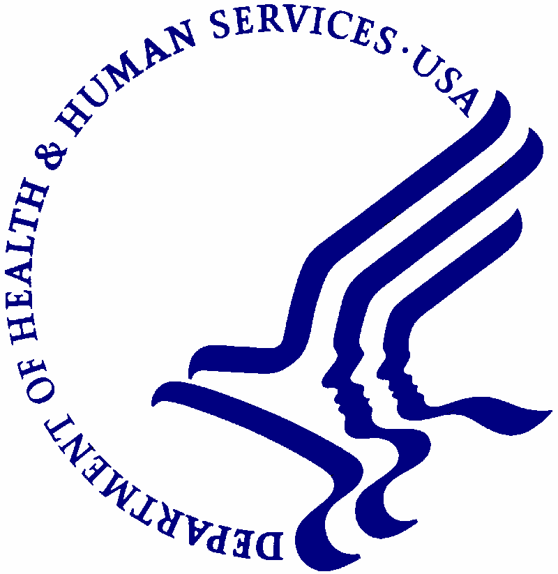
DEPARTMENT OF HEALTH & HUMAN SERVICES Office of the Secretary

DATE: March 31, 2021

TO: OMB Designee HHS Desk Officer Office of Management and Budget

FROM: CDC

SUBJECT: Request for Emergency Clearance of the Paperwork Reduction Act
Package for SimpleReport Mobile Application

Emergency Justification

The Centers for Medicare & Medicaid Services (CMS) is requesting that an information
collection request for State Health Insurance Exchange Security Incident Reporting to be
processed under the emergency clearance process associated with Paperwork Reduction Act of
1995 (PRA), specifically 5 CFR 1320.13(a)(2)(i). Public harm is reasonably likely to occur if the
normal, non-emergency -clearance procedures are followed. The information required is necessary to determine a laboratory’s compliance with the CLIA SARS-CoV-2 test reporting requirements at 42 CFR §§493.41, 493.555(c) and 493.1100(a). Legislative authority for these requirements and the supporting regulations is found in Section 353 of the Public Health Service Act. This information collection reflects a series of records required to be maintained by laboratories participating in the CLIA program and are based upon the publication of an interim final rule with comment (CMS-3401-IFC) on September 2, 2020. This data is being collected in order to record and data about point of care test results for the facility doing the testing and report the data to public health departments on behalf of the testing facility. SimpleReport will allow the user after the administration of a test to load in patient data, data about the facility, data about the testing device. The user can then use the application as a part of their testing workflow to manage their work. At present, SimpleReport is being deployed to a limited number of sites and has the following capabilities:

1. Test Queue:

- Add a person/people to the queue
- Complete ‘time of test questions’ (do you have symptoms, when was your last test, are you pregnant). These are Ask at Order Entry questions in the HL7 specification as designated in the HHS reporting requirements.
- If there are multiple options at the facility, select device type and swab type
- Enter the result for the test
- Submit the result

2. Manage People:

- Add new profile of a person
- Upload bulk CSV of people (possibly future version)
- Edit profiles of people
- Look at person’s profile
- Current data about that person
- Test and symptom history for a person

3. Results:

- View results of tests performed for this organization

4. Settings:

- Update settings for the facility
- Name
- CLIA Number
- Ordering provider name, phone, address, NPI
- Add testing devices (BD Veritor, Quidel Sofia, Abbott IDNow, Abbott BinaxNow card)
- Set default device

Future versions may include a range of capabilities based upon feedback and user testing. These may include, among others: the ability to collect additional data for people who test positive, describing the swab type and default, setting of timers, appointments and testing schedule management. Future versions may have greater capability to sort, filter and search test results, filters based on role, and downloadable CSVs of results. Future versions may also be able to capture more information about facilities, including contact information, whether there are multiple ordering providers, viewing multiple facilities within an organization, and roles for users within an organization. Finally, the application may ultimately include patient access to edit, enter, and view information.

Outside of the capabilities and future capabilities of the application, the fields currently collected for each POC test administered include:

• Patient Name
• Lookup ID (The ID an organization uses for its own purposes, e.g., MRN, employee ID, student ID)
• Role (resident, staff, visitor, student)
• Date of Birth
• Phone
• Email
• Address
• Race
• Ethnicity
• Sex
• Resident in congregate care setting (y/n)
• Employed in Healthcare (y/n)
• Result date
• Result (Positive/Negative/Inconclusive

Future versions may include additional identifiers as necessary or legally required by the states.

Background

On March 13, 2020, the President declared a national emergency in response to the public health emergency (PHE) caused by the SARS–CoV–2 virus, otherwise known as COVID-19.
The CARES Act was published in response to the PHE that requires “every laboratory that performs or analyzes a test that is intended to detect SARS–CoV–2 or to diagnose a possible case of COVID–19 shall report the results from each such test.” A CLIA-certified laboratory or testing site must also report all COVID-19 test results to their respective state, local, tribal, or territorial health department. CMS-certified long-term care facilities must also report SARS-CoV-2 point-of-care antigen test data and other on-site COVID-19 laboratory testing data.

SimpleReport is a free web-based application that provides an easy way to manage the testing workflow, to record results for rapid point of care COVID tests, to report the results to the appropriate public health department on behalf of the testing site, and to comply with existing requirements.

The data collected through this app is crucial for public health departments to take action during the current health crisis. Currently, many point of care tests are reported on paper, on fax, or are not reported at all. The Diagnostics and Testing task force, estimates that only 10% of point of care tests are being reported today. Paper and fax test results create a large burden for health departments to digitize the data and much of it is incomplete or has typos.

Many community mitigations are based on laboratory positivity rate in the community. If the percentage increases, schools and restaurants may close and hospitals may cancel elective surgeries. The negative results are critical to ensuring an accurate positivity rate and the current hypothesis is that many of these negative results from point of care tests are not being reported. Millions of point of care tests are being sent to the states for distribution and soon the point of care tests will outnumber the traditional PCR tests.

SimpleReport will help public health departments get faster, better data and help them:

• Receive high quality, timely data
• Do contact tracing and case investigation faster with positive cases
• Identify outbreaks in the community faster
• Calculate percent positivity for testing continuously

