

**Electronic Consent Based Social Security Number Verification (eCBSV)**

**SCREEN PACKAGE**

Table of Contents

**1.** **eCBSV Registration Screens** 5

**a.** **Optional Screens to Test Open ID Connect (OIDC) Registration** 5

i. Validate to Perform Dynamic Client Registration 5

ii. Validation successful 6

iii. Invalid Issuer URL Validation - Failure message 7

iv. Validate to Perform Dynamic Client Registration using Authorization Header Credentials 8

v. Validation successful 9

vi. Validation failure 10

**b.** **Entity Registration for Direct Customers** 11

i. Provide Information 11

ii. Review and Submit 13

iii. Entity Registration Success 14

iv. Sample Entity Registration Email 14

**c.** **Financial Institution Registration for Indirect Customers** 15

i. Enter Information & EIN Consent 15

ii. Permitted Entity Certification 16

iii. Sign Permitted Entity Certification 18

iv. Financial Institution Success 21

**2.** **eCBSV Customer Connection Screens** 22

**a.** **Login Screen** 22

**b.** **Redirected to Entity Login Screen** 23

**c.** **Unenrolled Home Screen** 24

**d.** **Contacts** 25

i. First-Time User 25

ii. Add Contact and Assign Role(s) 26

iii. Contact Main Screen 28

**e.** **Permitted Entity Certification** 29

i. Main Screen 29

ii. Sign Certification 31

iii. Main Screen After Signature 36

**f.** **User Agreement** 37

i. User Agreement Main 37

ii. User Reads & Initials User Agreement Section(s) 39

iii. Sign Agreement 41

iv. Main Screen After Signature 46

**g.** **Tier Subscription** 47

i. Select Tier Selection 47

ii. Tier Subscription Review & Pay 49

iii. Pay.Gov Redirect 50

iv. Pay.gov Pay Screen 1 (for payments of $24,999 or lower) 51

v. Pay.gov Pay Screen 2 (Checking or Savings Account (ACH)) 52

vi. Pay.gov Pay Screen 3 (Credit or Debit Card) 53

vii. Pay.gov Pay Screen 4 (Review and Submit Payment) 54

**h.** **Start Exchanging** 55

i. Payment Confirmation 55

ii. Print/Download Page Contents 56

**i.** **Payment Receipt** 57

i. Receipt 57

ii. Print/Download Receipt 58

iii. Sample Enrollment Email 59

**j.** **Enrolled User Home Screen** 60

**k.** **Entity Information** 61

**l.** **Tier Subscription Renewal** 62

i. Tier Subscription Selection 62

ii. Tier Subscription Review & Pay 64

iii. Pay.gov Redirect 65

**m.** **Documents** 66

**n.** **ETE Registration** 67

i. Registration 67

ii. ETE Registration Success 68

# **eCBSV Registration Screens**

## **Optional Screens to Test Open ID Connect (OIDC) Registration**

### Validate to Perform Dynamic Client Registration

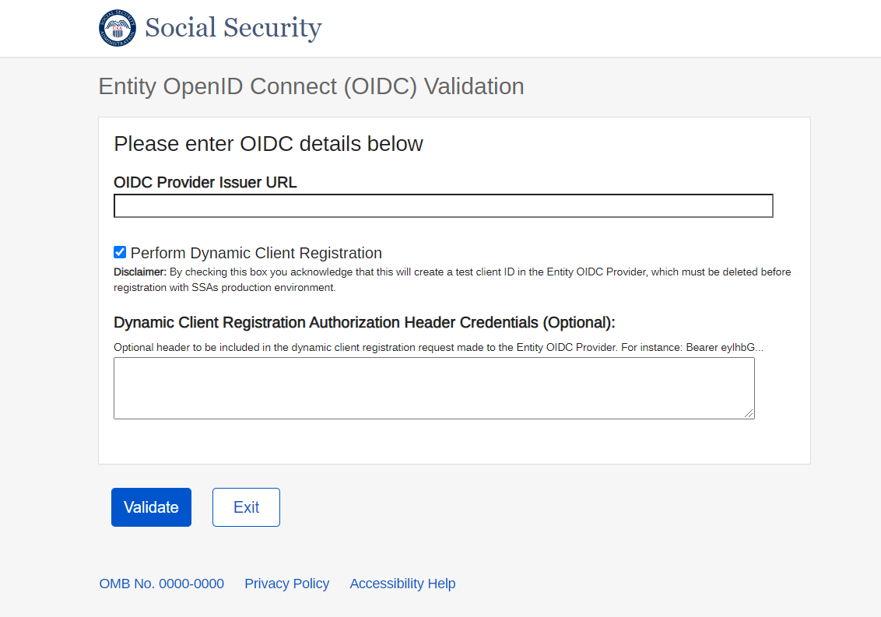

* + 1. Validation successful

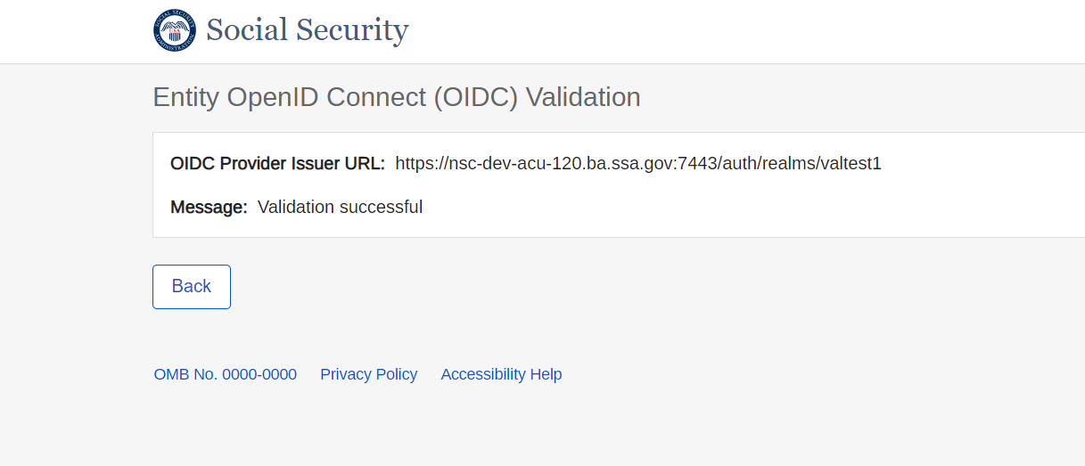

* + 1. Invalid Issuer URL Validation - Failure message

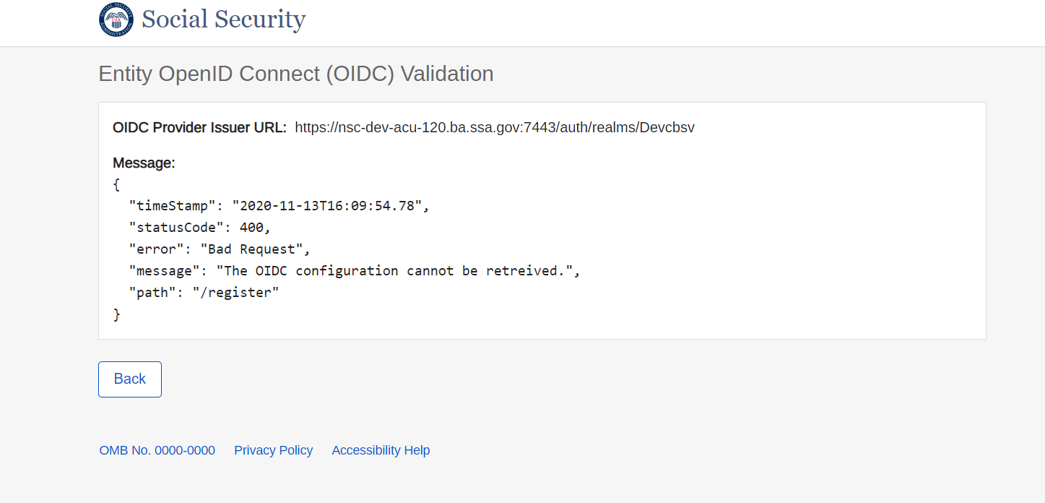

* + 1. Validate to Perform Dynamic Client Registration using Authorization Header Credentials

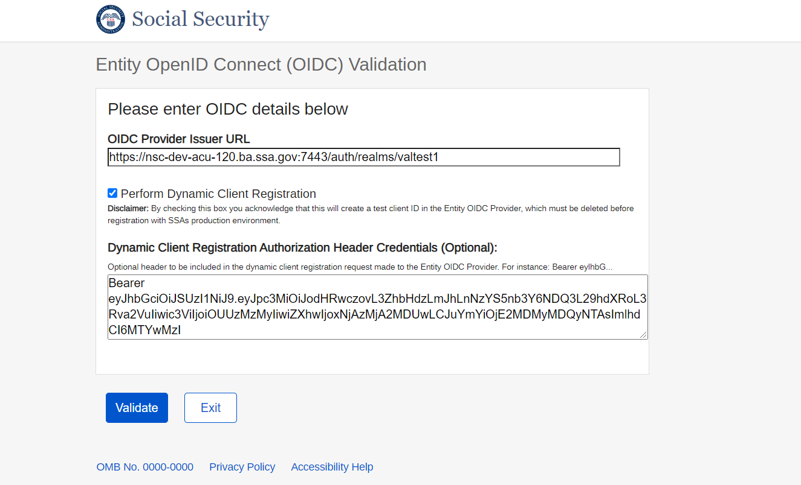

* + 1. Validation successful



* + 1. Validation failure

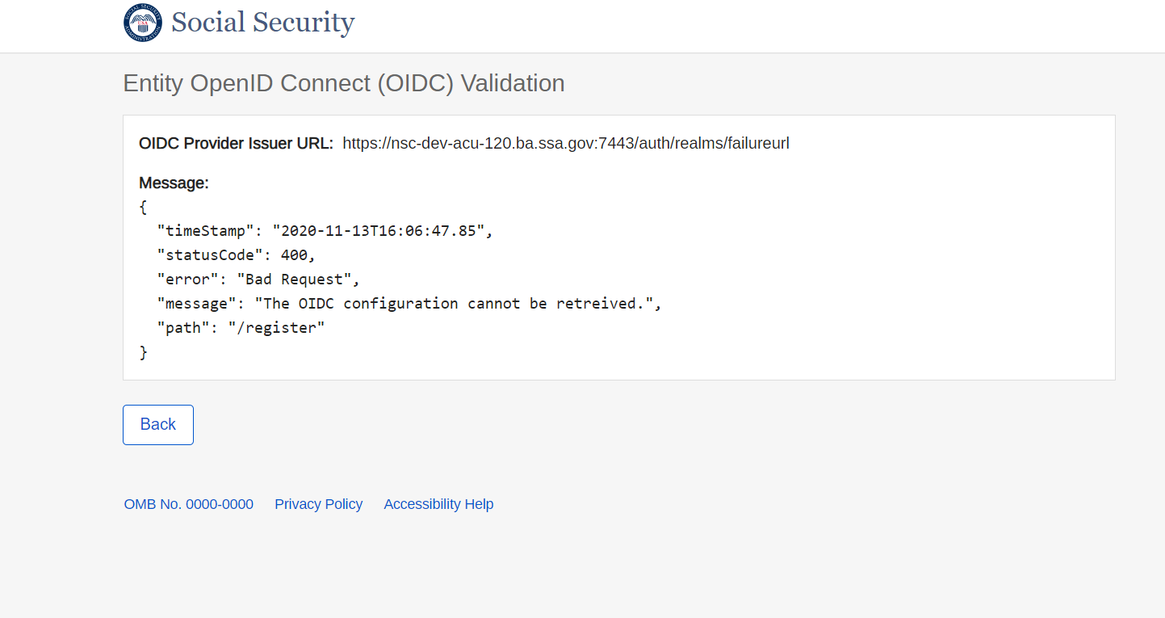

## **Entity Registration for Direct Customers**

### Provide Information

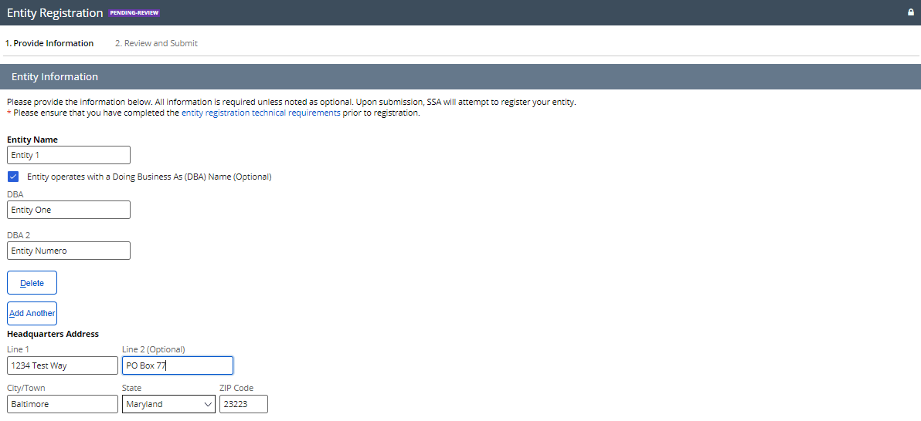

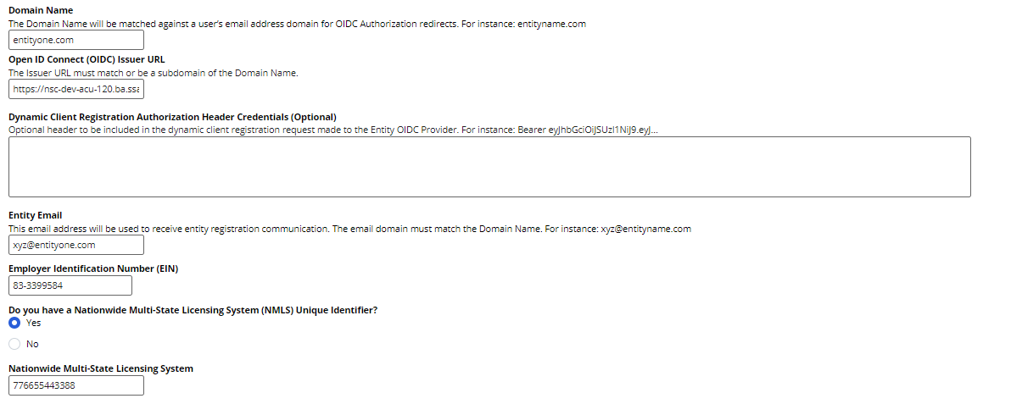

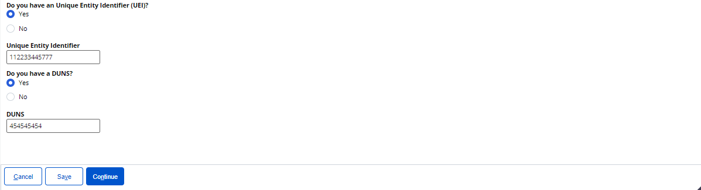

### Review and Submit

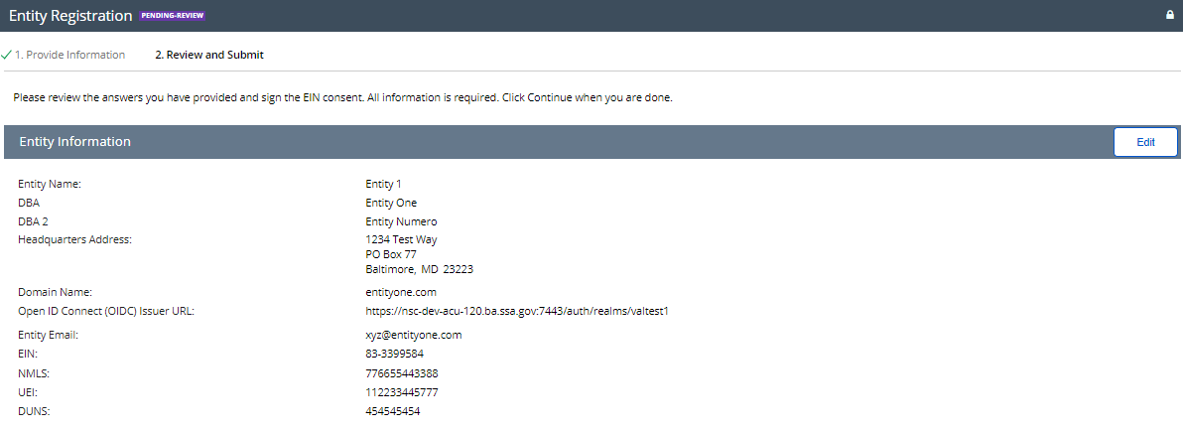

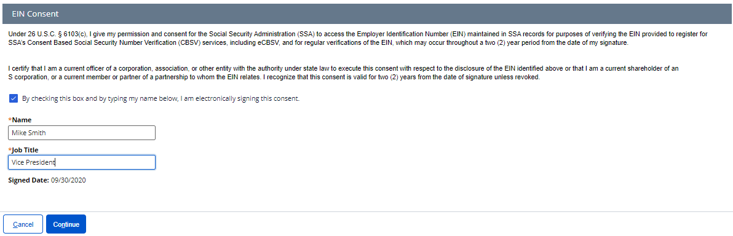

### Entity Registration Success

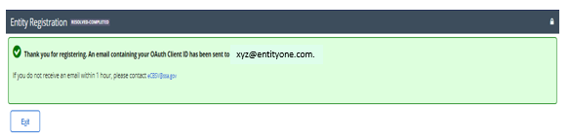

### Sample Entity Registration Email

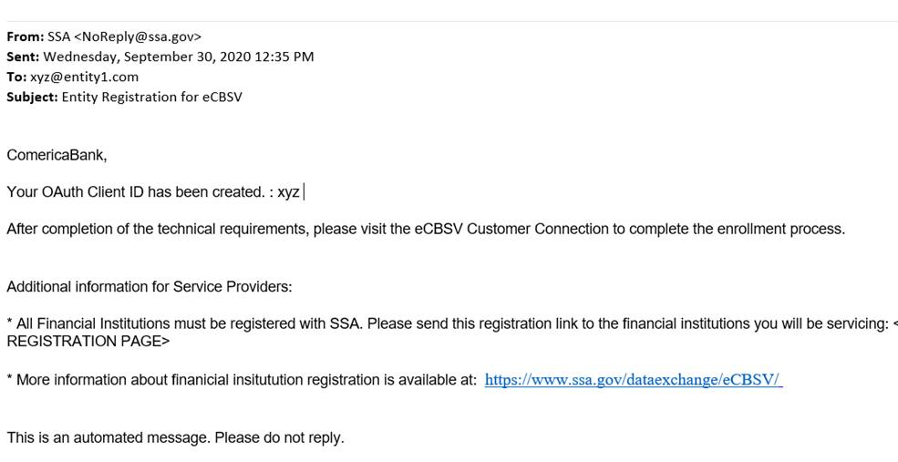

Entity 1,

## **Financial Institution Registration for Indirect Customers**

### Enter Information & EIN Consent

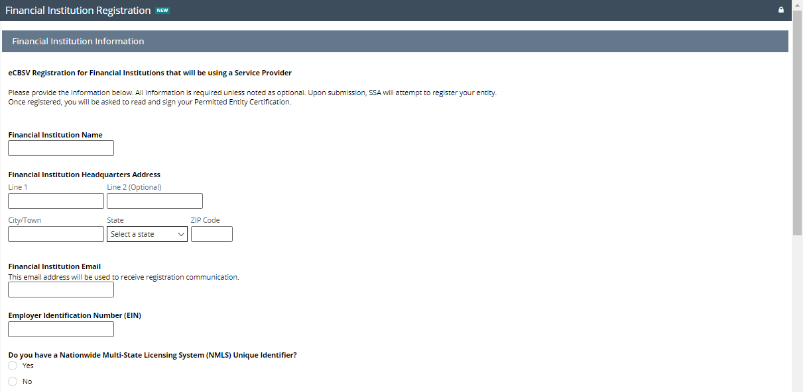

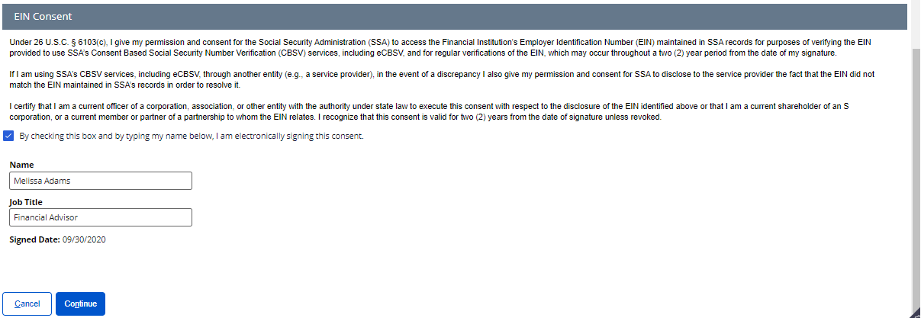

### Permitted Entity Certification

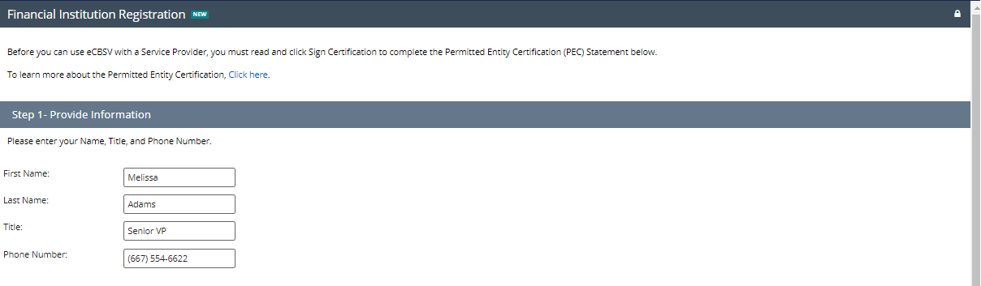

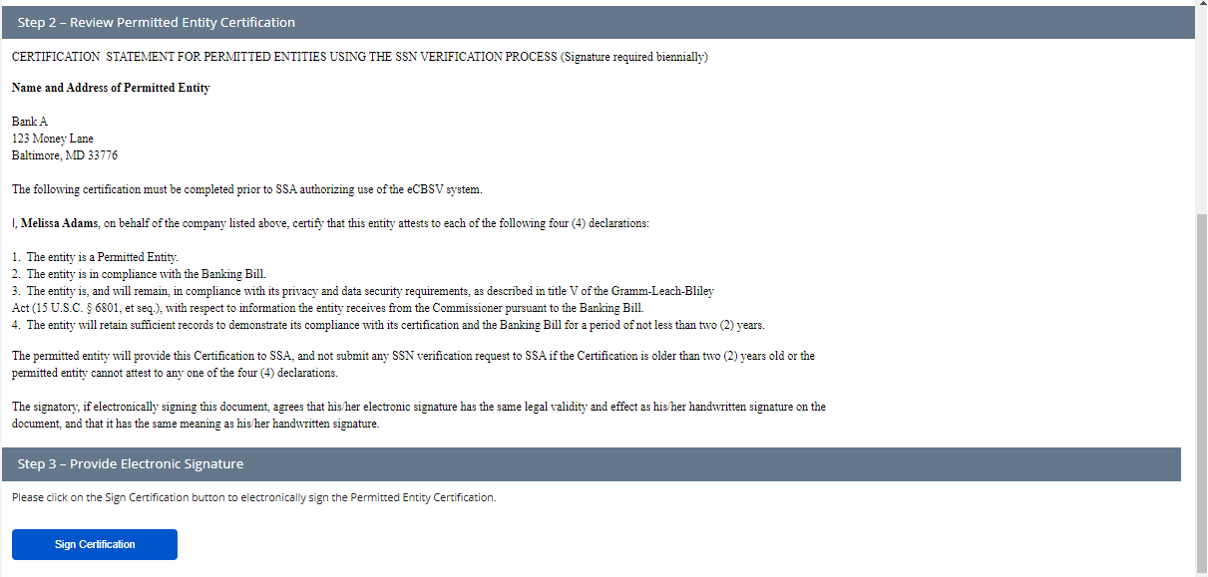

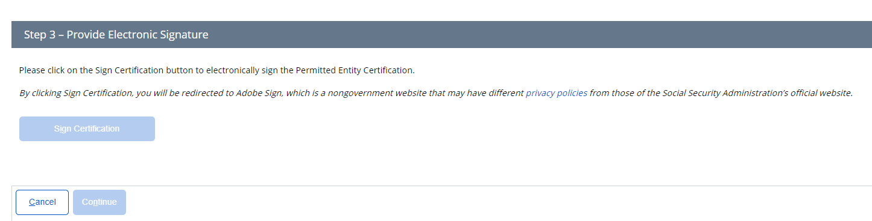

### Sign Permitted Entity Certification

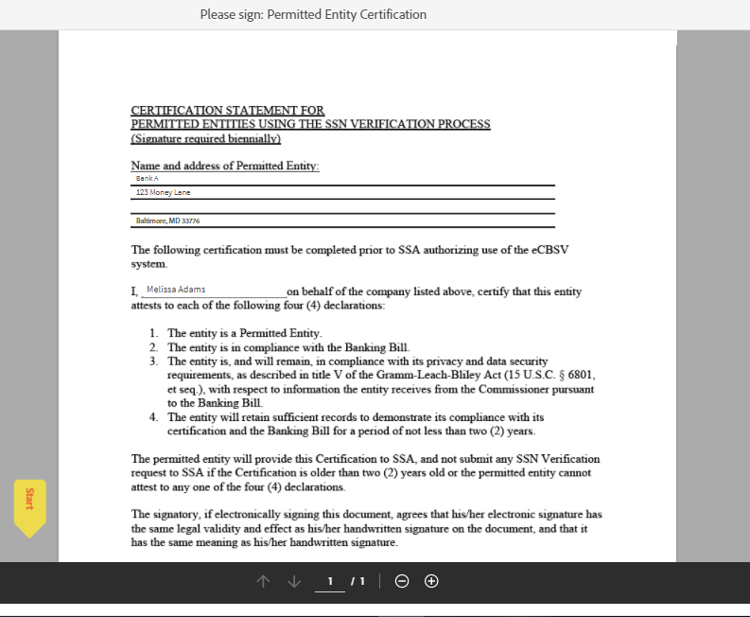

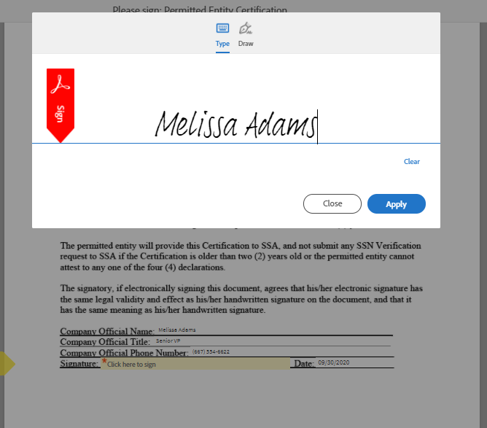

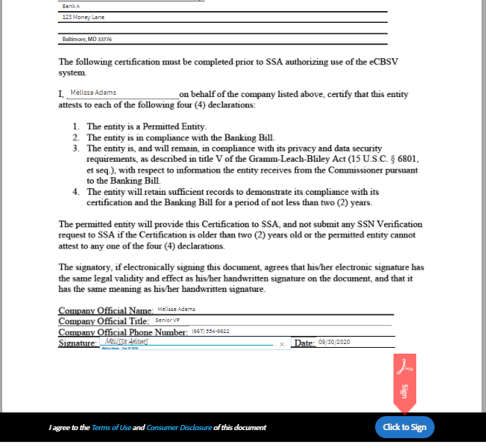

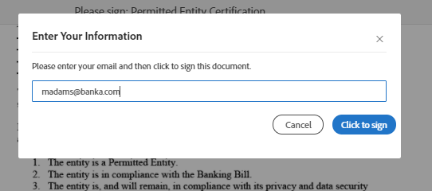

### Financial Institution Success



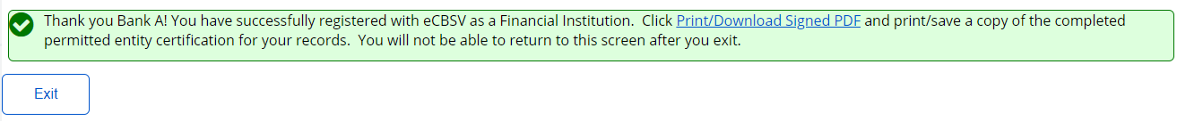

# **eCBSV Customer Connection Screens**

## **Login Screen**

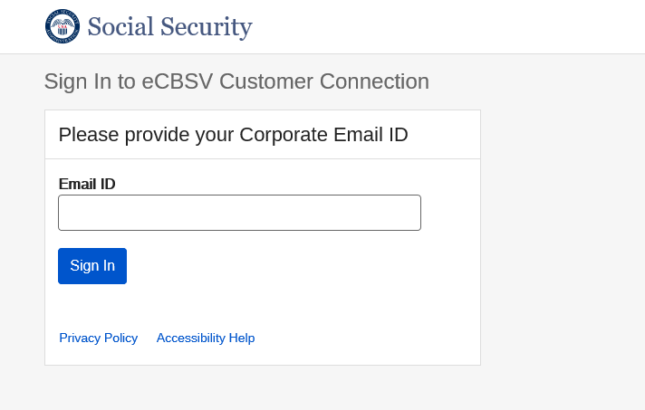

## **Redirected to Entity Login Screen**

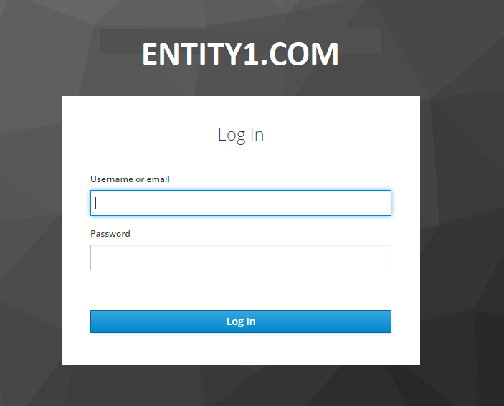

## **Unenrolled Home Screen**

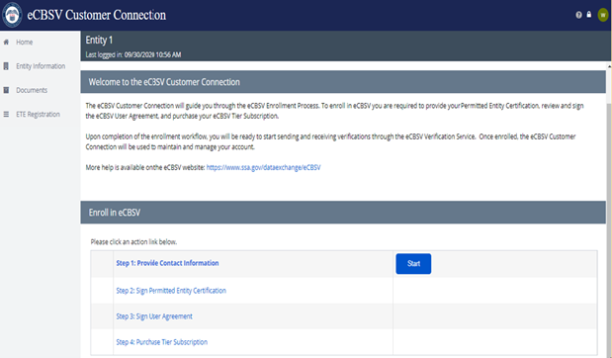

* 1. **Contacts**
     1. First-Time User

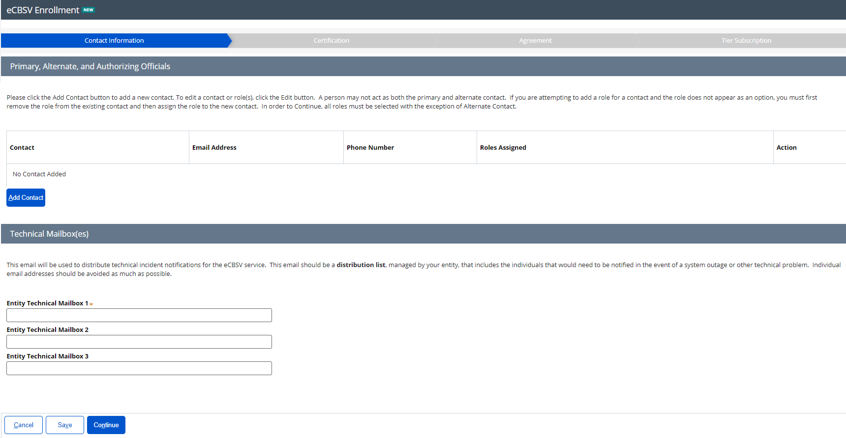

### Add Contact and Assign Role(s)

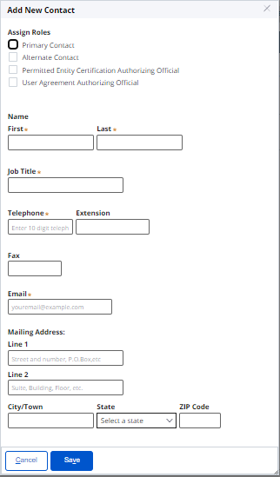

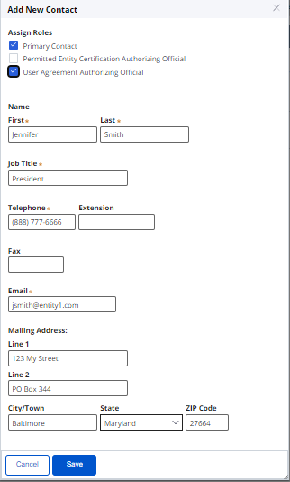

### Contact Main Screen

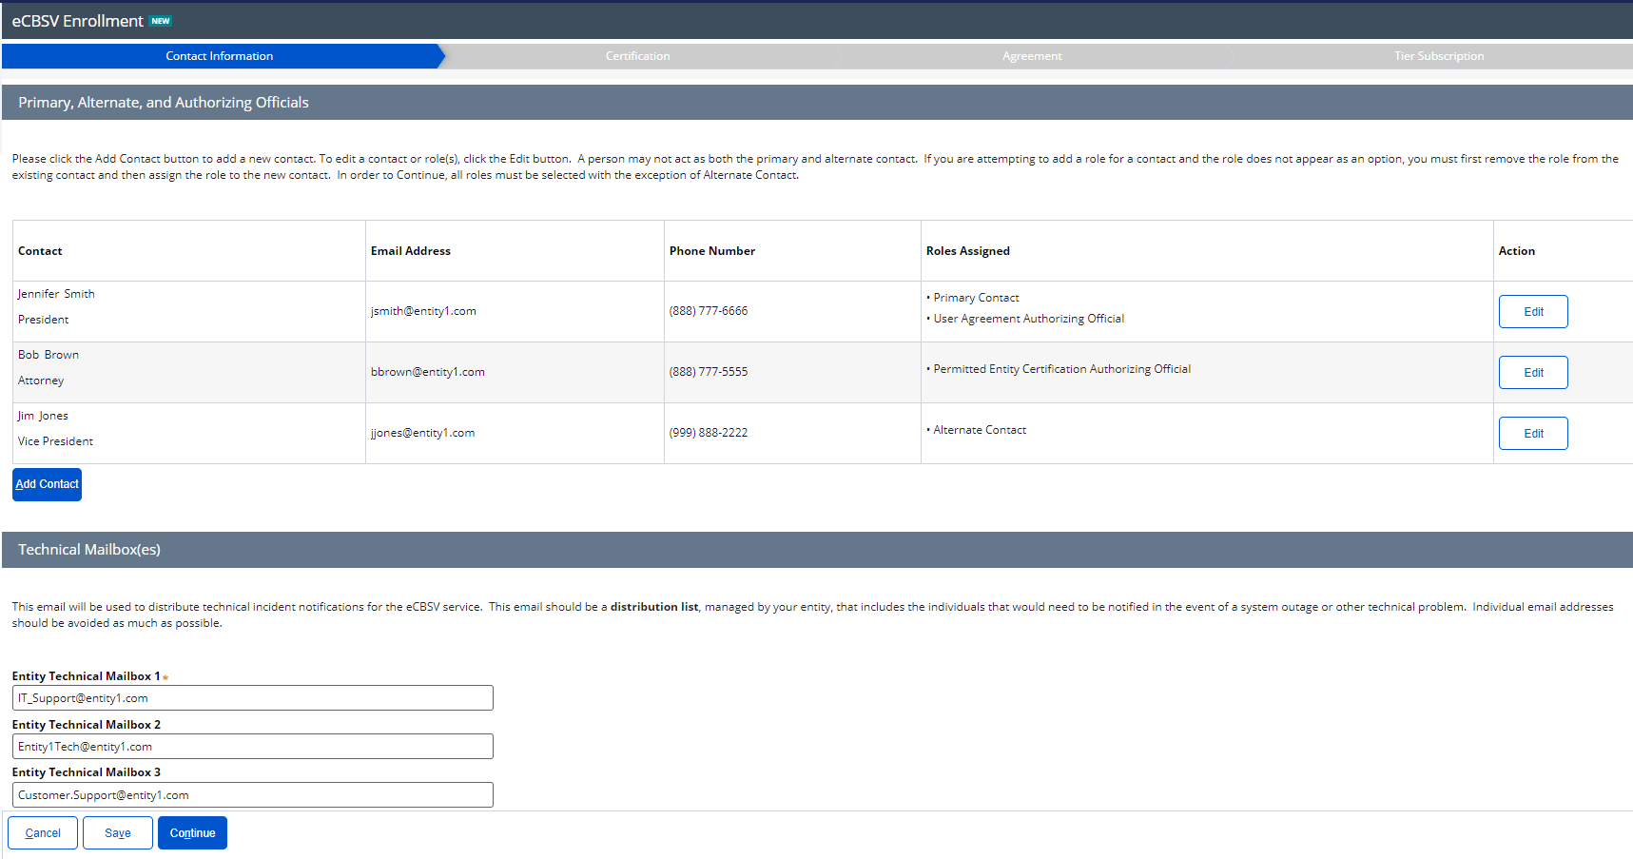

## **Permitted Entity Certification**

### Main Screen

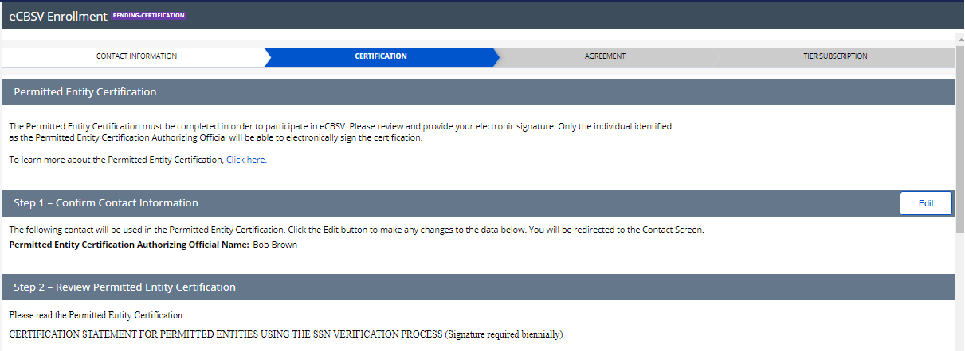

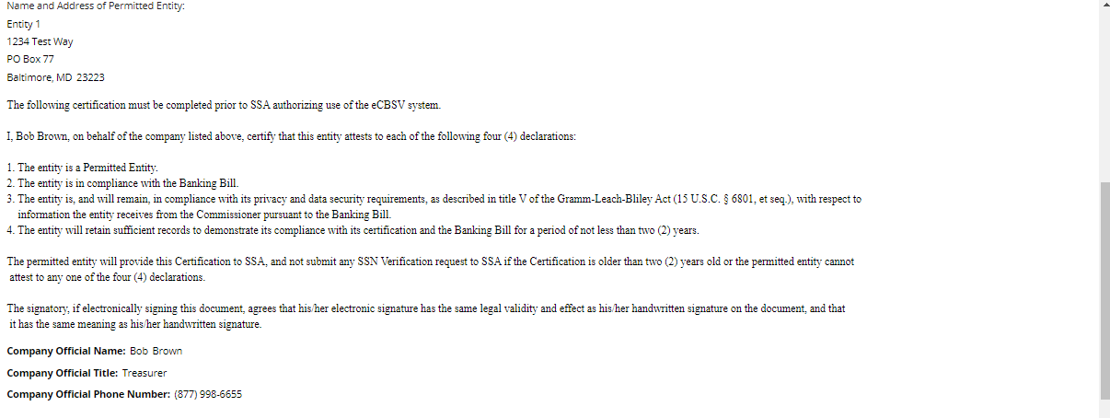



* + 1. Sign Certification

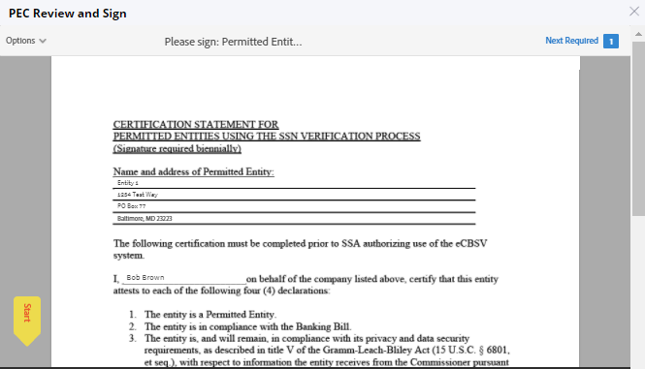

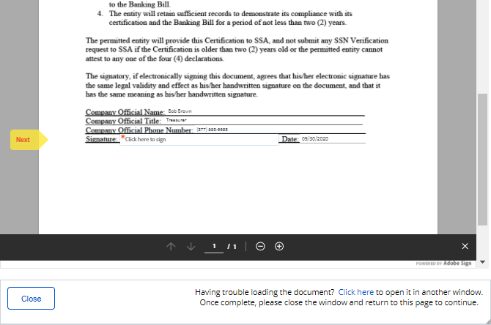

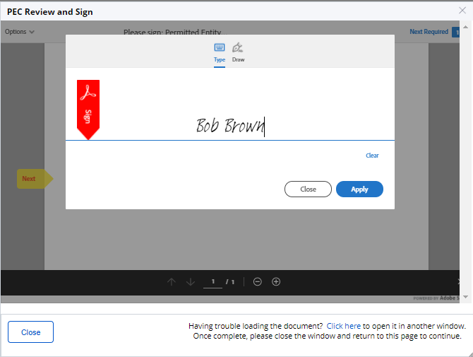

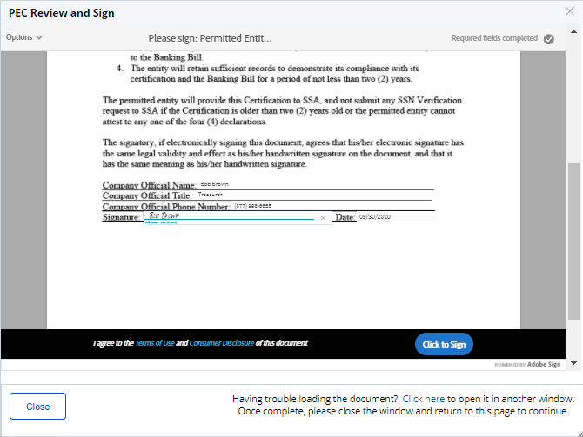

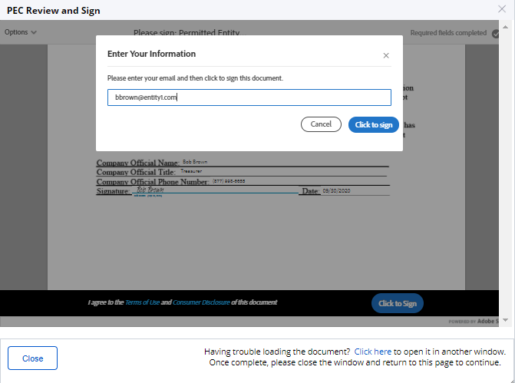

* + 1. Main Screen After Signature

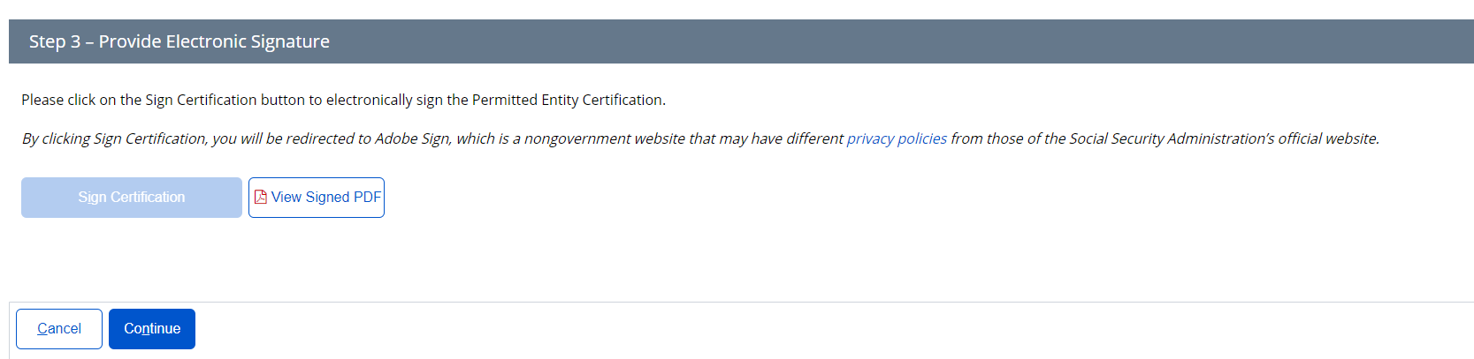

* 1. **User Agreement**
     1. User Agreement Main

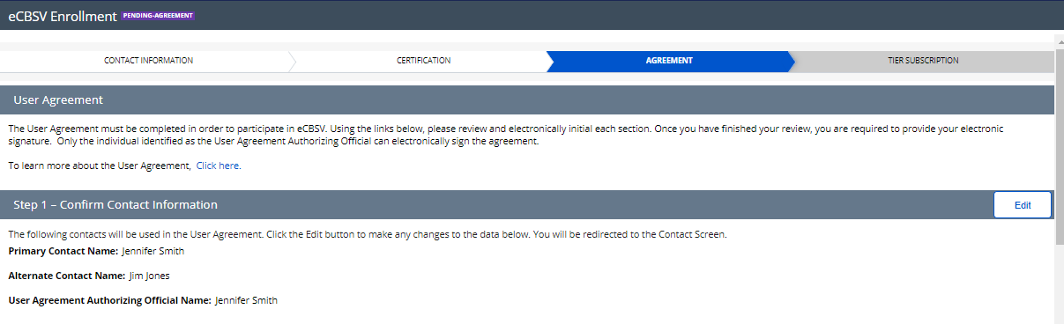

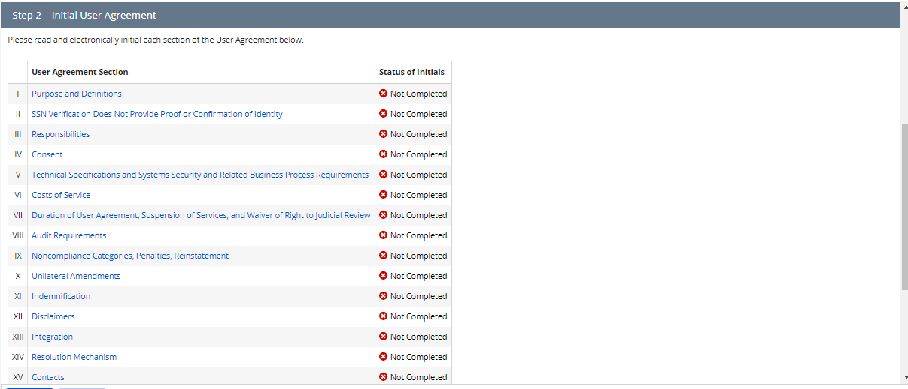

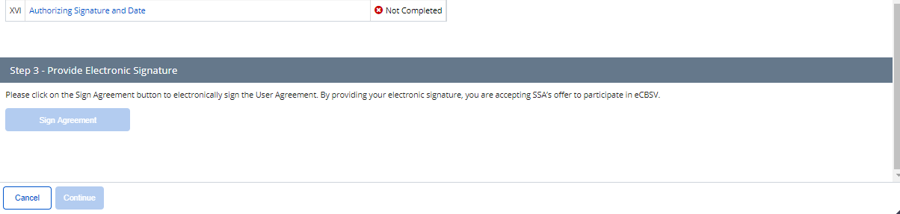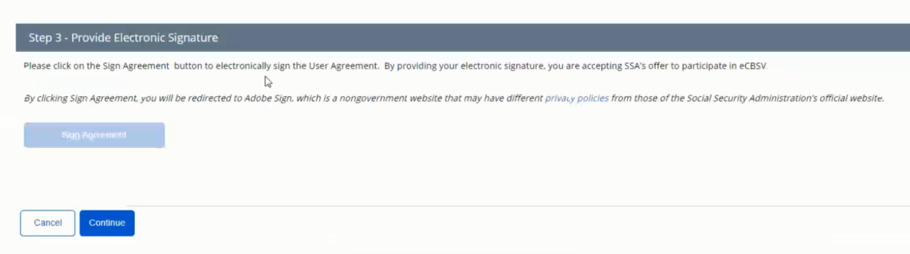

### User Reads & Initials User Agreement Section(s)

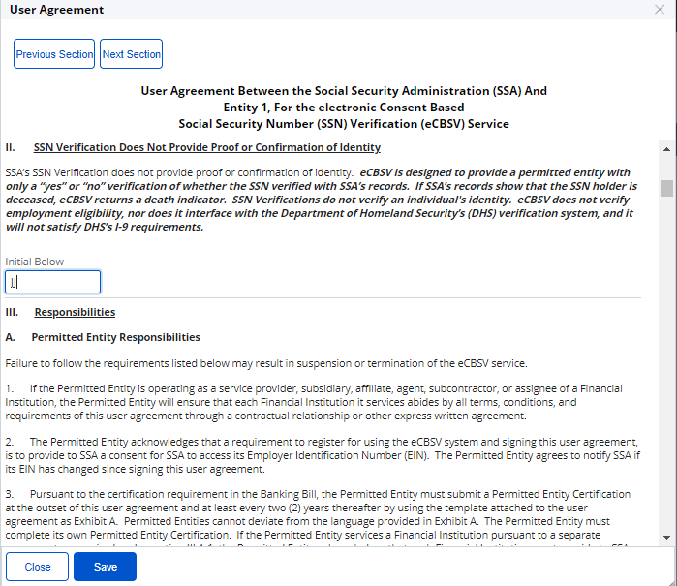

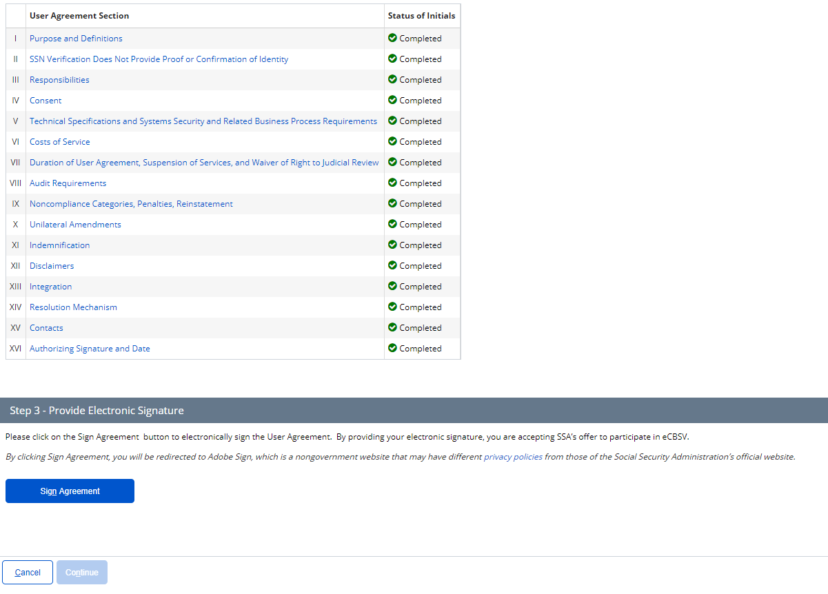

* + 1. Sign Agreement

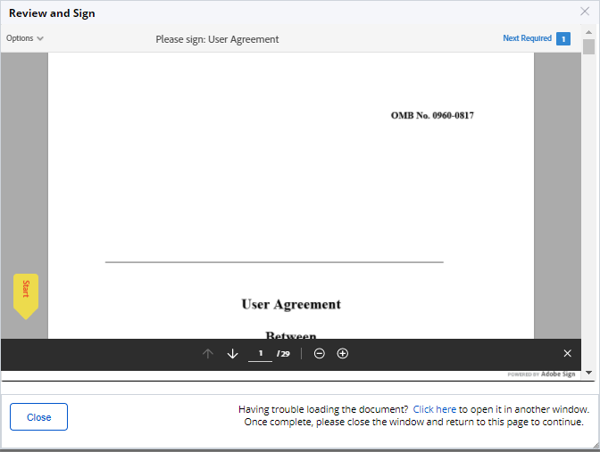

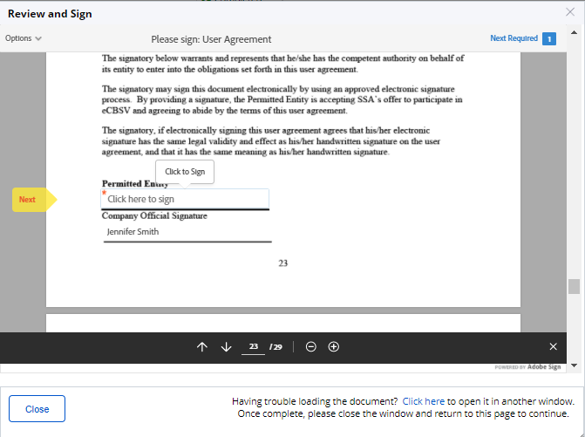

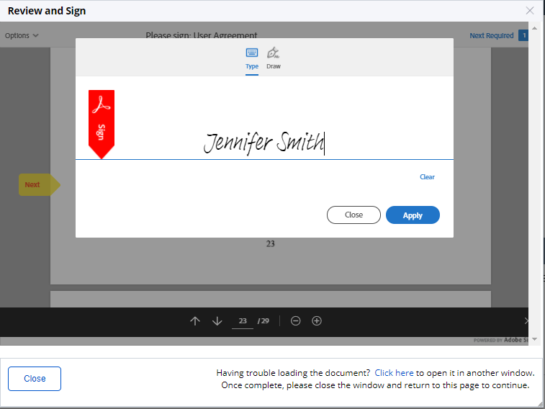

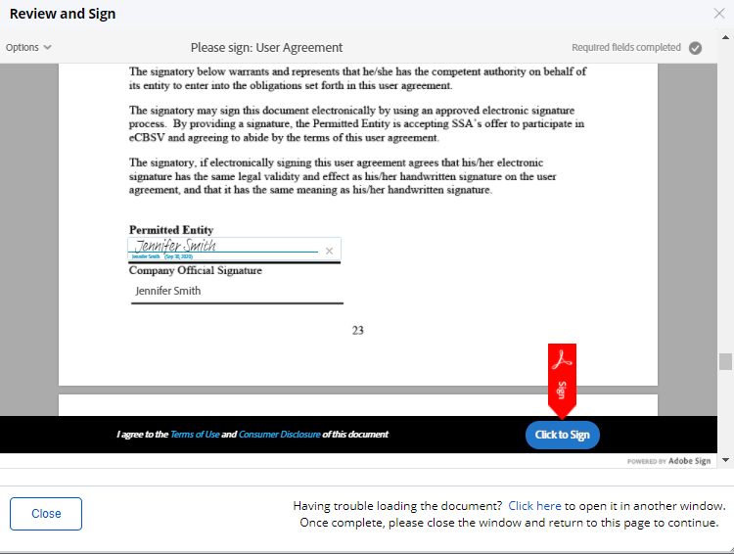

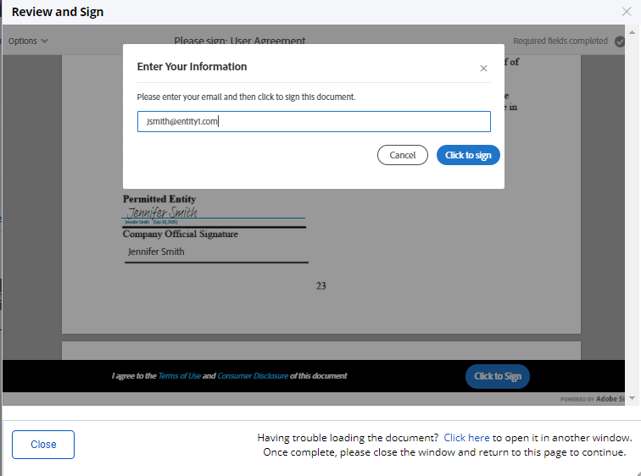

* + 1. Main Screen After Signature

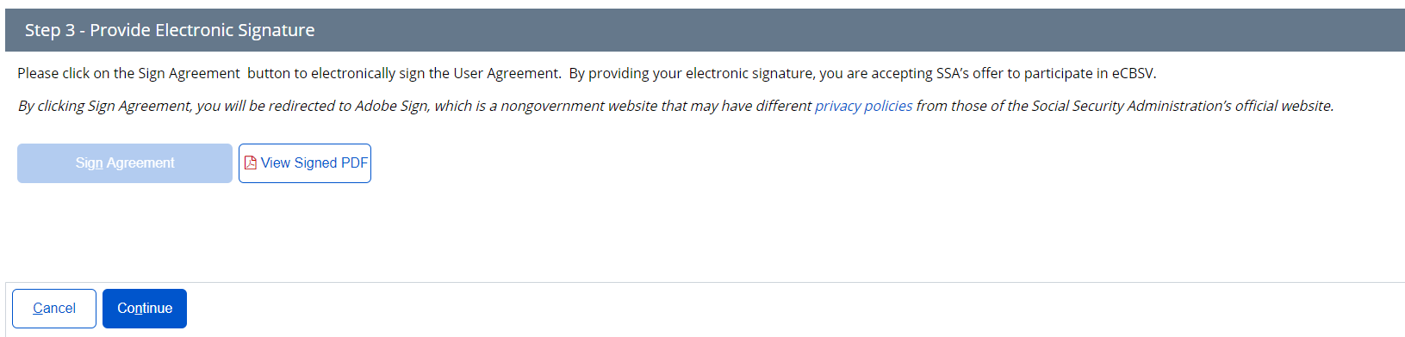

* 1. **Tier Subscription**
     1. Select Tier Selection

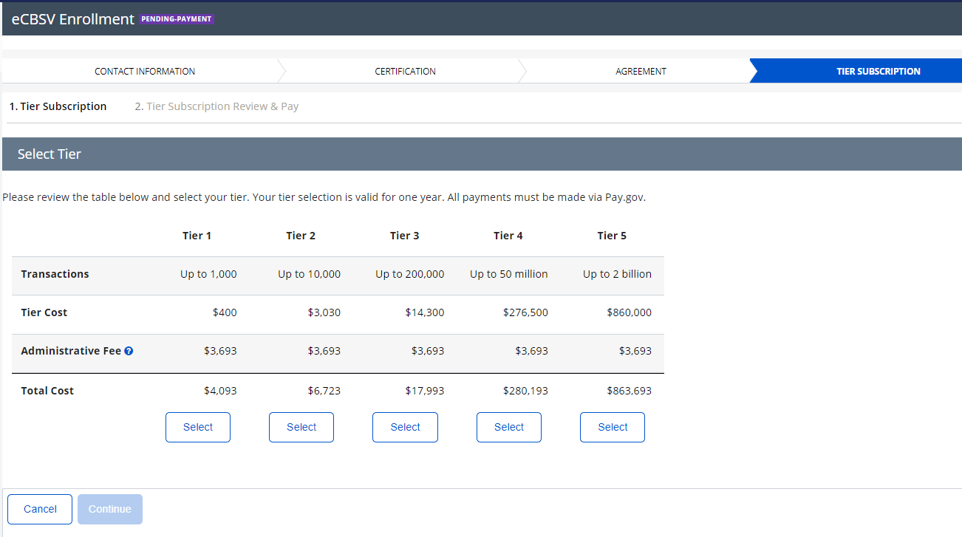

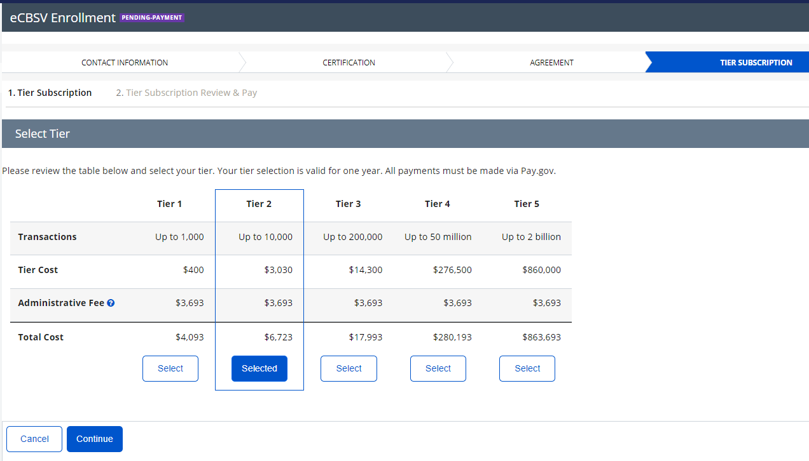

* + 1. Tier Subscription Review & Pay

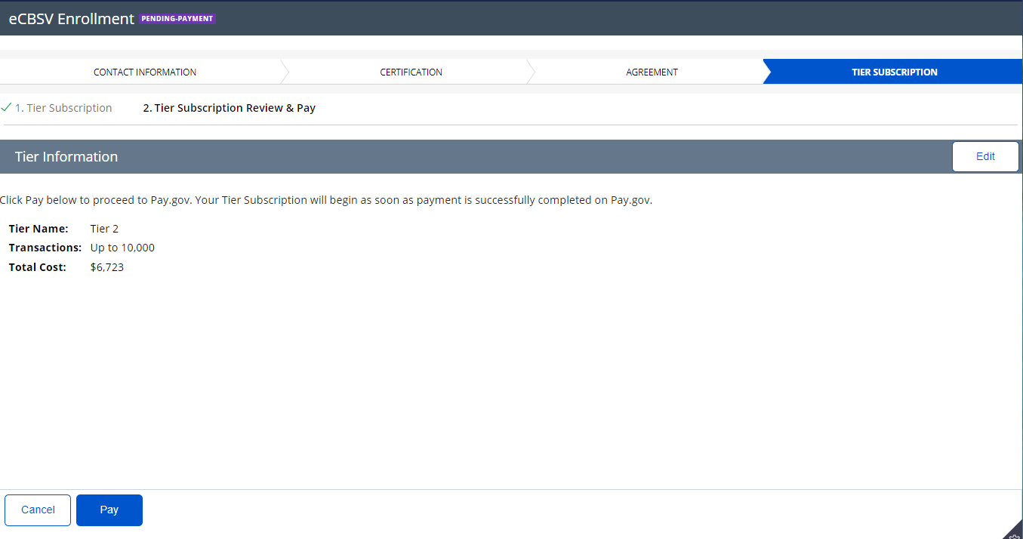

* + 1. Pay.Gov Redirect

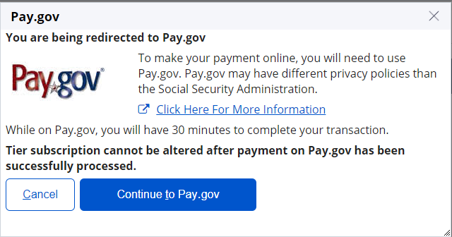

* + 1. Pay.gov Pay Screen 1 (for payments of $24,999 or lower)

Note: Customers with payments of $25,000 and greater will not see this screen as they will be required to pay by ACH.

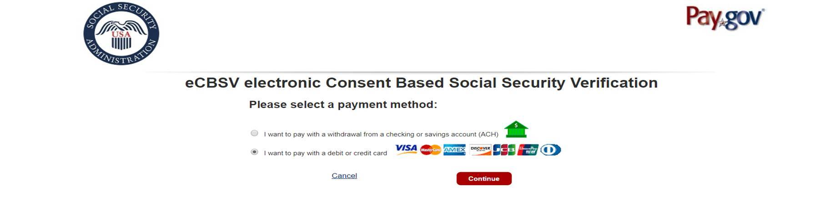

* + 1. Pay.gov Pay Screen 2 (Checking or Savings Account (ACH))

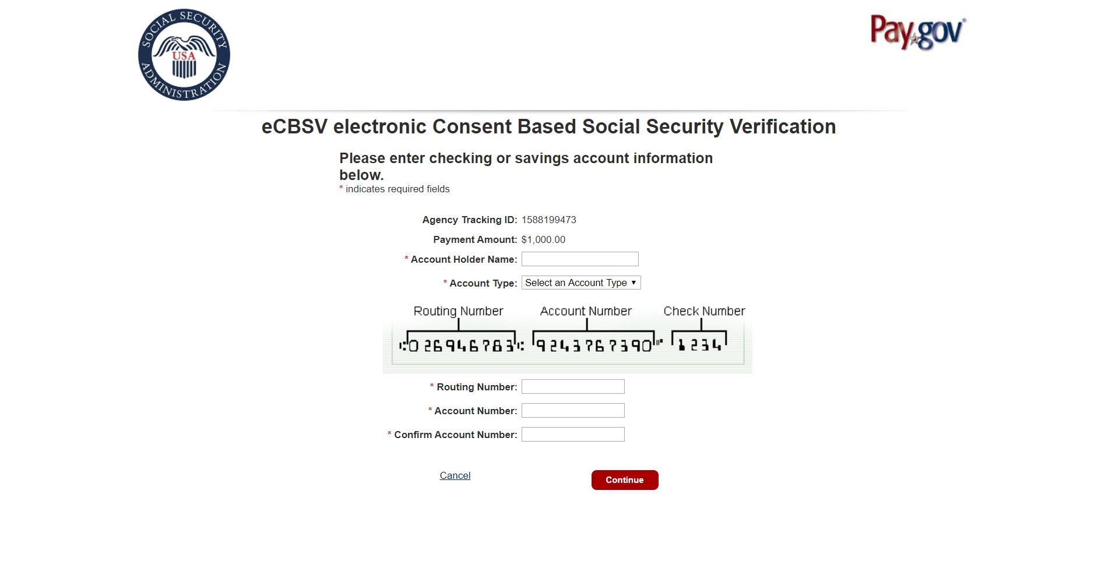

* + 1. Pay.gov Pay Screen 3 (Credit or Debit Card)

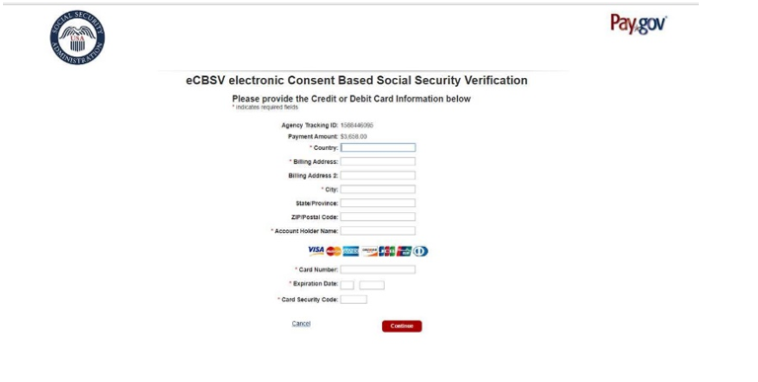

* + 1. Pay.gov Pay Screen 4 (Review and Submit Payment)

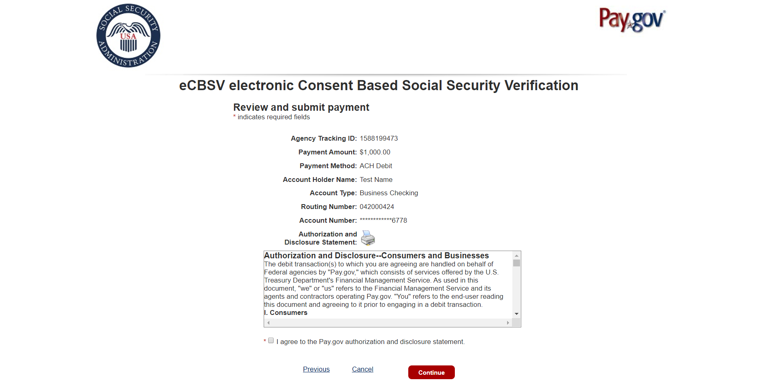

* 1. **Start Exchanging** 
     1. Payment Confirmation

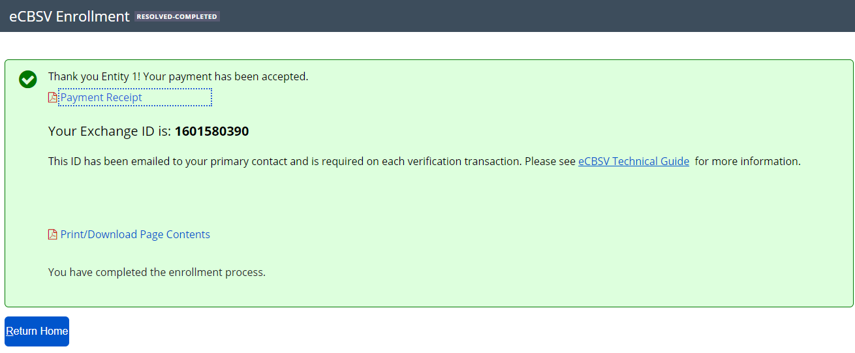

* + 1. Print/Download Page Contents

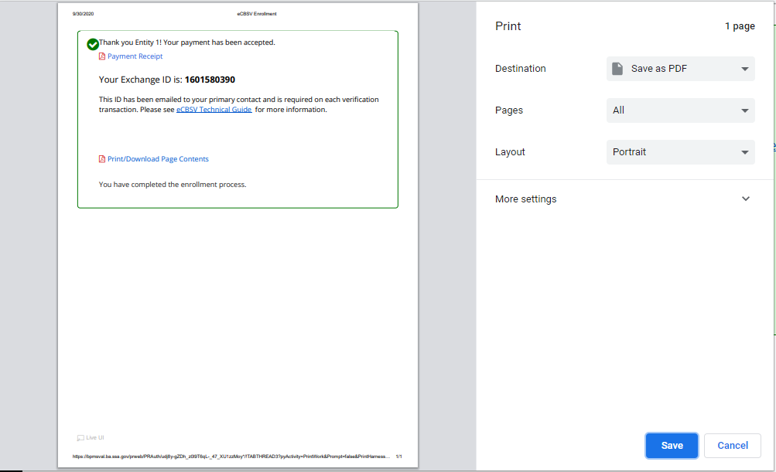

* 1. **Payment Receipt**
     1. Receipt

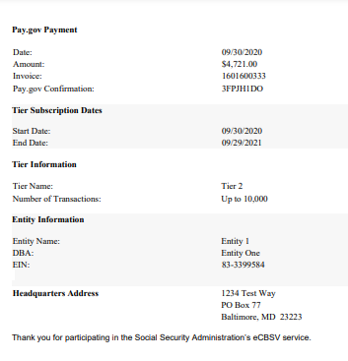

### Print/Download Receipt

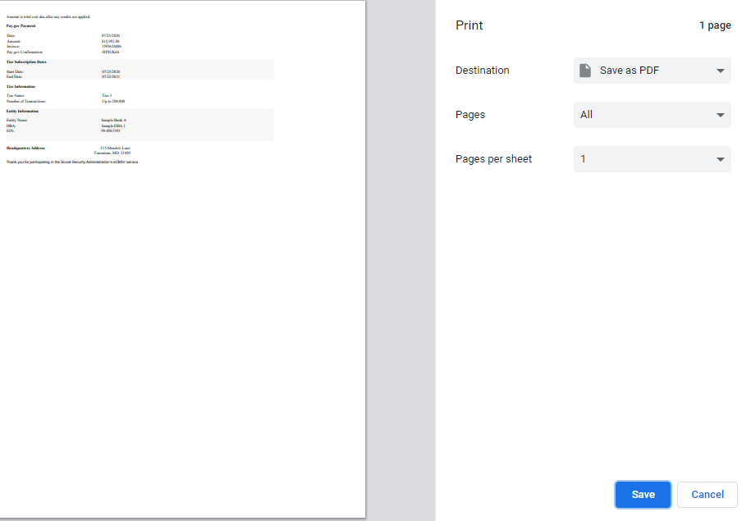

* + 1. Sample Enrollment Email

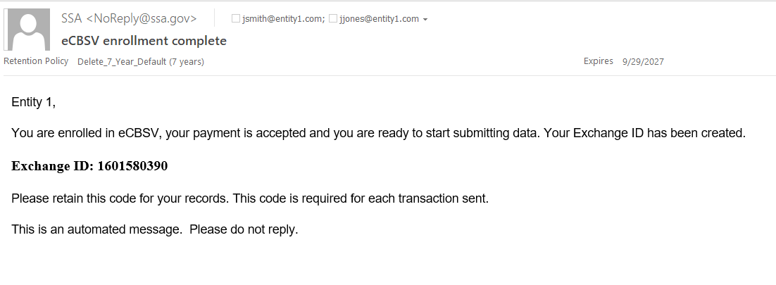

## **Enrolled User Home Screen**

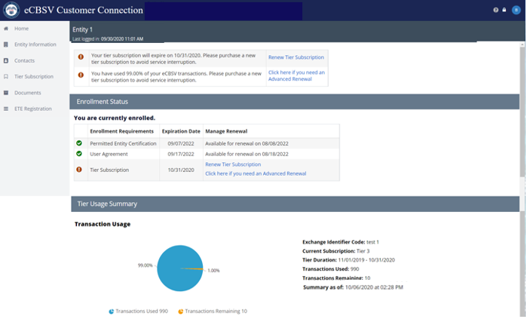

## **Entity Information**

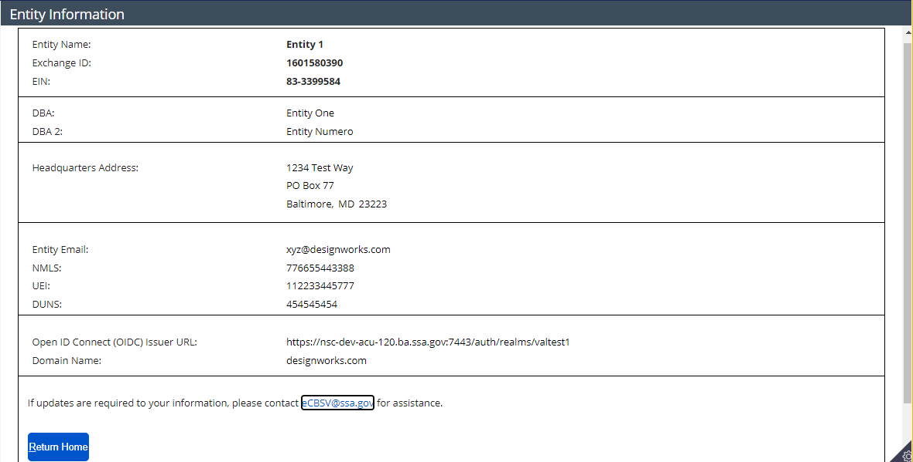

## **Tier Subscription Renewal**

## Tier Subscription Selection

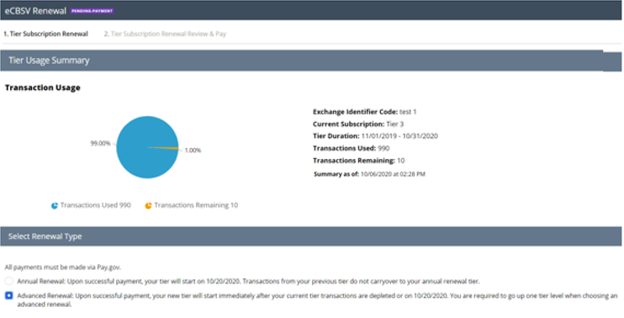

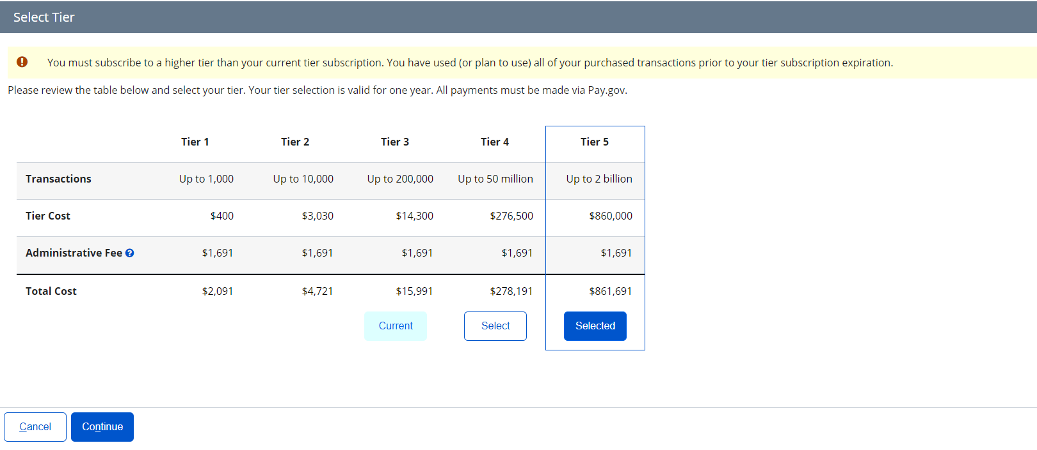

### Tier Subscription Review & Pay

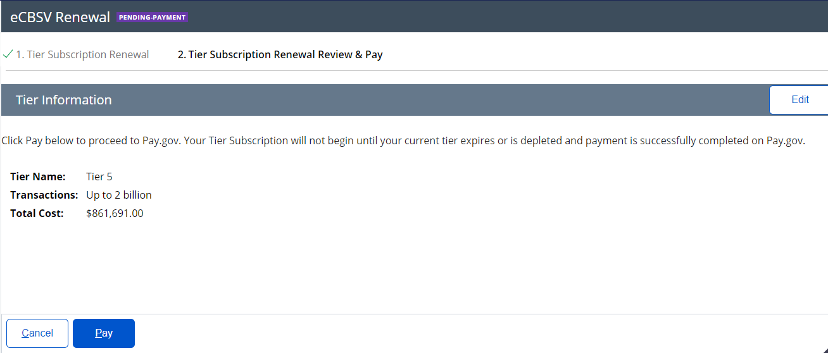

### Pay.gov Redirect



## **Documents**

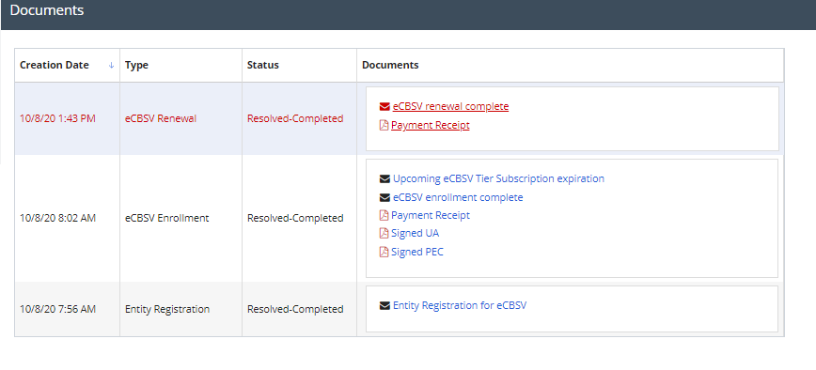

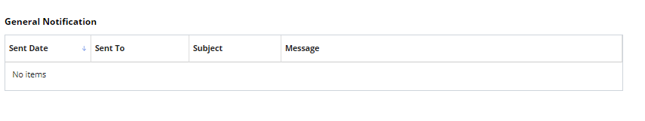

## **ETE Registration**

### Registration

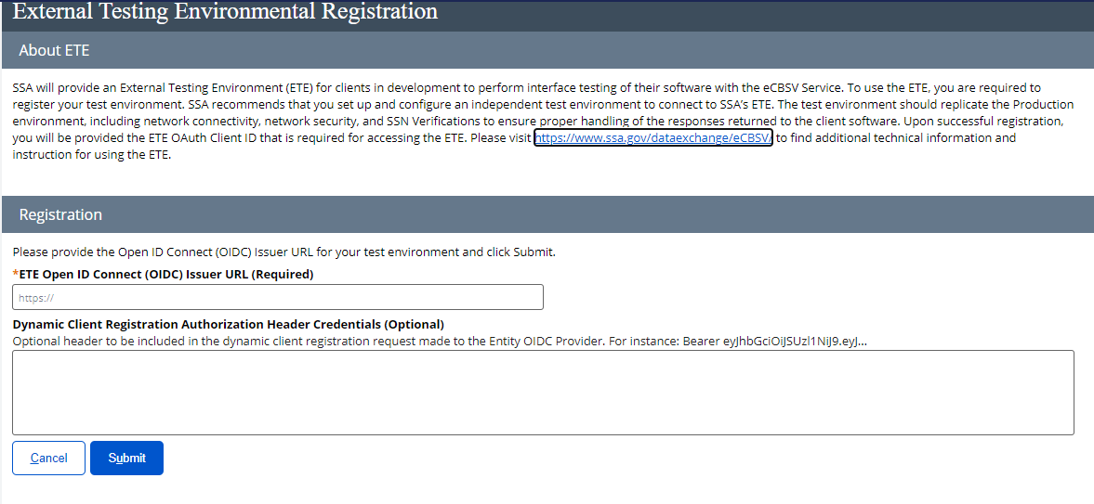

### ETE Registration Success

