One Page Project Overview

Policymakers have long been concerned about the poor outcomes experienced by youth transitioning out of foster care into adulthood. The John H. Chafee Foster Care Independence Act (the Chafee Act) provides $140 million in federal funding annually to help states provide independent living services to youth making this transition and allocates 1.5 percent of those funds to rigorous evaluation of such programs. Although the first round of evaluations of independent living programs conducted under the Chafee Act, the Multi-Site Evaluation of Foster Youth Programs, found limited evidence of the effectiveness of the specific programs studied, the project demonstrated that rigorous evaluation of independent living services is possible, and that experimental methods can be used. Yet, few programs are sufficiently ready for rigorous evaluation. The reasons include:

- Programs may have relatively weak intervention "dosages" so youth outcomes are not very strong or easy to detect
- Programs may have a limited understanding of the characteristics of the populations they are intended to serve, which can lead to poor service targeting;
- Programs may have limited capacity for data collection and management;
- Program referral processes may not be systematic or well understood making them difficult to evaluate; and
- Many programs serve a relatively small number of youth, which poses challenges for rigorous evaluation methods.

A team of researchers at the Urban Institute and Chapin Hall at the University of Chicago has been contracted by the Administration for Children and Families (ACF) of the US Department of Health and Human Services to plan a next-generation evaluation agenda for the John H. Chafee Foster Care Independence Program. This is an opportunity to engage the field in a collaborative process of identifying promising independent living programs, exploring what these programs would need to do to become ready for rigorous evaluation.

The project team has been speaking with individuals who operate categories of programs of particular interest to ACF, including college success, Education and Training Vouchers (ETVs) employment services, housing, and specialized case management programs. The purpose of these exploratory interviews is to help the research team better understand the types of programs that currently exist in each of these areas, learn more about how those programs operate on the ground, and identify next steps for readying and scaling-up some of these programs for potential future evaluation activities.
An agency may not conduct or sponsor, and a person is not required to respond to, a collection of information unless it displays a currently valid OMB control number. The OMB number for this information collection is 0970-0489 and the expiration date is XX/XX/XXXX.

Project Fact Sheet
This form answers a number of questions that potential focus group participants may have about the focus groups.
- Who is doing the focus group and why?
The focus group is being done by researchers from the Urban Institute and Chapin Hall at the University of Chicago. The researchers are conducting a study of programs for transition age foster youth for the Administration for Children and Families (ACF), an agency in the federal government. ACF is particularly interested in programs that help young people succeed in college/become employed. The purpose of the focus group is to learn more about the experiences of young people who are participating in those programs.
- What will you be asked to do?
You will be asked to take part in a discussion about your experiences in the program and to share your ideas about the support the program provides. The group will last no more than 2 hours.

- How many focus groups are being done and how many youth will participate?
We plan to do between 14 or 16 focus groups with campus support/employment program participants. Each focus group will include 8 to 12 young people like yourself.

- Will the focus group be recorded?
We will audiotape the focus group so that we have an accurate record of what is said. However, we will not audiotape the focus group if you or any other focus group participant does not want it to be recorded. One of the facilitators will be taking detailed notes, but will not include your name.

- How will the information that is shared during the focus groups be used?
We will share what we learn about your experiences with these programs with ACF and use this information to decide if any of these programs might be good candidates for further study.
- Will anyone know what you say during the focus group?
Although we will share the ideas that are discussed during the focus groups with ACF, we won’t share your name or other information that could be used to identify you. Additionally, we will not allow anyone outside the research team to listen to the focus group audiotapes. Because the focus group involves a group discussion we cannot guarantee that other participants won’t share what is said in the focus group. However, the focus group facilitators will make it clear that it is important to respect everyone’s privacy and not share what was said during the focus group with others outside of the focus group.

- Are there are any exceptions when your name would be shared?
We are required by law to notify the authorities if you tell us that you intend to harm yourself or someone else.

- Could you be harmed by participating in the focus group?
You may feel uncomfortable sharing your experiences or ideas with the group. However, you can always choose not to take part in the discussion.

- Could you benefit from participating in the focus group?
It is unlikely that you will benefit directly from participating in the focus group, although some young people appreciate the opportunity to share their experiences and ideas with a group of their peers.

- Will you receive money if you participate in the focus group?
You will receive a $25 thank you for participation today after the focus group has ended if you participate in the focus group. You will still receive the $25 even if you choose not to take part in some or all of the discussion.

- Can you refuse to participate in the focus group?
Yes. Your participation in the focus group is voluntary and will in no way affect your participation in the program or any services you receive.

- Who can you call if you have any questions about the study?
If you have any questions about the study you can call:

Mike Pergamit Mark Courtney
Urban Institute University of Chicago
202-261-5276 773-702-1219
mpergamit@urban.org markc@uchicago.edu

- What can you do if you participate in the study and you feel you have been treated unfairly or been harmed?
If you feel you have been harmed or were treated unfairly, you may contact:

The Institutional Review Board Coordinator
Everett Madden
Urban Institute
2100 M Street NW
Washington DC 20037
Phone: 202-261-5632

SSA-Chapin Hall IRB Coordinator
University of Chicago School of Social Services Administration
969 E. 60th Street
Chicago, IL 60637
Phone: 773-834-0402

An agency may not conduct or sponsor, and a person is not required to respond to, a collection of information unless it displays a currently valid OMB control number. The OMB number for this information collection is 0970-0489 and the expiration date is XX/XX/XXXX..

ETV One Page Project Overview

Many youth transitioning out of foster care strive to make a successful transition into adulthood but may also need support to do so. The John H. Chafee Foster Care Independence Act (the Chafee Act) provides $140 million in federal funding annually to help states provide independent living services to youth making this transition and allocates 1.5 percent of those funds to rigorous evaluation of such programs. Although the first round of evaluations of independent living programs conducted under the Chafee Act, the Multi-Site Evaluation of Foster Youth Programs, found limited evidence of the effectiveness of the specific programs studied, the project demonstrated that rigorous evaluation of independent living services is possible, and that experimental methods can be used. Yet, few programs are sufficiently ready for rigorous evaluation.

A team of researchers at the Urban Institute and Chapin Hall at the University of Chicago has been contracted by the Administration for Children and Families (ACF) of the US Department of Health and Human Services to plan a next-generation evaluation agenda for the John H. Chafee Foster Care Independence Program. This is an opportunity to engage the field in a collaborative process of identifying promising independent living programs, exploring what these programs would need to do to become ready for rigorous evaluation.

The project team has been speaking with individuals who operate categories of programs of particular interest to ACF, including college success, Education and Training Vouchers (ETVs) [also called [Local name of ETV program]], employment services, housing, and specialized case management programs. The purpose of these exploratory interviews has been to help the research team better understand the types of programs that currently exist in each of these areas, learn more about how those programs operate on the ground, and identify next steps for readying and scaling-up some of these programs for potential future evaluation activities.

Many young people leaving foster care strive to earn a college degree, but also need support to do so. The Chafee ETV program offers youth currently or formerly in foster care financial supports to pursue post-secondary education or vocational training.

A next step in the project is to take a deeper dive into the administration of ETVs. To do this, the project team will be speaking with groups of youth in 10 states who have received ETVs to better understand their experiences with the vouchers, including challenges encountered that suggest areas where the program could be improved.

An agency may not conduct or sponsor, and a person is not required to respond to, a collection of information unless it displays a currently valid OMB control number. The OMB number for this information collection is 0970-0489 and the expiration date is XX/XX/XXXX.

An agency may not conduct or sponsor, and a person is not required to respond to, a collection of information unless it displays a currently valid OMB control number. The OMB number for this information collection is 0970-0489 and the expiration date is 03/31/2021.

ETV Focus Group Frequently Asked Questions (FAQs)
- Who is doing the focus group and why?
The focus group is being done by researchers from the Urban Institute and Chapin Hall at the University of Chicago. The researchers are conducting a study of programs for transition age foster youth for the Administration for Children and Families (ACF), an agency in the federal government. ACF is particularly interested in programs that help young people succeed in college/become employed. The purpose of the focus group is to learn more about the experiences of young people who received Education and Training Vouchers (ETVs) [also called [Local name of ETV program]].
- What will you be asked to do?
You will be asked to take part in a discussion about your experiences with [Local name of ETV program] and to share your ideas about the support they provide. The group will last no more than 2 hours.

- How many focus groups are being done and how many youth will participate?
We plan to do up to 10 focus groups with [Local name of ETV program] participants, each with participants in a different state. Each focus group will include a handful of young people like yourself.

- Will the focus group be recorded?
We will audio record the focus group so that we have an accurate record of what is said. However, we will not audio record the focus group if you or any other focus group participant does not want it to be recorded. One of the facilitators will be taking detailed notes, but will not include your name.

- How will the information that is shared during the focus groups be used?
We will share what we learn about your experiences with [Local name of ETV program] with ACF and use this information to decide if any of these programs might be good candidates for further study.
- Will anyone know what you say during the focus group?
Although we will share the ideas that are discussed during the focus groups with ACF, we won’t share your name or other information that could be used to identify you. Additionally, we will not allow anyone outside the research team to listen to the focus group audiotapes. Because the focus group involves a group discussion we cannot guarantee that other participants won’t share what is said in the focus group. However, the focus group facilitators will make it clear that it is important to respect everyone’s privacy and not share what was said during the focus group with others outside of the focus group.

- Are there are any exceptions when your name would be shared?
We are required by law to notify the authorities if you tell us that you intend to harm yourself or someone else.

- Could you be harmed by participating in the focus group?
You may feel uncomfortable sharing your experiences or ideas with the group. However, you can always choose not to take part in the discussion.

- Could you benefit from participating in the focus group?
It is unlikely that you will benefit directly from participating in the focus group, although some young people appreciate the opportunity to share their experiences and ideas with a group of their peers.

- Will you receive money if you participate in the focus group?
You will receive a $25 thank you for participation today after the focus group has ended if you participate in the focus group. You will still receive the $25 even if you choose not to take part in some or all of the discussion.

- Can you refuse to participate in the focus group?
Yes. Your participation in the focus group is voluntary and will in no way affect your participation in the program or any services you receive.

An agency may not conduct or sponsor, and a person is not required to respond to, a collection of information unless it displays a currently valid OMB control number. The OMB number for this information collection is 0970-0489 and the expiration date is XX/XX/XXXX.

Focus Group Recruitment Flyer
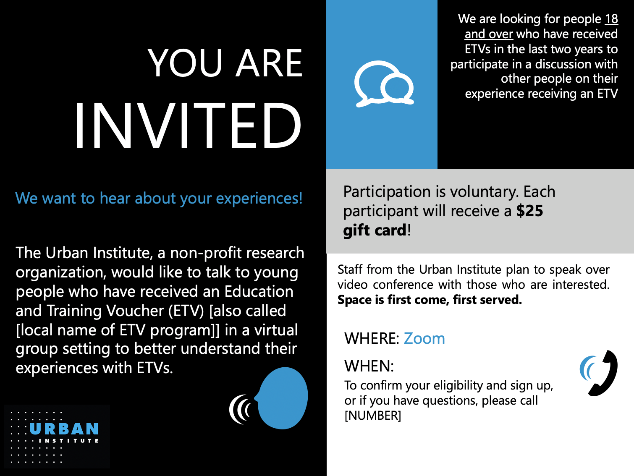
An agency may not conduct or sponsor, and a person is not required to respond to, a collection of information unless it displays a currently valid OMB control number. The OMB number for the described information collection is 0970-0489 and the expiration date is XX/XX/XXXX.

Reports from the Multi-Site Evaluation of Foster Youth Programs can be found at the following web address: http://www.acf.hhs.gov/programs/opre/research/project/multi-site-evaluation-of-foster-youth-programs-chafee-independent-living
Reports from the Multi-Site Evaluation of Foster Youth Programs can be found at the following web address: http://www.acf.hhs.gov/programs/opre/research/project/multi-site-evaluation-of-foster-youth-programs-chafee-independent-living

