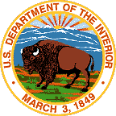
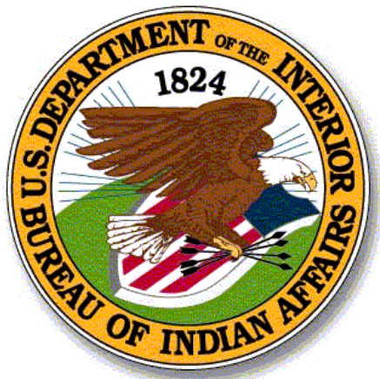
UNITED STATES DEPARTMENT OF THE INTERIOR
BUREAU OF INDIAN AFFAIRS
FY 2021 Tribal Enrollment Collection Form

Welcome to the Indian Affairs FY 2021 Tribal Enrollment Data Collection Form

What This Form Is: This is a form to collect current enrollment information for federally recognized tribes. Enrollment data is an important source of information which allows the Indian Affairs and other Federal agencies to equitably distribute resources because it is a quantifiable representation of a Tribe’s overall population.

The information to be collected is a count of the number of individuals enrolled with the Tribe. The collection does not ask for personal details of any member(s), nor does the collection ask for the data to be disaggregated in any way.

Use of the Information: BIA requests this information immediately to ensure effective, accurate, and timely distribution of assistance to respond to the coronavirus pandemic in Indian Country, as provided in the American Rescue Plan which was recently signed into law. Specifically, enrollment data will be a primary data source to inform Indian Affairs’ allocation of assistance to Tribal nations, as well as funding to be distributed by the Department of the Treasury. Therefore, once each Tribe receives the form, an authorized Tribal government official is requested to complete, endorse, and return the form within 7-10 days.

USER GUIDE

How to use this Form:

This Form is composed of a drop down box to select your tribal entity, a standard input field for you to enter your total tribal enrollment, a check box field for you to acknowledge the use of the information, and signature block for Tribal Leader sign off and certification of the number provided.

Note: You must download the form from email on to your computer before opening it in Adobe Acrobat in order for the drop down box to work properly.

If you are having trouble gaining access to complete the tool in Adobe, look for the "Enable All Features" button in your upper left corner. If you have this line, you must click on the yellow "Enable All Features" button to access the Tool.
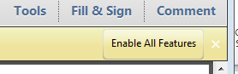

Submitting the Form:

Please submit only one completed form with all the requested information from your Tribe. The final form should be certified by the Tribal Leader and sent via email to your designated Regional Office Data Collection email as outlined below. If you do not have access to send your file via email, you can submit by mailing or faxing your form as outlined below.

Email – Email a copy of your completed form to the email for your designated regional office.

Printing & Mailing – If you do not have access to email, you may submit a printed copy of the form. Complete the information, certify and sign the form and mail or fax it to the fax number listed below.

Please remember NOT to include any Privacy & Personally Identifiable Information (PII) in your responses. Some examples of PII include information which can be used to distinguish or trace an individual's identity, such as their social security number, date and place of birth, mother's maiden name, biometric records, etc.

Department of the Interior Privacy Notice:
The Department of the Interior (DOI), Bureau of Indian Affairs (BIA) is requesting this information for use in making equitable fund distributions. The information you have provided will only be used for this purpose. Please do not include any Personally Identifiable Information (PII) in your responses. The BIA will not share this information with third parties for promotional purposes.

Privacy Policy (https://www.doi.gov/privacy) Disclaimer (https://www.doi.gov/disclaimer) Notices (https://www.doi.gov/notices) Accessibility (https://www.doi.gov/accessibility) Copyright (https://www.doi.gov/accessibility)

For general assistance with this Collection, please contact the phone number for your region.

Region | Email | Address | Phone Number | Fax Number
Alaska | Alaska-Data@bia.gov | 3601 C Street, Suite 1100  Anchorage, AK 99503 | 907-271-1734 | 907-271-1349
Eastern | Eastern-Data@bia.gov | 545 Marriott Drive, Suite 700  Nashville, TN 37214 | 615-564-6500 | 615-564-6701
Eastern Oklahoma | EasternOklahoma-Data@bia.gov | 3100 W. Peak Blvd.  Muskogee, OK 74401 | 918-781-4608 | 918-781-4604
Great Plains | GreatPlains-Data@bia.gov | 115 4th Avenue, SE, Suite 400  Aberdeen, SD 57401 | 605-226-7343 | 605-226-7446
Midwest | Midwest-Data@bia.gov | 5600 W. American Blvd.,  Suite #500,  Bloomington, MN 55437 | 612-725-4500 | 612-713-4401
Navajo | Navajo-Data@bia.gov | P.O. Box 1060  Gallup, NM 87305 | 505-863-8314 | 505-863-8324
Northwest | Northwest-Data@bia.gov | 911 NE 11 Avenue  Portland, OR 97232 | 503-231-6702 | 503-231-2201
Pacific | Pacific-Data@bia.gov | 2800 Cottage Way  Sacramento, CA 95825 | 916-978-6000 | 916-978-6099
Rocky Mountain | RockyMountain-Data@bia.gov | 2021 Fourth Avenue North  Billings, MT 59101 | 406-247-7943 | 406-247-7976
Southern Plains | SouthernPlains-Data@bia.gov | 1 Mile North, Hwy 281, Riverside Drive  Anadarko, OK 73005 | 405-247-6673 | 405-247-5611
Southwest | Southwest-Data@bia.gov | 1001 Indian School Road, NW  Albuquerque, NM 87104 | 505-563-3103 | 505-563-3101
Western | Western-Data@bia.gov | 2600 N. Central Avenue  Phoenix, AZ 85004 | 602-379-6600 | 602-379-4139

