**Law Enforcement Public Contact (LEPC) Questionnaire Platform**

**Data Collection:**

Participating agencies will submit total annual counts in the three areas of public contacts relevant to the LEPC

* Citizen Calls for Service
* Unit/Officer Initiated Contact
* Court/Bailiff Activates

These counts will be entered into the electronic form found on the National Use-of-Force portal located on the Law Enforcement Enterprise Portal (LEEP). Below is an example of how the LEPC survey questions will be presented on the Use-of-Force portal.

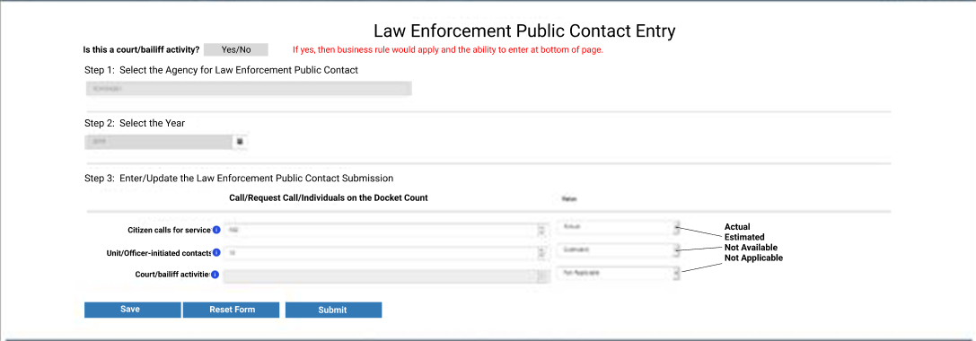

This layout represents what participating agencies will see when they log onto the site. The layout of the platform may change as adjustments are made to the system for the final launch of the collection, but the three text fields and the corresponding dropdowns indicating actual or estimated counts will remain for all agencies to use in submitting their annual data.