NATIONAL CENTER FOR EDUCATION STATISTICS NATIONAL ASSESSMENT OF EDUCATIONAL PROGRESS

National Assessment of Educational Progress (NAEP) 2021 School and Teacher Questionnaire Special Study

Appendix J2

2021 Teacher Questionnaires

OMB# 1850-0956 v.2

March 2021

Table of Contents
Teacher Questionnaires
Teacher Questionnaire Login Screens 3
Appendix J2-1: Summary of Changes Operational Grade 4 CORE 5
Appendix J2-2: Operational Grade 4 CORE 12
Appendix J2-3: Summary of Changes Operational Grade 8 CORE 20
Appendix J2-4: Operational Grade 8 CORE 27
Appendix J2-5: Summary of Changes Operational Grade 4 Mathematics 38
Appendix J2-6: Operational Grade 4 Mathematics 43
Appendix J2-7: Summary of Changes Operational Grade 8 Mathematics 51
Appendix J2-8: Operational Grade 8 Mathematics 58
Appendix J2-9: Summary of Changes Operational Grade 4 Reading 67
Appendix J2-10: Operational Grade 4 Reading 72
Appendix J2-11: Summary of Changes Operational Grade 8 Reading 77
Appendix J2-12: Operational Grade 8 Reading 82
Appendix J2-13: Operational Grade 4 COVID-19 89
Appendix J2-14: Operational Grade 8 COVID-19 93

Teacher Questionnaire Login Screens
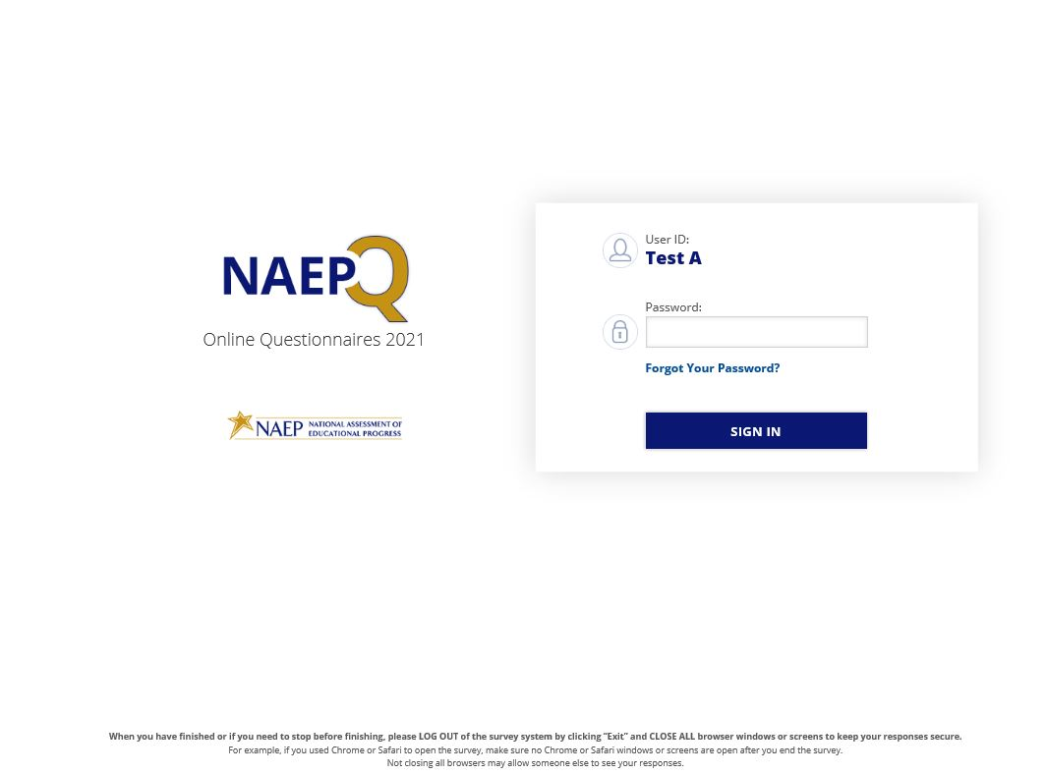
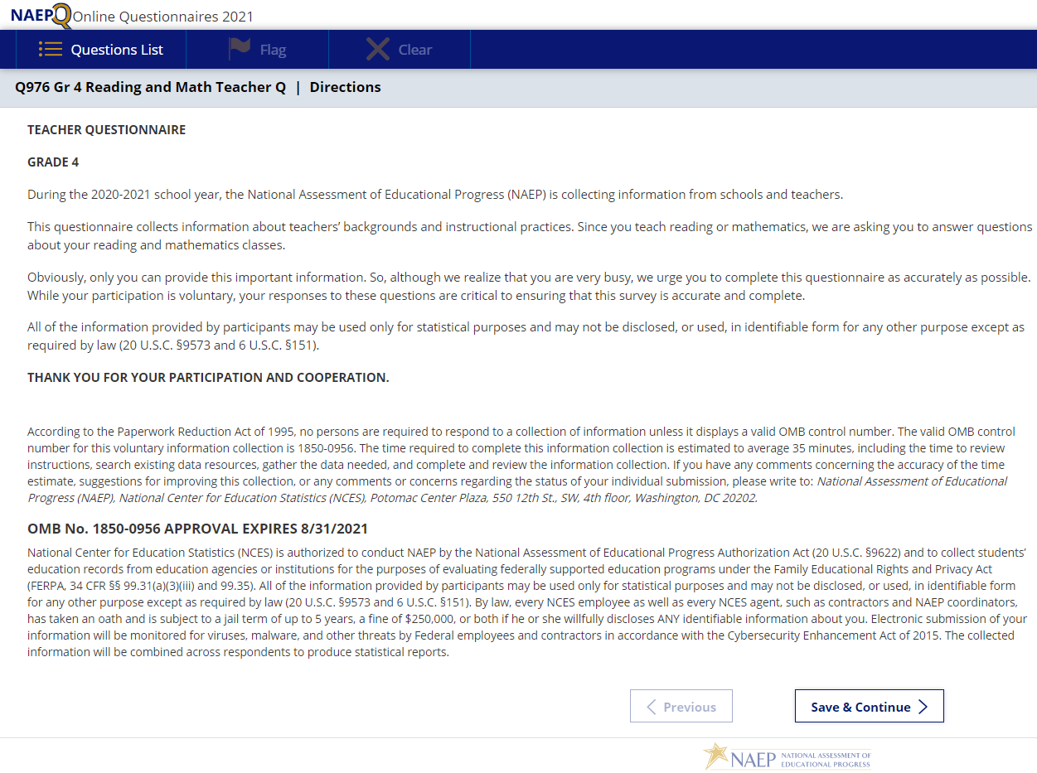
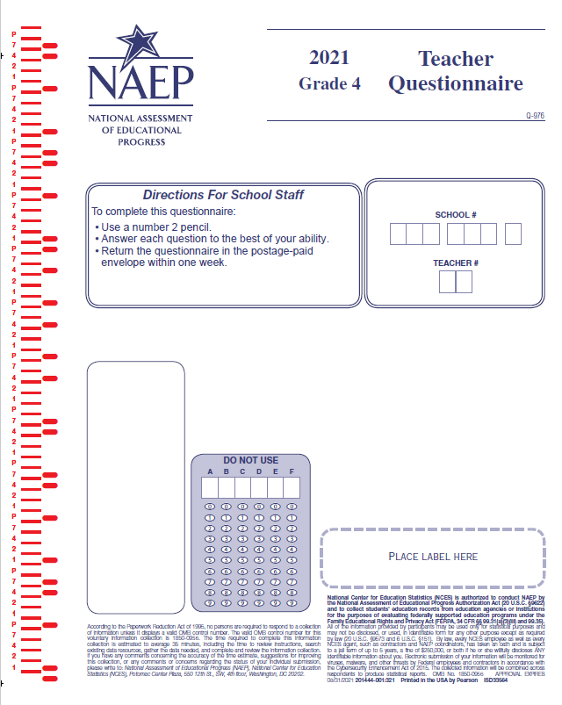

Appendix J2-1: Summary of Changes Operational Grade 4 CORE
2021 Operational Grade 4 Core Teacher

Previous item | 2021 item | D/A/ R/NC+ | Rationale
(2019 Grade 4) | Issue: Gender | NC | N/A
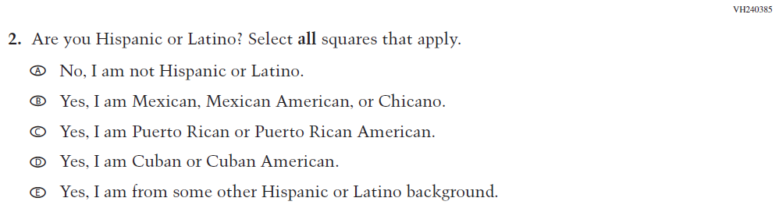  (2019 Grade 4) | 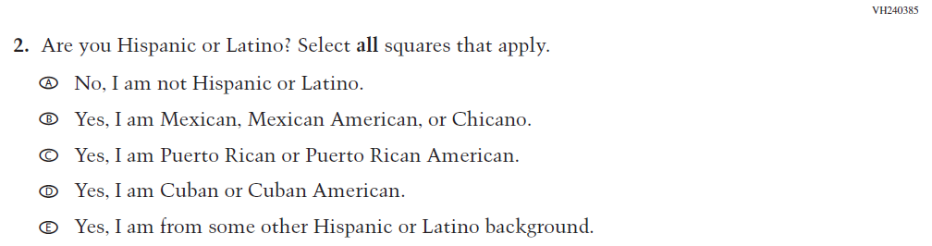  Issue: Race/Ethnicity | NC | N/A
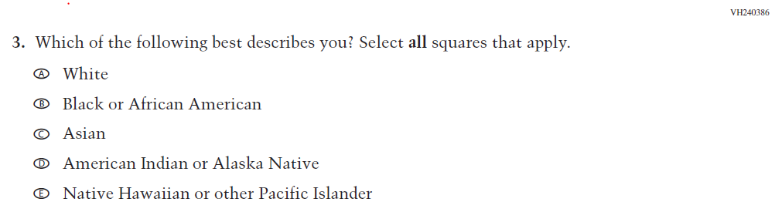  (2019 Grade 4) | 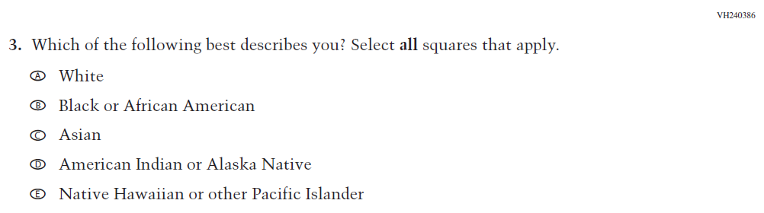  Issue: Race/Ethnicity | NC | N/A
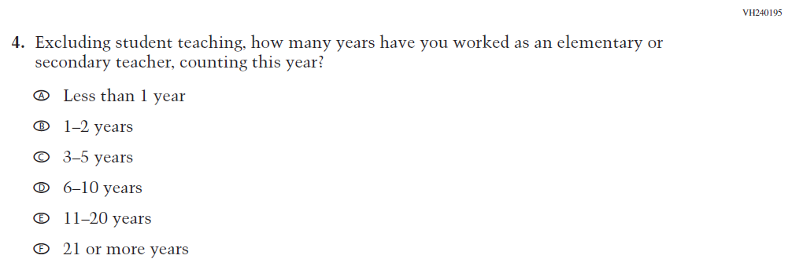  (2019 Grade 4) | 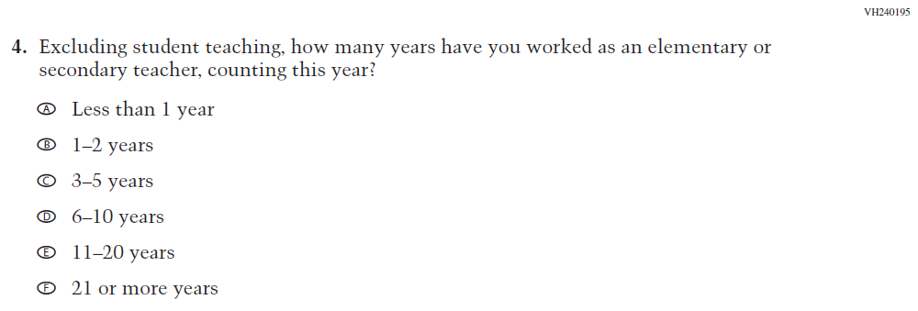  Issue: Teacher Preparation | NC | N/A

2021 Operational Grade 4 Core Teacher

Previous item | 2021 item | D/A/ R/NC+ | Rationale
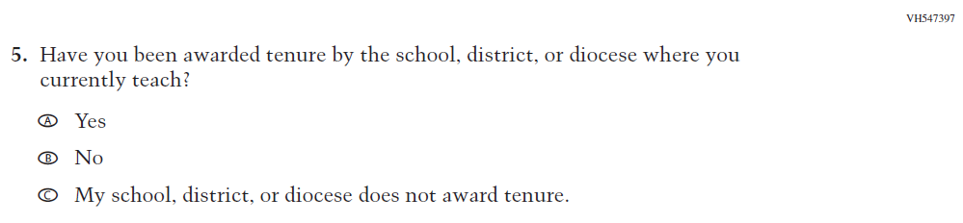  (2019 Grade 4) | 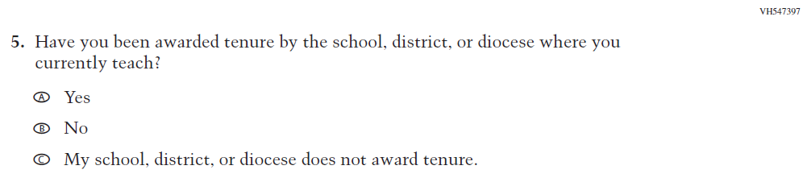  Issue: Teacher Preparation | NC | N/A
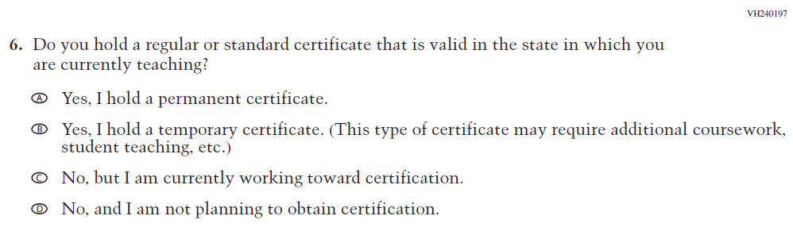  (2019 Grade 4) | 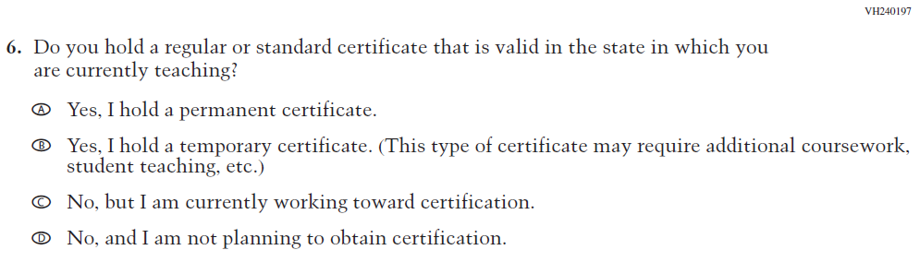  Issue: Teacher Preparation | NC | N/A
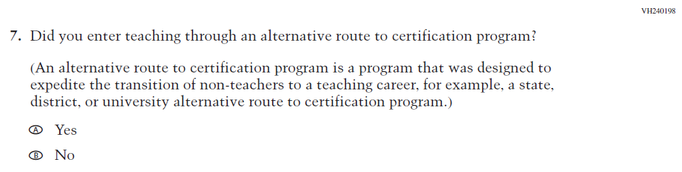  (2019 Grade 4) | 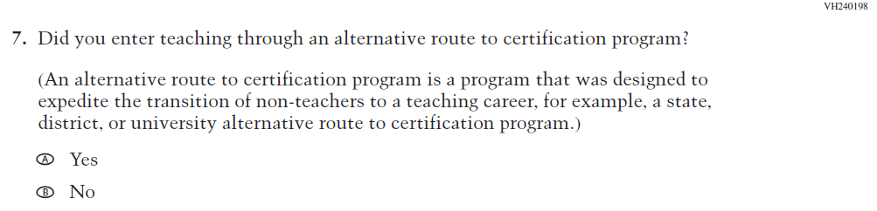  Issue: Teacher Preparation | NC | N/A

2021 Operational Grade 4 Core Teacher

Previous item | 2021 item | D/A/ R/NC+ | Rationale
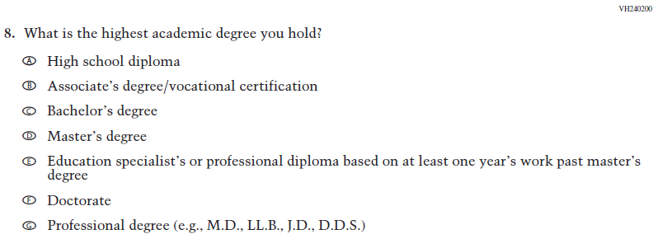  (2019 Grade 4) | Issue: Teacher Preparation | N/A | N/A
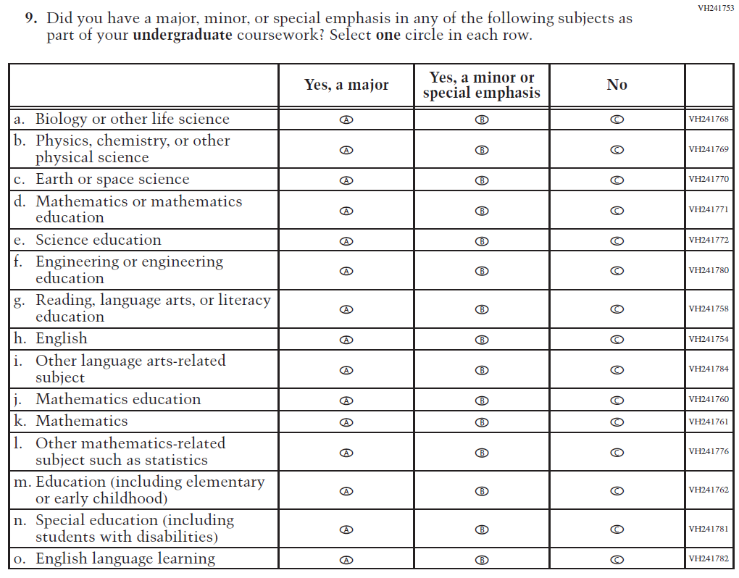  (2019 Grade 4) | 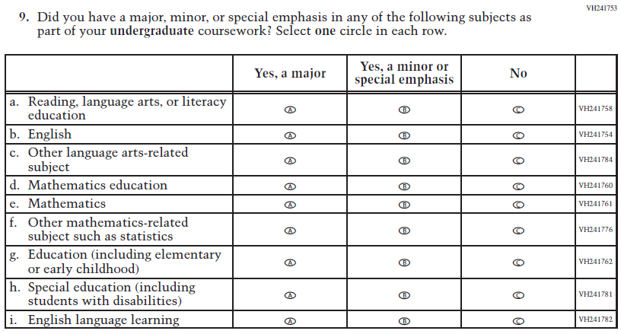  Issue: Teacher Preparation | R | This item is customized by subject and has been revised to remove sub-items for science.
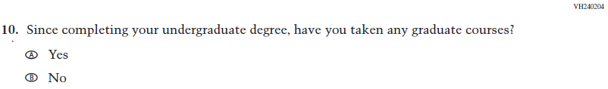  (2019 Grade 4) | Issue: Teacher Preparation | NC | N/A

2021 Operational Grade 4 Core Teacher

Previous item | 2021 item | D/A/ R/NC+ | Rationale
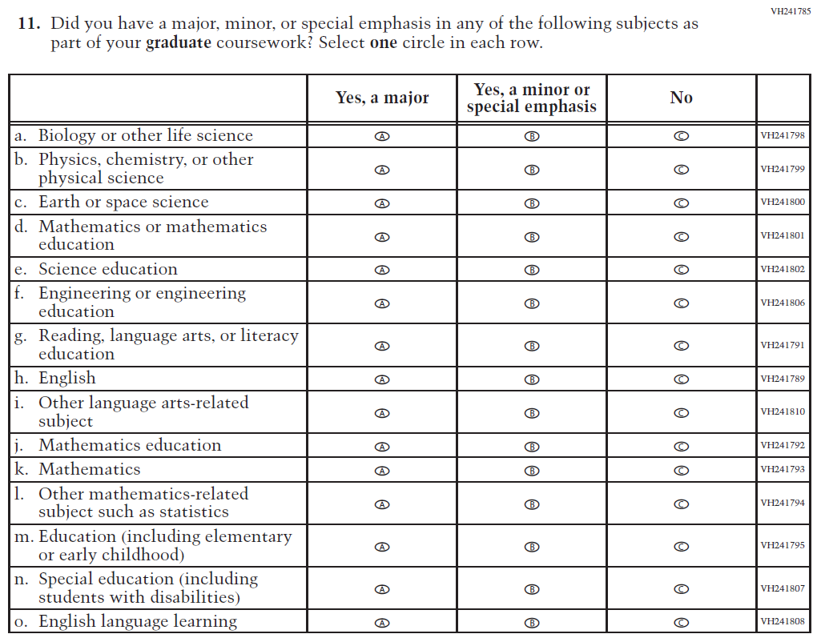  (2019 Grade 4) | 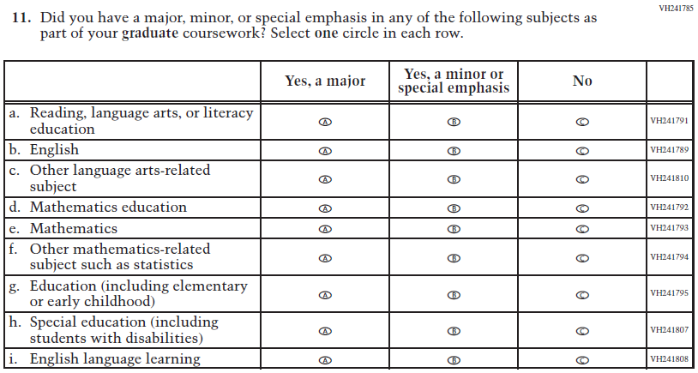  Issue: Teacher Preparation | R | This item is customized by subject and has been revised to remove sub-items for science.
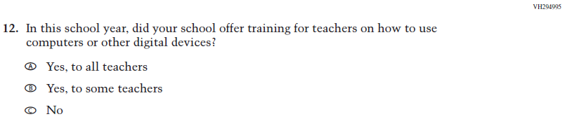  (2019 Grade 4) | 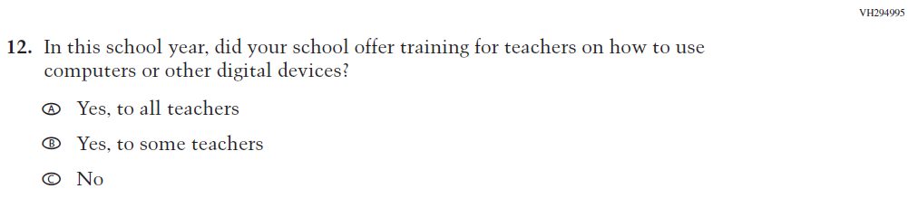  Issue: Technology Use | NC | N/A
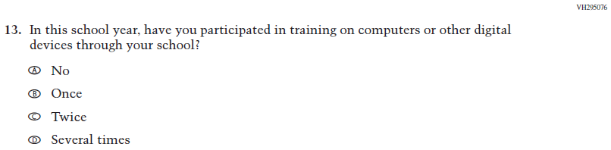  (2019 Grade 4) | Issue: Technology Use | NC | N/A
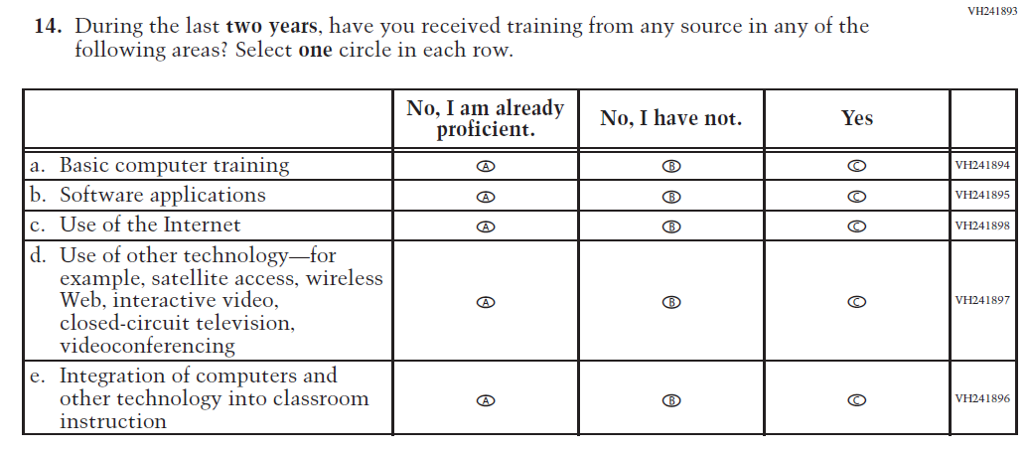  (2019 Grade 4) | 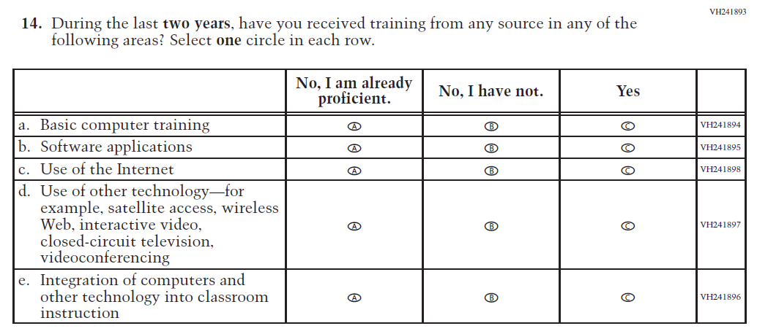  Issue: Teacher Preparation | NC | N/A
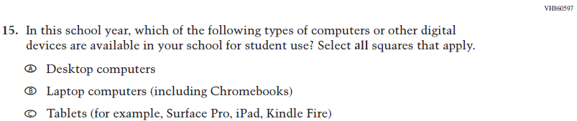  (2019 Grade 4) | Issue: Technology Use | NC | N/A
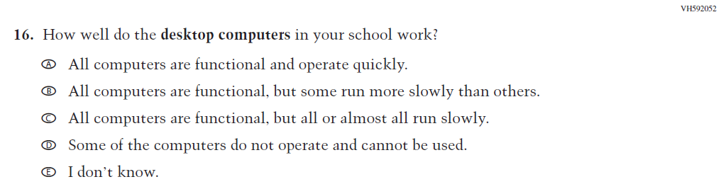  (2019 Grade 4) | Issue: Technology Use | NC | N/A
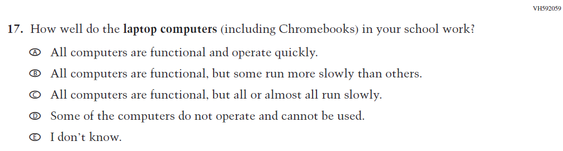  (2019 Grade 4) | Issue: Technology Use | NC | N/A

2021 Operational Grade 4 Core Teacher

Previous item | 2021 item | D/A/ R/NC+ | Rationale
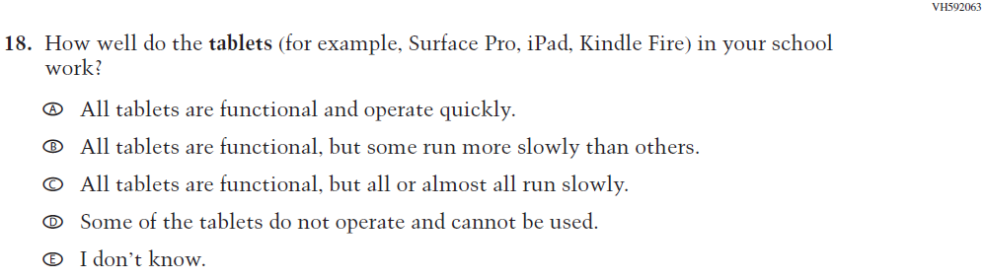  (2019 Grade 4) | Issue: Technology Use | NC | N/A
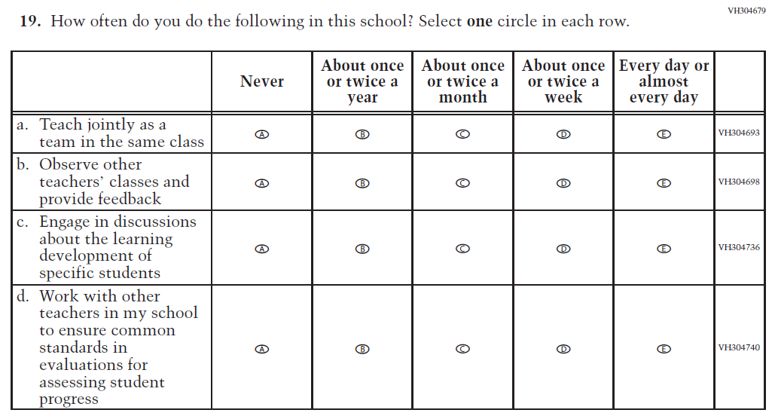  (2019 Grade 4) | Issue: School Climate | NC | N/A
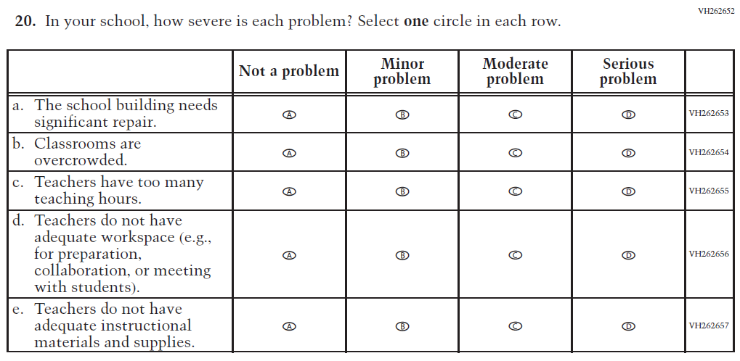  (2019 Grade 4) | Issue: School Climate | NC | N/A

2021 Operational Grade 4 Core Teacher

Previous item | 2021 item | D/A/ R/NC+ | Rationale
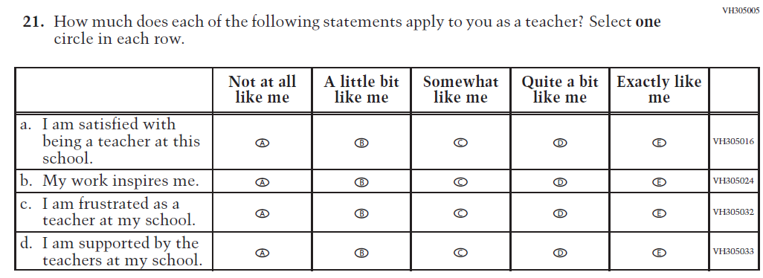  (2019 Grade 4) | Issue: School Climate | NC | N/A
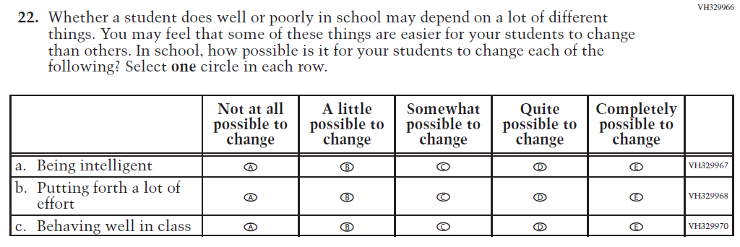  (2019 Grade 4) | Issue: Desire for Learning | NC | N/A

Appendix J2-2: Operational Grade 4 CORE
Grade/Respondent | Item Number Initiating Skip Logic | Item Response(s) Initiating Skip Logic | Item Number(s) Being Skipped
Grade 4 Teacher | 8 | A | 9, 10, 11
Grade 4 Teacher | 8 | B | 10, 11
Grade 4 Teacher | 10 | B | 11
Grade 4 Teacher | 12 | C | 13
Grade 4 Teacher | 15 | A | Do NOT skip 16
Grade 4 Teacher | 15 | B | Do NOT skip 17
Grade 4 Teacher | 15 | C | Do NOT skip 18

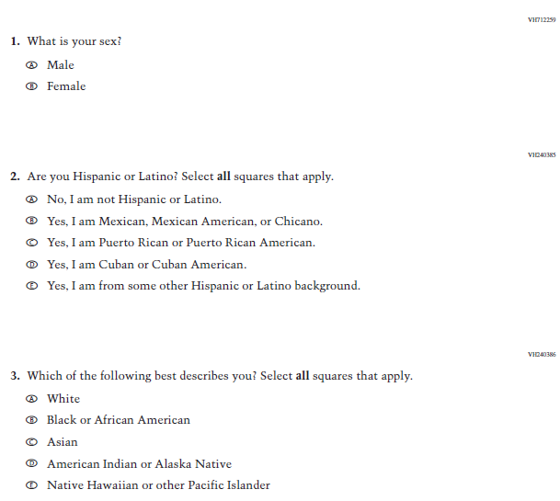
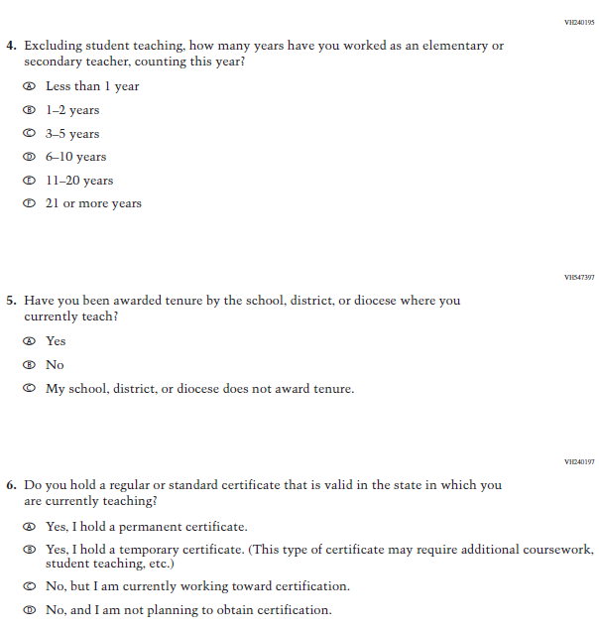
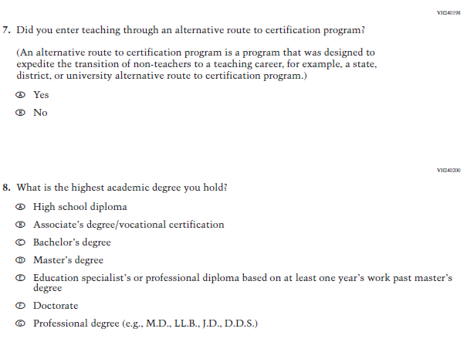
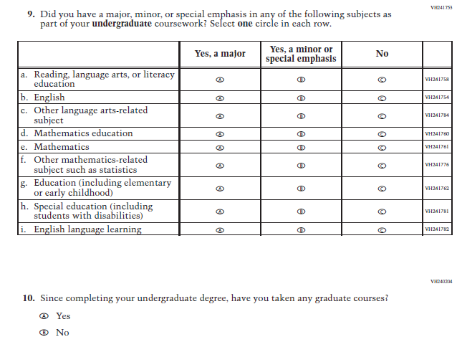
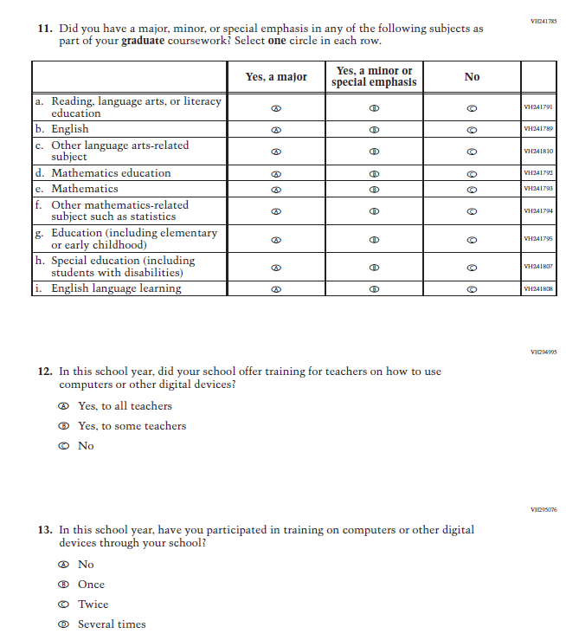

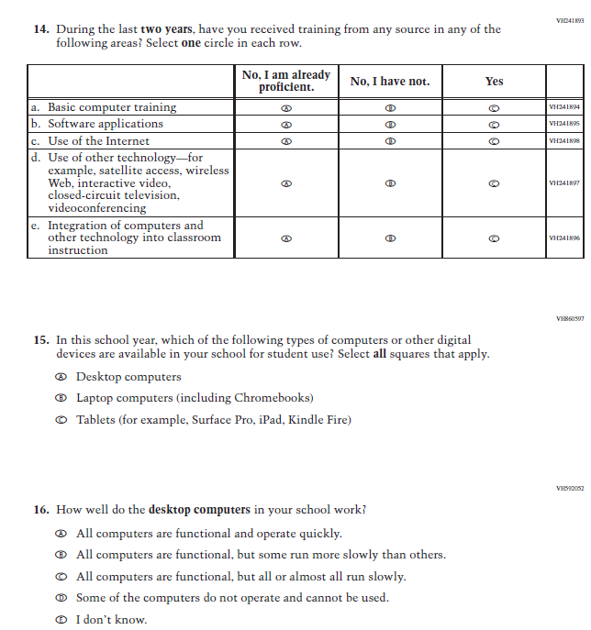

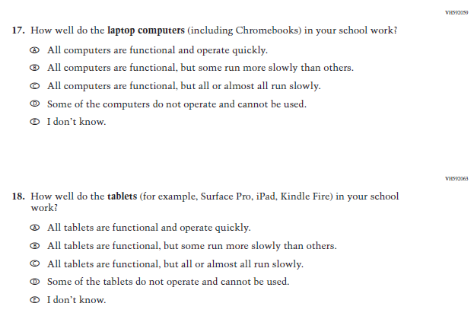

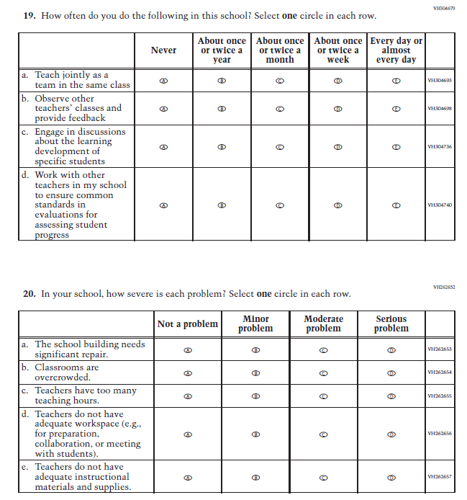

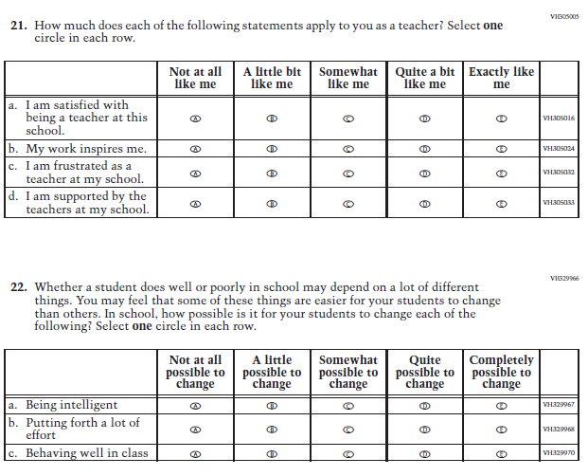

Appendix J2-3: Summary of Changes Operational Grade 8 CORE
2021 Operational Grade 8 Core Teacher

Previous item | 2021 item | D/A/ R/NC+ | Rationale
(2019 Grade 8) | Issue: Gender | NC | N/A
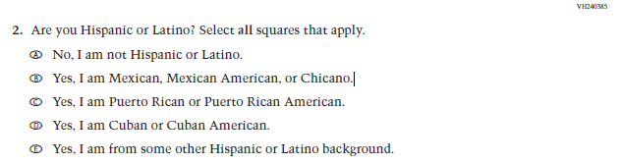  (2019 Grade 8) | Issue: Race/Ethnicity | NC | N/A
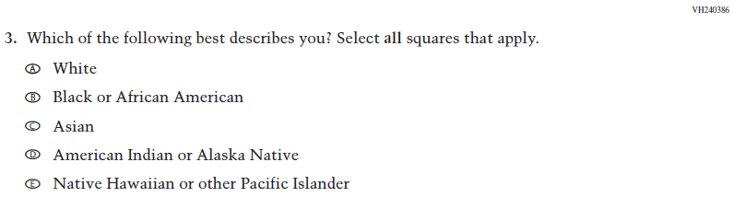  (2019 Grade 8) | Issue: Race/Ethnicity | NC | N/A
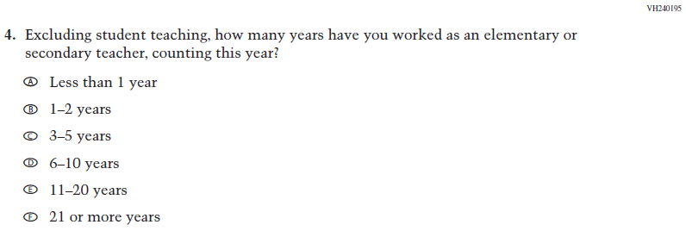  (2019 Grade 8) | Issue: Teacher Preparation | NC | N/A
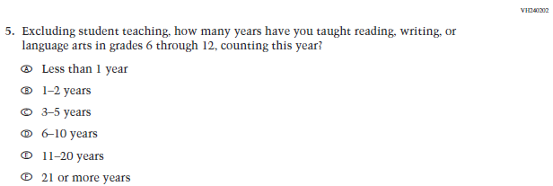  (2019 Grade 8) | Issue: Teacher Preparation | NC | N/A
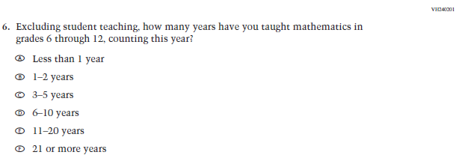  (2019 Grade 8) | Issue: Teacher Preparation | NC | N/A
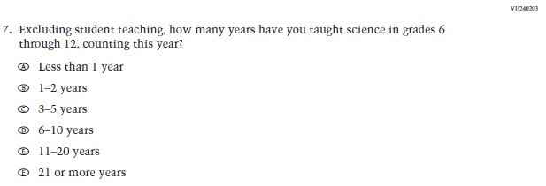  (2019 Grade 8) | N/A | D | The item was dropped because science will not be administered in 2021.
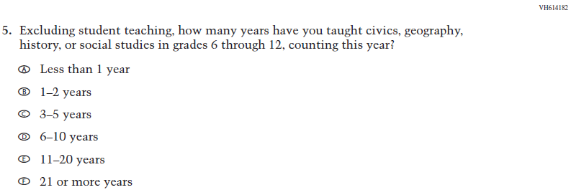  (2018 Grade 8) | 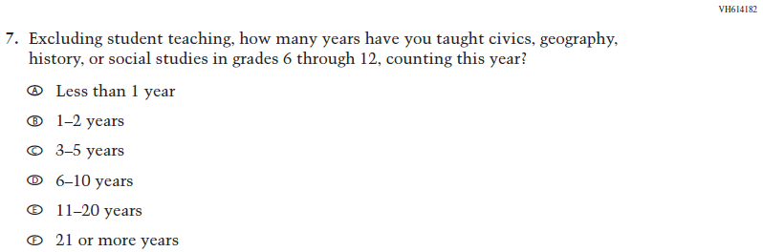  Issue: Teacher Preparation | NC | N/A
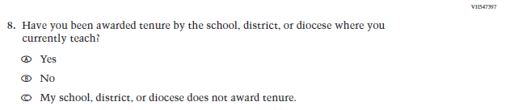  (2019 Grade 8) | Issue: Teacher Preparation | NC | N/A
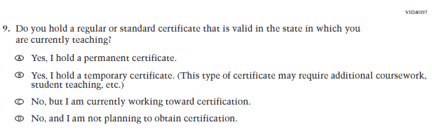  (2019 Grade 8) | Issue: Teacher Preparation | NC | N/A
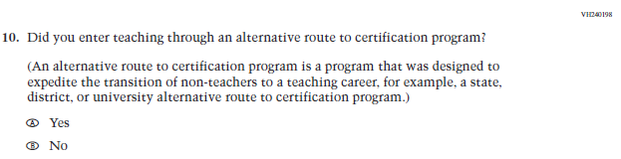  (2019 Grade 8) | Issue: Teacher Preparation | NC | N/A
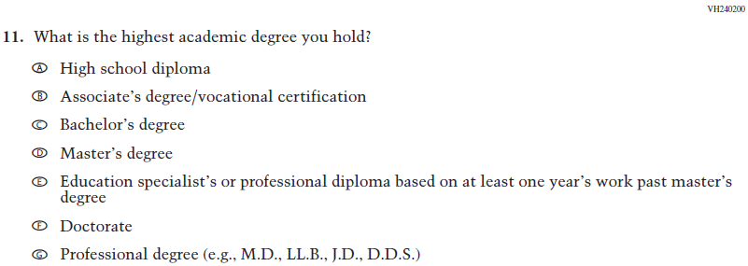  (2019 Grade 8) | Issue: Teacher Preparation | NC | N/A
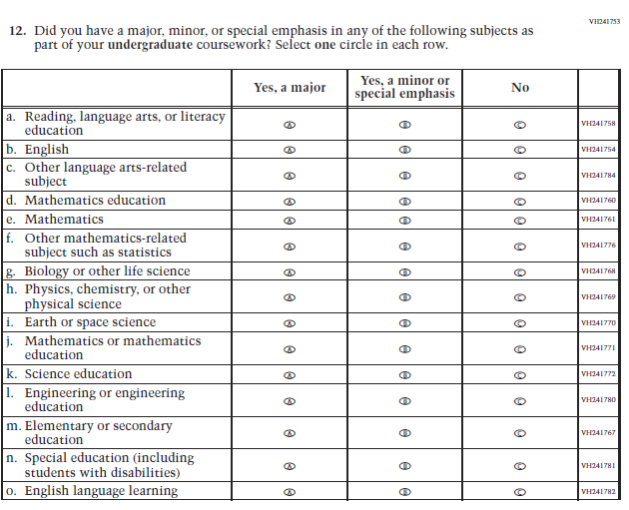  (2019 Grade 8) | 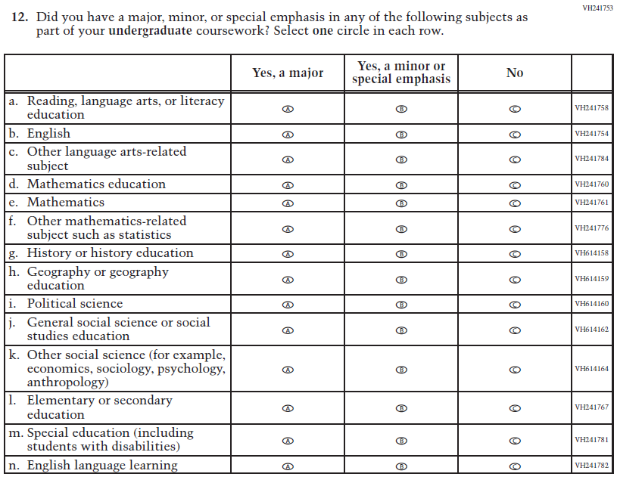  Issue: Teacher Preparation | R | This item is customized by subject and has been revised to remove sub-items for science and expanded to also include sub-items for social studies.
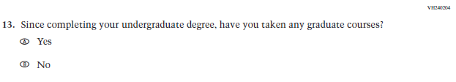  (2019 Grade 8) | Issue: Teacher Preparation | NC | N/A
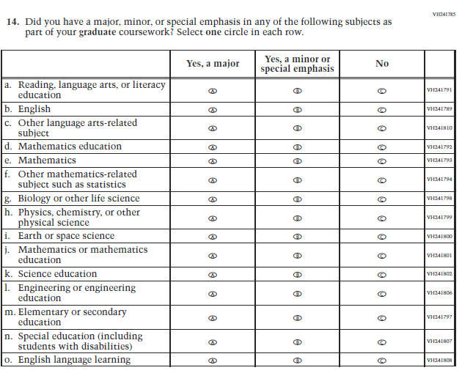  (2019 Grade 8) | 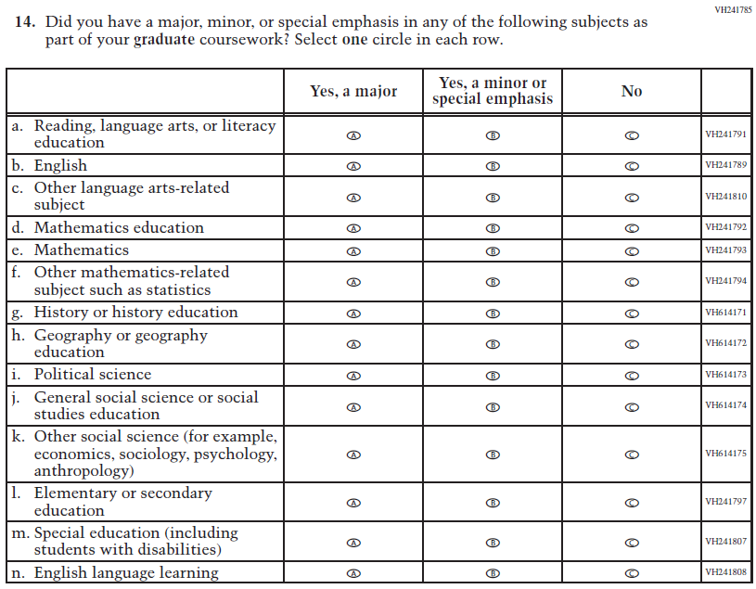  Issue: Teacher Preparation | R | This item is customized by subject and has been revised to remove sub-items for science and expanded to also include sub-items for social studies.
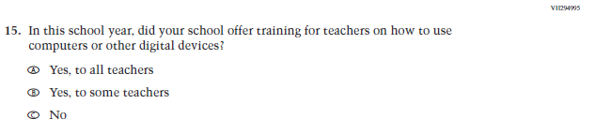  (2019 Grade 8) | Issue: Technology Use | NC | N/A
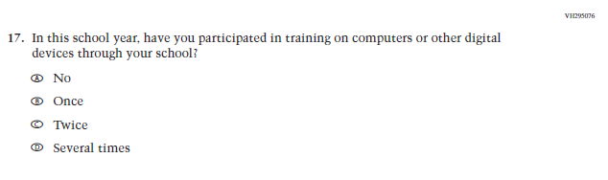(2019 Grade 8) | 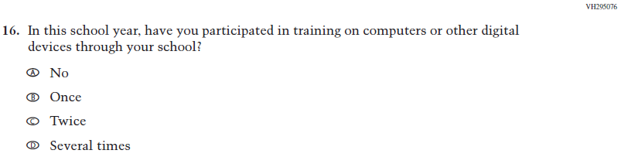  Issue: Technology Use | NC | N/A
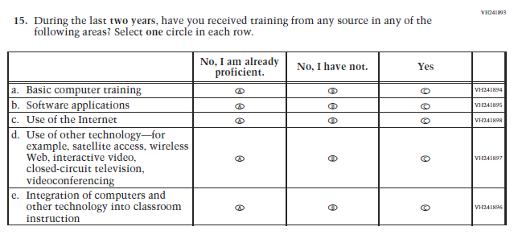  (2019 Grade 8) | 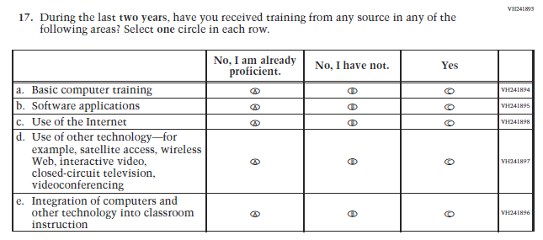  Issue: Teacher Preparation | NC | N/A
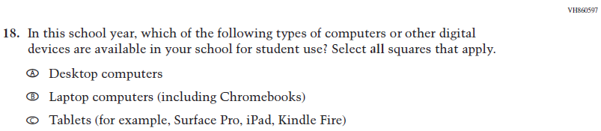  (2019 Grade 8) | Issue: Technology Use | NC | N/A
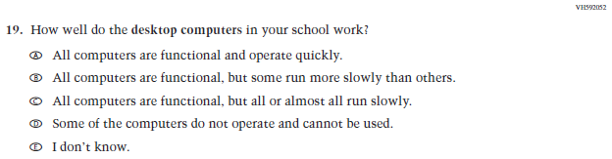  (2019 Grade 8) | Issue: Technology Use | NC | N/A
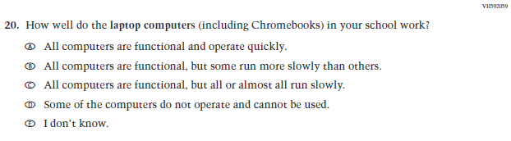  (2019 Grade 8) | Issue: Technology Use | NC | N/A
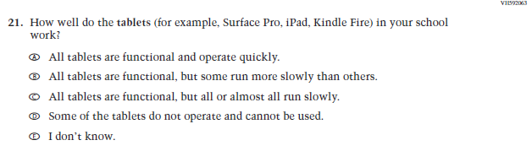  (2019 Grade 8) | Issue: Technology Use | NC | N/A
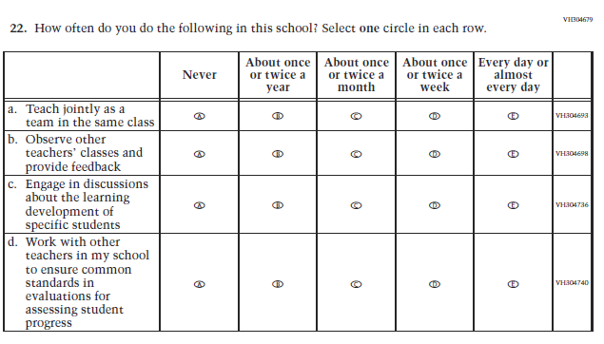  (2019 Grade 8) | Issue: School Climate | NC | N/A
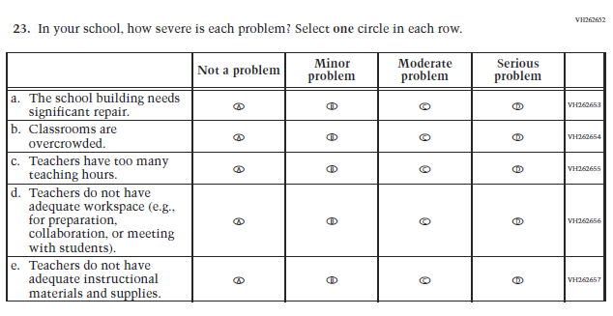  (2019 Grade 8) | Issue: School Climate | NC | N/A
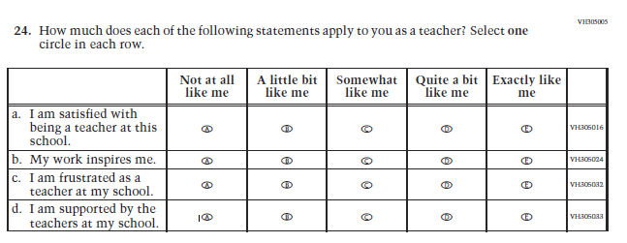  (2019 Grade 8) | Issue: School Climate | NC | N/A
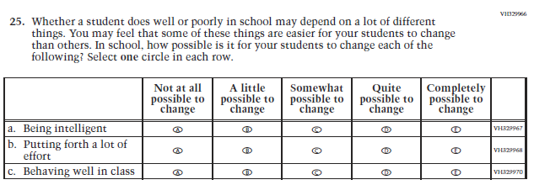  (2019 Grade 8) | Issue: Desire for Learning | NC | N/A

Appendix J2-4: Operational Grade 8 CORE

Grade/Respondent | Item Number Initiating Skip Logic | Item Response(s) Initiating Skip Logic | Item Number(s) Being Skipped
Grade 8 Teacher | 11 | A | 12, 13, 14
Grade 8 Teacher | 11 | B | 13, 14
Grade 8 Teacher | 13 | B | 14
Grade 8 Teacher | 15 | C | 16
Grade 8 Teacher | 18 | A | Do NOT skip 19
Grade 8 Teacher | 18 | B | Do NOT skip 20
Grade 8 Teacher | 18 | C | Do NOT skip 21

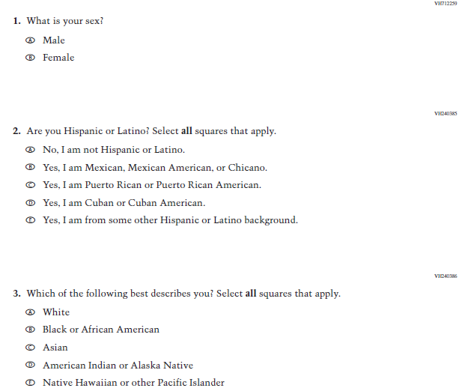
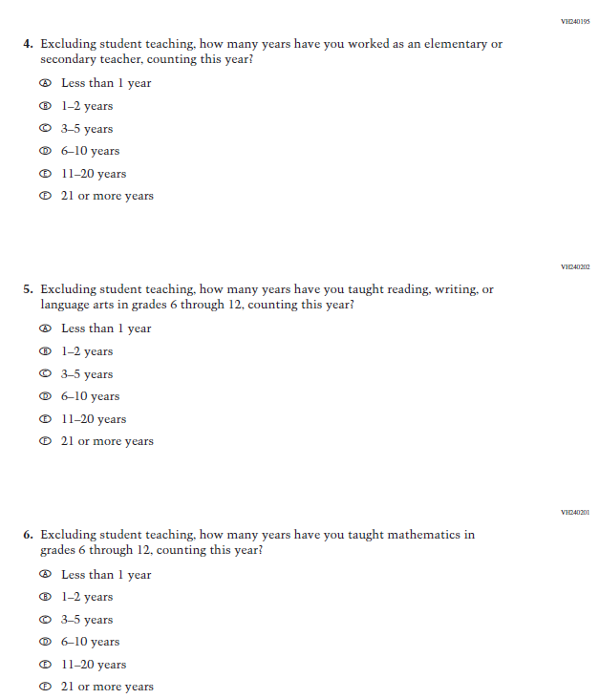
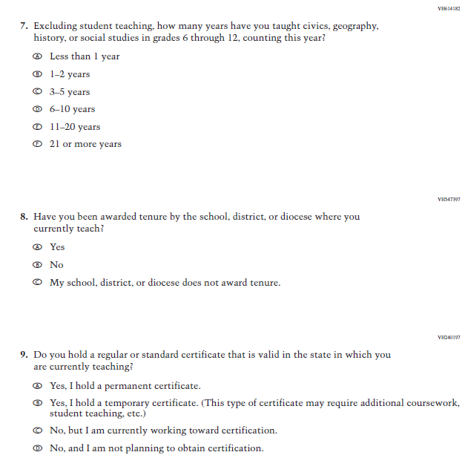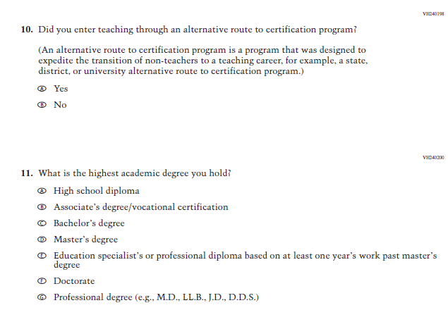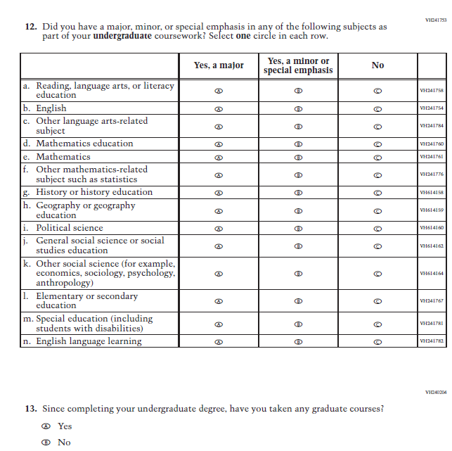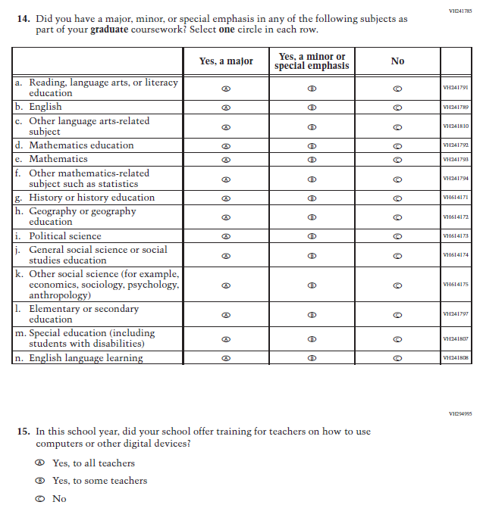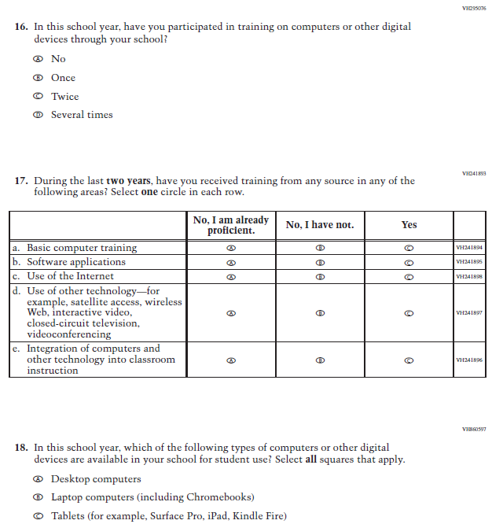
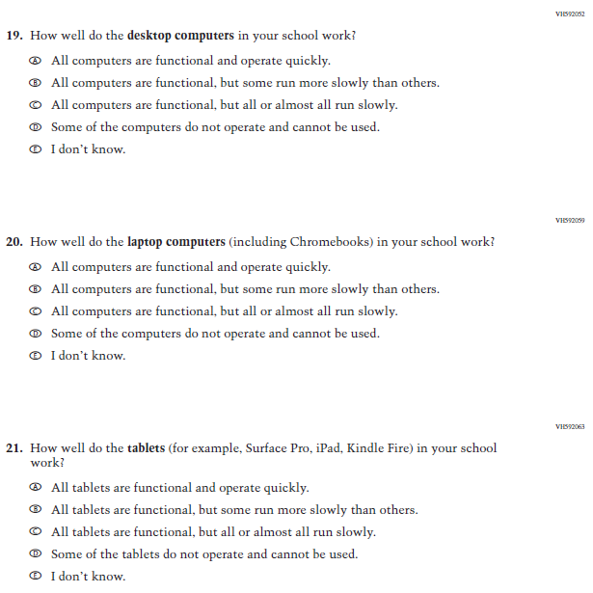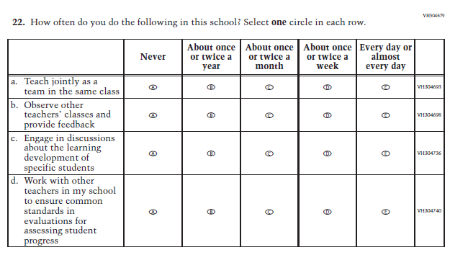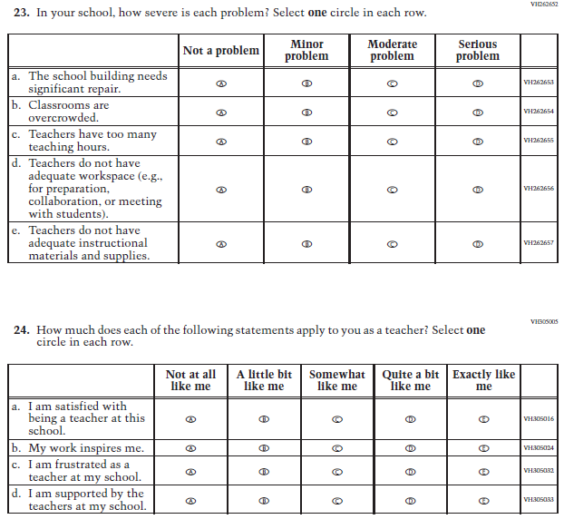
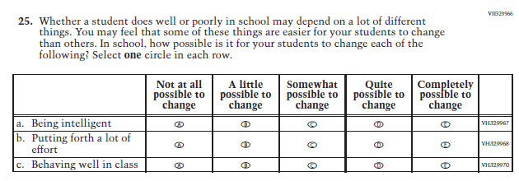

Appendix J2-5: Summary of Changes Operational Grade 4 Mathematics
2021 Operational Grade 4 Mathematics Teacher

Previous item | 2021 item | D/A/ R/NC+ | Rationale
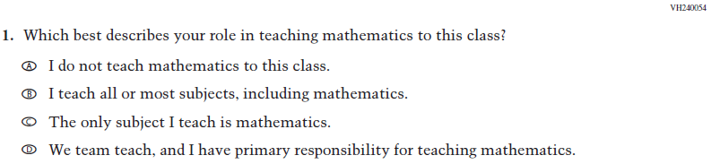  (2019 Grade 4) | Issue: Resources for Learning and Instruction | NC | N/A
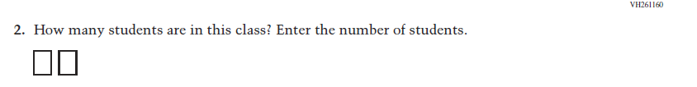  (2019 Grade 4) | Issue: Resources for Learning and Instruction | NC | N/A
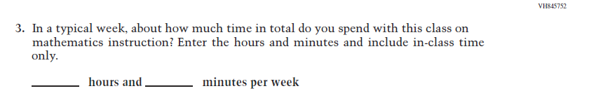  (2019 Grade 4) | Issue: Resources for Learning and Instruction | NC | N/A
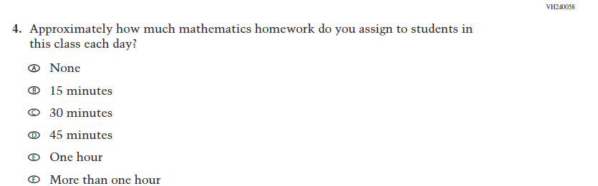  (2019 Grade 4) | Issue: Organization of Instruction | NC | N/A
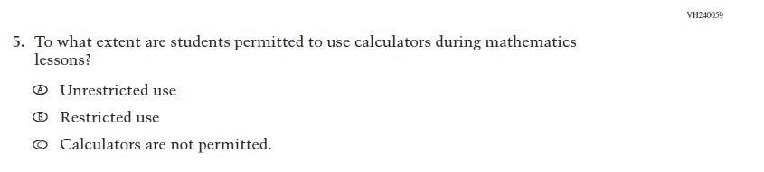  (2019 Grade 4) | Issue: Organization of Instruction | NC | N/A
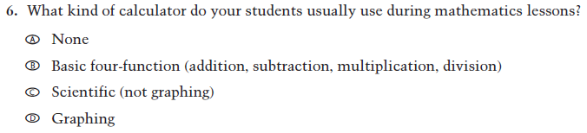  (2019 Grade 4) | Issue: Resources for learning and instruction | NC | N/A
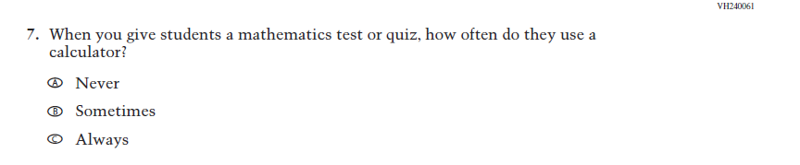  (2019 Grade 4) | Issue: Organization of Instruction | NC | N/A
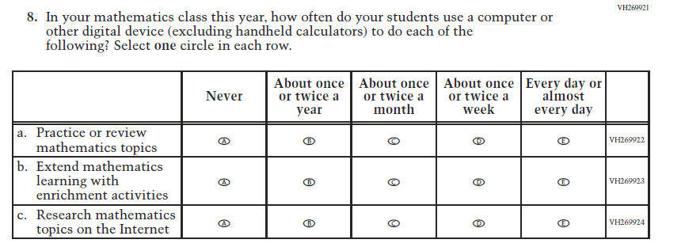  (2019 Grade 4) | Issue: Organization of Instruction | NC | N/A
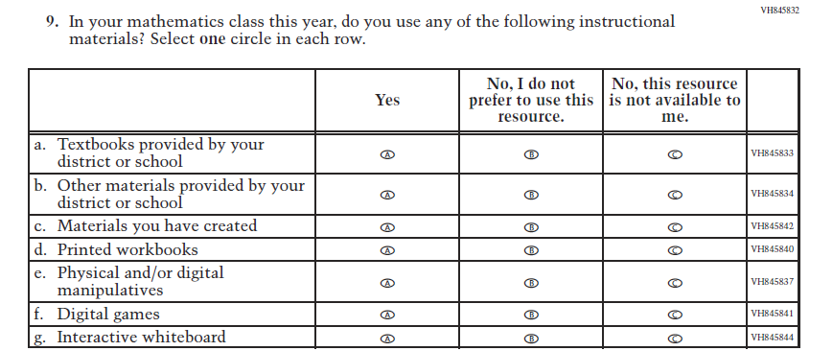  (2019 Grade 4) | Issue: Resources for Learning and Instruction | NC | N/A
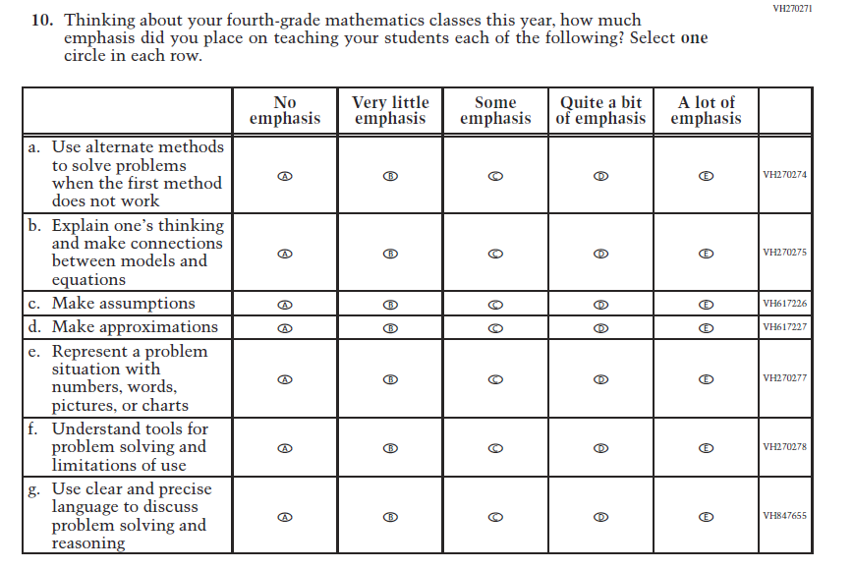  (2019 Grade 4) | Issue: Organization of Instruction | NC | N/A
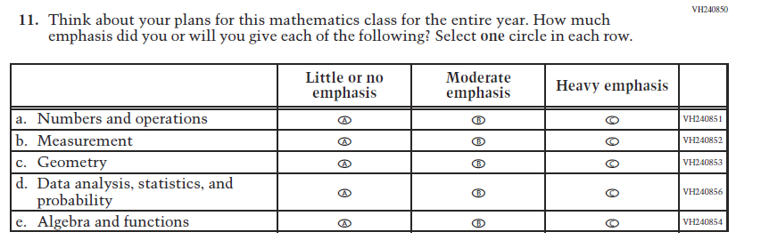  (2019 Grade 4) | Issue: Organization of Instruction | NC | N/A
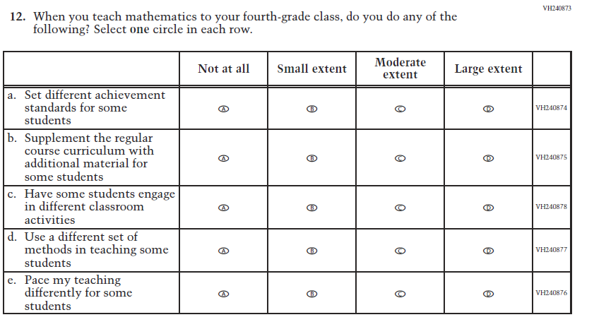  (2019 Grade 4) | Issue: Organization of Instruction | NC | N/A
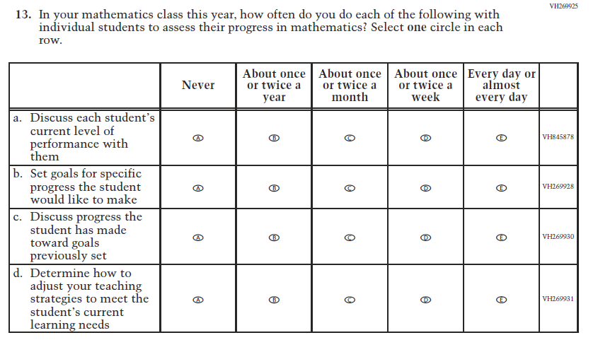  (2019 Grade 4) | Issue: Organization of Instruction | NC | N/A
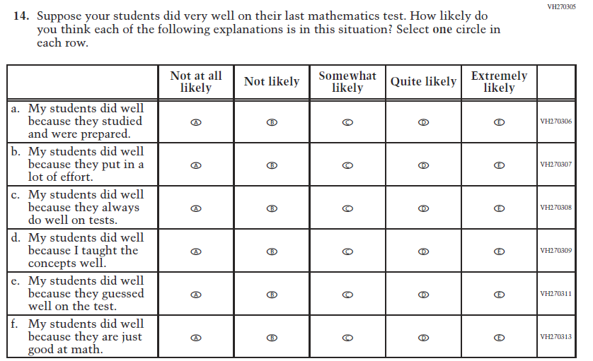  (2019 Grade 4) | Issue: Teacher Preparation | NC | N/A
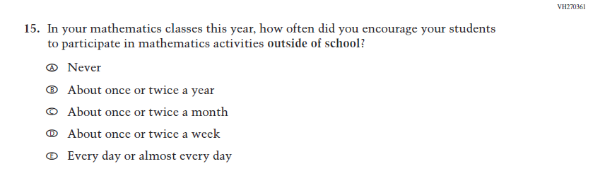  (2019 Grade 4) | Issue: Resources for Learning and Instruction | NC | N/A
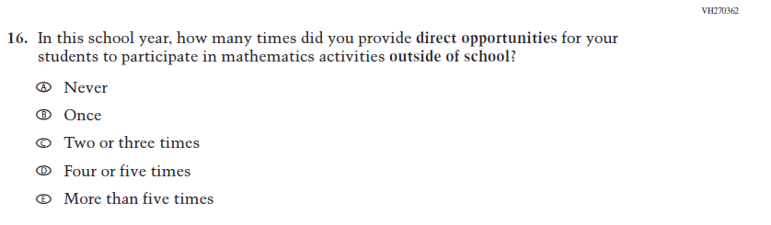  (2019 Grade 4) | Issue: Resources for Learning and Instruction | NC | N/A

Appendix J2-6: Operational Grade 4 Mathematics

Grade/Respondent | Item Number Initiating Skip Logic | Item Response(s) Initiating Skip Logic | Item Number(s) Being Skipped
Grade 4 Teacher | 1 | A | 2, 3, 4, 5, 6, 7, 8, 9, 10, 11, 12, 13, 14, 15, 16
Grade 4 Teacher | 5 | C | 6

Directions: The following questions ask about the organization of your classroom for mathematics instruction. If you teach more than one fourth-grade class, please choose a single class to use as the basis for answering the questions about classroom organization.
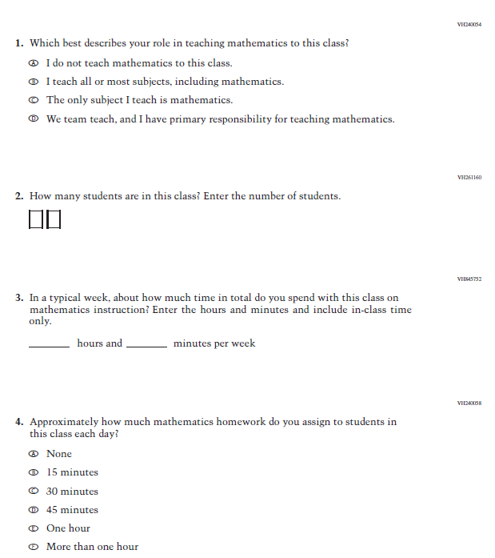

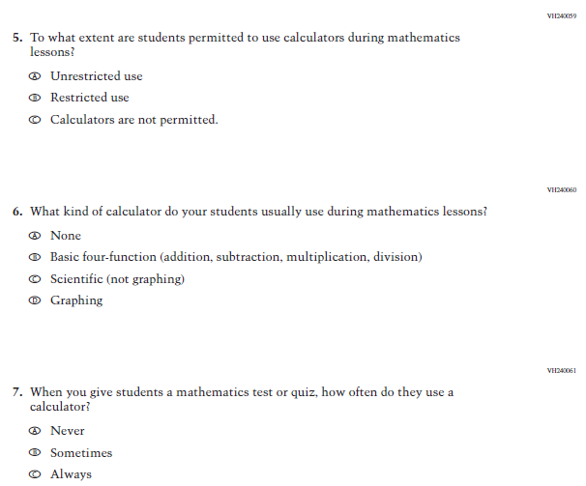

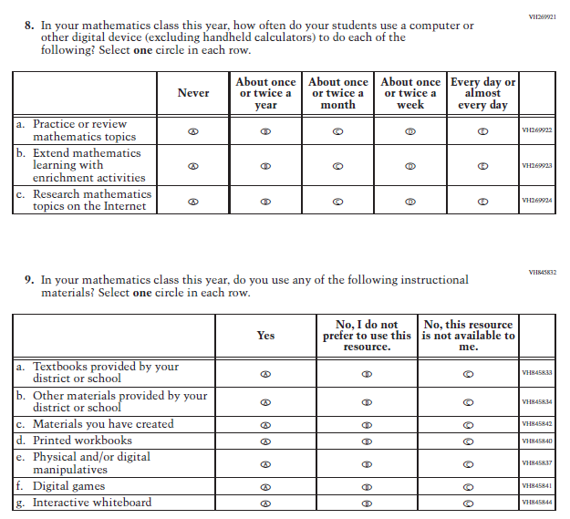

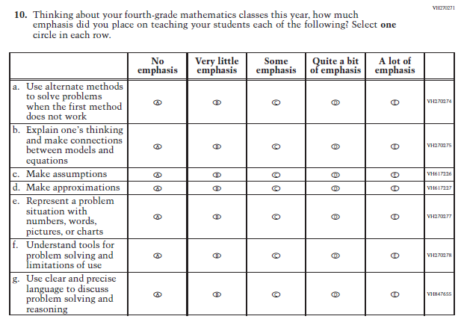
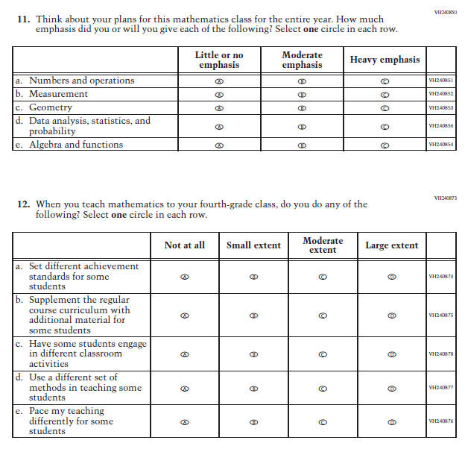
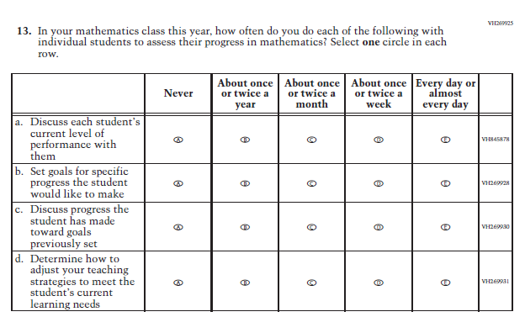

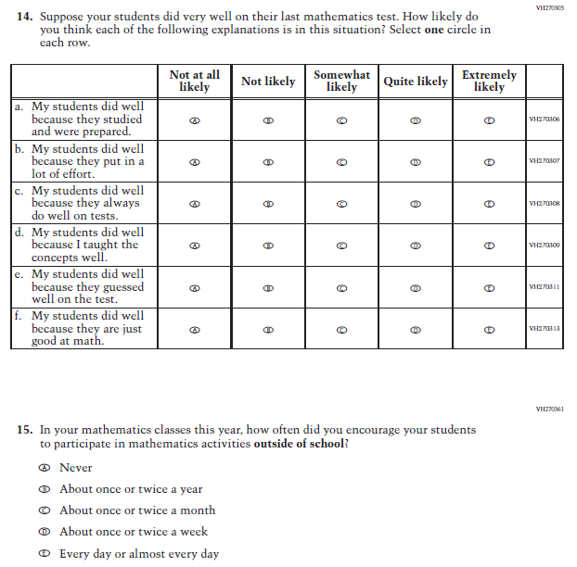
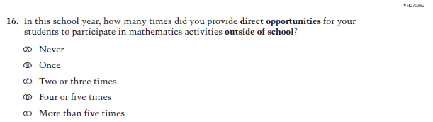

Appendix J2-7: Summary of Changes Operational Grade 8 Mathematics
2021 Operational Grade 8 Mathematics Teacher

Previous item | 2021 item | D/A/ R/NC+ | Rationale
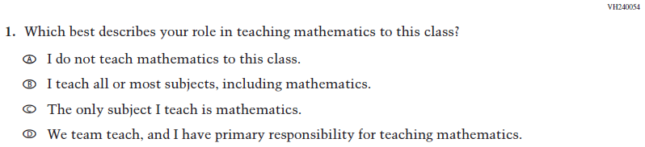  (2019 Grade 8) | Issue: Resources for Learning and Instruction | NC | N/A
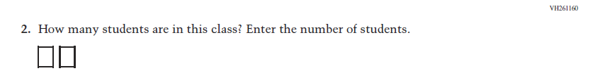  (2019 Grade 8) | 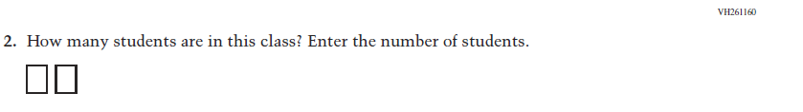  Issue: Resources for Learning and Instruction | NC | N/A
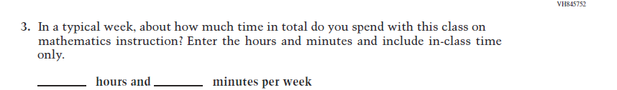  (2019 Grade 8) | Issue: Resources for Learning and Instruction | NC | N/A
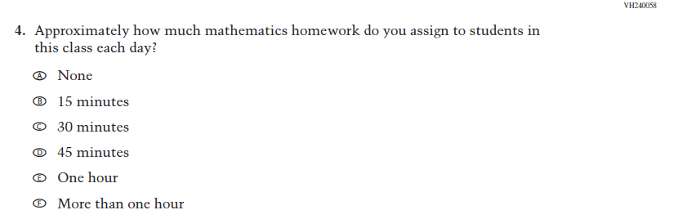  (2019 Grade 8) | Issue: Organization of Instruction | NC | N/A
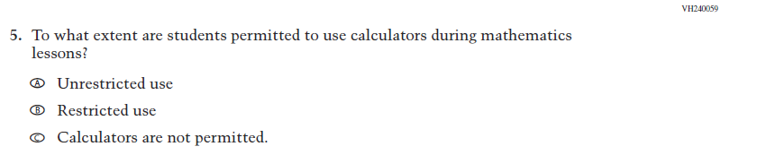  (2019 Grade 8) | Issue: Organization of Instruction | NC | N/A
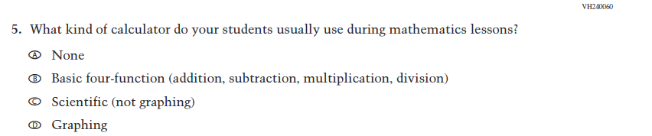  (2019 Grade 8) | 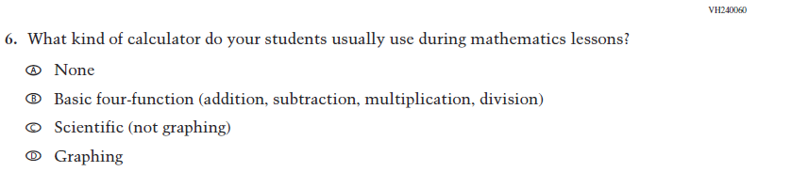  Issue: Resources for Learning and Instruction | NC | N/A
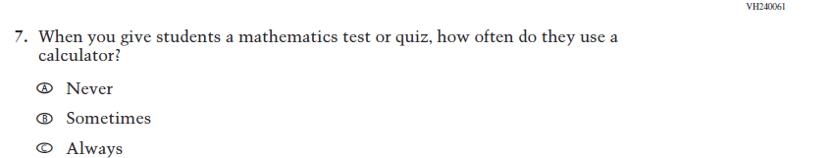  (2019 Grade 8) | Issue: Organization of Instruction | NC | N/A
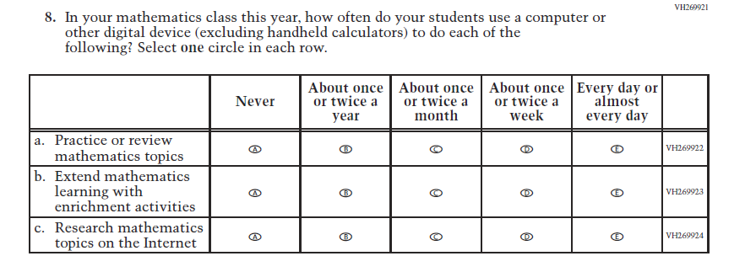  (2019 Grade 8) | Issue: Organization of Instruction | NC | N/A
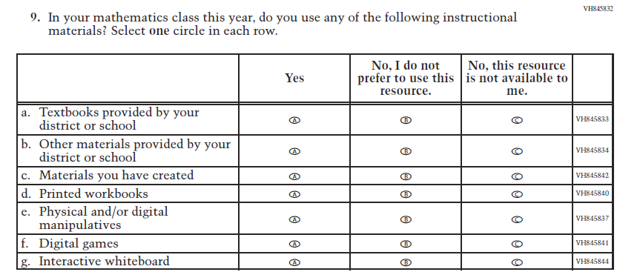  (2019 Grade 8) | Issue: Resources for Learning and Instruction | NC | N/A

2021 Operational Grade 8 Mathematics Teacher

Previous item | 2021 item | D/A/ R/NC+ | Rationale
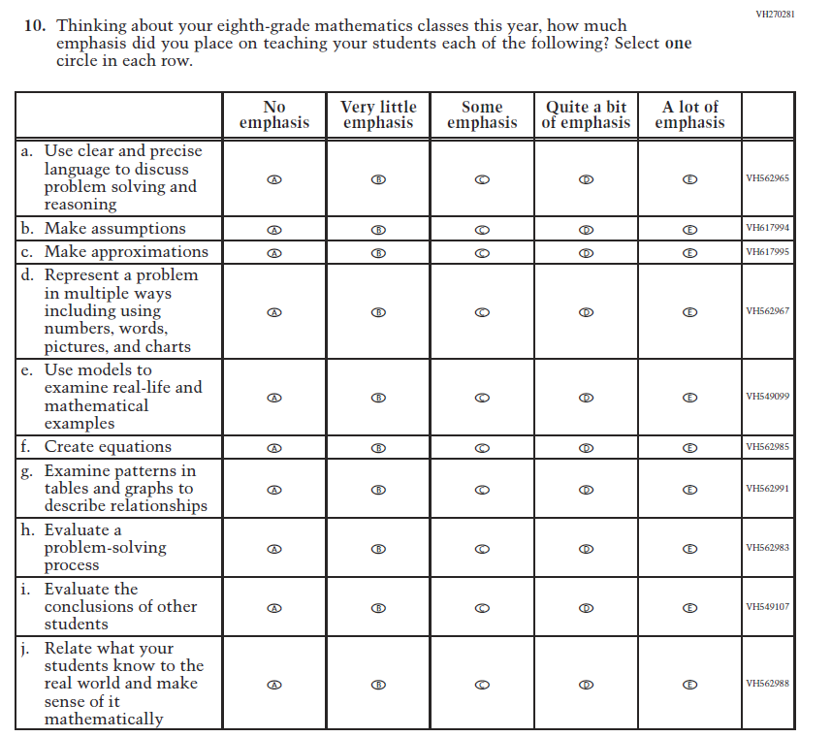  (2019 Grade 8) | Issue: Organization of Instruction | NC | N/A
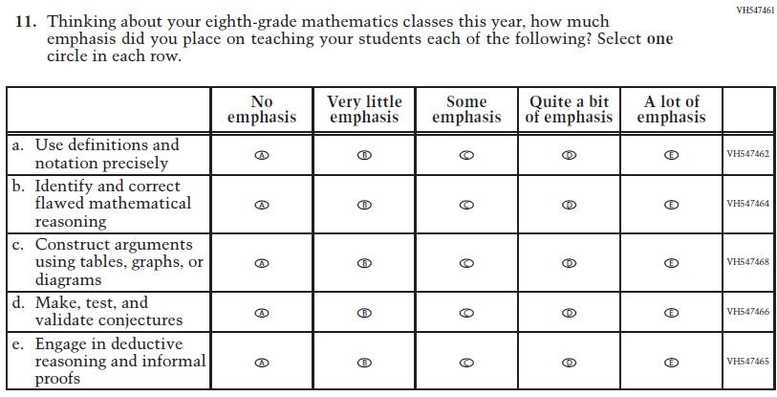  (2019 Grade 8) | Issue: Organization of Instruction | NC | N/A

2021 Operational Grade 8 Mathematics Teacher

Previous item | 2021 item | D/A/ R/NC+ | Rationale
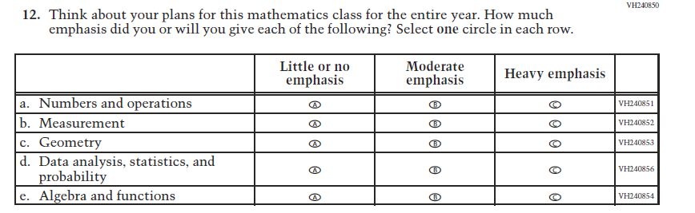  (2019 Grade 8) | Issue: Organization of Instruction | NC | N/A
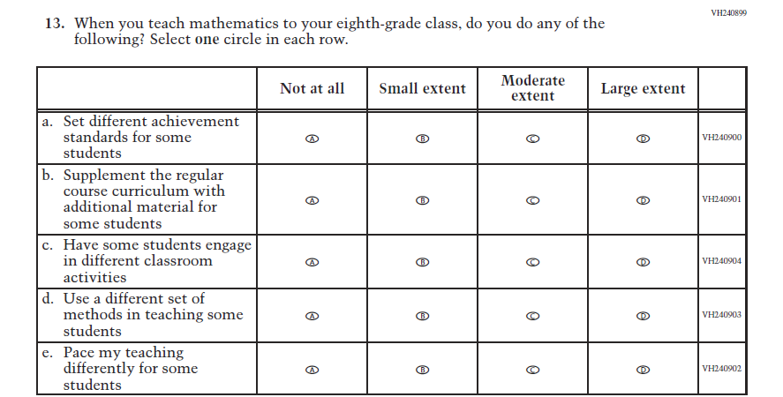  (2019 Grade 8) | Issue: Organization of Instruction | NC | N/A

2021 Operational Grade 8 Mathematics Teacher

Previous item | 2021 item | D/A/ R/NC+ | Rationale
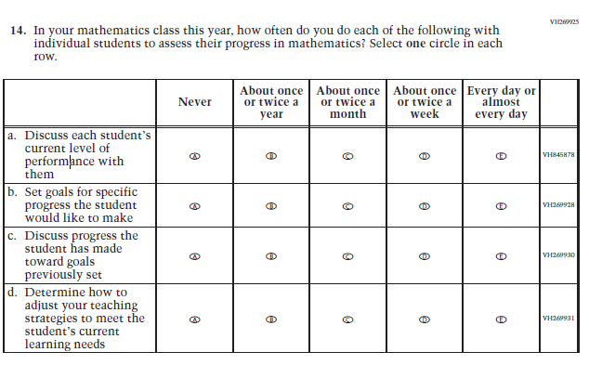  (2019 Grade 8) | Issue: Organization of Instruction | NC | N/A
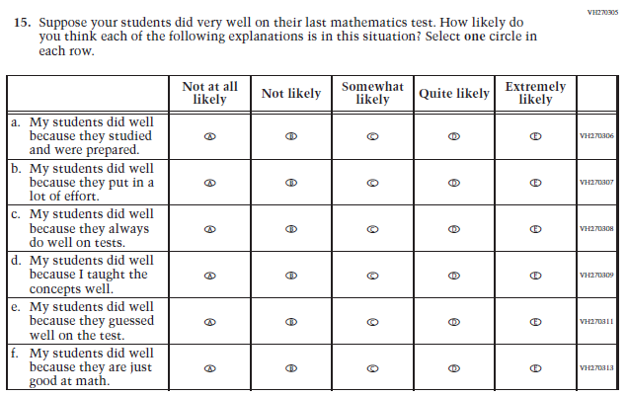  (2019 Grade 8) | Issue: Teacher Preparation | NC | N/A

2021 Operational Grade 8 Mathematics Teacher

Previous item | 2021 item | D/A/ R/NC+ | Rationale
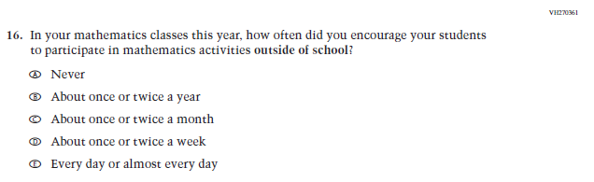  (2019 Grade 8) | Issue: Resources for Learning and Instruction | NC | N/A
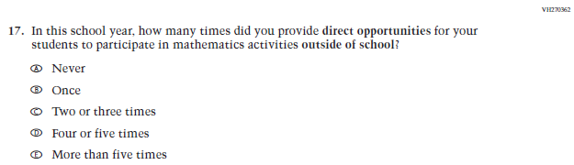  (2019 Grade 8) | Issue: Resources for Learning and Instruction | NC | N/A
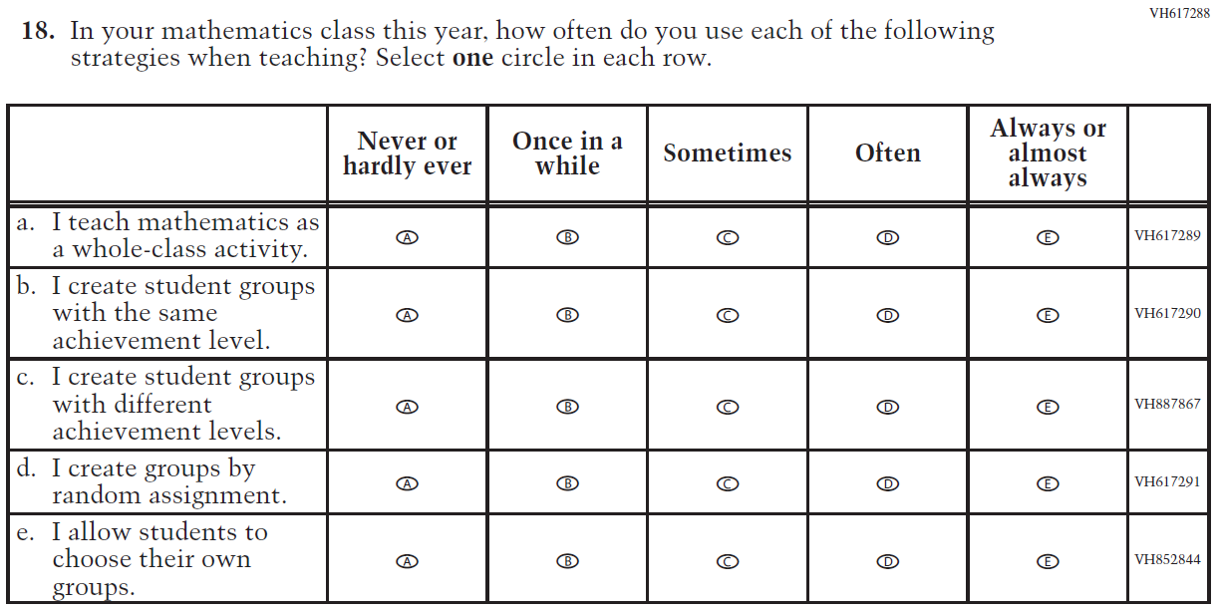  (2019 Grade 8) | Issue: Organization of Instruction | NC | N/A

Appendix J2-8: Operational Grade 8 Mathematics
Grade/Respondent | Item Number Initiating Skip Logic | Item Response(s) Initiating Skip Logic | Item Number(s) Being Skipped
Grade 8 Teacher | 1 | A | 2, 3, 4, 5, 6, 7, 8, 9, 10, 11, 12, 13, 14, 15, 16, 17, 18
Grade 8 Teacher | 5 | C | 6

Directions: The following questions ask about the organization of your classroom for mathematics instruction. If you teach more than one eighth-grade class, please choose a single class to use as the basis for answering the questions about classroom organization.

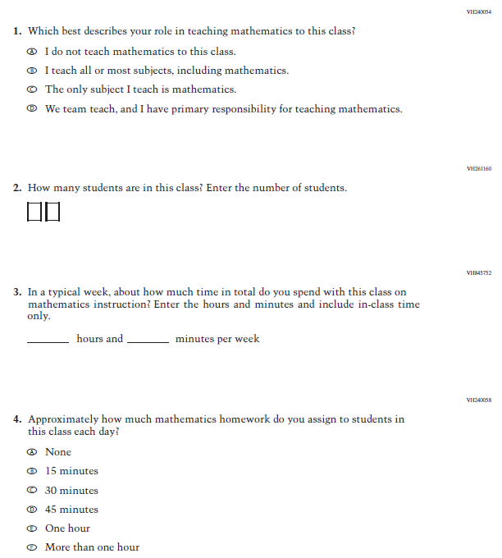

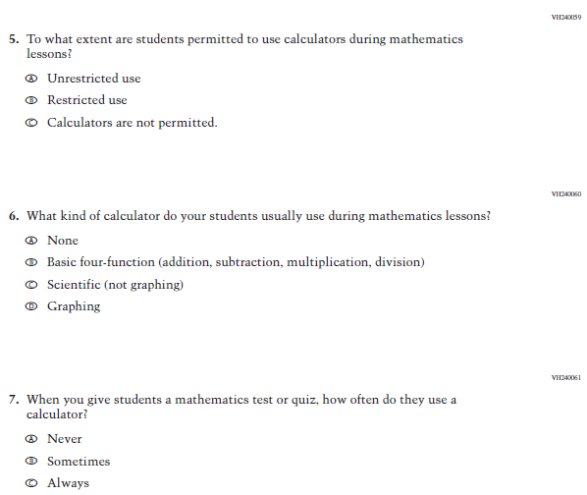
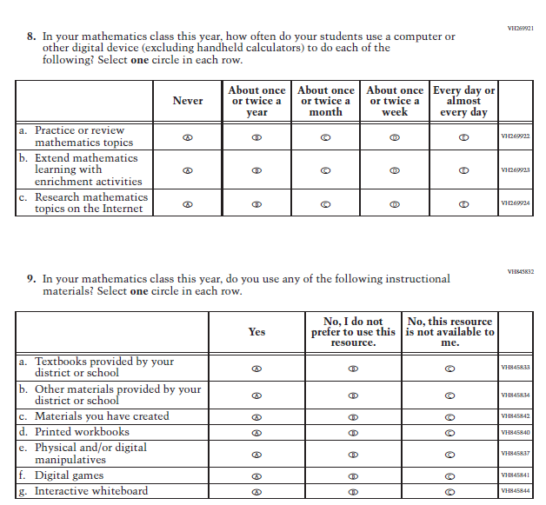

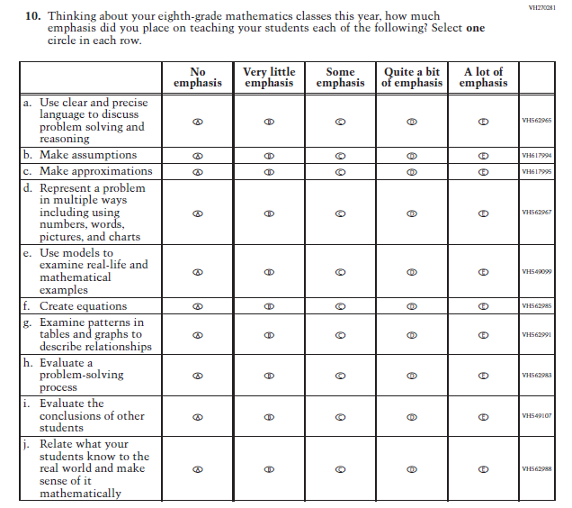
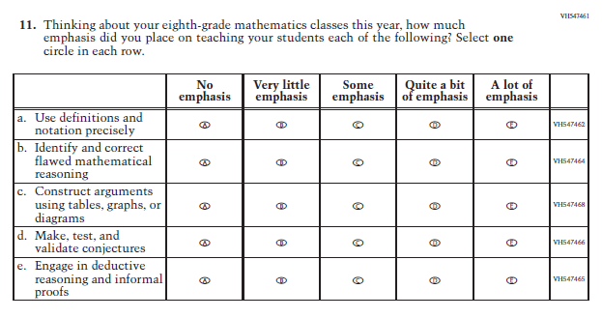
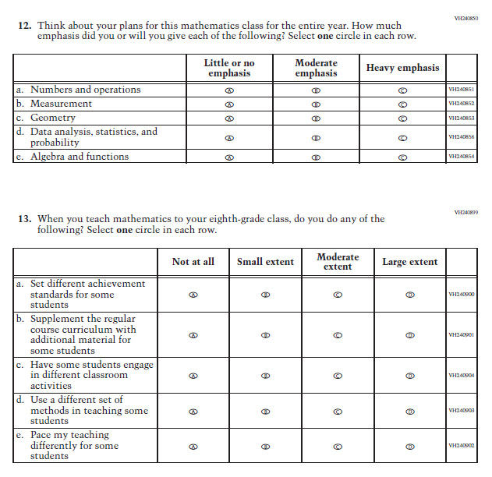
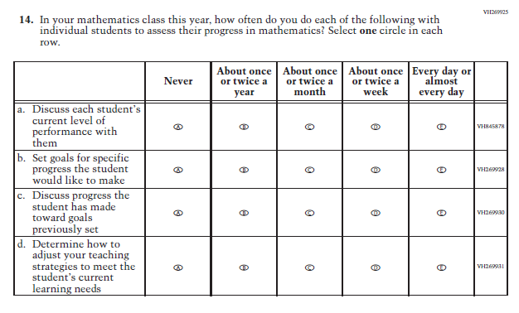
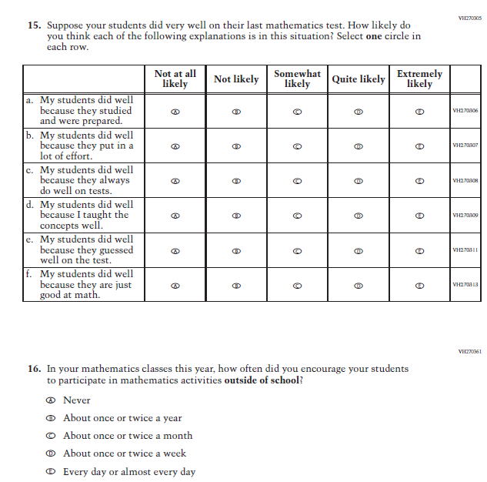
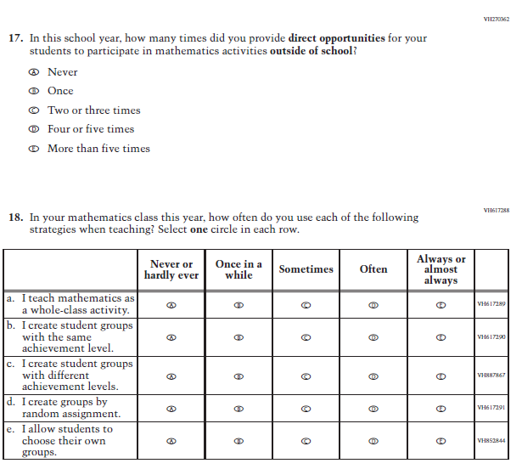

Appendix J2-9: Summary of Changes Operational Grade 4 Reading
2021 Operational Grade 4 Reading Teacher

Previous item | 2021 item | D/A/ R/NC+ | Rationale
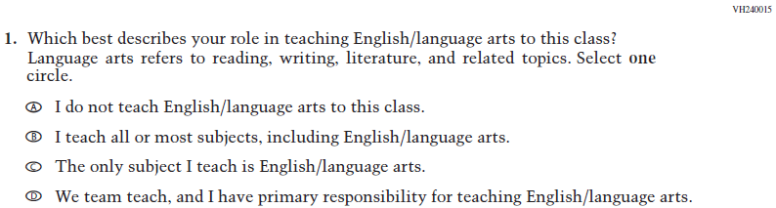  (2019 Grade 4) | Issue: Resources for Learning and Instruction | NC | N/A
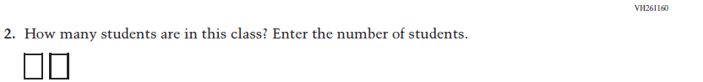  (2019 Grade 4) | Issue: Resources for Learning and Instruction | NC | N/A
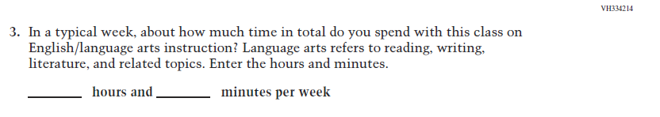  (2019 Grade 4) | Issue: Resources for Learning and Instruction | NC | N/A
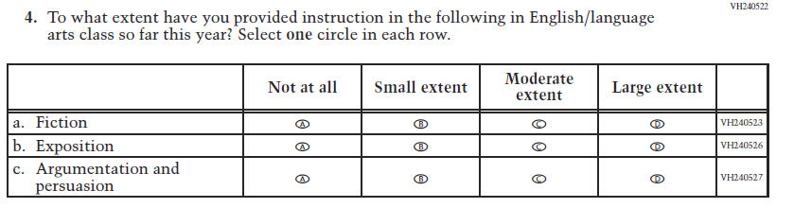  (2019 Grade 4) | Issue: Organization of Instruction | NC | N/A

2021 Operational Grade 4 Reading Teacher

Previous item | 2021 item | D/A/ R/NC+ | Rationale
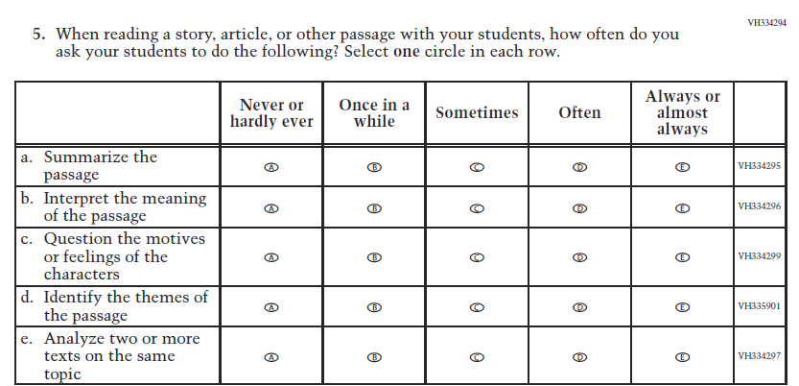  (2019 Grade 4) | Issue: Organization of Instruction | NC | N/A
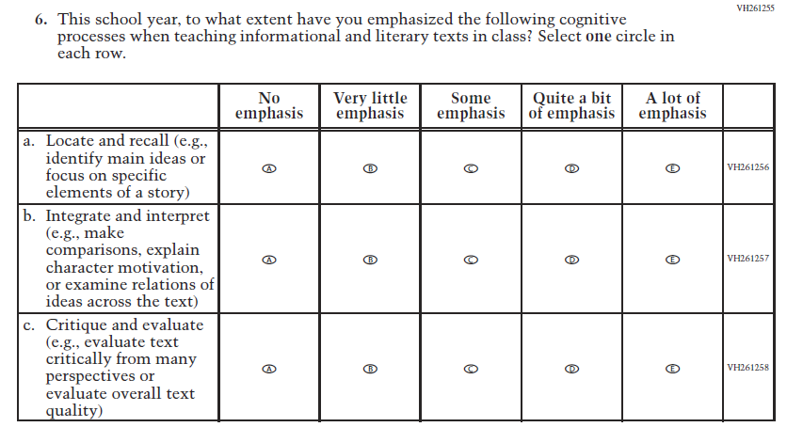  (2019 Grade 4) | Issue: Organization of Instruction | NC | N/A

2021 Operational Grade 4 Reading Teacher

Previous item | 2021 item | D/A/ R/NC+ | Rationale
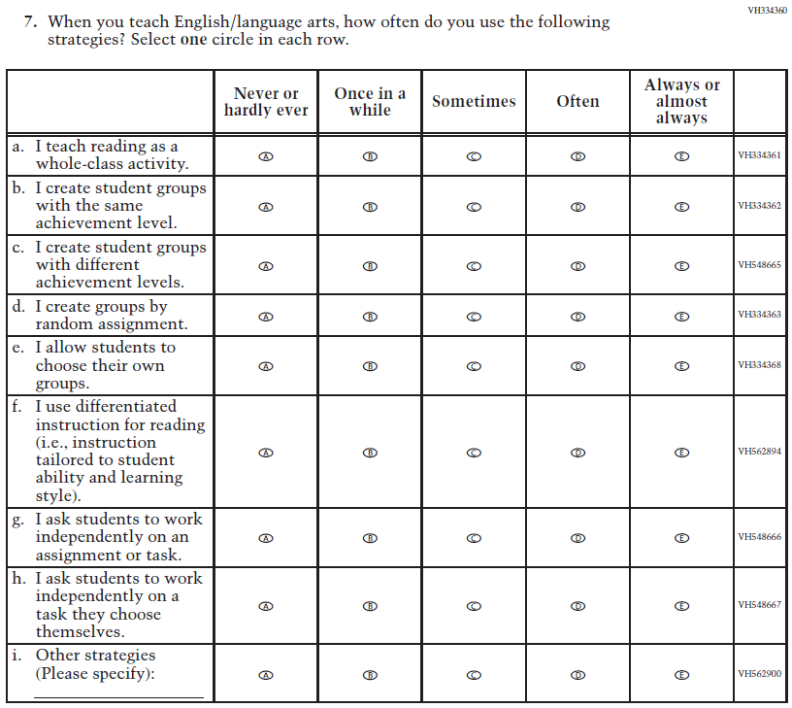  (2019 Grade 4) | Issue: Organization of Instruction | NC | N/A

2021 Operational Grade 4 Reading Teacher

Previous item | 2021 item | D/A/ R/NC+ | Rationale
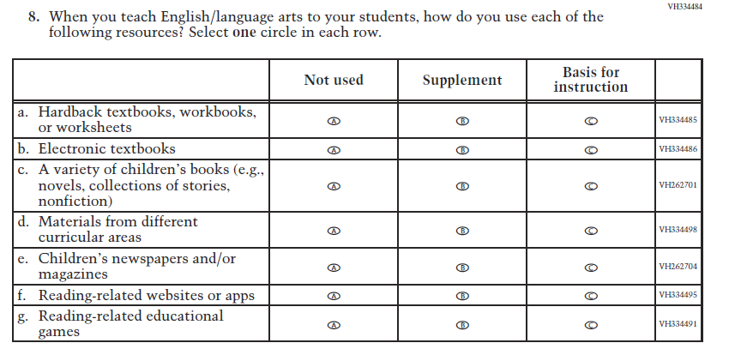  (2019 Grade 4) | Issue: Organization of Instruction | NC | N/A
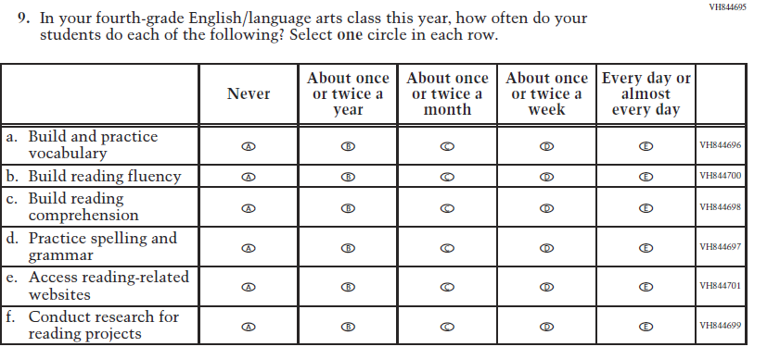  (2019 Grade 4) | Issue: Organization of Instruction | NC | N/A

2021 Operational Grade 4 Reading Teacher

Previous item | 2021 item | D/A/ R/NC+ | Rationale
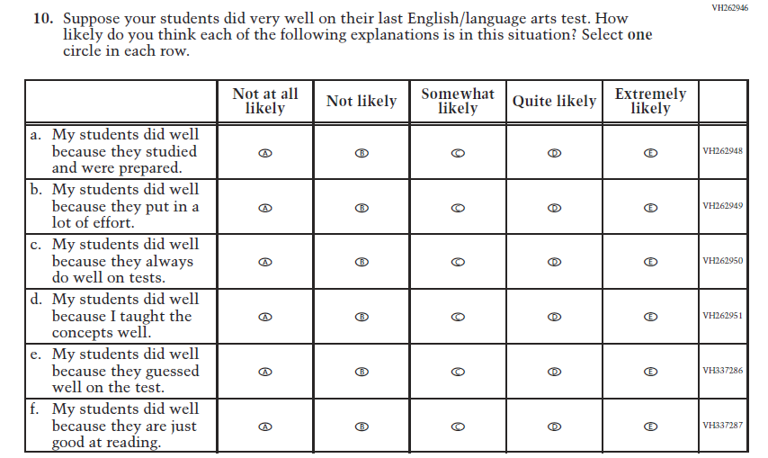  (2019 Grade 4) | Issue: Teacher Preparation | NC | N/A
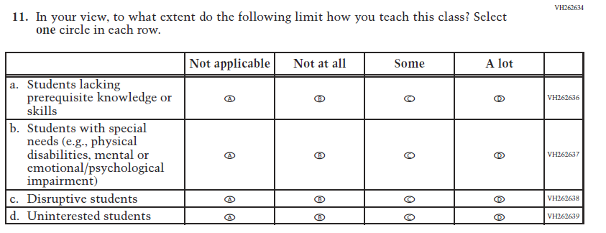  (2019 Grade 4) | Issue: Resources for Learning and Instruction | NC | N/A

Appendix J2-10: Operational Grade 4 Reading

Grade/Respondent | Item Number Initiating Skip Logic | Item Response(s) Initiating Skip Logic | Item Number(s) Being Skipped
Grade 4 Teacher | 1 | A | 2, 3, 4, 5, 6, 7, 8, 9, 10, 11

Directions: The following questions ask about the organization of your classroom for reading,
English, or language arts instruction. Please think about the reading, English, or
language arts class that you teach when questioned about “reading,” “language
arts,” “English,” or “English/language arts.” If you teach more than one
fourth-grade class, please choose a single class to use as the basis for answering the
questions about classroom organization.
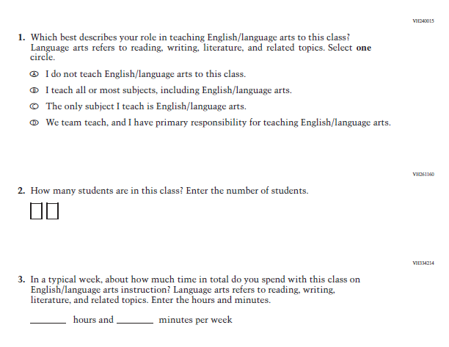

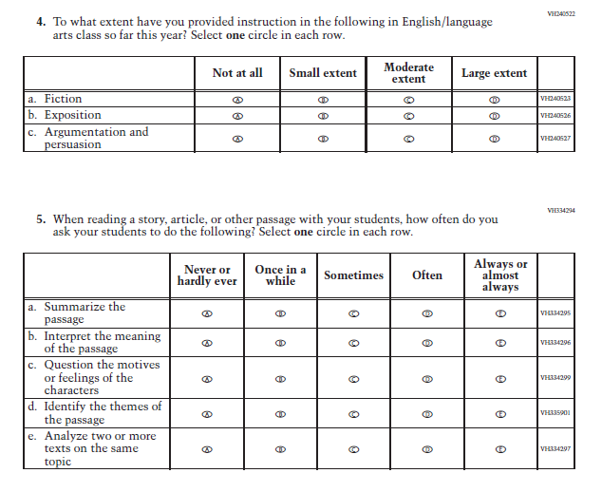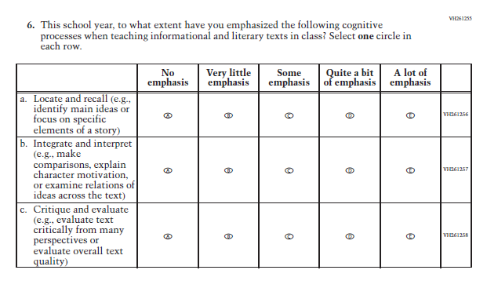
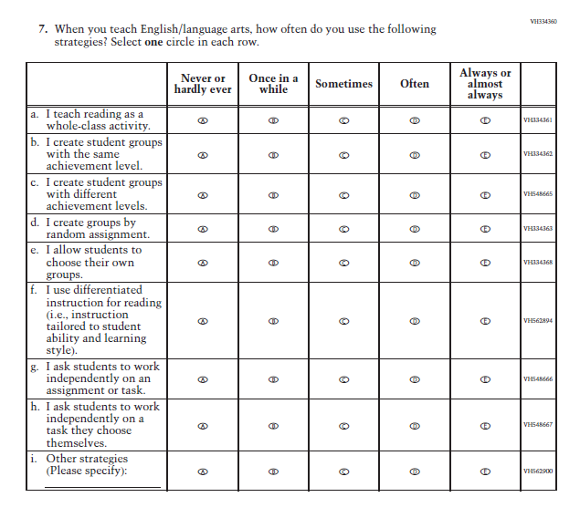

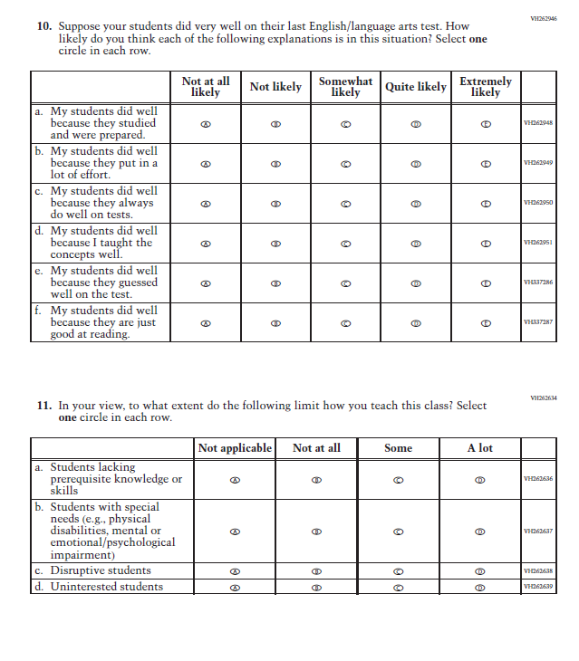

Appendix J2-11: Summary of Changes Operational Grade 8 Reading
2021 Operational Grade 8 Reading Teacher

Previous item | 2021 item | D/A/ R/NC+ | Rationale
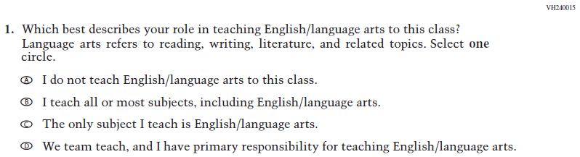  (2019 Grade 8) | Issue: Resources for Learning and Instruction | NC | N/A
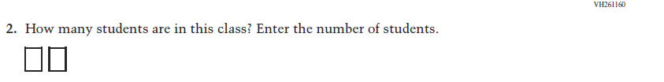  (2019 Grade 8) | Issue: Resources for Learning and Instruction | NC | N/A
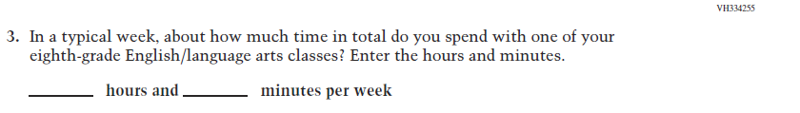  (2019 Grade 8) | Issue: Resources for Learning and Instruction | NC | N/A
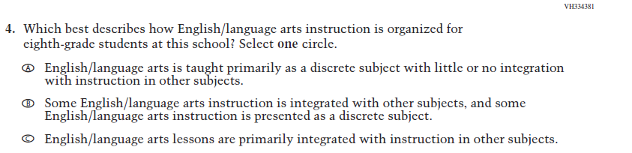  (2019 Grade 8) | Issue: Organization of Instruction | NC | N/A

2021 Operational Grade 8 Reading Teacher

Previous item | 2021 item | D/A/ R/NC+ | Rationale
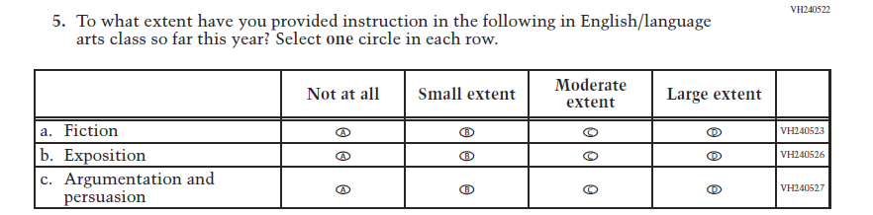  (2019 Grade 8) | Issue: Organization of Instruction | NC | N/A
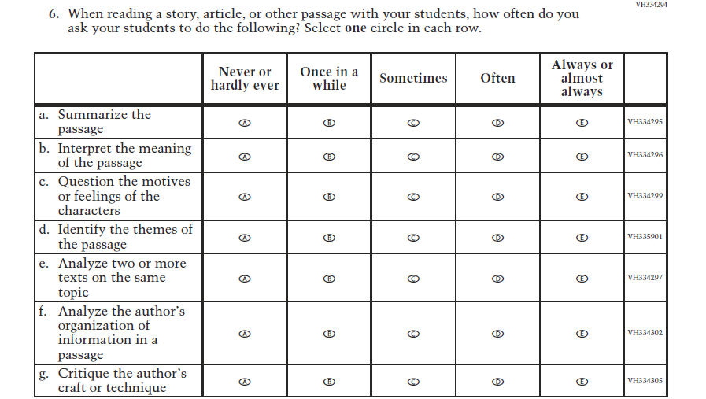  (2019 Grade 8) | Issue: Organization of Instruction | NC | N/A

.
2021 Operational Grade 8 Reading Teacher

Previous item | 2021 item | D/A/ R/NC+ | Rationale
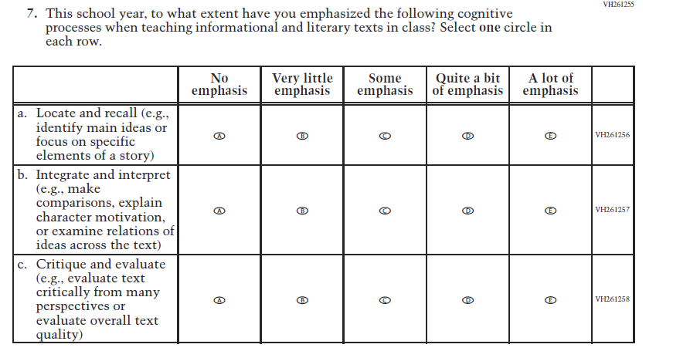  (2019 Grade 8) | Issue: Organization of Instruction | NC | N/A
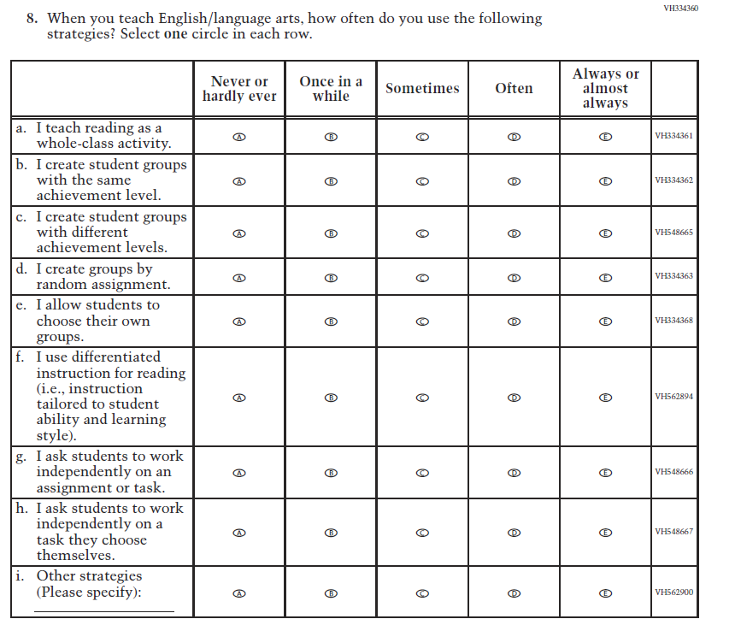  (2019 Grade 8) | Issue: Organization of Instruction | NC | N/A

2021 Operational Grade 8 Reading Teacher

Previous item | 2021 item | D/A/ R/NC+ | Rationale
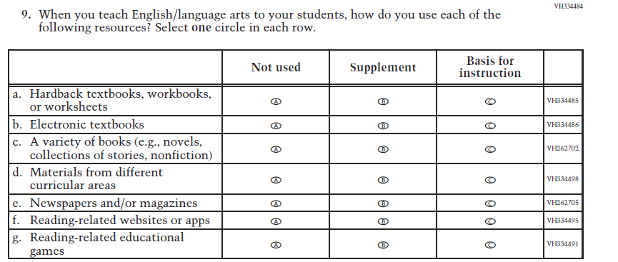  (2019 Grade 8) | Issue: Organization of Instruction | NC | N/A
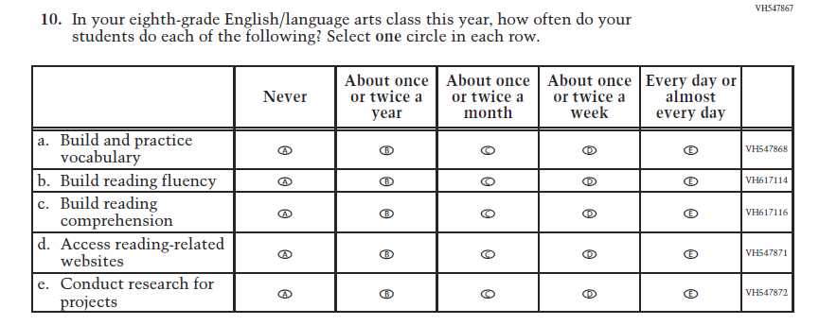  (2019 Grade 8) | Issue: Organization of Instruction | NC | N/A

2021 Operational Grade 8 Reading Teacher

Previous item | 2021 item | D/A/ R/NC+ | Rationale
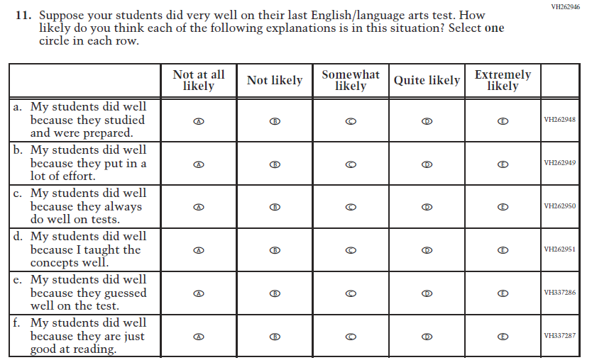  (2019 Grade 8) | Issue: Teacher Preparation | NC | N/A
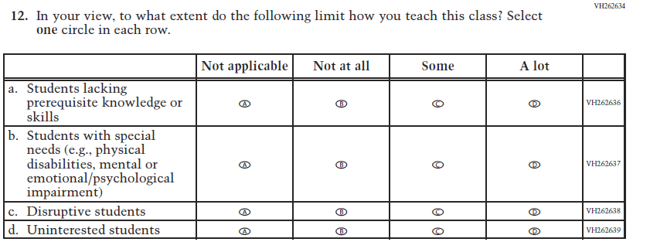  (2019 Grade 8) | Issue: Resources for Learning and Instruction | NC | N/A

Appendix J2-12: Operational Grade 8 Reading

Grade/Respondent | Item Number Initiating Skip Logic | Item Response(s) Initiating Skip Logic | Item Number(s) Being Skipped
Grade 8 Teacher | 1 | A | 2, 3, 4, 5, 6, 7, 8, 9, 10, 11, 12

Directions: The following questions ask about the organization of your classroom for reading,
English, or language arts instruction. Please think about the reading, English, or
language arts class that you teach when questioned about “reading,” “language
arts,” “English,” or “English/language arts.” If you teach more than one
eighth-grade class, please choose a single class to use as the basis for answering the
questions about classroom organization.
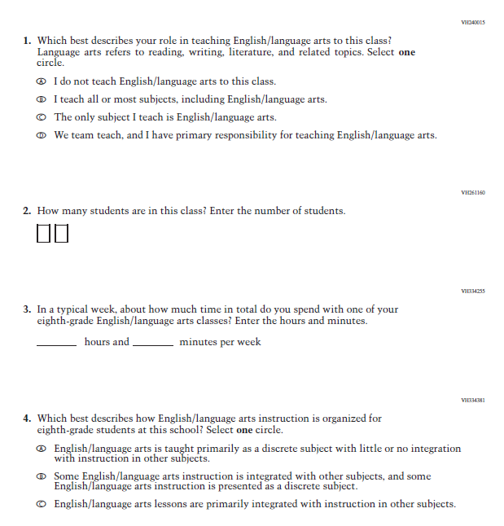

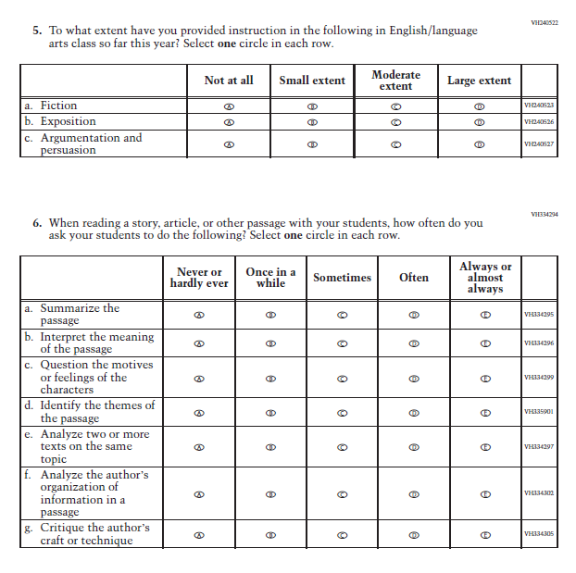

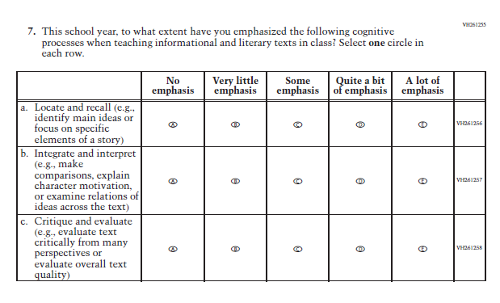

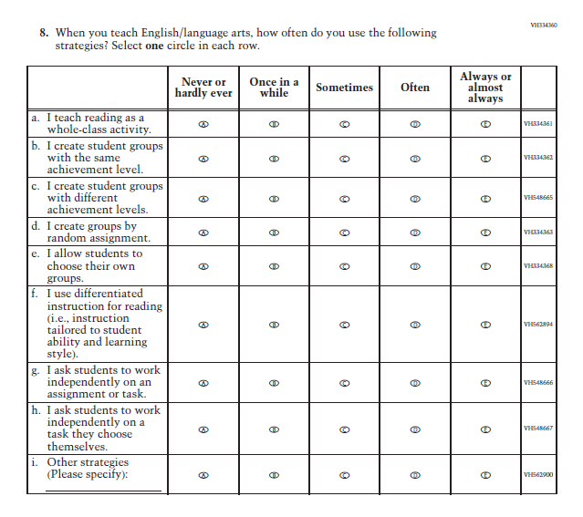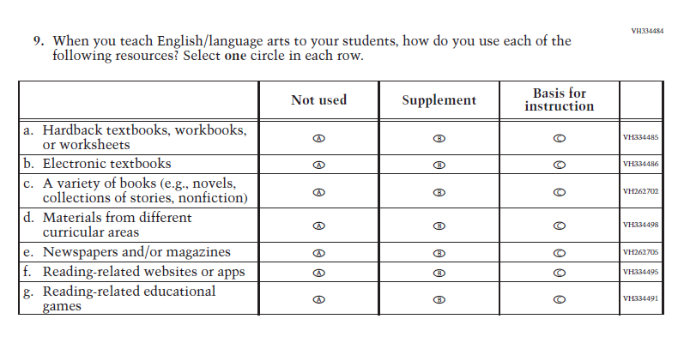

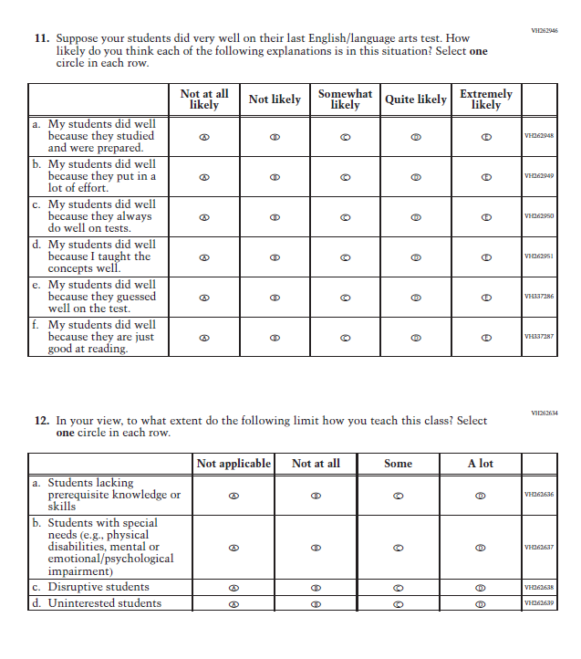

Appendix J2-13: Operational Grade 4 COVID-19
Skip Logic Table
Grade/Respondent | Item Number Initiating Skip Logic | Item Response(s) Initiating Skip Logic | Item Number(s) Being Skipped
Grade 4 Teacher | 1 | B | 2

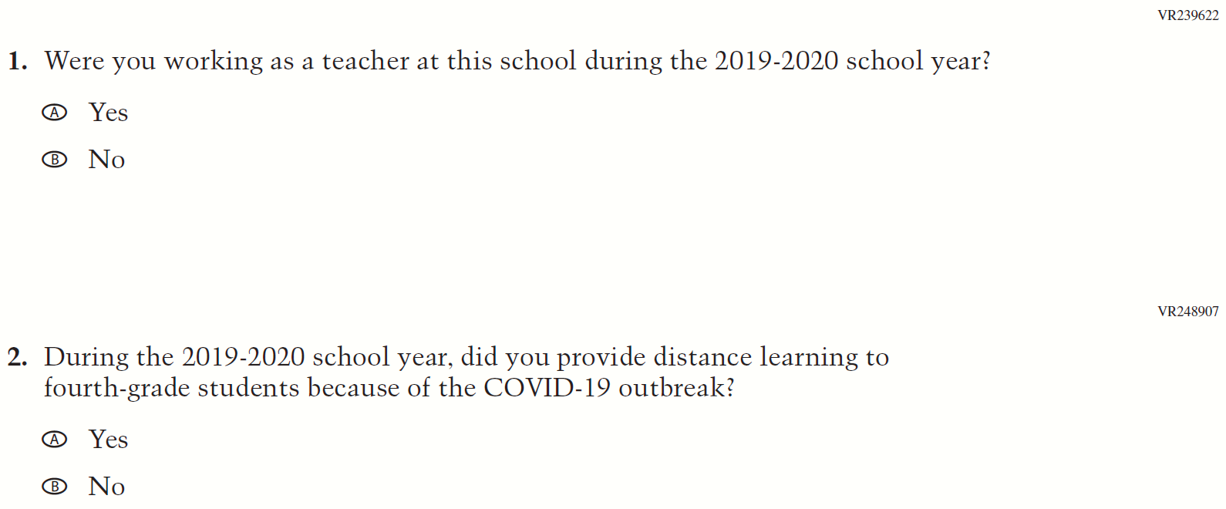
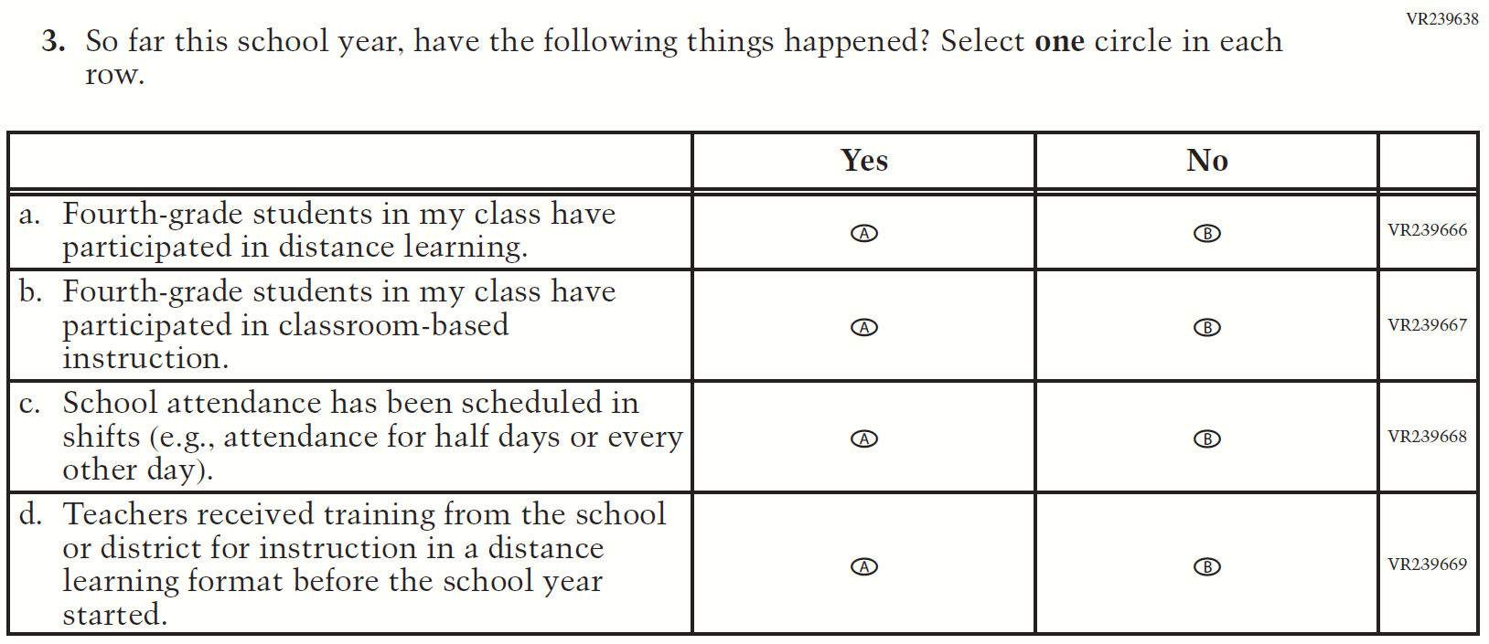
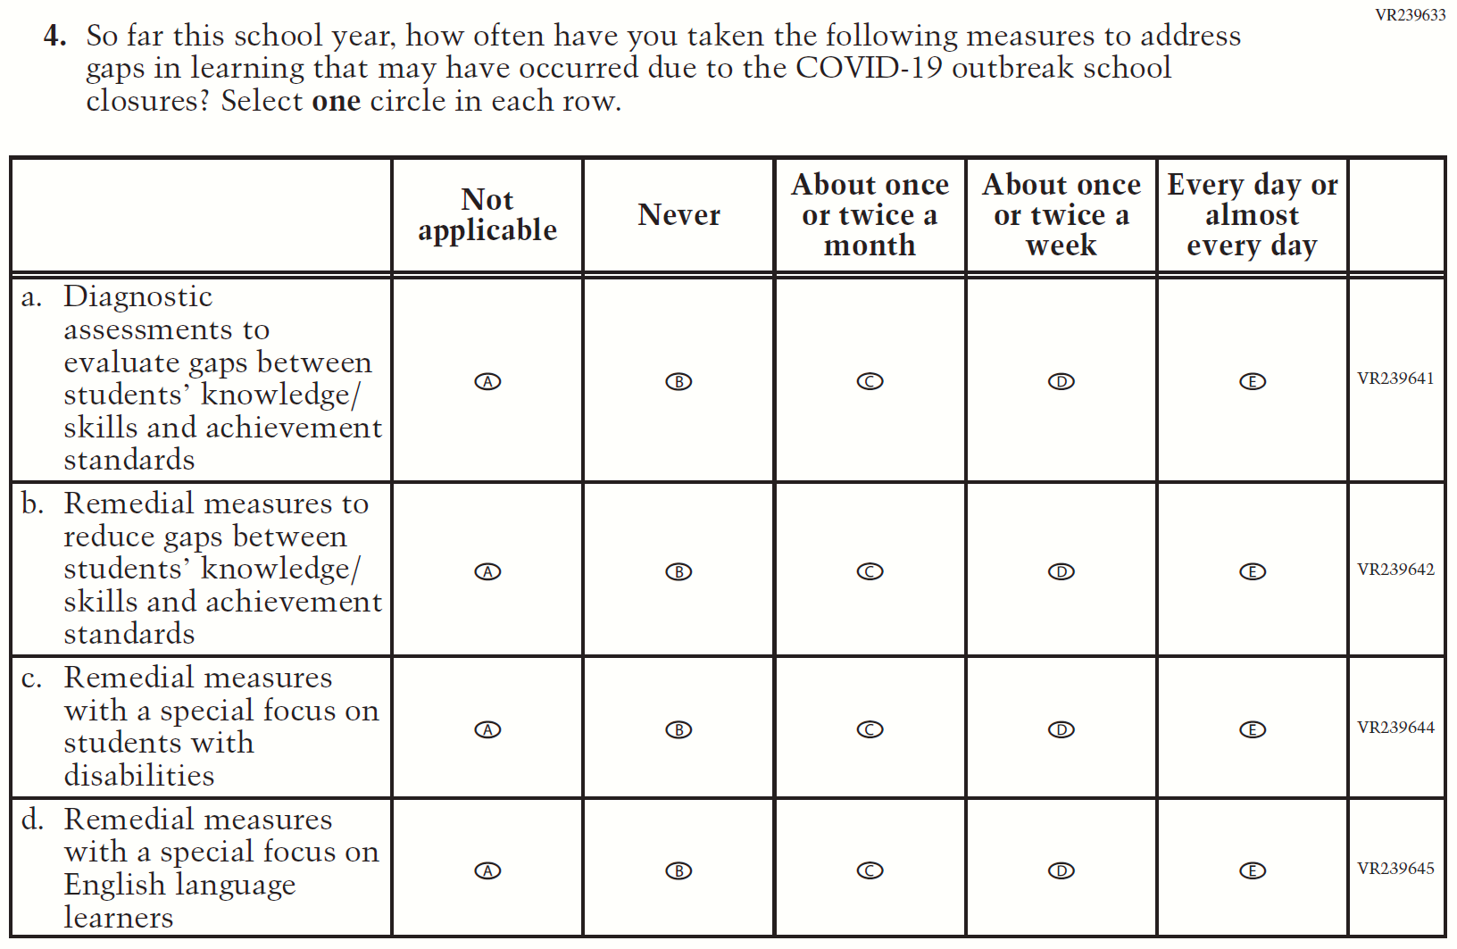
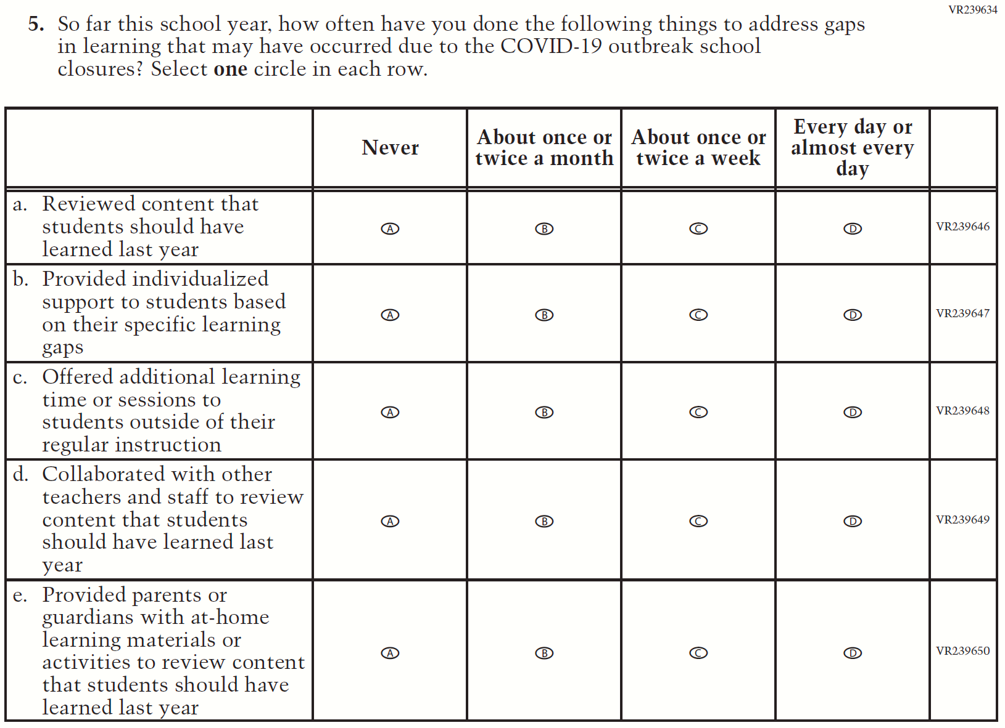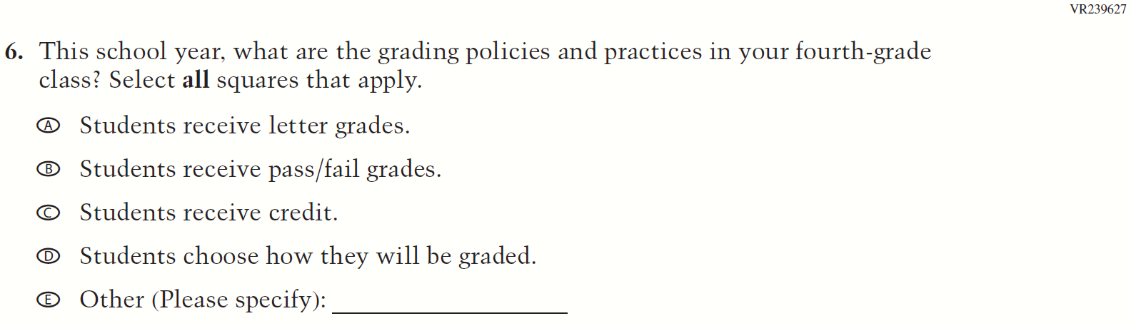
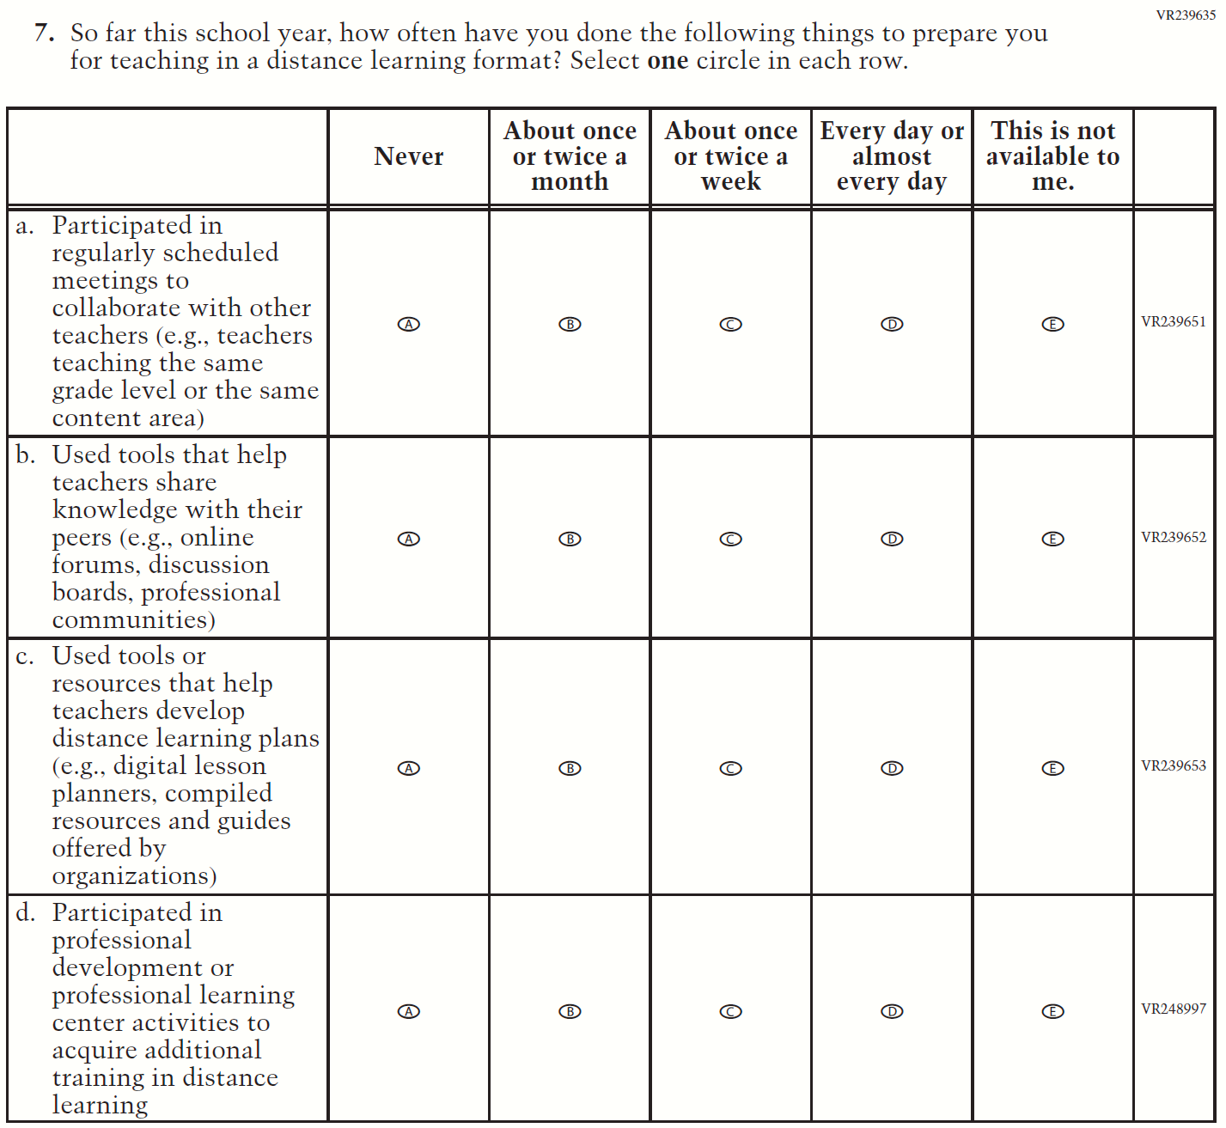
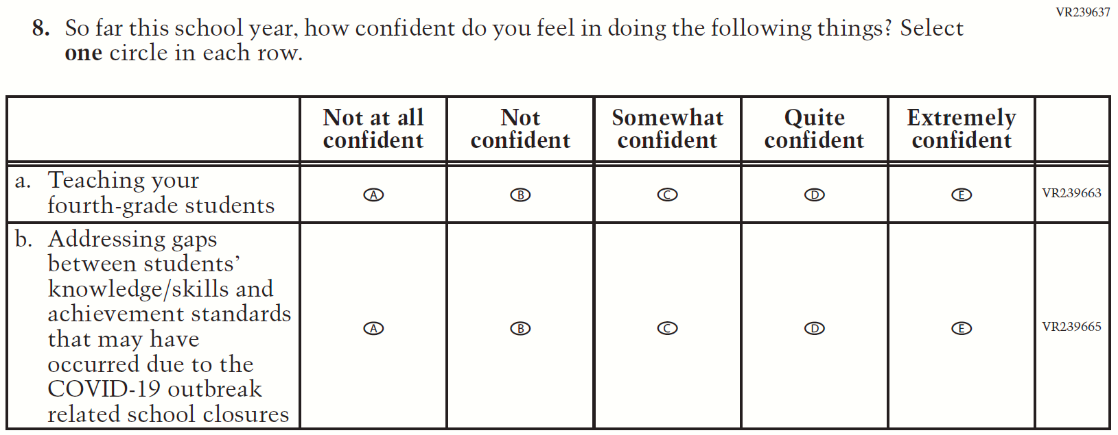
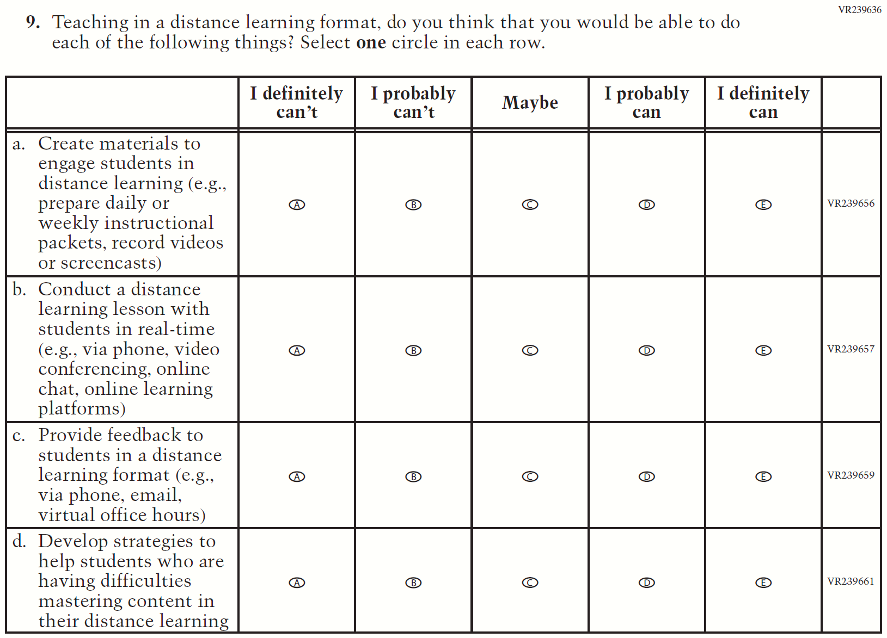

Appendix J2-14: Operational Grade 8 COVID-19
Skip Logic Table
Grade/Respondent | Item Number Initiating Skip Logic | Item Response(s) Initiating Skip Logic | Item Number(s) Being Skipped
Grade 8 Teacher | 1 | B | 2

