NATIONAL CENTER FOR EDUCATION STATISTICS NATIONAL ASSESSMENT OF EDUCATIONAL PROGRESS

National Assessment of Educational Progress (NAEP)
2021 School and Teacher Questionnaire Special Study

Appendix J-S

2021 Spanish Questionnaires

OMB# 1850-0956 v.2

March 2021

Table of Contents
Teacher Login Screen 3
Appendix J-2-s: Spanish Translations of Teacher Questionnaires 5
Appendix J-2a-s-PR: Summary of Changes Operational Grade 4 CORE 6
Appendix J-2a-s-PR: Operational Grade 4 CORE 14
Appendix J-2b-s-PR: Summary of Changes Operational Grade 8 CORE 21
Appendix J-2b-s-PR: Operational Grade 8 CORE 29
Appendix J-2c-s-PR: Summary of Changes Operational Grade 4 Mathematics 37
Appendix J-2c-s-PR: Operational Grade 4 Mathematics 43
Appendix J-2d-s-PR: Summary of Changes Operational Grade 8 Mathematics 49
Appendix J-2d-s-PR: Operational Grade 8 Mathematics 56
Appendix J-2e-s-PR: Operational Grade 4 COVID-19 62
Appendix J-2f-s-PR: Operational Grade 8 COVID-19 67
School Administrator Login Screen 72
Appendix J-3-s: Spanish Translations of School Questionnaires 74
Appendix J-3a-s-PR: Summary of Changes Operational Grade 4 CORE 75
Appendix J-3a-s-PR: Operational Grade 4 CORE 87
Appendix J-3b-s-PR: Summary of Changes Operational Grade 8 CORE 99
Appendix J-3b-s-PR: Operational Grade 8 CORE 111
Appendix J-3c-s-PR: Summary of Changes Operational Grade 4 Mathematics 123
Appendix J-3c-s-PR: Operational Grade 4 Mathematics 126
Appendix J-3d-s-PR: Summary of Changes Operational Grade 8 Mathematics 129
Appendix J-3d-s-PR: Operational Grade 8 Mathematics 132
Appendix J-3e-s-PR: Operational Grade 4 COVID-19 136
Appendix J-3f-s-PR: Operational Grade 8 COVID-19 145

Teacher Login Screen

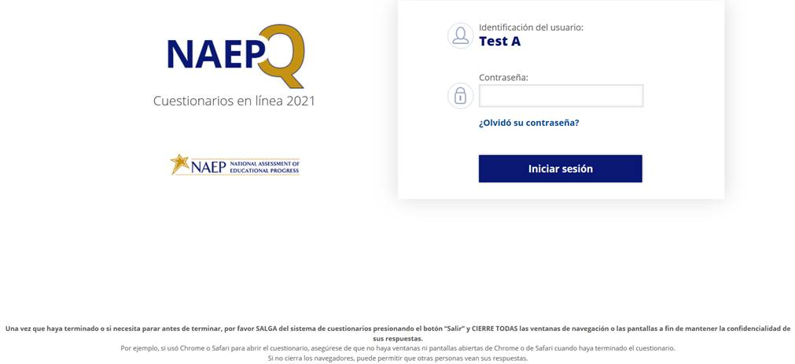
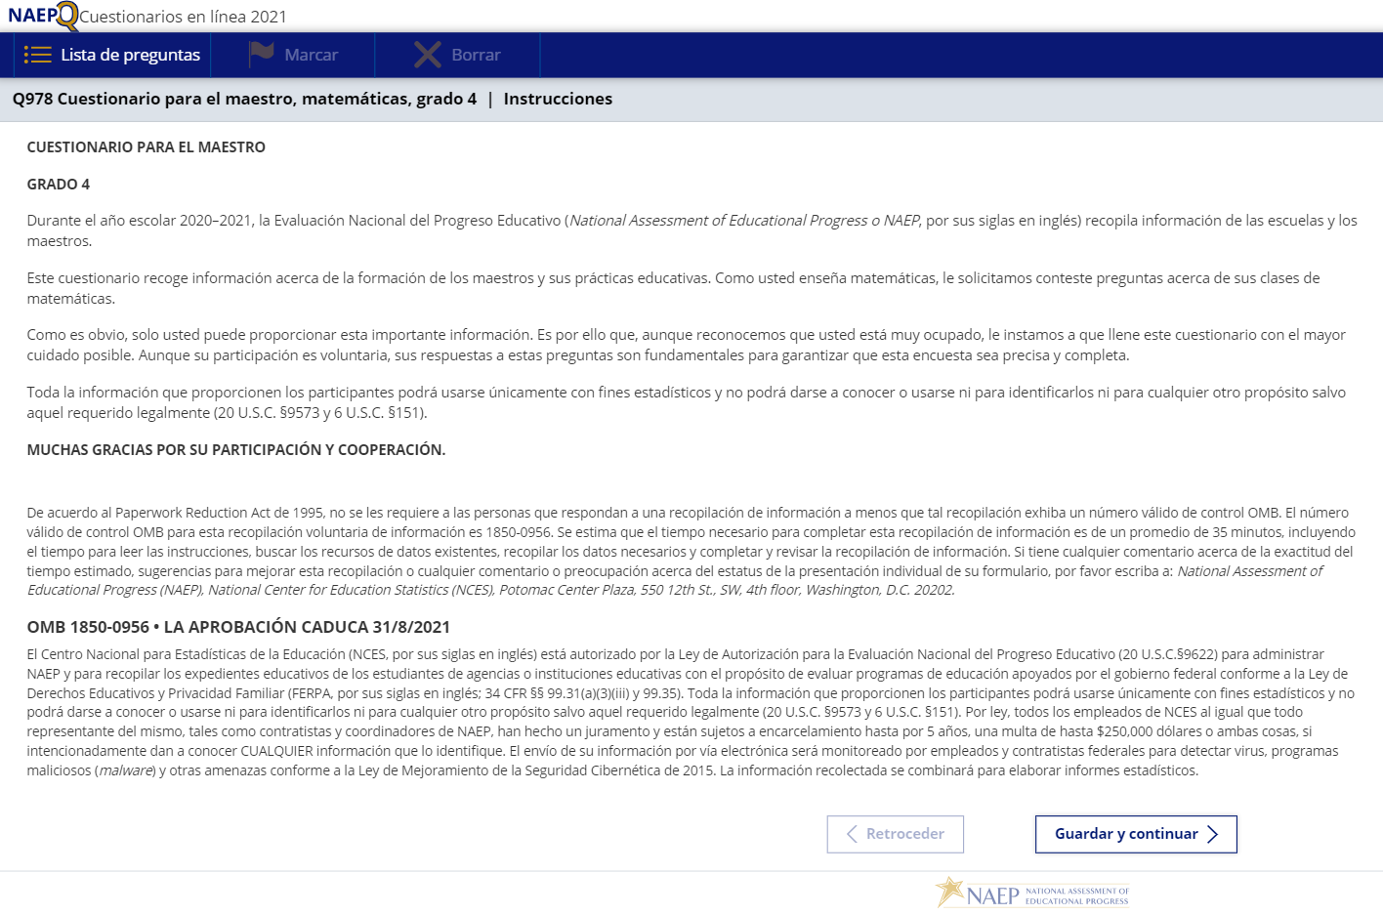

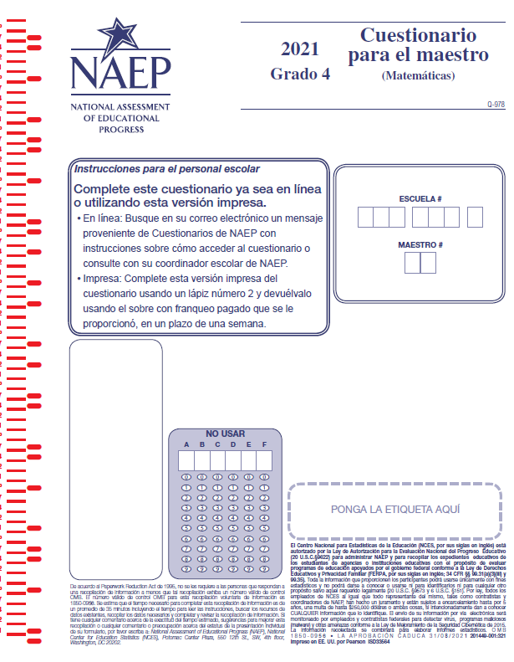

Appendix J-2-s: Spanish Translations of Teacher Questionnaires

Appendix J-2a-s-PR: Summary of Changes Operational Grade 4 CORE
2021 Operational Grade 4 Core Teacher – Puerto Rico
Previous item | 2021 item | D/A/R/NC+ | Rationale
VH835832  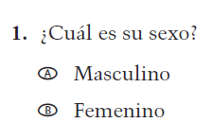  (2019 Operational Grade 4 Teacher Core – Puerto Rico) | VH835832  Issue: Gender | NC | N/A
VH319761  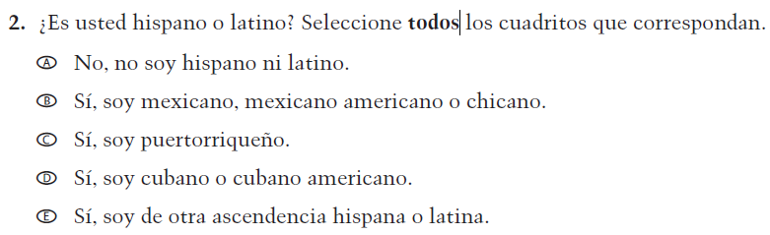  (2019 Operational Grade 4 Teacher Core – Puerto Rico) | VH319761  Issue: Race/Ethnicity | NC | N/A
VH319763  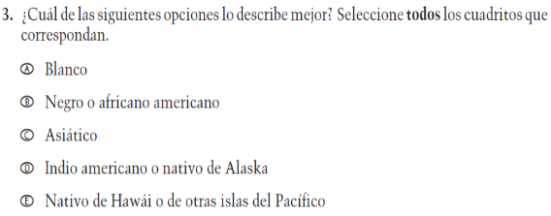  (2019 Operational Grade 4 Teacher Core – Puerto Rico) | VH319763  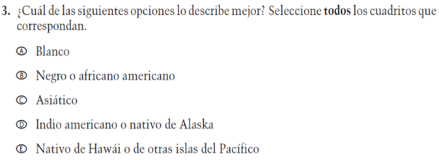  Issue: Race/Ethnicity | NC | N/A

2021 Operational Grade 4 Core Teacher – Puerto Rico
Previous item | 2021 item | D/A/R/NC+ | Rationale
VH319764  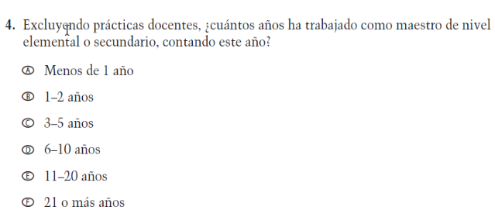  (2019 Operational Grade 4 Teacher Core – Puerto Rico) | VH319764  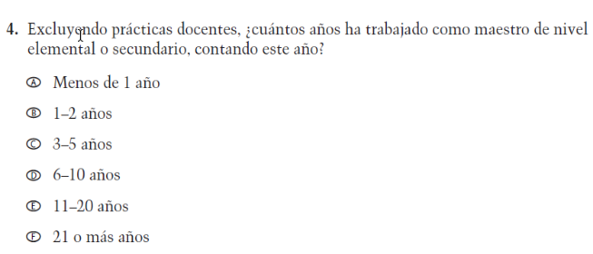  Issue: Teacher Preparation | NC | N/A
VH835831  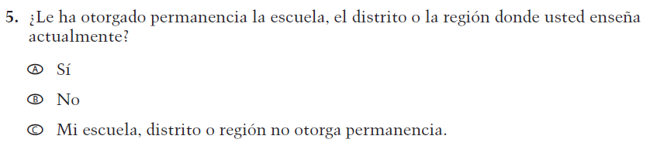  (2019 Operational Grade 4 Teacher Core – Puerto Rico) | VH835831  Issue: Teacher Preparation | NC | N/A
VH319767  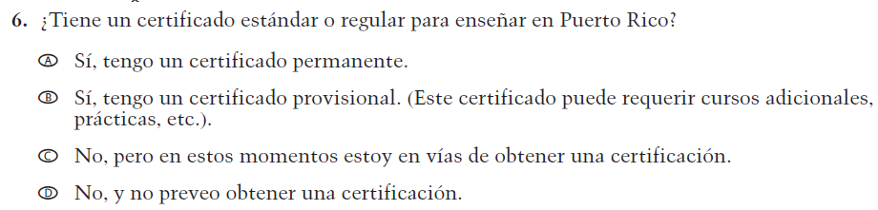  (2019 Operational Grade 4 Teacher Core – Puerto Rico) | VH319767  Issue: Teacher Preparation | NC | N/A

2021 Operational Grade 4 Core Teacher – Puerto Rico
Previous item | 2021 item | D/A/R/NC+ | Rationale
VH319769  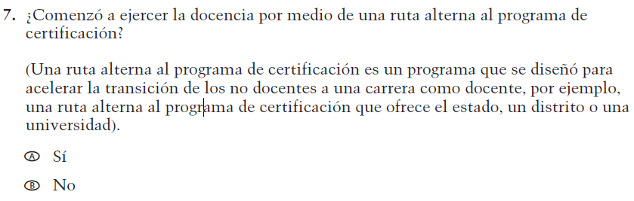  (2019 Operational Grade 4 Teacher Core – Puerto Rico) | VH319769  Issue: Teacher Preparation | NC | N/A
VH319773  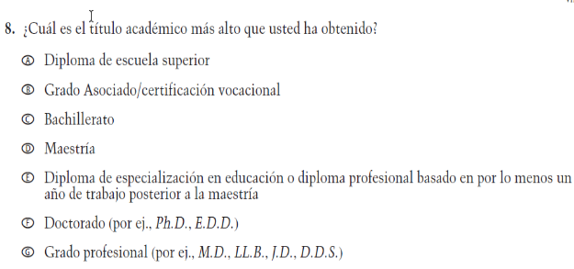  (2019 Operational Grade 4 Teacher Core – Puerto Rico) | VH319773  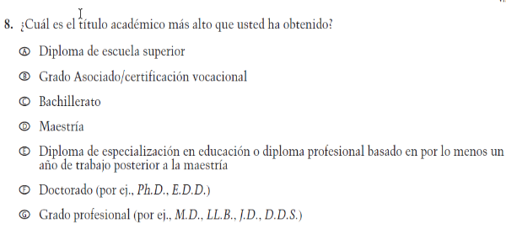  Issue: Teacher Preparation | NC | N/A
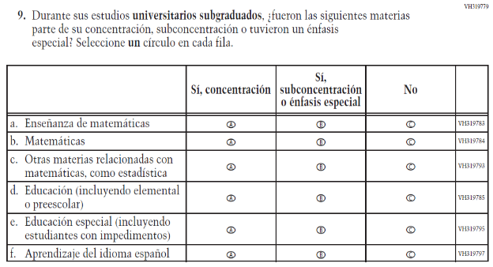  (2019 Operational Grade 4 Teacher Core – Puerto Rico) | 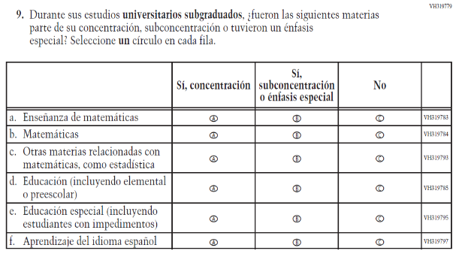  Issue: Teacher Preparation | NC | N/A

2021 Operational Grade 4 Core Teacher – Puerto Rico
Previous item | 2021 item | D/A/R/NC+ | Rationale
VH319827  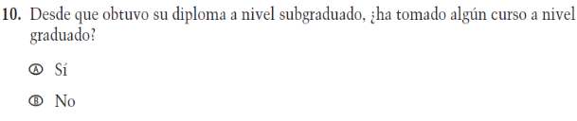  (2019 Operational Grade 4 Teacher Core – Puerto Rico) | VH319827  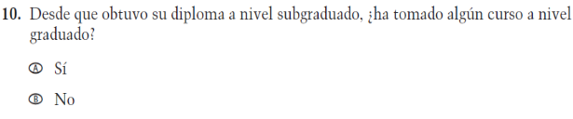  Issue: Teacher Preparation | NC | N/A
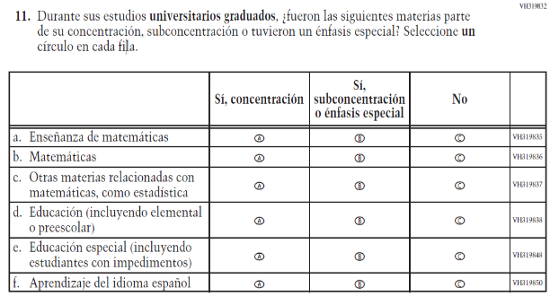  (2019 Operational Grade 4 Teacher Core – Puerto Rico) | 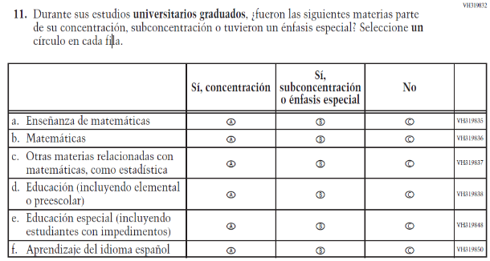  Issue: Teacher Preparation | NC | N/A
VH579698  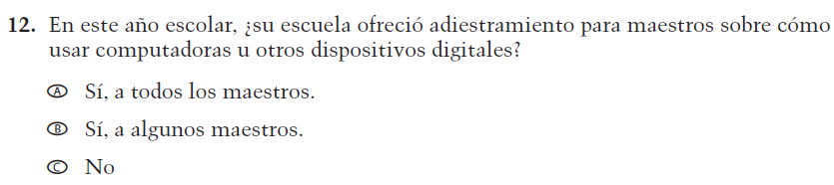  (2019 Operational Grade 4 Teacher Core – Puerto Rico) | VH579698  Issue: Technology Use | NC | N/A

2021 Operational Grade 4 Core Teacher – Puerto Rico
Previous item | 2021 item | D/A/R/NC+ | Rationale
VH579699  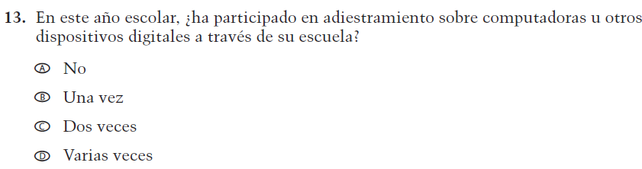  (2019 Operational Grade 4 Teacher Core – Puerto Rico) | VH579699  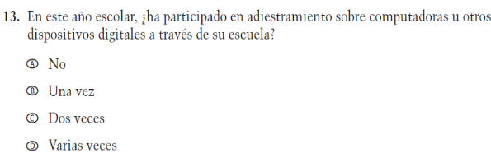  Issue: Technology Use | NC | N/A
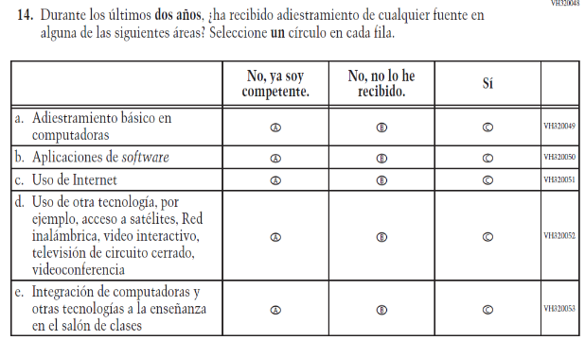  (2019 Operational Grade 4 Teacher Core – Puerto Rico) | 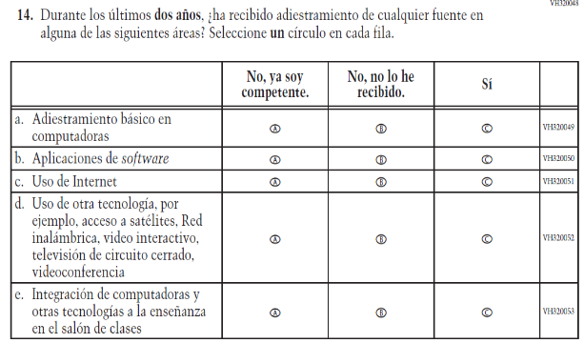  Issue: Technology Use | NC | N/A
VH893860  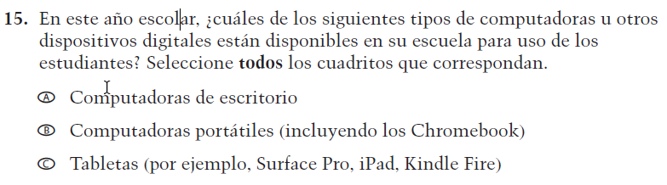  (2019 Operational Grade 4 Teacher Core – Puerto Rico) | VH893860  Issue: Technology Use | NC | N/A

2021 Operational Grade 4 Core Teacher – Puerto Rico
Previous item | 2021 item | D/A/R/NC+ | Rationale
VH579690  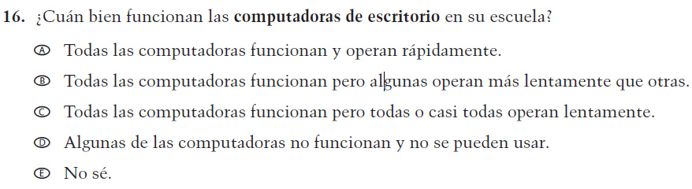  (2019 Operational Grade 4 Teacher Core – Puerto Rico) | VH579690  Issue: Technology Use | NC | N/A
VH579692  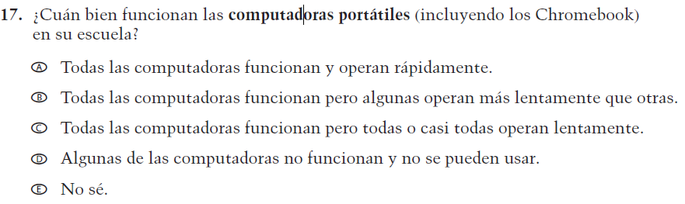  (2019 Operational Grade 4 Teacher Core – Puerto Rico) | VH579692  Issue: Technology Use | NC | N/A
VH579694  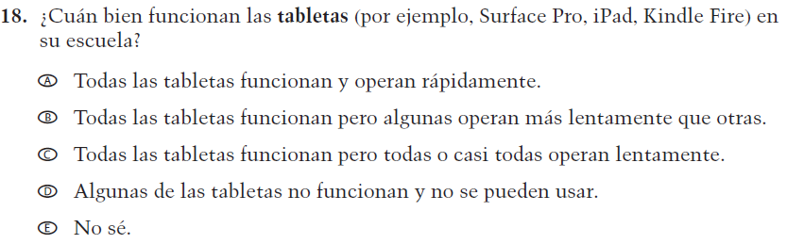  (2019 Operational Grade 4 Teacher Core – Puerto Rico) | VH579694  Issue: Technology Use | NC | N/A

2021 Operational Grade 4 Core Teacher – Puerto Rico
Previous item | 2021 item | D/A/R/NC+ | Rationale
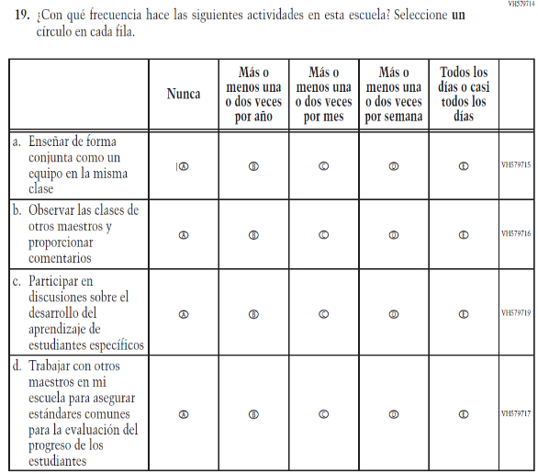  (2019 Operational Grade 4 Teacher Core – Puerto Rico) | 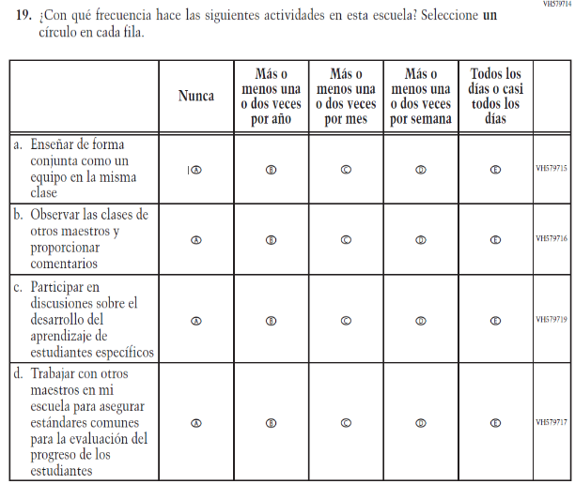  Issue: School Climate | NC | N/A
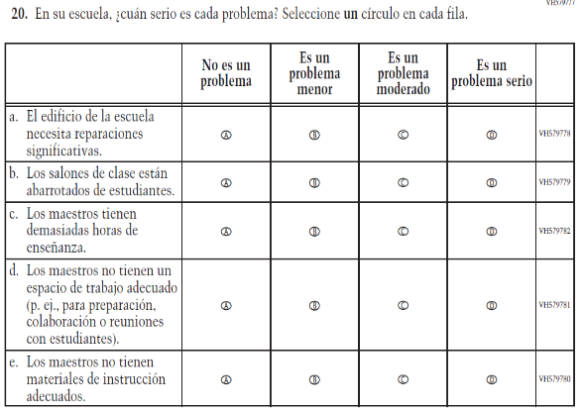  (2019 Operational Grade 4 Teacher Core – Puerto Rico) | 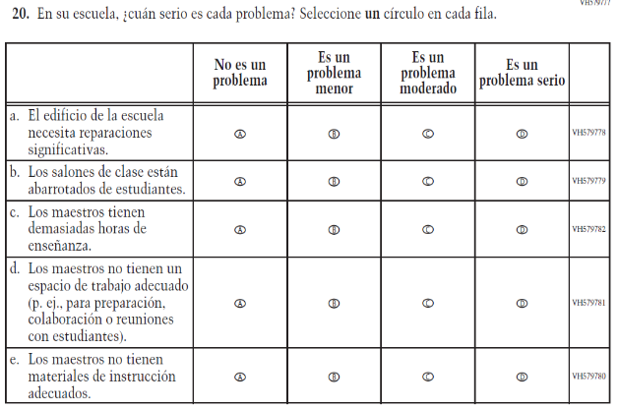  Issue: School Climate | NC | N/A

2021 Operational Grade 4 Core Teacher – Puerto Rico
Previous item | 2021 item | D/A/R/NC+ | Rationale
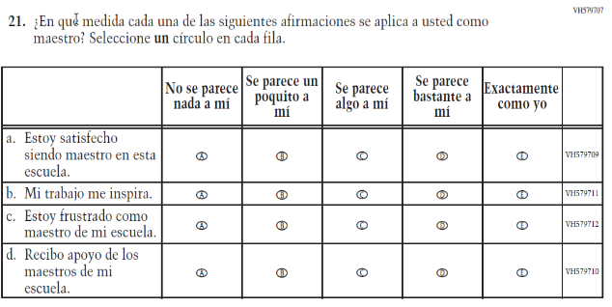  (2019 Operational Grade 4 Teacher Core – Puerto Rico) | 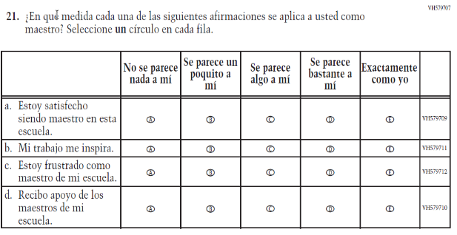  Issue: School Climate | NC | N/A
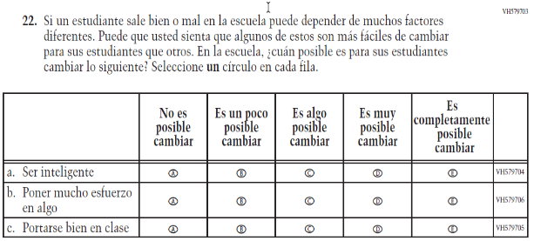  (2019 Operational Grade 4 Teacher Core – Puerto Rico) | 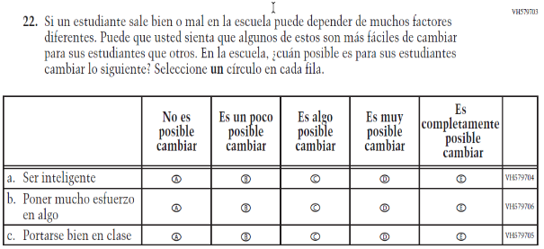  Issue: School Climate | NC | N/A

Appendix J-2a-s-PR: Operational Grade 4 CORE
Grade/Respondent | Item Number Initiating Skip Logic | Item Response(s) Initiating Skip Logic | Item Number(s) Being Skipped
Grade 4 Teacher | 8 | A | 9, 10, 11
Grade 4 Teacher | 8 | B | 10, 11
Grade 4 Teacher | 10 | B | 11
Grade 4 Teacher | 12 | C | 13
Grade 4 Teacher | 15 | A | Do NOT skip 16
Grade 4 Teacher | 15 | B | Do NOT skip 17
Grade 4 Teacher | 15 | C | Do NOT skip 18

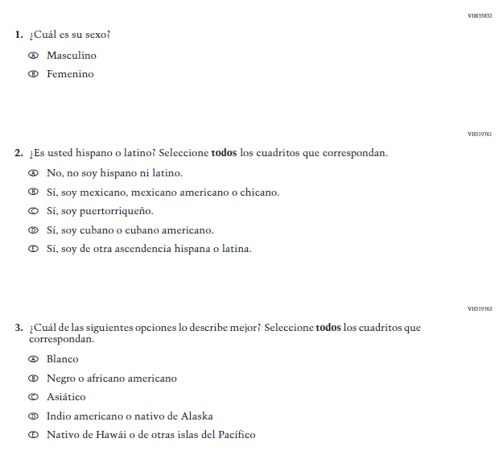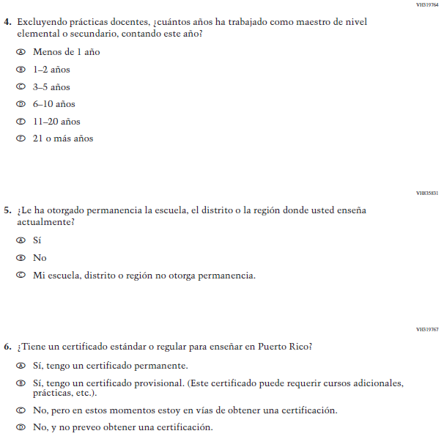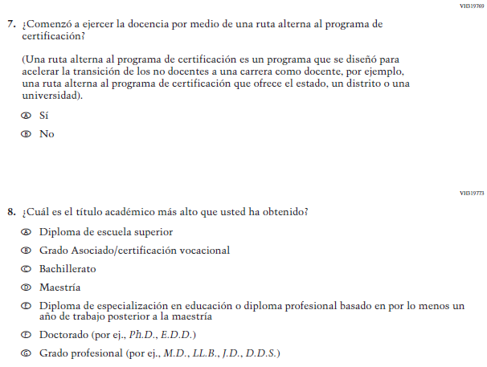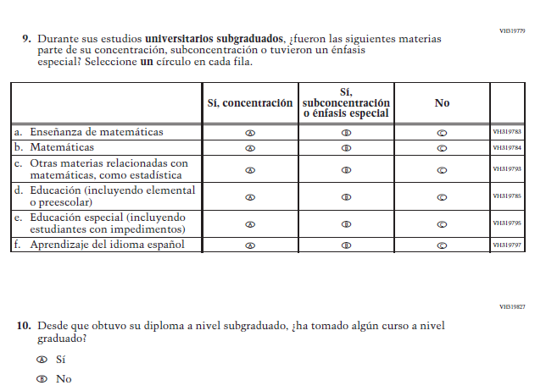
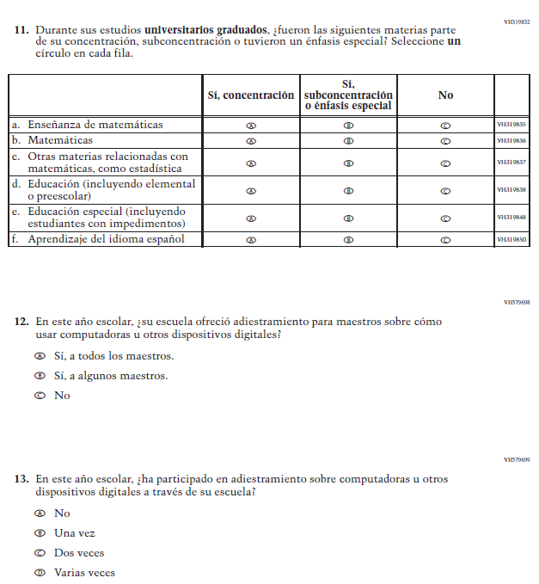
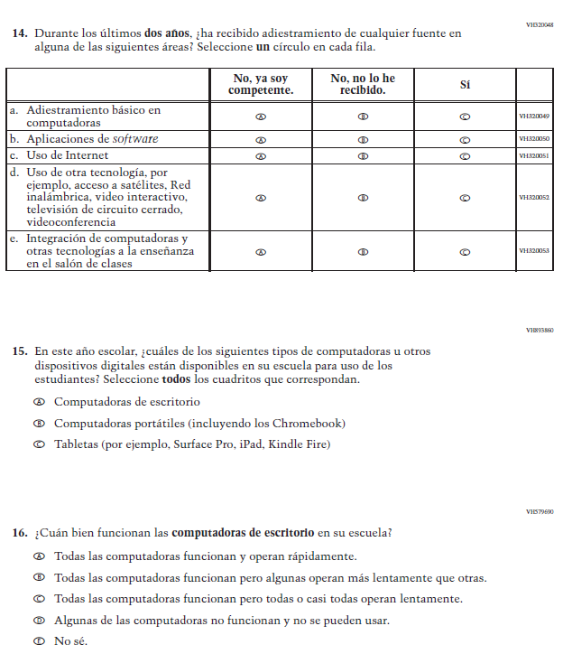
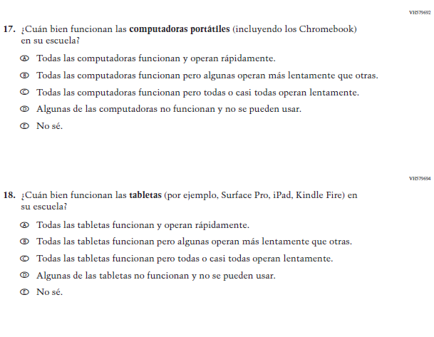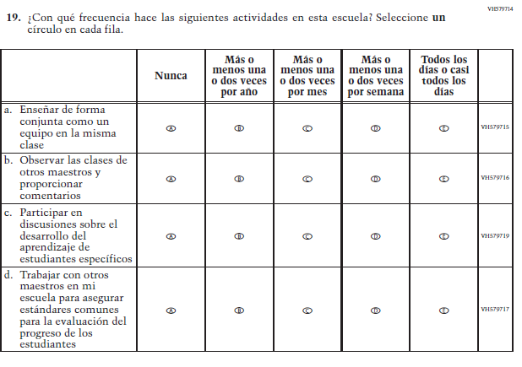
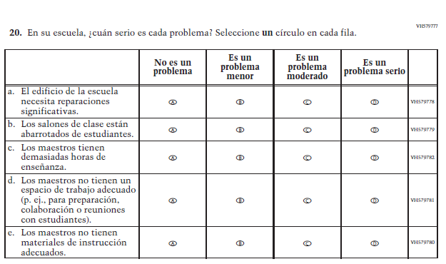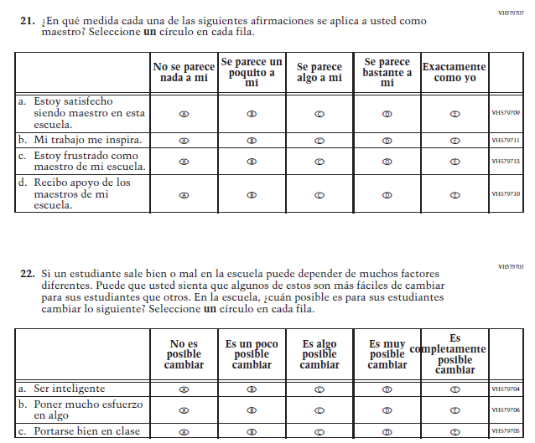

Appendix J-2b-s-PR: Summary of Changes Operational Grade 8 CORE
2021 Operational Grade 8 Core Teacher – Puerto Rico
Previous item | 2021 item | D/A/R/NC+ | Rationale
VH835832  (2019 Operational Grade 8 Teacher Core – Puerto Rico) | VH835832  Issue: Gender | NC | N/A
VH319761  (2019 Operational Grade 8 Teacher Core – Puerto Rico) | VH319761  Issue: Race/Ethnicity | NC | N/A
VH319763  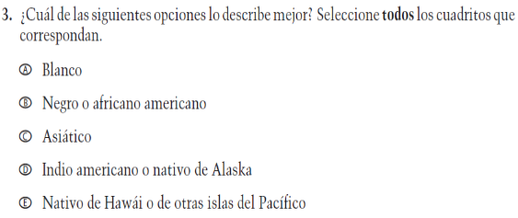  (2019 Operational Grade 8 Teacher Core – Puerto Rico) | VH319763  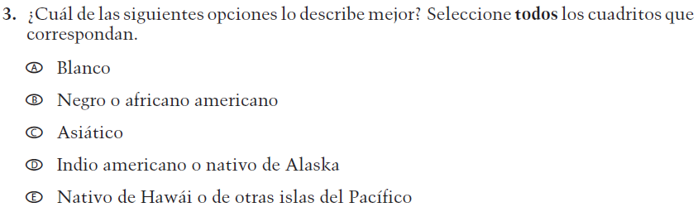  Issue: Race/Ethnicity | NC | N/A

2021 Operational Grade 8 Core Teacher – Puerto Rico
Previous item | 2021 item | D/A/R/NC+ | Rationale
VH319764  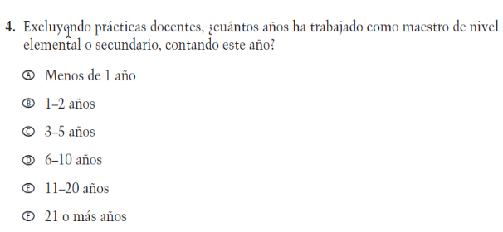  (2019 Operational Grade 8 Teacher Core – Puerto Rico) | VH319764  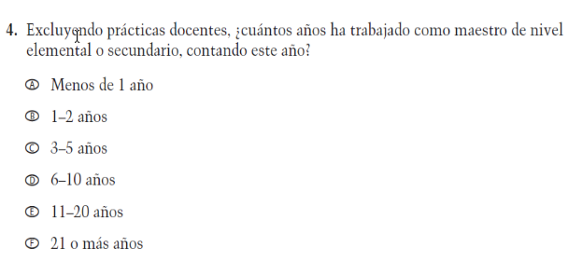  Issue: Teacher Preparation | NC | N/A
VH319892  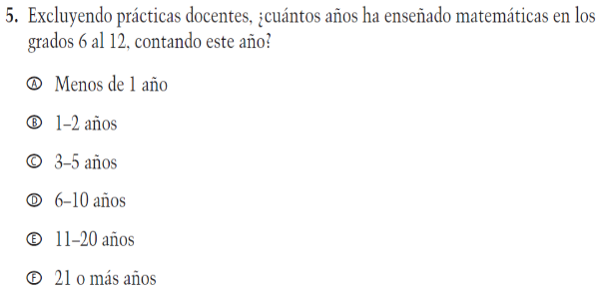  (2019 Operational Grade 8 Teacher Core – Puerto Rico) | VH319892  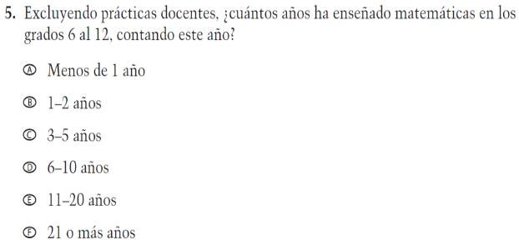  Issue: Teacher Preparation | NC | N/A
VH835831  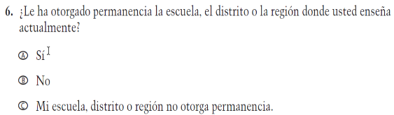  (2019 Operational Grade 8 Teacher Core – Puerto Rico) | VH835831  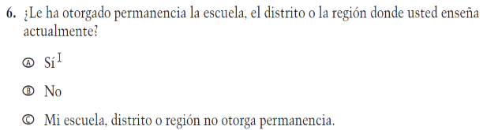  Issue: Teacher Preparation | NC | N/A

2021 Operational Grade 8 Core Teacher – Puerto Rico
Previous item | 2021 item | D/A/R/NC+ | Rationale
VH319767  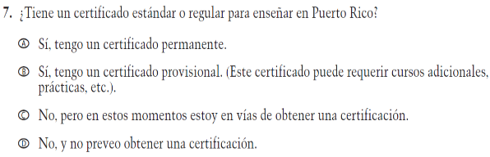  (2019 Operational Grade 8 Teacher Core – Puerto Rico) | VH319767  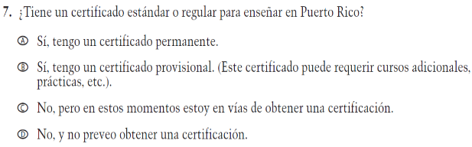  Issue: Teacher Preparation | NC | N/A
VH319769  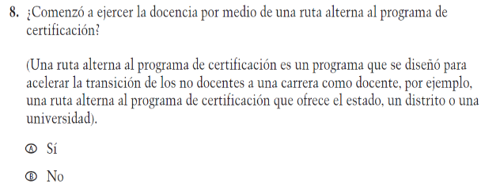  (2019 Operational Grade 8 Teacher Core – Puerto Rico) | VH319769  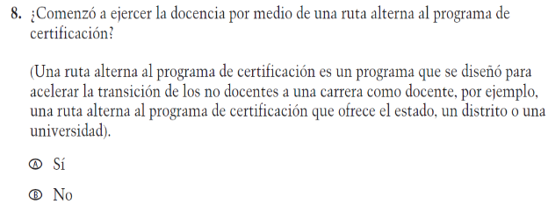  Issue: Teacher Preparation | NC | N/A
VH319773  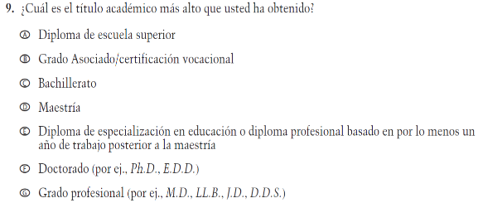  (2019 Operational Grade 8 Teacher Core – Puerto Rico) | VH319773  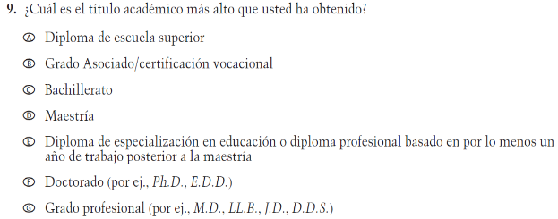  Issue: Teacher Preparation | NC | N/A

2021 Operational Grade 8 Core Teacher – Puerto Rico
Previous item | 2021 item | D/A/R/NC+ | Rationale
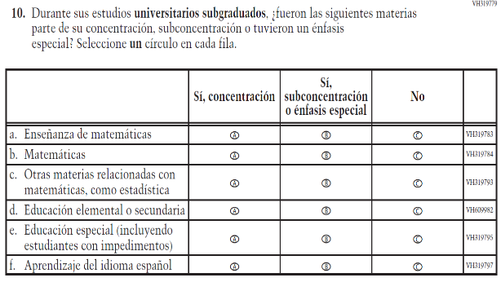  (2019 Operational Grade 8 Teacher Core – Puerto Rico) | 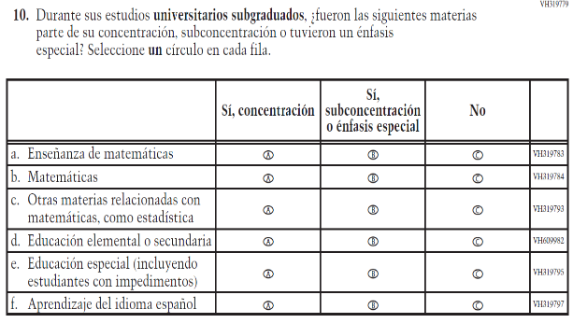  Issue: Teacher Preparation | NC | N/A
VH319827  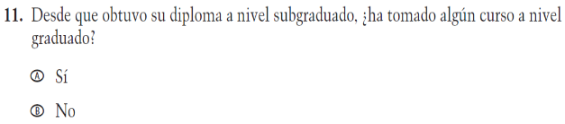  (2019 Operational Grade 8 Teacher Core – Puerto Rico) | VH319827  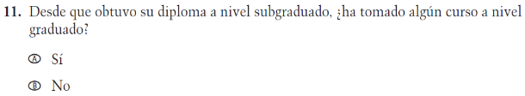  Issue: Teacher Preparation | NC | N/A
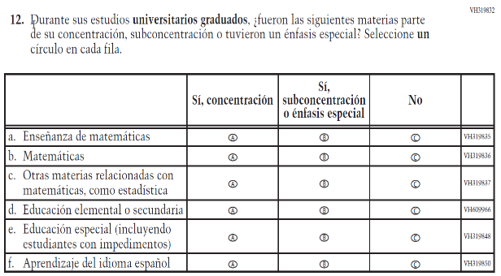  (2019 Operational Grade 8 Teacher Core – Puerto Rico) | 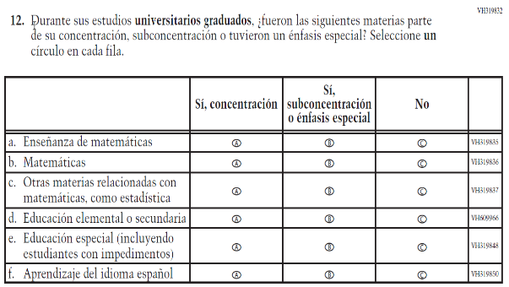  Issue: Teacher Preparation | NC | N/A

2021 Operational Grade 8 Core Teacher – Puerto Rico
Previous item | 2021 item | D/A/R/NC+ | Rationale
VH579698  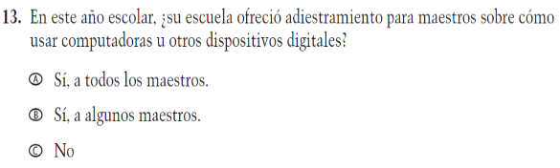  (2019 Operational Grade 8 Teacher Core – Puerto Rico) | VH579698  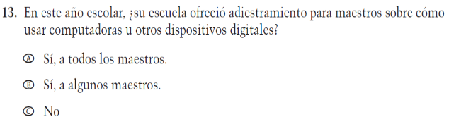  Issue: Technology Use | NC | N/A
VH579699  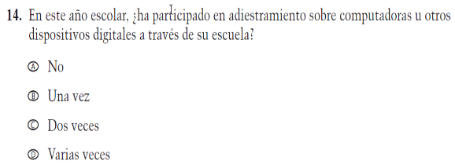  (2019 Operational Grade 8 Teacher Core – Puerto Rico) | VH579699  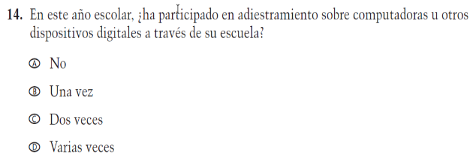  Issue: Technology Use | NC | N/A
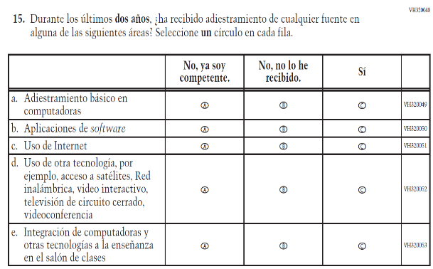  (2019 Operational Grade 8 Teacher Core – Puerto Rico) | 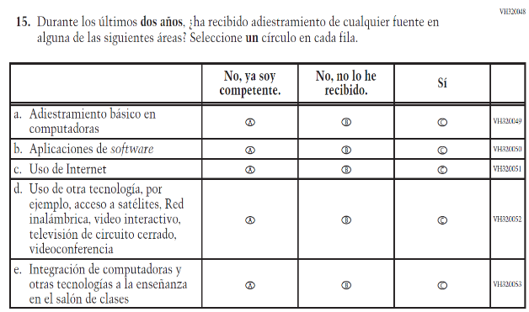  Issue: Teacher Preparation | NC | N/A

2021 Operational Grade 8 Core Teacher – Puerto Rico
Previous item | 2021 item | D/A/R/NC+ | Rationale
VH893860  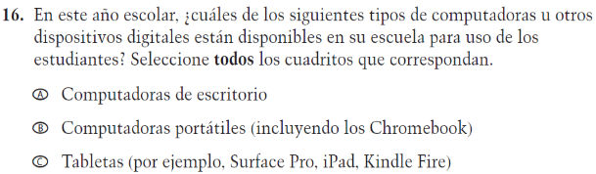  (2019 Operational Grade 8 Teacher Core – Puerto Rico) | VH893860  Issue: Technology Use | NC | N/A
VH579690  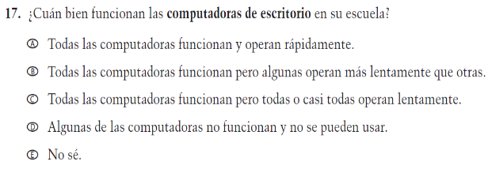  (2019 Operational Grade 8 Teacher Core – Puerto Rico) | VH579690  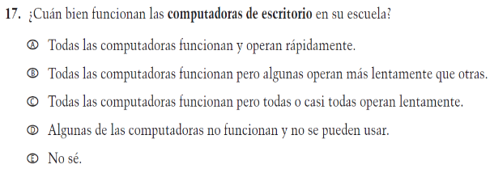  Issue: Technology Use | NC | N/A
VH579692  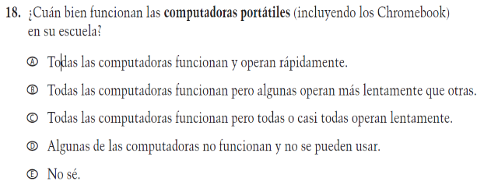  (2019 Operational Grade 8 Teacher Core – Puerto Rico) | VH579692  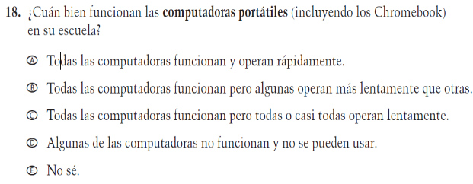  Issue: Technology Use | NC | N/A
VH579694  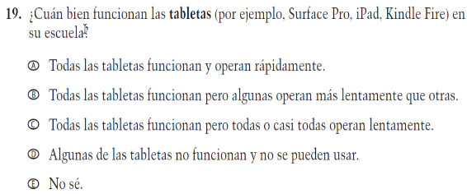  (2019 Operational Grade 8 Teacher Core – Puerto Rico) | VH579694  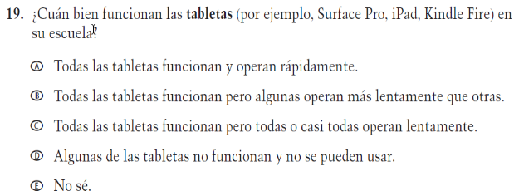  Issue: Technology Use | NC | N/A

2021 Operational Grade 8 Core Teacher – Puerto Rico
Previous item | 2021 item | D/A/R/NC+ | Rationale
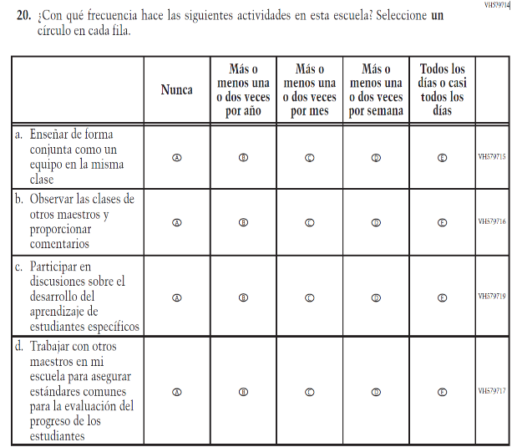  (2019 Operational Grade 8 Teacher Core – Puerto Rico) | 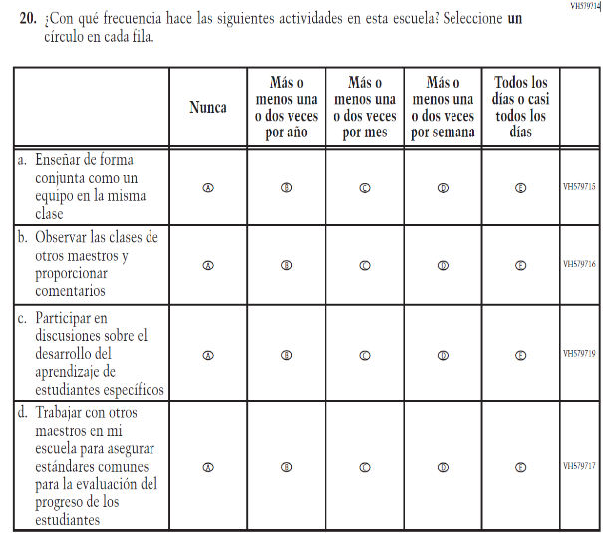  Issue: School Climate | NC | N/A
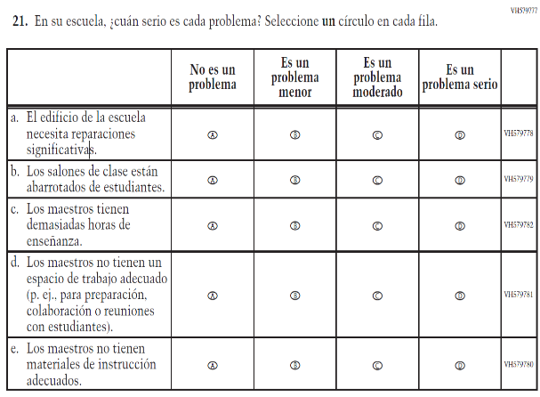  (2019 Operational Grade 8 Teacher Core – Puerto Rico) | 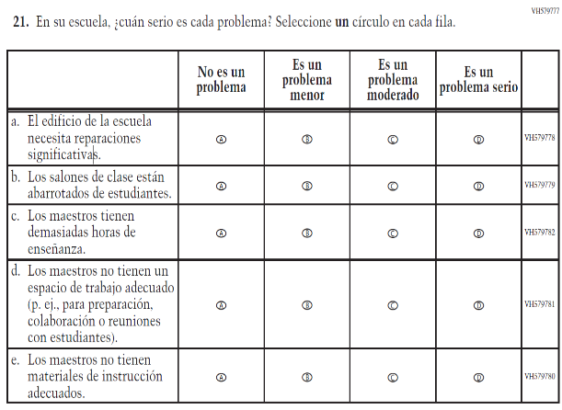  Issue: School Climate | NC | N/A

2021 Operational Grade 8 Core Teacher – Puerto Rico
Previous item | 2021 item | D/A/R/NC+ | Rationale
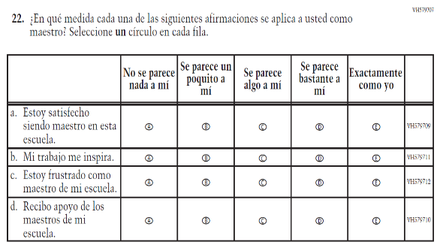  (2019 Operational Grade 8 Teacher Core – Puerto Rico) | 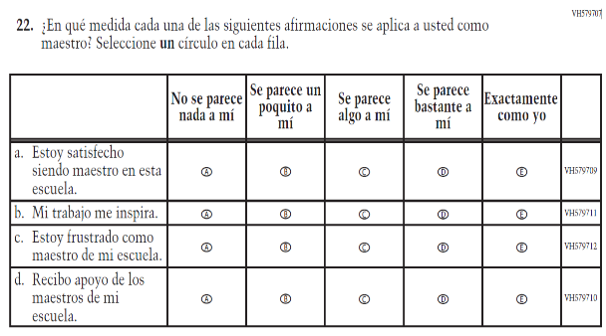  Issue: School Climate | NC | N/A
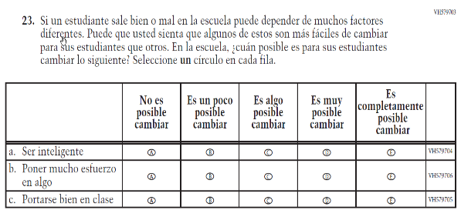  (2019 Operational Grade 8 Teacher Core – Puerto Rico) | 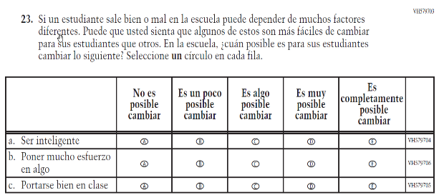  Issue: Desire for Learning | NC | N/A

Appendix J-2b-s-PR: Operational Grade 8 CORE

Grade/Respondent | Item Number Initiating Skip Logic | Item Response(s) Initiating Skip Logic | Item Number(s) Being Skipped
Grade 8 Teacher | 9 | B | 10, 11, 12
Grade 8 Teacher | 11 | B | 12
Grade 8 Teacher | 13 | C | 14
Grade 8 Teacher | 16 | A | Do NOT skip 17
Grade 8 Teacher | 16 | B | Do NOT skip 18
Grade 8 Teacher | 16 | C | Do NOT skip 19

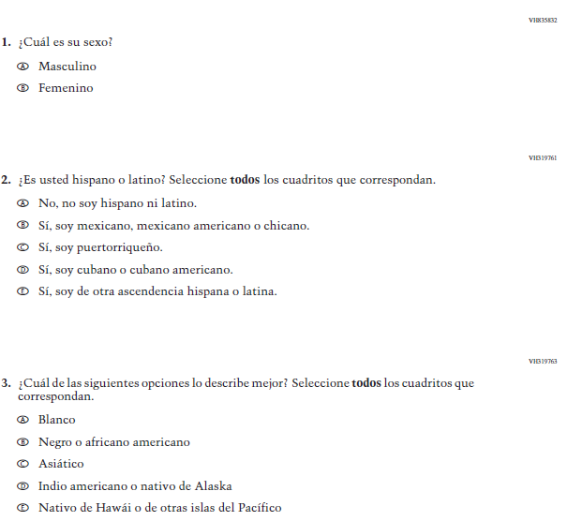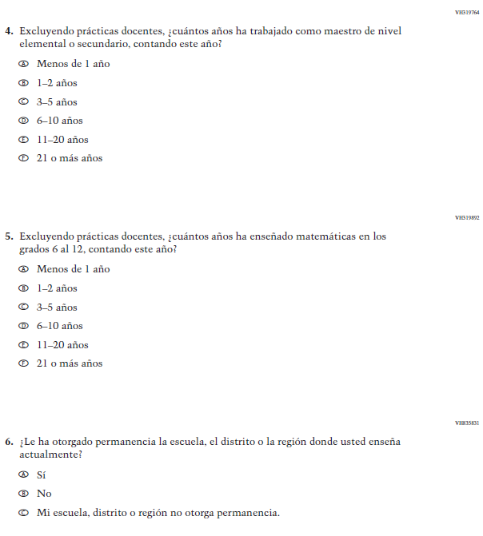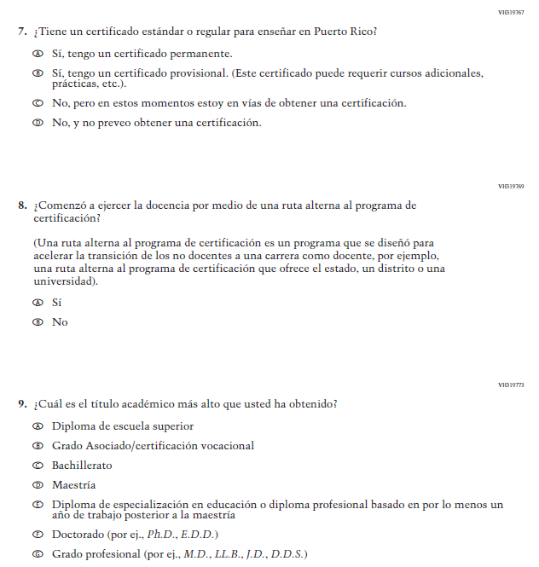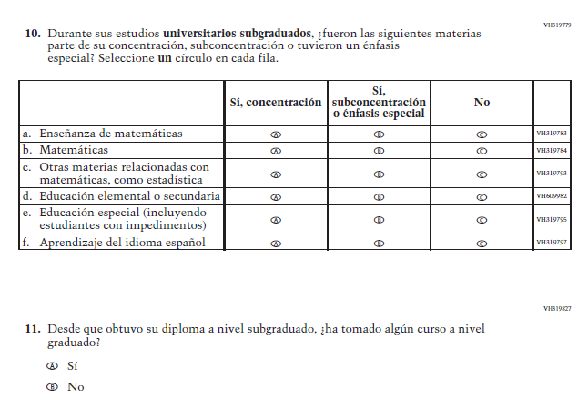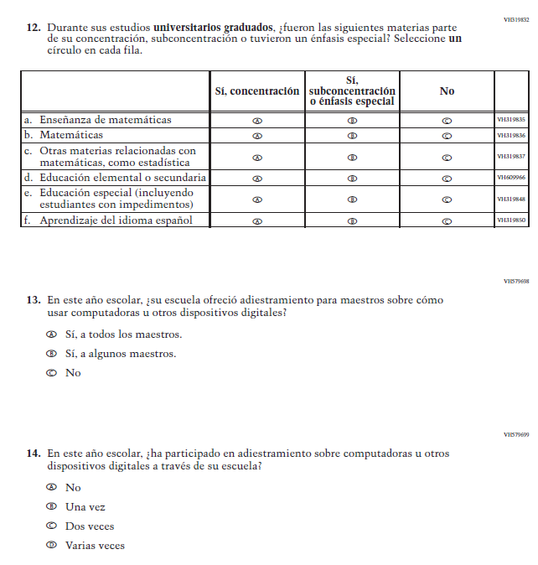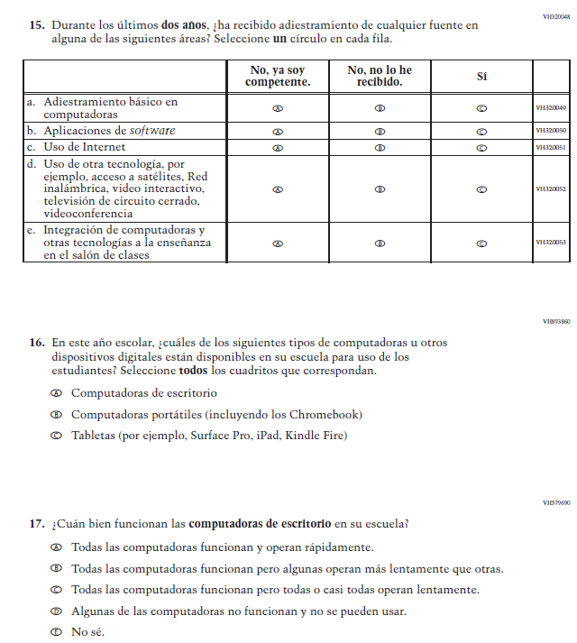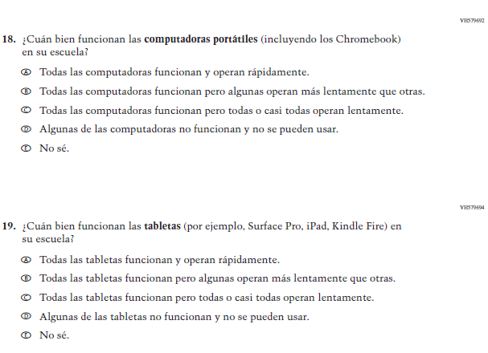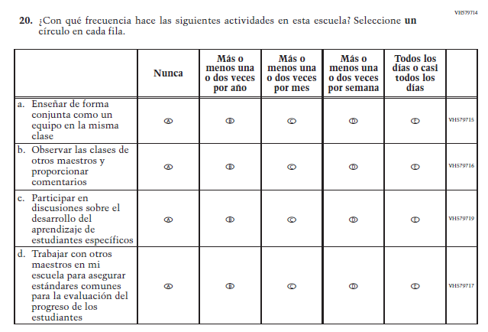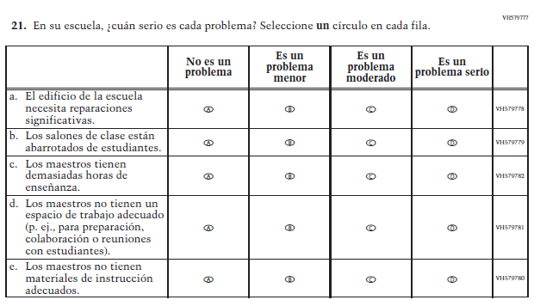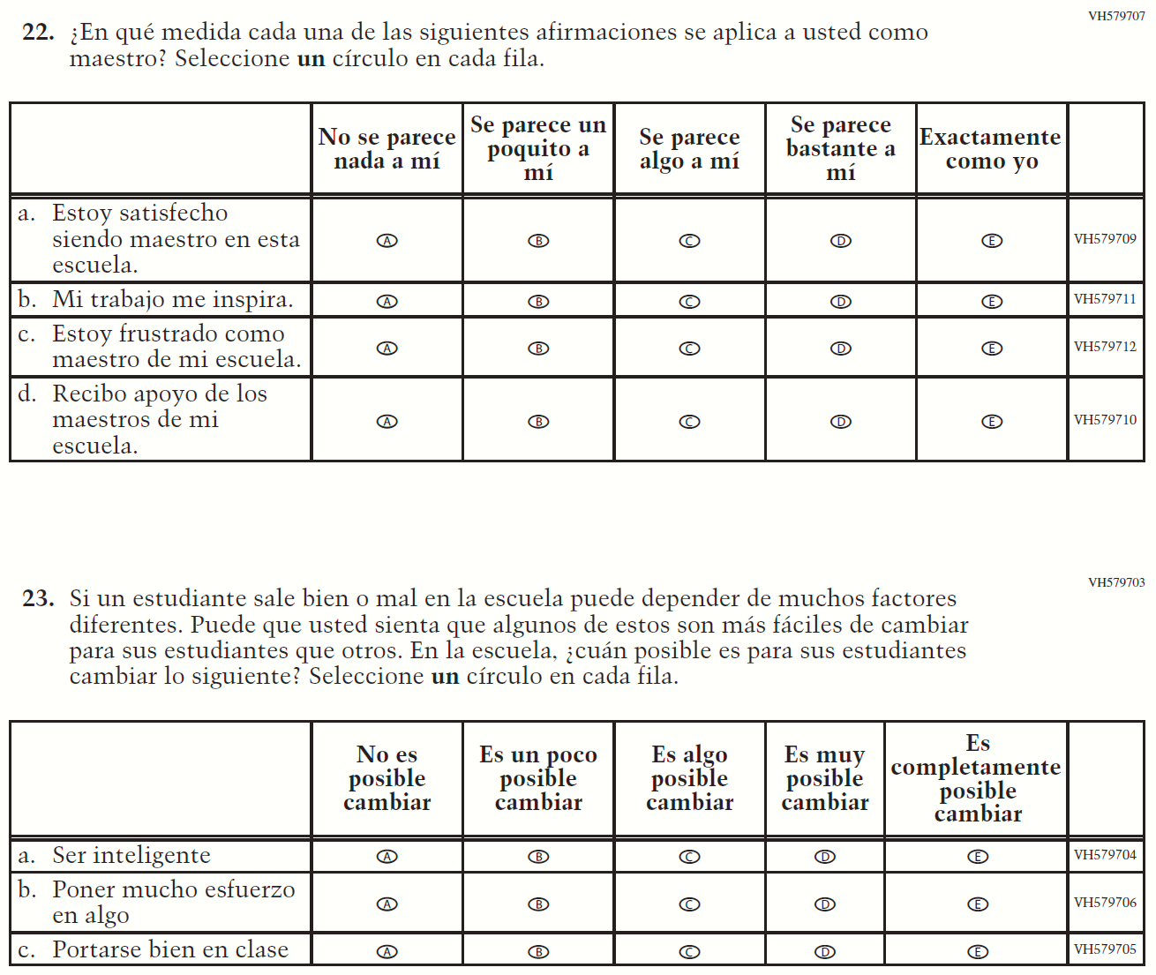

Appendix J-2c-s-PR: Summary of Changes Operational Grade 4 Mathematics
2021 Operational Grade 4 Mathematics Teacher – Puerto Rico
Previous item | 2021 item | D/A/R/NC+ | Rationale
VH320096  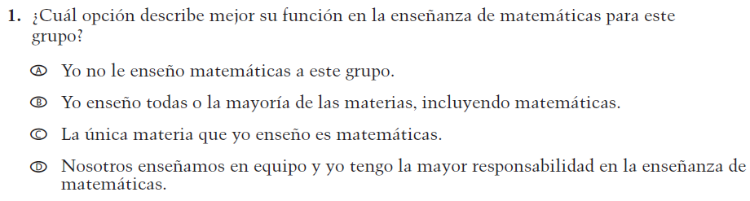  (2019 Operational Grade 4 Teacher Mathematics – Puerto Rico) | VH320096  Issue: Resources for Learning and Instruction | NC | N/A
VH579728  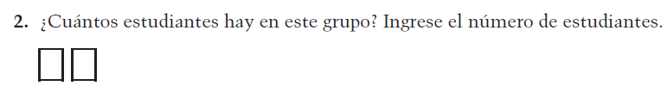  (2019 Operational Grade 4 Teacher Mathematics – Puerto Rico) | VH579728  Issue: Resources for Learning and Instruction | NC | N/A
VH857347  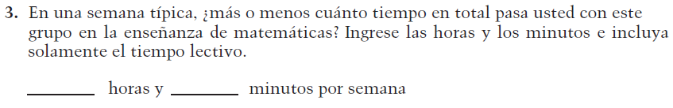  (2019 Operational Grade 4 Teacher Mathematics – Puerto Rico) | VH857347  Issue: Resources for Learning and Instruction | N/C | N/A
VH320121  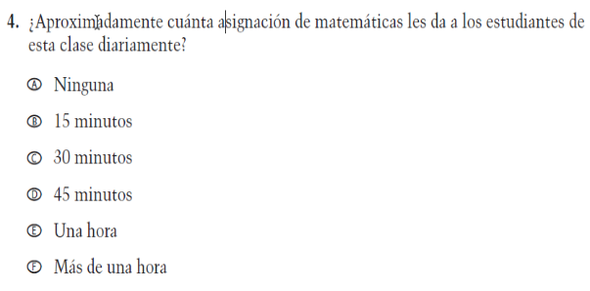  (2019 Operational Grade 4 Teacher Mathematics – Puerto Rico) | VH320121  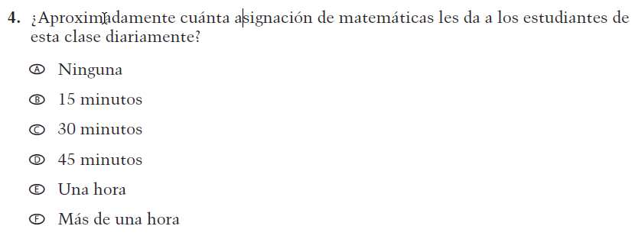  Issue: Organization of Instruction | NC | N/A

2021 Operational Grade 4 Mathematics Teacher – Puerto Rico
Previous item | 2021 item | D/A/R/NC+ | Rationale
VH320125  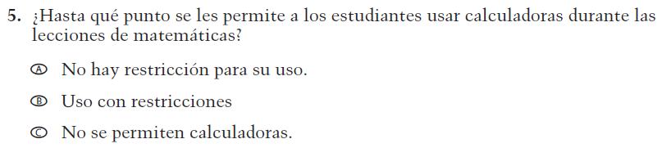  (2019 Operational Grade 4 Teacher Mathematics – Puerto Rico) | VH320125  Issue: Organization of Instruction | NC | N/A
VH320129  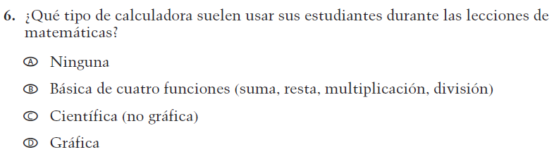  (2019 Operational Grade 4 Teacher Mathematics – Puerto Rico) | VH320129  Issue: Resources for learning and instruction | NC | N/A
VH320132  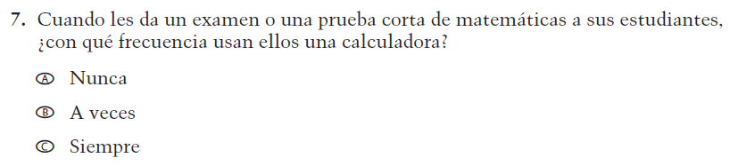  (2019 Operational Grade 4 Teacher Mathematics – Puerto Rico) | VH320132  Issue: Organization of Instruction | NC | N/A
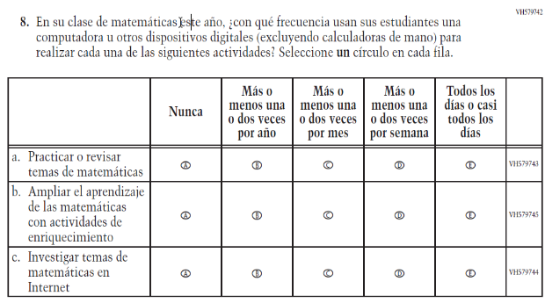  (2019 Operational Grade 4 Teacher Mathematics – Puerto Rico) | 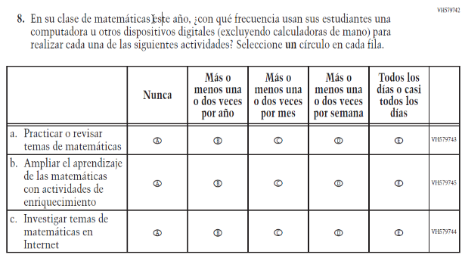  Issue: Organization of Instruction | NC | N/A

2021 Operational Grade 4 Mathematics Teacher – Puerto Rico
Previous item | 2021 item | D/A/R/NC+ | Rationale
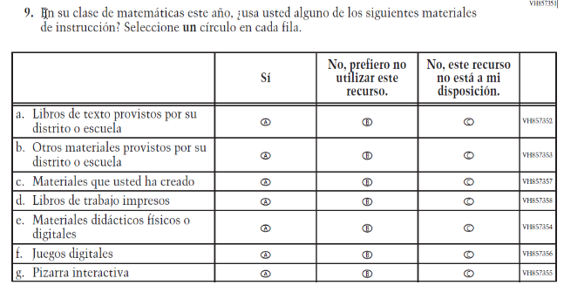  (2019 Operational Grade 4 Teacher Mathematics – Puerto Rico) | 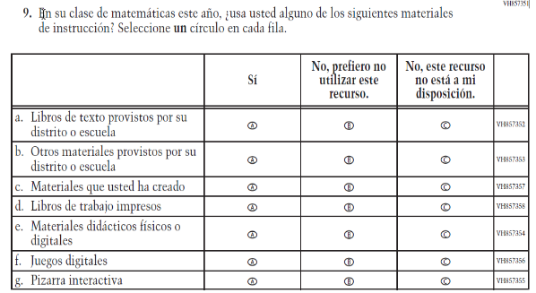  Issue: Resources for Learning and Instruction | NC | N/A
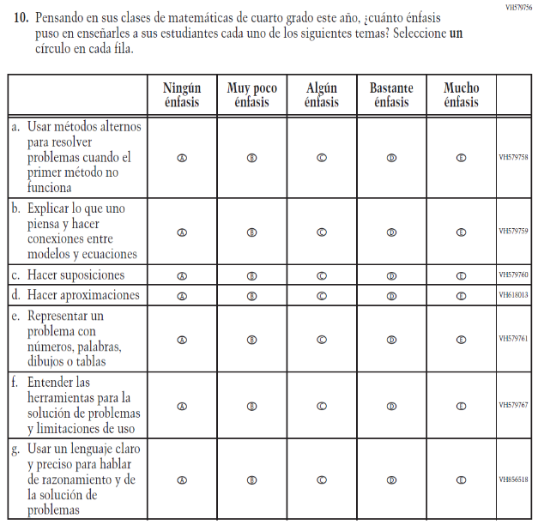  (2019 Operational Grade 4 Teacher Mathematics – Puerto Rico) | 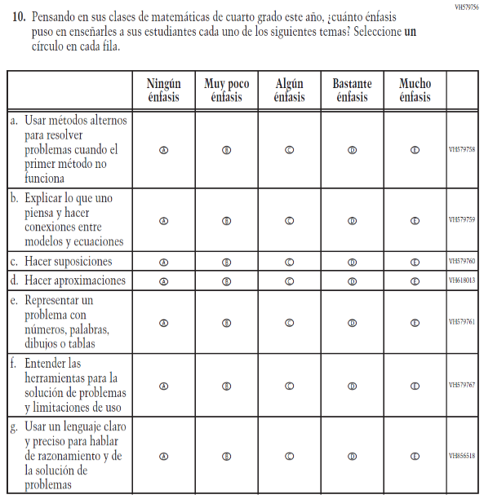  Issue: Organization of Instruction | NC | N/A

2021 Operational Grade 4 Mathematics Teacher – Puerto Rico
Previous item | 2021 item | D/A/R/NC+ | Rationale
VH320151  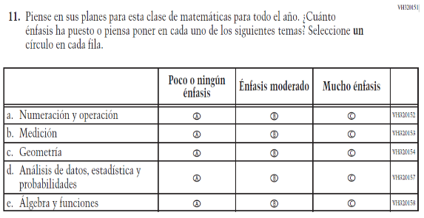  (2019 Operational Grade 4 Teacher Mathematics – Puerto Rico) | VH320151  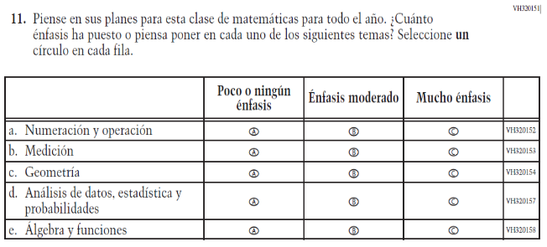  Issue: Organization of Instruction | NC | N/A
VH320200  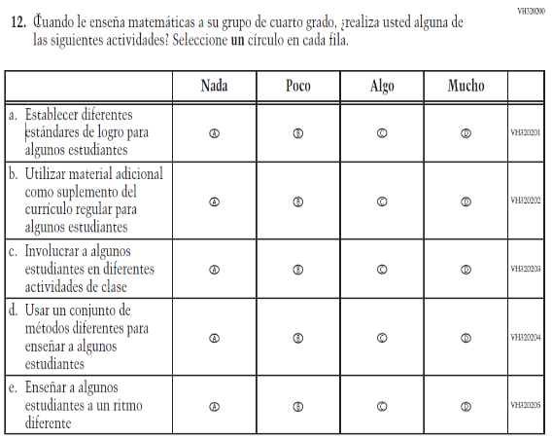  (2019 Operational Grade 4 Teacher Mathematics – Puerto Rico) | VH320200  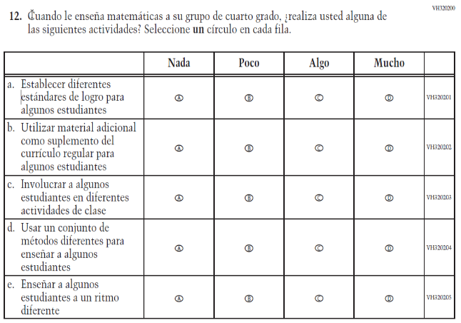  Issue: Organization of Instruction | NC | N/A

2021 Operational Grade 4 Mathematics Teacher – Puerto Rico
Previous item | 2021 item | D/A/R/NC+ | Rationale
VH579746  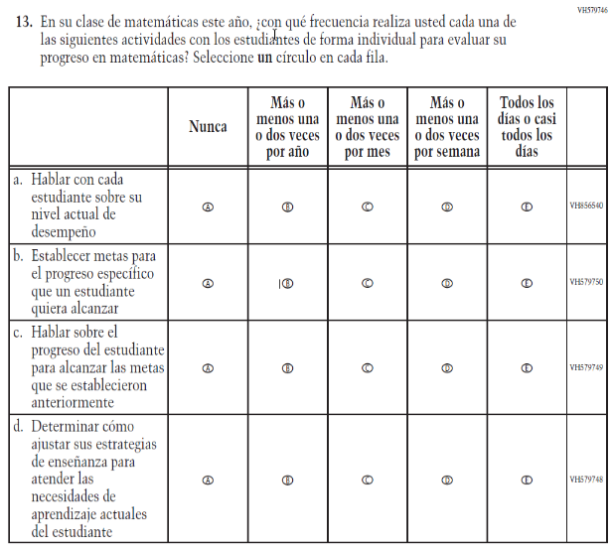  (2019 Operational Grade 4 Teacher Mathematics – Puerto Rico) | VH579746  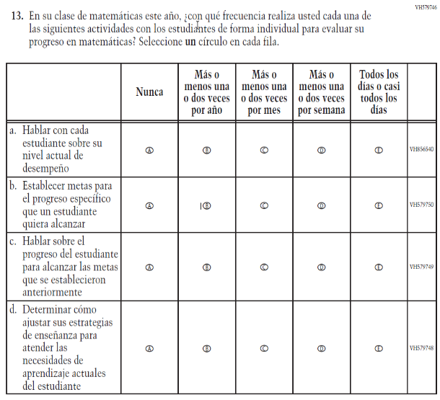  Issue: Organization of Instruction | NC | N/A
VH579768  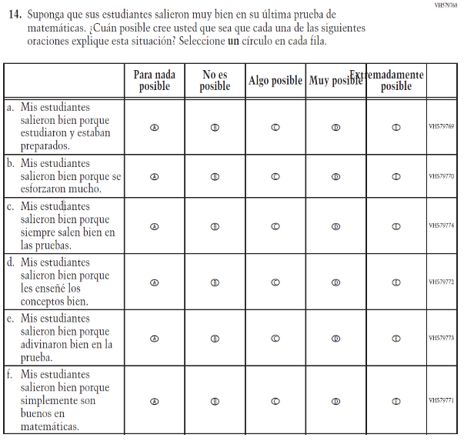  (2019 Operational Grade 4 Teacher Mathematics – Puerto Rico) | VH579768  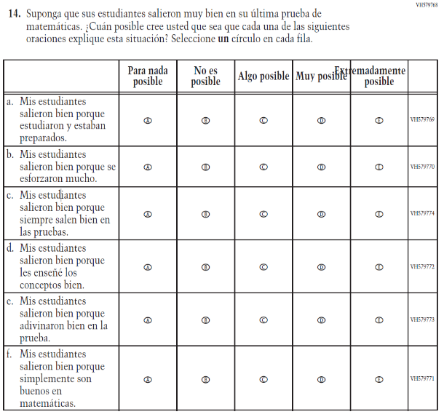  Issue: Teacher Preparation | NC | N/A

2021 Operational Grade 4 Mathematics Teacher – Puerto Rico
Previous item | 2021 item | D/A/R/NC+ | Rationale
VH579775  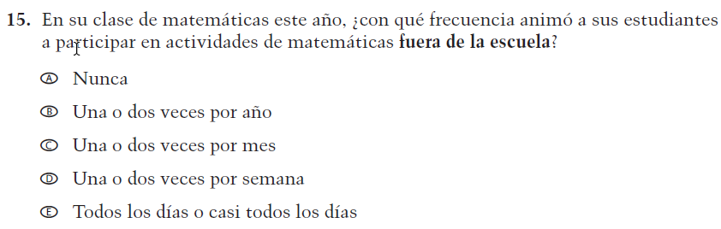  (2019 Operational Grade 4 Teacher Mathematics – Puerto Rico) | VH579775  Issue: Resources for Learning and Instruction | NC | N/A
VH579776  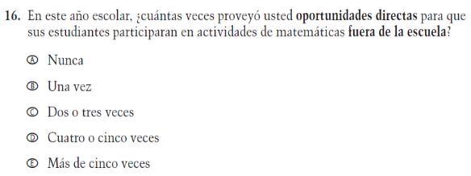  (2019 Operational Grade 4 Teacher Mathematics – Puerto Rico) | VH579776  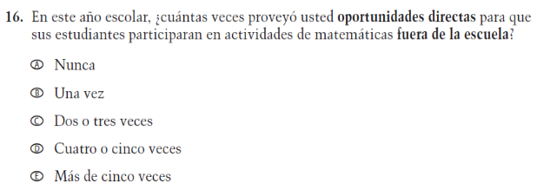  Issue: Resources for Learning and Instruction | NC | N/A

Appendix J-2c-s-PR: Operational Grade 4 Mathematics
Grade/Respondent | Item Number Initiating Skip Logic | Item Response(s) Initiating Skip Logic | Item Number(s) Being Skipped
Grade 4 Teacher | 1 | A | 2, 3, 4, 5, 6, 7, 8, 9, 10, 11, 12, 13, 14, 15, 16
Grade 4 Teacher | 5 | C | 6

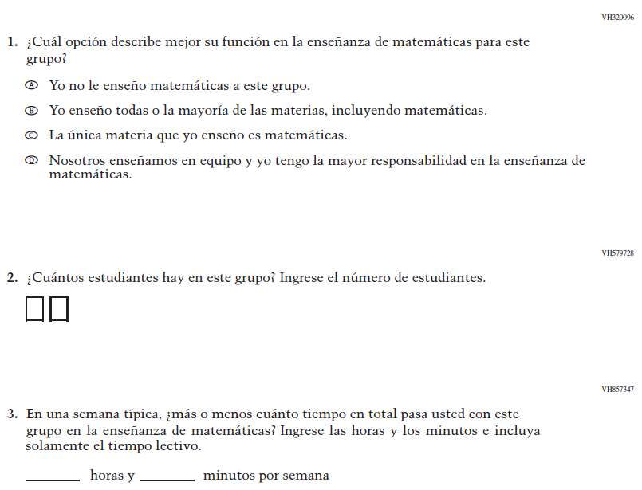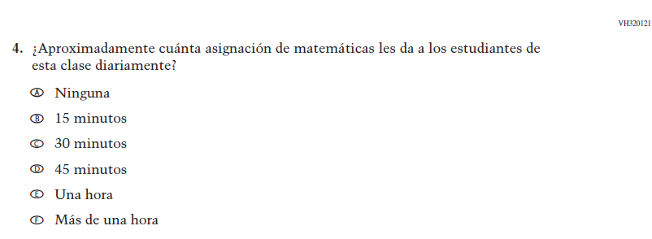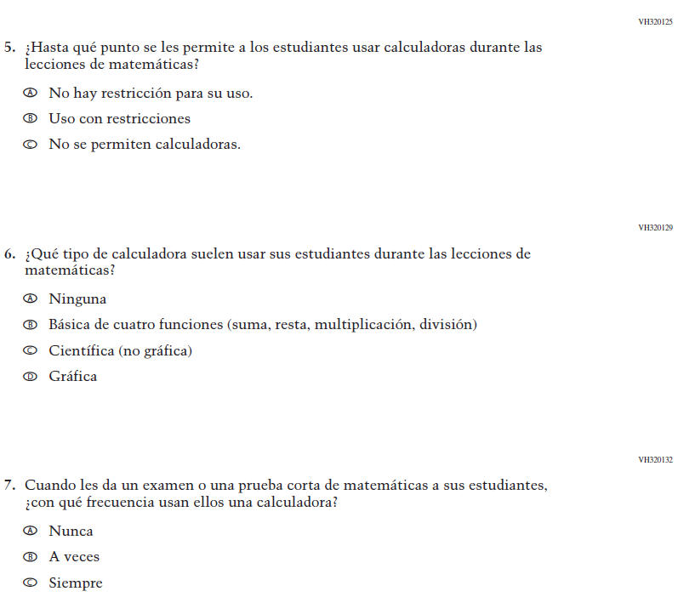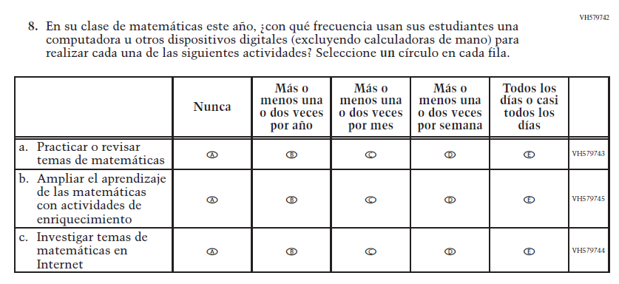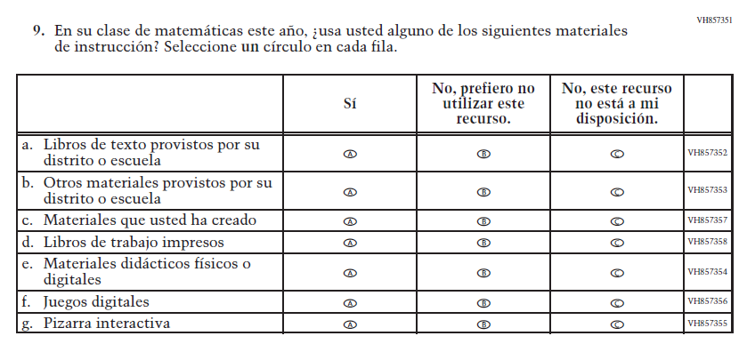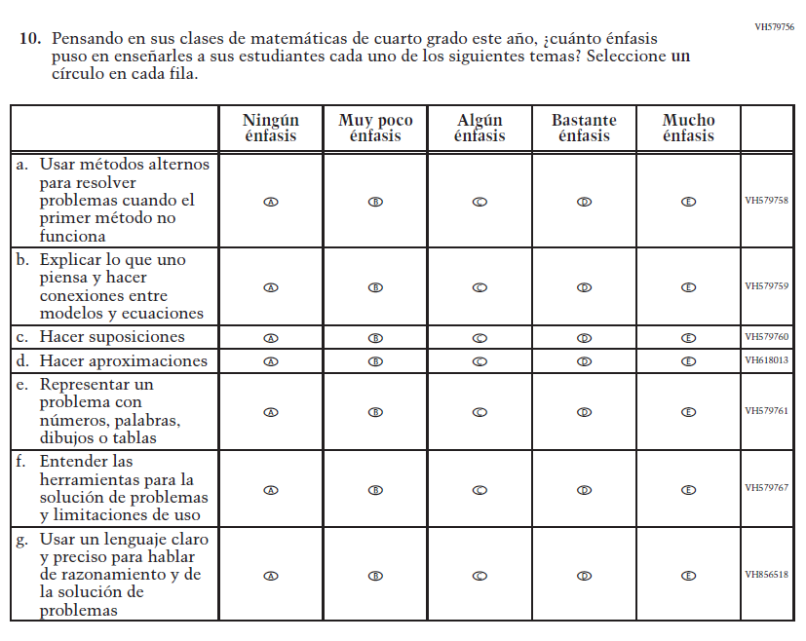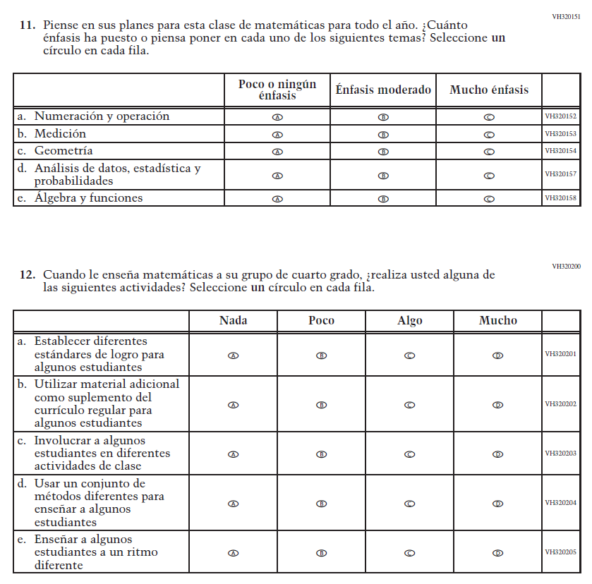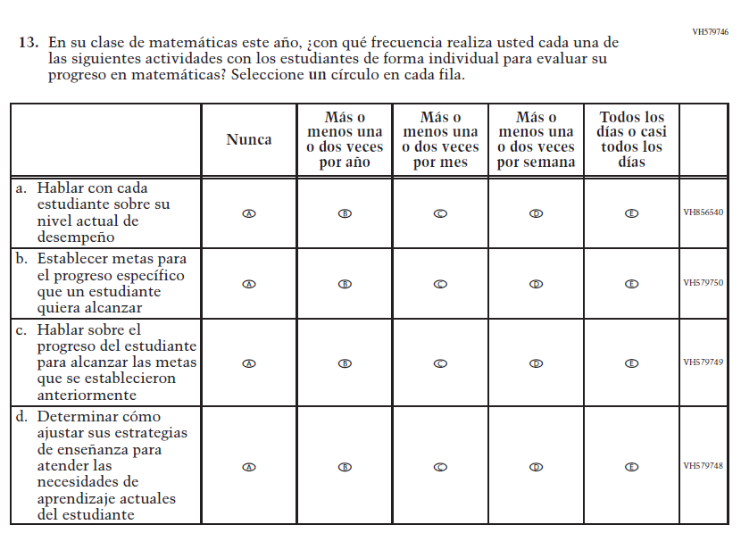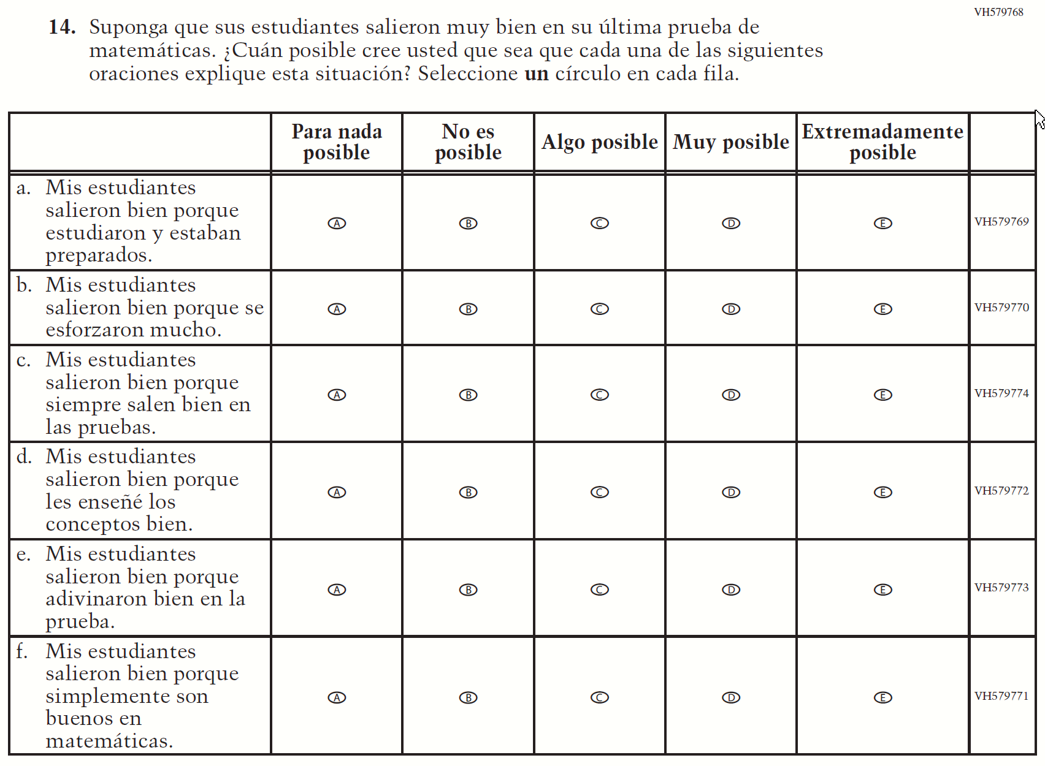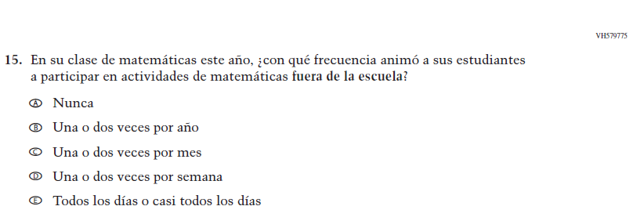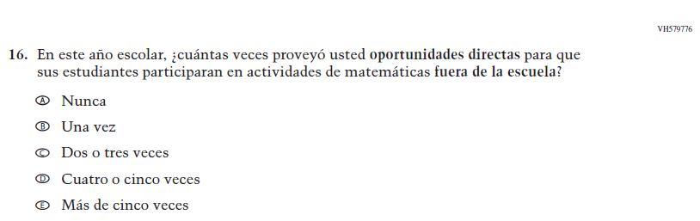

Appendix J-2d-s-PR: Summary of Changes Operational Grade 8 Mathematics
2021 Operational Grade 8 Mathematics Teacher – Puerto Rico
Previous item | 2021 item | D/A/R/NC+ | Rationale
VH320096  (2019 Operational Grade 8 Teacher Mathematics – Puerto Rico) | VH320096  Issue: Resources for Learning and Instruction | NC | N/A
VH579728  (2019 Operational Grade 8 Teacher Mathematics – Puerto Rico) | VH579728  Issue: Resources for Learning and Instruction | NC | N/A
VH857347  (2019 Operational Grade 8 Teacher Mathematics – Puerto Rico) | VH857347  Issue: Resources for Learning and Instruction | N/C | N/A
VH320121  (  2019 Operational Grade 8 Teacher Mathematics – Puerto Rico) | VH320121  Issue: Organization of Instruction | NC | N/A

2021 Operational Grade 8 Mathematics Teacher – Puerto Rico
Previous item | 2021 item | D/A/R/NC+ | Rationale
VH320125  (2019 Operational Grade 8 Teacher Mathematics – Puerto Rico) | VH320125  Issue: Organization of Instruction | NC | N/A
VH320129  (2019 Operational Grade 8 Teacher Mathematics – Puerto Rico) | VH320129  Issue: Resources for Learning and Instruction | NC | N/A
VH320132  (2019 Operational Grade 8 Teacher Mathematics – Puerto Rico) | VH320132  Issue: Organization of Instruction | NC | N/A
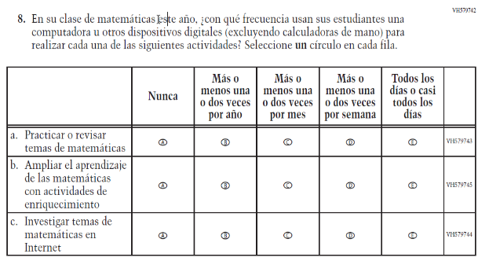  (2019 Operational Grade 8 Teacher Mathematics – Puerto Rico) | 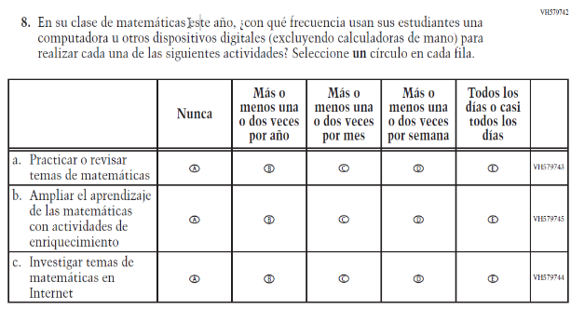  Issue: Organization of Instruction | NC | N/A

2021 Operational Grade 8 Mathematics Teacher – Puerto Rico
Previous item | 2021 item | D/A/R/NC+ | Rationale
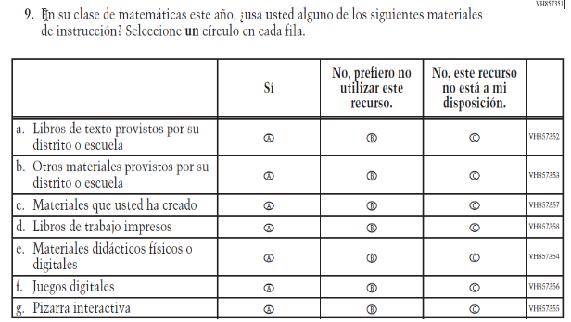  (2019 Operational Grade 8 Teacher Mathematics – Puerto Rico) | Issue: Resources for Learning and Instruction | NC | N/A
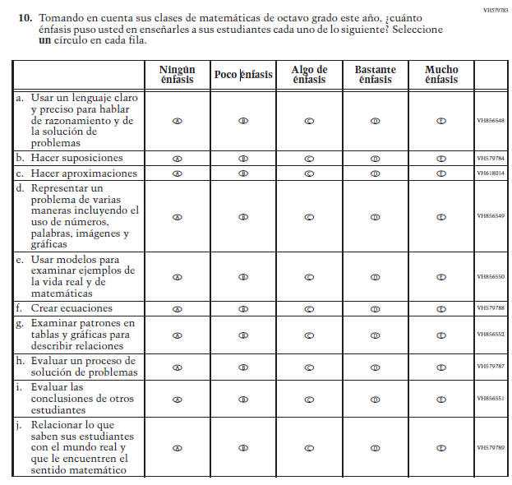  (2019 Operational Grade 8 Teacher Mathematics – Puerto Rico) | Issue: Organization of Instruction | NC | N/A

2021 Operational Grade 8 Mathematics Teacher – Puerto Rico
Previous item | 2021 item | D/A/R/NC+ | Rationale
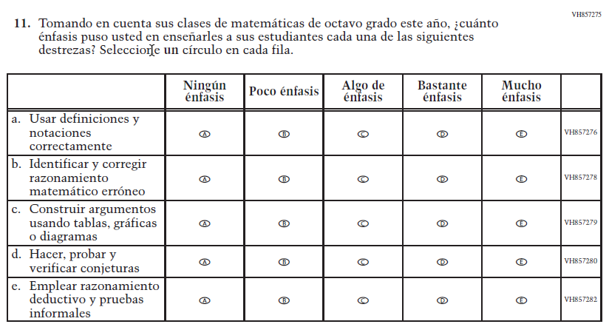  (2019 Operational Grade 8 Teacher Mathematics – Puerto Rico) | Issue: Organization of Instruction | NC | N/A
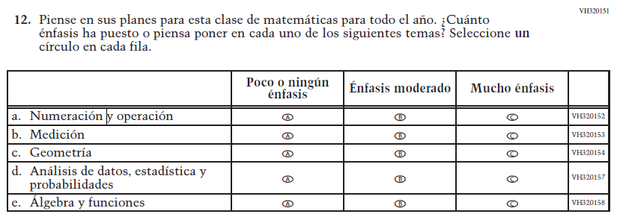  (2019 Operational Grade 8 Teacher Mathematics – Puerto Rico) | Issue: Organization of Instruction | NC | N/A

2021 Operational Grade 8 Mathematics Teacher – Puerto Rico
Previous item | 2021 item | D/A/R/NC+ | Rationale
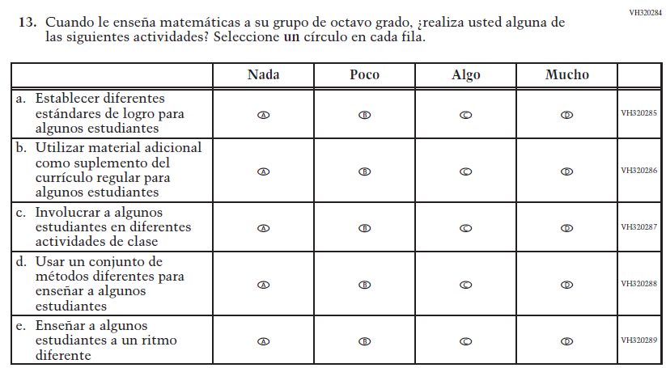  (2019 Operational Grade 8 Teacher Mathematics – Puerto Rico) | Issue: Organization of Instruction | NC | N/A
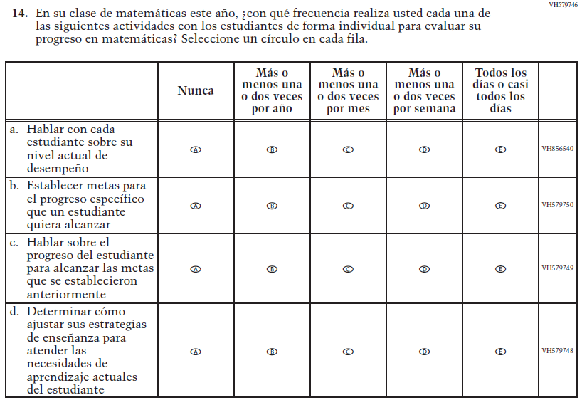  (2019 Operational Grade 8 Teacher Mathematics – Puerto Rico) | Issue: Organization of Instruction | NC | N/A

2021 Operational Grade 8 Mathematics Teacher – Puerto Rico
Previous item | 2021 item | D/A/R/NC+ | Rationale
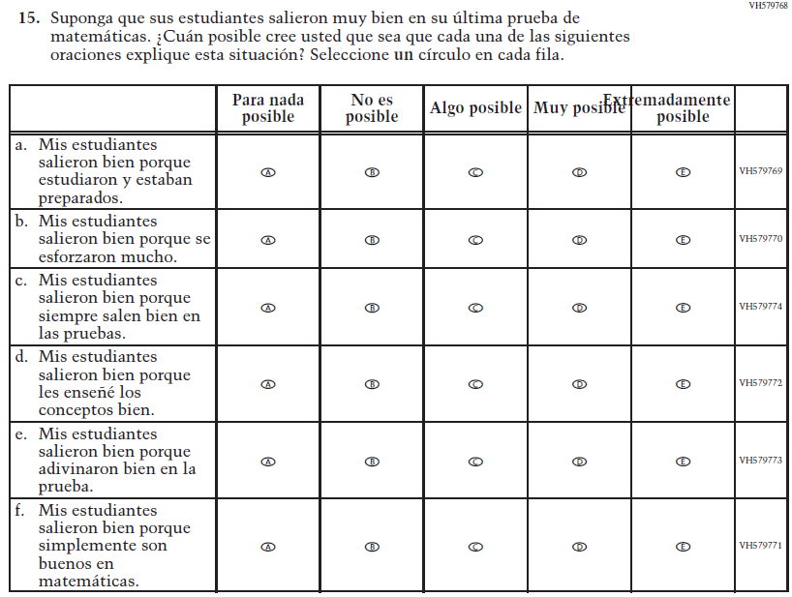  (2019 Operational Grade 8 Teacher Mathematics – Puerto Rico) | Issue: Teacher Preparation | NC | N/A
VH579775  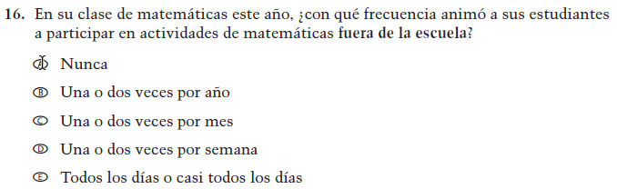  (2019 Operational Grade 8 Teacher Mathematics – Puerto Rico) | VH579775  Issue: Resources for Learning and Instruction | NC | N/A

2021 Operational Grade 8 Mathematics Teacher – Puerto Rico
Previous item | 2021 item | D/A/R/NC+ | Rationale
VH579776  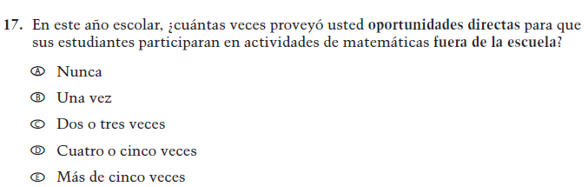  (2019 Operational Grade 8 Teacher Mathematics – Puerto Rico) | VH579776  Issue: Resources for Learning and Instruction | NC | N/A
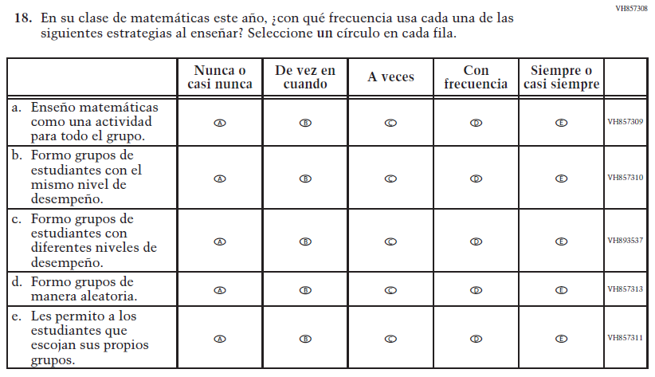  (2019 Operational Grade 8 Teacher Mathematics – Puerto Rico) | Issue: Organization of Instruction | NC | N/A

Appendix J-2d-s-PR: Operational Grade 8 Mathematics
Grade/Respondent | Item Number Initiating Skip Logic | Item Response(s) Initiating Skip Logic | Item Number(s) Being Skipped
Grade 8 Teacher | 1 | A | 2, 3, 4, 5, 6, 7, 8, 9, 10, 11, 12, 13, 14, 15, 16, 17, 18
Grade 8 Teacher | 5 | C | 6

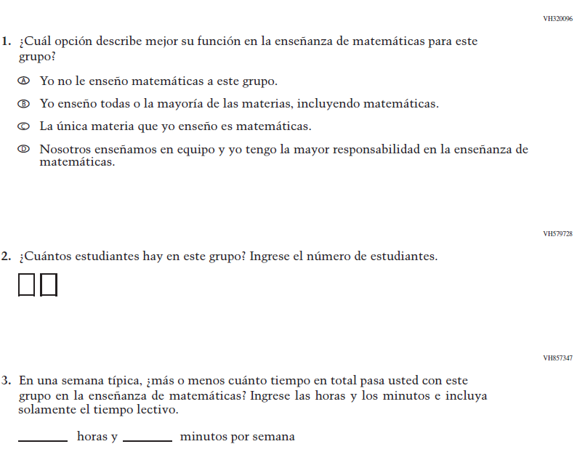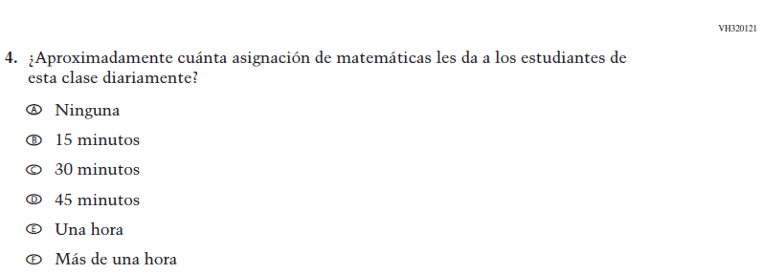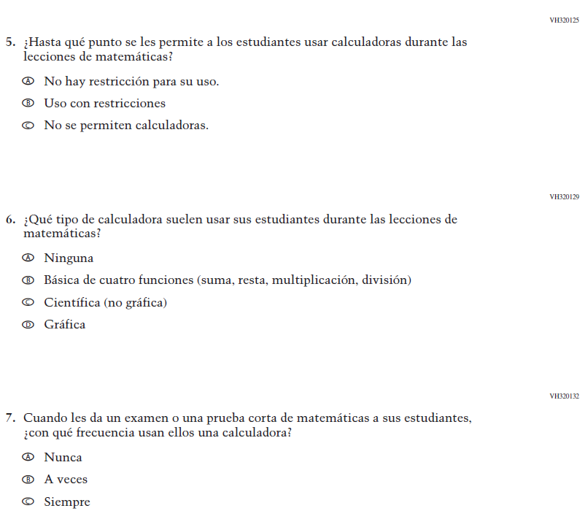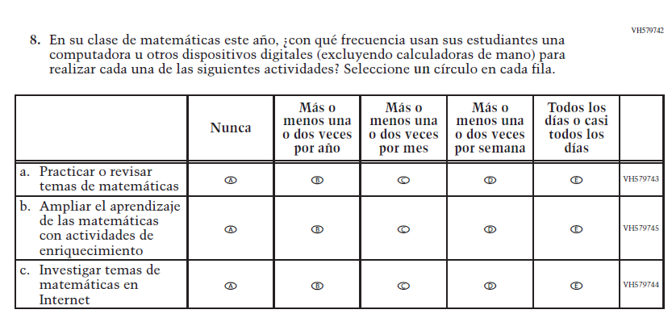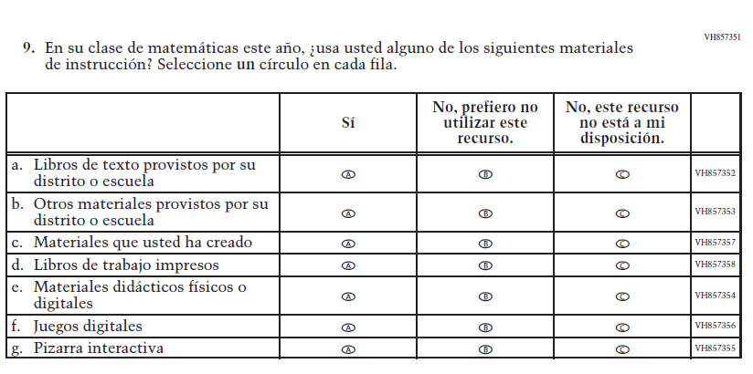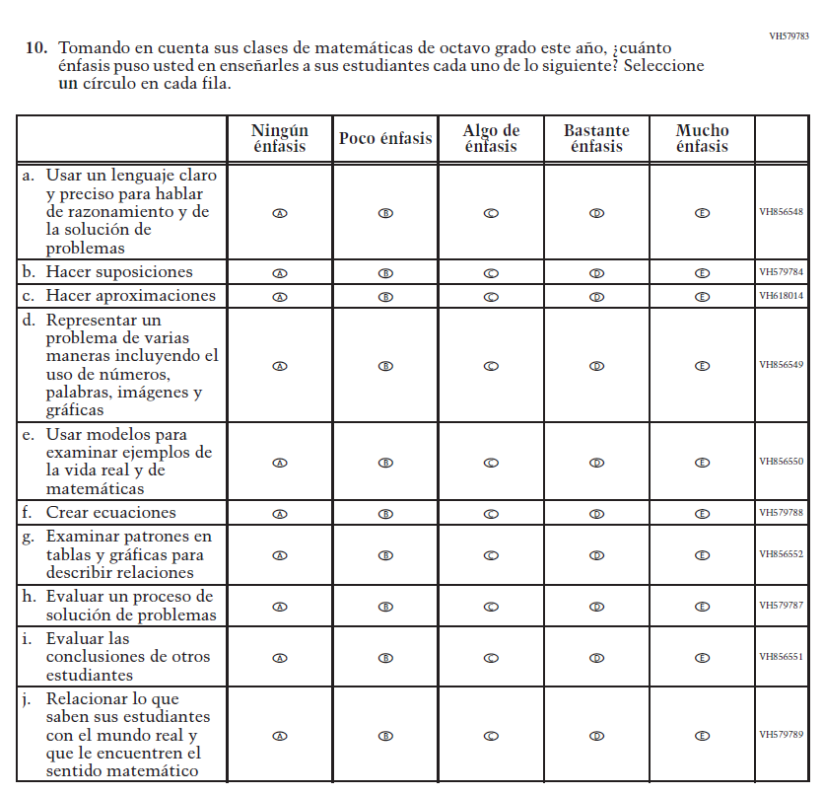
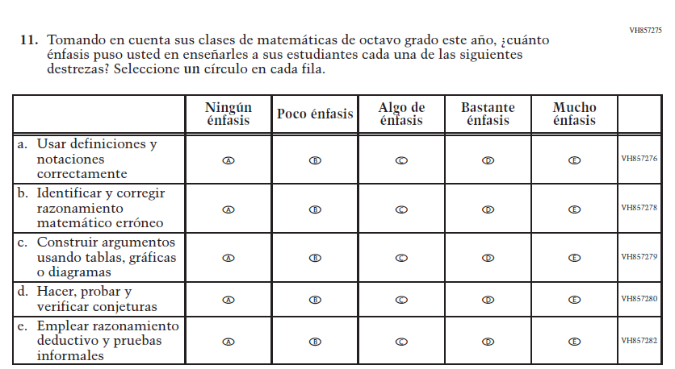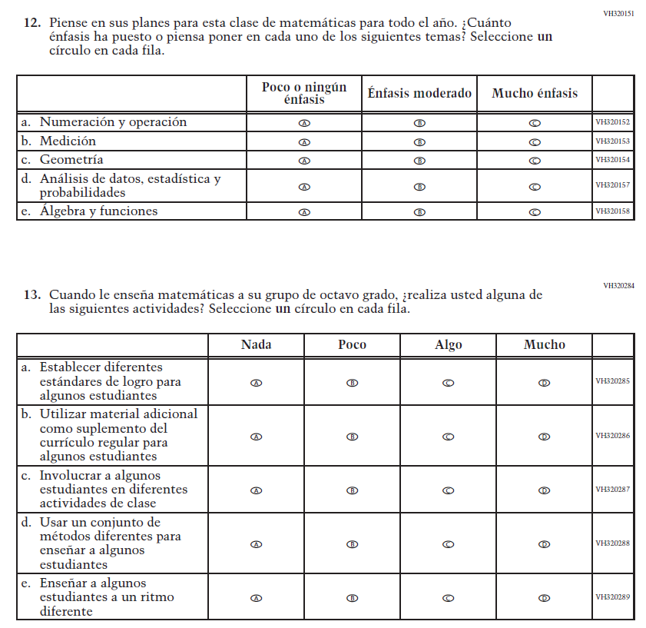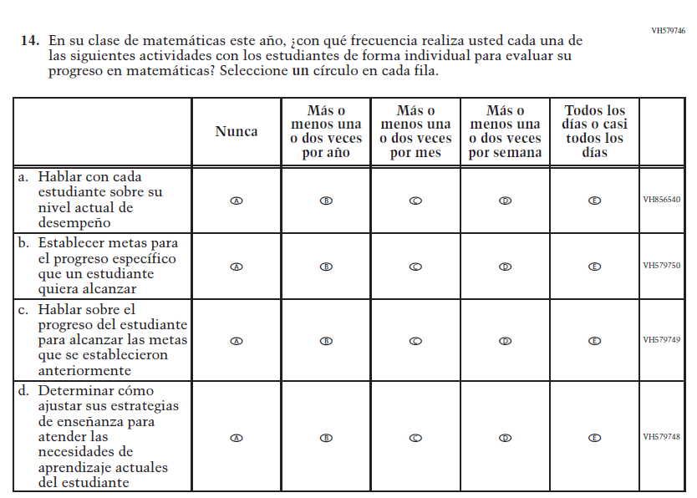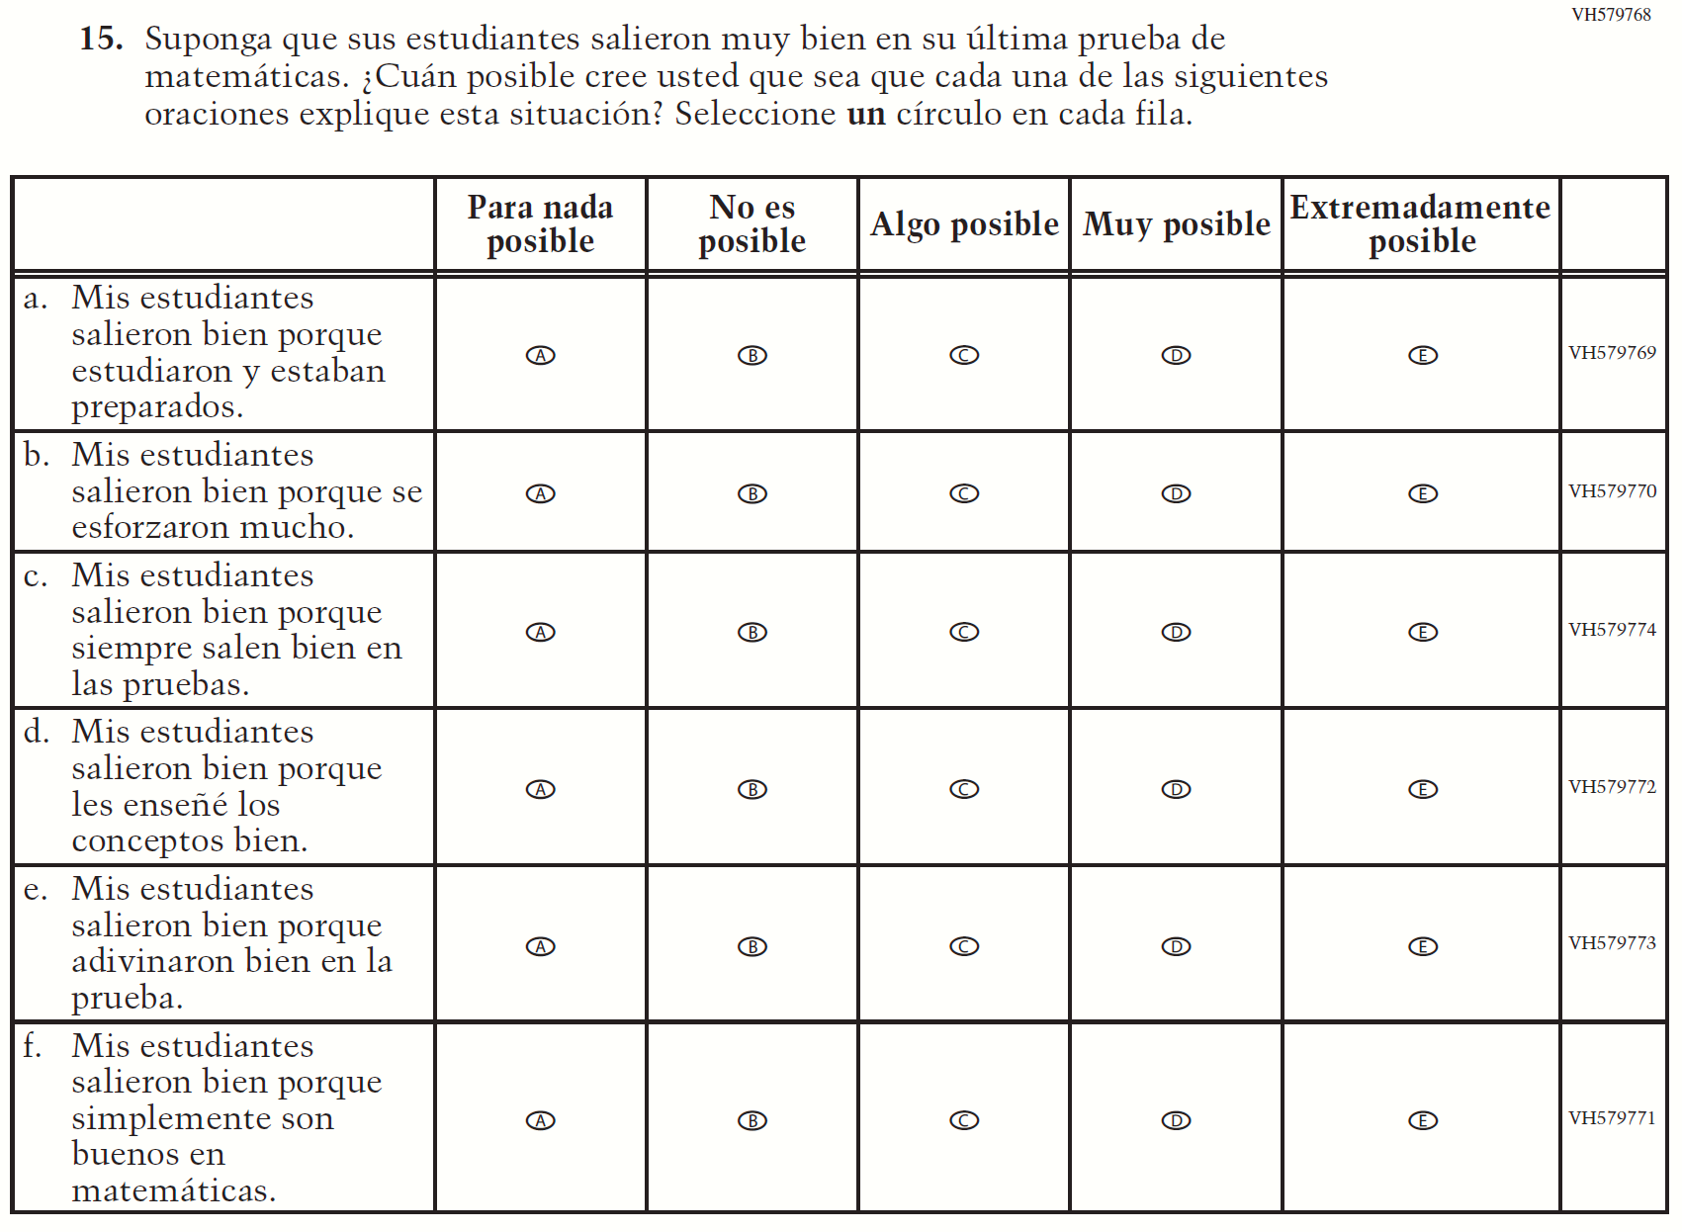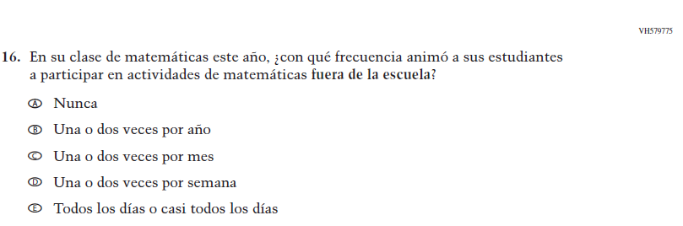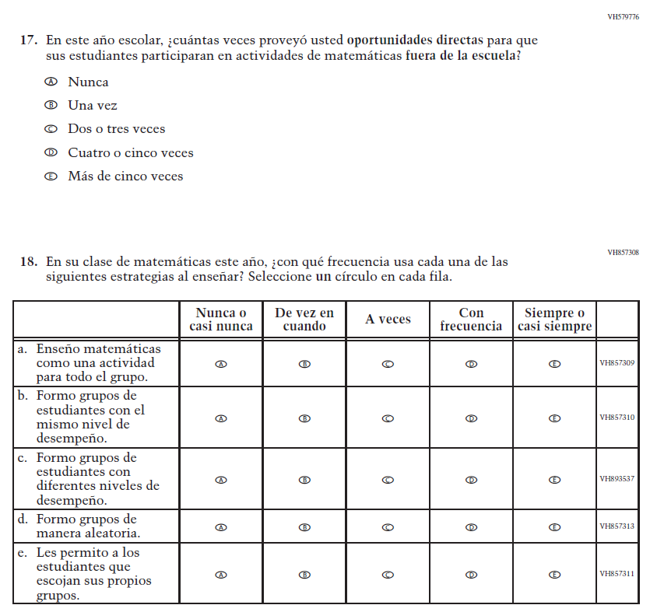

Appendix J-2e-s-PR: Operational Grade 4 COVID-19
Skip Logic Table
Grade/Respondent | Item Number Initiating Skip Logic | Item Response(s) Initiating Skip Logic | Item Number(s) Being Skipped
Grade 4 Teacher | 1 | B | 2

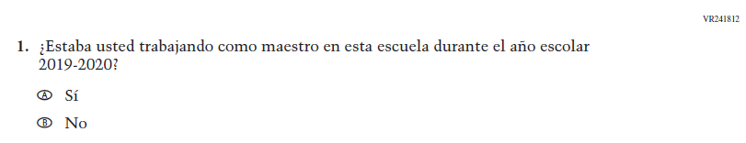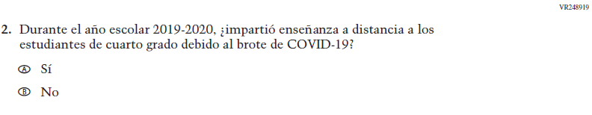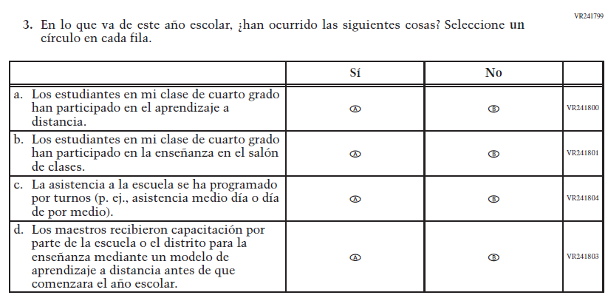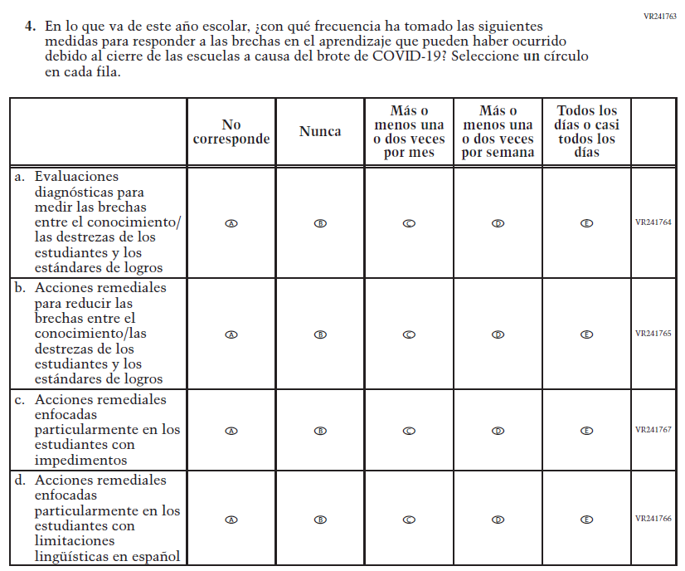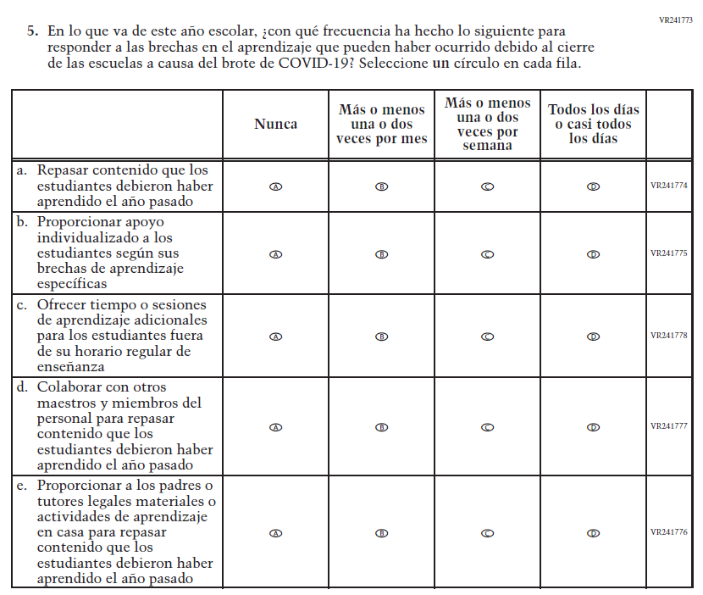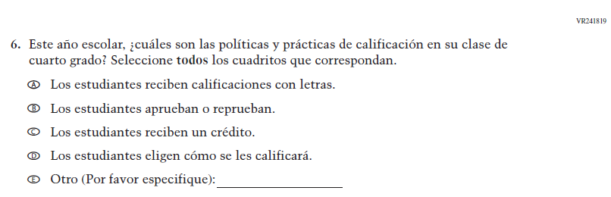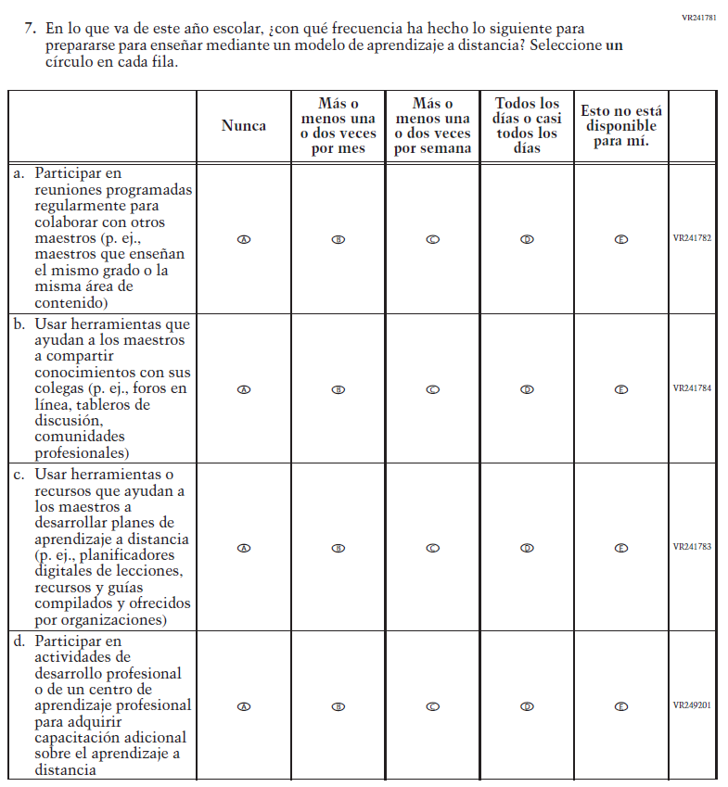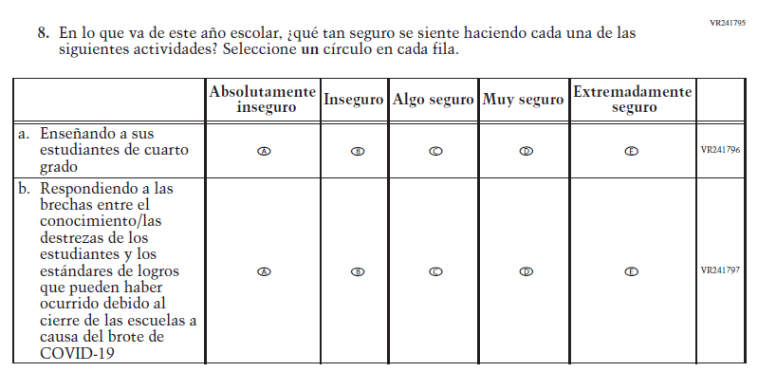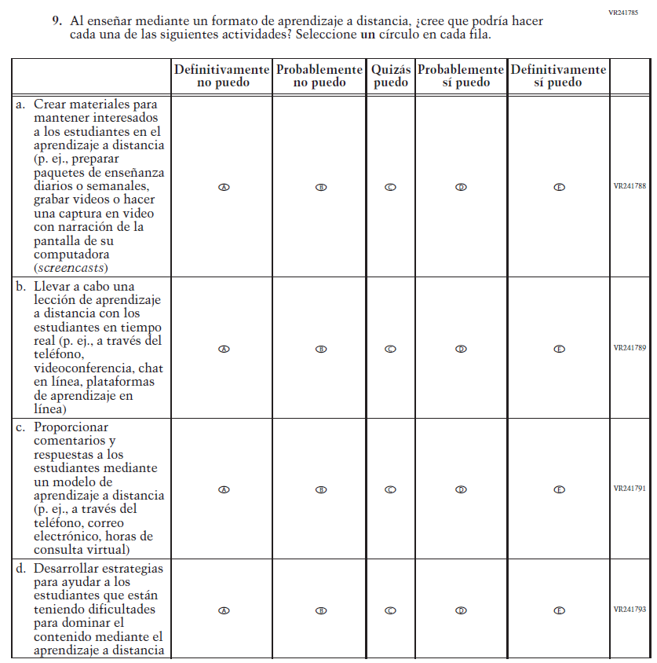

Appendix J-2f-s-PR: Operational Grade 8 COVID-19
Skip Logic Table
Grade/Respondent | Item Number Initiating Skip Logic | Item Response(s) Initiating Skip Logic | Item Number(s) Being Skipped
Grade 8 Teacher | 1 | B | 2

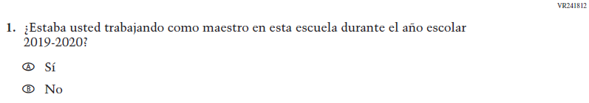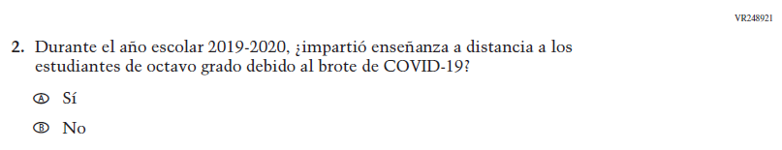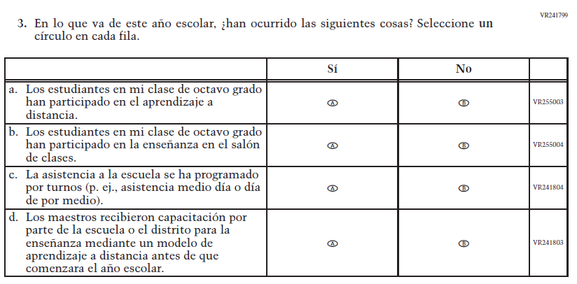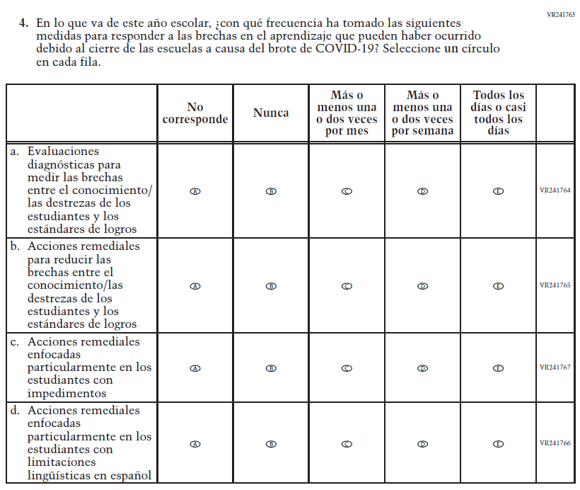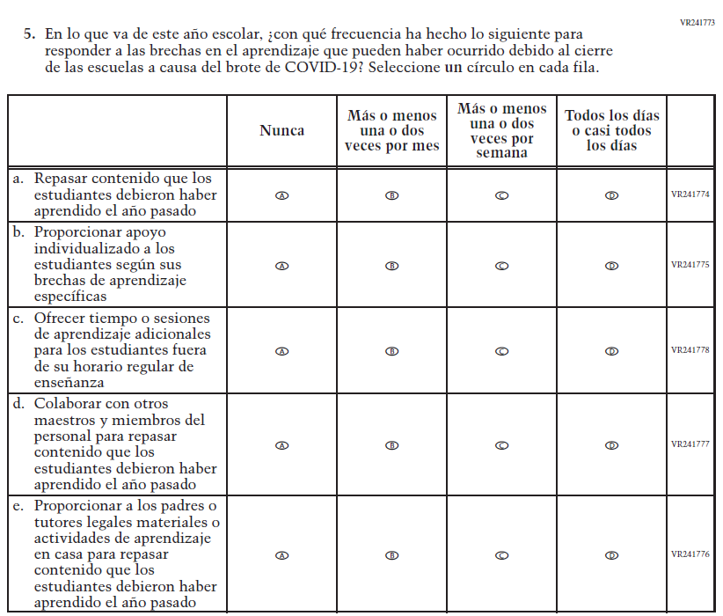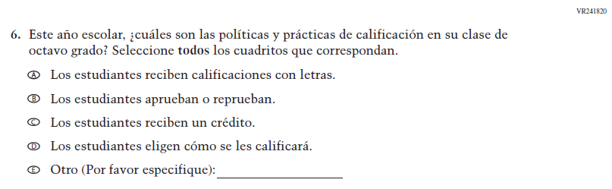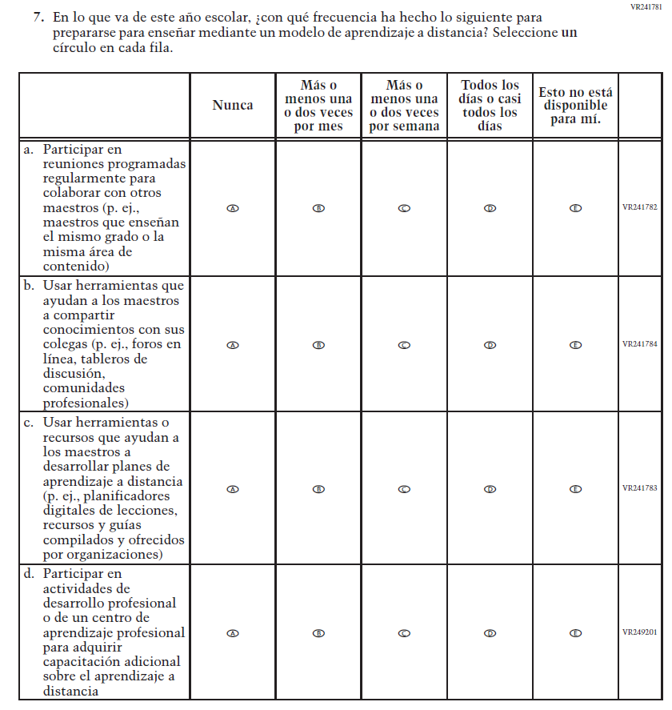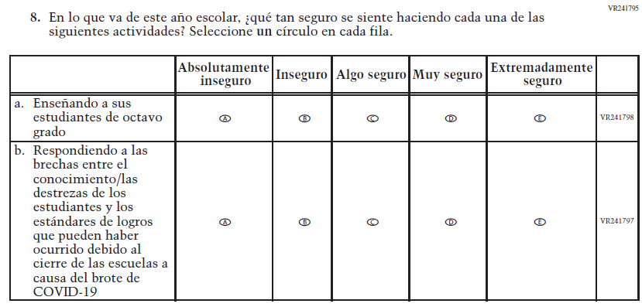
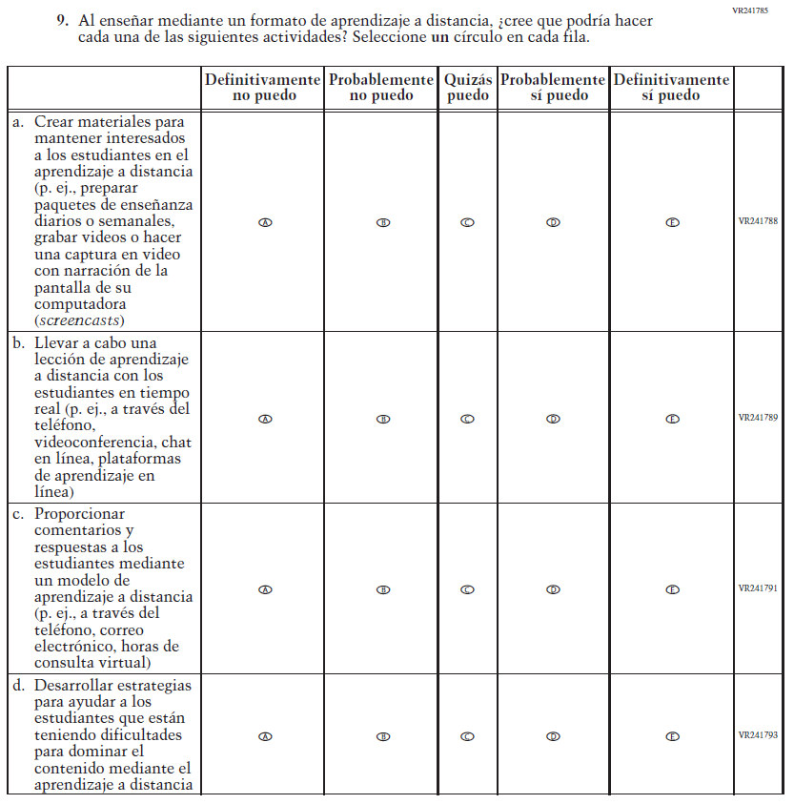

School Administrator Login Screen

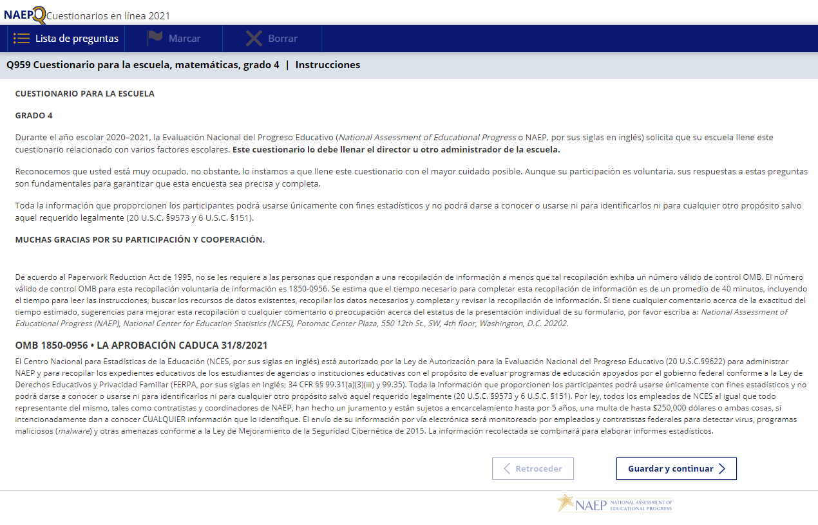

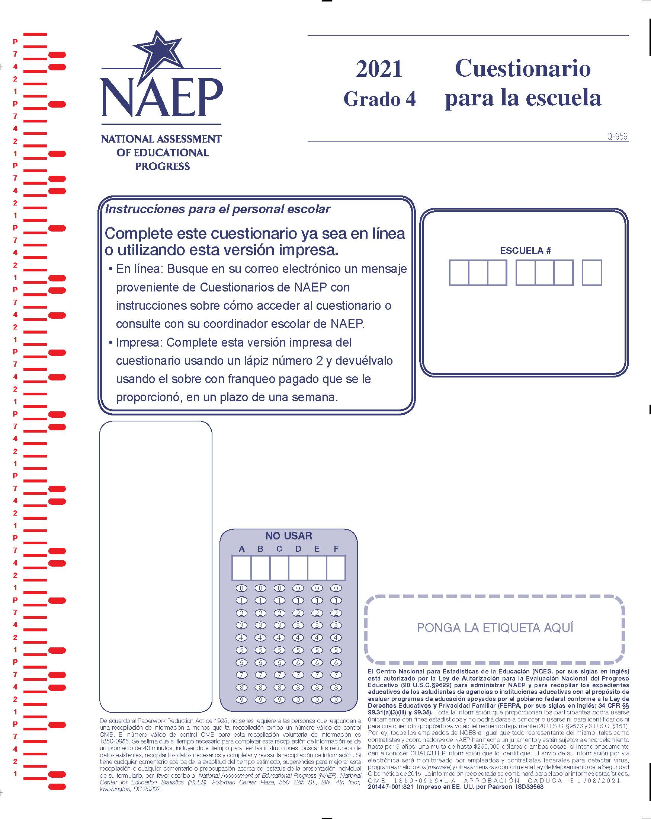

Appendix J-3-s: Spanish Translations of School Questionnaires

Appendix J-3a-s-PR: Summary of Changes Operational Grade 4 CORE
2021 Operational Grade 4 Core School – Puerto Rico
Previous item | 2021 item | D/A/R/NC+ | Rationale
VH835832  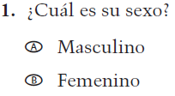  (2019 Operational Grade 4 School Core – Puerto Rico) | VH835832  Issue: Gender | NC | N/A
VH318287  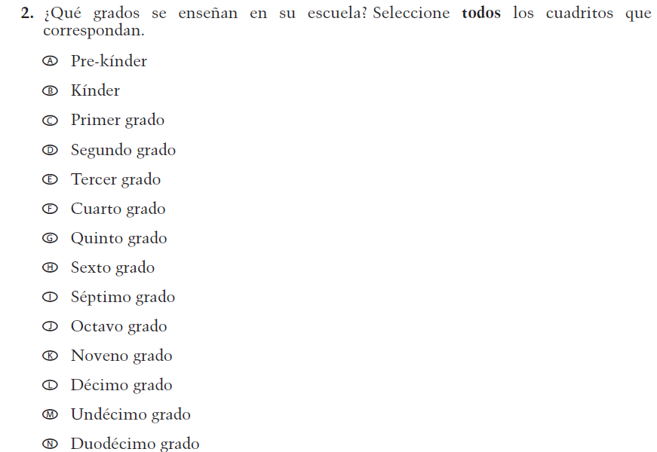  (2019 Operational Grade 4 School Core – Puerto Rico) | VH318287  Issue: School Climate | NC | N/A

2021 Operational Grade 4 Core School – Puerto Rico
Previous item | 2021 item | D/A/R/NC+ | Rationale
VH893344  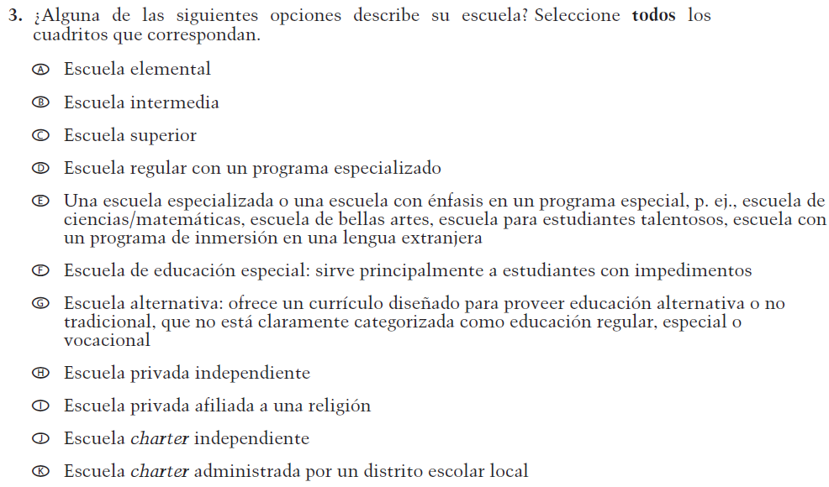  (2019 Operational Grade 4 School Core – Puerto Rico) | VH893344  Issue: School Climate | NC | N/A
VH835855  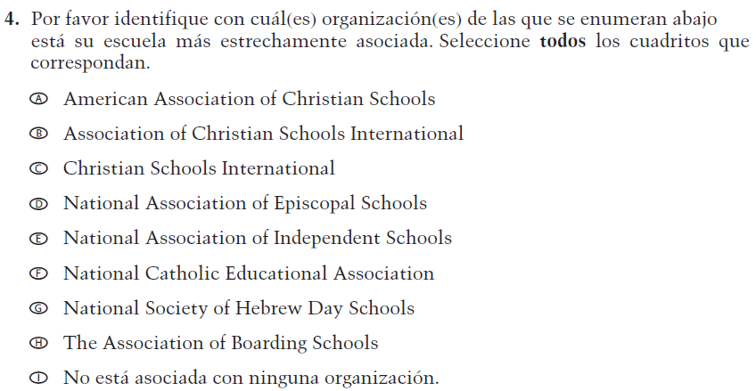  (2019 Operational Grade 4 School Core – Puerto Rico) | VH835855  Issue: School Climate | NC | N/A

2021 Operational Grade 4 Core School – Puerto Rico
Previous item | 2021 item | D/A/R/NC+ | Rationale
VH318289  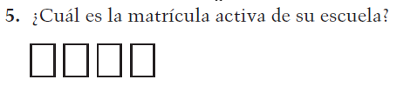  (2019 Operational Grade 4 School Core – Puerto Rico) | VH318289  Issue: School Climate | NC | N/A
VH318292  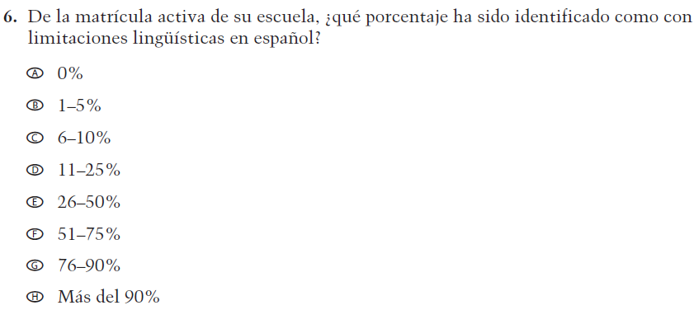  (2019 Operational Grade 4 School Core – Puerto Rico) | VH318292  Issue: School Climate | NC | N/A
VH318291  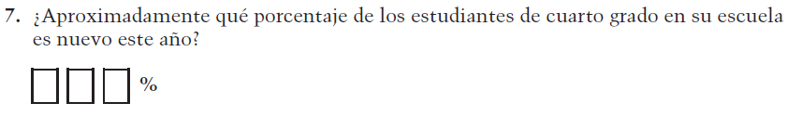  (2019 Operational Grade 4 School Core – Puerto Rico) | VH318291  Issue: School Climate | NC | N/A

2021 Operational Grade 4 Core School – Puerto Rico
Previous item | 2021 item | D/A/R/NC+ | Rationale
VH318298  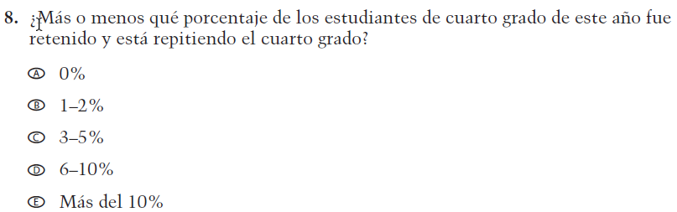  (2019 Operational Grade 4 School Core – Puerto Rico) | VH318298  Issue: School Climate | NC | N/A
VH318293  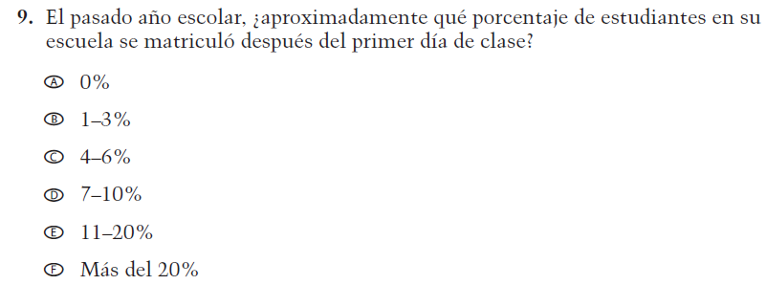  (2019 Operational Grade 4 School Core – Puerto Rico) | VH318293  Issue: School Climate | NC | N/A
VH318294  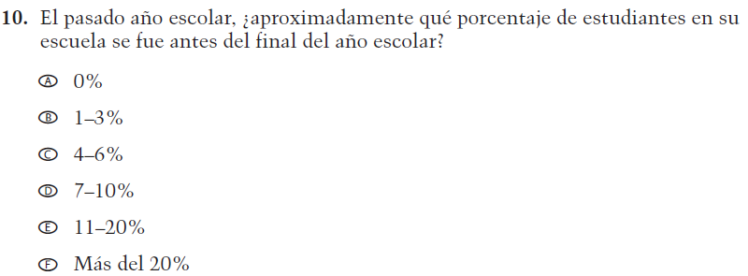  (2019 Operational Grade 4 School Core – Puerto Rico) | VH318294  Issue: School Climate | NC | N/A

2021 Operational Grade 4 Core School – Puerto Rico
Previous item | 2021 item | D/A/R/NC+ |  | Rationale
VH318297  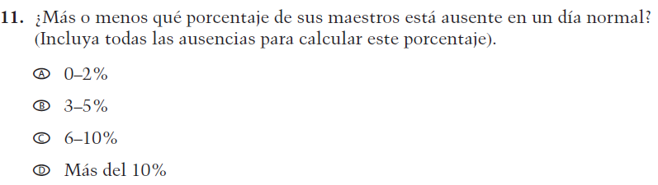  (2019 Operational Grade 4 School Core – Puerto Rico) | VH318297  Issue: School Climate | NC |  | N/A
VH318299  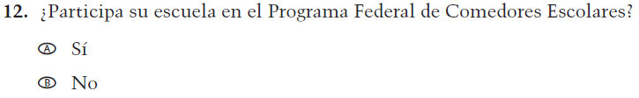  (2019 Operational Grade 4 School Core – Puerto Rico) | VH318299  Issue: Socioeconomic Status | NC |  | N/A
VH318300  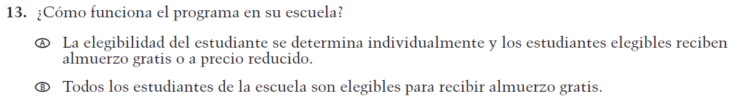  (2019 Operational Grade 4 School Core – Puerto Rico) | VH318300  Issue: Socioeconomic Status | NC |  | N/A
VH318303  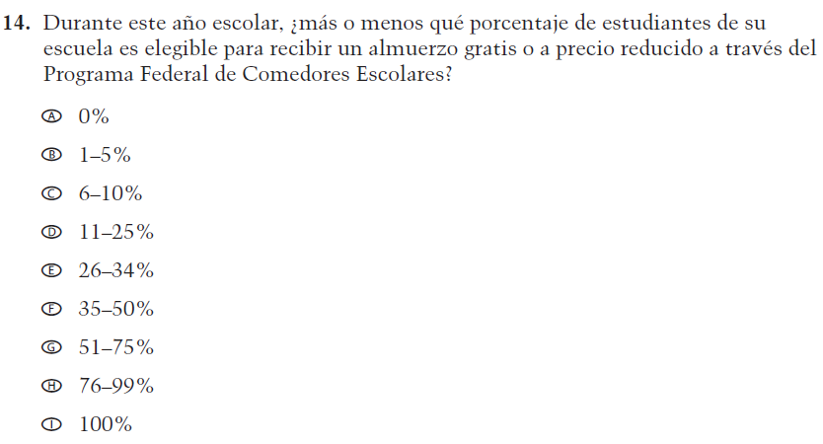  (2019 Operational Grade 4 School Core – Puerto Rico) | VH318303  Issue: Socioeconomic Status | NC |  | N/A
2021 Operational Grade 4 Core School – Puerto Rico
Previous item | 2021 item | D/A/R/NC+ | Rationale
VH318304  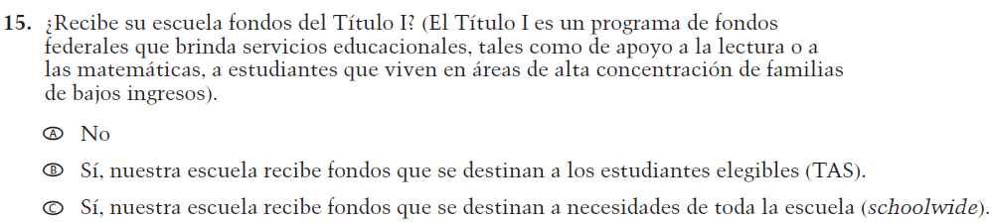  (2019 Operational Grade 4 School Core – Puerto Rico) | VH318304  Issue: Socioeconomic Status | NC | N/A
VH318306  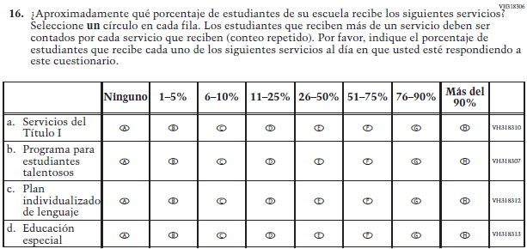  (2019 Operational Grade 4 School Core – Puerto Rico) | VH318306  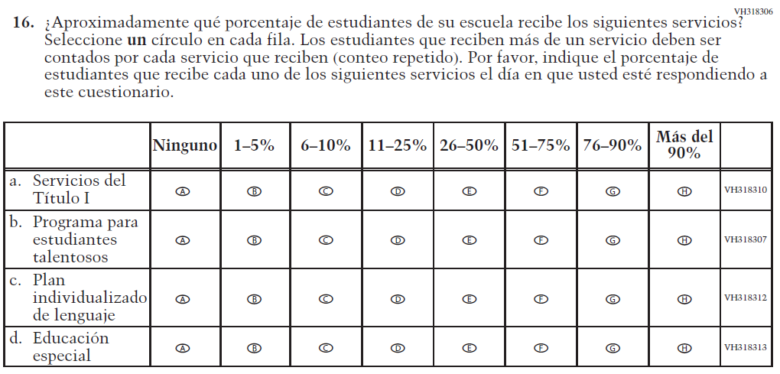  Issue: School Climate | R –  “al día en que usted” changed to “el día en que usted” in SL  NC – subitems a through d | To correct a grammar error.

2021 Operational Grade 4 Core School – Puerto Rico
Previous item | 2021 item | D/A/R/NC+ | Rationale
VH318316  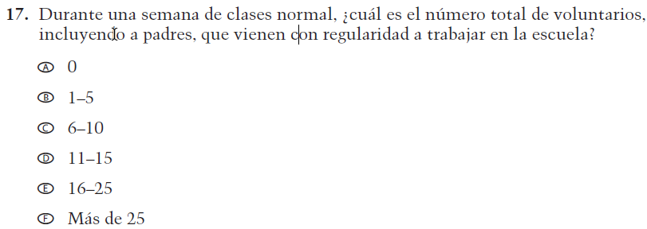  (2019 Operational Grade 4 School Core – Puerto Rico) | VH318316  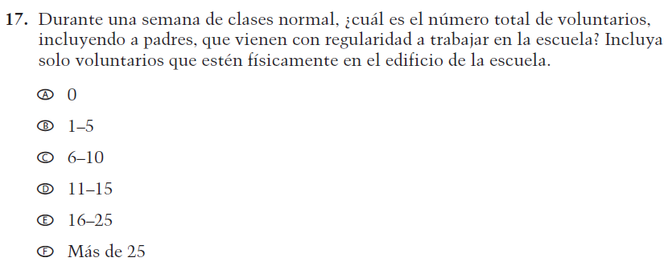  Issue: School Climate | R –  “Incluya solo voluntarios que estén físicamente en el edificio de la escuela.” added in SL  NC – options A through F | Additional sentence has been added to adapt the item to reflect the context of the COVID-19 pandemic.
VH318317  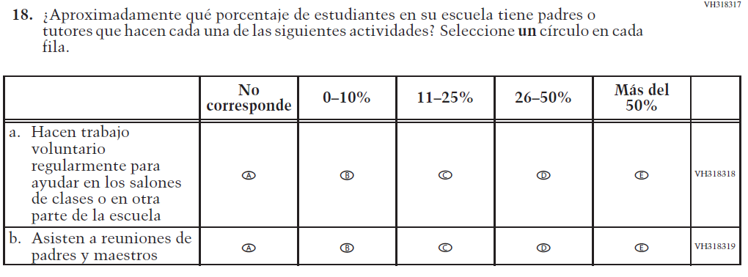  (2019 Operational Grade 4 School Core – Puerto Rico) | VH318317  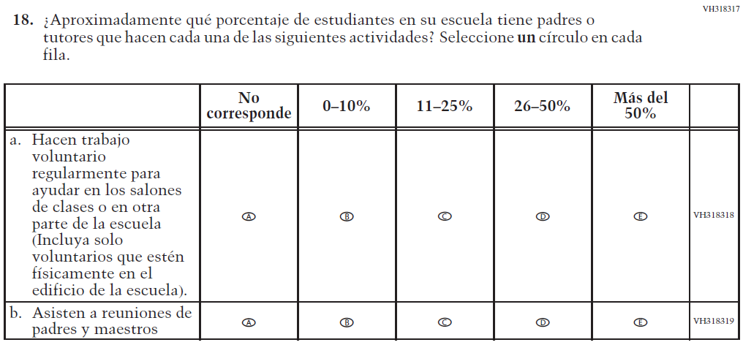  Issue: School Climate | R –  “(Incluya  solo voluntarios que estén físicamente en el edificio de la escuela).” was added to sub-item a  NC – SL and  sub-item b | Parenthetical has been added to sub-item a to adapt the item to reflect the context of the COVID-19 pandemic.

2021 Operational Grade 4 Core School – Puerto Rico
Previous item | 2021 item | D/A/R/NC+ | Rationale
VH318321  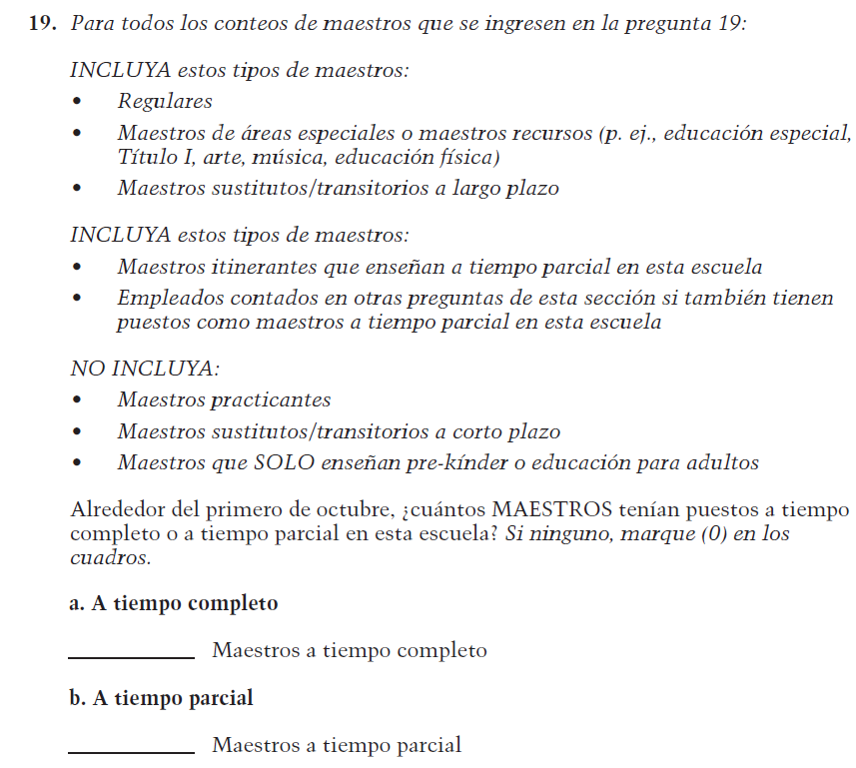  (2019 Operational Grade 4 School Core – Puerto Rico) | VH318321  Issue: School Climate | NC | N/A
VH835853  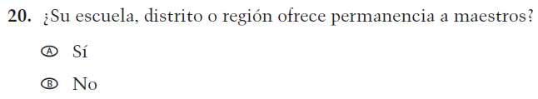  (2019 Operational Grade 4 School Core – Puerto Rico) | VH835853  Issue: School Climate | NC | N/A

2021 Operational Grade 4 Core School – Puerto Rico
Previous item | 2021 item | D/A/R/NC+ | Rationale
VH893347  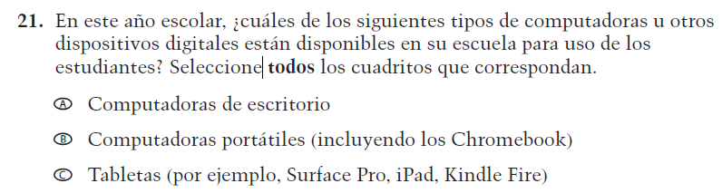  (2019 Operational Grade 4 School Core – Puerto Rico) | VH893347  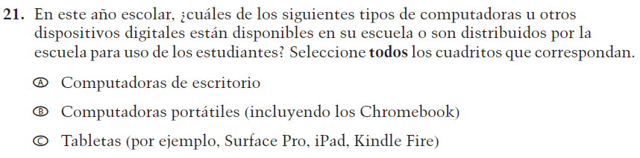  Issue: Technology Use | R –  “están disponibles en su escuela para uso” changed to “están disponibles en su escuela o son distribuidos por la escuela para uso” in SL  NC – options A through C | Additional text has been added to adapt the item to reflect the context of the COVID-19 pandemic.
VH579614  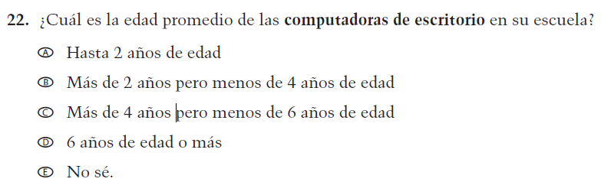  (2019 Operational Grade 4 School Core – Puerto Rico) | VH579614  Issue: Technology Use | NC | N/A

2021 Operational Grade 4 Core School – Puerto Rico
Previous item | 2021 item | D/A/R/NC+ | Rationale
VH893348  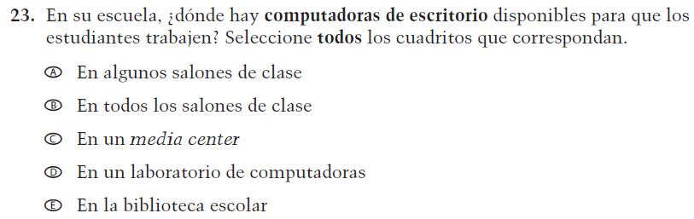  (2019 Operational Grade 4 School Core – Puerto Rico) | VH893348  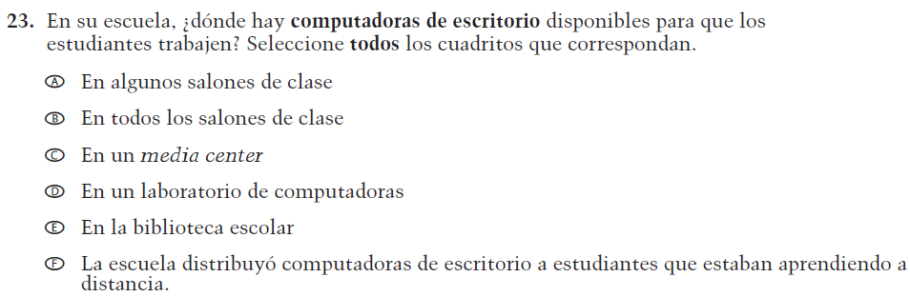  Issue: Technology Use | R –  "La escuela distribuyó computadoras de escritorio a estudiantes que estaban aprendiendo a distancia." was added as new response option F  NC – SL and options A through E | Response option F has been added to adapt the item to reflect the context of the COVID-19 pandemic.
VH579616  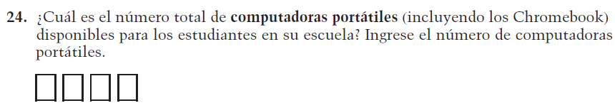  (2019 Operational Grade 4 School Core – Puerto Rico) | VH579616  Issue: Technology Use | NC | N/A
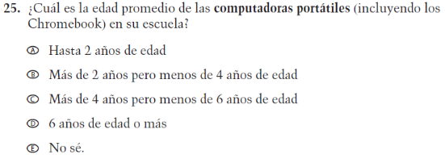  VH579617  (2019 Operational Grade 4 School Core – Puerto Rico) | 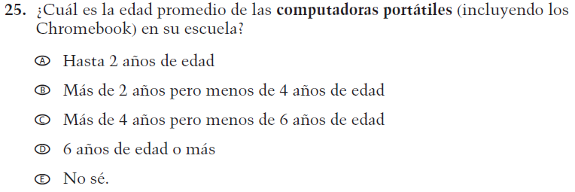  VH579617  Issue: Technology Use | NC | N/A

2021 Operational Grade 4 Core School – Puerto Rico
Previous item | 2021 item | D/A/R/NC+ | Rationale
VH893351  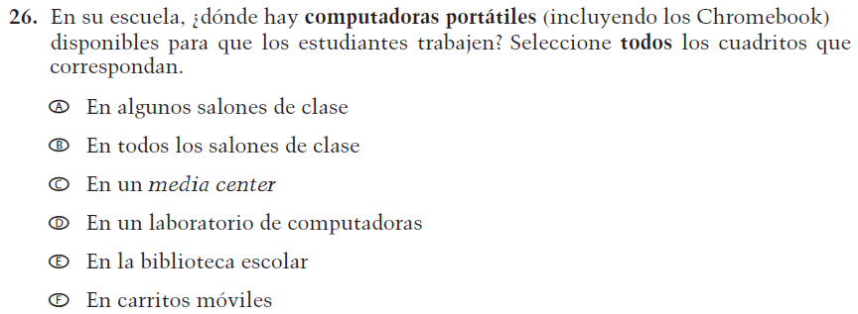  (2019 Operational Grade 4 School Core – Puerto Rico) | VH893351  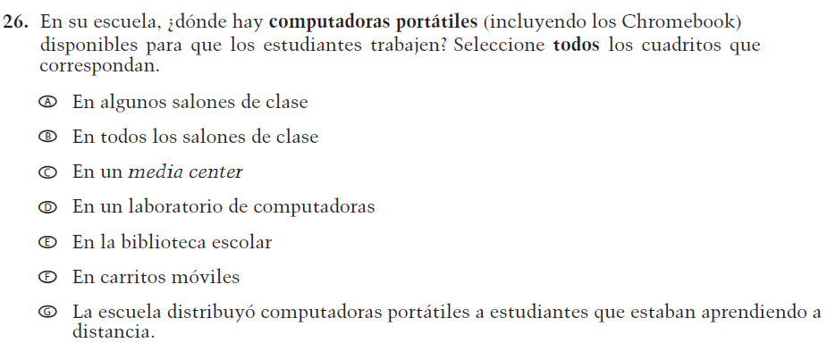  Issue: Technology Use | R –  "La escuela distribuyó computadoras portátiles a estudiantes que estaban aprendiendo a distancia." was added as new response option G  NC – SL and options A through F | Response option G has been added to adapt the item to reflect the context of the COVID-19 pandemic.
VH579619  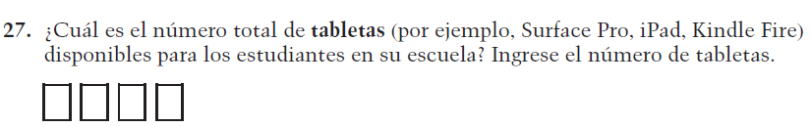  (2019 Operational Grade 4 School Core – Puerto Rico) | VH579619  Issue: Technology Use | NC | N/A
VH579620  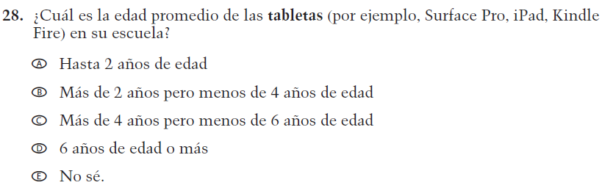  (2019 Operational Grade 4 School Core – Puerto Rico) | VH579620  Issue: Technology Use | NC | N/A

2021 Operational Grade 4 Core School – Puerto Rico
Previous item | 2021 item | D/A/R/NC+ | Rationale
VH893352  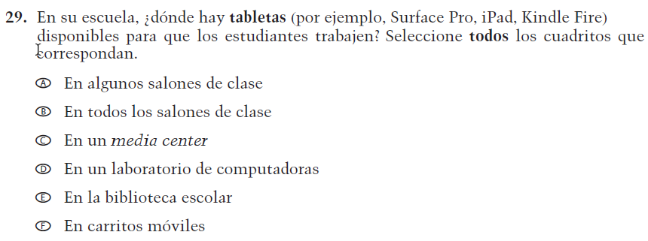  (2019 Operational Grade 4 School Core – Puerto Rico) | VH893352  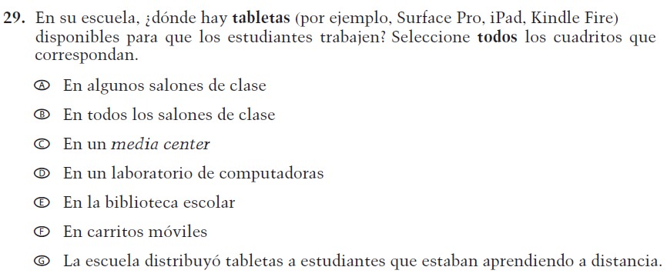  Issue: Technology Use | R –  "La escuela distribuyó tabletas a estudiantes que estaban aprendiendo a distancia." was added as new response option G  NC – SL and options A through F | Response option G has been added to adapt the item to reflect the context of the COVID-19 pandemic.
VH579601  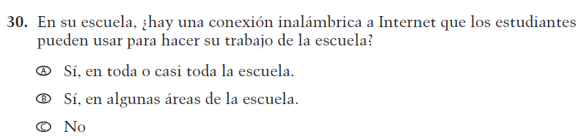  (2019 Operational Grade 4 School Core – Puerto Rico) | VH579601  Issue: Technology Use | NC | N/A

Appendix J-3a-s-PR: Operational Grade 4 CORE
Grade/Respondent | Item Number Initiating Skip Logic | Item Response(s) Initiating Skip Logic | Item Number(s) Being Skipped
Grade 4 School | 3 | A, B, C, D, E, F, G, and K | 4
Grade 4 School | 3 | H, I, J | Do NOT skip 4
Grade 4 School | 3 | No response | 4
Grade 4 School | 12 | B | 13, 14
Grade 4 School | 13 | B | 14
Grade 4 School | 21 | A | Do NOT skip 22, 23
Grade 4 School | 21 | B | Do NOT skip 24, 25, 26
Grade 4 School | 21 | C | Do NOT skip 27, 28, 29
Grade 4 School | 21 | No response | 22, 23, 24, 25, 26, 27, 28, 29
Grade 4 School | 24 | If answered “0” | 25, 26
Grade 4 School | 27 | If answered “0” | 28, 29

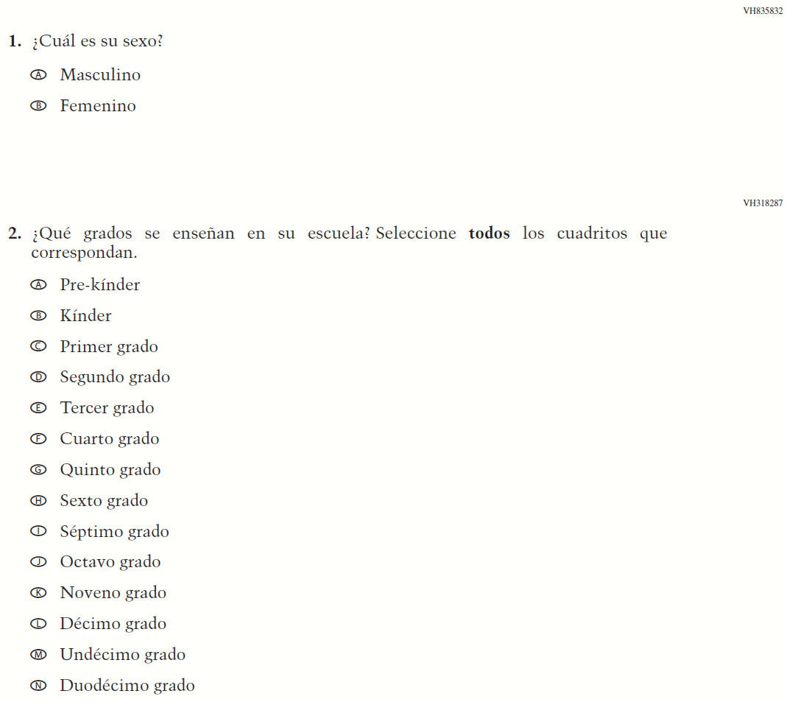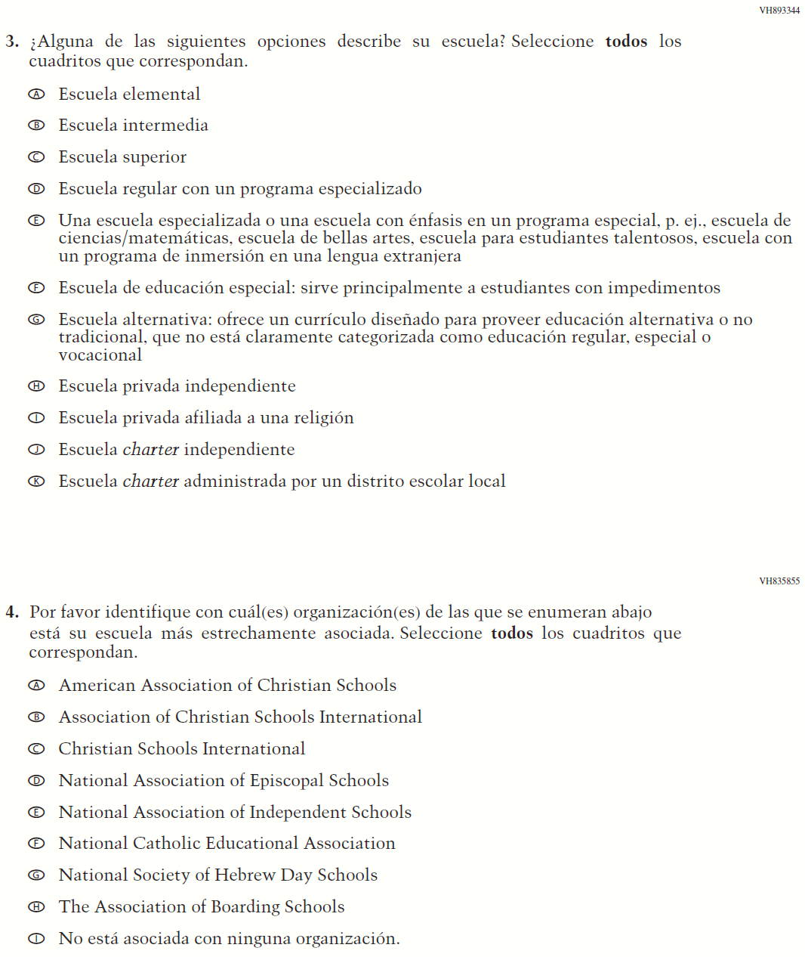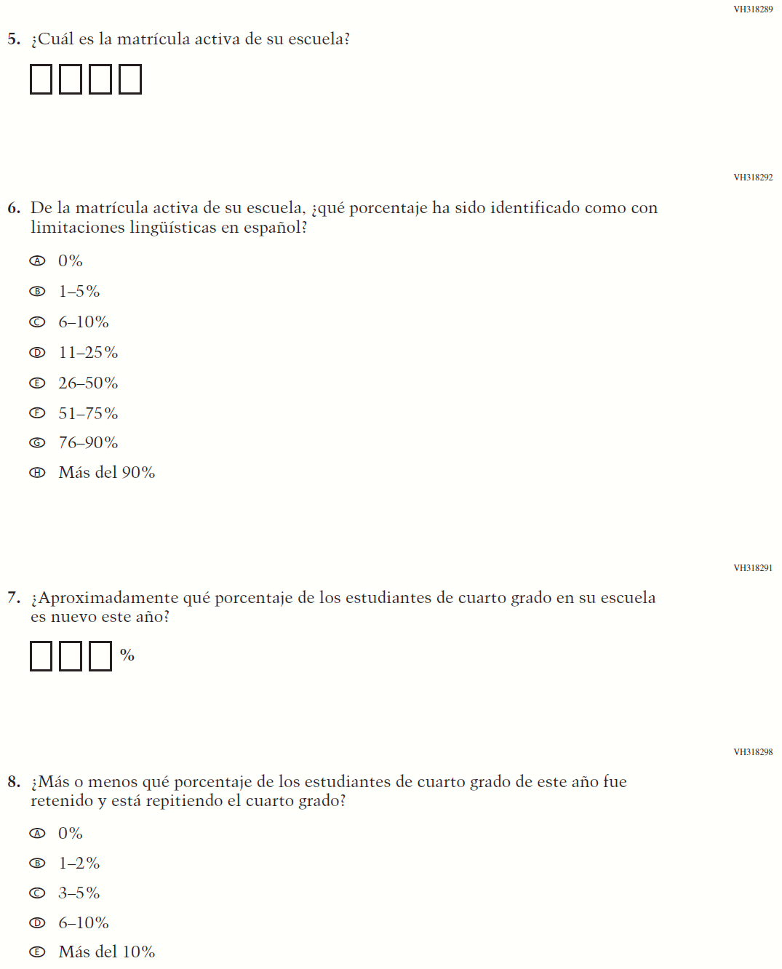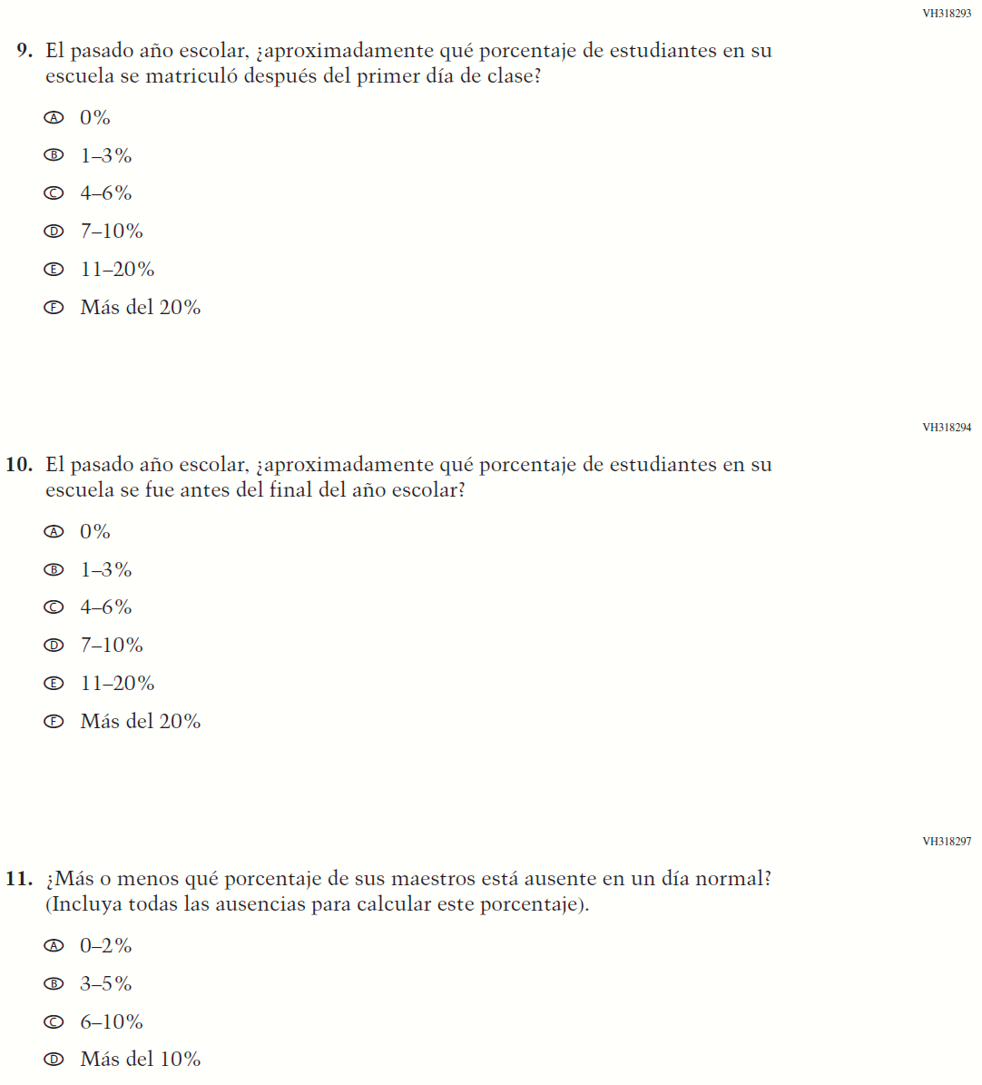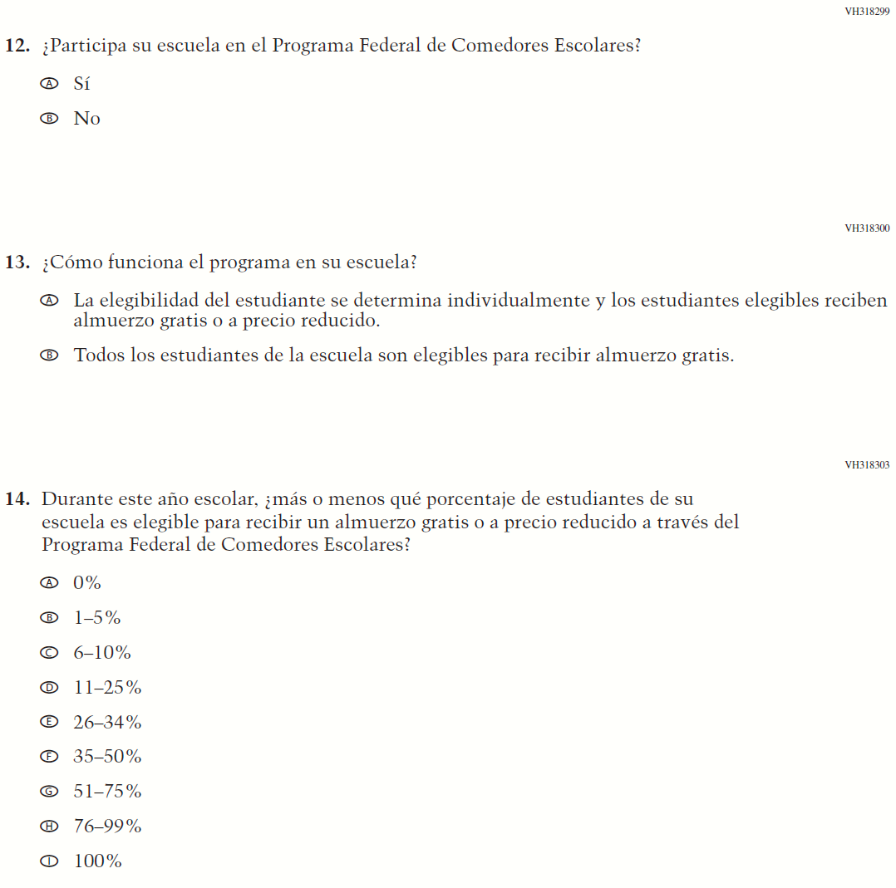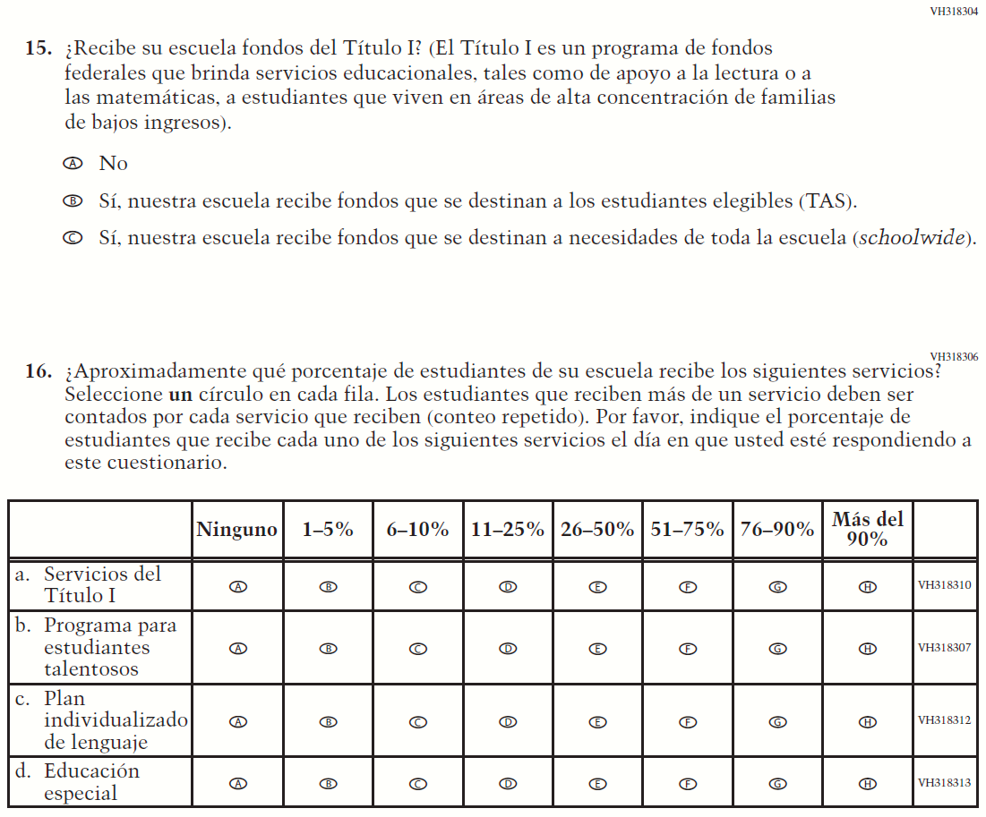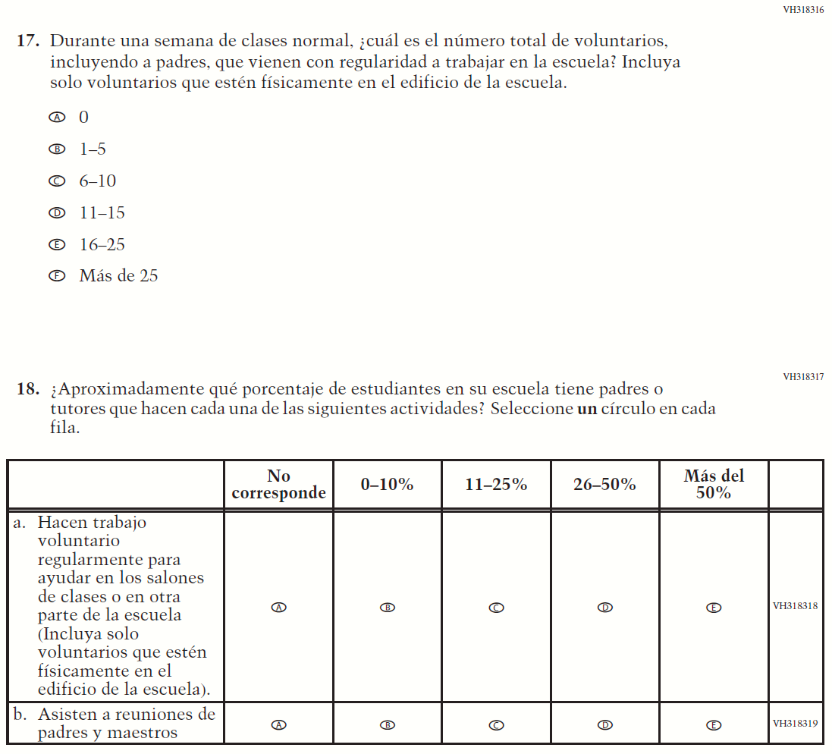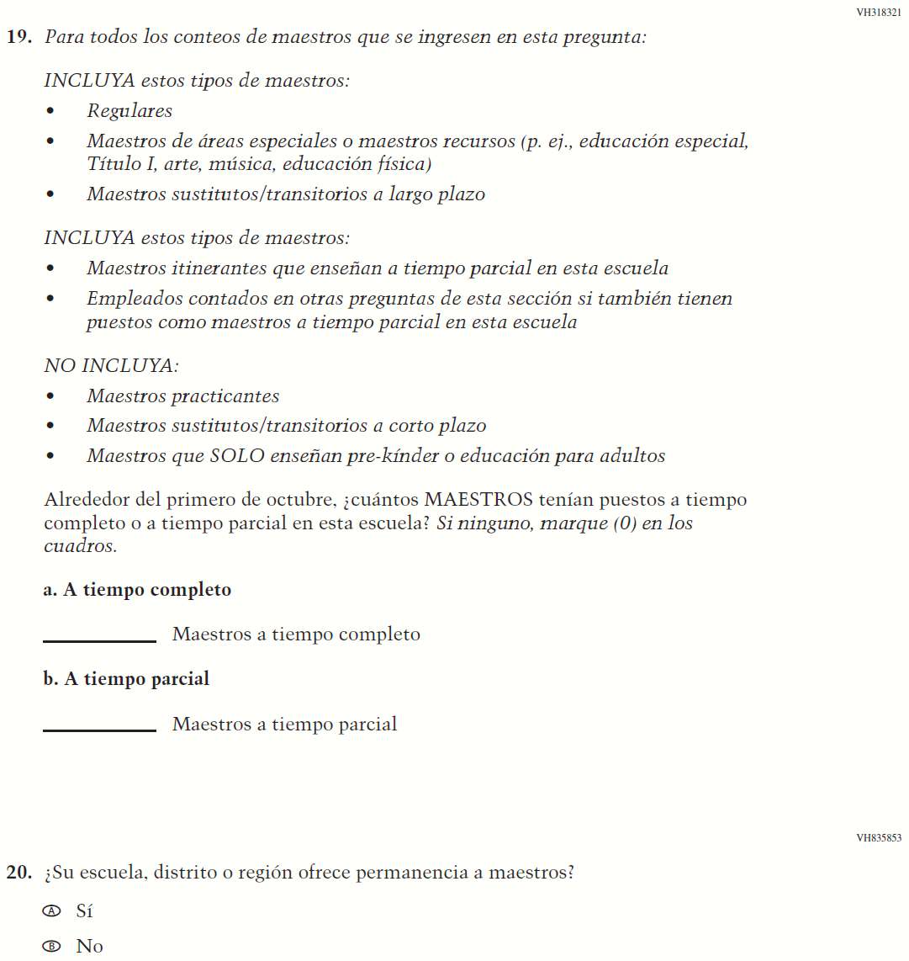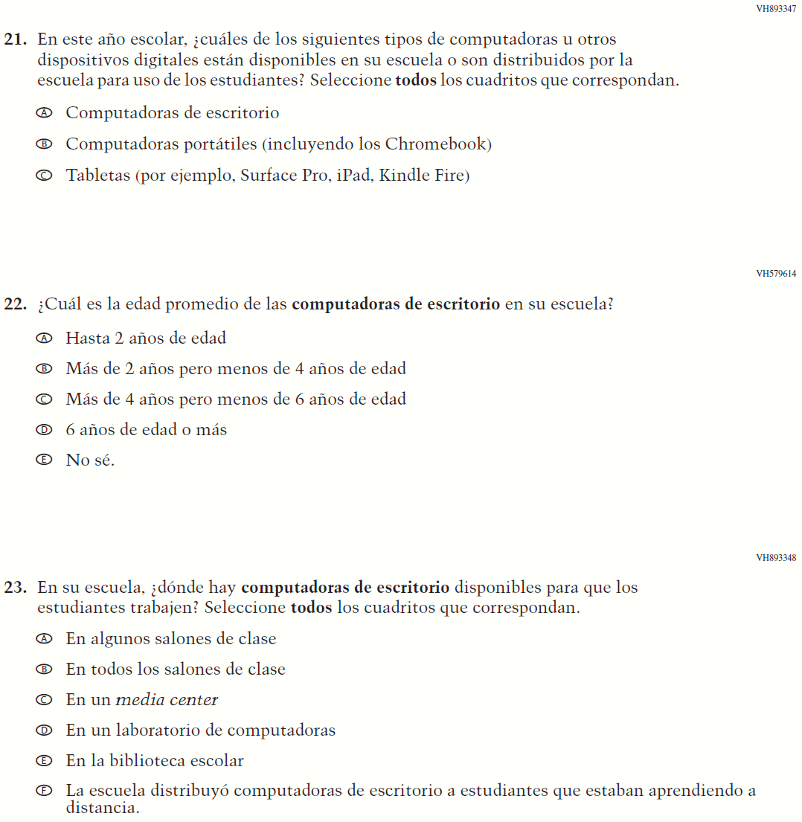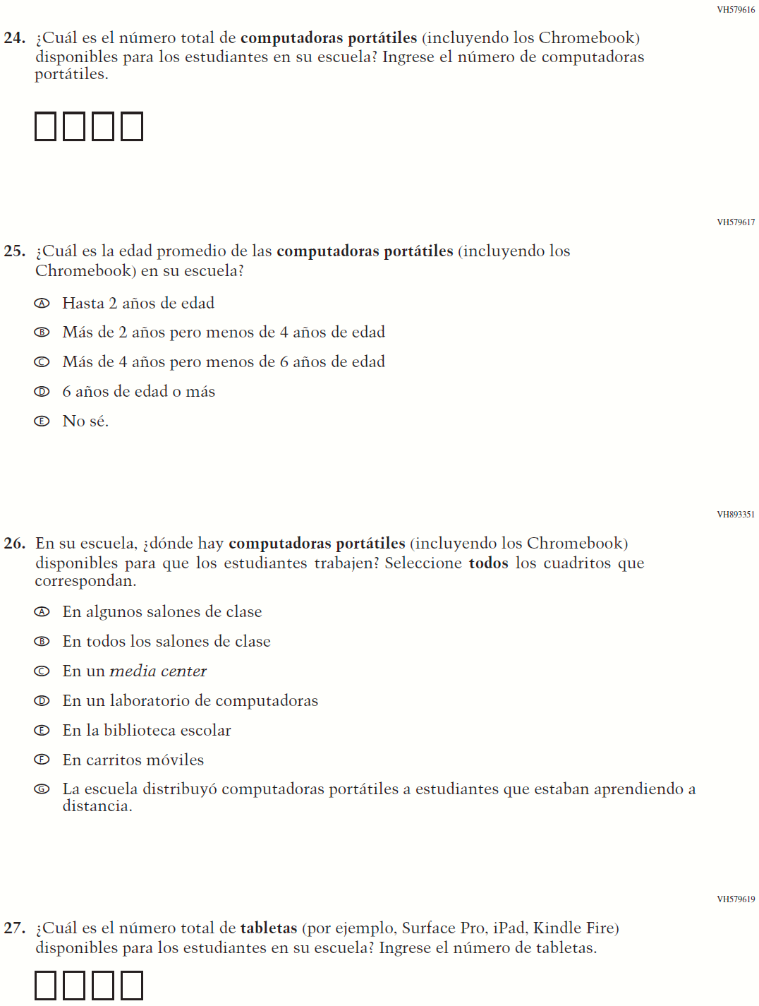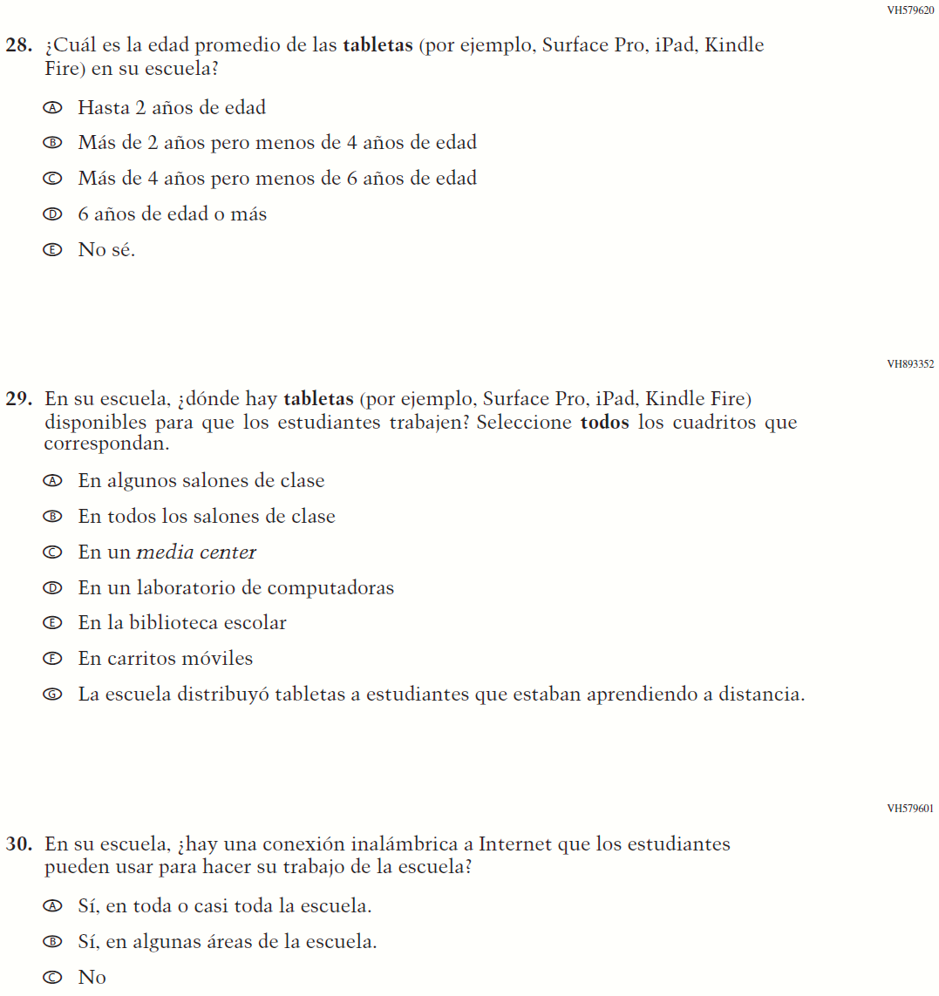

Appendix J-3b-s-PR: Summary of Changes Operational Grade 8 CORE
2021 Operational Grade 8 Core School – Puerto Rico
Previous item | 2021 item | D/A/R/NC+ | Rationale
VH835832  (2019 Operational Grade 8 School Core – Puerto Rico) | VH835832  Issue: Gender | NC | N/A
VH318287  (2019 Operational Grade 8 School Core – Puerto Rico) | VH318287  Issue: School Climate | NC | N/A

2021 Operational Grade 8 Core School – Puerto Rico
Previous item | 2021 item | D/A/R/NC+ | Rationale
VH893344  (2019 Operational Grade 8 School Core – Puerto Rico) | VH893344  Issue: School Climate | NC | N/A
VH835855  (2019 Operational Grade 8 School Core – Puerto Rico) | VH835855  Issue: School Climate | NC | N/A

2021 Operational Grade 8 Core School – Puerto Rico
Previous item | 2021 item | D/A/R/NC+ | Rationale
VH318289  (2019 Operational Grade 8 School Core – Puerto Rico) | VH318289  Issue: School Climate | NC | N/A
VH318292  (2019 Operational Grade 8 School Core – Puerto Rico) | VH318292  Issue: School Climate | NC | N/A
VH318558  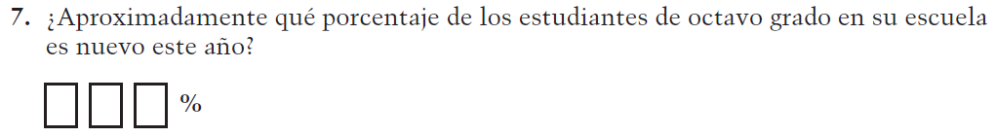  (2019 Operational Grade 8 School Core – Puerto Rico) | VH318558  Issue: School Climate | NC | N/A

2021 Operational Grade 8 Core School – Puerto Rico
Previous item | 2021 item | D/A/R/NC+ | Rationale
VH319391  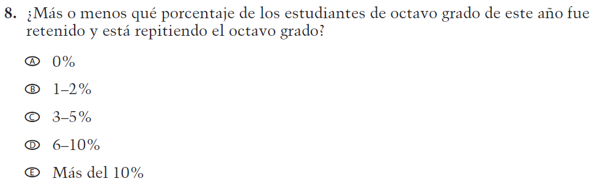  (2019 Operational Grade 8 School Core – Puerto Rico) | VH319391  Issue: School Climate | NC | N/A
VH318293  (2019 Operational Grade 8 School Core – Puerto Rico) | VH318293  Issue: School Climate | NC | N/A
VH318294  (2019 Operational Grade 8 School Core – Puerto Rico) | VH318294  Issue: School Climate | NC | N/A

2021 Operational Grade 8 Core School – Puerto Rico
Previous item | 2021 item | D/A/R/NC+ | Rationale
VH318297  (2019 Operational Grade 8 School Core – Puerto Rico) | VH318297  Issue: School Climate | NC | N/A
VH318299  (2019 Operational Grade 8 School Core – Puerto Rico) | VH318299  Issue: Socioeconomic Status | NC | N/A
VH318300  (2019 Operational Grade 8 School Core – Puerto Rico) | VH318300  Issue: Socioeconomic Status | NC | N/A
VH318303  (2019 Operational Grade 8 School Core – Puerto Rico) | VH318303  Issue: Socioeconomic Status | NC | N/A

2021 Operational Grade 8 Core School – Puerto Rico
Previous item | 2021 item | D/A/R/NC+ | Rationale
VH318304  (2019 Operational Grade 8 School Core – Puerto Rico) | VH318304  Issue: Socioeconomic Status | NC | N/A
VH318306  (2019 Operational Grade 8 School Core – Puerto Rico) | VH318306  Issue: School Climate | R –  “al día en que usted” changed to “el día en que usted” in SL  NC – subitems a through d | To correct a grammar error.

2021 Operational Grade 8 Core School – Puerto Rico
Previous item | 2021 item | D/A/R/NC+ | Rationale
VH318316  (2019 Operational Grade 8 School Core – Puerto Rico) | VH318316  Issue: School Climate | R –  “Incluya solo voluntarios que estén físicamente en el edificio de la escuela.” added in SL  NC – options A through F | Additional sentence has been added to adapt the item to reflect the context of the COVID-19 pandemic.
VH318317  (2019 Operational Grade 8 School Core – Puerto Rico) | VH318317  Issue: School Climate | R –  “(Incluya  solo voluntarios que estén físicamente en el edificio de la escuela).” was added to sub-item a  NC – SL and  sub-item b | Parenthetical has been added to sub-item a to adapt the item to reflect the context of the COVID-19 pandemic.

2021 Operational Grade 8 Core School – Puerto Rico
Previous item | 2021 item | D/A/R/NC+ | Rationale
VH318321  (2019 Operational Grade 8 School Core – Puerto Rico) | VH318321  Issue: School Climate | NC | N/A
VH835853  (2019 Operational Grade 8 School Core – Puerto Rico) | VH835853  Issue: School Climate | NC | N/A

2021 Operational Grade 8 Core School – Puerto Rico
Previous item | 2021 item | D/A/R/NC+ | Rationale
VH893347  (2019 Operational Grade 8 School Core – Puerto Rico) | VH893347  Issue: Technology Use | R –  “están disponibles en su escuela para uso” changed to “están disponibles en su escuela o son distribuidos por la escuela para uso” in SL  NC – options A through C | Additional text has been added to adapt the item to reflect the context of the COVID-19 pandemic.
VH579614  (2019 Operational Grade 8 School Core – Puerto Rico) | VH579614  Issue: Technology Use | NC | N/A

2021 Operational Grade 8 Core School – Puerto Rico
Previous item | 2021 item | D/A/R/NC+ | Rationale
VH893348  (2019 Operational Grade 8 School Core – Puerto Rico) | VH893348  Issue: Technology Use | R –  "La escuela distribuyó computadoras de escritorio a estudiantes que estaban aprendiendo a distancia." was added as new response option F  NC – SL and options A through E | Response option F has been added to adapt the item to reflect the context of the COVID-19 pandemic.
VH579616  (2019 Operational Grade 8 School Core – Puerto Rico) | VH579616  Issue: Technology Use | NC | N/A
VH579617  (2019 Operational Grade 8 School Core – Puerto Rico) | VH579617  Issue: Technology Use | NC | N/A

2021 Operational Grade 8 Core School – Puerto Rico
Previous item | 2021 item |  |  | D/A/R/NC+ |  | Rationale
VH893351  (2019 Operational Grade 8 School Core – Puerto Rico) | VH893351  Issue: Technology Use |  |  | R –  "La escuela distribuyó computadoras portátiles a estudiantes que estaban aprendiendo a distancia." was added as new response option G  NC – SL and options A through F |  | Response option G has been added to adapt the item to reflect the context of the COVID-19 pandemic.
VH579619  (2019 Operational Grade 8 School Core – Puerto Rico) | VH579619  Issue: Technology Use |  |  | NC |  | N/A
VH579620  (2019 Operational Grade 8 School Core – Puerto Rico) | VH579620  Issue: Technology Use |  |  | NC |  | N/A
2021 Operational Grade 8 Core School – Puerto Rico
Previous item |  | 2021 item | D/A/R/NC+ |  | Rationale
VH893352  (2019 Operational Grade 8 School Core – Puerto Rico) |  | VH893352  Issue: Technology Use | R –  "La escuela distribuyó tabletas a estudiantes que estaban aprendiendo a distancia." was added as new response option G  NC – SL and options A through F |  | Response option G has been added to adapt the item to reflect the context of the COVID-19 pandemic.
VH579601  (2019 Operational Grade 8 School Core – Puerto Rico) |  | VH579601  Issue: Technology Use | NC |  | N/A

Appendix J-3b-s-PR: Operational Grade 8 CORE
Grade/Respondent | Item Number Initiating Skip Logic | Item Response(s) Initiating Skip Logic | Item Number(s) Being Skipped
Grade 8 School | 3 | A, B, C, D, E, F, G, and K | 4
Grade 8 School | 3 | H, I, J | Do NOT skip 4
Grade 8 School | 3 | No response | 4
Grade 8 School | 12 | B | 13, 14
Grade 8 School | 13 | B | 14
Grade 8 School | 21 | A | Do NOT skip 22, 23
Grade 8 School | 21 | B | Do NOT skip 24, 25, 26
Grade 8 School | 21 | C | Do NOT skip 27, 28, 29
Grade 8 School | 21 | No response | 22, 23, 24, 25, 26, 27, 28, 29
Grade 8 School | 24 | If answered “0” | 25, 26
Grade 8 School | 27 | If answered “0” | 28, 29

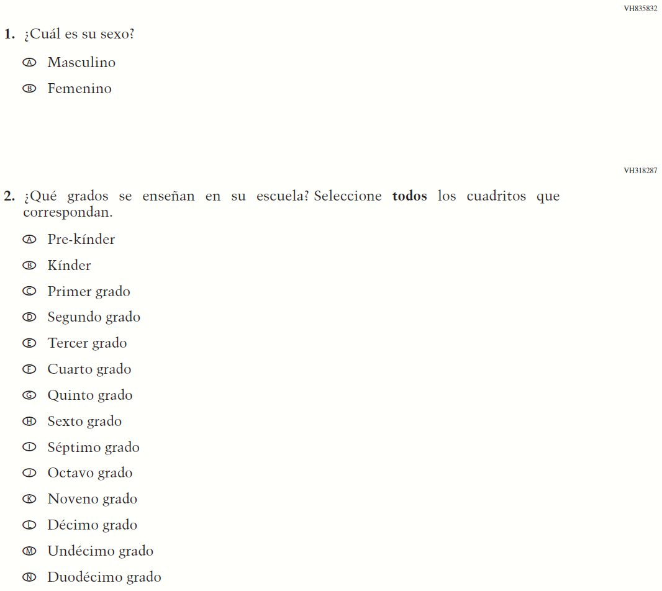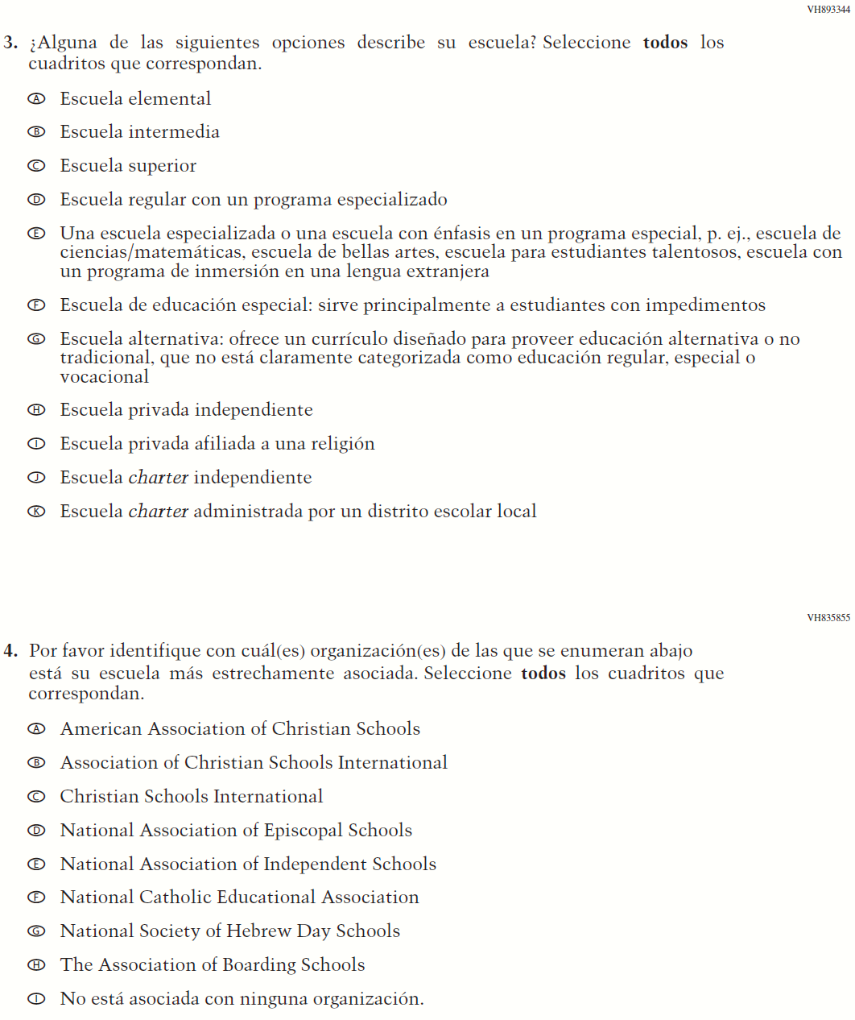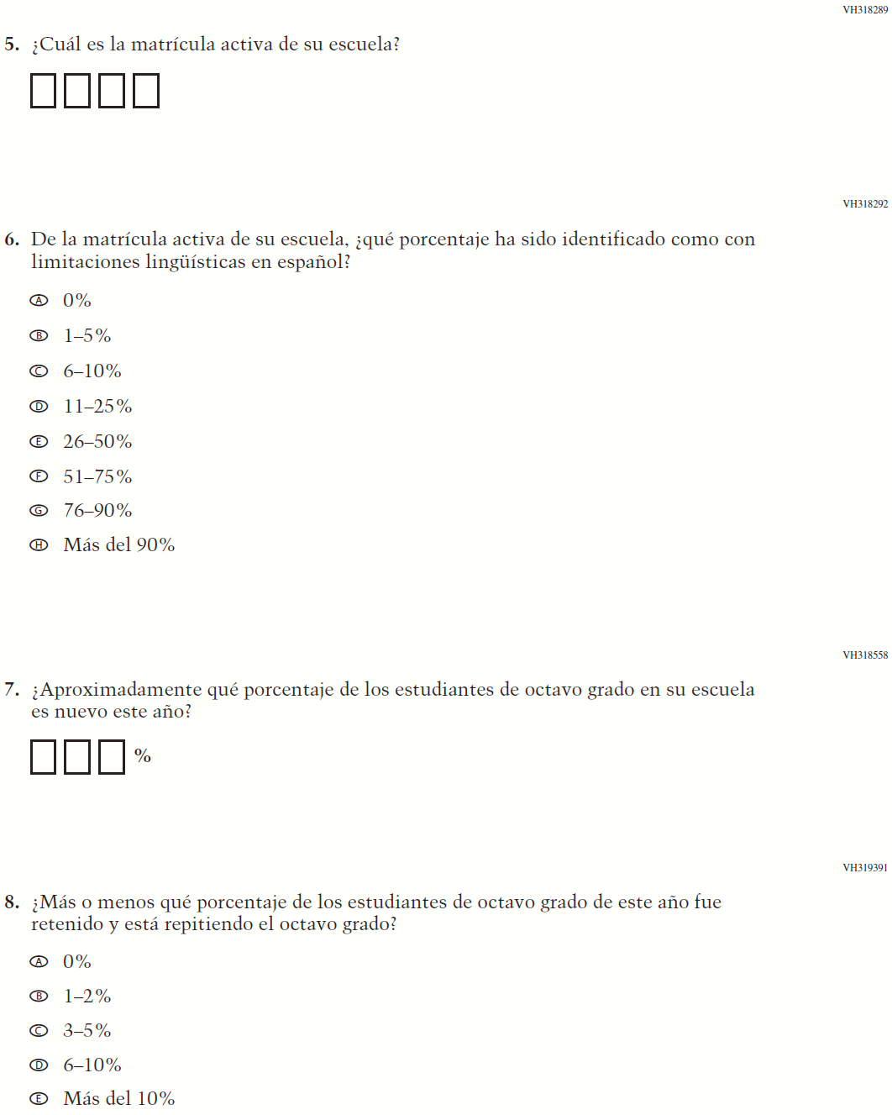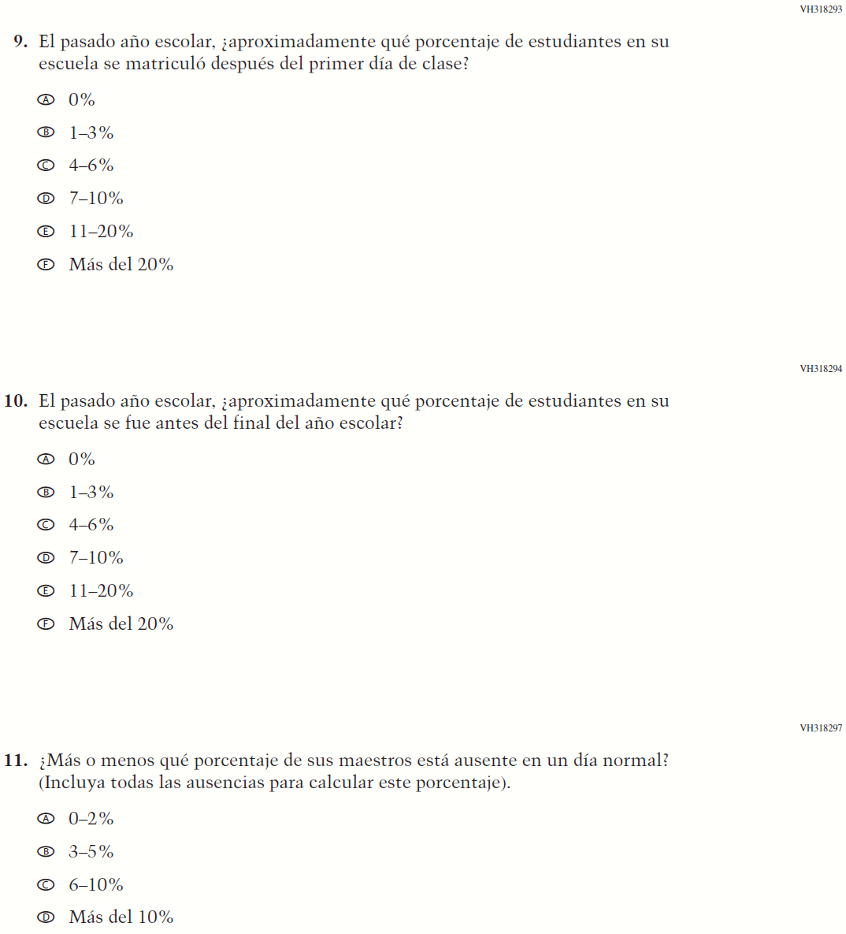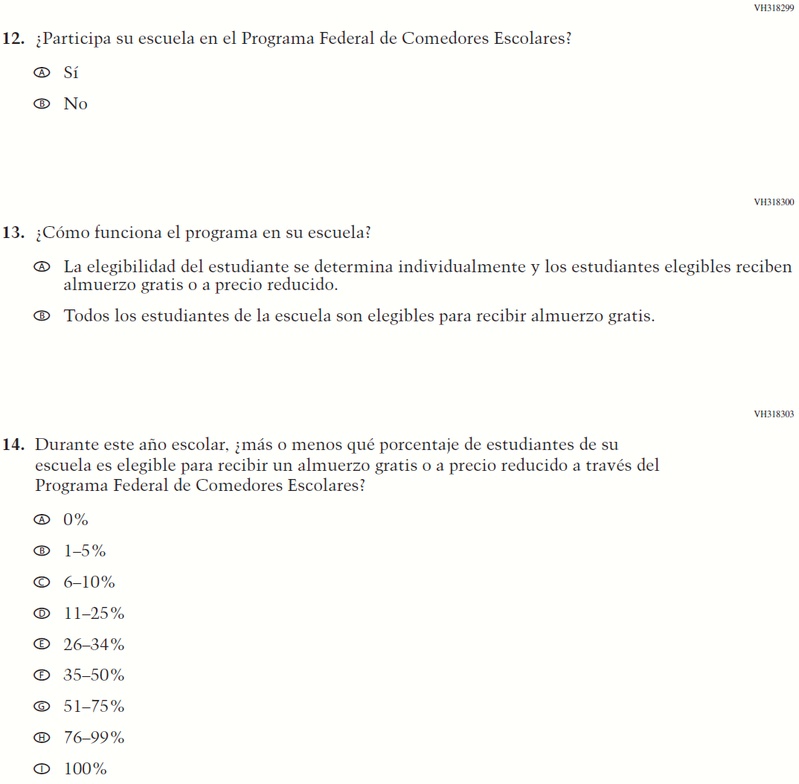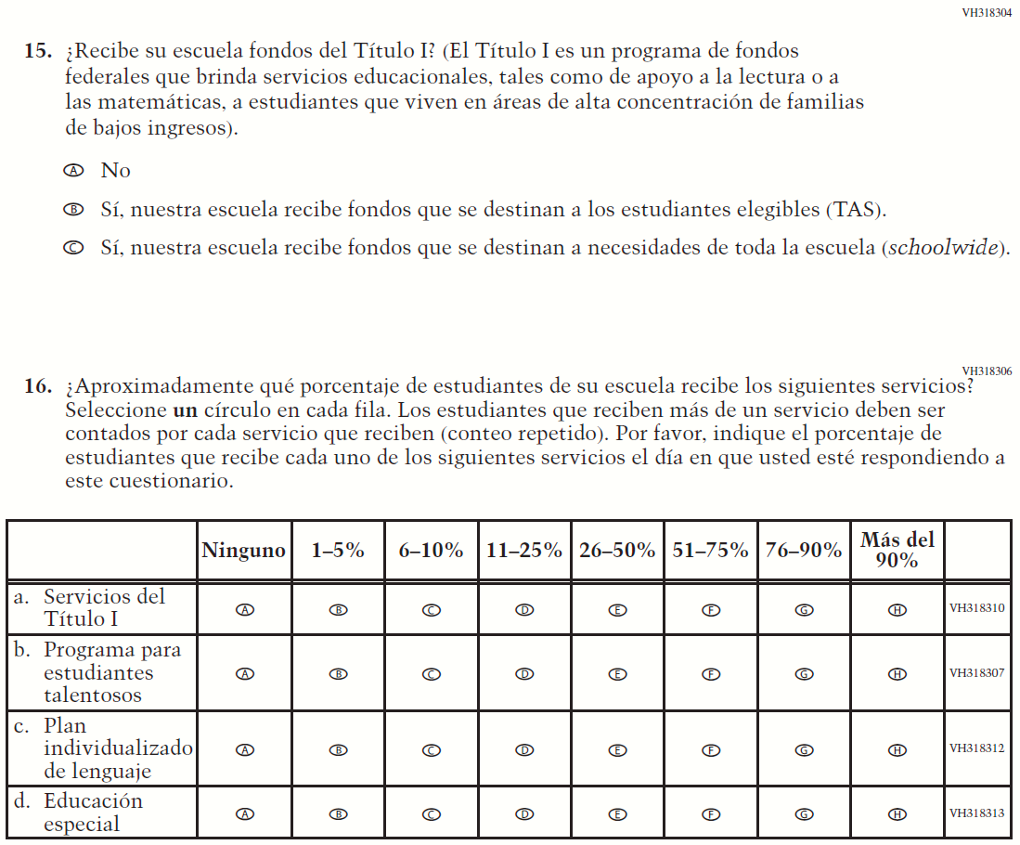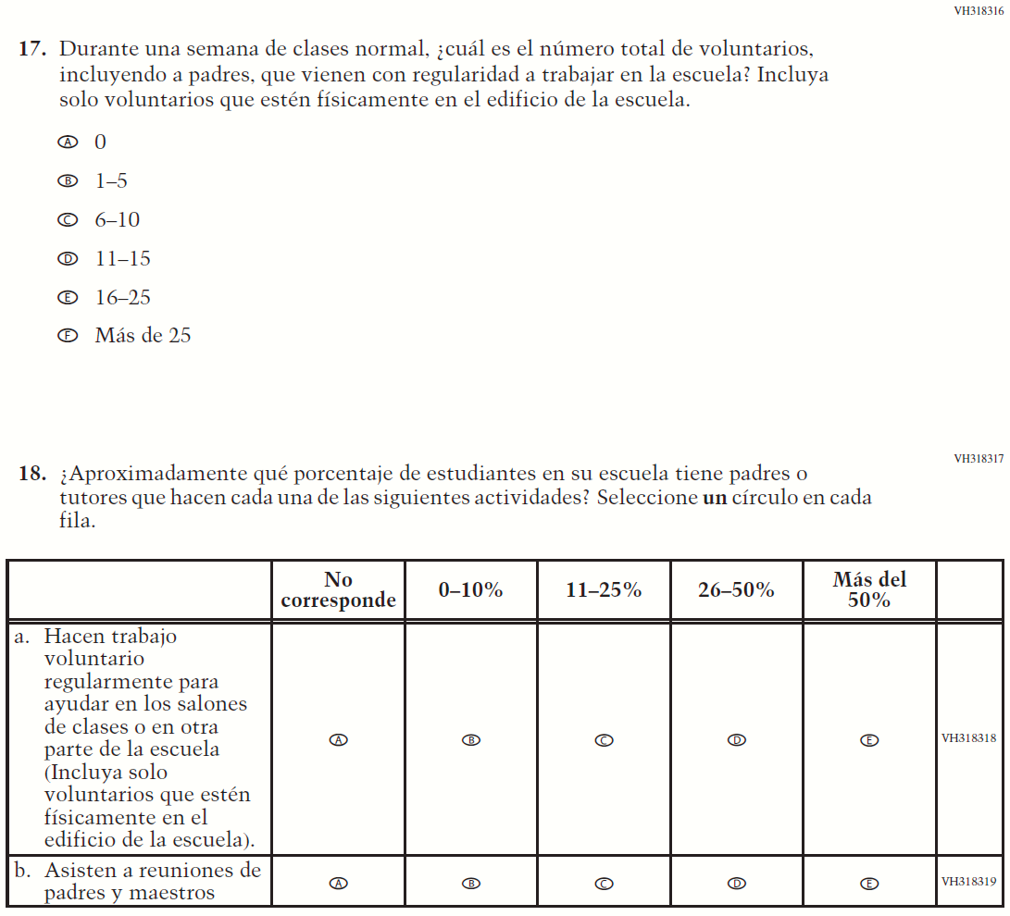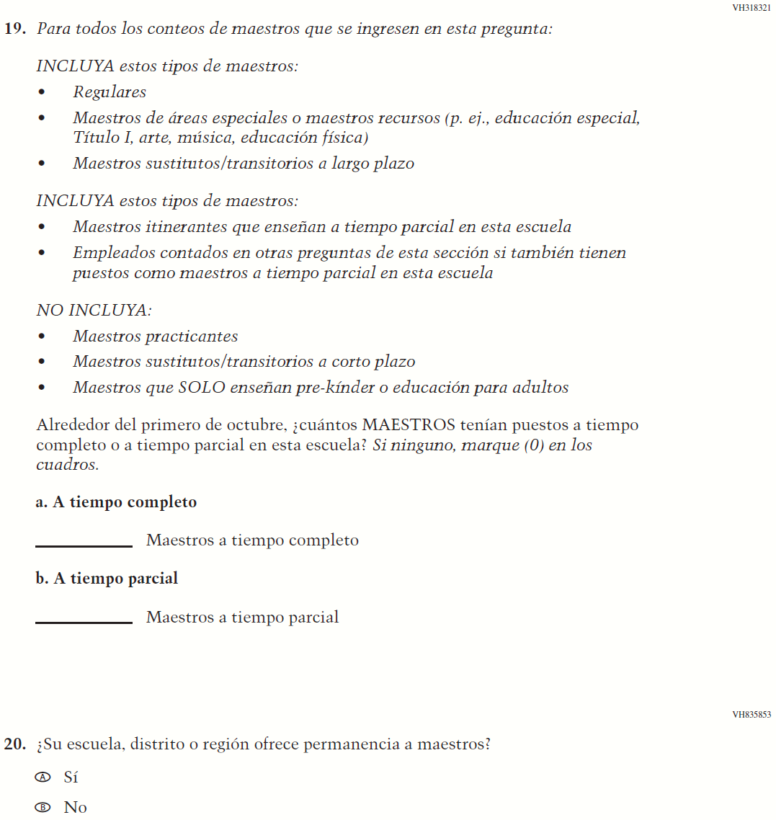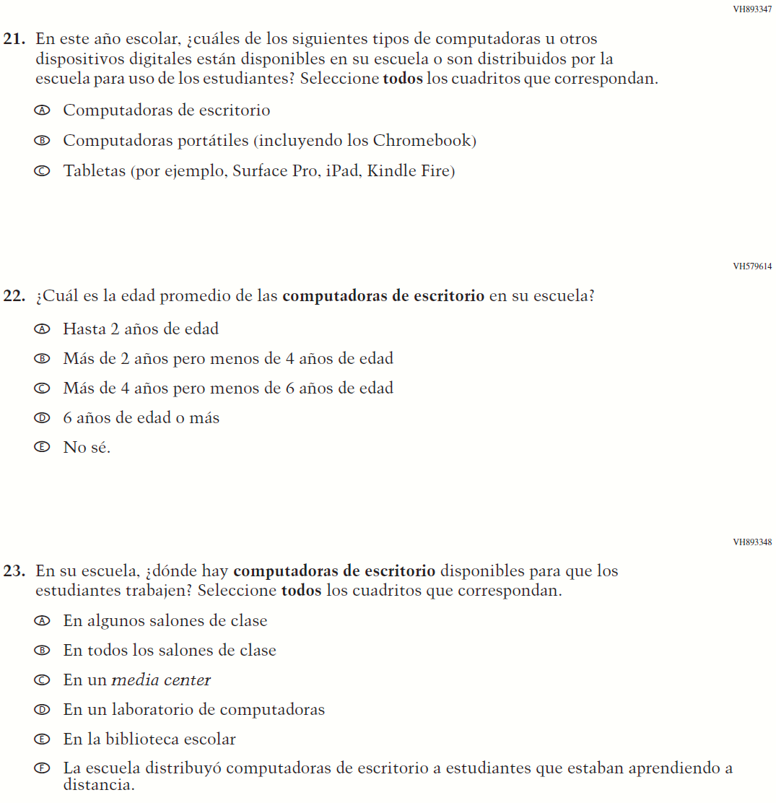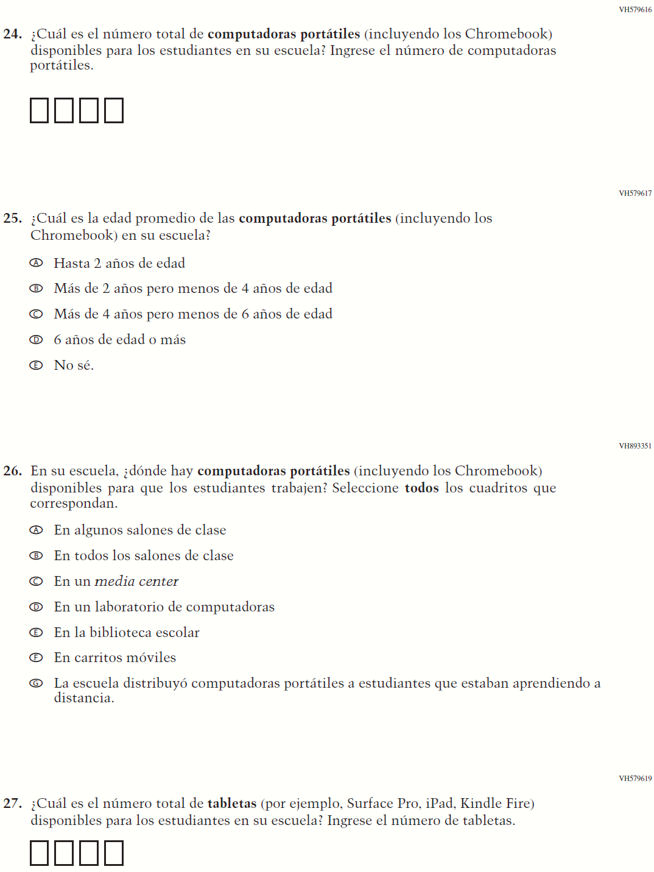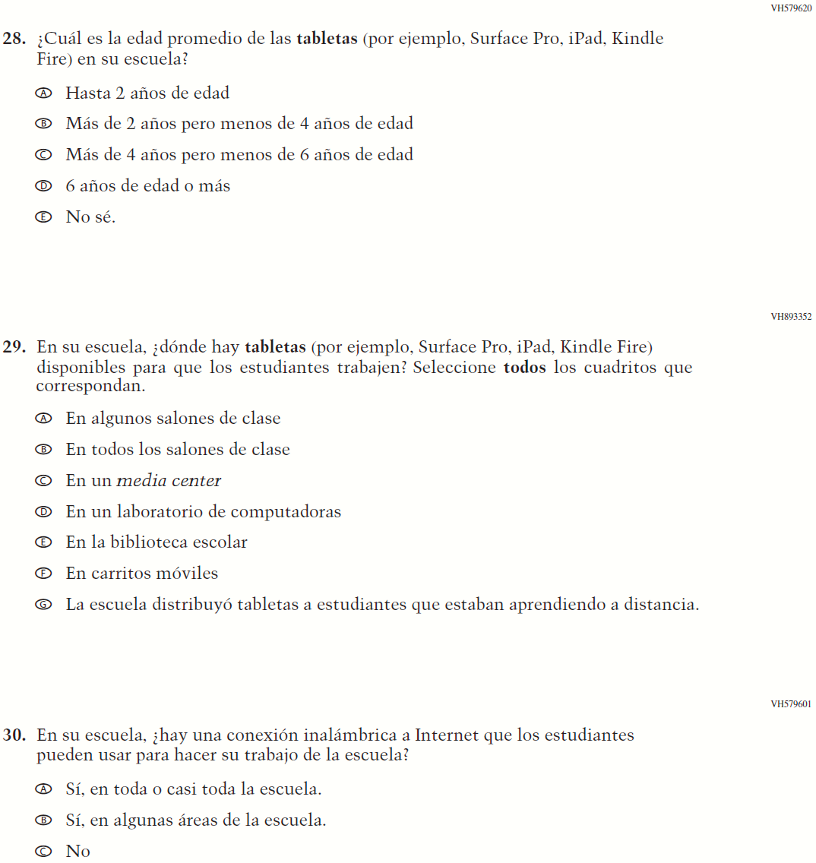

Appendix J-3c-s-PR: Summary of Changes Operational Grade 4 Mathematics
2021 Operational Grade 4 Mathematics School – Puerto Rico
Previous item | 2021 item | D/A/R/NC+ | Rationale
VH579623  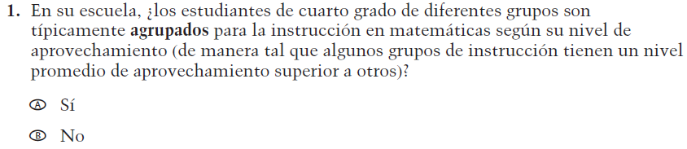  (2019 Operational Grade 4 School Mathematics – Puerto Rico) | VH579623  Issue: Resources for Learning and Instruction | NC | N/A
VH857365  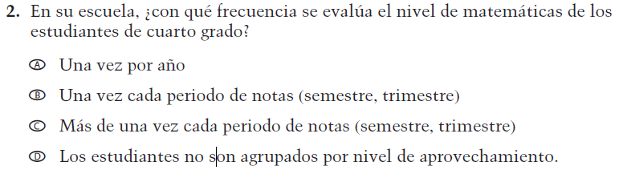  (2019 Operational Grade 4 School Mathematics – Puerto Rico) | VH857365  Issue: Organization of Instruction | NC | N/A
VH579648  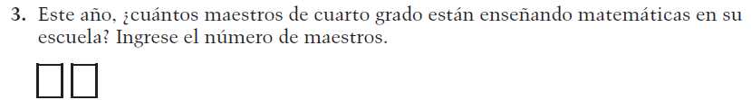  (2019 Operational Grade 4 School Mathematics – Puerto Rico) | VH579648  Issue: Resources for Learning and Instruction | N/C | N/A
VH318441  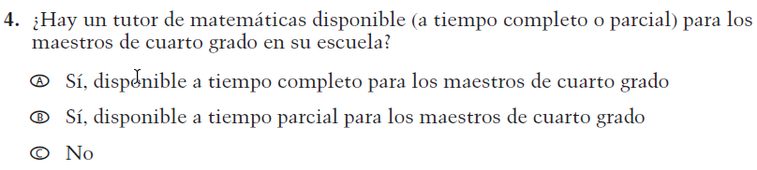  (2019 Operational Grade 4 School Mathematics – Puerto Rico) | VH318441  Issue: Resources for Learning and Instruction | NC | N/A

2021 Operational Grade 4 Mathematics School – Puerto Rico
Previous item | 2021 item | D/A/R/NC+ | Rationale
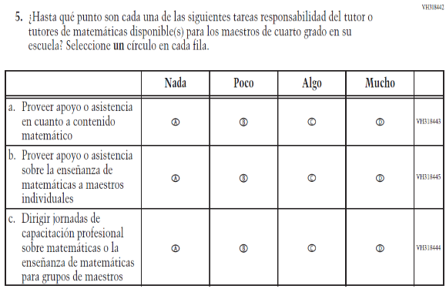  (2019 Operational Grade 4 School Mathematics – Puerto Rico) | 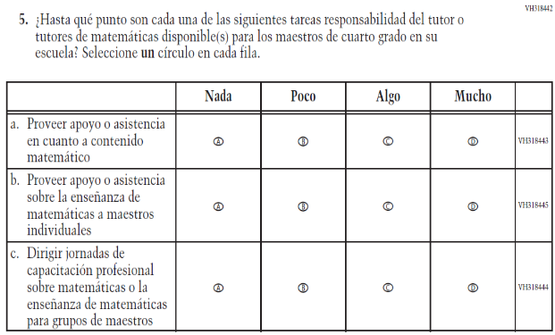  Issue: Resources for Learning and Instruction | NC | N/A
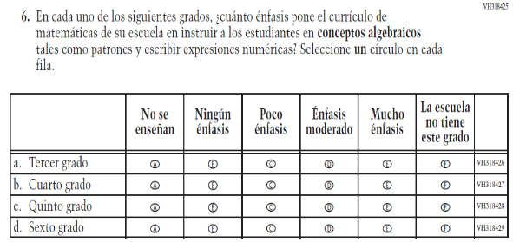  (2019 Operational Grade 4 School Mathematics – Puerto Rico) | 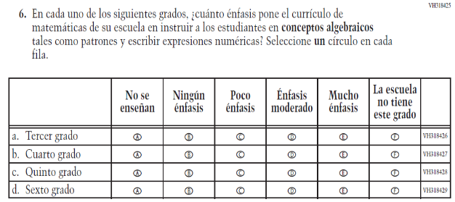  Issue: Organization of Instruction | NC | N/A
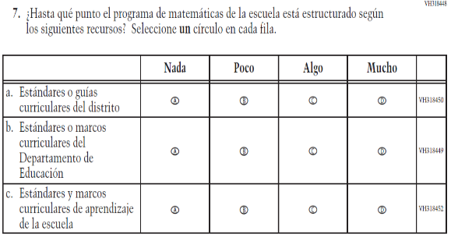  (2019 Operational Grade 4 School Mathematics – Puerto Rico) | 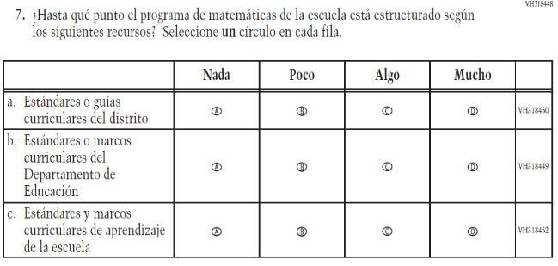  Issue: Organization of Instruction | NC | N/A

2021 Operational Grade 4 Mathematics School – Puerto Rico
Previous item | 2021 item | D/A/R/NC+ | Rationale
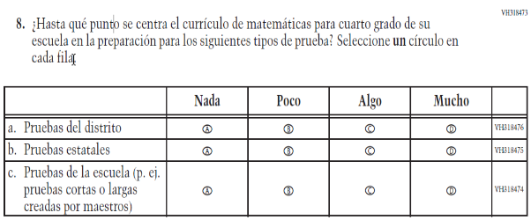  (2019 Operational Grade 4 School Mathematics – Puerto Rico) | 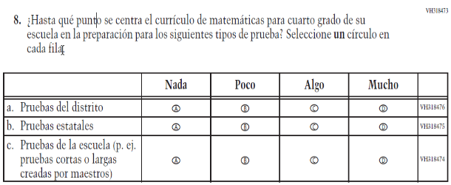  Issue: Organization of Instruction | NC | N/A
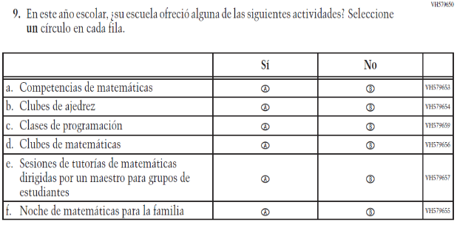  (2019 Operational Grade 4 School Mathematics – Puerto Rico) | 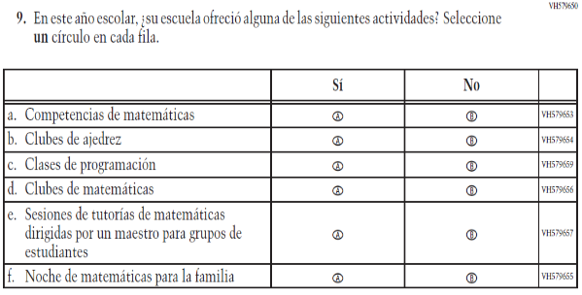  Issue: Resources for Learning and Instruction | NC | N/A

Appendix J-3c-s-PR: Operational Grade 4 Mathematics
Grade/Respondent | Item Number Initiating Skip Logic | Item Response(s) Initiating Skip Logic | Item Number(s) Being Skipped
Grade 4 School | 4 | C | 5
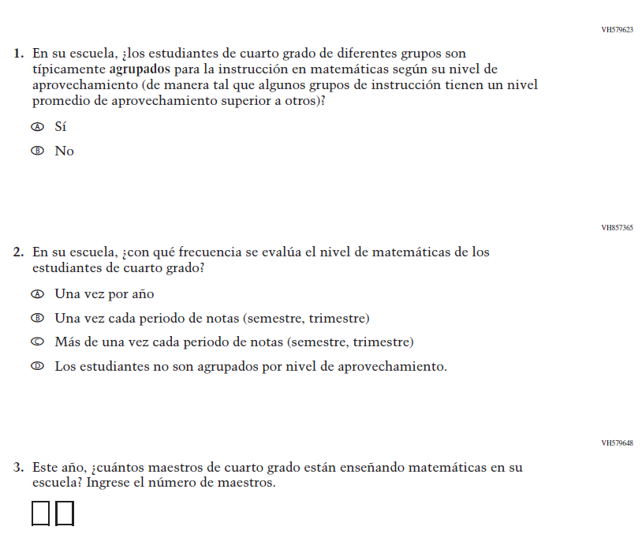
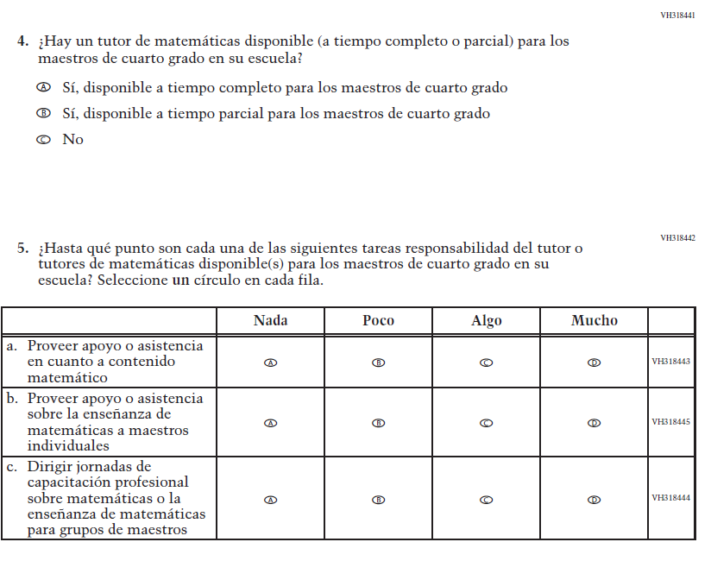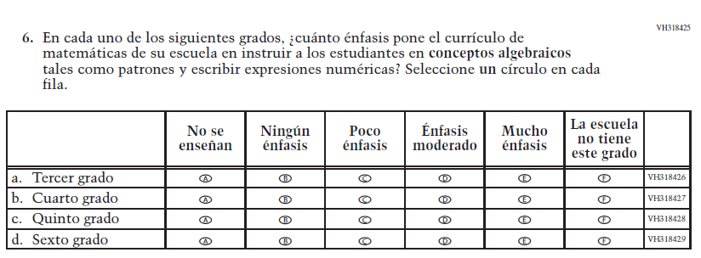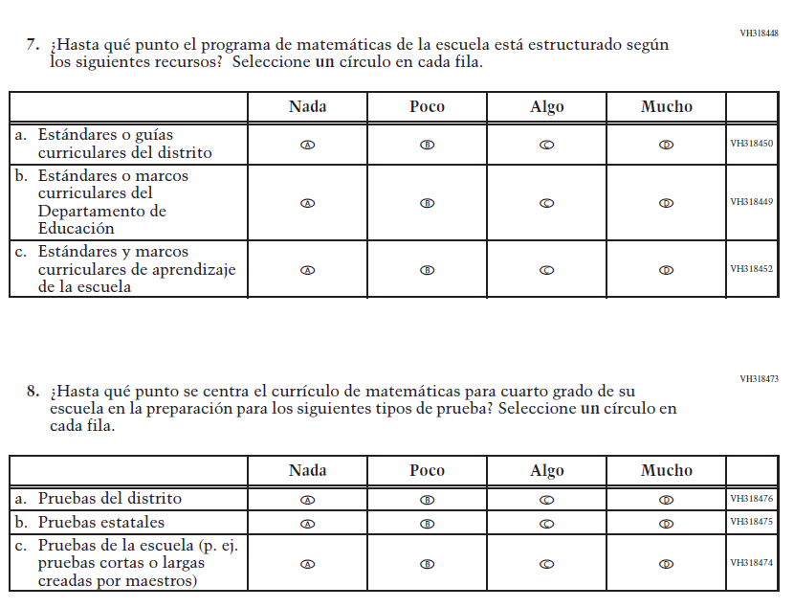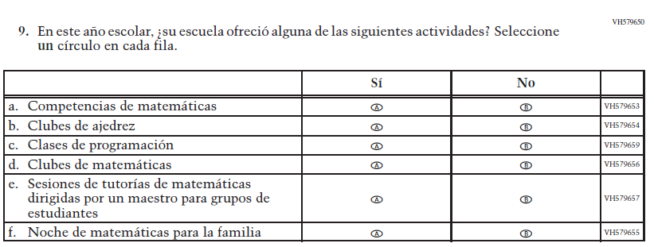

Appendix J-3d-s-PR: Summary of Changes Operational Grade 8 Mathematics
2021 Operational Grade 8 Mathematics School – Puerto Rico
Previous item | 2021 item | D/A/R/NC+ | Rationale
VH610664  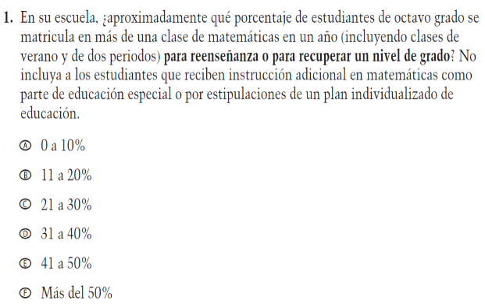  (2019 Operational Grade 8 School Mathematics – Puerto Rico) | VH610664  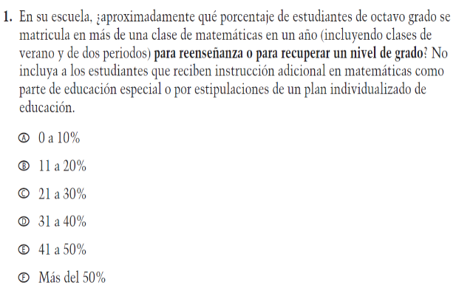  Issue: Organization of Instruction | NC | N/A
VH610661  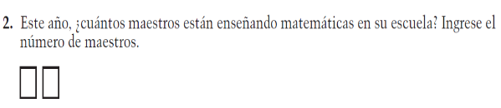  (2019 Operational Grade 8 School Mathematics – Puerto Rico) | VH610661  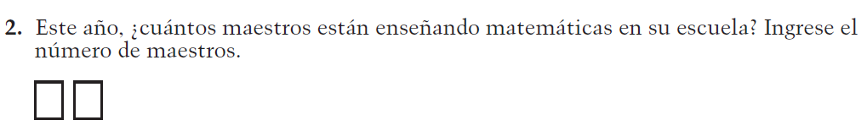  Issue: Resources for Learning and Instruction | NC | N/A
VH857377  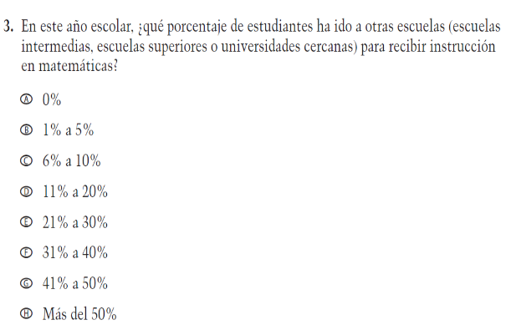  (2019 Operational Grade 8 School Mathematics – Puerto Rico) | VH857377  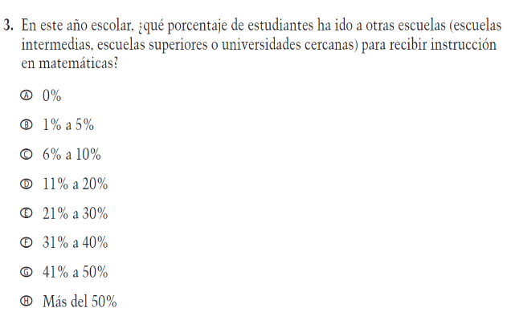  Issue: Resources for Learning and Instruction | N/C | N/A

2021 Operational Grade 8 Mathematics School – Puerto Rico
Previous item | 2021 item | D/A/R/NC+ | Rationale
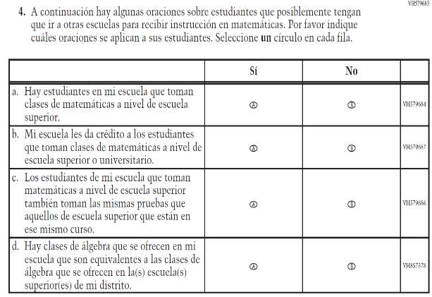  (2019 Operational Grade 8 School Mathematics – Puerto Rico) | 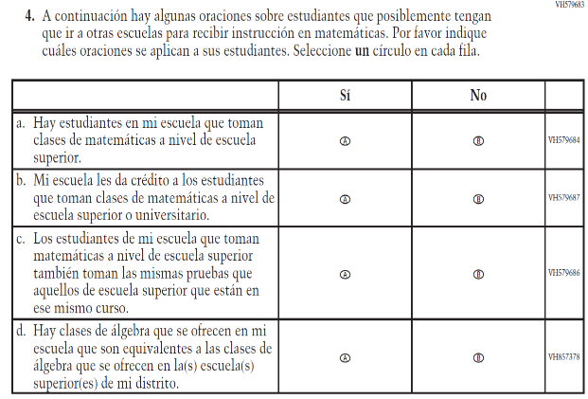  Issue: Resources for Learning and Instruction | NC | N/A
VH318639  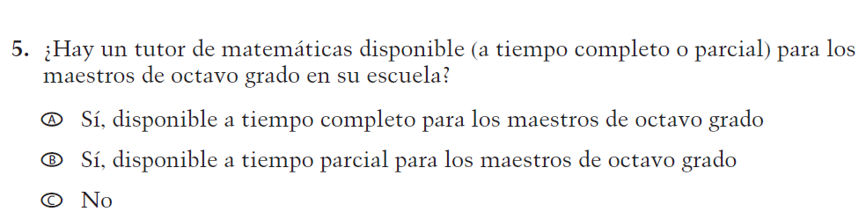  (2019 Operational Grade 8 School Mathematics – Puerto Rico) | VH318639  Issue: Resources for Learning and Instruction | NC | N/A
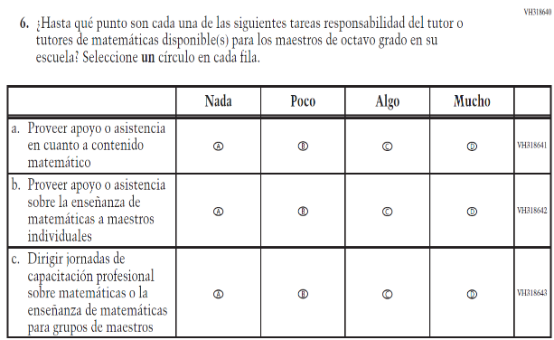  (2019 Operational Grade 8 School Mathematics – Puerto Rico) | 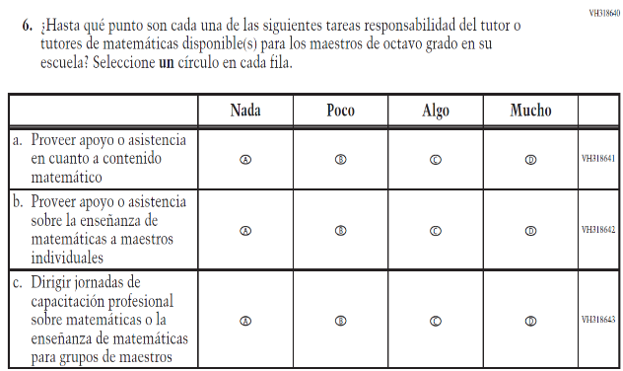  Issue: Resources for Learning and Instruction | NC | N/A

2021 Operational Grade 8 Mathematics School – Puerto Rico
Previous item | 2021 item | D/A/R/NC+ | Rationale
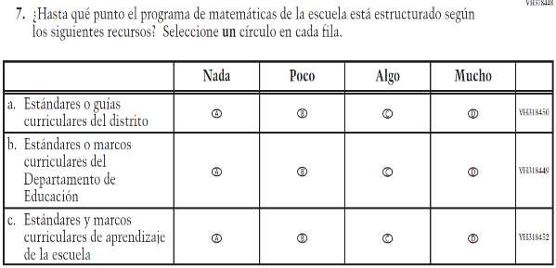  (2019 Operational Grade 8 School Mathematics – Puerto Rico) | 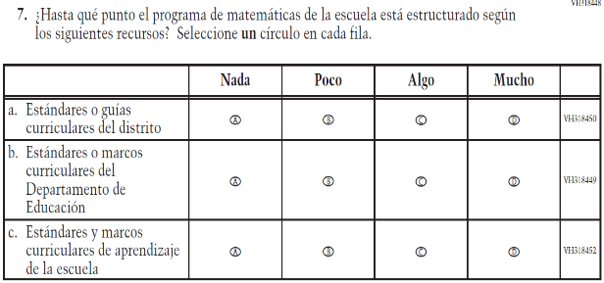  Issue: Organization of Instruction | NC | N/A
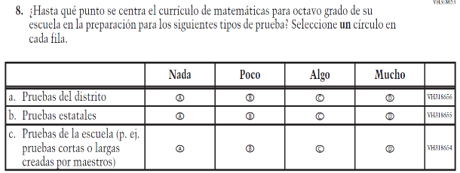  (2019 Operational Grade 8 School Mathematics – Puerto Rico) | 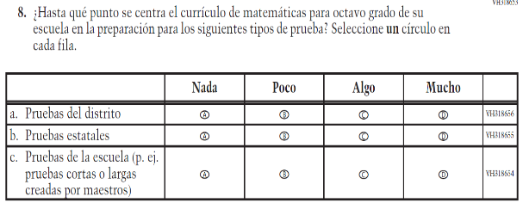  Issue: Organization of Instruction | NC | N/A
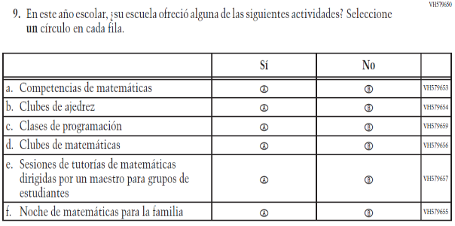  (2019 Operational Grade 8 School Mathematics – Puerto Rico) | 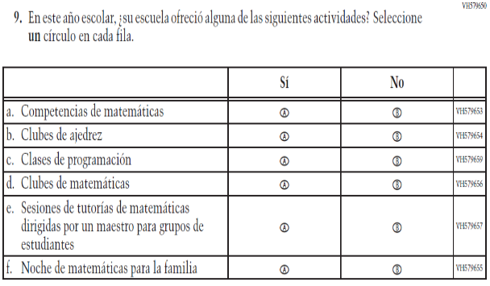  Issue: Resources for Learning and Instruction | NC | N/A

Appendix J-3d-s-PR: Operational Grade 8 Mathematics
Grade/Respondent | Item Number Initiating Skip Logic | Item Response(s) Initiating Skip Logic | Item Number(s) Being Skipped
Grade 8 School | 3 | A | 4
Grade 8 School | 5 | C | 6

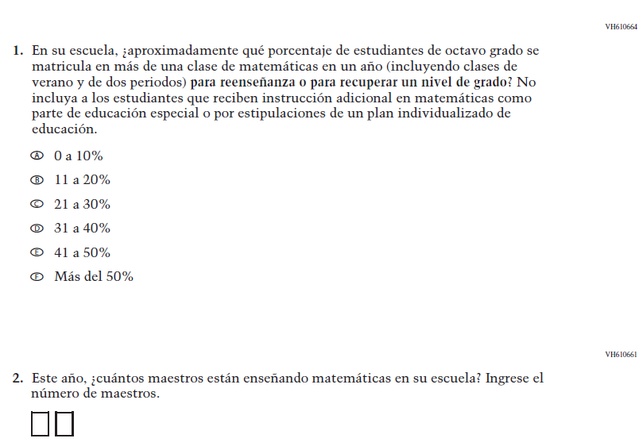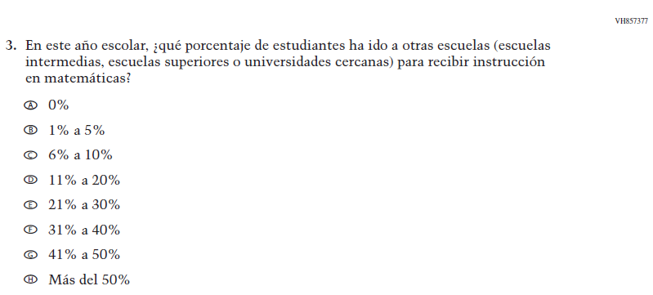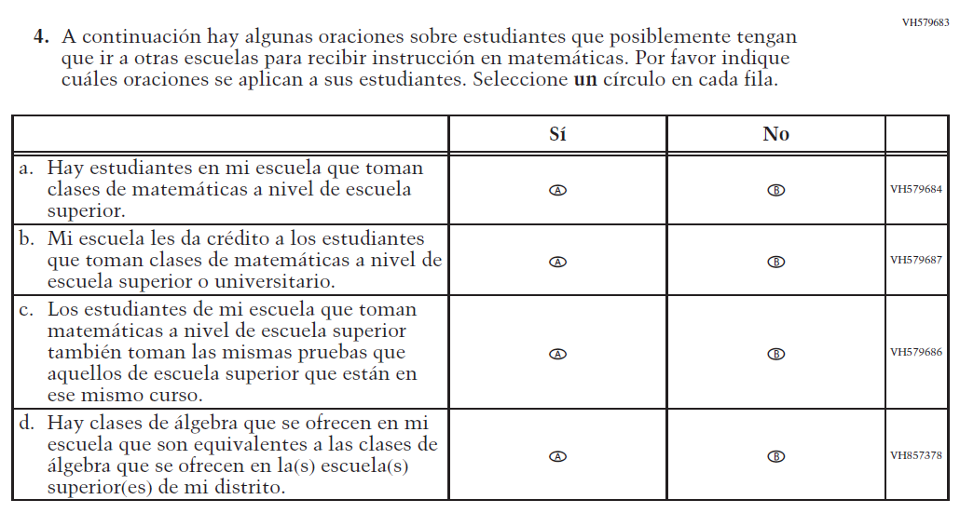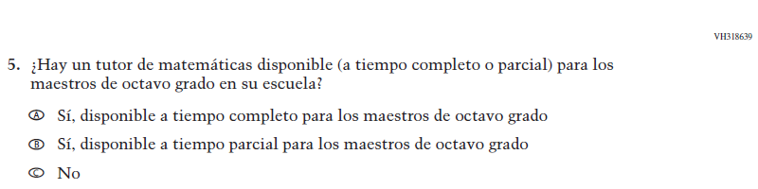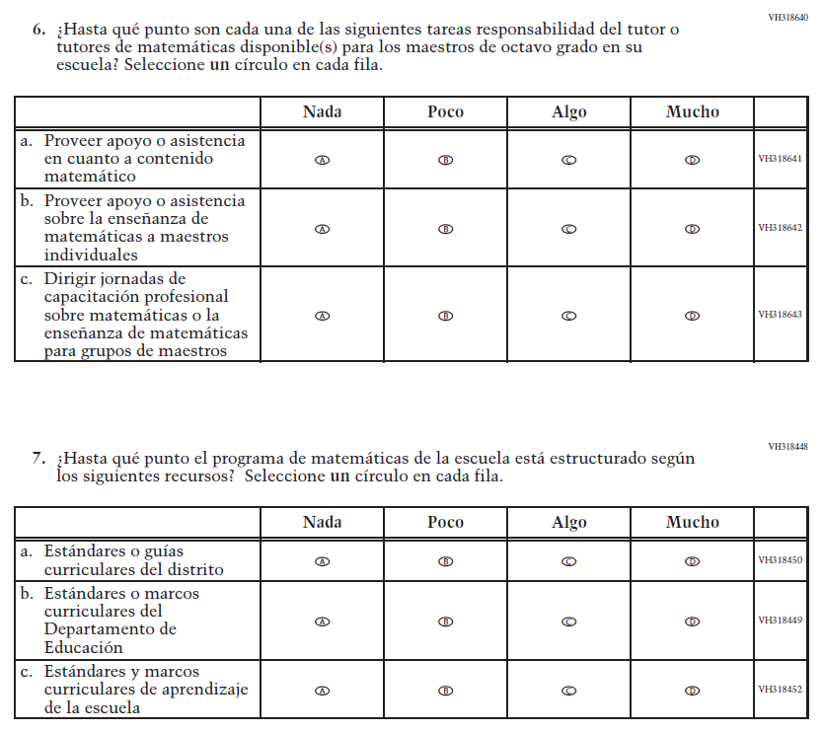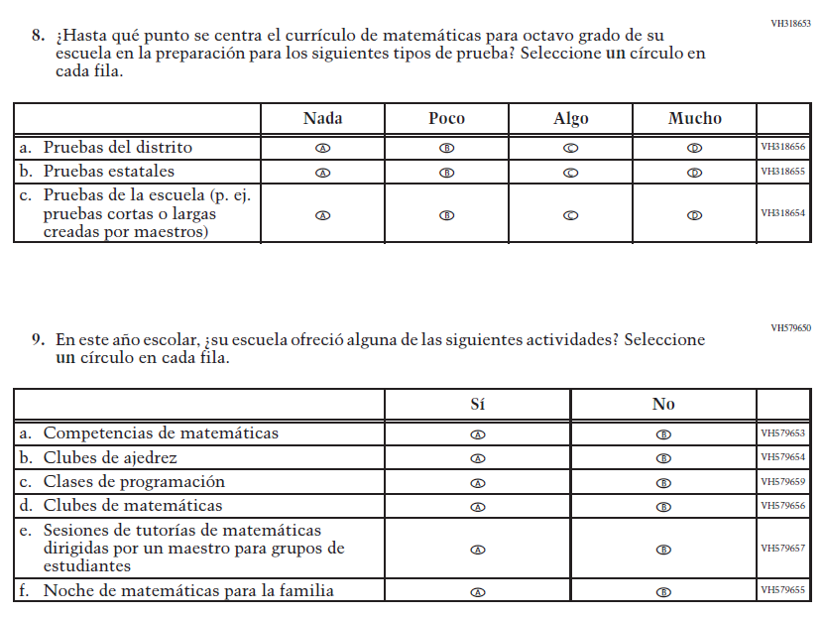

Appendix J-3e-s-PR: Operational Grade 4 COVID-19
Skip Logic Table
Grade/Respondent | Item Number Initiating Skip Logic | Item Response(s) Initiating Skip Logic | Item Number(s) Being Skipped
Grade 4 School | 7 | B | 8, 9, 10, 11, 12, 13, 14

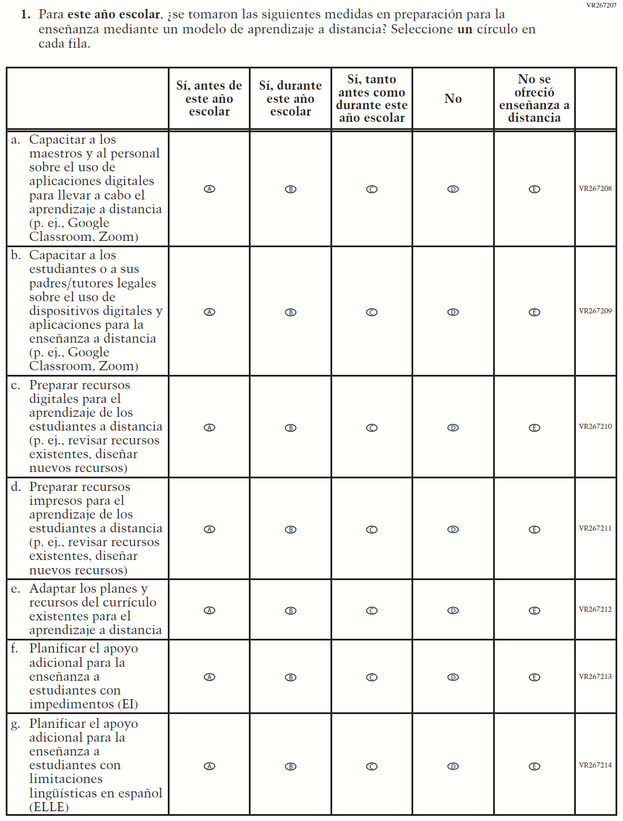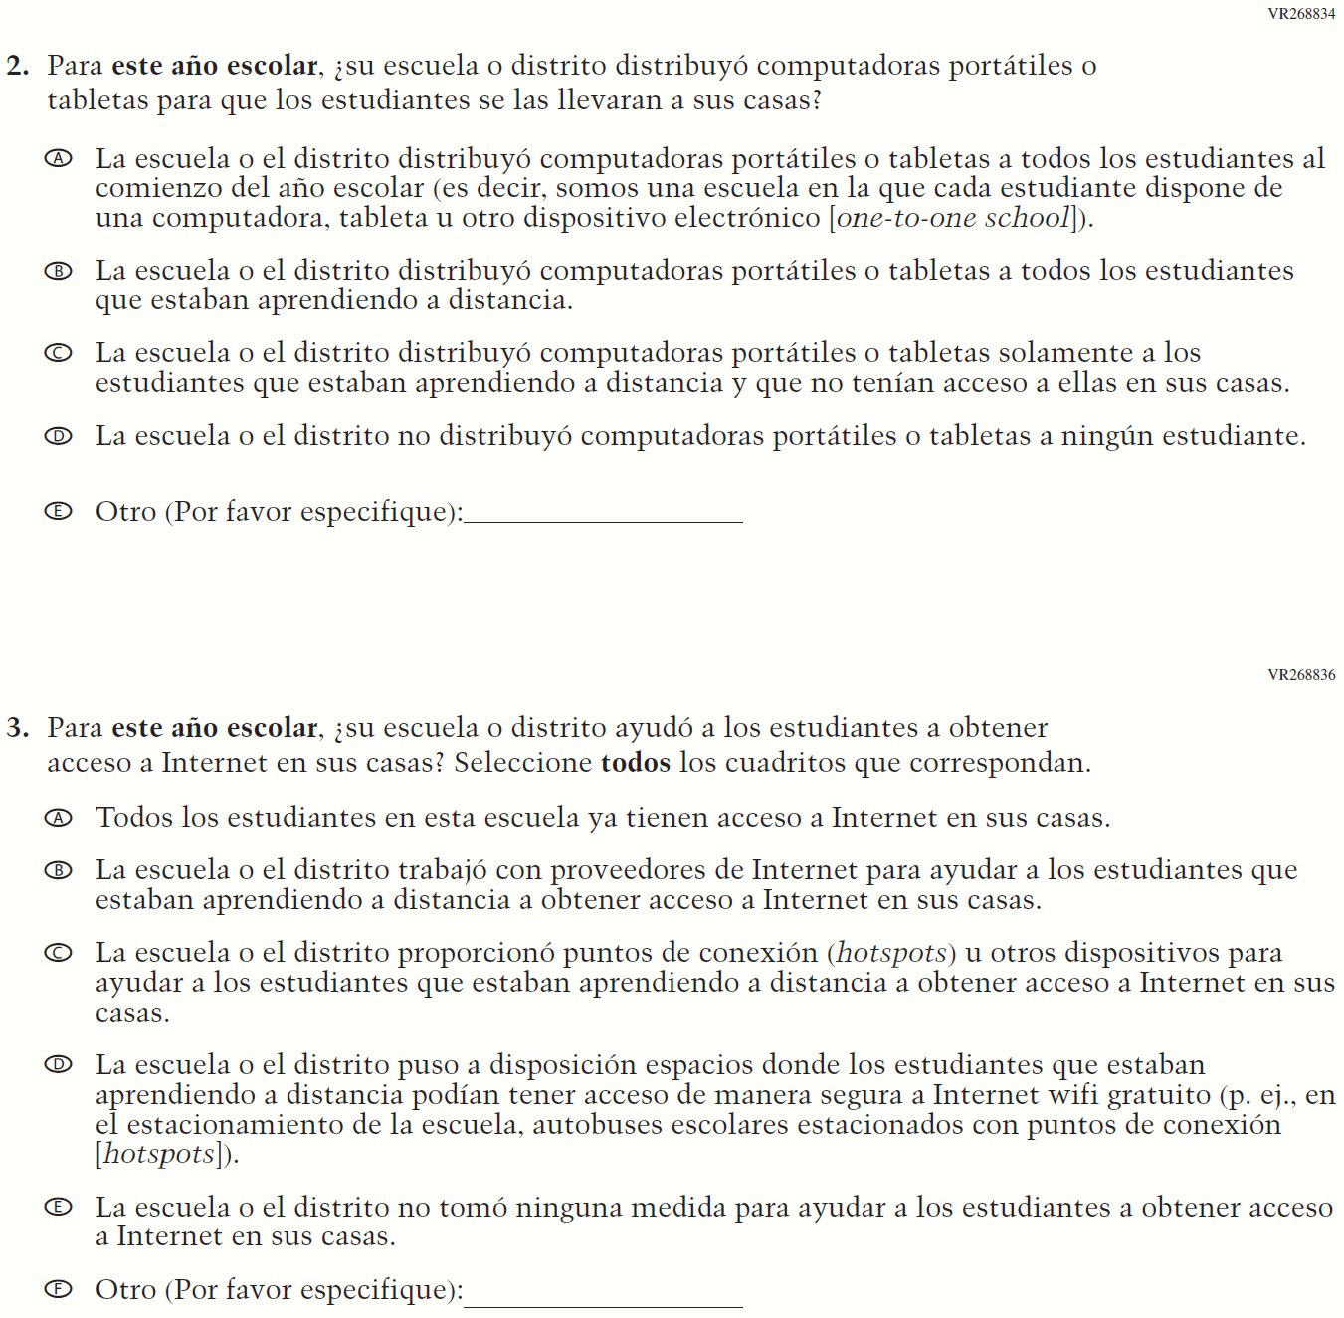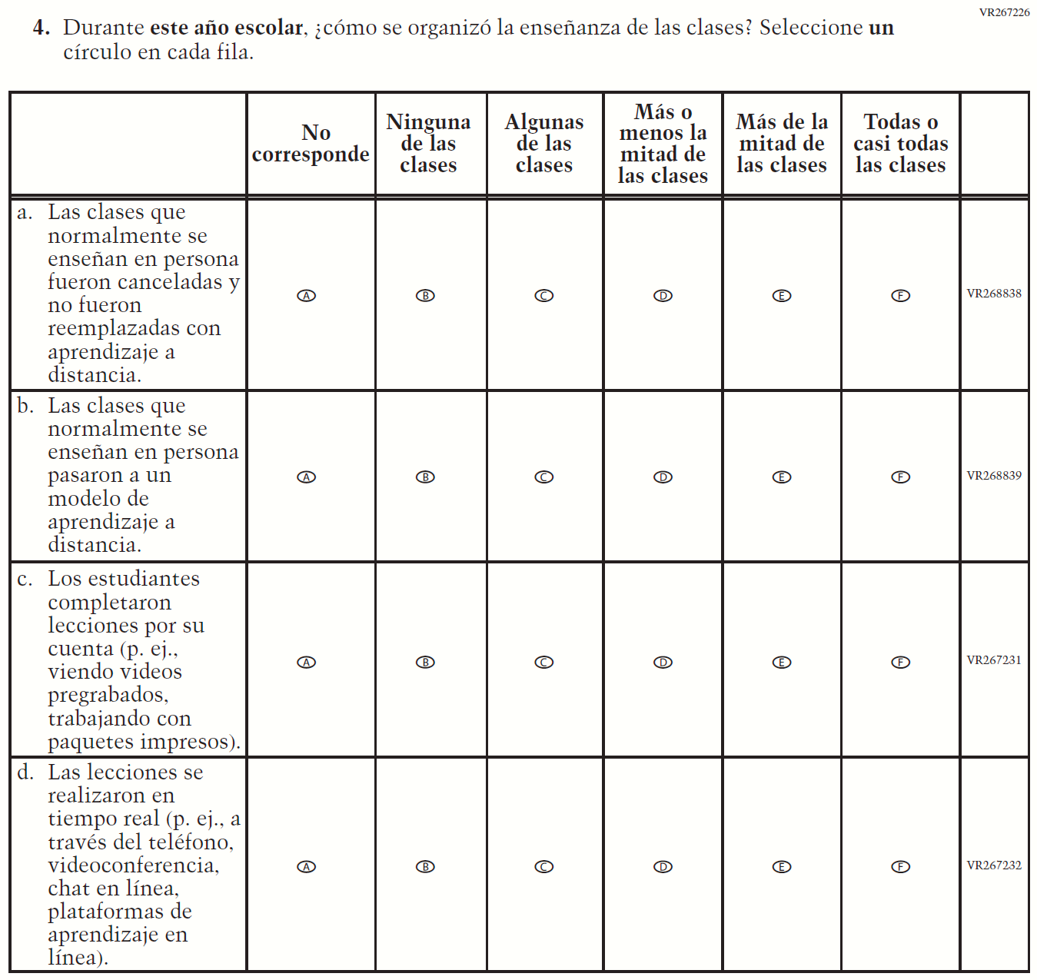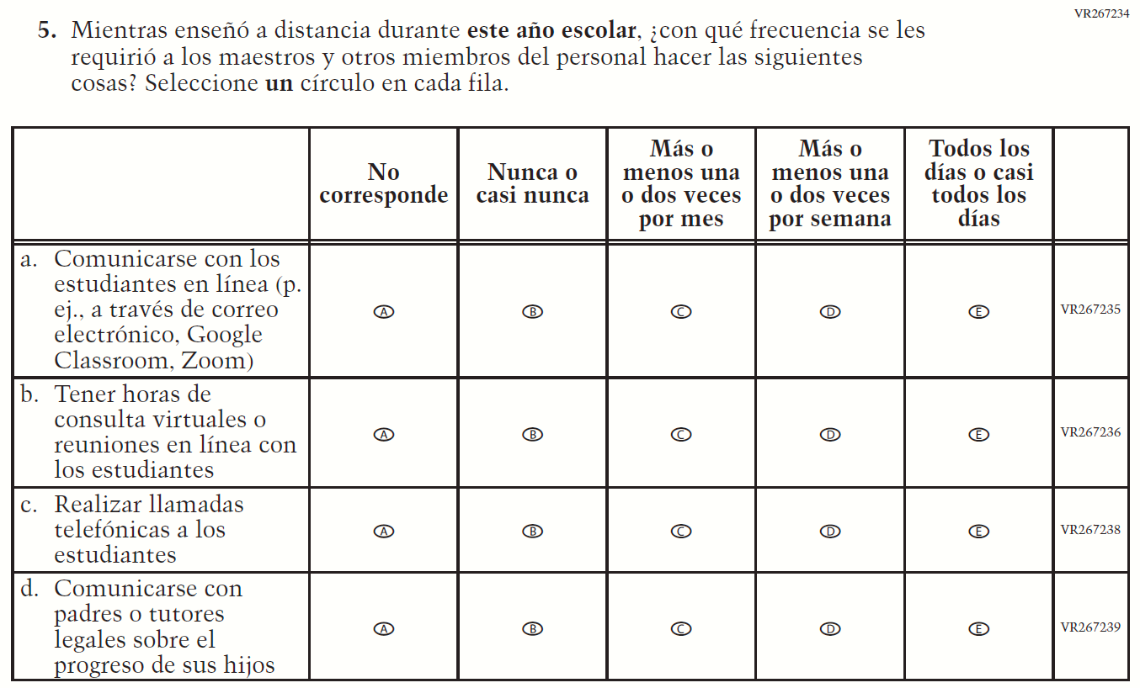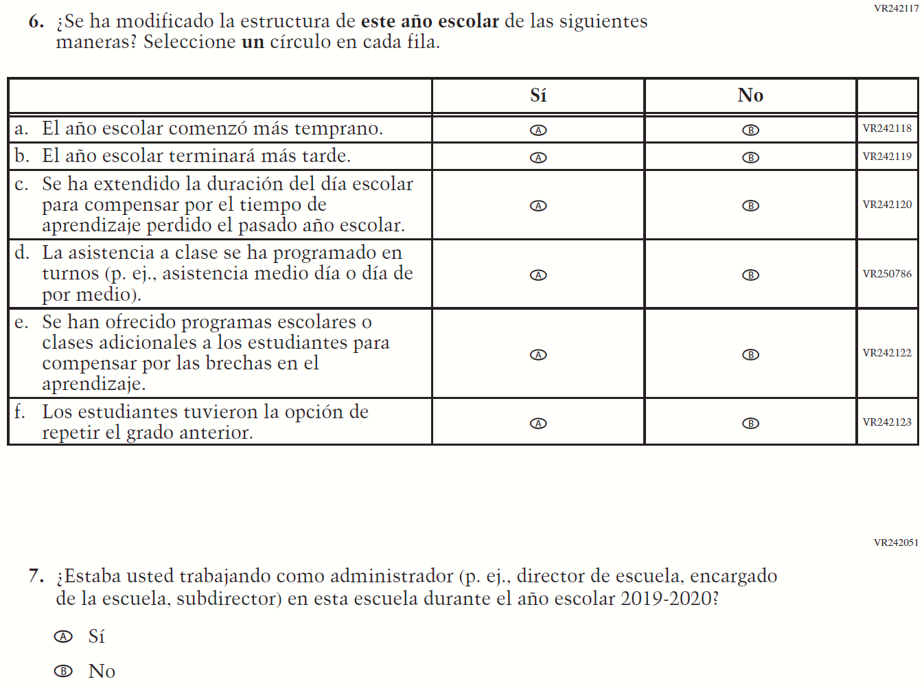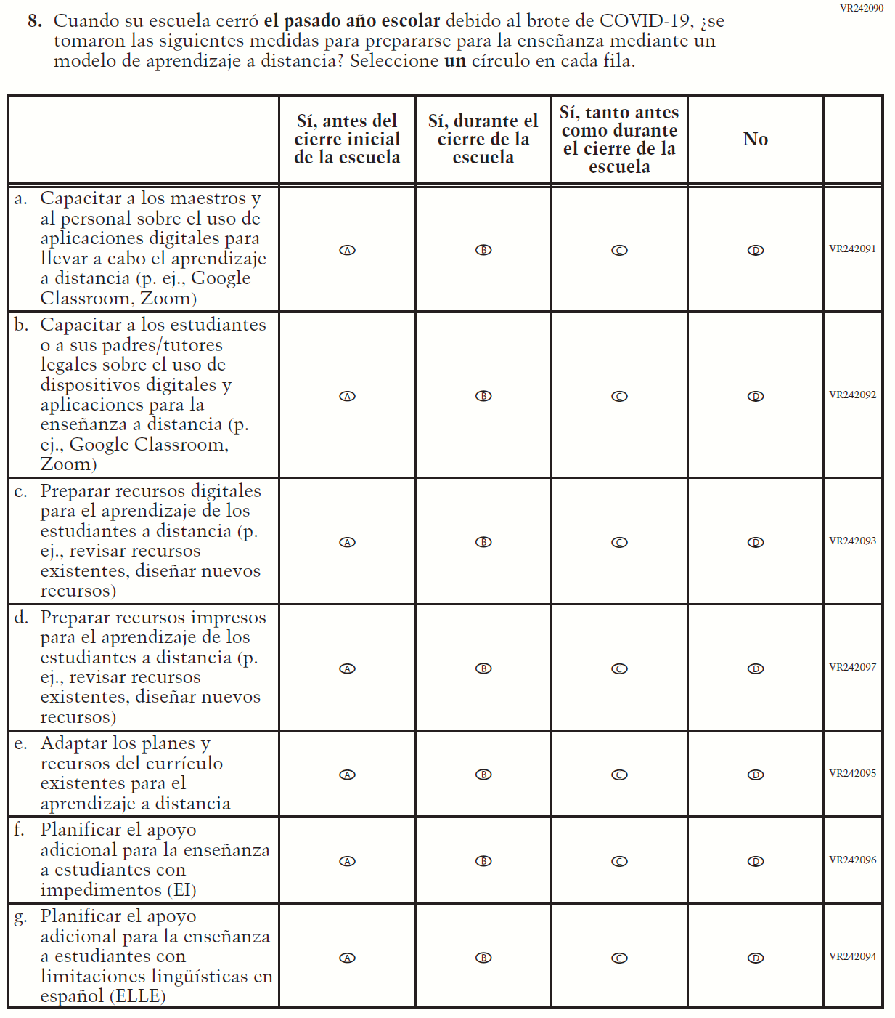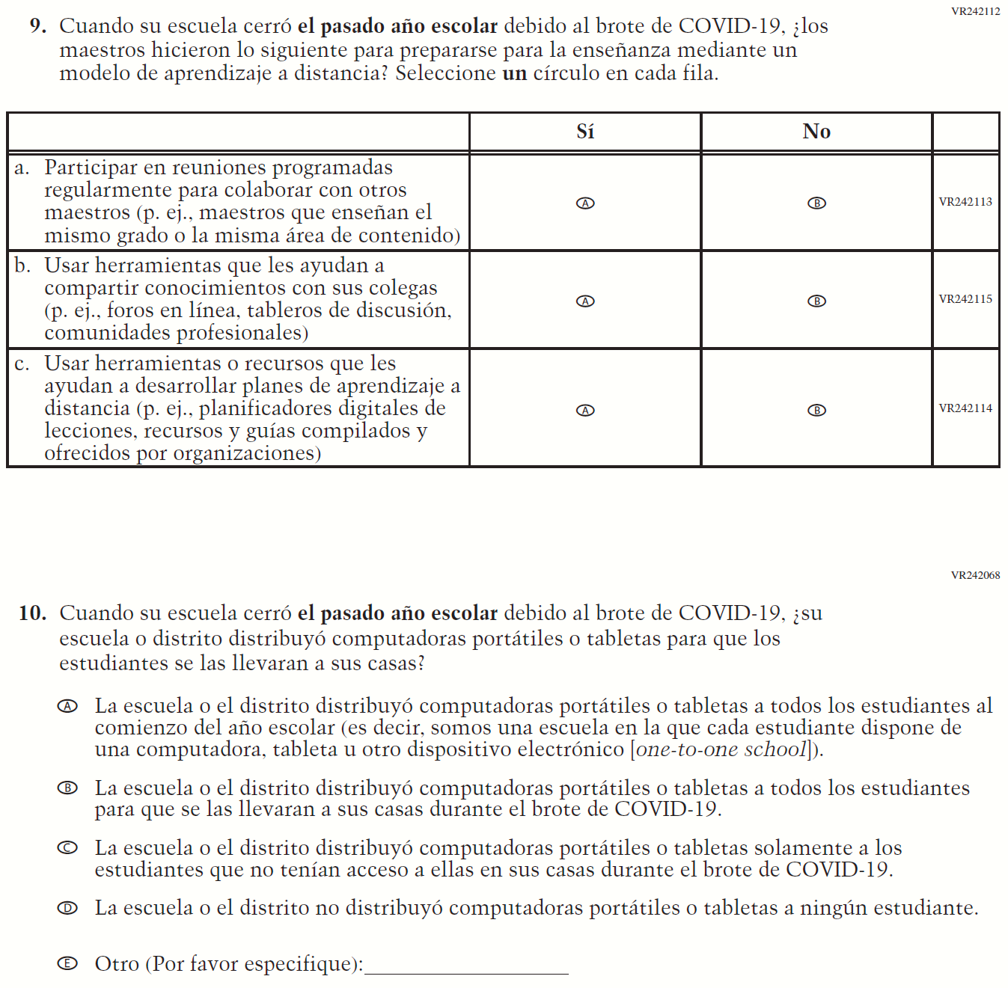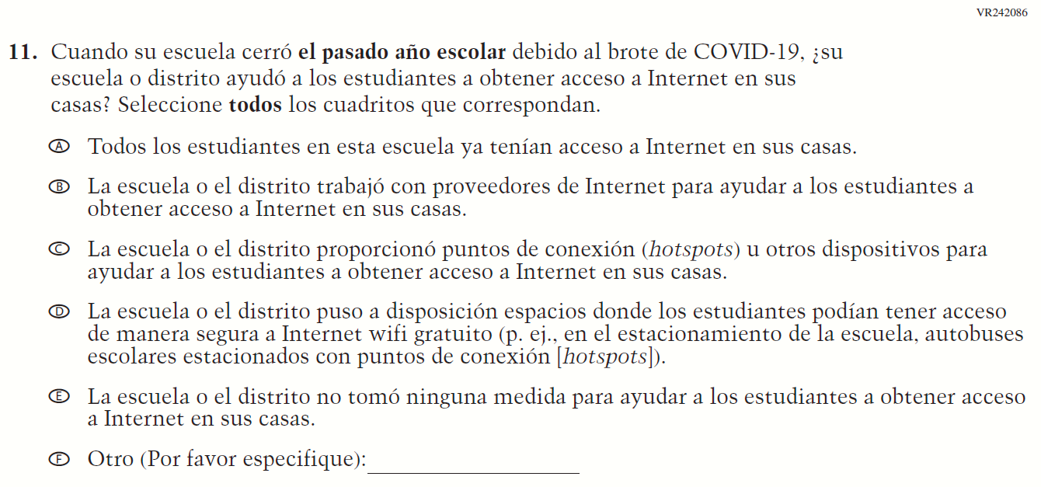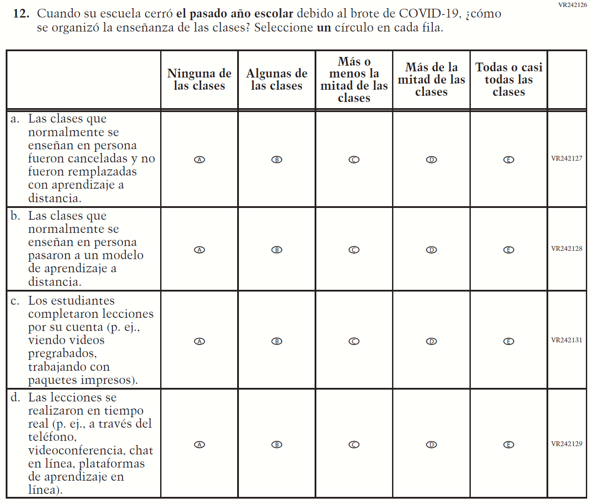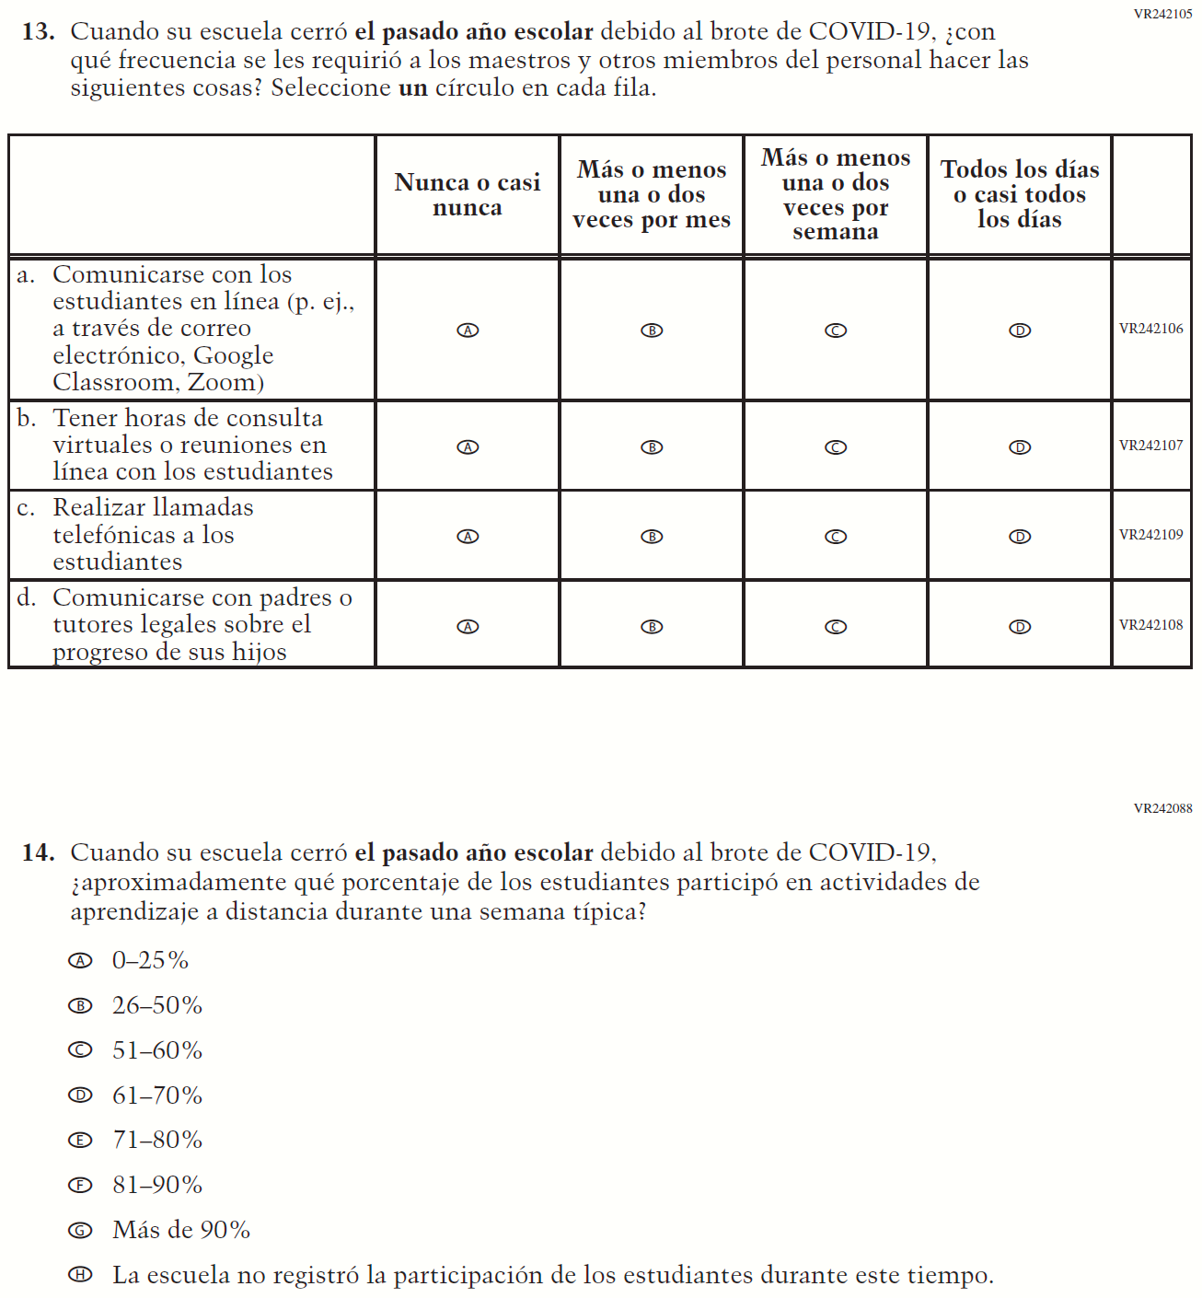

Appendix J-3f-s-PR: Operational Grade 8 COVID-19
Skip Logic Table
Grade/Respondent | Item Number Initiating Skip Logic | Item Response(s) Initiating Skip Logic | Item Number(s) Being Skipped
Grade 8 School | 7 | B | 8, 9, 10, 11, 12, 13, 14

