NATIONAL CENTER FOR EDUCATION STATISTICS NATIONAL ASSESSMENT OF EDUCATIONAL PROGRESS

National Assessment of Educational Progress (NAEP) 2021 Schools and Teacher Questionnaire Special Study

Appendix I
NAEP 2021 Content of MyNAEP System

OMB# 1850-0956 v.2



March 2021

This submission revises MyNAEP procedures by eliminating actions needed for administering student assessments in 2021. Most schools did complete the Provide School Information prior to NCES’ decision to postpone main NAEP 2021 and the burden is accounted for in Part A. The MyNAEP system has been modified and streamlined to provide school coordinators the tools necessary to manage the teacher and school questionnaires.

Table of Contents

MyNAEP Login Screen 3
Home page 6
Provide School Information 8
Student Attendance and Schedules (New Provide School Information Questions) 9
Manage Questionnaires 15
Identify Questionnaire Respondents 16
Send Welcome Emails and Questionnaires 18
Monitor Questionnaire Completion and Send Reminder Emails 19
Manage Questionnaire 20
Manage Questionnaires Welcome Email Teachers 20
Manage Questionnaires Welcome Email School 21

Description of MyNAEP: The school coordinators are responsible for preparing for the assessment in their school using the MyNAEP system, which is an online secure site that provides participating schools with a convenient way to prepare for the upcoming assessment. Since the 2021 main NAEP for students has been postponed, teachers and schools will still be asked to complete online surveys to collect information about the school year. MyNAEP Spanish has been modified and those active sections are included in the appendix.
Notes on the organization of Appendix I
- Red text indicates descriptive notes and references to Appendices other than I
- Green text indicates text from hyperlinks or references within this document.

MyNAEP Login Screen

Welcome
MyNAEP is a restricted-use website that contains information on the National Assessment of Educational Progress (NAEP), widely known as The Nation's Report Card.
Login
Email or Username:
Password:
Forgot Username or Password
Having trouble logging in?
First time visiting the 2021 MyNAEP site?
Please register
Paperwork Burden Statement, OMB Information
According to the Paperwork Reduction Act of 1995, no persons are required to respond to a collection of information unless it displays a valid OMB control number. The valid OMB control number for this voluntary information collection is 1850-0956 for NAEP 2021 School and Teacher Questionnaire Special Study and 1850-0957 for the NAEP 2021 School Survey. The time required to complete this information collection is estimated to average 65 minutes for the NAEP 2021 School and Teacher Questionnaire Special Study and 30 minutes for the NAEP 2021 School Survey, including the time to review instructions, search existing data resources, gather the data needed, and complete and review the information collection. If you have any comments concerning the accuracy of the time estimate, suggestions for improving this collection, or any comments or concerns regarding the status of your individual submission, please write to: National Assessment of Educational Progress (NAEP), National Center for Education Statistics (NCES), Potomac Center Plaza, 550 12th St., SW, 4th floor, Washington, DC 20202.

OMB No. 1850-0956 APPROVAL EXPIRES 8/31/2021 for the NAEP 2021 School and Teacher Questionnaire Special Study

OMB No. 1850-0957 APPROVAL EXPIRES 8/31/2021 for the NAEP 2021 School Survey.

Authorization and Confidentiality Assurance
National Center for Education Statistics (NCES) is authorized to conduct NAEP by the National Assessment of Educational Progress Authorization Act (20 U.S.C. §9622) and to collect students’ education records from education agencies or institutions for the purposes of evaluating federally supported education programs under the Family Educational Rights and Privacy Act (FERPA, 34 CFR §§ 99.31(a)(3)(iii) and 99.35).

All of the information provided by participants may be used only for statistical purposes and may not be disclosed, or used, in identifiable form for any other purpose except as required by law (20 U.S.C. §9573 and 6 U.S.C. §151). By law, every NCES employee as well as every NCES agent, such as contractors and NAEP coordinators, has taken an oath and is subject to a jail term of up to 5 years, a fine of $250,000, or both if he or she willfully discloses ANY identifiable information about participants. Electronic submission of participant’s information will be monitored for viruses, malware, and other threats by Federal employees and contractors in accordance with the Cybersecurity Enhancement Act of 2015. The collected information will be combined across respondents to produce statistical reports.

If you have questions or need help accessing the website, please contact the NAEP Help Desk at 1-800-283-6237 or naephelp@westat.com Monday through Friday between 8 a.m. and 5:30 p.m. ET.
Summary of Changes from 2019 to 2021:
- Updated the year from 2019 to 2021
- Removed security banner
- Capitalized NAEP Help Desk
Screenshot

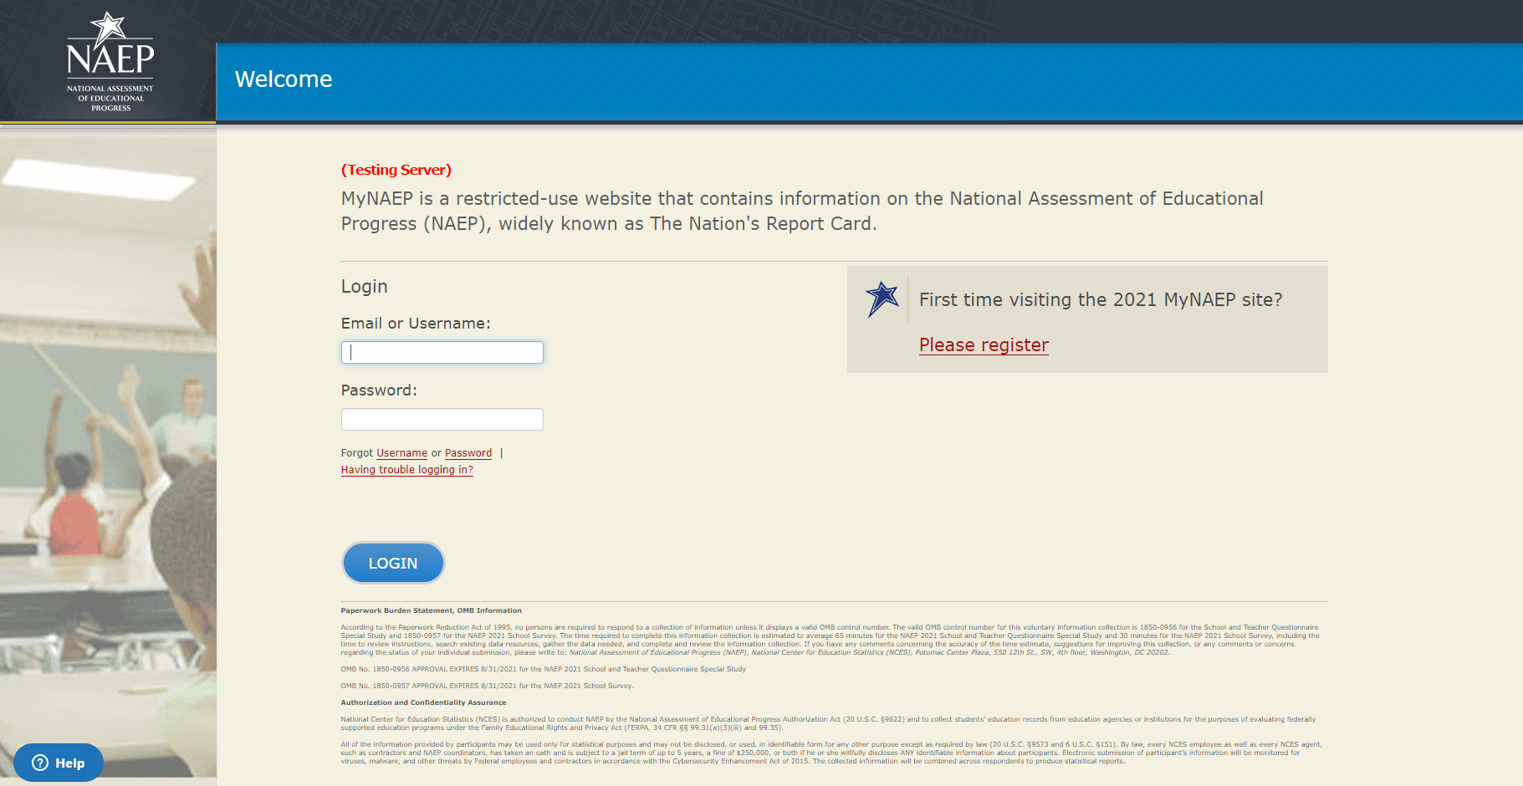

All school personnel that register for MyNAEP must accept a confidentiality agreement. Please review and accept the agreement to access the site

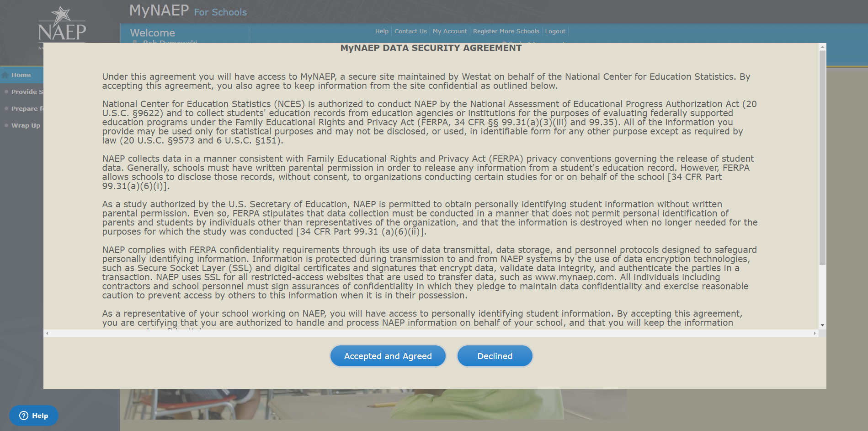

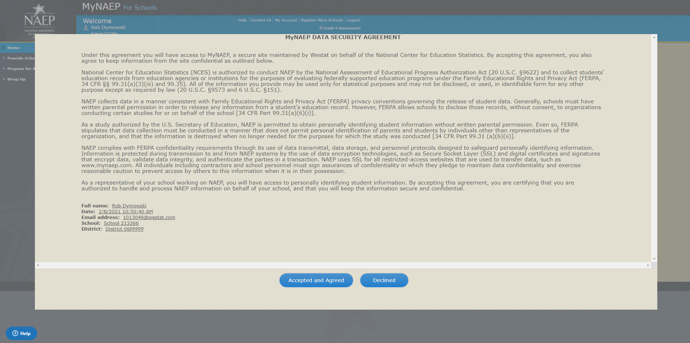

Home page
Welcome to the National Assessment of Educational Progress!
The MyNAEP website will help you prepare for the assessment.
Assessment Details
Grade:
Subject(s):
Assessment Date:
Preassessment Review Call Date:
NAEP Representative:
MyNAEP Registration ID:
NAEP School Coordinator:
*If a school coordinator name does not appear above, then no one is currently assigned as school coordinator. Notify your NAEP State Coordinator, _________, at ________ if this information is missing. School coordinators must register their own MyNAEP account.

Summary of Changes from 2019 to 2021:
- Removed the 2019 Administration Date
- Removed the 2019 MyNAEP Registration ID
- Removed the 2019 NAEP School Coordinator’s name and references to contacting School Coordinator

Screenshot
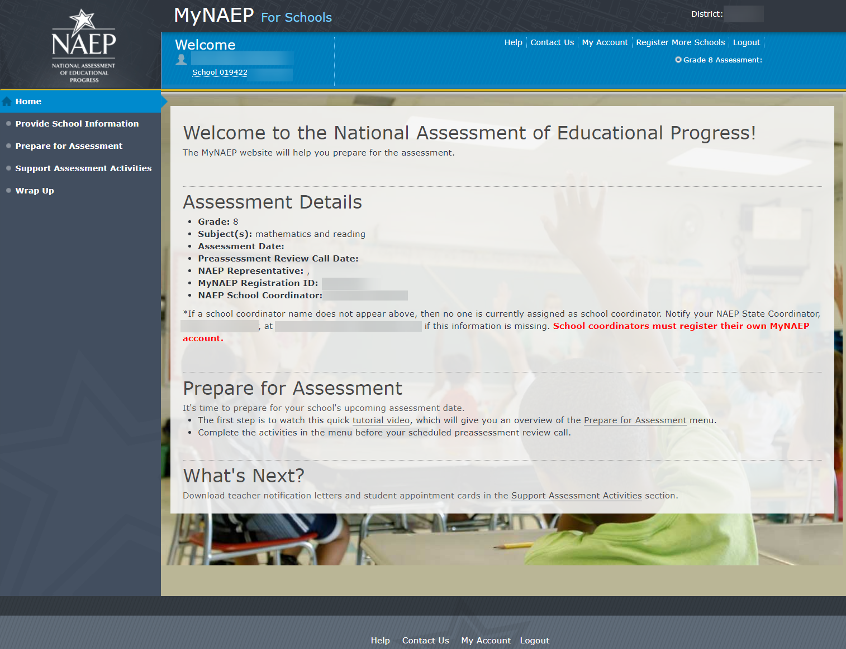

Provide School Information
Provide School Information
Please use the links below to ensure that NAEP has the most up-to-date information about your school.
Complete the following:
School Contact Information
- School name and address
- Shipping address
- Principal contact information
- School coordinator contact information
School Characteristics Information
- Student enrollment
- Charter school status
- Date school adjourns for winter break in December
- Date school returns from winter break in January
- School calendar type (traditional or year round)
- School start and end times
Student Attendance and Schedules
- Student Attendance
- Location of Students
- Use of Distance Learning
- Visitor Policy
Screenshot
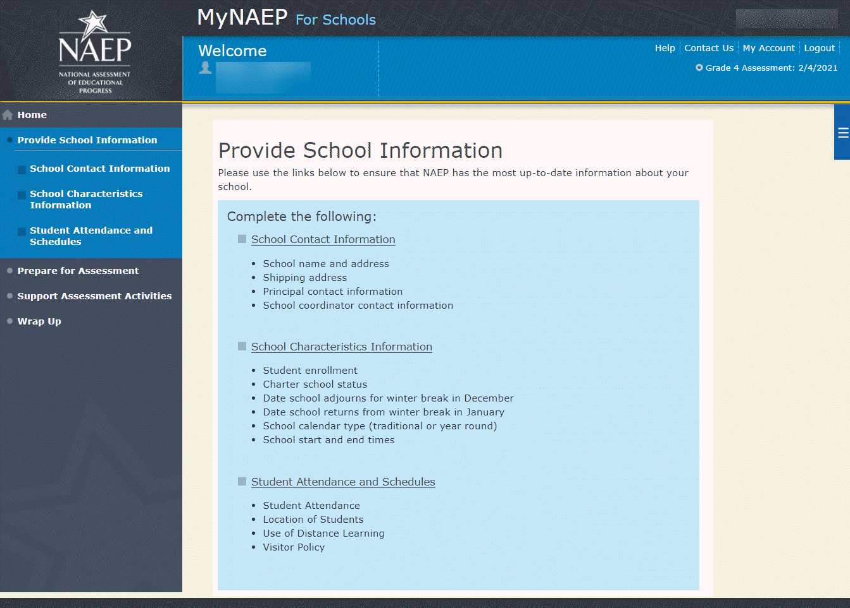

Student Attendance and Schedules (New Provide School Information Questions)

Provide School Information COVID-19 Questions
Due to COVID-19, we know schools may have adapted schedules to protect the health and safety of students and staff. So that appropriate plans can be made to assess sampled students, it is important for NAEP to know how students are expected to attend school during the NAEP assessment window, from January through March 2021.
In these questions, “in person” means that students attend classes at the physical school building. The term “distance learning” refers to students attending school at home, using computers and/or at-home packets to learn remotely.
Please answer the questions below, to the best of your knowledge.
We understand that these plans may change. You will have an opportunity to update this information in December and January.
- To the best of your current knowledge, how do you expect grade X students to attend school between January 25 and March 19, 2021?
- Most students will attend in person. [SKIP TO Q26]
- Most students will attend school through distance, remote, or virtual learning. [SKIP TO Q31]
- Most students will attend in person and through distance, remote, or virtual learning. (“hybrid/blended” approach)
- Don’t know [SKIP TO Q27]
- [If hybrid approach] Select the following schedule that best describes how grade X students are expected to attend school between January 25 and March 19, 2021.
- Students will attend school in person for half the day. ("half-day rotation”) [SKIP TO Q3]
- Students will attend school in person one full day per week. (“one-day rotation”) [SKIP TO Q8]
- Students will attend school in person two full days per week. (“two-day rotation”) [SKIP TO Q15]
- Students will attend school in person for one full week at a time. (“A/B weeks”) [SKIP TO Q20]
- Our student attendance plan is not listed above. [SKIP TO Q25]
Half-Day Rotation

- [if half-day rotation] During the NAEP assessment window (from January through March), how will grade X students attend school in person?
- All students will attend school together in person in the morning.
- All students will attend school together in person in the afternoon.
- Some students will attend school in person in the morning and some in the afternoon.
- Don’t know GO TO Q26
- Please select all days in which grade X students are expected to attend school
in person.
- Monday
- Tuesday
- Wednesday
- Thursday
- Friday
- Don’t know
- [IF CHOICE 3 TO Q3:]How will grade X students be divided into groups for different on-site times?
- Alphabetical by last name
- By teacher
- By ability
- By geographic area (for example bus routes)
- By parental choice
- Some other criteria
- [IF SOME OTHER CRITERIA] Please provide additional information on how these groups are specified for different on-site times.

- How many groups of grade 4/8 students do you expect there will be at the school?

[SKIP TO Q27]
One-Day Rotation

- [IF ONE-DAY ROTATION PER Q2] During the NAEP assessment window (from January through March), how will students in grade X attend school in person?
- All students will attend school in person on the same day every week. SKIP TO Q10
- All students will attend school in person on different days every week. SKIP TO Q11
- Groups of students will attend school in person on different days of the week. [SKIP TO Q11]
- None of the above; we will have a different structure to our one-day rotation.
- [IF NONE OF THE ABOVE PER Q8] Please describe the structure of your one-day rotation.

- [IF ALL GRADE 4/8 ATTEND ON THE SAME DAY PER Q8] On which day of the week will grade X students attend school in person?
- Monday
- Tuesday
- Wednesday
- Thursday
- Friday
- Don’t know
- [IF GRADE 4/8 STUDENTS ATTEND ON DIFFERENT DAYS PER Q8] Please select all days during which grade X students will attend school in person.
- Monday
- Tuesday
- Wednesday
- Thursday
- Friday
- Don’t know
- How will grade X students be divided into groups?
- Alphabetical by last name
- By teacher
- By ability
- By geographic area (for example bus routes)
- By parental choice
- Some other criteria
- [IF SOME OTHER CRITERIA] Please provide additional information on how these groups are specified for different on-site times.

- How many groups of grade X students do you expect there will be at the school?

[SKIP TO Q27]
Two-Day Rotation

- [IF TWO-DAY ROTATION PER Q2] During the NAEP assessment window (from January through March), how will students in grade X attend school in person?
- All students will attend school together in person on the same days every week.
- All students will attend school together in person on different days every week.
- Groups of students will attend school in person on different days of the week (for example, one group attends Monday and Tuesday, and the other attends Thursday and Friday). [SKIP TO Q17]
- [IF ALL GRADE 4/8 STUDENTS ATTEND ON THE SAME DAYS OF THE WEEK] Please specify the days of the week that grade X students will attend school in person.
- Monday
- Tuesday
- Wednesday
- Thursday
- Friday
- Don’t know
- [IF GROUPS OF GRADE 4/8 STUDENTS ATTEND ON DIFFERENT DAYS OF THE WEEK] How will grade X students be divided into groups?
- Alphabetical by last name
- By teacher
- By ability
- By geographic area (for example bus routes)
- By parental choice
- Some other criteria
- [IF SOME OTHER CRITERIA PER Q17] Please provide additional information on how these groups are specified for different on-site times.

- How many groups of grade X students do you expect there will be at the school?

[SKIP TO Q27]
A/B Week

- [A/B week] During the NAEP assessment window (from January through March), how will students in grade X attend school in person?
- All students will attend school together in person in the same week.
- Groups of students will attend school in person in different weeks.
- Please select all of the weeks that grade X students will attend school in person.
- January 25–29, 2021
- February 1–5, 2021
- February 8–12, 2021
- February 15–19, 2021
- February 22–26, 2021
- March 1–5, 2021
- March 8–12, 2021
- March 15–19, 2021
- Don’t know
- [IF CHOICE 2 TO Q20] How will grade X students be divided into groups?
- Alphabetical by last name
- By teacher
- By ability
- By geographic area (for example bus routes)
- By parental choice
- Some other criteria
- [IF SOME OTHER CRITERIA PER Q22] Please provide additional information on how these groups are specified for different on-site times.

- How many groups of grade X students do you expect there will be at the school?

Other Student Attendance Plan

- [IF STUDENT ATTENDANCE PLAN IS NOT LISTED IN Q2] Please describe the grade X student attendance plan for the NAEP assessment window (January through March).

Location of Students

- [IF MOST STUDENTS ATTEND IN PERSON IN Q1 OR IF DON’T KNOW HALF-DAY ROTATION SCHEDULE IN Q3] Please select all days in which grade X students will attend school in person.
- Monday
- Tuesday
- Wednesday
- Thursday
- Friday
- Don’t know

- Regardless of when and how frequently grade X students attend school in person, will these students attend school in person at the same school building?
- Yes
- NoGO TO Q29
- [IF YES TO Q27] Will they attend <insert name of school>, located at <insert address of school>?
- Yes GO TO Q30
- No
- [IF NO TO Q 27 or Q28] List the building name(s) and address(es) where grade X students will attend school.

Use of Distance Learning

- Will any grade X students attend school solely through distance learning (i.e., they never attend school in person)?
- Yes
- No GO TO Q32
- What percent of grade X students will attend school solely through distance learning? [_____]%

- Will any grade X students attend school solely in person (that is, they never attend school through distance learning)?
- Yes
- No [SKIP TO Q34]
- What percent of grade X students will attend school solely in person? [_____]%
Visitors

- Are visitors allowed at the school?
- Yes
- No

Manage Questionnaires

Note: In this section the school coordinator identifies respondents for school and teacher questionnaires, sends respondents links to online questionnaires, and monitors completion of questionnaires. Additionally, the school coordinator distributes information about NAEP to teachers (see Appendix D1-4). The results of the questionnaire are used to provide contextual data from schools and teachers in The Nation’s Report Card.
Prepare for Assessment
Manage Questionnaires
NAEP collects information using questionnaires to provide a context for reporting student performance.
- School Questionnaires gather information on school policies and characteristics.
- Teacher Questionnaires gather information on teacher training and instructional practices.
Complete the following:
- Watch Manage Questionnaires Tutorial (4:03) (https://bcove.video/2xiQOiX)
- Identify Questionnaire Respondents
- Send Welcome Emails and Questionnaires
- Monitor Questionnaire Completion
- Print Reports
Additional Resources
- Facts for Teachers (see Appendix D1-4)
Summary of Changes from 2019 to 2021:
- Removed the Print Reports link and Monitor Questionnaire Completion Report because field staff are being instructed to review questionnaire completion statuses directly from MyNAEP in the Monitor Questionnaire Completion and Send Reminder Emails link

Screenshot
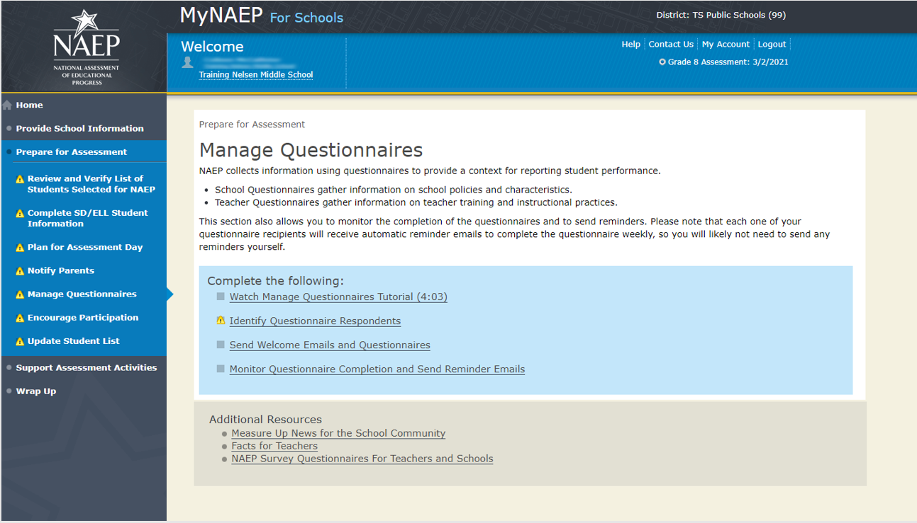

Identify Questionnaire Respondents

Identify Questionnaire Respondents-QX-RES-1
Check this box if all your teachers use the same email domain.
- For example, @myschool.edu
- What email domain do they use? @
- Select Save to save the domain for all teachers.
Select the Add Teacher button to enter contact information for all teachers who teach mathematics or reading to grade 8 students. (Note: teacher’s first name, last name, and email address are entered by the school coordinator as shown in the screenshot below)
- Please include special education, ESL, and resource teachers who teach mathematics or reading to grade 8 students.
- Make sure each name and email address is correct.
  - Select the pencil to make corrections.
  - Select the red x to delete a teacher.
- When finished entering all teachers, select Save and Continue.

Screenshot
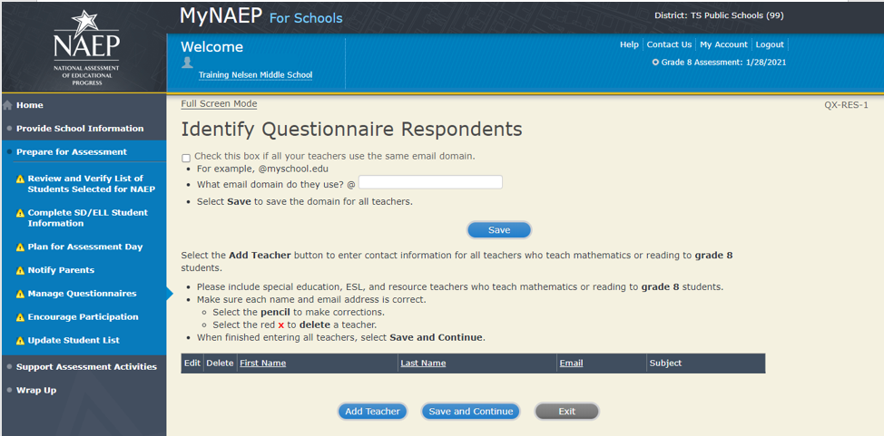

Send Welcome Emails and Questionnaires

Send Welcome Emails-QX-WEL-1
(see the Additional Resources section of this document for the text of the Welcome Email)
Now it's time to make sure that NAEP has the correct email addresses of your recipients. Select the Send buttons in the table below to send each person a welcome email.
Not sure if everyone received the welcome email?
- Check to ensure each recipient received the email.
- Double-check the email address. If the address is correct and the recipient still did not receive the email, the recipient should check his or her junk email folder.
- To add, edit, or delete recipients, return to the Identify Respondents page.

Screenshot
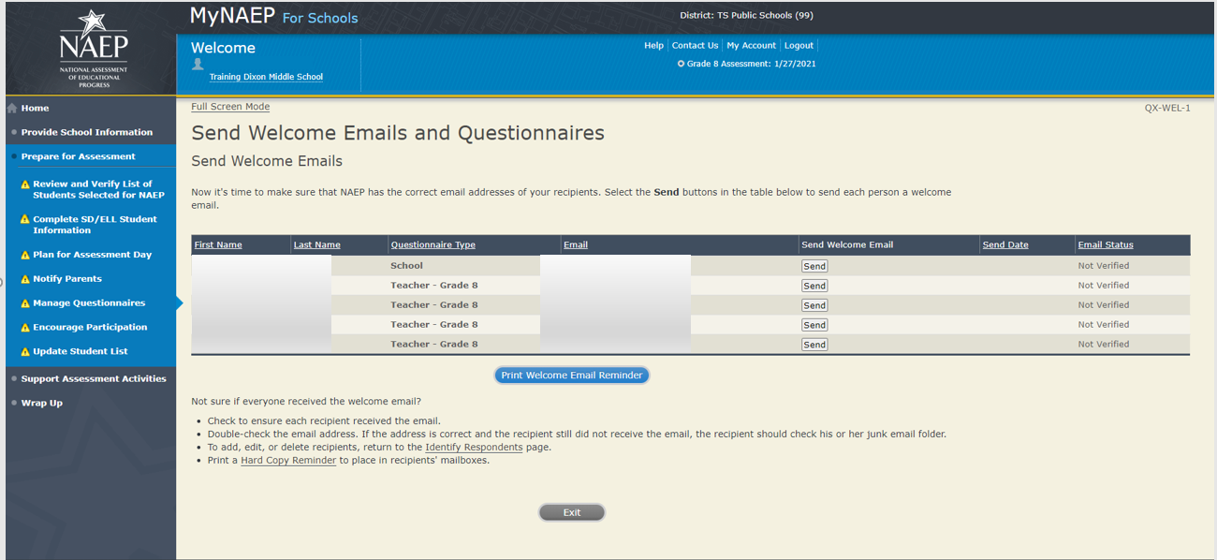

Monitor Questionnaire Completion and Send Reminder Emails

QX-MON-1
- Please confirm that these are the correct teachers and the list is complete, showing all teachers who teach mathematics or reading to grade 8 students.
- Monitor questionnaire completion using the Status column. Please ensure that all questionnaires have a status of "Completed" before your assessment day.
- Select Send to send teachers and administrators email reminders.
- If you need to add a teacher, select the Add Teacher button.
*The green check mark will only appear if the questionnaire status is Complete, Hard Copy, Refused, or No longer at school.
Screenshot
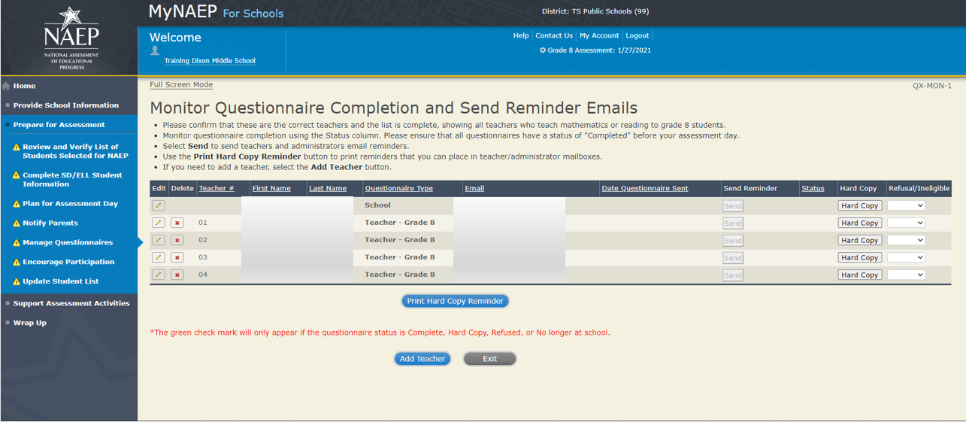

Manage Questionnaire

Manage Questionnaires Welcome Email Teachers
Dear [QUESTIONNAIRENAME],
Thank you for your support of the National Assessment of Educational Progress (NAEP). Your school coordinator, [SCHOOLCOORDINATORNAME], at [SCHOOL NAME] has designated you as a respondent for the NAEP Teacher Questionnaire.

Guidance for Completing the NAEP 2021 Teacher Questionnaire Special Study

Although the National Center for Education Statistics (NCES) is unable to conduct the National Assessment of Educational Progress (NAEP) student assessments due to the COVID-19 outbreak, NCES is collecting information from teachers during the 2020–21 school year. This information can help fill a critical gap in understanding how teaching was conducted and supported across regions and states during the COVID-19 outbreak. In particular, the questionnaires will focus on the types of instructional models, teacher training and preparation, and the availability of digital access for distance learning.

Please note the following information before completing your questionnaire:
- Disregard all references to students taking the NAEP assessment during the 2020–21 school year since this data collection has been postponed.
- Answer all questions to the best of your ability. A few questions may not be applicable to your school’s instructional context during the 2020–21 school year; in these cases, please skip the question and move on to the next one.

Below is the link to the questionnaire. You will need a password to access the site. For security purposes, the password has been sent in a separate email with the following subject: NAEP Teacher Questionnaire – Password.
[NAEPQURL]
Please click on the link or copy and paste it into your browser. Enter the password to complete the Teacher Questionnaire by [autofill with date, 1 week from this email’s sent date].
For assistance, contact the NAEP help desk at 1-800-283-NAEP (6237) or NAEPHelp@westat.com. For more information about NAEP, visit the website at http://www.nces.ed.gov/nationsreportcard.
Thank you in advance for contributing to this important study!

Manage Questionnaires Welcome Email School

Dear [QUESTIONNAIRENAME],
Thank you for your support of the National Assessment of Educational Progress (NAEP). Your school coordinator, [SCHOOLCOORDINATORNAME], at [SCHOOL NAME] has designated you as a respondent for the NAEP School Questionnaire.

Guidance for Completing the NAEP 2021 School Questionnaire Special Study

Although the National Center for Education Statistics (NCES) is unable to conduct the National Assessment of Educational Progress (NAEP) student assessments due to the COVID-19 outbreak, NCES is collecting information from schools during the 2020–21 school year. This information can help fill a critical gap in understanding how teaching was conducted and supported across regions and states during the COVID-19 outbreak. In particular, the questionnaires will focus on the types of instructional models, teacher training and preparation, and the availability of digital access for distance learning.

Please note the following information before completing your questionnaire:
- Disregard all references to students taking the NAEP assessment during the 2020–21 school year since this data collection has been postponed.
- Answer all questions to the best of your ability. A few questions may not be applicable to your school’s instructional context during the 2020–21 school year; in these cases, please skip the question and move on to the next one.

Below is the link to the questionnaire. You will need a password to access the site. For security purposes, the password has been sent in a separate email with the following subject: NAEP School Questionnaire – Password.
[NAEPQURL]
Please click on the link or copy and paste it into your browser. Enter the password to complete the School Questionnaire by [autofill with date, 1 week from this email’s sent date].
For assistance, contact the NAEP help desk at 1-800-283-NAEP (6237) or NAEPHelp@westat.com. For more information about NAEP, visit the website at http://www.nces.ed.gov/nationsreportcard.
Thank you in advance for contributing to this important study!

