NATIONAL CENTER FOR EDUCATION STATISTICS NATIONAL ASSESSMENT OF EDUCATIONAL PROGRESS

National Assessment of Educational Progress (NAEP)
2021 School and Teacher Questionnaire Special Study

Appendix J3

2021 School Questionnaires

OMB# 1850-0956 v.2



March 2021

Table of Contents
School Questionnaires
NAEPq School Login 3
Appendix J3-1: Summary of Changes Operational Grade 4 CORE 5
Appendix J3-2: Operational Grade 4 CORE 14
Appendix J3-3: Summary of Changes Operational Grade 8 CORE 26
Appendix J3-4: Operational Grade 8 CORE 36
Appendix J3-5: Summary of Changes Operational Grade 4 and 8 Charter School 48
Appendix J3-6: Operational Grade 4 and 8 Charter School 51
Appendix J3-7: Summary of Changes Operational Grade 4 Mathematics 53
Appendix J3-8: Operational Grade 4 Mathematics 56
Appendix J3-9: Summary of Changes Operational Grade 8 Mathematics 60
Appendix J3-10: Operational Grade 8 Mathematics 64
Appendix J3-11: Summary of Changes Operational Grade 4 Reading 69
Appendix J3-12: Operational Grade 4 Reading 73
Appendix J3-13: Summary of Changes Operational Grade 8 Reading 78
Appendix J3-14: Operational Grade 8 Reading 83
Appendix J3-15: Operational Grade 4 COVID-19 School Items 88
Appendix J3-16: Operational Grade 8 COVID-19 School Items 97

NAEPq School Login

School Administrator Questionnaire Login Screen
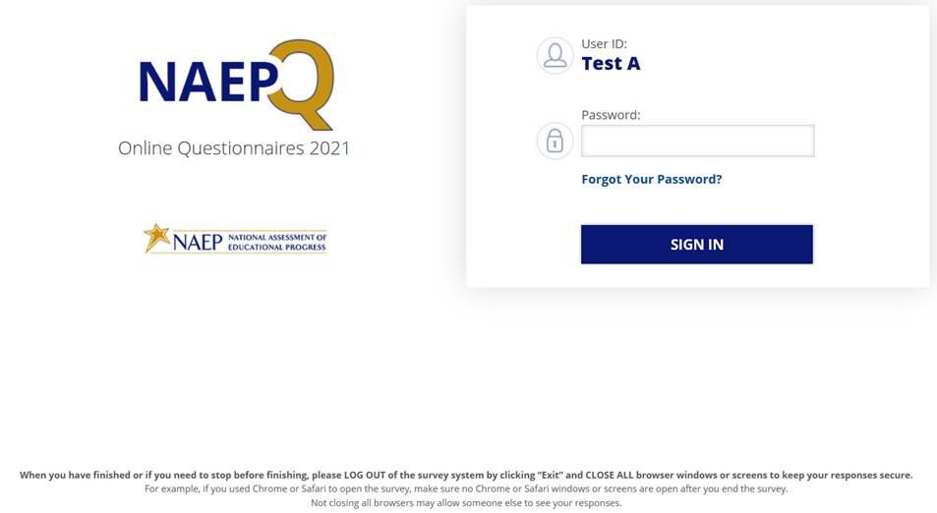
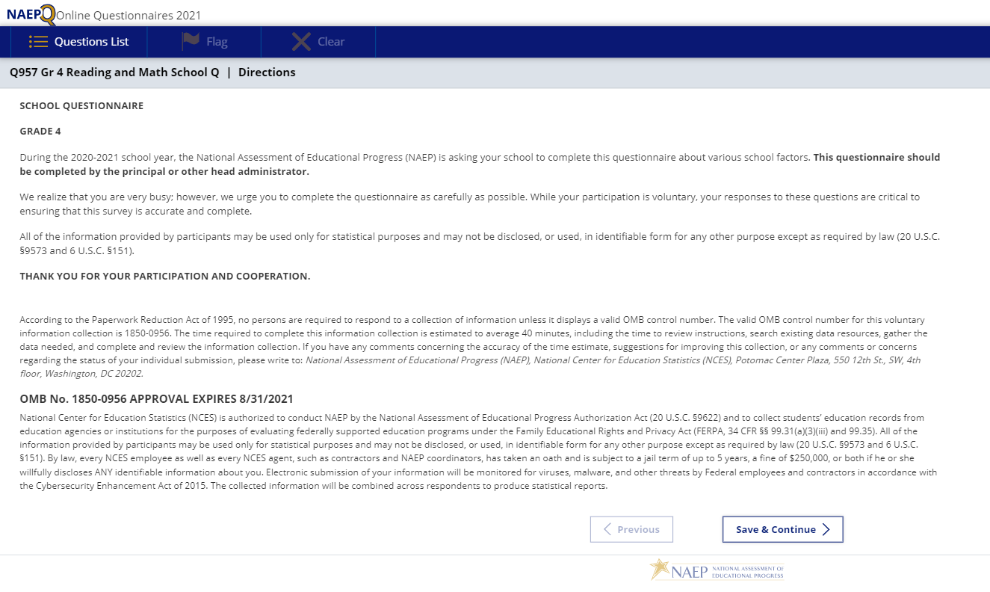

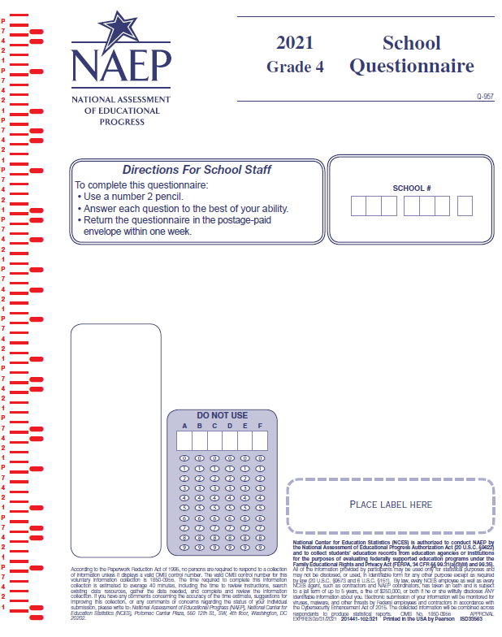

Appendix J3-1: Summary of Changes Operational Grade 4 CORE

2021 Operational Grade 4 Core School

Previous item | 2021 item | D/A/ R/NC+ | Rationale
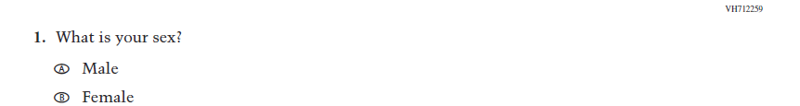  (2019 Grade 4) | 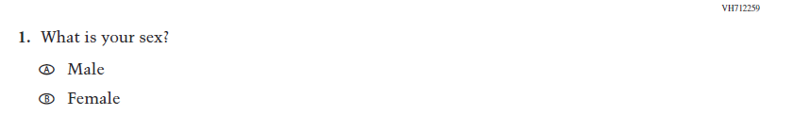  Issue: Gender | NC | N/A
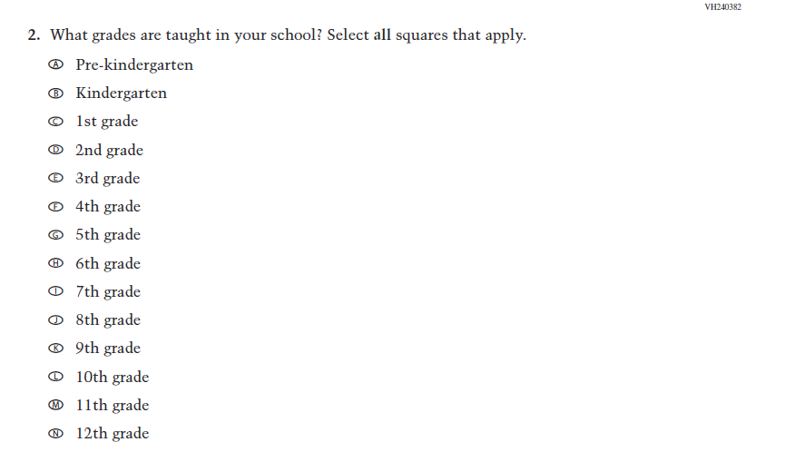  (2019 Grade 4) | 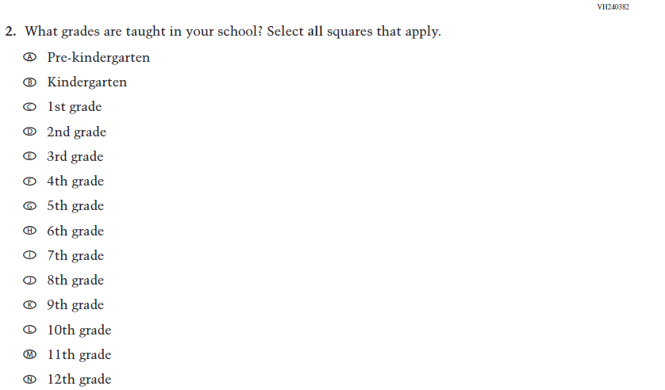  Issue: School Climate | NC | N/A
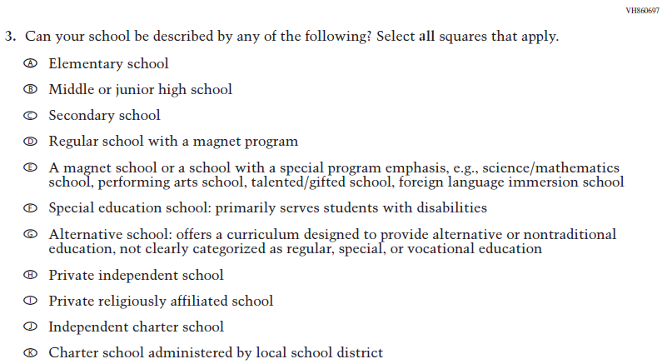  (2019 Grade 4) | Issue: School Climate | NC | N/A
2021 Operational Grade 4 Core School

Previous item | 2021 item | D/A/ R/NC+ | Rationale
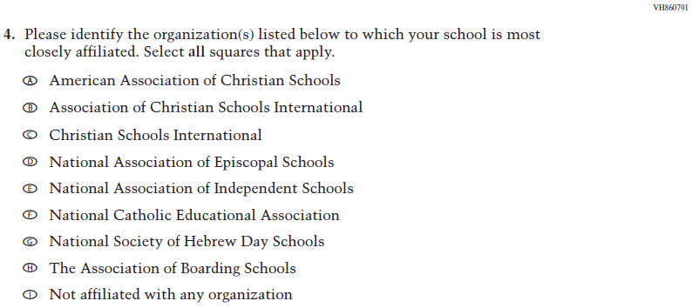  (2019 Grade 4) | Issue: School Climate | NC | N/A
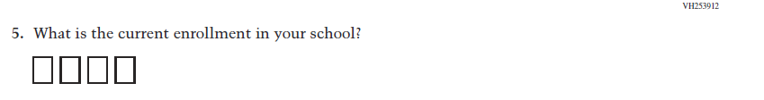  (2019 Grade 4) | 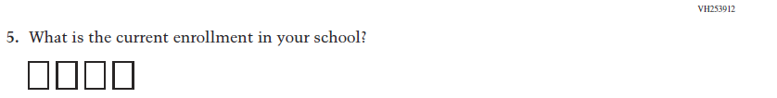  Issue: School Climate | NC | N/A
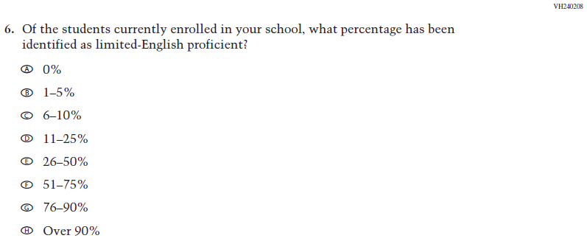  (2019 Grade 4) | Issue: School Climate | NC | N/A
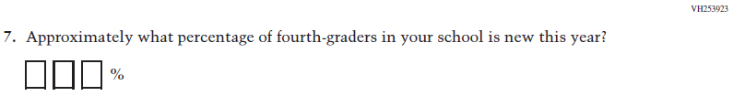  (2019 Grade 4) | Issue: School Climate | NC | N/A

2021 Operational Grade 4 Core School

Previous item | 2021 item | D/A/ R/NC+ | Rationale
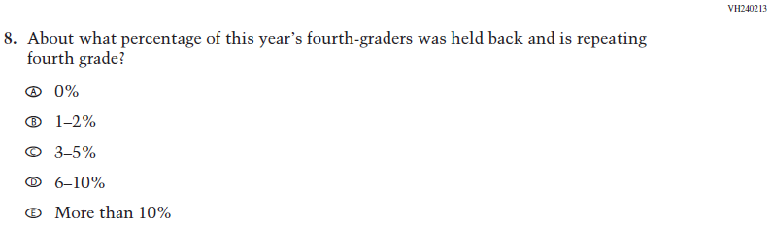  (2019 Grade 4) | Issue: School Climate | NC | N/A
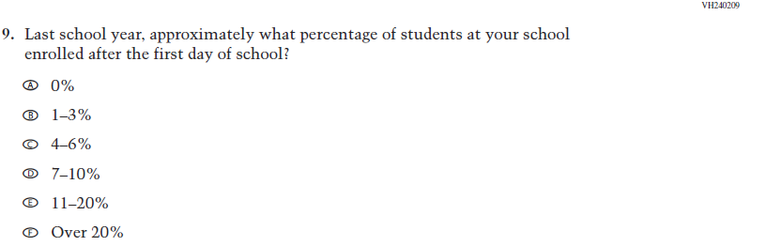  (2019 Grade 4) | Issue: School Climate | NC | N/A
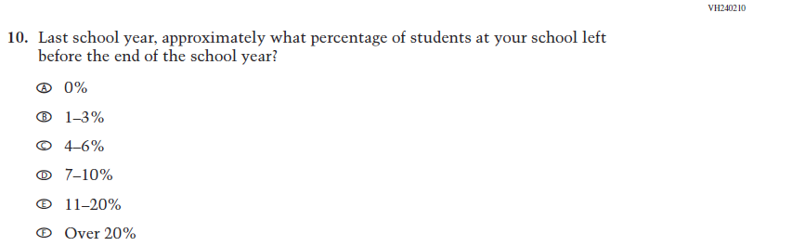  (2019 Grade 4) | Issue: School Climate | NC | N/A
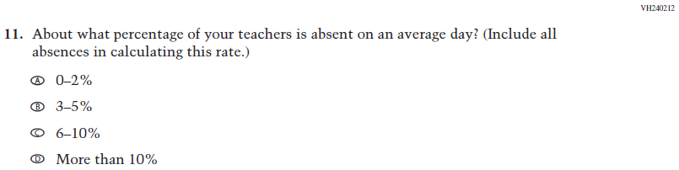  (2019 Grade 4) | Issue: School Climate | NC | N/A

2021 Operational Grade 4 Core School

Previous item | 2021 item | D/A/ R/NC+ | Rationale
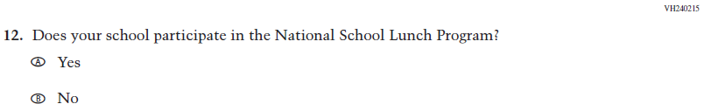  (2019 Grade 4) | Issue: Socioeconomic Status | NC | N/A
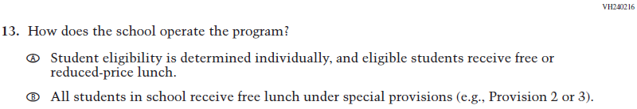  (2019 Grade 4) | Issue: Socioeconomic Status | NC | N/A
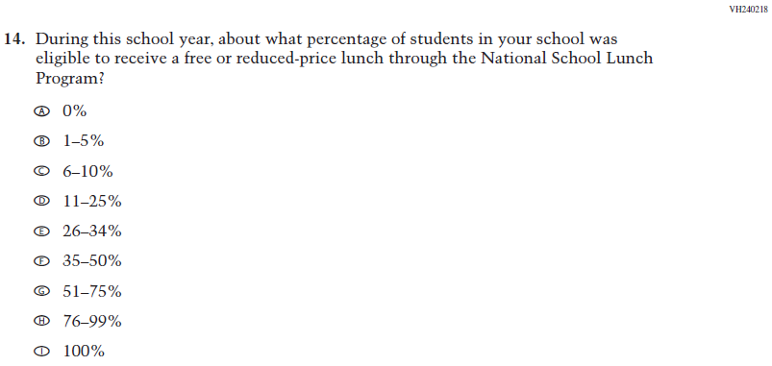  (2019 Grade 4) | Issue: Socioeconomic Status | NC | N/A
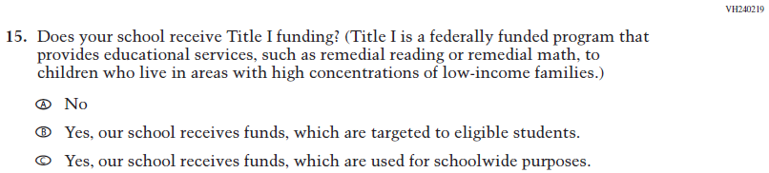  (2019 Grade 4) | Issue: Socioeconomic Status | NC | N/A
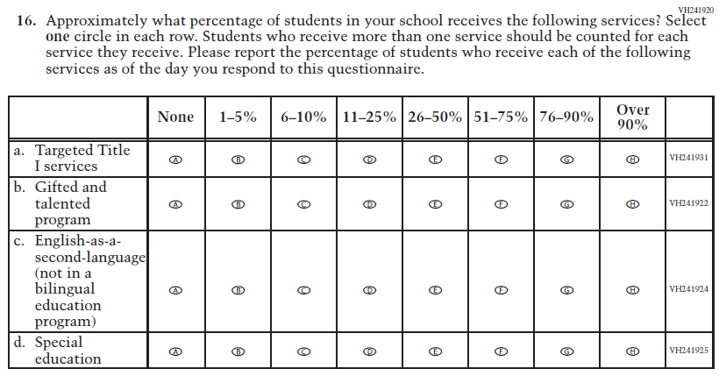  (2019 Grade 4) | Issue: School Climate | NC | N/A
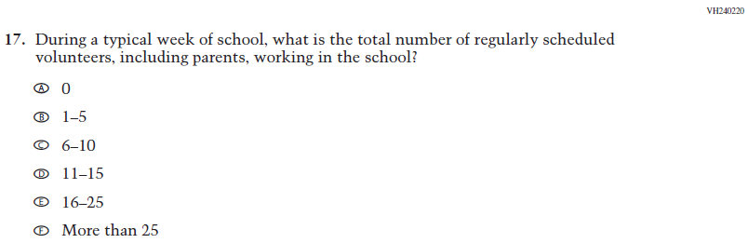  (2019 Grade 4) | 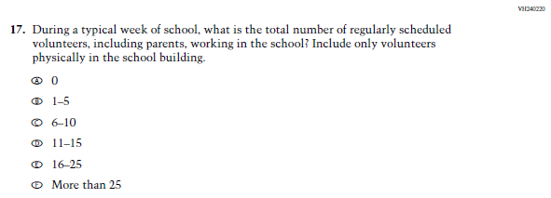  Issue: School Climate | R | Additional sentence has been added to adapt the item to reflect the context of the COVID-19 pandemic
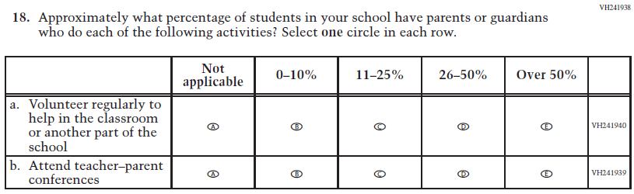  (2019 Grade 4) | 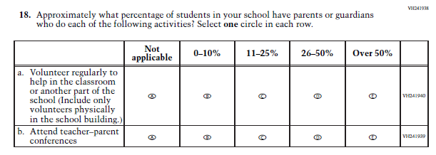  Issue: School Climate | R | Parenthetical has been added to sub-item a to adapt the item to reflect the context of the COVID-19 pandemic
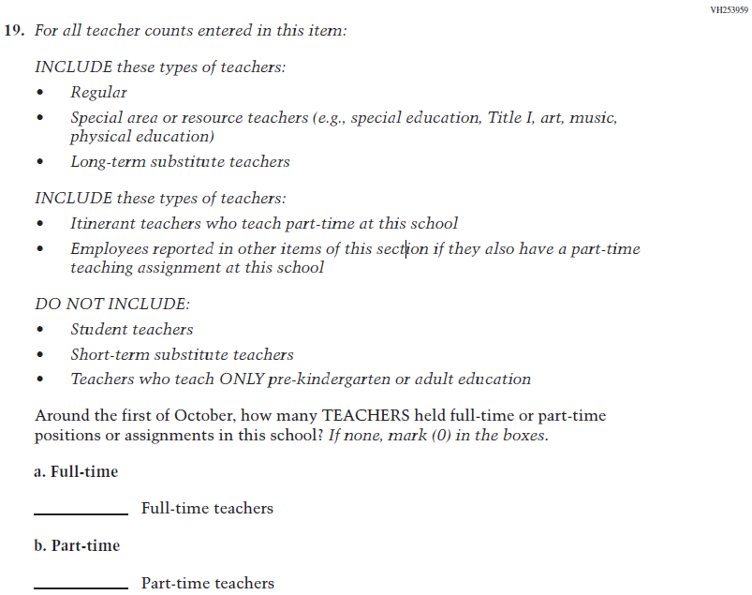  (2019 Grade 4) | Issue: School Climate | NC | N/A
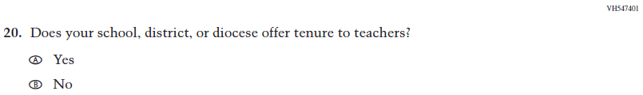  (2019 Grade 4) | Issue: School Climate | NC | N/A
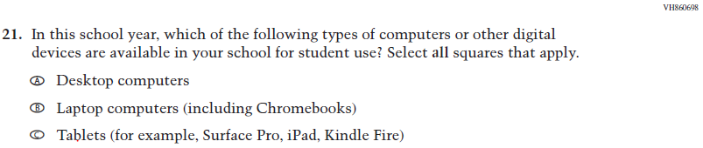  (2019 Grade 4) | 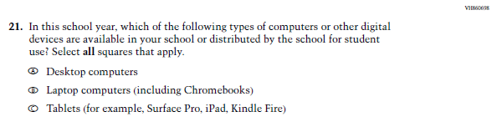  Issue: Technology Use | R | Additional text has been added to adapt the item to reflect the context of the COVID-19 pandemic
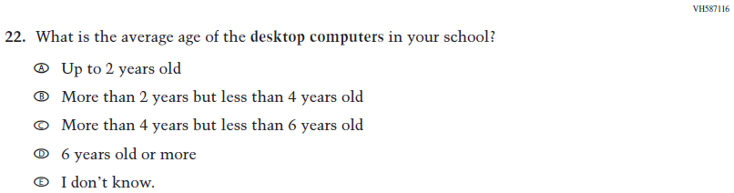  (2019 Grade 4) | Issue: Technology Use | NC | N/A
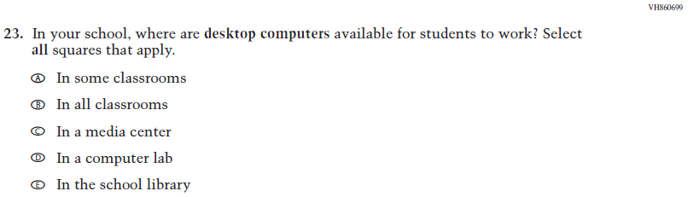  (2019 Grade 4) | 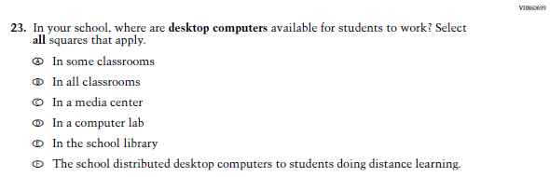  Issue: Technology Use | R | Response option F has been added to adapt the item to reflect the context of the COVID-19 pandemic
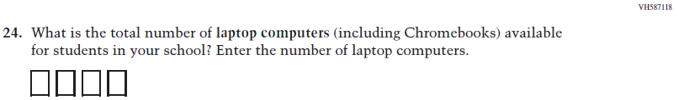  (2019 Grade 4) | Issue: Technology Use | NC | N/A
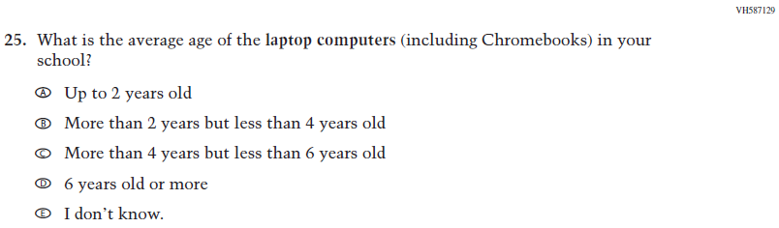  (2019 Grade 4) | Issue: Technology Use | NC | N/A
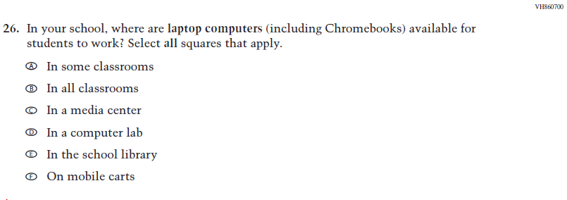  (2019 Grade 4) | 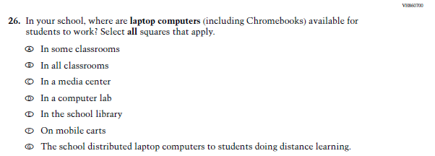  Issue: Technology Use | R | Response option G has been added to adapt the item to reflect the context of the COVID-19 pandemic
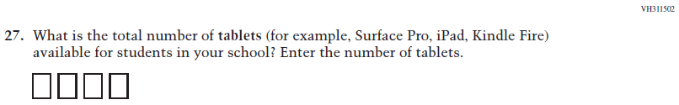  (2019 Grade 4) | Issue: Technology Use | NC | N/A
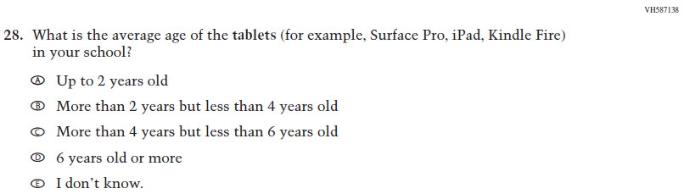  (2019 Grade 4) | Issue: Technology Use | NC | N/A
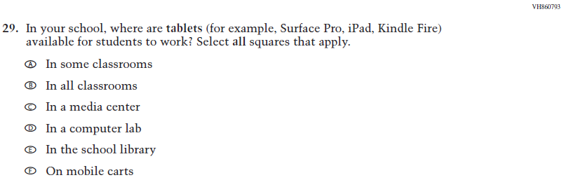  (2019 Grade 4) | 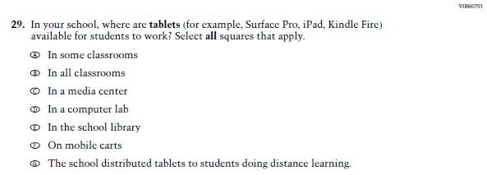  Issue: Technology Use | R | Response option G has been added to adapt the item to reflect the context of the COVID-19 pandemic
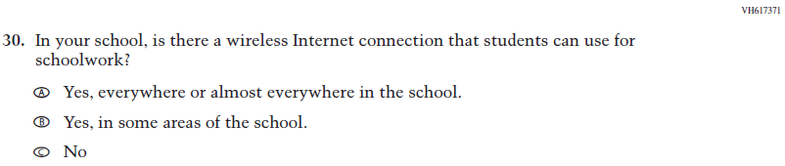  (2019 Grade 4) | Issue: Technology Use | NC | N/A

Appendix J3-2: Operational Grade 4 CORE
Grade/Respondent | Item Number Initiating Skip Logic | Item Response(s) Initiating Skip Logic | Item Number(s) Being Skipped
Grade 4 School | 3 | A, B, C, D, E, F, G, and K | 4
Grade 4 School | 3 | H, I, J | Do NOT skip 4
Grade 4 School | 3 | No response | 4
Grade 4 School | 12 | B | 13, 14
Grade 4 School | 13 | B | 14
Grade 4 School | 21 | A | Do NOT skip 22, 23
Grade 4 School | 21 | B | Do NOT skip 24, 25, 26
Grade 4 School | 21 | C | Do NOT skip 27, 28, 29
Grade 4 School | 21 | No response | 22, 23, 24, 25, 26, 27, 28, 29
Grade 4 School | 24 | If answered “0” | 25, 26
Grade 4 School | 27 | If answered “0” | 28, 29

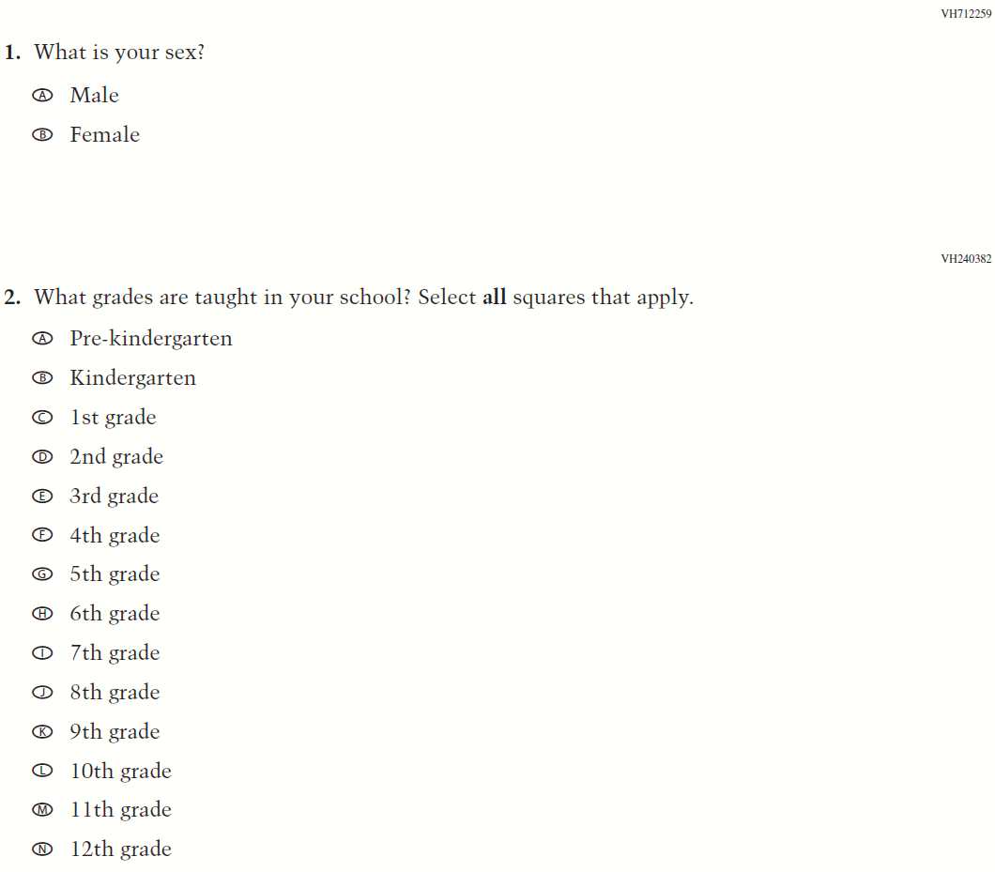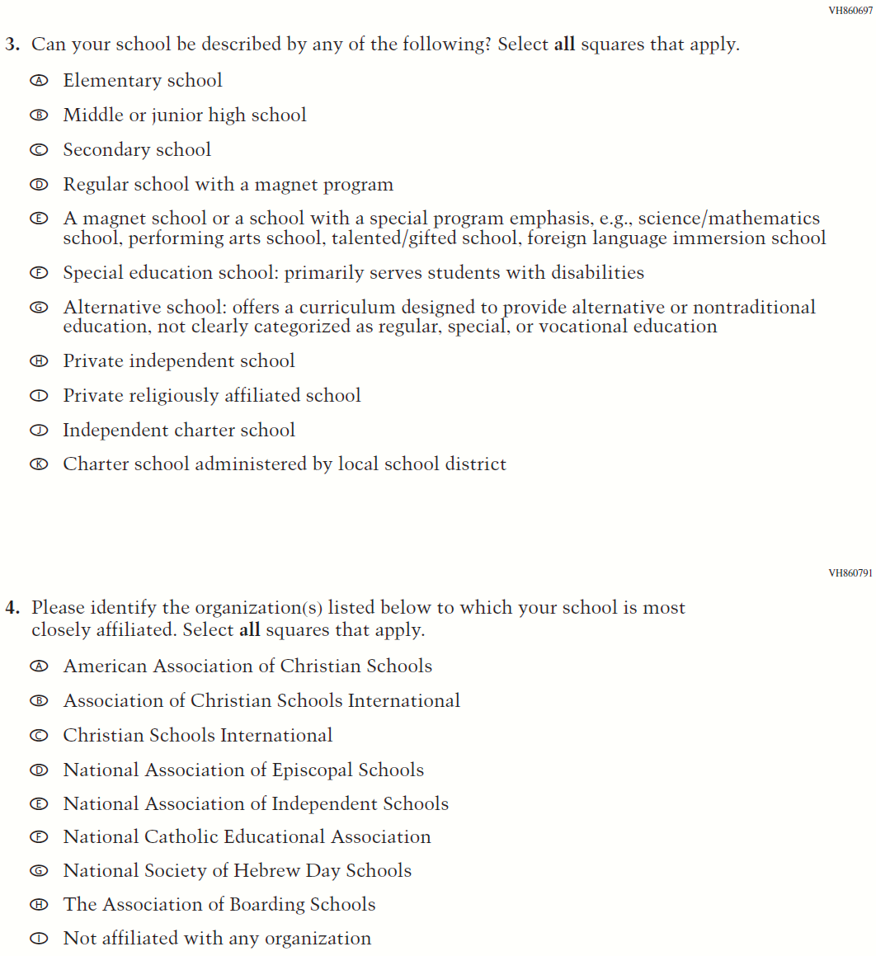

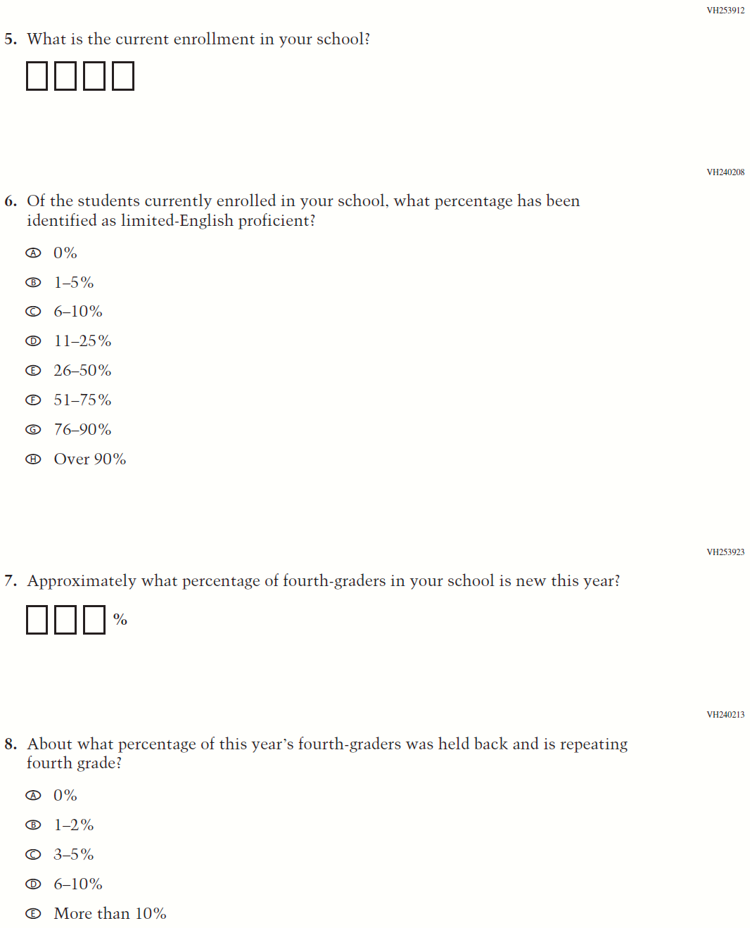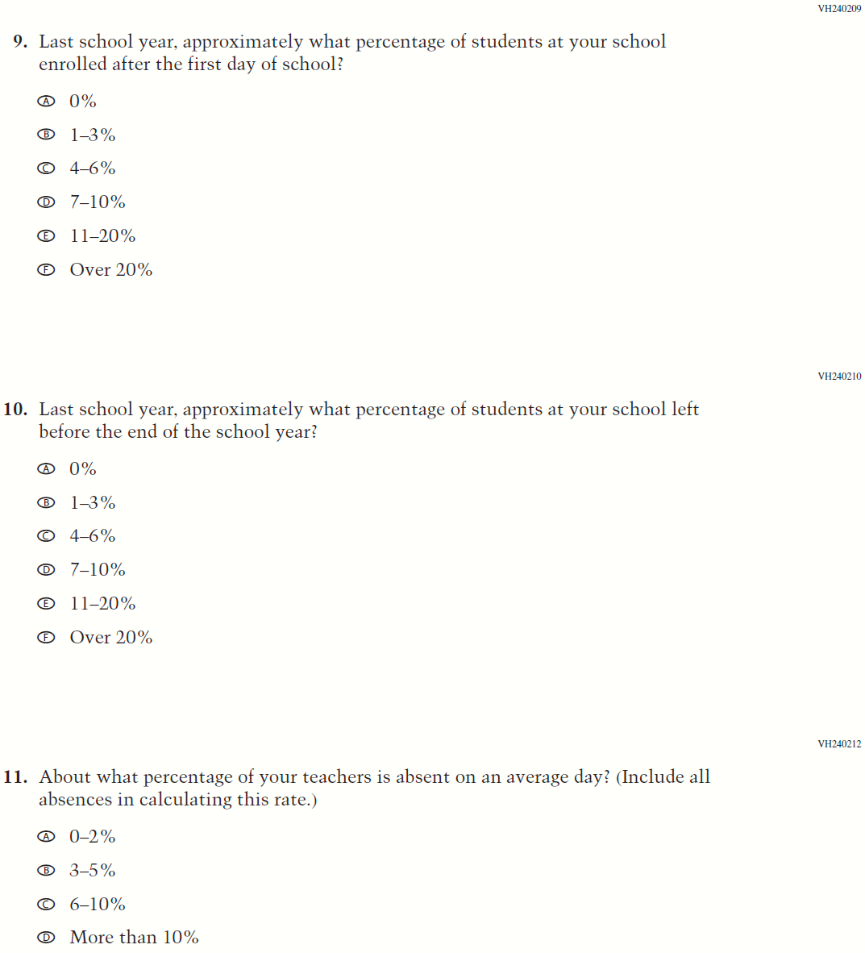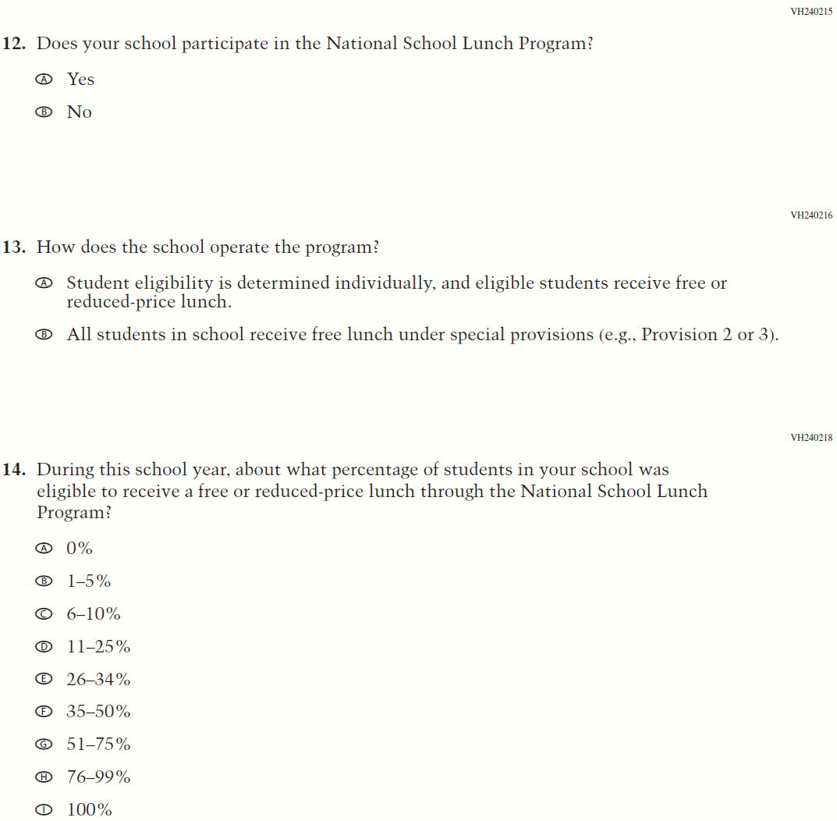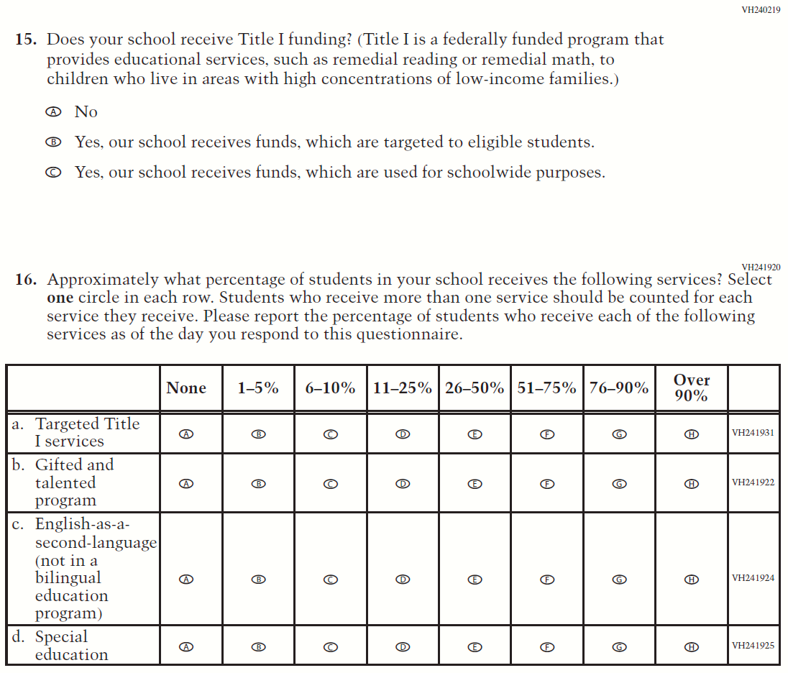

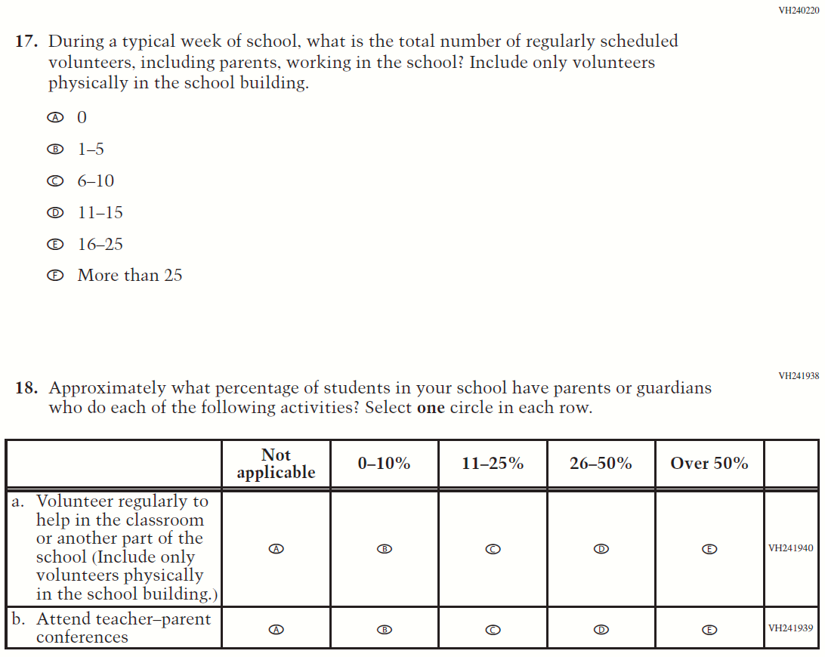

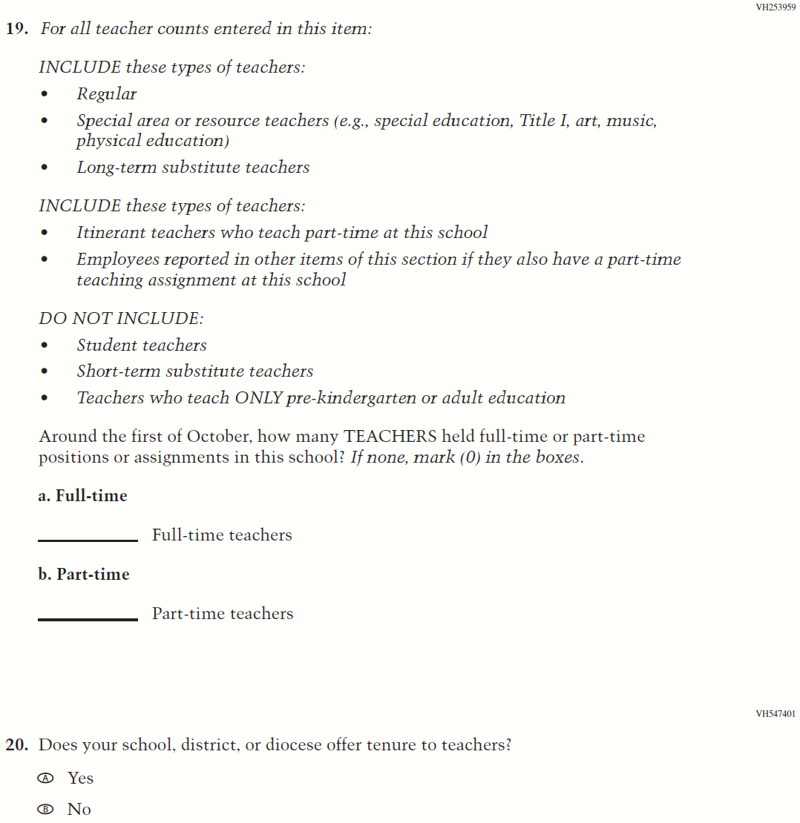

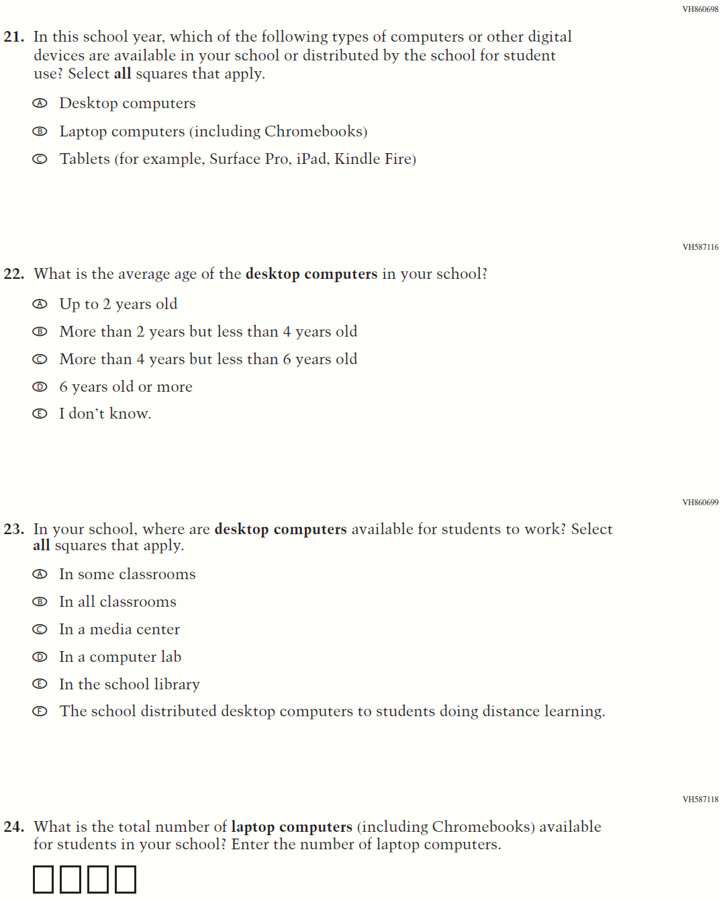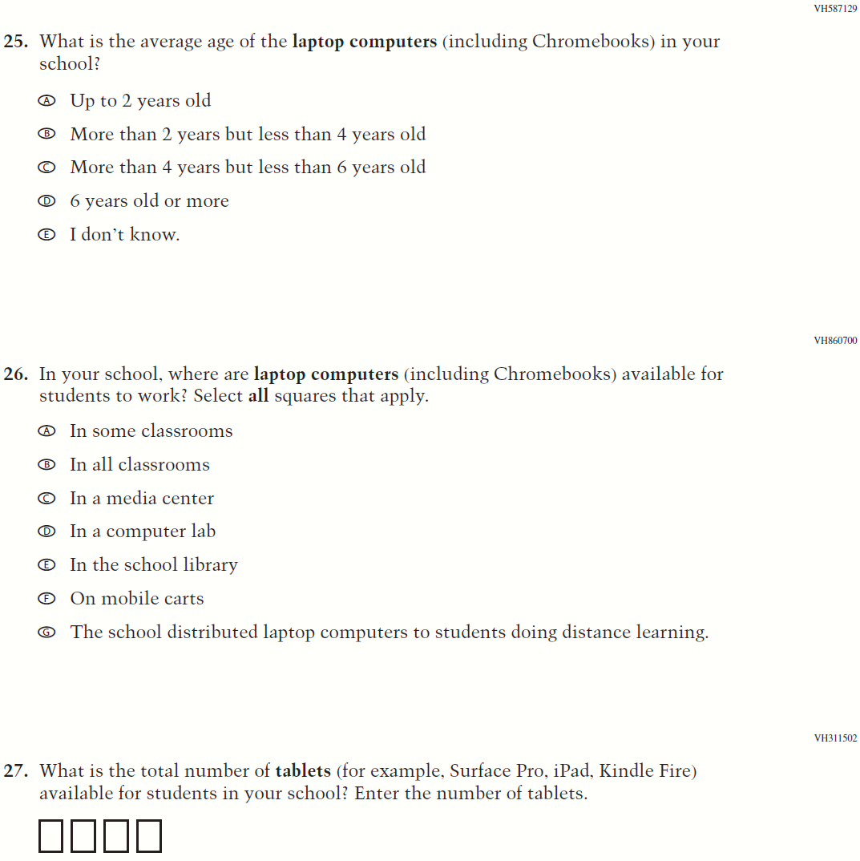

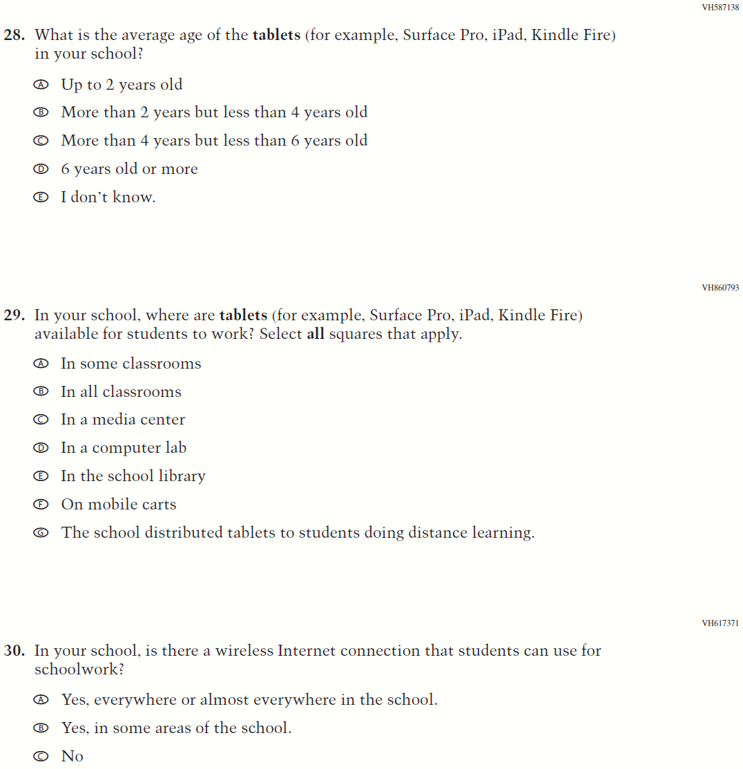

Appendix J3-3: Summary of Changes Operational Grade 8 CORE

2021 Operational Grade 8 Core School

Previous item | 2021 item | D/A/ R/NC+ | Rationale
(2019 Grade 8) | Issue: Gender | NC | N/A
(2019 Grade 8) | Issue: School Climate | NC | N/A
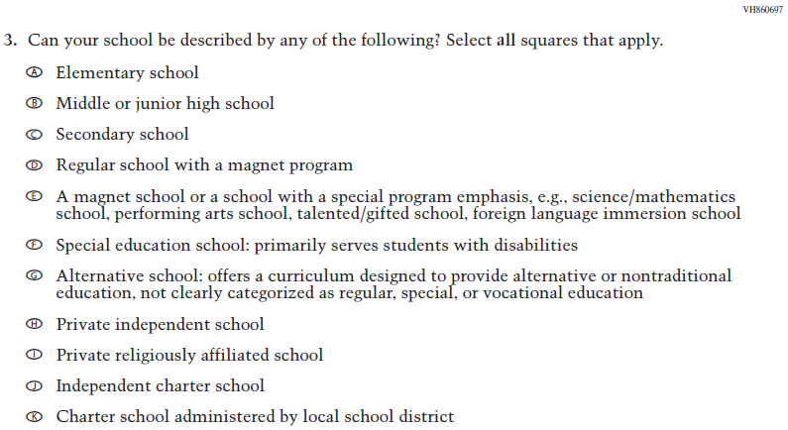  (2019 Grade 8) | Issue: School Climate | NC | N/A
2021 Operational Grade 8 Core School

Previous item | 2021 item | D/A/ R/NC+ | Rationale
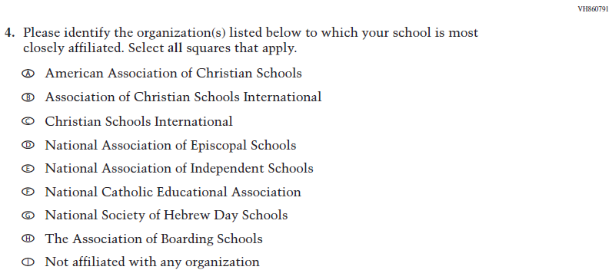  (2019 Grade 8) | Issue: School Climate | NC | N/A
(2019 Grade 8) | Issue: School Climate | NC | N/A
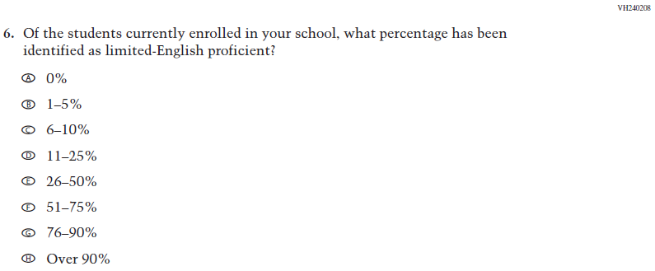  (2019 Grade 8) | Issue: School Climate | NC | N/A
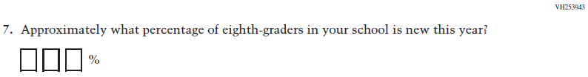  (2019 Grade 8) | Issue: School Climate | NC | N/A

2021 Operational Grade 8 Core School

Previous item | 2021 item | D/A/ R/NC+ | Rationale
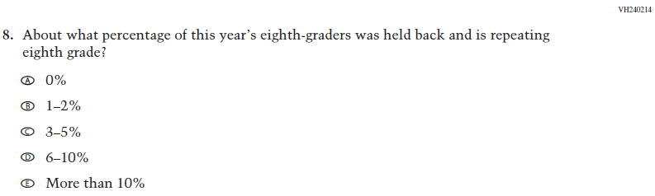  (2019 Grade 8) | Issue: School Climate | NC | N/A
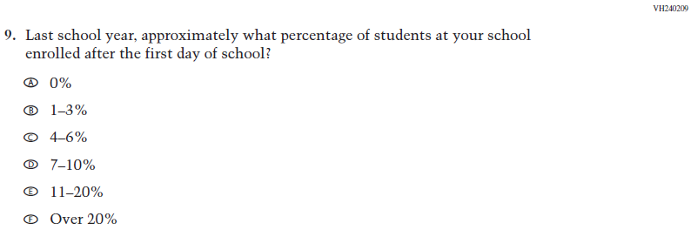  (2019 Grade 8) | Issue: School Climate | NC | N/A
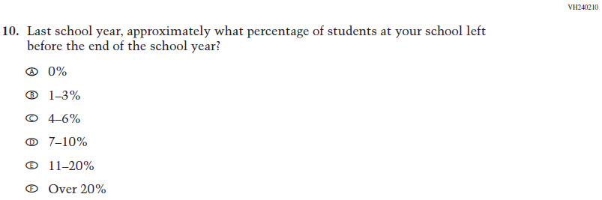  (2019 Grade 8) | Issue: School Climate | NC | N/A

2021 Operational Grade 8 Core School

Previous item | 2021 item | D/A/ R/NC+ | Rationale
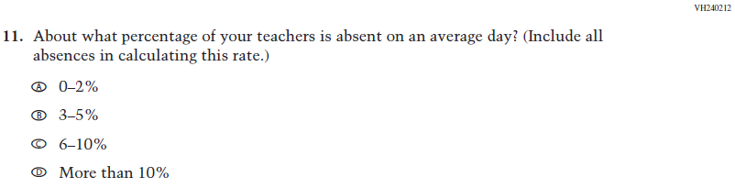  (2019 Grade 8) | Issue: School Climate | NC | N/A
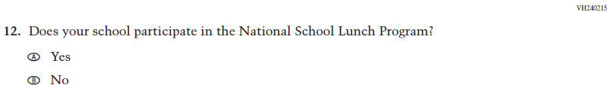  (2019 Grade 8) | Issue: Socioeconomic Status | NC | N/A
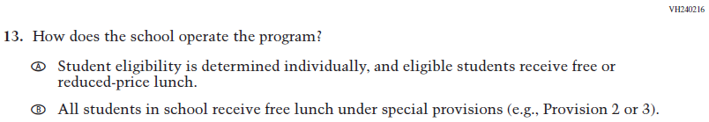  (2019 Grade 8) | Issue: Socioeconomic Status | NC | N/A
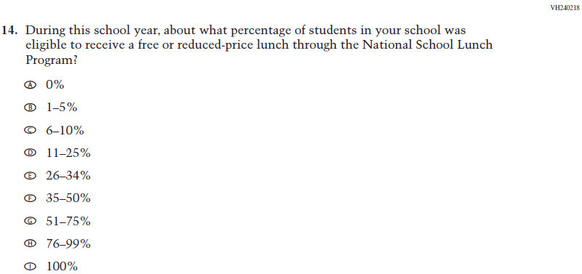  (2019 Grade 8) | Issue: Socioeconomic Status | NC | N/A
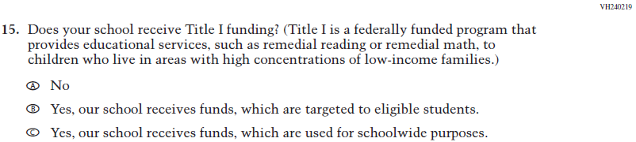  (2019 Grade 8) | Issue: Socioeconomic Status | NC | N/A
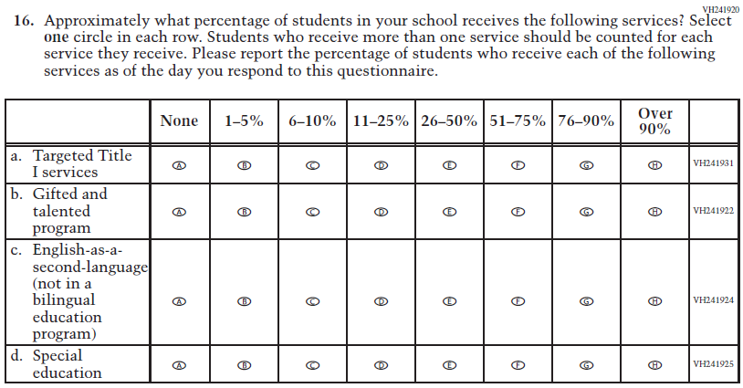  (2019 Grade 8) | Issue: School Climate | NC | N/A
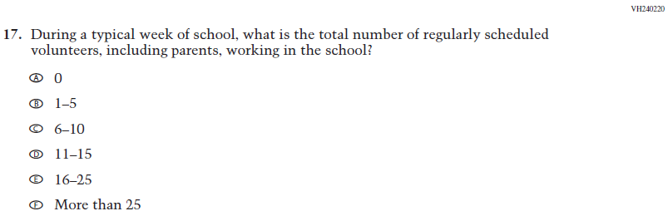  (2019 Grade 8) | Issue: School Climate | R | Additional sentence has been added to adapt the item to reflect the context of the COVID-19 pandemic
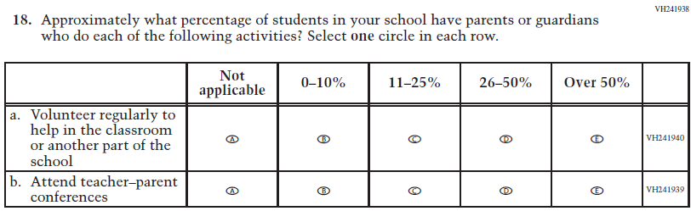  (2019 Grade 8) | Issue: School Climate | R | Parenthetical has been added to sub-item a to adapt the item to reflect the context of the COVID-19 pandemic
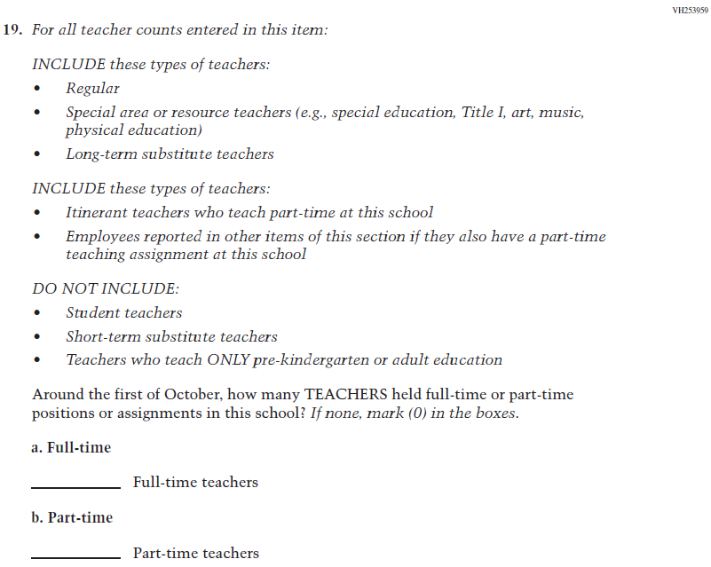  (2019 Grade 8) | Issue: School Climate | NC | N/A
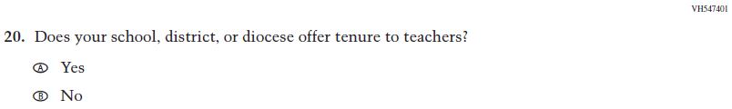  (2019 Grade 8) | Issue: School Climate | NC | N/A

2021 Operational Grade 8 Core School
Previous item | 2021 item | D/A/ R/NC+ | Rationale
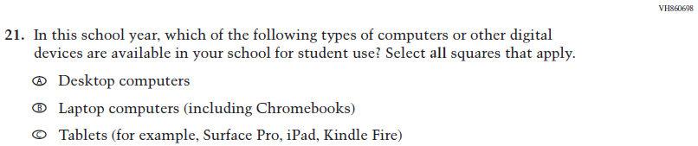  (2019 Grade 8) | Issue: Technology Use | R | Additional text has been added to adapt the item to reflect the context of the COVID-19 pandemic
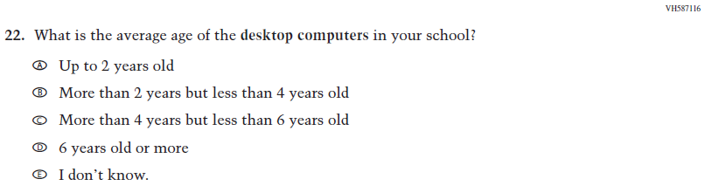  (2019 Grade 8) | Issue: Technology Use | NC | N/A
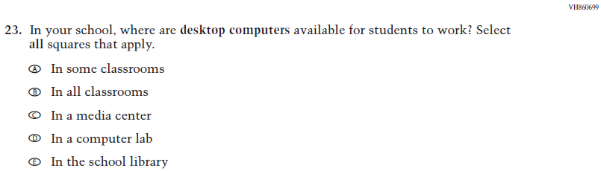  (2019 Grade 8) | Issue: Technology Use | R | Response option F has been added to adapt the item to reflect the context of the COVID-19 pandemic
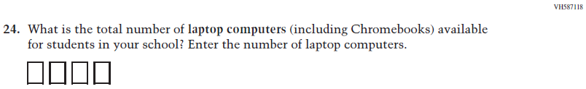  (2019 Grade 8) | Issue: Technology Use | NC | N/A
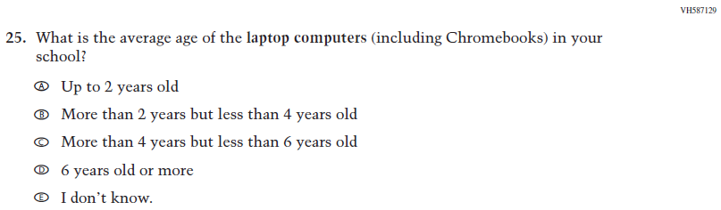  (2019 Grade 8) | Issue: Technology Use | NC | N/A
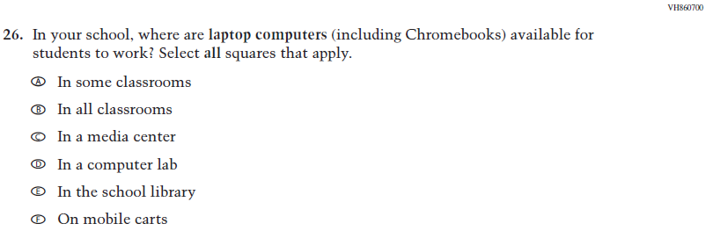  (2019 Grade 8) | Issue: Technology Use | R | Response option G has been added to adapt the item to reflect the context of the COVID-19 pandemic
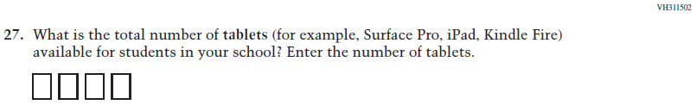  (2019 Grade 8) | Issue: Technology Use | NC | N/A

2021 Operational Grade 8 Core School

Previous item | 2021 item | D/A/ R/NC+ | Rationale
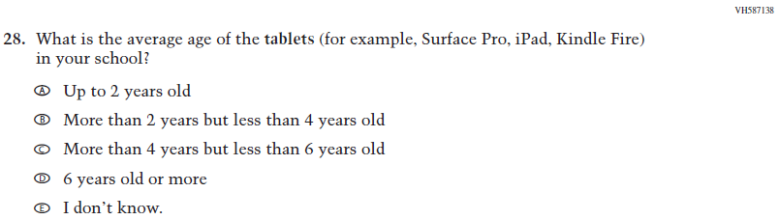  (2019 Grade 8) | Issue: Technology Use | NC | N/A
(2019 Grade 8) | Issue: Technology Use | R | Response option G has been added to adapt the item to reflect the context of the COVID-19 pandemic
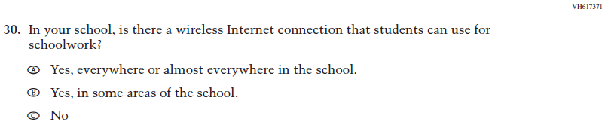  (2019 Grade 8) | Issue: Technology Use | NC | N/A

Appendix J3-4: Operational Grade 8 CORE
Grade/Respondent | Item Number Initiating Skip Logic | Item Response(s) Initiating Skip Logic | Item Number(s) Being Skipped
Grade 8 School | 3 | A, B, C, D, E, F, G, and K | 4
Grade 8 School | 3 | H, I, J | Do NOT skip 4
Grade 8 School | 3 | No response | 4
Grade 8 School | 12 | B | 13, 14
Grade 8 School | 13 | B | 14
Grade 8 School | 21 | A | Do NOT skip 22, 23
Grade 8 School | 21 | B | Do NOT skip 24, 25, 26
Grade 8 School | 21 | C | Do NOT skip 27, 28, 29
Grade 8 School | 21 | No response | 22, 23, 24, 25, 26, 27, 28, 29
Grade 8 School | 24 | If answered “0” | 25, 26
Grade 8 School | 27 | If answered “0” | 28, 29

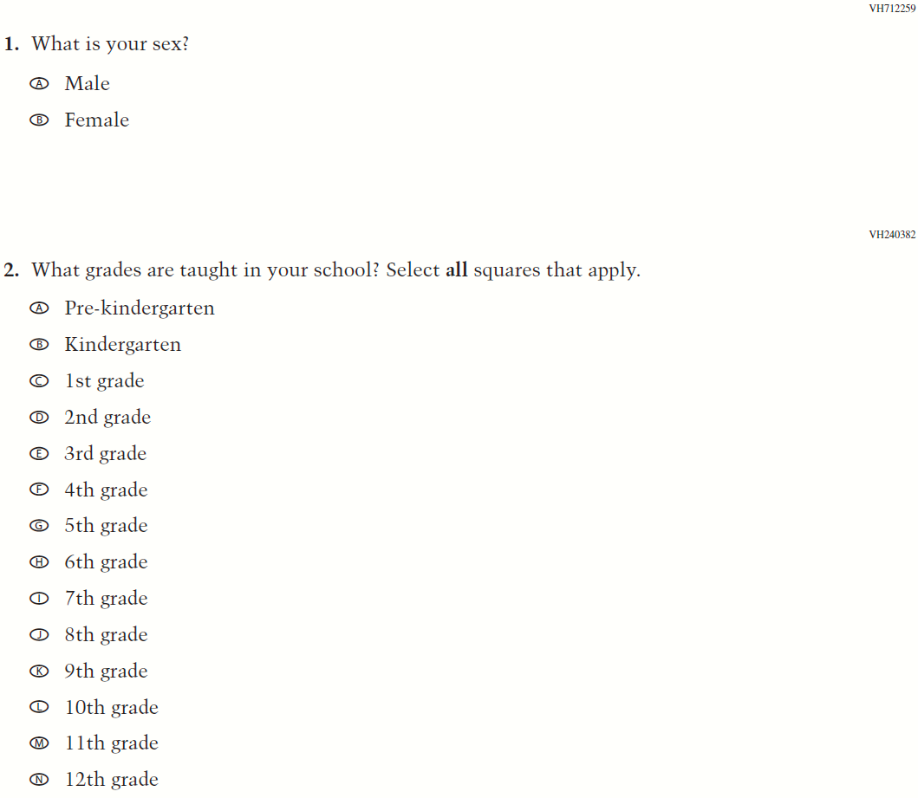

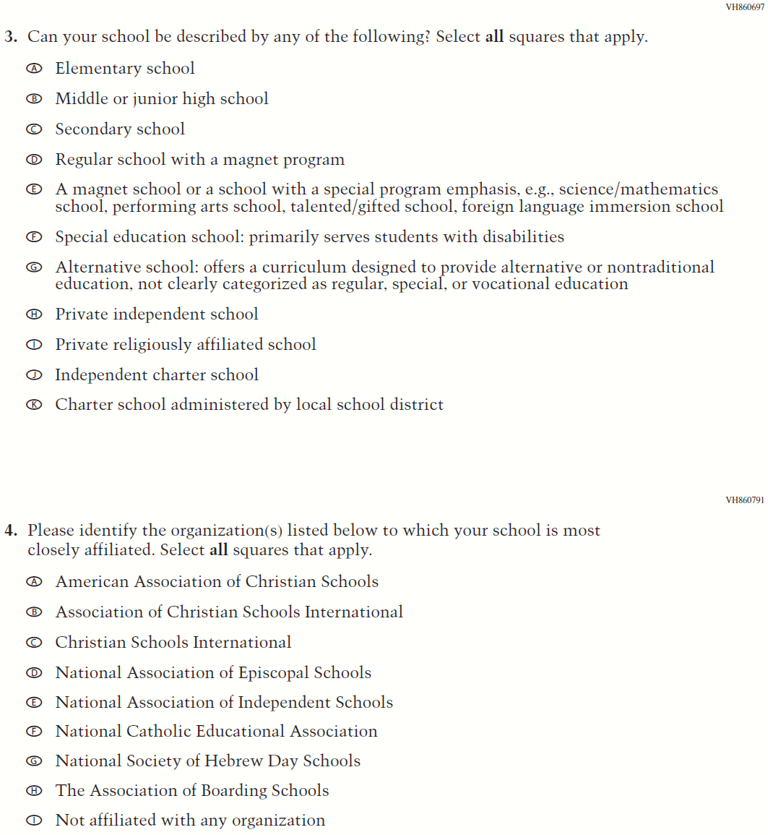
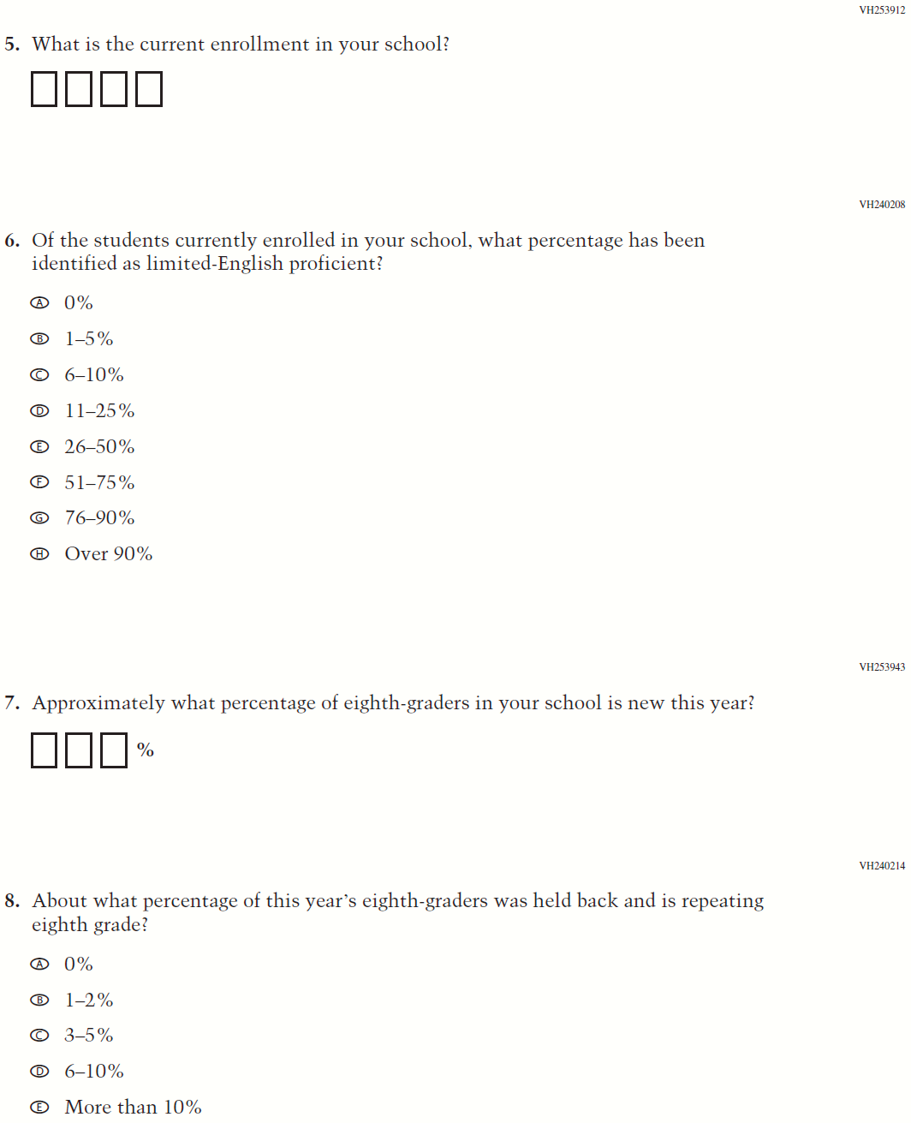

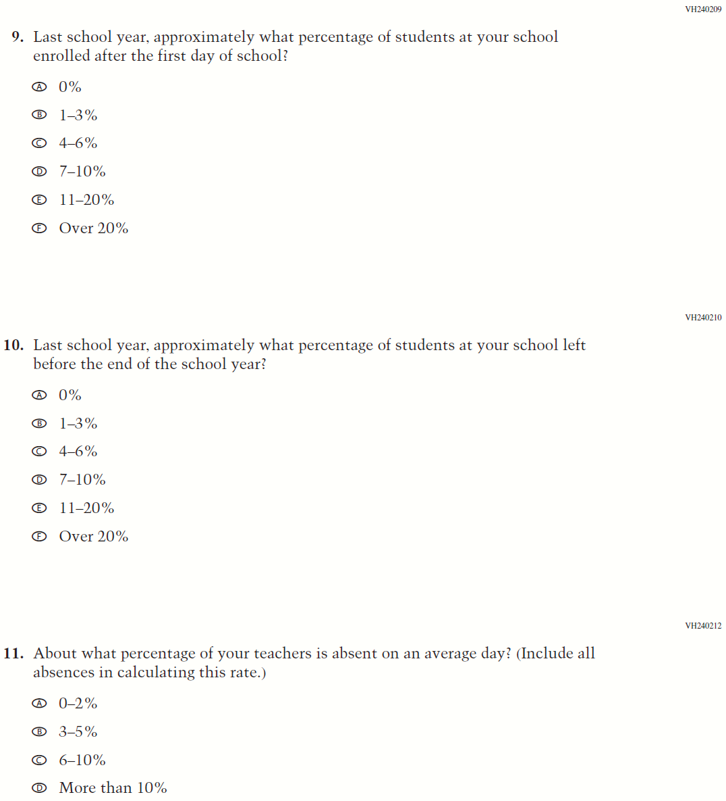

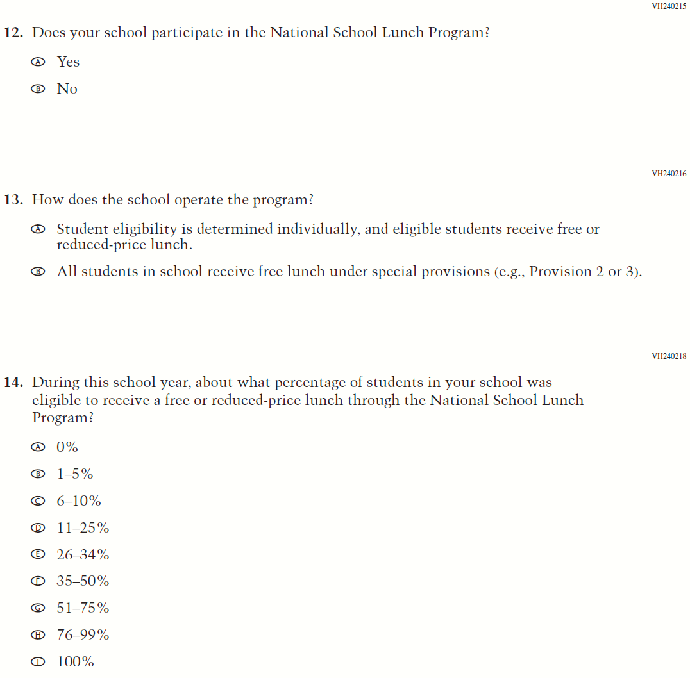

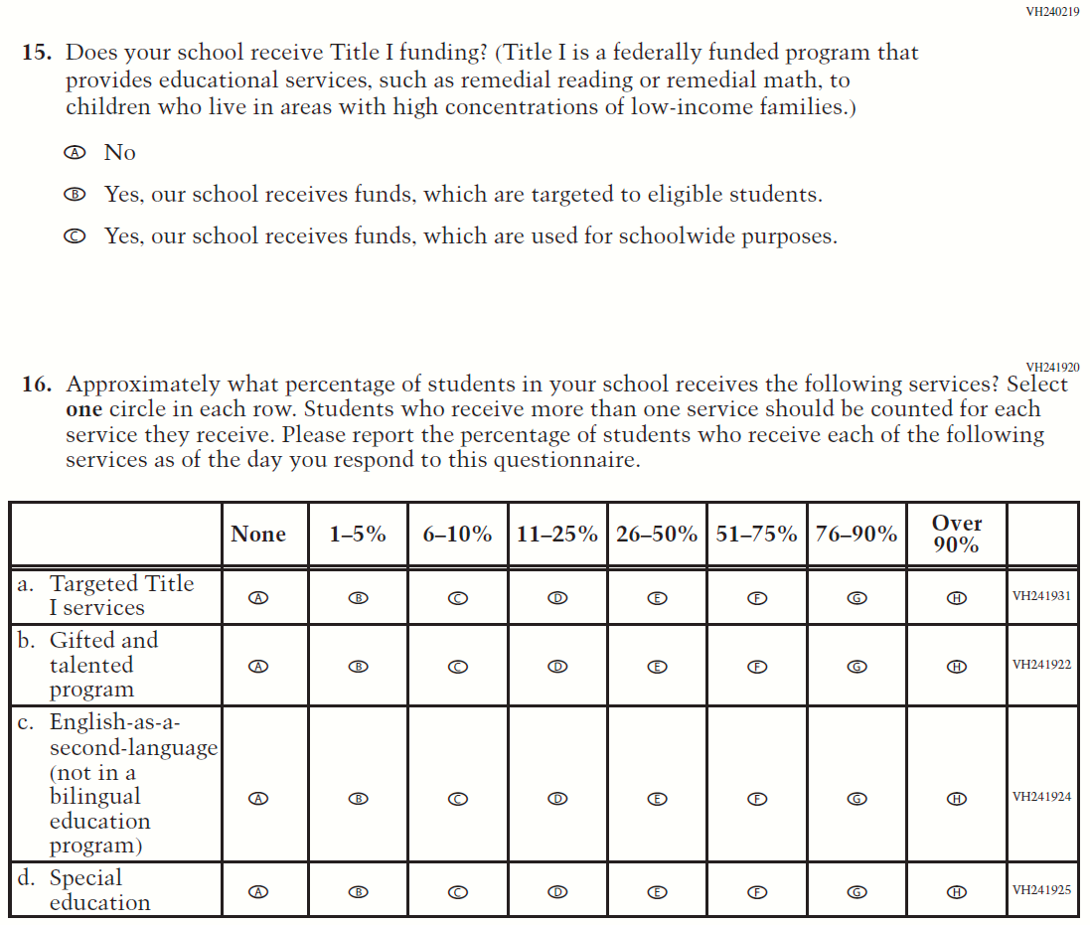

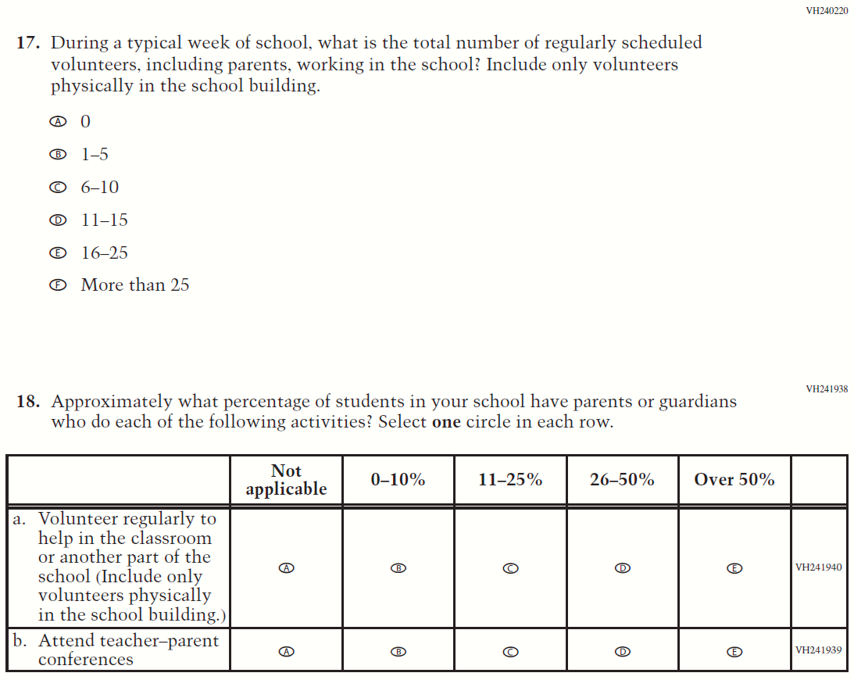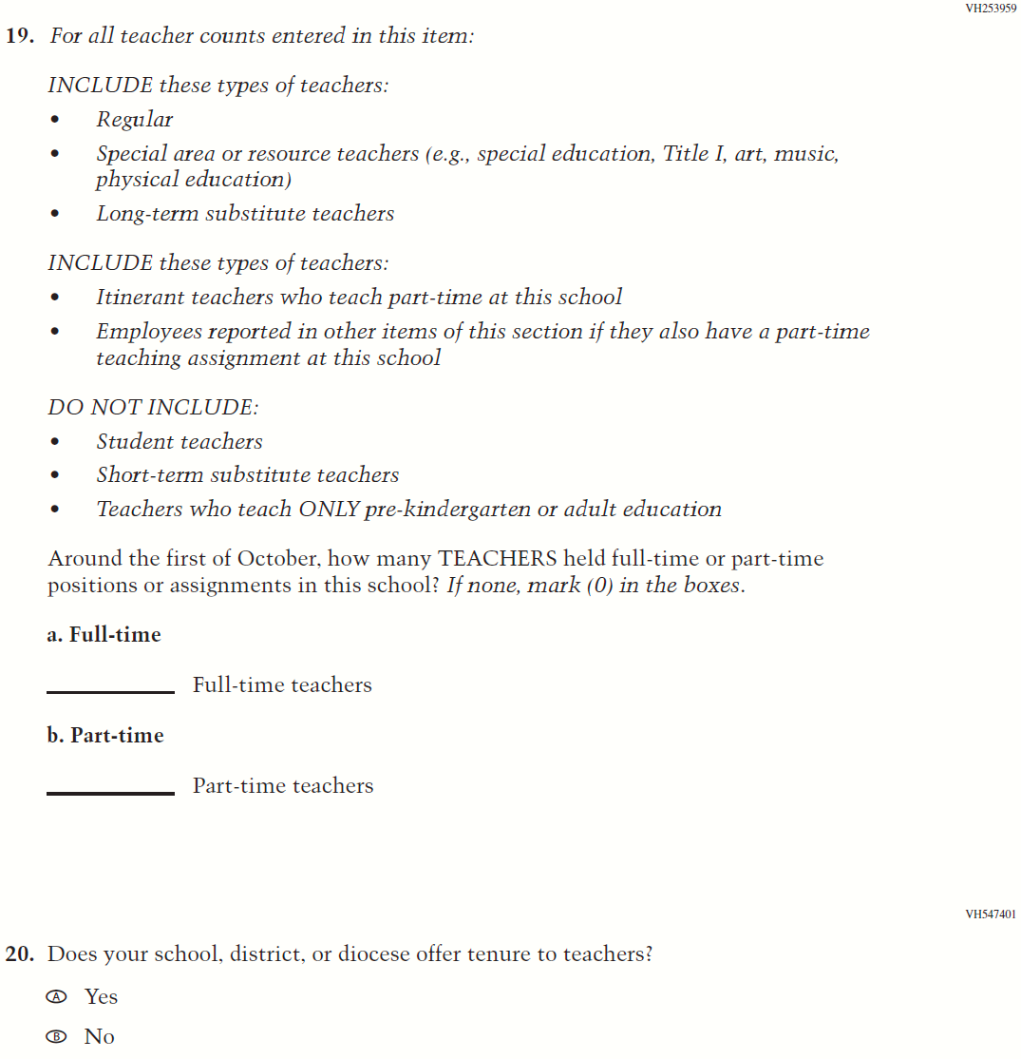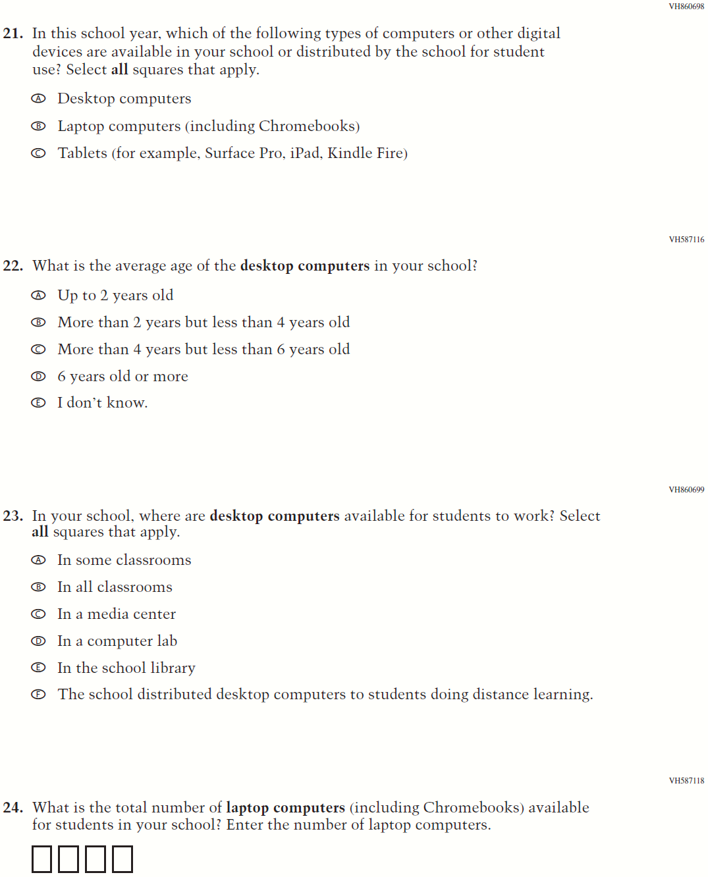
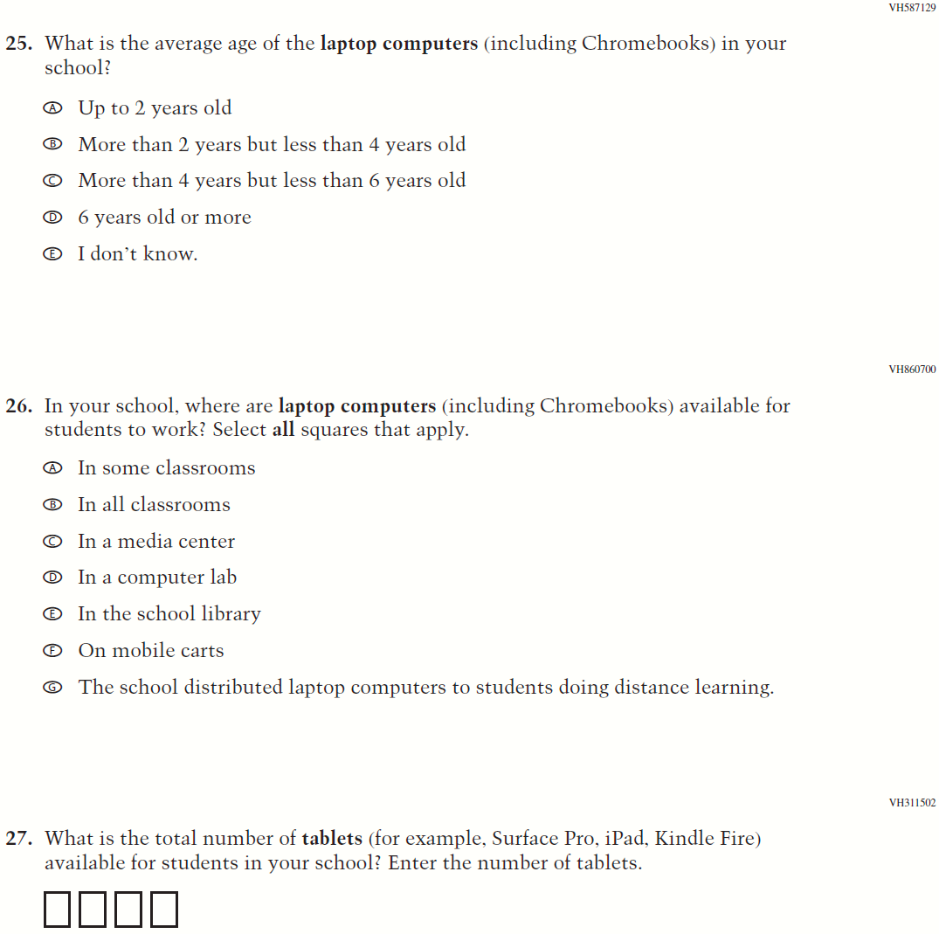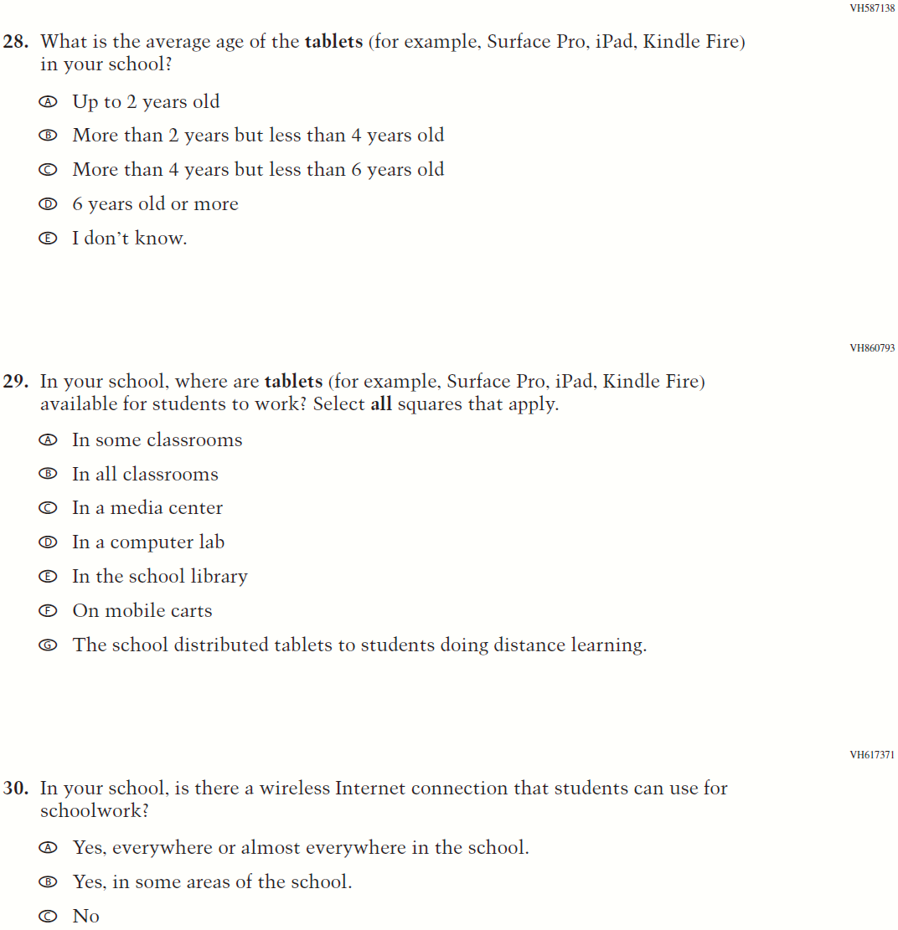

Appendix J3-5: Summary of Changes Operational Grade 4 and 8 Charter School

2021 Operational Grade 4 and 8 Charter School

Previous item | 2021 item | D/A/ R/NC+ | Rationale
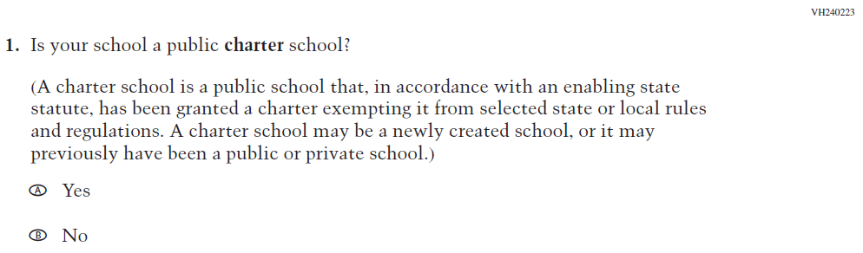  (2019 Grade 4, 8, and 12) | 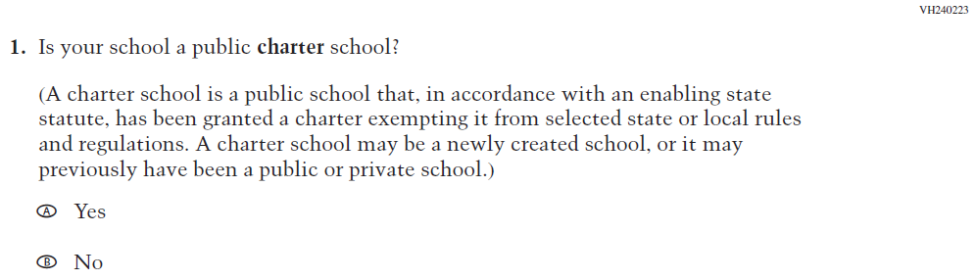  Issue: School Climate | NC | N/A
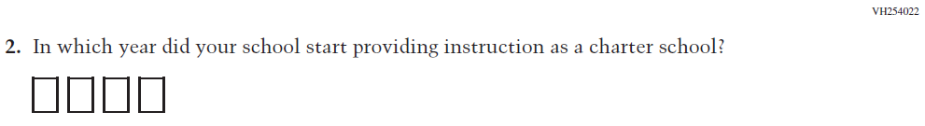  (2019 Grade 4, 8, and 12) | 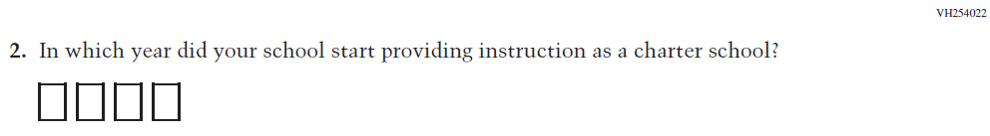  Issue: School Climate | NC | N/A
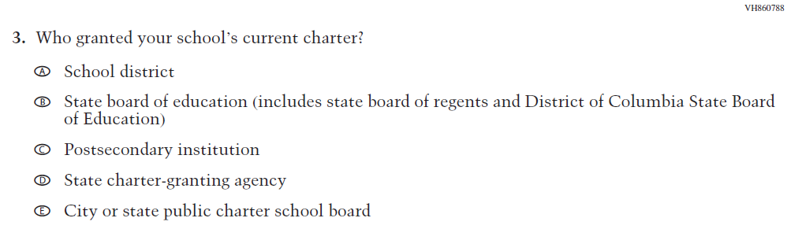  (2019 Grade 4, 8, and 12) | Issue: School Climate | NC | N/A
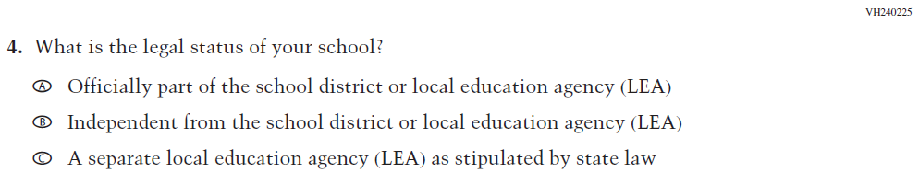  (2019 Grade 4, 8, and 12) | 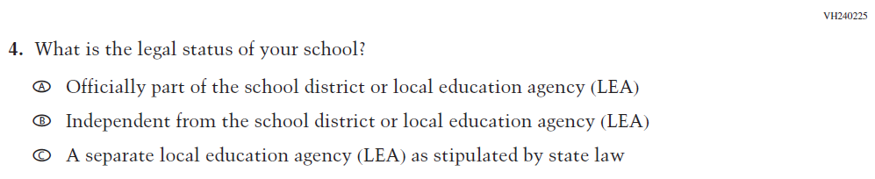  Issue: School Climate | NC | N/A

2021 Operational Grade 4 and 8 Charter School

Previous item | 2021 item | D/A/ R/NC+ | Rationale
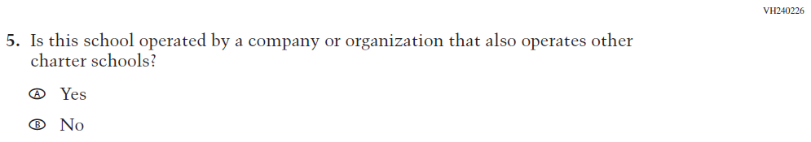  (2019 Grade 4, 8, and 12) | 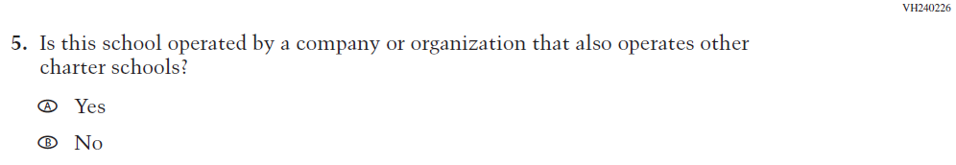  Issue: School Climate | NC | N/A
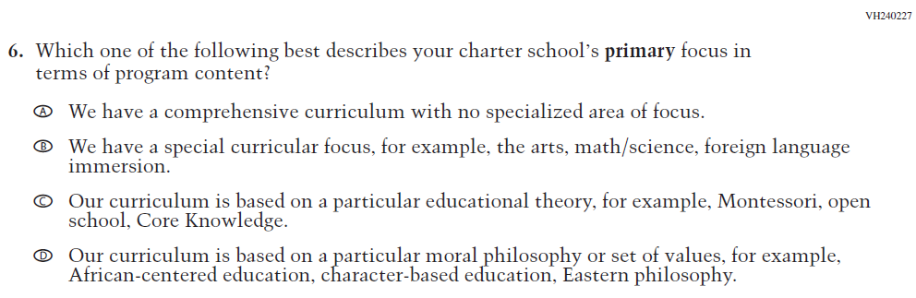  (2019 Grade 4, 8, and 12) | 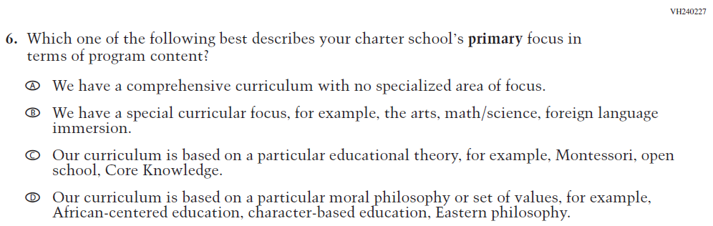  Issue: School Climate | NC | N/A
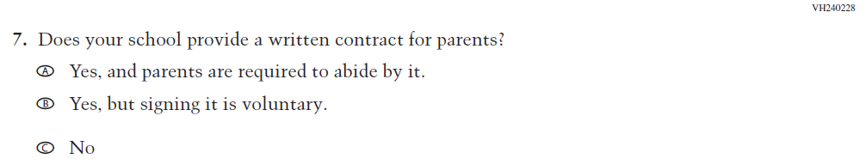  (2019 Grade 4, 8, and 12) | 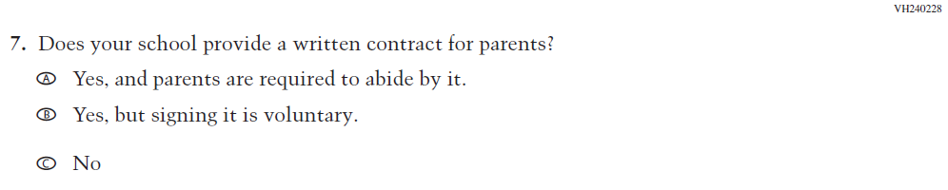  Issue: School Climate | NC | N/A
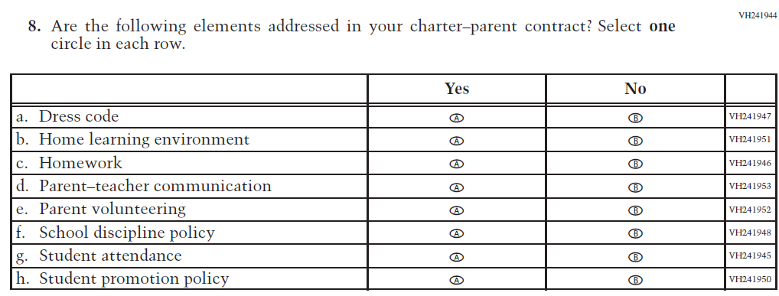  (2019 Grade 4, 8, and 12) | Issue: School Climate | NC | N/A

Appendix J3-6: Operational Grade 4 and 8 Charter School
Grade/Respondent | Item Number Initiating Skip Logic | Item Response(s) Initiating Skip Logic | Item Number(s) Being Skipped
Grade 4, 8, 12 School | 1 | B | 2, 3, 4, 5, 6, 7, 8
Grade 4, 8, 12 School | 7 | C | 8

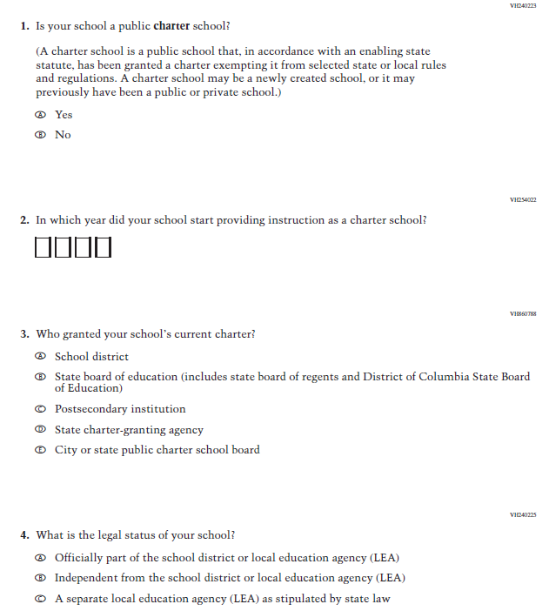

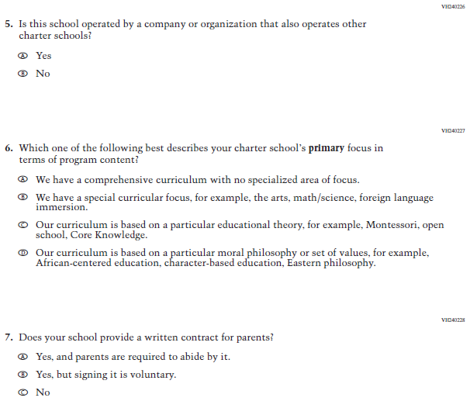

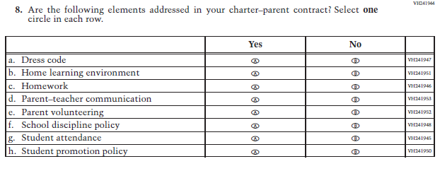

Appendix J3-7: Summary of Changes Operational Grade 4 Mathematics
2021 Operational Grade 4 Mathematics School

Previous item | 2021 item | D/A/ R/NC+ | Rationale
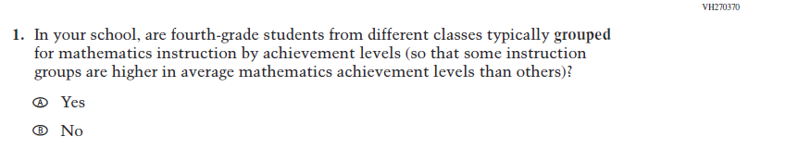  (2019 Grade 4) | Issue: Resources for Learning and Instruction | NC | N/A
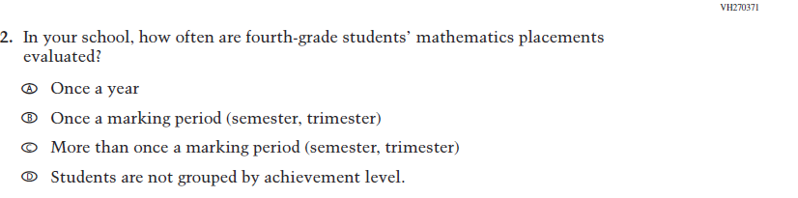  (2019 Grade 4) | Issue: Organization of Instruction | NC | N/A
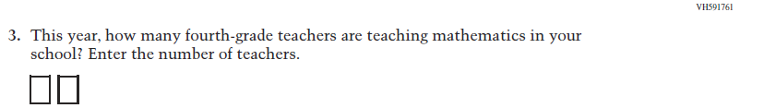  (2019 Grade 4) | Issue: Resources for Learning and Instruction | NC | N/A
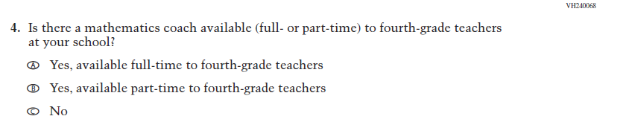  (2019 Grade 4) | Issue: Resources for Learning and Instruction | NC | N/A

2021 Operational Grade 4 Mathematics School

Previous item | 2021 item | D/A/ R/NC+ | Rationale
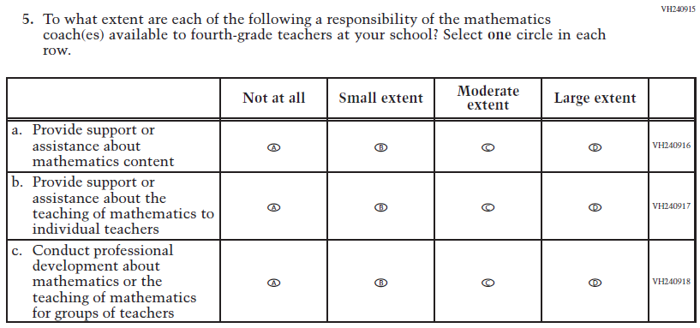  (2019 Grade 4) | Issue: Resources for Learning and Instruction | NC | N/A
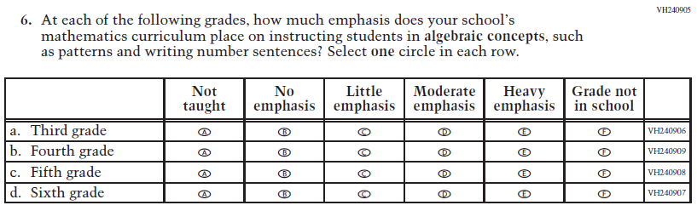  (2019 Grade 4) | Issue: Organization of Instruction | NC | N/A
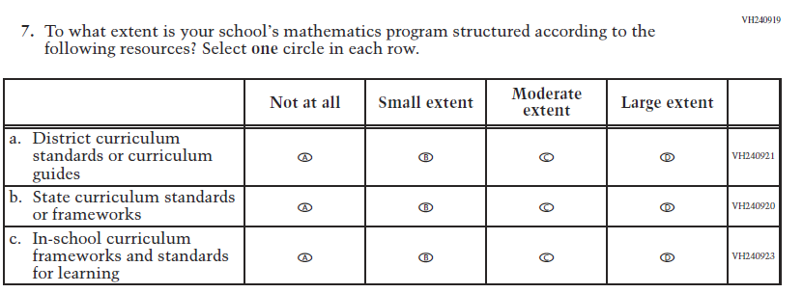  (2019 Grade 4) | Issue: Organization of Instruction | NC | N/A

2021 Operational Grade 4 Mathematics School

Previous item | 2021 item | D/A/ R/NC+ | Rationale
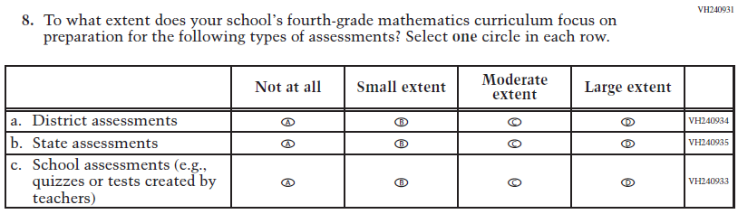  (2019 Grade 4) | Issue: Organization of Instruction | NC | N/A
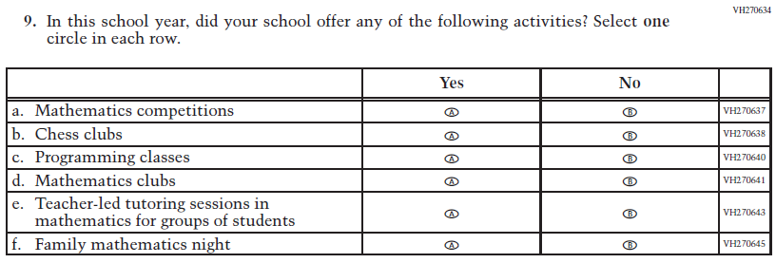  (2019 Grade 4) | Issue: Resources for Learning and Instruction | NC | N/A

Appendix J3-8: Operational Grade 4 Mathematics

Grade/Respondent | Item Number Initiating Skip Logic | Item Response(s) Initiating Skip Logic | Item Number(s) Being Skipped
Grade 4 School | 4 | C | 5

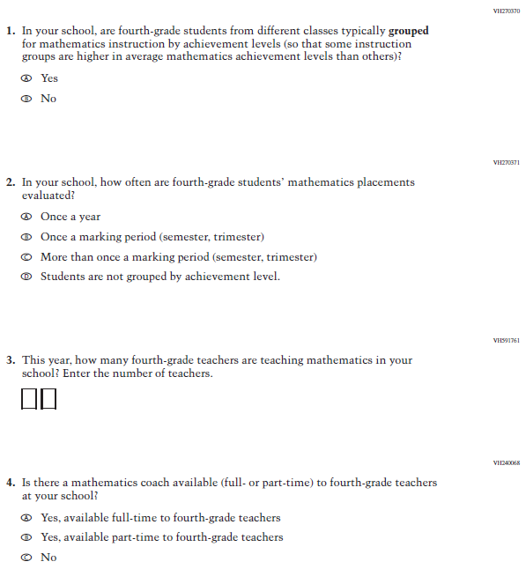

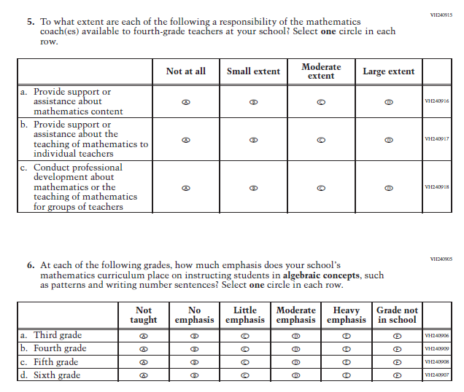

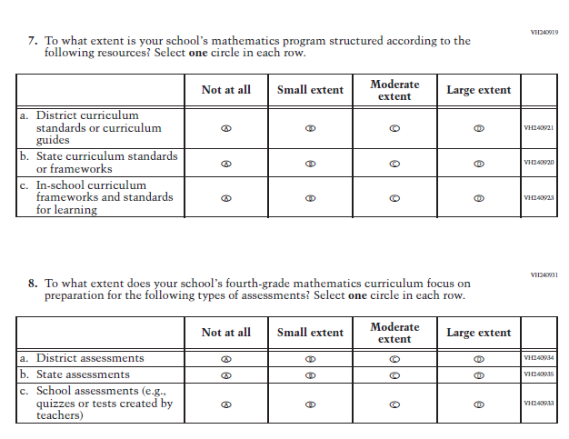

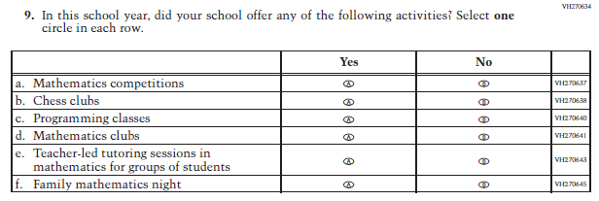

Appendix J3-9: Summary of Changes Operational Grade 8 Mathematics

2021 Operational Grade 8 Mathematics School

Previous item | 2021 item | D/A/ R/NC+ | Rationale
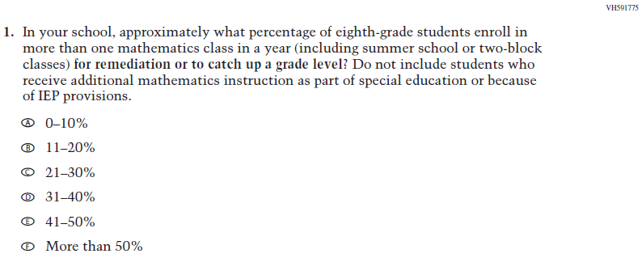  (2019 Grade 8) | Issue: Organization of Instruction | NC | N/A
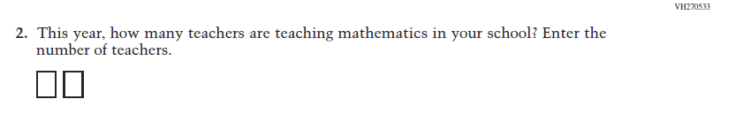  (2019 Grade 8) | Issue: Resources for Learning and Instruction | NC | N/A
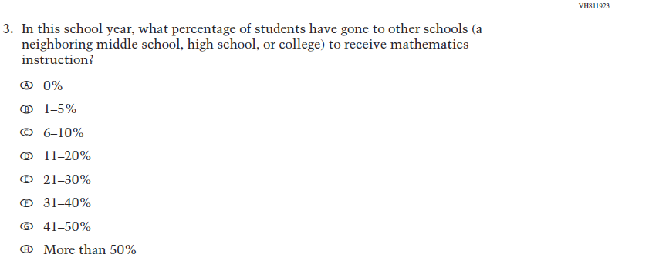  (2019 Grade 8) | Issue: Resources for Learning and Instruction | NC | N/A
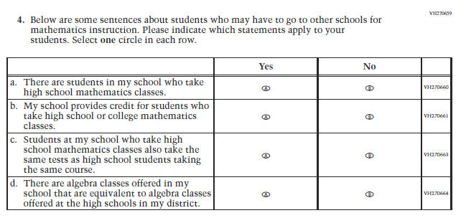(2019 Grade 8) | Issue: Resources for Learning and Instruction | NC | N/A
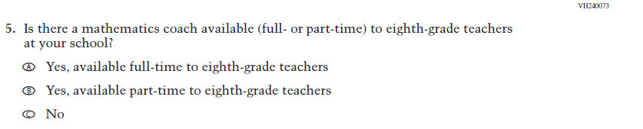  (2019 Grade 8) | Issue: Resources for Learning and Instruction | NC | N/A
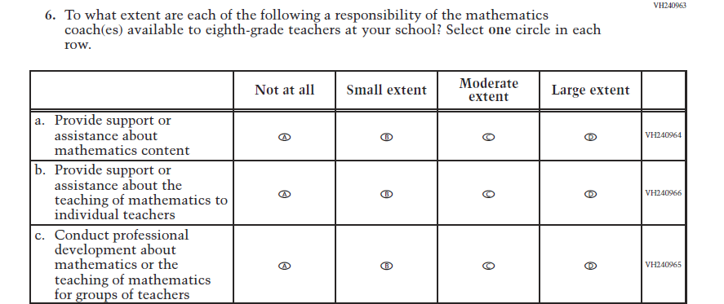  (2019 Grade 8) | Issue: Resources for Learning and Instruction | NC | N/A
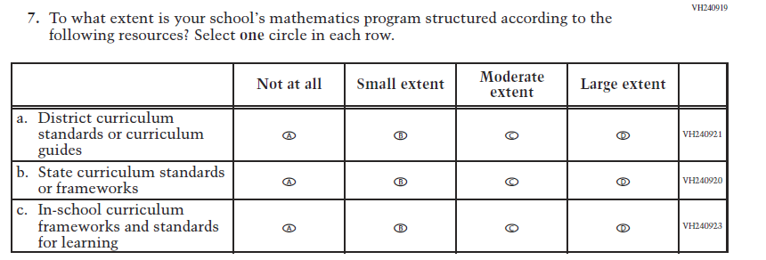  (2019 Grade 8) | Issue: Organization of instruction | NC | N/A
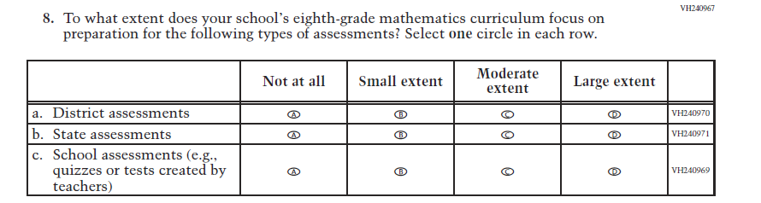  (2019 Grade 8) | Issue: Organization of instruction | NC | N/A
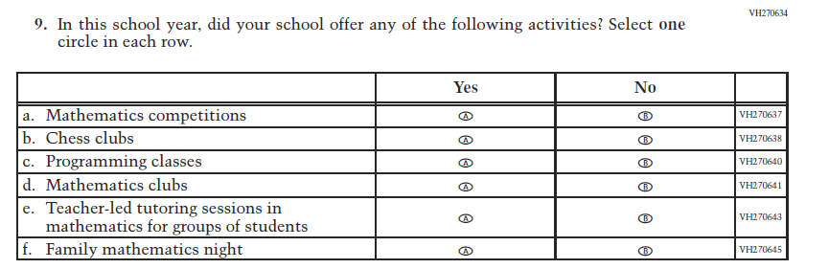  (2019 Grade 8) | Issue: Resources for Learning and Instruction | NC | N/A

Appendix J3-10: Operational Grade 8 Mathematics

Grade/Respondent | Item Number Initiating Skip Logic | Item Response(s) Initiating Skip Logic | Item Number(s) Being Skipped
Grade 8 School | 3 | A | 4
Grade 8 School | 5 | C | 6

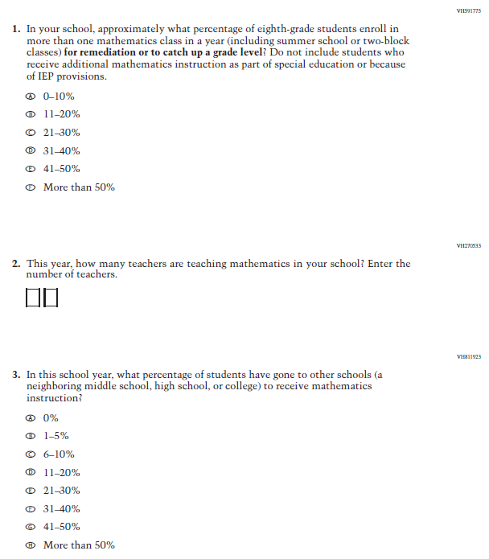

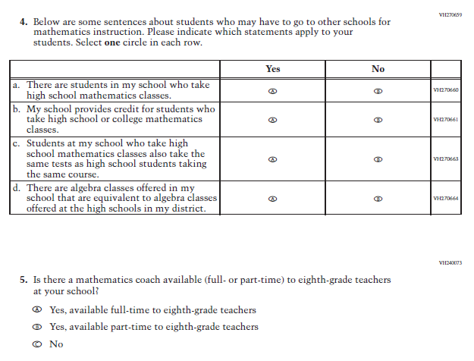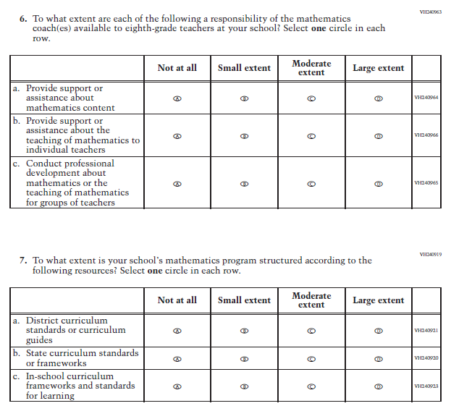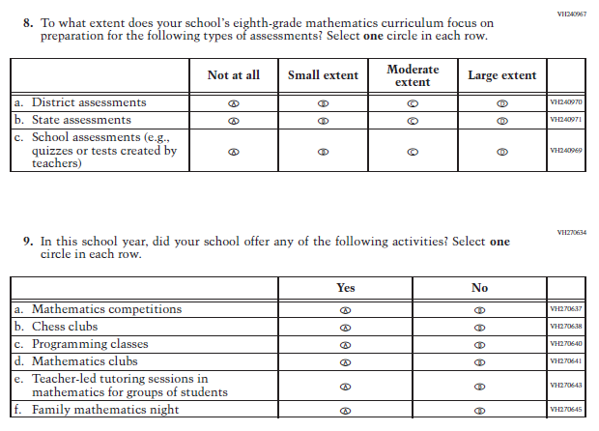

Appendix J3-11: Summary of Changes Operational Grade 4 Reading

2021 Operational Grade 4 Reading School

Previous item | 2021 item | D/A/ R/NC+ | Rationale
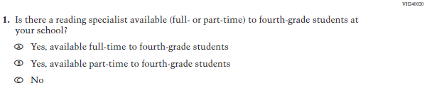  (2019 Grade 4) | Issue: Resources for Learning and Instruction | NC | N/A
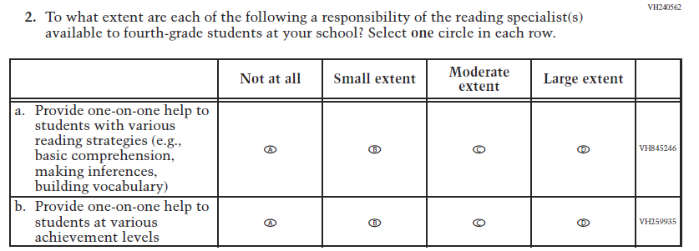  (2019 Grade 4) | Issue: Resources for Learning and Instruction | NC | N/A
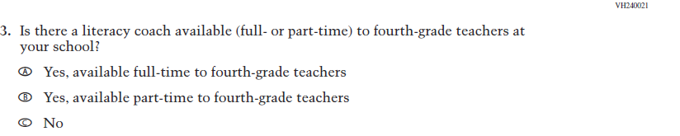  (2019 Grade 4) | Issue: Resources for Learning and Instruction | NC | N/A

2021 Operational Grade 4 Reading School

Previous item | 2021 item | D/A/ R/NC+ | Rationale
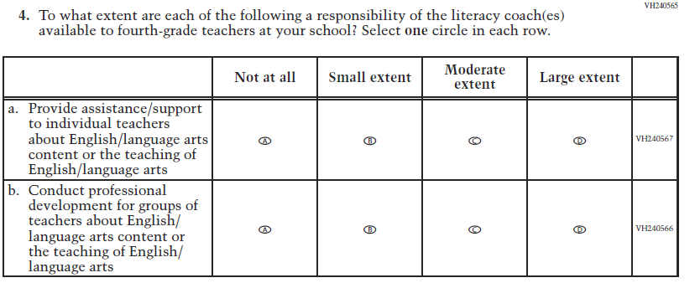  (2019 Grade 4) | Issue: Resources for Learning and Instruction | NC | N/A
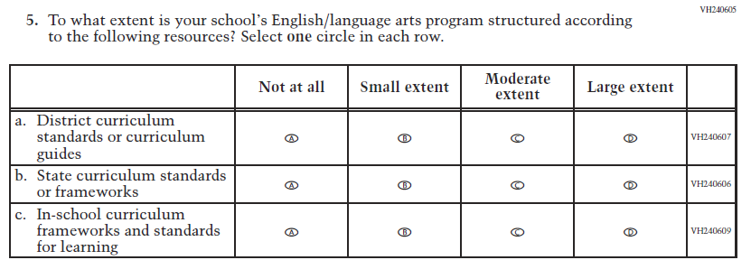  (2019 Grade 4) | Issue: Organization of Instruction | NC | N/A
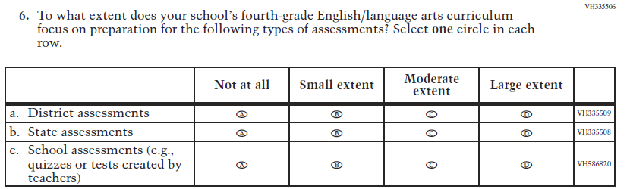  (2019 Grade 4) | Issue: Organization of Instruction | NC | N/A

2021 Operational Grade 4 Reading School

Previous item | 2021 item | D/A/ R/NC+ | Rationale
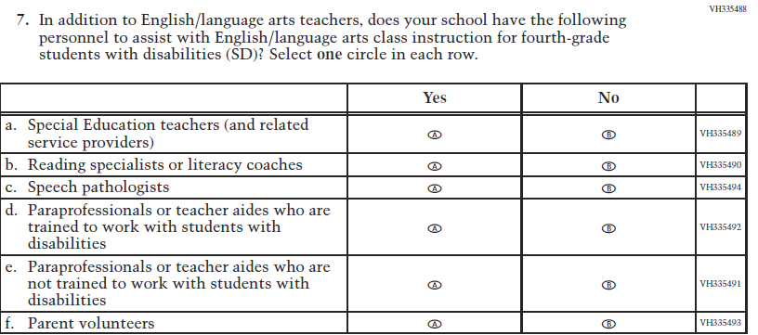  (2019 Grade 4) | Issue: Resources for Learning and Instruction | NC | N/A
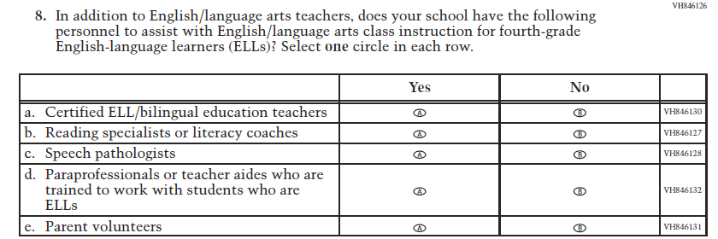  (2019 Grade 4) | Issue: Resources for Learning and Instruction | NC | N/A
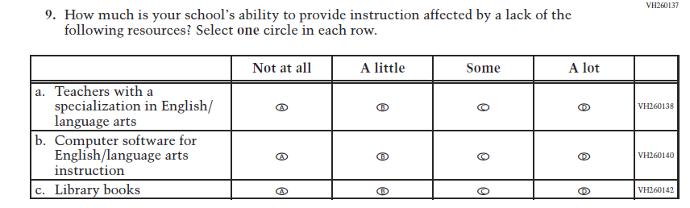  (2019 Grade 8) | Issue: Resources for Learning and Instruction | NC | N/A

Appendix J3-12: Operational Grade 4 Reading

Grade/Respondent | Item Number Initiating Skip Logic | Item Response(s) Initiating Skip Logic | Item Number(s) Being Skipped
Grade 4 School | 1 | C | 2
Grade 4 School | 3 | C | 4

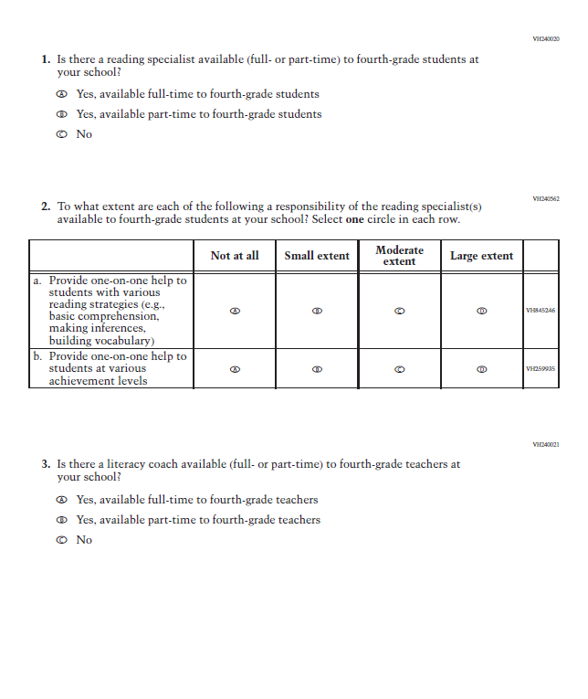

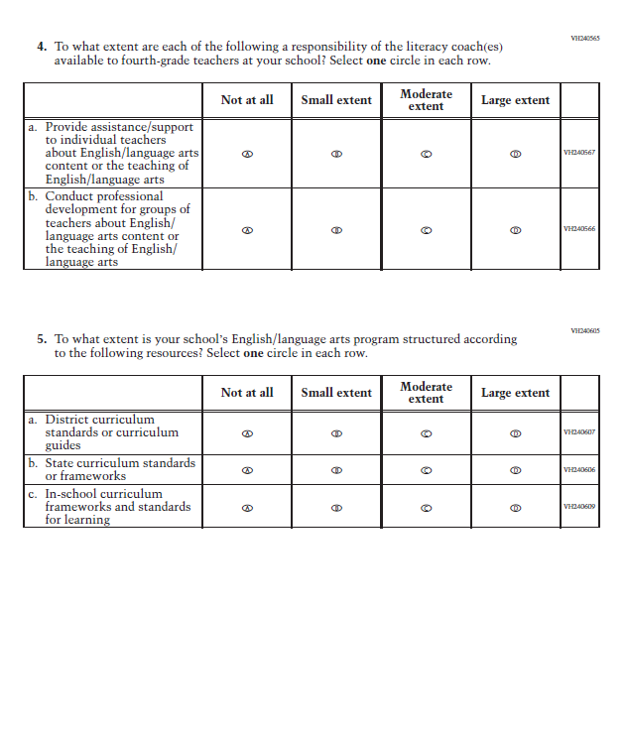

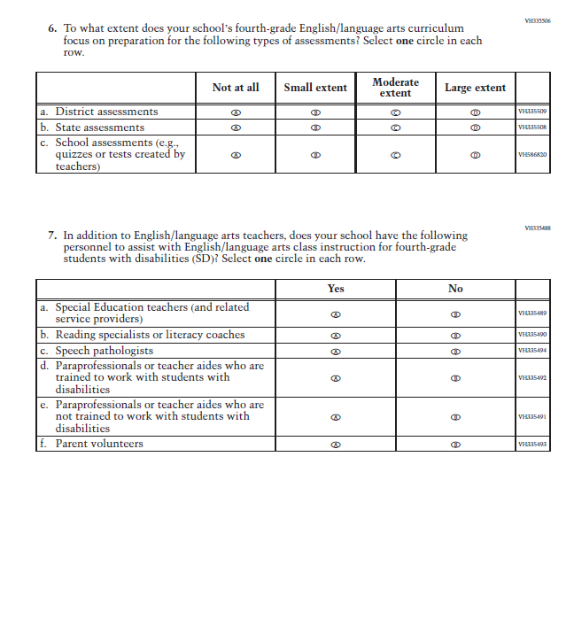
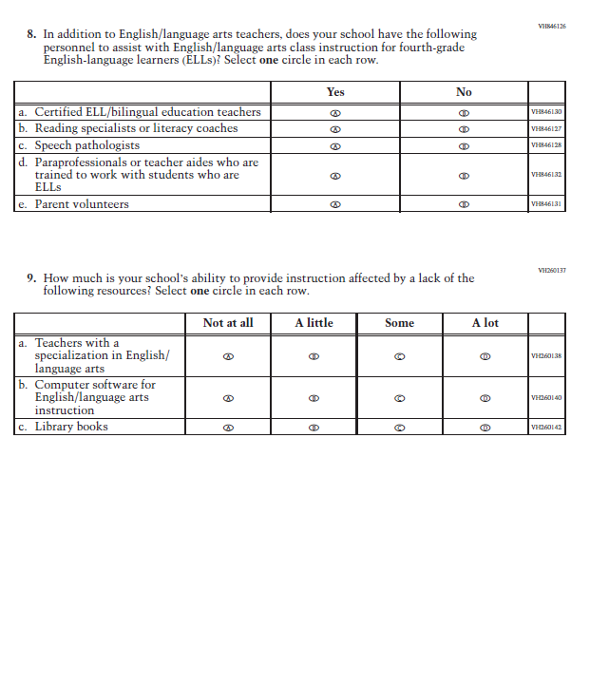

Appendix J3-13: Summary of Changes Operational Grade 8 Reading

2021 Operational Grade 8 Reading School

Previous item | 2021 item | D/A/ R/NC+ | Rationale
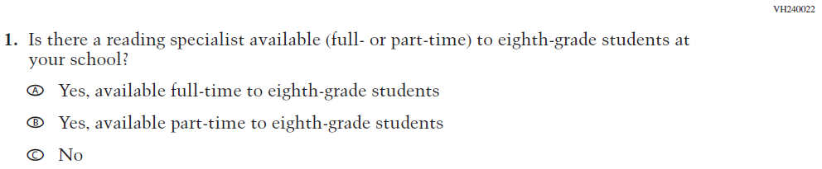  (2019 Grade 8) | Issue: Resources for Learning and Instruction | NC | N/A
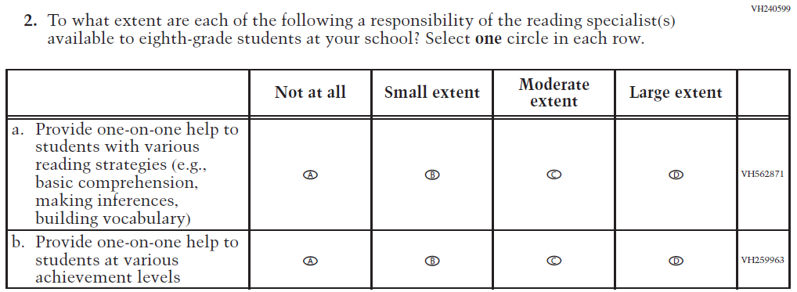  (2019 Grade 8) | Issue: Resources for Learning and Instruction | NC | N/A

2021 Operational Grade 8 Reading School

Previous item | 2021 item | D/A/ R/NC+ | Rationale
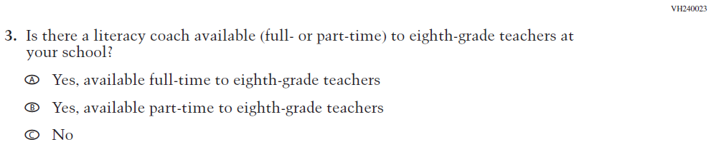  (2019 Grade 8) | Issue: Resources for Learning and Instruction | NC | N/A
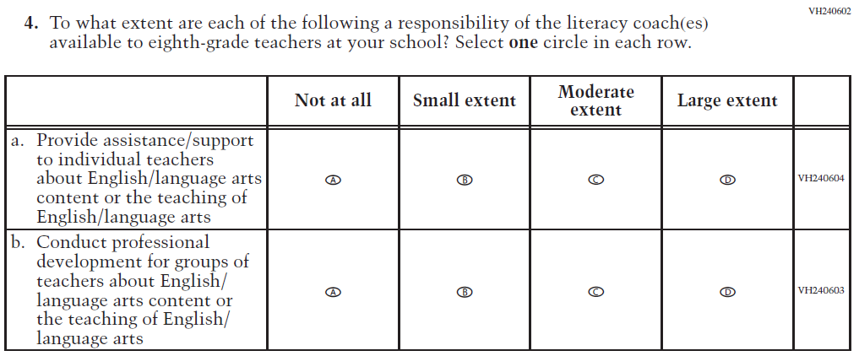  (2019 Grade 8) | Issue: Resources for Learning and Instruction | NC | N/A
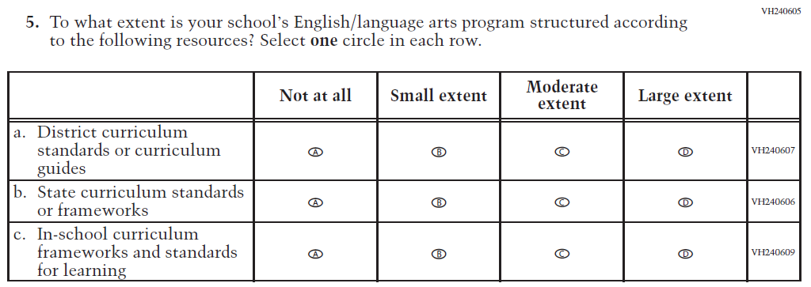  (2019 Grade 8) | Issue: Organization of Instruction | NC | N/A

2021 Operational Grade 8 Reading School

Previous item | 2021 item | D/A/ R/NC+ | Rationale
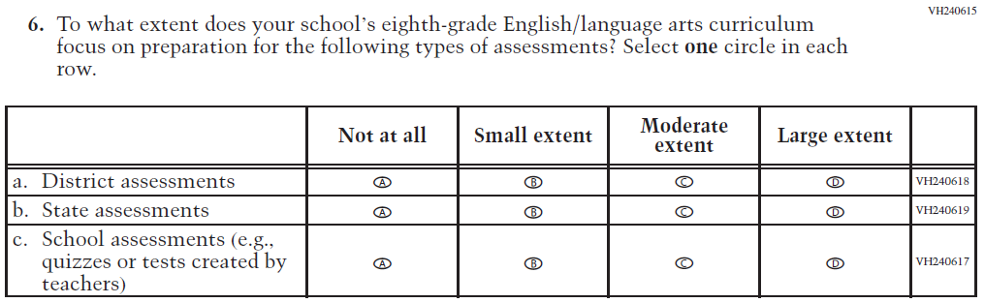  (2019 Grade 8) | Issue: Organization of Instruction | NC | N/A
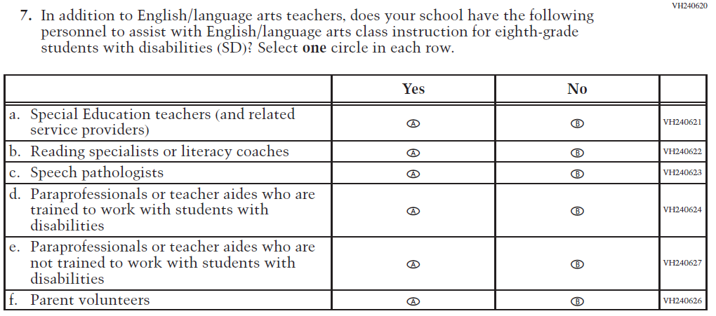  (2019 Grade 8) | Issue: Resources for Learning and Instruction | NC | N/A

2021 Operational Grade 8 Reading School

Previous item | 2021 item | D/A/ R/NC+ | Rationale
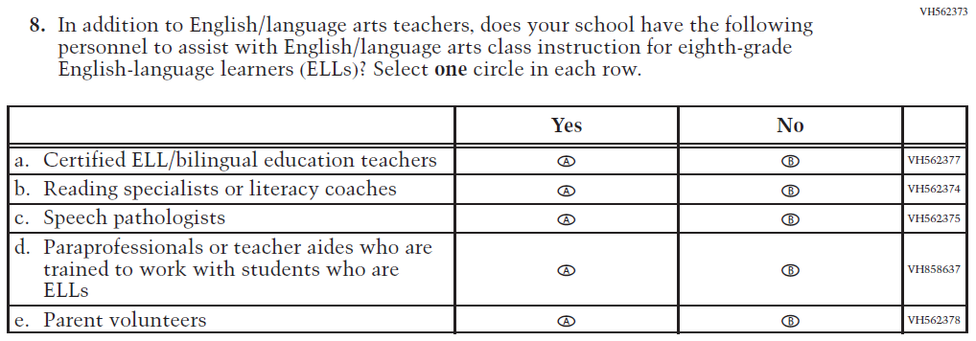  (2019 Grade 8) | Issue: Resources for Learning and Instruction | NC | N/A
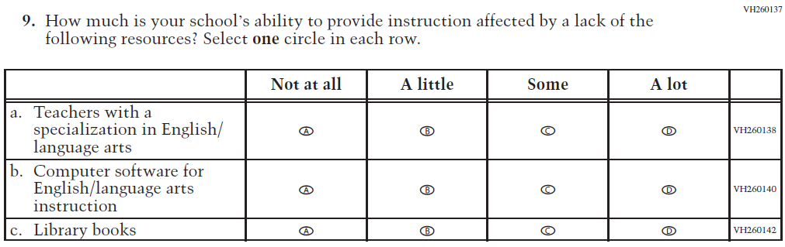  (2019 Grade 8) | Issue: Resources for Learning and Instruction | NC | N/A

.

Appendix J3-14: Operational Grade 8 Reading

Grade/Respondent | Item Number Initiating Skip Logic | Item Response(s) Initiating Skip Logic | Item Number(s) Being Skipped
Grade 8 School | 1 | C | 2
Grade 8 School | 3 | C | 4

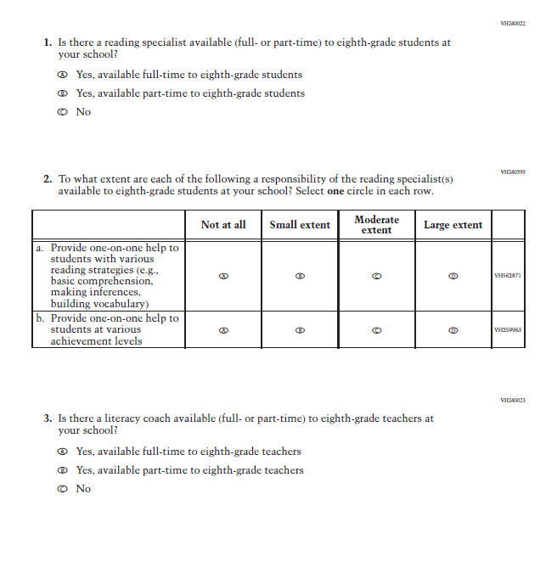
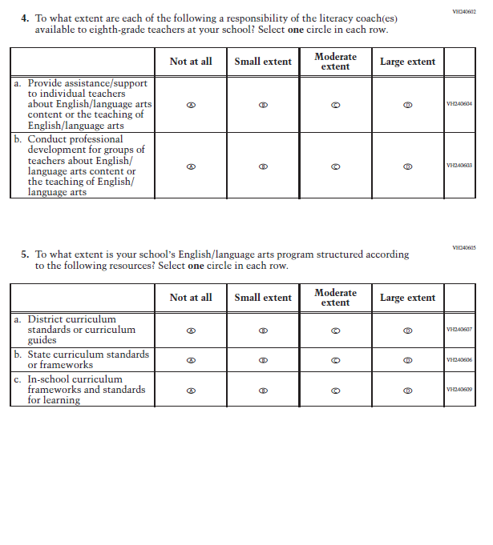
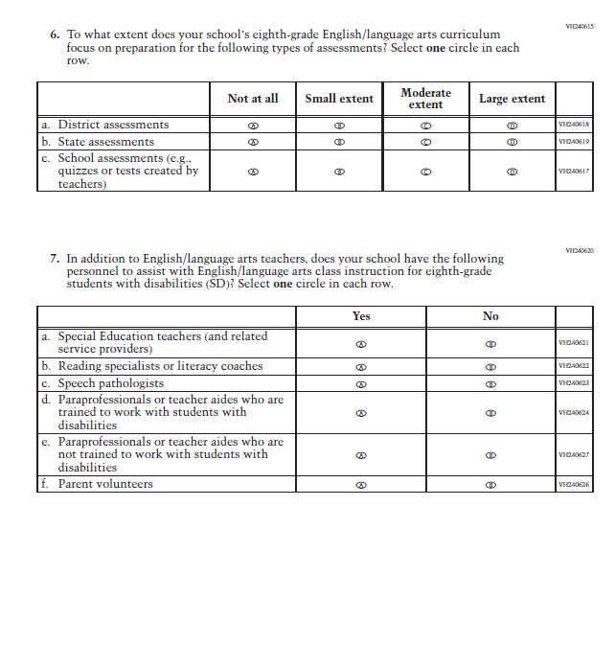
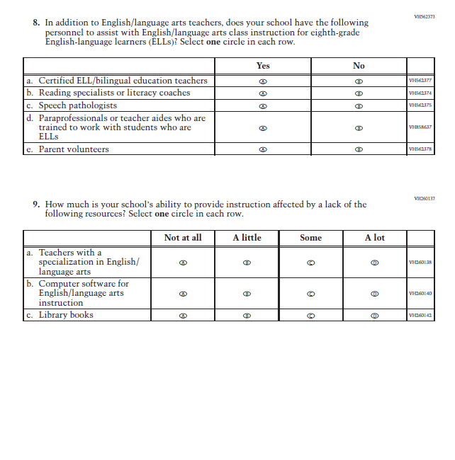

Appendix J3-15: Operational Grade 4 COVID-19 School Items
Skip Logic Table
Grade/Respondent | Item Number Initiating Skip Logic | Item Response(s) Initiating Skip Logic | Item Number(s) Being Skipped
Grade 4 School | 7 | B | 8, 9, 10, 11, 12, 13, 14

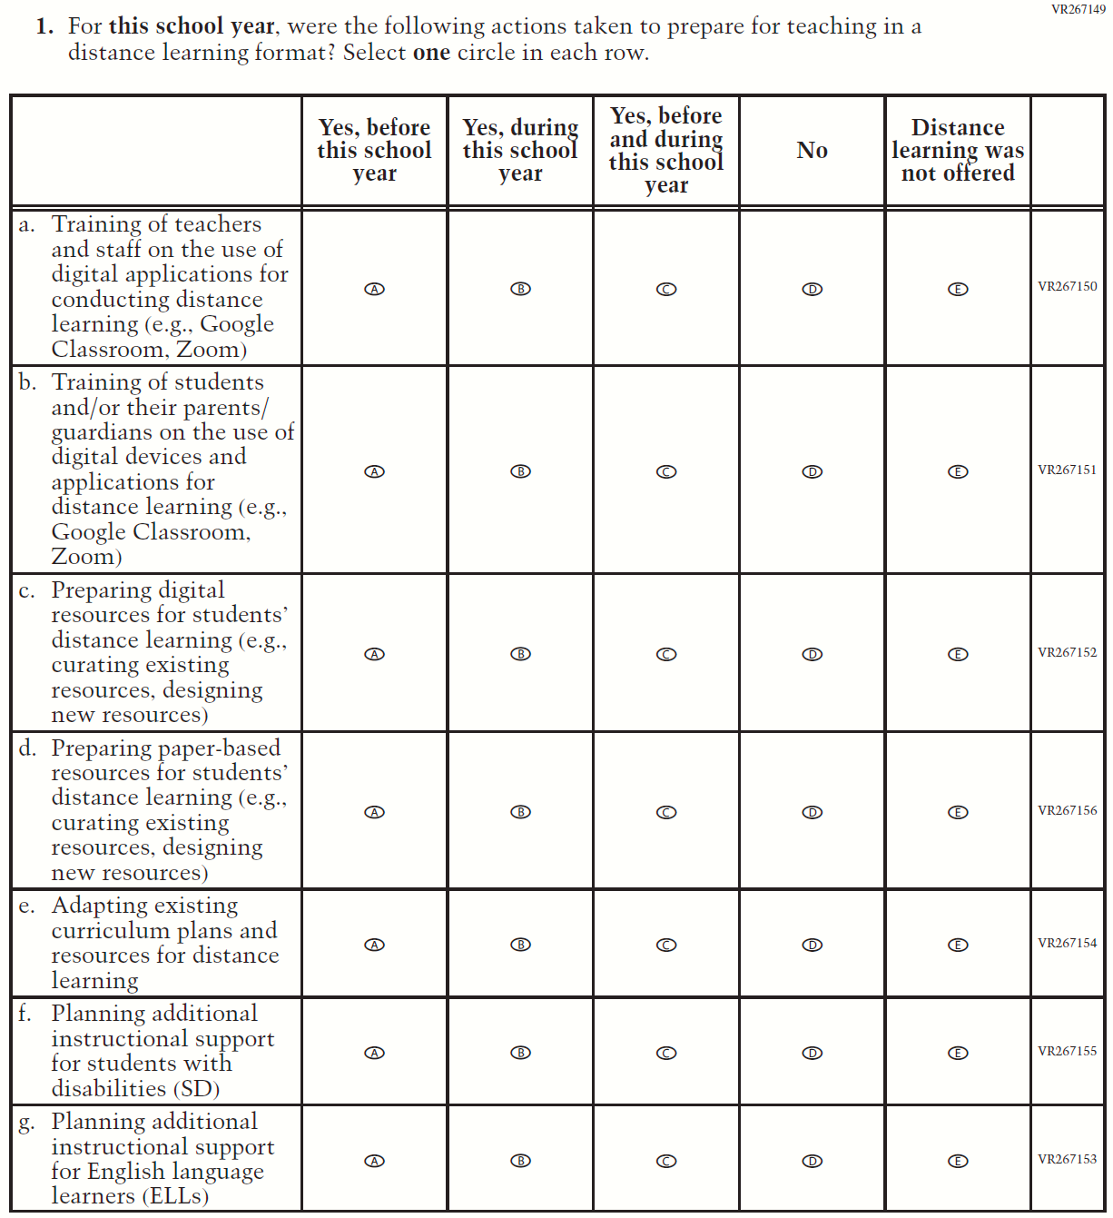

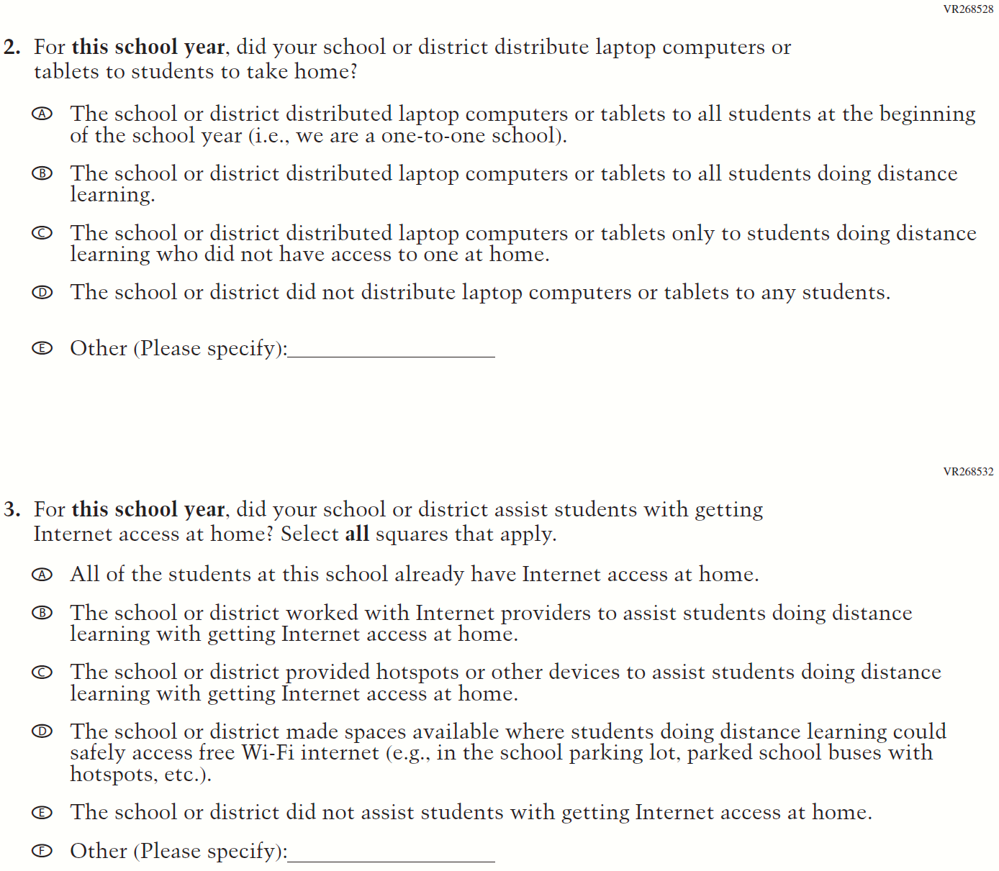

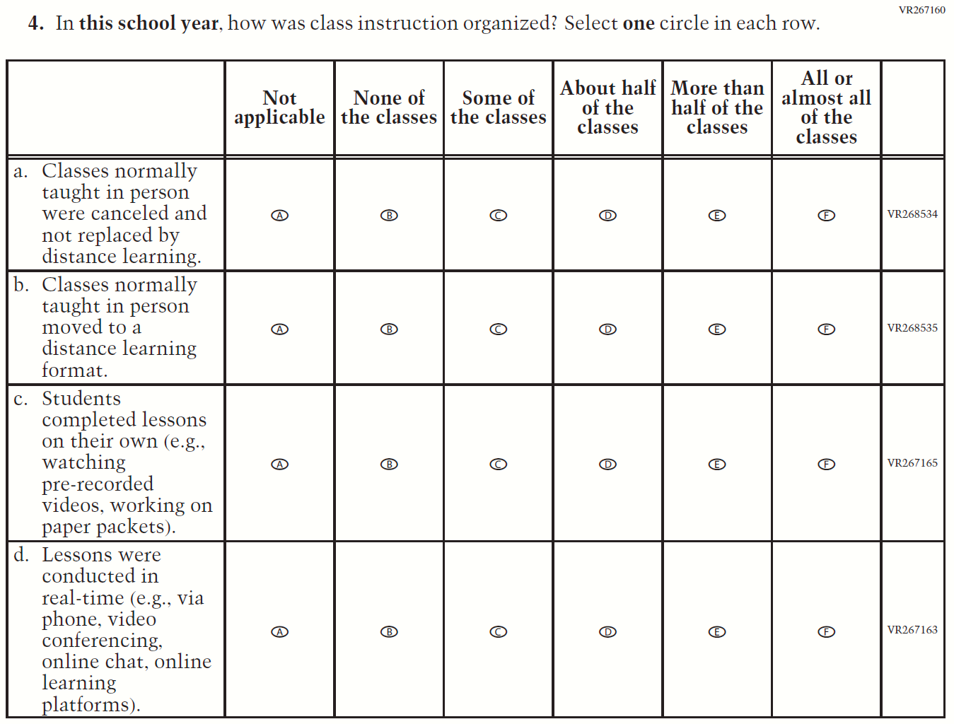
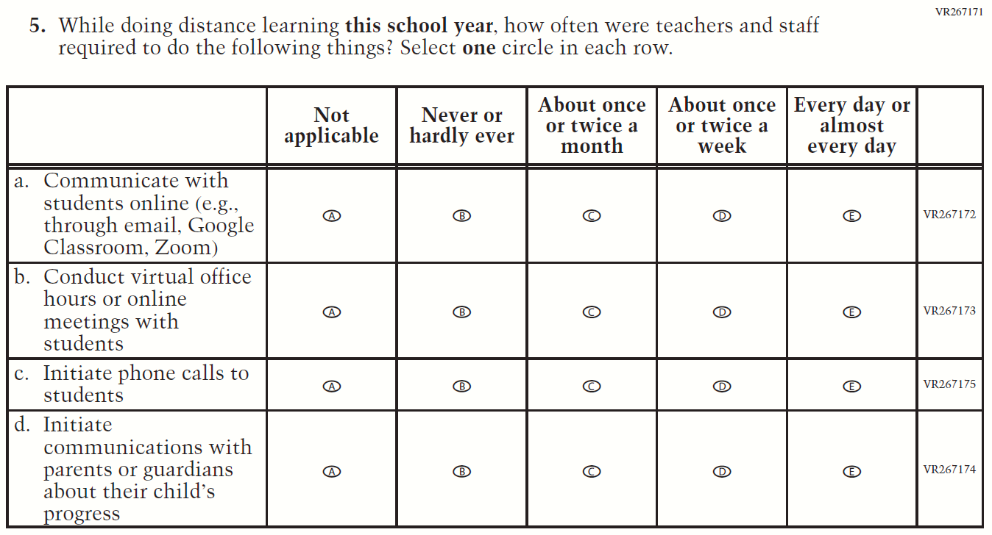

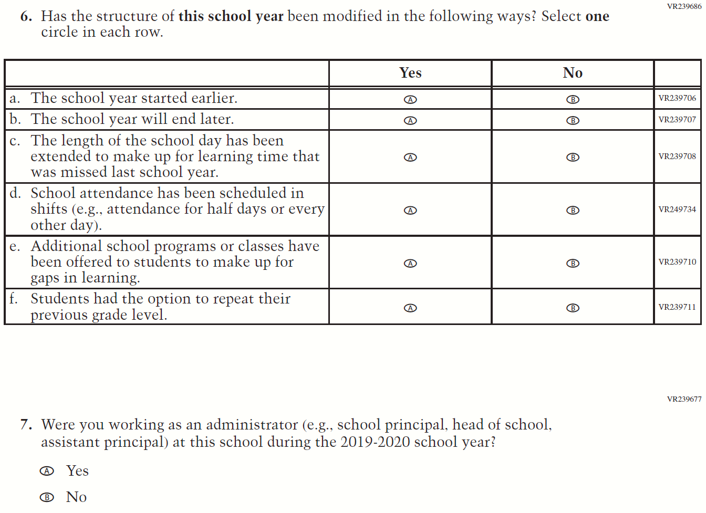

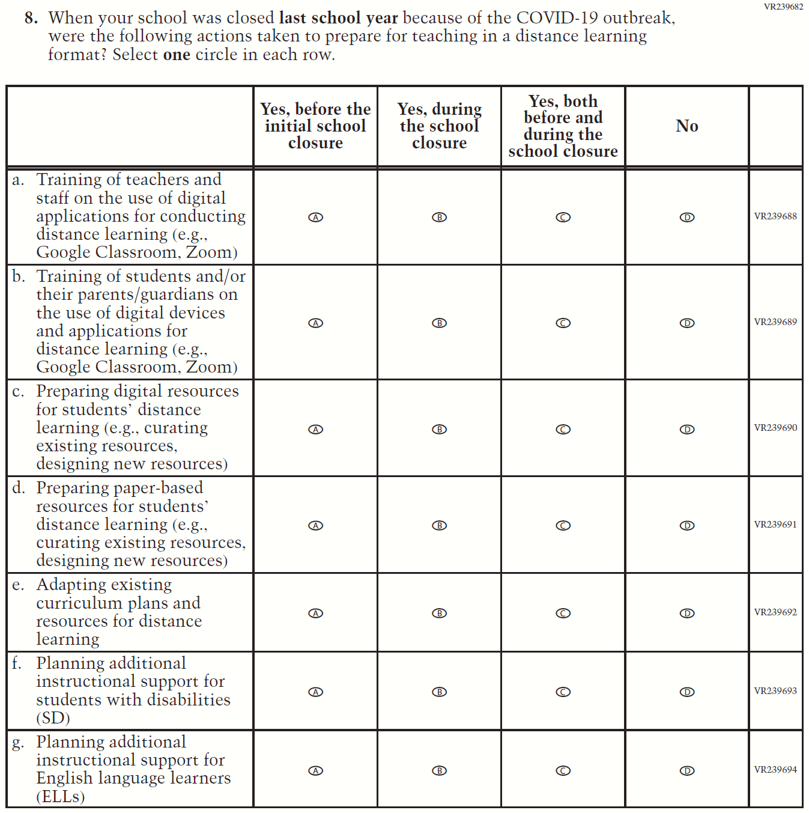

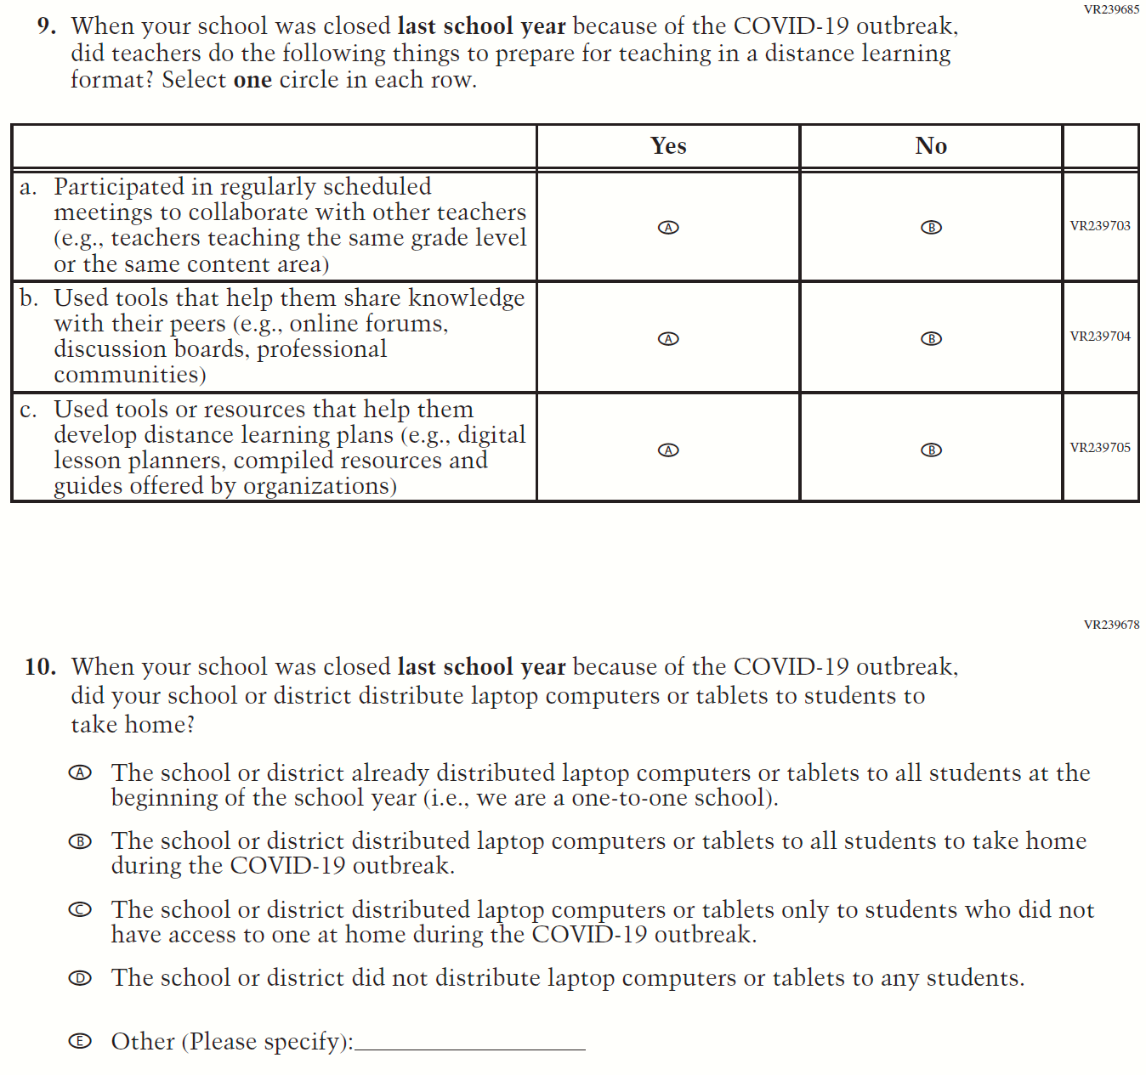

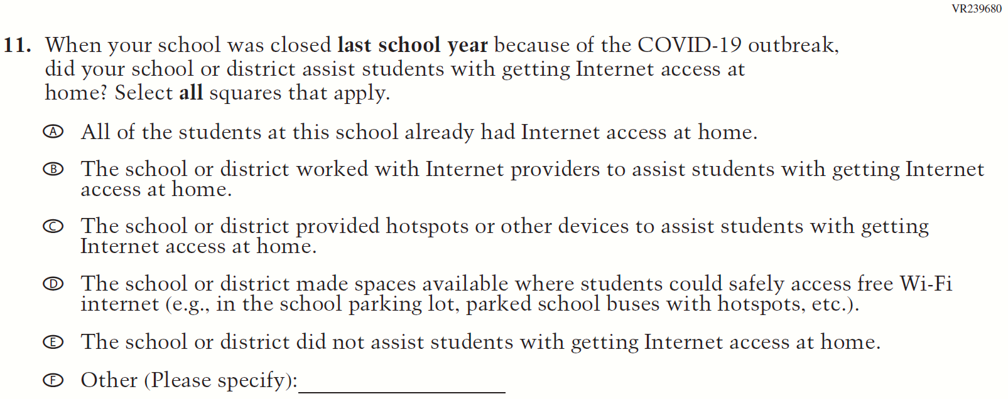

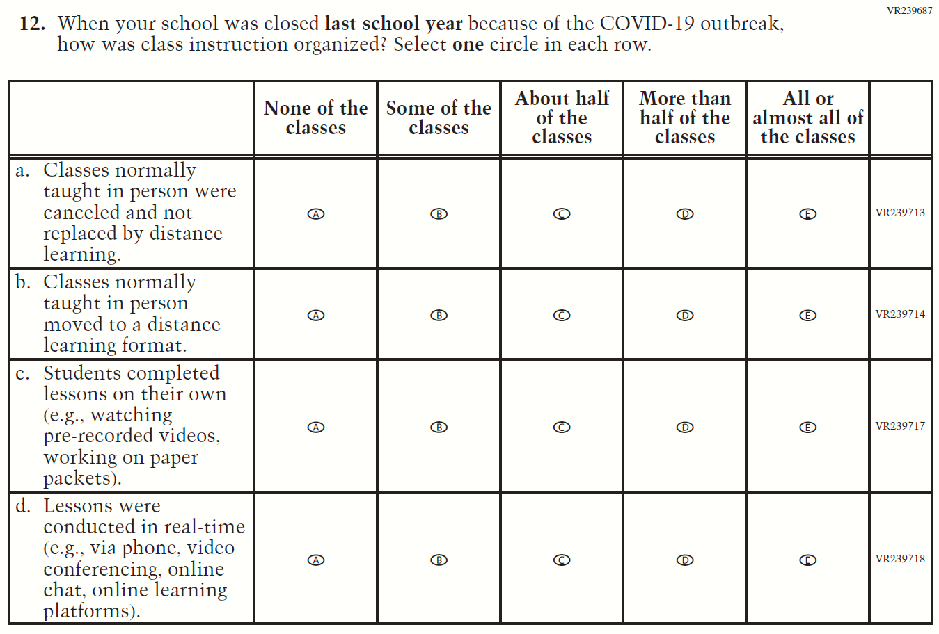

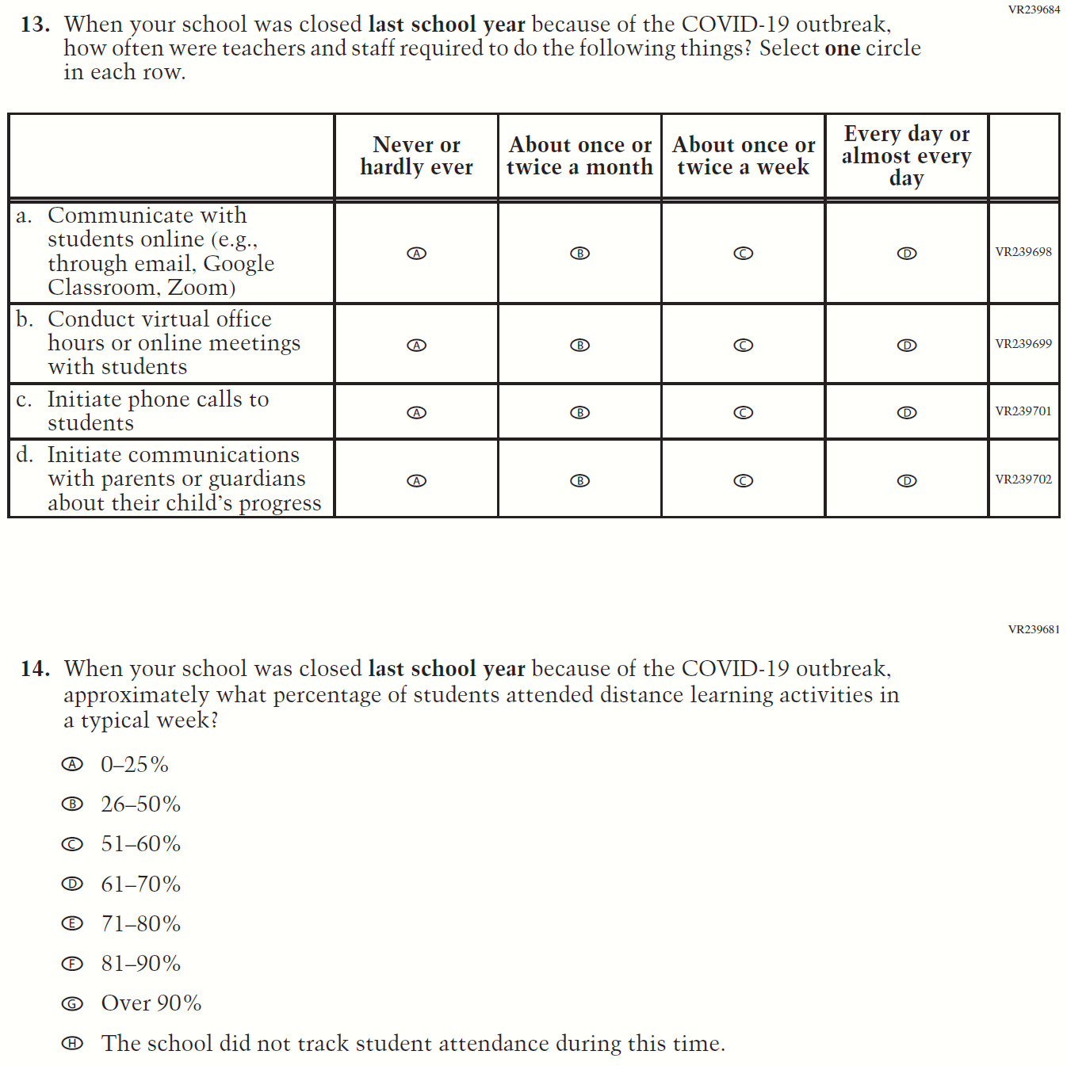

Appendix J3-16: Operational Grade 8 COVID-19 School Items
Skip Logic Table
Grade/Respondent | Item Number Initiating Skip Logic | Item Response(s) Initiating Skip Logic | Item Number(s) Being Skipped
Grade 8 School | 7 | B | 8, 9, 10, 11, 12, 13, 14

