Supporting Statement for Uranium Data Program

Part B: Collections of Information Employing Statistical Methods
OMB No. 1905-0160
Form EIA-851A Domestic Uranium Production Report (Annual)
Form EIA-851Q Domestic Uranium Production Report (Quarterly)
Form EIA-858 Uranium Marketing Annual Survey

December 2020

Independent Statistics & Analysis
www.eia.gov
U.S. Department of Energy
Washington, DC 20585

Table of Contents
Part B: Collections of Information Employing Statistical Methods i
B.1. Respondent Universe 1
B.2. Statistical Methods 1
B.3. Maximizing Response Rates 2
B.4. Test Procedures and Form Consultations 2
B.5. Statistical Consultations 2

B.1. Respondent Universe
EIA’s Uranium Data Program (UDP) respondent universe currently consists of 80 unique respondents filing 102 surveys in each calendar year because some respondents are required to complete multiple surveys based upon their business activities. Table 1 shows the number of respondents for each individual survey form. Table 2 shows which respondents are required to submit multiple survey forms. All entities involved in the U.S. domestic uranium industry are required to fill out at least one of the three surveys, regardless of size. The respondent universe is researched and updated annually using Nuclear Regulatory Commission and state mining/environmental department project lists. Current respondents are also required to identify counterparties in the contract section of the EIA-858 survey. Depending on the range of business activities, a respondent may be required to fill out one, two, or all three surveys. Of the 80 respondents, 9 submit all three surveys, 2 submit both Forms EIA-851Q and EIA-851A, 2 submit both Forms EIA-851A and EIA-858, 17 submit only Form EIA-851A, and 50 submit only Form EIA-858.

Table 1: Number of respondents for each survey
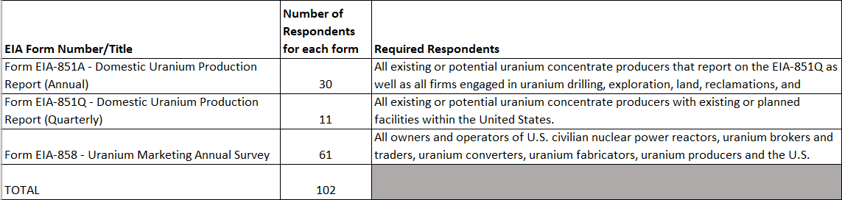
Table 2: Unique respondent survey frame
EIA Form Number | Number of respondents who submit all three surveys | Number of respondents who only submit both the EIA-851Q and EIA-851A | Number of respondents who only submit both the EIA-851A and EIA-858 | Number of respondents who only submit the  EIA-851A | Number of respondents who only submit the  EIA-858 | Total respondent universe
Form EIA-851Q | 9 | 2
Form EIA-851A |  |  | 2 | 17
Form EIA-858 |  |  |  |  | 50
Total | 9 | 2 | 2 | 17 | 50 | 80

B.2. Statistical Methods
There are no sampling methodologies used with EIA UDP forms, as all these surveys are censuses of the target populations. Surveys have historically received 100% response rates and have not used imputation or estimation methods. After data checks, if there are any edits, the respondent is contacted to ensure their reported figures are correct.

B.3. Maximizing Response Rates
To maximize response rates, EIA surveys and instructions are designed to be concise and written to facilitate accurate reporting. Data that are not expected to change from year-to-year or month-to-month are pre-populated on the forms, such as respondent contact information and prior year uranium inventory balances. Notifications are emailed early to maximize the time respondents have to complete the surveys.
EIA’s Internet data collection system makes forms available on-line as soon as respondents obtain a secure ID and password. All respondents currently access and complete their required forms through the on-line EIA Internet data collection system. Form due dates are the same each period so that respondents can schedule their completion activities.
Response rates are 100%. The table below shows the response rates of each survey for the 2020 calendar year. Any non-respondents are contacted by email, telephone, and letter to request data submission, until a zero non-response rate is obtained. Follow-up email messages citing failure to file the required form are sent to all non-respondents. If the follow-up email messages do not result in a response, additional correspondence requesting immediate submission is sent to the supervisor of the primary contact and, if necessary, to higher-level management officials at the non-responding entity. These letters are sent from the EIA Office Director or, on rare occasions, from the Assistant Administrator or Administrator of EIA.
Table 3: 2020 Response Rates
EIA Survey | Response Rates for 2020
851Q | 100%
851A | 100%
858 | 100%

Respondents who file via the Internet system are given the opportunity to either correct or explain unusual data during their submission. These explanations are reviewed by EIA staff. Respondents are contacted if further clarification is needed.

B.4. Test Procedures and Form Consultations
Every data element of every survey submission is reviewed for accuracy by the survey manager.

B.5. Statistical Consultations
For information concerning this request for OMB approval, please contact Tim Shear, at 202-586-0403, or by email at Tim.Shear@eia.gov.

