Reminder Email for households that started but did not finish the survey

Subject:

Reminder: National Household Travel Survey (%%ANO%%)
Description:
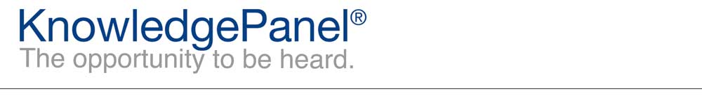

Dear %%firstname%%,
We recently sent you the National Household Travel Survey for the US Department of Transportation. Your answers are very important to us! It looks like we need some additional information in order to consider the survey completed; if there are additional household members who need to complete their section and they’re not available please complete it for them so that we can include your responses in this study. We would appreciate you finishing this survey at your earliest convenience by using the link below. If you have already completed the survey, thank you and please disregard this email.
%%LINK%%
Depending on your email reader, you may need to copy and paste the link into your web browser.
Thanks,
The KnowledgePanel Team

Participating in KnowledgePanel® gives you the unique opportunity to make your opinions heard among business and policy decision makers. You can express those opinions fully confident that KnowledgePanel is committed to safeguarding your privacy. We will never transfer your personally identifiable information (name, address, phone number) to users of our research without your consent, nor will we ever try to sell you anything.
If you have any questions about our Privacy Policy or practices, you can email us at privacy@knowledgepanel.com.
If you believe you have received this email in error or prefer to opt out from receiving our emails, send a message to KnowledgePanel support at support@knowledgepanel.com or call us toll free at 1-800-782-6899.
© 2019 Ipsos | Panel Relations
1 Upper Pond Rd #D-2, Parsippany, NJ 07054

