# Supporting Statement for Statement of Assurance of Compliance with 85 Percent Enrollment Ratios - VA Form #10215 & #10215a

**OMB #2900-NEW**

1. **Justification**

# Explain the circumstances that make the collection of information necessary. Identify legal or administrative requirements that necessitate the collection of information.

The Department of Veterans Affairs (VA) is authorized to pay education benefits to Veterans and other eligible persons pursuing approved programs of education under chapters 30, 31, 32, 33, and 35 of title 38, U.S.C., and chapter 1606 of title 10, U.S.C.

As part of the benefits authorization process, Code of Federal Regulations (CFR) Title 38 § 21.4201 places restrictions on enrollment based on the percentage of students receiving financial support in any approved program. Except as otherwise provided by regulation, VA shall not approve an [enrollment](https://www.law.cornell.edu/definitions/index.php?width=840&height=800&iframe=true&def_id=3afee38aaf8ee638868154c9da65c5a2&term_occur=999&term_src=Title%3A38%3AChapter%3AI%3APart%3A21%3ASubpart%3AD%3ASubjgrp%3A234%3A21.4201) in any course for an eligible Veteran, not already enrolled, for any period during which more than 85 percent of the students enrolled in the course are having all or part of their tuition, fees or other charges paid for them by the educational institution or by VA under title 38, U.S.C., or under title 10,

U.S.C. This is known as the 85/15 Rule and is applicable to Institutions of Higher Learning (IHLs) and Non-College Degree postsecondary schools (NCDs).

The requirements apply to all courses, not otherwise exempt or waived, offered by all educational institutions, regardless of whether the institution is degree-granting, proprietary profit, proprietary nonprofit, eleemosynary, public and/or tax-supported.

These schools are required to submit information necessary to determine if their programs of training are approved for the payment of VA educational assistance. This specified information is submitted either to VA or to the State Approving Agency (SAA) having jurisdiction over that school.

# Indicate how, by whom, and for what purposes the information is to be used; indicate actual use the agency has made of the information received from current collection.

VA uses data from this information collection to ensure the compliance of Institutions of Higher Learning and Non-College Degree training institutions that are approved by the VA and that no more than 85% of students in any approved program are students in receipt of financial support from the educational institution or by VA under title 38, U.S.C., or under title 10, U.S.C. Without this information, VA might pay benefits in error.

# Describe whether, and to what extent, the collection of information involves the use of automated, electronic, mechanical, or other technological collection techniques or other forms of information technology, e.g. permitting electronic submission of responses, and the basis for the decision for adopting this means of collection. Also describe any consideration of using information technology to reduce burden.

Information technology is being used to reduce the burden to the extent currently possible. This form is available as a fillable PDF document and is submitted to VA via email. Most schools utilize financial aid software packages that allow VA beneficiary data to be sorted/reported when appropriately categorized. This allows the school to readily identify affected VA students among the total student population in receipt of financial aid.

# Describe efforts to identify duplication. Show specifically why any similar information already available cannot be used or modified for use for the purposes described in Item 2 above.

Program reviews were conducted to identify potential areas of duplication; however, none were found to exist. There is no known department or agency which maintains the necessary information, nor is it available from other sources within our department.

# If the collection of information impacts small businesses or other small entities, describe any methods used to minimize burden.

The collection of information will not have a significant impact on a substantial number of small entities. Only schools with programs approved for the payment of VA Education benefits are required to supply this information.

# Describe the consequences to Federal program or policy activities if the collection is not conducted or is conducted less frequently as well as any technical or legal obstacles to reducing burden.

There are no consequences to Federal program or policy activities without this collection, other than directly violating § 21.4201.

# Explain any special circumstances that would cause an information collection to be conducted more often than quarterly or require respondents to prepare written responses to a collection of information in fewer than 30 days after receipt of it; submit more than an original and two copies of any document; retain records, other than health, medical,

**government contract, grant-in-aid, or tax records for more than three years; in connection with a statistical survey that is not designed to produce valid and reliable results that can be generalized to the universe of study and require the use of a statistical data classification that has not been reviewed and approved by OMB.**

The collection of this information does not require any special circumstances.

# If applicable, provide a copy and identify the date and page number of the publication in the Federal Register of the sponsor’s notice, required by 5 CFR 1320.8(d), soliciting comments on the information collection prior to submission to OMB. Summarize public comments received in response to that notice and describe actions taken by the sponsor in responses to these comments. Specifically address comments received on cost and hour burden.

The Department notice was published in the Federal Register on July 28, 2021,

No. 142, Volume Number 86 page 40680. One comment received as shown below.

September 24, 2021

Department of Veterans Affairs 810 Vermont Avenue NW Washington, DC 20420 *Submitted via electronic portal*

Re: Agency Information Collection Activity: Statement of Assurance of Compliance with 85 Percent Enrollment Ratios, 86 FR 40680

To Whom It May Concern:

The undersigned veterans and military service organizations write to comment on the collection of statements of assurance of compliance with the 85 percent enrollment ratios at the Department of Veterans Affairs (VA). VA has also published a notice for comment on the collection of 35 percent exemption requests from the 85-15 reporting requirement (86 FR 41536). We submit this comment for both notices as they are closely related topics concerning the 85-15 rule. We agree with the continued collection of these statements of assurance and 35 percent exemption requests as they are needed to understand whether institutions of higher education have violated the 85-15 rule or are in compliance.

The 85-15 rule prohibits paying VA benefits to students in a program with more than 85 percent of students enrolled having their tuition paid in whole or in part by the school or VA. The 85-15 rule has a long history at VA and was instituted to combat fraud and abuse by predatory for­ profit schools targeting veterans for their GI Bill benefits following World War 11. While it has undergone numerous amendments over the decades, it has served as a model for Title IV protections such as the 90-10 rule and continues to protect veterans to this day.

Institutions that have less than 35 percent veteran enrollment are exempt from reporting 85-15 calculations. Using data from the 2017 GI Bill Comparison Tool, we estimated that about 2.8 percent of schools (178 of 6,117) exceeded the 35 percent threshold and should be submitting enrollment reports to VA.1 About three-quarters of these schools were for-pro fit institutions .

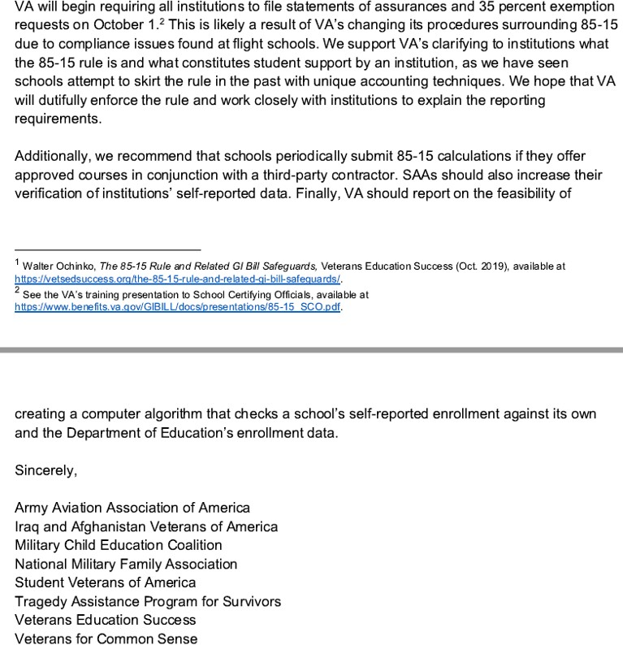

**VA Response:** Thanks for your comment regarding the VA Forms 22-10215 and 10215a (Statement of Assurance of Compliance with 85 Percent Enrollment Ratios), and the 22-10216 (35% Exemption Request From 85/15 Reporting Requirement), OMB numbers 2900-NEW.

# Explain any decision to provide any payment or gift to respondents, other than remuneration of contractors or grantees.

VA does not provide any gifts to respondents.

# Describe any assurance of privacy, to the extent permitted by law, provided to respondents and the basis for the assurance in statute, regulation, or agency policy.

Our assurance of confidentiality is covered by 38 U.S.C. 5701 and our System of Records, Compensation, Pension, Education and Vocational Rehabilitation and Employment Records – VA (58VA21/22/28), which are contained in the Privacy Act Issuances, 2012 Compilation.

# Provide additional justification for any questions of a sensitive nature (Information that, with a reasonable degree of medical certainty, is likely to have a serious adverse effect on an individual's mental or physical health if revealed to him or her), such as sexual behavior and attitudes, religious beliefs, and other matters that are commonly considered private; include specific uses to be made of the information, the explanation to be given to persons from whom the information is requested, and any steps to be taken to obtain their consent.

None of the information collected is of a sensitive nature.

# Estimate of the hour burden of the collection of information:

Estimate of Information Collection Burden.

* + 1. Number of Respondents: 10,000.
    2. Frequency of Response: Quarterly.
    3. Annual Burden Hours: 40,000 (40,000 X 60 / 60)
    4. Estimated Completion Time: 60 minutes
    5. The respondent population for VA Form 22-10215 and the corresponding continuation sheet, VA Form 22-10215a is comprised of School Certifying Officials who are required to periodically report this information to the VA. VA cannot make further assumptions about the population of respondents because of the variability of factors such as the educational background and wage potential of respondents. Therefore, VBA used general wage data to estimate the respondents’ costs associated with completing the information collection.

The Bureau of Labor Statistics (BLS) gathers information on full-time wage and salary workers. According to the latest available BLS data, the mean hourly wage is $27.17 based on the BLS wage code – “00-0000 All Occupations.” This information was taken from the following website: [https://www.bls.gov/oes/current/oes_nat.htm.](https://www.bls.gov/oes/current/oes_nat.htm)

Legally, respondents may not pay a person or business for assistance in completing the information collection. Therefore, there are no expected overhead costs for completing the information collection. VBA estimates the total cost to all respondents to be $1,086,800.00 (40,000 burden hours x

$27.17 per hour).

# Provide an estimate of the total annual cost burden to respondents or record-keepers resulting from the collection of information. (Do not include the cost of any hour burden shown in Items 12 and 14).

This submission does not involve any record keeping charges.

# Provide estimates of annual cost to the Federal Government. Also, provide a description of the method used to estimate cost, which should include quantification of hours, operation expenses (such as equipment, overhead, printing, and support staff), and any other expense that would not have been incurred without this collection of information. Agencies also may aggregate cost estimates from Items 12, 13, and 14 in a single table.

Estimated Charges to the Federal Government:

|  |  |  |  |  |  |  |
| --- | --- | --- | --- | --- | --- | --- |
| Grade | Step | Burden Time | Hourly Rate | Cost Per Response | Number of Respondents | Total |
| 11 | 05 | 30  minutes | $30.28 | $ 15.14 | 40,000 | $ 605,600.00 |
| Overhead at 100% Salary | | | | | | $ 605,600.00 |
| Overhead charges are 100% of salary and are the same as the wage listed above; and the amount is included in the total. | | | | | |  |
| Processing / Analyzing Charges | | | | | | $ 0.00 |
| Printing and Production Cost | | | | | | $ 0.00 |
| Total Cost to Government | | | | | | $ 605,600.00 |

The processing time estimates above were based on the actual amount of time employees of the grade level spent to process to completion a VA Form 22-10215 (and VA Form 22-102015a if applicable,) received from an approved IHL or NCD.

# Explain the reason for any burden hour changes since the last submission.

N/A, new collection.

# For collections of information whose results will be published, outline plans for tabulation and publication. Address any complex analytical techniques that will be used. Provide the time schedule for the entire project, including beginning and ending dates of the collection of information, completion of report, publication dates, and other actions.

The information collection is not for publication or tabulation use.

# If seeking approval to not display the expiration date for OMB approval of the information collection, explain the reasons that display would be inappropriate.

We are not seeking approval to omit the expiration date for OMB approval.

# Explain each exception to the certification statement identified in Item 19, “Certification for Paperwork Reduction Act Submissions,” of OMB 83-I.

This submission does not contain any exceptions to the certification statement.

1. **Collection of Information Employing Statistical Methods**

This collection of information does not employ statistical methods.