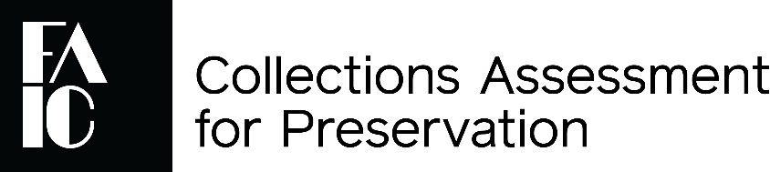

Follow-Up Survey

The Foundation for Advancement in Conservation is interested in understanding the short-term and long-term impacts of the CAP Program. Please share your experience of the past year with us by completing this Follow-Up Survey.
Only aggregate results will be shared outside FAIC and IMLS staff. We thank you in advance for your feedback and appreciate any comments you may have.
Name of Institution:
1. How many times has anyone in your institution consulted your CAP report within the last year?
- have not consulted CAP report
- 1-3 times
- 4-10 times
- more than 10 times
- don’t know
2. Since CAP, has your institution created, revised, or begun development of the following collections care policies/guidelines:
 | Created | Revised | In Development | No Action Taken | Policy Was Already in Place
Collections Management Policy | ☐ | ☐ | ☐ | ☐ | ☐
Long-Range Preservation Plan | ☐ | ☐ | ☐ | ☐ | ☐
Emergency Plan that includes collections | ☐ | ☐ | ☐ | ☐ | ☐
Other policy or plan | ☐ | ☐ | ☐ | ☐ | ☐

If you indicated that you have created, revised, or are developing “other policies/guidelines,” please explain:

3. Indicate whether additional training has been provided for staff or volunteers in the following areas since your participation in CAP:
 | Yes | No | Don’t know
Collection preservation activities | ☐ | ☐ | ☐
Handling collection items | ☐ | ☐ | ☐
Climate control and environment | ☐ | ☐ | ☐
Emergency preparedness | ☐ | ☐ | ☐
Preventive conservation | ☐ | ☐ | ☐
Pest management | ☐ | ☐ | ☐
Other collections care training | ☐ | ☐ | ☐
4. Has your institution explored the Resources page on the CAP website (https://www.culturalheritage.org/resources/collections-care/cap/resource-list)?
☐ Yes ☐ No
If yes, how helpful were the Resources on the CAP website? (check one box below)
Extremely Helpful | Very Helpful | Somewhat Helpful | Not Very Helpful | Not at All Helpful
☐ | ☐ | ☐ | ☐ | ☐
What additional resources would be helpful to you as you implement the recommendations in your CAP report? (optional)
5. Since your assessment, has your institution (i.e. – your leadership, board, or parent organization) committed funds to the preservation of the collection?
☐ Yes ☐ No
If yes, approximately how much money has been dedicated to the preservation of the collection since your CAP assessment? (Include budgeted funds for staff who perform preservation duties, supplies, equipment, surveys, treatments, and consultants.) $______________________
6. Has your institution used your CAP experience and report to PLAN OR APPLY FOR outside funding (i.e. - grants, donations) for collections conservation?
☐ Yes ☐ No
If yes, please indicate whether you plan to apply or have applied for. (Check all that apply.)
☐ a federal grant or assistance program
☐ state grant or assistance program
☐ county or municipal grant or assistance program
☐ foundation funding
☐ private donor
☐ crowdfunding (e.g., Kickstarter, GoFundMe)
☐ other funding source (Specify: )
7. Since CAP, has your institution been AWARDED outside funding for collections conservation?
☐ Yes ☐ No
If yes, please indicate whether your award is from: (Check all that apply.)
☐ a federal grant or assistance program
☐ state grant or assistance program
☐ county or municipal grant or assistance program
☐ foundation funding
☐ private donor
☐ crowdfunding (e.g., Kickstarter, GoFundMe)
☐ other funding source (Specify: )
What was the total amount of funding awarded? $
8. Considering the prioritized list of recommendations provided in your CAP report, how much progress would you say your institution has made toward completing the recommendations? (Please select a number on a scale of 0 to 100, where 0 indicates no progress and 100 indicates completion of all recommendations.)
9. Have you completed the follow-up meeting with your assessor(s)?
☐ Yes ☐ No
If yes, how helpful was the follow-up meeting with your assessors?
Extremely Helpful | Very Helpful | Somewhat Helpful | Not Very Helpful | Not at All Helpful
☐ | ☐ | ☐ | ☐ | ☐
What could have been done to make the follow-up meeting more helpful?

Please use this space to share any additional information.

