Veterans’ Interconnection Screen Shots
Veteran with a disability rating from the VA:
After signing in participants will see a banner at the top of the page. Participants will click “Get started” to begin.
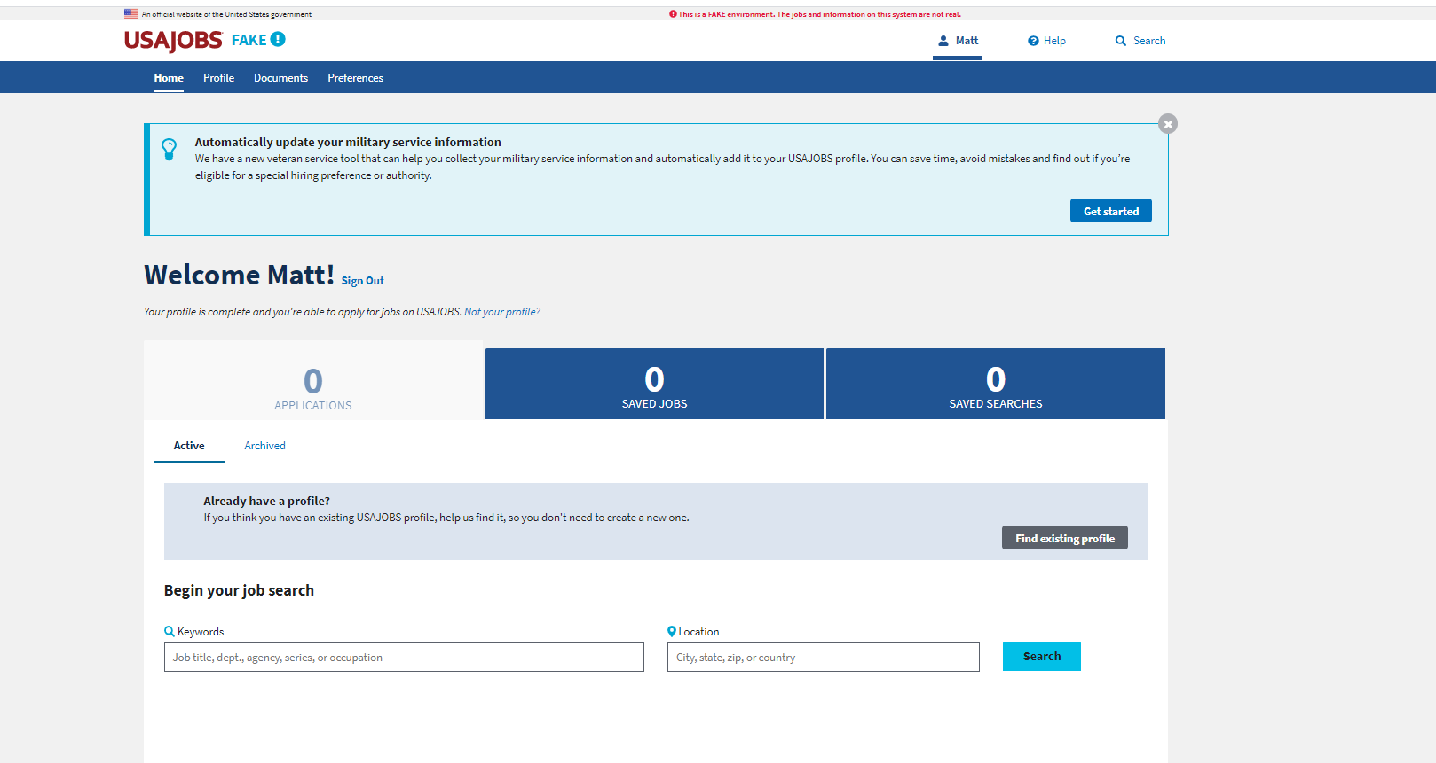

The participant will answer all of the questions on this page.
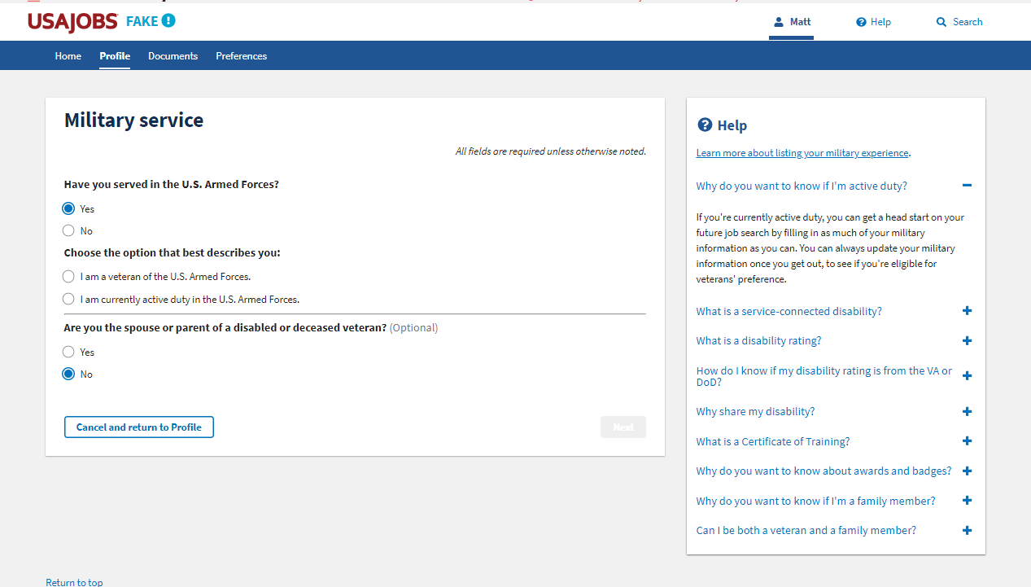
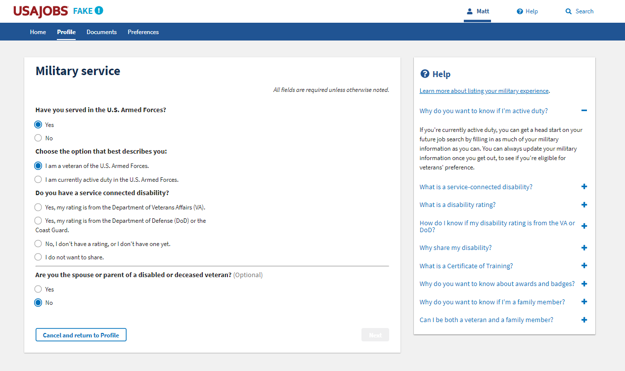
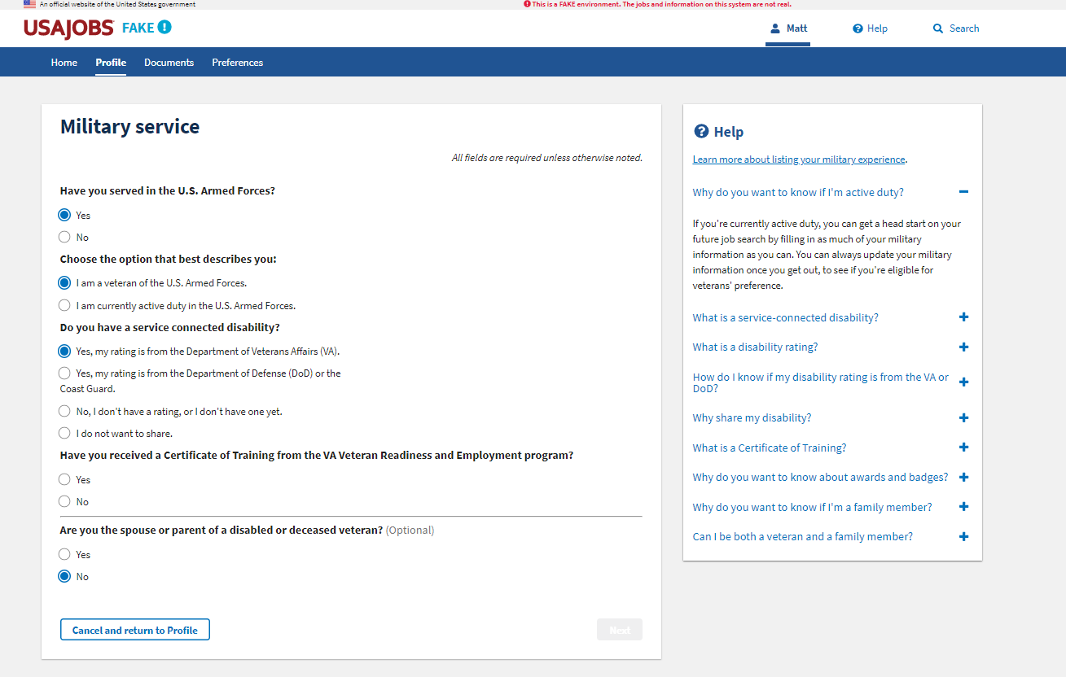
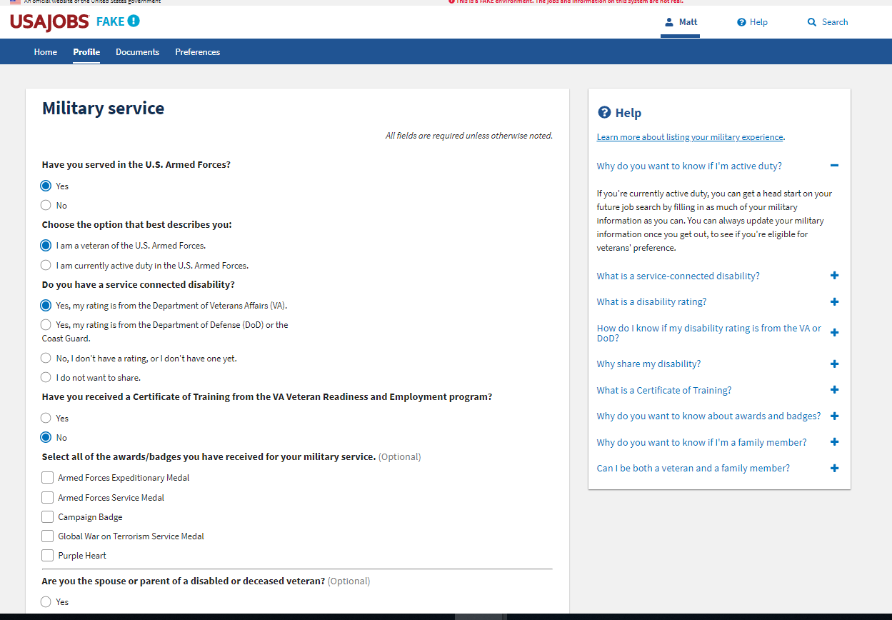
Participant will click “Next” when they have completed all of the questions.
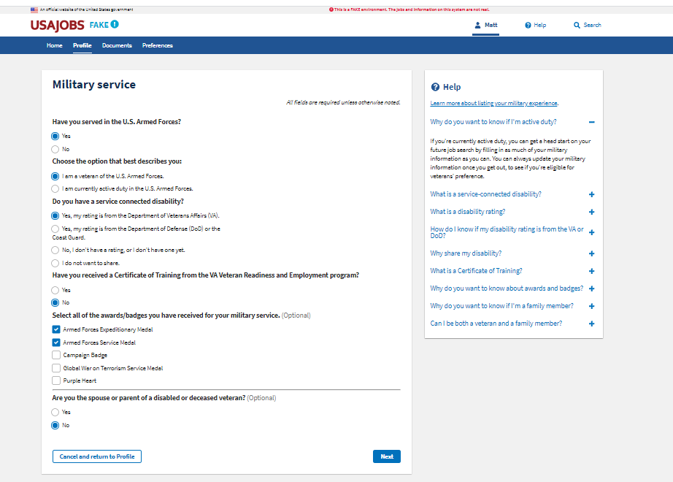

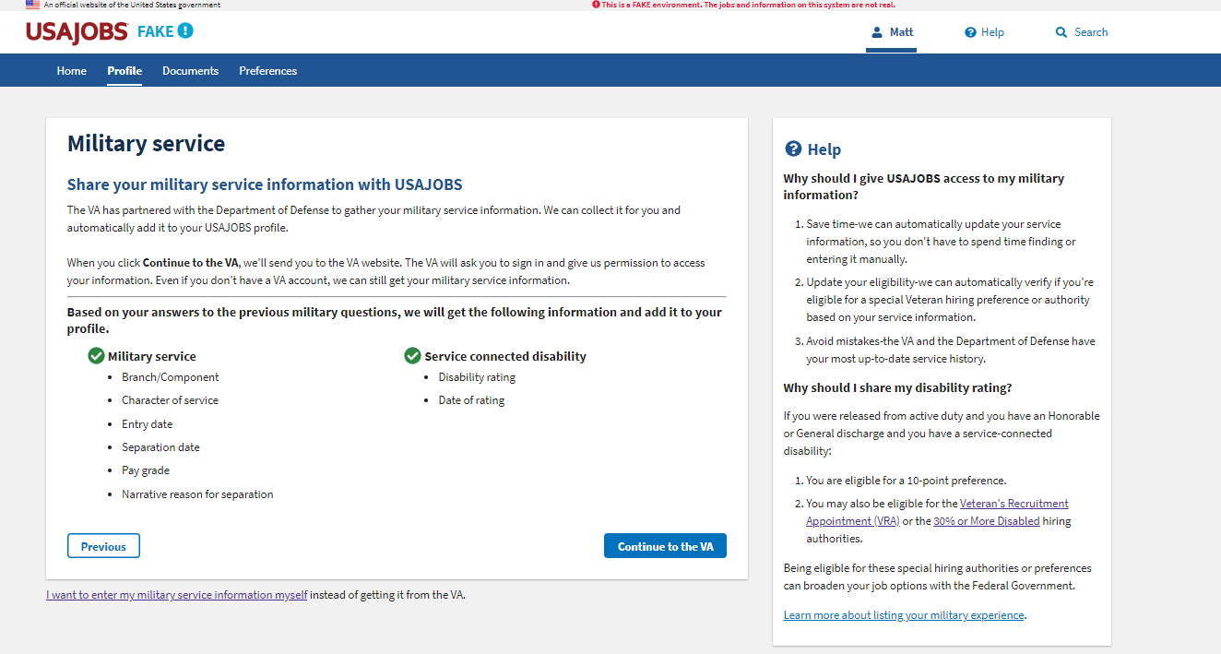
Participants will sign into their VA account or access their service and disability rating using ID.me.
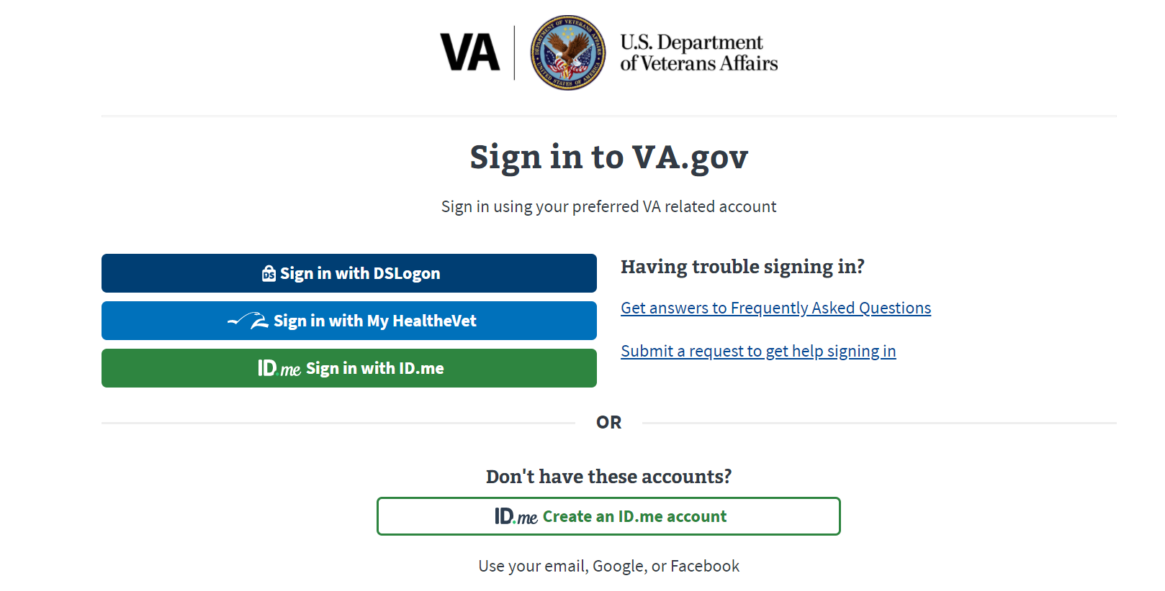
Participants will compare this information to the information on their DD214, DD215 (if they have one) and their VA Disability Letter (if they have a disability rating from the VA).
