Resume Builder is found on the documents page once a user is logged in. Select Upload or Build resume to create.
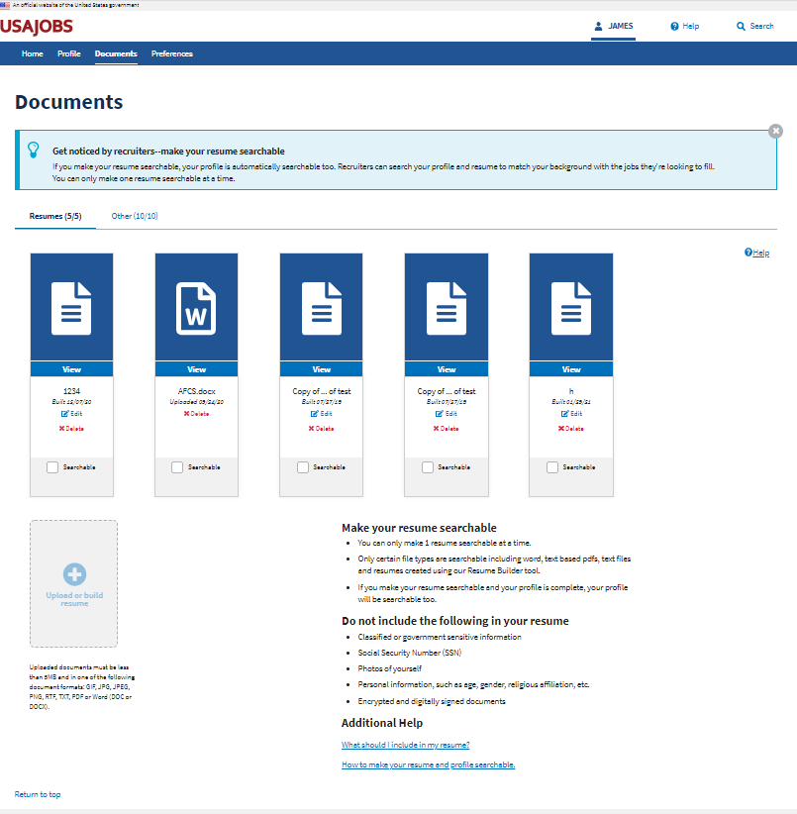

Provide a name for the resume
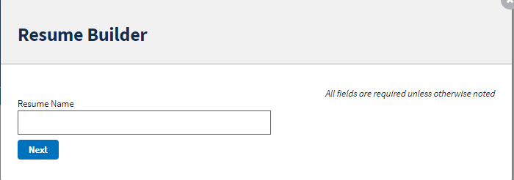

Click Add Work experience to add a new work experience or specific “I do not wish to provide work experience” by checking the box. Click Next to continue.

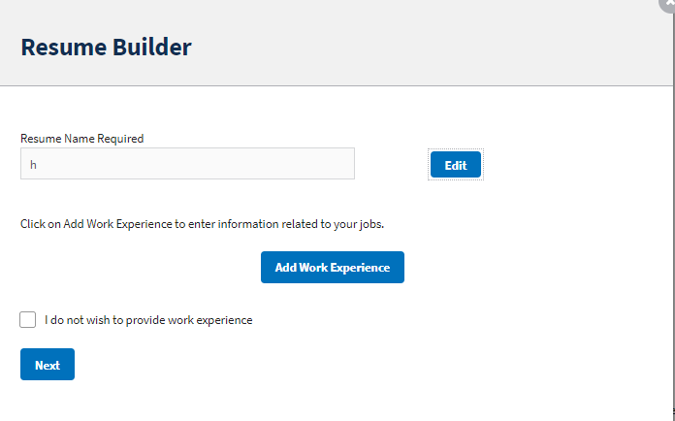

Work experience page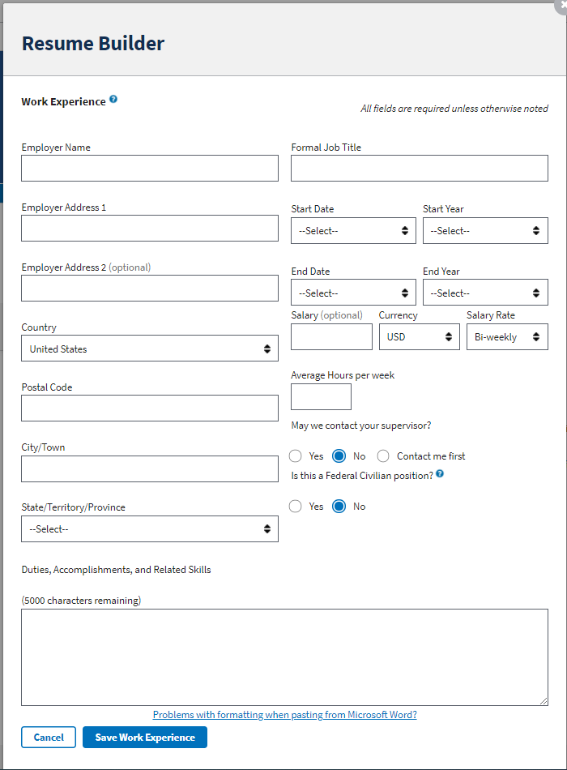

Click Add Education to add a new work experience or specific “I do not wish to provide education” by checking the box. Click Next to continue.

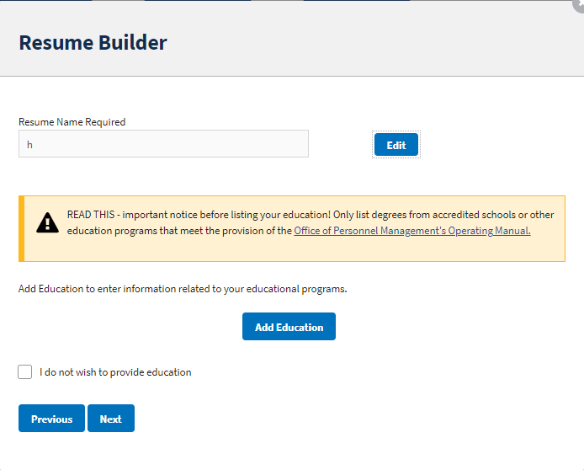

Education page
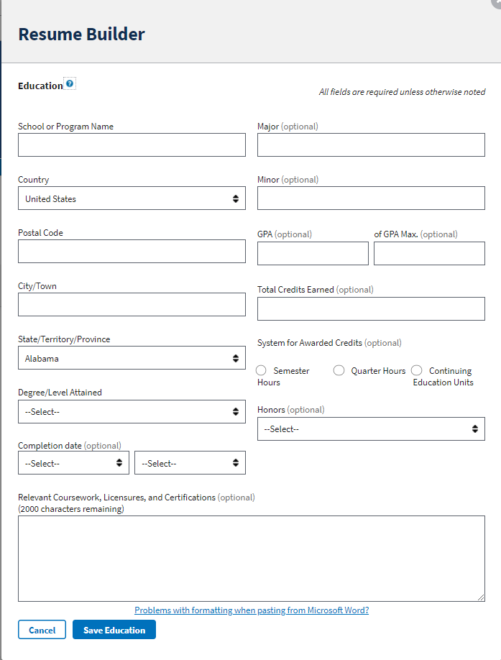

Next is references, Click “Add Reference” to create a new reference or select “references available upon request”
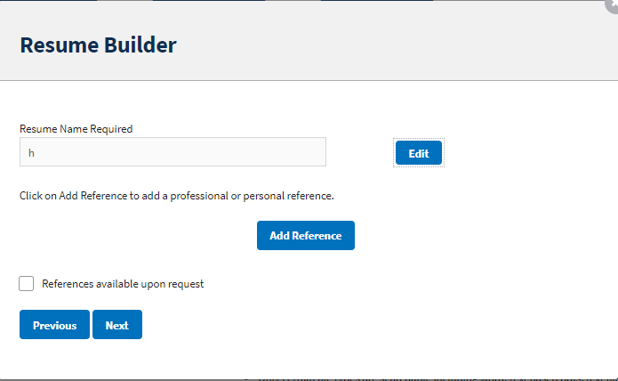

References Page
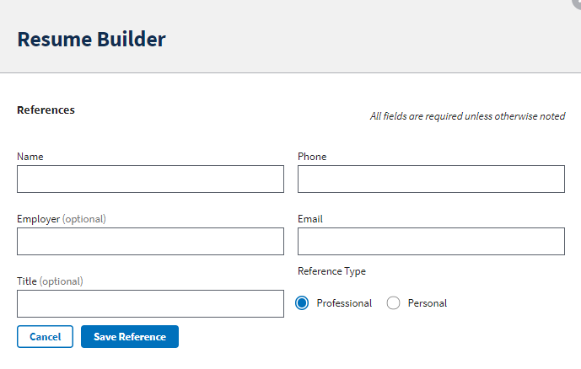

Final Step is your Job Related Training, Language Skills, Organizations/Affiliations, Professional Publications, Additional Information pages
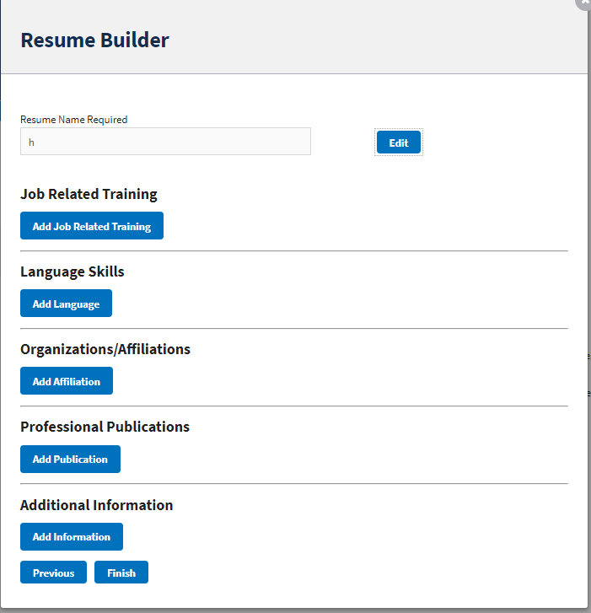

Job Related Training
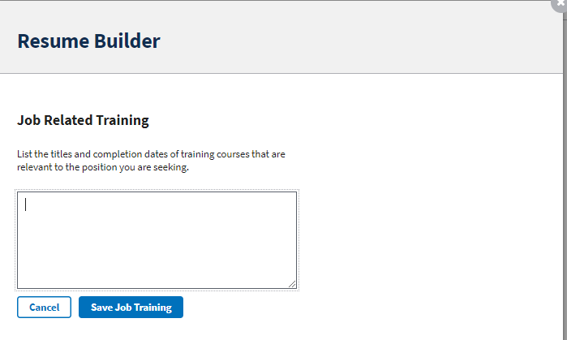

Language Skills

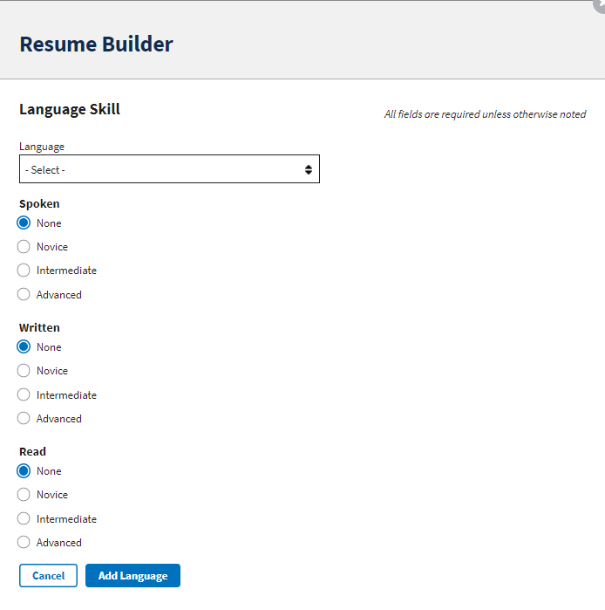

Organizations/Affiliations
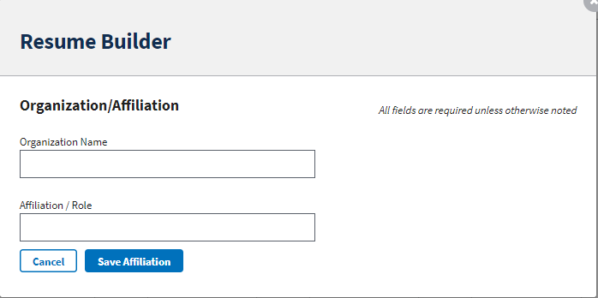

Professional Publications
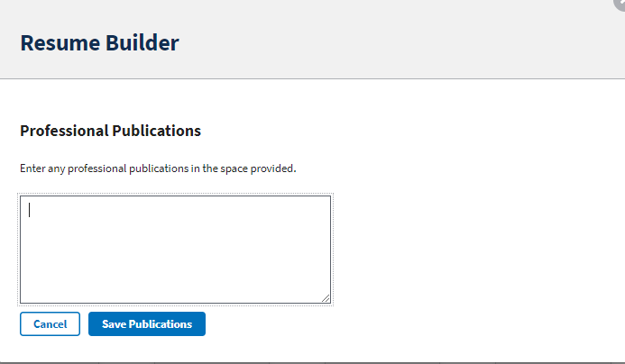

Additional Information
